Local Government Act 2000

FORWARD PLAN OF KEY DECISIONS

The following is a list of key decisions that are proposed to be made during the period of four months commencing on 1st February, 2004.
Particulars of each proposed decision are contained in the appendices to this list.

No | Subject | Date/Period of Decision | Type of Decision | Scrutiny Committee, if Decision Called-in
7. | 289/299, Great Clowes Street, Salford – Environmental Improvements  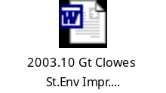 | February, 2004 | Lead Member | Environmental
9. | Improvement of Barton Road/Lane Junction   | 1st December, 2003/  31st March, 2004 | Lead Member | Environmental
10. | External Refurbishment of Dwellings at Seedley West  – Phase 2   | February, 2004 | Lead Member | Environmental
11. | Improvement of Leicester Road/Great Cheetham Street Junction   | 1st December, 2003/  31st March, 2004 | Lead Member | Environmental
12. | Improvement of Silk Street/Blackfriars Road Junction   | 1st December, 2003/  31st March | Lead Member | Environmental
13. | Improvement of A575 Walkden Road (Manchester Road to Park Road   | 1st December, 2003/  31st March, 2004 | Lead Member | Environmental
14. | Painting of Wallness Bridge   | 1st December, 2003/  31st March, 2004 | Lead Member | Environmental
15. | Relocation of Environmental  Services  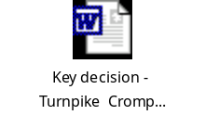 | February, 2004 | Lead Member | Quality and Performance
16. | Littleton Road, Charlestown – External Block Improvement  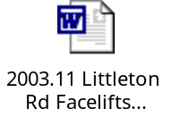 | February, 2004 | Lead Member | Environmental
18. | Various Disposals and Acquisitions of Land   | See appropriate attached form | Lead Member | Environmental
22. | Duchy Estate, Salford – External Refurbishment of Dwellings  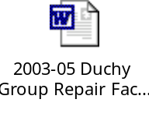 | February/March, 2004 | Lead Member | Environmental
27. | Seedley North West, Phase 3 – External Refurbishment of Dwellings   | February, 2004 | Lead Member | Environmental
30. | Light Vehicle Fleet Tender   | 25th February, 2004 | Cabinet | Environmental
31. | Buile Hill Park Conservation Management Plan and Policies  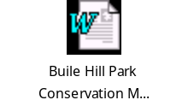 | 25th February, 2004 | Cabinet | Environmental
34. | Approval of a “Rethinking Construction” Partner  – Electrical Services  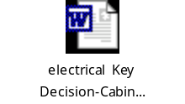 | February, 2004 | Lead Member | Environmental
35. | Best Value Review – Grounds Maintenance   | 11th February, 2004 | Cabinet | Environmental
43. | Development Services Strategic Partner  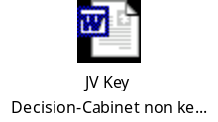 | March, 2003 | Cabinet | Environmental
48. | Eccles New Road, Salford – External Refurbishment of Dwellings   | March/  April, 2004 | Lead Member | Environmental
49. | Appointment of two “Rethinking Construction” Partners - Major new building and refurbishment work  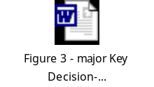 | April, 2004 | Lead Member | Environmental
51. | Acquisition of Land  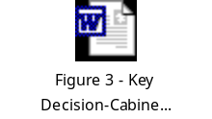  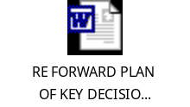 | December, 2003 to June, 2004 | Lead Member | Environmental
 | Items for future Forward Plans
A. | Approval of a “Rethinking Construction” Partner – Highway Structures   | June, 2004 | Lead Member | Environmental
B. | Approval of two “Rethinking Construction” Partners – Highway and Civil Engineering   | June, 2004 | Lead Member | Environmental
C. | Approval of two “Rethinking Construction” Partners – Other New Building and Refurbishment Work   | June, 2004 | Lead Member | Environmental
D. | Approval of a “Rethinking Construction” Partner – Mechanical Services   | September, 2004 | Lead Member | Environmental
E. | Approval of one or two “Rethinking Construction” Partners – Landscape Works   | November, 2004 | Lead Member | Environmental
F. | Approval of two or three “Rethinking Construction” Partners – Minor Building Works  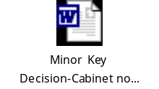 | January, 2005 | Lead Member | Environmental
G. | Approval of two or three “Rethinking Construction” Partners – Responsive and Routine Maintenance   | January, 2005 | Lead Member | Environmental
17th January, 2004

Law and Administration Division
Corporate Services Directorate
Salford City Council
Salford Civic Centre
Chorley Road
Swinton, M27 9TN

Tel No: 0161 793 3018
Fax No: 0161 793 3160
E-mail Address: Paul.Templeton@salford.gov.uk
Internet Site: www.salford.gov.uk

