
Appendix 1

BUDGET CONSULTATION

2006/07

HAVE YOUR SAY


What is this paper about?
This paper is about giving you the opportunity to let us have your views on the priorities that you believe the council should be considering as part of its budget planning process for 2006/07.

It is designed to provide a brief summary of the City Council’s budget for 2005/06, giving details of how much is spent, where it is spent, where it comes from and the services we deliver.

A questionnaire designed to give us a greater understanding of the things that matter most to you is enclosed. These views along with those gathered at consultation meetings will be considered by councillors as part of the budget process and help us make informed decisions.

What is Budget Consultation?
The Council has to set a budget every year based on the cost of providing a wide range of services to residents and businesses in the City. In setting its budget, which in turn sets the level of Council Tax for the year, the Council is keen to hear the views of residents about spending priorities.

The Council has carried out budget consultation exercises in each of the last eight years. Councillors have considered the views and issues raised prior to taking final decisions about the amounts allocated to the various council services and also the level of the Council Tax increase.

The Council is currently developing its spending plans for the financial year April 2006 to March 2007. The Council expects to approve the proposed budget and Council Tax level at its meeting in February 2005.

In advance of this date consultation with the public about its financial plans will take place with community committees, at public meetings at the Civic Centre and by other methods. Your contribution to the debate on the Council’s spending priorities is welcomed.

What is the size of the City Councils budget?
The City Council’s budget in 2005/06 is £294.772m, this is net of service income generated from fees and charges, grants and other service related income. The services this is to be spent on are as follows:

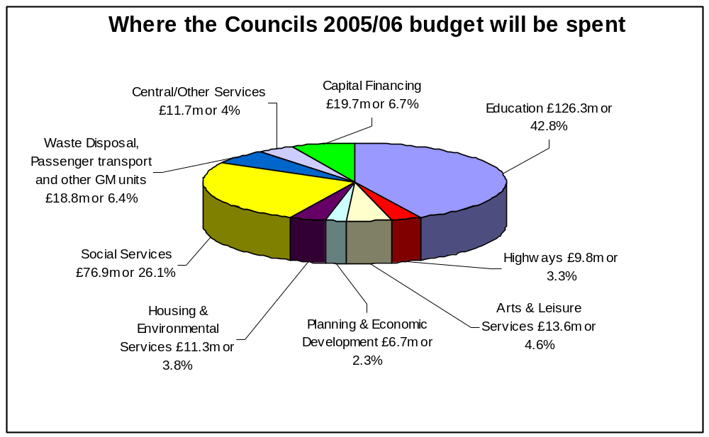

Where does the money come from?
The city council’s budget requirement of £294.8m is funded from two main sources, the Government via its revenue support grant and the redistribution of income collected from business rates and council taxpayers via the council tax charge levied by the council. The position is summarised below:

ANALYSIS OF INCOME | Amounts in 2005/06 |  | Proportion of the Budget
 | £m |  | %
Central Government
Government revenue support grant | 149.3 |  | 50.6
Redistributed non domestic rates (business rates) | 72.2 |  | 24.5
 | 221.5 |  | 75.1
Council taxpayers | 73.3 |  | 24.9
 | 294.8 |  | 100.0

What other services does my Council Tax pay for?
In addition to the costs of the City Councils services your council tax also covers the precepts issued by the Greater Manchester Police and the Fire and Civil Defence Authorities. In summary the Council Tax for a Band D property is as follows:

SERVICES | Band D Council Tax 2005/06 | Proportion of the Council Tax Bill
 | £ | %
Salford City Council | 1,178.40 | 88.7
Greater Manchester Police Authority | 105.41 | 7.9
Greater Manchester Fire & Civil Defence Authority | 44.73 | 3.4
 | 1,328.54 | 100.0

Please note that over 54% of taxpayers in Salford live in Band A properties for which the Council Tax payable is £885.69.

Do we pay for Council Housing?
From 1st April 1990 it became a statutory requirement for local authorities to maintain a separate ‘ring-fenced’ account, known as the housing revenue account (HRA) which sets out the expenditure and income relating to the provision, supervision and management of council housing, flats and accommodation.

Under the ‘ring-fencing’ arrangements the costs of council housing are met from rents, government grants and other related income. Therefore, the costs of this service do not have any impact on the council tax you pay.

How do we decide what to spend the money on?
We operate a medium-term financial strategy that is closely linked to our vision for Salford to create a city where people choose to live and work. We aim to improve the quality of life of all our citizens and it is our view that this can be achieved through the implementation of the council's seven pledges as summarised below: -

- Improving health
- Reducing crime
- Encouraging learning, leisure and creativity
- Investing in young people
- Promoting inclusion – tackling poverty and social inequalities
- Creating prosperity
- Enhancing life

The strategy ensures that there is a close link between the above pledges and the allocation of resources to services so that we can achieve specific service results and deliver the pledges. The strategy takes into account the key messages emerging from the various independent reviews of services that the council provides, in particular the Government’s comprehensive performance assessment, Best Value reviews, service inspections and the Quality of Life survey together with key messages from consultation with the public in previous years.

What is the current position on the 2005/06 budget?
We are currently firming up our spending plans for next year which will be based on providing the same level of service as last year but include budget aspirations linked to the delivery of our pledges. Details of the level of Government support will be available in mid-November. As over 50% of the council’s spending needs is funded from the Revenue Support Grant this has a major impact on the council’s budget and the council tax level. There is increased uncertainty this year as the government introduces three-year settlements for councils.

Initial forecasts of our spending requirements in 2006/07 together with our assumptions as to what money the Government will give us next year suggest that it is likely that there will be a shortfall of resources. It is inevitable that difficult choices will have to be made as we strive to strike the right balance taking into account the need:

- to meet our service targets as set out in our pledges,
- to identify efficiency savings,
- to consider the impact of cutting services,
- to keep the Council Tax at an affordable level, and
- to protect those people who depend on our services, which we are statutorily required to provide for free at the point of delivery.

Are your views listened to?
Salford City Council held budget consultation events during November 2004 and January 2005 where we asked you for your views on Council Tax levels, the quality and quantity of services provided, options for increasing or reducing spending etc.

Last year (and in previous years) three of the main priorities of the public raised during the consultation process were:
- Reducing crime
- Improving the environment
- Providing facilities for young people
In setting its budget for 2005/06 the council invested additional money in these services which it found from improving efficiency in other services.

The results and reports of the 2005/06 budget consultation exercise are available on the council’s website at:
http://www.salford.gov.uk/council/finance/budget/budget-consultation/consultation2005-06.htm

Why should you take the time to contribute to the Budget Debate?
The City Council is again reviewing its services and challenging every area of its spending to ensure that it is used to provide effective services that meet the needs of its residents. It is essential to the success of that process that we continue to hear your views about the services that you value the most.

If you wish to have a greater say in the budget debate please may we encourage you to
attend the public budget consultation meeting to be held at the Civic Centre, Chorley Road, Swinton at 6.00 p.m. on Wednesday 26th October 2005.

Each community committee is also requested to consider their views on council spending priorities and to present them for consideration. You may wish to make your views known at your local community committee.

The short questionnaire enclosed with this booklet is designed to give us an indication of your priorities. Please can we ask you to spend a few minutes to complete it and return it by sending it to the freepost address:

Budget Consultation
Freepost NWW1358,
Swinton.
M27 7BD

The questionnaire is also available on the council website and can be completed and submitted electronically at http://www.salford.gov.uk/council/finance/budget/budget-consultation/consultation2005-06.htm

You can also let us have your comments or request further information by:

- email: budgetconsultaiton@salford.gov.uk
- writing to: Budget Consultation, Freepost NWW1358, Swinton M27 7BD
- telephoning: 0161 793 3057

If you have any special requirements such as access or languages please contact Carolyn Haslam on 0161 793 3057

More details of the budget proposals for next year can be found at www.salford.gov.uk/budget-consultation

