Part one open to the public | ITEM NO.A1

REPORT OF CHIEF EXECUTIVE

TO
THE CITY MAYOR
and
CABINET
ON
12TH JUNE 2012

TITLE: Salix Homes: Investment and Management Issues

RECOMMENDATIONS:

That the City Mayor, in consultation with his Cabinet, confirms:

- The need to commence a formal appraisal of the investment and management options for all remaining non-PFI council owned homes in Salford.

- That the options appraisal must be guided by the tests detailed at 4.4 in the report.

- The establishment of a tenant led Options Appraisal Board to appraise options and to make a recommendation to the City Mayor as to the preferred option.

- The establishment of a dedicated project team to take this work forward and to support the Options Appraisal Board.

EXECUTIVE SUMMARY:

The Localism Act 2011 confirms the implementation of Housing Revenue Account (HRA) Self Financing from 1st April 2012.

This has brought about the abolition of the HRA housing subsidy system, removed centrally approved council housing investment programmes such as Decent Homes and has left councils with the responsibility of managing their housing debt. The council must manage and maintain the housing stock to at least the Decent Homes standard, but is limited on what it can borrow to do this because of the introduction of a ‘debt’ or ‘borrowing cap.’ It is also restricted on how it can set local rents and there is an assumption that council rents will be comparable with local housing association rents by 2015. This is called ‘rent convergence.’
The imposition of a debt cap, the reduction in backlog funding available to the council and Salix Homes for Decent Homes investment, the investment standard agreed for Pendleton PFI and the standard being achieved by City West through stock transfer means that within a short space of time, tenants will be paying the same rent in central Salford as that charged by City West and the Pendleton PFI contractor, but for a vastly inferior investment standard. This has occurred as a consequence of a change in the level of resources that are now available for the Salix Homes managed stock compared to when the original stock options appraisal was undertaken in 2005.

An independent study has been commissioned by the council (undertaken by Sector Treasury Services) which concludes that “despite the revision of the debt settlement, the overall picture for the Salford stock remains that the General (Salix Homes managed) stock will suffer a level of delays to its investment programme that are likely to impact on the level of decency in those properties.. Given the interaction of the various stock solutions in Salford, we would suggest that consideration should be given to an option appraisal for the financing and maintenance of the housing stock to address the issue arising from the self-financing settlement. There are a number of options to consider.”

A key recommendation of the report is that the Council undertakes a full investment and management option appraisal of its stock to ensure that the following tests are met:

- Provides all the investment needed, and at the right time, for all the remaining non-PFI managed homes in Salford;

- Maximises customer involvement, self regulation and governance;

- At least maintains the current service standard and performance levels achieved by Salix Homes; and

- Enables the council to fully fund a 30 year Pendleton PFI business plan.

Given one of the potential outcomes of this work could be for tenants to choose some kind of stock transfer route, early consideration needs to be given as to any realistic prospect of funding.

There is likely to be a lot of interest in stock transfer and only limited, if any, funding will be made available to support a transfer programme; the earlier Salford puts a marker down the better to ensure that transfer is a realistic option during the appraisal process. Putting a marker down does not commit to the transfer route but allows it to be treated as an equally weighted option alongside the options for retention.

BACKGROUND DOCUMENTS:
(Available for public inspection)

See Appendix 1 (Salix Homes Stock 30 Year Investment Profile)

See Appendix 2 (Sector Report)

See Appendix 3 (Project Initiation Document and Plan)

KEY DECISION: YES

DETAILS:

- DETAILED BACKGROUND

  - The Localism Act 2011 confirms the implementation of Housing Revenue Account (HRA) Self Financing from 1st April 2012.

  - In effect this marks the most radical change ever in the financing of council housing and from this financial year 2012/13 onwards we will see:

- An end to a subsidised HRA in Salford with the council solely responsible for ensuring a viable 30 year business plan for its housing stock;
- No more government funded capital programmes such as Decent Homes once the current backlog programme has been committed at the end of 2014/15; and
- An ‘opening’ debt level determined by government which will have to be serviced from the HRA.

  - Salford will be allowed to keep all the money coming into the housing revenue account from rents and service charges, though not all of any right to buy receipts; Salford will be allowed to use this income to provide services, maintain homes and to meet the costs of borrowing necessary to fund the future investment needs of its housing stock.

  - Critically however the government has introduced a self financing ‘debt cap,’ a prescribed figure above which the council will not be allowed to borrow. This restriction is a major problem for Salford.

  - It is also important to add that under self financing, council rents will be required to match those for local equivalent housing association owned homes by 2015. This is called rent convergence and will mean an increase on current average weekly weeks of almost £20 over the next four years.

  - This means that within four years tenants living in the Salix Homes managed stock will be paying broadly equivalent rents to tenants in similar housing association homes; however City West tenants and tenants living within the PFI area will benefit from a much higher standard of investment than what will be achieved for the Salix Homes managed stock.

- WHAT A SELF FINANCED HRA WILL MEAN FOR SALFORD

  - The government has valued Salford’s housing stock as follows:

Government Valuation at 1st April 2012

Debt Cap £66.343m
Actual Debt £53.776m
Headroom to Borrow £12.567m

  - In other words the council will be allowed to borrow up to £12.567m at any time from 1st April to fund its housing investment programme.

  - Unfortunately this is not enough.

  - The investment needed for the homes managed by Salix Homes will be delayed significantly (between 9 and 15 years) as a consequence of the limited headroom to borrow. Over 30 years an investment shortfall of £93m builds up under self financing; it is highly unlikely that the Salix Homes managed stock will ever achieve and / or maintain the decent homes standard.

See Appendix 1 (Salix Homes Stock 30 Year Investment Profile)

- THE PROBLEM IN MORE DETAIL

  - The government has assumed that there will be one self financed HRA in Salford, covering the homes managed by Salix Homes and the stock to be transferred to the successful Pendleton PFI bidder later this year.

  - It is important to stress therefore that a continuing financial relationship will exist between the Salix Homes managed stock and the PFI managed stock during 2012/13 and beyond.

  - However, whilst there will be one self financed HRA covering all of the retained housing stock, it will be necessary to have a separate 30 year business plan for the PFI managed stock once the contract has been awarded, and to have a separate 30 year business plan for the Salix Homes managed stock.

  - As a result the council commissioned consultants Sector earlier this year to examine a number of models under self financing as follows:

- What a combined 30 year HRA business plan with the Salix Homes and the PFI managed stock treated as one would look like;
- A 30 year business plan for the Salix Homes managed stock only; and
- A 30 year business plan for the PFI managed stock only.

  - Key assumptions in looking at the above have been:

  - PFI scheme starts September 2012;
  - The investment standard for the Salix Homes managed stock is lower than the PFI or City West investment standard;
  - There is a continued reduction in management and maintenance costs over time for the Salix Homes managed homes;
  - Gradual increase in planned maintenance over time for the Salix Homes managed homes;
  - That all of the headroom for borrowing is used during 2012/13; and
  - Rent convergence is achieved by 2015/16.

Any changes to these assumptions will have an impact on the various models.

  - The conclusions are:

    - A combined HRA does not work; in effect the Salix Homes managed stock would continue to fall into non decency at the expense of achieving the PFI scheme and the necessary investment would take between 9 and 15 years to recover depending on interest rate levels and the strategy adopted for managing debt.

    - A 30 year business plan for the Salix Homes managed stock only is severely restricted by the debt cap; the investment needed is always constrained by the limited access to funding imposed by the debt cap.

    - A 30 year business plan for the PFI managed stock needs a contribution from the council in addition to the likely level of PFI credits.

See Appendix 2 (SECTOR Report)

  - There has always been an expectation that the council will support the PFI scheme either from the HRA or the general fund. However the situation has changed dramatically since the ‘signing off’ by the government of Salford’s housing options appraisal in 2005. In particular it is important to note 4 key developments:

- The advent of self financing and the loss of subsidy;
- Reduced PFI credits from the government;
- Salix Homes has not been allocated decent homes funding at the time it was originally expected nor the amount originally planned for putting further pressure on its investment and business plans; and
- The overall financial position of the council has worsened considerably since April 2010.

  - It is also important to note that a number of other Round 6 ALMOs are experiencing similar difficulties in constructing a viable 30 year self financed HRA; this is largely due to an assumption under self financing that councils have met the decent homes standard and have no other significant backlog investment. In addition to one of the highest non-decency levels in England, the Salix Homes managed stock also experiences major backlog investment in areas such as:

- fire risk compliance;
- DDA compliance;
- the external integrity of apartment blocks;
- energy efficiency measures to reduce fuel poverty;
- sheltered housing;
- garages and shops;
- works to the homes on the Beech Farm estate; and
- environmental works such as fencing on all of our estates.

- OPTIONS AVAILABLE

  - The key challenges and risks the council faces with self financing relate to the Salix Homes managed stock only, assuming the PFI contract is finally awarded later this year and that the required contribution to the PFI business plan going forward can be identified.

  - The options available to the council in seeking to address these challenges and risks can be summarised as follows:

- Retain ownership of the properties and manage them using one of the available options remaining within the HRA Self Financing regime such as ‘in house’ management or through Salix Homes; or

- Transfer the ownership of the stock to a Registered Provider, thereby taking ownership of the stock and borrowing outside the HRA Self Financing regime.

  - These options would need to be appraised fully over the coming weeks and would also require the involvement of:

- Government and the Homes and Communities Agency;
- Tenants and the Salix Homes Customer Senate; and
- Salix Homes Board and employees.

What is not an option is a challenge to self financing itself; all the political parties support self financing. Self financing has now been implemented on a national basis and it is clear that Government will only consider transfer of stock out of the self financing regime in exceptional circumstances and provided the alternative produces a value for money outcome.

  - In considering the options it will be necessary to apply a number of tests and to determine whether or not a particular test could be met for the Salix Homes managed properties. These tests will include:

- Will the option provide all the investment needed, and at the right time, for the remaining council owned homes in Salford?;

- Will the option satisfy the government's requirement for a value for money solution?;

- Will the option maximise customer involvement, customer led self regulation and place customers at the heart of governance?;

- Will the option at least maintain the current service standards and performance levels achieved by Salix Homes?; and

- Will the option enable the council to fully fund a 30 year Pendleton PFI business plan?.

Further desirable outcomes to be tested include:

- The ability to provide new homes;

- Be recognised as a strategic partner within the City; and

- Have wider neighbourhood responsibilities than housing provision alone.

  - Unless the government is to change the rules relating to self financing and remove the ’debt cap’ placed on Salford’s HRA a retained ownership option is not going to satisfy all of the tests above. Feedback from government officials is clear that the HRA Self Financing rules will not be changed to enable additional borrowing. Indeed there have been a number of indications since the latest budget announcement that the Treasury is considering further restrictions on borrowing under self financing.

  - A stock transfer option will allow access to borrowing above the debt cap and therefore access to the funding necessary to achieve and maintain decency for the Salix Homes managed properties and deal with all other backlog repairs. The only limitation on borrowing is simply what the business plan can afford. To enable a stock transfer the government would need to provide sufficient funding to effectively write off some or all of the council’s HRA debt.

  - A stock transfer would also allow:

- The debt associated with the Salix Homes managed properties to be removed from the council;

- A likely income for the council from a VAT shelter sharing agreement;

- Confirmed funding for the Pendleton PFI scheme business plan without the need for a general fund contribution; and

- Potential to build new affordable homes when the transfer business plan allows (usually when all backlog investment has been met).

  - In addition a stock transfer would give the council an opportunity to promote its commitment to the development of co-operatives and mutuals. Salix Homes has already commenced a debate with tenants as to how it can further develop its tenant involvement arrangements; ideas around mutuality have been explored and favourably received so far. The Salix Homes Customer Senate has met with its equivalent body in Rochdale to learn more about the recent positive vote to convert the ALMO into a co-operative.

  - However a stock transfer solution would not be without its difficulties. Agreement would have to be reached with government to enable a transfer to take place. The current government has tightened the rules around the financing of transfers and there are a range of value for money tests that would have to be satisfied before government approval for a stock transfer would be given.

  - In addition tenants, rightly, would have the final say. A transfer of ownership would only proceed if it were supported through a future ballot of all tenants.

- NEXT STEPS

  - There are a number of next steps as follows:

    - Initial discussion with the Homes and Communities Agency and CLG: There is likely to be a lot of interest in stock transfer and only limited funding will be made available to support a transfer programme; the earlier Salford puts a marker down the better if only to ensure that transfer is a realistic option during the appraisal process. Putting a marker down does not commit to the transfer route but allows it to be treated as an equally weighted option alongside the options for retention.

    - Establish a tenant led Options Appraisal Board: Supported by a council appointed Project Director, membership of the Board will include council nominees, Salix Homes Customer Senators as well as Salix Homes Board and staff representatives.

    - Appoint an Independent Tenant Adviser: Tenants will need independent advice throughout the appraisal process and they will need to procure an ITA at an early opportunity.

    - Approval of the Project Initiation Document and Plan: This document confirms the scope of the project, likely resources needed and where they will be funded from, key actions and dates.

See Appendix 3 (Project Initiation Document and Plan)

- OPTIONS APPRAISAL RECOMMENDATION

  - The Options Appraisal Board will make a recommendation as to its preferred investment and management option to the City Mayor (and Cabinet) in September 2012.

  - Any recommendation will have to be formally approved by the council before it can be implemented.

KEY COUNCIL POLICIES:

Shaping Our Place … Our Strategy for Housing in Salford 2008-2011

EQUALITY IMPACT ASSESSMENT AND IMPLICATIONS:

A full equality impact assessment will be carried out comparing the impacts of the various options as part of the appraisal process.

ASSESSMENT OF RISK:

- RISKS AND CHALLENGES FOR THE COUNCIL

  - Self financing therefore brings many challenges and risks for the council:

    - Rents will continue to rise significantly over the next four years as the requirement to meet rent convergence is met

The council could choose not to comply with rent convergence and ‘challenge’ the government; however this would have a critical impact on the HRA’s ability to fund services, investment, the PFI scheme and debt.

    - A differential investment standard in Salford will emerge

Salix Homes managed properties are unlikely to achieve the decency standard for a considerable number of years and it will be a struggle to maintain the decency standard where this has been achieved. In addition self financing has assumed a lesser investment standard (a basic decent homes standard, not the Salford standard) than that for City West and Pendleton PFI – yet tenants in the Salix Homes managed stock will be paying the same levels of rent as those in Pendleton PFI and City West homes.

    - Tenants in the Salix Homes managed stock would be ‘subsidising’ the Pendleton PFI scheme

Assuming the council makes its financial contribution to the Pendleton PFI scheme from a combined self financed HRA, this would be seen by a number of tenants in the Salix Homes managed properties as their rents being used to ‘subsidise’ a much better investment standard in Pendleton at the expense of investment in their own homes

    - There will be less money to spend on services

Reducing management and maintenance expenditure over time has been built into the self financed HRA. However reducing operational costs will do nothing to solve the investment problem for the Salix Homes managed properties. Bringing the ALMO back ‘in house’ may help achieve some of the required efficiencies, but the council will still have to contend with the stranglehold of the debt cap.

In fact the tenants of Salix Homes managed properties will face a ‘triple whammy’ of: increasing rents, reducing services, and poorer standard of investment when it eventually arrives.

    - Significant performance requirements remain

The government has built into self financing challenging performance expectations, particularly in relation to the level of bad debts and void loss. There will be a constant pressure on the need to achieve efficiencies against the need to maintain high performance in key areas. Any reduced income to the HRA will just add to its difficulties and this is likely to be more even more of a challenge when the government’s planned welfare reforms and intention to pay the housing element of the Universal Credit direct to tenants is factored in.

    - The Pendleton PFI scheme must proceed

Any solutions to these risks and challenges must ensure that the PFI scheme proceeds and that the level of investment so far secured for the Pendleton area remains intact.

7.1.7 Consultation

This report and recommendations have been considered and are supported by the Assistant Mayor for Housing and Environment.

SOURCE OF FUNDING: Salix Homes

LEGAL IMPLICATIONS Supplied by: Nicky Smith, Solicitor, Legal Services.
Contact: 0161 219 6315; email: n.smith@manchester.gov.uk

All statutory guidelines and legal obligations will be followed whilst undertaking the option appraisal. Each option to be appraised will have detailed legal implications which will be fully considered as part of the option appraisal process.

FINANCIAL IMPLICATIONS Supplied by Neil Thornton, Chief Financial Officer
Contact: 0161 686 6200; email: neil.thornton@salford.gov.uk

Restrictions on the long term funding of the HRA are as set out within the report above. Final confirmation of the impact of the Pendleton PFI scheme upon the HRA is still required, however, Sector have modelled the anticipated costs of the PFI within a combined HRA business plan. This demonstrates that the debt cap placed upon the HRA will limit the Council’s ability to invest in the Salix managed stock.

The estimated cost of the initial option appraisal is £50,000 which includes the costs of financial advice along with an independent tenant advisor. This will be funded by Salix Homes via the HRA. The longer term financial impact of the various options will be considered during the options appraisal process.

OTHER DIRECTORATES CONSULTED:

Office of the Chief Executive, Environment and Community Safety, Sustainable Regeneration.

CONTACT OFFICERS: Barbara Spicer, Chief Executive, Salford City Council
Kevin Scarlett, Chief Executive, Salix Homes

WARD(S) TO WHICH REPORT RELATE(S):

All Central Salford Wards and Swinton North

Appendix 1

Salix Homes Stock 30 Year Investment Profile

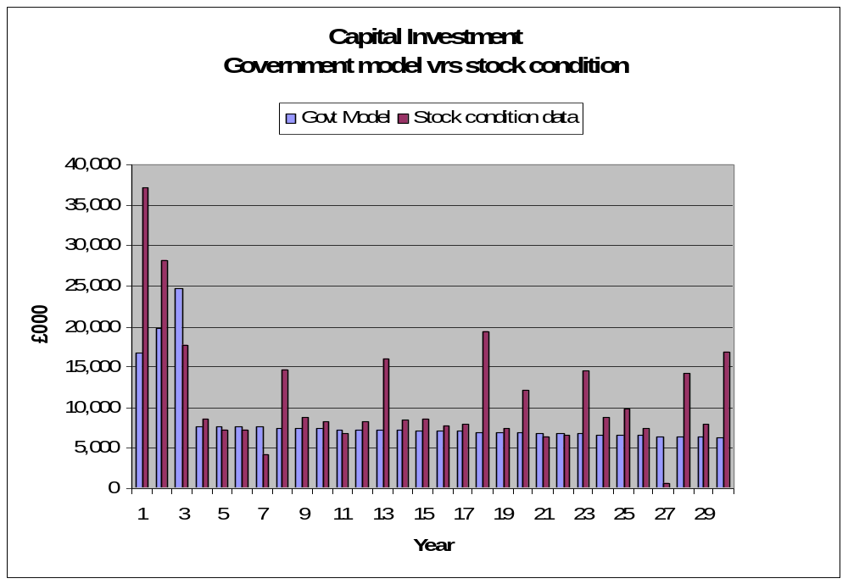
Represents a £93 million shortfall over 30 years

Note: Years 1 to 3 of the Government Model columns includes the Decent Homes Backlog Funding remaining allocation of £38.8 million. The year 1 allocation (2012/13) of £9 million is committed; years 2 and 3 (2013/14 and 2014/15) of £29.8 million are indicative only.


Appendix 2

Salford City Council
HRA Reform - Revised Outcomes re changes to Debt Premia Assumptions
Jan 2012

Date 9 January 2012

This report is intended for the use and assistance of customers of Sector Treasury Services Ltd (“Sector”). It should not be regarded as a substitute for the exercise by the recipient of its own judgement. Sector exists to provide its clients with advice primarily on borrowing and investment. We are not legal experts and we have not obtained legal advice in giving our opinions and interpretations in this paper. Clients are advised to seek expert legal advice before taking action as a result of any advice given in this paper. Whilst Sector makes every effort to ensure that all information provided by it is accurate and complete, it does not guarantee the correctness or the due receipt of such information and will not be held responsible for any errors therein or omissions arising there from. Furthermore, Sector shall not be held liable in contract, tort or otherwise for any loss or damage (whether direct, or indirect or consequential) resulting from negligence, delay or failure on the part of Sector or its officers, employees or agents in procuring, presenting, communicating or otherwise providing information or advice whether sustained by Sector’s customer or any third party directly or indirectly making use of such information or advice, including but not limited to any loss or damage resulting as a consequence of inaccuracy or errors in such information or advice. All information supplied by Sector should only be used as a factor to assist in the making of a business decision and should not be used as a sole basis for any decision.

Sector is the trading name of Sector Treasury Services Limited, which is authorised and regulated by the Financial Services Authority (FSA) for the provision of the investment advisory services it provides as part of its Treasury Management Service and is also a member of the Finance and Leasing Association (FLA). Registered in England No. 2652033. We operate as part of Capita plc.

1. Introduction

  - Following on from the report produced for the Council, dated 5 December 2011, we have been asked to revise the assumptions given on the repayment of debt premia and the opening balance on the HRA reserve.

  - The Council completed the annual base data return of HRA information in August 2012. One section of the document asked for “the aggregate value of the remaining HRA share of premiums on loans redeemed between 1 April 1995 and 1 February 2011” to which the response given was £18,382,924. In addition the following question asked for “the aggregate value of the remaining income from the HRA share of the discounts received between 1 April 1995 and 1 February 2011” to which the response given was £603,128. The net amount of the two being £17,779,796. These amounts were not allocated out to future years (as had been the case in the February 2011 Government modelling). The debt settlement of £67.102m included the net cost of the historic premia of £17.780m as a year 1 cost, and as such the settlement is lower than it would have been if the premia had been spread out over future years.

  - The report dated 5 December 2012, assumed that the real assumption for Salford on repayment of debt matched that of the Government settlement and assumed that a payment of £17.780m would need to be made in 2012/13. This affected the amount of cash available in the early years for repair work and housing services.

  - The Council has recently provided Sector with a breakdown of the actual premia and discount payments as they fall due over the period 2012/13 to 2025/26 inclusive. These are as follows:

Year | Premia  £ | Discount  £ | Stock Premium  £ | Net Cashflow  £
2012-13 | 3,596,152 | -134,398 | 67,365 | 3,529,119
2013-14 | 3,158,127 | -125,507 | 67,365 | 3,099,985
2014-15 | 2,230,884 | -118,342 | 67,365 | 2,179,907
2015-16 | ,2,230,884 | -114,283 | 67,365 | 2,183,966
2016-17 | 2,230,884 | -110,598 | 67,365 | 2,187,651
2017-18 | 2,230,883 | 0 | 67,365 | 2,298,248
2018-19 | 2,183,546 | 0 | 14,670 | 2,198,216
2019-20 | 0 | 0 | 14,670 | 14,670
2020-21 | 0 | 0 | 14,669 | 14,669
2021-22 | 0 | 0 | 14,669 | 14,669
2022-23 | 0 | 0 | 14,669 | 14,669
2023-24 | 0 | 0 | 14,669 | 14,669
2024-25 | 0 | 0 | 14,669 | 14,669
2025-26 | 0 | 0 | 14,669 | 14,669
TOTAL | 17,861,360 | -603,128 | 521,544 | 17,779,776

We have been asked to re-model the outcomes for the models in section 4.2 of the December 2011 report if it is assumed that the premia and discounts fall in the years as expected in the table above, rather than all in 2012/13. We have assumed that these sums are the actual cash sums payable at the time and that inflation does not apply. In addition, we have been asked to assume that as well as maintaining a minimum HRA cash balance of £1.5m, the opening reserve balance is also £1.5m.

  - It should be noted that had the Government settlement included these costs in the years that they are expected to be paid, the debt settlement figure of £67.102m would have been £69.772m, an increase of £2.67m.

So the revised figures would be:
Debt settlement figure £69.772 m
SCFR £127.399m

Payment due to Salford £57.627m

On 28th March 2012, The Council would have:

Actual debt = HCFR (excl new build) £114.831m
Receipt from Govt to repay debt (£ 57.627m)

Remaining actual debt (excl new build) £57.204m
Add new build debt £ 4.235m

Total debt £61.439m

Debt cap (incl new build) £74.007m

Headroom in borrowing £12.568m

The headroom was previously £12.568m with £67.102m debt cap and remains so the same despite the increase in the debt cap.

2. Revised Outcomes – combined Salix and PFI stock

  - The following sensitivities relate to the Salford HRA model assuming that Salix continue to manage the general stock and that a PFI scheme begins in July 2012 for part of the stock that were previously discussed in paragraph 4.2 of the Dec 2011 report.

  - The models also assume that following:

- The debt cap is £67.102m
- The headroom is £12.568m and is drawn down as necessary to meet SCS requirements
- The opening HRA cash reserve is £1.5m and maintained at that minimum
- Cash resources are used to repay debt at the earliest opportunity

2.3 a) Original Plan 4.9% interest rate

In Paragraph 4.2 of the December 2011 report, we see that if we assume that the interest rate is 4.9% and that the historic debt premia is all paid in year 1 and all of the headroom is available, then the business plan results were:

Peak Loans Balance £96.900m (cap is effectively £67.102m)

Peak year 2

Repayment of loan – Year 27

The debt cap was breached, so there would need to be some re-phasing of investment works delaying the works to the general stock not the PFI. The table below sets out how this looked:

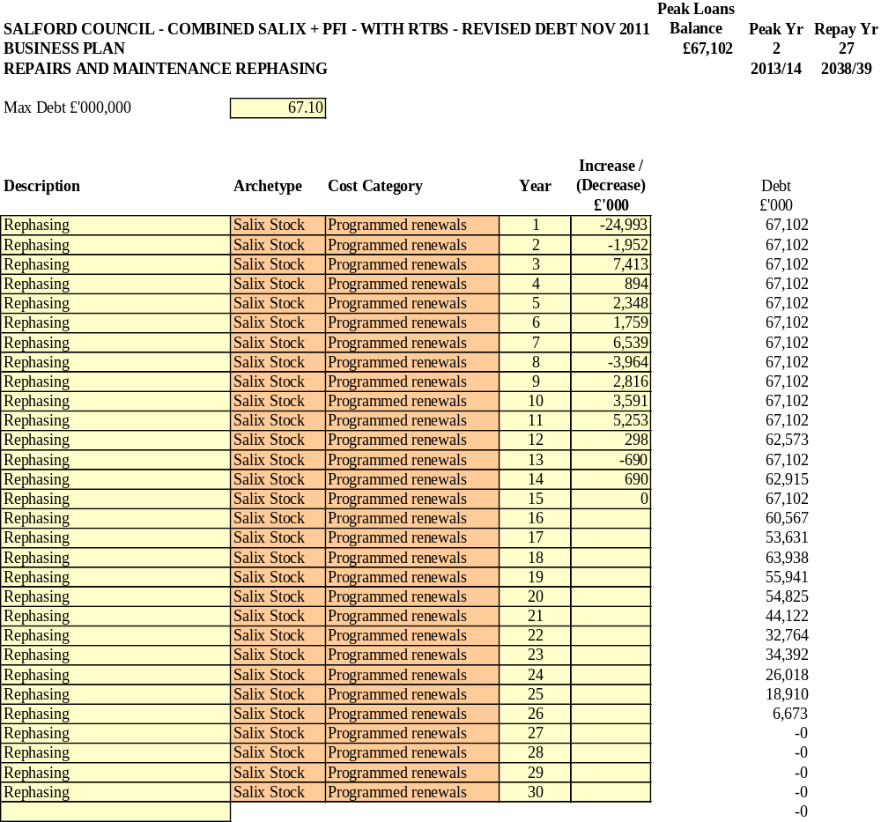

This shows that in trying to keep within the debt cap, works to the general stock properties would fall into non-decency at the expense of achieving the PFI scheme. £27m of work needed in the first 2 years would need to be pushed back and would take 15 years to recover.

The PFI stock would be subject to a contract and as such can be considered to be fixed cashflows, rents are controlled by a formula and cannot increase, the day-to-day management and maintenance in our modelling has been reduced below the current levels and as such the variable therefore must be the investment works in the general stock.

The plan could repay by year 27 but the delay in works will increase pressure on repairs budgets and this in turn will cause further delays in investment.

The plan would be compromised further if the DHS backlog funding is withdrawn.

2.3 b) Revised Plan with re-profiled historic debt premia and interest rate at 4.9%

Revising the debt premia assumption and the opening cash reserve, but still assuming that the debt cap is £67.102m and interest rates are 4.9% would give the following business plan result:

Peak Loans Balance £83.074m (cap is effectively £67.102m)

Peak year 2

Repayment of loan – Year 26

The debt cap is still breached, so there would need to be some re-phasing of investment works delaying the works to the general stock not the PFI. The table below sets out how this may look:

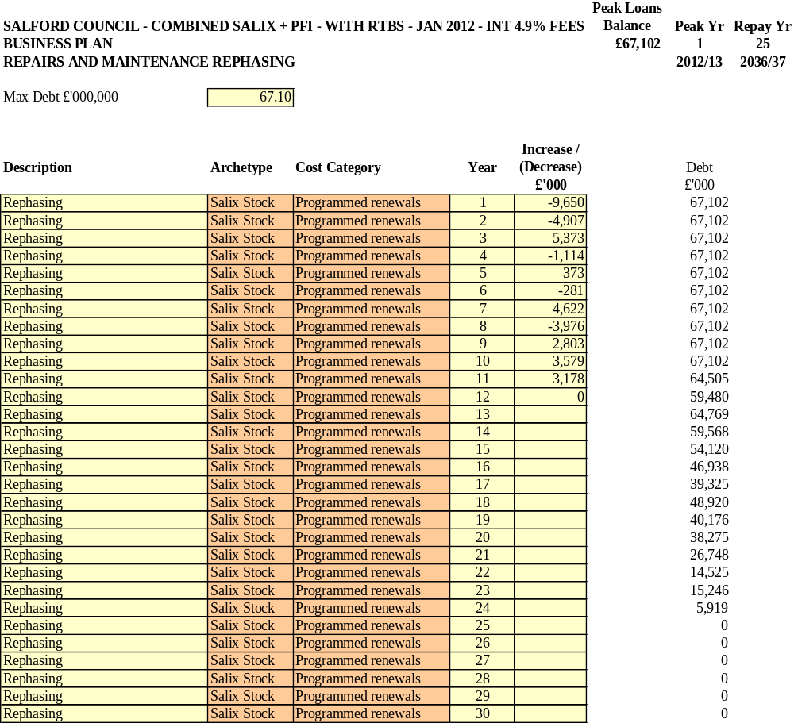

£14.5m of works in the first 2 years would need to be deferred and this would take a total of 9 years to recover, with further slippage along the way.

Result

Less works would need to be delayed in the early years and it would take slightly less time for the works to be recovered.

  - a) Original Plan 3% interest rate

In the previous report, we demonstrated the effect of assuming an interest rate of 3% rather than 4.9%.Taking the headroom into account and a rate of say 3% which may be available with a one pool approach to treasury management, the combined business plan with a one-year hit of debt premia showed:

Peak Loans Balance £93.594m (cap is effectively £67.102m)

Peak year 2

Repayment of loan – Year 22

There is still almost £25m of investment works in the general stock that cannot be done at the right time, even with an interest rate as low as 3%.The investment delay needed to stay within the debt cap is shown below:

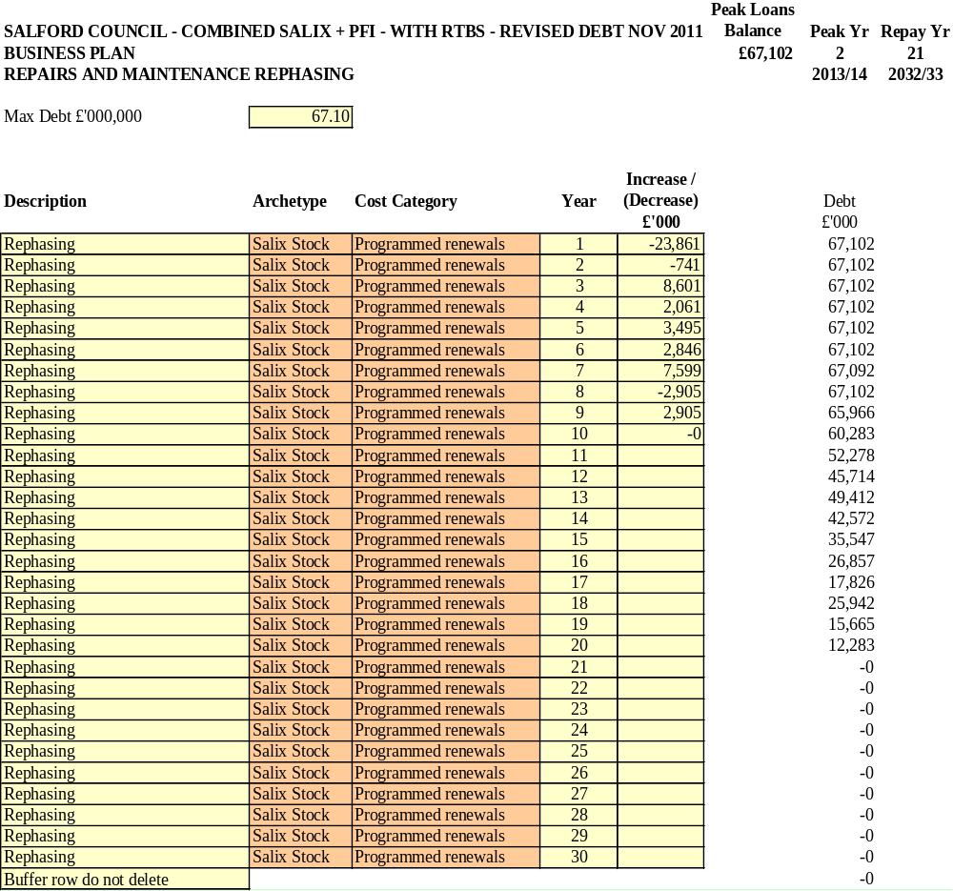

2.4 b) Revised Plan with re-profiled historic debt premia and interest rate at 3%

If we now use the revised debt premia assumption and a 3% interest rate (this assumes all new borrowing will allow the Council to stay within an average of 3% for 30 years), then the business plan headlines are:

Peak Loans Balance £80.230m (cap is effectively £67.102m)

Peak year 2

Repayment of loan – Year 21

There is still £12.2m of investment works in the general stock that cannot be done at the right time, even with an interest rate as low as 3%.The investment delay needed to stay within the debt cap is shown below:

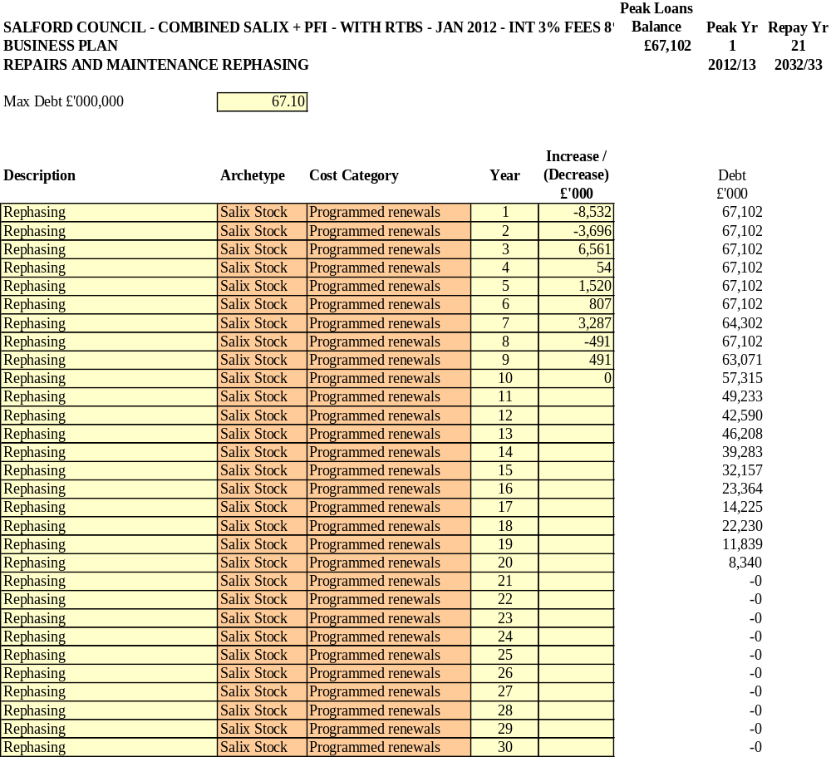

Result
Less works need to be delayed in the earliest years, but the time to recover the works remains the same.

2.5 Fee Rates at 10% rather than the 8% assumed

- Original Plan with 4.9% interest rate

In the December 2011 report, we demonstrated the effect of not being able to achieve a professional fee rate of 8% on the investment programme, and instead maintaining the 10% fee paid currently. Using the original debt premia and 4.9% interest rate the business plan results showed:

Peak Loans Balance £98.255m (cap is effectively £67.102m)

Peak year 2

Repayment of loan – Year 31

The re-phasing of the works to the general stock to keep within the debt cap showed the investment programme is still delayed.

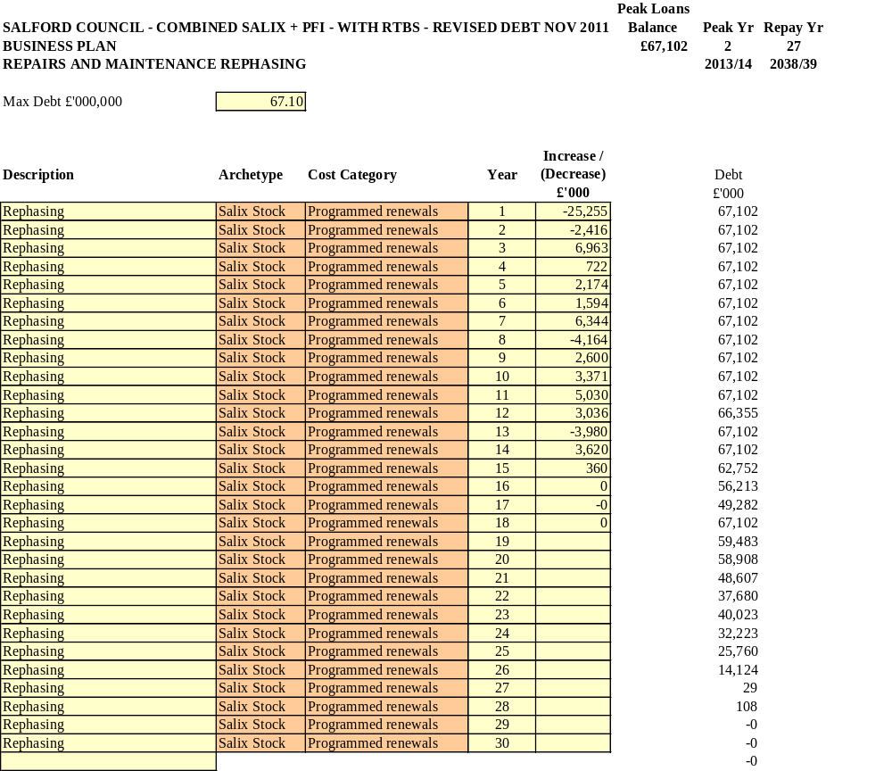

.

- Revised debt premia assumption and 4.9% interest rate

If we consider the position now with 4.9% interest rates, 10% fees and the revised profile of the actual debt premia assumption then we see the following results:

Peak Loans Balance £84.694m (cap is effectively £67.102m)

Peak year 8

Repayment of loan – Year 27

With these assumptions, £15.5m of work on general stock properties would nee to be delayed and it would take up to year 14 to recover the programme with additional slippages during this period.

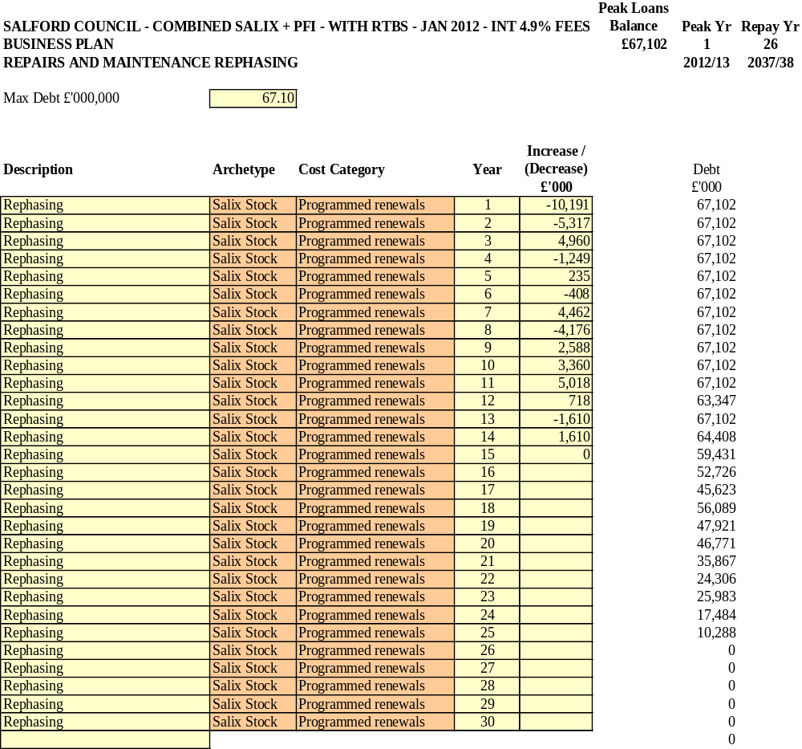

Result

Less works in the early period are delayed, but the time for works recovery is almost the same.

- Revised debt premia assumption and 3% interest rate

If we assume the new debt premia re-profiling and an average 3% interest rate throughout the business plan, then the business plan results show:

Peak Loans Balance £81.557m (cap is effectively £67.102m)

Peak year 2

Repayment of loan – Year 22

Again the debt cap is breached and £13.2m of works need to be delayed, although the recovery period is shorter at 9 years. They profile of the delay is as follows:
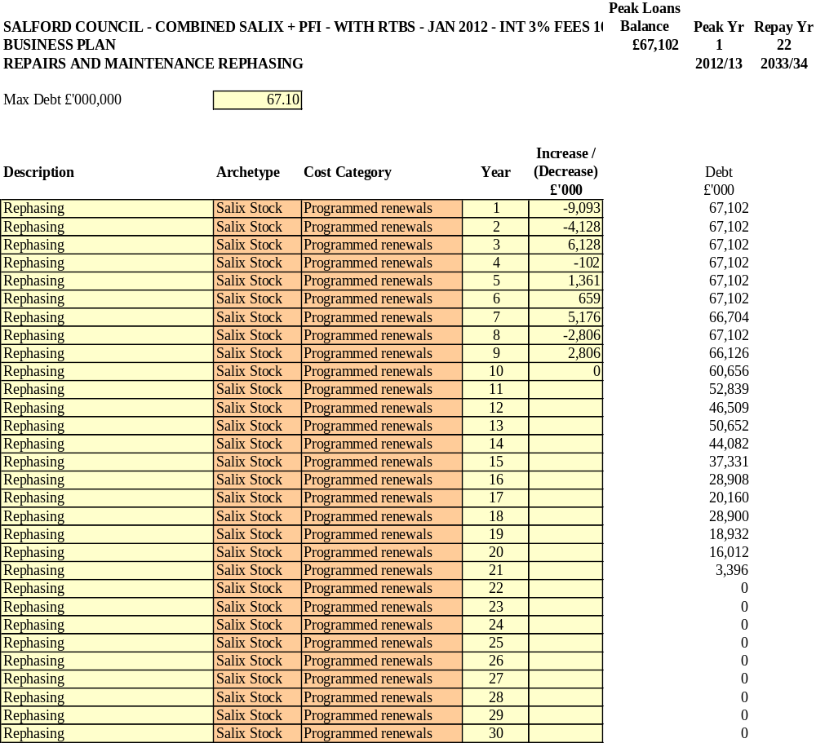

3. Conclusions and Next Steps

  - The combined stock business plan assuming a PFI does not appear to allow Salford to deliver at least the DHS for all of its stock and maintain it, even at very low rates of interest. Having re-profiled the debt premia payments, the results are improved in that less works in the early years need to be delayed, but these are still substantial sums and the recovery period for the works is not short.

  - The results show that the Council’s revised debt settlement at £67.102m , despite being less of a liability initially, creates its own issues in that :

- It further restrict the amount that the Council can borrow to for maintaining the properties;

- It provides early cash to the Council, but will reduce the cash resources available directly to the PFI. Consideration will need to be given as to whether debt can be paid down or whether a reserve is needed;

- Not paying down debt in order to fund the PFI would put more pressure on the plan if interest rates on investment are not high enough;

  - More detail is required from DCLG with regard to the effect that recalculation of the debt settlement will have on the expected PFI credits. The business plans for PFI need to be revised to reflect this and also the fact that there is no longer HRA subsidy support. Instead, these assumptions should be updated to reflect the fact that rents will be kept, but debt needs to be serviced.

  - It is of concern that even with the headroom of £12.5m applied to the Government model, the assumptions show that borrowing is required above the cap. This did not happen previously when the headroom was £23m. The Council may wish to discuss this with DCLG.

  - Despite the revision of the debt settlement, the overall picture for the Salford stock remains that the General Stock will suffer a level of delays to its investment programme that are likely to impact on the level of decency in those properties.. Given the interaction of the various stock solutions in Salford, we would suggest that consideration should be given to an option appraisal for the financing and maintenance of the housing stock to address the issues arising from the self-financing settlement. There are a number of options to consider. There is still an option to consider stock transfer and there is a new stock transfer manual due to be published by DCLG this year. Government sources report that there is currently a project team in place to discuss the future arrangements for transfer and that there are targets to achieve in future. There are new models being developed for transfer including the Mutual Model and the Co-Co Model (where cheap Council housing debt may not need to be paid off, but be serviced by the new landlord) which can be considered. There is also an option to bring the work done by the ALMO back in-house as some Council’s are now looking to do. An alternative may also be to transfer the management of the stock (but not the ownership) to an RSL partner as an outsourcing option.

Appendix 3
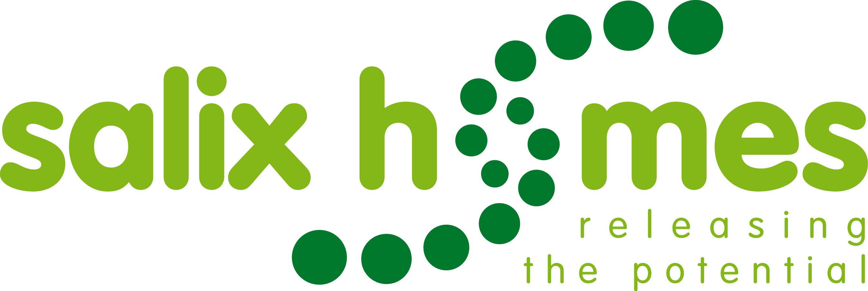

Project Initiation Document

Name of Project | Strategic Stock Option Appraisal for Central Salford Council Stock | Project start & end dates | 12th June 2012  30th Sept 2012
Project Manager | tbc | Project Ref No. | tbc.
Project Sponsor/Board | Project Sponsor – Barbara Spicer, CEO Salford City Council  Governance of the project will be via a Stock Options Project Board consisting of engaged council tenants and leaseholders, senior members of SCC, members of the Salix Homes Board

1. BACKGROUND

The Localism Act 2011 confirms the implementation of Housing Revenue Account (HRA) Self Financing from 1st April 2012.

This brings about the abolition of the HRA Housing Subsidy system and replacement with Self-Financing for stock owning local authorities from 1 April 2012 and has left Councils with the responsibility of managing their own housing debt. The Council must manage and maintain the housing stock to at least the Decent Homes Standard, but is limited on what it can borrow to do this because of the introduction of a “debt or borrowing cap”. It is also restricted on how it can raise social housing rents and this is particularly pertinent in Salford, where City West Housing Trust set comparable rents using the Government’s rent restructuring policy.

The imposition of a debt cap as a limit on what the Council can borrow, the reduction in backlog funding available to the Council for Decent Homes work, the standard agreed for the PFI and the standard being achieved by City West through stock transfer means that within a short space of time, tenants will be paying the same rent, but for vastly different standards in their homes. This is not through mismanagement of resources, but simply a change in the level of resources that are now available compared to when the original options appraisal was undertaken in 2005.

An independent study has been commissioned by the Council and undertaken by Sector Treasury Services which concludes that “despite the revision of the debt settlement, the overall picture for the Salford stock remains that the General Stock will suffer a level of delays to its investment programme that are likely to impact on the level of decency in those properties.. Given the interaction of the various stock solutions in Salford, we would suggest that consideration should be given to an option appraisal for the financing and maintenance of the housing stock to address the issues arising from the self-financing settlement. There are a number of options to consider.”

A key recommendation of the report is that the Council undertakes a full option appraisal of its stock to ensure that the following tests are met:

- Does the option provide all the investment needed, and at the right time, for the remaining council owned homes in Salford;

- Will the option maximise customer involvement and self regulation;

- Will the option maintain the current service standards and performance levels achieved by Salix Homes;

- Will the option enable the council to fully fund a 30 year Pendleton PFI business plan.

2. BUSINESS CASE

The government has now valued Salford’s housing stock as follows:
Government Valuation at 1st April 2012
Debt Cap £66.343m
Actual Debt £53.776m
Headroom to Borrow £12.567m
In other words the council will be allowed to borrow up to £12.567m at any time from the 1st April to fund its housing investment programme.
This is insufficient to meet and maintain investment needs.
The investment needed for the homes managed by Salix Homes will be delayed significantly (between 9 and 15 years) as a consequence of the limited headroom to borrow. Over 30 years an investment shortfall of £93m builds up under self financing; it is highly unlikely that the Salix Homes managed stock will ever achieve and / or maintain the decent homes standard.
The government has assumed that there will be one self financed HRA in Salford, covering the homes managed by Salix Homes and the stock to be transferred to the successful Pendleton PFI bidder later this year.
It is important to stress therefore that a continuing financial relationship will exist between the Salix Homes managed stock and the PFI managed stock during 2012/13 and beyond.
However, whilst there will be one self financed HRA covering all of the retained housing stock, it will be necessary to have a separate 30 year business plan for the PFI managed stock once the contract has been awarded, and to have a separate 30 year business plan for the Salix Homes managed stock.
As a result the council commissioned consultants Sector earlier this year to examine a number of models under self financing as follows:
- What a combined 30 year HRA business plan with the Salix Homes and the PFI managed stock treated as one would look like
- A 30 year business plan for the Salix Homes managed stock only
- A 30 year business plan for the PFI managed stock only
Key assumptions in looking at the above have been:
- PFI scheme starts September 2012;
- The investment standard for the Salix Homes managed stock is lower than the PFI or City West investment standard;
- There is a continued reduction in management and maintenance costs over time for the Salix Homes managed homes;
- Gradual increase in planned maintenance over time for the Salix Homes managed homes;
- That all of the headroom for borrowing is used during 2012/13;
- Rent convergence is achieved by 2015/16.
Any changes to these assumptions will have an impact on the various models.
The conclusions are:
- A combined HRA does not work; in effect the Salix Homes managed stock would continue to fall into non decency at the expense of achieving the PFI scheme and the necessary investment would take between 9 and 15 years to recover depending on interest rate levels and the strategy adopted for managing debt.
- A 30 year business plan for the Salix Homes managed stock only is severely restricted by the debt cap; the investment needed is always constrained by the limited access to funding imposed by the debt cap.
- A 30 year business plan for the PFI managed stock needs a contribution from the council in addition to the likely level of PFI credits.
See Appendix 1 (Salford City Council HRA Reform - Revised Outcomes re changes to Debt Premia Assumptions, January 2012, Sector Treasury Services Ltd).

3. OBJECTIVES OF THE PROJECT

- To fully appraise the available stock options to provide all the investment needed, and at the right time, for the remaining council owned homes in Salford;
- To maximise customer involvement in the option appraisal process itself;
- To ensure options are appraised to maximise ongoing customer involvement and self regulation;
- To maintain and continuously improve the current service standards and performance levels achieved by Salix Homes;
- To enable a 30 year Pendleton PFI business plan to be affordable within a sustainable self financed Housing Revenue Account;
- To clearly identify the benefits and risks of each option taking into account the above objectives;
- To provide appropriate independent advice to customers in regard to the benefits and risks associated with all options considered;
- To provide a final report which details the rationale, process and methodology used to produce a recommendation on a preferred option to key decision makers including the Stock Options Board, Lead member(s), the Mayor and Cabinet.
- To provide an equality and customer impact assessment of each option
- To anticipate any potential procurement requirements as an outcome of selection of a preferred option.

SCOPE OF THE PROJECT

The key challenges and risks the council faces with self financing relate to the Salix Homes managed stock only, assuming the PFI contract is finally awarded later this year and that the required contribution to the PFI business plan going forward can be identified.

The options available to the Council in seeking to address the challenges and risks identified included in scope are:

- Retain stock ownership and,
- Manage the homes directly by the Council, in effect bringing the existing ALMO in house, or
- Continue to manage the homes through Salix Homes; or

- Transfer stock ownership either to:
- Salix Homes established as a registered social landlord/registered provider, or
- An existing registered social landlord/registered provider

These options would need to be fully appraised over the duration of the project and would require the involvement of:

- Government Department for Communities and Local Government (CLG) and the Homes and Communities Agency;
- Council tenants (and leaseholders) in central Salford;
- Key Salford City Council stakeholders (the Mayor, elected members and senior officers;
- Salix Homes Board and employees.

Included in scope will be, for each option:
- An impact assessment on customers across the range of diversity categories
- An assessment of the financial implications for the Council’s Housing Revenue Account and General Fund, particularly in regard to debt management and on the assumption that the Pendleton PFI scheme proceeds
- An assessment of other potential corporate impacts.

What is out of scope is the possibility of challenging HRA self financing itself as it is clear that it is a model that works for and benefits the vast majority of local authorities/ALMOs.

The project will require the formal appointment of key external consultants/advisors to support the process, particularly:

- An independent Tenant Advisor to support customers, tenants and leaseholders through the process;
- A financial advisor to support the generation, assessment and analysis of the options utilising the most up to date knowledge and skills in relation to government policy, both currently in place and in development in regard to the relevant areas.

5. RISK ANALYSIS AND RISK MANAGEMENT
There are two categories of risk, those associated with the challenges brought about by HRA self financing and the long term sustainability of the Council stock and, secondly the project specific risks associated with undertaking the Stock Options Appraisal:
Self financing brings challenges and risks for the council:
Rents will continue to rise significantly over the next 4 years as the requirement to meet rent convergence is met.
The council could choose not to comply with rent convergence and ‘challenge’ the government; however this would have a critical impact on the HRA’s ability to fund services, investment, the PFI scheme and debt.
A differential investment standard in Salford will emerge.
Salix Homes managed properties are unlikely to achieve the decency standard for a considerable number of years and it will be a struggle to maintain the decency standard where this has already been achieved. In addition self financing has assumed a lesser investment standard (a basic decent homes standard, not the Salford standard) than that for City West and Pendleton PFI – yet tenants in the Salix Homes managed stock will be paying the same levels of rent as those in Pendleton PFI and City West homes.
Tenants in the Salix Homes managed stock would be ‘subsidising’ the Pendleton PFI scheme
Assuming the council makes its financial contribution to the Pendleton PFI scheme from a combined self financed HRA, this would be seen by a number of tenants in the Salix Homes managed properties as their rents being used to ‘subsidise’ a much better investment standard in Pendleton at the expense of investment in their own homes
There will be less money to spend on services.
Reducing management and maintenance expenditure over time has been built into the self financed HRA. However reducing operational costs will do nothing to solve the investment problem for the Salix Homes managed properties. Bringing the ALMO back ‘in house’ may help achieve some of the required efficiencies, but the council will still have to contend with the restrictions brought about by the debt cap.
The above risks will act in combination so that tenants of Salix Homes managed properties will face a ‘triple whammy’ of: increasing rents, reducing services, and delayed, poorer standard of investment.

How and to what extent of these risks will be mitigated by each of the stock options to be appraised will be a key element of the project.

Project specific risks include:

- Ensuring that the scope of the project is well defined and that “project creep” does not affect the deliverable outcomes. This will be mitigated by adopting robust project management principles and methodology;
- That the project timetable will overrun
- That key stakeholders are not fully aware or involved in the process
- Insufficient skill to undertake full appraisal
- Expectations of customers are raised whilst options require government approval
- Governance is insufficiently robust
- There are insufficient human and financial resources to deliver the project
- Procurement rules are not properly followed leading to potential for challenge

A full risk register with mitigating actions will be developed as an early action for the project.

6. RESOURCES

The project will require financial and human resources for successful delivery

Proposed Governance and project management structure (see attached PM structure)

Internal resources
- finance
- legal
- communications
- strategic/corporate impacts

Budget estimates are provided for the procurement of external support as follows:

External agencies – ITA £15,000; Financial advisor £30,000

7. COMMUNICATION

There will be a dedicated communications workstream as part of the project management structure.

A stakeholder mapping exercise will be undertaken early in the project to identify key stakeholders , project champions and areas of potential support and resistance.

Key stakeholders include:

- Mayor/Cabinet, Deputy and Assistant Mayors and ward members
- Direct customers – Salix Homes managed Council tenants and leaseholders in central Salford, Beech Farm and Rainsough Brough
- Salix Homes staff
- Council and Salix Homes Partners – contractors, UV, developers, City West & other RSLs
- Other Council departments – Environment, Adult Services etc
- Police, NHS et al
- The Homes and Communities Agency
- Department for Communities and Local Government

It is intended to involve engaged customers in the project governance via the Option Appraisal Board and it will be vital to ensure involvement of the wider customer body in the appraisal process. This will be in scope and a key objective for the Independent Tenant Advisor as well as the resources available to the communications workstream.

A full marketing and communications plan will be developed early in the project.

8. QUALITY CONTROL

Quality control to be undertaken via the option Appraisal Board, involving customer members supported by the ITA who will undertake an evaluation of the project.

9. PROJECT PLAN

A draft project plan is attached:

The key milestones are:

Mayor/Cabinet approval 12/06/2012
Initial HCA/CLG Consultation 30/06/2012
Complete desktop study 15/07/2012
Establish Appraisal Board 09/07/2012
Procure external advisors 09/07/2012
Customer conference 11/09/2012
Preferred option to cabinet 28/09/2012

