Part 1 Open to the | ITEM NO A3

REPORT OF THE ASSISTANT MAYOR FOR SERVICES FOR CHILDREN AND YOUNG PEOPLE

To The Mayoral Team 24th July 2012

TITLE: Salford Trust

Conclusion

- Salford City College and the University of Salford are establishing an educational trust (the Salford Trust) to act as a corporate sponsor to academies
- This report proposes that Salford City Council should join this Trust
- The Heads of Agreement, Members agreement, Articles of Association and Directors Undertakings are now in place for approval
- The Salford Trust will provide a local solution to those schools who are due to become enforced academies by the Secretary of State.
- Three schools (The Albion High School, Marlborough Road Primary School and Dukesgate Primary School) are due to convert to academies under the Salford Trust on 1 September 2012.

RECOMMENDATION:

- That the City Mayor, in consultation with Cabinet, approves the legal documents to establish the Salford Trust.

EXECUTIVE SUMMARY: Salford City College proposes to establish an education trust (the Salford Trust) to act as the corporate sponsor of a multi-academy trust for the operation of schools as academies.

It is proposed that the Salford City Council should join the Salford Trust, a charitable company limited by guarantee, along with the Salford City College and the University of Salford. It is proposed that the Heads of Agreement, Members agreement, Articles of Association and Directors Undertakings are signed by all partners by the end of July. This partnership will ensure that the statutory duties and powers of intervention of the Strategic Director for Children’s Services and the Assistant Mayors are maintained in any schools who become academies.

BACKGROUND DOCUMENTS: (Available for public inspection)

KEY DECISION: Yes

DETAILS:

- Background

  - Salford City College (Salford City College) has been approved by the DfE as an academy sponsor. Salford City College proposes to establish an education trust (the Salford Trust) to act as the corporate sponsor of a multi-academy trust for the operation of a number of schools as academies. It is proposed that this trust is set up in partnership with the Council and the University.

  - The Albion High School, Marlborough Road Primary School and Dukesgate Primary School have now received Academy orders for their conversion to academies on 1st September 2012. The Albion and Marlborough Road conversions will be supported by the project management company, Appleyards. As Dukesgate is being fast tracked this additional support is not deemed necessary by the DFE but the college have agreed to commission support as needed.

  - Principal Designate appointments are underway for all three schools.

The Albion Principal Designate appointment has been made following a national advert. Steve Aveyard, the current Headteacher of Albion High School, has accepted the role of Chief Executive Officer for the Salford Trust.

The current headteacher of Marlborough Road Primary school has undergone a single candidate assessment process and has been appointed as the Principal Designate.

A new Principal Designate has now been appointed for Dukesgate Primary School.

  - Formal consultation regarding the academy conversions have commenced with all stakeholders. All stakeholders will involve parents, pupils, local schools, local community groups, local employers, trade union representatives and Councillors ( and anyone else the schools consider to be a stakeholder)

3 May 2012 – Formal consultation commences with Dukesgate Staff
16 May 2012 - Formal consultation commences with Marlborough Road Staff
17 May 2012 - Formal consultation commences with Albion Staff

- Governance Model

The diagram below shows the governance model for the Salford Trust and the multi academy trust. The Salford Learning Partnership, chaired by The City Mayor, will have a strategic influence on the Salford Trust and a direct reporting line to the Children’s Trust.

The Salford Trust, at member level (A), will have a number of members of the company. The Local Authority will need to nominate one representative to act in the manner provided in Section 323 of the Companies Act 2006. The Members are likely to meet annually.

At Director level (B), the Salford Trust will have a maximum of 6 directors. Again the Local Authority will need to nominate a Director. The directors will manage the business of the charity. The Articles of Association gives further detail. The Directors are likely to meet twice a year.

The Salford Trust will establish a multi academy trust. At Member level (C) this will be set up using the Department for Education’s model for sponsored academies. A Local Authority representative cannot be nominated at this level. It’s likely that these members will meet annually.

Of the 15 Multi Academy trust directors (D), 8 will be appointed by the Salford Trust. One Local Authority representative will appointed at this level. It is likely that these Directors will meet at least termly.

The Local Boards (E) will be the Governing bodies of each school. These meetings are likely to be convened termly.
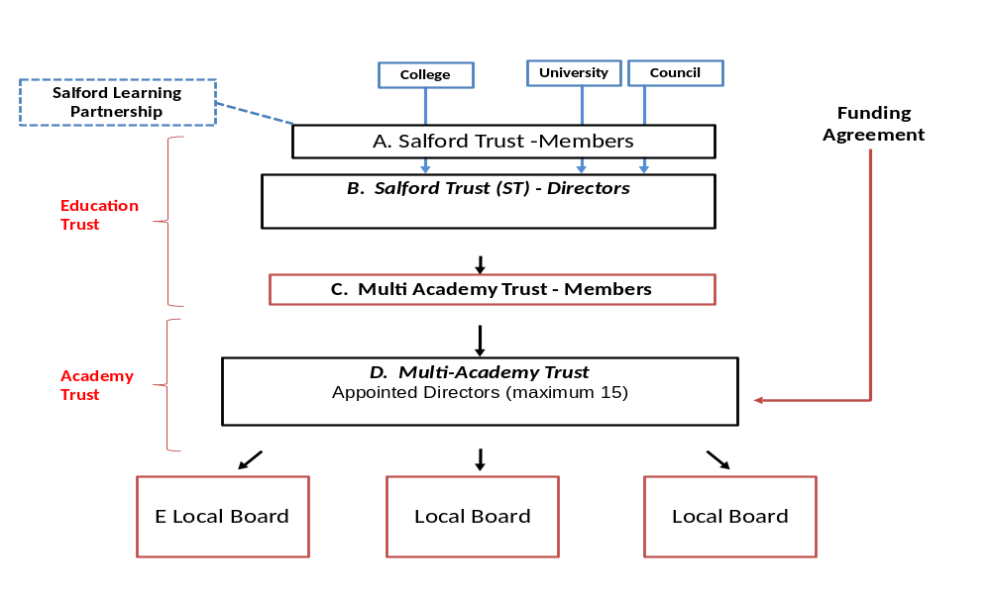

- Establishing the Salford Trust (ST)
It is proposed that Salford City College, University of Salford and Salford City Council will establish a new charitable education trust to be called Salford Trust (“Salford Trust”). This will be in the form of a charitable company limited by guarantee. The Salford Trust will act as both the sponsor of the academy group and the trust for any trust schools. This umbrella organisation aims to support a family of inspirational and inclusive academies in the City of Salford, and to provide a Salford solution for schools wishing and those identified by the secretary of state for enforced “academisation” to convert to Academy status. Salford Learning Partnership, a sub-group of the Children’s Trust, will have a key influencing role on the Salford Trust Salford Trust (ST) should be constituted in such a way as to reflect the agreed roles and rights of each of the education partners. There will be a members’ agreement to govern this relationship
  - It is currently proposed that the Salford Trust will have 8 members. This will be made up of:

  - Salford City College together with the chair and vice-chair of Salford City College’s corporation (6)
  - The University (1)
  - The Local Authority (1)

  - At director level, the Salford Trust is proposed to have a board of six directors comprising of:

- Salford City College ( 4)
- The University (1)
- The Local Authority (1)

This board composition is proposed to avoid Salford Trust becoming a local authority influenced company through the board having no more than 19.99% local authority persons as directors.

  - The parties will enter into a Members’ Agreement which will govern the relationship between them. The Members of the Salford Trust will be the shareholders of the charitable company limited by guarantee and are likely to meet once a year. The Directors of the Salford Trust are likely to meet twice a year. .

- Establishing the Multi Academy Trust

  - The Salford Trust will establish a multi-academy trust (the “Academy Trust”). The Academy Trust will have Articles of Association based on the Department for Education’s model for sponsored academies.

  - The Academy Trust will have 3 members:

- Salford Trust; and
- Two persons appointed by Salford Trust (such appointments to be made pursuant to the agreement under the Members Agreement).

  - The Academy Trust will have will have a maximum board of 15 directors comprising of:

- Eight persons appointed by Salford Trust (such appointments to be made pursuant to the agreement under the Members Agreement, this will include one Local Authority appointment);
- The CEO of the Academy Trust
- Two parents from amongst the parents elected to the local governing bodies of the academies;
- Up to 4 chairs of the local governing bodies of the academies (where there are more than 4 academies than the chairs shall elect 4 from their number. Such chairs shall be appointed to the local governing bodies by Salford Trust.

3.4 The directors of the Multi-Academy Trust are likely to meet on a termly basis.

- Legal Agreements

The detail in the legal agreements will ensure that:

- The statutory duties and the powers of intervention of the Strategic Director of Children’s Services and the Assistant Mayors’ are maintained in any schools who become academies;
- The business plan will be jointly agreed by all partners and will safeguard crucial areas such as admissions, Special Educational Needs, nationally agreed terms and conditions for all staff and safeguarding.
- Any amendments to the members of the trust will be agreed by all partners
- There is a right for each partner to terminate this agreement by giving written notice

- Conclusion

- Salford City College and the University of Salford are establishing an educational trust (the Salford Trust) to act as a corporate sponsor to academies
- This report proposes that Salford City Council should join this Trust
- The Heads of Agreement, Members agreement, Articles of Association and Directors Undertakings are now in place for approval
- The Salford Trust will provide a local solution to those schools who are due to become enforced academies by the Secretary of State.
- Three schools (The Albion High School, Marlborough Road Primary School and Dukesgate Primary School) are due to convert to academies under the Salford Trust on 1September 2012.

KEY COUNCIL POLICIES: CYP Trust plan, Family Poverty Strategy

EQUALITY IMPACT ASSESSMENT AND IMPLICATIONS: The partnership between Salford City Council, Salford City College and the University will ensure our children and young people have equal access to the benefits of being part of our Salford family of schools.

ASSESSMENT OF RISK: Low

SOURCE OF FUNDING: No funding is required.

LEGAL IMPLICATIONS Supplied by Tony Hatton

Legal have been involved in the process leading up to the drafting of this report. Regular meetings have taken and will take place as appropriate. Our liability is limited. (See Clause 2 of the Draft Articles of Association of Salford Trust The Report recommends that the City Council joins the Salford Trust, which will be a charitable company limited by guarantee, with Salford City College and the University of Salford. The arrangement is set out in detail within the Report. The Heads of Agreement, Members agreement, Articles of Association and Directors Undertakings attached to the Report are to be signed by all parties by the end of July. The arrangement will ensure that the statutory duties and powers of intervention of the Strategic Director for Children’s Services and the Assistant Mayors are maintained in any schools which become academies. The parties will agree a Business Plan, to which all must be in accord, and which is regularly reviewed.

FINANCIAL IMPLICATIONS: Supplied by Paula Summersfield
There are no financial transactions or liabilities in this arrangement.

OTHER DIRECTORATES CONSULTED: Customer Services and Support Directorate via Legal Services.

CONTACT OFFICER: Cathy Starbuck TEL. NO. 778 0183

WARD(S) TO WHICH REPORT RELATE(S): All

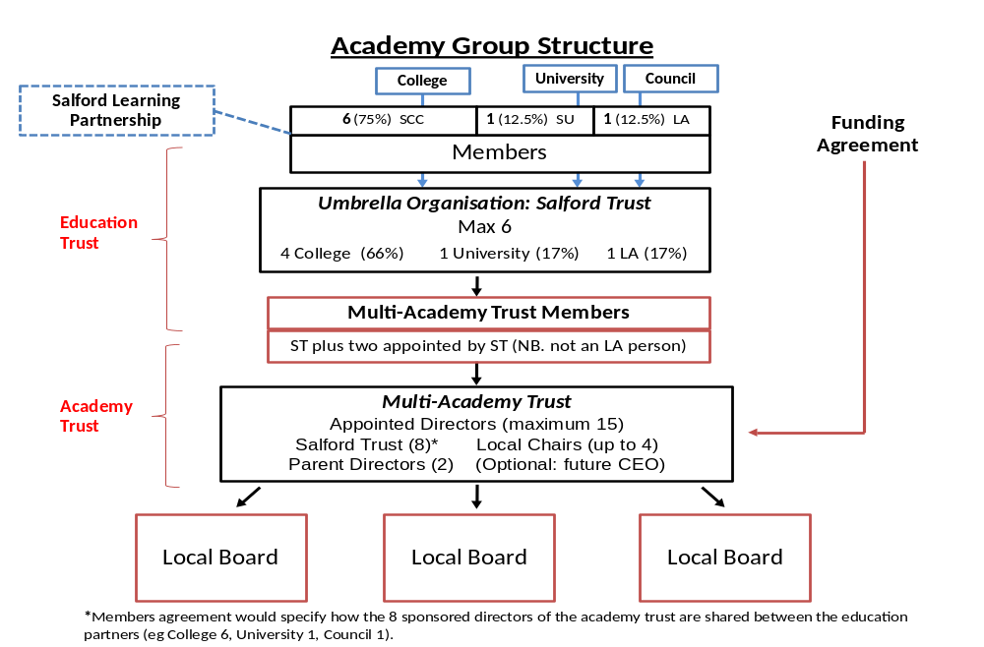Appendix 1

