Part One open to the Public | ITEM NO.A1

REPORT OF
Lead member for Adult Health and Social Care

TO
Cabinet
ON
March 27 2012

TITLE: Public Health Transition Plan

RECOMMENDATION: That Cabinet agree that the draft assurance plan for submission to the Strategic Health Authority as signed off by the Lead Member for Health and Social Care to enable it to be submitted by the deadline of March 26 be approved

EXECUTIVE SUMMARY:
This assurance paper outlines the planning for the transition of public health responsibilities to their future host organisations. The paper sets out a clear vision for public health and a future operating model, and it documents the risks for the system during this transition year. It sets out in more detail the possible risks and issues around the future financial position and details the planning processes and key milestones within them. The Health Improvement Service which transferred from NHS Salford in April 2011 and is currently managed through a Section 75 agreement is not directly in scope for this work; but will transfer into Adult Health & Social Care on a permanent basis to complete the Transfer of Community Services process commenced in January 2011.
This paper will provide the supporting detail to accompany the assurance template which will be the Salford response for Strategic Health Authority sign off. The deadline for submission of the assurance framework (which is being re-drafted in response to the SHA feedback to the initial January submission) and supporting documents is March 26th. Cabinet is therefore requested to approve that the assurance frame work be signed off by Lead Member for Health & Social Care with the final submission to be brought to Cabinet for information.

BACKGROUND DOCUMENTS:
- NHS White Paper ‘Equity and excellence: liberating the NHS
- Healthy Lives, Healthy People: Our strategy for Public Health in England
- Local Government Leading for Health, Factsheets

KEY DECISION: No

PUBLIC HEALTH TRANSITION
Project Initiation Document
Document Author
Author | Role
Angharad Jackson | Programme Manager, Salford City Council

Approvals
Author | Role
David Herne
Melanie Sirotkin
Sue Lightup

Version Control
Version | Date | Author | Comments
0.8 | 05/03/2012 | AR/DEPARTMENT OF HEALTH

Background
The public health White Paper for England, Healthy Lives, Healthy People, published in November 2010 sets out the Government’s commitment to public health and its plans to reform the English public health system. The white paper describes a range of reforms which will include from 2013, Local Authorities having a new statutory duty for health improvement.
DRAFT

Salford has a rich public health history with the City Council playing a long standing role in improving health and leading local collaboration with the health sector through the Health and Wellbeing Board. This role is further strengthened in the new national arrangements which will see additional health responsibilities as public health is brought back into local government. This provides opportunities to build public health transformation alongside the public sector reform programme and develop an integrated public health service for Salford that builds on innovation and tackles inequality. In taking this forward the City Council will be supported by the Director of Public Health (DPH) who is responsible for exercising these new public health functions.

What is public health?
- an approach that focuses on the health and well being of a society and the most effective means of protecting and improving it.
- It encompasses the science, art and politics of preventing illness and disease and promoting health and well being.
- It addresses inequalities, injustices and denials of human rights, which frequently explain large variations in health locally, nationally and globally.
- It works effectively through partnerships that cut across professional and organisational boundaries and seeks to eliminate avoidable distinctions.
- It relies upon evidence, judgment and skills and promotes the participation of the populations who are themselves the subject of policy and action.
(UK Public Health Association summary definition)

This document outlines the transition programme for the Salford Public Health system to the new arrangements. Whilst this predominantly concerns the migration of new roles, commissioning budgets & processes and staff to the Local Authority, there are also significant aspects of the transition to the NHS commissioning board and Public Health England which also need to be managed as part of the programme. Although Salfords’ initial submission along with the rest of GM cluster submissions was rated as Amber, this draft plan was one of two submitted to Public Health England as examples of good practice and considered as green in terms of direction of travel.

Salford City Council and NHS Salford are well placed to deliver the transition programme having made an early decision to accelerate the alignment of the specialist public health function with Salford City Council during 2011 and the early part of 2012.
- The Director of Public Health (DPH) became a full member of Salford City Council’s Corporate Management Team and directly accountable to the Chief Executive.
- The Director of Public Health and specialist public health team aligned directorate support arrangements with the Directorate of Community Health and Social Care.
- The Director of Public Health and specialist public health team provided public health advice to the lead member for Health and Social Care.
- The Director of Public Health and specialist public health team moved into new accommodation at Unity House in January 2012.
DRAFT
The transfer of the public health function will be transformational in nature ensuring it is fully integrated into the operation of the City Council. For the transition year, decision-making, governance and accountability for delivery remain with Salford Primary Care Trust/NHS Greater Manchester and will do so until 1 April 2013 when public health duties will transfer to Salford City Council.

Progress with developing Salford’s Pathfinder Health and Wellbeing Board is well advanced. Interim terms of reference setting out strong representation from both Council Members and GPs from the Clinical Commissioning Group (CCG) were agreed by all key parties in the summer of 2011. The first meeting of the new board took place in October with a schedule of monthly meetings in place for the remainder of this transition period. A comprehensive development programme for board members is currently being finalised with an initial baseline review of member’s aspirations and needs for this new and challenging role.
A detailed action plan is monitored within the Salford Cabinet work plan (reported quarterly to Lead Member of Health and Social Care) which includes the development of the health and wellbeing board, the transfer of public health functions and workforce and the Joint Strategic Needs Assessment.

1.2 National policy milestones
The Department of Health has set out the following guidance to Primary Care Trust Clusters for managing the transition process. A supplementary letter from the Regional Directors of Public Health on December 22nd set out specific public health milestones.

All Primary Care Trust clusters to have an integrated plan agreed with Local Authorities which includes:
- Detailed public health transition plan by 26th March 2012.
- The substantial majority of Primary Care Trusts with local authority agreement to have transferred public health duties to local authorities with robust governance in place for the remainder of 2012/13 by the end October 2012.
- Within the transition planning requirements are a number of specific tasks:
- develop a communication and engagement plan, first draft by March 2012
- agree an approach to the development and delivery of the local public health vision by June 2012.
- agree arrangements on public health information requirements and information governance by September 2012.
- test arrangements for the delivery of specific public health services, in particular screening and immunisation by October 2012.
- test arrangements for the role of public health in emergency planning, in particular the role of the Director of Public Health and local authority based public health by October 2012.
- ensure an early draft of legacy and handover documents is produced by October 2012.
- ensure final legacy and handover documents are produced by January 2013.
- All remaining duties will be transferred by end December 2012.
- All Primary Care Trusts must have completed the formal handover of public health responsibilities to Local Authorities by end March 2013.

1.3 Greater Manchester level progress
Greater Manchester is well prepared for the transfer of public health functions to local authorities. There is a track record of strong collaborative working that recognises the economic, social, organisational and clinical interdependence in Greater Manchester. The 10 Greater Manchester Authorities are committed to improving wellbeing as a fundamental part of Public Sector Reform and specifically through opportunities created in the Community Budgets programme.

In Greater Manchester we will seize the opportunity of the return of public health to its local authority home to enhance and support our public sector reform programme which addresses our long standing commitments to improving life chances, connecting people to opportunities and addressing poverty.

The Directors of Public Health as part of the GM Network will build on their strong history of collaboration and shared management of public health activity to work together to develop robust GM level work programmes which can contribute to new delivery models that support the integration of services and provide a robust evidence base that allows us to understand the impact of our investment in terms of improved life chances.

The vision is to deliver a high quality high value public health system for Greater Manchester that supports the delivery of the new duties and responsibilities for local authorities. It will offer a GM population perspective and evidence base to Clinical Commissioning Groups, and maximise the gain to, and protection of population health through robust leadership, resilient arrangements and deployment of expertise via local authorities and local health and well being boards, as well as on behalf of Public Health England.

The key challenge for this work is be to retain local sensitivity and support to the local leadership of public health whilst acknowledging that in some cases better value and outcomes can be achieved through aggregation of what will be a scarcity of public health skills and expertise. The Greater Manchester Directors of Public Health group is currently undertaking a review of stakeholders to understand the appetite for shared services at a GM level. The focus of this work includes:

- Health Protection commissioning advice and support service for infection control and immunisations and vaccinations linked to emergency planning.
- Public Health Intelligence and Research capacity
- Public health commissioning advice, support and co-ordination for screening programmes
- Promotion of Behaviour Change , through focused social marketing activity and in particular bringing investment into GM
- Support to Local Authorities for the commissioning of health improvement services specified in their commissioning responsibilities (examples include healthy weight, alcohol and sexual health) and potentially public health support to Clinical Commissioning Groups.

Building on innovation – an integrated public health service for salford
Salford has a rich public health history stemming back to the nineteenth century when it was one of the first local authorities to install intercepting sewers to the Irwell. This had a significant impact on reducing cholera and typhoid – both major causes of early death and poor life expectancy in Salford at the time. Dr Lance Burn Salford’s medical officer for health in 1948 was instrumental in Salford becoming the first city in Great Britain to wipe out diphtheria and one of the first to tackle TB with mass X-Rays.
Whilst many of the communicable disease risks from the past have reduced we now find some such as TB re-emerging and HIV becoming an increasingly important public health issue. Lifestyle issues such as smoking, alcohol and diet continue to impact on people’s health in Salford and we are much more aware of the need to improve mental well being for our population. In Salford people still die young from preventable diseases such as cancer (lung cancer is most common), heart disease and respiratory disease. Some of our children are not getting a healthy start in life – breastfeeding is low, smoking in pregnancy is high, teenage pregnancy is high; we don’t yet know the full impact of high consumption of alcohol on Salford’s children. Underlying challenges are family poverty, parenting, worklessness and crime.
DRAFT
Although there is more work to be done there are significant achievements to be celebrated; the gap in life expectancy in Salford is reducing for both males and females and we have improved the take up of childhood immunisations and now have some of the best rates of uptake of MMR in the country. Salford can be rightly proud of its public health history and continues to build on the foundations set by Lance Burn and others through a strong community strategy vision of a healthy city focused on a public health approach with an emphasis on prevention rather than cure.

Salford is taking the opportunity of the national public health reforms to build on its track record of innovative practice by integrating the public health transition with the public sector reform programme which focuses on the City priorities of improving life chances and tackling child and family poverty. Through this route we will transform our capacity to tackle fundamental public health issues in Salford.

A natural home for the public health function is being developed as part of the Public Sector Reform programme, where a workstream led by the Director of Public Health is developing an integrated commissioning hub initially for the City Council but with wider opportunities for joint commissioning in the future. The local Place Board which brings together senior leadership across the local economy to build integrated approaches across organizations, is driving this work and is already identifying potential opportunities for linking this to the community budget programme. Hundreds Health Salford (our local clinical commissioning group) are engaged and supportive of the “hub” as the focal point for their public health specialist advice and support.

The Integrated Commissioning Hub will be fundamental in supporting the Council and partners in their commissioning intent. The core public health team will be integrated into functions of the hub, ensuring it has a broad capacity to support future development and commissioning activity for the Council and across future integrated commissioning structures.

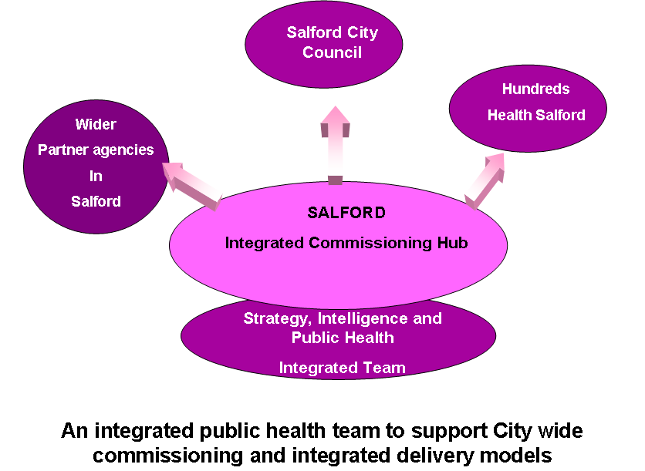

Project Objectives
- To ensure a robust transfer of systems and services from NHS Salford to Salford City Council, NHS Commissioning Board and Public Health England.
- To ensure public health delivery continues to meet the relevant targets during the transition year (January 2012 – March 2013).
- To transfer staff in accordance with the principles encapsulated within the Public Health Human Resources Concordat by 1 April 2013.
- To ensure a robust transfer of governance arrangements from NHS Salford to Salford City Council.
- To deliver an appropriate and efficient enabling infrastructure and resource plan.
- To engage effectively with key stakeholder groups including appropriate consultation and communications.
- To deliver a solution that meets both the tactical requirements of the public health transition (national policy milestones) and the strategic aims of the partnership.

Project Approach
DRAFT
This project will be managed by Salford City Council’s Corporate Programme and Project Management team using the Salford Method (which is based on PRINCE2). The project will be managed by exception.

There will be 8 work streams in the project aligned with the planning guidance presented by Department of Health (see detail in appendix A).

- Business plan/operating framework.
- Staff transition plan. To manage the transfer of staff from NHS Salford into Salford City Council
- Joint Strategic Needs Assessment & Joint Health & Wellbeing Strategy.
- Commissioning transition plan/assurance framework, to migrate the contracts covered by the future Public Health allocation into their future legacy organizations eg City Council, NHS Commissioning Board, Public health England etc
- A communication and engagement plan, to raise awareness and understanding amongst key partners, stakeholders and staff of the changing roles and responsibilities, the migration of the public health team and the links to the public sector reform agenda
- Information management, to define key information requirements for future public health functioning and set out agreements for making these available
- Management of risk/accountability/clinical governance.
- Legacy handover document, ie the business transfer agreement to complete the handover of business from NHS Salford to Salford City Council

Project plans and activities will be co-ordinated across the public health transition and the integrated commissioning hub work to ensure that we meet both tactical (national policy milestones) and strategic aims. This will ensure consistent communications, engagement with staff and reduce duplication of effort. The workforce and communication and engagement work streams - will be delivered jointly via joint plans and tasks within the Public Sector Reform Programme.

Scope
The new responsibilities for local authorities are described in two factsheets produced by Department of Health(Local government’s new public health functions and Commissioning responsibilities, see detail in appendix B). The ‘aim is to create a set of responsibilities which clearly demonstrate local authorities’ leadership role in:
- Tackling the causes of ill-health, and reducing health inequalities.
- Promoting and protecting health.
- Promoting social justice and safer communities.
The full list of commissioning responsibilities is included in Appendix A at the end of this document.

People and organisation
There are 37 members of staff transferring from NHS Salford to Salford City Council. This is the public health, intelligence and strategy function. This project is taking a phased approach to transfer of staff.

Phase 1: January 2012-September 2012
- PH staff will co-locate with City Council staff on the main civic campus.
- City Council and NHS Salford will work collaboratively on creating a structure for a new joint service as part of the first phase of the Integrated Commissioning Hub (ICH). This will have three functional areas: intelligence, strategy and public health.
- PH functions will be mapped against the new ICH structure and a restructuring exercise will take place under NHS terms and conditions so that the Job Descriptions and roles within PH will mirror those within the intelligence hub.
- By the end of the transfer phase, staff from NHS Salford public health (still under NHS terms and conditions) and City Council will be co-located, working together as a single team.
DRAFT
- Public health staff who do not have an intelligence or strategy function will move into the public health function of the intelligence hub.

Phase 2: October 2012 – April 2013
- The transfer of staff from Salford NHS to City Council as outlined in the Public Health Human Resources Concordat.
- Staff who would sit within a corporate common function, such as administration, will be identified and transferred appropriately. Wherever appropriate inductions and subject matter specific training e.g. procurement will be arranged.
- Opportunities for shared services across Greater Manchester will have been identified by Autumn 2012 and again, roles which in scope of agreed public health shared services would be identified and transformed appropriately.
- On 1 April 2013 all staff will be employees of Salford City Council.

Key milestones for the transition year are summarized in the following timeline (detailed project milestones set out in Appendix C).

The transition will be supported by staff from NHS Salford and officers from Salford City Council. The transition delivery team includes heads of service whose services will, post-transition, provide business as usual support to public health. Salford City Council operates a common functions model in which functional areas are centralised to provide an efficient, robust service.

Salford City Council Public Health Transition Delivery Team

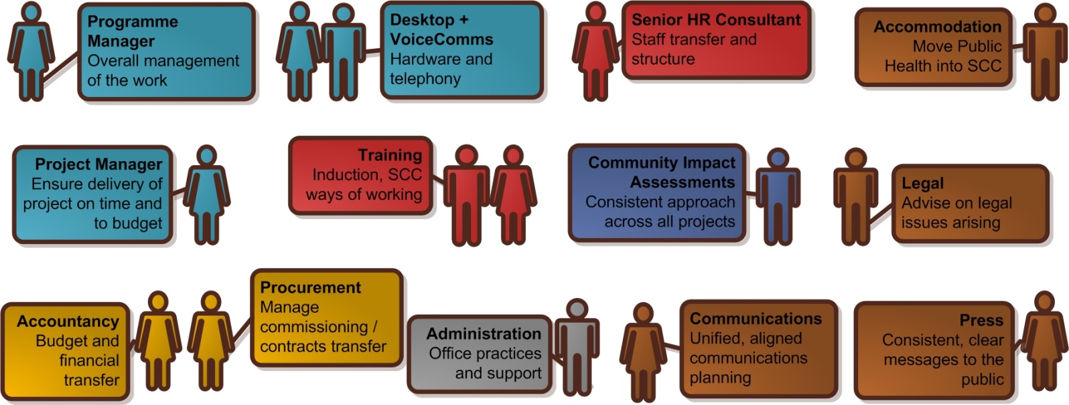
DRAFT

Key risks
This project carries a significant number of risks which the authorizing organizations need to be sighted on, these fall broadly into two categories:

Those which are shaped by national policy and are largely beyond the scope of this programme to influence or control. These are largely related to required further national guidance on the build and operation of the future public health system including HR guidance about staff migration, financial allocations, and risks to the Health & Social Care bills passage through the House of Commons.

Those which are within the direct scope of the programme and can be managed locally, these relate to local capacities to enable and support the transition process, the additional complexities of possible GM solutions to future PH function and the interrelationship of the PH transition with the creation of the Integrated Commissioning Hub.

The main risk categories within the risk log fall into the following categories:
- Commissioning risks associated with the migration of contracts to legacy organisations
- HR / People issues within the transferring staff group
- Capacity of support functions to manage the transfer
- Business continuity ie maintaining the current good performance
- Legislation/policy risks
Samples from the risk log have been drawn out below, but these will be managed within the governance structure described below with risks allocated to the dedicated task groups for the work areas and reported through the transition programme board into the City Council and NHS structures:

there is a risk that... | Risk grouping
The Public Health allocation is significantly less than expected leading to cuts in both key public health programmes and core public health staffing | Public health commissioning
The release of the Public Health allocation is significantly delayed leading to inability to restructure in readiness for 2013 financial operating position | Public health commissioning
The JOINT STRATEGIC NEEDS ASSESSMENT is not developed sufficiently to inform the Health and Wellbeing Strategy and ensure it is available for the CLINICAL COMMISSIONING GROUP to use as part of its authorisation process | Public health commissioning
Loss of key resources to other organisations leading to fragmentation of Public Health delivery, reducing quantity, quality and organisational memory | Public health commissioning
The lack of clarity over future National Commissioning Board and Public Health England local structures and functions means that the migration of functions and commissioning arrangements to those bodies cannot be planned and implemented in a timely fashion | Business continuity
The impact of transitioning roles and responsibilities impacts on the resilience of screening and health protection services leading to loss of performance eg fall in vaccination and immunisation rates or Hospital and Community acquired infections | Business continuity
New operating models do not provide for local NHS preparedness, resilience and response compromising the capacity and ability to respond to major Public Health incidents | Business continuity
Uncertainty over collaborative arrangements for Public Health operation at a Greater Manchester level eg Health Protection, sexual health commissioning etc delay and complicate the design of local Public Health delivery delaying or necessitating further redesign work. | Capacity to manage the transfer
The contracting and finance services do not have the necessary capacity to effectively support the migration of contracts from NHS Salford to City Council. | Capacity to manage the transfer
The national HR guidance is not released early enough impeding the planning process and delaying the transfer of staff | HR/people
The project plans for the Integration Commissioning Hub and the Public Health Transition are not aligned | HR/people
The HR services do not have the necessary capacity to effectively support the transfer of staff within the required timescales and ensure compliance with the PH concordat | HR/people
The restructure is not completed by the end of December 2012, so that redundancies are not resolved by April 2013 risking legacy redundancy costs for Salford City Council | HR/people
The Health Reform Bill is significantly delayed or does not achieve assent impacting on the timing of the re-organistion | Legislation /national policy and guidance

Risk response to the SHA
The first draft of the Salford Public Health Transition plan submitted in January was rated by the SHA as Amber (along with all other PH transition plans in the NW) in terms of assurance that the local planning has addressed the necessary risk areas. The draft plan was one of two submitted to Public Health England as examples of good practice and considered as green in terms of direction of travel. The original assurance submission for the Strategic Health Authority can be found in Appendix E which sets these out against the key programme areas of:
- Ensuring a robust transfer of systems and services
- Delivering public health responsibilities during transition and preparing for 2013/14
- Workforce
- Governance
- Enabling infrastructure
- Communication and engagement (see Appendix D for the draft comms brief for transition programme)
For the March 26th submission date a revised assurance template (based on the the template in Appendix E) must be submitted providing further detail in key areas following feedback on the original submission and further clarification on key aspects from the Strategic Health Authority.

Finance
The Government recently announced the baselines for local authority public health grant allocations. It is important to be aware that this is a baseline not a shadow allocation. Between now and the announcement of 2013/14 allocations towards the end of the year it is important that Salford works to prepare for any potential financial risks that a reduced allocation might bring. Whilst there are clear signals that a Pace Of Change approach will be applied once the funding allocations are announced it is unclear how long this will be and therefore what the scale of risk is to Salford in terms of overall operating budget and pace to align spend with allocation.
DRAFT

The estimate of spend in 2010/11 which covers the commissioning functions which will move to local authorities is £13,507,000 with a 2012/2013 baseline estimate of £14,220,000.

NHS Salford submitted its audit of public health spend at 2010/11 as £14,490,000 however this included a number of commissioning areas which have subsequently been moved elsewhere in the commissioning system eg termination costs. These budgets have therefore been removed from the national estimate for Salford bringing it more closely into line with the return for 2010/11, and the estimate for 2012/2013.

The 2012/13 figure equates to £59 per head of Salford population compared to a North West figure of £49 per head and a national figure of £40 per head. It is impossible to speculate at this point as to whether this will leave Salford as an outlier when the allocation is calculated particularly when the range of spend per head is so great across the country, with Buckinghamshire at £15/head and Tower Hamlets at £117/head.

In signing off the public health audit data Salfords potential risks were made clear in a number of caveats which remain as yet unanswered potentially impacting on future spend position:
- The potential impact of reporting part year spend in 2010/11 which will not reflect the full year commitments for following years.
- The possible shortfall in resource based on the 2010/11 spend whilst further investment continues through to the end of 2012/13.
- The wide range of provision the grant covers including some areas currently within City Council structures.
- The significant commissioning requirements to manage the grant and the possible rebalancing of resource.
- The lack of any acknowledgement of the range of contractual commitments for the services commissioned using the public health resource. These contractual arrangements may prevent re-profiling of future spend against a zero based budgeting approach as a result of the national allocation. This transitional issue needs to be addressed by the DoH rather being left to individual councils to manage.
- The unknown nature of the top slice which will be drawn from the allocation to resource Public Health England and the Health Premium (reward grant).
- The national guidance for the inclusion of the public health core team within the admin section of the public health leadership section and not the programme costs. This has implications for future cuts in administrative resource currently suggested as being 30%. This will have implications for City Council in being able to deliver the core functions of the public health role.

A number of pieces of work are currently being undertaken as a matter urgency to assess the impact of the 2012/13 allocation to:
- Identify the shortfalls on existing budgets that the 2012/13 settlement may create eg identify local spend on abortion and check whether this equates accurately to the sum removed to go to NHSCB.
- Check whether the Department has amended our submission eg adding in on nil lines, or as in some districts removing Drug And Alcohol Action Team spending from the submissions.
- Identify any underspend carried in 2010/11 and any further investments for 2011/12 and assess if these are covered by the allocation.
- Lobby Department of Health on any calculation ‘errors’ we identify to make right any shortfall.
DRAFT
- Notify Department of Health and the SHA of the increased additional investment (approximately £4,000,000) into the public health budget 2012/13 (after the audit was undertaken).

Project Governance
There is a robust local governance framework is in place to manage transition planning. Over site in NHS Salford is undertaken through the NHS Salford Transition Programme Board which has senior representation from NHS Salford, Clinical Commissioning Group and Salford City Council. Representatives include:
- Chairman – Hundreds Health Salford.
- Lead Member, Community Services and Health – Salford City Council.
- NHS Salford Managing Director and Director of Strategic Commissioning.
- NHS Salford Locality Director of Finance.
- NHS Salford/Salford City Council Director of Public Health.
- NHS Salford Director of Clinical Professional Leadership.
- NHS Salford Strategic HR/OD Lead.
- Director of Community, Health and (Adult) Social Care – Salford City Council.

Governance within the City Council is through Lead Member Briefing (Adult Social Care and Health ) and Corporate Management Team with sign off by Cabinet.

Project management for the programme is through the transition project team which has representation from both City Council and NHS Salford (and from the staff groups affected) including officers with experience of managing transfers between NHS and City Council from the TCS transfer process in 2011. Project management support from the City Council project management team will provide specialist expertise in managing the process and ensuring planning and reporting are thorough and effective. Reporting lines into the individual partner organisations are shown in Appendix H. Melanie Sirotkin and Sue Lightup are the two Senior Responsible Officers (SROs) (on behalf of the Primary Care Trust and the City Council) and will be providing direct oversight to the project management team from March 2012 onwards.

Project Management of key work streams will be progressed through the transition project team and a number of task and finish groups with both City Council and NHS Salford representation (see SHA risk response for details of membership), which will lead on specific areas of the transition plan including, Finance, HR, Commissioning, Health Protection/Emergency Planning, Public Health Information and Communications. The project team will provide oversight for the work streams with risks being escalated to the transition programme board as part of the routine project reporting structure via the SROs. The project groups will all meet at least once by the end of March but the rate of progress in delivering key tasks in their project brief is to a large part dictated by the release of relevant national policy guidance or information eg the release of the Public Health HR policy guidance (expected within the month) and the release of the funding formula for the PH allocation (expected towards the end of the year) as well as the progress of developing GM level solutions in some areas.

Sign off for the transition plan has been carefully mapped out through all three organisations, NHS Salford, City Council and Clinical Commissioning Group to ensure all three are clearly sighted on both the draft and final plans before submission:
Date | Meeting
5/3/12 | Lead member briefing
6/3/12 | CMT
7/3/12 | NHS Salford Leadership team
13/3/12 | Cabinet Briefing
14/3/12 | HHS Formal board
27/3/12 | Cabinet
16/3/12 | Lead member briefing
28/3/12 | NHS Salford Locality Committee
11/04/12 | Transition programme board

The plan will also be presented for information at the Pathfinder Health and Well Being Board on 15th March 2012.

What is a clinical commissioning group?
GP consortia have evolved into Clinical Commissioning Groups (CLINICAL COMMISSIONING GROUP) following consultation on the NHS reforms. CLINICAL COMMISSIONING GROUP membership has expanded to include a wider range of professionals and at least two lay members. All CLINICAL COMMISSIONING GROUP s need to ‘have a governing body with decision-making powers, to ensure that decisions about patient services and use of taxpayers’ money are made in an open, transparent and accountable way.’ The CLINICAL COMMISSIONING GROUP in Salford is Hundreds Health Salford
DRAFT
(See governance chart in in appendix H)

Appendices

Appendix A
Key transition work programme areas
- Business plan/operating framework – which will form the basis of the core offer for the public health team and will be an agreement between the City Council, CLINICAL COMMISSIONING GROUP and NHS Salford it will describe how the public health system will operate during the transition year.

- Staff transition plan will describe the process for transfer of the public health core workforce to their receiving organisation, it will include key milestone points within the year and support arrangements for staff throughout the process. This will be closely aligned with the work to create the first phase of the Integrated Commissioning Hub in the City Councili.e. the Research/Intelligence/Policy and Strategy function which will drive future commissioning intentions.

- Joint Strategic Needs Assessment & Joint Health & Wellbeing Strategy development process. Salford is well advanced with its JOINT STRATEGIC NEEDS ASSESSMENT refresh which will set high level priorities for the City and compliment this with some detailed analysis of locality health and wellbeing. The neighbourhood profiles which have formed the focus of this refresh will be available in February. Key to the continued development and management of the JOINT STRATEGIC NEEDS ASSESSMENT process will be regular high level oversight through the Health & wellbeing Board. The Joint Health & Wellbeing Strategy is clearly a central plank of the reforms. It will define both the shared priorities for the locality; the outcomes which Salford intends to achieve and key programmes to deliver them. It will be an essential part of the authorisation process for Hundreds Health Salford with a requirement for at least a draft JHWS to be informing the business planning of the Clinical Commissioning Group by July and for it have been agreed by the Health and Wellbeing Board and driving collective local health planning for 2013/14 by September.
DRAFT

- Commissioning transition plan/assurance framework. Transition will create risks around the public health programmes as both the commissioning arrangements and contracts are transferred, key to this will be ensuring programme leads are sighted on the potential risks and have put robust management plans in place to address these risks to ensure performance does not falter during the shadow year. Part of this process will be a contract review for all programmes within the public health allocation, to identify contract value, provider and state of commissioning arrangements, this will inform a commissioning transition plan which will draw this information together with the programme leads management plans into a consistent approach to managing the transition period.

- A communication and Engagement plan which must link up both the transfer of the public health staffing transfer together with the creation of the Integrated Commissioning Hub and the shift of responsibilities with the City Councilleading for health.

- Information Management, the physical transfer of the public health intelligence team in January will resolve much of the practical IT aspects of the transition. However this leaves many questions about information requirements which will need to be resolved. The risk of fragmentation of information sources means a clear information schedule will be required to set out what information is required to be supplied by which organisations and this to be agreed by all parties to avoid the intelligence function being compromised.

- Management of risk/accountability/clinical governance through transition will be a significant challenge. Present performance and clinical governance lines for the public health programmes are clearly laid out within the existing governance arrangements for NHS Salford, a fact reflected in its routine high ratings on assurance. However the transition of roles, functions, personnel, organisations, contracts and services which 2012/13 will bring risks the clear line of sight arrangements for this governance being degraded. A clear transitional governance framework led by NHS GM/Salford will be required to set out local arrangements.

- A Legacy document will be required to document all key assets transferring from the NHS to the PRIMARY CARE TRUST, this is unlikely to include any aspects of the estate but is likely to include IT both hardware and software licenses as well as any specific items of equipment eg light boxes used by the health protection team as part of their training. It may well have to document the legacy risks for the transfer of staff which may be impacted upon by the future PH allocation and pace of change requirements.
DRAFT
Appendix B

Commissioning responsibilities for Local Authorities April 2013
- tobacco control and smoking cessation services
- alcohol and drug misuse services
- public health services for children and young people aged 5-19 (including Healthy Child Programme 5-19) (and in the longer term all public health services for children and young people)
- the National Child Measurement Programme
- interventions to tackle obesity such as community lifestyle and weight management services
- locally-led nutrition initiatives
- increasing levels of physical activity in the local population
- NHS Health Check assessments
- public mental health services
- dental public health services
- accidental injury prevention
- population level interventions to reduce and prevent birth defects
- behavioural and lifestyle campaigns to prevent cancer and long-term conditions
- local initiatives on workplace health
- supporting, reviewing and challenging delivery of key public health funded and NHS delivered services such as immunisation and screening programmes
- comprehensive sexual health services (including testing and treatment for sexually transmitted infections, contraception outside of the GP contract and sexual health promotion and disease prevention)
- local initiatives to reduce excess deaths as a result of seasonal mortality
- the local authority role in dealing with health protection incidents, outbreaks and emergencies
- public health aspects of promotion of community safety, violence prevention and response
DRAFT
- public health aspects of local initiatives to tackle social exclusion
- local initiatives that reduce public health impacts of environmental risks

Appendix C – Project milestones
The plan on the following pages shows the actions and timescales for delivery. Each workstream is allocated to a task and finish group as shown in the table below. These workstreams are also referenced in Appendix D – risk log.
Task group | Membership | Key tasks | Anticipated completion date
PHT Delivery team | PH leads / CITY COUNCILresource owners and leads | Business plan / operating framework  Information Management  JOINT STRATEGIC NEEDS ASSESSMENT, JHWS | April 2012
HR task and finish group | HR leads from CITY COUNCILand NHS Salford | Staff transition plan | April 2013
Finance task and finish group | Senior finance and procurement / commissioning leads from NHS Salford and CITY COUNCIL | Commissioning transition plan and assurance framework  Legacy / handover document | September 2012  December 2012
Communications and engagement task and finish group | Communications leads from NHS Salford and CITY COUNCIL | A communication and engagement plan | April 2013
Health and Wellbeing board |  | Management of risk / accountability / clinical governance | April 2013

DRAFT

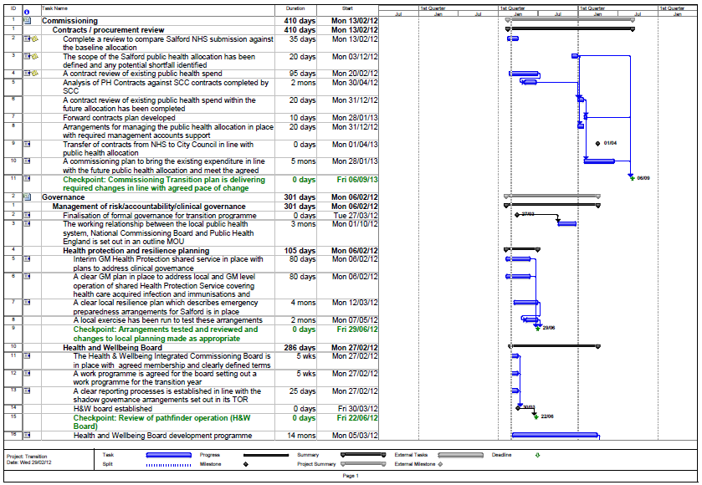

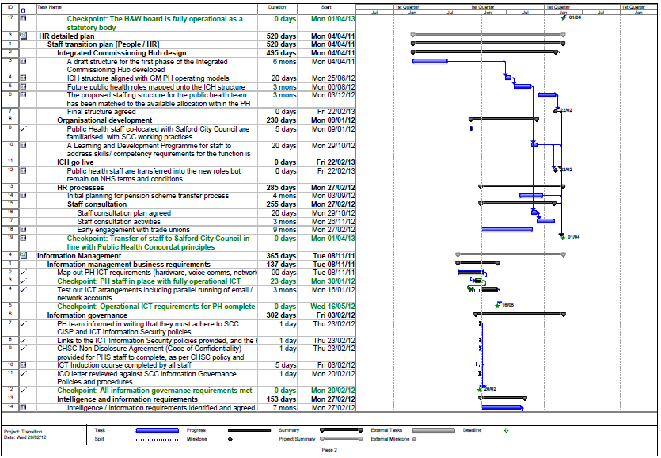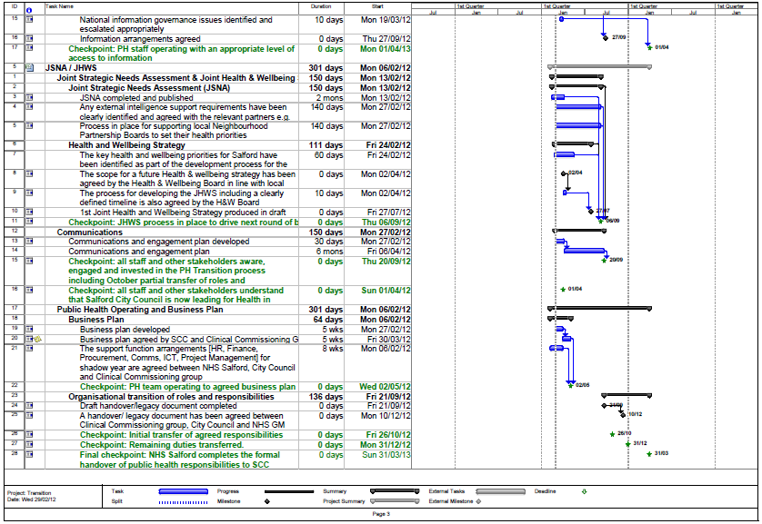

Appendix – D

Public Health Transition Communication Brief
2012/13 is a key year for Salford, it is a year of transition when major role shift happens for the current statutory sector organisations with significant shift of role from the NHS to Local Government during this year. Whilst the year will be the focus for the transition activity it won’t be the end of it, the public sector is likely to see an ongoing programme of reform to drive out efficiencies, improve service provision and integration across services.
The transfer of public health responsibilities suggests three headline communication themes which underpin each other:

- A high level theme covering the shift of role between organisations , which profiles the range of new responsibilities the City Councilwill have from March 2013.
This will reflect the information set out in the fact sheets “Local Government Leading for Health” which suggest that LG is best placed to improve the populations health because of its
• population focus
• ability to shape services to meet local needs
• ability to influence wider social determinants of health
• ability to tackle health inequalities.

Local Government will in future be the local lead for health, defining local need, drawing key partners together to address them, investing in the appropriate prevention programmes to improve the health of the local population and protecting the health of the population by ensuring emergency preparedness is robust and effective.
DRAFT
The time frame for the transfer of responsibilities is for the City Councilto be operating in these new arrangements in shadow form by October 2012 at the earliest and December 2012 at the latest. The final legal transfer of responsibilities will take place in March 2013.

Key high level milestones for this process
March / April JOINT STRATEGIC NEEDS ASSESSMENT completed and published
July 1st Joint Health and Wellbeing Strategy produced in draft
August Emergency planning test exercise to check new arrangements are robust
October City Councilto adopt new responsibilities in shadow arrangement
October? Clinical Commissioning Group Authorisation
December Any remaining functions to be taken up by City Council
March 2013 Final legal handover of responsibilities

- A second theme which is about the preparations to deliver this role in Salford through the development of a new Integrated structure which will develop local health policy and strategy based on a new research and intelligence function. This structure will be called the Integrated commissioning hub because the intention is to use the policy/strategy and intelligence function to drive and shape service commissioning in the future.
The hub will draw together the Public Health team which is about to transfer physically to the City Counciltogether with elements of the existing policy, research and intelligence functions of the Council. The creation of the policy/strategy and intelligence team within the ICH will happen in two phases, an initial transfer of staff (Public Health team into City CouncilOffices) followed by a transformation to develop new structures and roles fit for the new service. The time frame for this service going live is October 2012.
- A third strand which is the communication to the people directly affected by the creation of the Integrated Commissioning Hubs ie those staff who are transferring into City Councilas part of the public health team transfer and the staff from the research, policy and strategy teams in the City Council. This will be a very people focused comms strand to enable the people involved to feel they have had an opportunity to contribute to the design process, are aware of the implications for themselves at each stage and have clear opportunities to consult on the proposals which impact on their future employment prospects.

Work strand | Key messages | Stakeholders
1  DRAFT | From 2013 Council is the lead for public health in Salford  That carries some key responsibilities with it:  lead the improvement of local population health  define local need,  draw key partners together to address them  invest in the appropriate prevention programmes protect the health of the population  The council will work closely with other health commissioners | Public  CLINICAL COMMISSIONING GROUP (ie Hundreds Health)  NHS Commissioning Board  PHE  Members of the SSP  Councillors  NPB members
2 | The City Councilwill largely deliver its new health leadership role through the creation of a new structure called the Integrated Commissioning Hub  The ICH will provide:  A strong ‘intelligence and public health driven strategic approach’ based on:  - What works, what services give value for money and makes a positive difference  - Using public health and JOINT STRATEGIC NEEDS ASSESSMENT to shape investment and service strategy going forward  - Community / service user needs and assets  - Trends in service use and predictive cost and impact models | CLINICAL COMMISSIONING GROUP (ie Hundreds Health)  NHS Commissioning Board  PHE  Members of the SSP  Councillors  NPB members
3 | The ICH will be totally new development  The teams who are in scope for the design work  Creating the ICH will require a complete re-design of the existing teams  The timeline for the development of the process  The points where people can feed in, to inform and shape the ICH design  The process for migrating people onto the new structure  When we expect the process to be completed by | City Councilresearch, policy, strategy teams  Public Health team from NHS Salford

Communications plan requirements
As agreed we will develop a milestone timeline for the three themes and once we have the two documents we will commission a communications plan which identifies for each of the three strands, when we should be communicating – ie a calendar of comms events through to March 2013, for each when - a what/who and how.

And for each comms event an assessment to identify any potential risks or issues which might impact on the communications at that point.

Appendix E
DRAFT
Assurance Framework submission January 2012
DRAFT
DRAFT
Work area | Transition planning requirements | Commentary on local progress | Issues and risks
A.  DRAFT  DRAFT  Ensuring a robust transfer of systems and services | - Is there an understood and agreed (PRIMARY CARE TRUST cluster/LA) set of arrangements as to how the local public health system will operate during 2012/13 in readiness for the statutory transfer in 2013? | Business plan/operating framework – which will form the basis of the core offer for the public health team and will be an agreement between the City Council, Hundreds Health Salford Clinical Commissioning Group (CLINICAL COMMISSIONING GROUP ) and NHS Salford it will describe how the public health system will operate during the transition year. | - Finance allocations not released nationally.  - The national outcomes framework is awaited.  - Challenging time scale.
 | - Is there a clear local plan which sets out the main elements of transfer including functions, staff and commissioning contracts for 2013/14 and beyond? | Staff transition plan will describe the process for transfer of the public health core workforce to their receiving organisation; it will include key milestone points within the year and support arrangements for staff throughout the process. In Salford this will be closely aligned with the work to create the first phase of the Integrated Commissioning Hub in the City Councili.e. the Research/Intelligence/Policy and Strategy function which will drive future commissioning intentions. A full review of commissioning contracts will need to be undertaken between NHS Salford and Salford City Council. Early preparation is underway. (see section 5) | - National HR guidance not yet released.  - Need to join up the timeframe up with Commissioning Hub  - Timescale for developing roles JDs and carrying out consultation with staff.  - Finance allocation not yet received.
 | - Are there locally agreed transition milestones for the transition year, 2012/13? | Set out in the transition plan to be developed by City CouncilProject management support and aligned with the plan for the Integrated Commissioning Hub.
 | - Is there a clear local plan for developing the JOINT STRATEGIC NEEDS ASSESSMENT in order to support the H&WB strategy? | Joint Strategic Needs Assessment - Salford is well advanced with its JOINT STRATEGIC NEEDS ASSESSMENT refresh which will set high level priorities for the City and complement this with some detailed analysis of locality health and wellbeing. The neighbourhood profiles which have formed the focus of this refresh will be available in the first quarter of the year.  Joint Health & Wellbeing Strategy - will define the shared priorities for the locality and the outcomes which Salford intends to achieve as well as key programmes to deliver them. It is an essential part of the authorisation process for Hundreds Health Salford. Key dates: July 2012 - a draft JHWS to inform the business planning of the Clinical Commissioning Group, Sept 2012 - agreed by the Health and Wellbeing Board and driving collective local health planning for 2013/14.  This work must be aligned to the development of the Health and Wellbeing Board, and Health & Wellbeing Integrated Commissioning Board which will underpin it. | - JOINT STRATEGIC NEEDS ASSESSMENT refresh will be ready to support JHWS.  - Lack of any national guidance on content for JHWS  - Timeframe for developing it by June to enable CLINICAL COMMISSIONING GROUP authorisation will be stretching due to capacity (staff resource)
 | - Is there a clearly developed plan for ensuring a smooth transfer of commissioning arrangements for the services described in Healthy Lives, Healthy People that Local Authorities will be responsible for commissioning? | Commissioning transition plan/assurance framework. Transition will create risks for the public health programmes as both the commissioning arrangements and contracts are transferred. Programme leads will need to be sighted on the potential risks and have put robust management plans in place to ensure performance does not falter. There will be a contract review for all programmes within the public health allocation, to identify contract value, provider and state of commissioning arrangements, this will inform a commissioning transition plan which will draw this information together with the programme leads management plans into a consistent approach to managing the transition period  Greater Manchester work continues on sharing and developing best practice clinical pathways and specifications and (for some issues) jointly commissioned activity. This includes healthy weight specifications, alcohol interventions, Drug and Alcohol Team Specifications, consideration of collaborative tobacco control activity, minimum standards for Domestic violence services, and consistent contract terms in maternity specifications to promote breastfeeding. | - Delays in completing the contracts review  - Complications of unknown future GM arrangements in some areas of operation  - Range of contracts/commissions to manage  - Lack of clarity over future NCB & PHE commissions  - Funding envelope not received
 | - Is there a clearly developed plan for ensuring a smooth transfer of those PH functions and commissioning arrangements migrating to NHS CB and PHE? | Commissioning transition plan/assurance framework.  This plan is not yet in place due to the lack of clarity regarding staff transfer to NHS Commissioning Board and Public Health England. Plans will be put in place when HR Guidance is clearer.  A particular focus for the GM programme is ensuring the safe transition of collaboratively commissioned activity into future commissioning responsible authorities. This is aided in Greater Manchester by the establishment of the GM Clinical Commissioning Board – involving the chairs of all GM Clinical Commissioning Groupss and supported by Directors of Public Health. The following programmes are at different stages of transition but all have been highlighted to the Clinical Commissioning Board:  - GM AAA Screening Programme - Secure Transition of Provision and Commissioning Responsibility  - GM Hepatitis C Strategy  - GM TB Strategy and Service Specification  - RU Clear Chlamydia Screening programme  - Sexual Assault Referral Centre  - Drug Liaison Officers  - Commissioning of the Rapid Response Unexpected Death in Childhood Service  - Bowel Cancer Screening Programme | - Lack of clarity over future NCB & PHE commissions  - HR guidance not received
 | - Is there local agreement on the delivery of a core offer providing LA based public health advice to Clinical Commissioning Groups? | Business plan/operating framework  Early work has been undertaken with Hundreds Health Salford to describe the current offer and the potential future offer within and aligned to the Integrated Commissioning Hub. This will be further worked up through a narrative plan to be agreed by City Council and HHS.  Individual Public Health Functions are working with local authorities and Clinical Commissioning Group to clarify the offer.  At a GM level, focus is being given to development of GM level offer in:the generation of new EUR policies, needs assessment, Health Impact Assessment, engagement with GM wide service configuration issues (e.g. safe and sustainable), prioritisation and development of standard assessment methodologies, evaluation of innovation, pulling together the outcomes of clinical audits to support clinical audit outcome implementation. | Emergent role of HHS, will they be able to clearly define their support requirements?  Local PH capacity to meet Clinical Commissioning Group aspirations
B.  Delivering public health responsibilities during transition and preparing for 2013/14 | - Is it clear how future mandated services and steps are to be delivered during transition and in the new local public health services:  - Appropriate access to sexual health services,  - Plans in place to protect the health of the population,  - Public health advice to NHS commissioners,  - National Child Measurement Programme,  - NHS Health check assessment? | Public health responsibilities during transition are described within the Cabinet Paper of March 2011. Mandated services will continue to be delivered through the core public health team and performance managed an appropriate through NHS Salford/Hundreds Health Salford and the Cabinet Work plan. As a system this will be held to account via the Pathfinder Health and Wellbeing Board.  Proposals from the Sexual Health Network for initial consideration of GM joint commissioning arrangements for sexual health services, prior to wider consultation with stakeholders are due for consideration at the February GM DsPH meeting | - Keeping performance on track whilst the system changes and the personal risks for the pH programme leads impact
 | - Is there clarity around the delivery of critical PH services/programmes locally, specifically: screening programmes; immunisation programmes; drugs & alcohol services and infection prevention & control? | Health Protection: There is an interim shared service in place for health protection across Greater Manchester which covers infection, prevention and control and immunisation/vaccination. Proposals for a GM shared service are being scoped to assess the potential for the formation of a pooled budget and flexible workforce for a health protection function across Greater Manchester. This will recognise the importance of local delivery and relationships minimise risks and ensure resilience through the transition period and beyond. It will include Immunisation and Vaccination and Infection Control with a thematic approach of bringing a range of health protection resources together with shared goals and accountability.  Screening: A recent review of all screening programmes has been undertaken and the recommendations will go to NHS Salford locality board. This may be a future area for shared service. Drug and alcohol service commissioning and delivery has been ratified through a Section 75 and future re-commissioning of service through the CSP.  GM work will pull together the key issues arising from the self-assessments of all Primary Care Trusts, together with performance and quality assurance data, to produce a cluster screening risk register and mitigation plan. GM DPHs, though the lead Director of Public Health arrangement to NHS Greater Manchester Board are reporting on areas where assurance is weakest and developing plans to address these during the transition.  GM DPHs have a well established joint work plan on the national screening programmes delivered by the GM Public Health Network.  We are looking to build on this in the future as part of a wider programme of transformation of the current GM level services. The lead Director of Public Health at GM on Screening Risk Assurance is collaborating with the lead screening DPHs for Cheshire & Merseyside, Lancashire and Cumbria and have agreed with the SHA a series of principles that will guide how we develop a suitable approach to mitigating risks across the screening programmes. In addition, plans for the provision of PH advice to the NHS and clarity on screening responsibilities in the future are under development. These will form part of the GM PH transition plan on behalf of all the GM DPHs.  Drugs and alcohol commissioning is currently undertaken through the local DAAT and overseen by the Community Safety Partnership CSP). The Deputy Director of Public Health is a member of the DAAT Commissioning Group and the Director of Public Health sits on the CSP. In the medium term the commissioning of drugs and alcohol services in Salford will set within a new Integrated Commissioning Hub. The Director of Public Health is leading this work stream on behalf of the City Council. | - As above.  - There are resilience risks for both screening and health protection. These are being managed but may be more secure through a GM shared service option.
C.  Workforce | - Has the workforce elements of the plan been developed in accordance with the principles encapsulated within the Public Health Human Resources Concordat? | This will be covered in the Staff Transition Plan. All Primary Care Trust staff have been offered a package of career management support commissioned by the Primary Care Trust Staff. This support will continue at least through to the mid point in 2012/13. | - Will require considerable support from both NHS and CITY COUNCILHR departments
D.  Governance | - Does the PRIMARY CARE TRUST cluster with LA have in place robust internal accountability and performance monitoring arrangements to cover the whole of the transition year, including schemes of delegation agreed as appropriate?  - Are there robust arrangements in place for key public health functions during transition and have they been tested e.g. new emergency planning response to include:  - Accountability and governance,  - Details of how the DPH, on behalf of LA, assures themselves about the arrangements in place,  - Lead DIRECTOR OF PUBLIC HEALTH arrangements for EPRR and how it works across the LRF area?  - Are there robust plans for clinical governance arrangements during transition including for example arrangements for the reporting of SUIs/incident reporting and Patient Group Directions?  - Has the PRIMARY CARE TRUST cluster with the LA agreed a risk sharing based approach to transition?  - Is there an agreed approach to sector led improvement?  - Is the local authority engaged with the planning and supportive of the PRIMARY CARE TRUST cluster approach to PH transition? | - We will have clear project management through City Council project mgt support and reporting through the Transition board and into CMT and Lead Member as appropriate.  - Under the terms of the Memorandum of Understanding (MOU) between NHS Greater Manchester and NHS North the delegated responsibility for ensuring the local NHS response and preparedness resides with the Chief Executive Officer of the Cluster Primary Care Trust. This document details the planning, training & exercising requirement on all NHS Trusts and the accountability of the signatories to ensure these are in place, it was signed in June 2011.  The establishment of the GM NHS Resilience Team following the changes to Primary Care Trusts was predicated on several basic tenets, amongst which were  - A Greater Manchester NHS Lead role will be continued, and will be accountable to the NHS Greater Manchester CEO and have strong links into the ten public health systems (to be housed within local authorities) across Greater Manchester and to Public Health England. This function will be delivered by the GM NHS Resilience team.  - Resilience Managers can be called upon to attend, or provide reports to, to the Locality Managing Directors and DPHs in the localities in which they are based to update on resilience issues.  - The GM NHS Resilience Team is currently working at a Greater Manchester level to explore an existing synergy with Greater Manchester Police, GM Fire & Rescue and the new AGMA Central Resilience Unit to define potential co-location and working arrangements. Once established this will further enhance the cooperation and generic working across LA and NHS organisations.  Lead Director of Public Health for EPRR and GMRF arrangements:  - Lead Director of Public Health – This post linked to the outcome of discussions around GM Public Health Network. Links from the Network to the GM NHS Resilience Team and the NHS CB would be relatively simple to construct given the current existing cross-overs and working arrangements.  - GMRF – Currently the NHS is represented by three seats at the GMRF and subsequent SCG in any response, these are:  - NHS Strategic Commander (as representative of Cat 1 NHS responders)  - Ambulance Strategic Commander (as separate Cat 1 responder and 1st response blue light service)  - Health Protection Agency (as separate Cat 1 responder).  Local Authorities are represented by a single LA Chief Executive who attends on behalf of their peers for all 10  LAs.  - Needs GM input i.e. a GM level statement about governance  - As part of the overall project management all risks will need to be identified and mitigating actions or risk share approach agreed for each individual risk.  - This needs further development and consideration.  - The City Councilis actively supporting the transition process; they have both senior officer and lead member positions on the joint transition board which oversees the work. The Director of Public Health is on the Corporate Management Team for the Council and routinely feed information on transition issues through that route to senior Execs, the Council has also provided dedicated project management support to the process | - Local planning and reporting arrangements are well developed  - Plans to test the local systems articulated as yet  - No clarity over 3-5 as yet – these probably require a cluster level response
Enabling infrastructure | - Has the PRIMARY CARE TRUST cluster with LA identified sufficient capability and capacity to ensure delivery of their plan?  - Has the PRIMARY CARE TRUST cluster with LA identified and resolved significant financial issues?  - Has the PRIMARY CARE TRUST cluster with LA agreed novation/other arrangements for the handover of all agreed PH contracts?  - Are all clinical and non-clinical risk and indemnity issues identified for contracts?  - Are there plans in place to ensure access to IT systems, sharing of data and access to health intelligence in line with information governance and business requirements during transition and beyond transfer?  - Have all issues in relation to facilities, estates, asset registers been resolved?  - Is there a plan in place for the development of a legacy handover document during 2012/13? | - Project management arrangements are already in place to support the transition process with the joint transition board across City Council, Hundreds Health Salford and NHS Salford with both senior officer and lead member engagement. This is underpinned by dedicated project management expertise and a senior public health lead. An outline programme and PID are being developed to manage the next year as a project, with clear objectives, key milestones and interdependencies mapped, risks identified and monitored and clear reporting arrangements.  - This will need to be clarified through the transition plan – no future financial envelope confirmed.  - As above  - As Above  - Information Management, The risk of fragmentation of information sources means a clear information schedule will be required to set out what information is required to be supplied by which organisations and this to be agreed by all parties to avoid the intelligence function being compromised. Discussions are taking place at a GM level to actively determine which public health intelligence functions are best delivered at a local level and which might be better delivered at Greater Manchester level, either directly through the public health intelligence network or in partnership with other agencies, such as the Greater Manchester Commissioning Support Service (CSS) or Public Health England. As part of this, a Memorandum of Understanding (MoU) is being established to govern the relationship between the public health system and CSS as a precursor to the development of a series of similar agreements with all potential future partners of a more centralised public health intelligence function.  - A Legacy document will be required to document all key assets transferring from the NHS to the Primary Care Trust, this is unlikely to include any aspects of the estate but is likely to include IT both hardware and software licences as well as any specific items of equipment e.g. light boxes used by the health protection team as part of their training  - As Above | - Good project management support and senior PH input but will impact on senior PH capacity  - No clarity over the financials  - Dependent on contract review – which may delay progress until May  - Will be largely resolved during the physical move in January but will need to have an MOU in place to ensure future data support requirements are met  - Majority will be during the physical move in January but the remainder will be tied up before the drafting of the Legacy document  - Yes its in the milestones but clearly no clarity as to what as yet
Communication and engagement | - Is there a robust communications plan? Does it consider relationships with the Health and Well being Board; clinical commissioning groups and NHSCB; Health Watch; local professional networks?  - Is there a robust engagement plan involving stakeholders, patients, public, providers of PH services, contractors and PHE? | - A communication and Engagement plan which must link up both the transfer of the public health staffing transfer together with the creation of the Integrated Commissioning Hub and the shift of responsibilities with the City Council leading for health.  - As Above | Capacity and resource  Lack of clarity nationally re finance and HR

Appendix F
Local Transition Governance Arrangements
Greater Manchester Cluster
Hundreds Health Salford CCG
NHS Salford
Leadership Team
Salford City Council Cabinet
NHS Salford
Transition Programme Board
Lead Member Briefing
Health & Adult Social Care
Transition Project Team

Communications
Task & Finish gp
Finance
Task & Finish gp
Human Resources
Task & Finish gp
Health Protection/Emergency Preparedness
Task & Finish gp

Integrated Commissioning Hub Project team
Public Health Information
Task & Finish gp
Commissioning
Task & Finish gp

Direct line of sight accountability
Alignment of work streams

KEY COUNCIL POLICIES: Tobacco, Control Strategy, Healthy Weight Strategy, Teenage Pregnancy Strategy, Infant Feeding Strategy, Child Poverty Strategy, and other relevant strategies/policies

EQUALITY IMPACT ASSESSMENT AND IMPLICATIONS:- Will be required for the plan before it is agreed by all responsible parties

ASSESSMENT OF RISK:
Medium – see examples set out in section 6, key risk areas include:
- Commissioning risks associated with the migration of contracts to legacy organisations
- HR / People issues within the transferring staff group
- Capacity of support functions to manage the transfer
- Business continuity ie maintaining the current good performance
- Legislation/policy risks

SOURCE OF FUNDING: None required for the transitional period, the administration will be managed within existing resources by PRIMARY CARE TRUST and City Councilin 2012/13

LEGAL IMPLICATIONS. None until the completion of shadow arrangements in March 2013 b

FINANCIAL IMPLICATIONS: Supplied by and what are they in respect of your proposal and how to they affect the Councils position in making the decision you are recommending?
None the transition process will be managed within resources

See section 8 for detail but the key finance risk is:
The future allocation for 2013/14 is insufficient to cover the existing commitments

OTHER DIRECTORATES CONSULTED:

CONTACT OFFICER: Melanie Sirotkin TEL. NO: 0161 793 3542

WARD(S) TO WHICH REPORT RELATE(S): All

Government response to NHS Future Forum Report

