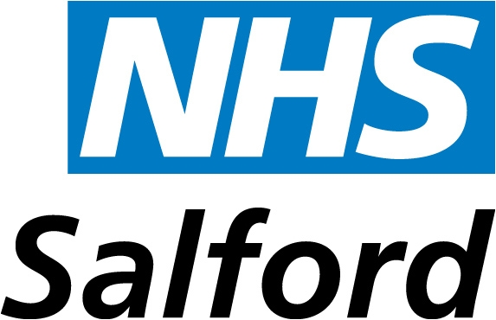

‘A Good Life with Alcohol in Salford:

An Alcohol Harm Reduction Strategy
For 2010–2020

Contents

- Foreword

- Alcohol Related Harm in Salford

- Alcohol Social Marketing Insights

- What Works Reducing Alcohol Harm

- Strategic Objectives

- Current Activity & Gaps

- Strategic Objectives, Targets & Outcomes

- Governance Pages

1. Foreword: A Refresh of the Alcohol Harm Reduction Strategy

Alcohol Harm Reduction has been a national theme since at least 1066. when the English army was drunk before the Battle of Hastings, which it lost, but had run out of beer before the Battle of Agincourt in 1415, which it won. Today the total cost of alcohol-related harm in England and Wales has been estimated at £55.1bn a year. The estimated costs to the NHS, Criminal Justice System and Workplace in a typical Manchester borough may be £150 million rising to £190 million by 2015. Alcohol Related Hospital admissions in Salford cost the NHS £37 million annually. Acute, chronic, mental and behavioural admissions costs £19.4m and hypertensive diseases cost £17.2 million - 50% of all admissions.

Since 1998 there has been an overall increase in drinking that exceeds the recommended weekly limits. This change has been more marked among adult women, and is described as a ‘robust trend’, identified across different surveys and different measures of consumption, including the General Household Survey and the Health Survey for England – that report concluded;

‘…Overall, there is no sign that…aims to reduce harmful alcohol consumption have been achieved…much of the potential improvement lies outside the NHS, including greater control of advertising, pricing strategies, and initiatives to limit the physical availability of alcohol...’

A Kings Fund review of alcohol harm reduction strategies between 1997 and 2010 acknowledged the increase in consumption since 1998, accompanied by a rise in alcohol-related hospital admissions and rates of liver disease. It suggested the need for more aggressive, cross-departmental action for the future. It also suggested that there is a limit to what can be achieved by the focus of previous alcohol strategy: treatment and enforcement. The challenge is to move beyond education and control of those who cannot control themselves to fostering a culture and environment which sustains change. The challenge for Salford is to raise the aspirations of local people to want to be well, do more, and want more, and to be enabled to take charge of their own destiny.
This strategy shifts the balance of planning to recognise this mix of needs, creating a longer term approach with five high level strategic objectives which broaden the approach. The action plan for delivery of these objectives is in development and will detail investment against the key actions required. It will sit alongside this document being refreshed annually to take account of the rapidly changing shape of national policy around alcohol. A separate Alcohol Action Plan of the strategic objectives and opportunities to better align the communication to support the delivery of the strategic objectives via partnerships.
This strategy will deliver Salford’s vision of tackling the long term problems of alcohol related harm. The political nature of the issue is reflected in the challenging decisions which will require strong strategic and political leadership, across Greater Manchester.

Developing the Salford Alcohol Harm Reduction Strategy:

The development of this strategy has involved discussions with local residents, employees and officers. Local residents described what alcohol harm reduction means to them, and how change could be achieved. Partners who delivered the Alcohol Strategy 2008 – 2011 reviewed their actions and reflected on more recent guidance and strategic imperatives, leading to a jointly shared vision and implementation plan for Alcohol Harm Reduction Strategy 2010 – 2020. For the first time an alcohol strategy includes a strategic vision which reflects the themes and comments from the visioning day held in September 2009.

The key components of the local vision being that in 2020:

- The challenge of alcohol related harm has led to a strong political consensus and investment in many areas alongside treatment.

- Salford encourages the development of local social enterprise which enables local people to socialise in environments where alcohol is consumed at safe and sensible levels.

- People talk about their journey to wellbeing.

- Life expectations are changed.

- Treatment is quicker and easier to get.

- From 2010 people talk of the breweries and distillers as they did when the term ‘big tobacco’ was coined in the 1990s.

Strategic Alignment:

The scale of the challenge means highly developed local solutions are required, with a number of challenging political decisions, which will require strong strategic and political leadership at both Salford and Greater Manchester level. The Alcohol Harm Reduction Strategy 2010–2020 goes beyond the existing 2008-2011 Strategy recognising the pace of recent national alcohol policy shift but also developing new strategic objectives which have not featured in previous planning. The refreshed Alcohol Harm Reduction Strategy aligns with the Crime and Disorder Reduction Strategy 2011-2014, annual Strategic Threat Assessment Plan.

The strategy aligns with Salford City Council, Cabinet Work Plans on community cohesion, tackling child poverty, tackling inequalities, and the NHS Strategic Commissioning Plan. The strategy resonates with the Sustainable Community Strategy which sets out a clear vision for the city over the next 15 years. The implementation work of the alcohol strategy will align to the planned implementation of ‘Building Better Neighborhoods’ - developing neighborhood working and the Greater Manchester ‘Life Chances’ pilots.
Greater Manchester and North West level work will underpin many aspects of the implementation work for example, the development of Alcohol Treatment Pathways, the Greater Manchester Homeless Discharge Protocol, the North West Case For Change partnership, to share and learn from good practice and the potential to link to other partnership work.
A detailed version of this strategy document and a related action plan is available which sets out best practice and emerging areas for development e.g. Self Help, Social Enterprise, Social Marketing, Wellbeing and the Local Authority Power of Wellbeing, the Price and Availability of Alcohol, investment in High Impact Changes, Data Sharing, Planning and the Environment, Bring Back The Pub – with links to a reference papers and schemes nationally.

2. Alcohol Related Harm in Salford

Since the late 1950s there has been a more than 100% escalation in per capita consumption of pure alcohol per year, from about four litres to over eight litres. Today this is reflected in drinking patterns which show that England’s 1.39 million 11-18 year old drinker’s consume on average 12.5 units per week each, spending £610 per year on alcohol. This adds up to a total of £849.7 million pounds spent per year by underage drinkers.

The cost of alcohol-related harm in England is over £20 Billion per annum. These harms include: those to health, crime and anti-social behaviour, loss of productivity in the workplace, and social harms, such as family breakdown. Alcohol contributes 10% of the UK disease burden that is 22,000 deaths per year (and rising) in England, through liver disease, some cancers, high blood pressure, coronary heart disease, stroke, depression and anxiety among others. It also contributes 6% of road casualties and 17% of road deaths.

The annual national cost of crime and anti social behaviour is estimated to be £7.3 billion with 1.2 million violent incidents and 36,000 domestic violence incidents linked to alcohol misuse. Alcohol is consumed before 73% of domestic violence incidents and 48% of those convicted of domestic violence were dependant on alcohol. 40% of binge drinkers admitted committing a crime in the past 12 months and crime reports show that in 90% of assaults victim, offender or both usually drank in the previous 4 hours.

The wider social impact can be seen through its drain on the economy where output lost due to alcohol use costs the UK economy approximately £6.4bn every year. It has been estimated that taken together the costs to the NHS, Criminal Justice System and Workplace in a typical Manchester borough are likely to be in the order of £190 Million by 2015. The impact of alcohol related harm in Salford is unaffordable in the current economic climate.

The local picture

The national Alcohol Needs Assessment Research Project (ANARP) 2004 (the most comprehensive up to date assessment available) suggested there could be as many as 40,000 male and 20,000 female problem drinkers in Salford of which currently only 3% enter services. It also suggested that only 29.17 % of females and 34.6% of males keep within the recommended weekly limits across Salford. Winton shows the highest percentage of females drinking over the recommended limit (40.48%). Walkden North shows the highest percentage for males (56.76%).

ANARP found that 26% of the adult population in England (aged 16 – 64) has an alcohol use disorder, which is equivalent to approximately 8.2 million people. Among these, 7.1 million are hazardous or harmful users (including 4.6 million binge drinkers) and 1.1 million are alcohol dependent. While it is recognised that older people are also at risk of the harms associated with alcohol misuse, data for older people was not collected. Using these estimates we can project that in Salford 23% of the population drink alcohol in a manner harmful to their health, 7.55% in a manner hazardous to their health, and 4% in a manner where they are likely to develop dependency this suggests therefore that in Salford there are approximately:

- 40,400 hazardous drinkers (23%)
- 13,200 harmful drinkers (7.5%)
- 4,200 dependent drinkers (4%)
- This includes 44,000 (26.5%) binge drinkers (the cross-over between hazardous and harmful drinking).

Newer evidence suggests this may well be an underestimate. Locally alcohol-related hospital admissions in Salford are the 9th highest in England:

Alcohol and Inequality - wards with higher prevalence

Alcohol related death rates are 45% higher among the poorest sections of local communities. 45% of the Salford population live in wards which are in the top 20% most deprived areas in England (compared to 30% in the North West and 20% in England. Therefore alcohol related mortality is higher in Salford and in those wards particularly than both the North West average and that for England.

Local evidence demonstrates that demand for treatment is considerably higher in wards with postcodes M6, M28, M30, M38, with significantly higher rates of usage for alcohol services. Consequently the alcohol related mortality contributes to lower life expectancy in these most deprived wards, lower than both the rest of the North West and England.

In 2009 the contribution of alcohol to reduced life expectancy was above both national and regional averages - 13.70 months of life lost for males and had increased to 7.11 months of life lost for females. Alcohol contributed to a range of early deaths from acute illness as reflected Alcohol Related Hospital Admissions – of which hypertension remains the largest group. This is described in detail below:

Salford Ward | Alcohol Related Hospital Admissions –  against National Average (per 000)
Salford Ward | Mental Disorder (3.08) | Liver Disease (0.86)
Pendleton | 14.30 | 2.07
Broughton | 12.05 | 3.04
Weaste & Seedley | 10.11 | 3.05
Blackfriars | 9.98 | 1.92
Langworthy | 9.56 | 3.88
Ordsall | 9.10 | 2.65
Barton | 9.06 | 2.12
Eccles | 8.74 | 1.49
Claremont | 8.68 | 1.01
Little Hulton | 8.14 | 1.57
Winton | 8.07 | 1.25
Swinton North | 7.79 | 1.86
Pendlebury | 6.62 | 2.55
Walkden North | 5.69 | 1.33
Kersal | 5.55 | 0.84
Cadishead | 4.06 | 0.56
Irlam | 3.88 | 0.29
Walkden South | 3.21 | 0.38
Worsley & Boothstown | 2.35 | 1.14
Swinton South | 1.91 | 0.72

Nationally key groups are most at risk due to alcohol misuse:

Young people under 15: Government advice is that ideally young people under the age of 15 do not drink alcohol at all – there are significant numbers of primary alcohol users presenting in services for young people
Young people 15-25: experimental behaviours shift towards patterns of behaviour for adult life
Adults 25+: a significant proportion of the Salford population binge drink alcohol – these adults become harmful, hazardous and dependent drinkers
Young people, adults and the elderly: already presenting to general practice, Salford Royal and the Criminal Justice system for alcohol-related or alcohol-specific reasons.
Adults 65+: alcohol complicates care and exacerbates a wide range of medical conditions.

The main challenges:

- Problem drinking reduces life expectancy significantly and is proven to limit citizens from playing an active part in their local communities and the workplace.
- Problems are beginning at a younger age.
- The rate of increase in alcohol-related deaths has risen most steeply among middle and older age groups
- The political focus on youth drinking, whilst valid, ignores the striking fact that those in their 30s, 40s and 50s, regularly taking advantage of discounted alcohol, are at a much higher risk of an early death due to heavy drinking.
- Problem drinking, increasingly starting in the home, has become so commonplace that the impact is often regarded as the norm and has a corrosive effect on our community
- Health information is misunderstood, or routinely ignored
- People deny early signs of harm.
- Women are becoming problem drinkers younger, with attendant increases in related problems e.g. Foetal Alcohol Syndrome.

Without action by all partners the impact of alcohol over consumption will overwhelm services within five to ten years - with attendant wider costs which are unaffordable. The evidence demonstrates a strong case for local action on alcohol related harm.

Local impressions of alcohol use

Salford residents surveyed during the ‘Big Drink Debate’ by Our Life clearly believe action is needed to address the alcohol problem. On an admittedly self selecting and relatively small sample

- 80% believed low prices increase people’s drinking
- 74% were concerned about the drunken behaviour of others
- 53% wanted action in their local area
- 53% believed longer licensing hours increased local problems

These impressions have some clear basis in fact however:

- Alcohol is 75% more affordable than in 1980 – 330ml of cola 32 pence, 440ml strong cider 33 pence
- 4,550 alcohol related hospital admissions in Salford in 2008-2009 – 10% more than the previous year
- 2007-2008 1,914 violent crimes in Salford attributed to alcohol

3. Alcohol Social Marketing Insights

In 2009 the Department of Health commissioned social marketing research which defined the key priority groups of drinkers in each area of the country. Social Marketing is derived from a variety of sources including longstanding commercial marketing data and seeks to describe the lifestyle and behaviour and attitudes of key priority groups. These are described as ‘segments’ against which information, services, and interventions, or ‘products’ may be ‘placed’, as with commercial advertising.

The dominant segments in Salford are described overleaf:

Segment | % Age of Popln. | Characteristics
8 | 20% | Blue collar workers, live in terraces or semi-detached houses rented from local authorities. High hospital admissions, likely to smoke and to drink bitter, lager and spirits, mostly at home.
9 | 14% | Parents in their late 20's to early 30's - have several young children. Many divorced and/or single parents. Likely to live in flats or terraced houses & be unemployed or unskilled. High hospital admissions, likely to smoke, eat fast food and drink vodka and canned lager.
12 | 14% | Broad range of ages, likely to live in terraces in former industrial areas. Generally have the worst levels of overall health, with asthma, cholesterol and heart conditions as well as high acute hospital admissions. Likely to smoke and drink beer/ lager, at home and in pubs.
13 | 9% | Young people in 20s - have a very high rate of acute admissions. Likely to live alone in local authority flats or hostels, be unemployed and some are single parents. Likely to smoke and drink large amounts of beer & spirits.

In 2009 Salford commissioned Social Marketing Insight work for alcohol. This local research helps build an understanding of local drinking behaviours, the social context in which it happens and the types of messages and service offers which might shift local attitudes and help in engaging people with the support appropriate for their drinking behaviour. It provides a valuable insight to the ‘causes of the causes’ i.e. the underpinning reasons why people drink – aspects which have been frequently overlooked in previous alcohol strategy planning and therefore contributed to the failure to deliver the required reductions in alcohol related harm. This link between the wider socio economic agenda and alcohol misuse is a thread through the research. It shows that for those living in the most challenged communities’ life is hard:

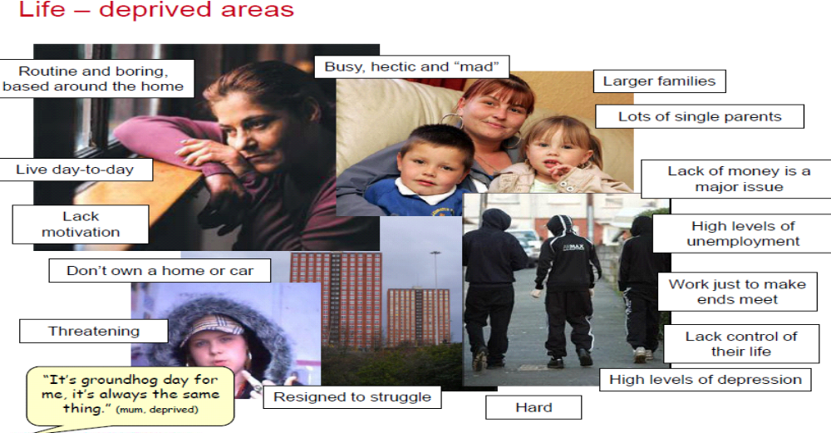

Whilst this is not life in Salford for everyone it is a clear summary of life in those areas where alcohol impact is highest as seen in Section 2. It particularly demonstrated the relationship between not working and alcohol use.
Given cameras to record their daily life the images recorded provide a stark reminder of the relationship between, employment, having purpose and structure in day to day life and the role of alcohol:
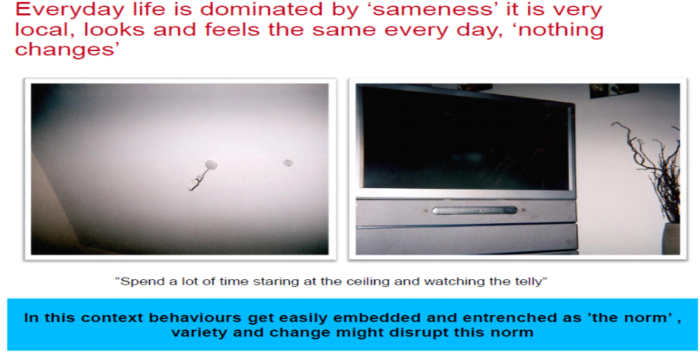

A second strand throughout the research is the part alcohol plays as the glue in the social fabric of Salford, being the thing which brings people together. People frequently commented on the need to have alcohol present to be able to socialise with friends, as described overleaf.

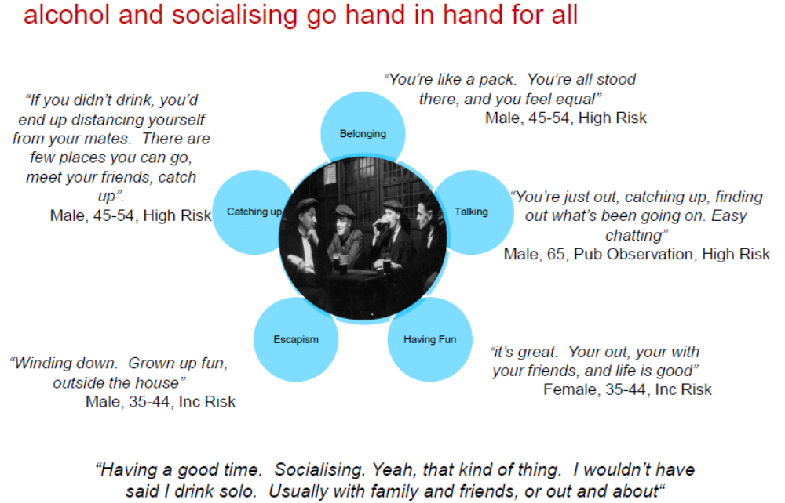

From these insights it is clear that:
- The population is not a homogeneous and requires better tailored interventions in the future

- Getting people into employment will be a key intervention, without purpose and structure in life people routinely fall back on alcohol to deal with boredom

- Attitudes to alcohol misuse are culturally entrenched they need to be challenged through a concerted programme of activity

- Aspirations around alcohol related harm need to be realistic, people wont cut back to safe limits quickly this is a long term programme

- People need to be able to help themselves through a much improved self care approach

- The industry clearly has a role in the solution, people feel strongly about local pubs and the groundswell around projects like the woolpack suggest a real opportunity to explore social enterprise solutions that rethink the role of the pub

- Alcohol misuse is a highly stigmatised problem – this is major barrier to people seeking help from treatment services

4. What works in reducing alcohol related harm?

The diagram overleaf, describes the High Impact Changes defined by the Department of Health as contributing to effective reduction of alcohol related harm. The lack of impact on alcohol harm reflects the failure of most areas to implement the full range of interventions leading to partial or minimal impact.

These interventions include: social advertising campaigns, accident and emergency data sharing, proactive licensing, alcohol arrest referral schemes, prevention activity with young people, accident and emergency diversion activity to deflect people and manage them more effectively, an effective treatment system, and finally brief interventions in primary care, the criminal justice system, accident and emergency and specialist clinics.

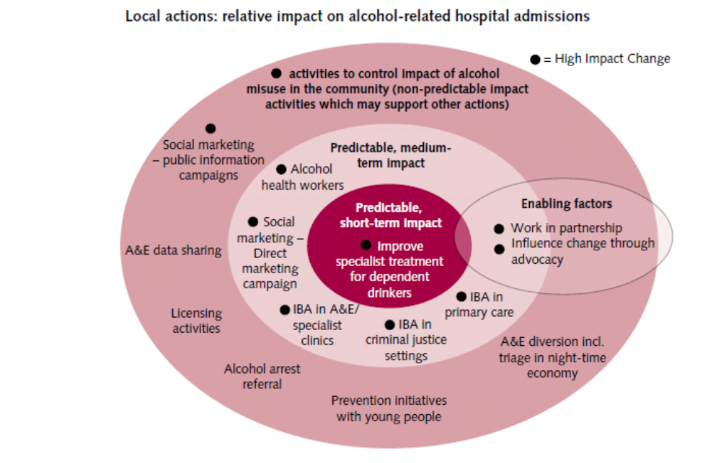
The key national documents are the National Treatment Agency 2006 summary of the Review of the Effectiveness of Treatment for Alcohol Problems, together with more recently published guidance from the National Institute for Clinical Excellence (NICE).

The national framework Models of Care for Alcohol Misusers (MOCAM) recognises that the term ‘treatment’ ranges widely across: information, advice, structured advice, motivation, counselling, and other ‘talking therapies’, to medically managed detoxification, long term prescribing, and residential services, which may help patients achieve and then sustain abstinence, or better manage crises – ‘treatment’ may last for a brief period to many years. Treatment ‘success’ relies on the motivation of the patient, their circumstances, and levels of support.

Screening: There are a wide variety of screening tools for detecting excessive alcohol consumption. Research suggests such tools can lead to an 80% decrease in the number of excessive drinkers, and screening in itself can encourage some people to reduce consumption.

Brief Interventions: There is a large body of international research evidence to demonstrate the effectiveness of brief advice, in reducing people’s drinking levels and alcohol related harm. A positive impact has been demonstrated on consumption, mortality, alcohol related injuries, alcohol related social consequences and healthcare resources use. Brief advice and interventions have been shown to be effective in both men and women and when delivered opportunistically to non treatment seeking populations. There is some evidence that even simple, very brief interventions are effective.

Treatment There is also consistent evidence that behavioural and pharmacological therapies are effective in treating alcohol use disorders. For example motivational enhancement therapy offers some proven benefit Patient education and counselling delivered by physicians and clinicians are effective in achieving behaviour change in heavy drinkers and in preventing the onset of alcohol dependence. Alcohol withdrawals may be supported by well researched drug therapy. There are also some anti craving and sensitising agents with proven efficacy for alcohol.

5. Strategic Objectives

The need for a new upstream approach

In response to this agenda a new approach to alcohol strategy planning is set out in this document; it is built around five key ‘drivers’ for the creation of a Salford where alcohol is consumed safely. Each driver frames a work programme being developed as part of the accompanying action plan which will govern future delivery. The emphasis clearly shifts away from treatment and control through the criminal justice system towards prevention through change in social attitudes and provision of a range of alternatives for socialising without alcohol.

These latter two drivers present challenges as aspects of the strategy which have not been addressed before and have underdeveloped evidence of effectiveness to underpin planning. However the insight research demonstrates that without wider attitudinal shift and alternatives which might support that, the best Salford can hope for is a costly treatment and containment approach to the problem in the short term

These drivers can be summarised as:

Driver 1: Provision of high quality treatment

Driver 2: Alternatives to alcohol

Driver 3: Well managed supply

Driver 4: Appropriate attitudes to safe alcohol use

Driver 5: A well managed environment

The impact these drivers have on reducing alcohol related harm is described in outline in the table overleaf:
Reduce the harm
caused by alcohol
High-quality Treatment
Alternatives to Alcohol
TreatmentWell defined treatment pathwaysNumbers signposted /referred through pathwaysNumbers accessing self helpNumbers accessing brief advice and interventions in generic services and specialist servicesNumbers controlling / reducing units alcohol / achieving more with lives Numbers accessing treatment from target populationsNumber of unsuccessful attempts to control drinkingRange accessible low threshold, routine screening, opportunistic, specialist treatment provision accessible from target drinkersRange community / residential detoxification / recovery services
AttitudesNumber school activities with alcohol education and healthy activity focusPerceptions drunken / rowdy behaviourNumber drinkers positive statement intention to control use Number requests for controlled drinking / unit information packsSubsequent motivation to change drinking behaviourNumber making change in drinking behaviours, and reducing drinking Number drinkers making changes in home / work / family life Availability unstructured / semi-structured peer supportWorkplace exemplar initiatives
AlternativesAvailability high quality / affordable / activities for young peopleAvailability high quality / affordable / activities for individuals / familiesAvailability high quality / affordable / activities for older people
Well Managed Environment
Appropriate
Attitudes
Well-Managed Supply
EnvironmentAlcohol Free ZonesStringent Licensing controlPositive Planning alcohol free / sensible drinking zones Monitor numbers no fixed abode drinkers access servicesMonitor number alcohol free social environments / who accessesMonitor treatment user ‘reasons I drink’ questionnaires
SupplyMonitor under age and illicit sales and unit price alcoholNumber of positive non drinking social activities delivered, who aimed, whereMonitor anti-social crimes / admissions
Secondary Drivers

Primary Drivers

Objective

6. Current Activity & Gaps

Current sustainable investment reflects the past emphasis on treatment and control of those who cannot. Currently NHS Salford and Salford City Council invest over £1.047m in treatment services, the bulk of which (£667k) is with Greater Manchester West NHS Foundation Trust. However a range of other providers are also engaged as set out in the table below

Current Spend On Alcohol Treatment Services
Tiers (Models of Care Framework) | Greater Manchester  West NHS Foundation Trust | Salford Royal NHS Foundation Trust | NHS Salford / Primary Care /  3rd Sector
Tier 1 |  |  | GP Incentive Scheme (£80K)
Tier 2 | Dedicated GP Service £130K  Criminal Justice Service £76K (Area Based Grant)
Tier 3 | Specialist Community Service £461K | Specialist Adult Alcohol Nurse Service (£80K) | Lifeline Young People’s Service Specialist Nurse (£40K)
Tier 4 | Chapman Barker Unit Complex Drug and Alcohol Detoxification Service (Regional) |  | Turning Point Smithfield Service (£115K)  Residential Rehabilitation (Community Care) £65K)
Total (£1.047M) | £667K | £80K | £300K

Tier 2 Dedicated Alcohol Service General Practice (£130K): This is the first Quarter of operation. The service is developing relations with the Tier 1 General Practice Incentive Scheme which targets high risk patients.

Tier 2-3 Alcohol Specialist Nurse Adult Service (£80K): The service demonstrates impressive outcomes in reducing alcohol use over a 3 month period. This service and the links which it has developed with the young people’s nurse and Tier 3 and 4 services form the basis of the North West Case for Change. The assertive outreach pilot works with a wide range of partners sharing data – targeting high risk patients who frequently attend accident and emergency and are admitted to hospital.

Tier 2-3 Alcohol Specialist Nurse Young People Service (£40K): partly based at Salford Royal. Last year 123 young people were admitted for alcohol related reasons but only 3 required longer term treatment (North West Public Health Observatory and provider data). A review of substance misuse services for under-25s is underway as the current provision is not regarded as fit for purpose – the alcohol nurse however is a notable exception.

Tier 2-3 Criminal Justice Service (£76K Area Based Grant): The service sees 400 offenders a year and contributes towards a Greater Manchester target for Alcohol Treatment Conditions. The service meets Greater Manchester targets for Alcohol Treatment requirements and is benchmarked by the National Offender Management Service as a model of good practice.

Tier 3 Specialist Community Alcohol Team (£461K): the service has capacity to see 1200 patients a year and is currently over capacity at 1381, leading to delays in first appointments for new clients. The service achieves impressive reductions in alcohol units consumed (from an average of 138 units/week of alcohol on entry down to 15 units on exit) and better quality of life measures which engage patients and enable staff and managers direct sight of service performance.

Tier 4 Non Complex 7-day detoxification (£115K): purchasing 620 bed nights at Smithfield plus ‘spot purchased beds’. Salford also benefits from the regional Chapman Barker Unit for complex care. The completion rate for the 21 day regime is consistently over 90% and 76% of all Tier 4 patients complete detoxification.

Tier 4 Residential Rehabilitation (£65K) There is annual demand for 30 - 40 places managed within the allocated Community Care budget. In 2009-2010, 31 were referred, 20 started, 8 are waiting, with 14 unplanned discharges, 2 planned discharges and the balance in treatment. The current is return on investment.

The DAAT needs analysis shows a need for the development of the local recovery community in Salford to ensure people exiting the alcohol treatment services have a robust maintenance support system to help them maintain their reduction in alcohol consumption. At present there is no specific investment for alcohol recovery support unlike that available to those exiting the drugs treatment system. A further assessment looking at the needs of patients with diagnoses relating to alcohol and drugs and also mental health problems (i.e. ‘dual diagnosis’) has recently been commissioned by the alcohol, drug and mental health commissioners. This group have been highlighted as a major contributor to repeat admissions through Accident and Emergency - actively case managing these patients forms the core of the assertive outreach service which is being developed at Salford Royal.

Treatment services are operating at or close to capacity. Nonetheless all services demonstrate good outcomes in reducing levels of alcohol consumed and quality of life, however it is inevitable that demand will soon start to outstrip the available resource. This has implications for achievement of National Indicator 39 where although Salford currently is successful, future trajectory suggest we will be off target at some point within 2010/11. There are estimates that the ration of problems alcohol causes as against drug related harm is about three to one. The ratio of investment in alcohol services is about a third of that in drug services – this and the clear overlaps with other areas of related commissioning e.g. mental health, children and families, the elderly, raises questions as to how best to commission for the future. The Case for Change pilot in Salford shows the way forward to be in assertive, not reactive complex case management across a wide range of activity – for whole families in some cases. The overall aim of future is to see the High Impact Changes have full effect on the rate of hospital admissions, and at the same time raise the quality of the patient experience of recovery.

Against the primary drivers the local picture suggests a need for:

High Quality Treatment:

The treatment system is about to be overwhelmed – this is the case even though only 3% of existing problem drinkers seek help. Department of Health recommendations are to ensure specialist treatment for at least 15% of dependent drinkers in area: capacity in treatment needs to increase to at least 630 treatment places per annum.

The alcohol unit guidelines are ineffective in getting the message to enough problem drinkers and future problem drinkers. Current investment does not support recovery after treatment. There is a need for investment in services which track, manage and follow up complex cases which cost local partners the most money. The lessons learned from the mental health and criminal justice arenas need to be heeded on a much larger scale in this area.

There is a need to develop a comprehensive service system for the under 25 age group where alcohol, tobacco and illicit drug use are inextricably linked. There is a need to develop a lifestyle and wellbeing service.

There is a need to scale up ‘brief alcohol interventions’ at points where unmet need is seen – General Practice, Hospital, and the criminal justice system

Alternatives to Alcohol:

Salford needs more provision for individuals, young people, family, adults, older people, and whole communities to delay and reduce the impact of alcohol through a range of alternative activities which will ensure that alcohol is additional to people’s enjoyment of life, not central to it.

Well Managed Supply:

Salford’s pioneering work in this area needs to go further to address challenging issues such as the management of the price and availability of alcohol and social enterprise to make drinking out of the home cheaper and more attractive than home drinking, where more damage is caused.

There is a clear requirement to work with the industry to engage them in shaping local solutions to the problem. This will require a proactive approach from licensing e.g. through the development of quality mark approaches (similar to the Best Bar None scheme).

Appropriate Attitudes:

There is a need for sustained and scaled up investment in activity which will foster a culture of safe sensible consumption and self help, help for young people, parents, families and older people. Without the attitudinal shifts required people are unlikely to recognise their own problematic drinking behaviours and either change it themselves or access the relevant support.

Well Managed Environment:

This is an underdeveloped area of activity; Salford requires proactive services for homeless problem drinkers who left unsupported are a major cost to all areas of the public sector.

Licensing and Planning need to work with Social Enterprise to foster competition to the Alcohol Industry. The outcome needs to be that ‘off’ and ‘on’ sales of alcohol undercut the retail price of alcohol for home consumption, that sales to those who are drunk face serious penalties, and that over ten years Salford becomes a place where more adults drink alcohol safely and sensibly away from the home environment where consumption is less easy to control.

There is a need to balance the needs of the under 25s in terms of play alongside managing crime and disorder. This embraces new ideas on Social Value and Commissioning.

There are new ideas emerging from Social Enterprise organisations as to ‘market economy’ and ‘non market economy’ solutions to alcohol harm reduction. Market economy solutions add social value by engaging the community, training and employing local people, with lower impact on the local environment.

Non market solutions engage ‘free’ resources such as skills, knowledge, social networks, as well as unused capacity in local services e.g. cinemas, sports stadia, swimming pools, rewarding people for positive social behaviour, for using their existing skills and knowledge to the common good, e.g. via ‘time banking’, or ‘agency time credits’, at limited real financial cost, but great social benefit.

There is a need for consistent workplace alcohol policies across all areas of the partnership.

7. Strategic Objectives, Targets and Outcomes

The summary recommendations of the alcohol strategy are set out in the following strategic objectives under which are described the types of actions which will be evidenced in the action planning. Alongside this are the indictors which will be used to track impact – most data for these lead indicators is already collected– some needs to be developed via the Salford Observatory:

Strategic Objective 1: Provision of high quality treatment
Exemplar Actions:

- An equitable substance misuse service accessible to over 25s
- Effective treatment via GPs, Criminal Justice and Hospital staff. Treatment will include brief alcohol screening, advice and interventions, community detoxification, cognitive behavioural interventions, residential detoxification, rehabilitation and recovery
- Self help groups for problem drinkers widely available
- Social marketing Insights to develop the ‘wellness’ brand and relate this to emerging issues e.g. women’s increased drinking and risks in pregnancy
- Wellness Service developed to enable easier access to a more holistic treatment offer initially encompassing alcohol, tobacco and healthy weight but growing to link in with the Life Chances pilot approach

Lead Indicators:

- Numbers accessing treatment in postcode areas with highest numbers problem drinkers
- Numbers alcohol related hospital admissions of adults and under 18s

Strategic Objective 2: Alternatives to Alcohol
Exemplar Actions:

- Effective campaigns and interventions in homes, schools, workplaces, public space, to develop self knowledge, self-awareness and self-efficacy
- Front line brief advice screening and advice and interventions
- Lifestyle campaigns and interventions reduce barriers to seeking help
- An equitable service accessible for all under 25s
- Young people offered positive activities
- Young people want to engage with mainstream activity and lifestyles

Lead Indicators:

- Price per capita of entertainment versus drinking for young people and adults (‘what can you buy for a fiver?’)
- Sports / Entertainment / Education / Training Employment / usage by young people and adults in postcode areas with highest numbers problem drinkers

Strategic Objective 3: Well managed Supply
Exemplar Actions:

- Regional / National examples of good practice for managing local supply
- Develop a quality mark approach similar to the Best Bar None scheme
- Develop existing good practice on control of sales to under 18s sales in line with national best practice in the local context

Lead Indicators:

- Numbers on and off outlets, responsible on and off sales
- Numbers young people purchasing alcohol underage

Strategic Objective 4: Appropriate Attitudes
Exemplar Actions:

- Social Enterprise developing local solutions in on and off sales of alcohol and related services and activities
- Social marketing designed campaigns, interventions and services
- Community projects to shift local attitudes to alcohol use through Neighbourhood and Health Improvement teams

Lead Indicators:

- Numbers of www hits, requests for help, attending self help groups, engaging brief advice and interventions in services in segments
- Perceptions drunken and rowdy behaviour in segments

Strategic Objective 5: Well Managed Environment
Exemplar Actions:

- Homeless problem drinkers helped via the Greater Manchester protocol
- Alcohol Free Zones will extend widely to public places.
- Encourage Social Enterprise to provide alternative outlets for the sale of alcohol, making alcohol cheaper than at home, encouraging family life, and social cohesion as well as managing consumption
- Develop education, training, employment and ‘volunteering / occupation’ opportunity from Social Enterprise activity
- Encourage Alcohol Free Space for families, young people, adults, older people and to help those in recovery to better manage their lives
- Salford Workforce encouraged to set an example
- Salford Employers develop Workplace Alcohol Policy within Greater Manchester Action Plan and best practice on role key staff e.g. in Human Resources / Occupational Health ‘wellness’ staff.

Lead Indicators:

- Numbers A+E victims / perpetrators alcohol related crime in Salford
- Numbers young people drinking underage in streets / public places
- Numbers young people drinking underage in the home

9. Governance

The Alcohol Harm Reduction Strategy 2010–2020 ‘A Good Life and Alcohol in Salford’ sits within the governance of the Health and Wellbeing Board where it will be programme managed by the Think Healthy Living Project Board. The Strategy also reports to the Drug and Alcohol Action Team and Crime and Disorder Reduction Partnership.

The Chair of the Alcohol Reference Group will be a member of the Think Healthy Living (THL) Project Board and will report progress in line with Think Healthy Living Project Board guidelines.

The actions within the Alcohol Action Plan will be managed through the reporting structures and performance management systems in place for the Health & Wellbeing Board and THL.

Agencies which agree to an action within the implementation plan will be expected to:

- Embed it within their organisational annual planning framework
- Complete the relevant performance documentation for reporting to THL and the Health & Wellbeing Board / Crime and Disorder Reduction Partnership
- Routinely report on progress using the performance management framework

The role of the Alcohol Reference Group will be to both provide oversight for delivery of the implementation plan and to carry out annual reviews of the plan to ensure it is aligned with the emerging national policy.

The governance framework is described overleaf.

Salford Strategic Partnership
Health and Wellbeing Board
Crime and Disorder Partnership Executive
Think Healthy Living
Alcohol Reference Group
Alcohol Treatment sub group
Responsible authorities Group

Governance Model 2010 – 2020 Alcohol Harm Reduction Strategy

Appendix: A vision of A Good Life and Alcohol in Salford’

The words below were adapted from local stakeholder views from the Alcohol Visioning day in September 2009 – they also resonate with the opinions of local people captured in the Alcohol Social Marketing Insight work in 2010.

The challenge of alcohol related harm has led to a strong political consensus and investment in many areas alongside treatment. An Alcohol Cabinet run by senior managers and politicians makes sure plans the community want, happen and move money around within the partnership system to make things better. Salford staff offer advice and support to help people feel better for losing weight by ‘doing a bit more’. More people seek help to quit smoking. People see the way to wellbeing requires planning but this leads to a better mood and doing more. People live longer in a happier thriving city.

Salford encourages people to go out more. Salford partners help local and national social enterprise develop responsible off and on sales outlets for alcohol across the city. It is cheaper to both eat and drink out and enjoy time with friends and family. Salford pubs are in a renaissance. Salford Shopping City is one of the top places to visit in Greater Manchester. Families come out at night to see high class entertainment drawn to the Media City development. Community run sarsaparilla cafes offer free www access and dance. In the summer Salford Quays turn into a Lido, in the winter, ice rinks are created in the street markets selling food grown in local allotments. Alcohol Free Zones and strong licensing close down business which contributes to crime and disorder. Alcohol related offending is dealt with by an offer of help to those who need it. Offenders make reparations relevant to the crime. Street drinkers see staff with the things they need, right away.

People talk about their journey to wellbeing. People still drink alcohol but do so more and more in restaurants and community run public houses such as ‘The Woolpack’. The community runs some public houses and shops which sell alcohol. Alcohol related businesses are all run ethically and licensing focuses on improvement more than enforcement. Customers call in on the way from Fit City. Healthy food and alcohol are sold at reasonable prices. Alcohol is now much cheaper to drink out than at home. Licensees will not serve customers who are intoxicated.

Life expectations are changed. People have ambition and opportunity to match it. People have information, education, advice and help around their lifestyle. It is no longer normal to just want to get drunk. It is more normal to want to be healthy. The city invests in self help groups wherever and whenever people need them run by local people who managed to control their alcohol use, got healthier and ended up in a new job. Local champions give people someone to look up to. Groups have local names, and people can find one just right for them. Alcohol Harm Prevention is available 24 hours a day. People go on the web and blog and text each other on how to get through Y Factor sober!

Treatment is quicker and easier to get. People have cut down and have alcohol free days. People do not struggle with a drink problem and other problems alone. So things do not build up in the same way, doing less harm to others and so the path to recovery is shorter. However you come into treatment – from your GP, the Police, the Court, or a concerned friend or relative, services work closely together to get you back on your feet, and make sure you get what you need when you need it. The Way 2 Wellbeing Service is well known locally as a friendly, private, non-judgemental place for local people to go for lifestyle problems and for times more intensive help is needed to be passed to specialists. The service is there afterwards to rebuild confidence and develop a new life not based around alcohol. People take up new hobbies, exercise, healthy cookery, training and employment. People have personal trainers to help them keep it up!

Looking back to 2010 and longer ago.... What people say of the breweries and distillers is very much like what people started to say about ‘big tobacco’ back in the 1990s. Alcohol is now back where it was in the 1950s and 1960s in terms of consumption. The pub is back, but is of course now ‘smoke free’ and family friendly. No one really talks much about that anymore! The pub is a place local people enjoy and which can be controlled. No one talks about fights in pubs or drink driving. It is a really nice place to live. We are proud of Salford. We have made a better future by getting a grip on how we sell alcohol, which we now treat with a great deal of respect as a very strong, but enjoyable drug.

