Introduction

This report summarises the progress being made on key projects and programmes across the City. It describes activity within the following areas:

Central Salford:

- Broughton
- Chapel Street
- Ordsall
- Pendleton Centre
- Seedley Village
- Charlestown and Lower Kersal
- Claremont Village
- Salford Quays

Salford West:

  - Eccles
  - Swinton

Summary of Key Issues

Key developments have occurred over the past six weeks within the following areas:

Programmes:
- Housing Market Renewal – 319 properties acquired, 2970 refurbished and 199 demolished during 2003/04 financial year.
- Central Salford - International Competition for Vision and Regeneration Framework - Expressions of Interest received, five consortia shortlisted.
- Knowledge Capital – Arc of opportunity strategies and key activity action plans are being finalised. A Marketing strategy has been signed off by the Manchester Knowledge Capital board, and Salford City Council are part of the working group that will implement the strategy.

Projects:
- Salford Central Station - Phase 1 improvements being designed and costed (completion August 2004). ERDF Technical Appraisal to be undertaken August/September 2004.
- Greengate - Planning and implementation groups set up to consider next stages of approval, delivery and implementation.
- Seedley and Langworthy - MMHG allocation from Housing Corporation has been confirmed with a proposed investment in the area by the organisation of £9 million over the next 2 years.
- Liverpool Road Regeneration - 5 Blocks identified for potential improvements as part of block improvement scheme. £200K funding secured.

Central Salford
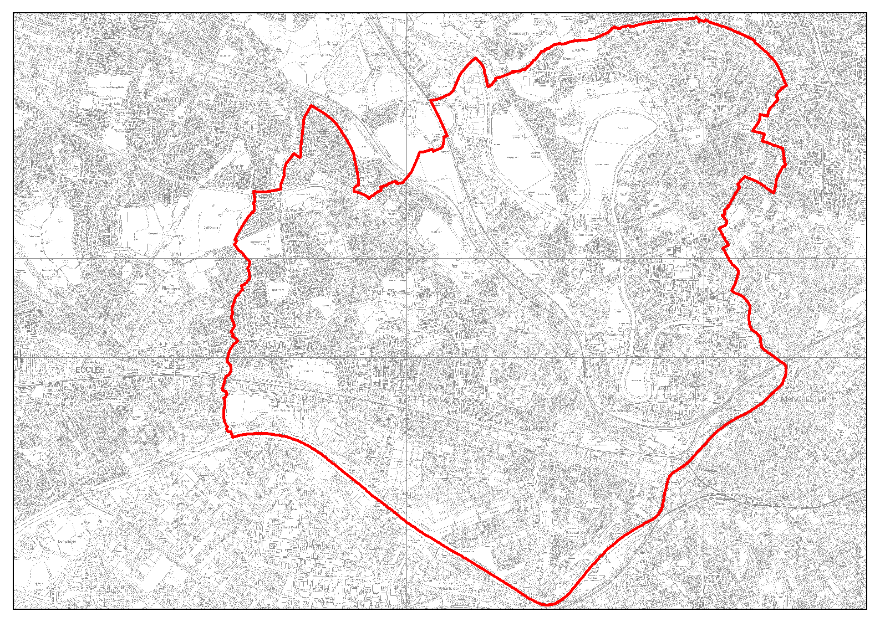

Areas covered within this report:

Broughton
Chapel Street
Ordsall
Pendleton Centre
Seedley Village
Charlestown and Lower Kersal
Claremont Village
Salford Quays

Broughton

Higher Broughton – Homeswap to new build
- Contour (formerly Portico HA) has helped set up the homeowner solutions group. The group meets monthly and is integral to the development of Home Swaps, the area’s development and in successfully engaging the community in the ‘Top Streets’ area.
- English Partnerships was briefed on the model on April 2004. There has been a positive response and further meeting took place July 2004.

Higher Broughton – Investigation works to playing fields
- On site investigation work completed March 2004; Low levels of contamination only. Consolidation also required.
- Remediation works to the playing fields due to start over late August and in earnest by mid September.

Higher Broughton Renewal Area
- Partnership agreement with ‘In Partnership’ and Royal Bank of Scotland and City Spirit Regeneration has been completed and first Board meeting held. Good progress on sales and with planning permission. CPO confirmation received 6/8/04, judicial review period now running.
- Resident consultation for those in the CPO area being reactivated. Top Streets CPO to be commenced in near future. Affordable Housing consultations between Development partnership, residents and Council.

Lower Broughton
- Lower Broughton community listening event May 2004, with over 200 attendees. Representatives were recruited from the local community to work with officers to work towards the redevelopment of the area. Further community event planned for 22nd – 26th September led by Countryside properties. Drop in centre established.
- Kevin Murray Associates were appointed as consultants to work with residents and key stakeholders.
- Leader and Chief Executive of Salford City Council met with Countryside in June 2004.
- Business Plan being developed in August 2004.

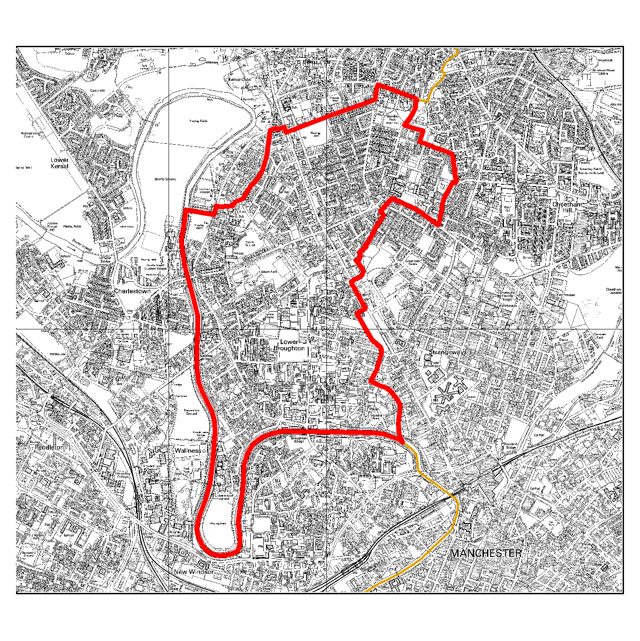

Chapel Street

Adelphi Media Quarter
- Outline planning permission granted for part of the site for residential use and interested developer looking at remainder for residential.

Greengate
- Final draft development framework presented to joint clients July 2004.
- Consultation with businesses and stakeholders in area undertaken July 2004.
  - Planning and implementation groups set up to consider next stages of approval, delivery and implementation.

Salford Central Station
- Partnership of GMPTE, City Council, Network Rail and First North Western to undertake major regeneration scheme for the Station.
- Phase 1 improvements being designed and costed (completion August 2004).
- ERDF Technical Appraisal to be undertaken August/September 2004.

Springfield Lane
- Final terms of Development agreement approved by Lead Members on end June 2004. Agreement to be legally completed by September 2004.

Manchester Bury and Bolton Canal
- Project formally launched.
- Project Steering Group and sub-groups established.
- Detailed funding application to NWDA submitted.
- ERDF (EDZ) funding sought for phase 1 Middlewood. Technical Appraisal underway.
- NWDA funding now agreed for phase 1 Middlewood (subject to usual conditions).

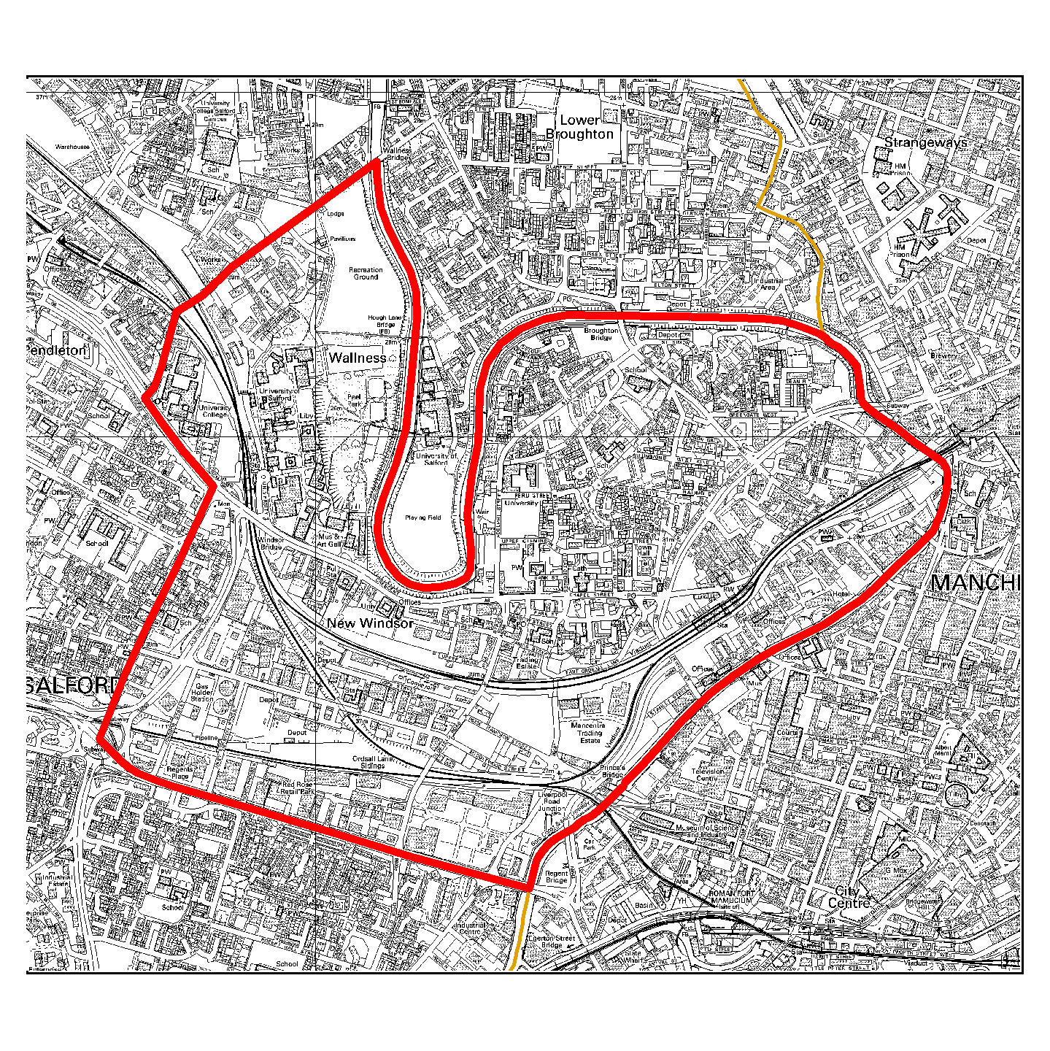

Ordsall

Ordsall Development

- Agreement to and signature of statement of intent with Legendary
Properties Ltd.
- Appointment of BPTW as masterplanners.
- An exhibition of BPTW’s ideas for the area was held between 17th and 25th April, at Ordsall Hall.
- Final report by BPTW being completed.
- Selection of site for new primary school.
- Planning Permission granted to Bellway for Woden St site. Construction underway.
- Planning Permission granted to LPC for the Views.
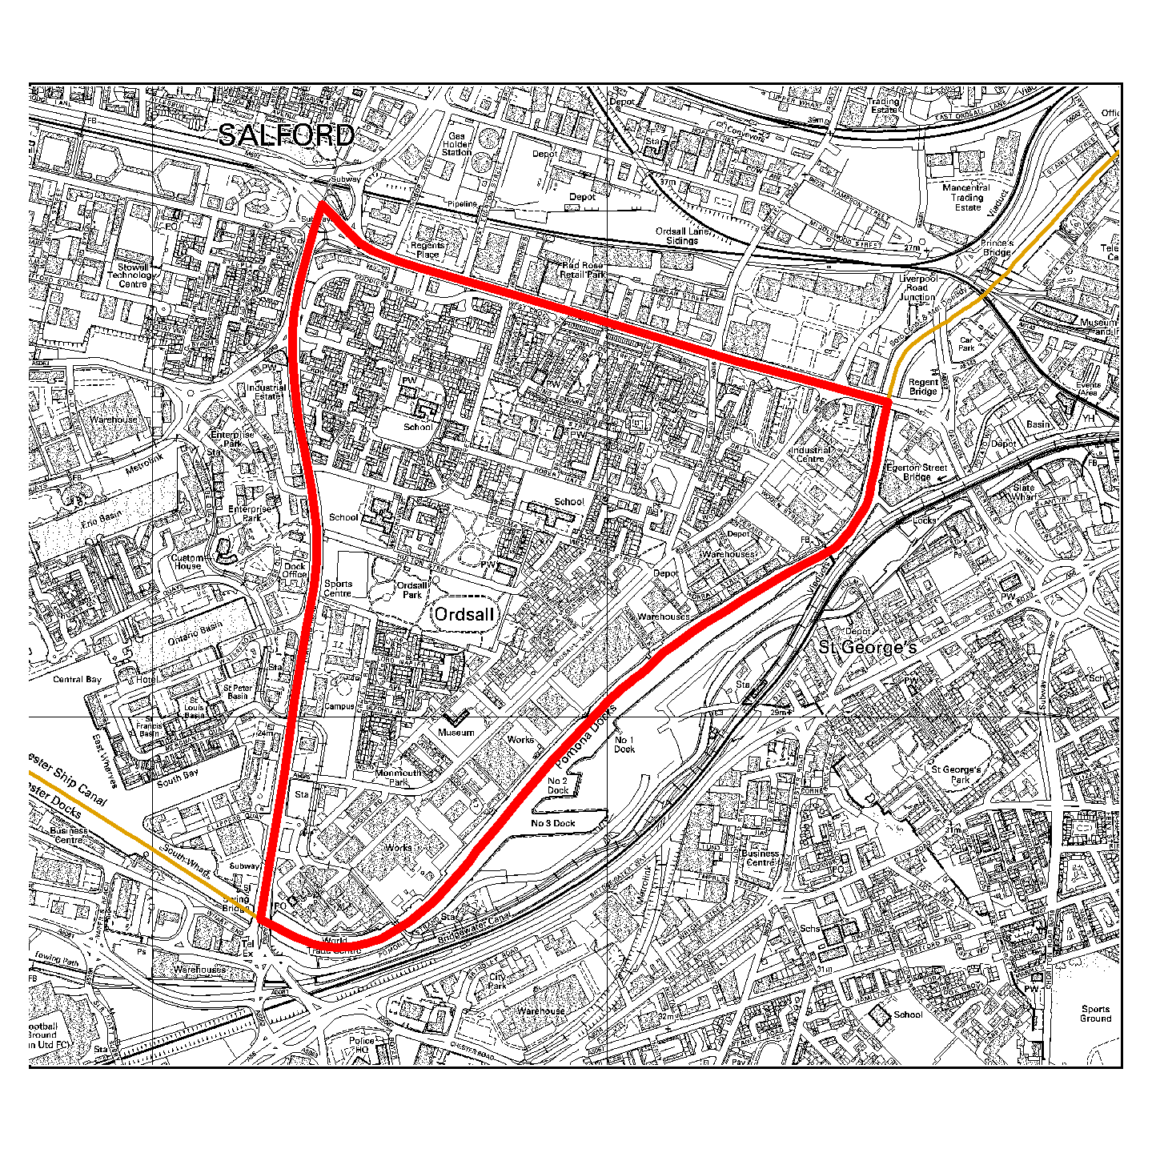

Pendleton Centre

Pendleton Masterplanning (CABE)
- Acquisition of ‘Kingsley Court’ site completed April 2004.
- English Partnerships confirmed as partners during the masterplanning phase and to assist in site assembly April 2004.
- Masterplanning project group established and development of masterplan underway.
- PFI expression of interest deferred until round 3 (early 2005).

Proposed TESCO adjacent to Shopping City
- Agreement on new school sizes reached April 2004.
- Planning application for food store expected soon subject to resolution of design, size and location issues.
- Discussions relating to scheme design, size and associated matters ongoing.
Development Agreement will be completed once scheme has been agreed.
- Preparatory work on CPO ongoing with a view to public enquiry once Foodstore Planning Application submitted.
- Architect appointed for new Ecumenical Church. Steering and Design Groups established to progress.
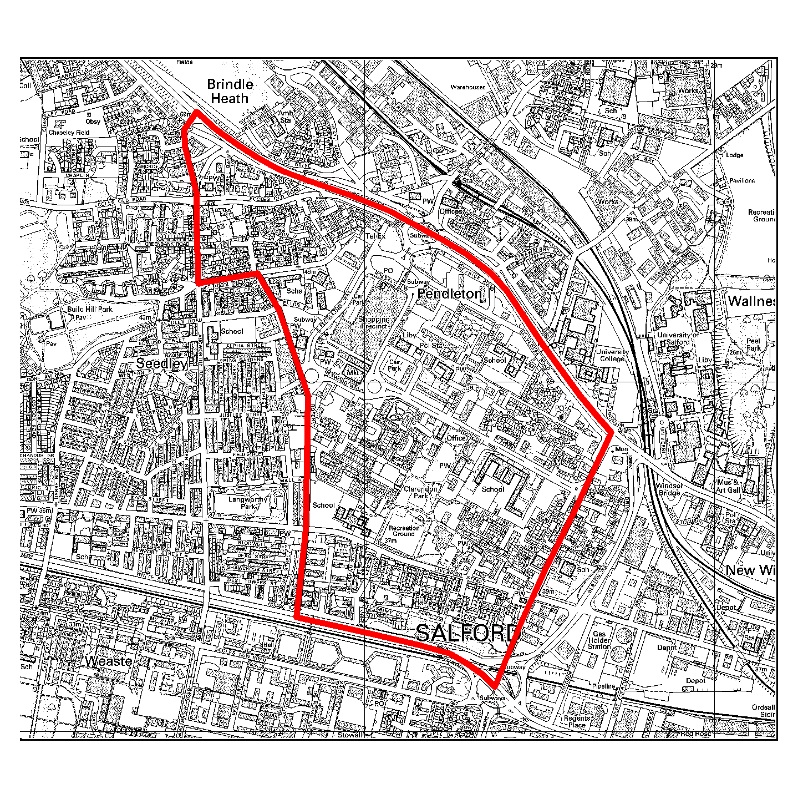

Seedley Village

Seedley and Langworthy
- Homeswap programme – 54 home swappers have already moved into their new homes. In May the partnership celebrated its 50th Homeswap completion. A total of 66 additional properties are either in contract or due to start, the majority of which will be complete between now and December 2004.
- 3 alleygating schemes have been completed (Annie Street, Milford Street and Highfield Road/Fitzwarren Street). An additional 18 schemes are planned to go ahead within the area.
- Acquisition and demolition programme continues – Demolition of houses on Norway Street in Seedley south complete. Most of the selective demolition work is now completed and a review of the successes / difficulties is being drawn together.
- MMHG allocation from Housing Corporation has been confirmed with a proposed investment in the area by the organisation of £9 million over the next two years.
- Brief for the consultants for the design competition for Chimney Pot Park has been developed along side the Landscape Institute who have agreed to facilitate the competition as part of their 75th anniversary celebrations.
- All security works in Urban Splash area have been completed and the Compulsory Purchase Order Public Enquiry has now been completed. A decision is expected in the near future on the outcome of the enquiry. Funding negotiations with English Partnerships are nearing completion.
- Seedley in Bloom - Bloom 2004 planting programme started, judges visited on 12th August 2004.
- Manager has been appointed for Cornerstone building whose main role will be to secure a realistic future for the building.
- SALI have been awarded the contract for the community governance development for the Cornerstone building.
- SRBV outturn 2003/04 indicates spend of £1.5million – which is on target.

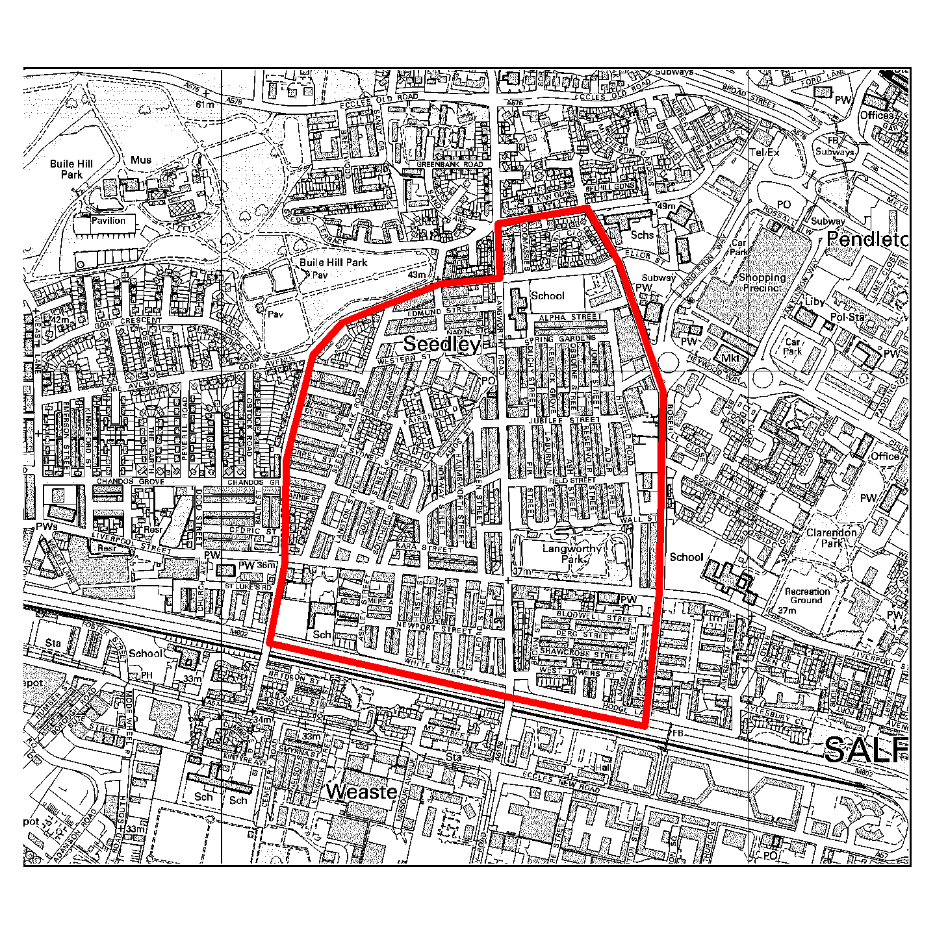

Charlestown and Lower Kersal NDC

- Steering Group membership and responsibilities reviewed and new governance arrangements introduced.
- Funding for 2004/2005 approved at £7.5 million.
- Pendleton House works for new Health Care facility completed.
- New Communication and Marketing Officer in post.
- Beacon Centre project back on site.
- Brunswick House START project works near completion.

Salford Innovation Park

- Multi-agency Steering Group and Officer Working Group established.
- Temporary Executive Director for Salford Innovation Park recently recruited and planning permission for the building granted.
- NWDA business plan for the SIP due to be finalised in early August 2004.

Charlestown and Lower Kersal
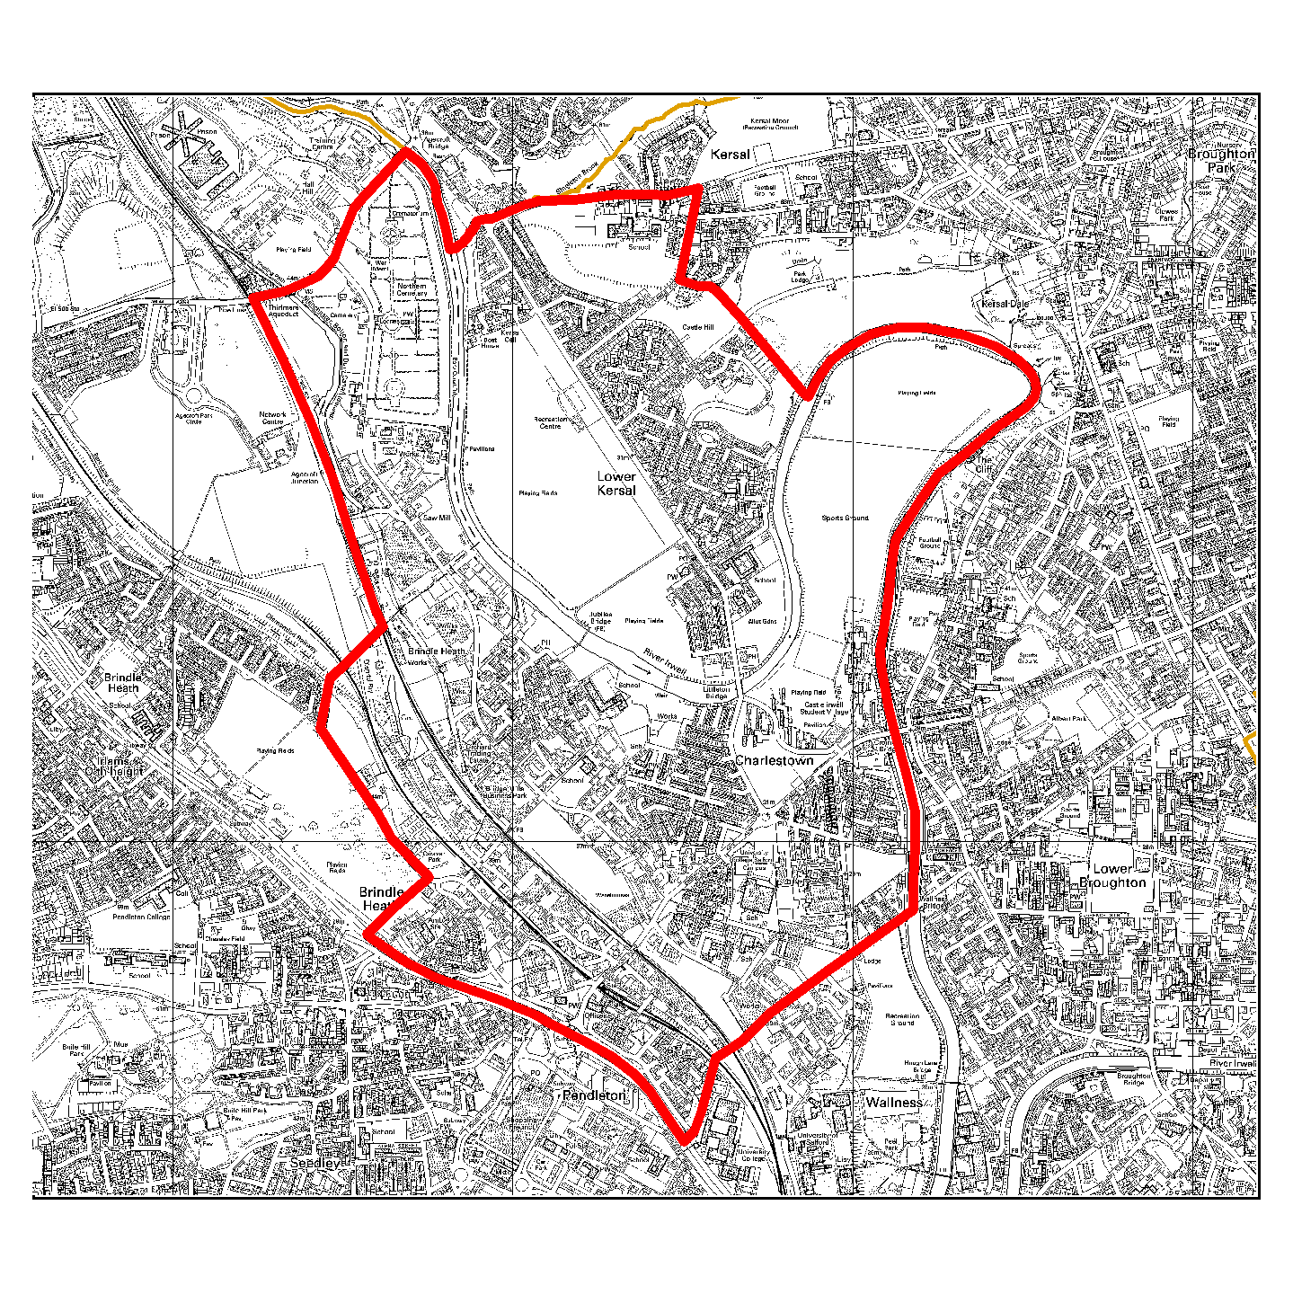

Claremont Village

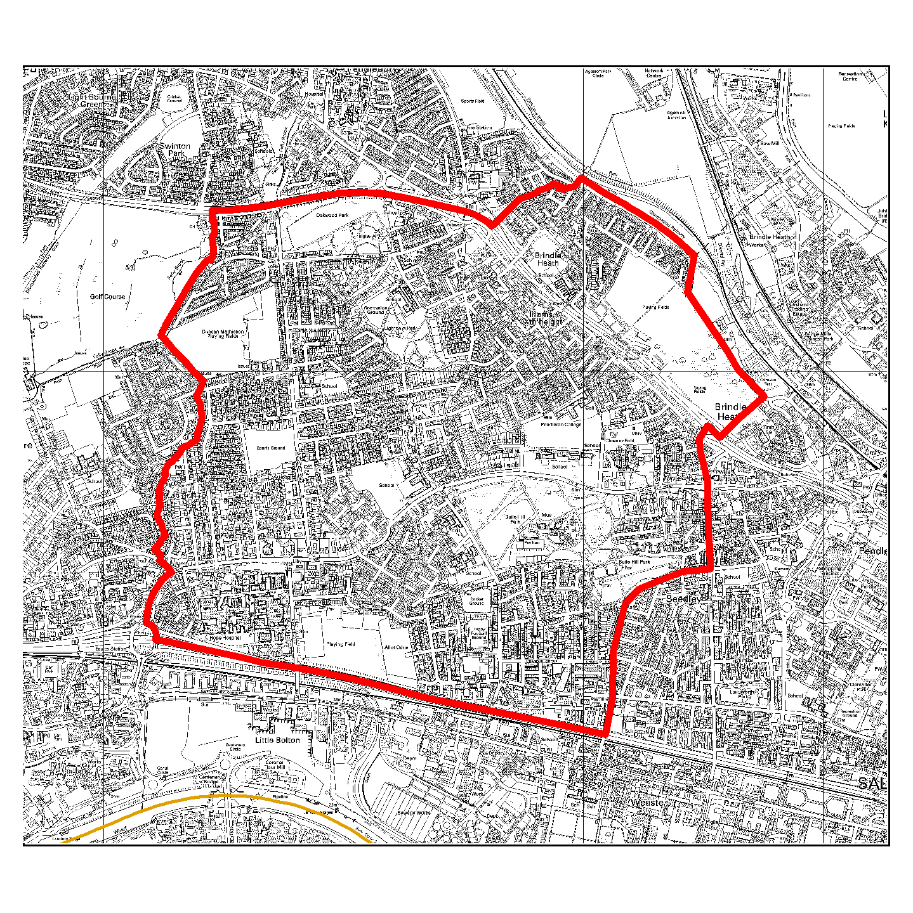

Weaste Renewal Area

- Alley gating projects ongoing with Groundwork. Statutory closure attained July 2004. Physical works to be implemented in Autumn 2004, to the benefit of 261 properties.
- Neighbourhood Planning Forums ongoing monthly.
- Kennedy and Barff Road improvements ongoing. Works on site, completion due in October 2004.

Duchy and Pendlebury Renewal Area.
- Formal Declaration of Clearance area scheduled for September 2004.
- Block improvements on Johnson and Houghton Streets due for completion mid-summer.
- Duchy redevelopment proposals in partnership with Space New Living commenced April 2004, development programme ongoing, draft proposals expected February 2005.

Salford Quays

Eccles New Road Renewal Area
- CPO confirmed for Stowell and Bridson Street. Demolition to commence August 2004.
- Neighbourhood planning process ongoing.
- Clearance area declared for Nelson St aiming for September 2004.

Dock 9
- New planning permission submitted for 203 apartments plus ground floor restaurants in 2 blocks (20 floors and 9 floors).
- Extension of time limit on the outline planning permission granted.

Clippers Quay
  - Developer has engaged architects who are developing concepts for the mixed use development of the site including masterplan and building design.
  - Still at the preliminary stage - no planning application expected for some time.

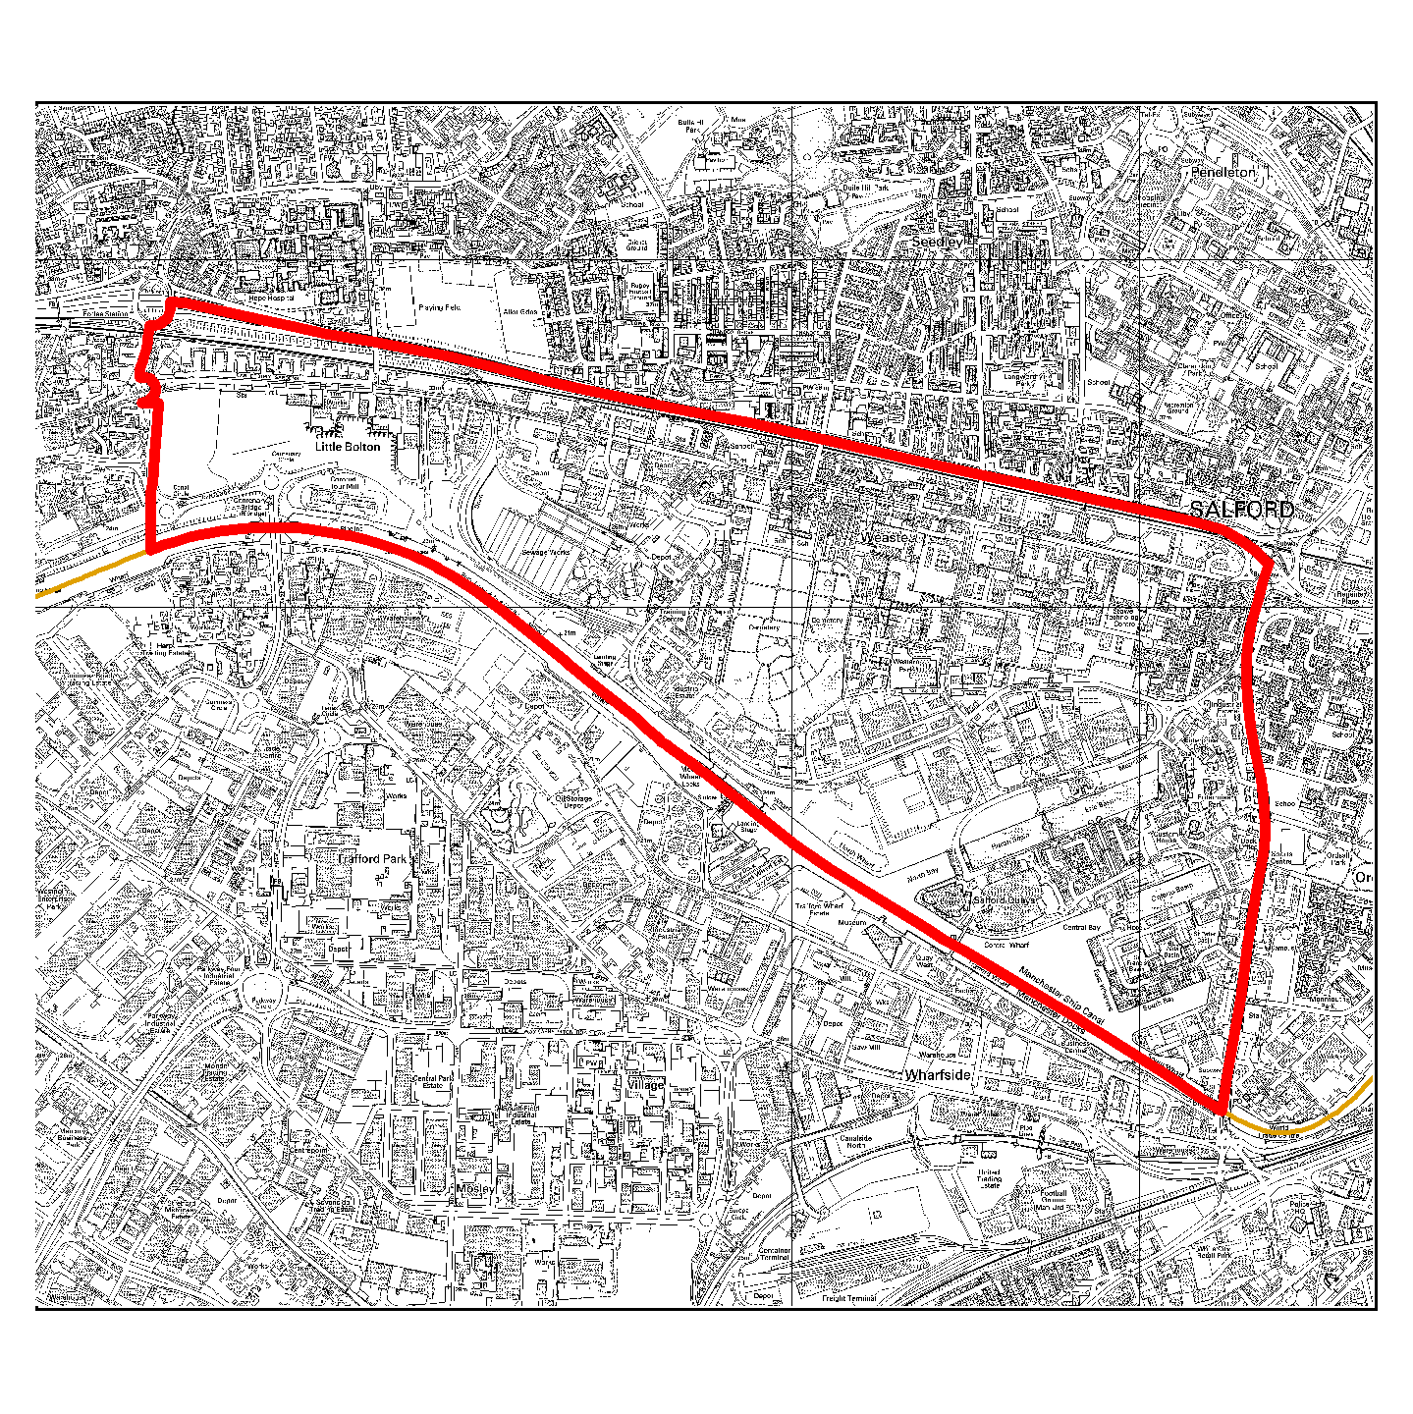

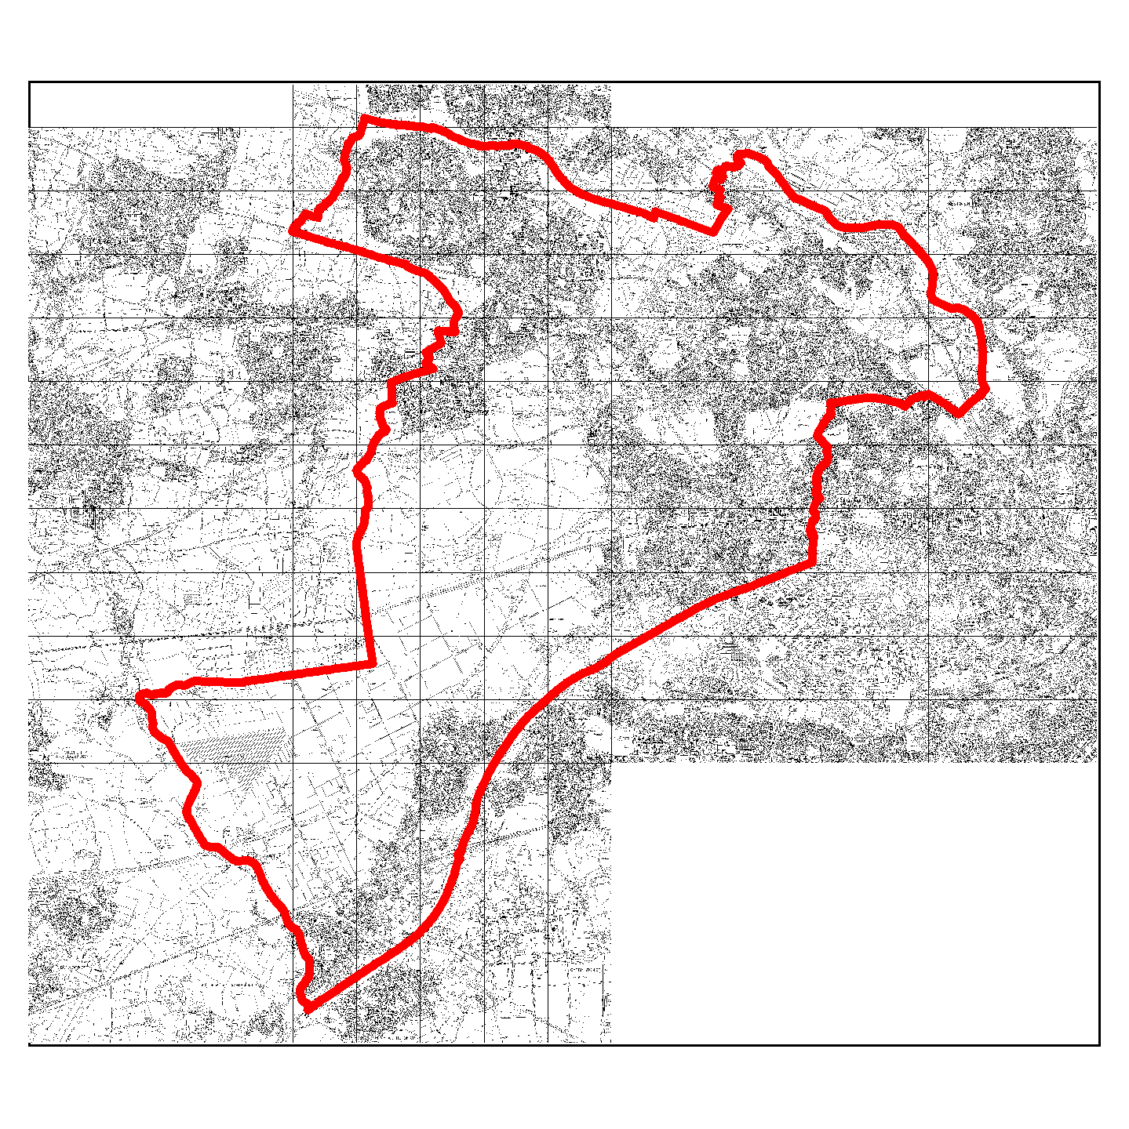
Salford West

Areas covered within this report:

Eccles
Swinton

Eccles and its environs

Barton Strategic Site
Salford Reds
- Planning application for stadium and supporting areas submitted by Reds, and exclusivity agreement completed. Lease terms nearing agreement.
- Highways Agency article 14 direction lifted with some reservations.
Peel Holdings
- Planning applications for Port Salford and stand alone stadium / casino submitted by Peel Holdings.
- Further details awaited on environmental and traffic impact for the stadium / casino proposal - no progress on this application is possible until this information is received.
- Consideration of planning application for Port Salford progressing.
- Both Peel & Reds in discussion about agreeing a joint scheme.

Liverpool Road
- Economic Development Officer responsible for Linear Corridors is now in post.
- Detailed costs regarding the block improvement scheme have been obtained.
- Brief for joint work with Eccles Town Centre under preparation.
- 5 Blocks identified for potential improvements - £200K funding secured.

Meeting to consult with Traders/Landlords arranged.

Identification of properties for possible acquisitions – ongoing.

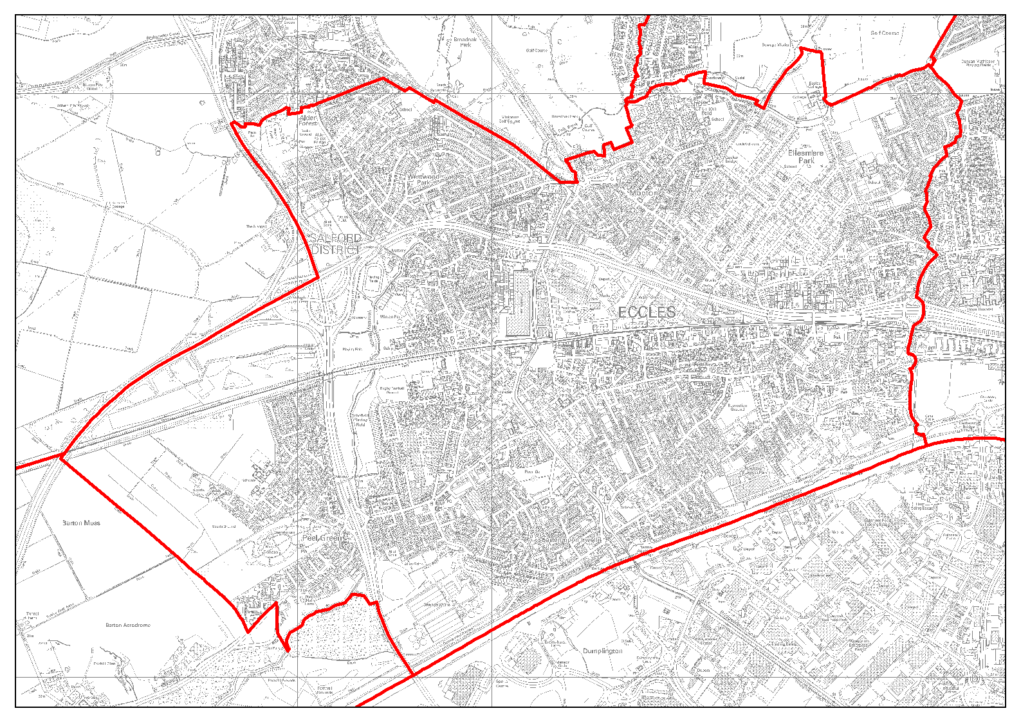

Swinton and its environs

Magistrates Court and Justice Centre

- Due to reorganisation of regional court services, no decision will be taken by DCA on court size until September at earliest.

LIVIA
- A LIVIA Officer Steering Group and a Key Stakeholder Group has been established.
- ‘Quick wins’ programme is completed.
- Draft Vision/ Masterplan completed for consultation purposes.

