SALFORD COMMUNITY LEISURE LIMITED

OUTLINE BUSINESS PLAN

1st October 2003 – March 31st 2007

September 2003

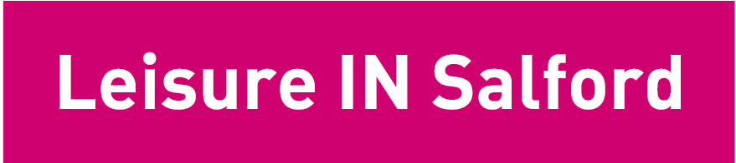

INTRODUCTION

Salford Community Leisure Limited (SCL) is a newly established not for profit organisation that has been incorporated under the Industrial & Provident Societies Act as a society for carrying on business for the benefit of the community.

Our statement of purpose explains the philosophy underlying the creation of SCL:

“The purpose of SCL is to enable the community to promote the well-being of its people through healthy recreation and physical activity.”

The Board of Directors believe that sport and physical activity is a vital ingredient in improving health, quality of life and life chances of people in Salford and in supporting the regeneration of the City. This is a vision shared by Salford City Council.

SCL has been created by the transfer of the staff and activities from Salford City Council’s Sports Development & City Leisure teams to a newly formed independent body.

Both the City Council and the Shadow Board of Directors saw the formation of SCL as providing greater opportunities for investment, greater involvement by communities and employees in the operation of the services, and a greater flexibility in meeting the needs of the local communities. We are confident that SCL provides an ideal partnership base for funding applications and we look forward to maximising this opportunity for the City. In addition both parties agree that it is desirable to have employees involved in the business in which they work. Membership of SCL gives them ownership and, it is to be hoped, a commitment to the service that they deliver and the business that they work for.

The City Council remains committed to this philosophy through its annual purchase commitment and broader support to SCL.

The 1st October 2003 to the 31st March 2004 period will be SCL’s first 6 months of operation and as such will be a transitional period. This plan therefore outlines the rationale for SCL and focuses on establishing SCL on a sound financial footing.

The Shadow Board of Directors very much look forward to working with staff, the City Council, partner organisations, sports clubs, governing bodies, community groups and the general public. This is a very exciting time and one of great opportunity for developing the range of sports and leisure services across the City.

Mark Dutton – Chair of the Shadow Board of Directors

CONTENTS

Section Title Page

1.0 Executive Summary 5

2.0 Beneficiaries 6
2.1 City Of Salford Overview 6
2.2 Participation 10
2.3 Key Stakeholders / Partners 11
2.4 Competition 12
2.5 Summary 12

3.0 Mission & Objectives of SCL 13
3.1 Policy and Strategic Background 13
  - Statement of Purpose and Strategic Aims and Objectives 14
  - Business Development 17
3.4 Developing People 17
3.5 Marketing Plan 18
3.6 Summary 18

4.0 Main Activities 18
4.1 SCL 18

5.0 Governance 20
5.1 Structure 20
5.2 Rules 21
5.3 Board of Directors 21
5.4 Operation of the Board of Directors 23

6.0 Relationship with the City Council 23
6.1 Management Agreement – Aims & Objectives of Both Parties 24
6.2 Transfer Agreements 24
6.3 Leases 24
6.4 Service Level Agreements 24
6.5 Liaison 24
6.6 Performance Measurement 25

7.0 Financial Summary 25
  - Headline Figures 25
  - Key Financial Assumptions 26
7.3 Income 27
7.4 Expenditure 28
7.5 Set Up Costs 29
7.6 Financial Services Function 29
7.7 Sensitivity Analysis 30
7.8 VAT 30
7.9 Contingency Plans 31

APPENDIX 1 – Assets of SCL 32
APPENDIX 2 – SCL Maintenance Responsibilities 35
APPENDIX 3 – SCL Society Structure 36
APPENDIX 4 – Financial Plan 37
APPENDIX 5 – Capital Investment Schedule 38
APPENDIX 6 – Summary of Results of Sensitivity Analysis 41
APPENDIX 7 - Rationalisation Criteria 42

- EXECUTIVE SUMMARY

SCL is being established from 1st October 2003 by the transfer of the activities of the former City Leisure & Sports Development teams of Salford City Council to a non-profit distribution organisation (Industrial & Provident Society with exempt charity status).

SCL will provide a range of diverse sports and physical activity activities in the City of Salford. These include sports centres, swimming pools, specialist sports facilities, sports development and sports events.

The City of Salford has some of the highest pockets of deprivation in the Country and participation in sport and physical activity is relatively low. However both the City Council and the Board of Directors believe there is considerable potential for raising the quality of life of everyone in the City by involving communities in the services and through increasing investment in the provision of these services. This provides the rationale behind the creation of SCL.

SCL will be managed by a board of 16 Directors (with the option to co-opt a further two people), which includes 2 representatives from Salford City Council. SCL and the City Council will work together in partnership and have developed a detailed Management Agreement stating the mutual strategic aims and objectives of this new venture.

This has guided the preparation of the diverse legal documents governing the transfer. Of critical importance is the Management Agreement setting out the terms and conditions of Salford City Council’s purchase of services from SCL.

The Management Agreement, which has been entered into for an initial period of 3½ years, guarantees SCL nearly £1.7million for a minimum purchase agreement from the City Council in 2003/04, its first 6 months of operation. This includes grant income from external sources claimed via the City Council. It further guarantees a minimum purchase for year 2 (£3.5m) and an indicative figure for year 3 and 4 giving the Board of Directors a degree of certainty. This will be rolled forward on an annual basis. The City Council will pay this quarterly, in advance. The City Council's “minimum purchase agreement” for the purchase of services from SCL will be added to the income generated by SCL from its activities and other sources of income, which amount to around £2.6million per annum.

Taking into account the cost savings accrued from not for profit status, such as the NNDR (rate) Relief, this will produce a saving to the City Council of around £340,000 per annum. In addition, the staffing establishment for SCL has been reduced by a further £130,000 p.a. to close the historical gap between budgeted and actual expenditure. A key objective for SCL is to manage the business within its financial plan and to deliver the assumed budget reductions.

SCL’s income and expenditure projections are based on existing budget levels, adjusted to reflect anticipated efficiencies arising from better management of the business. Over the 3½ year period a small cumulative surplus of less than £30,000 is anticipated but actual income and expenditure levels may vary due to a whole range of external factors. The key to the success of the business will be how such variations are managed within overall financial plan.

Steps have been taken to identify areas of risk in the budget and actions identified to minimise this risk. SCL has also taken steps to strengthen its internal finance unit by appointing a new “Head of Finance” to meet the needs of SCL. In addition SCL is in the process of recruiting a new “Head of Human Resources”.

The last 6 months of 2003/04 will be a transitional period for SCL as it seeks to establish itself and develop its plans for the future. The projections made in this plan are therefore cautious and the Board of Directors and Management of SCL are confident they provide a sound and exciting basis for the launch of this new venture.

- BENEFICIARIES

The initial field of operation will be the City of Salford and a significant proportion of support will come from Salford City Council.

The overriding aim of SCL will be to enable the community to promote the well-being of its people through healthy recreation and physical activity.

This section provides background information on the area and its population.

CITY OF SALFORD OVERVIEW

Salford covers an area of 9,719 hectares and has a population of approximately 216.119 (2001 Census).

The changing employment picture of the last 20 years, the loss of traditional industry including the docks, coal mining and manufacturing has had a dramatic impact upon the City (at one point in the mid to late 1980s, unemployment in Salford was over twice the national average. It is still relatively high; 3.8 per cent compared to the national average of 3.2 per cent.

Salford: IMD employment ranking – by ward

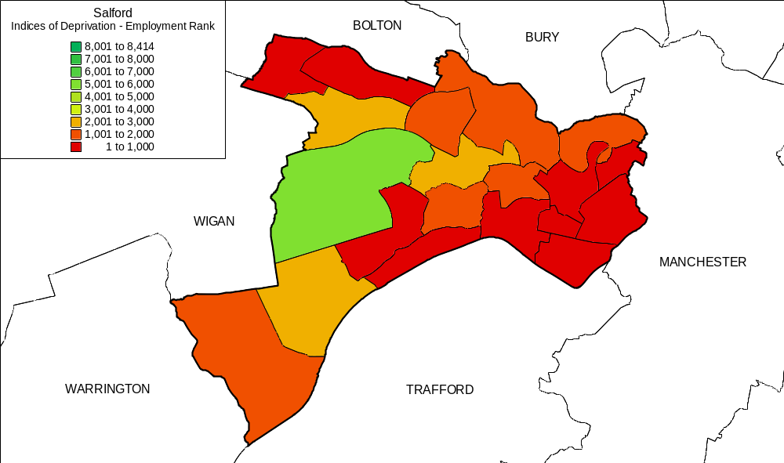

Salford is the 28th most deprived council area in England. The City comprises 20 wards, seven of which are in the top 500 (of 8,414) deprived wards in England. Eight other wards are also in the top 20% and, as such, are designated by Sport England as Priority Award Initiative (PAI) wards. These are listed below:

PAI ward (top 500) | IMD ranking | PAI ward (top 20%) | IMD ranking
Broughton | 126 | Weaste and Seedley | 570
Little Hulton | 138 | Barton | 729
Blackfriars | 156 | Walkden North | 880
Ordsall | 166 | Pendlebury | 1030
Pendleton | 201 | Kersal | 1542
Langworthy | 260 | Eccles | 1551
Winton | 471 | Swinton North | 1608
 |  | Cadishead | 1652

Salford: PAI wards
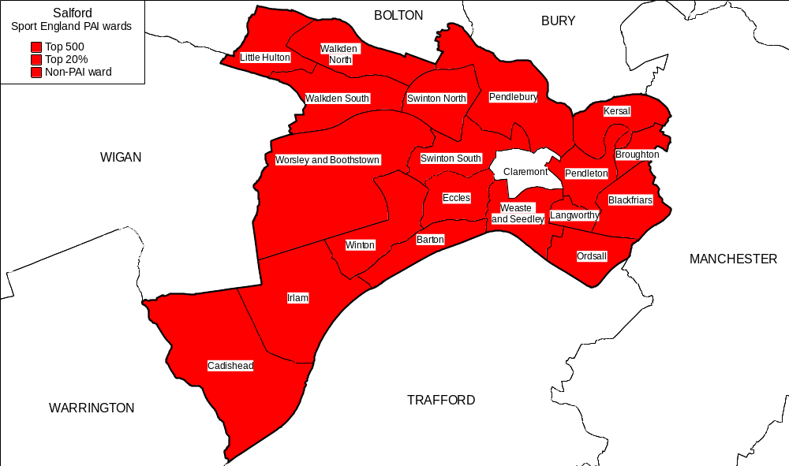
Poor health is commonplace, death rates are 35 per cent higher than the national average and the City has the third highest proportion of children in care in England. Overall crime rates and incidences of street/car crime and anti-social behaviour are high. Crime and poor health has had a detrimental impact upon the City’s communities. The City centre has experienced considerable out-migration while significant dereliction is located alongside the City’s well-known regeneration areas.

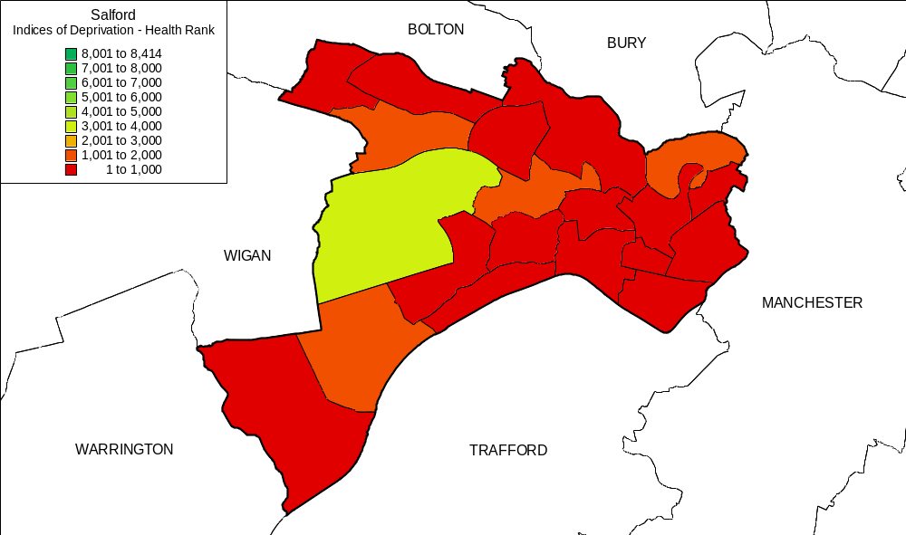
Salford: IMD health rankings – by ward

Salford faces other key problems. Educational attainment is low. In Greater Manchester only Manchester City Council has a lower proportion of pupils gaining 5 A-Cs at GCSE.
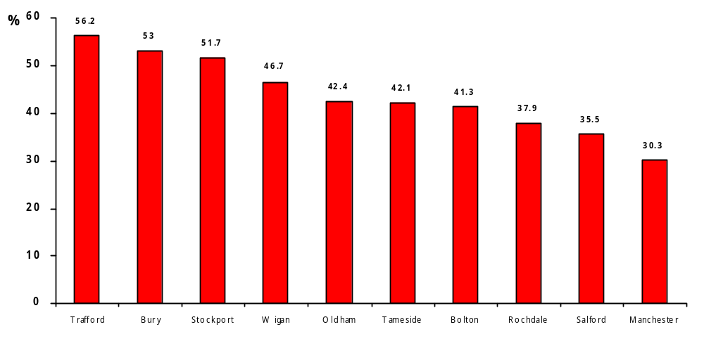
Greater Manchester: Proportion of young people gaining 5 or more A-Cs at GCSE – 2001

There is, of course, significant variation across the City but in 2000-2001, at only two of the City’s secondary schools did more than 50% of pupils gaining 5 or more A-C grades at GCSE. (Research Assessment Exercise 2001).

Salford schools – by GCSE passes at A-C: 2001
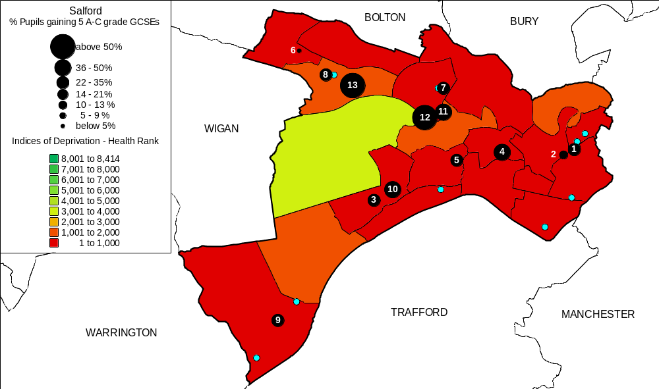
This is, of course, linked to a number of factors. There is, for example, unsurprisingly a fairly strong correlation between school academic performance and the relative deprivation of the catchments areas serviced.

Id | School | % Free School Meals
1 | The Albion High School | 49.4
2 | All Hallows RC High School | 47.7
3 | Canon Williamson CofE High School | 37.8
4 | Buile Hill High School | 35.2
5 | Wentworth High School | 29.1
6 | Harrop Fold School | 28.6
7 | The Swinton High School | 25.0
8 | St George's RC High School | 23.6
9 | Irlam and Cadishead Community High School | 21.6
10 | St Patrick's RC High School | 15.9
11 | St Ambrose Barlow RC High School | 13.6
12 | Moorside High School | 10.3
13 | Walkden High School | 7.7

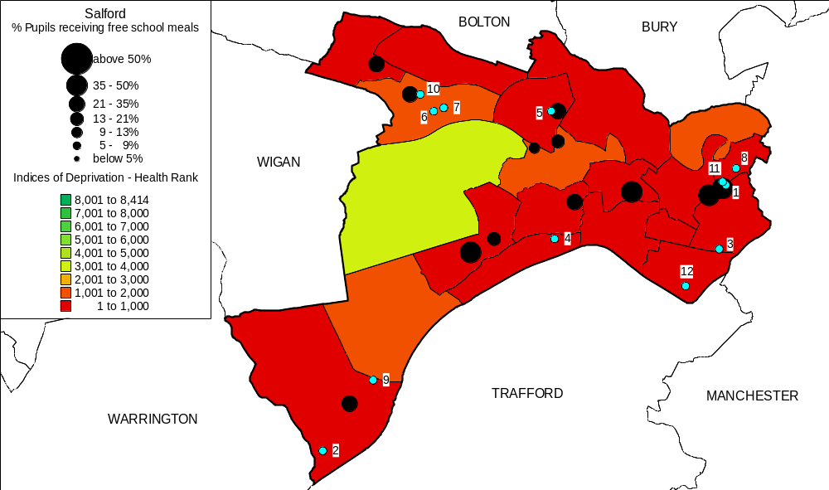
Percentage of pupils on free school meals (97-01 Research Assessment Exercise)

At 34%, levels of car ownership in the inner city are half the national average. Physical isolation, mobility and variable public transport means that travel within and across the City and commuting between one neighbourhood and another can be problematic.

  - PARTICIPATION

The best value review of City Leisure & Sports Development undertaken during 2002/3 incorporated the gathering of extensive information from other authorities. These included:

- Local authorities in Greater Manchester.
- Salford’s ‘CIPFA Family’ authorities.
- Authorities specifically recommended via Sport England and other sources.
- Beacon councils.
- Authorities in Sport England’s ‘Performance Measurement for the Development of Sport Pilot’; London Borough of Newham, Barrow Borough Council and North Norfolk District Council.

Information gathered compared Salford’s progress in a range of operational areas through the limited quantity of broadly and/or directly comparable, performance measures available via mechanisms such as the Greater Manchester Year 9 Census Survey of youth participation in sport and related indicators, and the Sport England Performance Measurement Pilot.

In addition City Leisure undertook a “census week” to assemble a comprehensive snapshot of the user profile at the City’s sports facilities. This information provides a baseline for ongoing comparison of the City’s provision with other authorities that have followed this process, for example, Leeds City Council.

The extensive information gathered demonstrates a mixed picture of participation. Salford compares very favourably, and could legitimately claim to be a leading authority, in certain areas of provision (for example the low proportion of young people in the City that are poor, or non-swimmers). There are, however, clear deficiencies in other areas such as girls extracurricular and out-of-school participation rates. In addition the participation of young people at the City’s leisure facilities compares favourably with the others surveyed by Sport England in its National Performance Measurement Pilot, although adult participation rates are much lower in comparison.

Examples of this information for Salford gathered by MORI for Sport England are:

- 89.3% of young people have taken part in sporting activity at a local authority sports facility in the past 12 months, where as this figure is only 39.1% for adults.
- 6.4% of adult residents contribute to sport as a volunteer for at least one hour per week
- 19.2% of residents have been a member of a sports club over the past 12 months
- 79.1% of young people are able to swim 25m without floating aids
- 60.9% of residents strongly agree that sport helps to improve health, and 45.2% strongly agree that a sport makes the area a better place

Further detailed information on comparisons are available within the Best Value Review files available at SCL Head Office.

  - KEY STAKEHOLDERS / PARTNERS

SCL will operate with a complete network of stakeholders and partners both within the City and Nationally. The following are some examples of partnerships, which already exist:

Public Sector: Salford City Council
Government Departments, DCMS etc
Sport England and other funding bodies
Greater Manchester Police
Countryside Agency
Etc

Education: Salford LEA
Local Schools and colleges
Salford University
Etc

Health: Local NHS Trust
British Heart Foundation
Etc

Voluntary groups: Sports clubs
Salford District Sports Council
Community and resident organisations
Sports Governing Bodies
Etc

Business: Private sector sponsors,
Salford Tourism Forum
Etc

Youth: Salford Connexions Service (Better Choices)
Fairbridge
Etc

Local Media: Manchester Evening News
Salford Advertiser
Century FM
GMR
Other North West media.

These partnerships built up by the Salford City Council Sports Development and City Leisure teams will be picked up by SCL giving it strong links on which to build. In addition new partnerships will be developed.

  - COMPETITION

Salford has a network of neighbourhood leisure facilities located throughout the City. There is provision in 8 of the 9 community committee areas. Survey results indicates that a significant proportion of residents would cease exercising all together if their local sports facility closed. Other complementary surveys demonstrate the very parochial nature of Salford residents in the context of their awareness and use of facilities.

There is limited competition within the City relative to that faced in many neighbouring and comparable authorities. The small number of private fitness facilities operate, and appear to attract most of their custom from, areas where the City Council has no, or only limited facilities; e.g. Worsley/Boothstown. The opening of the JJB Soccer Dome in Trafford has had an impact on demand for 5 –a-side football.

However few private providers can meet the social needs that SCL has set as its objectives.

There are plans in place across the City for a programme of significant improvements for school sports facilities through PFI and/or NOF PE & Sport. These new facilities will provide a significant step change in the school sports provision within the City and also provide both opportunities and threats for SCL. Further detailed work and discussions on this will be required once the PFI and NOF programmes are finalised.

  - SUMMARY

The City of Salford, is characterised by:

- A strong sense of local community and a developing voluntary sector.

- High levels of deprivation with poor health

- High levels of crime and fear of crime

- Low levels of participation in leisure activities

The Board of Directors of SCL and Salford City Council believe that there would be significant benefits to the residents of the City by using sports and physical activity as a vehicle to deliver key social objectives and laying specific emphasis on improving provision for the under represented.

- MISSION & OBJECTIVES OF SCL

This section of the Business Plan develops its mission and strategic objectives.

3.1 POLICY AND STRATEGIC BACKGROUND

In reaching this point the City Council have followed a process of first approaching the private sector to obtain and discuss proposals for transfer of the services under an outsourcing contract. After careful and detailed evaluation of these Outline Proposals received from four companies and comparing them with the benefits of moving to a locally managed not-for-profit organisation, the Council determined that it will pursue the future management of its leisure facilities through a locally managed not-for-profit organisation. The Outline Proposals from the four private companies did not demonstrate the anticipated levels of investment or risk transfer.

In determining the not-for-profit options the recommended option adopted was to set up an Industrial and Provident Society (IPS) Community Benefit model.

It was felt this model will:

- Be able to meet the City Council’s financial aspirations of a not-for-profit organisation
- Be able to meet the City Council’s community involvement objectives
- Involve and empower employees

There are a number of key documents that formed the background to the decision to transfer services to SCL. These are also seen as vital in the ongoing relationship between SCL and its single largest customer (the City Council).

These were:

- The Council’s 6 Pledges
- The Community Plan
- The Cultural Strategy
- Best Value Review of City Leisure & Sports Development 2002/2003
- Salford Sports & Health Strategy 2003
- Arts & Leisure Strategy 2003

In progressing the Mission Statement and Strategic Objectives of SCL, and developing the Business Plan, account has been taken of these strategic documents. This ensures there is a basis for a strong partnership in achieving mutual objectives through delivering programmes and services which are available to the whole community. By adopting this approach, clear links have been established between the City Council’s corporate objectives and the Mission Statement and Strategic Aims of SCL.
  - STATEMENT OF PURPOSE AND STRATEGIC AIMS AND OBJECTIVES

    - SCL is committed to providing a clear policy statement that identifies its vision, statement of purpose, and overall strategic aims and objectives. These strategic aims will be translated into specific plans at service level to ensure service delivery is focussed on “core business” in the achievement of SCL’s objects.

    - SCL’s Statement of Purpose:

“The purpose of SCL is to enable the community to promote the well-being of its people through healthy recreation and physical activity.”

This will be achieved by:

- Working with a range of partners to provide a highly diverse range of accessible and affordable sport and health activities and services to meet the needs of the local community.

- Working with the communities of the City to develop and implement the Sport & Health Strategy in partnership with the City Council and other statutory agencies.

- Delivering the aims and objectives of SCL in the context of community involvement, sustainability, accountability, flexibility and innovation.
- Working with partners to ensure that SCL’s services and activities contribute to the quality of life of Salford’s citizens.

- Monitoring and evaluating performance and developing a culture of continuous improvement.

3.2.3 Strategic Aims of SCL

Flowing from the Statement of Purpose, SCL has developed corporate objectives within seven overarching strategic aims. Each of these is set in a strategic context.

The formation of the Mission Statement and Strategic Aims are the culmination of a best value review of ‘sports services’ and take account of key strategic documents as detailed in 3.1 above. The review also encapsulated CPA ‘Gap Inspection’ recommendations, the development of a new ‘Sport & Health Strategy’ and the ongoing work on exploring alternative options for the management of leisure facilities (i.e. Public Private Partnership versus Not For Profit Distributing Organisation).

- Strategic Aim 1

To manage and maintain leisure facilities to a high quality to meet expectations of all existing and potential users

Objectives:

- To encourage more and a broader range of people of all ages and from all sections of the community to take a lifelong interest in sport and leisure activities.

- To make the best use of existing facilities and to develop improved facilities through reinvestment/refurbishment, or the provision of new facilities where appropriate.

- Strategic Aim 2

To improve health outcomes and reduce health inequalities

Objectives to support the achievement of Strategic Aim 2

- To develop effective, integrated programmes to improve the health of key groups in Salford and enhance the effectiveness of partnership work with key agencies in this context.
- To ensure that exercise/fitness development is a “priority sport” and becomes an integrated whole service programme.
- To develop “the right to swim” as a key corporate goal and ensure the City’s swimming programme is efficient and effective.

- Strategic Aim 3

To raise education and skill levels and promote cultural and leisure enhancement.

Objectives to support the achievement of Strategic Aim 3.

- To support movement literacy initiatives for very young children.
- To work to raise standards of movement literacy and general fitness among young people attending Primary Schools.
- To develop and implement mechanisms to enable secondary schools to improve the delivery of PE and sport.
- To co-ordinate outdoor activities/watersports provision.
- To support and develop programmes designed to improve performance, behaviour and attendance.
- To develop community use of schools, focusing on improving co-ordination of community use and the developments of new agreements in areas of low sporting participation.
- To develop closer working relationships with further and higher education institutions in the City.

- Strategic Aim 4

To tackle social inequities, maximise opportunities for children and young people and increase involvement of local people and communities in sport and physical activity.

Objectives to support the achievement of Strategic Aim 4.

- To develop programmes to cater for the sporting needs and aspirations of girls.
- To work closely with key groups to develop programmes to cater for sporting needs & aspirations of young people from targeted communities (areas of severe health and social deprivation, black and ethnic minority communities, looked after children/young people, children/young people with disabilities).
- To work closely with and inform other key professionals in youth/ community/social work to ensure that they are in a position to utilise sport as a vehicle in the delivery of their objectives and are in a position to refer young people to appropriately structured sporting options.

- Strategic Aim 5

To deliver and support programmes designed to reduce crime and disorder.

Objectives to support the achievement of Strategic Aim 5

- To work with Salford Community Safety Partnership to promote sport as a vehicle to achieve its objectives.
- To make effective use of the full range of sports, arts and watersports based activities available in the City, and via SCL’s resources, to work with disaffected young people.
- To support and encourage training, qualification and employment opportunities linked to the sport ‘sector’.

- Strategic Aim 6

To co-ordinate, manage and develop sport in, and across the City.

Objectives to support the achievement of Strategic Aim 6.

- To review the sports with which SCL will work on a priority basis.
- To target the skills, facilities and resources available to the voluntary sports sector for the delivery of sport for young people.
- To develop a programme for the recruitment, training and deployment of coaches and volunteers.
- To assess and determine the rationale for SCL’s support for talented individuals.
- To prioritise, deliver and enable a range of sports events (from local competitions to major international events) and holiday programmes.

- Strategic Aim 7

To deliver value for money – effectively balancing financial efficiency and the delivery of high value social outcomes.

Objectives to support the achievement of Strategic Aim 7.

- To plan strategically for facility provision among all sectors of the City of Salford and to seek and allocate resources to improve the quality, and accessibility, of sports facilities.
- To implement QUEST “Quality Scheme” for Sports Development and Leisure Management.
- To review and introduce improvements to facility programming, pricing and leisure card as detailed in the Sport & Health Strategy.
- To raise the profile of SCL with key partners and customers through an effective communication and marketing strategy.
- To develop effective consultation and market research systems, and consultation procedures with customers, partners and stakeholders.
- To manage services on an efficient and cost effective basis.
- To focus on customer care as a primary driver for return trade.
viii) To maximise the potential of staff and to empower them to contribute to improvements in performance and service delivery.

3.3 BUSINESS DEVELOPMENT

The Best Value Review Of “Sports Services” in 2002/3 followed several approaches that considered the strengths, weaknesses and internal/external influences on the services (e.g. EFQM and PEST analysis)

Key issues from these processes were:

- high dependence upon external funding
- trading driven service
- major gaps in measurement/evaluation
- short-term planning
- poorly funded
- undervalued service
- quality, committed staff
- high degree of collaboration between sections
- open recognition of required direction
- quality ambition for the services

The introduction of the new fitness suites and the development of ‘all-inclusive’ memberships has been a significant business area. The need to ensure focus on this key area is reflected in the financial projections and the detail contained within individual service plans.

The development of improved school sports facilities provides opportunity for SCL, and SCL will proactively seek to maximise its involvement in the management and operation of education establishment sports facilities across the City.

DEVELOPING PEOPLE

SCL recognises the importance of having the “right” people – staff, managers and Board members – with the necessary experience and skills. Effective training will lead to improved staff performance and a better quality of customer service from a more skilled and motivated staff who know their responsibilities and are developing their abilities further. Appropriate training is important for all staff. A comprehensive training programme will act to eliminate any weaknesses in the skills and knowledge necessary to run the services whilst developmental training will also increase individual employee confidence and motivation. This attitude will be reflected in the relationship with the service users/customers and will underline the importance of people within the process.

SCL will strive to create the foundations and give staff confidence from knowing what they are expected to achieve and having received the right training. In addition the approach will be based on staff enjoying the work, choosing the right attitude and then seeing our customers respond in a positive manner.

3.5 MARKETING PLAN

As with any new business a strong marketing plan will help SCL create, guide and co-ordinate its marketing efforts. In addition the process of preparing this plan encourages staff to examine and appraise the current state of the services.

The marketing plan is the road map in assisting SCL in setting and realising goals and keeping it on course. This plan consists of information on the services, marketing activities objectives and strategies, and methods for measuring success.

The plan is currently being developed and will be an addendum to this Business Plan.

3.6 SUMMARY

Drawing on these Strategic Objectives SCL will develop specific action plans for each of its services areas during our first year of operation.

4.0 MAIN ACTIVITIES

This section briefly describes the activities and range of services to be offered by SCL.

A list of the facilities can be found in Appendix 1.

  - SCL

      - 4.1.1 SPORTS DEVELOPMENT

The Sports Development Team has a responsibility for the development of sport & leisure opportunity within the City and is also the main point of contact for the voluntary sports sector in terms of support and advice.

The services provided are:

  - Day to day management of Watersports Centre and all associated disciplines.
  - Day to day management of North Salford Trampolining and Gymnastic Centre – including the provision of all activity within City Leisure facilities.
  - Management of Pendleton College swimming pool through an SLA with the college.
  - Management and deployment of the Community Sports Development Officer Team.
  - The provision and development of activities relating to women and girls. The development and management of activity relating to disability sport.
  - The continuation and expansion of the Primary / Secondary school sports programme.
  - The provision of quality holiday programmes in all areas of the City – to liase with funding partners in the design and delivery of such schemes.
  - The continuation and expansion of the Salford District Sports Council and the development of links with agencies such as the CVS.
  - The continuation and expansion of the Active Lifestyles Team, involving partners from the PCT and other organisations.
  - Working as a key partner within the Greater Sport Partnership and ensuring Salford are represented on the Greater Sport Board.
  - The continuation and expansion of the current competitive swimming programme and its associated partners.
  - Involvement in community regeneration and juvenile nuisance based projects such as SPARKY, SAYO and New Deal.

    - CITY LEISURE

City Leisure employs approximately 170 full and part time staff and is responsible for delivering services through the following portfolio of facilities:

Dry Leisure Centres

- Fit City Broughton Centre

Fit City Cadishead
- Fit City Ordsall
- Fit City Walkden (managed through an SLA with Walkden High School)

Cleavley Athletic Track

Swimming Pools

Fit City Broughton Pool

Fit City Irlam Pool

Fit City Worsley Pool

Dry/Wet Leisure Complexes

Fit City Clarendon

Fit City Eccles
- Fit City Pendlebury (Dual use facility linked with Swinton High School)

nb1 The three Astroturf pitches at Ordsall, Clarendon and Albert Park will not be transferred into SCL and will remain with the City Council. However, SCL will manage and operate the facilities in the short term whilst exploring the future viability of the sites.
nb2 City Leisure manages the “Learn to Swim Programme”.

    - SPORTS EVENTS

The Services provided by the Principal Events Development Officer are:
- Advice, advocacy, information and support for community groups, council officers, and voluntary groups.
- Links into the Events Strategy.
- Support for major sporting events e.g. World Cup Triathlon

Demand from community groups is high for staffing resources, health & safety issues, insurance issues, equipment loan/hire.

In addition this section will provide and enable a range of events and activities for “members” of SCL.

4.1.4 CENTRAL SUPPORT SERVICES

The Head Quarters and registered office of SCL is located at Minerva House, Swinton in offices shared with the Local Education Authority.

The HQ houses the following central services that will be provided to SCL:
- The Senior Management Team. The Chief Executive, Service Director, Head of Finance, Board Secretary and other key management personnel.

- Administration & Support Services. A number of staff providing administration support.

- Finance. A Head of Finance and a small team, with the support of the City Council through a service level agreement, providing financial support to sections and meeting SCL’s statutory requirements.

At present other central support services are purchased from the City Council under service level agreements. SCL is in the process of recruiting the new “Head of Finance” and “Head of Human Resources” both of whom will be based at Head Quarters.

    - SUPPORT SERVICES

SCL has agreed to follow a process of minimum change to ensure a smooth transfer of assets, rights, liabilities and activities. In following this approach SCL will continue to purchase the majority of its support services from Salford City Council during an initial 18-month transition period. Once established SCL will actively explore ‘the market’ to determine whether it is receiving best value from these City Council services and will subsequently purchase future services on the basis of this process.

However, SCL will not be purchasing the Personnel “Outstationed” Team and will utilise this budget to recruit its own Head of Human Resources.

In addition SCL will not be purchasing grounds maintenance from the City Council and will be utilising this budget to purchase services through Community Service (GM Probation). The decision is based on findings from the CPA report that highlighted the poor grounds maintenance. This approach using Community Service will provide a more flexible service that can deliver a wider range of maintenance tasks and in addition is more in line with SCL’s social objectives.

5.0 GOVERNANCE

This section provides details on the governance of SCL.

  - STRUCTURE

Following extensive discussions, both internally and with external financial and legal advisors the City Council concluded that the most effective structure for SCL would be an Industrial & Provident Society for community benefit.

This structure is depicted in the diagram in appendix 3.

  - RULES

SCL was registered with the FSA on the 5th September 2003 under the Industrial and Provident Societies Acts 1965 – 2002.

The registered office is –

Minerva House
Pendlebury Road
Swinton
Salford
M27 4EQ

The Rules of SCL set out the structure and purpose of the organisation.

The Rules list the Purpose and Charitable Objects of SCL:

PURPOSE

The purpose of SCL is to enable the community to promote the well being of its people through healthy recreation and physical activity.

OBJECTS

SCL’s objects are, for the benefit of the public

  - to provide the public with sports centres, recreation grounds, playing fields, swimming pools and similar facilities for healthy recreation and physical activity;

  - to promote community participation in healthy recreation;

  - to educate people about healthy living;

  - to promote community capacity building by:

  - teaching people new skills and competencies

  - promoting people’s self-confidence;

  - encouraging and promoting self-development;

  - encouraging people to become involved in their community and wider society by promoting citizenship and social responsibility

  - BOARD OF DIRECTORS

The Board is to have not less than 16 and not more than 18 members and will be made up as follows:
- four community members who are users of SCL’s facilities. Of these, one will be elected by and from the Salford District Sports Council, and one will be the chair of the Salford District Sports Council. The other two will be users who hold a Passport to Leisure who are elected by the community members;
- three employee members elected by the employee members;
- three persons who are members of the Community Committees (but not employee members, or members or officers of Salford City Council) and elected by those serving on the Community Committees;
- two representatives of Salford City Council including at least one local councillor;
- four persons appointed by the Salford Partnership in accordance with a Board membership policy, which the Board will develop and adopt. The purpose of the Board membership policy will be to ensure that the interests of the community served by SCL are adequately represented, and that key partner organizations including business, health, education and community safety are appropriately represented;
- not more than 2 members who may be co-opted by the Board in accordance with the Board membership policy to ensure that the Board has the skills and experience which it needs to operate effectively.

Until the first annual general meeting of SCL a Shadow Board will operate. Those in position on the Shadow Board to date are:

- Mark Dutton (Chair) – Mark is currently the chair of Salford District Sports Council and also chair of Eccles Rugby Union Club. Mark also has a financial services and small business background.

- Steve Hitchen – Steve has been Chair of Agecroft Rowing Club for 10 years and has overseen the development of the club over many years to its new home in the brand new Lottery Sports Fund building on Salford Quays. Steve has coached at the Commonwealth Games and has produced 10 national champions and 3 Henley winners. Steve is also an active member of Salford District Sports Council and chair of the North West Rowing Council. Steve also has business experience through his role in managing a small company.

Guy Williams – Guy is a retired Police Officer having worked on the ‘M’ (Trafford Division) and the ‘F’ (Salford) with 15 years of service based at Salford Traffic Unit. In 1993 Guy was elected Chairman of Cadishead Sport’s Junior Football Club and has recently retired as Chairman. Guy has received certification from the Football Association “Awarded in recognition of outstanding contribution to Football.” In 1997 Guy represented Cadishead Sport’s and became a member of the Irlam and Cadishead Community Committee. Guy is a qualified First Responder with Greater Manchester Ambulance Service based within Irlam and Cadishead.

Mark McGhee – Mark has been co-opted onto the Shadow Board to provide legal advice for Board members. Partner Mark McGhee heads up the “Linder Myers” psychological injury department, the only such department of its kind in the country. The department has evolved as a result of Mark’s specialisation in all aspects of mental health law over the last ten years. Mark has an active interest in hockey and cricket.

Dr Julie Higgins – Dr Julie Higgins qualified from London University with a PHD in immunology. She moved back to the Northwest in 1996 where she joined the health promotion team at West Pennine Health Authority where she dealt with a wide range of issues that affected health. Julie completed her Masters in Public Health in 1997 at Manchester University and later moved into a Public Health post. She joined Salford in 2000 as a specialist in Public Health and has been a Deputy Director in PH since 2002. Julie is at present Acting Director of Public Health for Salford Primary Care Trust.

George Rogerson -George has worked for City Leisure for a total of 17 years. He is the Duty Officer at Pendlebury Recreation Centre. He is a R.L.S.S Pool lifeguard trainer/assessor and a First Aid Instructor and is the shop steward and Health and Safety Representative for G.M.B.

Councillor Davina Miller - Davina Miller is a Councillor for the Kersal ward. She was Executive Support Member for Arts and Leisure in 2002-03 and is Chair of the Littleton Road Sports Village Steering Group, a bid by the FA, New Deal for Communities and Salford City Council to develop a community football facility. She is a senior lecturer in Peace Studies at the University of Bradford, having previously taught at Salford and Lancaster Universities and the Royal Military Academy, Sandhurst.

Faith Mann - Faith Mann is currently Assistant Director within the Education and Leisure Directorate at Salford. She has responsibility for Lifelong Learning and Leisure across the Directorate. Faith has had a varied career, working in the voluntary sector, local government and, more recently, the Home Office and DfES. Faith’s background is in adult education and youth work but she has a strong interest in sports and leisure services as a user of such facilities, as she finds that attendance at the gym is a good way to unwind and forget about the working day – as long as you don’t bump into too many people from work. Faith’s other interests include art, music, travel and reading, so lifelong learning and leisure services seem to be her natural home.

    - Karen Keohane – Karen has been co-opted onto the Board. Karen is currently the Head of Partnerships & Delivery for Sport England (North West Region). Karen has a sports science degree from Liverpool University. Karen previously worked for Stockport MBC as Head of Sports Development, a role that incorporated managing the successful Swim Stockport Scheme and the first GP Referral Scheme in the Country. Karen is an active tennis player.

  - OPERATION OF THE BOARD OF DIRECTORS

Operation of the board is set out in Rules of SCL.

    - RELATIONSHIP WITH THE CITY COUNCIL

The relationship between SCL and the City Council will be of critical importance both for SCL’s long-term survival and in terms of independence.
The City Council will be the largest “customer” for SCL and through the purchase of services will clearly require the development and maintenance of effective relationships between both parties.

A number of documents discussed below will govern this relationship.

  - MANAGEMENT AGREEMENT – AIMS AND OBJECTIVES OF BOTH PARTIES

The Management Agreement sets out the aims and objectives of both the City Council and SCL and clearly lays out the framework by which the two parties will work together in the future. It does not go into specific cases or detail. Within the Management Agreement are the principles setting out the City Council’s commitment to the minimum purchase of services from SCL.

The length and terms of the agreements give a degree of certainty to the Board.

  - TRANSFER AGREEMENTS

A number of Transfer Agreements were prepared to transfer the various elements of the City Council Services to SCL.

These cover principally the transfer of the staff, which is under TUPE provisions. This ensures SCL will have continuity by retaining the skills and experience of the former City Council staff. The trade unions, in particular Unison and GMB have been actively involved throughout the transfer process.

The agreements also make provision for the transfer of the benefits of any contract relating to the business entered into by the City Council to SCL.

  - LEASES

13 facilities as listed in Appendix 1 are to be leased by the City Council to SCL.

It is felt by the Board that the terms give SCL an acceptable tenure with which to plan service provision without exposing the organisation to potential large structural repair and maintenance bills should there be a major failure at any particular facility or a claim under the Disability Discrimination Act (DDA).

Initially there will be a temporary licence for the facilities pending grant of the lease for the agreed term. This will be backdated to the 1st October 2003.

  - SERVICE LEVEL AGREEMENTS

Initially SCL will purchase from the City Council certain services which, in the short term it could not easily or economically source itself. The City Council and SCL will enter into Service Level Agreements setting out what levels of services are to be provided, to what standard and at what cost. Detailed performance, tracking and reporting processes are being developed.

These agreements will be time limited initially for 18 months so that the market can be tested in due course once SCL is established.

  - LIAISON

In order to manage the relationship between the City Council and SCL and to enable the Council to measure and justify its expenditure to SCL a number of processes have been put in place.

Delivery Plan

A delivery plan will be agreed each year between SCL and the “Client” (Director of Education & Leisure) as part of the Management Agreement.

Meetings

SCL will be required to attend a schedule of meetings as detailed in the “Management Agreement”. This schedule will ensure that effective communication is maintained. In addition, both parties have a desire to work pro-actively in a sprit of partnership.

Capital Programme

As the buildings remain in City Council ownership it has been agreed that SCL may submit bids to the City Council’s capital programme for consideration. SCL may also undertake capital works for which it has obtained its own funding with the permission of the City Council.

  - PERFORMANCE MEASUREMENT

Any assessment of value for money requires the application of clear performance indicators and the collation of underpinning information. Performance measures should clearly demonstrate the impact made by the service. They must also take account of the difficulties associated with working with particular groups and generating participation.

The development of improved management information systems is a key issue for SCL, especially in the context of developing a clear justification for ongoing investment in leisure/sport. There is a shortfall in funding available of £35k to procure and install a new system. Without this investment SCL will not have the systems in place, in the short term, to provide the detailed performance information.

The key performance indicators for SCL will be developed in accordance with the Management Agreement. One of the key tools is for SCL to utilise Sport England’s Quest (or its newly developed alternative) as the basis for evaluation of the quality of its operation.

7.0 FINANCIAL SUMMARY

7.1 HEADLINE FIGURES:

The table in Appendix 4 shows the Financial Plan for SCL for the financial years 2003/04 (half year) to 2006/07. This shows an accumulated surplus of £29,217 at the end of 2006/07.

The half year figures for 2003/04 are based on a firm indication of income to be received from Salford City Council following its annual budget setting process.

The figures for 2004/05 are based on an equivalent level of income from Salford City Council allowing for inflation.

The 2005/06 and 2006/07 figures are based on our best information for a similar level of trading activity, again assuming equivalent income levels from the City Council allowing for inflation.

The overall aim has been to produce a balanced budget over the period October 2003 to March 2007 using the assumptions detailed below, and the accumulated surplus represents less than 0.5% of the overall turnover. If the budget is delivered to plan there will be a very small surplus arising. It would clearly be desirable to produce a larger surplus as this could be used to re-invest in the development of the service (see Appendix 5). On the other hand it will be necessary to avoid accumulating a deficit as SCL has no contingency or financial cushion on which to fall back.

In order to deliver the budget to plan, or even exceed target, it will be necessary to have a very firm control on the key financial drivers such as income and staffing costs. This will necessitate a 'culture change' on the part of the whole organisation, which will be supported through the provision of improved training.

A brief description of how the financial projections were derived is given below.

  - KEY FINANCIAL ASSUMPTIONS

The base budget for 2003/04 has been compiled following a detailed review of the 2003/04 estimates currently in operation for the service as operated within the City Council together with consideration of the 2002/03 financial outturn. The net outturn for the service for 2002/03 was approximately £130,000 greater than had been budgeted for, with similar figures in previous years, and the staffing establishment has been realigned to reduce the likelihood of this deficit recurring. This has been achieved by reviewing staffing costs and a key assumption is that efficiencies in the management of the staffing budget can be obtained. This will require active management of the issue.

Another key assumption is that budgeted income levels from the fitness suites are deliverable. The budget is based upon the income sharing arrangements agreed between the City Council and Alliance Leisure. This contract commenced on 19th December 2001, although a number of the new fitness suites were not opened until Autumn 2002. Therefore the figures for a full year’s trading activity are not yet available.

For the six month period to 31st March 2004 the revised budget has been pro-rated for six months. The estimates for the following three years (2004/05 to 2006/07) have been compiled using the following assumptions:

- Salaries and Wages increase by 3.5% p.a.
- General running expenses increase by 2.5% p.a.
- Income from activities increase by 3.5% p.a.
- Water charges increase by 15% in 2004/05
- Electricity charges increase by 20% in 2004/05
- Gas charges increase by 10% in 2004/05
- Increases in utility budgets in 2004/05 will be offset by increased income from the City Council
- Increases in superannuation costs will be offset by increased income from the City Council
- Income from the City Council is increased by 2.5% p.a. ,in addition to the agreed increases noted immediately above
- Interest will accrue/be charged on cash flow surpluses/deficits, though this is anticipated to be minimum overall

  - INCOME

SCL is taking over a number of established businesses. All of the income projections are therefore based upon income currently budgeted by the services operated by City Leisure and Sports Development with appropriate adjustments for known income trends and for inflation.

The financial projections show the categories of income, which will be received by SCL through each of its service areas.

    - INCOME FROM ACTIVITIES

SCL’s activities will generate income from a number of different sources:

- Sporting income includes such items as use of a sports centre, swimming pools, fitness suites and sports courses.
Projected as £2,332,000 in 2004/05

- Sales include over the counter sales at reception and vending income.
Projected as £166,000 in 2004/05

SCL therefore already generates considerable income from its ongoing business activities.

The figures above do not include the additional income that will arise from SCL being treated differently for VAT. The anticipated financial projections therefore assume VAT to produce a net benefit to SCL. A more detailed explanation of the VAT position is set out in Section 7.7.

    - EXTERNAL INCOME AND FUNDING

SCL will be reliant on various external funding sources to support the delivery of services. The anticipated level of external funding is contained in the Financial Plan.

Clearly, both for existing and new external funding opportunities in the future, these opportunities should sit comfortably with SCL’s mission and objectives as contained in section 3.

Key focus for external funding:

- Creating investment opportunities for facilities. Investment priorities to focus on service improvements and opportunities to develop or enhance income streams (Appendix 5 details initial capital investment strategy)

- Opportunities to sustain and enhance successful development activity as contained in the business/operational plan

In highlighting external funding, SCL should also concentrate on seeking sponsorship opportunities with a view to attracting a whole business sponsor. This arrangement may offer further funding benefits through Sportsmatch.

SCL expects to receive external income and funding from a number of sources:

- Salford City Council. The bulk of the income received by SCL will come from the City Council for the purchase of services from SCL.

Confirmed as £3,060,104 in 2004/05.

The terms under which SCL is to receive income from the City Council are set out in the Management Agreement. Given the size and proportion of this income the terms are obviously critical to SCL, key provisions are:

Duration: | 15 years initially
Terms: | 2003/04 (half year) fixed, 2004/05 guaranteed minimum, 2005/06 and 2006/07 indicative.  The following years negotiations would then fix 2005/06 subject to any growth bids accepted by the City Council, set a guaranteed minimum for 2006/07 and produce an indicative estimate for 2007/08. This programme will then roll on in subsequent years.
Payment: | Four equal quarterly payments made in advance to ensure continued cash flow. The first payment to cover the first six month period will be made on 1st October 2003.

In addition SCL will continue to receive external funding from a number of other sources.

- External grant income, e.g. Single Regeneration Budget and Neighbourhood Renewal Fund

Projected as £511,000 in 2004/05, paid as part of the Minimum Purchase Agreement

SCL is acting as the vehicle in achieving the LPSA target on sporting participation (“To increase the number of young people aged 6-16 years participating regularly in sporting activities by 25% by 2005”). If the target is successfully achieved in Spring 2005 then the “reward” payment in excess of £500,000 provides significant investment opportunity for SCL subject to confirmation by the City Council. Details of this are contained in the Management Agreement.

  - EXPENDITURE

Expenditure projections are based upon budgets for the services currently operated by the City Council with appropriate adjustments for known changes and inflation.

- Employee’s costs, including Salaries, Wages, National Insurance and Superannuation, assume the currently level of staff and staffing structures with the exception of a number of appointments to strengthen SCL in the areas of Finance, Personnel and Administration. This adds £76,000 to the staffing budget which is anticipated will be met from the VAT savings.

Projected as £3,862,133 in 2004/05.

- Premises Related Expenditure assumes SCL will receive non-domestic rate relief of 100% on those premises where the occupancy is deemed to be charitable. The savings achieved from this relief will be accrued by the City Council and not SCL. Expenditure on Repairs and Maintenance are based on existing expenditure.

Budgeted as £575,605 in 2004/05 after NNDR relief removed.

- Supplies & Services relates to general purchases of supplies and equipment from third parties and assumes SCL will take over all existing contracts with the City Council and third parties at existing cost. Where an additional cost is expected, such as on insurance a provision has been made within the budget.

Budgeted as £1,433,516 in 2004/05.

- Support services relate to central support services that will initially be purchased from Salford City Council. This will be market tested in the early years of SCL.

Budgeted as £253,934 in 2004/05.

- Other costs relating to transport and fees

Budgeted as £81,383 in 2004/05.

  - SET UP COSTS

The establishment of SCL has resulted in some additional costs.

The support from external consultants with the original work in exploring the future management options for leisure. Due mainly to the need to obtain expert legal and financial advice costs were incurred during 2003/04. This expenditure has been met by the City Council.

  - FINANCIAL SERVICES FUNCTION

    - STAFFING

To ensure the ongoing viability of SCL a key new position has been created to strengthen SCL’s finance capability, namely

- Recruitment of Head of Finance

    - BANKING

On the 21st July 2003 the Shadow Board appointed the Co-operative Bank plc as its Banker.

    - AUDITORS

External auditors will be appointed by competitive tender early in 2004 as detailed in the Shadow Board Report of 29th September 2003. A provision for these costs has been made in the budget.

    - FINANCIAL SYSTEMS

Initially SCL will use a separate company domain within the City Council’s Financial Management Information System (SAP) for IT purposes.

  - SENSITIVITY ANALYSIS

    - Changes in income and expenditure levels

The budgets are based on current levels of income and expenditure reflecting where possible known changes as discussed in section 7.2 and 7.3.

The projections have been made on a prudent basis, allowing for inflation in future years. However there may be circumstances where trading conditions change, which will impact on expenditure and income. An example may be the loss of income due to competition from other providers. In such circumstances SCL may not have the ability, in the short term at least, to withstand changes in activity. The effects of changes to costs and income have been modelled and are shown in Appendix 6. This shows how the overall trading position would vary if running expenses and income were to vary, in either direction, by 5 or 10%.

    - Changes to the level of income received from the City Council

The projections assume no reductions in the level of income from the City Council. If income was reduced by £60,000 p.a. (approximately 2%) then this would result in an annual trading deficit of around £45,000 in 2004/05, £116,000 in 2005/06 and £191,000 in 2006/07.

  - VAT

Treatment of expenditure and income will differ from that which applied under the City Council, in particular it is envisaged that a large element of the charges for general use of the sports facilities will be exempt from VAT since SCL will be a non profit distributing organisation. There may, however, be additional VAT costs derived from the purchase of central services from Salford City Council and other suppliers.

As it is envisaged that the charges for general use of the sports facilities will mainly be exempt from VAT, SCL will be required to restrict the recovery of an element of the VAT that it incurs on goods and services bought in from either the City Council or other suppliers.

The level to which VAT recovery is restricted by SCL will largely depend on the VAT treatment of the income it receives from the City Council under the terms of the Management Agreement. If this income can be treated as being liable to VAT it may be possible to offset some of the VAT costs incurred by SCL against the VAT chargeable by SCL to the City Council. If this is possible, it is envisaged that this will result in an overall annual VAT cost of approximately £169,000 for SCL, compared to the current VAT cost of approximately £260,000 incurred by the City Council in operating the city leisure services. A VAT saving of £91,000 may therefore accrue.

If this is not possible, it is envisaged that the annual level of VAT costs incurred by SCL will be increased by approximately £141,000, resulting in an overall annual VAT cost of approximately £310,000. There may therefore be an additional VAT cost of £50,000.

The financial plan assumes that the saving in VAT costs amounting to £91,000 can be achieved. However it is recognised that there is some degree of uncertainty in this position until acceptance of the proposed VAT treatment has been confirmed in writing by HM Customs & Excise. It could be some months before such confirmation is received. The additional VAT savings have been assumed o offset additional staffing costs (Head of Finance and Administrative Support) of £76,000 and other services currently not budgeted for. Clearly if the VAT savings are not achievable then other measures would have to put in place to increase income or reduce expenditure accordingly.

7.9 CONTINGENCY PLANS

Deficit budgeting 1st October 2003 – 31st March 2004

In recognising that,

- this is a transfer of assets, rights, liabilities and activities part way through a financial year
- hard information is likely to be easier when SCL is a separate legal entity,
- existing management and financial information has not been available within timescales and is not in easily transferable format

the initial phase of the business plan (01/10/03 – 31/03/04) is a temporary arrangement where Salford City Council provides a payment to SCL sufficient to enable it be break even at the end of the 03/04 financial year. This will be reflected in the business plan.

Rationalisation

Work with staff, Trade Unions and various Council Directorates has established criteria for the rationalisation of leisure facilities. This criteria is detailed in Appendix 7.

APPENDIX 1

ASSETS OF SCL

The following facilities are included in the scope of SCL business and are leased from Salford City Council to SCL for a period of 15 years from SCL’s inception on 01/10/03.

Fit City Eccles
Fit City Worsley
Fit City Clarendon
Fit City Broughton Centre
Fit City Broughton Pool
Fit City Irlam
Fit City Ordsall
Fit City Cadishead
Fit City Pendlebury
Salford Watersports Centre
North Salford Gymnastics & Trampolining Centre
Cleavley Athletics Track
Chimney Pot Community Centre

Fit City Eccles
Barton Lane
Eccles
Manchester M30 0EN
- Fit City Eccles: 25m pool, sports hall, sauna, sunbeds, fitness suite.

Fit City Worsley
Bridgewater Road
Walkden
Manchester M28 5AB
- Fit City Worsley: 25m pool, 2 x teaching pools, sauna, sunbeds, fitness suite, activity room.

Fit City Clarendon
Liverpool Road
Salford
Manchester M5 4LY
- Fit City Clarendon: 25m pool, teaching pool, squash courts, sports hall, fitness suite, full size astroturf pitch, 2 multi sport pitches.

Fit City Broughton Centre
Camp Street
Salford
Manchester M7 1ZT

- Fit City Broughton Centre: Sports hall, climbing wall, squash courts, gym, ICT suite in partnership with Community Consortium, off site full size astroturf pitch.
Fit City Broughton Pool
Great Cheetham Street West
Salford
Manchester M7 1ZT
- Fit City Broughton Pool: 25m pool, teaching pool, fitness suite, sauna, sunbeds.

Fit City Irlam
Liverpool Road
Irlam
Manchester M44 6BR
- Fit City Irlam: 33m pool, teaching pool, sauna, sunbeds, fitness suite.

Fit City Ordsall
Craven Drive
Ordsall
Manchester M5 3DJ
- Fit City Ordsall: Sports hall, squash court, fitness suite to be constructed, long mat bowling area, full size astroturf pitch, ‘jungle gym’ activity room.

Fit City Cadishead
Lords Street
Cadishead
Manchester M44 5EH
- Fit City Cadishead: Sports hall, squash court, fitness suite, out of school club.

Fit City Pendlebury
Cromwell Road
Pendlebury
Manchester M27 2SZ
- Fit City Pendlebury (Dual Use site): 25m pool, sports hall, fitness suite.

Salford Watersports Centre
15 The Quays
Salford
Manchester M5 2SQ
- Salford Watersports Centre: climbing wall, multi activity centre @ Salford Quays, office accommodation, training room

North Salford Gymnastics & Trampolining Centre
Devonshire Street
North Salford
Manchester M7 4RE
- North Salford Gymnastics & Trampolining Centre: Specialist gymnastics and trampolining hall.

Cleavley Athletics Track
Blantyre Street
Winton
Eccles
Manchester M30 8HY
- Cleavley Athletics Track: Polymeric surfaced 8-lane track, weights room (needs modernisation), changing accommodation (services neighbouring playing fields) football/rugby pitch/field events grassed area.

Chimney Pot Community Centre
Bladwell Street
Salford
Manchester M6 5RX
- Chimney Pot Community Centre: Small community and activity centre for children/young people.

In addition the following two facilities are managed by SCL through a service level agreement:

Walkden High School Sports Centre
Birch Road
Walkden M28 7FJ

and

Pendleton College Swimming Pool
Dronfield Road
Salford M6 7FR

The repair and renewal responsibilities for the facilities are split between SCL and Salford City Council. Full details of the repair and renewal schedule is contained in Appendix 2.

APPENDIX 2

SCL MAINTENANCE RESPONSIBILITIES

- All shower and mixer valves to be serviced and maintained
- All air handling filters to be checked and replaced
(responsibility for any total pool plant/filter renewals would revert to council.)
- All furniture inc lockers but not fixed counters and benches.
- All electrical equipment related to the service eg hand driers , mobile heaters, vending, sound equipment etc from the point of connection [council maintain fixed wiring and sockets/spurs]
- Changing lamps and bulbs
- All internal building cleaning – to be done in a manner that does not spoil decorations etc by inappropriate methods – hosing down etc .
- Security Alarms and CCTV Systems
- Audio systems
- Catering equipment including to heat/boil water for drinks inc vending and the need to connect/disconnect.
- Patent toilet roll, soap dispenser and towel systems where used.
- All equipment and fixtures used directly for activities – not just mobile equipment but “fixed” net screens, lane rope anchors, basket ball nets, goal posts, pool slides complete with supports etc
- Line markings
- Applied protective coatings to sports floors IE the granwood floors.
- Sauna boxes and steam rooms complete with internals. The Worsley Aerotone
- Fire extinguishers, signs

Salford City Council is responsible for everything else.

Appendix 3
SCL
Society Structure

SCL
Industrial & Provident Society

Board of Directors

Salford City Council
Management Agreement Tax Relief

Lease Agreement Rate Relief

Transfer Agreement Improved
(Staff) Service for Salford

Sports Development
Leisure Facilities
Sports Events

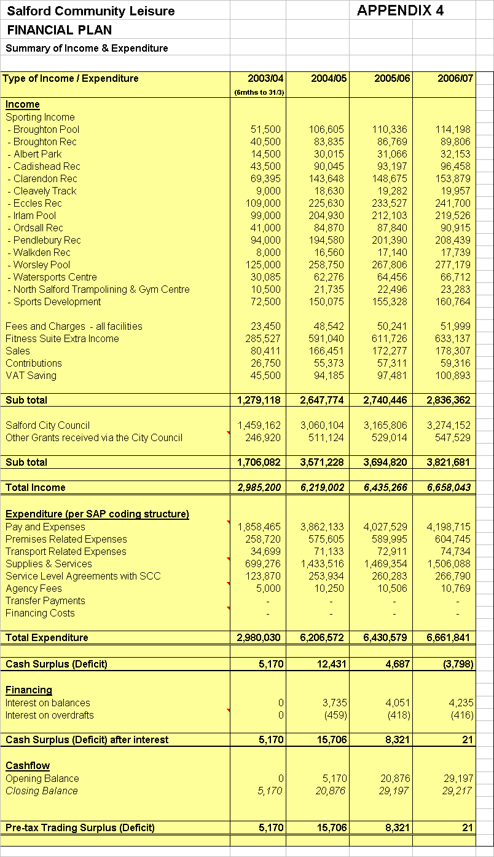
APPENDIX 5

“Feeding the Baby – initial capital investment requirements”

Salford Community Leisure Limited requires capital investment to provide greater opportunity for successful establishment and to nurture it through the early years. The investment projects have been split into 3 key areas with a priority list in each of the areas:

- Income Streams Priority Matrix
- Service Improvement
- Efficiency High = H
Medium = M

1. Income Streams Low = L

Priority | Site | Project | Cost
H | Fit City Eccles | Relocation of vending area and installation of activity/crèche area | £20,000
H | Fit City Ordsall | Fitness suite improvements | £50,000
M | Fit City Broughton Pool | Expansion of conference facilities & introduction of activity area | £40,000
M | Fit City Broughton | Conversion of disused bar area into multi-function area | £15,000
M | Fit City Broughton | Soft play provision (1 x squash court conversion) | £30,000
M | Fit City Clarendon | Introduce spin studio (1 x squash court conversion) | £35,000
M | Fit City Worsley | Multi Activity Area – Convert section of female changing rooms | £20,000
L | Fit City Irlam | Swimming pool boom | £80,000

2. Service Improvement

Priority | Site | Project | Cost
H | Fit City Worsley | Repair to small pool | £200,000
H | Fit City Worsley | Extend car parking facilities | £70,000
H | Fit City facilities | General repairs to cubicles & toilets | £30,000
H | Fit City facilities | General external improvements e.g. car park relining, cleaning down facades, lighting, signage | £20,000
H | Fit City facilities | Establishing the network for the computerised management information system | £30,000
H | Fit City Worsley, Eccles, Broughton & Clarendon | Expand the installation of swimming pool disabled hoists to all pools | £24,000
M | Fit City Albert Park | Synthetic pitch surface replacement | £200,000
M | Fit City Broughton Centre | Resurface car park | £10,000
M | Fit City Cadishead | Replace sports hall roof | £50,000
M | Fit City Cadishead | Air conditioning in fitness suite | £8,000
M | Fit City Cadishead | Extension to car park | £15,000
M | Fit City Irlam | Convert male changing to unisex village style changing accommodation & convert the female changing to multi activity area | £80,000
M | Fit City Pendlebury | Resurface car park and approaches and install additional disabled parking | £20,000
M | All | General DDA issues to improve disability access including pool hoists, signage, leaflets, changing accommodation | £100,000
M | All | Out of hours key holding service | £6,000
M | All | 2 way radios | £5,000
M | All | Improved CCTV systems | £150,000
M | Fit City facilities | Internal decoration of front of house | £50,000
M | North Salford Gymnastics & Trampolining Centre | Changing room improvements | £50,000
L | Fit City Irlam | Relocate disabled changing onto poolside & convert current changing to office accommodation | £20,000
L | Fit City Pendlebury | Additional storage capacity | £20,000
L | Fit City Pendlebury | Institute repairs to sports hall floor | £20,000
L | Fit City Worsley | Roofing repairs, electrical upgrades & external improvements | £300,000
L | Albert Park, Fit City Clarendon & Ordsall | Synthetic pitch floodlight repairs | £30,000
L | North Salford Gymnastics & Trampolining Centre | Refurbishment of gymnastics floor area and pit | £50,000
L | Watersports Centre | Bike rack & improved fencing | £5,000
L | Fit City Pendlebury, Broughton & Ordsall | Spinning bikes | £22,500
L | All | Improve vending areas | £30,000

3. Efficiency

Priority | Site | Project | Cost
H | Fit City Worsley | Heating plant | £400,000
H | Fit City Irlam, Broughton & Clarendon | Shot blast & reline filters | £27,000
M | Fit City Worsley Pool Broughton & Clarendon | Reline bund walls | £3,000
L | Fit City Broughton Pool | Pool hall ventilation dessicated wheel heat recovery | £55,000
L | Fit City Irlam | Pool hall heat recovery | £9,000
L | Fit City Irlam | Pool hall lighting | £855

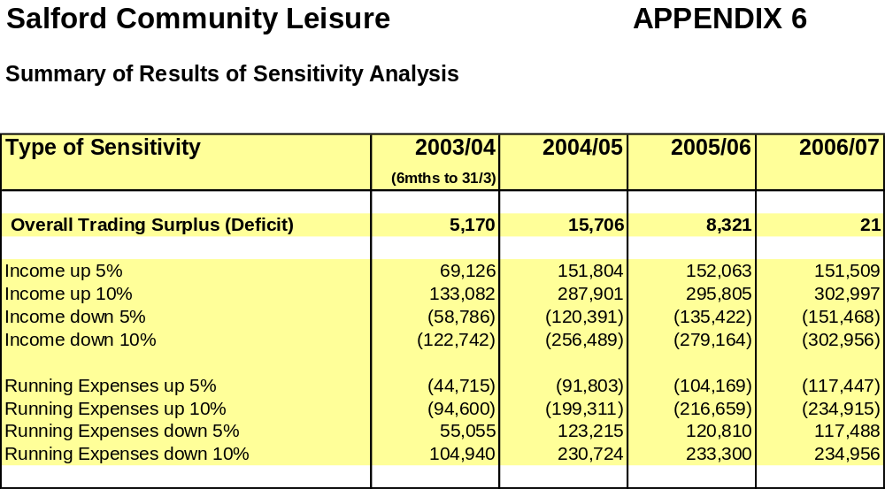
Appendix 7

Rationalisation Criteria and Weightings
Criterion | Rank | Weighting
Passports sold | 1= | 5
"All inclusive" customers | 1= | 5
"TD" & "Young Star" customers | 3 | 4
Number of "over 60's" passes sold | 4 | 4
Social Inclusion Pass usage | 5 | 4
Schools use (number of wet & dry bookings) | 6 | 4
Distance to nearest alternative | 7 | 3
Ward deprivation index | 8 | 3
Net present cost (maintenance) | 9 | 3
Subsidy | 10= | 2
Ward health deprivation index | 10= | 2
Catchment population | 12 | 2
Cost per head of population | 13= | 2
Disposal value potential | 13= | 2
Development potential | 15 | 2
Travel time to nearest alternative | 16 | 2
Cost per user | 17 | 2
Catchment population overlap | 18 | 1

Year 9 Survey
Sport England

