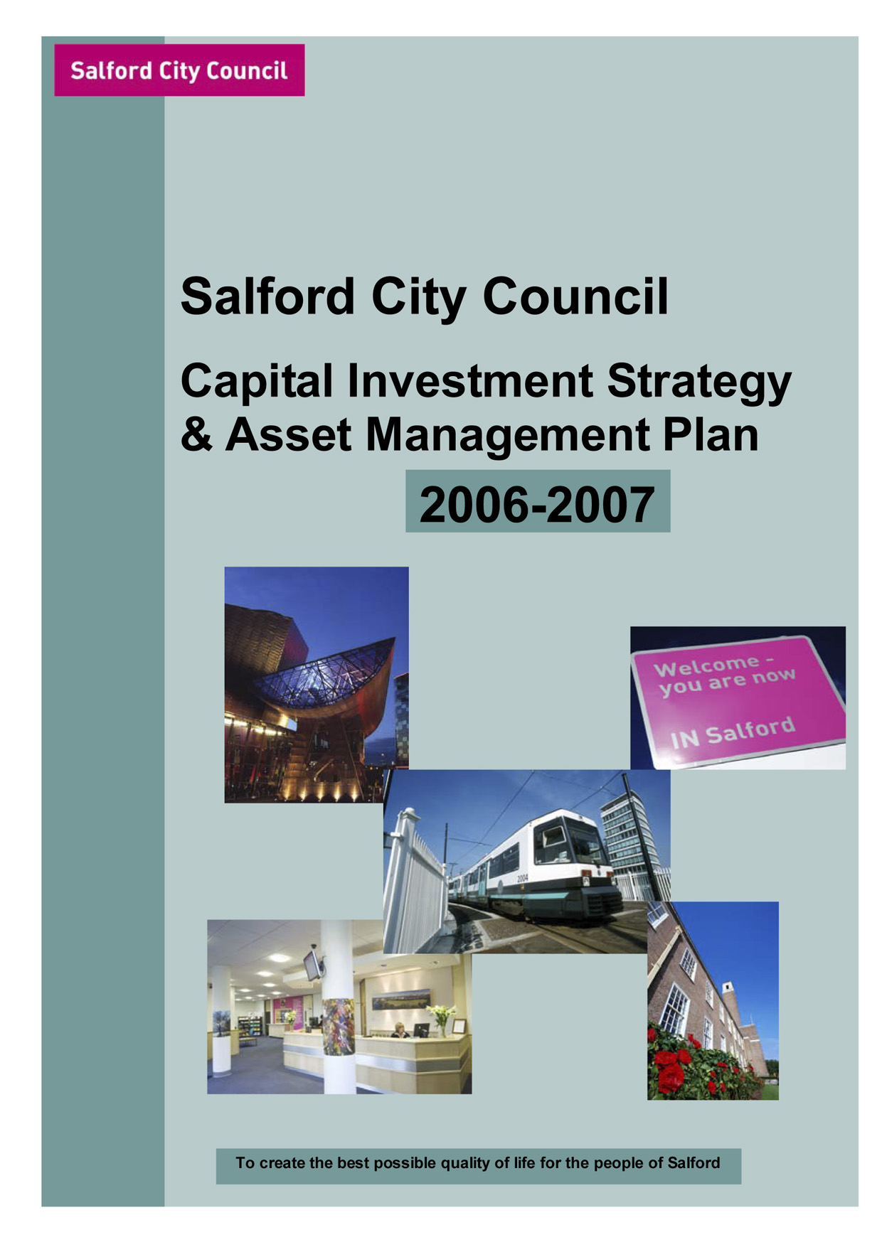

INDEX

Page

- Background to Salford 2

Capital Investment Strategy

- Introduction 1

- Key areas of capital expenditure 2

- Five year Capital Programme & Resource Summary 2

- Other financial implications 7

- Unsupported Borrowing 7
- Cross cutting activity 8

- Consultation 8

- Links with other partners plans and programmes 8

- Performance measurement and innovation 9

- Management and evaluation 10
Asset Management Plan

- Summary 12

- Introduction 16

- Supporting corporate and service plan objectives 17

- Organisational arrangements for Corporate Asset Management 22

- Inclusion and Engagement 24

- Existing portfolio and its current performance 27

- Portfolio performance, management and monitoring 30

- Likely future property requirements 34

- Key Issues 40

Appendices

Appendix 1 Reporting structure for Resource Planning Group & SPMU
Appendix 2 Aims and Objectives
Appendix 3 Key Issues
Appendix 4 National Performance Indicators
Appendix 5 Use of National Performance Indicators
Appendix 6 Running Costs of Portfolio
Appendix 7 Best Value Review / CPA Improvement Activity
Appendix 8 Property Appraisal Model
Appendix 9 Achievements

BACKGROUND TO SALFORD

Salford is truly a city of contrasts. Situated in the heart of the Greater Manchester conurbation, it is of the fastest growing regions outside London. The City is at the hub of the transport network, with M602, M60, M61 and M62 motorways all within the City boundaries, and there are also excellent rail and air links, and the Metrolink now extends to Eccles and Salford Quays from Manchester City Centre.

A dynamic and forward looking City, Salford has undergone radical transformation since becoming one of the world’s first industrial cities, redeveloping areas such as the Salford Quays and building the Lowry Centre, a multi-million pound arts and theatre complex.

Salford a Metropolitan Borough Council with a population of 216,103 according to the 2001 Census. The City is experiencing population loss which has significant resource implications for mainstream service delivery. Since 1991, 14,900 people have left the City with migration levels highest in the inner city.

Over the last thirty years Salford has seen great change; losing almost a third of its traditional employment base has created areas blighted by physical dereliction and social deprivation. However, over the last ten years the City has been successful in tackling many of the social and physical dereliction problems. The redevelopment of Salford Quays has created a world-class business and cultural area of great national and regional significance. Its success has led to the fastest drop in unemployment within the Greater Manchester region.

Within this trailblazing, vibrant City there still exists severe pockets of deprivation; Salford is placed the 4th most deprived local authority area in the North West and 12th nationally.

22.7% of all households with children are lone parent households. The City’s dependent and elderly populations are growing; lone parent households account for 12% of all Salford households of the population and there has been substantial growth in the numbers of looked after children in recent years. The number peaked in 2001 when the number was nearly double that of 1993. The actual number of children looked after in 2005 (although a slight increase over 2004) shows a decrease of 4% from the peak of 2001. Latest national statistics (to 2004) show that a decreasing trend is against the national trend of increase but that Salford still had the sixth highest number of children looked after per 1,000 population in England.

Due to a number of factors, the changing dynamics of the housing market, i.e. a housing market that is currently buoyant, the increasing tenure shift towards greater levels of owner-occupation together with the removal of unpopular stock has contributed to the decrease in the number of Local Authority (Housing) owned void properties in the city. The Councils success in reducing the number of local authority voids in lettable condition has continued during 2004 / 2005. The number of council house empty but in a lettable condition had been improved from 853 in April 2003 to 449 in March 2004 and has now been further reduced to 348 or 1.26% of total stock in April 2005.

Within individual wards there are pockets of multiple deprivation, and a number of areas within the City are currently benefiting from regeneration initiatives, supported by Single Regeneration Budget, European Programmes and New Deal for Communities. The City, in partnership with Manchester, is a Housing Market Renewal Pathfinder area that will bring significant resources into Central Salford to revitalise housing markets. The Regional Development Agency and English Partnerships are also involved in developing schemes that will bring economic and social progress to Central Salford.

CAPITAL INVESTMENT STRATEGY

SECTION 1 - INTRODUCTION

This Capital Investment Strategy sets out what the Salford City Council wants to achieve in terms of our capital investment over the next five years, covering all key aspects of capital expenditure within the authority and giving examples of partnering and partnership based capital scheme development and delivery. It is our response to the Government’s drive for improved financial planning and accountability and securing value for money from capital investment. It builds upon our last submission and takes account of comments made by GONW.

The City Council and Partners IN Salford (the City’s Local Strategic Partnership) believe that the people of Salford deserve the very best in terms of service delivery and quality. Salford’s newly updated Community Plan (2006 – 2016) developed jointly by the LSP and the City Council sets the overall vision for our City. It sets the context for this capital strategy with future investment priorities driven by the seven themes of the Community Plan and developed both internally and with our partners and communities.

The Plan aims to create a clean, safe and healthy city with strong sustainable communities and a buoyant economy, where children and young people can thrive and benefit from excellent educational and cultural opportunities and facilities. It will enable the Council and its partners to make the best possible use of public sector assets in order to tackle the crosscutting priorities facing our City in a strategic, partnership based and comprehensive manner.

The Neighbourhood Renewal Strategy, the City’s framework for Neighbourhood Renewal, puts regeneration and mainstream service improvement at the heart of the City’s priorities and gives a clear spatial dimension to our interventions. It aims to:

- Develop an integrated strategy to regenerate Central Salford including the areas of major change in Broughton, Seedley and Langworthy and Charlestown/Kersal
- Target action to stabilise communities in Salford West and maximise opportunities
- Work with our communities to achieve change.

Key targets are included within the Community Plan and the Neighbourhood Renewal Strategy to measure the success of our policies over the next five years. These targets reflect the updated National Floor Targets, include key Best Value Performance Indicators and incorporate local performance indicators designed to challenge, target and improve service delivery in particular areas. The targets set have formed the basis of the Partnership’s 2nd Round Local Public Service Agreement with Government, which will run from 2005-2009 and will be the pre cursor of a Local Area Agreement.

Integrated within the Community Plan are the City Council’s 7 Pledges that are Council priorities for both statutory and local service delivery. The impact of the pledges has involved the re-alignment of Best Value Performance indicators and service plans to reflect an agreed corporate approach, setting out a commitment towards: Improving Health in Salford, Reducing Crime in Salford, Encouraging Learning, Leisure and Creativity in Salford, Investing in Young People in Salford, Promoting inclusion in Salford, Creating Prosperity in Salford and Enhancing Life in Salford.

The Community Plan, Neighbourhood Renewal Strategy and Capital Investment Strategy together enables the City Council to continue the regeneration of the City and move towards high quality modern services designed to meet local need.

SECTION 2 - KEY AREAS OF CAPITAL EXPENDITURE

Increasingly, we continue to add value to the City Council’s own capital programme and capital receipt income by capital resources derived from funding from the NWDA and English Partnerships, from special funding such as the Housing Market Renewal Pathfinder and from PFI. In addition, several major developers, house builders and financial institutions are investing within the City and working in partnership with the Council and the Pathfinder. This creates a new and key challenge for the Council to integrate our resources and programmes more effectively and to gear the use of our own resources clearly to meet the objectives of stimulating other investment to promote the regeneration of the City and better services. We outline below the key areas of existing and prospective capital expenditure in Regeneration, Housing, Education, Transport and Social Services, which are also summarised in the table below.

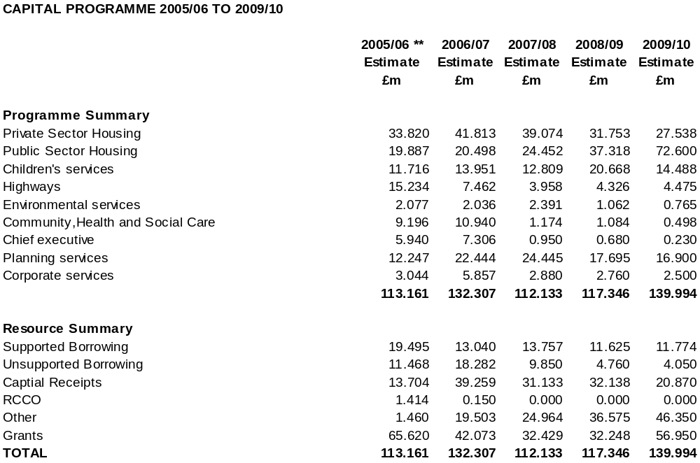

Regeneration

Approval was given in February 2005 to set up an Urban Regeneration Company (URC) within Central Salford with founding partners the City Council, the North West Development Agency and English Partnerships. The URC will co-ordinate and add value to strategic interventions and promote Central Salford to the private sector. The emerging Vision and Regeneration Framework for Central Salford will guide future investment. Further HMR funding for 2006/07 onwards is being sought and a Scheme Update bid for resources was submitted in October 2005.

There are existing commitments to capital spend within the City’s main regeneration programmes as follows:
- Housing Market Renewal Programme focused on Central Salford
- Objective 2 Priority 2 European Regional Development Fund Action Plan
- Objective 2 Priority 3 Economic Development Zone in partnership with Manchester City Council along the Irwell Corridor
- SRB5 in Seedley and Langworthy
- The New Deal for Communities programme in Charlestown/Kersal
- Chapel Street Initiative
- National Lottery New Opportunities Fair Shares Transforming your space programme

In addition a number of major masterplanning exercises are underway, including with development partners, which it is anticipated will bring in substantial private sector funding.

Housing

In November 2003 Housing launched the “Fresh Start for Housing”. This sets out a new vision for housing in Salford and was a statement of intent. That vision for Housing was and still is to “Help create a future where people see Salford as a great place to live. A place where you can find a choice of popular homes in desirable locations, served by excellent housing services”.

At that time the emerging “Sustainable Communities Plan” had a marked affect on the future investment strategy for Housing in two key areas:

- We were required to have a “signed off, fit for purpose”, as determined by ODPM/CHTF, Housing stock option appraisal by July 2005.
- The designation of Manchester/Salford as a Housing Market Renewal Pathfinder has resulted in the opportunity for increased resources available to renew housing markets and proactively manage neighbourhoods and make a step-change in the housing market in the 7 Inner City wards.

In terms of the Stock Option Appraisal, sign off was achieved within the timescale. The customer consultation and involvement that took place was the most comprehensive that Housing Services had ever done in Salford. In brief, the completed appraisal found that the level of capital investment required to meet the decent homes target, together with the negative value of the Council’s stock meant that no one single option would provide the total resources needed to achieve decency, with a sustainable HRA in the mid to long term.

Continuing with a single ALMO vehicle was not a viable option – it was unable to provide all of the investment needed. The appraisal found that it was necessary to maximise the investment potential provided by all 3 options, ALMO, PFI and transfer to Local Housing Companies. A mixed procurement strategy for the final rounds of Decent Homes funding programmes is being finalised, it is likely that the bid for resources will be in the region of £400m. Working with tenants, members and stakeholders we anticipate that bids will be submitted to ODPM early 2006 and a programme announcement is expected in the spring of 2006.

Our “Fit for purpose” Housing Strategy and Housing Revenue Account (HRA) Business Plan, together with our investment strategy for Council owned homes sets out clear priorities for the City over the years ahead.

We will drive forward our strategies and plans, plus we will help to ensure that every person in the City lives in a decent home and will achieve this by:

- Investment in the management and maintenance of Council, new organisations and existing registered social landlord owned dwellings
- Working with home owners and private landlords to help them manage and maintain their properties effectively
- Continue to work to the Government’s target of removing all non-decent public sector housing by 2010
- Continue to work with private sector partners to reduce unfitness and hazards

The strategic housing priorities over the next five years will be:

- Enable independent living in all our communities
- Provide greater choice of homes and housing services
- Bring all homes to a decent standard
- Ensure equal access to homes and housing services
- Make sure we have the means to deliver our strategies

Children’s Services

The new Children’s Services Directorate came about as a result of the Children Act 2004. The focus of the Directorate now encompasses the five outcomes from “Every Child Matters”. These five outcomes are as follows:

- Be Healthy
- Stay Safe
- Enjoy and Achieve
- Make a Positive Contribution
- Achieve Economic Well-being

Education

The Education Asset Management Plan (AMP) sets out the need to provide high quality Education in accommodation that stimulates a learning environment for school pupils and members of the community.

The current thrust of Education’s capital programme for primary schools is to remove surplus places and reduce the back-log of condition works, based on significant OfSTED drivers. This has led to a mass of minor projects being undertaken at any one time. However, as part of a current review of the strategic approach to these matters consideration is being given to the exploration of strategies, which will mean the Council undertaking projects of greater scope to bring about better outcomes.

In the March 2005 budget the Government announced additional funding of £500m per year, as from 2008, for the upgrading of over half of all primary schools. As yet the Council has not been advised how this funding will be allocated, but we expect to be consulted later this year. We therefore anticipate that this, plus the DfES annual formula capital allocations that are ring fenced to primary schools and potential capital receipts, will be utilised to accelerate a programme of works that could include building new primary schools.

The first phase of the review of primary school places has been completed and the refurbishment projects identified in this review will be completed by December 2005. Included in the proposals was a new school for Ordsall for which funds have been secured from the DfES and this is expected to open in September 2007. Ongoing consultations about future proposals are being conducted with area review groups that are linked to the regeneration agenda.

In the secondary sector PFI credits were secured for 2 schools, Buile Hill and Harrop Fold, whilst all 3 Special High Schools have been replaced via PFI, one opened in April 2004, with the other 2 schools opening in September of the same year.

In September 2005 Canon Williamson became Salford’s first academy, which is a new type of independently managed school established by sponsors from business, faith or voluntary groups working in highly innovative partnerships with central and local government. The Council is exploring with the DfES and potential sponsors, the possibility of establishing another academy in Central Salford to replace an existing high school.

The DfES has ambitious plans to replace or refurbish, subject to funds being available, all secondary schools within a 10 to 15 year time frame. Salford is in the third wave of this major capital investment, “Building Schools for the Future” (BSF). Partnerships for Schools (PfS) is being set up by the Department for Education and Skills (DfES) and Partnerships UK (PUK), to implement and deliver the BSF programme. To achieve the aims of this new programme a more strategic approach to implementation of local investment will be needed and a visioning exercise is currently being undertaken.

Children’s Services continues to develop the quality of provision in schools for ICT by adding value to the Broadband infrastructure in schools through considerable targeted funding. As part of “Building Schools for the Future” programme we have been advised that our initial benchmark funding allocation will include £11m to provide high quality ICT provision at all our high schools.
Priorities over the next five years will be:
- To reduce the back-log maintenance works at primary schools to at or below £1,000 per pupil
- To reduce the surplus places within the primary sector by undertaking major refurbishment and / or new building projects
- To manage the secondary school estate via the “Building Schools for the Future” programme
- To open the new PFI schools for Buile Hill and Harrop Fold

Social Care

Energy audit surveys have been undertaken at Children’s Homes that have identified certain requirements and it could be that there are other areas of significant investment once other surveys are carried out. There will be a requirement to support the overall themes of:
- Modernisation of assets to provide fit for purpose buildings meeting children’s needs and the Disability and Discrimination Act
- Modern accommodation for the effective and efficient delivery of services to children
- Secure long term accommodation for sensitive children’s files that have to be retained for 70 years

Specific capital schemes will include:
- Investment in children’s disability service to provide better foster care accommodation and respite care
- Investment in locality teams to provide services for children to create integrated single access teams across the health and social care sector

Transport

The Unitary Development Plan and Greater Manchester Local Transport Plan set out the transport priorities for the City and wider conurbation. The policies contained in these documents focus on safety, sustainability and regeneration whilst conforming to Planning Policy and Regional Planning guidance.

More recently the GMLTP has collaborated with the Department for Transport and set stretch targets for Road Safety, Air Quality, Accessibility and Congestion. Success in these areas should ensure greater capital allocations in the coming years. The current GMLTP will expire at the end of March 2006, to be replaced by a revised GMLTP2, which is currently under production.

The UDP and LTP objectives are summarised below:

- A focus on regeneration and sustainability
- An holistic approach to urban renewal
- Competing in the global economy
- Creating a dynamic and accessible Regional Centre
- Promotion of sustainable neighbourhoods
- Enhancing urban centres
- Improving the urban fringe and countryside
- Providing high quality sustainable transport
- Reducing population loss from inner areas
- Sustainable growth of Manchester Airport

Arising from these objectives are major transport schemes such as the now completed Manchester/Salford Inner Relief Route at an estimated cost of £27 million, Cadishead Way Stage 2 recently completed at an estimated cost of £18.5m with land purchases still outstanding and the Leigh/Salford/Manchester Quality Bus Corridor for which funding was recently deferred pending a regional prioritisation process.

Many minor transport schemes aimed at supporting our public service agreement by improving road safety, promoting integration and maintaining the fabric of the networks are also ongoing, running at approximately £4 million per annum.

Community, Health and Social Care

The Directorate’s capital strategy is to support
- Improving the life chances and promoting the independence of people in Salford, through a whole system approach towards Health and Social Care.
- To ensure that, through wide and inclusive access to learning and creativity, the City meets its targets on health, crime, learning, young people, community cohesion and inclusion.

The Authority continues to build on its partnerships with users and carers, Salford Primary Care Trust, NHS Trusts, the voluntary sector, independent providers and others to shape services across all areas of the Directorate. These links are seen as vital in providing stronger, more stable communities in which to support a range of preventive services, helping people to live inclusively.

Salford‘s Health Improvement for Tomorrow (SHIFT) and Local Investment Finance Trust (LIFT) programmes are catalysts for change in primary health, social care and community services in the City. It is hoped the new build programme for the 4 major centres will commence in 2006, and early planning for future development has commenced.

Capital resources will be used to support the overall themes of:

- Greater joint working with Health and other partner agencies.
- Modernisation of assets to provide “fit for purpose” buildings meeting people’s needs and Disability Discrimination legislation.
- Modern, high quality accommodation capable of delivering effective and efficient services and providing working environments to assist staff in these objectives.
- ICT infrastructure to develop access to and increase innovation and creativity in, alternative media for communication and information handling and as a means of meeting e-Government objectives.
- Providing modern multi-use community facilities that will enable social, educational and leisure activities, which will promote active and vibrant communities.
- The maintenance and development of Grade 1 and 2 listed buildings.
- Development of outreach and access for all Salford’s citizens.

Specific capital schemes will include:

- Investment in services to modernise the physical environment of day care opportunities to promote independence by supporting people to live at home.
- Investment in the essential maintenance of the Directorate’s service delivery properties to ensure their continuing fit for purpose.
- Investment in the ICT infrastructure to extend delivery of service through email, internet and intranet, plus further development of the CareFirst client information system and improvement in the communications network
- Development of document management and e-Procurement to support ESCR and e-Government.
- Development and improvement of community facilities to support and promote strong communities, including community sport and leisure facilities, community libraries, community performing artspaces, community heritage facilities in partnership with a wide range of organisations and agencies including: Salford Community Leisure, SHIFT and LIFT, Building Schools for the Future, Regeneration Agencies and other external funding bodies.
- Supporting grant applications for Ordsall Hall’s development.

Environment Directorate

The Directorate’s capital strategy is targeted at supporting the regeneration of the City, promoting health and well being, addressing national targets with regards to waste management including recycling and providing investment in the sustainability of key heritage and community assets and services.

Specific capital schemes include:

- Improvements to infrastructure within Parks and Cemeteries
- Development of recycling facilities and increased participation
- Investment to address the remediation of contaminated land and to progress Air Quality monitoring
- Investment in physical assets to facilitate the promotion of health and well being

SECTION 3 – OTHER FINANCIAL IMPLICATIONS

Revenue Implications

The Council has habitually considered the revenue implications of capital projects before approving them for inclusion in the capital programme. The revenue budget planning incorporates any project with revenue implications. Provision is made annually in the revenue budget for the additional maintenance costs of capital projects emerging from their contract maintenance period. The prudential code for capital finance has now codified this practice as a requirement in determining the affordability of capital plans and borrowing limits. There will be a need to scrutinise the implications of the various submissions in the strategy to determine any revenue implications.

The Council’s first PFI scheme for 3 new secondary special high schools was completed in 2004/05 and the unitary charge from the provider and the associated Revenue Support Grant have been accounted for in the revenue budget.

The budgetary plans for 2005/06 to 2007/08 also envisage a major use of unsupported borrowing on an invest to save basis for investment in the improvement of roads and footpaths, which should reduce the revenue provision for tripping claims in particular.

Approach to PPP/PFI

The Council is committed to PPP/PFI as a means of achieving desired outcomes where this is the most viable option, as can be evidenced by the following activity: -

- 3 PFI Special schools are now operational.
- The DfES has approved a £50m PFI scheme for 2 new high schools.
- Indicative pre-OBC approval from the LCD to a £22m PFI scheme for new magistrates courts in Bolton and Salford.
- Provision of new joint health/local authority facilities as part of the LIFT development with Salford NHS PCT, GMAS, other local authorities and private sector partner Excelcare Ltd. Six facilities to be located in Salford in the first wave; the first two opened in November 2005, financial close for the remainder expected by March 2006.
- A Limited Partnership has been entered into with a funder and developer for regeneration work in Higher Broughton and works are now on site with first properties due for completion April 2006.
- Outline heads of term have been agreed for a partnership for area wide regeneration of Ordsall.
- A public/private development agreement has been completed with a national developer for regeneration of a large part of Lower Broughton.
- Continue with Housing’s HRA PFI bid for Pendleton to the ODPM. This is likely to be submitted January 2006, and if approved will be the biggest Housing PFI project within the country to date.
- Contractual close on the transfer of homes for older people to a private care provider has been achieved.
- The establishment of a not-for-profit trust for the management of the City’s leisure centres.
- Support to the Greater Manchester Waste Disposal Authority in procuring a new long term waste disposal contract via PFI by April 2006.
- The establishment of a joint venture company, Urban Vision with Capita Symonds and Morrison plc for the provision of the Council’s technical and associated support services (architectural, engineering and property).

Unsupported Borrowing

The Council in 2005/06 has started to use its’ unsupported borrowing powers to fund schemes such as a major investment in the Highways to reduce the amount of tripping claims that will reduce the insurance costs that the Council is currently incurring. This scheme is programmed through a Business Case to be run over five years with the payback coming in the years after this.

Another project that the Council is using these powers on is the redevelopment of Lower Broughton through the Partnership working with Countryside Properties whereby the Council is acquiring land and properties using unsupported borrowing with the payback coming through future receipts from house sales via the Partnership.

The general ethos that the Council is adopting for the use of unsupported borrowing is that there should be a demonstration of payback within a ten year period, although obviously there can be slight variations to this rule. Within the strategy outlined above there are a number of schemes proposed to be funded via unsupported borrowing including the two examples given in this section.

SECTION 4 – CROSS CUTTING ACTIVITY

Disposal Strategy

The disposal strategy of the Council has been heavily influenced by the funding needs of annual capital programmes, the extent of buoyancy in the property market locally, the need to stimulate private sector investment in certain parts of the City and the supply of assets for disposal. The Council seeks to balance these sometimes conflicting requirements so as to manage the tensions between the need to generate capital receipts and maximise the amount from each disposal by bringing assets to market at the most suitable time.

The City Council will increasingly use its assets to stimulate private sector interest and investment in partnership schemes rather than to secure capital receipts via disposal. The advent of the Central Salford URC will be a further factor in the disposal of property assets. Protocols are being established with the URC with regard to property and planning to guide consultation processes and to aid joint working.

Best Value

Capital investment is an integral consideration in best value reviews. Through the Authority’s performance management system a systematic approach ensures that we monitor our performance against our own short and medium term targets and compare our performance with the best. Detailed consideration is given to the actions necessary to improve our performance. Best value reviews concentrate on the experience and needs of the customer and inform investment decisions. Performance monitoring systems incorporate service results as comparative data and provide benchmarking information, to ascertain where service improvements are needed and, where appropriate, used to inform cross cutting action.

Best Value results are communicated extensively to stakeholders through the Best Value Performance Plan summary document, which is distributed to all households, containing performance feedback from previous year’s targets and targets for future years.
All services have been required to undertake Value for Money self-assessments and the outcomes of these will facilitate a future programme of service and Best Value reviews.

SECTION 5 - CONSULTATION

Partners IN Salford has been consulted on the development of the Capital Strategy with key partners such as the Salford Primary Care Trust, Police, Job Centre Plus, Manchester Enterprises and the faith community and voluntary sectors endorsing the strategy and ensuring links with the Community Plan. The City’s Community Strategy and Community Committee structures have also been utilised as a consultation mechanism on the Community Plan and Neighbourhood Renewal Strategies from which this strategy flows.

The new Community Plan has been underpinned by wide ranging stakeholder and community consultation.

Local transport programmes, structural and management decisions in the education sector, housing developments and service provision with Social Services are all subject to separate consultation and approval mechanisms within local communities, underpinned by the authority’s approach to customer care, quality services and consultation. Consultation will be taken in accordance with the Council’s constitution and will be linked with the revenue budget process.

Regeneration programmes such as the SRB 5 area in Seedley and Langworthy and the NDC area in Charlestown/Lower Kersal have strong and robust mechanisms for active community involvement in decision-making and developing programmes. The Participatory Appraisal approach is now widely used across the City to actively involve local people in the decisions affecting their neighbourhoods and is widely regarded by Government Office as a significant tool for achieving this.

SECTION 6 - LINKS WITH OTHER PARTNERS, PLANS AND PROGRAMMES

The NWDA’s re-launched Regional Economic Strategy and the City Region Development Programme (CRDP) provide a key context in the City’s activities and programmes at regional and sub-regional level. Through Partners IN Salford the Community Plan formalises partnership arrangements across the City ensuring consistency across the range of other plans that the Council can influence, including the Health Improvement Programme, LA 21 strategy, Education Development Plan, Lifelong Learning Framework, Economic Development Strategy, Children & Young People’s Strategy and Crime and Disorder Strategy.

Salford has an extremely successful history of working with neighbouring authorities. Well-developed links exist on the transportation and environmental quality themes with the Greater Manchester Transport Plan and Air Quality Strategies. Work with Manchester City Council has developed significantly. The HMRF Pathfinder, the Objective 2 Economic Development Zone, Knowledge Capital/Science City and work to develop the River Irwell Corridor and key locations within it and other regional centre locations are key areas of joint work.

Partnerships with the private sector also play a crucial role in our approach to capital investment. In Education the Directorate is currently working with the DfES, Partnerships for Schools and potential private sector partners to take forward the delivery of the “Building Schools for the Future” capital investment strategy. This could include the setting up of a LEP.

Our partnership with the Central Salford URC will oversee the regeneration of Central Salford. Innovative solutions have been developed with financial institutions to ensure communities are kept together. Over 100 Homeswaps have been completed in Seedley and Langworthy and a customised model is being developed in Broughton. New and exciting proposals for terraced properties in Seedley and Langworthy are under development between the Council, English Partnerships, and Urban Splash and may promote an alternative to clearance in appropriate circumstances. Housing renewal areas are being drawn up in conjunction with private sectors partners such as InPartnership in Higher Broughton, Legendary Properties in Ordsall, Opus Developments in the New Deal area and Countryside Properties in Lower Broughton, to tackle neighbourhood renewal in a more comprehensive and innovative way.

Partnership working has been developed so that we enjoy an even stronger engagement than previously, both strategically and locally, and on the joint delivery of services. Developments include: -
- New financial products, based on equity loan models, are under development jointly with Manchester City Council via the Manchester Salford Pathfinder;
- Regular meetings between the SCC Chief Executive, the Leader and the chair of the Central Salford URC;
- Closer working with partners through the introduction of forums where the Chief Executive meets with partner CEs (e.g. vice chancellor of the university, CE of PCT, chief of police, government office, chair of LSP) on a regular basis, to discuss common issues;
- Development of a multi-agency partnership approach at the local level, including the council, PCT and police, through our neighbourhood management proposals;
- Reducing crime in our communities, in which our community sector teams and CDRP have been key factors;
- Joint commissioning in the areas of health and social care with the PCT. We now have a number of joint appointments, notably a joint director of public health who is now a member of our Directors Management Team. This partnership working is serving to develop and increase capacity both for the council and for our partners.

SECTION 7 - PERFORMANCE MEASUREMENT AND INNOVATION

The City’s Best Value Performance Plan sets out key performance indicators across service areas with results scrutinised closely by the 5 Scrutiny Committees and annually by the Audit Commission. Achievements and results are communicated across key partners as part of a corporate information strategy but also through individual service and regeneration programmes. The authority is currently looking to develop benchmarking activity in conjunction with neighbouring authorities to analyse more fully the impact of the capital programmes on the desired outcomes for the City. Our Strategic and Best Value Performance Plan for 2005/06 sets out a series of aspirational targets for our services over the next three years. Central to this is the Think Customer pilot that is providing a coherent, multi agency approach to customer focused service delivery.

The City's Best Value Review of its office support accommodation has established a series of PI's including running costs and occupancy levels. Performance targets have been set and are benchmarked through the Sheffield Hallam University Benchmarking Group. This is resulting in improved space utilisation.

The City Council had Beacon Status during 2004/05 for Benefits Administration and Supporting People.

Since the 2002 Corporate Assessment the Council’s CPA rating has been weak. During that time the Council has implemented a wide ranging Improvement Programme which tackles both service specific and corporate issues. The next annual CPA assessment will be made in December 2005 followed by a second corporate assessment in January 2006. The City Council is hopeful that the improvements made over the last three years will be reflected in an improved rating.

As part of our commitment to improve, the Council has signed a 2nd Local Public Service Agreement (LPSA), to meet 12/13 challenging targets across various services and to be delivered by March 2009. The LSP has played a key role in negotiating the LPSA2.

The Council has taken note of the partnering approach to procuring development recommended by Sir John Egan and utilises that approach in a number of ways. We take a long term view of partnering arrangements and current examples include:

Housing and Planning have initiated a Joint Venture – Urban Vision – for a range of services which will increase capacity to meet our ambitions and facilitate massive investment in the City’s highway infrastructure.

Under the Rethinking Construction Implementation Strategy expressions of interest are being sought to work with the Council to provide the planning, design, construction and maintenance services of the Development Services Directorate over the next 5-7 years. In the interim the Council has been Rethinking Construction in a number of ways including applying innovative approaches to procurement on the Eccles Town Centre bypass and Stage 3 of the Salford Inner Relief route which will be developed further for the procurement of Cadishead Way Stage 2, the application of the principles of Rethinking Construction to a £3m Housing Environmental Improvement scheme at Spike Island and a partnership between the City Council’s Landscape Design Group and a Landscape Contractor to bid for, design and construct 3 gardens at the Royal Horticultural Society’s Tatton Park Show.

Information and Communications Technology Impact

Salford City Council has long since recognised that ICT is a powerful enabler in delivering effective and efficient public services and in helping bring about its transformation agenda.

Through its modern business application portfolio and technology infrastructure and comprehensive transformational, operational and support services, ICT is critical to high quality, joined up and sustainable services to citizens, communities and businesses.

The Council’s e-Government programme too, has helped to create a new wave of creativity, innovation and choice in local service provision with solutions aimed at improving front-line and back office processed, democratic engagement and scrutiny functions and new services to the business community.

As one of the original e-Government Pathfinders and a partner in the national CRM Programme, we have played our part on the national stage to help in capacity building within the local government family, centring on transformation and change management tools, which have played a key role not just in assisting other Councils throughout the UK but been central to Salford’s own modernisation plans.

Some of the more notable ICT developments include: -

- Contributing to the development of an award winning customer contact centre, and transactional status web site Customer Call Centre
- Achieved 100% e-enablement of transactions 9 months ahead of Government deadline
- Excellent progress on achievement of e-Government Priority Service Outcomes
- Developed several highly successful in-house applications, which are core to the Council’s service programmes including CRM (Citizen) and e-democracy (SOLAR) for access to Council decisions, reports and minutes
- Supporting the role of Members in the community through solutions for e-surgeries and dedicated web sites for all Councillors
- Providing a substantial ICT skills development programme for officers and Members of around 6000 delegates per annum, based around ECDL where we have ECDL test centre status and are a Learn Direct Hub
- Continuing investment in our core ICT infrastructure including Broadband rollout, e-mail. Internet and Intranet and a move to thin client technologies for lower costs and greater reliability
- Ongoing improvements to back office systems embracing SAP, document management, content management and GIS
- Provision of a new data centre for greater service resilience, reliability and security
- Continuing community ICT capacity building through the provision of ICT in localities e.g. Libraries, Community Centres, City Learning Centres and mobile facilities and skills training and support, including ECDL testing

SECTION 8 - MANAGEMENT AND EVALUATION

The Cabinet considers the Capital Investment Strategy and Asset Management Plan and recommends their adoption to the Council. The annual capital programme is considered within the context of the Strategy and also approved by Cabinet and Council. A spending profile is identified for each approved capital scheme and officers monitor actual cash flow against the profile at monthly intervals during the year. Also, key milestones are identified for each major capital receipt above £100k and monitored by the Corporate Property Officer and the Head of Finance.

The Council has a well structured approach to the monitoring of the capital programme. Project managers and accountants are responsible for the day-to-day management of the programme. Regular progress meetings at this officer level feed into a corporate monthly report on the progress of capital expenditure against the programme to a Budget and Audit Scrutiny Committee. Information on asset disposal is also fed into the committee reports via regular progress meetings between Corporate Property Officers and the Head of Finance.

The Budget Scrutiny Committee scrutinises progress with the programme and individual schemes, and makes any recommendations thereon to Cabinet and Council. This process enables closer monitoring of capital cash flow to ensure that the available resources are not over-committed. Service directors are responsible for monitoring and reviewing progress on capital schemes in terms of outputs and outcomes, reporting performance to their Lead Members. The Chief Executive performs a co-ordinating role for cross-cutting and regeneration schemes.

Approach to Prioritisation/Core Criteria/Option Appraisal

The Council currently prioritises its capital investment according to whether it: -

- Meets the Government’s annual capital guideline for each major service
- Maximises available external funding and stimulates other investment
- Meets national, regional and local priorities
- Targets its key priority regeneration areas, i.e. Central Salford, Seedley/Langworthy, Higher Broughton and Kersal/Charlestown
- Supports the revenue budget

The Council has over recent years sought to develop a more objective means of assessing its priorities for capital investment which embraces a wider range of assessment criteria, such as the extent to which they satisfy health and safety requirements, contribute towards enhancing the life of an asset, improve the environment, stimulate the local economy, reduce risk, engage partners and consult with the public. As part of the prioritisation process it has been agreed that weighting is placed upon the assessment criteria in terms of high, medium and low priorities, these consist of the following:

- High Priority Mandatory requirement, maximises external resources or
whereby specific assets will be improved/used
- Medium Priority Strategic impact of the scheme and contribution towards the key themes of the Community Plan
- Low Priority Other relevant information required to assess prioritisation e.g. revenue savings

A cross-directorate group comprising officer representatives of the Resource Planning Group and the Asset Management Group tested a prioritisation model for the 2003/04 capital programme, which proved to support the Council’s key criteria for capital investment, and was retained for determining the 2004/05 capital programme.

All Directorates have been invited to submit proposals for the capital programme. Customer and Support Services will carry out basic financial checks, all proposals which satisfy these checks will be submitted to an appraisal panel to be scored against set eligibility criteria. The appraisal panel will consist of officers from a number of directorates combining financial and project appraisal expertise.

ASSET MANAGEMENT PLAN

SUMMARY

Background
The council owns in excess of 700 properties (excluding council houses) with a value of approximately £300m. It is essential that the council use, occupation and management of these properties fully support the councils Corporate Objectives and Directorate Service Plan requirements. To guide its asset management, a set of four property aims and a series of specific objectives have been established with SMART targets to measure performance and progress.

To ensure that asset management planning involves the whole council a Corporate Resource Planning Group is in operation and a Strategic Property Management Unit acts as a focus and catalyst to raise and promote consideration of corporate property issues. The Lead Member for Property who is also Deputy Leader of the council takes an active role in strategic matters relating to property with other Lead Members having responsibility for operational property matters.

Consultation is an important element of the asset management planning process. The council is committed to its asset management activity supporting better services and delivering improved outcomes for the people of Salford.

Achievements
Some of our achievements are illustrated below.

Access to services for people with disabilities
More buildings are now accessible with the provision of ramps automatic doors accessible toilets and other access improvements. The number of accessible buildings has increased from four in 2001 to forty four in 2005 and 44% of the councils public access buildings are now accessible. People with disability can now access services more easily and with more dignity as defined by the stringent criteria of Part M of the Building Regulations. Access to services is now much more equitable and people with disabilities can now access services more easily and with more dignity

Reception Areas
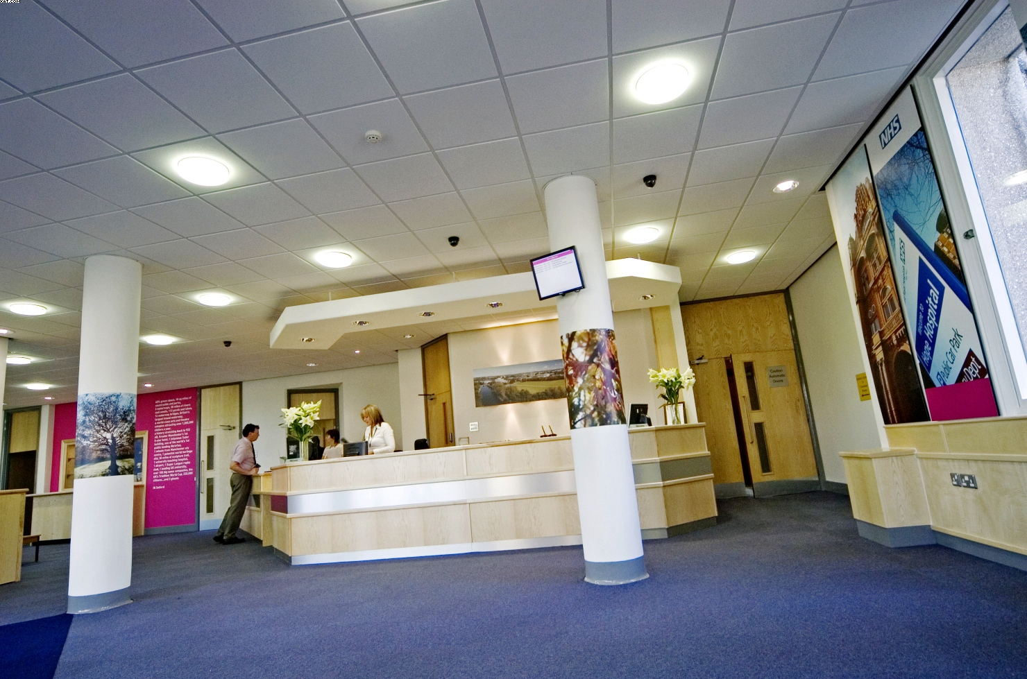
The quality of reception areas has been significantly improved e.g. Swinton Civic Centre and Turnpike House. Enquiries are dealt with more efficiently in modern pleasant and comfortable surroundings.

Provision of better office space in fewer buildings
The office accommodation strategy has reduced the number of buildings occupied providing better working environments for staff. Appropriate working environments aid staff motivation & retention and supports delivery of quality services.

Improving Community Centres
Four community centres have been substantially modernised making them modern attractive facilities. Access for people with disabilities has been improved and the buildings are much better suited for the needs of the users.

Intermediate Care Centres
Two centres in Swinton the Limes and White Meadows have been substantially improved. They are now more comfortable and suited for client and staff needs.

Day Care Centres
To respond to increasing disability among older people living in the community the councils four day centres have been substantially improved including improvements to bathroom and toilet facilities. This has given users greater levels of dignity and removed the need for costly and unwanted placements in residential care.

Leisure Centres
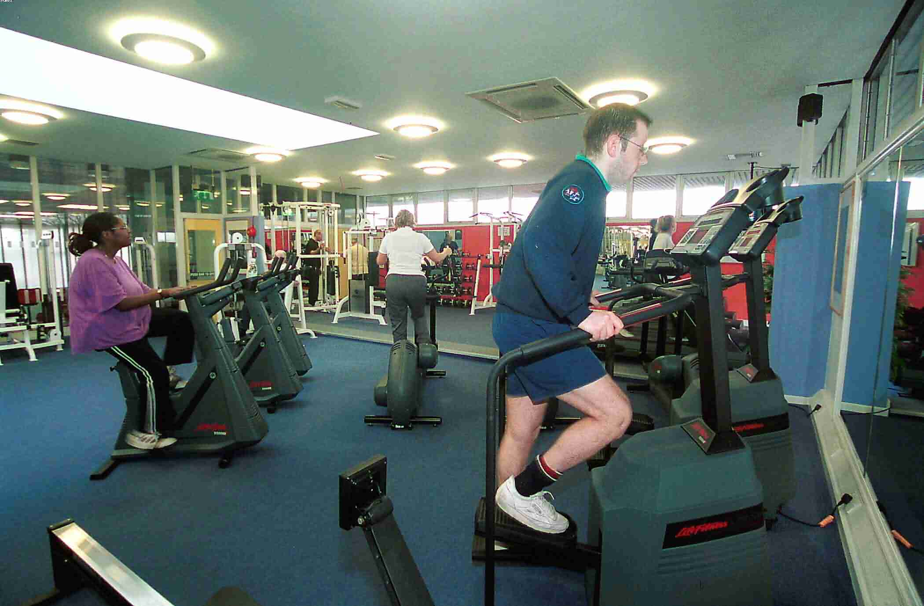
Salford Community Leisure (SCL) established in 2003 is securing significant new investment from various sources to improve leisure facilities. Fit City Clarendon has been redeveloped to provide a fully accessible site providing a citywide centre of excellence for activities for people with disabilities. Cleavley running track has been refurbished. These enhanced facilities improve the health and well being of the people of Salford through encouraging and improving access to healthy recreation and physical activity.

Regeneration
The council’s regeneration priorities are clearly outlined in the neighbourhood renewal strategy. A significant element area for regeneration is Central Salford where the council is involved in a significant programme of property acquisition, site assembly and securing development agreements to support regeneration priorities. The establishment of the Central Salford Urban Regeneration Company will bring significant private sector resources to support the regeneration process. Regeneration supports all of the council’s pledges for the people of Salford.

Improving Schools
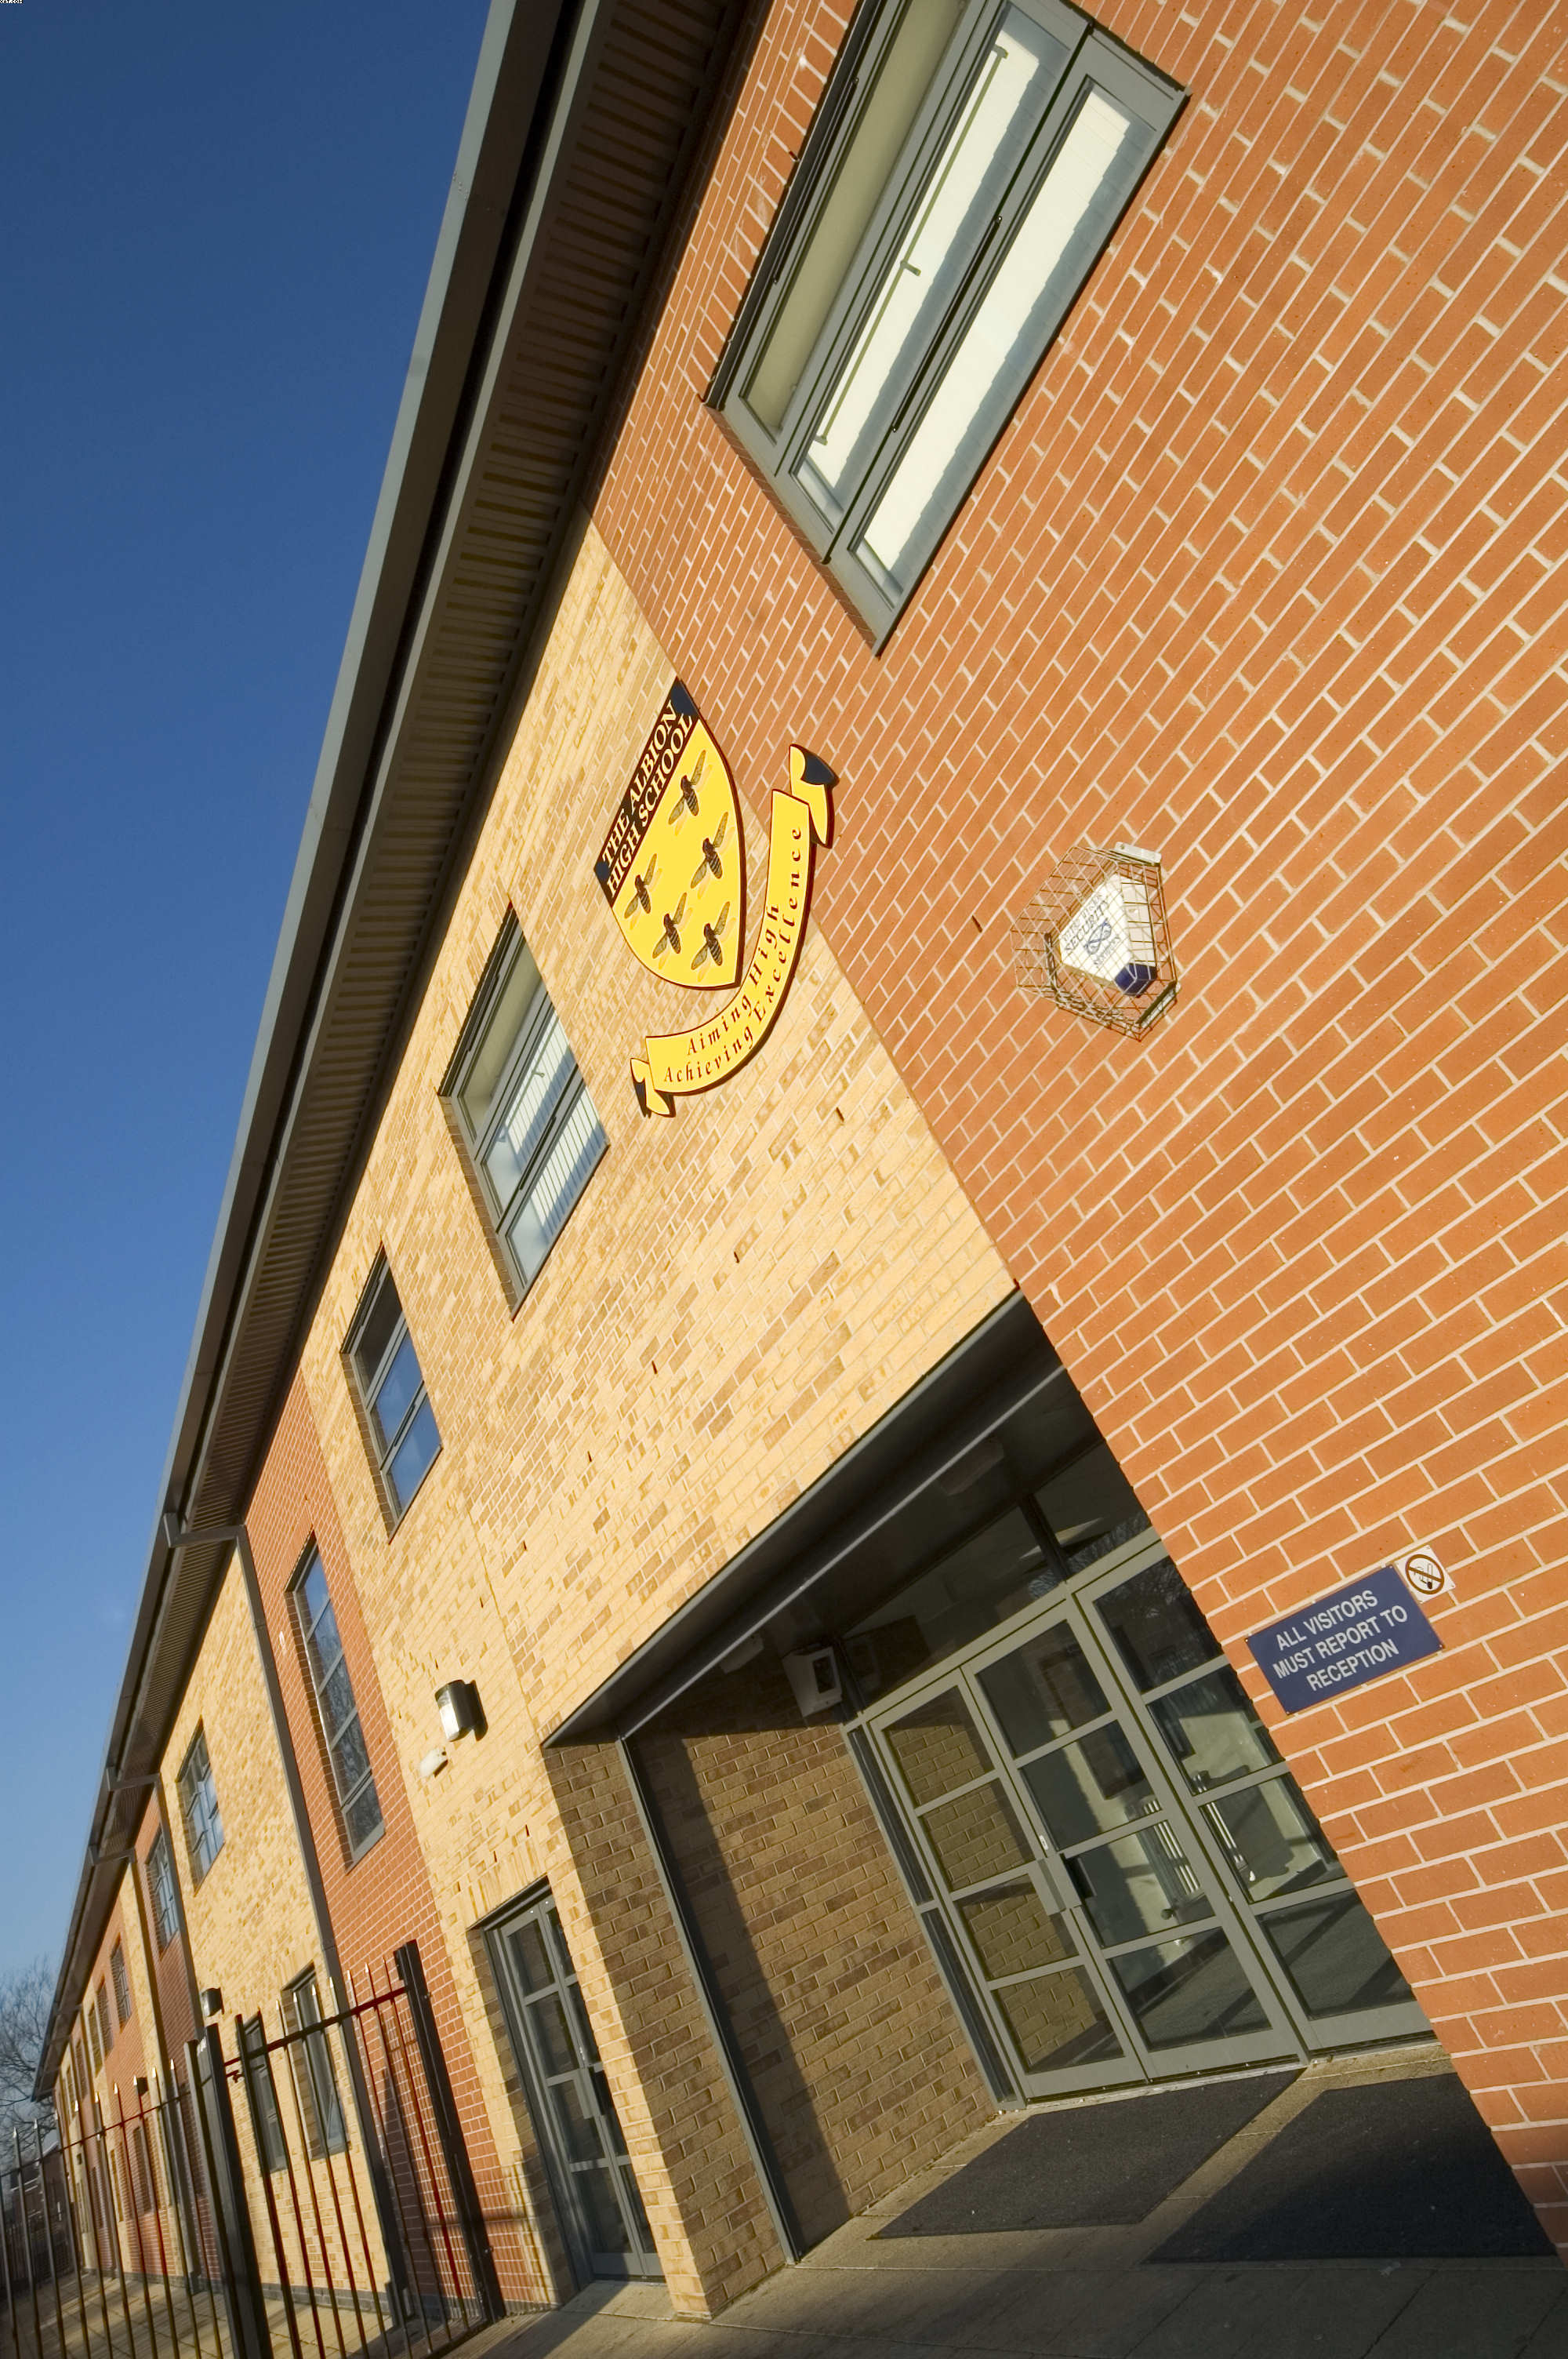
Over the last year three high schools have moved into new buildings procured through PFI. The condition of others together with access for people with disabilities has also been improved. The level of backlog maintenance has been reduced

Improvements to suitability, quality and condition of school buildings is supporting improved education outcomes with significant improvement in pupil attainment being achieved in 2004/05

Housing
The Councils Housing Service has achieved notable successes over the last few years and it has a Housing Strategy and Business Plan that strive, and have achieved the governments Fit for Purpose status. Our priorities for Housing in the city are set out within these documents and include clear plans and actions that are needed to realise our vision for housing in Salford.

In addition, through the stock option appraisal process Housing Services went through the most comprehensive consultation exercise it has ever undertaken. This resulted in having an ambitious yet deliverable investment strategy for council owned homes, signed off by government, and this strategy is likely to draw in £400 million of additional resources.

Children’s Centres
In line with the governments agenda the council has an ambitious programme for the construction of children’s centres across Salford. The first phase of works will see the completion of nine centres by summer 2006. These centres will deliver a one stop integrated service bringing together, adult education and employment advice, social welfare, health and family support combined with high quality integrated education and child care for preschool children. The centres will also provide information for families and ‘joined up’ services that are readily accessible and suited to the needs of the community.

Street Scene
Collaborative working across the council and with external partners together with a single point of access for customers is providing a more efficient and effective resolution to street scene issues.
This is improving safety and the quality of the environment for the people and businesses of Salford and will support urban regeneration activity.

Property Data and Performance
An essential element of asset management is maintaining accurate data. As well as maintaining up to date information on ownership, size and user. The council uses a set of local performance indicators and collects and compares its property performance against the National Property Performance Indicators.

It is recognised that the councils performance against the National Property PI’s in building condition / backlog maintenance and performance in delivering capital projects on time and on budget are below average. These problems are now being addressed but the required improvements have not yet been achieved.

Significant Performance improvements have been achieved in other areas. Overall the number of properties held by the council is decreasing.

Implementing the council’s office accommodation strategy has reduced the number of buildings from 50 to 34 and floor areas occupied from 48,000 Sq.m to 34,000 S.qm. Occupancy levels have increased with space utilisation targets now being met. The quality of office accommodation has been improved, providing open plan flexible offices, capable of accommodating future change.

The number of public access buildings providing access to services for people with disabilities has improved significantly from 4 in 2004 to 44 in 2005 and a 5-year improvement programme has been established. Energy efficiency measures have been implemented in poorly performing buildings, where energy usage has reduced. This work continues.

Portfolio Change
The size and content of the property portfolio is changing and the pace of change is likely to increase.

Potentially surplus property is identified through service reviews, area based reviews and specific changes in service delivery. Corporate consideration is given to the retention or disposal of property through the Resource Planning Group and Lead Member for Property.

Property disposals generate substantial capital receipts with a target income of £9m of usable capital receipt in 05/06, which is reinvested in new projects and facilities.

Backlog maintenance
Property in poor condition that has been targeted for disposal has until recently been the principal contributor to reducing the total amount for backlog maintenance in the operational portfolio. Whilst disposals will continue to contribute in reducing backlog maintenance it is recognised that additional monies will be needed to deal with this problem. In education backlog maintenance is being tackle through PFI and the ‘Building Schools for the Future’ programme. In housing a ‘mixed’ procurement strategy is being adopted for the final rounds of Decent Homes funding with an outcome expected in spring 2006. In highways maintenance an investment of £30m is being financed through prudential borrowing.

Consequently, whilst the total amount of backlog maintenance across all sectors is large significant investment is being secured, with much remaining to be achieved.

Future requirements
The asset management planning process clearly identifies the future property requirements.

The development of Service Property Strategies (SPS’s) is assisting service managers to identify the changes required which are set out in detail in Appendix 3 with key areas summarised below.

Education
Continued modernisation is to be secured via ‘Building Schools for the Future’. Salford is in the third wave with nine high schools being replaced or refurbished. This will provide high quality flexible and suitable accommodation supporting improved education outcomes for the children of Salford.

Housing
Funds secured from the Housing Market Renewal Fund by the Manchester Salford Pathfinder Partnership will continue to be spent on improving neighbourhoods through extensive regeneration. This will deliver transformational change improving conditions for people in some of the most deprived wards in salford.
Access to services for people with disabilities
Directorate service managers working with Urban Vision staff will be implementing the DDA 5-year building improvement programme. This will support the provision of equal access to services for all the people of Salford.

Meeting changing office requirements
Directorate project leaders working with Urban Vision staff will be undertaking staff moves to meet changing service requirements. A range of moves is due for completion through 2006 to support effective strategic directorate organisational requirements and neighbourhood management.

The Salford LIFT project
The council working in partnership with Salford PCT and the LIFT Company has completed the first LIFT scheme at Douglas Green, Salford and will be will be commencing development of the four major Walkden, Eccles, Pendleton and Swinton tranche of schemes in 2006. This will deliver service improvements through providing readily accessible single point of access to council and health services, library, information and community space.

Reconfiguration of Day Care Services
The emphasis to provide building based day services for people supported with learning difficulties and those with a mental health difficulty has moved to meeting their needs in community settings. In line with this Orchard Mount, a centre for learning difficulties, and Duchy House, mental health, will close early in 2006.

There is, however, an identified need to improve access to services for people with profound multiple learning disabilities in the south of the city and extensive re – modelling of Craig Hall is proposed in the first half of 2006 to meet this need. This development will mirror the highly successful Waterside Resource Centre in the range of specialist facilities required to support people with complex needs by providing locally integrated Directorate and health services and links with college and leisure providers.

Mixed market in Residential Care
Negotiations were concluded in the summer and contracts signed with Manchester Care to build and manage two homes for older people, one in Irlam the other in Little Hulton. Construction work commenced in July and both homes should be available for their first residents in the autumn of 2006. Their opening will allow the closure of the two interim homes, Brynheys and The Withies, which Manchester Care have been managing since 2003. These buildings which remain Council assets will then be disposed of.

Improving Museums and Art Galleries
The council is pursuing the improvement and development of Ordsall Hall Museum [Grade 1 listed] through a Heritage Lottery Fund bid and working to deliver a vision and development plan for Salford Museum and Art Gallery [Grade 2 listed]. Completion of these schemes will deliver a secure and sustainable future for these facilities.

Sports and Leisure
Salford community Leisure in working with council staff to redevelop and refurbish Fit City Worsley and develop the new ‘Salford Sports Village’ where through football access for all age groups will be encouraged. These new and improved facilities will directly support improvements to health, a key objective for the city.

Providing Children’s Centres
Children’s services are successfully delivering 9 schemes during 2006 and will be agreeing and delivering 6 schemes in phase 2 by the end of March 2008. Delivery of phase 2 will complete the provision of integrated health and childcare services to communities in Salford.

Conclusion
Asset Management Planning has moved on from developing the necessary processes and procedures for good asset management to ensuring that effective asset management is delivering better outcomes for the people of Salford.

The council’s priorities are now clearly stated and asset management activity is now much better aligned to those priorities.

Significant progress has been made and there is clarity about what needs to be achieved. This view is supported by the Audit Commission CPA judgement on how Salford manages its property assets, which is a 3 out of 4, ‘consistently above minimum requirements – performing well’

1. INTRODUCTION

Property is a key corporate resource and the occupation of property is fundamental to the delivery of the council’s services. Leaving aside council housing the council owns in excess of 700 properties that have a value (in accordance with Local Authority accountancy and valuation practices) of approximately £300,000,000. Annual property costs, excluding capital charges, are approximately £19m representing 6.6% of the councils annual net revenue budget (2005/06 financial year)

Asset management planning involves all of the Council’s directorates, supported by the operation of the Council’s Resource Planning Group and Strategic Property Management Unit (SPMU), the activities of the Corporate Property Officer and the role and function of the Lead Member for Property.

Effective asset management is helping to deliver change and improving outcomes for the people of Salford.

2 SUPPORTING CORPORATE AND SERVICE PLAN OBJECTIVES

  - Corporate Objectives
Property owned or occupied by the Council must be used and managed efficiently, effectively and economically to support the council in achieving its Mission, which is: -

“To create the best possible quality of life for the people of Salford”

To assist the Council in achieving its Mission the Council has made seven pledges to all the people of Salford. These Pledges, which were adopted in 2004, are the Council’s priorities for both statutory and local service delivery. The Pledges and their ‘high level’ links to asset management are set out below.

 | Pledge | Links to Asset Management
(1) | Improving health in Salford  We will improve the health, well-being and social care of the people in Salford | Deliver, in partnership with Salford PCT and the private sector, all six new primary care centres in Swinton, Eccles, Walkden, Pendleton, Charlestown and Lower Kersal.  Investment in modernising buildings providing day care, rehabilitative and respite care will continue.
(2) | Reducing crime in Salford  We will reduce crime and disorder and improve community safety | New building improvement schemes to reflect secure by design criteria.  Promoting CCTV proposals.
(3) | Encouraging learning, leisure and creativity in Salford  We will raise education and skill levels and further enhance cultural and leisure opportunities | Create schools of sufficient size, with stable viable pupil intake, financially stable and sustainable, in appropriate condition to provide a suitable stimulating and attractive learning environment to support curriculum delivery and raise education standards.  Improve the quality of recreation facilities.
(4) | Investing in young people in Salford  We will focus on services, activities and opportunities to support children and young people in achieving their full potential | Appropriate community, youth, teaching, and residential accommodation for young people in care to be provided.
(5) | Promoting inclusion in Salford  We will tackle poverty and social inequalities and increase the involvement of local communities in shaping the future of the city | Where improving access to services requires building improvement these are identified and undertaken. e.g. DDA compliance for public access buildings.  The policy of promoting social inclusion for people with learning difficulties and physical disabilities will continue by increasing the use of community based services and activities.
(6) | Creating prosperity in Salford  We will ensure an economically prosperous city with good jobs and a thriving economy | Utilise the Council’s property as appropriate particularly within Central Salford Regeneration area, Higher Broughton, Lower Broughton, Seedley and Langworthy, Lower Kersal and Charlestown and other emerging partnership regeneration areas
(7) | Enhancing life in Salford  We will ensure that Salford is a city that’s good to live in with a quality environment and decent, affordable homes which meet the needs of a local people | Improve the built environment and in particular the city’s highway and transport network. Including improving highway safety.  Achieve the Decent Homes Standard

  - Property Aims and Objectives
In order to guide its management, use and occupation of property to support the delivery of its mission and pledges the council has established a set of four property aims a series of specific property objectives supporting each aim.

Whilst the councils mission and pledges do not provide a direct route to defining property aims and objectives, the clear themes coming out of the mission and pledges are that the council is aiming to provide high quality services accessible to all its people in a prosperous city within a clean and safe environment.

Being able to provide appropriate services to achieve this mission and pledges is the product of high quality staff, good support infrastructure, sound management and the efficient use of resources. This has implications for property in terms of its amount, type, size, location condition and suitability to support efficient and effective service delivery. For example the quality, location and specification of operational buildings affects the quality of the service experienced by and the impression given to customers. In addition the workplace can help or hinder organisational management and can be an important factor in staff productivity. Using buildings efficiently also increases resources available for direct service delivery.

The council’s property can also be used to stimulate and promote regeneration and attract investment.
Through encouraging quality development, production of appropriate design guidance and good standards of maintenance, property can contribute to make Salford a safer and better place to live.

These themes have informed the establishment of the aims and objectives for property as set out over.

AIMS |  |  | OBJECTIVES
AIM 1. | To Provide property to meet corporate and service directorate requirements as efficiently, and economically as possible to enhance service provision for the people of Salford. | a)  b)  c)  d)  e)  f)  g) | To provide property that meets the needs of users in terms of condition, location, quantity and suitability  To improve year on year with respect to a series of key property performance indicators  To utilise space at a level of efficiency commensurate with best practice taking into account the limitations of the building stock  To retain only that service property which is necessary to meet service and service users needs  To reduce the maintenance backlog in accordance with a plan and timetable  To improve disabled access and comply with other statutory duties  To reduce CO₂ emissions through energy conservation and efficiency measures
AIM 2. | To ensure that property is fully recognised as a corporate asset and that it is managed accordingly | a)  b)  c) | To provide and support the working arrangements necessary to produce effective corporate asset management  Actively engage all directorates on strategic property matters to the overall benefit of the Council  To promote the shared use of property by Directorates and between the council and other partner organisations
AIM 3. | To ensure that the investment portfolio provides both income and capital to help to support the Council’s budgetary requirements | a)  b)  c)  d)  e)  f) | To optimise rental income through the estate management activities undertaken  To achieve a target Internal Rate of Return (IRR) from the investment estate.  To maintain or increase the capital value of the investment estate.  To meet the Council’s revenue generation targets  To reduce voids  To reduce rent arrears
AIM 4. | To ensure that where appropriate the Council’s property is used to support urban regeneration initiatives and community well being | a)  b) | To identify where property can support and act as a catalyst in initiatives  To define which of the councils non operational property is occupied primarily to support community well being objectives and to manage it in ways which support these objectives

  - Service Property Strategies
To ensure that property supports individual service plan objectives the SPMU has worked with service directorates to identify key issues affecting property and their future property requirements to produce service property strategies (SPS’s). In developing these Service Property Strategies consideration has been given to: -

    - Where each service is going and where it thinks it might be in 5 years time
    - Particular changes in service delivery, which will affect accommodation
    - Possible changes in staff headcounts / FTE’s
    - The impact of partnership working on the service
    - The impact of any outsourcing of the service
    - Views on the possible impacts of Local Government Reorganisation on the service
    - The way in which the service will be influenced by wider corporate initiatives
    - Current problems with services existing property portfolio in meeting current service needs
    - Changes required in the portfolio for the future
    - Steps necessary to manage and support business continuity plans.

The SPS’s set out the vision for a particular service, its property and performance in terms of running costs, condition, backlog maintenance and DDA compliance and identifies the changes to the portfolio that are planned.

The service property strategies form a bridge between service plans and the Corporate Asset Management Plan (AMP). The corporate AMP sets out the key issues affecting the council in Section 8 and both Directorate and corporate property issues in the table at Appendix 3.

This table has been developed from the key property issues table in the 2005/06 AMP. Matters that have been dealt with since last year have been removed and new issues added.
The table shows the current position together with future action and timescales. This is a shorthand summary of the situation which acts as a quick reference point, which is reported to Directors, and Members in order that progress in delivery can be monitored and any problems or areas where additional action is required can be identified.

Housing, Education and Transport requirements are dealt with in detail in their respective Plans and Programmes.

  - CPA and Best Value
CPA improvement planning along with Best Value review programmes, are key elements of the Governments agenda to modernise local government and drive improvement.
As part of Salford’s Best Value review process property and asset management issues are identified and addressed. Whilst Salford’s programme of Best Value reviews comes to an end in 05/06 CPA is placing greater emphasis on the “use of resources” with specific reference to how councils manage their asset base. Within the CPA process, Audit Commission Inspectors now make an assessment of how well the management of property assets are linked into corporate and service strategic management and how well asset management is supported by appropriate systems processes and practices. This is likely to be of increasing importance in future assessments. The Council’s Strategic Property Management Unit is working with other directorates to ensure appropriate consideration is given to property issues for these improvement activities.

The most significant Best Value review in terms of impact on property to date has been the best value review of Property and Asset Management. This review was undertaken in two phases. Phase 1 was a review of Office Support Accommodation and Strategic Property Management. On inspection in May 2001, the Inspectors found a ‘fair’ service, which was ‘probably’ going to improve.

In March 2002 the Phase II review of the remaining property portfolio and property service was completed, though this is not being inspected at the present time.

The completion of this review has made a positive contribution to asset management planning and has been particularly useful in assessing and driving improvement in the performance of the Council’s property see section 6.1

Key changes resulting from the review have been: -
- The establishment of an office accommodation strategy
- The introduction of office space standards
- The centralisation of Facilities Management Services
- The introduction of local property performance indicators
- Measures to improve the cost effectiveness of the property service
- Measures to improve building and services user satisfaction
- Identification of property held for investment or social purposes

The property implications of other Best Value reviews and CPA improvement activity is shown at Appendix 7

  - Financial Context
The council has to provide its services within a constrained financial regime. The overarching objective of its Medium Term Financial strategy is to ensure that financial resources are utilised efficiently, economically and effectively to enable the council’s vision for the city to be delivered and sustained. While the strategy encompasses continuous performance improvement, it puts certain constraints on resources and the council is seeking:

- to meet continuing commitments from currently-available resources;
- to limit council tax increases to 3 per cent year-on-year;
- to achieve annual efficiency savings in line with Gershon principles, i.e. 2.5% per annum.

Consequently service ambition and property requirements need to be carefully considered and prioritised and buildings need to be occupied and managed as efficiently and effectively as possible.

In this context the government proposals for ‘whole of government accounts’ and depreciation based support have been noted and will be considered in developing the councils asset management plan.

The council’s property assets also support capital and revenue requirements by income generated from the investment estate and capital receipts from the sale of assets. The Corporate Property Officer and Head of Finance set targets for revenue and capital generation as part of the budget planning process.

In 2005/06 the council’s property portfolio will generate income of approximately £3.07M to support the revenue budget. (This compares with £2.94m in 04/05) This income is made up of; industrial estates £815K, other commercial properties £1.298M, housing shops and properties £604K, markets £230K and other properties and land in the city of £125K.

The capital receipts target for 2005/06 is £9.0m of useable capital receipts

3 ORGANISATIONAL ARRANGEMENTS FOR CORPORATE ASSET MANAGEMENT

Asset Management and its planning needs to involve the whole local authority organisation not just property managers. To ensure that this takes place Salford has put in place the arrangement set out below

3.1 The Resource Planning Group (RPG)
The RPG was established in June 2003 through the amalgamation of the former Asset Management Group and Budget Planning Group.

The terms of reference and role of the RPG includes the strategic management of the Council’s property portfolio and development of the Asset Management Plan and Capital Strategy.
Senior representatives, mainly at assistant director level from all directorates, attend the group with the lead for property matters being taken by the Corporate Property Officer (CPO).

The RPG meets regularly usually on a 4 weekly cycle with additional meetings to consider specific matters when necessary

The Group makes recommendations regarding property to the Lead Member for Property, Directors Team and Cabinet for approval.

  - Strategic Property Management Unit (SPMU)
The SPMU was established in 2000 as a result of the Council’s Best Value Review of office accommodation and strategic property management. The SPMU is a corporate resource. It acts as a catalyst to raise and promote consideration of corporate property issues and holds and maintains property data and performance information.

The Unit is responsible for raising the profile of property and property performance and for developing and improving strategic management activities including: -

- Property Data | - Accommodation Strategy
- Property Performance | - Planned Maintenance
- Property Strategy | - Financial Planning for property
- Building Condition | Compliance with Statutory requirements /Regulatory Codes

  - Corporate Property Officer (CPO)
The Council has a designated CPO responsible for the development of corporate asset management. Terms of reference for the CPO follow ODPM guidance.
The terms of reference and roles of the RPG, SPMU and CPO have been endorsed by directorates and approved by Cabinet.

These terms of reference and roles are published on the Council’s intranet site and updated as appropriate. The CPO is involved in the preparation of the Asset Management Plan and Capital Strategy including the setting of capital and revenue targets for property in conjunction with the Head of Finance and he is also a member of the Resource Planning Group. The reporting procedure of the RPG, SPMU and CPO through to Directors Team and Members is shown in Appendix 1

  - Lead Member for Property
The Council has a Lead Member for property. His cross cutting role and responsibilities have been defined and agreed by Cabinet. In addition to the formal reporting processes, regular briefings take place between the CPO and Lead Member to ensure that he is aware of and briefed on important property matters. The Lead Member can similarly raise issues with the CPO.

The Lead Member has monthly meetings with the CPO and key officers from the property division and SPMU to receive reports from Resource Planning Group and consider other property matters.

  - The Delivery of Property Services through other Service Providers.
The City Council has entered into a joint venture partnership company, Urban Vision Partnership Limited, with Capita Symonds plc and Morrison plc. The new joint venture company was established in February 2005, with the objectives of: improving services, delivering efficiencies, increasing capacity, investing in the city’s highways and creating new markets. The services delivered by the company to the Council include property, design, maintenance, highways and planning services to the council. The Housing and Planning Directorate acts as the client for these services setting down the services required. The property division of Urban Vision work closely with the SPMU to ensure that appropriate support is given to strategic activities and plans are implemented.

New Prospect Housing Limited is an arms length company established by the council to manage Housing Revenue Account assets. The Housing and Planning Directorate has an asset management post to coordinate the Council’s asset management planning and processes with New Prospect Ltd and act as the key link with the Resource Planning Group.

4 INCLUSION AND ENGAGEMENT

  - Consultation and Partnership Working
Consultation is an important element in the asset management planning process. The Council’s consultation process includes:

- The ‘Big listening’ council and PCT consultation with citizens
- Central Salford Vision and Regeneration Framework – consultation on draft by the Central Salford Urban Regeneration Company (URC)
- The revision of the Community Plan process
- Consultation by Directorates with building users
- The result of consultation within individual Best Value reviews
- Consultation process linked to Education Asset Management Plan and Schools Organisational Plan
- Staff consultation on property proposals
- Input provided by the SPMU from their cross directorate activities
- High level surveys to establish current perceptions and needs - e.g. Disability Forum
- The operation of the RPG and input to the Group from directorate representatives

Results from these activities are used to inform the development of Service Property Strategies and the formation of the key issues in Section 8 and Appendix 3

Partners IN Salford, the City’s Local Strategic Partnership (LSP) brings together key agencies across the public, private, community and voluntary sectors to promote and develop close collaborative working and has been responsible for the development of the Community Plan and Neighbourhood Renewal Strategy.

The process of revising the Community Plan for re-launch in late 2005 has deepened collaborative working between the LSP and key partners.

The Plan aims to create a clean, safe and healthy city with strong sustainable communities and a buoyant economy, where children and young people can thrive and benefit from excellent educational and cultural opportunities and facilities. It will enable the Council and its partners to make the best possible use of public sector assets in order to tackle the crosscutting priorities facing our City in a strategic, partnership based and comprehensive manner.

The Neighbourhood Renewal Strategy, the City’s framework for Neighbourhood Renewal, puts regeneration and mainstream service improvement at the heart of the City’s priorities and gives a clear spatial dimension to our interventions. It aims to:

- Develop an integrated strategy to regenerate Central Salford including the areas of major change in Broughton, Seedley and Langworthy and Charlestown/Kersal
- Target action to stabilise communities in Salford West and maximise opportunities
- Work with our communities to achieve change.

Key targets are included within the Community Plan and the Neighbourhood Renewal Strategy to measure the success of our policies over the next five years. These targets reflect the updated National Floor Targets, include key Best Value Performance Indicators and incorporate local performance indicators designed to challenge, target and improve service delivery in particular areas. The targets set have formed the basis of the Partnership’s 2nd Round Local Public Service Agreement with Government, which will run from 2005-2009 and will be the pre cursor of a Local Area Agreement.

Integrated within the Community Plan are the City Council’s 7 Pledges that are Council priorities for both statutory and local service delivery. The impact of the pledges has involved the re-alignment of Best Value Performance indicators and service plans to reflect an agreed corporate approach, setting out a commitment towards: Improving Health in Salford, Reducing Crime in Salford, Encouraging Learning, Leisure and Creativity in Salford, Investing in Young People in Salford, Promoting inclusion in Salford, Creating Prosperity in Salford and Enhancing Life in Salford.

During 2003/04 the LSP prioritised and developed partnership based delivery in three over-arching priority areas. These are:

- Education and basic skills uplift
- Improving the image of Salford
- Improving service delivery and implementing Neighbourhood Management.

The LSP has also prioritised the need to improve the quality and co-ordination of community involvement activities across partnership agencies and to target disadvantaged groups and neighbourhoods. The Good Practice in Community Involvement Project has been established by the LSP. A Best Value review of Community Engagement has also been conducted. Innovative methods of working with the private sector are being pursued across the City and are having a positive impact on property provision. Social Services have secured the transfer of Elderly Persons Homes to a Trust designed to secure improved services and facilities by achieving investment in assets; Education will have three special high schools fully operational during 2004 which have been delivered via PFI. Approval has also been given by the DfES for the provision of replacement schools for three mainstream high schools through PFI. In addition Education is seeking to be part of the second wave of local authority's to replace our remaining secondary schools as part of the BSF capital investment, which could include the setting up of a LEP involving the private sector.

Partnership working within communities is the most important aspect of the City's Community Strategy with the establishment of Community Committees since 1992 enabling local people to participate in the decisions directly affecting them. Community Action Plans outlining local priorities, developed by the community, feed directly into the Community Plan. Regeneration schemes such as the SRB 5 programme in Seedley and Langworthy and the New Deal for Communities programme in Charlestown/Kersal promote local partnership working within communities, with local people directly involved in the management structures established within them. Salford, along with Manchester, has received Housing Market Renewal Funds for 2003/4-2005/06, which will bring in £44m into Central Salford. A Scheme Update for HMR funding from 2006/07 onwards was submitted in October 2005.

The Central Salford URC was established in February 2005 through founding partners the City Council, the North West Development Agency and English Partnerships. It is anticipated that this will bring in significant private and public resources to assist the City’s successful regeneration, complementing the £44m that Housing Market Renewal funding is bringing in up to 2005/06 initially. A Vision and Regeneration Framework for Central Salford which will co-ordinate activity and guide investment will be finalised during 2005/06.

Partners IN Salford fully intends to remain action focussed and has an agreed work programme to deliver. The Partnership has identified a number of clear opportunities to strengthen its role and performance including:

- The delivery of the Neighbourhood Renewal Strategy.
- The major investment in health services (and in the associated physical, economic and social regeneration) represented by the SHIFT Programme (Salford Health Improvement for Tomorrow - £130m investment over 10 years in Salford’s health services)

Partnership working has also been developed so that we enjoy an even stronger engagement than previously, both strategically and locally, and on the joint delivery of services. Developments include: -

- Closer working with partners through the introduction of forums where the Chief Executive meets with partner Chief Executives (e.g. vice chancellor of the university, CE of PCT, chief of police, government office, chair of LSP) on a regular basis, to discuss common issues;
- Development of a multi-agency partnership approach at the local level, including the council, PCT and police, through our neighbourhood management proposals;
- Reducing crime in our communities, in which our community sector teams and the Crime and Disorder Partnership (CDP) have been key factors;
- Joint commissioning in the areas of health and social care with the PCT. We now have a number of joint appointments, notably a joint director of public health who is now a member of the City Council’s Directors Management Team. This partnership working is serving to develop and increase capacity both for the council and for our partners.

  - Learning From Others
Strategic asset management is a developing field and the council has recognised the usefulness of comparing practices and learning from the ideas and experience of others.

Salford is a member of CIPFA Asset Management Network, has links with ACES and is attending Beacon Council Asset Management events all of which assists in identifying good practice and different approaches to asset management issues.

  - User Satisfaction
The need to develop building occupier and user satisfaction surveys was initially identified in the 2001/02 AMP.

Extensive user satisfaction surveys were undertaken as part of the Best Value Review of Property and Asset Management. The results identified repair and maintenance issues in certain buildings being as a particular concern.

Within the Community & Social Services Directorate, consultation with users, carers, and staff is an integral element of service delivery and review. The consultation process includes reference to the suitability of the building to deliver modern services compliant with regulatory requirements. In settings where personal care services are delivered the process also includes the ability to maintain the privacy and dignity of the service user.

User satisfaction is also being used in area based property reviews as one of a set of measures used to assess building performance

  - Community Consultation

The revised Community Plan is based on the priorities identified within Community Action Plans developed by Community Committees across the City, developed and endorsed by local communities alongside the Council’s pledges. Consultation with Community Committees has been underway. A fuller explanation and examples of the types of community consultation undertaken are included in the Capital Strategy at Section 5.

The Community Plan and Community Action Plans, Directorate’s Service Plans and the operation of specific initiatives Task Groups are key drivers, which shape asset needs. These are fed into the asset management process the development of service property strategies and the key property implications are reflected in the AMP.

- EXISTING PORTFOLIO AND ITS CURRENT PERFORMANCE

  - Existing Portfolio
The SPMU maintains a property database that holds core and intermediate data on all the Council’s property, which brings information together from a range of sources. The portfolio is clearly defined and has been categorised into the CIPFA categories plus surplus property. The portfolio and the number of individual assets and their capital value are shown below.

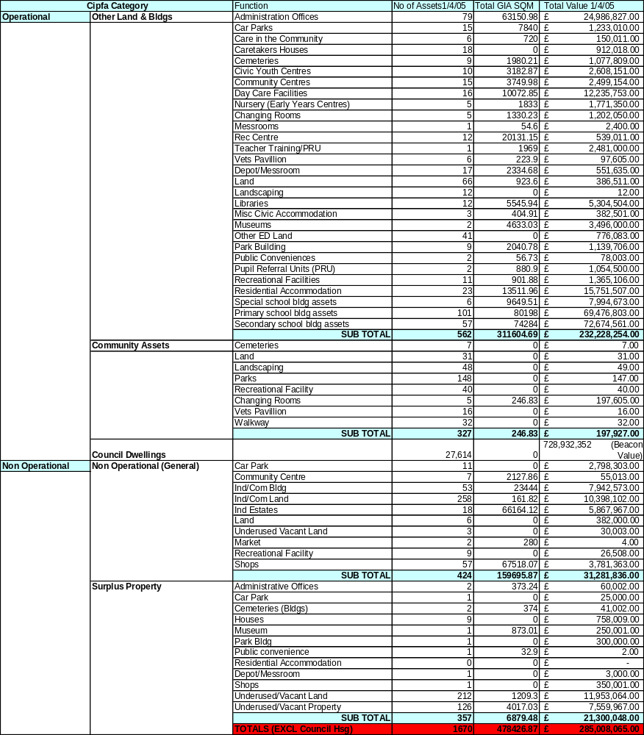
Note. Areas refer to building areas only. Surplus property includes properties that are being held
for regeneration purposes

  - Changes in Portfolio
Through a process of performance assessment and improved alignment of property with service delivery needs, the Council has been able to identify assets that are surplus to its requirements. Implementation of the Surplus Property Policy has enabled the Council to continue to reduce the amount of property within its ownership. In 04/05 the disposal of surplus assets (excluding Council houses) generated £9.9m in usable capital receipts for reuse by the Council supporting the Capital Programme.
A summary of the changes in the portfolio from April 2004 to April 2005 can be seen in the table below;

CIPFA CAT | No of Assets | Building Area (GIA) Sq.M | Comments
Operational
Other Land & Buildings | -25 | -17825M² | The data shows a reduction in number of assets and in the area of buildings occupied
Community | +24 | -276M² | Increase in assets is mainly due to the separate identification of pavilions and changing rooms
Non-Operational
General | +33 | +310M² | Whilst through acquisition and disposal the number of assets has increased by 33 the area of assets has only increased marginally
Surplus | -77 | -1982M² | The number of surplus assets is reducing essentially through the disposal of assets acquired for regeneration purposes.
TOTALS | 45 Less | 19,773M² Less floorspace | The overall reduction in assets and areas is the product of effective asset management.

Through formal and informal stakeholder consultation we know that the remodelled portfolio is generally better suited to support modern service delivery approaches and has increased staff satisfaction levels without there being any detrimental effect on access to services.

  - Surplus Property Policy
The operation of the Council’s surplus property policy has continued to be improved. This policy also introduced a detailed decommissioning checklist to ensure that an appropriate and consistent approach to decommissioning was adopted across all Council directorates.

The policy has been implemented through the operation of the RPG who are provided with an option appraisal for each building that is declared surplus. The RPG recommendations are then reported to the appropriate Lead Members for approval. The policy has established a target for property to be disposed of within one year of it being declared surplus unless there are specific reasons for a longer period e.g. where land or buildings are being retained for regeneration purposes.

The effective operation of this policy improves performance by: -

- Better decisions being taken through acting corporately
- Reducing the amount of time properties are vacant.
- Target setting and monitoring performance
- Encouraging positive action to identify surplus property

  - Data Management

The need for accurate and up to date property data underpins effective asset management

- Core Data
The database holds all core data, including a CIPFA property categorisation and a description of the function of the property.

- Transient Data
The SPMU is very aware that in addition to the core data, only that data which is relevant and of use in supporting property PI’s, which can be used to improve performance, should be collected. Data is collected to support the national property PI’s and the Council’s local property PI’s that have been derived from the corporate aims and objectives for property.

This transient data, e.g. running costs, occupancy levels and condition is collected and held on the property database. The Council’s financial information is held on a SAP system. This information is currently manually extracted and input into the property database. Transient data is reviewed and updated annually. From the core and transient data, a range of reports can be run on the performance of the Council’s portfolio.

The council operates a SAP financial accounting system and a key area for improvement is the direct transfer of financial information from the SAP system to the property database. However whilst this is being considered in the system development it appears that it will be very difficult to achieve in the short term.

The validity of the core and transient data is tested. The data held on the database is checked against and reconciled with primary source data. In updating records, information is received and checked. The data is checked and verified through its use in implementing Best Value review outcomes, in supporting PI’s, providing data to benchmarking groups and also through condition surveys and Target Setting. Whilst there is no formal audit of the data these processes ensure that the data is firmly based and accurate.

- UPRN and Systems Development
The asset management data is held in an Access database system supported by Excel spreadsheets. The data held contains a UPRN for each land and property asset. Future development will require changes to the Council’s systems to comply with the government’s proposals for the NLPG and BS 7666

The asset management planning work undertaken over the last four years has involved the development of the existing database to a level where further development will require procurement of an integrated corporate property system.

Alternative systems have been evaluated against the Council’s requirements for introduction in 2004/06.

Staff in the SPMU have had appropriate training in the operation of the existing systems.
The introduction of a new system will also require operators and users to receive appropriate training. These needs will be identified and provided as an integral part of the actions required to introduce the new system.

- Geographical Information System (GIS)
The Council’s property portfolio is plotted onto a GIS system. This information facilitates area based property reviews enabling the Council to analyse the distribution of property by category types across the city.

6 PORTFOLIO PERFORMANCE, MANAGEMENT AND MONITORING

The SPMU continues to raise the profile of property and the importance of property performance through the operation of the RPG and reports to Directors Team and Members.

The Best Value Review of Property and Asset Management was used to develop a range of local performance indicators for property and the property service. These measure both building and service performance and user and client satisfaction see Appendix 2. These performance indicators will also be used to measure progress in delivering the corporately agreed Aims and Objectives for property.

Performance in relation to the ODPM national pPI’s is reported annually to resource Planning Group and the Lead Member for Property and Directors Team. This performance is shown in Appendix 4. These national pPI’s will be used to improve performance and these together with the improvements and outcomes that could be achieved are shown in Appendix 5

Implementing the Council’s Office Accommodation Strategy and Improvement Plan has resulted in improvements in cost and occupancy performance. Moves being implemented in 05/06 will also support the establishment of the councils strategic directorates bringing appropriate staff together on each of the councils four core sites.

The running costs for various categories of Council property are shown in Appendix 6. Directors are made aware of their respective services property costs and current office occupancy levels set against the Council’s corporate targets. Performance is also reported to the RPG, Directors Team and the Lead Member for Property.

Property performance information including annual running costs, backlog maintenance and condition category, and DDA issues are included within Service Property Strategies (SPS’s)

It is recognised that Service Directorates could be assisted through the development of further ‘business related ‘ property PPI’s. These will relate business unit transactions (e.g. books lent/enquires handled) to property costs and space occupied and will be progressed as part of developing Service Property Strategies. The Council is continuing its work with benchmarking groups – e.g. IPF, AGMA, and Core Cities to assess performance against other organisations..

  - Implementing Best Value Outcomes
The Best Value Review of Property and Asset Management has been the most significant Best Value Review affecting all property and directorates. This review defined the Council’s office accommodation strategy and identified property service improvements. Significant progress has been made in implementing the office accommodation strategy and the improvement in occupancy performance is shown below. (Note; data includes ALMO occupied buildings)

ITEM | 1999-00 | 2000-01 | 2001-02 | 2002-03 | 2003-04 | 2004-05
Number of buildings occupied | 50 | 44 | 40 | 35 | 35 | 34
Number of buildings % change in year | baseline | -12% | -9% | -12.5% | 0% | -2.86%
Total floor space Sq.m | 48538 | 43309 | 39792 | 33293 | 33916 | 34024
Total floor space % change in year | baseline | -10% | -8.1% | -16.3% | +1.87% | +0.32%

The council has continued to reduce the number of buildings occupied, from an initial 50 to 34 in 2004/05. Since 1999/2000 the total floor area has reduced significantly, though over the last two years there has been a marginal increase in the area occupied due to the increases in staff numbers. The councils corporate office space standards are broadly being achieved.

The Phase I review produced a three-year improvement plan that came to an end in September 2003. At the end of this plan period further rationalisation of the office portfolio was required and a further two-year plan was agreed with Scrutiny Sub Group up to September 2005. Implementation of the plan has taken longer than anticipated and will continue to be delivered through 2006.

  - Directorate Property Performance
All directorates are informed of their property performance in respect of the office portfolio they occupy. Where directorates occupy other service property its running costs are also reported to them. This process raises directorates’ awareness of property costs and assists in identifying and targeting potential areas for improvement.

  - Building Condition
All buildings where the Council has a repairing obligation have been categorised into condition category A to D. The City Council has developed a 5-year rolling programme of surveys, with 20% of the portfolio being inspected every year. This allows for a detailed analysis of a section of the portfolio the percentage change of which is then applied to the remaining buildings where the council have a repairing obligation. To increase the accuracy of the data in 04/05 buildings with backlog maintenance over £100,000 not included in the 20% surveyed sample were also assessed. This approach has been adopted to facilitate a more manageable and accurate surveying process. This data has been used to update and refine the backlog maintenance figure included in the context sheet and to support the national PPI 1A & B
The information on condition categories A to D and priority levels one to three has been broken down into CIPFA categories is shown in Appendix 4 along with the other National PI’s. A summary detailing the overall condition categories A to D is shown below.

Overall Condition Assessment A-D (Total GIA Sq m and %)
A | B | C | D
4.11 | 61.43 | 33.33 | 1.13

The condition of the Education portfolio has been assessed in accordance with DfES guidelines and the resultant information is contained within the Education AMP.

  - Energy Performance
The energy / water consumption performance of the councils buildings is measured, analysed and reported to Members and Directors. Performance for various categories of buildings is compared to benchmark data and areas of poor performance identified this enables investment in energy efficiency measures to be prioritised and directed to the areas of worst performance

  - National Performance Indicators
The Council has continued to collect information required to support the national PPI’s. These PI’s exclude housing and schools and cover: -

- The condition of the council’s buildings
- The amount of backlog maintenance in council buildings
- The financial rate of return (IRR) from the council’s investment estate
- Building running costs for repair and maintenance, energy costs and water costs
- Building CO2 emissions
- Performance in delivering capital schemes on time and on budget.

Salford’s performance against these PI’ s is set out in Appendix 4

Salford’s performance is being compared with that of other local authorities through IPF’s Asset Management Network. This is being used to improve Salford’s performance and how this can be achieved is shown in Appendix 5.

Salford’s current level of performance in relation to the national PI’s are set out in the table below.

National pPI | Salford’s Totals 2002/03 | Salford’s Totals 2003/04 | Salford’s Totals 2004/05 | Comments
1A (Condition assessment % of GIA in categories A-D)
(Good) % A  (Satisfactory) % B  (Poor) % C  (Bad) % D | 4.11% | 3.68% | 4.11% | Little change in data trends – area in bad condition reducing
(Good) % A  (Satisfactory) % B  (Poor) % C  (Bad) % D | 59.75% | 62.21% | 61.43%
(Good) % A  (Satisfactory) % B  (Poor) % C  (Bad) % D | 34.82% | 32.86% | 33.33%
(Good) % A  (Satisfactory) % B  (Poor) % C  (Bad) % D | 1.32% | 1.25% | 1.13%
1B (% of Value in priority 1-3)
(Urgent) 1  (Essential 2yrs) 2  (Desirable3-5yrs)3 | 34.55% | 28.53% | 38.81% | Improvements shown in 02/03 and 03/04 now reversed
(Urgent) 1  (Essential 2yrs) 2  (Desirable3-5yrs)3 | 39.86% | 43.27% | 42.22% | Improvements shown in 02/03 and 03/04 now reversed
(Urgent) 1  (Essential 2yrs) 2  (Desirable3-5yrs)3 | 25.59% | 28.20% | 19.97% | Improvements shown in 02/03 and 03/04 now reversed
2 A,B&C (Internal Rate of Return)
(Industrial) A | 12.30% | 12.72% | 13.05% | Little change in overall data
(Retail) B | 13.98% | 13.95% | 13.69% | Poorly performing assets being identified for action
(Agricultural) C | 12.12% | 12.12% | 12.12% | No change
3 (Strategic Management Cost)
Cost per Sq m | £0.40 | £0.55 | £0.57 | Slight upward trend – not an issue
4 A,B,C&D (Revenue running costs per sq m)
Repairs A | £16.74 | £12.53 | £17.33 | Data broadly consistent over the period
Energy B | £6.12 | £6.47 | £7.85 | Data broadly consistent over the period
Water C | £1.54 | £2.73 | £2.23 | Data broadly consistent over the period
CO2 D | 0.080 tonnes | 0.080 tonnes | 0.085  Tonnes | Data broadly consistent over the period
5 A & B ( % Capital Projects on time/on budget )
(% on Budget) A | 42.86% | 25.00% | 20.00% | Data shows performance has deteriorated this year – issue being addressed
(% on Time) B | 17.39% | 24.44% | 20.00%

  - National PI Summary

With the exception of PI 1A & B(condition and backlog maintenance) and 5 A & B (delivering capital projects on time and on budget) Salford’s general position in relation to the National PI’s is close to the average figures collated by the IPF benchmarking Group. It is recognised that Salford’s portfolio is in a worse condition than the average of other authorities. The underlying reasons for these results have been considered by undertaking further detailed work with the AGMA benchmarking group. It has been concluded that this poorer than average performance could be due to the age of the portfolio, the type of buildings, discrepancies in survey techniques and historic under funding of maintenance budgets.

Between 2000 and 2004 the council reduced its backlog maintenance through actively pursuing the disposal/demolition of surplus assets that also allowed the maintenance budget to be spent on a reduced portfolio. In 2004/05 backlog maintenance increased and this is reflected in the increase in the percentage of the spend required urgently or within two years. Performance is below the average of other authorities and additional capital and revenue allocation is being sought to begin to remedy this situation.

Performance in delivering capital projects on time and on budget has also remained below average. However this result is based on a small number of projects and time and cost predictability is affected by a number of external factors, not just the performance of the City Council and its joint venture company, Urban Vision Partnership Ltd. The Council has adopted a policy of procuring its future construction work through partnering with contractors (as opposed to competitive tendering). Its first partnership (for building works with values between £500,000 and £5,000,000) was established in July 2004, with two further partnerships being established in 2005. It will take time for new projects procured in this way to reach practical completion but the Council believes that the adoption of this 'Rethinking Construction' approach to procurement will lead to significantly improved cost and time predictability."

  - COPROP Performance Initiative
The association of Chief Corporate Property Officers has been working in conjunction with the Government on reviewing the national property performance indicators and producing a revised suite of indicators. Salford will consider these indicators with a view their being used and supported in 2006.

- LIKELY FUTURE PROPERTY REQUIREMENTS

  - Future Asset Requirements
The asset management planning process has brought together consideration of the Council’s Mission and Pledges which support the Community Plan, key drivers of change from the Strategic and Best Value Performance Plan, Service Property Strategies and Directorates Service Plan derived property requirements to produce the key property issues table shown in Appendix 3
This table sets out the Key Issues and their property implications together with a current position statement and action required. This table is reviewed mid year and is updated as part of an annual review process. New areas for change are added which are then prioritised through the Council’s capital project appraisal process and built in to the Capital Strategy and Capital Programme as appropriate.

  - Property Review and Rationalisation
There are three processes driving the change in the Council’s operational property portfolio these being: -

- Changes in service delivery
- Area based property reviews and service property requirements
- The Best Value Review of Property and Asset Management

Changes in the way services are being delivered is having a significant impact. The Council is working with Salford Primary Care Trust through the Salford LIFT Project to provide new buildings to accommodate a range of Council, PCT and other services. These buildings will also provide accommodation for the Council’s One Shops which is also being integrated with the PCT. In addition Social Services are continuing to deliver other joint service delivery initiatives with the PCT and Education, in developing Children’s Centres proposals with for example Sure Start, involve the sharing of accommodation.

The area-based reviews assess the performance of property, its condition, suitability, sufficiency and its market value. A review has been undertaken in Irlam and Cadishead, and Walkden and Little Hulton are under way. This work has identified surplus property for disposal to support and enhance the delivery of services. The appraisal model used in area-based reviews is shown in Appendix 8

The key outcome from the Best Value Review of Property is the clearly established office accommodation strategy setting out clear performance targets for occupancy levels and rationalisation of building stock into four core sites and up to twenty satellite offices. Significant progress has been made since 2000 in reducing the number of buildings occupied, reducing running costs and providing improved accommodation. – see section 6.1.

  - Option Assessment
Option assessment is undertaken at both the strategic and project specific levels.

At the strategic level various options for dealing with the Council’s property requirements have been considered as follows:

- Continue current ownership and traditional procurement
- Leasehold occupation
- PFI
- Sale and Leaseback
- Transfer to Trust
- Arms Length Management Organisations taking some responsibilities for property

No single option provides the solution to meet all the Council’s property requirements and different options are selected dependant on circumstances. Generally the approach is to own buildings for which there is a long term need and to lease to meet short and medium term requirements.

Examples of the adoption of new solutions are the use of PFI for the replacement of schools, the move to arms length management for the Council’s housing stock and transfer to trusts for elderly persons homes and leisure centres. The Council has also increased its use of leasehold occupation of office space, as an appropriate solution to meet short and medium term office needs.

At the project specific level different options are considered in order that the most effective option can be brought forward for project appraisal and prioritisation.

  - Project Appraisal and Prioritisation
High-level option appraisal is undertaken for major regeneration, service and infrastructure proposals to establish the strategic direction for medium to long-term capital investment, with options being presented to Cabinet members for decision

Having established preferred investment options the Council then prioritises its capital investment according to whether it: -

- Meets the Government's annual capital guideline for each major service;
- Maximises available external funding;
- Meets national, regional and local priorities;
- Targets its key priority regeneration areas, i.e. Seedley/Langworthy, Higher and Lower Broughton and Kersal/Charlestown, Chapel Street and renewal areas; and
Provides continuing support to the revenue budget.

The Council has over the past 12 months sought to develop a more objective means of assessing its priorities for capital investment which embraces a wider range of assessment criteria, such as the extent to which they satisfy health and safety requirements, contribute towards enhancing the life of an asset, improve the environment, stimulate the local economy, reduce risk, engage partners and consult with the public. As part of the prioritisation process it has been suggested that weighting is placed upon the assessment criteria in terms of high, medium and low priorities, these consist of the following:

- High Priority | Mandatory requirement, maximises external resources or whereby specific assets will be improved/used
- Medium Priority | Strategic Impact of the scheme and contribution towards the key themes of the Community Plan
- Low Priority | Other relevant information required to assess prioritisation e.g. revenue savings
With investment in regeneration areas being afforded the highest priority.

The model for assessing priorities has been developed and used by a cross-directorate group comprising officer representatives of the Resource Planning Group for the 2004/05 capital programme. To enable the effectiveness of schemes to be reviewed and assessed the appraisal model also requires clear output /outcome targets to be identified.

The lessons learned from applying the model for the first time in 2003/04 were used to shape the process for 2004/05

  - Financial Planning
A 5-year Capital Strategy sets out the council’s spending plans and priorities, and forecasts how they will be funded, taking into account expected borrowing approvals and grant availability from the Government, forecasts of capital receipts and any other internally-generated funds. Capital investment planning is linked to service planning by ensuring through the priority assessment process that it supports the delivery of the outcomes required from the Community Plan, directorate service plans, the Best Value Performance Plan and the Asset Management Plan, whilst also ensuring that these plans are explicit in outlining major capital and revenue resource implications.

The annual capital programme is refined in the light of actual funding announcements from the Government, the updating of capital receipt forecasts and any emerging spending priorities, e.g. as a result of new Government initiatives, which may not have been identified during the capital investment planning process.

A spending profile is identified for each approved capital scheme and officers monitor actual cash flow against the profile at monthly intervals during the year. Likewise, key milestones are identified for each major capital receipt above £100,000 and monitored by the CPO and Head of Finance. Monthly reports are made to members of Budget Committee and Cabinet on the financial and physical progress with the capital programme and its funding. More detail of this process is outlined in the Capital Strategy document

The introduction of the Prudential Code for Capital Finance in Local Authorities has removed previous controls over financing capital expenditure and replaced them with a self-governing framework where authorities are free to pursue capital investment plans, so long as they are affordable, prudent and sustainable. The freedom to use “Prudential” borrowing, ie borrowing unsupported by government grants, has assisted the council with its asset management proposals. It is allowing better capital planning by smoothing of timing imbalances caused in the past with borrowing and grant approvals and completion of disposals for capital receipts. It has facilitated the consideration of more invest to save type proposals, which might have failed in the past due to the lack of available funding.

Developments in tax law and accounting for leases increasingly reduce the likelihood that leasing companies can offer attractive contracts. When equipment leases, for example for vehicles and wheeled bins, come up for renewal, a thorough options appraisal is now conducted to determine the best means to finance the investment. Similarly, bids for new investment that might previously have been financed by lease, especially in IT equipment, undergo the same appraisal. In many cases, Prudential borrowing has proven to be the most attractive and efficient means of obtaining finance and £1.661m has been financed in this manner since the introduction of the Code.

It had been recognised that the state of the highway network in the city of Salford was poor and there was a chronic shortage of funds to address the situation. This, along with the current claims culture, resulted in steadily increasing numbers of tripping claims being aimed at the council and monies being used to pay out insurance claims rather than improving the footpaths and highways.
Urban vision Partnership Ltd, the council’s innovative joint venture with the private sector, has begun a massive investment of £22m over 12 years to improve the condition of highways and footpaths. This investment is to be funded from prudential borrowing and the borrowing costs offset by the reduction in the number of insurance claims payouts. This investment is now underway and significant improvements in claim payouts are anticipated to begin in year 3 of the programme.

  - Shared Use
The benefits to be derived from shared use between service directorates and with other bodies have been accepted by the Council and are being positively progressed. Current examples include shared use with the Salford PCT at the Cornerstone and at Burrows House and shared use with the Community Home Care and Salford Community Venture at Salford Opportunities Centre. The Council is developing further links with other bodies through the operation of the Salford Partnership.

Work is most advanced in working with the Salford PCT particularly in connection with the Primary Care Centre initiative and the LIFT project. New LIFT facilities are proposed in six locations within Salford. The first scheme at Douglas Green, Charlestown opened in October 2005. The second is in build at Lower Kersal. The four remaining schemes at Swinton, Eccles, Walkden and Pendleton are due to commence on site in 2006.

Joint working with the police is established with the intention of providing Police posts within shared use premises where appropriate.

Shared use by service directorates is well established in various locations e.g. Ordsall Neighbourhood Office and this principle is part of the Council’s office accommodation strategy.

  - Planned Maintenance and Backlog Repairs
Total backlog maintenance totals for the main service areas are set out below.
 | £m
Housing (Dwelling/other buildings) | 360.6 | Based on stock condition survey Nov 2003
Education (Schools) | 31.8 | Estimate for December 2005
All other Services | 14.9
Transport | 100

Addressing this backlog in order to deliver the Council’s condition target established as part of the Best Value Review of Office Support Accommodation and to respond to the outcomes from the work on condition priority gradings is a substantial challenge. Information on backlog and how this is being addressed is reported to Directors Team and Members and is set out below. It is included in the National Property Performance Indicator 1b shown in Appendix 4

Housing
The Council’s options appraisal across the city has identified that the Council has insufficient resources to bring its properties up to the Decent Homes standard by 2010. The stock condition survey (Nov 2003), that was completed as a key component part of the appraisal, confirms the extent of non decency in the city and the investment needed not just to meet the Decent Homes standard but to keep council homes in a reasonable state of repair and to maintain a viable HRA.

The Stock Condition survey report concluded that although the Council’s properties had been reasonably well maintained within available resources, major capital investment has been lacking. Consequently, a significant number of major components either have reached or are near to reaching the end of their economic life and will require replacement in the short term.

The sample survey indicated that the total forecast expenditure to improve and maintain the stock over 30-years is some £1.53bn. This equates to £52,593 per dwelling or £1,765 per dwelling per annum. These costs are at November 2003 prices, they include building works and contract preliminaries, but exclude professional fees, management costs and VAT. Professional fees and management costs are expected to add a further Circa.10% to the major works and cyclical costs. With the addition of professional fees and management costs the total 30-year costs could increase to some £1.682 billion.

The full extent of investment needed to the stock to achieve and maintain the Decent Homes Standard and to keep the building elements in a good state of repair, over the next ten years, is estimated to be in the region of £443 million. Analysis has indicated that under current Council policies the amount of investment resources available to the Housing Revenue Account over the next 10 years is some £161 million. This leaves a funding gap of £282 million, or approximately £9,760 per dwelling. If the Council were to change its policies in relation to usable right-to-buy (RTB) receipts and Supported Capital Expenditure being recycled into housing investment, then funding gap would probably reduce to some £232 million (£8,050 per dwelling).

It should be noted this analysis is based upon the stock within the HRA at the time of the survey, i.e. 28,877 dwellings, and the rate of right to buy sales at the time, which indicated a reduction in stock by an estimated 3,100 homes over the next 10 years. Subsequent right to buy activity has increased substantially and is currently running at around 860 per annum, although this may slow again particularly if there is a sufficient rise in mortgage interest rates.

The options appraisal process examined ways of meeting the investment resources needed through ALMO, PFI, Transfer(s), or a mixed economy of provision, in ways that seek to meet tenants’ and residents’ aspirations while being part of a coherent and sustainable HRA investment strategy.

Given the level of capital investment required, the negative value of the Council’s housing stock and considering the resources available under each investment option no one single option will provide the total resources needed to achieve the Decent Homes target and a sustainable HRA in the mid to long term. Continuing with a single ALMO vehicle is not a viable option - it is unable to provide all of the investment needed. It will be necessary therefore to maximise the investment potential provided by all 3 options. A ‘mixed’ procurement strategy for the final rounds of Decent Homes funding programmes is being finalised. Working with tenants, members and stakeholders we anticipate that bids will be submitted to ODPM in the New Year and we anticipate an announcement in the late spring of 2006.

For full details of the Investment strategy and the HRA Business Plan are available from the Options Delivery Team within Housing Strategy and Renewal.

Education
The most recent Education AMP condition data published by the DfES in 2004, using data provided by us in 2003, has identified a maintenance backlog of approximately £43m. This does not include condition data for the six high schools that are having their buildings replaced via PFI. The condition data for these schools equates to approximately £24m. The total backlog, as at 2003 would therefore have been approximately £67m if these buildings had been included.

Over the past 12 months three of the high schools have moved into their new buildings and as such the backlog has reduced by approximately £11m. One of the high schools has become an academy reducing the backlog by approximately £5m. A further £6m reduction has been achieved by combining various funding sources such as, Schools Devolved Formula Capital, NDS Modernisation, TCF, and Supported Borrowing, to remove surplus places in the primary sector, which will include the closure of one school. Consequently by the end of 2005 the backlog maintenance is likely to be in the region of £32m.

As indicated above Salford was awarded PFI credits to replace six high schools, three of which are fully operational. The next stage was to replace Buile Hill, Hope and Harrop Fold High schools. Unfortunately, due to issues relating to affordability it is likely that we will only be able to replace Buile Hill and Harrop Fold utilising the PFI credits already awarded. We are therefore exploring the academy option in relation to Hope High school.

The rest of the secondary school estate will be catered for via the DfES ‘Building
Schools for the Future’ programme. Salford is in the third wave of this programme, which means contract signature for delivery will be signed in 2007/2008. This will accelerate the reduction to the condition backlog and should remove all current suitability issues in the school buildings.

Other Operational and Non-Operational Property
The estimated cost of backlog maintenance for 2004/05 is £14.9m (excluding transport infrastructure, Housing and Schools). This figure is an increase from 12.08m in 2003/04. The reductions in backlog maintenance in previous years have primarily been the result of the disposal of assets with high backlog maintenance. In 2004/05 disposals of assets with large backlog maintenance did not happen. As a result the maintenance accruing within the year exceeded expenditure on planned maintenance resulting in the increase of £2.01m for 2004/05.

The council’s strategy to deal with the backlog maintenance is a combination of further rationalisation of the building stock, increasing the level of council expenditure directed to planned maintenance and accessing other sources of funding.

The disposal or refurbishment of assets anticipated within current plans will reduce the current backlog by approximately £4m and a further amount of approximately £4m would be expected within a maintenance cycle keeping buildings at least in satisfactory condition. This leaves a balance of backlog maintenance of approximately £7m to be dealt with.

Highways
Significant progress has been made over the last year in developing the transport Asset Management Plan including an inventory of all highway assets and a more detailed assessment of highways backlog maintenance. The total highways backlog maintenance is estimated at £100m, comprising £65m for classified roads and £35m for side roads with a requirement for £17m to fund an initial five-year plan.

Further capital investment of £22m over 12 years is also being applied to highway maintenance through Urban Vision Partnership Ltd which is financed through prudential borrowing.

In addition the maintenance of highways within council housing estates is being considered in the anticipated stock transfers. This issue is addressed as part of the bid submission to ODPM, the outcome of which will be known in late spring 2006.

- KEY ISSUES

The key issues for the Council, which impact upon the property portfolio, are set out below.

  - Health and Social Care

Social Care
There are significant challenges in delivering community and social care services in the city, given high levels of health, economic, educational and social disadvantage experienced by many local people.

To meet these challenges the development of partnership working with statutory, voluntary and private sector providers is essential and there are examples of each where successful partnering is assisting with the delivery of modern, integrated services.

The major example of these can be seen in the partnership arrangements with the NHS particularly in the areas of integrated care for older people, learning difficulties, mental health, and therapy services. These initiatives include the joint utilisation of buildings for service delivery and it is anticipated further integration will be made.

The negotiations with Manchester Care in respect of Homes for Older People have been concluded and the construction of the two new homes by Manchester Care has commenced. These new builds are scheduled for completion in the Autumn of 2006 when the two interim homes presently providing residential care under Manchester Care’s management will close. These assets will be surplus to the Directorates requirements.

Day care services for older people have been reviewed and the four existing buildings for these will be retained. Each has had substantial recent investment to make them fit for purpose in meeting the needs of the more dependant members of the community. Investment in the two Directorate intermediate care centres continues to make them fit for purpose and options to rectify the major deficiencies in the heating and hot water systems highlighted in a recent Energy Audit report are being considered. Both centres have considerable NHS resources input in service provision.

Day care services for people supported with a learning difficulty continue to be less building based in favour of service opportunities in the community. This strategy will lead to the closure of one centre by March 2006. However, it is also recognised that facilities for the more profoundly disabled need to be improved and substantial investment in a remaining day centre is planned in 2006.

The opportunity afforded by the closure of the centre referred to above will allow the temporary relocation of the centre being modernised for the duration of the works.

Formal day centre facilities for the mental health service will cease early in 2006 with the closure of Duchy House. Alternative drop-in facilities will be provided in the locality before the day centre closes.
.
The strategy to resolve most of the outstanding office accommodation issues around poor quality working conditions and making service delivery improvements is nearing a conclusion and it is hoped 2006 will see most of these resolved as part of the wider corporate initiatives In this area.

Culture and Sport
13 of the City's leisure facilities were leased to Salford Community Leisure Limited (a new not for profit organisation) for 15 years from the 1st October 2003. In addition Salford Community Leisure (SCL) operates a number of other facilities through a service level agreement.

The maintenance responsibilities between Salford Community Leisure and the City Council are clearly defined in a management agreement with the majority of the responsibility remaining with the council.

There are several capital schemes being developed to refurbish and enhance the City's leisure facilities. These will be funded from a combination of sources including Council capital funding with bids being considered within the Council’s prioritisation framework.

There will be key changes in library accommodation as a result of the LIFT project. This will result in the modernisation of the service and allow for joint service development, as libraries will operate from shared buildings. Libraries included in the first phase of the LIFT project are Swinton, Eccles, Walkden and Pendleton.

A significant bid to the Heritage Lottery Fund is expected to be made [Stage 1] in early 2006 to fund the development of Ordsall Hall. The grounds at Ordsall Hall are expected to be relandscaped before May 2006.

A review of the function and development of Salford Museum and Art Gallery will be completed by April 2006 in order to inform a basis for seeking development funds from a range of agencies.

The management of the Working Class Movement Library will pass to the Trustees of the Library in April 2006. Landlord responsibility for the building will sit with Housing and Planning/Urban Vision.

  - Children’s Services

Education
The key challenge is to respond to the falling numbers of pupils and the need to reduce the number of school places and address the substantial backlog of repairs, which includes buildings that are not fit for purpose.

The directorate has adopted a joint approach with schools regarding the use of Devolved Formula Capital to help fund, small-scale surplus place removal schemes.

A second PFI project to replace two mainstream high schools, will also help the city meet its surplus place target, by closing one of the school buildings currently occupied.

A further challenge will be to accelerate the capital investment programme to modernise the school estate, so that schools have high quality, flexible and suitable designs which are fully accessible and secure providing accommodation catering for a wide range of users including parents, adult learners, early years provision and support services and facilities supporting learning through ICT. The council will be supported with this major challenge by the DfES who have plans to replace or refurbish, subject to funds being available, all secondary schools within a 10 to 15 year time frame, via their Building Schools for the Future (BSF) capital investment strategy. Salford is in the third wave of this major capital investment, which should help eradicate the backlog of maintenance works in the secondary schools.

In the 2005 Budget, government announced additional funding at £500m per year for the upgrading of over half of all primary schools over the next 15 years. As yet we have not been advised how the funding will be allocated which is expected to come on stream in 2008/2009. The directorate is therefore currently exploring options in relation to an investment programme for the primary school estate, to reduce the backlog of maintenance works and remove surplus places. Consideration is being given to a proposal to link this additional funding to other DfES capital grant and capital receipts.

A key issue for the Early Years Service is the development of 450 new childcare places before September 2006. Currently, taking into account child minder networks (45) places, and not including the potential of 83 child care places at Ordsall, the council are on course to deliver 443 new child care places. Whilst we have not hit the target yet, a substantial amount of re appraisal, further planning, and creative thinking has gone into finding other routes to find a remedy for the potential loss at Ordsall, which is due to the programme of works for the new Ordsall primary school slipping by approximately one year.

Social Care & Additional Services
The Directorate maintains ten children’s homes that have fairly high maintenance requirements because of their purpose.

Following service re-design work in the new Directorate four locality teams are being created and premises will be required for three of them in Central Salford, Swinton and Eccles/Irlam with a capacity for 15-20 staff and public access. Other re-design work may create further need for office accommodation to bring new staff teams together, to take account of the withdrawal from the Irwell Park school site and the plan to close Avon House.

8.3 Housing

The vision for housing is to:

“Help create a future where people see Salford as a great place to live”.

A place where you can find a choice of popular homes in desirable locations, served by excellent housing services”.

The priorities and plans for housing have been developed in the wider context of creating and maintaining sustainable communities. As a consequence the strategies and plans of our partners and the national and regional strategies, plans and priorities of the Government have influenced our work. In particular the vision of the Government’s national action plan, ‘Sustainable Communities: Building for the Future’, (the Communities Plan), of building “successful, thriving and inclusive communities…” has reflected the key changes within Housing Services.

Outline of key changes

The Council has demonstrated its commitment to deliver its new Housing Strategy Framework, ‘A Fresh Start for Housing’ launched in November 2003 heralded the beginning of our work with Council tenants and leaseholders to fully appraise the options available for the future investment and management of their homes. The signed off stock options appraisal (June 05) highlighted that a mixed economy of provision (ALMO, PFI and transfer to Local Housing Companies) was the most appropriate way forward that satisfied tenants’ and residents’ aspirations while being part of a coherent and sustainable HRA investment strategy

The mixed model approach proposed will involve significant changes for a large number of stakeholders and staff. In order to manage the change process effectively and maximise the positive effects of change whilst minimizing the negative effects, the council has developed a Change Management Strategy and has set up a Change Management Group. Housing Services are keen to ensure that the impact of change as indicated by the option appraisal results will fully take into account the corporate impacts and the needs in relation to staff that will be part of any TUPE arrangements to new landlord organizations.

The Manchester Salford Pathfinder Partnership has been successful in securing £125m for three years (2003 – 2006) from the Government’s Housing Market Renewal Fund (HMRF) to improve neighbourhoods through extensive regeneration, focusing on wards in both Authority areas around Manchester City Centre. The HMR teams within housing services have been and will continue to deliver transformational change over the year ahead

The MSP have just submitted an HMR scheme update for the next phase of the HMR programme. An ODPM announcement is anticipated in the Spring 2006. A successful outcome will be vital to continue with the transformational agenda for housing in Central Salford.

We will be completing a review of our Regulatory Reform Policy and will be implementing new proposals. This will include, new ways of levering in private sector finance when providing assistance for those that need it, in private sector housing;

We will introduce new ways of working that will effectively manage and support financial efficiencies within our Supporting People Programme.

We will be concluding a homelessness service review in the New Year. It is likely that this will develop and deliver alternative accommodation and support for homeless people in need. It will also focus our service provision on effective support, assessment and prevention

  - Regeneration and Community Strategy

The City’s LSP has played a key role in the development of the Neighbourhood Renewal Strategy which in turn has become an integral part of the Community Plan.

The Council’s regeneration priorities are clearly outlined in the Neighbourhood Renewal Strategy (NRS) published in October 2002. It sets out the priorities for investment both across the city and locally within neighbourhoods. It is apparent from all the indices used to measure levels of deprivation that the traditional inner city areas experience the most severe problems.

The NRS reflects this situation and the framework for the Strategy is based on the following three items:

- Tackling areas of major change – focussed on Central Salford covering areas such as Broughton, Seedley and Langworthy and Charlestown and Lower Kersal.
- Targeted action to stabilize communities in decline and maximise opportunity – focussed on Salford West
- Working with our communities to achieve change.

A significant element of this work in Central Salford, and to a lesser extent in Salford West is the physical regeneration of these areas through redevelopment, refurbishment, remodelling and environmental improvements. This will involve the Council in a significant programme of property acquisitions, site assembly and the negotiation and securing of development agreements and land sales to support the regeneration priorities.

The Central Salford Urban Regeneration Company was established in February 2005 through founding partners the City Council, the North West Development Agency and English Partnerships. It is anticipated that this will bring in significant private and public resources to assist the City’s successful regeneration, complementing the £44m that Housing Market Renewal funding is bringing in up to 2005/06 initially. A Vision and Regeneration Framework for Central Salford will be finalised during 2005/06 and will bring together and add value to existing strategies and programmes and guide future investment. A Scheme Update for HMR resources beyond 2005/06 was submitted in October 2005 in order to secure resources to continue to move forward the physical transformation of Central Salford.

8.5 Environment

The Directorate has recently introduced Citywide (catering and cleaning) and Licensing Services into its portfolio of services.

The main issues in relation to the Directorate are:

- Ensuring adequate office accommodation, including the establishment of the Directorate on one site
- Ensuring that operational depots and satellite messing facilities are fit for purpose and have effective layout to meet operational requirements including safe access / egress etc
- That school kitchens are provided that meet customer, operational and legislative requirements. This will require an investment portfolio to be established in conjunction with Head teachers, Governing Bodies and the LEA.
- Ensuring that Crematoria provision meets legislative requirements with regards to the control of emissions. This may require that Agecroft Crematoria is adapted to achieve improvements required.

8.6 Access to Services

The Council is committed to improving public access to services

Call Centre

In line with demand for services, an integrated call centre approach has been implemented. This is proving to be a considerable success in terms of improved access to service, improved productivity and improved back office performance. There is evidence that this method of customer contact will increase over the next three years compared with other access methods, including face-to-face access. Driven forward by the Council’s “Think Customer” initiative it is evident that the range of services integrated within the call centre will increase dramatically, and with it, the demands for accommodation, as staffs are moved from ‘back office’ to the call centre.

A total of 105 staff (fte) are now employed on call centre duties (this included NPHL staff seconded to the call centre). Because of accommodation constraints this is on split sites within the Civic Centre complex. The premises at Elmstead have been at full capacity for some time, and this has hampering expansion of the service to other areas. Additional call centre accommodation is now required as a matter of urgency to permit expansion of the service to meet customer and service demand and e-government targets. To meet service needs a lease of office accommodation at Orbit House in Eccles has been taken out and relocation will take place in November 05 This will provide a single site call centre to replace the current split site operation.

Face to Face

Although there is some evidence at national level that this access method is set to decrease, there will continue to be situations when face to face access is the only suitable method for dealing with certain types of enquiry. Currently personal visits are conducted from a wide range of outlets within the City. These outlets do not always meet customer needs and have not been upgraded for some years. Consequently options for improvement have been considered in conjunction with other partners who are also changing the way they deliver face-to-face services. It is expected that joint outlets within the LIFT project will help to resolve some of the current situation. It is expected that implementation will take place over the next 2 years.

Disability and Discrimination Act Compliance

The Disability and Discrimination Act 1995 placed a requirement on building owners/occupiers to make services provided within buildings accessible to the public.

The Council has developed a five-year DDA building improvement plan. Significant progress has already been made in improving access to services. Funding has been allocated to commence implementation of the improvement plan in 2005/06.

8.7 Highways

There are approximately 800Km of roads in Salford, 160Km of which are Classified, the remainder being side roads.
In the 1960’s and 70’s many of the A roads (e.g. A6 Manchester Road /Cresent /Chapel Street, A57 Liverpool Road, Peel Green, A580 East Lancs. Road and A57 Regent Road) were constructed or widened as part of the package of works required to provide access and capacity to and from the motorway network (M61,62 and 602) These roads carry significant traffic flows- up to 55000 vehicles/ day and will require significant maintenance in the coming years.

The quality, cleanliness and safety of the city’s highways have a direct impact on the quality of the environment and the people and businesses of Salford and supports urban regeneration activity. A coordinated approach has been developed across directorates and with partner organisations to deliver improvements in the street scene through the introduction of improved systems and working practices and earlier remedial actions.

There is also a need to coordinate investment in the Street Scene so that the greening of streets and improved lighting can be delivered alongside the highways programme.

  - Impact on the Property Portfolio

The key issues set out above have been considered and a more detailed breakdown of their property implications and actions and programmes being undertaken to address them is shown in Appendix 3.

It should also be noted that an underlying theme in these challenges is the need to address previous underinvestment in the maintenance and renewal of physical assets. This applies to Council assets particularly in the Education and Housing service areas that are being addressed (see section 7.6) and also in the private sector where the urban regeneration and community strategy is assisting in addressing this problem.

As part of the ongoing asset management planning process the key issues and their property implications are reviewed annually. The actions identified in Appendix 3 are monitored and reviewed through the activity of the RPG and SPMU to identify any additional action required.

APPENDIX 1.

REPORTING STRUCTURE FOR RESOURCE PLANNING GROUP

AND STRATEGIC PROPERTY MANAGEMENT UNIT

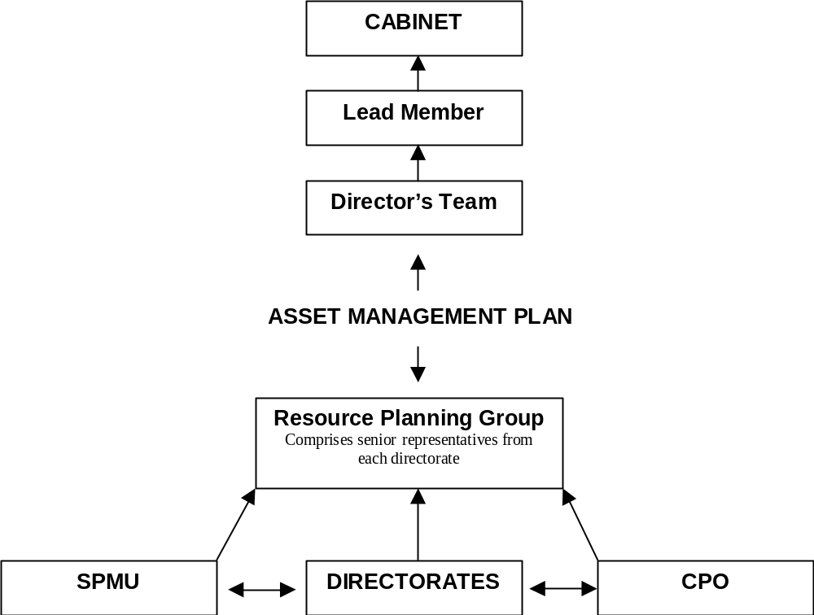

APPENDIX 2
AIMS AND OBJECTIVES FOR PROPERTY
AND ASSOCIATED PERFORMANCE INDICATORS

AIMS | OBJECTIVES | PERFORMANCE INDICATOR
AIM 1  To Provide property to meet corporate and service directorate requirements as efficiently, and economically as possible | To provide property that meets the needs of users in terms of condition, location, quantity and suitability | The band of the Herriot Watt University variance tool into which office accommodation falls measured by customer surveys, user satisfaction surveys
 | To improve year on year with respect to a series of key property performance indicators | Average running costs per M² for specific building categories
 | To utilise space at a level of efficiency commensurate with best practice taking into account the limitations of the building stock | Average M² per person measured using NIA - for office buildings
 | To retain only that service property which is necessary to meet service and service users needs | Production of relevant service property strategies
 | To reduce the maintenance backlog in accordance with a plan and timetable | % of floor area of operational and non operational buildings that are in condition category A-D  % of maintenance costs of operational and non operational buildings in priority level 1 to 3
 | To improve disabled access and comply with other statutory duties | % of buildings suitable for access by disabled people
AIMS | OBJECTIVES | PERFORMANCE INDICATOR
AIM 2  To ensure that property is fully recognised as a corporate asset and that it is managed accordingly | To provide and support the working arrangements necessary to produce effective corporate asset management | Production of annually updated AMP
 | Actively engage all directorates on strategic property matters to the overall benefit of the Council | Does the Resource Planning Group meet regularly and fulfil its role
 | To promote the shared use of property by Directorates and between the council and other partner organisations
AIM 3  To ensure that the investment portfolio provides both income and capital to help to support the Council’s budgetary requirements | To optimise rental income through the estate management activities undertaken
 | To achieve a target Internal Rate of Return (IRR) from the investment estate. | Target IRR
 | To maintain or increase the capital value of the investment estate. | Capital value of the investment estate
 | To meet the Council’s revenue generation targets | The target for capital and revenue income
 | To reduce voids | Occupancy levels in the investment estate
 | To reduce rent arrears | Rent arrears as a % of rent invoiced for the investment estate
AIM 4  To ensure that where appropriate the Council’s property is used to support urban regeneration initiatives and community well being | To identify where property can support and act as a catalyst in initiatives | To identify all council property in urban regeneration areas
 | To define which of the councils non operational property is occupied primarily to support community well being objectives and to manage it in ways which support these objectives

APPENDIX 3

KEY ISSUES
KEY ISSUES | PROPERTY IMPLICATIONS | CURRENT POSITION | FUTURE ACTION | TARGET DATE
Corporate
Call Centre | Space required | To be relocated into Orbit House, Eccles | Complete relocation | Dec-05
Customer Service Centres | Accommodation required | Provide accommodation in LIFT centres | Deliver new accommodation on site | Dec-07
Provision of new Magistrates Court / County Court (incl Community Justice Initiative) | Suitable site required. Disposal/Re-use of existing site | Suitable site to be identified | Acquire suitable site. Agree transfer of Bexley Square | During 2006
Storage space review | Could release office space | Document Management being trialed and impact on storage needs being monitored | Consider corporate storage facility | Dec-06
 |  |  | Procure it appropriately | Jul-07
Office support accommodation | Surplus property to be identified. New needs to be identified. Appropriate accommodation and moves within core sites and satellite offices required | Additional core accommodation being procured. Some bldgs targeted for Disposal. New Strategic Directorates requirements being met | Implement agreed proposals | July 2006 and then ongoing
Work place strategies/ Home working/Hot desking | Potential to reduce office accommodation generally. | Space released by homeworking being occupied by expanding staff numbers | Implement where appropriate | On going action
Partnerships/Joint working with other agencies | Potential for surplus property for disposal or transfer of responsibility to third party and sharing accommodation with partners | 3 partnerships developed between Council and voluntary sector in respect of running children's homes. Joint working established through Salford Partnership. Discussions ongoing re schools | Further negotiations in respect of future partnerships. Continue joint working and identify opportunities for shared use of buildings | Outcomes will be Implemented over 5-years
Disability and Discrimination Act Compliance | Investment required to meet access regulations | Improvements being achieved through implementation of 5 year improvement programme | Implement 5 year improvement plan | Completion 2009
Internal Audit | Capacity constraints created by demand for additional staffing resource for joint computer audit service | Insufficient office space, shortage of meeting space and confidentiality, utilising flexible working as far as possible | Identify relocation opportunities and relocate | Apr-06

KEY ISSUES | PROPERTY IMPLICATIONS | CURRENT POSITION | FUTURE ACTION | TARGET DATE
Community, Health & Social Care

Care Provision - Market Mix In-house/Independent | Potential for surplus property for disposal or transfer of responsibility to third parties | Works progressing | The 2 homes providing interim care will be surplus to requirements | Autumn, 2006
Reconfiguration of day care services | Increased use of community based services/activities leading to a reduced dependency on buildings. Potentially surplus properties for disposal or reuse. | Strategies developed | One day centre in mental health services and one for learning difficulties will close by March 2006. The latter, however, may be retained for a short period to provide alternative accommodation for the duration of the major building works at another day centre. | Mar-06
NHS Partnerships | Shared use of buildings/relinquishing surplus property | A number of examples exist where directorate and NHS staff share buildings and further opportunities for this are being explored. | Continue co-sharing arrangements where efficiencies and service delivery can be achieved. | On-going.
Rationalisation of community facilities | Potential for surplus property for disposal. | It is considered the current number of community centres and the planned community space in the LIFT schemes will be appropriate to meet need. | Continue participation in LIFT project planning. | On-going.
Corporate Governance Restructure | 1) Identification of office accommodation requirements to support new Directorate structure.  2) Transfer of building assets between Directorates. | I) Office accommodation needs from the new directorate to be achieved as part of the corporate strategy approved August, 2005 II) Building assets transferred - September, 2005 | I) Project planning to achieve relocations in progress | Mid-2006

KEY ISSUES | PROPERTY IMPLICATIONS | CURRENT POSITION | FUTURE ACTION | TARGET DATE
Culture and Sport
Libraries Review | 3 neighbourhood libraries may relocate. 2 community libraries to be relocated. | 2 community libraries relocated | Implement remaining outcomes of plan when funding opportunities arise | Implementation anticipated 2007
Working with LIFT project | Integration of Swinton, Eccles, Walkden and Broadwalk Libraries into Primary Care Centres | Schemes agreed in principal | Deliver new accommodation on site | Completion not expected at least until end 2006
SureStart support at Winton | Redevelopment of Winton Library | Works commenced on site | Complete works | Completed
The Community Agenda (Broughton Master Plan) | Future of community based facilities may be affected | Look at New Build or Refurbishment for Broughton Library & North Salford Youth Centre and at the need for library in Lower Broughton/Blackfriars. Potential option identified. Need to draw up business plan with partners to obtain funding. | Respond to Broughton Master Plan and "connections agenda" | Implementation to be agreed
Ordsall Hall Museum | Secure future of building | Conservation Plan completed & upgrade works identified. Access Audience, Development and Archaeology reports completed. Project manager appointed. Architectural Plan expected November 2005. | HLF Funding bid-early 2006 | On-going
Salford Museum & Art Gallery | Physical upgrades to meet developing usage. 2 Categories of work - remedial & development | Awaiting funding for both remedial and development work | Vision and development plan by March 2006. Consultant to be appointed, 2005. | On-going

KEY ISSUES | PROPERTY IMPLICATIONS | CURRENT POSITION | FUTURE ACTION | TARGET DATE
Children’s Services
Schools surplus place review | Surplus schools for disposal/other use | Secondary Review Completed. Works on New Builds are to be carried out under PFI on existing sites, which will release one redundant building. | Once Harrop Fold has moved onto one site in its new PFI building need to deal with surplus buildings by disposal or other use. | Complete by Sept 08.
 |  | Investigating the potential for a second academy in Salford. Area being considered is Central Salford. | Liase with DfES & potential sponsors. | No target set.
 |  | First phase of Primary school review is complete & approved by Cabinet. | Outcomes of Primary review being implemented. | Complete by December 05.
 |  | Second phase of Primary review commenced. Following options considered by Cabinet on March 22nd 2005. One new 2 form entry school for the Weaste, Seedley, & Langworthy area. 2 new 2 form entry schools for the Kersal, Broughton & Blackfriars. | Subject to funding being identified as part of Education's Capital strategy. The new school in Weaste, Seedley & Langworthy is subject to a capital bid submitted to the DfES. | No target set.
 |  | Partnership groups to be set up for Eccles & Winton, plus Little Hulton. | Arrange meetings & discuss options for the schools in the area. | No target set.
 |  | RC Diocesan Review still in progress, but proposals have come forward to remove surplus places in 5 primary schools | No action by City Council | Completion to be agreed.

KEY ISSUES | PROPERTY IMPLICATIONS | CURRENT POSITION |  | FUTURE ACTION |  | TARGET DATE
Children’s' Services
Early Years Accommodation & Children's Centres | Review of Children's Centre complete. Sites identified for new accommodation |  | Commenced a programme of works to establish 9 Children’s Centres | To open all 9 within the funding deadline. 2 already operational at Barton Moss & Winton. Seeking to have the Ordsall Centre funding transferred to phase 2 due to slippage on the timescale for the new school. Other 6 in various stages of completion. | Need to deliver 450 new child care places by 2006. March 2006 for non-school sites. September 2006 for school sites.
Security for schools | Improved security can reduce repair costs |  | Some funding options identified. Works have commenced on various sites. | Encourage school governing bodies to fund security projects using DFC. | No target set.
School AMP - Suitability, Sufficiency & condition. | Remove surplus places and improve condition of remainder. Schools to be improved to help raise standards. |  | New AMP surveys being undertaken for approval by the DfES. Priority works for this financial year & all future years are linked to Education's Capital Investment strategy yet to receive Lead Member approval. | There will be a rolling programme of works for the next 5 years based on the priorities identified in the Education AMP & Capital Investment Strategy. | No target set yet as recommendations to be carried out in accordance with Education's Capital Investment Strategy & where possible linked to the DfES 'Building Schools for the Future' capital investment. In relation to primary schools, this is subject to a review of capital funding by the DfES.
Corporate Governance Restructure | Identify office accommodation requirements to support new directorate. Transfer building assets between directorates. |  | Work in progress | Review of property implications to continue. | January 2006
Jewish High School | School now fully operational, as an LEA maintained school, on the Oakwood site as from 4/01/2005. Completion of new school during 2006. |  | Temporarily sited on the Oakwood site from 1st January 2005 to a date sometime in 2006. New school currently under construction. | School opens on time in September 2006 | September 2006

KEY ISSUES | PROPERTY IMPLICATIONS | CURRENT POSITION | FUTURE ACTION | TARGET DATE
Children’s' Services
Relocation of PRU provision | Suitable site to be identified for one primary PRU. Grosvenor PRU (secondary age pupils) needs to be relocated due to Lower Broughton regeneration. Eccles & Irlam PRU closed due to H&S. | Site being investigated for primary pupils. Permanent Secondary pupils sites linked to BSF, not yet identified. Eccles & Irlam PRU relocated to the ex Silverdale primary school site. Name changed to the Clifton Centre. | Agree site and costed options for primary PRU. Identify temporary site for The Grosvenor PRU, permanent Secondary provision part of BSF. | September 2006 for primary PRU'S No target set for secondary.
Building Schools for the Future (BSF) | To replace/refurbish all secondary schools over a 10 to 15 year period | Notification received from DfES stating that Salford is in the Third Funding Wave. | Option appraisals are being undertaken to identify suitable sites. | Contract signature by 31/03/2008 at the latest.
Creation of 4 locality teams | Local office bases needed for each of these | 1 site identified (Brierley House in Little Hulton) | Identify potential sites for three teams | Spring 2006
Creation of Looked after services | Single office base for 80/100 staff with public access and training facilities (for foster carer training) | Staff of this new service are located on a variety of sites, none big enough for this team (Will assist in closing Avon House) | Identify potential site | Spring 2006
Document storage | There are quantities of bulky children’s social care records which require safe and secure storage | Evaluating suitability of old house at Barton Moss for this purpose | Complete evaluation | Spring 2006

KEY ISSUES | PROPERTY IMPLICATIONS | CURRENT POSITION | FUTURE ACTION | TARGET DATE
Environmental Services
Rationalisation of operational depots | Mess rooms in parks/bldgs to be reviewed | Current service review may lead to changes in property need | Identify changes required and draw up action plan | Complete review by end April 06. Commence action plan May 06.
Sale of cemetery bldgs | Reduction in number of buildings | Swinton Cemetery Lodge sold. Agecroft Cemetery Lodge under review. The lodge is to form part of the wider scheme in relation to the burial chapel. | Implement outcome of Agecroft Cemetery Lodge review. Dispose of lodge if required | Complete disposal if appropriate by Dec 06.
Improvement of mess room facilities | Improved building condition | Some improvements completed and work ongoing | Identify further bldgs for improvement and undertake programme of works | Complete programme by Mar 06.

KEY ISSUES | PROPERTY IMPLICATIONS | CURRENT POSITION | FUTURE ACTION | TARGET DATE
Development
Phase I & II BV Review of Property and the property service | Improved corporate asset management. Improved building 'fit for purpose'. Reduction in property that does not support service delivery requirements | Review progress and report performance | Complete works as set out in Action Plans and report performance | Ongoing
Development Services Partnership with Private Sector | May access resources to improve assets | Urban Vision Partnership Limited Established. | Review performance and investment in improving assets | Ongoing

NATIONAL PERFORMANCE INDICATORS
APPENDIX 4

Property Performance Indicator |  | Actual  2004/05
ODPM pPI 1A  Percentage of gross internal floor area in condition categories A-D | CIPFA Category |  | A | B | C | D
 | Other Land & Buildings |  | 5.22% | 82.21% | 12.43% | 0.14%
 | Community |  | 0% | 100% | 0% | 0%
 | Non-Operational (General) |  | 2.35% | 26.63% | 69.49% | 1.53%
 | Non-Operational Surplus |  | 0% | 50.87% | 37.02% | 12.12%
ODPM pPI 1B  Backlog of maintenance by cost, expressed  - as total value  - as a percentage in priority levels 1-3 |  | Value | P1 | P2 | P3
 | Other Land & Buildings | £11,105,858.00 | 43.50% | 32.97% | 23.52%
 | Community | £3,427.00 | 100% | 0% | 0%
 | Non-Operational (General) | £2,368,576.00 | 16.63% | 79.23% | 4.14%
 | Non-Operational Surplus | £121,924.00 | 40.82% | 55.35% | 3.83%
ODPM pPI 2A, B & C  Internal Rate of Return for: | A= Industrial | 13.05%
ODPM pPI 2A, B & C  Internal Rate of Return for: | B= Retail | 13.69%
ODPM pPI 2A, B & C  Internal Rate of Return for: | C= Agricultural | 12.12 (No change)
ODPM pPI 3  Total annual strategic management cost per sq.m GIA for the portfolio |  | £0.57 PSM
ODPM pPI 4A  Repair and maintenance costs per sq.m GIA |  | £17.33
ODPM pPI 4B  Energy costs per sq.m GIA (gas, electricity, oil, solid fuel) |  | £7.85
ODPM pPI 4C  Water costs per sq.m GIA |  | £2.23
ODPM pPI 4D  CO2 emissions in tonnes of carbon dioxide per sq.m GIA |  | 0.085 Tonnes PSM
ODPM pPI 5A  Cost Predictability – % of projects where outturn falls within +/- 5% of the estimated outturn, expressed as a % of the total number of projects completed in the financial year |  | 20%
ODPM pPI 5B  Time Predictability - % projects falling within +/- 5% of the estimated timescale, expressed as a % of the total number of projects completed |  | 20%

APPENDIX 5

USE OF NATIONAL PI ‘S
NATIONAL PROPERTY PI | USE OF DATA | EXPECTED IMPROVEMENTS/OUTCOMES
1A and B  To measure the condition of property and cost of backlog maintenance where the Council has a repairing liability | In property appraisal when considering changes to the portfolio and in allocating funds within the revenue budget and capital strategy | Improving the condition of poor buildings improving effective service delivery and client satisfaction
2A, B and C  To measure the financial rate of return from the industrial, retail and agricultural investment portfolio | To compare the rate of return from individual properties and categories of properties against a target rate | Will guide decisions on disposals of investment property, particularly where performance is below target
3  To measure strategic property management costs for operational and non-operational property | To compare Salford’s strategic property management costs with others. | That an appropriate level of strategic property management activity is undertaken.
4A, B, C and D  To measure the running costs (Repairs and Maintenance, Energy, Water and CO₂ emissions) for operational buildings | Overall performance is compared with other authorities and performance of individual buildings is compared to identify poor performance where remedial action will be taken | Running costs will be minimised and CO₂ emissions data will help Salford to meet Climate Change Programme targets through targeting action on poorly performing buildings
5A and B  To measure the delivery of capital projects within 5% of budget and estimated time scale | To monitor Salford’s performance and identify need for changes if performance does not meet target | Improvements in procurement process if current performance does not meet target.
APPENDIX 6

RUNNING COSTS OF PORTFOLIO

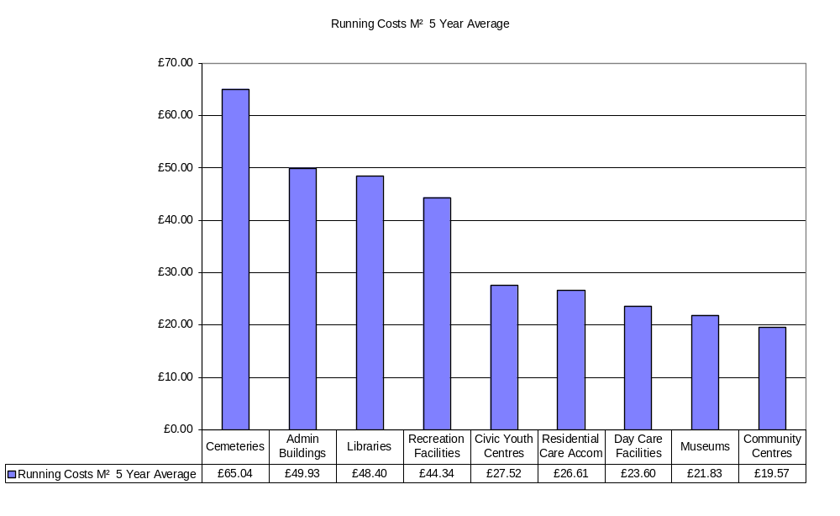

APPENDIX 7
CPA IMPROVEMENT / BEST VALUE REVIEW ACTIVITY

CPA IMPROVEMENT ACTIVITIES – 2005/06

Priority for improvement | Property Implications
Corporate improvement plan | Minimal property implications. Any implications largely around staffing and therefore office accommodation that will be considered in line with the authority’s approach to office accommodation.  Outcome of Stock Options appraisal may affect future of area housing offices
Children’s Services – review of primary school places | Potential implications for numbers of primary schools and /or uses of surplus space
Children’s Services– Early years childcare to be available to all | Potential property implications to provide accommodation for childcare places
Libraries and leisure – improvements to the quality of Salford’s libraries | Property issues arising from inclusion of libraries within  LIFT schemes to be addressed
Libraries and leisure – improving the quality of leisure facilities | Deliver agreed improvement schemes to leisure centres
Housing and Planning – Ensure successful operation of Urban Vision Partnership Ltd | Staff move to Eccles to be delivered December 05
Generally | Directorate improvement plans include a plethora of both process and service delivery improvements, some of which may lead to staffing implications and consequently office accommodation implications as the improvements are worked through and implemented. All such developments will be considered in line with the authority’s approach to office accommodation.

Current programme available for inspection / audit support

Best Value Reviews
Review Title | Lead Directorate | Property Implications
Support Older People at Home | Community & Social Services | Support for older people at home likely to remain therefore no property implications for Council
Support for people with learning difficulties | Community & Social Services | Possible reduction in buildings used for day care provision
Housing Repairs Review | Housing | Call Centre function being market tested. – outcome could affect Salford Directs accommodation requirements. Reduction in satellite office staff has been implemented.
Economic Development | Chief Executives | May affect investment estate holdings and regeneration strategy
Residential Care for Children | Community & Social Services | No property implications
Inspection & Advisory Service | Education & Leisure | No property implications
Housing Planned Maintenance | Housing | No implications for depot accommodation
Outdoor Services & Grounds Maintenance | Environmental Services | May affect occupation/control of depot accommodation
Bereavement Services | Environmental Services | Outcome of heritage lottery funding application may have implications for Agecroft cemetery lodge
Home to School and Social Care Transport | Education & Leisure/Social Services | Administrative base for Central Passenger Transport will be required (no impact on Turnpike operating base)
Building Control | Development Services | No property implications
Development Control and Development Planning | Development Services | No property implications
Construction and Design | Development Services | May affect office accommodation requirements
Youth Service | Education & Leisure | Inspection of youth service has identified property implications that need to be addressed
Culture, arts and heritage | Education & Leisure | Impact on existing museums & galleries
Registration of births, deaths and marriages | Corporate services | May affect Kingslea
Public Protection | Environmental Services | Possible office accommodation issues (minor)
SAP | Corporate services | No Property implications
Safeguarding Children | Community & Social Services | No property implications
Services to people with physical & sensory impairments | Community & Social Services | No property implications
IT NET/Salford Advance | Corporate Services | Possible accommodation issues
APPENDIX 8

PROPERTY APPRAISAL MODEL

Assessment Criteria Appraisal Process
AGREE RELOCATION OF STAFF TO SUITABLE PREMISES

OMV
- Estimated Realisation Price

Cost of relocation to suitable alternative accommodation exceed OMV ?

NO
NO
NO
YES
YES
YES
NO
NO
NO
PREMISES SOLD, LEASED

OR REUSED IF APPROPRIATE
YES
YES
YES

PROPERTY RETAINED
YES
IDENTIFY COSTS AND FUNDING AND BUILD INTO WORKS PROGRAMME

SUITABILITY
- Internal Space
- Support Space
- Location
- Access

MEETS CRITERIA

INVEST TO MEET
CRITERIA

SUFFICIENCY
- Is sufficient
- Well used
- Under used
- Vacant space

MEETS CRITERIA

IMPROVE
UTILISATION

CONDITION
- Category A – D
- Backlog maintenance priority 1 – 3 £

MEETS CRITERIA

INVEST TO MEET

CRITERIA

RUNNING COSTS
- Maintenance
- Energy
- Water
- CO² Emissions

MEETS CRITERIA

INVEST TO MEET

CRITERIA
NO
YES
NO
APPENDIX 9
ACHIEVEMENTS

ACHIEVEMENT | RESULT
Establishing a Strategic Property Management Unit | Ensuring that corporate asset management is achieved
Establishing a Corporate property Officer | Responsible officer for ensuring corporate asset management takes place
Establishing a Lead Member for Property | Ensures a Council focus and member responsibility for property matters
Establishing an intranet site providing information and promoting corporate asset management | Promotes awareness across the whole council
Operation of Environmental Scrutiny Committee | Involves member involvement in target setting, monitoring performance and driving improvement
Integrated working of Asset Management Group and Budget Planning Group through common officer representation | Integrated asset and financial planning
Completion of condition surveys and priority assessments | Accurate condition data and backlog maintenance assists property appraisal and financial planning
Established five year rolling programme of re-surveys | Programmed updating of information
Introduction and operation of Surplus Property Policy | Surplus property dealt with in effective corporate way
Introduction of property requirements database | Matches property needs to property available
Established Property Strategy and Aims and Objectives for Property derived from corporate Mission and Pledges | Establishes clear principles for holding property
Developed local pPI’s and targets to measure success in achieving objectives | Establishes targets monitors and measures improvements
Benchmarking introduced – Core Cities, AGMA, ACES, Sheffield Hallam University | Enables comparison with others and assists in target setting
Completed Property and Asset Management BV Review and implementing the Action plans | Identified improvements required in property and the service being implemented
Established performance reporting for office portfolio | Officer and member monitoring performance
Identification of running costs of the whole portfolio and cost per M² | Identifies areas of high costs and areas for improvement
Property performance reported to Directors | Raises awareness of property costs and performance and encourages improvement
Data needs identified | Only data required for property management and performance analysis collected
Accurate database of core and transient data established | Enables effective management of portfolio and performance assessment
UPRN established | Allows unique cross referencing of properties throughout the council
Storage Space Review | Raises awareness of costs, selected short term option to reduce storage space needs
Option appraisal introduced and being developed | Better resource allocation to meet priorities
Shared use of property with other organisation taking place | Improves service delivery and efficiency in use of buildings
Building occupier and user surveys introduced | Identifies occupier and user perception and needs to influence resource allocation
Suitability surveys introduced | Assist property appraisal and resource allocation
Area based reviews being implemented | Promotes property rationalisation, shared use and efficient use of buildings
Occupier survey of quality of FM services | Assist improvement in FM service
Gap analysis used in property strategy development | Property strategy will properly address future needs
Establishment and operation of the Resource Planning Group | Brings together in one corporate group finance and asset management planning
Achieving improved practices for dealing with surplus property | Cost savings will be achieved
Reduction in amount of operational property | Savings proposals, running costs and generation of capital receipts
Reduction in amount of surplus property | Savings in maintenance, running costs and generation of capital receipts
Achieving a ‘good’ assessment in the corporate AMP CIS and Education AMP | Government recognition of good practice produces financial rewards and freedoms
Significant reduction in schools backlog maintenance | Will improve teaching and learning through creating improved building environment
Establishment of a staff training facility at Broadwalk | Will permit disposal/reuse of existing accommodation

Cont..
ACHIEVEMENT | RESULT
Establishment of Leisure Trust to operate and manage leisure facilities | Focus on improving facilities and improved service to customers
Production of Service Property Strategies (SPS’s) for: -  - Youth Service  - Library and Information Service  - Residential Day Care and Community Services  - Office Support Services  - Sports and Leisure Services | Better awareness and understanding of property performance and defining of works to and changes in services property occupiers
Completion of Primary Schools Review
National Property PI performance comparison through IPF AMP Benchmarking Group | Comparison with other local authorities enables poor performance to be identified and addressed
Introduction of Post Project evaluation | Will assist improved project procurement
Introduction of Home Working principally in revenues and benefits | Reduces pressure for core office accommodation
Space for Sports and Arts at four school sites successfully provided | Improved facilities provided
Accommodation changes for Democratic Services successfully provided | Appropriate accommodation to meet changes in service requirements
Accommodation changes for GMPA at Civic Centre successfully provided | Appropriate accommodation to meet changes in service requirements
Commenced delivery of the Children’s Centres Strategy | New buildings will provide facilities to improve life choices and opportunities for young people.
Accommodation needs for new strategic directorates established and being delivered | Strategic directorates staff being brought together, improving management communication and efficiency
Establishment of Urban Vision Ltd in February 2005 will deliver property, architecture, QS and highway services to the council | Better services for the same or less money and better roads and pavements
DDA access to ‘public access’ buildings being provided | Improved access to council services
First LIFT building opened at Douglas Green, Charlestown | Public have improved access to services
Quality of core office reception areas significantly improved | Enquiries dealt with more efficiently – better customer experience
Four community centres substantially modernised. | Buildings much better suited to users needs
Two intermediate care centres substantially improved. | Building more comfortable and better suited to client and staff needs
Four day care centres substantially improved. | Greater levels of dignity for users. Residential care places avoided.
Leisure Facilities – Fit City Clarendon and Cleavley Running Track refurbished and improved. | Better facilities encourage and improve access to healthy recreation and physical activity resulting in improved health outcomes.
Central Salford URC established. | Will enhance regeneration progress and outcomes.
3 New high schools established using PFI. | Suitable and sufficient new facilities support improved education outcomes.

