

FINAL DRAFT

Salford

Local Improvement Finance Trust (LIFT)

Project Plan





December 2002
Kate Lucy

Contents Page

 | Page No
Foreword | 1
Introduction | 2 - 3
Part 1: Partnering Requirements | 4 – 8
1.1 The Founding Partners | 5
1.2 The Stakeholders | 7
Part 2: The Structure and Governance of LIFT in Salford | 9 - 11
2.1 Salford Executive LIFT Group (SELG) | 9
2.2 Salford PCT | 10
2.3 City of Salford – Cabinet | 10
2.4 Greater Manchester Ambulance services (GMAS) | 10
2.5 Locality Commissioning Groups | 10
2.6 Locality Stakeholder Forum | 10
2.7 Identification of Project | 11
2.8 Prioritisation of Developments | 11
Part 3: The Developments | 12 - 17
3.1 Service Model | 12
3.2 New Intermediate Tier | 12
3.3 1st Wave Developments | 13
3.4 2nd Wave Developments | 17
3.5 Wave 3 and Beyond | 17
Part 4: Action Plan | 18 - 19
Part 5: Glossary of Terms | 20
Appendix 1: Framework for Submitting a Proposal | A1 - i
Appendix 2: Remit of Multi-agency Groups | A2 - i

Foreword
Manchester, Salford & Trafford have been selected as one of the first six national pilot sites for the establishment of Local Improvement Finance Trust (LIFT) joint ventures. This is a tremendous opportunity for Salford PCT to deliver significant improvements to the primary care estate within the context of service development and modernisation.

As an organisation, the Primary Care Trust, will seek to maximise the advantage offered by the LIFT and Salford Health Investment For Tomorrow (SHIFT) to ensure that we reach our strategic aims of delivering the most appropriate service, by the right person, at the right time.

LIFT offers an unparalleled opportunity to facilitate high quality services in local settings.

Along with all our partners, the PCT intends to meet the challenge of securing better, more accessible services for Salford people.

I commend this proposal to you.

Dr E Fairhurst
Chairman, Salford Primary Care Trust

Introduction
The LIFT joint venture will enable the PCT its partners and stakeholders to improve access to services and address the inequalities in health and well-being that currently exist across Salford. By redesigning services to meet the needs of Salford people a genuine opportunity exists to meet the shared aims of a number of partners and stakeholders. We would expect, in future, to provide an increased number of joint services from joint sites with Salford City Council as well as other partners across the whole social economy.

Engaging in a joint venture with the private sector will offer the PCT and its partner’s two major opportunities. It will enable us, jointly with local stakeholders, to access private sector design and management expertise to develop the estate solutions for the delivery of redesigned services. LIFT will also enable us to access alternative sources of funding which are not otherwise available to the NHS.

The purpose of the document is to set the LIFT project within the context of the vision for the future of Salford. It will detail each partner’s requirements, the governance arrangements, current position statement, for each development and a timetable of actions and key dates in relation to the LIFT schemes of work.

The Local Strategic Partnership (LSP) has identified 7 cross-cutting themes that will work together to help deliver the Partnership’s vision for Salford:
- A healthy city
- A safe city
- A learning and creative city
- A City where children and young people are valued
- An inclusive city with stronger communities
- An economically prosperous city
- A city that’s good to live in.

LIFT provides potential to contribute to all 7 themes, but will particularly contribute to creating a healthy city and an inclusive city.

Salford is already benefiting from a major investment in infrastructure, which is being used as an opportunity to undertake whole system service redesign. The SHIFT Project (Salford’s Health Investment For Tomorrow) has unleashed an unparalleled level of creativity and involvement in redesigning health services. The effects are rippling more widely than the health sector, and we have active involvement from Salford City Council, Salford Community Health Council, Salford University, Greater Manchester Strategic Health Authority and Greater Manchester Workforce Confederation. It will deliver new facilities at the Hope Hospital and support the creation of a new intermediate tier of services. It is envisaged that the primary care estate solutions that will be required as a result of the service redesign work within the SHIFT project will be procured through LIFT.

LIFT provides a procurement solution for a fundamentally redesigned service in Salford, most notably the creation of a new intermediate tier of services. The difference between the existing and future arrangements can be characterised as follows:

EXISTING | FUTURE
- District primary, community and secondary sectors | - Pathway focused care with new intermediate tier of services building and extending current skills
- District in hours / out of hours provision | - Increased capacity for urgent care in various locations
- Variable access to services | - Improved access in terms of inequalities, geographical access and professional to professional access

The new network of local centres for Health and Social Care will assist in delivering this vision by: -
- Proving a hub for the co-ordination of activities
- Offering facilities for accessing diagnostic and specialist opinions (including “outpatients” visits)
- Providing extended opening for urgent treatment and advice (8 – late concept)
- Promote well-being through a positive, community focused environment
- Promote inter-agency working through the close proximity of various staff groups

Part 1: Partnering Requirements
The statutory agencies in Salford recognise the need to reform. In order to successfully modernise the health and social care system in line with and beyond the expectations outlined in the NHS Plan, we will work together and involve local citizens and businesses. This joint approach will be more successful than any individual organisation or person could be and as such, we take partnership working seriously. Never-the-less, organisations and individuals have different things to contribute and degrees of involvement vary.

Partners
Salford PCT, City of Salford and Greater Manchester Ambulance Service are formally signed up members of the Manchester Salford and Trafford LIFT and are known as contracting authorities.

Other partner agencies in Salford include statutory and voluntary agencies such as NHS trusts and Salford Community Health Council, some of which have formally pledged their support to the LIFT project. These partner agencies are represented at and contribute to the Salford Executive LIFT Group.

Stakeholders
In addition to the agencies which are working together to deliver the LIFT in Salford, there are a wide range of other stakeholders. Staff, citizens, users of services and local businesses are just a few. The partner agencies are systematically ensuring the involvement of all stakeholders in the developments.

We recognise that we are in the early stages of a new partnership venture and expect to improve the effectiveness of the partnership and increase the numbers of stakeholders involved over time.

It is fundamental that the investment in new and improved premises should not only allow for better co-operation between different agencies, but should also be the catalyst for service redesign. We believe that LIFT in Salford provides an outstanding opportunity for revitalising services across the city. It is understood that health services alone will not deliver the level of health improvement required. Therefore we aspire to commissioning and providing a full range of health and well-being related services and in accordance with the community plan, we seek an approach which addresses the influences on health in a co-ordinated and integrated manner ensuring agencies work together.

The principles that have been adopted, by the partners, to underpin the development of LIFT in Salford are drawn from the consultation exercise which was undertaken in the early phase of the Salford Health Investment For Tomorrow (SHIFT) initiative.
These are:

- Equity
- Accessibility
- Social acceptability
- Added value to regeneration
- Integration with non-NHS developments
- Current and planned developments
- Availability of sites
- Deliverability
- Efficiency

Stakeholder involvement throughout the process is recognised as crucial and the initial arrangements are described in part 2 of this document.

The Local Partners
Salford PCT, Salford City Council and Greater Manchester Ambulance Service are formally contracting authorities within the proposed Manchester, Salford and Trafford LIFT Company. Other Salford partners include the NHS Trusts and Salford CHC.

Each partner organisation brings its own unique resources and requirements to the project. The joint vision is:

“A healthier population, served by excellent services,
provided by the right person,
at the right time
in the most appropriate setting.”

As partners we are committed to a whole system approach where modern public services work in partnership with local people to address deprivation.

- Salford Primary Care Trust
Salford PCT was established in April 2001, as one of the 1st wave PCT establishments. The PCT was also one of the first to receive teaching and learning status. As a newly established organisation its aims and objectives are:
- To improve the health of local people
- To provide and develop primary and community services
- To commission hospital services from other NHS Trusts
To enable the PCT achieve its aims and objectives it is currently developing a new locality management model, which encompasses the NHS plan for modernised services provided locally and greater patient/user involvement. The modernisation agenda gives the PCT a framework within which to provide services differently. This is central to the SHIFT project. In addition the PCT has one of the first four pilot schemes for Local Pharmaceutical Services (LPS), and expert patient programmes.

The PCT offers a wide range of services for example, district nursing, community paediatricians, specialist nursing, psychiatry, psychology and therapies.

Salford PCT is the accountable organisation for the Salford dimension of the Manchester, Salford and Trafford LIFT. Substantial decisions relating to LIFT developments require the approval of the Primary Care Trust Board. As such the PCT takes the lead organisational role for the LIFT developments in Salford.

The PCT recognises that, in order to improve the health of the citizens of Salford, working in partnership is essential. It is only jointly that organisations can tackle the wider issues, which cause poor health such as poor housing, street lighting and crime. Through the LIFT development opportunities have arisen for providers of health social care services to jointly plan and provide services locally that will have an impact on the health and well being of the citizens of Salford. With the development of the new centres the PCT will be playing a part in the regeneration of the area by creating jobs, bringing investment into the city and improving the environments within which we live and work.

- Salford City Council
Salford City Council is responsible for a wide range of services to the citizens of Salford. The Council is committed to innovation, working in partnership and working with our communities. Improvements to the delivery of services and access to information are currently being developed.

The development of One Stop Shops across Salford is integral to the overall Customer Contact strategy. The aim is to improve access to information for the public by restructuring services so that they are holistic and outward facing, with staff based in a minimum number of locations. The One Stop Shop itself will provide a unified front line advice service to customers, which cuts across all services of the City Council. It should consist of generic skilled and empowered “front line” staff, supported by “back office” functional/specialist staff and robust procedures and systems.

The One Stop Shop is intended essentially to improve access to better quality services, by bringing together services, which are currently fragmented, and delivering comprehensive customer service. They will also improve access and opportunity by enabling customers to access service and information from any Customer Service Centre, (not just the specific centre in their locality) and help to develop stronger and more direct relationships with Customers, being more sensitive to their needs and aspirations, and be more able tailor services to local demand, for example, by hosting surgeries or awareness sessions specific to a particular neighbourhood.

The Libraries and Information Service’s objective is to provide equal opportunity of access to the world’s culture, to help overcome the social and economic barriers to education and to ensure that access to information is not restricted by income or computer literacy. Strategy to achieve these objectives includes policies to ensure that library services are provided at the heart of local communities, ensure that library services are provided as part of a multi- agency approach to service delivery and to ensure the continued provision of free access to information in all forms, including the internet. There should be continuing investment in facilities and materials that support the full range of learning in the community, especially targeting people for whom a formal or institutional setting is a barrier.

The Council is responsible for providing personal social services to children and adults who need support to maximise their life chances or to live as independently as possible. The Government is encouraging closer links and service developments between Social Care and NHS services. In Salford the Community & Social Services Directorate, the Primary Care Trust and other NHS Trusts have been working to deliver the modernising agenda in a way relevant to Salford. An integrated joint team now provides adult Learning Disability services. Work is in hand to create an integrated Adult Mental Health service. In 2003 it is likely that there will be significant development in the integration of children’s services.

- Greater Manchester Ambulance Service (GMAS)
Greater Manchester Ambulance Service (GMAS) will be a full shareholder in MAST LIFT. The Trust sees this membership as essential to both its plans for its estate, and as a vehicle for further integration of its services within the local health economy. The principle aims within Salford are for:

- Development of a network of emergency ambulance stations within the new local centres for health and social care. These will ensure more effective coverage across the borough, resolve problems with the poor condition of existing ambulance stations, and develop a closer working relationship with colleagues in primary and community care. This will potentially be linked on some sites to the development of the role of Emergency Care Practitioner (ECP), and the Community Paramedic

- Effective planning for provision of Patient Transport Services (PTS) to the new sites planned for Salford

- GMAS is looking to re-provide a combined Paramedic Emergency Control and NHS Direct Call Centre, to replace the current inadequate facilities. It has been established that this would be located in either Salford or North Manchester, depending on the availability of suitable land. The combined centre, wherever it is located, could potentially act as a control centre for a wider range of out-of-hours and emergency services, including GP, rapid response nursing and CPNs

- An option under consideration would be the transfer of education and training facilities to the Eccles site.

Stakeholders
In order to achieve our vision, stakeholder involvement will be crucial. Stakeholders fall within 3 main groups: local people, staff and local businesses. A stakeholder forum has been established in each of the four PCT localities.

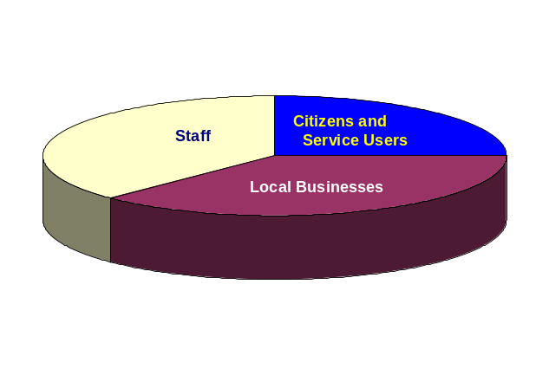
Historically in Salford, local people have been involved in the design and delivery of services. There are numerous examples of exemplary initiatives. This longstanding commitment underpins the development of the Salford Partnership. It is also the basis of the health systems early work on public involvement, which will embrace the development of PALS and Patient Forums and locality working. It is also recognised that we have a long way to go, and look to all partners, including the prospective private partner, to take responsibility for putting local people at the centre of provision. It should be noted that Public involvement in LIFT is taken into account as part of the review of “Involving People” led by City of Salford through the Salford’s Local Strategic Partnership. Figure 2 below sets out the framework for public involvement in the LIFT process.
Figure 1

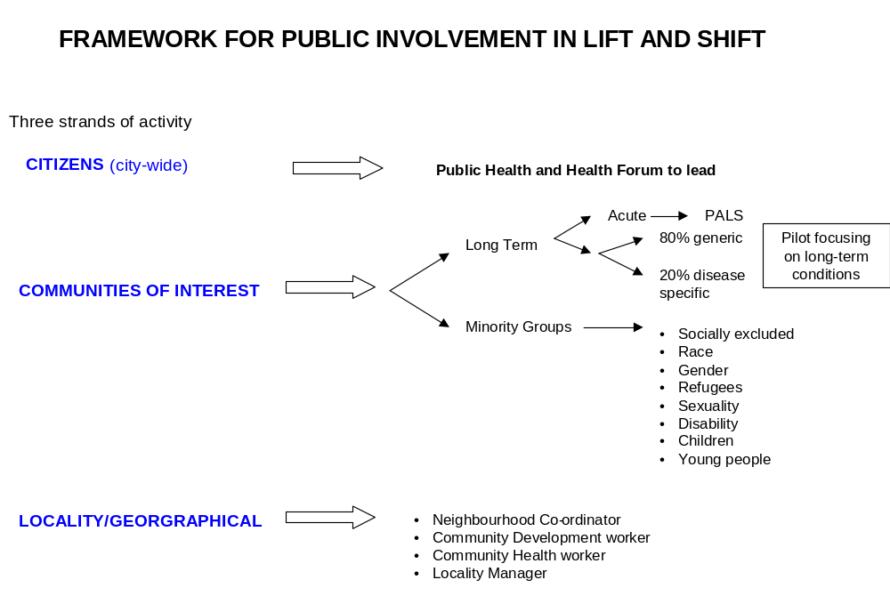 Figure 2

Part 2: The Structure and Governance of LIFT in Salford

Salford Executive LIFT Group
The Salford Executive LIFT Group (SELG) has been established to enable the partners and stakeholders to work effectively together. SELG will to ensure the engagement and consensus of a wide range of stakeholders prior to decisions being made by the Primary Care Trust board. SELG will link into Salford Healthy City Forum as part of the Local Strategic Partnership.

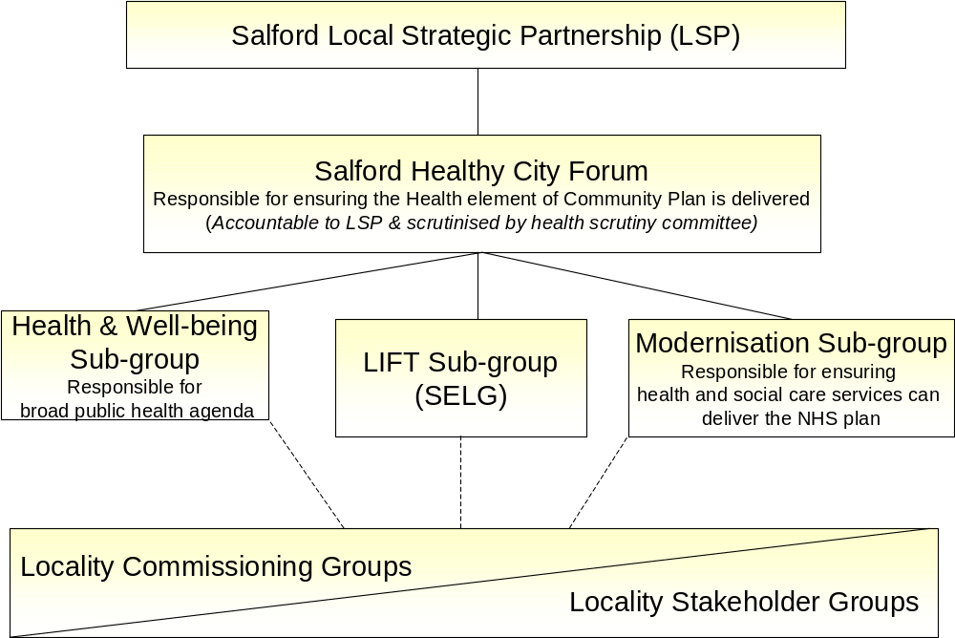
DRAFT STRUCTURE
Figure 3

(For further information on the remit of the LSP refer to appendix 2)

SELG will also engage with the formal decision making mechanisms of the other partners where this is required or desirable.

The Salford Executive LIFT Group is responsible for leadership and co-ordination for Salford LIFT activity, ensuring:

- Recommendations are taken forward to respective decision making bodies.
- Involvement of all key Salford stakeholders.
- Appropriate linkage with Manchester, Salford and Trafford LIFT decision making and governance arrangements.
- Active communication with SHIFT partnership board and sharing of SHIFT processes where feasible.
- Active links with related regeneration initiatives within the Salford Partnership.
- Multi-agency sign up to Salford LIFT plans.
- The development of joint service provision.

Salford PCT
Salford PCT is the accountable organisation for the Salford dimension of the Manchester, Salford and Trafford LIFT. Substantial decisions relating to LIFT developments require the approval of the Primary Care Trust Board.

City of Salford
The City Council operates a cabinet system of government. Decisions relating to the Council’s involvement in LIFT require the approval of the relevant lead member within the cabinet.

In view of the fast track nature of the initial stages of the LIFT project, the Cabinet has formally delegated powers to take decisions in respect of the NHS LIFT Project to the Lead Member for Corporate Services, in consultation with other appropriate Lead Members.

The City Council also has a formal role in the scrutiny of services provided by through the LIFT project. The health and social care scrutiny committee will consider performance against plans, review policy, manage and undertake Best Value Reviews and monitor action plans in respect of its functions and the requirements of the Health and Social Care Act 2001.

Greater Manchester Ambulance Services
Substantial decisions relating to LIFT developments require the approval of the Greater Manchester Ambulance Service NHS Trust Board.

Locality Commissioning Groups
These will be established in each PCT locality. These groups, which will enable a local focus in the planning process, will serve an agenda beyond LIFT and will provide a forum to affect procurement of an increasing range of services. They will advise on how best to make improvements at a local and city-wide level, taking into account national requirements.

Locality Stakeholder Forum
These have been established in each of the four PCT localities as a mechanism to draw together stakeholder views and provide a forum for dialogue. The network of local centres for health and social care will provide a point of initial interest to the new groups, however it is envisaged that their remit will become broader to encompass the wider SHIFT redesign initiative and beyond, as determined by local interest.

Identification of Projects

As the proposed structure develops, future project ideas will be considered from a locality commissioning perspective. The proposal might be put to the locality commissioning group by any stakeholder including an individual contractor, a group of contractors, local people, Salford City Council Members and officers and PCT staff. (A Framework for submitting a proposal can be found in appendix 1)

Prioritisation of Developments

SELG will establish a process for the prioritisation of second and subsequent wave project proposals. Prior to consideration by SELG, proposals should have the support of the Locality Commissioning Group.
Criteria that will contribute to the assessment of proposals for Salford LIFT projects include:

- Implementation of SHIFT Service Redesign
- Contribution to meeting the NHS Plan targets
- Delivery of The Salford Primary Care Strategy
- Resources
- Workforce

Part 3: The Developments
LIFT facilities should not approach health issues in isolation, but should be inclusive, and responsive to the wider needs of the community in which they are located. The opportunity will be taken to mix traditional health services with other functions that attract the widest range of visitors into each facility. For example, it is proposed that the four largest centers will include public libraries, encouraging better dissemination of public information as well as drawing customers into the buildings, and one-stop shops, allowing visitors to access information relating to services provided by all partners. It is also intended that the centres should be designed to allow for a wide range of community uses, including at least one large room available for Community group meetings at each of the town centres.

Service Model
In the future, it is envisaged that services will be:
- Evidenced based
- Co-located in a way that is meaningful
- Provided locally where feasible

The reasons for making these changes are that:
- Current arrangements are not capable of delivering the highest quality health service as measures by national targets.
- Waiting is an issue; we are attempting to design waiting out of the system
- Salford people have poorer health than even the Northwest average; accessing services earlier is an issue.
- People’s health experience is in large part not dependent on health services; we need a whole system approach.
- Land on Hope Hospital site is limited and local people are not in favour of increasing its usage

New Intermediate Tier
The concept of a new intermediate tier recognises that capacity in the current primary and secondary care systems cannot meet anticipated demand.

Emerging from the redesign work of SHIFT is a new perspective on the way of meeting required targets.

This is based on the premise that it is not appropriate to expect clinicians to “just do more”, we have to fundamentally reengineer the provision of service.

Key features of the new intermediate tier are:

- A directly managed electronic booking system
- Providing low risk clinical services in town centre and local settings (including some outpatient clinics)
- Managing diagnostics closer to the patient in order to hasten the process and reduce pressure on hospital sites
- Providing low risk specialist services (including minor surgery, specialist therapies and children’s services) in new, purpose-built town centre facilities.
- Managing an integrated intermediate care service with increased capacity
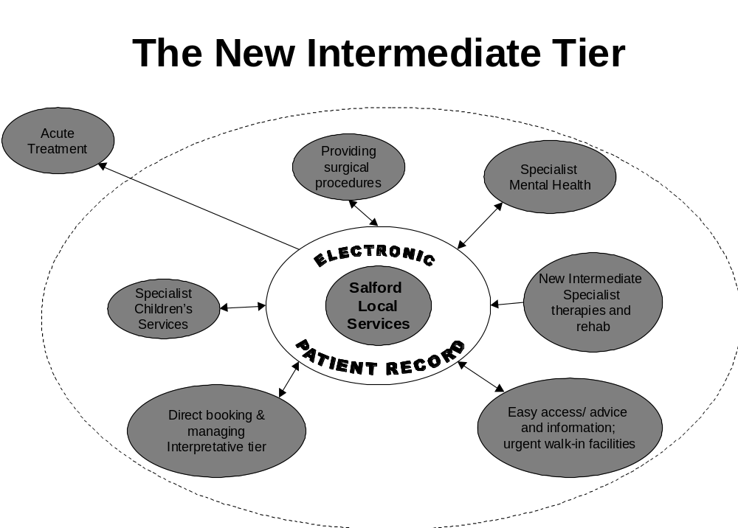
Figure 4

1st Wave Developments
The prioritisation of first wave LIFT projects in Salford is directly linked to the implementation of SHIFT. The SHIFT enabling programme contained in the Outline Business Case provides the time-scale.

The implementation of the SHIFT plan has led to an early focus on the following services:

- Children’s services
- Specialist therapies
- Minor surgery and diagnostics
- Teaching and learning
- Primary care developments

The network of Local Centres for Health and Social Care will include:
First Wave
- Eccles, Walkden, Swinton and Pendleton. These town centre sites will also include specialist, city-wide provision. There will also be two smaller developments in Lower Kersal and Charlestown.

Second Wave
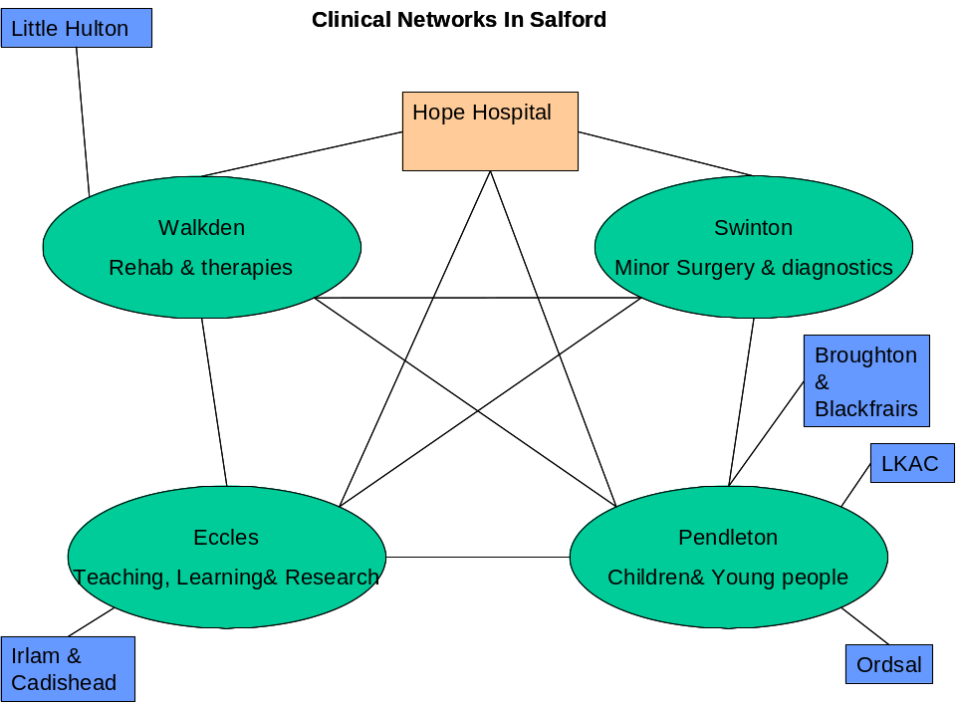
- Little Hulton, Ordsall, Broughton and Blackfriars, Irlam and Cadishead.

Figure 5

Four of the six first wave developments are linked to the service redesign work be undertaken as part of the SHIFT project. With the provision of more specialised services continuing to be provided on a city-wide basis but some of them will be provided in new centres. Providing access to two additional places to obtain an X-ray in Salford will help reduce hospital waiting times for tests. Care will be taken to ensure that best practice guidelines from Royal Colleges, will be taken into account and that unnecessary duplication and destabilisation of services are avoided.

A process to listen to the views of a range of stakeholders has been developed to identify which centres are built in which locations. This has incorporated feedback from City of Salford, local people and practitioners working in the city.

The remaining two schemes are part of an initiative already underway as part of The Lower Kersal and Charlestown New Deal for Communities regeneration project. This work has been developed over two years and aims to provide two centres within Lower Kersal and Charlestown. The developments will have specific themes, and encourage the involvement of local people in the development of the centres.

The map below illustrates the location of the developments across the city.

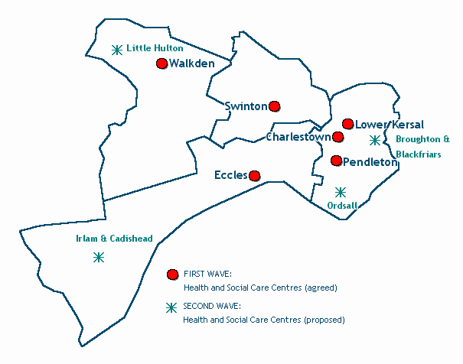
Figure 6
Swinton
The Site:
- Lancastrian Hall & Car park at Partington Lane and Vicarage Road (this land is currently used as a staff car park for City Council Staff)

The Swinton centre will:
- Provide core health and social care services
- Provide specialist minor surgery and diagnostic services (level 2 services)
- Accommodate Swinton library
- Accommodate facilities for a number of community services vital to the area.
- Accommodate a GMAS ambulance station

Walkden
The Site:
- Fitchfield and Cloverfield walk, Walkden

The Walkden centre will:
- Provide core health and social care services.
- Provide specialist therapeutic and rehabilitation services (level 2 services).
- Accommodate facilities for a number of community services vital to the area.
- Accommodate Walkden library.
- Accommodate a GMAS station.

Eccles

The Site:
- The existing Health centre and social services building on Corporation Road
- Potentially the car park adjacent to the social services building.

The Eccles centre will:
- Provide core health and social care services
- Provide specialist teaching, learning and research facilities
- Accommodate facilities for a number of community services vital to the area.
- Accommodate a GMAS ambulance station.

Pendleton

The Site:
- Loganberry Avenue car park
- Potentially the library and police station

The Pendleton centre will:
- Provide core health and social care services
- Provide specialist services for children and young people as well as some diagnostic services (level 2 services).
- Accommodate facilities for a number of community services vital to the area.
- Accommodate Pendleton library

Charlestown
The site:
- St Sebastian’s Church, Douglas Green, Salford, M6 6ES

The centre will:
- Provide core health services and services associated with children and young people and Expert patient programmes.
- Provide a base for the Food Co-op to retail from
- Accommodate facilities for a number of community services vital to the area.
- Accommodate an LPS Pharmacy
- Provide a community garden

Lower Kersal
The site:
- St. Aidan’s Church Hall, Littleton Road and The Vicarage, St Aidan's Church, 90 Littleton Road

The centre will:
- Provide core health services and services associated with children and young people and Expert patient programmes
- Provide a Food co-op (via a mobile vehicle)
- Accommodate a community Launderette
- Accommodate a community Café
- Provide Crèche facilities
- Accommodate facilities for a number of community services vital to the area.

2nd Wave Developments
Second wave schemes will provide health, and social care services to a local area. The philosophy of providing a central point of contact for all health and social care services locally is fundamental to the development of these centres. Further work will be undertaken to describe each project within the relevant localities.

The Schemes are planned for development in: - Irlam & Cadishead, Little Hulton, Ordsall and Broughton & Blackfriars.

Wave 3 and Beyond

Whilst the first and second wave of projects will address some of the greatest needs for new and modernised accommodation in Salford there are still areas which require some further work. Many buildings housing health and social care services are in need of modernisation or extension. LIFT will continue to provide a mechanism to procure new and modernised premises.

Part 4: Action Plan

Key Work Areas | Tasks | Deadline | PCT Lead | Partners
Operational Issues | Joint approach to facilities management – plan  Joint approach to buildings management - plan  Scheduling room use  Joint approach to equipment  Joint approach to one stop, staff management and training | Jan 03  Dec 02  Jan 03  Jan 03 | KL | PCT  City Council  MH  PCT  City Council  MH  All  Partners  All  PCT  City Council
Financial / Legal Issues | Clarity on who can own shares and process for becoming shareholder – Shareholder Agreement  Clarity on leases, sub-leases costing and room sharing  Private Practice Liability  Process / Timetable for purchasing property / land deals / opposition etc. | Dec. 02  Nov. 02  Dec. 02  Dec. 02 | MB | MAST LIFT

Key Work Areas | Tasks | Deadline | PCT Lead | Partners
Technical Design Issues | Agreement on Standards  Link on excellence in design – Princes Trust / Cabe  Link on secure by design  Outline specification check |  | Overview from SHIFT team  (SN/GP) | CC
 | Advice on compliance – Safety, DDA, access, etc. |  |  | PCT  (TM)
Establishing Joint Venture Co. | Identify Salford process for selecting preferred  bidder  Salford representation on board  Salford representation on LIFT Company and mechanism for engagement across MAST | Nov. 02 | MB

Part 5: Glossary of Terms
Term | Definition
CHAP | Community Health Action Partnership
CPNs | Community Psychiatric Nurses
GMAS | Greater Manchester Ambulance Services
LIFT | Local Improvement Finance Trust
LPS | Local Pharmaceutical Service
LSP | Local Strategic Partnership
NDC | New Deal for Communities – is a regeneration programme, in the Lower Kersal and Charlestown are of Salford
Partners | Contracting Authorities: Salford PCT (Lead), Salford City Council and GMAS
PCT | Primary Care Trust
SHIFT | Salford Health Investment For Tomorrow – A project that is undertaking whole systems service redesign across Salford.
Stakeholders | People, agencies, groups, providers of services and voluntary organisations that have an interest in the development of new health and social care centres.

APPENDIX 1

FRAMEWORK FOR

SUBMITTING A PROPOSAL
Framework for submitting a proposal
To ensure that each proposed LIFT development meets the needs of the stakeholders and is affordable, a process must be followed, this includes the completion of a series of documents:

Flow Diagram:
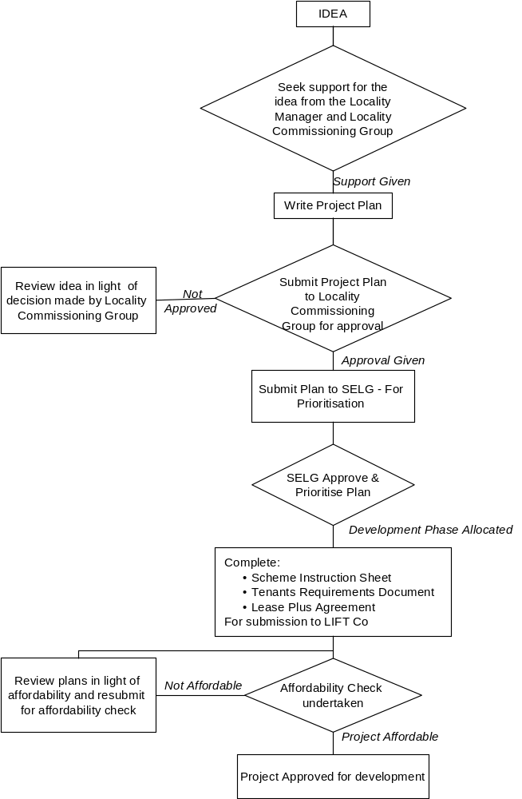

- Project Proposal Plan
The project proposal plan is the initial document that sets the scene for the proposed development. The plan details the current provision of services in the area, outlines the case for change, provides a description of the proposed service/facility and a financial analysis of the proposal.

- Scheme Instruction Sheet (SIS)
The SIS details the properties or sites that are directly involved or related to the development of the scheme. It also details the post development arrangements, this includes identification of the occupiers, lease arrangements and services that occupiers require the LIFT Company to provide.

- Tenants Requirements Document
This document is more detailed than both the project proposal plan and the SIS. It draws information from both these documents to provide a comprehensive brief for the private partner to enable them to develop the project to meet the specified requirements. It briefs the developer of the room requirements, the required atmosphere and operational planning issues. It also specifies the technical requirements / standards that the building must comply with.

- Lease-Plus Agreement Instruction Sheets
The lease-plus agreement instruction sheet, relates to the formation of the lease agreement, it asks a number of questions relating form identifying the tenant(s) to what services the landlord is required to provide.

Copies of all documents are available on request from the Development Directorate.

E-mail address: lift.project@salford-pct.nhs.uk
Telephone Number: 0161 212 4021

APPENDIX 2

REMIT OF MULTI-AGENCY GROUPS

SALFORD PARTNERSHIP- General Protocols
(Agreed at Partnership Meeting July 2001)

The Salford Partnership
The Salford Partnership has been in existence since 1994, and has a core membership that consists of a range of public, private, voluntary and community representatives. In line with Government guidance it is now acting as the Local Strategic Partnership for the whole of Salford.

Terms of reference
Terms of reference as agreed in June 2000 and amended in July 20001 are as follows:
- To harness the energy, expertise, assets and resources of both partners and our communities towards the sustainable development of the City;
- To promote collaborative working and joint action towards agreed priorities within the City;
- To attract and manage all resources effectively and efficiently to improve the quality of life of Salford people
- To work together to raise the city’s profile and influence external policies/decisions

Composition
The Salford Partnership will be made up of the following representatives: -

3 Salford City Council Members – (Leader, Deputy Leader, Housing lead Member);
2 Community representatives (2 Community Committee Chairs);
1 Faith sector (Archdeacon of Manchester)
1 Business Representatives (Chamber of Commerce);
2 Voluntary Sector (Chair and Chief Officer of Salford CVS- 1 voting right);
1 Greater Manchester Police
1 Higher Education- Salford University
1 Lifelong Learning Partnership
1 Learning & Skills Council
1 Manchester Enterprises
1 Benefits Agency
1 Employment Services
2 Health: Salford & Trafford Health Authority and Salford Primary Care Trust

Officers/support from the partner organisations may attend if presenting information or supporting the meeting.

Strategic Protocols
1 The Salford Partnership will work together to achieve the following vision for the City:
“ To create a City of Opportunity where people choose to live and work.”

2 The members of the Partnership will be jointly and separately committed to developing and implementing the Salford Community Plan and its successor documents as the over-arching framework for individual and joint strategies and actions.

3 Partnership Members will be responsible for the review and monitoring of Partner Corporate Strategies and Business Plans to ensure the maximisation of their contribution to the achievement of our shared Vision and Action
Plan as set out in the Salford Community Plan and its successor documents.

4 The Salford Partnership will support the integration and rationalization of existing partnerships to reduce the “bureaucratic burden” and enable local thematic partnerships to become the responsible fora for the development and implementation of the Salford Community Plan and other inter-agency initiatives. Appropriate structural relationships will be developed to be endorsed by all parties.

5 The Partnership will work together to secure the alignment of all existing and future
public resources spent in Salford to achieve the Vision set out above to include
appropriate joint planning and management arrangements.

6 The Salford Partnership will actively and consistently seek to secure community involvement in the work of the Partnership and to ensure the Partnership is accountable to the communities and other stakeholders of Salford.

7 The Salford Partnership will work together to promote the Salford Vision and Partnership targets with other agencies and interests operating both within the City and at the sub-regional, regional, national and international level.

Operating Protocols for the Salford Partnership

1 The Salford Partnership will constitute the Local Strategic Partnership (LSP) for the whole of the area within the local authority boundary of the City of Salford and will undertake responsibilities of an LSP as set out in Government guidance having regard to local and national Good Practice.

2 Members of the Salford Partnership will be Chairs/Leaders/Chief Executives of partner agencies with delegated authority to effect change in the way agencies work together.

3 Membership of the Salford Partnership represents personal commitment to the work of the Partnership, to attend meetings personally and regularly and to prioritise Salford partnership business.

4 Partnership representatives will be nominated and appointed by their relevant constituencies and will be members for a period of 12 months and can be re-appointed or re-nominated. The membership of the Partnership will be reviewed at the Annual Stakeholder conference and can also be reviewed during the year if agreed by the Partnership.

5 Any representative may send a named deputy to the Salford Partnership if he or she is unable to attend, provided the deputy has the support of the representative’s nominating organisation or constituency.

6 The Chair the Partnership shall revolve on an annual basis, to serve for 12 months from each September. Nominations and decision shall be made at the previous scheduled meeting.

7 Salford Partnership meetings will take place approx every 8 weeks.

8 The agenda of the meetings will include discussion on items identified in the Annual Partnership Work Programme and other items identified by individual Members and confirmed by the current Chair.

9 The Partnership will nominate representatives to regional and sub-regional bodies who are normally the most senior person responsible for the relevant activities in Salford.

10 Items that are solely for the Partnership’s information will be circulated separately from the agenda for the meeting but a summary of any issues arising will be made available.

9 The Partnership will commission regular progress reports from the implementation partnerships for the Salford Community Plan.

10 The Partnership will identify joint funding and resources to ensure the effective operation of the Partnership, for example supporting a dedicated Partnership team and commissioning survey or promotional work to benefit the wider Partnership.

11 The Partnership will host an Annual event for all stakeholders who have a direct input into delivery of the aims, objectives and targets of the Salford Community Plan. This will include a report on progress in delivering the Community Plan and will review the constitution, membership and priorities of the Salford Partnership.

Conduct of Meetings
1 The agenda and all accompanying papers will be sent to Partnership Members at least five working days prior to the meeting. Late items may be accepted at the discretion of the chair, or by a majority of voting members.
2 The quorum for the Salford Partnership will be 9 representatives.
3 Decisions taken by the Partnership will be on a consensus basis where possible. In the event of not being able to reach consensus a simple majority vote of these attending will be taken.
4 Minutes of the meeting will be drawn up and circulated to all representatives within one week of the meeting and will be presented for approval at the next meeting.
5 Where confidential items are to be discussed the agenda will be split to clearly identify at which point observers will be excluded.

6 Issues deemed from time to time to be sensitive should remain confidential to limit recognised consequences of disclosure. Members will be expected to adhere to any confidentiality agreement within their own organisations and public meetings until such time that the embargo is lifted.
Items to be identified as confidential only with the agreement of the chair.
7 The Chair in consultation with the Partnership Manager may call additional meetings of the Salford Partnership. Any Salford Partnership member may also call an additional meeting of the Salford Partnership provided that the purpose of the meeting is supported by at least two other members from different organisations including the Chair.

Values and principles of the Partnership

These Values will provide a guide for the actions for the Salford Partnership and other organisations it works with:
- Equality of opportunity and social inclusion
- Honesty and transparency
- Plain language
- Joint accountabilities
- Respect for similarity and differences in ways of working, and the rightful place of legitimate conflict in partnership

Guiding principles describe how the Salford Partnership will act:
- A strong and inclusive partnership
- Quality and customer focus
- Commitment to decision making at local level
- Best value- effective use of resources
- Co-operation
- Valuing the knowledge of other stakeholders
- Making clear priorities
- Promoting self help and independence
- Making it mainstream

The Seven Principles of Public Life
In addition, the Salford Partnership has adopted the Seven Principles of Public Life as good practice for its Members:
Selflessness
Holders of public office should take decisions solely in terms of the public interest. They should not do so in order to gain financial or other material benefits for themselves, their family or their friends.
Integrity
Holders of public office should not place themselves under any financial or other obligation to outside individuals or organisations that might influence them in the performance of their official duties.
Objectivity
In carrying out public business, including making public appointments, awarding contracts, or recommending individuals for rewards or benefits, holders of public office should make choices on their merits.
Accountability
Holders of public office are accountable for their decisions and actions to the public and must submit themselves to whatever scrutiny is appropriate to their office.
Openness
Holders of public office should be as open as possible about all the decisions and actions that they take. They should give reasons for their decisions and restrict information only when the wider public interest clearly demands.
Honesty
Holders of public office have a duty to declare any private interests relating to their public duties and to take steps to resolve any conflicts arising in a way that protects the public interests.
Leadership
Holders of public office should promote and support these principles by leadership and example.

Declaration of intent
“As partners in the Salford Partnership we agree to abide by and vigorously
promote the Vision and general Protocols set out above:
Signed……..”

Salford Partnership Members as at October 2002

Members:

Angie Robinson Chamber of Commerce (Chair)
Archdeacon Wolstencroft Archdeacon of Manchester
C/Supt Brian Wroe Greater Manchester Police
Martin McManus Learning & Skills Council
Edna Robinson Salford Primary Care Trust
Ian Whittaker NWDA
Hinds, Councillor B Salford City Council
John Matthews Chair Eccles Community Committee
Lindsey Harman Employment Services
Jane Doyle GONW
Merry, Councilor Salford City Council
Michael Sheehan Life long Learning Partnership Chair
Paul Thomas Manchester Enterprises
Prof P Bowker Salford University
Tom Togher Salford CAB
David Mottram Salford CVS
Warmisham, Councilor J Salford City Council
Willis, John Salford City Council
Dr Eileen Fairhurst Salford Primary Care Trust
Beryl Howard Vice-Chair Worsley/Boothstown CC

