APPENDIX 1

Planning for Children’s Services

The Children and Young People’s Plan

IN SALFORD

Introduction

All agencies have been required to develop and produce a range of plans. The government has given a commitment to radically reduce the number of plans both statutory and non-statutory required from all agencies. There is also a renewed focus from central government to develop and promote good practice in planning rather than prescribing the content of local plans.

The existing plans are to be replaced by a single children and young people’s plan. The Children Act requires a Children’s Services Authority (CSA) to prepare and publish a plan setting out the Authority’s strategy for discharging their functions in relation to children and young people. This should rationalise the planning arrangements, increase the effectiveness of planning and assist in reducing burdens (‘Excellent’ authorities - CPA - are not required to have a plan).

Requirements

- The plan is the responsibility of the Director of Children’s Services.
- The plan must address the 5 outcomes for children.
- The plan should cover all local authority services e.g. early years and childcare, education, lifelong learning, youth and play services, children’s social services, planning and regeneration, housing, leisure.
- It will also include health, advice and guidance, drugs and alcohol, youth justice, voluntary and community services, education by other authorities.
- The plan must start on 1st April 2006 and may use the model of a three year development plan.
- The plan must contain:

  - A statement of local vision for children and young people:

(a) What the key outcomes (local and national) are
(b) The commitment by all relevant partners to delivering them
(c) The timescale in which this will take place.

- A strategic analysis against the key outcomes.

- An outline of the strategic actions planned to achieve the outcomes, with timescale and costs.

- How the outcomes will be achieved through the development of integrated arrangements at all levels of planning and delivery of children’s services, within the context of the Local Change Programme.

- An explanation of how the plan links to any related plans of key partner agencies and other persons or bodies of any nature who exercise functions or are engaged in activities in relation to the children of Salford, e.g. Police 3 year strategy, Youth Justice, Probation plan, Crime and Disorder, Drug and Alcohol Action Team (DAAT), Schools, 14-19, Child and Adolescent Mental Health Service (CAMHS), Healthy Schools etc.

- An explanation of how the plan fits within the Performance Management and review of services for children in Salford.

- In preparing the plan the Authority must consult:

- The partners within the Salford Children’s Trust
- Children, young people and families
- The Governing Body and Headteacher of every school maintained by the Authority.
- The appropriate diocesan authority for any foundation or voluntary school in Salford which is a Church of England or Roman Catholic Church School.
- Salford’s School Organisation Committee.
- The Early Years and Childcare Partnership.
- Voluntary and Community Sector partners in line with the compact code for consultation and Policy Appraisal.
- The proprietor of every independent school situated in Salford.
- The Local Safeguarding Children Board.

- The plan does not have to be submitted to Central Government but it must be published by 1st April in the year that it starts. Salford must publish the plan by:

(a) Sending a copy to the partners who have been consulted.
(b) Placing it on the Website.
(c) Depositing a copy of the plan in public libraries and other appropriate outlets in Salford.

- The plan must be reviewed annually and this review must be completed by 1st April in any year in which the authority is not required to produce the plan. The review must consider the proposals contained in the plan and their implementation including updating data on key outcomes. Salford must decide whether it is necessary to make any new proposals in respect of the matters reviewed. In conducting the review Salford must consult with those partners who were involved in the development of the plan.

The Children’s Services Improvement Cycle

The Children and Young People’s Plan must be set within the context of a general improvement cycle. The following cycle has been developed by the DfES:

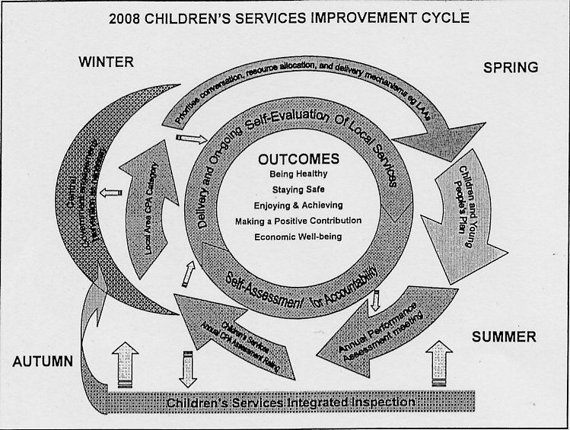

The DfES are introducing the improvement cycle to meet the following objects:

- Encourage better outcomes for children based on the 5 outcomes and 25 aims.
- Promote and support service integration and ensure it is sustained.
- Provide an annual cycle for central and local government over the improvement of Children’s Services Authority’s SA and service areas.
- Utilise Local Area agreements and 2nd generation LPSA’s.
- Align assessment/inspection/improvement activity .
- Align strategic and specialist field forces.

The improvement cycle includes the following key elements:

- Conversation about strategic improvement priorities.

- Self-assessment by CSA and their local partners.

- Planning.

- Annual assessment of children’s services.

- CPA children’s block judgements contributes to overall CPA.

- Integrated inspection - Joint Area Reviews across education, social care and health.

- Agreed, focused support from integrated field forces.

- Where necessary, engagement and intervention by central government to tackle under-performance.

