

Salford City Council

Capital Strategy
&
Asset Management Plan
2005-2006

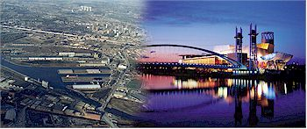

INDEX

Local Authority Core Data Page

- Background to Salford 2

- Revenue Budget 3

- Core Data 3

- Maintenance Backlog 4

- Five year Capital Programme & Resourcing Summary 4

- Unsupported Borrowing 5

Capital Strategy

- Introduction 6

- Key areas of capital expenditure 6

- Other financial implications 9

- Cross cutting activity 10

- Consultation 11

- Links with other partners plans and programmes 11

- Performance measurement and innovation 12

- Management and evaluation 13

Asset Management Plan

- Organisational arrangements for Corporate Asset Management 15

- Consultation 20

- Data Management 23

- Performance Management and Monitoring 26

- Programme and Plan Development and Implementation 29

- Key Issues – Major Challenges 33

APPENDICES

Appendix 1 Reporting procedure flow chart
Appendix 2 Aims and objectives for property and associated performance indicators
Appendix 3 Key Issues
Appendix 4 National Performance Indicators
Appendix 5 Use of National PI ‘s
Appendix 6 Running costs of portfolio
Appendix 7 Best Value Reviews/CPA Improvement Activity
Appendix 8 Property Appraisal Model
Appendix 9 Achievements
Appendix 10 AMP Assessment Criteria Referencing
1. BACKGROUND TO SALFORD

Salford is truly a city of contrasts. Situated in the heart of the Greater Manchester conurbation, it is of the fastest growing regions outside London. The City is at the hub of the transport network, with M602, M60, M61 and M62 motorways all within the City boundaries, and there are also excellent rail and air links, and the Metrolink now extends to Eccles and Salford Quays from Manchester City Centre.

A dynamic and forward looking City, Salford has undergone radical transformation since becoming one of the world’s first industrial cities, redeveloping areas such as the Salford Quays and building the Lowry Centre, a multi-million pound arts and theatre complex.

Salford is a Metropolitan Borough Council with a population of 216,103 according to the 2001 Census. The City is experiencing population loss which has significant resource implications for mainstream service delivery. Since 1991, 14,900 people have left the City with migration levels highest in the inner city.

Over the last thirty years Salford has seen great change; losing almost a third of its traditional employment base has created areas blighted by physical dereliction and social deprivation. However, over the last ten years the City has been successful in tackling many of the social and physical dereliction problems. The redevelopment of Salford Quays has created a world-class business and cultural area of great national and regional significance. Its success has led to the fastest drop in unemployment within the Greater Manchester region.

Within this trailblazing, vibrant City there still exists severe pockets of deprivation; Salford is placed the 4th most deprived local authority area in the North West and 12th nationally.

22.7% of all households with children are lone parent households. The City’s dependent and elderly populations are growing; lone parent households account for 12% of all Salford households of the population and there has been substantial growth in the numbers of looked after children in recent years. The number peaked in 2001 when the number was nearly double that of 1993. The actual number of children looked after in 2004 has decreased by 6% from the peak of 2001. Latest national statistics (to 2002) show that a decrease is against a national trend of increase but that Salford still had the sixth highest number of children looked after per 1,000 population in England.

Due to a number of factors, including the housing market boom and a commitment to the demolition of low demand stock, the numbers of Local Authority voids in the city have fallen considerably. In April 2003, 853 of the city’s 28500 council houses were in a lettable condition but void, by March 2004 this had fallen to 449 or 1.57% of the total stock, falling below the government recommended ceiling of 2%.

Within individual wards there are pockets of multiple deprivation, and a number of areas within the City are currently benefiting from regeneration initiatives, supported by Single Regeneration Budget, European Programmes and New Deal for Communities. The City, in partnership with Manchester, is a Housing Market Renewal Pathfinder area that will bring significant resources into Central Salford to revitalise housing markets. The Regional Development Agency and English Partnerships are also involved in developing schemes that will bring economic and social progress to Central Salford.

We believe the council has an established reputation for its partnership working. We are confident that by working together, listening to our communities and pooling our efforts and resources we will tackle some of the deep-rooted and complex problems faced by local people. We were one of the first authorities to establish a strategic partnership in 1994. Partners IN Salford is now fully accredited by Government as Salford’s Local Strategic Partnership. We have a dynamic chair from the private sector. The Partnership has been rationalised to focus on key priorities. The Partnership's vision, priorities and targets were set down in Salford's first Community Plan, published in 2001.

At the local level we have a well-established partnership/area approach to our communities. Eight community committees are in place, comprising Councillors, representatives of local community/voluntary groups and agencies such as Greater Manchester Police and Salford Primary Care Trust. Each community committee has a local action plan which feeds directly into the Local Strategic Partnership’s 7 themes for the city. The alignment of service delivery by the council, PCT and police with the Council’s community committee areas is developing further local capacity. For example, in health and social care we have embraced the joint commissioning agenda with the PCT. There is extensive ongoing inter-agency service development; for example in the development of the LIFT health centres with the PCT.

The Council continues to face an increasing demand for its services, particularly the care of children. These pressures are within the context of extremely difficult financial circumstances. Consequently, the Council has embarked on a process of reviewing its priorities and corporate objectives to ensure that these guide the distribution of resources, the level at which it carries out its responsibilities and the way in which it exercises its functions.

LOCAL AUTHORITY CORE DATA

2. REVENUE BUDGET
The Council's gross revenue expenditure for 2004/05 is £577.516m and its net revenue budget is £280.403m.

3. THE COUNCIL’S PROPERTY ASSETS

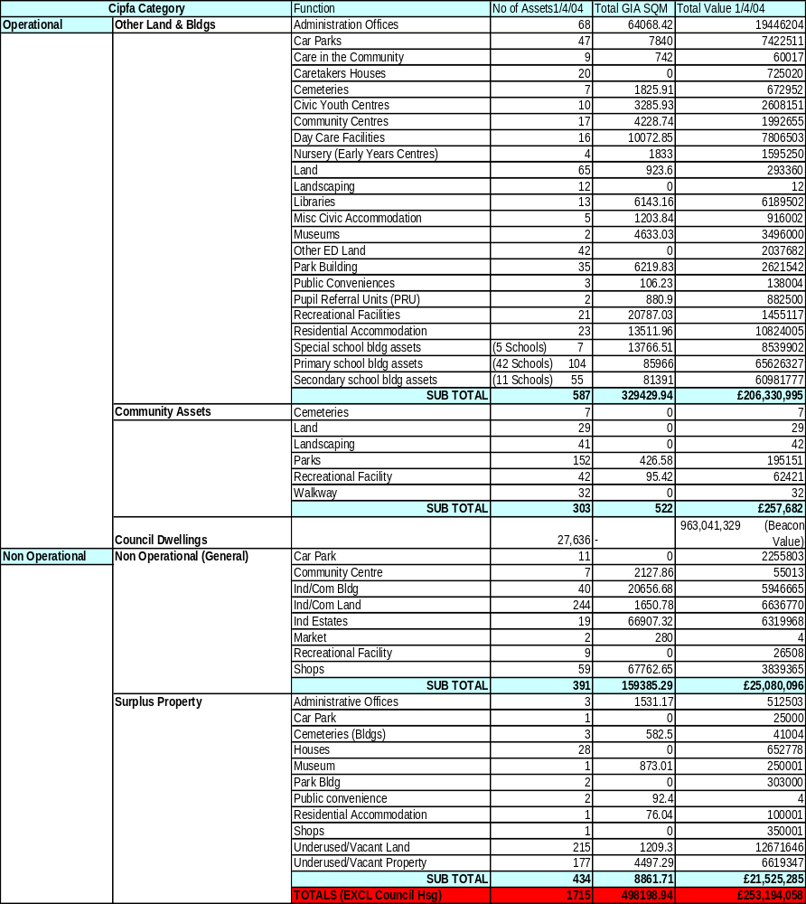

4. MAINTENANCE BACKLOG

Total Requirement Over 5 years @ 2002 prices
£m

HOUSING – Dwellings/Other Buildings | 350 (DATA TO BE UPDATED)
EDUCATION - Schools | 38.3
EDUCATION - Other Buildings | 14.14(DATA TO BE UPDATED)
COMMUNITY & SOCIAL SERVICES | 14.14(DATA TO BE UPDATED)
LEISURE SERVICES  ENVIRONMENTAL SERVICES  DEVELOPMENT SERVICES | 14.14(DATA TO BE UPDATED)
TRANSPORT | 50

5. 5 YEAR CAPITAL PROGRAMME AND RESOURCING SUMMARY

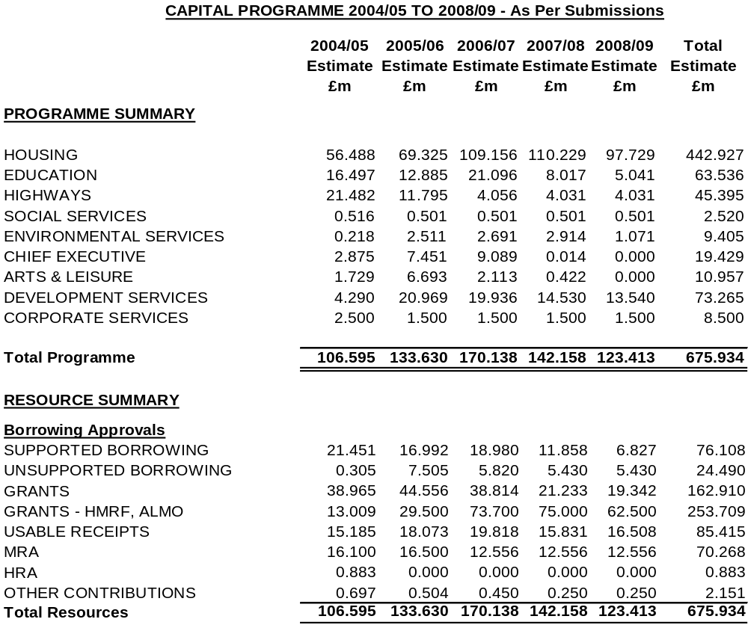

6. UNSUPPORTED BORROWING

The Council will use unsupported borrowing in prescribed circumstances, namely for invest to save purposes, to provide temporary cover for any delayed capital receipt or Government grant, or for priority proposals where it has considered the business case and has determined it can afford the revenue consequences in its revenue budget. Unsupported borrowing of £400k for one project to invest in the improvement of school kitchens and dining rooms has been approved to date, although a number of other proposals are under active consideration for future investment utilising this source of funding,
e.g. investment in the improvement of roads and footpaths, I T investment and pump priming work to stimulate major private sector investment in the Middlebrook area of Salford, and these and other proposals are included in the summary capital programme above.

CAPITAL INVESTMENT STRATEGY

SECTION 1 - INTRODUCTION

This Capital Investment Strategy sets out what the City of Salford wants to achieve in terms of our capital investment over the next five years, covering all key aspects of capital expenditure within the authority and giving examples of partnering and partnership based capital scheme development and delivery. It is our response to the Government’s drive for improved financial planning and accountability and securing value for money from capital investment. It builds upon our last submission and takes account of comments made by GONW.

The City Council and Partners IN Salford (the City’s Local Strategic Partnership) believe that the people of Salford deserve the very best in terms of service delivery and quality. Salford’s first Community Plan (2001 – 2006) drawn up by the Salford Partnership sets the overall vision for our City. It sets the context for this capital strategy with future investment priorities driven by the seven themes of the Community Plan and developed both internally and with our partners and communities.

The Plan aims to create a clean, safe and healthy city with strong sustainable communities and a buoyant economy, where children and young people can thrive and benefit from excellent educational and cultural opportunities and facilities. It will enable the Council and its partners to make the best possible use of public sector assets in order to tackle the crosscutting priorities facing our City in a strategic, partnership based and comprehensive manner.

The Neighbourhood Renewal Strategy, the City’s framework for Neighbourhood Renewal over the next five years, puts regeneration and mainstream service improvement at the heart of the City’s priorities and gives a clear spatial dimension to our interventions. It aims to:

- Develop an integrated strategy to regenerate Central Salford including the areas of major change in Broughton, Seedley and Langworthy and Charlestown/Kersal
- Target action to stabilise communities in Salford West and maximise opportunities
- Work with our communities to achieve change.

Key targets are included within the Community Plan and the Neighbourhood Renewal Strategy to measure the success of our policies over the next five years. These targets reflect the National Floor Targets set by Government through the New Commitment to Neighbourhood Renewal, include key Best Value Performance Indicators and incorporate local performance indicators designed to challenge, target and improve service delivery in particular areas. The targets set have formed the basis of the Partnership’s Local Public Service Agreement with Government, which was agreed in July 2002.

The Community Plan will be reviewed in 2004/05 and the Implementation Framework for the Neighbourhood Renewal Strategy strengthened.

As a parallel to, and integrated within the Community Plan, the Council has developed 7 Pledges that are Council priorities for both statutory and local service delivery. The impact of the pledges has involved the re-alignment of Best Value Performance indicators and service plans to reflect an agreed corporate approach, setting out a commitment towards: Improving Health in Salford, Reducing Crime in Salford, Encouraging Learning, Leisure and Creativity in Salford, Investing in Young People in Salford, Promoting inclusion in Salford, Creating Prosperity in Salford and Enhancing Life in Salford.

The Community Plan, Neighbourhood Renewal Strategy and Capital Investment Strategy together will enable the City Council to continue the regeneration of the City and move towards high quality modern services designed to meet local need.

SECTION 2 - KEY AREAS OF CAPITAL EXPENDITURE

Increasingly, we continue to add value to the City’s Council own capital programme and capital receipt income by capital resources derived from funding from the NWDA and English Partnerships, from special funding such as the Housing Market Renewal Pathfinder and from PFI. In addition, several major developers, house builders and financial institutions are investing within the City and working in partnership with the Council. This creates a new and key challenge for the Council to integrate our resources and programmes more effectively and to gear the use of our own resources clearly to meet the objectives of stimulating other investment to promote the regeneration of the City and better services. We outline below the key areas of existing and prospective capital expenditure in Regeneration, Housing, Education, Transport and Social Services.

Regeneration

The Central Salford initiative is progressing with negotiations underway to form a new model Urban Regeneration Company through founding partners the City Council, the North West Development Agency and English Partnerships. It is anticipated that this will bring in significant private and public resources to assist the City’s successful regeneration, complementing the £44m that Housing Market Renewal funding is bringing in up to 2005/06 initially.

There are existing commitments to capital spend within the City’s main regeneration programmes as follows:
- Housing Market Renewal Programme focused on Central Salford
- Objective 2 Priority 2 European Regional Development Fund Action Plan
- Objective 2 Priority 3 Economic Development Zone in partnership with Manchester City Council along the Irwell Corridor
- SRB5 in Seedley and Langworthy
- The New Deal for Communities programme in Charlestown/Kersal
- Chapel Street Initiative
- National Lottery New Opportunities Fair Shares Transforming your space programme
- Knowledge Capital funding

In addition a number of major masterplanning exercises are underway, including with development partners, which it is anticipated will bring in substantial private sector funding.

Housing

The launch of the “Fresh Start for Housing” sets out a new vision for housing in Salford and we are working hard to realise that. The Housing Strategy and Housing Revenue Account (HRA) Business Plan set out clear priorities for the City. An arms length company model (New Prospect Housing Ltd) became operational in September 2002. New Prospect has taken over the management of housing properties and will play a key role in bringing stock up to the decency standard by 2010.

The “Sustainable Communities Plan” has had a marked affect on future capital investment planning for Housing in two key areas: -

- We are required to have “sign off”, as determined by ODPM/CHTF, of our stock option appraisal process by July 2005. The process was initiated during the summer of 2003 and is driven locally by the following documents:

  - The City Council launched an overarching document “A Fresh Start for Housing” in the autumn of 2003 which re-enforced our strategic intentions
  - The Stock Options Tenant Empowerment and Communication Strategy (TECS) was established in November 2003
  - The Stock Option Appraisal Project Plan

- The designation of Manchester/Salford as a Housing Market Renewal Pathfinder has resulted in the opportunity for increased resources available to renew housing markets and proactively manage neighbourhoods and make a step-change in the Housing Market in the 7 Inner City wards.

The Council’s vision is to help to ensure that every person in the City lives in a decent home and will achieve this by:

- Investment in the management and maintenance of Council and registered social landlord owned dwellings
- Working with home owners and private landlords to help them manage and maintain their properties effectively
- Work to the Government’s target of removing all non-decent public sector housing by 2010 (the stock options work described above will facilitate this)
- Work with private sector partners to reduce unfit and empty private sector housing by one third by 2004
- At present Salford’s ALMO (New Prospect Housing Limited) manages council owned homes. The Audit Commission Inspection 2003 reported that the services provided by NPHL did not attain the standard requirement to draw down ALMO funding. Therefore the City Council withdrew from the ALMO round 2 process and all appropriate options are currently being reconsidered as part of the Stock Option Appraisal.

Priorities over the next five years will be:

- Tackling empty properties throughout the City
- Tackling areas of major change – consistent with the corporate regeneration strategy (see later)
- Dealing with pockets of deprivation to consolidate and stabilise areas (i.e. emerging from the Stock Condition Survey)
- Consolidating and maintaining popular estates and those which have benefited from major investment
- Commissioning and funding the provision of specialist Housing for those vulnerable groups identified in the most housing need through our Homelessness, Supporting People, and Black & Minority Ethnic Housing Strategies.

Education

The Education Asset Management Plan sets out the need to provide high quality Education in accommodation that stimulates a learning environment for school pupils and members of the community. In the medium term the two key priorities within the education capital expenditure will be the significant reduction of the backlog of work identified within the AMP and implementation of proposals resulting from the removal of surplus places, and which should at the same time have an impact on raising educational attainment.

The Directorate has completed a review of secondary places and this is in the process of implementation. PFI credits for Buile Hill, Hope, and Harrop Fold High Schools have been secured to replace all three schools. All three of our Special High schools have been replaced via PFI and one opened in April, with the remaining two schools opening in September 2004.

- The DfES has ambitious plans to replace or refurbish, subject to funds being available, all secondary schools within a 10 to 15 year time frame. Salford is seeking to be in the second wave of the major capital investment, “Building Schools for the Future” (BSF). Partnerships for Schools (PfS) is being set up by the Department for Education and Skills (DfES) and Partnerships UK (PUK), to implement and deliver the BSF programme. To achieve the aims of this new programme a more strategic approach to implementation of local investment will be needed.

- The review of primary school places has been completed and we are implementing the first phase over the next two years. Ongoing consultations about future proposals are being conducted with area review groups that are linked to the regeneration agenda.

Transport

The Unitary Development Plan and Greater Manchester Local Transport Plan set out the transport priorities for the City and wider conurbation. The policies contained in these documents focus on safety, sustainability and regeneration whilst conforming to Planning Policy and Regional Planning guidance.

More recently the GMLTP has collaborated with the Department for Transport and set stretch targets for Road Safety, Air Quality, Accessibility and Congestion. Success in these areas should ensure greater capital allocations in the coming years. Later this year the revised version of the UDP will be the subject of a Local Public Inquiry.

The UDP and LTP objectives are summarised below:

- A focus on regeneration and sustainability
- An holistic approach to urban renewal
- Competing in the global economy
- Creating a dynamic and accessible Regional Centre
- Promotion of sustainable neighbourhoods
- Enhancing urban centres
- Improving the urban fringe and countryside
- Providing high quality sustainable transport
- Reducing population loss from inner areas
- Sustainable growth of Manchester Airport

Arising from these objectives are major transport schemes such as the Manchester/Salford Inner Relief Route currently under construction at an estimated cost of £27 million and due for completion in Autumn 2004, Cadishead Way Stage 2 for which funding of some £19.7 million has now been allocated and work has started and the Leigh/Salford/Manchester Quality Bus Corridor for which funding of £25.9 million has been secured (this scheme has been the subject of a public inquiry which has still to report).

Many minor transport schemes aimed at supporting our public service agreement by improving road safety, promoting integration and maintaining the fabric of the networks are also ongoing, running at approximately £4 million per annum.

Social Services

Social Services’ capital strategy is supporting the improvement of life chances and promoting the independence of people in Salford, through a whole system approach towards Health and Social Care.

The Authority continues to build on its partnerships with users/carers, Salford Primary Care Trust, NHS Trusts, the voluntary sector and independent providers, to shape services to provide integrated single access, support people to live at home and improve life chances of children. The development of Community capacity and neighbourhood management will provide stronger, more stable communities in which to support a range of preventive services, helping vulnerable people to live inclusively.

Salford‘s Health Improvement for Tomorrow (SHIFT) and Local Investment Finance Trust (LIFT) programmes will revolutionise primary health and social care in the City, building 4 new centres for health and social care and bringing forward very substantial investment levels.

Capital resources will be used to support the overall themes of:

- Greater joint working with Health and other partner agencies
- Modernisation of assets to provide “fit for purpose” buildings meeting people’s needs and Disability Discrimination regulations
- Modern accommodation for the effective and efficient delivery of services to people
- ICT infrastructure to develop alternative media for communication and information handling
- Providing modern community centres that will enable social, educational and leisure activities, which will promote active and vibrant communities.

Specific capital schemes will include:

- Investment in Children’s disability service to provide better foster care accommodation and respite care provision
- Investment in Mental Health services to create integrated single access teams across health and social care sector. Including investment to implement the Social Inclusion Unit recommendations
- Investment in the ICT infrastructure to extend electronic delivery of service through email, internet and intranet, plus further development of the CareFirst client information system and improvement in the communications network
- Development of document management and E-procurement to support ESCR and E-government targets for modern service delivery and interaction with service users and providers
- Investment in services to modernise the physical environment of day care opportunities to promote independence by supporting people to live at home
- Development of Community Centres with New Opportunities Funding, to provide community assets to support and promote strong communities

SECTION 3 – OTHER FINANCIAL IMPLICATIONS

Revenue Implications

The Council has habitually considered the revenue implications of capital projects before approving them for inclusion in the capital programme. The revenue budget planning incorporates any project with revenue implications. Provision is made annually in the revenue budget for the additional maintenance costs of capital projects emerging from their contract maintenance period. The prudential code for capital finance has now codified this practice as a requirement in determining the affordability of capital plans and borrowing limits. There are currently no capital projects in the 5-year plan that have major revenue implications for the future.

The Council’s first PFI scheme for 2 new secondary special high schools has been completed in 2004/05 and the unitary charge from the provider and the associated Revenue Support Grant have been accounted for in the revenue budget.

The budgetary plans for 2005/06 to 2007/08 also envisage a major use of unsupported borrowing on an invest to save basis for investment in the improvement of roads and footpaths, which should reduce the revenue provision for tripping claims in particular.

The capital programme continues to support the revenue budget by funding the capitalisation of certain revenue expenditure with the support of Section 40(6) directions from the Secretary of State, utilising capital receipts. The budgetary plans for 2004/05 begin to unwind the capitalisation of revenue expenditure and the elimination of Section 40(6) support and the provisional budgetary plans for 2005/06 envisage a complete unwinding of capitalisation.

Approach to PPP/PFI

The Council is committed to PPP/PFI as a means of achieving desired outcomes where this is the most viable option, as can be evidenced by the following activity: -

- One PFI Special school is now operational, the other two will be operational from September 2004
- Indicative pre-OBC approval from the DfES to a £48m PFI scheme for 3 new high schools
- Indicative pre-OBC approval from the LCD to a £22m PFI scheme for new magistrates courts in Bolton and Salford
- Financial close with the NHS, Salford PCT and other local authorities for the provision of new joint health/local authority facilities, 6 of which will be located in Salford as part of the first wave of development by the end of 2005.
- A limited partnership has been entered into with a funder and developer for regeneration work in Higher Broughton
- Outline heads of term have been agreed for a partnership for area wide regeneration of Lower Broughton and Ordsall
- Nearing contractual close on the transfer of elderly persons homes to a private care provider
- The establishment of a not-for-profit trust for the management of the City’s leisure centres
- Support to the Greater Manchester Waste Disposal Authority in procuring a new long term waste disposal contract via PFI by April 2006
- Selection of preferred strategic and operational partner for the provision of the Council’s technical and associated support services (architectural, engineering and property) are at an advanced stage in the procurement process.
- The City Councils corporate support services such as finance, legal, administration, IT, customer services, HR) services are subject to service reviews to ascertain the most appropriate partnership approaches which would produce the greatest benefit to the City Council.

SECTION 4 – CROSS CUTTING ACTIVITY

Disposal Strategy

The disposal strategy of the Council has been heavily influenced by the funding needs of annual capital programmes, the extent of buoyancy in the property market locally, the need to stimulate private sector investment in certain parts of the City and the supply of assets for disposal. The Council seeks to balance these sometimes conflicting requirements so as to manage the tensions between the need to generate capital receipts and maximise the amount from each disposal by bringing assets to market at the most suitable time.

Between 2000 and 2002 the Council had an over-riding need to raise exceptional amounts through the disposal of assets in order to support the revenue budget through difficult times, by funding revenue that had to be capitalised. Last year these demands eased substantially and this year’s requirement for capital generated from the sale of assets together with projections going forward, is much more modest and has allowed more emphasis to be placed on the timing of disposals and stimulating investment, particularly in the Central Salford area. The City Council will increasingly use its assets to stimulate private sector interest and investment in partnership schemes rather than to secure capital receipts via disposal.

Best Value

Capital investment is an integral consideration in best value reviews. Through the Authority’s performance management system a systematic approach ensures that we monitor our performance against our own short and medium term targets and compare our performance with the best. Detailed consideration is given to the actions necessary to improve our performance. Best value reviews concentrate on the experience and needs of the customer and inform investment decisions. Performance monitoring systems incorporate service results as comparative data and provide benchmarking information, to ascertain where service improvements are needed and, where appropriate, used to inform cross cutting action.

Best Value results are communicated extensively to stakeholders through the Best Value Performance Plan summary document, which is distributed to all households, containing performance feedback from previous years targets and targets for future years.

SECTION 5 - CONSULTATION

Partners IN Salford has been consulted on the development of the Capital Strategy with key partners such as the Salford Primary Care Trust, Police, Job Centre Plus, Manchester Enterprises and the faith community and voluntary sectors endorsing the strategy and ensuring links with the Community Plan. The City’s Community Strategy and Community Committee structures have also been utilised as a consultation mechanism on the Community Plan and Neighbourhood Renewal Strategies from which this strategy flows.

The review of the Community Plan which will take place during 2004/05 will represent a significant opportunity for further consultation.

Local transport programmes, structural and management decisions in the education sector, housing developments and service provision with Social Services are all subject to separate consultation and approval mechanisms within local communities, underpinned by the authority’s approach to customer care, quality services and consultation. Consultation will be taken in accordance with the Council’s constitution and will be linked with the revenue budget process.

Regeneration programmes such as the SRB 5 area in Seedley and Langworthy and the NDC area in Charlestown/Kersal have strong and robust mechanisms for active community involvement in decision-making and developing programmes. The Participatory Appraisal approach is now widely used across the City to actively involve local people in the decisions affecting their neighbourhoods and is widely regarded by Government Office as a significant tool for achieving this.

SECTION 6 - LINKS WITH OTHER PARTNERS, PLANS AND PROGRAMMES

The NWDA’s re-launched Regional Economic Strategy and the emerging Greater Manchester Sub-Regional Strategic Framework provides a key context for the City’s activities and programmes at regional and sub-regional level. Through Partners IN Salford the Community Plan formalises partnership arrangements across the City ensuring consistency across the range of other plans that the Council can influence, including the Health Improvement Programme, LA 21 strategy, Education Development Plan, Lifelong Learning Framework, Economic Development Strategy, Children & Young People’s Strategy and Crime and Disorder Strategy.

Salford has an extremely successful history of working with neighbouring authorities. Close working relationships were developed with Bolton (SRB 3) and Manchester (SRB2). The City Pride Forum brings together the five authorities of Salford, Tameside, Manchester, Trafford and Stockport to promote a sub-regional approach to regeneration, resource procurement and investment. Well-developed links exist on the transportation and environmental quality themes with the Greater Manchester Transport Plan and Air Quality Strategies. The HMRF Pathfinder, the Objective 2 Economic Development Zone and the Knowledge Capital initiative and work to develop the River Irwell and other regional centre locations are current examples of work under development jointly with Manchester City Council.

Partnerships with the private sector also play a crucial role in our approach to capital investment. In Education the Directorate is currently working with the DfES, Partnerships for Schools and potential private sector partners to take forward the delivery of the “Building Schools for the Future” capital investment strategy. This could include the setting up of a LEP.

Innovative solutions have been developed with financial institutions to ensure communities are kept together. The first Homeswap schemes have been completed in Seedley and Langworthy and a customised model is being developed in Broughton. New and exciting proposals for terraced properties in Seedley and Langworthy are under development between the Council, English Partnerships, Urban Splash and may promote an alternative to clearance in appropriate circumstances. Housing renewal areas are being drawn up in conjunction with private sectors partners such as Bovis Lendlease in Broughton, to tackle neighbourhood renewal in a more comprehensive and innovative way. The Chapel Street Initiative has secured significant sums from the private sector to regenerate the area adjacent to the regional centre. The proposed Central Salford Urban Regeneration Company will build upon this and draw in substantial additional private investment and ensure work on current programmes is co-ordinated to deliver added value.

Partnership working has been developed so that we enjoy an even stronger engagement than previously, both strategically and locally, and on the joint delivery of services. Developments include: -
- Closer working with partners through the introduction of forums where the Chief Executive meets with partner CEs (e.g. vice chancellor of the university, CE of PCT, chief of police, government office, chair of LSP) on a regular basis, to discuss common issues;
- Development of a multi-agency partnership approach at the local level, including the council, PCT and police, through our neighbourhood management proposals;
- Reducing crime in our communities, in which our community sector teams and CDRP have been key factors;
- Joint commissioning in the areas of health and social care with the PCT. We now have a number of joint appointments, notably a joint director of public health who is now a member of our Directors Management Team. This partnership working is serving to develop and increase capacity both for the council and for our partners.

SECTION 7 - PERFORMANCE MEASUREMENT AND INNOVATION

The City’s Best Value Performance Plan sets out key performance indicators across service areas with results scrutinised closely by the 5 Scrutiny Committees and annually by the Audit Commission. Achievements and results are communicated across key partners as part of a corporate information strategy but also through individual service and regeneration programmes. The authority is currently looking to develop benchmarking activity in conjunction with neighbouring authorities to analyse more fully the impact of the capital programmes on the desired outcomes for the City. Our Strategic and Best Value Performance Plan for 2004/05 sets out a series of aspirational targets for our services over the next three years. Central to this is the Think Customer pilot that is providing a coherent, multi agency approach to customer focused service delivery.

The City's Best Value Review of its office support accommodation has established a series of PI's including running costs and occupancy levels. Performance targets have been set and are benchmarked through the Sheffield Hallam University Benchmarking Group. This is resulting in improved space utilisation.

The City Council has recently been awarded Beacon Status for Benefits Administration and Supporting People.

Comprehensive Performance Assessment (CPA) provides an additional means of measuring how well services are provided, and how well the Council is run, in comparison to other Local Authorities. Service areas such as benefits and education were praised, but the overall categorisation result was disappointing. Since its CPA designation is “weak,” the Council has built upon its strengths and tackled its weaknesses via improvement planning. These planning proposals will look at two sections: service and cross-cutting issues, and corporate improvements to build capacity. Salford is participating in the pilot scheme for the revised CPA arrangements and will be inspected in July 2004.

As part of our commitment to improve, the Council has signed a Local Public Service Agreement, to meet 12 challenging targets across various services. The City has been awarded £1 M to initiate the improvements. If achieved by March 2005, a further £6M will be made available for additional service improvement. We are at the start of developing our second generation LPSA which will be more partnership based and negotiated with Government for implementation in April 2005.

The Council has taken note of the partnering approach to procuring development recommended by Sir John Egan and utilises that approach in a number of ways. We take a long term view of partnering arrangements and current examples include:

- Development Services Directorate will decide in 2004/5 on a joint venture partner to work alongside in an innovative joint venture company, for all their services which will increase capacity to meet our ambitions and facilitate massive investment in the City’s highway infrastructure.

- Under the Rethinking Construction Implementation Strategy expressions of interest are being sought to work with the Council to provide the planning, design, construction and maintenance services of the Development Services Directorate over the next 5-7 years. In the interim the Council has been Rethinking Construction in a number of ways including applying innovative approaches to procurement on the Eccles Town Centre bypass and Stage 3 of the Salford Inner Relief route which will be developed further for the procurement of Cadishead Way Stage 2, the application of the principles of Rethinking Construction to a £3m Housing Environmental Improvement scheme at Spike Island and a partnership between the City Council’s Landscape Design Group and a Landscape Contractor to bid for, design and construct 3 gardens at the Royal Horticultural Society’s Tatton Park Show.

New Technology Impact

The Council recognises the tremendous capacity improvements that can be achieved via the contribution of ICT in developing modern business structures and processes. We have been a national pathfinder for E-Government for the past three years, and one of only 6 national Customer Relationship Management (CRM) programme partners, and have achieved over 75% e-enablement of council transactions to date through a range of developments. We have implemented (and continue to implement) a range of highly significant and successful initiatives including: -
- The development of an award winning customer contact centre, and an award winning web site www.salford.gov.uk/council/corporate/e-government/contact_centre www.salford.gov.uk
- ECDL (advanced) approved test centre
- Learn Direct – we are one of a handful of hubs nationally and are due to be upgraded to full provider status imminently
- Further improvements to customer access including customer relationship management system, and e-democracy applications
- Improvements to back office systems e.g. SAP, document management, content management
- Continuing investment in core ICT infrastructure to enable improved service provision e.g. broadband rollout, e-mail, Internet and intranet access, e-forms
- Improvements in community ICT capacity through the provision of ICT in local facilities e.g. libraries, community centres, city learning centres and mobile facilities
- Delivering our customer first strategy – The Think Customer pilot is aimed principally at providing the first point of contact to citizens, around life events (including partners), using telephone, face to face, internet and paper channels, and from there reengineering back office services. The pilot has taken the innovative approach of concentrating efforts into a 100 day period up to the 18th June 2004, to evaluate the potential benefits, risks and costs of a collaborative service delivery model, involving both the council and partners.

SECTION 8 - MANAGEMENT AND EVALUATION

The Cabinet considers the Capital Investment Strategy and Asset Management Plan and recommends their adoption to the Council. The annual capital programme is considered within the context of the Strategy and also approved by Cabinet and Council. A spending profile is identified for each approved capital scheme and officers monitor actual cash flow against the profile at monthly intervals during the year. Also, key milestones are identified for each major capital receipt above £100k and monitored by the Corporate Property Officer and the Head of Finance.

The Council has a well structured approach to the monitoring of the capital programme. Project managers and accountants are responsible for the day-to-day management of the programme. Regular progress meetings at this officer level feed into a corporate monthly report on the progress of capital expenditure against the programme to a Budget Scrutiny Committee. Information on asset disposal is also fed into the committee reports via regular progress meetings between Corporate Property Officers and the Head of Finance.

The Budget Scrutiny Committee scrutinises progress with the programme and individual schemes, and makes any recommendations thereon to Cabinet and Council. This process enables closer monitoring of capital cash flow to ensure that the available resources are not over-committed. Service directors are responsible for monitoring and reviewing progress on capital schemes in terms of outputs and outcomes, reporting performance to their Lead Members. The Chief Executive performs a co-ordinating role for cross-cutting and regeneration schemes.

Approach to Prioritisation/Core Criteria/Option Appraisal

The Council currently prioritises its capital investment according to whether it: -

- Meets the Government’s annual capital guideline for each major service
- Maximises available external funding and stimulates other investment
- Meets national, regional and local priorities
- Targets its key priority regeneration areas, i.e. Central Salford, Seedley/Langworthy, Higher Broughton and Kersal/Charlestown
- Supports the revenue budget

The Council has over recent years sought to develop a more objective means of assessing its priorities for capital investment which embraces a wider range of assessment criteria, such as the extent to which they satisfy health and safety requirements, contribute towards enhancing the life of an asset, improve the environment, stimulate the local economy, reduce risk, engage partners and consult with the public. As part of the prioritisation process it has been agreed that weighting is placed upon the assessment criteria in terms of high, medium and low priorities, these consist of the following:

- High Priority Mandatory requirement, maximises external resources or
whereby specific assets will be improved/used
- Medium Priority Strategic impact of the scheme and contribution towards the key themes
of the Community Plan
- Low Priority Other relevant information required to assess prioritisation e.g. revenue
savings

A cross-directorate group comprising officer representatives of the Resource Planning Group and the Asset Management Group tested a prioritisation model for the 2003/04 capital programme, which proved to support the Council’s key criteria for capital investment, and was retained for determining the 2004/05 capital programme.

All Directorates have been invited to submit proposals for the capital programme. Corporate Services will carry out basic financial checks, all proposals which satisfy these checks will be submitted to an appraisal panel to be scored against set eligibility criteria. The appraisal panel will consist of officers from a number of directorates combining financial and project appraisal expertise.

ASSET MANAGEMENT PLAN

1. ORGANISATIONAL ARRANGEMENTS FOR CORPORATE ASSET MANAGEMENT

A. INTRODUCTION
The occupation of property is fundamental to the delivery of the Council’s services. To ensure that the Council’s property is used efficiently and effectively organisational arrangements have been put in place to facilitate the corporate management of assets.

Fundamental to corporate asset management is the operation of the Council’s Resource Planning Group and Strategic Property Management Unit, the activities of the Corporate Property Officer and the role and function of the Lead Member for Property.

This years Asset Management Plan updates the 2003/04 document.

- THE RESOURCE PLANNING GROUP (RPG)
The RPG was established in June 2003 through the amalgamation of the former Asset Management Group and Budget Planning Group.

The terms of reference and role of the RPG includes the strategic management of the Council’s property portfolio and development of the Asset Management Plan and Capital Strategy.
Senior representatives, mainly at assistant director level from all directorates, attend the group with the lead for property matters being taken by the Corporate Property Officer (CPO).

The RPG meets regularly usually on a 4 weekly cycle with additional meetings to consider specific matters when necessary

The Group makes recommendations regarding property to the Lead Member for Property, Directors Team and Cabinet for approval.

With the formation of New Prospect Housing Ltd an arms length company to manage Housing Revenue Account assets, the Housing Services Directorate has created an asset management post to coordinate the Council’s asset management planning and processes with the company and act as the key link with the corporate Resource Planning Group.

- STRATEGIC PROPERTY MANAGEMENT UNIT (SPMU)
The SPMU was established in 2000 as a result of the Council’s Best Value Review of office accommodation and strategic property management. The SPMU is a corporate resource. It acts as a catalyst to raise and promote consideration of corporate property issues and holds and maintains property data and performance information.

The Unit is responsible for raising the profile of property and property performance and for developing and improving strategic management activities including: -

- Property Data | - Accommodation Strategy
- Property Performance | - Procurement and Disposal
- Property Strategy | - Planned Maintenance
 | - Financial Planning for property

- CORPORATE PROPERTY OFFICER (CPO)
The Council has a designated CPO responsible for the development of corporate asset management. Terms of reference for the CPO follow ODPM prevailing guidance.
The terms of reference and roles of the RPG, SPMU and CPO have been endorsed by directorates and approved by Cabinet.

These terms of reference and roles are published on the Council’s intranet site and updated as appropriate. The CPO is involved in the preparation of the Asset Management Plan and Capital Strategy including the setting of capital and revenue targets for property in conjunction with the Head of Finance and he is also a member of the Resource Planning Group. As Head of the Property Division he has an overview of all property matters and is the lead officer for property related public/private sector joint company partnership proposals. The reporting procedure of the RPG, SPMU and CPO through to Directors Team and Members is shown in Appendix 1
- LEAD MEMBER FOR PROPERTY
The Council has a Lead Member for property. His cross cutting role and responsibilities have been defined and agreed by Cabinet. In addition to the formal reporting processes, regular briefings take place between the CPO and Lead Member to ensure that he is aware of and briefed on important property matters. The Lead Member can similarly raise issues with the CPO.

The Lead Member has monthly meetings with the CPO and key officers from the property division and SPMU to receive reports from Resource Planning Group and consider other property matters.

- SUPPORTING CORPORATE AND SERVICE PLAN OBJECTIVES

CORPORATE OBJECTIVES
Property owned or occupied by the Council must be used and managed efficiently, effectively and economically to support the council in achieving its Mission, which is: -

“To create the best possible quality of life for the people of Salford”

To assist the Council in achieving its Mission the Council has made seven pledges to all Salford’s local communities. These Pledges, which were adopted in 2004, are the Council’s priorities for both statutory and local service delivery and are set out below.

 | Pledge | Links to Asset Management
(1) | Improving health in Salford  We will improve the health, well-being and social care of the people in Salford | Start work, in partnership with Salford PCT and the private sector, on the six new primary care centres in Swinton, Eccles, Walkden, Pendleton, Charlestown and Lower Kersal.  Investment in modernising buildings providing day care, rehabilitative and respite care will continue.
(2) | Reducing crime in Salford  We will reduce crime and disorder and improve community safety | Building and improvement schemes to reflect secure by design criteria. Highway works to improve highway safety. Promoting CCTV proposals
(3) | Encouraging learning, leisure and creativity in Salford  We will raise education and skill levels and further enhance cultural and leisure opportunities | Create schools of sufficient size, with stable viable pupil intake and financial stability and sustainability and improve building condition which will provide a suitable stimulating and attractive learning environment to support the delivery of the curriculum and raise education standards. Improve the quality of recreation facilities.
(4) | Investing in young people in Salford  We will focus on services, activities and opportunities to support children and young people in achieving their full potential | Appropriate community, youth, teaching, and residential accommodation for young people in care to be provided.
(5) | Promoting inclusion in Salford  We will tackle poverty and social inequalities and increase the involvement of local communities in shaping the future of the city | Where improving access to services requires building improvement these are identified and undertaken. e.g. DDA compliance for public access buildings.  The policy of promoting social inclusion for people with learning difficulties and physical disabilities will continue by increasing the use of community based services and activities.
(6) | Creating prosperity in Salford  We will ensure an economically prosperous city with good jobs and a thriving economy | Utilise the Council’s property as appropriate particularly within Central Salford Regeneration area, Higher Broughton & Lower Broughton, Seedley and Langworthy, Lower Kersal and Charlestown.
(7) | Enhancing life in Salford  We will ensure that Salford is a city that’s good to live in with a quality environment and decent, affordable homes which meet the needs of a local people | Improve the built environment and in particular the city’s highway and transport network

These Pledges are the strategic drivers for service delivery and service planning across the Council in its support of and contribution to Salford’s Community Plan Objectives and will assist the council to achieve its vision “To create a City where people choose to live and work”

In order to guide its management, use and occupation of property the council has taken the themes arising from its Mission and Pledges, which are reflected in the Strategic and Best Value Performance Plan, to establish a set of six property aims and a series of specific property objectives supporting each aim.

These Aims and Objectives are incorporated into the Council’s’ Property Strategy that has been approved by the RPG, Directors Team and Cabinet. PI’S to measure performance and progress in achieving these objectives have also been established. The Aims Objectives and PI’s are set out in Appendix 2.

- SERVICE PROPERTY STRATEGIES
To ensure that property supports individual service plan objectives the SPMU has worked with service directorates to identify key issues affecting property and their future property requirements to produce service property strategies (SPS’s) These documents set out the vision for a particular service, its property and performance in terms of running costs, condition and backlog maintenance and identifies the changes to the portfolio that are planned.

The service property strategies form a bridge between service plans and the Corporate Asset Management Plan. The corporate AMP identifies the key issues affecting the council in Section 6 and sets outs both Directorate and corporate property issues in the table at Appendix 3.

This table has been developed from the key property issues table in the 2002/03 AMP. Matters that have been dealt with since last year have been removed and new issues added.
The table shows the current position together with future action and time scales. This is a shorthand summary of the situation which acts as a quick reference point, which is reported to Directors, and Members in order that progress in delivery can be monitored and any problems or areas where additional action is required can be identified.

Housing, Education and Transport requirements are dealt with in detail in their respective Plans and Programmes.

- CPA AND BEST VALUE
CPA improvement planning along with Best Value review programmes, are key elements of the Governments agenda to modernise local government and drive improvement. As part of Salford’s Best Value review process property and asset management issues are identified and addressed in each Best Value review. CPA improvement planning generates improvement activities additional to the Best Value review programme. The Council’s Strategic Property Management Unit is working with directorates to ensure appropriate consideration is given to property issues for these improvement activities.

The most significant review in terms of impact on property to date has been the best value review of Property and Asset Management. This review was undertaken in two phases. Phase 1 was a review of Office Support Accommodation and Strategic Property Management. On inspection in May 2001, the Inspectors found a ‘fair’ service, which was ‘probably’ going to improve.

In March 2002 the Phase II review of the remaining property portfolio and property service was completed, though this is not being inspected at the present time.

The completion of this review has made a positive contribution to asset management planning and has been particularly useful in assessing and driving improvement in the performance of the Council’s property see section 4B

Key changes resulting from the review have been: -
- The establishment of an office accommodation strategy
- The introduction of office space standards
- The centralisation of Facilities Management Services
- The introduction of local property performance indicators
- Measures to improve the cost effectiveness of the property service
- Measures to improve building and services user satisfaction
- Identification of property held for investment or social purposes

The property implications of other Best Value reviews and CPA improvement activity is shown at Appendix 7

- FINANCIAL REQUIREMENTS OF THE AUTHORITY
The Council’s capital and revenue requirements are supported by income generated from the investment estate and capital receipts from the sale of assets.

The CPO and Head of Finance as part of the budget planning process set targets for revenue and capital generation.

In 2004/05 the Council’s property portfolio will generate income of approximately £2.94M to support the revenue budget. (This compares with £2.97m in 03/04) This income is made up of; industrial estates and other commercial properties totalling £1.934M, housing shops and properties £666K, markets £210K and other properties and land in the city of £133K.

The capital receipts target for 2004/05 is £11.3m of useable capital receipts
- CONSULTATION

Consultation is an important element in the asset management planning process. The authorities consultation process includes: -

- The operation of the RPG and input to the Group from directorate representatives
- One to one interviews with individual RPG representatives and others to identify key property issues
- High level surveys to establish current perceptions and needs
- Input provided by the SPMU from their cross directorate activities
- Staff consultation on perception of need and property proposals
- Consultation by Directorates with building users
- The Community Plan process
- The result of consultation within individual Best Value reviews
- Consultation process linked to Education Asset Management Plan and Schools Organisational Plan

The results of these activities have informed the formation of the key issues in Section 6 and Appendix 3

- PARTNERSHIP WORKING
Partners IN Salford, the City’s Local Strategic Partnership (LSP) established in 1994, brings together key agencies across the public, private, community and voluntary sectors to promote and develop close collaborative working and has been responsible for the development of the Community Plan and Neighbourhood Renewal Strategy. The Partnership has been consulted on the Capital Strategy.

Through the period of producing the Community Plan the Salford Partnership has achieved a great deal. Collaborative working across many key partners has improved and for the first time integrates the City’s Community Strategy so that local people can see clearly where their priorities fit into the wider picture.

The Community Plan Incorporates more than 50 targets for improving the quality of life over the next five years. These are being delivered within a framework of 7 strategic delivery partnerships which champion the Community Plans themes.

Over the last year these targets have been monitored, reviewed and progress reported to the local strategic partnership. A major review of the whole Community Plan will be undertaken during the coming year with the objective of identifying a small number of key strategic targets which are dependent upon effective partnership working.

In October 2002 the Salford Partnership’s Neighbourhood Renewal Strategy (NRS) was published which provides extensive evidence of local deprivation. It incorporates the floor targets set in the Governments New Commitment to Regeneration - National Strategy Action Plan. The NRS is providing the future framework for renewal activity across partnership agencies. It is a dynamic strategy and will be informed by the unique early warning system, which is a diverse and regularly maintained database which will alert the partnership to the possibility of neighbourhood decline before it has progressed too far.

The Partnership seeks to ensure that all its targets, both within the context of the Community Plan, and NRS, are consistent with other agencies’ targets, including the City Council’s Best Value Performance Plan and Public Service Agreements.

During 2003/04 the LSP prioritised and developed partnership based delivery in three over-arching priority areas. These are:

- Education and basic skills uplift
- Improving the image of Salford
- Improving service delivery and implementing Neighbourhood Management.

The need to improve the quality and co-ordination of community involvement activities across partnership agencies. Funding has been secured to develop a project to progress this and a Good Practice Project has been established. A Best Value review of Community Engagement has also been conducted.

Innovative methods of working with the private sector are being pursued across the City and are having a positive impact on property provision. The creation of an Arms Length Company has taken over the day to day running of housing properties and will bring them up to a decent standard following the provisional resource allocation of £53.5m to manage and maintain local authority housing; Social Services have secured the transfer of Elderly Persons Homes to a Trust designed to secure improved services and facilities by achieving investment in assets; Education will have three special high schools fully operational during 2004 which have been delivered via PFI. Approval has also been given by the DfES for the provision of replacement schools for three mainstream high schools through PFI.
In addition Education is seeking to be part of the second wave of local authority's to replace our remaining secondary schools as part of the BSF capital investment, which could include the setting up of a LEP involving the private sector.

Partnership working within communities is the most important aspect of the City's Community Strategy with the establishment of Community Committees since 1992 enabling local people to participate in the decisions directly affecting them. Community Action Plans outlining local priorities, developed by the community, feed directly into the Community Plan. Regeneration schemes such as the SRB 5 programme in Seedley and Langworthy and the New Deal for Communities programme in Charlestown/Kersal promote local partnership working within communities, with local people directly involved in the management structures established within them. Salford, along with Manchester, has received Housing Market Renewal Funds for 2003/4-2005/06, which will bring in £44m into Central Salford.

The Central Salford initiative is progressing with negotiations underway to form a new model Urban Regeneration Company through founding partners the City Council, the North West Development Agency and English Partnerships. It is anticipated that this will bring in significant private and public resources to assist the City’s successful regeneration, complementing the £44m that Housing Market Renewal funding is bringing in up to 2005/06 initially.

Partners IN Salford fully intends to remain action focussed and it has an agreed work programme to deliver. The Partnership has identified a number of clear opportunities to strengthen its role and performance including:

- The delivery of the Neighbourhood Renewal Strategy.
- The major investment in health services (and in the associated physical, economic and social regeneration) represented by the SHIFT Programme (Salford Health Improvement for Tomorrow - £130m investment over 10 years in Salford’s health services)

In addition the Community Plan will be reviewed during 2004/05 and the Implementation Framework of the NRS strengthened which will offer a major opportunity for greater clarity of partners roles as well as supporting greater efficiency and effectiveness.

Partnership working has also been developed so that we enjoy an even stronger engagement than previously, both strategically and locally, and on the joint delivery of services. Developments include: -

- Closer working with partners through the introduction of forums where the Chief Executive meets with partner CEs (e.g. vice chancellor of the university, CE of PCT, chief of police, government office, chair of LSP) on a regular basis, to discuss common issues;
- Development of a multi-agency partnership approach at the local level, including the council, PCT and police, through our neighbourhood management proposals;
- Reducing crime in our communities, in which our community sector teams and the Crime and Disorder Partnership (CDP) have been key factors;
- Joint commissioning in the areas of health and social care with the PCT. We now have a number of joint appointments, notably a joint director of public health who is now a member of the City Council’s Directors Management Team. This partnership working is serving to develop and increase capacity both for the council and for our partners.

- USER SATISFACTION
The need to develop building occupier and user satisfaction surveys was initially identified in the 2001/02 AMP.

Extensive user satisfaction surveys were undertaken as part of the Best Value Review of Property and Asset Management. The results identified repair and maintenance issues in certain buildings being a particular concern..

Within the Community & Social Services Directorate, consultation with users, carers, and staff is an integral element of service delivery and review. The consultation process includes reference to the suitability of the building to deliver modern services compliant with regulatory requirements. In settings where personal care services are delivered the process also includes the ability to maintain the privacy and dignity of the service user.

User satisfaction is also being used in area based property reviews as one of a set of measures used to assess building performance, as part of the corporate asset management planning.

- COMMUNITY CONSULTATION
The City's Community Plan, which was approved in 2001, is based on the priorities identified within 9 Community Based Action Plans across the City, developed and endorsed by local communities. Consultation with Community Committees on the Community Plan is currently underway. A fuller explanation and examples of the types of community consultation undertaken are included in the Capital Strategy at Section 5.

The Community Plan and Community Action Plans, Directorate’s Service Plans and the operation of specific initiatives Task Groups are recognised as key drivers, which shape asset needs. These are fed into the asset management process and key property implications are reflected in the AMP. This process is shown in the diagram below:

COMMUNITY
PLAN

AMP
Service Delivery
Plans
Property
Implications
Property
Implications

Capital Strategy
-
Thematic Priorities for investment
Specific Initiative
Task Groups
High Level
Property
Implications
Property
Implications
PARTNERS PLANS
Businesses and Other
Public Bodies

9 Local Action
Plans

The implications for property and the changes required identified as a result of these consultation processes is shown in the table of key property issues in Appendix 3.

3. DATA MANAGEMENT
The SPMU maintains a property database that holds core and intermediate data on all the Council’s property, which brings information together from a range of sources. The portfolio is clearly defined and has been categorised into the CIPFA categories plus surplus property. The portfolio and the number of individual assets and their capital value are shown below:

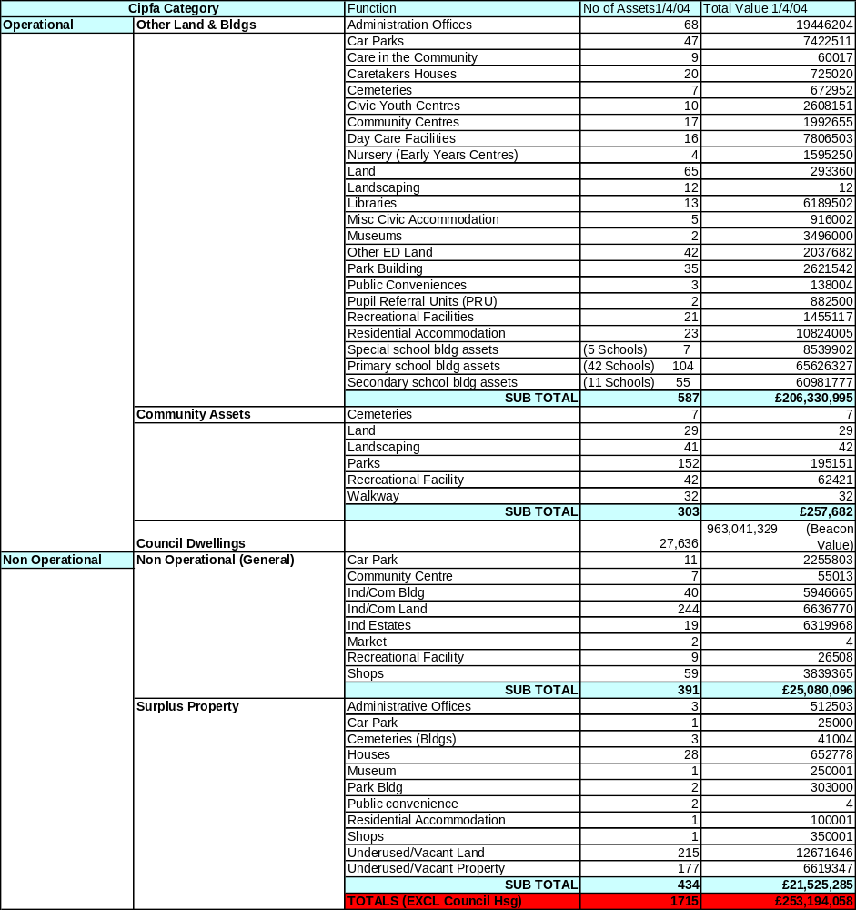

Changes in Portfolio

Through a process performance assessment and improved alignment of property with service delivery needs, the Council has been able to identify assets that are surplus to its requirements. Implementation of the Surplus Property Policy has enabled the Council to significantly reduce the amount of property within its ownership. Reducing the amount of property held has reduced the call on the revenue budget to support building running costs so allowing money that would otherwise have been spent on this property to be redirected to support service delivery. In 03/04 the disposal of surplus assets (excluding Council houses) generated £9.9m in usable capital receipts for reuse by the Council supporting the Capital Programme.
A summary of the changes in the portfolio from April 2003 to April 2004 can be seen in the table below;

CIPFA CAT | No of Assets | Building Area (GIA) Sq.M | Comments
Operational
Other Land & Buildings | Less 8 assets | Plus 30217 Sq.m |  | A recalculation of school building areas has increased the overall Sq.m of operational buildings. Some buildings identified as surplus to requirements through service reviews
Community | Less 2 assets | No change Sq.m |  | 2 land assets removed
Non-Operational
General | Less 6 assets | Plus 2835 Sq.m |  | Some land assets disposed and new buildings included
Surplus | Less 6 assets | Less 22485 Sq.m |  | Larger surplus school building disposed and new smaller surplus assets added
TOTALS | Less 22 assets | Plus 10566 Sq.m |  | Increased area for school buildings plus some land assets removed and some schools extended

Through formal and informal stakeholder consultation we know that the remodelled portfolio is generally better suited to support modern service delivery approaches and has increased staff satisfaction levels without there being any detrimental effect on access to services.

- CORE DATA
The database holds all core data, including a CIPFA property categorisation and a description of the function of the property.

- TRANSIENT DATA
The SPMU is very aware that in addition to the core data, only that data which is relevant and of use in supporting property PI’s, which can be used to improve performance, should be collected. Data is collected to support the national property PI’s and the Council’s local property PI’s that have been derived from the corporate aims and objectives for property.

This transient data, e.g. running costs, occupancy levels and condition is collected and held on the property database. The Council’s financial information is held on a SAP system. This information is currently manually extracted and input into the property database. Transient data is reviewed and updated annually. From the core and transient data, a range of reports can be run on the performance of the Council’s portfolio.

A key area for improvement is the direct transfer of financial information from the SAP system to the property database. This will be addressed in the system development for 2004/06.

The validity of the core and transient data is tested. The data held on the database is checked against and reconciled with primary source data. In updating records, information is received and checked. The data is checked and verified through its use in implementing Best Value review outcomes, in supporting PI’s, providing data to benchmarking groups and also through condition surveys and Target Setting. Whilst there is no formal audit of the data these processes ensure that the data is firmly based and accurate.

- CONDITION SURVEYS
All buildings where the Council has a repairing obligation have been categorised into condition category A to D. The City Council has developed a 5-year rolling programme of surveys, with 20% of the portfolio being inspected every year. This allows for a detailed analysis of a section of the portfolio the percentage change of which is then applied to the remaining buildings where the council have a repairing obligation. This approach has been adopted to facilitate a more manageable and accurate surveying process.. This data has been used to update and refine the backlog maintenance figure included in the context sheet and to support pPI 1A & B
The information on condition categories A to D and priority levels one to three has been broken down into CIPFA categories is shown in Appendix 4 along with the other National PI’s. A summary detailing the overall condition categories A to D is shown below.

Overall Condition Assessment A-D (Total GIA Sq m and %)
A | B  DATA TO BE UPDATED | C | D

The condition of the Education portfolio has been assessed in accordance with DfES guidelines and the resultant information is contained within the Education AMP.

A Council housing stock survey was commissioned from FPD Savilles in Autumn 2003 and the final report was issued in February 2004. We now have a detailed database that includes a 17% sample of all Council housing stock. Analysis of the survey has forecast that expenditure to improve and maintain the stock over 30-years is some £1.53bn. This equates to £52,593 per dwelling or £1,765 per dwelling per annum. On the basis of the stock survey FPD Savills estimate that 69% of the Council’s housing stock failed the Decent Homes Standard (DHS).

The full extent of investment needed to the stock to achieve and maintain the DHS and to keep the building elements in a good state of repair, over the next ten years, is estimated to be in the region of £443 million. Initial analysis has indicated that under current Council policies the amount of investment resources available to the Housing Revenue Account over the next 10 years is some £161 million. This leaves a funding gap of £282 million, or approximately £9,760 per dwelling.
If the Council were to change its policies in relation to usable RTB receipts and Supported Capital Expenditure being recycled into housing investment, then funding gap would probably reduce to some £232 million (£8,050 per dwelling).

- GEOGRAPHICAL INFORMATION SYSTEM (GIS)
The Council’s property portfolio is plotted onto a GIS system. This information facilitates area based property reviews enabling the Council to analyse the distribution of property by category types across the city.

- UPRN AND SYSTEMS DEVELOPMENT
The asset management data is held in an Access database system supported by Excel spreadsheets. The data held contains a UPRN for each land and property asset. Future development will require changes to the Council’s systems to comply with the governments proposals for the NLPG and BS 7666

The Council operates a SAP financial accounting system and it had been expected to introduce a SAP asset management module. However the SAP asset management module proved to be unsuitable to meet all property needs and in particular the developing asset management requirements.

The asset management planning work undertaken over the last three years operating on the existing database has enabled the requirements of an integrated system to be defined and the improvements required to be identified.

Alternative systems have been evaluated against the Council’s requirements for introduction in 2004/06. The new system will bring together all property information and its integration with the SAP financial accounting system. Development Services are currently selecting a Joint Venture Partner who will assist with investment and system development.

Staff in the SPMU have had appropriate training in the operation of the existing systems.
The introduction of a new system will also require operators and users to receive appropriate training. These needs will be identified and provided as an integral part of the actions required to introduce the new system.

- PERFORMANCE MANAGEMENT AND MONITORING

- The SPMU continues to raise the profile of property and the importance of property performance through the operation of the RPG and reports to Directors Team and Members.

Member’s role in driving improvement through the operation of Scrutiny Committee is now well established in Salford. The responsibility for monitoring performance and delivering improvement in property related matters rests with the Development Services sub group (the Scrutiny Sub Group) of Environmental Scrutiny Committee.

The Best Value Review of Property and Asset Management was used to develop a range of local performance indicators for property and the property service. These measure both building and service performance and user and client satisfaction see Appendix 2. These performance indicators will also be used to measure progress in delivering the corporately agreed Aims and Objectives for property. As part of this process targets are agreed with Scrutiny Sub Group which monitors’ performance through a quarterly reporting cycle.

Performance in relation to the ODPM national pPI’s is reported annually to the Scrutiny Sub Group and Directors Team. This performance is shown in Appendix 4. Members have also been advised how these national pPI’s will be used to improve performance together with the improvements which could be achieved. See Appendix 5

Implementing the Council’s Office Accommodation Strategy and Improvement Plan has resulted in improvements in cost and occupancy performance. The improvements measured against the performance indicators and targets agreed with Scrutiny Committee are reported as part of the quarterly reporting cycle.

The running costs for various categories of Council property are shown in Appendix 6. Directors are made aware of their respective services property costs and current office occupancy levels set against the Council’s corporate targets. Performance is also reported to the RPG, Directors Team and the Lead Member for Property.

Property performance information including annual running costs, backlog maintenance and condition category, and DDA issues are included within Service Property Strategies (SPS’s)

It is recognised that Service Directorates could be assisted through the development of further ‘business related ‘ property pPI’s. These will relate business unit transactions (e.g. book lent/enquires handled) to property costs and space occupied and will be progressed as part of developing Service Property Strategies. The Council is continuing its work with benchmarking groups – e.g. IPF, AGMA, Core Cities and Sheffield Hallam University, to assess performance against other organisations. This benchmarking data is being used to set performance targets and improvements are being achieved.

- IMPLEMENTING BEST VALUE OUTCOMES
The Best Value Review of Property and Asset Management has been the most significant Best Value Review affecting all Directorates. This review defined the Council’s office accommodation strategy and identified property service improvements. Significant progress has been made in implementing the office accommodation strategy and the improvement in cost and occupancy performance is shown below. (Note; data includes ALMO occupied buildings)

ITEM | 1999-00 | 2000-01 | 2001-02 | 2002-03 | 2003-04
Number of buildings occupied | 50 | 44 | 40 | 35 | 35
Number of buildings % change in year | baseline | -12% | -9% | -12.5% | 0%
Total floor space Sq.m | 48538 | 43309 | 39792 | 33293 | 33916
Total floor space % change in year | baseline | -10% | -8.1% | -16.3% | +1.87%

The reduction in the amount of office support accommodation the Council occupies has resulted in year on year property running cost savings.

The Phase I review produced a three-year improvement plan that came to an end in September 2003. At the end of this plan period further rationalisation of the office portfolio was required and a further two-year plan has been agreed with Scrutiny Sub Group up to September 2005. The Phase II review produced a 46-point improvement plan approved in March 2002. Of the 46 points 27 have either been completed or are embedded in annual processes and we are on target for completion of the remaining points by the end of the 5-year plan.

- DIRECTORATE PROPERTY PERFORMANCE
All directorates have been informed of their property performance for 2003/04 financial year, in respect of the office portfolio they occupy. Where directorates occupy other service property its running costs have also been reported to them. This process raises directorates’ awareness of property costs and assists in identifying and targeting the potential areas for improvement.

- NATIONAL PERFORMANCE INDICATORS
The Council has collected information required to support the national pPI’s which are reported in Appendix 4

These performance indicators are being used to improve Salford’s performance and how this can be achieved is shown in Appendix 5

Salford’s current level of performance in relation to the national PI’s has been compared with the average figures collated by the IPF Benchmarking Group with a view to identifying and driving areas for improvement. The table below shows the current position;

National pPI | IPF Average  2001/2 | Salford’s Totals 2001/2 | Salford’s Totals 2002/3 | Comments
1A (Condition assessment % of GIA in categories A-D)
(Good) % A
(Satisfactory) % B
(Poor) % C
(Bad) % D
1B (% of Value in priority 1-3)
(Urgent) 1
(Essential 2yrs) 2
(Desirable3-5yrs)3
4
2 A,B&C (Internal Rate of Return)
(Industrial) A
(Retail) B
(Agricultural)C
3 (Strategic Management Cost)_Note: Day to day management costs collected in previous years.
Cost per Sq m | - | -
4 A,B,C&D (Revenue running costs per sq m)
Repairs A
Energy B
Water C
CO2 D
5 A & B ( % Capital Projects on time/on budget )
(% on Budget) A
(% on Time) B

DATA TO BE UPDATED

National PI Summary

With the exception of pPI 1A & B Salford’s general position in relation to the National PI’s is close to the average figures collated by the IPF benchmarking Group. It is recognised that Salford’s portfolio is in a worse condition than the average of other authorities. The underlying reasons for these results have been considered by undertaking further detailed work with the AGMA benchmarking group. It has been concluded that this poorer than average performance could be due to the age of the portfolio, the type of buildings, discrepancies in survey techniques or historic under funding of maintenance budgets. Whilst the council has also reduced its backlog maintenance through actively pursuing the disposal/demolition of surplus assets that has allowed the maintenance budget to be spent on a reduced portfolio, performance remains below the average of other authorities.

- PROGRAMME AND PLAN DEVELOPMENT AND IMPLEMENTATION

Over the past year Salford has continued to improve its asset management planning processes to improve the utilisation of the Council’s assets in support of efficient and effective service delivery, a key achievement being the production of Service Property Strategies.

- FUTURE ASSET REQUIREMENTS
The asset management planning process has brought together consideration of the Council’s Mission and Pledges which support the Community Plan, key drivers of change from the Strategic and Best Value Performance Plan, Service Property Strategies and Directorates Service Plan derived property requirements to produce the key property issues table shown in Appendix 3

This table sets out the Key Issues and their property implications together with a current position statement and action required. This table is reviewed mid year and is updated as part of an annual review process. New areas for change are added which are then prioritised through the Council’s project appraisal process and built in to the Capital Programme and Capital Strategy as appropriate.

- PROPERTY REVIEW AND RATIONALISATION
There are three processes driving the change in the Council’s operational property portfolio these being: -

- The Best Value Review of Property and Asset Management
- Changes in service delivery
- Area based property reviews

The key outcome from the Best Value Review of Property is the clearly established office accommodation strategy setting out clear performance targets for occupancy levels and rationalisation of building stock into four core sites and up to twenty satellite offices. Significant progress is being made in reducing the number of buildings occupied, reducing running costs and providing improved accommodation. – see section 4B

Changes in the way services are being delivered is having a significant impact. The Council is working with Salford Primary Care Trust through the Salford LIFT Project to provide new buildings to accommodate a range of Council, PCT and other services. These buildings will also provide accommodation for the Council’s One Shops which is also being integrated with the PCT. In addition Social Services are continuing to deliver other joint service delivery initiatives with the PCT and Education in developing Children’s Centres proposals with for example Sure Start, with the associated sharing of accommodation.

The area-based reviews assess the performance of property, its condition, suitability, sufficiency and its market value. A review has been undertaken in Irlam and Cadishead, and Walkden and Little Hulton are under way. This work has identified surplus property for disposal to support and enhance the delivery of services. The appraisal model used in area-based reviews is shown in Appendix 8

- OPTION ASSESSMENT
Option assessment is undertaken at both the strategic and project specific levels.

At the strategic level various options for dealing with the Council’s property requirements have been considered as follows:

- Continue current ownership and traditional procurement
- Leasehold occupation
- PFI
- Sale and Leaseback
- Transfer to Trust
- Arms Length Management Organisations taking some responsibilities for property

No single option provides the solution to meet all the Council’s property requirements and different options are selected dependant on circumstances.

Examples of the adoption of new solutions are the use of PFI for the replacement of schools, the move to arms length management for the Council’s housing stock and transfer to trusts for elderly persons homes and leisure centres. The Council has also increased its use of leasehold occupation of office space, as an appropriate solution to meet shorter-term office needs.

At the project specific level different options are considered in order that the most effective option can be brought forward for project appraisal and prioritisation.

- PROJECT APPRAISAL AND PRIORITISATION

High-level option appraisal is undertaken for major regeneration, service and infrastructure proposals to establish the strategic direction for medium to long-term capital investment, with options being presented to Cabinet members for decision

Having established preferred investment options the Council then prioritises its capital investment according to whether it: -

- Meets the Government's annual capital guideline for each major service;
- Maximises available external funding;
- Meets national, regional and local priorities;
- Targets its key priority regeneration areas, i.e. Seedley/Langworthy, Higher and Lower Broughton and Kersal/Charlestown, Chapel Street and renewal areas; and
Provides continuing support to the revenue budget.

The Council has over the past 12 months sought to develop a more objective means of assessing its priorities for capital investment which embraces a wider range of assessment criteria, such as the extent to which they satisfy health and safety requirements, contribute towards enhancing the life of an asset, improve the environment, stimulate the local economy, reduce risk, engage partners and consult with the public. As part of the prioritisation process it has been suggested that weighting is placed upon the assessment criteria in terms of high, medium and low priorities, these consist of the following:

- High Priority | Mandatory requirement, maximises external resources or whereby specific assets will be improved/used
- Medium Priority | Strategic Impact of the scheme and contribution towards the key themes of the Community Plan
- Low Priority | Other relevant information required to assess prioritisation e.g. revenue savings
With investment in regeneration areas being afforded the highest priority.

A model for assessing priorities has been developed and used by a cross-directorate group comprising officer representatives of the Resource Planning Group for the 2003/04 capital programme. To enable the effectiveness of schemes to be reviewed and assessed the appraisal model also requires clear output /outcome targets to be identified.

The lessons learned from applying the model for the first time in 2003/04 have been used to shape the process for 2004/05

- FINANCIAL PLANNING
A 5-year Capital Strategy sets out the Council’s spending plans and priorities, and forecasts how they will be funded, taking into account expected borrowing approvals and grant availability from the Government, forecasts of capital receipts and any other internally-generated funds. Capital investment planning is linked to service planning by ensuring through the priority assessment process that it supports the delivery of the outcomes required from the Community Plan, directorate service plans, the Best Value Performance Plan and the Asset Management Plan, whilst also ensuring that these plans are explicit in outlining major capital and revenue resource implications.

The annual capital programme is refined in the light of actual funding announcements from the Government, the updating of capital receipt forecasts and any emerging spending priorities, e.g. as a result of new Government initiatives, which may not have been identified during the capital investment planning process.

A spending profile is identified for each approved capital scheme and officers monitor actual cash flow against the profile at monthly intervals during the year. Likewise, key milestones are identified for each major capital receipt above £100,000 and monitored by the CPO and Head of Finance. Monthly reports are made to members of Budget Committee and Cabinet on the financial and physical progress with the capital programme and it’s funding. More detail of this process is outlined in the Capital Strategy document section 8.

The introduction of the prudential borrowing code should allow better capital planning by smoothing of timing imbalances caused in the past with borrowing and grant approvals and completion of disposals for capital receipts. It should also facilitate the consideration of more invest to save type proposals, which might have failed in the past due to the lack of available funding.

- SHARED USE
The benefits to be derived from shared use between service directorates and with other bodies have been accepted by the Council and are being positively progressed. Current examples include shared use with the Salford PCT at the Cornerstone and at Burrows House and shared use with the Job Shop, Community Home Care and Salford Community Venture at Salford Opportunities Centre. The Council is developing further links with other bodies through the operation of the Salford Partnership.

Work is most advanced in working with the Salford PCT particularly in connection with the Primary Care Centre initiative and the LIFT project. New LIFT facilities are proposed in six locations within Salford and the first schemes are programmed to commence in autumn 2004.

Joint working with the police is established with the intention of providing Police posts within shared use premises where appropriate.

Shared use by service directorates is well established in various locations e.g. Ordsall Neighbourhood Office and this principle is part of the Council’s office accommodation strategy.

- PLANNED MAINTENANCE AND BACKLOG REPAIRS
The backlog maintenance figures detailed on the context sheet show that the backlog is substantial.

Addressing this backlog in order to deliver the Council’s condition target established as part of the Best Value Review of Office Support Accommodation and to respond to the outcomes from the work on condition priority gradings is a substantial challenge. Information on backlog and how this is being addressed is reported to Directors Team and Members, is set out below and included in the ODPM Performance Indicator 1b shown in Appendix 4

Housing

The Stock Condition survey report concluded that although the Council’s properties had been reasonably well maintained within available resources, major capital investment has been lacking. Consequently, a significant number of major components either have reached or are near to reaching the end of their economic life and will require replacement in the short term.

The sample survey indicated that the total forecast expenditure to improve and maintain the stock over 30-years is some £1.53bn. This equates to £52,593 per dwelling or £1,765 per dwelling per annum. These costs are at November 2003 prices, they include building works and contract preliminaries, but exclude professional fees, management costs and VAT. Professional fees and management costs are expected to add a further c.10% to the major works and cyclical costs. With the addition of professional fees and management costs the total 30-year costs could increase to some £1.682 billion.

The full extent of investment needed to the stock to achieve and maintain the Decent Homes Standard and to keep the building elements in a good state of repair, over the next ten years, is estimated to be in the region of £443 million. Analysis has indicated that under current Council policies the amount of investment resources available to the Housing Revenue Account over the next 10 years is some £161 million. This leaves a funding gap of £282 million, or approximately £9,760 per dwelling. If the Council were to change its policies in relation to usable right-to-buy (RTB) receipts and Supported Capital Expenditure being recycled into housing investment, then funding gap would probably reduce to some £232 million (£8,050 per dwelling).

It should be noted this analysis is based upon the stock within the HRA at the time of the survey, ie 28,877 dwellings, and the rate of right to buy sales at the time, which indicated a reduction in stock by an estimated 3,100 homes over the next 10 years. Subsequent right to buy activity has increased substantially and is currently running at around 860 per annum, although this may slow again particularly if there is a sufficient rise in mortgage interest rates. While this will reduce the extent of the total gap

An options appraisal will examine ways of meeting the investment resources needed through ALMO, PFI, Transfer(s), or a mixed economy of provision, in ways that seek to meet tenants’ and residents’ aspirations while being part of a coherent and sustainable HRA investment strategy. Differences in investment requirements and in tenants’ and residents’ wishes in different parts of the City Council’s housing stock will be taken into account in seeking to produce realistic proposals and bids against government programmes and budgets.

Education

The most recent Education AMP condition data has identified a maintenance backlog of approximately £72.2m, which is likely to increase when the suitability issues for schools have been quantified. Funds, which have been secured, or are confidently, expected, will remove, over the next three years, a further £45.2m of this backlog plus a significant number of suitability issues. Such funds include Schools Devolved Formula Capital, NDS Modernisation, TCF, Supported Borrowing & PFI credits to replace six high schools.

The first stage of the review of the school estate was to remove surplus places in the secondary sector, which included replacing The Albion High school with a new school. This opened in September 2003. The next stage is to replace Buile Hill, Hope and Harrop Fold High schools, using PFI credits of £48m.

The DfES has ambitious plans to replace or refurbish, subject to funds being available, all secondary schools within a 10 to 15 year time frame. Salford is seeking to be in the second wave of this major capital investment,' Building Schools for the Future'. If successful this will help the LEA accelerate the reduction to the condition backlog and remove all current suitability issues in the secondary sector.

Other Directorates

The estimated cost of backlog repairs is £16.59m (excluding transport infrastructure, Housing and Schools). This figure has been reduced from 16.59m in 2003/04. This reduction is the result of a rationalisation and reduction in the Council’s total amount of property held planned maintenance expenditure and the identification and securing of additional resources to deliver specific projects. This approach will be continued though it’s considered that additional resources will be required if a significant improvement in the condition of retained buildings is to be achieved.

- DISPOSAL POLICY
The operation of the Council’s surplus property policy has continued to be improved. This policy also introduced a detailed decommissioning checklist to ensure that an appropriate and consistent approach to decommissioning was adopted across all Council directorates.

The policy has been implemented through the operation of the RPG who are provided with an option appraisal for each building that is declared surplus. The RPG recommendations are then reported to the appropriate Lead Members for approval. The Lead Member for Property also monitors progress monthly on the disposal of surplus assets against targets. The policy has established a target for property to be disposed of within one year of it being declared surplus unless there are specific reasons for a longer period e.g. where land or buildings are being retained for regeneration purposes.

The effective operation of this policy improves performance by: -

- Better decisions being taken through acting corporately
- Reducing the amount of time properties are vacant.
- Target setting and monitoring performance
- Encouraging positive action to identify surplus property

- KEY ISSUES – MAJOR CHALLENGES

The key challenges for the Council, which impact upon the property portfolio, are set out below.

A SOCIAL SERVICES

There are significant challenges in delivering community and social care services in the city, given high levels of health, economic, educational and social disadvantage experienced by many local people.

To meet these challenges the development of partnership working with statutory, voluntary and private sector providers is essential and there are examples of each where successful partnering is assisting with the delivery of modern, integrated services.

The major example of these can be seen in the partnership arrangements with the NHS particularly in the areas of integrated care for older people, learning difficulties, mental health, and therapy services. These initiatives include the joint utilisation of buildings for service delivery and it is anticipated further integration will be made.

The negotiations in respect of the transfer of Homes for Older People to Manchester Care are nearing conclusion. As part of these, two homes closed in April, 2003 have been demolished to give cleared sites to allow a prompt start on the development of new homes on the completion of the contract negotiations. Pending the availability of these, Manchester Care are providing residential care at two other Council owned homes which will close on completion of the new build.

Day care services for older people have been reviewed and the four existing buildings for these will be retained. Investment to modernise these, particularly in respect of bathroom and toilet facilities to meet the needs of the more dependent members of the community in a private and dignified manner, is continuing. Day care services for people supported with learning difficulties and/or physical disabilities are under continuing review with the aim of promoting social inclusion in the community. This may in the longer-term result in a review of building needs in this area.

Significant investment has been made in recent years in improving the Directorate’s office accommodation to provide both good working conditions and I.T. infrastructure. However, there remain a number of office bases in need of improvement or, more probably, relocating in accordance with the Council’s Office Accommodation Strategy. The office needs arising from the evolving Neighbourhood Management model will also need to be reflected in the Office Accommodation Strategy.

The affect of these initiatives has already been seen on the Directorate’s property requirements and it is anticipated future such innovation may further significantly impact upon the building bases needed to support modern service delivery.

B EDUCATION

The key challenge is to respond to the falling numbers of pupils and the need to reduce the number of school places and address the substantial backlog of repairs, which includes buildings that are not fit for purpose.

The LEA has adopted a joint approach with our schools regarding the use of Devolved Formula Capital to help fund the removal of surplus places. The DfES threshold for major capital bids is set at £400,000 and the Primary Review has identified a lot of minor schemes that will fall below this threshold in value.

The Albion High School created by the amalgamation of Lowry and Kersal High schools moved into the new school building in September 2003. The closure of the two old buildings has helped the City meet its target of reducing the surplus places on the secondary sector.

A second PFI project to replace three mainstream high schools, will also help the city meet its surplus place target, by closing one of the school buildings currently occupied.

A further challenge will be to accelerate the capital investment programme to modernise the school estate, so that schools have high quality, flexible and suitable designs which are fully accessible and secure providing accommodation catering for a wide range of users including parents, adult learners, early years provision and support services and facilities supporting learning through ICT. The LEA could be supported with this major challenge by the DfES who have plans to replace or refurbish, subject to funds being available, all secondary schools within a 10 to 15 year time frame, via their Building Schools for the future (BSF) capital investment strategy. Salford is therefore seeking to be in the second wave of this major capital investment.

A key issue for the Early Years Service is the future of the 4 Early Years Centres that provide education & care for 2 - 4 year olds. These centres are currently developing a range of activities to support families with young people. As part of a review of the Early Years Services provided by the city, consideration will be given to the development of these centres and that of children's centres across the city, for which the Local Authority will have responsibility.

C LEISURE SERVICES

13 of the City's leisure facilities were leased to Salford Community Leisure Limited (a new not for profit organisation) for 15 years from the 1st October 2003. In addition a number of other facilities are operated by Salford Community Leisure through a service level agreement.

The maintenance responsibilities between Salford Community Leisure and the City Council are clearly defined in a management agreement with the majority of the responsibility remaining with the council.

There are several capital schemes being developed to refurbish and enhance the City's leisure facilities. These will be funded from a combination of sources including Council capital funding with bids being considered within the Council’s prioritisation framework.

There will be key changes in library accommodation as a result of the LIFT project. This will result in the modernisation of the service and allow for joint service development, as libraries will operate from shared buildings. Libraries included in the first phase of the LIFT project are Swinton, Eccles, Walkden and Pendleton.

D HOUSING

There are significant potential changes in the way housing services are delivered and managed to respond to governments change agenda. Changes have already been introduced to management arrangements to facilitate the potential creation of an ‘Arms Length’ Housing Management Company. The shadow company was introduced in September 2002.

Good practice indicates that there should be physical separation between the Arms Length Company and the residual Monitoring Body. The physical location of the Monitoring Body, which is merging with Chief Executive’s ‘Strategy and Regeneration’, will need to be agreed. This merger should take place during the summer of 2003 and the opportunity to co-align both functions will be assessed. Relocation to Swinton Civic Centre would assist in the overall management of the housing service.

A call centre has been developed for key ALMO services, which will impact on office accommodation requirements 2003.

Other key changes in Housing Services are as follows:

Homelessness and Housing Advice - new legislation enacted this year requires the Council to fundamentally review its Homelessness Services. Modern and effective Homelessness Reception Services will be required if the Council is to satisfy the Best Value Review planned for 2005. These services are currently located at Halton House together with the ALMO's Asylum Seekers/Supported Tenancies teams. However, the office accommodation is overcrowded and not fit for purpose. If possible in the forthcoming One Stop Shops and LIFT facilities might be used to deliver theses services across the city.

Supporting People - a fundamental change in the funding of Care and Support to Vulnerable Groups is currently being introduced by a new Supporting People team that is based at Turnpike House. The relationship between Housing, Community and Social Services, Probation and the Health Services (specifically the PCT) is growing and strengthening. Consideration will need to be given to growing a team to facilitate this cooperation and suitable accommodation will be required for such a team,

Regulatory Reform of Private Sector Housing Renewal and the Housing Market Renewal Fund - the most significant change in legislation associated with the renewal of Private Sector Housing will be introduced in 2002. This is coupled with a significant move by government in recognising the necessity for wholesale market renewal in older stock in the core of the conurbation. It is anticipated that both changes will bring with them substantial resources and the need to manage significant programmes. Additional accommodation will be required to place staff both in central offices and in regeneration areas.

Senior Management Team – The senior management team of Housing Services is being strengthened and requires additional office accommodation.

E REGENERATION AND COMMUNITY STRATEGY

The City’s LSP has played a key role in the development of the Neighbourhood Renewal Strategy which in turn has become an integral part of the Community Plan.

The Council’s regeneration priorities are clearly outlined in the Neighbourhood Renewal Strategy (NRS) published in October 2002. It sets out the priorities for investment both across the city and locally within neighbourhoods. It is apparent from all the indices used to measure levels of deprivation that the traditional inner city areas experience the most severe problems.

The NRS reflects this situation and the framework for the Strategy is based on the following three items:

- Tackling areas of major change – focussed on Central Salford covering areas such as Broughton, Seedley and Langworthy and Charlestown and Kersal.
- Targeted action to stabilize communities in decline and maximise opportunity – focussed on Salford West
- Working with our communities to achieve change.

A significant element of this work in Central Salford, and to a lesser extent in Salford West is the physical regeneration of these areas through redevelopment, refurbishment, remodelling and environmental improvements. This will involve the Council in a significant programme of property acquisitions, site assembly and the negotiation and securing of development agreements and land sales to support the regeneration priorities.

The Central Salford initiative is progressing with negotiations underway to form a new model Urban Regeneration Company through founding partners the City Council, the North West Development Agency and English Partnerships. It is anticipated that this will bring in significant private and public resources to assist the City’s successful regeneration, complementing the £44m that Housing Market Renewal funding is bringing in up to 2005/06 initially.

F ACCESS TO SERVICES

The Council is committed to improving public access to services

(i) Call Centre

In line with demand for services, an integrated call centre approach has been implemented. This is proving to be a considerable success in terms of improved access to service, improved productivity and improved back office performance. There is evidence that this method of customer contact will increase over the next three years compared with other access methods, including face-to-face access. Driven forward by the Council’s “Think Customer” initiative it is evident that the range of services integrated within the call centre will increase dramatically, and with it, the demands for accommodation, as staff are moved from ‘back office’ to the call centre.

A total of 105 ftes are now employed on call centre duties (this included NPHL staff seconded to the call centre). Because of accommodation constraints this is on split sites within the Civic Centre complex. The premises at Elmstead have been at full capacity for some time, and this is hampering expansion of the service to other areas. Additional call centre accommodation is now required as a matter of urgency to permit expansion of the service to meet customer and service demand and e-government targets.

(ii) Face to Face

Although there is some evidence at national level that this access method is set to decrease, there will continue to be situations when face to face access is the only suitable method for dealing with certain types of enquiry. Currently personal visits are conducted from a wide range of outlets within the City. These outlets do not always meet customer needs and have not been upgraded for some years. Consequently options for improvement will be considered in conjunction with other partners who are also changing the way they deliver face-to-face services. It is expected that joint outlets within the LIFT project will help to resolve some of the current situation. It is expected that implementation will take place over the next 2 years.

(iii) Disability and Discrimination Act Compliance

The Disability and Discrimination Act 1995 puts a requirement on building owners/occupiers to make services provided within buildings accessible to the public.

The council is undertaking access audits of all relevant buildings that will inform an improvement plan to address access issues. Some works have already been undertaken and additional funding will be required to role forward the improvement plan.

IMPACT ON THE PROPERTY PORTFOLIO

The key issues set out in A to F above have been considered and a more detailed breakdown of their property implications and actions and programmes being undertaken to address them is shown in Appendix 3.

It should also be noted that an underlying theme in these challenges is the need to address previous underinvestment in the maintenance and renewal of physical assets. This applies to Council assets particularly in the Education and Housing service areas which is being addressed (see section 5G) and also in the private sector where the urban regeneration and community strategy is assisting in addressing this problem.

As part of the ongoing asset management planning process the key issues and their property implications are reviewed annually. The actions identified in Appendix 3. are monitored and reviewed through the activity of the RPG and SPMU to identify any additional action required.

APPENDIX 1.

REPORTING STRUCTURE FOR RESOURCE PLANNING GROUP

AND STRATEGIC PROPERTY MANAGEMENT UNIT

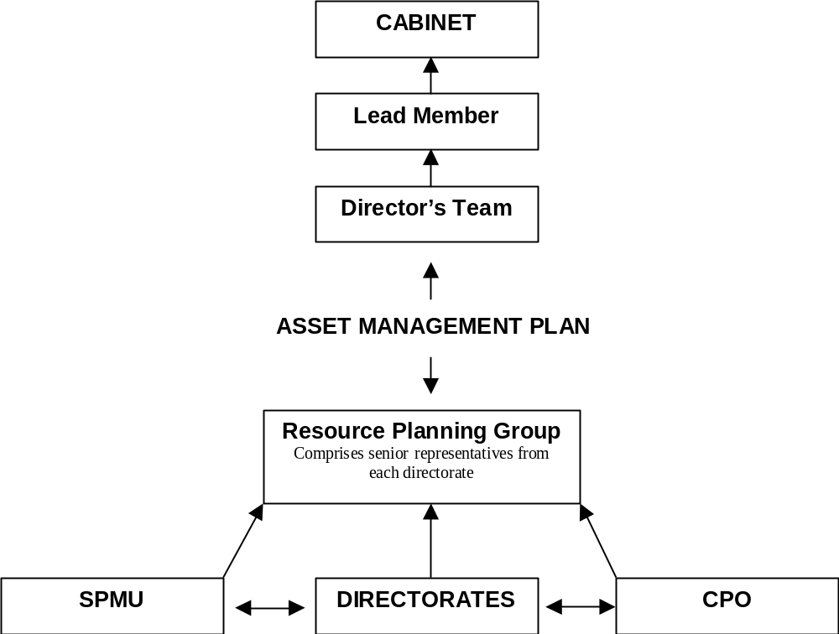

APPENDIX 2
AIMS AND OBJECTIVES FOR PROPERTY
AND ASSOCIATED PERFORMANCE INDICATORS

AIM 1. | To Provide property to meet corporate and service directorate requirements as efficiently, and economically as possible
OBJECTIVES |  | PERFORMANCE INDICATOR
To improve year on year with respect to a series of key property performance indicators |  | Average running costs per M² for specific building categories
To utilise space at a level of efficiency commensurate with best practice taking into account the limitations of the building stock |  | Average M² per person measured using Net Internal Area
To retain only that service property which is necessary to meet service and service users needs |  | Production of relevant Service Property Strategies

AIM 2. | To improve the effectiveness of property in meeting service and service users needs
OBJECTIVES |  | PERFORMANCE INDICATOR
To provide property that meets the needs of users in terms of condition, quantity and suitability |  | The band of the Herriot Watt University variance tool into which office accommodation falls measured by customer surveys
 |  | User satisfaction with building maintenance
To ensure that buildings meet defined condition standards and that the backlog of repairs is reduced in accordance with a plan and timetable |  | % of operational and non-operational buildings that are in condition category A to D
To provide buildings in locations which are readily accessible for staff and visitors |  | % Of workstations that are in buildings with adequate car parking  % Of workstations that are in buildings that are in buildings with public transport within 100m
To improve disabled access and comply with other statutory duties |  | % Of the buildings suitable for access by disabled persons

AIM 3. | To ensure that property is fully recognised as a corporate asset and that it is managed accordingly
OBJECTIVES |  | PERFORMANCE INDICATOR
To provide and support the working arrangements necessary to produce effective corporate asset management |  | Is there an Asset Management Plan that has been assessed as good or satisfactory
Actively engage all directorates on strategic property matters to the overall benefit of the Council |  | Does the Resource Planning Group meet regularly and fulfil its role

AIM 4. | To ensure that where appropriate the Council’s property is used to support urban regeneration initiatives and community well being
OBJECTIVES |  | PERFORMANCE INDICATOR
To identify where property can support and act as a catalyst in initiatives |  | To identify all Council property in urban regeneration areas
To identify the extent of the commercial estate occupied primarily to support community well being objectives |  | The amount of property within the Investment portfolio occupied primarily to support community well being objectives

AIM 5. | To ensure that the investment portfolio provides both income and capital to help to support the Council’s budgetary requirements
OBJECTIVES |  | PERFORMANCE INDICATOR
To set and achieve a target Internal Rate of Return (IRR) calculated in accordance with the ODPM Property Performance Indicator No2 |  | Target rate of return on the investment portfolio
To optimise rental income through the estate management activities undertaken
To meet the Council’s capital and revenue generation targets |  | The target for capital and revenue income
To reduce voids |  | Occupancy levels of the investment portfolio
To reduce rent arrears |  | Rent arrears as a % of rent invoiced

AIM 6. | To provide a property service that meets the needs of clients in terms of quality costs and timeliness
OBJECTIVES |  | PERFORMANCE INDICATOR
To improve the levels of client satisfaction in relation to a set of agreed performance indicators  To provide clients with relevant property advice to enable them to deliver their services efficiently and effectively |  | Satisfaction with planned and programmed  maintenance / repairs
 |  | Satisfaction with property management
 |  | Satisfaction with the Quaywatch scheme
To improve staff performance through providing appropriate staff training development and support to deal with a range of work requirements likely to arise |  | Staff rating on dealing with underperformance
 |  | Staff rating on training for job
To improve the cost competitiveness of the service through comparison and benchmarking with other service providers together with the introduction of appropriate targets and improvements in practices |  | Costs of property management staff per M² of operational buildings

APPENDIX 3

KEY ISSUES
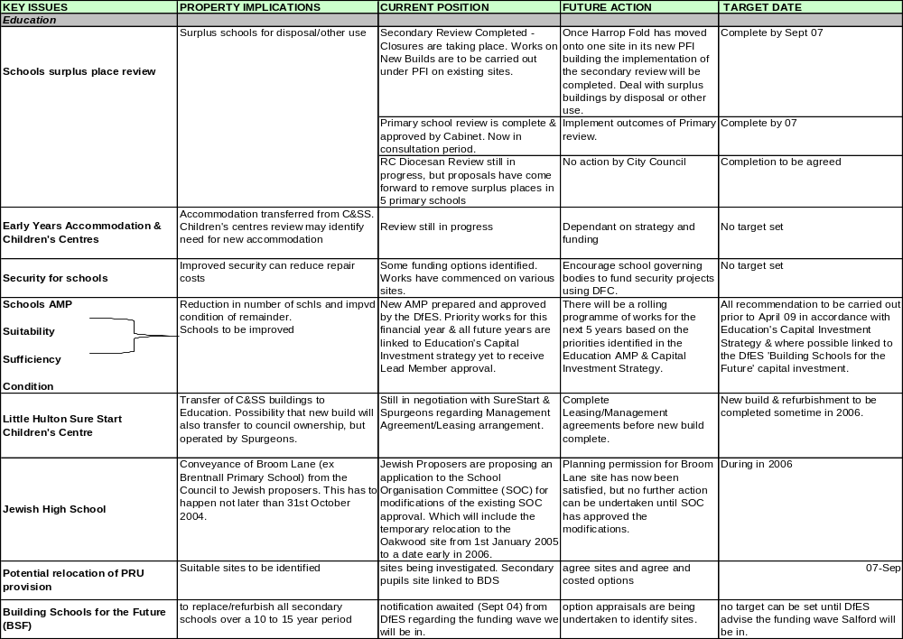

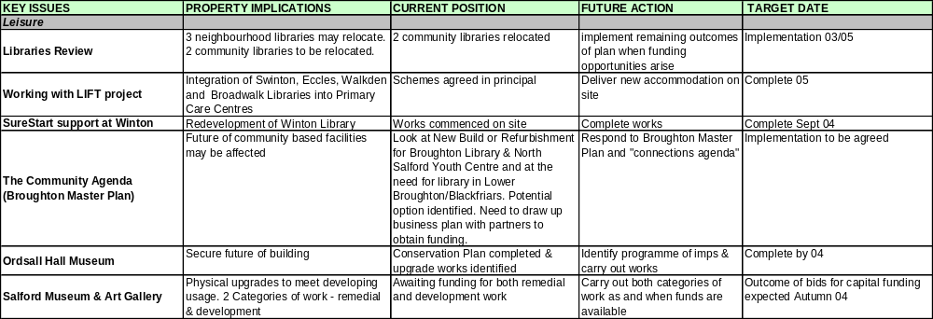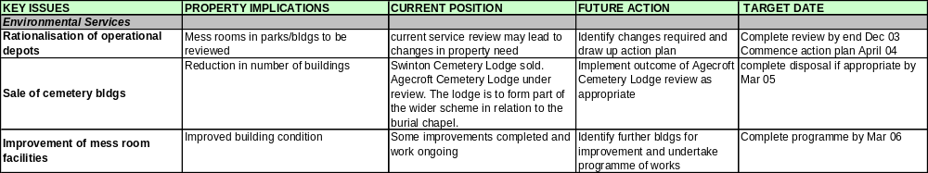

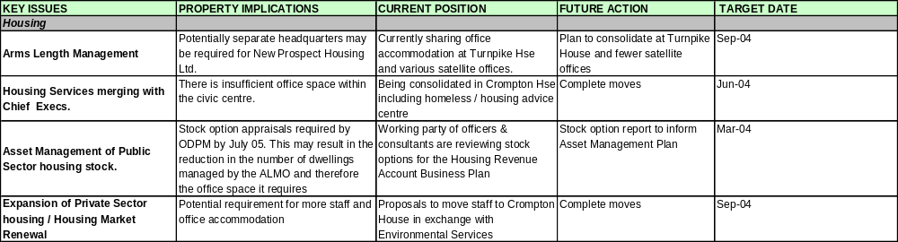

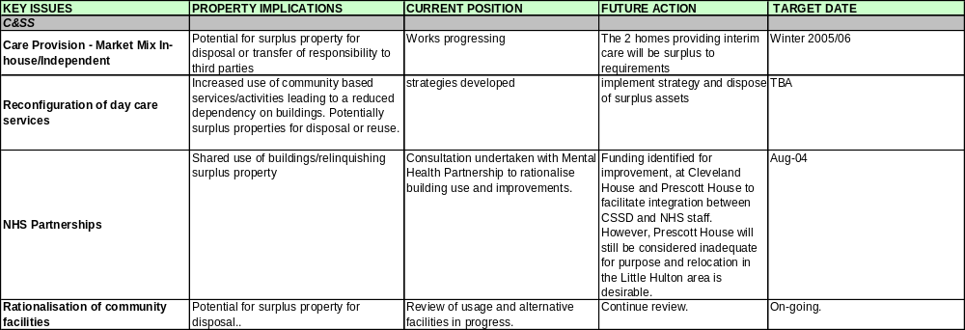
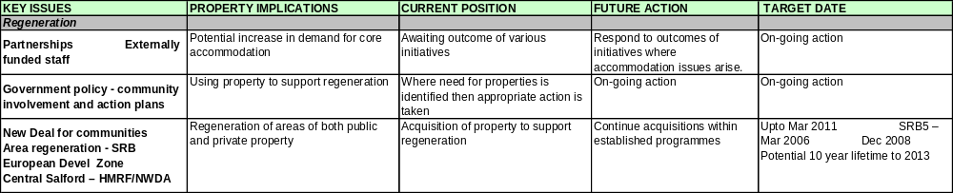
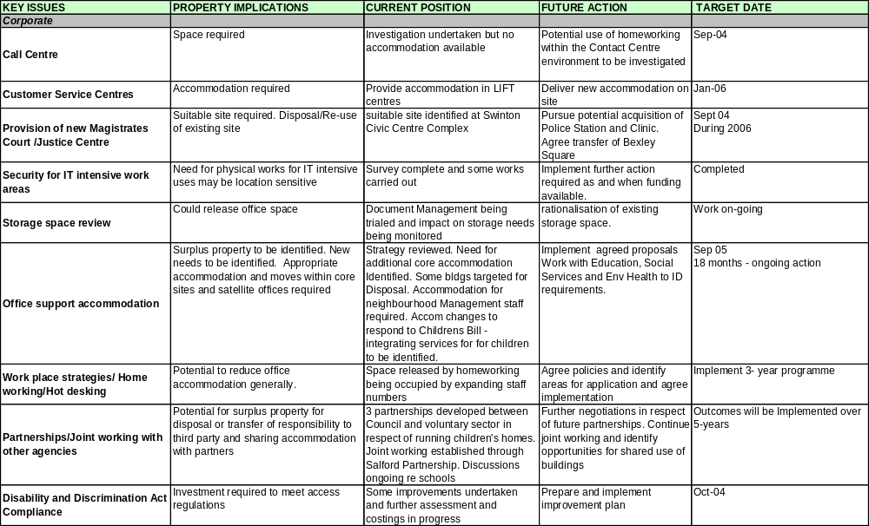

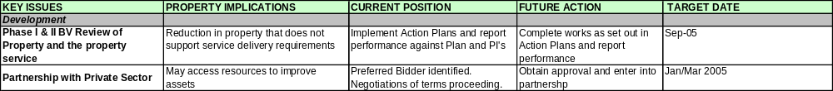
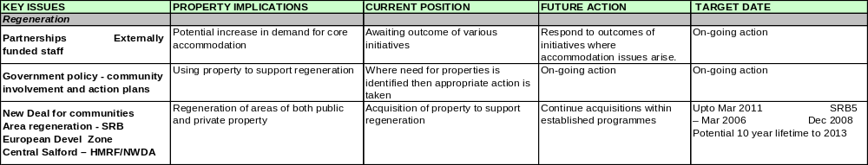

APPENDIX 4

Property Performance Indicator |  | Actual  2002/03
ODPM pPI 1A  Percentage of gross internal floor area in condition categories A-D  *For CIPFA breakdown Section 3 Data Management | CIPFA Category |  | A | B | C | D
 | Other Land & Buildings
 | Community
 | Non-Operational (General)
 | Non-Operational Surplus
ODPM pPI 1B  Backlog of maintenance by cost, expressed  - as total value  - as a percentage in priority levels 1-3 |  | Value
 | Other Land & Buildings
 | Community
 | Non-Operational (General)
 | Non-Operational Surplus
ODPM pPI 2A, B & C  Internal Rate of Return for: | A= Industrial
ODPM pPI 2A, B & C  Internal Rate of Return for: | B= Retail
ODPM pPI 2A, B & C  Internal Rate of Return for: | C= Agricultural

ODPM pPI 3
Total annual strategic management cost per sq.m GIA for the portfolio

ODPM pPI 4A
Repair and maintenance costs per sq.m GIA

ODPM pPI 4B
Energy costs per sq.m GIA (gas, electricity, oil, solid fuel)

ODPM pPI 4C
Water costs per sq.m GIA

ODPM pPI 4D
CO2 emissions in tonnes of carbon dioxide per sq.m GIA

ODPM pPI 5A
Cost Predictability – % of projects where outturn falls within +/- 5% of the estimated outturn, expressed as a % of the total number of projects completed in the financial year

ODPM pPI 5B
Time Predictability - % projects falling within + 5% of the estimated timescale, expressed as a % of the total number of projects completed

DATA TO BE UPDATED

DATA TO BE UPDATED

DATA TO BE UPDATED

APPENDIX 5

USE OF NATIONAL PI ‘S
NATIONAL PROPERTY PI | USE OF DATA | EXPECTED IMPROVEMENTS/OUTCOMES
1A and B  To measure the condition of property and cost of backlog maintenance where the Council has a repairing liability | In property appraisal when considering changes to the portfolio and in allocating funds within the revenue budget and capital strategy | Improving the condition of poor buildings improving effective service delivery and client satisfaction
2A, B and C  To measure the financial rate of return from the industrial, retail and agricultural investment portfolio | To compare the rate of return from individual properties and categories of properties against a target rate | Will guide decisions on disposals of investment property, particularly where performance is below target
3  To measure strategic property management costs for operational and non-operational property | To compare Salford’s strategic property management costs with others. | That an appropriate level of strategic property management activity is undertaken.
4A, B, C and D  To measure the running costs (Repairs and Maintenance, Energy, Water and CO₂ emissions) for operational buildings | Overall performance is compared with other authorities and performance of individual buildings is compared to identify poor performance where remedial action will be taken | Running costs will be minimised and CO₂ emissions data will help Salford to meet Climate Change Programme targets through targeting action on poorly performing buildings
5A and B  To measure the delivery of capital projects within 5% of budget and estimated time scale | To monitor Salford’s performance and identify need for changes if performance does not meet target | Improvements in procurement process if current performance does not meet target.
APPENDIX 6

RUNNING COSTS OF PORTFOLIO
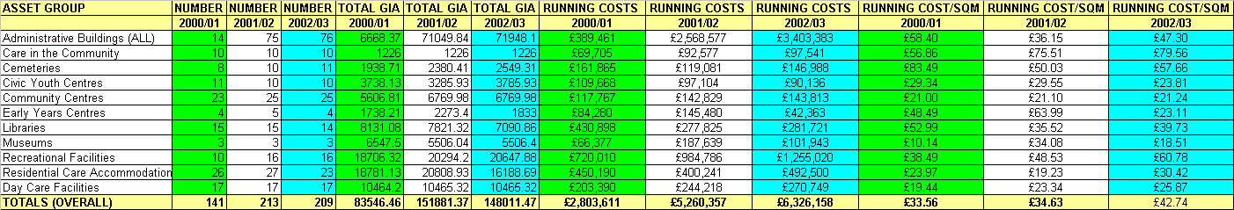

DATA TO BE UPDATED
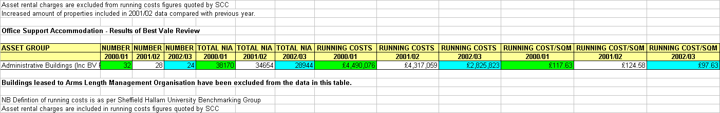

APPENDIX 7
BEST VALUE REVIEWS/CPA IMPROVEMENT ACTIVITY

Current programme available for inspection / audit support

Best Value Reviews
Review Title | Lead Directorate | Property Implications
Support Older People at Home | Community & Social Services | Support for older people at home likely to remain therefore no property implications for Council
Support for people with learning difficulties | Community & Social Services | Possible reduction in buildings used for day care provision
Housing Repairs Review | Housing | Call Centre function being market tested. – outcome could affect Salford Directs accommodation requirements. Reduction in satellite office staff has been implemented.
Economic Development | Chief Executives | May affect investment estate holdings and regeneration strategy
Residential Care for Children | Community & Social Services | No property implications
Inspection & Advisory Service | Education & Leisure | No property implications
Housing Planned Maintenance | Housing | No implications for depot accommodation
Outdoor Services & Grounds Maintenance | Environmental Services | May affect occupation/control of depot accommodation
Bereavement Services | Environmental Services | Outcome of heritage lottery funding application may have implications for Agecroft cemetery lodge
Home to School and Social Care Transport | Education & Leisure/Social Services | Administrative base for Central Passenger Transport will be required (no impact on Turnpike operating base)
Building Control | Development Services | No property implications
Development Control and Development Planning | Development Services | No property implications
Construction and Design | Development Services | May affect office accommodation requirements
Youth Service | Education & Leisure | May affect existing youth service property
Culture, arts and heritage | Education & Leisure | Impact on existing museums & galleries
Registration of births, deaths and marriages | Corporate services | May affect Kingslea
Public Protection | Environmental Services | Possible office accommodation issues (minor)
SAP | Corporate services | No Property implications
Safeguarding Children | Community & Social Services | No property implications
Services to people with physical & sensory impairments | Community & Social Services | No property implications
IT NET/Salford Advance | Corporate Services | Possible accommodation issues
CPA IMPROVEMENT ACTIVITIES – 2004/05
PROPERTY IMPLICATIONS

Priority for improvement | Property Implications
Corporate improvement plan | Minimal property implications. Any implications largely around staffing and therefore office accommodation which will be considered in line with the authority’s approach to office accommodation
Education – review of primary school places | Potential implications for numbers of primary schools and /or uses of surplus space
Education – Early years childcare to be available to all | Potential property implications to provide accommodation for childcare places
Libraries and leisure – improvements to the quality of Salford’s libraries | Property issues arising from inclusion of libraries within  LIFT scheme
Libraries and leisure – improving the quality of leisure facilities | Potential property implications arising from work of the leisure trust to attract investment
Development – move to JVC for development services | Potential office accommodation implications
Generally | Directorate improvement plans include a plethora of both process and service delivery improvements, some of which may lead to staffing implications and consequently office accommodation implications as the improvements are worked through and implemented. All such developments will be considered in line with the authority’s approach to office accommodation.

APPENDIX 8

PROPERTY APPRAISAL MODEL

Assessment Criteria Appraisal Process
AGREE RELOCATION OF STAFF TO SUITABLE PREMISES

OMV
- Estimated Realisation Price

Cost of relocation to suitable alternative accommodation exceed OMV ?

NO
NO
NO
YES
YES
YES
NO
NO
NO
PREMISES SOLD, LEASED

OR REUSED IF APPROPRIATE
YES
YES
YES

PROPERTY RETAINED
YES
IDENTIFY COSTS AND FUNDING AND BUILD INTO WORKS PROGRAMME

SUITABILITY
- Internal Space
- Support Space
- Location
- Access

MEETS CRITERIA

INVEST TO MEET
CRITERIA

SUFFICIENCY
- Is sufficient
- Well used
- Under used
- Vacant space

MEETS CRITERIA

IMPROVE
UTILISATION

CONDITION
- Category A – D
- Backlog maintenance priority 1 – 3 £

MEETS CRITERIA

INVEST TO MEET

CRITERIA

RUNNING COSTS
- Maintenance
- Energy
- Water
- CO² Emissions

MEETS CRITERIA

INVEST TO MEET

CRITERIA
NO
YES
NO
APPENDIX 9
ACHIEVEMENTS

ACHIEVEMENT | RESULT
Establishing a Strategic Property Management Unit | Ensuring that corporate asset management is achieved
Establishing a Corporate property Officer | Responsible officer for ensuring corporate asset management takes place
Establishing a Lead Member for Property | Ensures a Council focus and member responsibility for property matters
Establishing an intranet site providing information and promoting corporate asset management | Promotes awareness across the whole council
Operation of Environmental Scrutiny Committee | Involves member involvement in target setting, monitoring performance and driving improvement
Integrated working of Asset Management Group and Budget Planning Group through common officer representation | Integrated asset and financial planning
Completion of condition surveys and priority assessments | Accurate condition data and backlog maintenance assists property appraisal and financial planning
Established five year rolling programme of re-surveys | Programmed updating of information
Introduction and operation of Surplus Property Policy | Surplus property dealt with in effective corporate way
Introduction of property requirements database | Matches property needs to property available
Established Property Strategy and Aims and Objectives for Property derived from corporate Mission and Pledges | Establishes clear principles for holding property
Developed local pPI’s and targets to measure success in achieving objectives | Establishes targets monitors and measures improvements
Benchmarking introduced – Core Cities, AGMA, ACES, Sheffield Hallam University | Enables comparison with others and assists in target setting
Completed Property and Asset Management BV Review and implementing the Action plans | Identified improvements required in property and the service being implemented
Established performance reporting for office portfolio | Officer and member monitoring performance
Identification of running costs of the whole portfolio and cost per M² | Identifies areas of high costs and areas for improvement
Property performance reported to Directors | Raises awareness of property costs and performance and encourages improvement
Data needs identified | Only data required for property management and performance analysis collected
Accurate database of core and transient data established | Enables effective management of portfolio and performance assessment
UPRN established | Allows unique cross referencing of properties throughout the council
Storage Space Review | Raises awareness of costs, selected short term option to reduce storage space needs
Option appraisal introduced and being developed | Better resource allocation to meet priorities
Shared use of property with other organisation taking place | Improves service delivery and efficiency in use of buildings
Building occupier and user surveys introduced | Identifies occupier and user perception and needs to influence resource allocation
Suitability surveys introduced | Assist property appraisal and resource allocation
Area based reviews being implemented | Promotes property rationalisation, shared use and efficient use of buildings
Occupier survey of quality of FM services | Assist improvement in FM service
Gap analysis used in property strategy development | Property strategy will properly address future needs
Establishment and operation of the Resource Planning Group | Brings together in one corporate group finance and asset management planning
Achieving improved practices for dealing with surplus property | Cost savings will be achieved
Reduction in amount of operational property | Savings proposals, running costs and generation of capital receipts
Reduction in amount of surplus property | Savings in maintenance, running costs and generation of capital receipts
Achieving a ‘good’ assessment in the corporate AMP CIS and Education AMP | Government recognition of good practice produces financial rewards and freedoms
Significant reduction in schools backlog maintenance | Will improve teaching and learning through creating improved building environment
Establishment of a staff training facility at Broadwalk | Will permit disposal/reuse of existing accommodation

Cont..
ACHIEVEMENT | RESULT
Establishment of Leisure Trust to operate and manage leisure facilities | Focus on improving facilities and improved service to customers
Production of Service Property Strategies (SPS’s) for: -  - Youth Service  - Library and Information Service  - Residential Day Care and Community Services  - Office Support Services  - Sports and Leisure Services | Better awareness and understanding of property performance and defining of works to and changes in services property occupiers
Completion of Primary Schools Review
National Property PI performance comparison through IPF AMP Benchmarking Group | Comparison with other local authorities enables poor performance to be identified and addressed
Introduction of Post Project evaluation | Will assist improved project procurement
Introduction of Home Working principally in revenues and benefits | Reduces pressure for core office accommodation
Space for Sports and Arts at four school sites successfully provided | Improved facilities provided
Accommodation changes for Democratic Services successfully provided | Appropriate accommodation to meet changes in service requirements
Accommodation changes for GMPA at Civic Centre successfully provided | Appropriate accommodation to meet changes in service requirements

APPENDIX 10
AMP ASSESSMENT CRITERIA REFERENCING

Primary Criteria

Ref | 1. Organisational arrangements for corporate asset management | AMP  Para Ref
1.1 | A Corporate Property Officer (CPO) has been identified with authority to undertake all required developments in asset management. | 1.D
1.2 | Roles and responsibilities for the CPO (as indicated by the prevailing guidance) are clearly set out, explicit and have been communicated to all those concerned, in property management and use, throughout the authority. | 1.D
1.3 | The CPO reports and is accountable to a strategic, decision-making group both at officer and member levels. | 1.D & APP.1
1.4 | Clear evidence has been provided that a cross-service, senior management forum has been set up which includes the CPO, representatives from major services and, where appropriate, the finance directorate and officers involved in the development of the Capital Strategy and the Community Plan (or its equivalent). | 1.B
1.5 | The forum has formal terms of reference that includes the strategic management of the Council’s assets. | 1.B
1.6 | Evidence that the forum:  - Progresses the corporate Asset Management Plan and ensures that it is approved by senior officers and the Council;  - Ensures that the AMP is informed by and supports other key corporate and service plans and objectives;  - Meets regularly (at least twice a year or more often as may be appropriate). | 1.B  1.F  1.G  1.B

Ref | 2. Data Management | AMP  Para Ref
2.1 | CPO has ensured that a record is held and maintained of basic, core data on all the Council's property. | 3.A
2.2 | The validity of this information has been tested. | 3.B
2.3 | AMP can demonstrate a clear understanding of the data required to manage the performance of the property portfolio. | 3.B
2.4 | Statistical information on the overall condition of the portfolio (condition categories: A-D/1-3) and maintenance backlogs is included in the AMP. | 4.D  3.C  APP.4

Ref | 3. Performance Management, Monitoring & Information | AMP  Para Ref
3.1 | The CPO submits a formal report to Members and Chief Officers at least annually on the performance of the property portfolio, which now includes performance outcomes in relation to the ODPM National pPIs. | 4.A
3.2 | The AMP includes information showing how the authority is performing in relation to all five national pPIs. | 4.D AND APP.4
3.3 | Members are informed, as part of overall budget and performance monitoring, of the progress and performance of the capital programme. | 5.E

Ref | 4. Programme and Plan Development and Implementation | AMP  Para Ref
4.1 | The AMP outlines the council’s property related requirements and outlines the proposed programmes which are intended to meet these requirements. | 6 AND APP.3
4.2 | CPO has demonstrated that there is a methodology for option appraisal and corporate prioritising between projects. | 5.D
4.3 | A 3 year capital programme is developed including a forecast of the planned capital receipts. | 5.E
4.4 | Output/outcome targets are set for programmes and plans requiring capital investment. | 5.D

Secondary Criteria

Ref | Organisational arrangements for corporate asset management | AMP  Para ref
1. | Evidence that the CPO / Asset Management Forum routinely challenges and reviews the use, provision and performance of the council’s assets and its related property services, in order to achieve the most effective management, planning and use of these assets. Key findings and outcomes are reported to Chief Officers and the Council. | 1.B
2 | Evidence that the CPO / Asset Management Forum takes into account stakeholder satisfaction information relating to property and property services. | 2 and 2.B
3 | A cabinet member (or lead committee member) holds responsibilities for the authority’s property resource on behalf of the council. | 1.E
4 | The CPO is involved in the preparation of the Capital Strategy and contributes to the work of other relevant corporate and business planning groups. | 1.D
5 | There are references to the property asset implications in corporate policies and strategies such as the Best Value Performance Plan, Best Value Reviews, the Capital Strategy, the Community Plan and LPSAs. | 1.F, 1.G, 1H  2A, 2C
6 | There is evidence of cross service use, shared use and/or co-location of property resources within the authority and with other organisations. | 5.F

Ref | Consultation | AMP  Para ref
7 | Evidence that processes are being developed to obtain feedback from services, users and occupiers. | 2
8 | Evidence that consultation findings are used to influence the continuous improvement of property and property services performance. | 2.B

Ref | Data Management | AMP  Para ref
9 | CPO has undertaken a full survey of future data requirements for the  property portfolio. | 3.E
10 | CPO has identified a programme of necessary improvements | 3.E
11 | CPO has commenced development of a data system for “intermediate” data (i.e. property data which requires updating from time to time such as condition, rents and user details) | 3.B, 3.C
12 | CPO has implemented Unique Property Reference number (UPRN) system or set out detailed reasons why any alternative property referencing approach is considered more appropriate. | 3.E
13 | CPO has developed an approach for the centralised co-ordination of property management information and its integration with relevant Council financial information. | 3.B, 3.E
14 | CPO has undertaken a review of training needs for users of the data and set in place a system for satisfying those needs. | 3.E

Ref | Performance Management, Monitoring & Information | AMP  Para ref
15 | Clear evidence that the CPO is developing and using a set of local performance measures in relation to assets that link asset use to corporate objectives. | 1.F, 4.A  Appendix 2
16 | Clear evidence that the CPO is developing a process to enable the comparison of the performance and competitiveness of property and property services with other similar organisations and other providers. | 1.H, 4.A
17 | Clear evidence that the development of performance measures and monitoring takes into account stakeholder consultation and user satisfaction findings. | 4A &  Appendix 2
18 | Clear evidence that performance measurement feeds into a process of  continuous improvement. | 4.B
19 | Local Performance Indicators are in place and being used for measuring and Monitoring the amount of surplus property and space utilisation. | 4.A, 4.C
20 | A written report is produced for Members and Chief Officers on any maintenance backlog recommending appropriate action. | 5.G
21 | The CPO is collecting information on the “suitability” of the various categories of the portfolio for their current and future use. | 2.B, 5B

Ref | Programme and Plan Development and Implementation | AMP  Para ref
22 | The AMP demonstrates that the Council has identified the implications for property, which arise from the Council’s objectives. | 5.A, 1.F
23 | The AMP demonstrates service wide understanding of corporate ownership of assets. | 1.A, 1.B, 1.F
24 | The AMP demonstrates that the Council has undertaken a thorough investigation and analysis of the gaps between future requirements and the current provision and performance of the authority’s present property assets. | 6 & Appendix 3
25 | The Council has identified and appraised the options for closing these gaps. | "
26 | The AMP outlines the Council’s approved 3 – 5 year strategic action plan based on this analysis. | "
Notes Page…. GO TO INDEX

This page has been left blank for you to make notes...

