ITEM NO.

REPORT OF THE LEAD MEMBER FOR HOUSING

TO CABINET MEETING
ON 23rd MAY, 2006

TITLE : Building Sustainable Communities : Affordable Housing in Salford

RECOMMENDATIONS :

That the Cabinet notes the work to date in developing Salford’s Affordable Housing Strategy titled : “Building Sustainable Communities : Affordable Housing in Salford”, and subject to further consultation with political executives, in parallel with the Housing SPD, approves its adoption.

EXECUTIVE SUMMARY :

The affordable housing strategy sets out to tackle the issue of affordable housing in Salford. Historically Salford has had a plentiful supply of low cost housing and it has generally been considered that Salford does not have an affordable housing problem. This situation has changed rapidly in recent years. The strategy demonstrates that there is an affordability problem in Salford. It does so by investigating housing need; house price to income ratios; right to buy levels and increasing homelessness. Having established that there is a problem in Salford the strategy sets out the level of affordable housing required and variety of tools that Salford will investigate and implement, as appropriate, to deliver affordable housing in Salford.

The analysis for the strategy identifies two overlapping problems of affordability. Firstly the need for additional affordable rented housing is captured in the housing need calculations. Secondly, the house price to income ratio analysis points to a growing problem in the intermediate housing market. In other words increasing numbers of Salford residents are being priced out of owner occupation as house prices rise much more quickly than wages.

In the analysis of need a shortfall of 320 affordable properties annually is identified. This suggests that the council should be seeking for 20% of new housing developments to be affordable based on an annual requirement of 1600 new homes per year. However, it is proposed that a range between 20% minimum and 25% maximum will be used. 25% being the Council’s aspirational figure and 20% being its minimum.

The strategy outlines the options the Council and its partners are either taking or will develop/investigate to deliver affordable housing in Salford which include:

- Planning policy
- Stock Options
- Registered Social Landlords
- Financial tools
- Homebuy
- Bringing Empty properties back into use

A copy of the full strategy accompanies this report.

BACKGROUND DOCUMENTS :
(Available for public inspection)

Affordable Housing Strategy (Draft 1.1 December 2005)
Making the Future Happen our Strategy for Housing in Salford 2004-2006
Minutes from the consultation process are available upon request

ASSESSMENT OF RISK:

Medium – without an understanding of the reasons for recent changes in the affordable housing situation in Salford it will be difficult for the Council and its partners to target resources and policy towards remediating this problem.

SOURCE OF FUNDING: Within the strategy, financial implications will be considered as the different tools to deliver affordable housing are investigated and developed.

Funding has been allocated within the budget of the strategy and partnership team for design and publication of the strategy.

COMMENTS OF THE STRATEGIC DIRECTOR OF CUSTOMER AND SUPPORT SERVICES (or his representative):

- LEGAL IMPLICATIONS The legal implications will flow from options in use or being developed. As each option is developed it will be considered by Lead Member when the legal implications can be explored in detail. As such, there are no specific implications linked to this report.
Provided by : Richard Lester, Solicitor, 17th March 2006

- FINANCIAL IMPLICATIONS The financial implications will flow from options in use or being developed. As each option is developed it will be considered by Lead Member when the financial implications can be explored in detail. As such, there are no specific implications linked to this report.
Provided by : Joanne Hardman, Housing Accountant, 10th March 2006

PROPERTY (if applicable): n/a

HUMAN RESOURCES (if applicable): n/a

CONTACT OFFICER :

Michael Hemingway
0161-922 8707 Michael.Hemingway@salford.gov.uk

WARD(S) TO WHICH REPORT RELATE(S): ALL

KEY COUNCIL POLICIES:

Housing Strategy
Homelessness Review and Interim Strategy
Housing Supplementary Planning Document

DETAILS (Continued Overleaf)

1. Background

The Housing Strategy 2004-2006 identified a need for an Affordable Housing Strategy. Since the production of the Housing Strategy in 2004, Salford has witnessed significant changes in the local housing market. In addition to significant increases in house prices; there has been a reduction in the number of empty lettable council properties managed by New Prospect Housing Limited, an increase in the number of homeless applications and an increase in the number of right to buy sales across the city. The relocation of residents in Central Salford, following Compulsory Purchase Orders, has also had an impact on the market, as has the proliferation of the buy to let market which has not only affected available supply, but also influenced the type and tenure of new homes coming through the planning pipeline. The Head of Housing for Salford has also ensured that the Affordable Housing “Problem” has been discussed both at the group representing Greater Manchester and Merseyside Housing Authorities (the M62 group) and also at a regional level with the North West Housing Forum.

The primary purpose of the strategy is to promote the opportunities by which Salford can help to achieve neighbourhoods of choice in which residents have a “choice of popular homes in desirable locations, served by excellent housing services”. It is one means by which Salford can deliver the vision and priorities in its housing strategy. The strategy presents the range of interventions and policies the Council is or seeks to use, to achieve the vision.

2. Affordable Housing Working Group and Affordable Housing Steering Group

An Affordable Housing Working Group and Affordable Housing Steering Group were established to help inform the strategy and provide strategic guidance. The Affordable Housing Working Group is attended by officers from the both the Housing and Planning sides of the Housing & Planning Directorate of Salford City Council, a representative from Manchester City Council and a Registered Social Landlords representative. The Affordable Housing Steering group is attended by a councillor from each of the three political parties with the lead for housing and three representatives from Salford’s Housing Partnership. Manchester City Council is embarking on a similar process and we are working with them through the Manchester Salford Pathfinder.

3. Consultation

Salford’s Affordable Housing Strategy was circulated to a number of groups for their consideration and comments. The consultation process was through a range of meetings and focus groups.

Staff and elected members were consulted through the following groups:

- Affordable Housing Working Group
- Affordable Housing All Party Steering Group
- Seminar with Councillors
- Environmental, Housing & Planning Scrutiny Committee
- Housing Partnership Strategy Development Group
- Housing Market Renewal Technical Group
- Seedley & Langworthy Partnership
- New Deal for Communities Board
- Central Salford Urban Regeneration Company Board
- Link to the Internet via the Housing Strategy page (www.salford.gov.uk/housingstrategy)
- Staff within the Housing and Planning Directorate were informed that the draft Affordable Housing Strategy was available to read on the Council’s Internet and were asked to provide comments.

A special meeting of the Salford Strategic Housing Partnership was held to discuss the content of the Strategy and to incorporate members’ views. The Salford Strategic Housing Partnership was launched in September 2004 to bring together key stakeholders to provide strategic direction for the development of the housing system in Salford, and to ensure that strategies and priorities for housing have the full support and commitment of all partners, stakeholders and customers. The partnership is made up of public and private agencies, each with their part to play to improve housing and housing services in Salford.

The following external stakeholders were consulted:
- Private Developers
A focus group was held with our private developer partners to provide comments on the Affordable Housing Strategy and to incorporate their views.

- Registered Social Landlords
Salford's Registered Social Landlord (RSL) Strategic Issues Forum brings together the lead and support RSL partners in Salford, along with officers from the council and partner organisations to raise, discuss and take forward strategic issues of relevance to RSL activity across the city. The strategy was presented to the forum and their comments incorporated into the document.

In addition members were consulted through an Affordability and Housing Mix Seminar

The group contained councillors, officers of the city council and Central Salford Urban Regeneration Company and private sector developers. The discussion was centred around a number of set questions to facilitate debate on affordability and housing mix.

The main themes raised were:

- Need for certainty and clarity so that any policy is simple to understand for the public, officers, members and developers
- Need to ensure that people can purchase properties that are affordable in their local area; and
- Family housing should be included as part of any affordable housing requirement;
- Affordable units should be well integrated within developments - they should not be located in just one part of a development;
- Developers ‘do not have a problem’ with a 20% target for affordable housing so long as it is clear how this is calculated;
- Level of affordable housing sought should not make development unviable;
- Important that the need for affordability complements the Housing Market Renewal Initiative.
- Partnerships are essential to delivering objectives
- Need to capture land value up-lift - break land value cycle which affects provision of affordable housing - very frustrating
- Become smarter at using powers to bring back into use derelict sites/buildings
- Campaign and lobby to increase resources for affordable housing.

4. Data used & key findings

The Affordable Housing Working Group undertook analysis of local house prices and household incomes. From 2002 to 2004, the mean house price in Salford increased by 53.9% to £118,655 and the mean household income increased by 26.5% to £23,400. Although both house prices and household incomes have increased, house prices have increased at a greater rate than incomes, creating a citywide affordability issue.

In Central Salford, since the Housing Market Renewal Pathfinder was established, house prices have increased. The Pathfinder’s aim is to provide the optimal mix of higher value homes, within the market, to both retain existing residents and attract new. It will also re-provide affordable housing for residents affected by clearance with new relocation products. However, there will be aspirant home-owner households in Central Salford, whose incomes are unlikely to significantly change and will potentially be priced out of the improving market. In West Salford, there has been a rapid increase in high quality housing, with few pockets of affordable housing. In both Central and West Salford, supply does not effectively meet demand – both in terms of tenure, property type and affordability.

To determine where the areas in need of affordable housing lie, the group calculated the ratio of house prices to incomes for each ward, and mapped the results. The group have assumed that an affordable level is where house prices are three times household income for purchasing, or less than 30% gross household income for renting. The maps show that the number of affordable areas in Salford has significantly reduced from 2002 to 2004 and many people could not afford to buy a property in the areas in which they already live. The group also mapped the situation for key workers in Salford, showing the areas a key worker could not afford to buy a property. An example of this mapping is shown below.

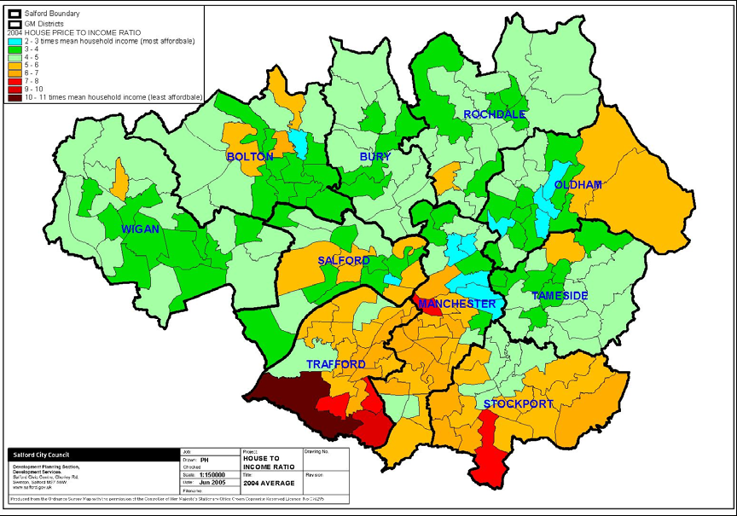

2004 House price / income ratio Map

The most visible need for affordable housing is homelessness. In recent years there has been a dramatic change in the level of homelessness in Salford. The number of homeless applications accepted in Salford between 1998 and 2003 dipped to a low of 483 in 2000/2001. However, during 2003/2004 acceptances dramatically increased to 1278 in three years.

Homelessness
Year | No. of Acceptances
1998/9 | 828
1999/00 | 519
2000/01 | 483
2001/02 | 687
2002/03 | 778
2003/04 | 1278
2004/05 | 1149

In addition to ratio analysis and mapping, the group are also using an ODPM model to calculate the number of households in need. The model provides an overall figure for the city, and takes into account current need, available stock to offset need, newly arising need and the supply of affordable units per year.

AVAILABLE STOCK TO OFFSET NEED (times a yearly quota)  Plus  NEWLY ARISING NEED  Minus  FUTURE SUPPLY OF AFFORDABLE UNITS  Equals  NET SHORTFALL (OR SURPLUS) of affordable units per year | 605  3309  3594  320

On the basis that Salford’s annual new housing requirement is 1,600 new homes a year based on the Draft Regional Spatial Strategy 2006. It would consequently seem appropriate for Salford to require that a minimum 20% of all new housing developments should be affordable given the need for approximately 320 affordable properties. However, it is our intention that a flexible approach is taken to the application of this percentage across the City. The details of its application will be set out in the Council’s affordable housing planning policy which will be adopted in November 2006.

5. Delivering Affordable Housing In Salford

We intend to use a combination of options to deliver affordable housing in the City.

The options we are using or investigating include

- Housing Market Renewal
- Smarter working with private developers
- Investment options for Council housing
- Small scale option appraisal
- Registered Social Landlords
- New equity share products
- Buy backs
- Tackling empty homes
- The planning system
- Community land trust – mutual home ownership model
- Self-build
- Homesteading
- Lobbying

A copy of the strategy accompanies this report.

