Part 1 (Open to the public) | ITEM NO.

REPORT OF THE REGENERATION INITIATIVES CABINET WORKING GROUP

To the: Cabinet
On: Tuesday 24th January 2006

TITLE: Progress on Regeneration Programmes and Projects

RECOMMENDATIONS:
Members are requested to note this report

EXECUTIVE SUMMARY:
This report summarises the progress being made on key projects and programmes across the City. This report is formatted according to Community Committee Areas.
BACKGROUND DOCUMENTS:
Community Plan, City Council Pledges, and Neighbourhood Renewal Strategy

ASSESSMENT OF RISK:
N/A

THE SOURCE OF FUNDING IS:
Various regeneration funds identified in the report

LEGAL ADVICE OBTAINED:
N/A

FINANCIAL ADVICE OBTAINED:
Nigel Dickens

CONTACT OFFICER:
Cath Inchbold, Assistant Director (Strategy and Regeneration), 0161 793 3796
John Bentley, Strategy and Resources Officer (Strategy and Regeneration) 0161 793 3449
WARD(S) TO WHICH REPORT RELATES:
All Wards

KEY COUNCIL POLICIES:
Regeneration

DETAILS:
N/A
Purpose of Report

To inform and up date on progress and issues surrounding key regeneration funding programmes and projects on a six weekly basis.

Detail

This report summarises the progress being made on key projects and programmes across the City. It describes the activity in the Community Committee areas:

- Claremont and Weaste
- East Salford
- Eccles
- Irlam and Cadished
- Ordsall and Langworthy

Swinton

Summary of Key Issues

Key developments have occurred over the past six weeks within the following areas:

Pledge | Area | Key Developments
All | Seedley & Langworthy | Renovation work to properties allocated to homeswappers on Co-operative Street is to begin on 27th February 2006.  Urban Splash on site and have liased with the Community Safety Officer and Police regarding security.  Marketing and sales for properties on the Urban Splash site are expected to begin in April 2006.
Enhancing Life | Higher Broughton | Positive residents response to the details of the 19 Homeswap properties proposed for Vincent St. One final consultation exercise on the construction of the houses is required before the scheme can go out to tender. Hoped to be achieved early January 2006.
Enhancing Life | Weaste Renewal Area | Environmental schemes put out to tender following successful application for ERDF funding.
Enhancing Life | Ordsall Development | Full planning permission granted and contract let for new primary school and children’s centre.
Creating Prosperity | Barton Strategic Site | Salford Reds:  Planning Panel resolved to grant planning permission at its meeting on 17th November 2005. Application referred to Secretary of State (GONW) on 24th November 2005. Initial 21 day period for reply has been extended by GONW.
Enhancing Life /Creating prosperity | Salford Central Station | Austin Smith Lord commissioned to undertake detailed design and tendering of Phase 1 works. Some changes are proposed to the design which will necessitate a revised Listed Building Consent application (but not planning application).
Enhancing Life /Creating prosperity | Greengate | Draft Planning Guidance approved by Lead Member for Planning 12th December, subject to minor amendments.  Further detailed design work to be commissioned from Urban Vision/Feilden Clegg Bradley to take public realm areas to submission of planning application stage.
Enhancing Life /Creating prosperity | Springfield Lane | All three planning applications submitted by Urban Splash were approved by the Planning and Transportation Regulatory Panel on the 15th December 2005.
Creating prosperity in Salford / Enhancing life in Salford | Dock 9 | Planning permission granted to mixed use development at Michigan Avenue 15th December Planning Panel.
Creating prosperity in Salford/ Enhancing life in Salford | TESCO - Shopping City | Way forward discussed at Cabinet on 8th November. Meeting with Tesco and Shopping City owners on 21st December. Now awaiting plans for new proposal, expected mid January 2006.  Ward members requested update on current situation. This request is being organised through Malcolm Sykes’ Office.

Claremont and Weaste

Areas covered within this report:

Claremont Village
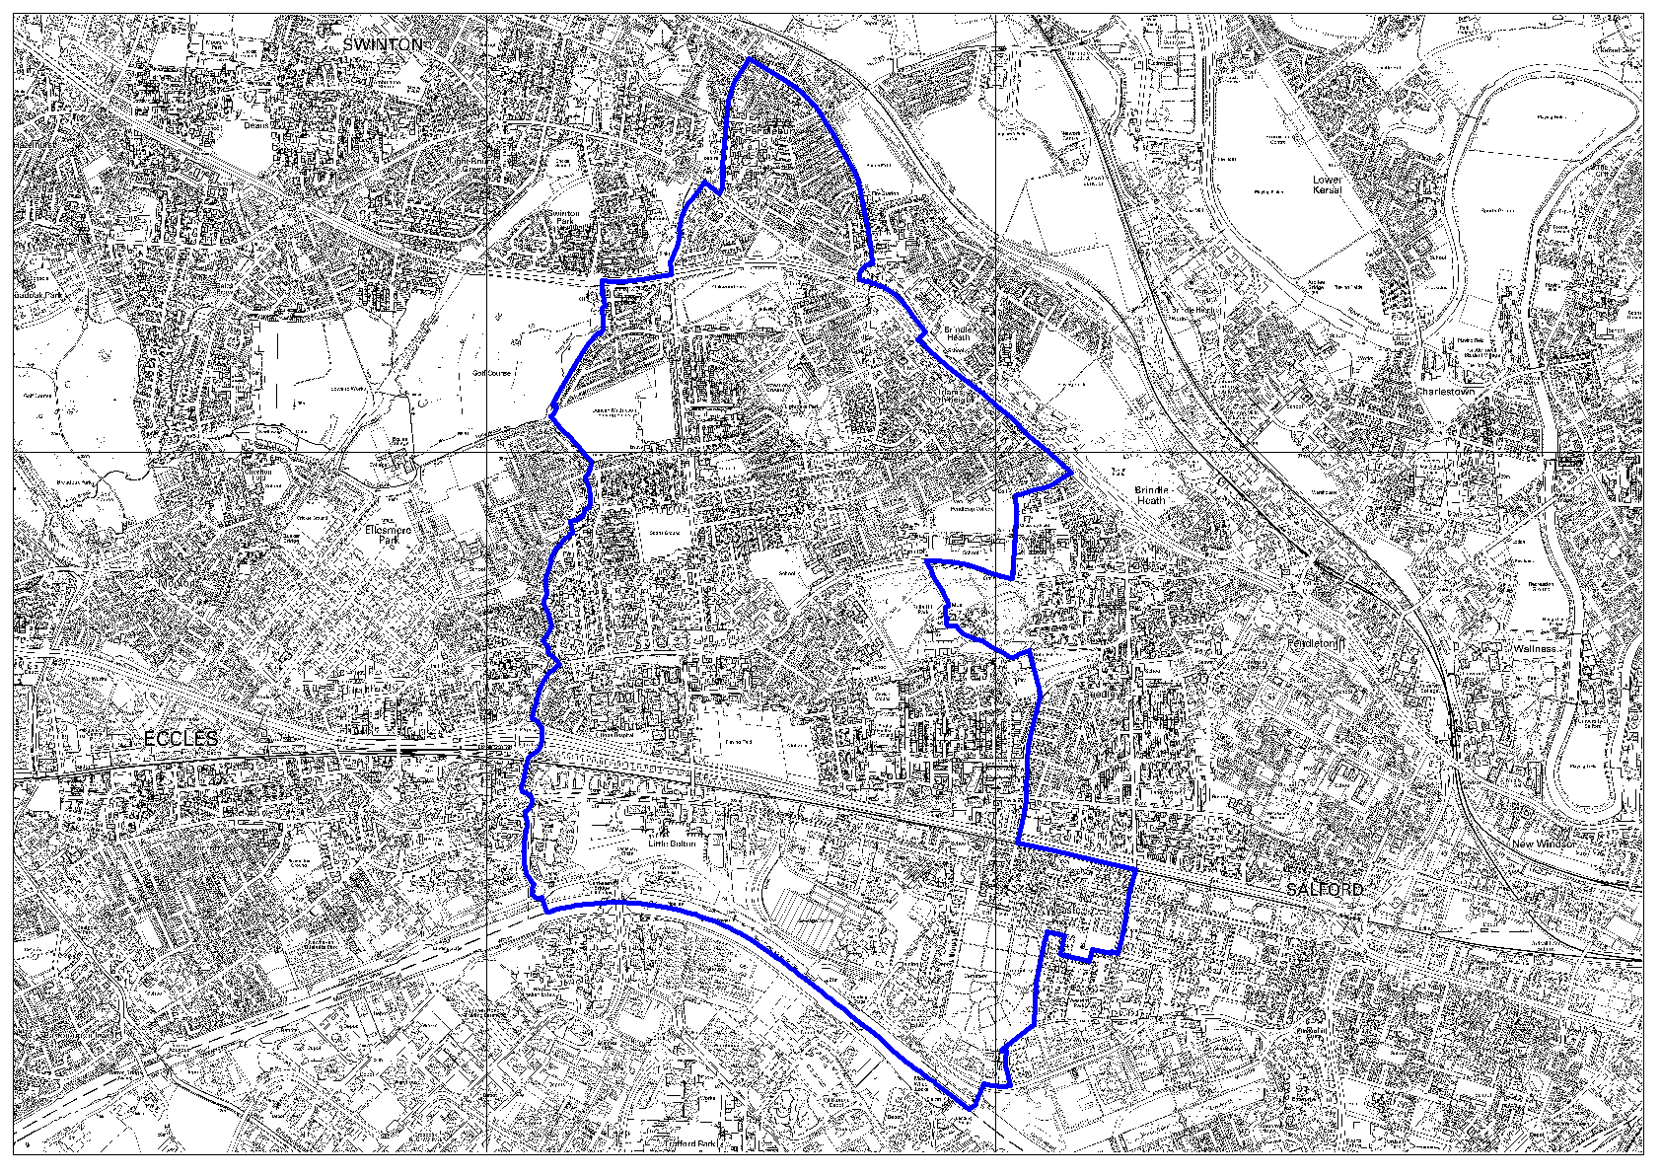

Weaste Renewal Area
- Environmental schemes put out to tender following successful application for ERDF funding.
- Work on the alleygating schemes in Weaste are complete, however Groundwork asked to provide costings for some additional works that will increase the security of the area.

- Eccles New Road Renewal Area
- Environmental improvements to two sites on the main Eccles New Road Corridor will greatly improve the visual impact these sites have on the area, helping to improve confidence in the housing market and attract more investment into the area. These projects will be on site January 2006.
- The Weaste Seedley Claremont Area Action Plan process is now underway with the aim of building on opportunities in the area to create plans for a sustainable future. The masterplan area has now doubled in size covering Claremont, Weaste and Seedley wards. The new draft brief is nearing completion. The selection process to appoint consultants is expected to start early 2006.

Claremont
- A comprehensive Alleygating scheme is now underway in the Irlam O’ th Height area of Claremont.

East Salford

Areas covered within this report:

Broughton
Chapel Street
Charlestown & Lower Kersal
Claremont Village

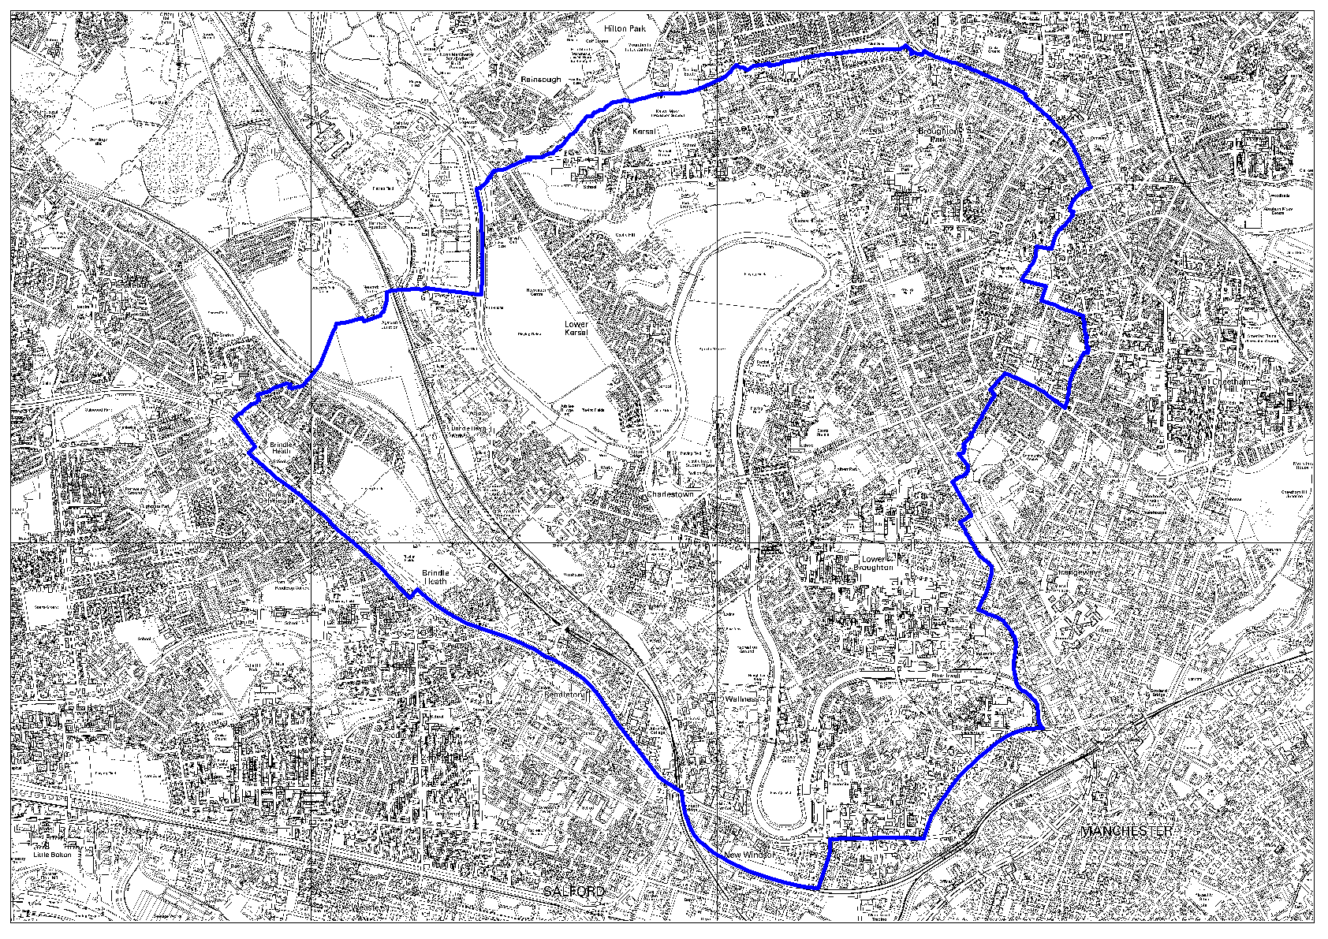

Broughton

Higher Broughton – Homeswap to new build
- Positive residents response to the details of the 19 Homeswap properties proposed for Vincent St. One final consultation exercise on the construction of the houses is required before the scheme can go out to tender. Hoped to be achieved early January 2006.
- The Road Closure process is still ongoing. It is hoped that this will be resolved by the start of February 2006.

Higher Broughton – Investigation works to playing fields
- Work to finalise the remediation of the Phase 1 Playing Fields site is ongoing. Attention is now moving to the Bottom St site and the relocation of the sports pitches.

Higher Broughton-Broughton Top Streets CPO area
- The legal CPO notices for the Top Streets area have now been sent to all property owners. The deadline for objections to the CPO was the 19th December 2005.
- The planning application for Bond Square and the Top Streets was submitted to the Council on 12/12/05.

Lower Broughton
- The first planning applications issues are not now expected to be submitted until March 2006.
- Rehousing of the last remaining household on Kempster Street has been completed.
- Approval has been given for the acceptance of tender for the demolition contract. P McGuinness & Sons Ltd has been appointed. Demolition is set to start in January 2006.

Chapel Street

Adelphi Media Quarter
- Terms now agreed between Salford University and Salford City Council for Adelphi Street and Meadow Road and for Irwell Valley campus.
- The transaction to be completed by the end of January 2006.

Greengate
- Draft Planning Guidance approved by Lead Member for Planning 12th December, subject to minor amendments.
- Further detailed design work to be commissioned from Urban Vision/Feilden Clegg Bradley to take public realm areas to submission of planning application stage.

Springfield Lane
- Three outline planning applications submitted by Urban Splash were considered and accepted by the Planning and Transportation Regulatory Panel on the 15th December 2005.
- Weston Williamson architects have been commissioned to prepare detailed plans for the first phase of development.

Charlestown and Lower Kersal

NDC
- Sports Village construction work due to complete February 06.
- Arrowhead housing improvements underway.
- St Aidan’s Healthy Living Centre underway.
- Alley-gating work commenced.

Salford Innovation Park
- Funding for the project approved from all 3 funding sources. ERDF offer letter now received.
- Signing of all legal agreements imminent.
- Awaiting positive planning decision.

Claremont Village

Duchy and Pendlebury Renewal Area.
- Planning and Closure Orders have been advertised on ERDF Alleygating scheme.
- CPO notices served affecting 116 properties within (Duchy Road) clearance area. A Public Inquiry is scheduled for March 2006.

Eccles
Areas covered within this report:

Eccles

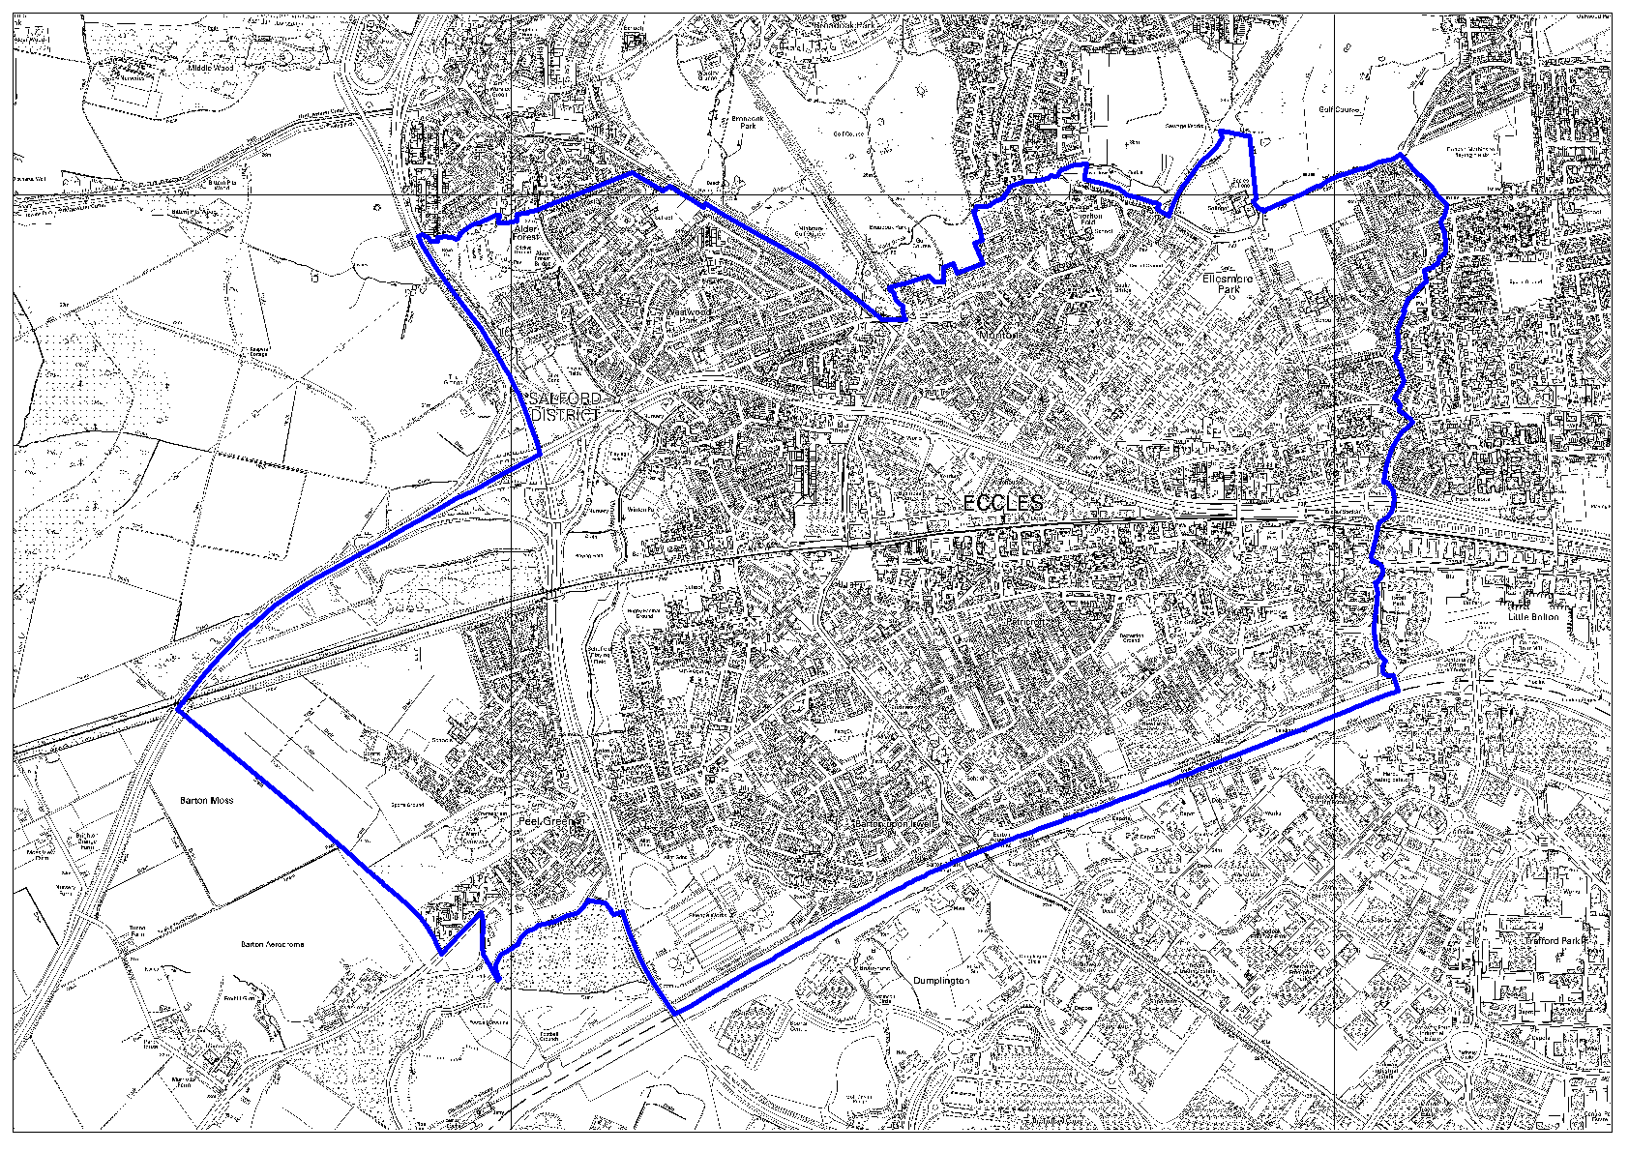
Liverpool Road
- Key Development Site - Crown Theatre, Church Street – Planning application approved for the development of the grade II listed building into 37 apartments together with retail space at the ground floor. Development to commence Jan/Feb 2006.
- Liverpool Road, Eccles Traders group formed Dec 05 with Chair, Secretary and Treasurer appointed.

Eccles Town Centre

- A meeting took place in December with landowners of Eccles town centre to discuss future plans for the centre.
- SCC call centre and 300 Urban Vision staff moved to Eccles in December 2005.

Magistrates Court and Justice Centre Initiative
- Terms need to be agreed with DCA & HMCS.
- Investigations as to siting, costing and design of multi-storey car parks continuing.
- Interim parking being investigated.
- Report to Cabinet planned for January / February 2006.

Areas covered within this report:

Barton

Irlam & Cadishead
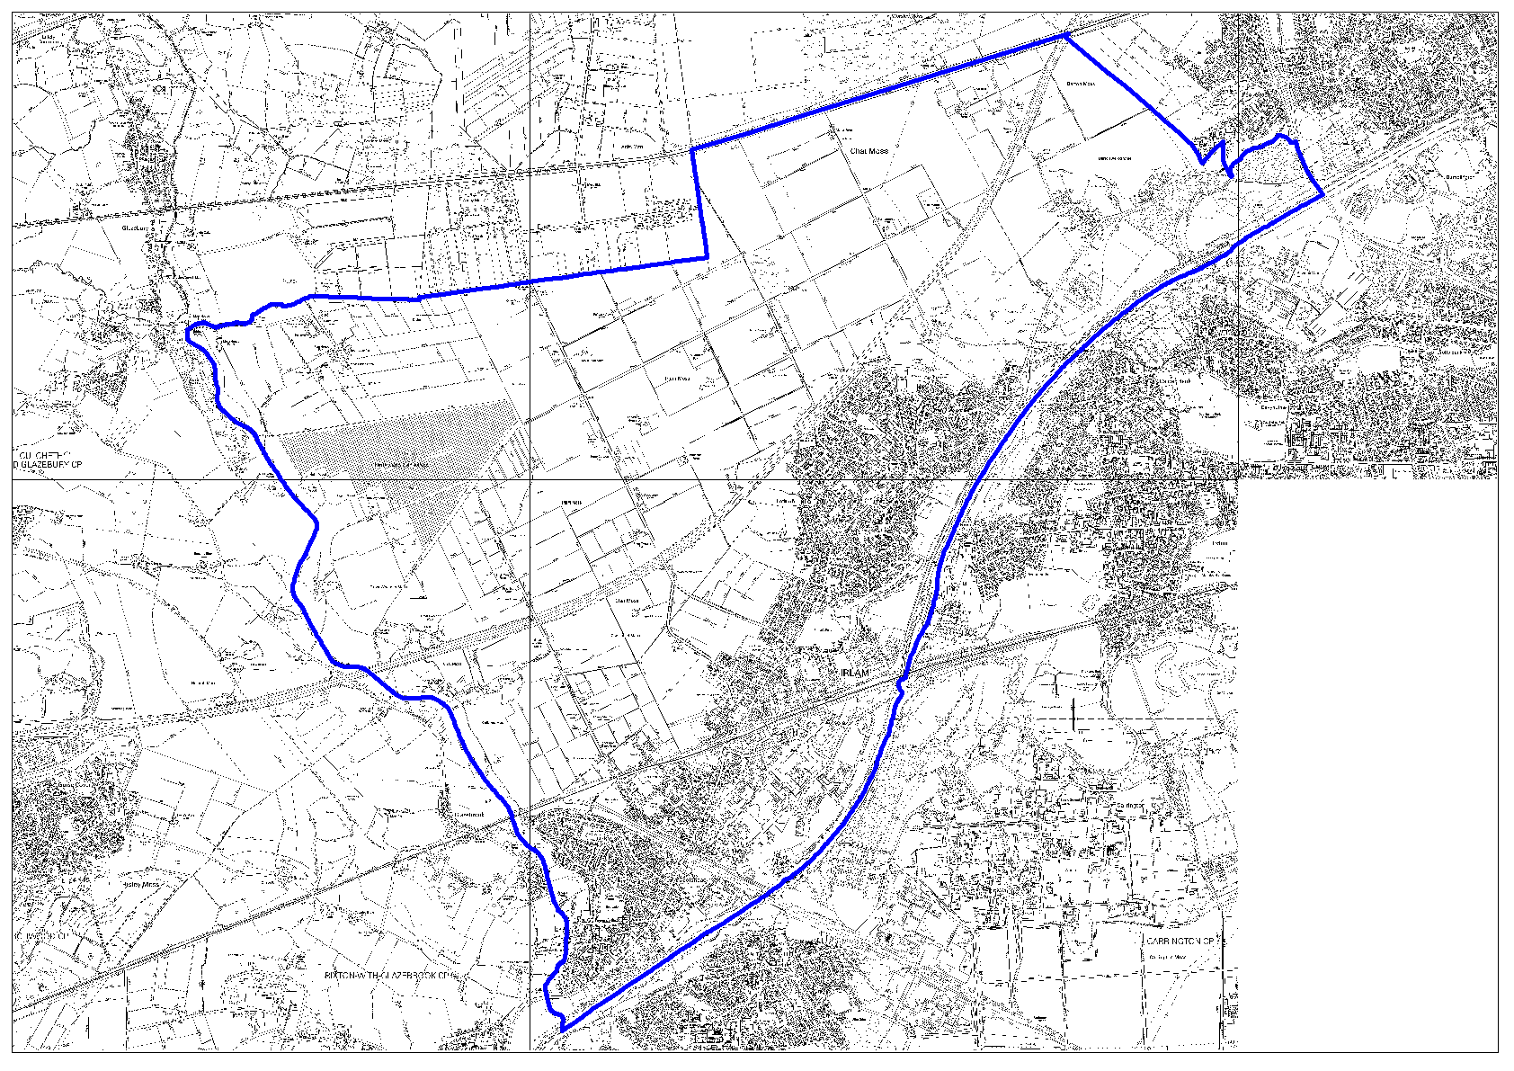
Barton Strategic Site

Red City Developments
- Planning Panel resolved to grant planning permission at its meeting on 17th November 2005. Application referred to Secretary of State (GONW) on 24th November 2005. Initial 21 day period for reply has been extended by GONW.
- Salford Reds business plan received and assessed by DTZ consultancy.

Peel Holdings
- Consideration of planning application for Port Salford progressing. Additional information on a range of environmental matters submitted on 19th December 2005. Need to reconsult local community and statutory consultees.
- Site allocation in the review Unitary Development Plan considered at Public Inquiry.

Areas covered within this report:

Chapel Street
Ordsall
Pendleton
Seedley Village
Salford Quays
Ordsall & Langworthy
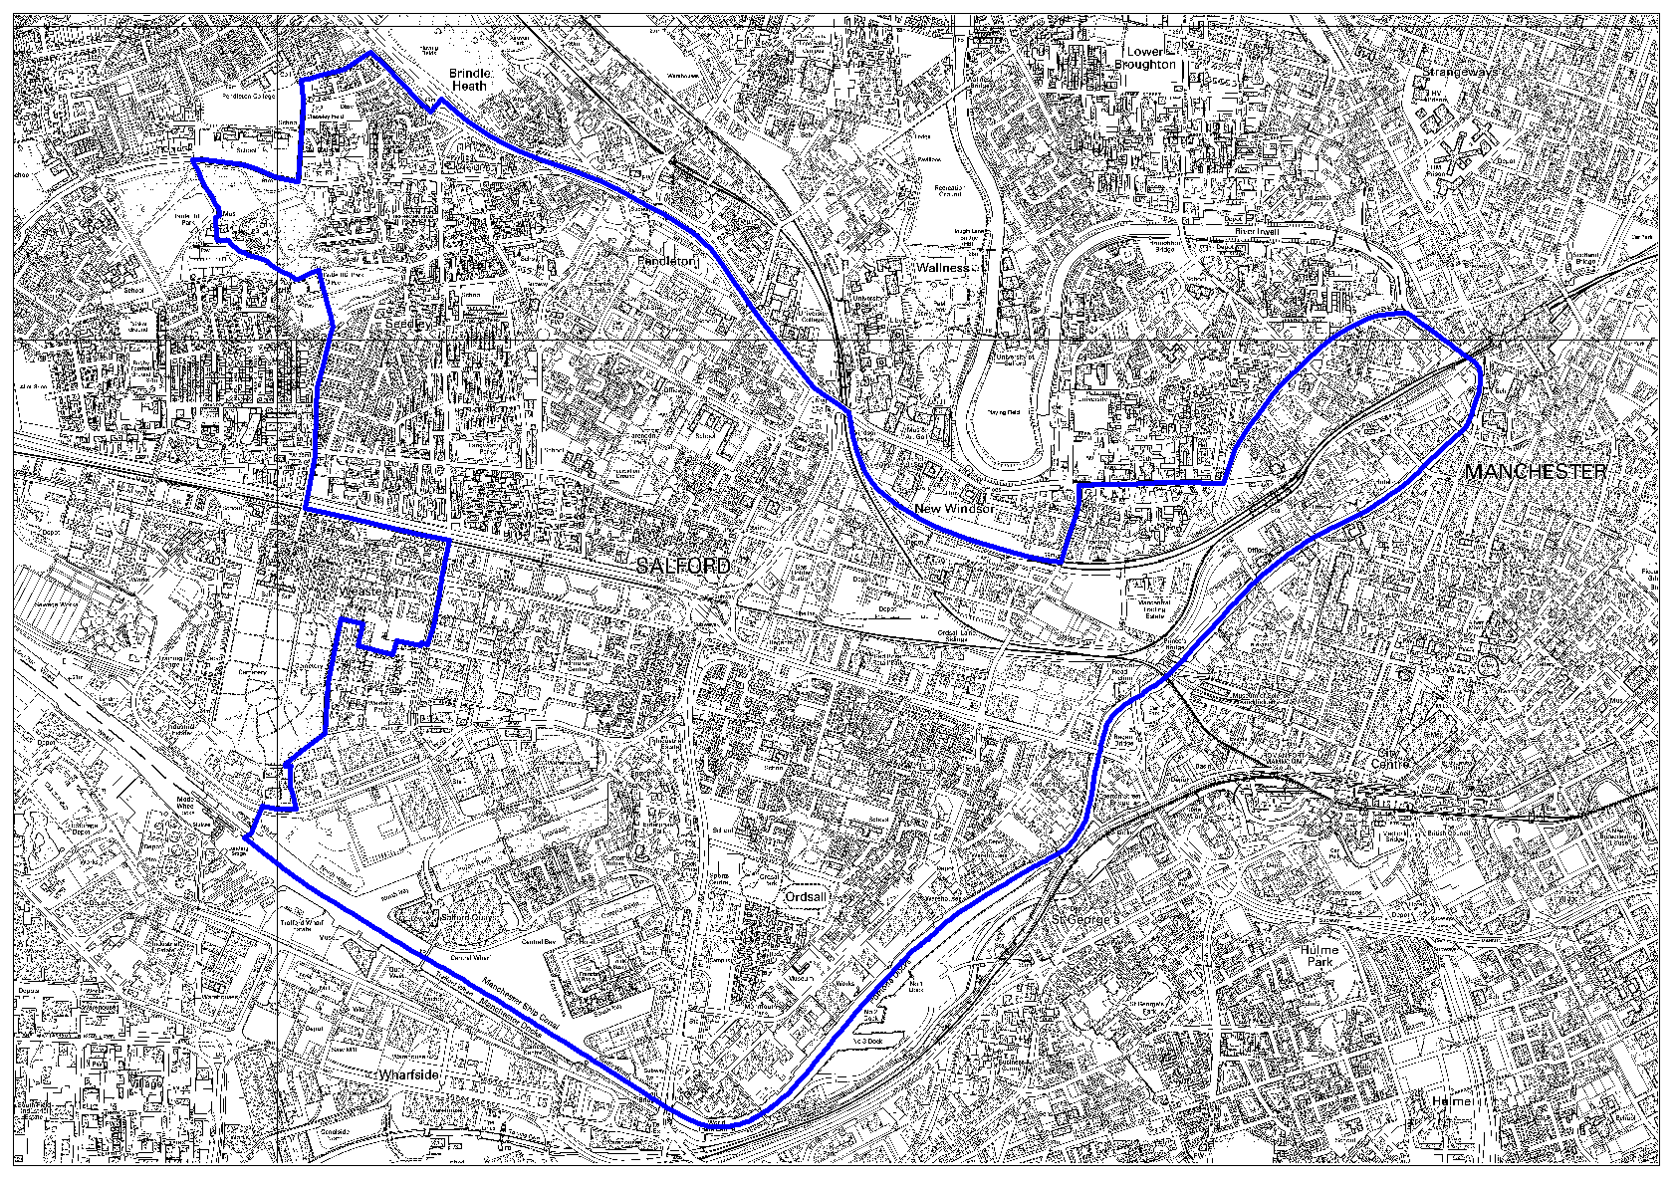

Chapel Street

Salford Central Station
- Listed Building Planning Consent application made by Network Rail following decision not to remove the central bridge. Phase 1 work will have to be amended.
- Meeting held on 4th November with URC to discuss next phases of improvement.

Manchester Bury and Bolton Canal
  - Land deal expected to be signed late January 2006 and start made on site on the main earthworks contract shortly after.

Ordsall
- Full planning permission granted and contract let for new primary school and children’s centre.
- Development Agreement and indicative infrastructure programme being drafted.
- Consultation event on proposed housing development on Hilton St held in December 2005.

Pendleton
Pendleton Masterplanning
- Consortium (led by Halcrow) completed of Stage 1A: Confirmation of key objectives, opportunities and constraints.
- Baseline study presented to Pendleton Steering Group in December 2005.

Proposed TESCO adjacent to Shopping City
- Meeting with Tesco and Shopping City owners on 21st December. Now awaiting plans for new proposal, expected mid January 2006.
- Planning application for new RC Primary School approved.

Seedley Village
Seedley and Langworthy
- Urban Splash now on site.
- Marketing and sales for properties on the Urban Splash site are expected to begin in April 2006.
- Renovation work to properties on Co-operative Street is to begin on 27th February 2006.
- Chimney Pot - Final designs are now being developed and physical work is due to begin in Spring 2006.
- Demolition on Nansen Street to provide space for the rear service yards for the shops to be completed by end January 2006.
- Governance arrangements are now in place for the Cornerstone building and the Langworthy Cornerstone Association Ltd has been set up.

Salford Quays
Dock 9
- Planning application submitted for the erection of 4 towers on opposite side of The Quays loop road to the NV buildings. 600 apartments, retail on ground floor. Retail and traffic studies requested. Highways Agency have directed no decision be made pending traffic assessment.
- Planning permission granted to mixed use development at Michigan Avenue 15th December Planning Panel.

Clippers Quay
- Planning application submitted for approx 290 studio residential units (Abito) on former pub site deferred by Planning Panel 19th January 2006 to seek increase in parking and contributions to green travel and secure community parking.

LIVIA
- Development of masterplan underway – Forestry Commission currently developing Forest Design plan.
- Single programme proposal to be submitted early in 2006.

Swinton


