 | PART I  (OPEN TO THE PUBLIC) | ITEM NO.

REPORT OF LEADER OF THE COUNCIL

To Cabinet Meeting
On 28th August, 2007

TITLE : Members Policy Day 20 June 2007 Connecting People
RECOMMENDATIONS:
It is recommended that members:
- Consider and agree the enclosed action plan following the recent Policy Day on Connecting People

EXECUTIVE SUMMARY: The report sets out the key findings of the recent Members Policy Day and outlines how the Council intends to respond to the key recommendations made

BACKGROUND DOCUMENTS: (available for public inspection)
- Cabinet Workplan 2007/08
ASSESSMENT OF RISK: Low
SOURCES OF FUNDING: Existing funds
COMMENTS OF THE STRATEGIC DIRECTOR OF CUSTOMER AND SUPPORT SERVICES (Or His Representative)
1. LEGAL IMPLICATIONS | Provided by: | N/A
2. FINANCIAL IMPLICATIONS | Provided by: | N/A
PROPERTY (if applicable): N/A
HUMAN RESOURCES (if applicable): N/A
CONTACT OFFICER: Martin Vickers, Director of Change 0161 7933407
WARD (S) TO WHICH REPORT RELATE (S): ALL
KEY COUNCIL POLICIES:

Background

  - The June policy day was the first policy development session undertaken with all Members of Council, the main focus of the session being the emerging Connecting People agenda. Members will find full details of the presentation at Appendix A.

  - Member’s views were sought in terms of development of the Connecting People agenda and a full summary of all responses is shown at Appendix B.

  - It is clear from this feedback that there are some consistent themes being expressed by Members which I would summarise as follows;

  - Improved engagement with employers in the City

  - The need for the Council to be an exemplar employer and thus influence its partners across the City

  - The need to raise aspirations

  - Continued raising of school attainment levels

  - Removing critical barriers such as transport, childcare provision

  - Provision of further statistical analysis

  - Improved communications with Members about the future development of the Connecting People Strategy

  - The need to better understand the skills gap and training provision within the City

2. Our improvement plans

2.1 Based upon the above themes, an improvement plan has been developed to reflect the follow-up action which will be required to effectively respond to Members questions/concerns. It will be noted that many of these actions were already included in the Cabinet Work plan for 2007/08 so it will be vital that we do communicate progress against the Workplan effectively during the year. Improved communications in respect of such important strategies was a common issue raised by Members and improvements such as the continued quarterly briefings around Cabinet Workplan progress and the introduction of a quarterly Connecting People Highlights report should assist the process.

2.2 Consideration must also be given to the role of Scrutiny Committees within the shaping of the Connecting People Strategy and Members may wish to consider requesting an appropriate Scrutiny Committee to examine in more detail a specific issue, for example, to investigate further some of the issues raised at Section 5 within the table below.

3. Improvement Action plan

Theme | Appropriate Cabinet Work plan reference | Action required | By whom
1. Improve engagement with employers in the City
1.1 Development of an engagement strategy for businesses |  | Further report to Chief Executive’s Lead Member Briefing by 30.9.07 to set out improvement plan | Kevin Brady
1.2 Ensure appropriate strategies eg. Economic Development/Marketing and Communications Strategies maximise the opportunities for inward investment opportunities and the positive development of our local companies | Reference 42 | Development of Economic Development strategy by 31 October 2007 for consideration by Cabinet, strategy to be circulated to all Members  Delivery of an effective whole City Marketing and Communications Strategy | Kevin Brady  Susan Wildman
2. Be an exemplar employer
2.1 Ensure our own recruitment strategies target appropriate groups eg. women, lone parents, long term unemployed | Reference 28 Delivery of SCC’s Corporate Employment and Skills Action plan | Finalise Corporate Employment and Skills Action plan and circulate to all Council Members  31 August 2007  This action plan will include the following;  a review of SCC recruitment strategy  a review of Apprenticeships  and Trainee Scheme opportunities and a review of SCC Skills for Life Strategy including the setting of clear 2007/08 skills targets for SCC staff | Martin Vickers
2.2 Examine opportunities for development of SCC Apprenticeships/Graduate Trainee Schemes | Reference 28 | See 2.1 | Martin Vickers
2.3 Seek to improve the skills levels of people in work | Reference 28 | See 2.1 | Martin Vickers
3. Raising aspirations
3.1 Ensure we have clear plans for our 16-19 year olds in terms of their skills/career development | Reference 33 Implement 13-19 strategy and pilot | Finalise and approve 13-19 strategy to 13-19 Partnership Board, Lead Member and to CYPPB | Faith Mann
4. Raising School attainment
4.1 Raise performance at Key stage 3-4 level including the development of the vocational and academic programme | Reference 2 Delivery of Local Area Agreement | Delivery plans in respect of Educational Attainment to reflect appropriate improvement actions | Paul Greenway
5. Removing the barriers
5.1 Better understand future employment issues regarding migrant workers | Reference 2 Reference 2  Delivery of Local Area Agreement | Within development of Local Area Agreement, Broughton Locality Planning pilot to examine such issues in further detail and make recommendations to Salford Strategic Partnership (30 September 2007) | Kevin Brady
5.2 Tackle unscrupulous employers |  | Within the development of City Strategy, SCC to pilot the use of new in work support to employers for example, mentoring to ensure effective management of employees, further quarterly reports to Chief Executive’s Lead Member Briefing on City Strategy progress | Kevin Brady
5.3 Better understand the barriers to work around health | Reference 2 Delivery of Local Area Agreement | Delivery plans in respect of Health and Economic Prosperity to reflect appropriate improvement actions | Julie Higgins
5.4 Work with Government to examine the issues of benefits/work ie incentivising return to work |  | SCC to engage with appropriate Government Agencies, Department of Work and Pensions, Government Office North West to ensure these issues are highlighted (30 September 2007) | Kevin Brady
5.5 Research to be undertaken to analyse transport links to areas of employment opportunity in Salford and Greater Manchester. This work could also examine the impact of TIF on employment prospects for Salfordians |  | Detailed research on such issues to be undertaken as part of TIF developments | Malcolm Sykes
5.6 Improved Child Care arrangements within the City | Reference 34 | Implement the national child care strategy | John Stephens
6. The role of Members/Scrutiny
6.1 Members to be provided with further regular communications in respect of Connecting People developments |  | Quarterly updates of Cabinet Work plan progress to be provided to all Members  Quarterly Connecting People highlights report of key achievements to be circulated to all Members | Martin Vickers  Susan Wildman
6.2 Members to communicate the Council’s Connecting People objectives and achievements within communities |  | Quarterly Connecting People highlights report of key achievements to be circulated to all Members | Susan Wildman
6.3 Members to be provided with further data to better understand the scale of the challenge  - True levels of inactivity  - Training uptake and fall out  - Ward Level data and information re local employment opportunities | Reference 38 Delivery of Observatory | Further investigations to ascertain whether such data can be provided within Phase 1 Salford Research and Intelligence Observatory (30 September 2007), access to this information will be for all Members | Martin Vickers
6.4 Examine the opportunities for accessing S106 funding for skills development |  | The SCC Evaluation of S106 Agreements Report, produced in June 2005, by the BE Group will be reviewed by the Salford Construction Partnership Executive Board and recommendations made by October 2007. | Kevin Brady
6.5 Cabinet to determine the extent of any future role for Scrutiny in Connecting People Agenda for example, in respect of barriers raised in Section 5 |  | Consideration by Cabinet 10 July 2007 | Cabinet
7. Understanding the Skills Gap/Training Provision within the City
7.1 Improved engagement with our employers so that we understand the skills demands of the future |  | See 1.1 | Kevin Brady
7.2 Better understand the skills provision across the City | Reference 2 Delivery of Local Area Agreement | Examination of these issues currently being progressed through Economic Prosperity block of Local Area Agreement and through development of City Strategy. Further report to Chief Executive’s Lead Member Briefing by 31.12.07 | Kevin Brady

- Recommendations

Members are asked to comment on and agree the proposed improvement plan following the recent Council Policy Day

APPENDIX A CONNECTING PEOPLE PRESENTATION


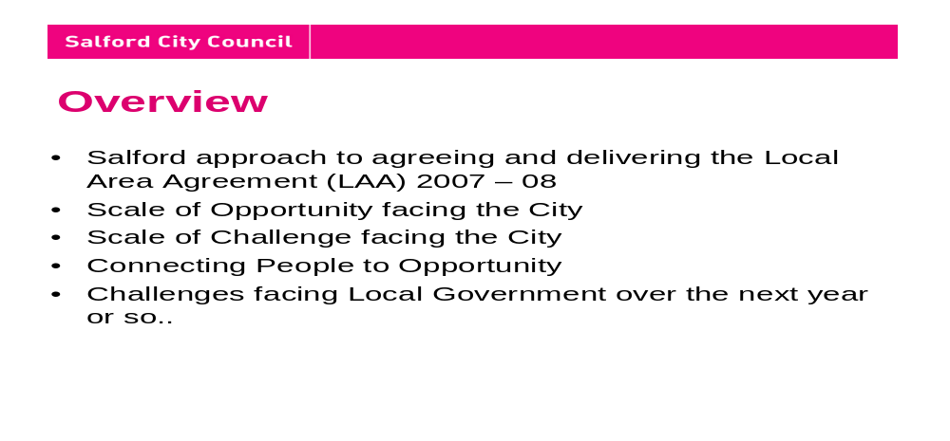
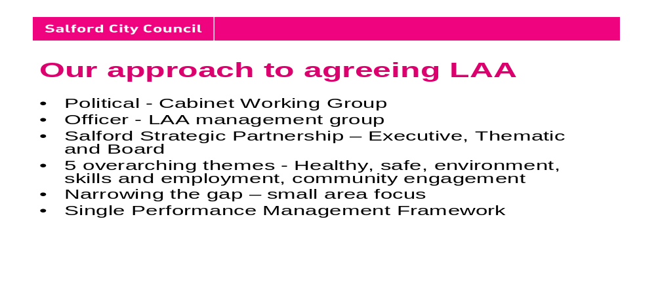

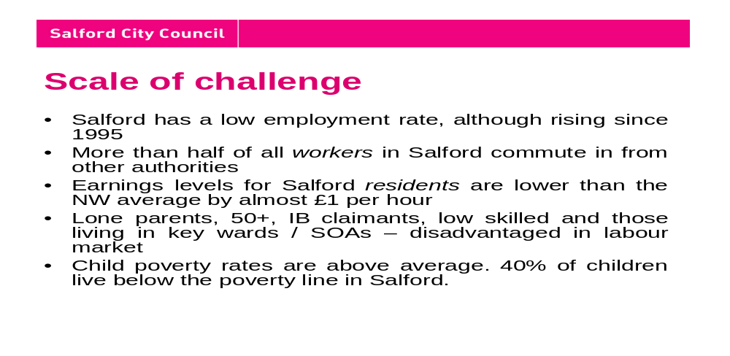
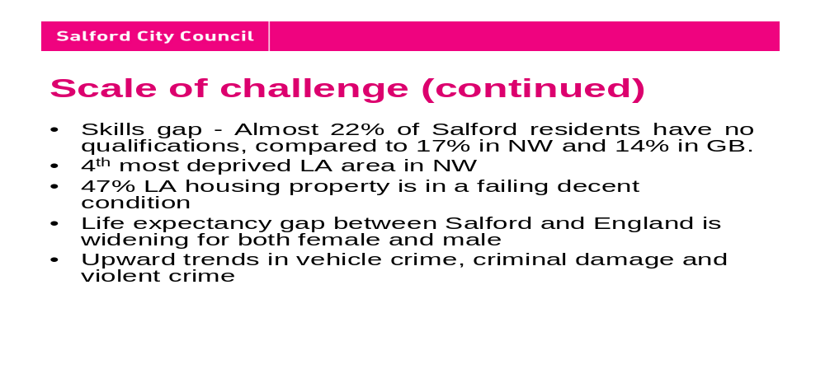
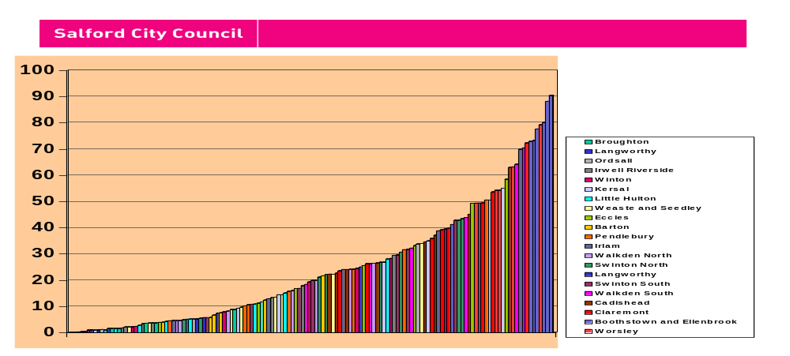
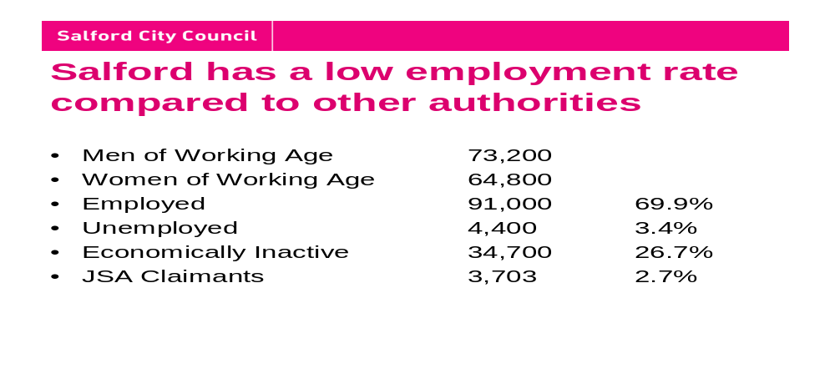
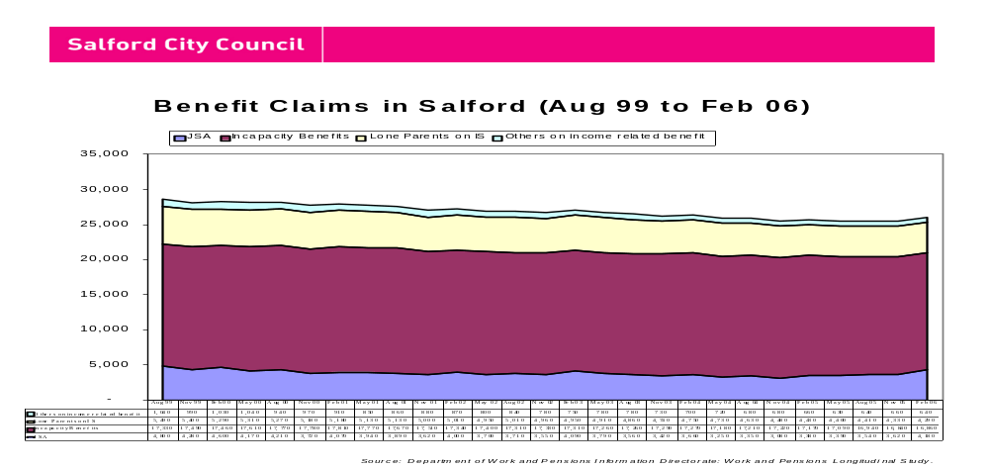
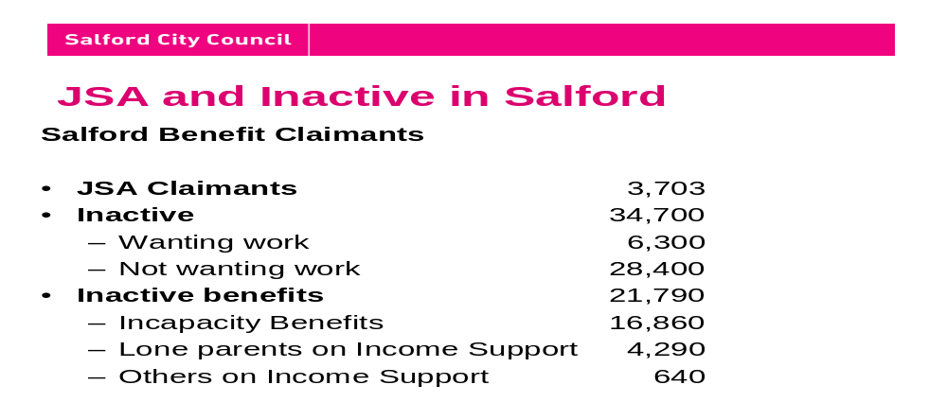
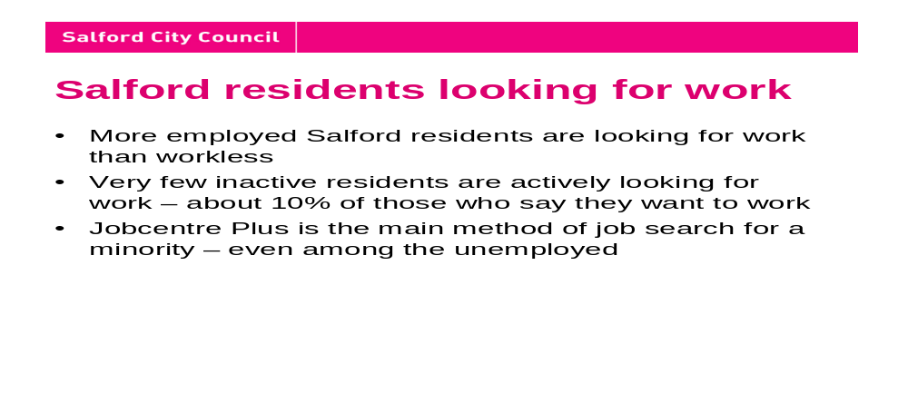
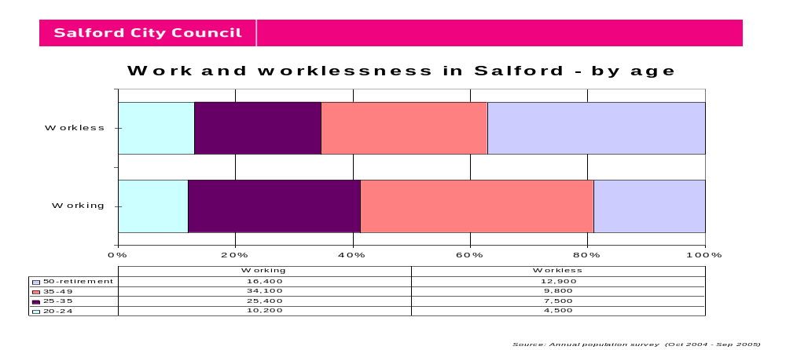
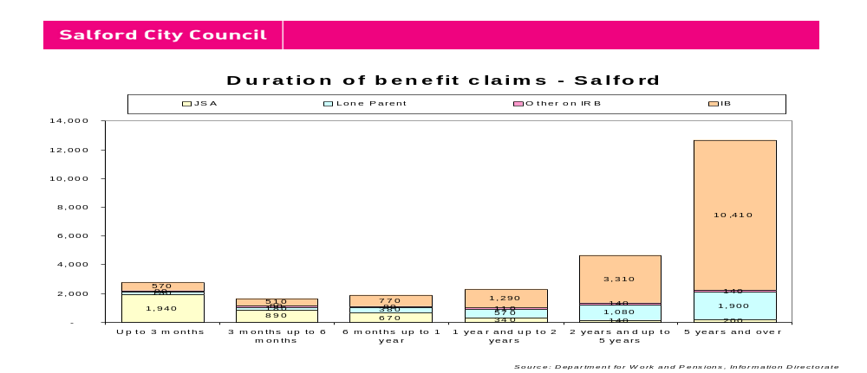
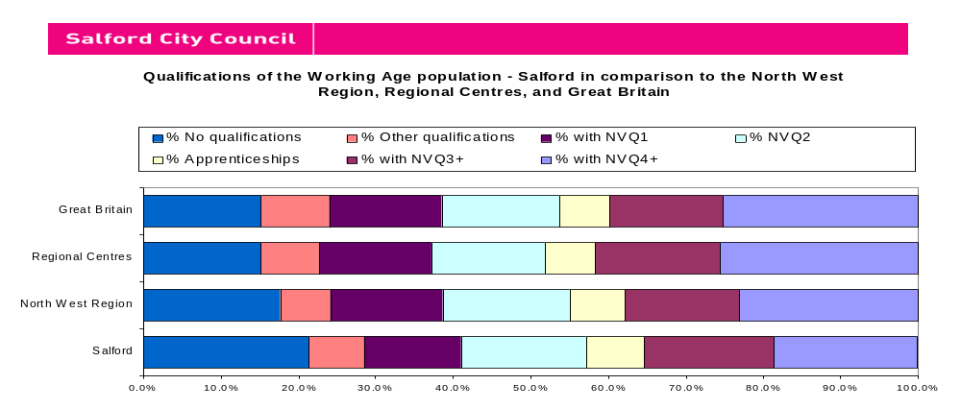
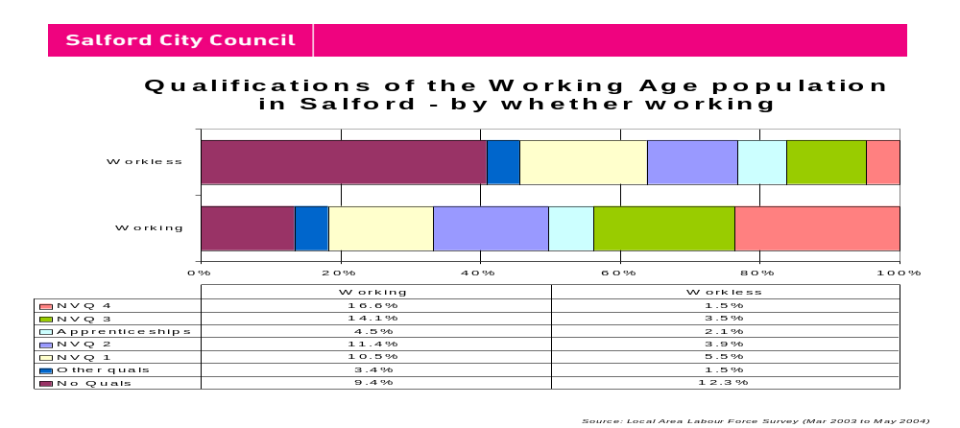
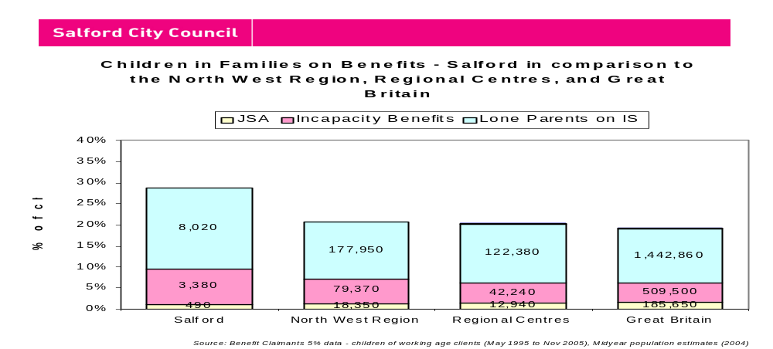
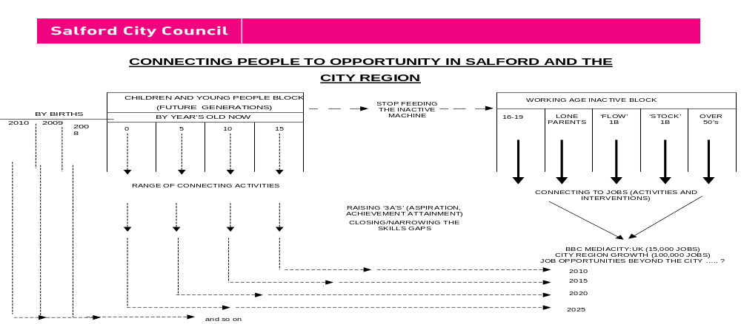
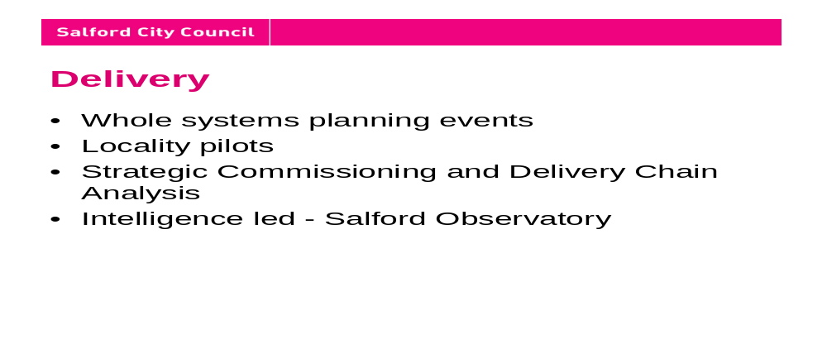
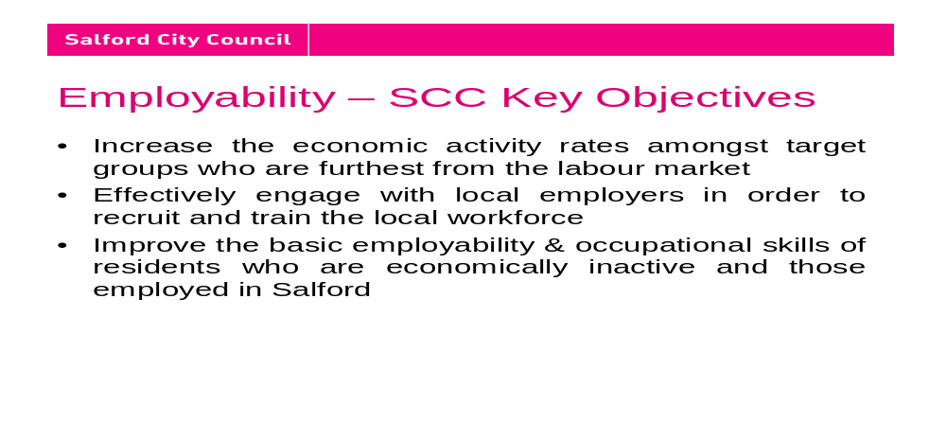
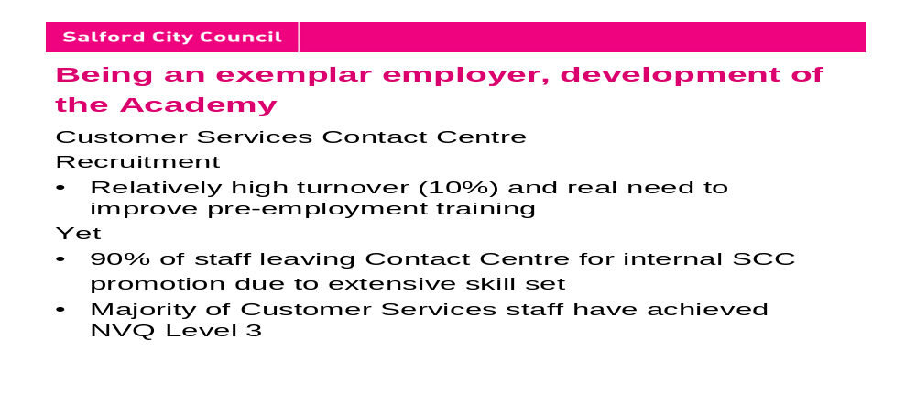
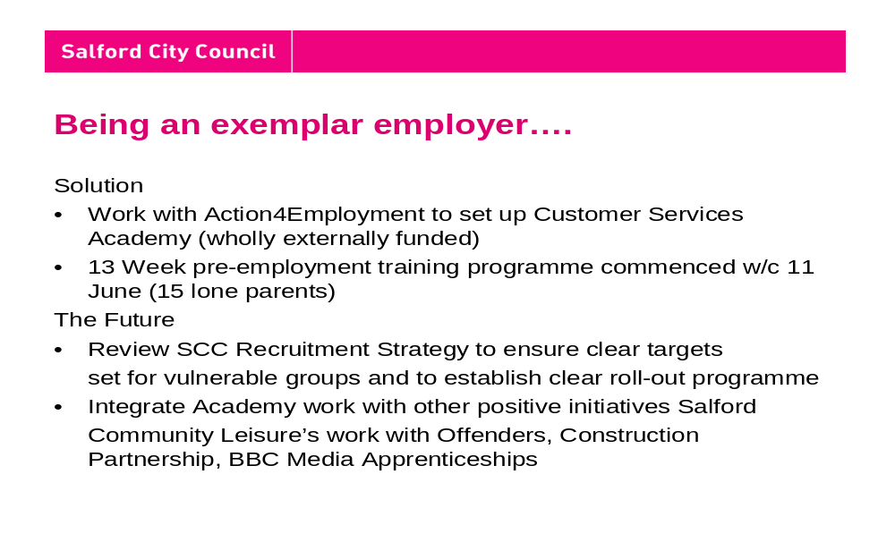

APPENDIX B COUNCIL POLICY FORUM FEEDBACK
20 June 2007

Are these the right issues for our focus?
What more should / could we be doing?
What implications are there for the way we do business and for our policies?

- Understanding business opportunities to understand skills needs - meet the gap
- Positive employment action for city region - incentives for employers (grants).
- Better connection with the children studying for appropriate qualifications.
- What about children without qualifications?
- Understanding better the careers service provision.
- Improving council infrastructure to attract people to city.
- Car parking - transport - barriers, childcare.
- Work more effectively with colleges.
- Better use of technology as an enabler - virtual office education.
- Better understand the issues with migrant workers.
- Review recruitment strategies.
- Improve relations with business.
- Better understand job opportunities - outside Salford but in region.
- Less reward for people who do not work - change the culture - more carrot and stick.
- Review employer practices - involve trade unions.
- Develop apprentice/graduate trainee scheme.
- Ask professionals why they live in Salford.
- Use 106 funds for training/skills
- Need for more depth/greater understanding of statistical information
- Incentives/rewards: how do we encourage people to return to work/training?
- Construction industry/employment: can we encourage developers to do more?
- Why aren’t ‘workless’ people looking for work?
- What can be done to encourage them to work?
- Campaign?
- Question re attitudes of families brought up on current culture.
- Raising aspirations in women (children not the only career option).
- Need for affordable childcare.
- Negotiations with employers?
- Benefits trap v low paid work
- Need to create quality jobs
- Training to be ‘credited’ against loss of benefits
- Is there a ‘block of disaffected’ people we can track?
- ‘Benefits trap’: is there also a “tax trap”? 10% rate of tax: Salford hit by abolition?
- How do we target/communicate with groups to get them into training/point towards jobs?
- Advertising? Direct contact?
- Be conscious of psychological effect of unemployment in communicating: has to be done face-to-face by people with skills
- Key to motivation
- Need a structure in place before members can tackle issue.
- Can we engage with children at a very early age, e.g. nursery?
- How do we encourage acquisition of practical/technical skills of old ‘technical colleges’?
- Accessibility
- Transport: people need to be able to get to jobs
- Information: no figures on people who have tried to access training
- Do people become disenchanted?
- Links to poor health/where they live/kind of work they’ve done
- May be different for Salford: need to understand this
- No. of people who commute into Salford: higher than elsewhere?
- Salford young people’s university: need to encourage schemes.
- Vocational partnerships in schools.
- How many workless people have no qualifications?
- Over half? 41%
- Reduction of teenage pregnancy?
- Community cohesion (inward immigration).
- Appropriate skill sets and mix.
- Build self-esteem.
- Parental responsibility.
- Raising parental expectations for their children.
- Proper and effective childcare.
- One size doesn’t fit all.
- Connecting PPL
- Gear up skill sets taught in high school e.g. mental maths.
- The Council must be an exemplar employer.
- Improve youth service provision e.g. ICT
- Change cultural perceptions - all jobs are important and contribute value. All roles are valuable - not just “professional” roles
- Raise wage base in Salford - incentive to work.
- Appropriate intervention e.g. sure start.
- Multifaceted approach required.
- Consistent message from all agencies
- It is possible to help children overcome ‘social stress’
- Local firms to link into schools and give presentations/talks about job skills needed.

In what ways can Scrutiny Committees support the development of the Connecting People strategy?
What can councillors do to help raise ambition and reduce working age inactivity in their wards?

- Focus on barriers - transport, migrant workers.
- Scrutinise business engagement audit.
- Clear actions from today
- Feedback to Members - better understanding of what we are doing.
- Scrutinise training provision.
- Exemplar employer - challenge partners.
- Need to engage on these issues with communities, spread the ‘gospel’ of attainment
- Force the issue to encourage business to the city.
- Joining up the positive stuff!
- School governors role.
- Become school governors (especially at primary level)
- More spending on primaries (but no less on secondaries!)
- Take part in Community Committees: agenda item
- Shout success about educational attainments/students’ successes
- Make sure we get resources needed in particular wards.
- Members can give intelligence and feed in, but need a framework.
- Need to engage key groups directly.
- Not all groups have governorship of schools
- Pass information to local communities.
- Celebrate the good as well as negative.
- Choose relevant areas of strategy for closer inspection.
- Engage community

