 | PART 1  (OPEN TO THE PUBLIC) | ITEM NO.
_____________________________________________________________

REPORT OF THE LEAD MEMBER FOR ENVIRONMENTAL SERVICES

TO THE CABINET MEETING 30th October, 2002

TITLE: PROPOSAL FOR THE DEVELOPMENT OF A CORPORATE RECYCLING STRATEGY

RECOMMENDATIONS:

- That members agree to the proposal that each Directorate identifies and nominates an existing officer to act as Lead Officer with responsibility for initiating, monitoring and reporting on recycling initiatives within their own Directorate.

- That each Directorate’s Lead Member receives feed back on their own Directorate’s recycling performance and takes any necessary actions they feel are needed.

- That members agree that consideration be given by each Directorate to Lead Officers being remunerated for the additional recycling responsibilities and that this responsibility be built into their job description.

- That all relevant specification and tender documents issued by Directorates Include environmental and recycling requirements (e.g. recycling, energy savings, sustainable resources etc.)

- That the Environmental Officers Working Group be resurrected to monitor environmental initiatives, in particular the progress on corporate recycling initiatives and Local Action 21 issues.

- That consideration be given to Lead Member presence on the Environmental Officers Working Group either on a permanent basis or as and when required to support corporate recycling. Reports or recommendations emanating from this group could be presented to the Environmental Scrutiny Committee for their consideration.

EXECUTIVE SUMMARY:

The report outlines the need for the City Council to develop a corporate approach to recycling the wastes it produces in the process of delivery services both internally and to residents of the City.

Directorates have identified the waste minimisation, re-use and recycling activities they are currently undertaking. The successes and barriers to further development and expansion of those activities are also highlighted.

Based on the desire to improve the City Councils corporate recycling activities the City Councils corporate recycling activities, the report provides a series of recommendations and suggested initiatives which need to be pursued if Corporate recycling rates are to be increased, one of which is the identification of Lead Officers within each Directorate who are given recognised responsibility to promote recycling.

BACKGROUND DOCUMENTS: (available for public inspection)

ASSESSMENT OF RISK: N/A

THE SOURCE OF FUNDING IS: N/A

LEGAL ADVICE OBTAINED: N/A

FINANCIAL ADVICE OBTAINED: N/A

CONTACT OFFICER: Wayne Priestley – 0161 793 2060

WARD(S) TO WHICH REPORT RELATE(S) N/A

KEY COUNCIL POLICIES:

Best Value
Budgeting Monitoring
Budget Strategy
Communications - Public Relations
Community Strategy
Environmental Strategy
Modernising Local Government
Procurement Policies
Recycling Policies
Scrutiny
Transport Strategy

Waste Management

REPORT TO LEAD MEMBERS WORKING GROUP

SUBJECT : Report to Lead Members Working Group Regarding The Current Situation of Corporate Recycling Initiatives

- Background

  - Following two reports to Cabinet on corporate recycling initiatives,

- A Corporate, Strategic and Operational Approach to Recycling (27.3.01)
- Update Report on Kerbside Recycling Proposals and Promoting Corporate Recycling (14.12.01)

a recommendation was given that a three Lead Member Working Group be established on behalf of Cabinet to report on the findings of the progress being made to develop and improve upon current corporate recycling initiatives.

  - The Lead Members from Environmental Services, Development Services and Housing were requested to assess the findings with the intention of reporting back to Cabinet at a later date.

  - A meeting was called by the Environmental Services Directorate to investigate what recycling was being carried out by each Directorate and the barriers (if any) present, which prevent expanding recycling within their Directorate.

  - A copy of the memorandum inviting Directorates to the meeting can be found at Appendix 1.

  - The meeting was held on the 15th January at Crompton House at which the following Directorates attended.

- Chief Executives
- Corporate Services
- Development Services
- Education and Leisure
- Environmental Services
- Housing Services

2.0 Details

  - The meeting outlined the need to meet Best Value national recycling targets for domestic waste, as failure to do so could be seen as evidence of a failing service, which could result in Secretary of State intervention, and ultimately loss of service.

  - The Council is currently trying to acquire funding to introduce kerbside collection schemes to reduce the amount of waste going to landfill. To do this it needs not only to find the finance, but also to re-educate the general public into changing their attitude to waste disposal and the need to see waste as a resource and therefore recycle it.

  - In promoting this message the City Council has a duty to take a lead on this, by recycling as much of its own waste as possible, including ensuring any work undertaken on its behalf, is also subject to sustainable practices (e.g. recycling) wherever possible.

  - Each Directorate was asked to explain what recycling activities it was currently undertaking and if there were any barriers to developing recycling further.

3.0 Directorate Recycling Progress

3.5.1 Chief Executives

3.5.1.1 Being mainly office-based they felt they could have little real physical impact on actually recycling large amounts of wastes. However, they did feel they could affect the ability to recycle from a strategic viewpoint, examples being;

    - Developing Greater Manchester wide initiatives such as the abandoned vehicle strategy with Greater Manchester Police, perhaps this element of ‘waste’ could be recycled more effectively particularly in view of the ‘End of Life Directive for Vehicles’.

    - Ensuring Single Regeneration Budget contracts look at environmental issues such as recycling.

    - General contract letting needs to have environmental issues built into them, e.g. how contracts take into account the aims of the City’s Environmental Strategy.

    - Influencing external partners such as AGMA and Manchester Airport.

      - The Chief Executives Directorate does support the recycling of office waste paper and has tried to re-use office equipment by offering it to staff on a ‘sold as seen’ basis.

      - It is also felt that work could be undertaken to develop an environmental awareness module within the induction process and to develop a broader awareness module as part of the corporate training portfolio.

3.5.2 Corporate Services

      - This Directorate has made attempts to promote environmentally friendly purchasing practices by developing a ‘Good Practice Guide on Purchasing and the Environment’. However it still feels that price determines most Purchasing Officers decisions.

      - In relation to ensuring the use of recycled paper, which this Directorate has often been the main supplier of to other Directorates, this has proved to be frustrating, as the quality of recycled paper is now as good as ordinary paper and therefore should be acceptable for almost all paper usages by the City Council. In fact most paper used by the City Council is environmentally friendly paper i.e. it has a high recycled content. However, as a result of the new SAP system there is an ability for Purchasing Officers to override the current bulk paper supplier who does have to take environmental considerations into account, if they can find a cheaper paper price elsewhere.

      - Corporate Services take a central lead on purchasing within the City Council but have not to date taken a proactive role in promoting environmentally friendly products, although the purchasing guide mentioned at 3.5.2.1 is a good start in addressing this problem. It is felt that the control the new SAP system has over a centralised system of purchasing could help promote the specifying of more environmentally friendly products by influencing suppliers who wish to win Council orders to offer ‘greener’ alternatives. This approach to developing a sustainable ‘cradle to grave’ approach to service delivery and purchasing is a crucial element to future Council activity. There is no point specifying recycled materials if the Council does not ensure that its ‘wastes’ are not tied into a recycling processor. A good example of this is the work of Jackson Lloyd, which currently provides responsive repairs for the Housing Directorate. The approach Jackson Lloyd has taken is highlighted in Appendix 3. The point to developing a ‘cradle to grave’ approach is that we need to ensure the production of a material is not environmentally damaging or wasteful of energy, be it made from virgin materials or recycled. When it is then used by the Council it must again not be used in a manner which has environmentally damaging effects. Its longevity must be maximised, and when it has reached its time of replacement, it must have a disposal route whereby every opportunity to re-use, recycle or compost must be considered. Only by ensuring these criteria are met will a truly sustainable supply/disposal chain be established.

      - Attempts have been made to recycle IT equipment but this too has hit problems, such as complying with the Data Protection Act which requires all hard drives to be cleared of sensitive information. This is time consuming and resource intensive. Also many IT pieces of equipment are obtained via 5-6 year leasing deals, which means even when they have outlived their usefulness, which is usually after 3 years, due to them being obtained via a leasing deal they are not the City Council’s property to recycle. As such large collections of IT equipment can build up.

      - Corporate Services do support office waste paper recycling and other general recycling initiatives such as aluminium can and ink toner recycling, but has difficulty in expanding recycling tonnages significantly, because of the nature of its office-based activities.

      - Corporate Services are also responsible for the City’s energy audit initiative, which promotes more effective and sustainable use of energy.

      - The Director of Corporate Services highlighted the progress on recycling laser and ink jet cartridges and photocopier toner, which is currently undertaken by IT Services staff when Directorates send them their used cartridges and toners. Boxes are provided by a company called ‘Office Green’ into which these items are placed. Currently c. 84 boxes a year are collected. When they are collected they are sorted by Office Green, who advise of their value by sending a Points Confirmation together with a claim form to redeem the value of the cartridges. This amount is then given to the City Council.

      - The issue of whether this system is as effective as it could be, was raised, i.e. all the recycling is done at one site, the Computer Centre. As such staff have to take their used equipment to this site, which if employees work in an outstationed office, is problematic. Therefore in order to promote this scheme across the Council, boxes would need to be placed in each building for it to be truly effective. In order to do this, discussions with Office Green need to be entered into to see whether they would provide such banks, and at what cost, if any. Also it may be that this company may have ideas on other office recycling schemes which could be adopted.

      - An additional point raised by the Director of Corporate Services is the fact that as so many homes now have computers, is there a city-wide need to provide recycling for print cartridges/toner recycling at the City’s recycling centres. Discussions therefore need to be entered into with initially Office Green to see whether they would provide banks for this purpose.

      - The City is part of the Greater Manchester Purchasing Consortium which is able to obtain preferential rates for different types of goods and services by virtue of bulk purchasing. It is felt the Consortium provides a golden opportunity to promote recycling and sustainability by forcing potential suppliers to build in environmental considerations if they want to supply any goods and services to local authorities. Therefore it is felt that there is a need to raise the issue of adopting a greener purchasing policy within The Consortium to achieve these aims. Perhaps the initial starting point should be the development of an environmental statement for the Consortium and once developed closer work on building environmental consideration into future tenders and specification.

3.5.3 Development Services

      - This Directorate has been instrumental in developing a number of recycling initiatives such as the office waste paper recycling scheme (run jointly with the Environmental Services Directorate), and recycling aggregates as a result of highways work.

      - Other initiatives include the recycling of fluorescent tubes, and developing green guides to help Directorate’s deliver services more sustainably.

      - Development Services also played the lead role in drawing up the City’s Environmental Strategy 1998-2008.

      - The Director of Development Services has identified two major areas where the Directorate can contribute to improving recycling levels across areas of its work.

Domestic / Employee Performance

The Office Waste Paper scheme has demonstrated a willingness to participate in recycling initiatives. This scheme has been a success because it has involved minimal disruption to working arrangements and is co-ordinated by “Green Volunteers”

It should be possible to extend the office paper scheme to include other consumables such as toner cartridges, fluorescent lighting tubes, computers and furniture. Currently this happens in an ad hoc fashion.
There are three factors that will prevent this happening.

Lack of Budget

Most recycling schemes would require a budget to cover, publicity, waste storage and collection costs e.g. fluorescent tubes would require purchase of redundant tube holders and there would be subject to an annual collection charge. There is currently no revenue funding to put to any such scheme.

Lack of Staff Time

Most recycling schemes have knock on effects for some staff. This may relate to the coordination of a scheme, collection and storage, or in some cases preparation of the product. Experience shows that recycling is not seen as a priority and in some cases regarded as an extra task that does not fall within their remit. E.g. redundant IT equipment has to be stripped of software before disposing in order to meet requirements of Data Protection Act.

“Someone Else’s Job”

There is a problem of securing ownership of a scheme. There is a lack of any corporate culture for taking responsibility for recycling / waste reduction. It is always someone else’s job! It is imperative to have a dedicated member of staff with a specific responsibility to promote good corporate practice and develop practical initiatives across the Council.

Contract and Tendering Performance

There are a number of areas where recycling / waste minimisation could be applied to the building and design services offered by Development Services Directorate.

Design for Minimum Waste
- design out waste during construction and during the life of the building
- involvement of materials supply chain
- careful specification of materials
- reuse of “waste” materials

Responsible Construction Contractors
- choose contractors who work on principles of continuous improvement, waste elimination, linked into recycled materials supply chain.
- Choose contractors committed to an environmental policy.
The Design Disciplines are already contributing in a number of ways through contract specification
- reuse existing equipment such as radiators, fan convectors and lighting fittings.
- Ensuring correct disposal of redundant equipment such as wiring, fluorescent tubes and asbestos based products.
- Use of bark mulch
- Use of recycled materials when possible. e.g. road scalpings

Some specific examples of what else could potentially be achieved are listed below:
- salvage material and street furniture for reuse ( high cost)
- greater use of recycled bricks ( high cost), crushed concrete ( low cost)
- design to avoid excessive excavation ( low cost)
- use materials with verifiable green credentials ( med. to high cost)
- meet all disciplines regularly to disseminate information about reusable materials.

There is great potential for improving performance in this area, but progress is patchy for a number of reasons;
- the Going for Green document produced by Architectural Design Services on behalf of all the design disciplines has not been progressed beyond draft stage.
- Clients may not be prepared to pay the additional costs of Green Design
- Clients sometimes see recycled materials as inferior
- incorporation of greater levels of recycling will usually lead to higher tender prices, which are unlikely to be accepted.
- environmentally responsible contractors are often more expensive and do not get chosen on the criteria of “cheapest is best”.

It may be recalled that Development Services drew up a Green Design Guide in 1996. The Guide was adopted by City Council and included a commitment to high energy efficiency for tendered purchase and development of council land. In reality, no tender price was ever accepted from a company taking this environmental responsibilities seriously, because their tender offer prices were higher than those from Companies that ignored the requirement, and as such, cost objectives overrode environmental objectives.

3.5.4 Education and Leisure

      - Initiatives this Directorate have been involved in, include supporting the corporate office waste paper recycling scheme, recycling ink cartridges and sending its old IT equipment to the Civic Centre for recycling.

      - Old furniture is re-used by distributing it around educational establishments, schools, Lledr Hall, and other Directorates. This is done by e-mailing interested parties thereby cutting down on paper usage.

      - Due to the advert of Local Management in schools (LMS), Headteachers are now able to buy in services and goods to meet their own individual schools needs. However, if sustainability in such areas is be developed there needs to be a ‘blanket agreement’ that all schools need to accept environmental principals in future purchases. Therefore there needs to be discussions with all school governors to begin this process.

3.5.5 Environmental Services

      - This Directorate has the lead role in recycling within the City Council. Most of its initiatives have been aimed at the residents of the City, including kerbside collections of paper and textiles, establishing recycling sites, distributing home composters, and developing schools education programmes via its environmental education unit, Salford Pride.

      - In relation to corporate recycling initiatives, together with Development Services it provides and runs the office waste paper recycling scheme. It also provides aluminium can recycling banks, and recycles ink cartridges.

      - Part of the Directorate, the Vehicle Management and Maintenance Section, as converted most of the Council’s vehicle fleet to low sulphur fuels and is currently looking at the potential for gas powered vehicles in order to cut vehicle emissions. It also ensures its used tyres are sent for recycling once their re-use by re-treading has been exhausted.

3.5.6 Housing Services

3.5.6.1 Housing Services like all Directorates, supports the office waste paper recycling scheme, but it also has the ability to ensure the recycling of large amounts of waste generated by its City Building Services Division as part of its work on housing repairs and renovation.

      - A policy was adopted whereby any contractor tendering for housing renovation/repair work had to submit two prices, one in which no recycling of waste was considered, and a second price where recycling of waste was considered. However prices being submitted were the same for both contracts. Therefore Housing Services now asks contractors how they will recycle specific materials for which it is known there is a market. Appendix 2 shows an example of this part of the tender document which requires Contractors to undertake the recycling of waste.

      - The current contract documents for all schemes require contractors to recycle all materials where are a market exits for these. As a consequence waste is removed from sites by skip directly to transfer stations or back to the builders yard by van to separate waste into individual skips for timber, bricks etc. which are then removed to transfer stations. The mix and type of waste involved will determine whether the direct or separation method is utilised, for although a timber only skip is cheaper to dispose of than a mixed skip the cost has to be balanced against the labour time involved in separation.

On receipt of building waste transfer stations will generally recycle the following:

- Tiles, slates, glass, bricks, sanitary ware, plaster: crushed and used for hardcore.
- Chipboard kitchen units and worktops: either mulched to make garden mulch, recycled to remake chipboard or shredded to make “biomass” for incineration at power stations.
- Timber skirtings, windows, cupboards, doors and facias: recycled to make chipboard and other building boards.
- Metal baths, cast iron pipes, copper pipes: all recycled for new metals.

      - Attempts were made to recycle/re-use white goods and furniture which had been left by tenants. The intention was to pass these items on to the Salvation Army or Community Transport to then refurbish and sell on to low-income families. Unfortunately the amounts of items left by tenants has reduced, also what is left is of poor quality, and due to the recent legislation regarding the disposal of fridges, this project has suffered as to its long-term viability.

      - Problems have arisen when trying to enforce recycling of housing waste in that as markets for the type of waste created by housing renovation work are poor, and often there is a good deal of unwanted contamination of material, the time and cost required to prepare materials for recycling can be prohibitive. However, as landfill tax costs are likely to significantly increase in the next few years, this may change the cost-benefit equation to favour more waste avoidance by recycling more waste.

      - Evidence that contractors can be encouraged to recycle and once participating, can find it is to their advantage to recycle can be found in the approach taken by Jackson Lloyd, the company currently responsible for much of the repair and renovation work carried out by the Housing Directorate. Appendix 3 is a brief case study on how this company has changed its working practices to promote recycling and at the same time gain financial savings.

4.0 The City of Salford Scrutiny Commission on Recycling (1998)

4.1 The Scrutiny Commission Report on Recycling identified 30 areas where the City Council could try to improve recycling both internally and externally. In relation to corporate recycling and influencing government policy, the main issues raised were;

- Changes to legislation.
- Carry out practical recycling measures to increase the City Council’s own recycling performance.

  - It would be presumptuous to assume that changes in Government policy have been totally due to the City’s influence but certainly the fact The Right Honourable Michael Meacher MP, Secretary for State (Environment) launched the report and took copies with him, did mean that the views of the Commission were read at the highest levels of Government policy thinking.

  - Legislative changes that have occurred which were highlighted by the Scrutiny Commission Report are;

- Greater levels of recycled paper to be used in newspapers and magazines.
- Additional funding from Government to promote recycling and greater research into developing markets to re-use recycled materials e.g. WRAP.
- Recycling highlighted within Best Value as being a crucial part of refuse collection with regards to future waste treatment.
- Consideration being given for greater access for Local Authorities to landfill tax, together with a higher proportion of the tax being earmarked for recycling.
- End of life directives to prevent valuable wastes’ being landfilled e.g. cars, electrical and electronic goods etc.

  - In relation to improvements that have occurred within the corporate recycling environment the following can be quoted;

- A recycling audit has been undertaken by each Directorate to establish what recycling work is undertaken, and what barriers prevent further expansion of such work.
- Environmentally friendly product guides have been produced.
- Recycling requirements have begun to be written into Council contracts, although much more work is still required.
- Sources of funding for recycling have been pursued and successes have been achieved e.g. Landfill Tax rebates, Local Public Service Agreements and DEFRA’s £140 Million Waste Minimisation and Recycling Fund.
- Partnerships have been entered into to promote recycling e.g. the Office Waste Paper Collection Scheme with Paperchase, and cartridge and toner recycling with Office Green.
- Funding for a recycling collection service has been achieved in the New Deal for Communities areas of Kersal and Charlestown.
- Council newsletters are being used to promote the message of recycling e.g. Salford People.
- Schools are being targeted to receive recycling and environmental messages.
- Consideration is being given to provide environmental awareness training to all Council employees either directly or as part of their induction training.

5.0 Issues for Consideration

  - It is apparent that most Directorates are making some attempts at recycling their waste or delivering their services in a more sustainable manner. Unfortunately what is also apparent is that most of the recycling is done/organised by employees who have a personal interest in recycling and therefore do it on a voluntary basis. Where recycling is required, (e.g. a contractual specification) the monitoring of compliance is difficult to ensure.

  - Another problem with promoting recycling is finance. The best example is that of office waste paper recycling. Despite its success, no revenue funding has been identified to continue the project i.e. monies for bags and bins, and therefore it is in danger of becoming disorganised, despite it being the most successful corporate recycling initiative to-date.

  - There is a need therefore to begin to formalise the need for more corporate recycling. Some examples of the type of measures which need to be taken are;

- Specify the use of recycled or environmentally friendly materials e.g. paper, office furniture made from soft-woods or renewable forestry, energy saving light bulbs both within the office and in corporately owned buildings e.g. council houses, street lamps etc., recycled aggregates in road construction etc.

- Identify within Directorates, officers who have a formally recognised role to promote recycling and sustainable practices, including writing this into job descriptions if necessary.

- Develop the ability to monitor progress and enforce it where needed.

- Develop and ensure compliance with corporate policies on recycling.

- Use the SAP system to promote the use of environmentally aware suppliers of goods and services, including take-back for re-use/recycling clauses.

- Develop an environmental awareness training programme for staff and new employees thereby creating a new culture which sees responsibility for the environment as ‘part of the day job’.

- Include recycling within the reunit of the Corporate Communications Group

- Use the authority of the City Council to influence partners to adopt more environmentally sustainable working practices.

6.0 Conclusion

  - To fully develop workable and sustainable corporate recycling schemes there needs to be a sense of ownership. This can only be achieved if officers are given specific roles to play and this is recognised formally.

  - Formal recognition may have financial implications but for the relatively low cost for 6-10 officers this will be far outweighed by savings achieved through landfill avoidance which is currently costing the City Council in excess, of £51 per tonne and this will increase steadily over the next five years particularly in relation to the Landfill Tax.

  - Many large organisations employ Environmental Policy Officers, or have a specific environmental unit which scrutinises an organisation’s operations and policies in relation to environmental awareness and legislatory compliance. This could be one option worthy of consideration in an organisation a large and complex as the City Council. Details on such a post can be found at Appendix 4.

  - Environmental awareness also scores highly in relation to meeting Best Value requirements, as it suggests an organisation which takes a more holistic and customer orientated approach to its service delivery. Certainly many private sector organisations make great play on their environmental credentials.

  - Recent inspections under the Corporate Performance Assessment guise, was critical of the lack of progress and commitment given to Local Agenda 21 and the infrequency with which the Environmental Officers Working Group meets. It is therefore necessary to re-establish this corporate commitment to these areas, and perhaps there is also a need to have member support on the working group to enforce the Council’s commitment to supporting environmental aims and targets it has set itself as well as those set by Government.

  - Decisions now need to be made on how best to approach the development of greater and more sustainable levels of corporate recycling, particularly if the City Council is asking its residents to increase their recycling rates. If the City Council fails to take the necessary action it will not only find itself out of step with government and the general public, but also out of time in its ability to address the issue of growing waste levels within its own policies and practices as increasing waste disposal costs spiral ever upwards.

Appendix 1
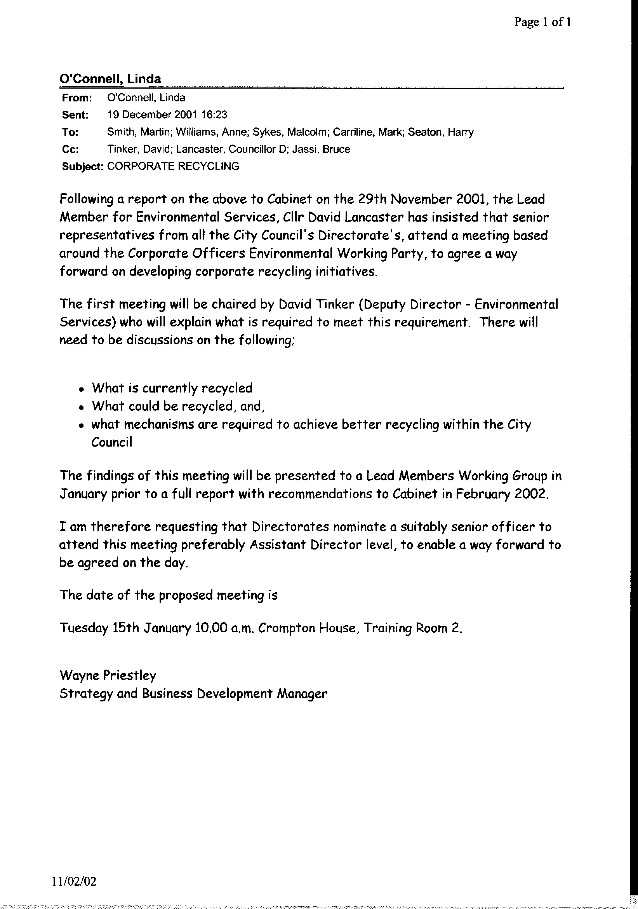

Appendix 2
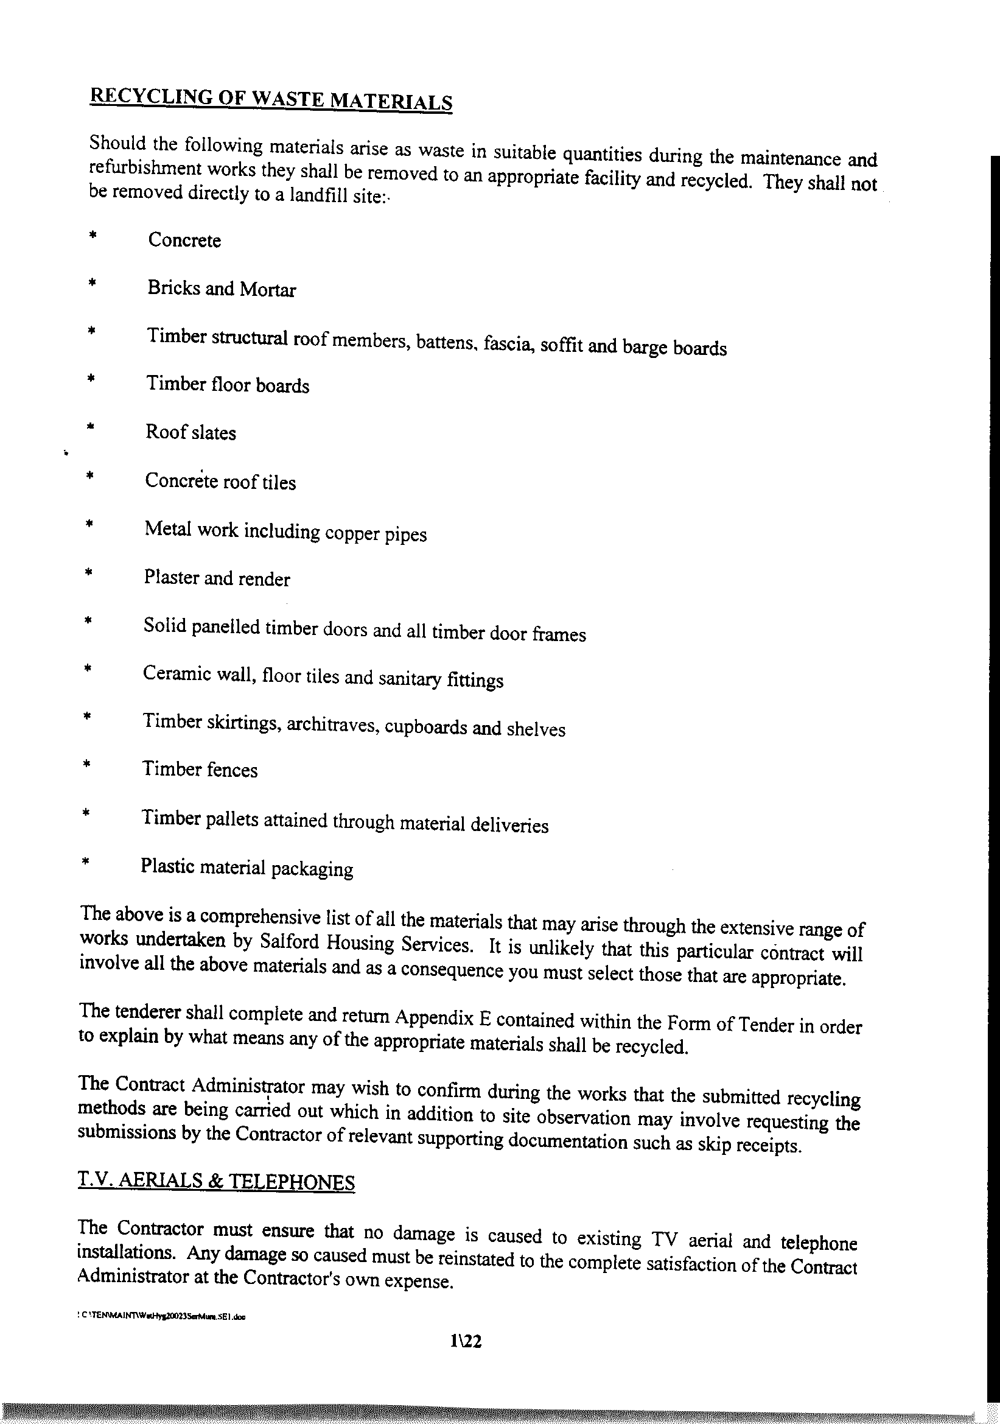
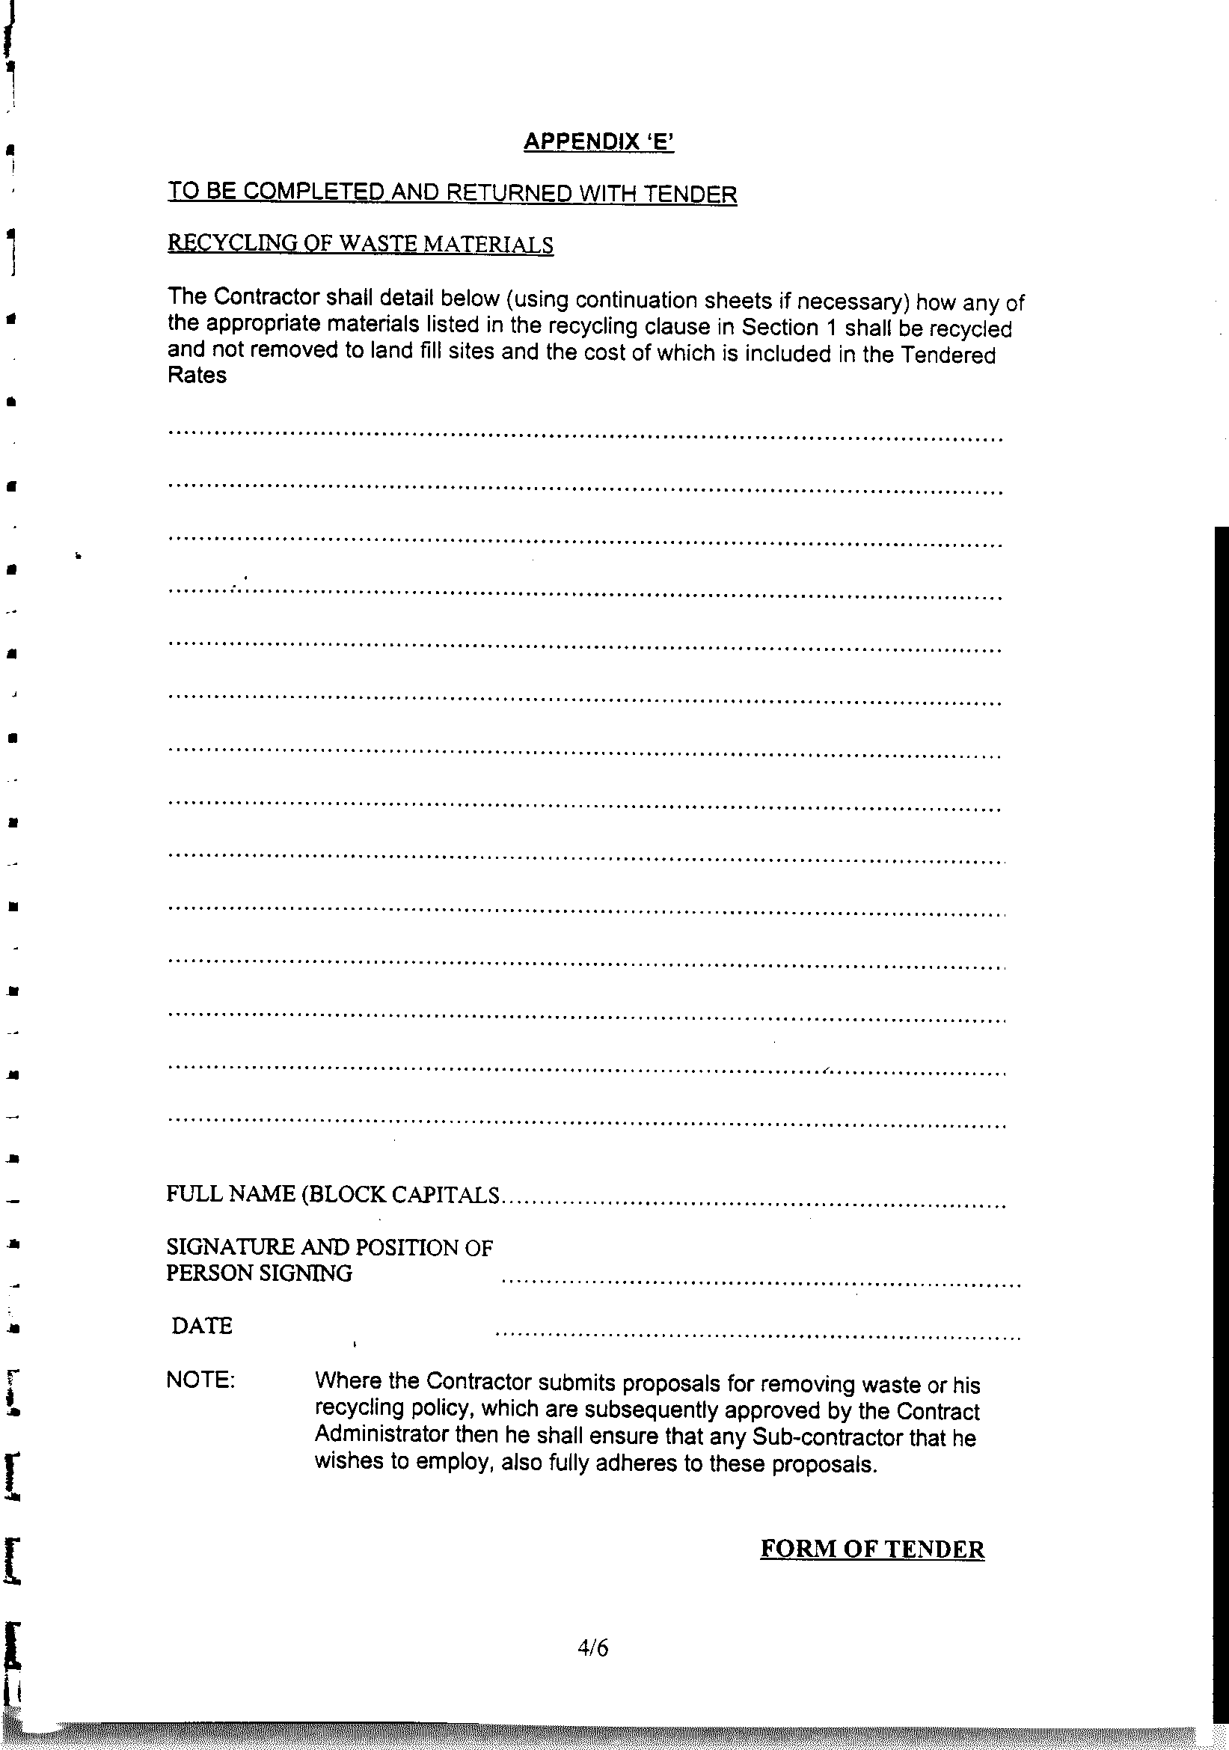

Appendix 3

CASE STUDY – JACKSON LLOYD

Responsible for the day-to-day responsive maintenance for the Housing Directorate, this company in the process of its work produces a large quantity of waste e.g. glass, plastic and wooden window frames, doors, concrete posts, green waste, metal piping etc. All of this material is re-useable or compostable/recyclable. Concern was initially raised at the company, about the high cost of landfilling such materials, as well as the environmental issues landfilling such waste raised. Therefore a decision was taken, that as much waste as possible should be diverted from landfill and ‘disposed of’ in a way which was sustainable. This approach required the segregating of all wastes to ensure the waste was not contaminated and therefore its recyclable value diminished. Although time consuming, it has resulted in significant reductions in the amount of waste going to landfill by almost 70%. This ability to divert waste has come about by the company establishing a data-base on the different companies who will use such wastes to produce a saleable product. Perhaps the best example, is the fact Tarmac will receive rubble from Jackson Lloyd, which, they then crush the to produce a fine material suitable for use as floors in buildings or in road construction. This material is bought back, at a reduced rate, by Jackson Lloyd, which they then use. The fact Tarmac receives this rubble, saves them £10 per tonne by not having to quarry virgin material in the first instance. Jackson Lloyd also saves significantly, as they send their rubble waste to Tarmac who receive it at a much cheaper cost than if Jackson Lloyd were to landfill it. Prior to segregating such waste, Jackson Lloyd were charged the full landfill tax rate, as often the rubble would contain wood, glass, metal and plastic. In fact so successful has the segregating of waste for reuse/recycling been, that Jackson Lloyd have made substantial savings of almost 50% on their previous disposal costs.

Jackson Lloyd have now fully committed themselves to this sustainable approach by appointing a Manager whose task it will be to ensure even greater levels of recycling and financial savings are achieved. They are also requiring sub-contractors to adopt a similar approach. Jackson Lloyd are also applying for ISO14001 Environmental Management Systems, which provides frameworks for companies to demonstrate their commitment to the environment.

Jackson Lloyd have now set up a detailed database on companies which will take wastes for recycling, and they are also identifying those companies which will provide sustainably produced materials such as hardwood doors made from wood grown via sustainable forestry methods.

Jackson Lloyd are now approaching customers, particularly local authorities, with a view to developing 5 – 7 year contracts which involve identifying environmental targets which improve over the period of contract, thereby developing a more environmentally ethical and sustainable partnership.

This attempt to develop a closed-loop approach to their companies’ work shows how Jackson Lloyd have found it possible, to meet environmental demands, without prejudicing the commercial viability of the operations or services they are involved in providing.
Appendix 4

Environmental Policy Officer

Although it is accepted, that with regards to recycling both for corporate waste and domestic waste, funding is an issue. However, if the City Council is to promote recycling, it has to be seen as leading the way by highlighting the changes it has made in its approach to recycling and sustainability in general.

In the initial report to Lead Members and the Lead Members Working Group on Corporate Recycling, a suggestion was made that in order to co-ordinate all corporate recycling and have the ability to audit council services as to their environmental impact and sustainability, then a post needed to be established which undertook this role, for without such a post then council recycling etc. would remain disjointed and ad-hoc.

A post which addresses these points has been created for the Yorkshire and Humber Assembly, with a remit to,

“provide expert advice and information on environmental issues and sustainable development, and develop and implement policies to deliver the region’s strategic objectives.” The Assembly aims to create a more sustainable region, encourage partnerships and other organisations to achieve sustainability, promote the region etc. The reason for highlighting this post is that, the Assembly has similar roles to many of those which the City Council is responsible for. A more detailed explanation of their remit can be found at Appendix A.

Although working on a much wider area, the point to be made, is that the Assembly sees the need for an officer who’s role is to co-ordinate the environmental policy of the Assembly as being paramount to ensuring the services or achievements are environmentally friendly and sustainable.

In fact so committed to sustainable development is the Assembly, that its regional development framework is built around the idea, (see Appendix B – for an abbreviated version of the strategy in relation to sustainability)

Appendix 2, mentions the use of targets and performance indications for sustainability aims, this is perhaps the approach the City Council needs to take in relation to its corporate aims on recycling, as it has with its Environmental Strategy document. The methodology used to monitor each identified performance indicator could be laid-out as at Appendix C. Such indicators could be used within the City Council’s Best Value Performance Plan as local indicators, thereby showing to both national Government, residents and businesses within the City, the Council’s commitment to recycling and sustainability within its own services and operations. This commitment would also support the City’s 6 Pledges document (in particular Pledge 3).

