Housing Options Review.

Methods used for engaging with residents as part of the phase three process.

Meetings and Drop in events:
Over 100 meetings and drop in events have been carried out throughout the city. The meetings content was tailored down to local level, and in some cases estate level. The Drop in sessions was held around the City including schools, community centres, area offices and shopping centres. They were held in the mornings, afternoons, evenings and weekends in order to reach the widest possible audience. A full list of meetings and events is attached to this report.

Advertisements and Marketing:
In order to promote the Housing Options Review, a number of methods have been used. As well as the two Housing Options Review booklets sent out, we have made use of:

- Posters and flyers in the local community
- Advertisements in the local press
- Bulletins in the Life IN Salford magazine
- A section was placed about the review in tenants and residents associations and placed on agendas of the meetings

We have used highly visual marketing materials, by promoting the review as much as possible with all our contact details, these include:

- Review Booklet
- Free Post address
- Free Phone number
- Email address
- Housing Options Pens
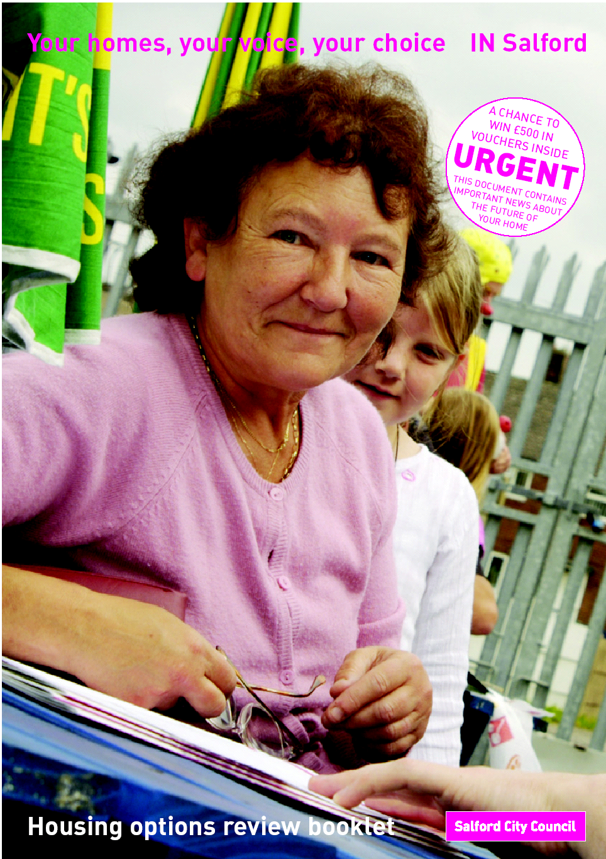
- Business cards with full contact details
- Fridge magnets with full contact details
- Balloons
- Promoting postcards

Text messaging reminders:
Text messaging was used as a reminder for tenants to send back their questionnaires in phases 2 and 3; the number of text messages that were sent out was over 6000. The messages that was sent throughout the review was:

Housing Options Review.
Questionnaires returned by the 15th April 2005
and be entered into free-prize draw
Free phone: 0800 328 4599 for more info.
Your views count!

Post card reminders:
Post card reminders were sent out to all Council tenants, Leaseholders and former council properties sold under the Right-To-Buy scheme. This was used to encourage people to fill out the questionnaire and send it back to us by the closing date so they could have there say on the future of housing services. Two designs have been used throughout the Housing Options Review. Over 34,500 postcards were sent out.

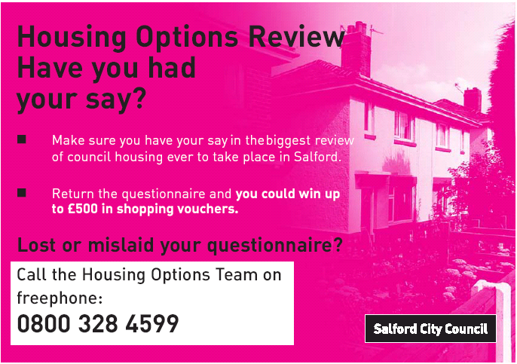

Poster reminder:
Reminder posters were used within the city to remind residents to fill out there questionnaire.

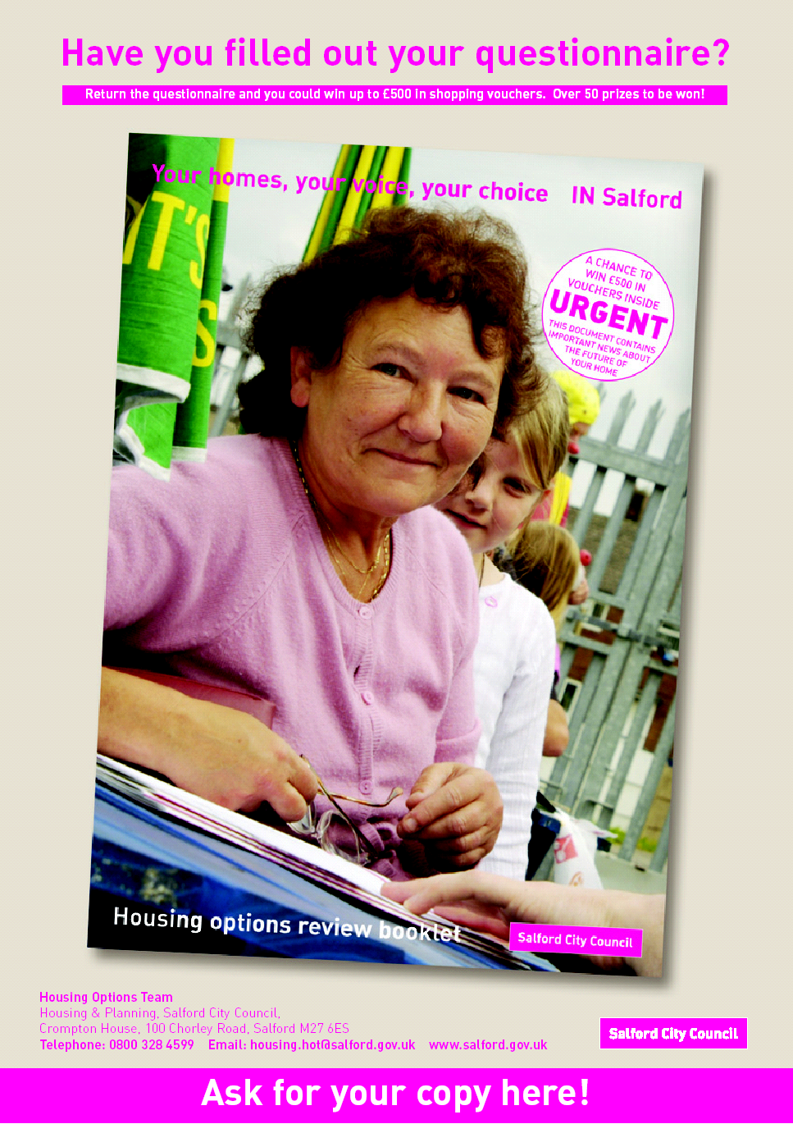

Letters/Sheets
A number of letters and information sheets have been sent out to:

- Confirm letter of receipt for questionnaires
- Resident and tenant associations as a reminder for people on there estate to send back the questionnaire
- Inform residents on frequently asked question sheets in the city.

Telephone:
A free phone line has been set up so residents can contact the team about the review with any questions they may have.

Cold Calling:
Approx 7,000 phone calls were made to tenants across the city. This was done to enhance the already highly visual reminders to return questionnaires by the return date. If residents had already received the booklet and had made a choice but had not completed their questionnaire, we completed them over the phone. 340 questionnaires were completed over the phone and other a thousand additional questionnaires and booklets were re-sent out, where people had lost or mislaid them. Members of the Housing Options Steering Group {HOSG} were involved in the cold calling sessions.

Emails:
Any events that were planned throughout the city were sent to all interested parties within the area. This was done so comments could be made about venues, dates and the time they were being held at.

