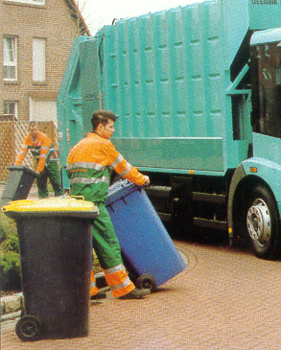

CITY OF SALFORD

ENVIRONMENTAL SERVICES DIRECTORATE

MODERNISING
SERVICE DELIVERY

IN

REFUSE COLLECTION

MODERNISING SERVICE DELIVERY IN REFUSE COLLECTION

1. INTRODUCTION

2. BUSINESS CASE FOR THE PROPOSED CHANGES

3. SERVICE PROVISION

4. PROPOSED CHANGES TO WORKING ARRANGEMENTS

5. CORE PRINCIPLES FOR ACHIEVING CHANGE

6. CONSULTATION AND INFORMATION

7. STAFFING ARRANGEMENTS – AMENDMENTS

8. ZONING

9. REMUNERATION

10. VEHICLES

11. COST

12. IMPLEMENTATION

13. OUTCOMES

14. FUTURE

15. CONCLUSION

16. RECOMMENDATION

REPORT OF THE DIRECTOR OF ENVIRONMENTAL SERVICES

TO

CABINET ON 31ST OCTOBER 2000

SUBJECT : MODERNISING SERVICE DELIVERY IN

REFUSE COLLECTION

OVERVIEW AND BACKGROUND

Over the past two years the Management of the Directorate having undertaken consultation with relevant stakeholders has been considering the delivery of its front line services. This resulted in the development of Environmental Co-ordinators, and increased mechanisation and enhancement of Street Cleansing Services.

The next stage was to fundamentally review the way we deliver our refuse collection service. This was brought about by concerns over certain performance indicators e.g. missed bins, operating on the edge of profitability, knock on effect through divesting street cleansing of human resource, and, most importantly, the imminent best value review of street care and the authority’s review of its strategic direction in terms of the method of service delivery i.e. in-house, partnership, out-sourcing.

When considering the review there were three distinct options as discussed at 1.1. in the following report.

When undertaking the review it was taken into account that any externalisation of the service could take between 18 months and 2 years, with unknown financial savings therefrom. The preferred option was therefore to seek quality improvements in the service, including investment, whilst reducing the cost burden, and therefore supporting not only best value, but also the corporate budget position.

1. INTRODUCTION

1.1 A major review of the Refuse Collection Service has been carried out. In carrying out this review, I am mindful that there are several options available in terms of service delivery.

(a) To continue to solely provide the service in-house.
(b) To seek a partner, to jointly provide the service.
(c) To externalise the service.

1.2 It is my considered view, that if the service improvements outlined in this report are adopted, then the in-house service provider is best placed to deliver the quality service demanded by the Community, and at a price that can meet the provisions of Best Value.

1.3 The Refuse Collection and Street Cleansing Services are under continuous pressure to provide and maintain quality levels of performance.

1.4 These refuse services are high profile, important areas of work in the eyes of the Community and are, therefore, subject to continuous and critical scrutiny by the service users and elected members.

1.5 It is essential that effective, efficient and economic services are provided and a continuous process of improvement is achieved. It is necessary to deliver an equitable service to both the staff we employ and customers we serve.

1.6 The current physical methods of service delivery have been in existence for over a decade and although changes have been made, there is still scope for improvement.

1.7 Through the review of working practices, significant improvements can be made which will result in :-

- more effective working, increasing the efficiency of the operation
- produce a more equitable distribution of the work
- deliver cost savings
- provide for a more cohesive higher quality and accountable service

2.0 BUSINESS CASE FOR THE PROPOSED CHANGES

2.1 It is evident that the current arrangements for operating the Refuse Collection and Street Cleansing Services are not operating satisfactorily and left unchanged, will not be able to pass the test of Best Value. We need to be seeking continuous improvement which will ensure effective outcomes and maintain profitability.

2.2 There is evidence to demonstrate (for example, absenteeism levels, unequal work levels), that the current method of operation, resource requirements and deployment, must be overhauled to deliver service improvements and cost efficiencies.

2.3 The proposed changes, which will follow, are designed to ensure that the service provided in the future, is regarded as both high quality and cost effective and at the same time, provides the basis for demonstrating Best Value.

3.0 SERVICE PROVISION

- The standard of service offered by the Council is usually a weekly collection of a wheeled bin.

- The standard issue of wheeled bin provided is a 240 litre capacity.

- If a family is larger than five in number and requests a larger wheeled bin, then a 360 litre wheeled bin is provided.

Note A 240 litre wheeled bin equates to approximately three / four of the old “traditional” dustbins in capacity, and a 360 litre equates to five / six.

- It is acknowledged that from time to time, families may create small additional amounts of excess in addition to the wheeled bin provided, i.e. packaging from the purchase of furniture or equipment. Any such excess waste shall be removed, as required, on a weekly basis by the refuse service.

- The above provision described in c) and d) has proved to be sufficient by virtually all of the community of Salford, the one exception has been the issue of large families. Many were issued with a 360 litre wheeled bin, but still complaints have been received that this is not sufficient.
It is therefore proposed that the policy will be revised such that families consisting of:-
1 - 5 people will receive a 240 litre wheeled bin
6 - 8 people will receive a 360 litre wheeled bin
9 and above will receive a 660 litre wheeled bin
This policy needs to be concurrent with a requirement for households to demonstrate their willingness to reduce waste by supporting recycling initiatives.

Any policy that is set has to be mindful of the need to be :-

- Consistent to all the residents of Salford.
- Manage the existing budget provision.
- The need to comply with the Government’s Waste Strategy.

f) This report and proposal it contains, has been prepared on the basis that you intend to adopt this revised current service provision as described earlier in this section.

g) Finally, it is recognised that some members of our community may not be able to physically manoeuvre the wheeled bins, i.e. the elderly and disabled people. There is, therefore, a mechanism for providing these people with an “assisted” collection service, where they have no-one else able to help them. In these instances, our collection staff will collect and return these bins. Following a survey carried out in March 2000, there are a total of 882 properties that are currently receiving this assistance.

h) The current kerbside collection schemes of paper and textiles need to be expanded.
4.0 PROPOSED CHANGES TO WORKING ARRANGEMENTS

4.1 Domestic Refuse, Trade Refuse and Bulky Refuse Collections

a) It is proposed that the current separate arrangements for the collection and disposal of domestic refuse, trade waste and reports (bulky refuse), will be replaced by generic gangs using multi-purpose collection vehicles.

b) As at present, each crew will comprise of a vehicle, driver and two loaders.

c) Revised work rounds have been established based upon detailed analysis of collections and standard times, and these are linked to the existing twenty wards and six Environmental Maintenance Areas.

d) The crews will be responsible for undertaking all of the above work within specific geographical areas of the City (zones).

e) The crews will be organised into two teams of between five and nine crews, fourteen in total.

f) The two teams will be deployed to complete the work within defined areas (zones), on a daily basis. This will involve organising the work each day to ensure that both regular and one-off collections are undertaken.

g) Each of the teams will have a working team leader.

h) The service will be provided from Tuesday to Friday inclusive. Whilst the approach will concentrate on specific areas of the City, i.e. adjacent wards, there will also be a need to continue trade refuse collections across the City, where the frequency of collections is more than once per week.

i) The current Clinical / Farm Waste round will continue to operate on a five-day week, Monday to Friday. The work of this round will be re-organised, to allow Monday to become a spare day that will provide a coverage on a Monday for any unscheduled work.

j) To facilitate the new approach, sufficient vehicles will be purchased to allow for the collection of both loose materials and standard collection containers for both domestic and trade waste.

4.2 STREET CLEANSING - This service is due to be reviewed and will be the subject of a separate report in due course. The service will be improved by the purchase of mini-mechanical sweepers and a reduction in the non-productive staffing levels.
4.3 SKIP SYSTEM - There is currently no intention to change the skip service provision, but the service will be subject to a separate report within the next six months.

4.4 WORKING ARRANGEMENTS AND HOURS

a) In order to provide a consistent level of service throughout the year, and to provide for a shorter week, it is proposed that the new arrangement will operate generally, over a four day week, Tuesday to Friday. This will remove the historical difficulties of having to re-organise collections for Monday Bank Holidays.

This simple change will remove one of our customers’ major complaints about our current service provision.

b) It is proposed that the working week will comprise of four days, Tuesday to Friday, equating to the standard working week, i.e. 37 hours. (This proposal has been projected to comply with the requirement to reduce to 36 hours in 2003).

c) The working day will commence at 06.30.

d) The work will be organised according to a schedule of regular collections in addition to reports work

e) In partnership, the team members and managers will work together to determine the most effective routes and collection times.

f) To provide a regular and consistent service to our stakeholders, it will be necessary to work :-

i) Good Friday
ii) Between Christmas and New Year (the following page identifying proposals for 2001 indicates how these arrangements would work)
This is a completely different arrangement than at present where the service closes down for this period.

g) The working day will be 9 hours and 15 minutes in duration (Tuesday to Friday inclusive).

BANK HOLIDAY REQUIREMENT 2002

• | GOOD FRIDAY | WORK
• | EASTER MONDAY | NON WORKING DAY
• | MAY DAY MONDAY | NON WORKING DAY
• | WHIT MONDAY | NON WORKING DAY
• | AUGUST BANK HOLIDAY | NON WORKING DAY
• | SUNDAY 22ND DECEMBER 2002 | COLLECT IN LIEU OF WEDNESDAY 25TH
• | MONDAY 23RD DECEMBER 2002 | COLLECTION IN LIEU OF THURSDAY 26TH
• | TUESDAY 24TH DECEMBER 2002 | COLLECTION AS NORMAL
• | WEDNESDAY 25TH DECEMBER 2002 | BANK HOLIDAY
• | THURSDAY 26TH DECEMBER 2002 | BANK HOLIDAY
• | FRIDAY 27TH DECEMBER 2002 | COLLECTION AS NORMAL
• | MONDAY 30TH DECEMBER 2002 | COLLECTION IN LIEU OF WEDNESDAY 1ST
• | TUESDAY 31ST DECEMBER 2002 | COLLECTION AS NORMAL
• | WEDNESDAY 1ST JANUARY 2003 | BANK HOLIDAY
• | THURSDAY 2ND JANUARY 2003 | COLLECTION AS NORMAL

5.0 CORE PRINCIPLES FOR ACHIEVING CHANGE

5.1 The most effective method to ensure full service delivery, is to use a combination of City Council staff (core) and “spot hire” of Agency staff, as and when required.

5.2 The following points represent the fundamental principles for achieving change and these will underpin the development of the new working arrangements.

- 100% performance of achievements on the work specification contract (all work completed on time and to standard).

- Continuation of an in-house service (core staffing) supplemented by agency cover (maintaining an in-house service).

- Voluntary approach to achieving reductions in the core staffing complement.

- Development of a comprehensive teamwork approach.

- A simplified remuneration system linked to the achievement of a minimum standard and completion.

- Contributing to the Best Value process, by improving service delivery and reducing the cost of the service.

6.0 CONSULTATION AND INFORMATION

6.1 It is vital that effective consultation takes place to ensure everyone involved understands the reasons for the proposed changes and their contribution.

6.2 Full and proper consultation needs to take place with the Trade Union and the workforce.

6.3 It is also important that other stakeholders, particularly politicians and members of the public, are fully consulted on these proposals. To this end this consultation document will be made widely available to these persons during November 2000, with a requirement for comments to be made before the ends of the month. This will then enable the Directorate to report an implementation plan to Cabinet in December 2000.

6.4 It is hoped to implement any changes to service provision from April 2001 and this will involve a large scale communications exercise, utilising:-

- Public Meetings
- Community Committees
- Press/Media
- Leaflets/Stickers
- Salford People
- Roadshow etc.

7.0 STAFFING ARRANGEMENTS – AMENDMENTS

7.1 At present, there are 69 operatives engaged on Refuse Collection, 60 operational and 9 relief.

7.2 Presently, there are 93 operatives engaged on Street Cleansing duties, 75 operational and 18 relief.

7.3 Therefore, total operational staff is currently 135 and 27 relief staff (20%).

7.4 The current levels of staffing on both Refuse Collection and Street Cleansing include a provision for relief cover. The level of relief cover has proved to be a significant financial burden and one that currently does not guarantee service standards are achieved.

It is proposed to change this method of operation by the introduction of a reduced core staffing structure, which will be supplemented by Agency staff, to provide cover for all absences, including :-

- Sickness
- Leave
- Training
- Special leave etc

7.5 As a result of the changes detailed within the report, it will be possible to operate with a reduced number of operatives overall. That is 47 on Refuse Collection and 75 on Street Cleansing, with a total operational staff of 122.

7.6 An important feature of these proposals includes the use of Agency staff to provide cover for absence from the core staffing complement. To facilitate this change, it is proposed that the relief posts will be deleted and that this reduction in numbers will be achieved by voluntary means. This reduction will be made up by deleting vacant posts, turnover and voluntary early retirements. The decision to implement an agency approach was approved by Lead Member on the 16th October 2000 and now awaits Council ratification.

8.0 ZONING

8.1 The current workloads have an unequal disparity and this was evident from the Management Services’ studies and other comparisons.

8.2 The new workloads provide an equal balance of work for all the operatives.

8.3 The zones have been designed to maintain the existing ward boundaries, which will make it easier for everyone to clearly understand. See the map overleaf.

8.4 By employing 14 collection rounds, this can provide, in the short term for :-

- Increased requirement for Trade Refuse Collection

- Increased Report Team workload

- Ability to reduce in 2003, to a 36 hour week as provided for in the recently agreed Single Status agreement.

- Development of separate collection of recyclables. (See point 14.0 later in this report).

DETAILS OF ZONES

TUESDAY |  |  |  | WEDNESDAY
 | Team |  |  |  | Team
Little Hulton | A |  |  | Broughton | B
Walkden North |  |  |  | Kersal
Walkden South |  |  |  | Pendleton
Cadishead | B |  |  | Langworthy | A
Irlam |  |  |  | Ordsall
 |  |  |  | Blackfriars
THURSDAY |  |  |  | FRIDAY
 | Team |  |  |  | Team
Eccles | B |  |  | Pendlebury | A
Barton |  |  |  | Swinton North
Winton
Claremont | A |  |  | Worsley / Boothstown | B
Weaste / Seedley |  |  |  | Swinton South

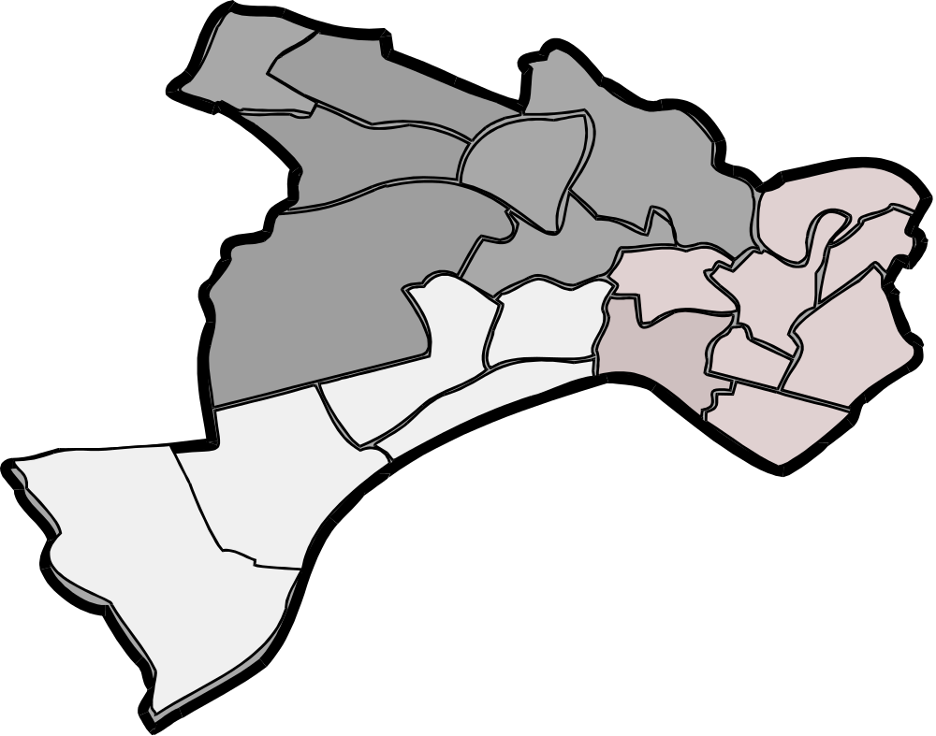

TUESDAY

TEAM A

FRIDAY

TEAM B

TUESDAY
TEAM B

FRIDAY

TEAM A
WEDNESDAY
TEAM B
WEDNESDAY
TEAM A

THURSDAY
TEAM B
THURS

TEAM A
WEDNESDAY
TEAM B
9.0 REMUNERATION

9.1 The present remuneration package to the workforce consists of :-

- Basic Pay
- Bonus
- Attendance Payment
- Overtime
- Pulling Up Payments
- Leading Hand Payment

a) Basic Pay Is a nationally negotiated payment, usually increased annually. There are two levels of payment :

Drivers : Spinal Column Point 7 = £188.95 per week
Labourers : Spinal Column Point 5 = £176.58 per week
This is based on a 37 hour week

b) Bonus As with all dated bonus schemes, there has been, over a period of time, a drift away from the basic principles of productivity to a method of boosting the take home pay for operatives.

Within the Domestic, Trade and Report Services, there are three levels of bonus paid, namely :-

Domestic 40% of Spinal Column Point 7
Trade 40% of Spinal Column Point 7
Reports 33% of Spinal Column Point 7

c) Attendance Payment This is a scheme introduced in September 1992, that was designed to reduce the unauthorised absentee levels. The scheme is described in Appendix 17.5.

- The maximum payment is £226.08, but in practise the actual payment is less than this.
- The payment is made in December each year.

d) Overtime No-one is contracted to receive any overtime payment and all payments made are casual. Since the Single Status agreement of 1st September 2000, the maximum payment would be at time and a half, irrespective of when any overtime was incurred.

e) Pulling Up Payments Currently, the Domestic Refuse Collection Service do not work any of the Bank Holidays and in theory, the week following a Bank Holiday equates to a collection of “double” the amount of the refuse. They receive a payment in compensation for pulling the work straight, after a Bank Holiday. On average, the payment of £539 (2000 / 2001) is made in December each year, (assuming the individual has worked all the required pulling up days, otherwise the payment is pro-rata). Trade Refuse, Skip Service and Medical Rounds are paid an average annual payment of £486 (per individual).

f) Leading Hand Payment A weekly payment of £8.83 is made to a nominated operative on the 13 Domestic Rounds, 4 Trade rounds and 1 Clinical / Farm Round.

9.2 PROPOSED

- Before detailing the proposals it is important to reflect upon the fact that following the authority’s recent agreement on Single Status there is a JOINT COMMITMENT with trade union colleagues to introduce a job evaluation scheme by 2003. The details of such a scheme have yet to be determined, but the intention is to cover all employee groups. Consequently it is important that, in the interim period, when introducing any changes to existing pay arrangements, regard is taken of any implications which there may be for a job evaluation scheme as part of our Single Status arrangements. Therefore with these points in mind, the draft proposals are as follows:-

a) Basic Pay Remains the same as at present.

b) Bonus It is proposed to discard the current bonus scheme and replace it with a Completion Payment Scheme. There will be specific and detailed criteria, but the key points are:-

- The Completion Payment is earned by the successful completion of the day’s work.

- It is proposed that the Completion Payment will be £100 per week (4 day), £25 per day payment.

- This represents a weekly increase of between £37.65 and £24.42 per individual in comparison with the existing bonus scheme.

c) Attendance Payment This scheme will be removed. The loss to the individual expressed as a weekly payment, is £226.08 ÷ 52 = £4.35. This assumes that each individual receives the maximum payment, which in practise, is not the case.

d) Leading Hand Payment This scheme will be removed (except for the Medical Round). The loss to the individual will be £8.83 per week. This will affect 17 individuals. This is a historical payment. The Leading Hand is responsible for the work of a crew. He is expected to deal with any associated paperwork and to report any incident to supervisory staff, i.e. Health and Safety issues, missed bins, access difficulties etc.

e) Team Leader

- The introduction of two new posts (ring-fenced to existing Refuse Collection staff) of two Team Leaders. These two Team Leaders will in addition to qualifying to receive the Completion Payment, will also receive a monthly payment of £167 (£2004 per annum – daily payment £9.63). This is equivalent to Spinal Column Point 11.

- Two other members of staff will be appointed as substitute Team Leaders to cover any absence (leave etc) of the two Team Leaders. These two Deputies will receive an equivalent payment, i.e. £9.63 per operational day, that they carry out the team leader function in the absence of the Team Leader.

f) Bank Holidays

The existing pulling up scheme and payment will be removed and replaced.

There will need to be a flexible approach at Christmas and New Year, as discussed previously.

The remuneration in respect of Bank Holidays is as follows :-

i) Bank four days (at 7 hours, 24 minutes) Holidays in lieu of the Bank Holiday Mondays (i.e. Easter Monday, May Day, Whit and August).

ii) Work Good Friday – Bank one day (7 hours, 24 minutes) Holiday and a payment of 9 hours, 15 minutes at time and a half.

iii) Christmas - No shutdown
- Bank three days Single Status (7.24 x 3)
- Work (See previous proposal)
- Work three “other” days (in lieu of Christmas Day, Boxing Day and New Year’s Day)
- Payment for the three “other” days of time and a half.

g) Introduction Payment A one off payment of £100 will be made to each operative within the first month of implementation. The terms of this payment will be the subject of specific and detailed criteria.

h) Holidays

- Due to the change in the duration of working days, it will be necessary to bank the holidays in hours and minutes rather than “days”. For example, the three Single Status days will be booked as 22 hours, 12 minutes.

- A day’s holiday will use up 9 hours, 15 minutes. Therefore, if an individual had 22 hours, 12 minutes in the holiday bank, then two days’ leave could be taken and leave 3 hours, 42 minutes in the bank, to be built up to another days’ leave.

9.3 Individual Weekly Financial Comparison

 | DIFFERENTIAL
Driver (Refuse Collection) | + 20.07
Labourer (Refuse Collection) | + 20.07
Driver (Reports) | + 33.30
Labourer (Reports) | + 37.38
AVERAGE | + 27.71

a) £20.07 x 52 = £1044 additional per annum

b) £33.30 x 52 = £1732 additional per annum

c) £37.38 x 52 = £1944 additional per annum

d) £27.71 x 52 = £1441 additional per annum

10.0 VEHICLES

10.1 There are a total number of 26 Refuse Collection vehicles in the fleet as at 1st September 2000.

10.2 It is proposed that the fleet (including spares) will be 19 as at 1st April 2001.

10.3 This will see a reduction of 7 vehicles (27%).

10.4 However, to provide for this new service delivery will require :-

a) Disposal of 13 of the existing fleet
b) Purchase of 6 new “multi-purpose” vehicles

10.5 Even allowing for the investment in new vehicles, it is projected that the maximum cost saving (2001 / 2002) in transport will be £36,663. However, there is an unknown element that cannot be projected for unscheduled repair and maintenance, which past experience indicates, could absorb a significant element of this saving.

11.0 COSTS

a) The costs of service provision for 2000 / 2001, are as follows :-

DIRECT LABOUR  £ | VEHICLES  £ | TOTAL  £
933,960 | 880,204 | 1,814,164

Note The costs shown above are the direct service costs. They do not represent costs for

- Sickness / Holiday cover
- Administration / Management costs
- Establishment costs

b) The proposed revised service will cost :-

ACTIVITY | DIRECT LABOUR  £ | VEHICLES  £ | TOTAL  £
Combined Service | 735,005 | 824,802 | 1,559,807
Medical / Farms | 27,792 | 18,699 | 46,491
TOTAL | 762,797 | 843,501 | 1,606,298

c) These proposed costs do not take account of the Single Status requirements for three extra days leave per employee, which in terms of contract requirements under CCT would have resulted in an application for Contract Variation and additional funding. With the revised structure in Cityclean resulting in a reduced establishment and the use of Agency cover, the projected cost variation would be - £20,250, as opposed to the existing service variation which would have been £37,422. Therefore this proposal achieves a further £17,172 on what would have been the cost variation, albeit that there is an actual cost of £20,250 as a result of Single Status not this review.

d) Therefore the real and implied annual savings as:-

Direct Labour | £ 150,953
Transport Costs | £36,663 | (This allows for the investment in the six new vehicles, required to carry out the service)  NB : comments at paragraph 10 re transport costs)
TOTAL | £187,616

e) In the first year, there are one-off implementation costs :-

Staffing – Introduction Payment = £4,200

f) Therefore, in the first year (2001 / 2003), the net saving, having regard to the need to retain the transport cost saving as discussed at paragraph 10, will be £150,953.

12.0 IMPLEMENTATION

12.1 The intended implementation date for this revised service provision is :-

1st April 2001

12.2 It should be noted that a major restructure of this size and nature will entail a degree of disruption and it is anticipated that it will take a month for the new working arrangements to be established and “bedded in”.

12.3 To minimise any disruption, for the month of April 2001 an Environmental Coordinator will be specifically seconded to oversee this implementation programme and this person will liase directly with the Team leaders and the public.

12.4 A phased introduction of the new working arrangements was considered, but was discounted in terms of cost, delivery the message to the public and practicality of implementation. In change such as this it is often held that the “big bang” approach is the most effective.

13.0 OUTCOMES

13.1 The proposed changes, as detailed within this report, will provide the basis for a more customer-focussed service, which is more efficient, effective and economical.

13.2 The revised workload arrangements will provide for a more equitable distribution of work across the City.

13.3 The development of the area teamwork concept will provide the basis for more involvement and participation from the staff concerned in the planning and undertaking of the work. This, in turn, will enhance motivation, commitment and ownership amongst the team leading to more effective working.

13.4 The core workforce will be better rewarded for a quality service.

13.5 There will be a career opportunity for two of the existing workforce to undertake the Team Leader role.

13.6 The new arrangements will contribute significantly to demonstrating Best Value and display a more professional, competent integrated service. In real terms this means:-

- A better service; where Bank Holidays are not an issue.
- The cost is lower.
- The staff receive better terms of employment.
- Productivity is guaranteed.
- An incentive for lower sickness and absenteeism .
- Customers receive a defined service day for refuse services.

14.0 FUTURE

14.1 Another major benefit of this zoning approach, is that after the principle has been fully accepted and established by the workforce and public, it will be possible to introduce the principle of separate collection of recyclables, by initially dedicating one of the “zone vehicles” for this purpose, and as the principle of recycling is accepted by the householders, the balance between the collection of waste and recyclables can be adjusted.

14.2 There will be a need to introduce specifically designed vehicles to enable this kerbside scheme to be developed. It is intended that the kerbside scheme would commence 12/18 months after implementation. At this time it will, in any event, become necessary to change some of the identified spare vehicles and the introduction of specialist “split body” recycling vehicles at that time would enable the seamless introduction of the kerbside recycling.

15.0 CONCLUSION

- This proposal allows for a gross projected saving of £203,666 in the financial year 2001 / 2002. However, as stated in paragraph 10.0, the net saving could be circa. £175,000.

- It can be seen from the report that the proposals have been very much in line with an invest to save approach. The investment in six new vehicles and a different way of working has resulted in a net saving. There are always opportunities to utilise this type of approach in DSO operations, but it is difficult, if not impossible, where derived surpluses are removed from the DSO annually.

- Consideration of the above point should be given when there is a determination on the use of the £151K saving, as regards its support for Corporate budget requirements or perhaps other service enhancement opportunities.

16.0 RECOMMENDATION

(A)

Cabinet are asked to accept and endorse, the contents of this service proposal.

(B)

To instruct your officers to develop and proceed with this proposal on the basis of an implementation date of 1st April 2001.

