SALFORD COMMUNITY LEISURE LIMITED

Report to the Community Health & Social Care Scrutiny Committee

On: | 21st April 2005

Title: | Performance Update
Recommendations: | That Committee notes the progress SCL has made in its actual performance and also in developing its performance infrastructure.
Executive Summary: | The report outlines the progress SCL have made in achieving its key performance indicators. The report also details progress made in developing a framework for managing performance.
Background Documents: | SCL Delivery Plan 2003/4 & 2004/5
Contact Officer: | Stephen Hassall – Chief Executive 0161 778 0358
 | steve.hassall@salford.gov.uk

- Background

In developing the first delivery plan for SCL (2003/4) a portfolio of key performance indicators were developed. These indicators included the 6 “core” indicators from Sport England and also a range of other indicators that covered the variety of services provided and the key areas of SCL’s business. These indicators were mainly annual indicators but also were supplemented by those collected on a three yearly basis by survey. The full list of indicators is detailed in appendix 1.

- Detail

PI’s
One of the key performance targets for SCL is the achievement of the LPSA I target on sports participation. This target is crucial as the reward money for achievement is around £500k. This target is measured by a survey of young people through schools. DCMS have insisted that the methodology is consistent with the original survey to establish the baseline, and therefore SCL have employed Sheffield University to work on this and to undertake the analysis. In order to keep costs down but also to maximise the opportunity to ensure a good return on the survey it has been agreed to keep the questions to a minimum (SCL are also increasing the sample size to ensure greater statistical accuracy). In addition, the Sport England pilot work from where the “core” indicators originated are no longer being used by Sport England or other authorities. Therefore there is no benefit in measuring things that do not enable any benchmarking or are expensive to collect and serve no purpose. Therefore there are a number of the PI’s that will not be collected.

SCL are currently gathering the information for the following PI’s that will be reported back in April:

- 1
- 2i
- 2iii
- 2v (part)
- 3
- 5
- 6
- 7
- 9
- 10
- 13

Delivery Plan
SCL has a rigorous monitoring procedure in place for its annual delivery plan. This process is shared with the City Council and involves monthly reporting to the City Council (as well as two reports to the relevant Scrutiny Committee).

The figures for 03/04 are as follows

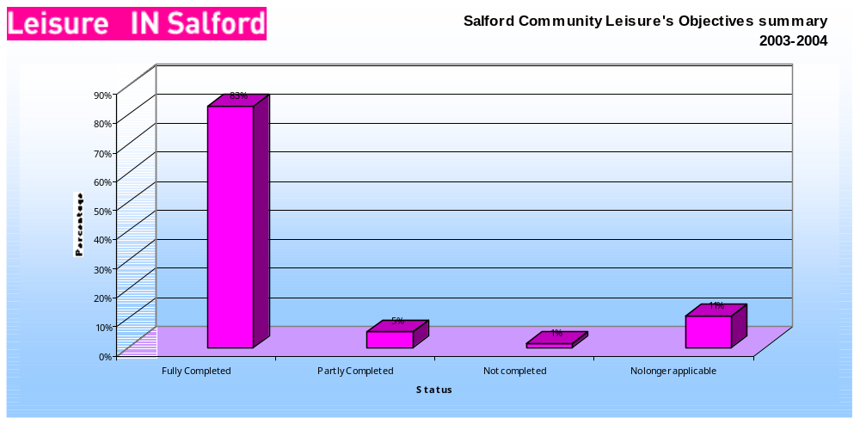
And 04/05 are

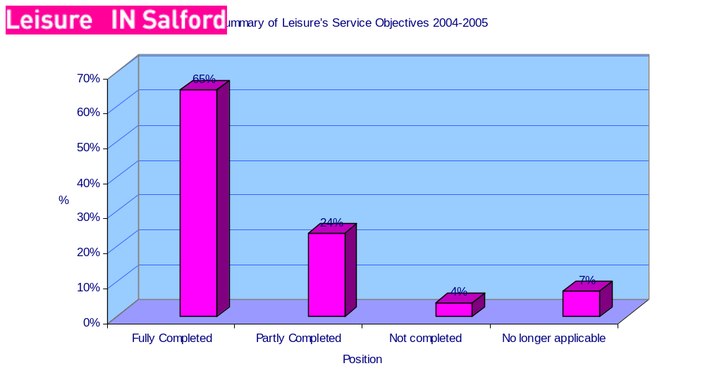

Complaints/Incidents and Points of View
There has been considerable work undertaken to establish regular reporting and analysis of customer complaints and also the Points of View Scheme. These processes ensure that SCL is able to monitor its performance and satisfaction from customers. These summaries are reported to the City Council through the normal monthly reporting procedures.

The following summaries detail the position from 1st April 2004 to 28th February 2005.

Complaints

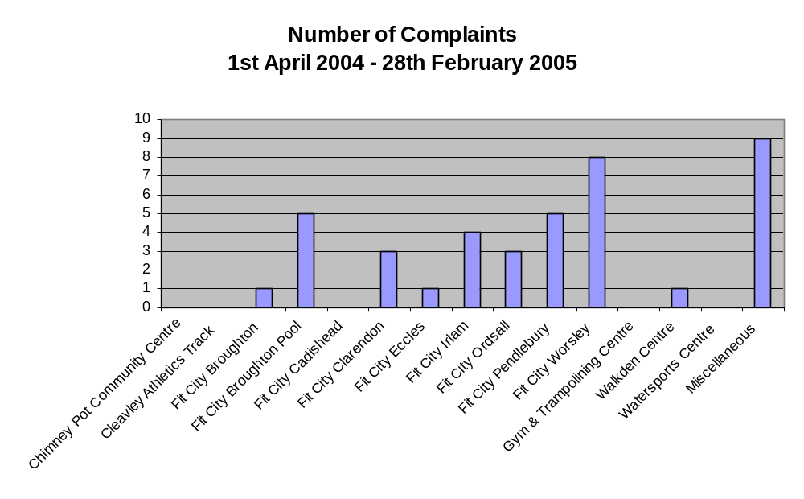

Points of View

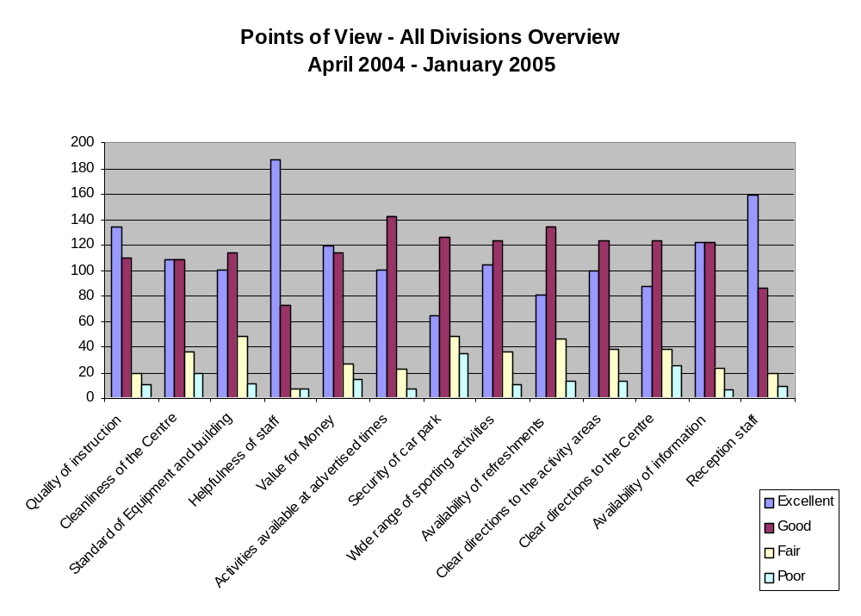In addition SCL has also developed a reporting procedure for “incidents”. These are reported via the Safety Committee that includes Trade Union representation and a City Council representative (Gemma Dowson). The following table outlines the current total position since April 2004
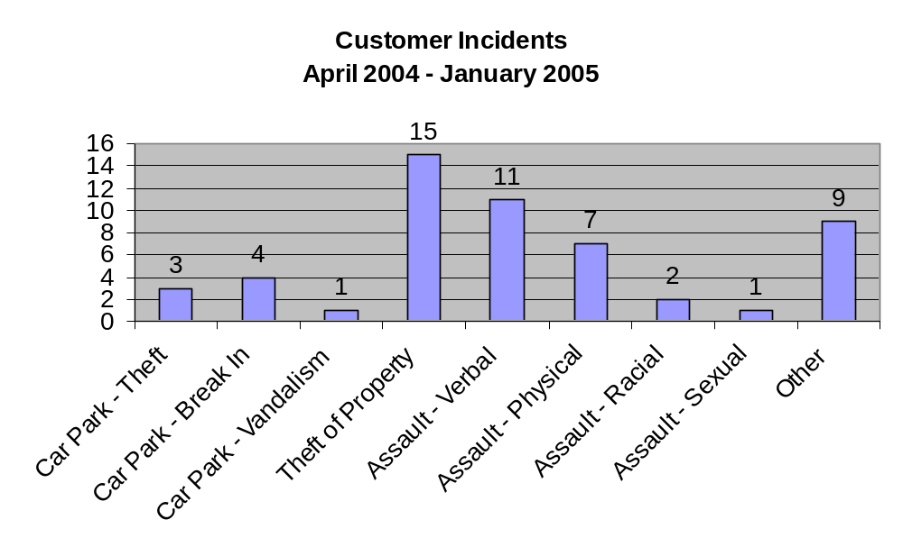

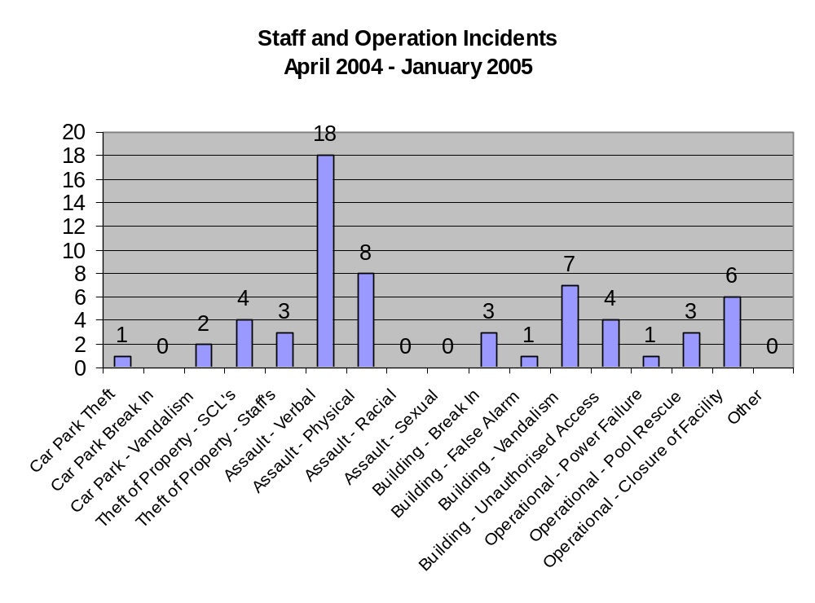

Financial information
There have been marked improvements in the financial information received by managers and the process of budget monitoring. The organisation has put in place monthly budget monitoring meetings that are not only supported by Finance but also include Personnel and Payroll. These meetings have made a real difference in the budget monitoring process and the accountability of managers. There remain gaps in experience and knowledge, and there are developments to deliver bespoke training for cost centre managers and to link into training opportunities organised by the Chamber of Commerce.

The Statement of Financial Accounts for 1st October 2003 – 31st March 2004 shows a surplus of £71k. This is a significant improvement from the 2002/2003 deficit budget for City Leisure.

- Developments

At the time of writing this report there is a great deal of uncertainty regarding the various national initiatives to develop a performance profile for culture (including sport). It is certain that there will be a new suite of national performance indicators for SCL to measure. Also it is likely SCL will be required to contribute towards a broader self-assessment and the collection of local performance indicators. This is further complicated by the development of a suite of PI’s relating to facility operation that are being developed by North West leisure trusts to enable benchmarking across trusts.

Furthermore, there are other initiatives that will help SCL measure, and compare, its performance. For example SCL will be part of a new “Mystery Visitor” scheme that will enable centres to be part of a benchmarking group.

For SCL the new Management Information System will considerably ease the collection of information for performance measures.

QUEST will also provide a performance process and structure for SCL. Fit City Irlam has been successful in its accreditation and recently Sports Development has also been successful with a very strong score on the inspection.

Whilst not finalised all these changes for 2005/6 will see a considerable improvement in the framework of performance measurement for SCL.

In addition SCL is in discussion with Eccles College regarding the development of a web-based database that will revolutionise the Society’s approach to performance measurement. If possible to implement this will offer the opportunity for centre, team and individual inputs into the performance framework and will support the emphasis on providing the tools for empowering staff at all levels.

- Conclusion

SCL has made considerable strides in developing structures to measure performance. Clearly, as detailed above, more is required and the developments highlighted will help move SCL forward. In particular the new Management Information System that went live at Fit City Eccles on 24th January, the new culture PI’s/self assessment, and the potential for a web-based database will all result in a stepped improvement for SCL. In addition training and development of staff will support this change.

SCL has made a very positive start and has successfully built foundations for the services to move forward effectively. The 2004 CPA Inspection that rated the service as “good” reinforced the progress made.

- Recommendations

That Committee notes the progress SCL has made in its actual performance and also in developing its performance infrastructure.

APPENDIX 1

MONITORING AND PERFORMANCE INDICATORS

Periodic survey PI’s (i.e. every 3 years)

1. | The number of young people aged 6-16 years participating in sporting activities within the last four weeks (baseline already established)  - To increase by 25% by 2005
2. | Six Sport England pilot core PIs (baselines already established)
i. | Does the authority have an adopted strategy for sport that meets Sport England guidelines?  Baseline = NO (target YES)
ii. | The % of adult residents from different social groups taking part in sport and physical activity (including walking) on at least four occasions in the previous four weeks?  Baseline = 58.8% (target 60%)
iii. | The % of young people who have participated in three sports (including walking) at least ten times in the past year in their leisure time out of school lessons?  Baseline = 49.0% (target aggregated with S5 young people for LPSA target 63.0%)
iv. | The % of adult residents from different social groups who think that sports provision in their local neighbourhood is good/very good?  Baseline = 42.8% (target 48%)
v. | The % of adult residents and the % of young people from different social groups who have participated in a sporting activity or event at a local authority sports facility:  in the past four weeks?  in the past 12 months?  Adults Baseline = 20.3% 4 weeks (target 22%)  Adults Baseline = 39.1% 12 months (target 41%)  YP = 63.5% 4 weeks (target aggregated with S5 young people for LPSA target 77.5%)  YP = 89.3% 12 months (target 90.0%)
vi. | The % of adult residents from different social groups contributing to sport as a volunteer?  Baseline 6.4% (target 6.5%)
3. | The % of young people deemed to be poor swimmers or non-swimmers (baseline already established (6.7%)  - To reduce to 6.6% by March 2004
4. | The % of young people entering the first level of the Greater Sport squad system (baseline already established)  - To increase the 2.1 & to 2.2% by March 2005
 | Annual PI’s
5. | The % of Salford schools in which SCL has provided sport and leisure activity within the last 12 months (baseline established)  - Baseline 96% (target 96%)
6. | The % of schools who feel that sport is playing a key role in driving up attainment and attendance, improving behaviour and reducing exclusions (baseline established March/April 2004)  - Baseline 73% (driving up attainment) target 75%  - Baseline 48% (driving up attendance) target 50%  - Baseline 82% (improving behaviour) target 84%  - Baseline 43% (reducing exclusions) target 45%
7. | The % of City of Salford swimming, gymnastics and trampolining squad members reaching national qualification times or targets (baseline established)  - Baseline 10% (swimming) target 11%  - Baseline 3% (gymnastics) target 7%  - Baseline 50% (trampolining) target 54%
8. | The total number of visits resulting in participation to SCL sports and leisure facilities (baseline established March/April 2004)  - To increase the number by X% by XX
9. | The % of users of SCL services who are satisfied (baseline established March/April 2004 - 95% satisfied or very satisfied)  - To increase the satisfaction by 1% to 96%
10. | To adopt QUEST Best Practice Principles and works towards achievement of QUEST accreditation within agreed timescales  - Quest Accreditation for Sports Development by March 2005  - Quest Accreditation for one sports centre by March 2005  - Quest Accreditation for 1 further sports centres per annum
11. | Schools view on “the quality of the school swimming service” (annual schools survey – baseline received September 2004)
 | Finance PI’s
12. | Business plan monitoring – Quarterly – Actual performance (excluding grants) is within 5% of profiled business plan and is projected to remain within surplus at year-end. (NB understanding that profiled business plan is crude and initial quarterly performance may not fall within 5% band).
13. | Business viability – annual – SCL accounts show it having net current assets.
14. | Financial management – annual – The number of audit (both internal and external) action points graded high, medium and low decrease on an annual basis. The number of action points graded high is less than the number graded medium, which in turn are less than the number graded low:

There are ongoing discussions relating to this measure and a final decision on whether to collect the information has yet to be taken.

