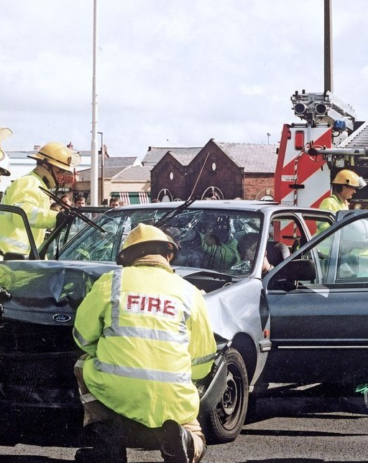
THE ROAD SAFETY PLAN
FOR SALFORD
2009/2010

Introduction

The Road Casualty Reduction Group (RCRG) consist of the Collision Investigation Unit and Road Safety Unit, more information about the work that each undertake is included later in the plan, however their sole aim is to reduce the number of casualties involved in road traffic collisions in line with casualty reduction targets set by the government.

National targets require that road casualties are reduced by the following levels by 2010 (compared with the 1994 - 98 average):

Child Killed or seriously injured (KSI) - 50% (Locally agreed targets stretch this to 55% by 2010)
2008 currently reported 13 KSI against the 2010 target of 12

Other KSI - 40% (Locally agreed targets stretch this to 50% by 2010)
2008 currently reported 92 KSI against the 2010 target of 76

10% reduction in slights (Locally agreed targets stretch this to 30% by 2010)
2008 reported 829 slight against the 2010 target of 1520.

The overall casualty record over the previous three years, compared to Greater Manchester as a whole, is outlined below:

 | 2006 | 2007 | %age reduction on previous year | 2008 | %age  reduction on previous  year
City of Salford | 991 | 971 | 2.0% | 921 | 5.0%
Greater Manchester | 11795 | 10702 | 9.2% | 9881 | 7.7%

Our strategy to maintain this downward trend is as follows:

- To continue monitoring the collision statistics and react to any unexpected occurrences.

- To continue using the collision statistics as the basis for collating our highways capital programme. (This includes highway maintenance monies, which are used to ensure that the road surface is inherently safe).

- To increase resources in the traditional areas of education, training and publicity, as well as introducing new training programmes which will specifically target child pedestrian casualties.

- Continue to encourage partnership working as part of the RCRG's ongoing efforts to reduce casualties and also to support the delivery of the road safety partnership strategy.

Measuring Performance

As in previous Road Safety Plans, the first two charts have been included to provide an overview of how Salford is performing alongside the other 9 Greater Manchester authorities.

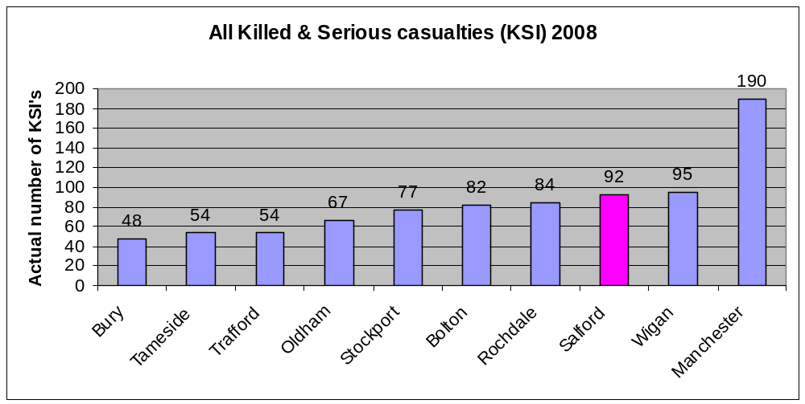
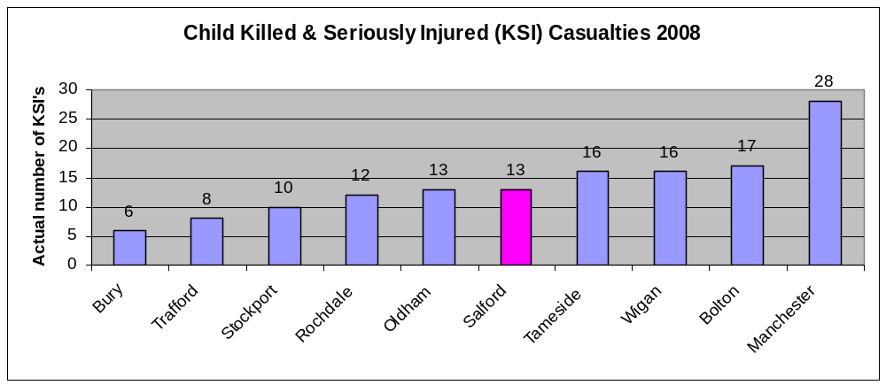

They show that in terms of All KSI’s Salford recorded 92 casualties, although this does not show a true reflection as in real terms the overall trend continues to be downward. Additionally, in terms of Child KSI’s Salford continues to perform well alongside the other Greater Manchester authorities.

In order to assess performance of safety schemes on a more local scale the authority used to measure the national performance indicators BVPI 99a, b and c, which simply reported year end casualty figures and compared that, in percentage terms, to the previous years performance and against the base years 1994-1998.

These have however, recently changed to become National Indicators NI47 and NI48. These indicators measure the same target groups contained in the old BVPI 99a and b, but the NI uses a figure calculated from the average of the latest 3 years, then compares it to the average from the previous 3 year period and expresses the difference as a percentage.

In order to be consistent with previous Road Safety plans the data in this report will continue to be illustrated in simple year end figures, this will permit a clearer comparison of trend lines and performance against national targets.

NI47 – Reduce the number of people killed/ seriously injured in road traffic collisions

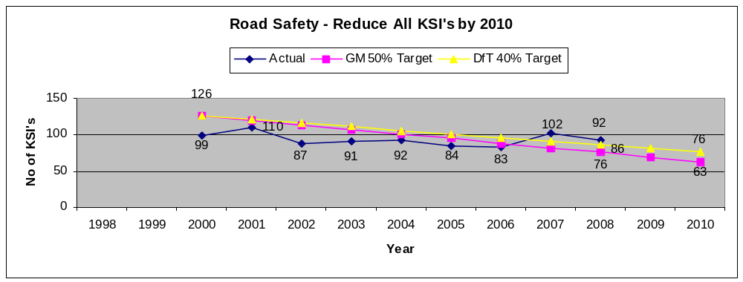
NI48 - Reduce the number children killed/ seriously injured in road traffic collisions

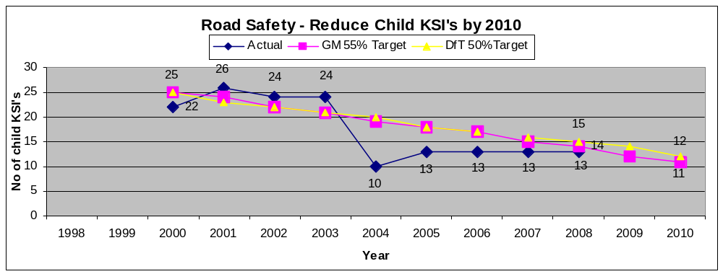

Reduce the number of people slightly injured in road traffic collisions

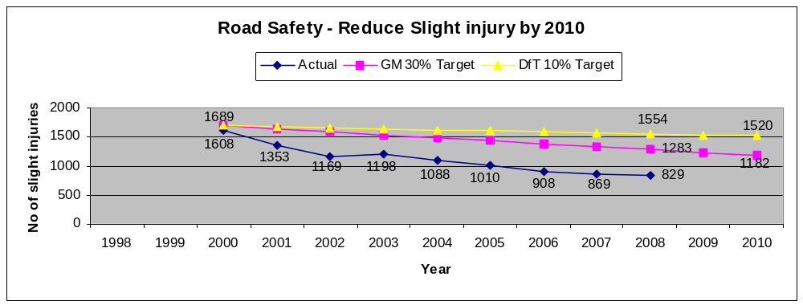
The figures show that with the exception of the last 2 years ‘All’ KSI figure, which has reverted to a downward trend, results have been very close to or better than the national targets. For the last 3 years the majority of targets have been successfully bettered, with the trend from 2000 continuing to be downward, the start of the 10 year casualty reduction programme.

The role of the Collision Investigation Unit

The process of identifying locations for inclusion into the Local Safety Scheme programme begins by interrogating the GMAXI system which is a database that holds records relating to all injury collisions that have been recorded by the police via their STATS 19 form. The form has a number of check boxes relating to the date and time of the collision, weather conditions, description of the casualties and their details and a commentary on what actually took place along with any prevailing factors that either definitely or might possibly have contributed to the collision.

It is possible to perform a variety of searches on this system relating to different criteria ie. Identifying those collisions purely involving child pedestrians, or those involving motorcyclists occurring between the hours of 10pm to 12pm on wet road conditions. The output of these searches can be shown in a number of different formats but the most useful is via the GMAPS system that actually places the location of the collision on an ordnance survey background, allowing identification of collision clusters to be highlighted.

‘Hard’ copies of the actual collision reports can also be printed off the system and a further analysis of the information contained in them allows any trends to be highlighted ie. Vehicles failing to conform to red traffic signals might be addressed by the introduction of a red light camera to reduce the likelihood that this type of collision will happen in the future.

Programmes of work are often divided into 4 distinct categories:-

Area wide – a scattering of pedestrian collisions in a residential area might best be tackled by the introduction of area-wide traffic calming measures in order to reduce the level of ‘short cutting’ traffic and to slow down the speed of vehicles that continue to use the residential area.

Mass action – concentrations of collisions involving vehicles skidding in wet road conditions, especially on the approach to junctions across the city may lead to consideration of treatment by implementing lengths of anti-skid surfacing on the relevant approaches.

Single site – collisions identified as being exclusive to one particular location are treated independently ie. collisions involving pedestrians at a signalised junction without protected pedestrian crossing facilities may require the upgrading of the signals to incorporate a red/green man crossing facility.

Route action – a scattering of collisions along a particular length of road involving concentrations at junctions often results in the treatment of the route as a whole, involving the use of refuges to encourage pedestrians to cross in safer conditions and centrally hatched areas of carriageway that not only narrow the road space available to motorists but also allow for the introduction of safe areas in which vehicles can wait before turning at junctions. It may also be the case that current levels of street lighting need to be upgraded if collisions along the route are predominantly in the dark and we would certainly implement improved lighting at new crossing locations where we are encouraging pedestrians to cross the road.

Additionally, a process to prioritise areas requiring traffic calming schemes has been undertaken that employed a number of relevant criteria ie. collisions, speeds, volumes, housing density etc. The result has provided us with a plan of the city that identifies locations requiring calming on an area wide basis and this will inform the programme of future work.

Approaches from the community also have a major part to play in the implementation of a scheme, especially if an area is perceived as unacceptably dangerous or traffic has reached levels that effectively divides a community. In these circumstances, improvements may be appropriate and so the approach is more pro-active rather than always being statistically led. Community involvement is always incorporated into the consultation element of scheme development, especially as local knowledge is invaluable in determining locations that are perceived as dangerous.

This has evolved even further with Community Committees being given a devolved budget to spend on highway matters that they have prioritised through their Community Action Plans (CAP). Following a campaign to increase awareness of road safety across the Community Committee membership, a significant number of road safety concerns are being included in the CAP’s.

The Collision Investigation Unit is constantly identifying new sites to be developed into schemes for future programmes of work and a table showing those schemes in the current (09/10) Local Safety Schemes programme is attached as Appendix 1.

The role of the Network Management Section

In terms of casualty reduction the Network Management Section plays a dual role. Firstly, Salford City Council is committed to carrying out regular skid resistance surveys on the Principal Road Network and high risk sites on the non-Principal Road network to identify locations where improvement of the skid resistance may be necessary following further detailed site investigations. In order to assist this a Skid Resistance Policy document has been drawn up by Network Management that details the process that is involved in undertaking the skid-resistance testing, the investigatory levels required to ‘trigger’ the surveys and a range of recommended measures based on the recorded intervention level that is observed at the site.

Secondly, they are responsible for the upkeep of all road markings on Salford’s highways. The obvious benefit of properly maintained road markings is to define carriageway lanes and edges and to give instructions to road users in a manner clearly visible in all conditions.

Salford provides road markings in appropriate locations using the layouts described in the ‘Traffic signs regulation and general directions’. Materials and application of road markings are provided in accordance with the "Specification For Highway Works".

Carriageway markings are currently replaced on a 5-year cycle, or on an ‘as-needs’ basis where a potential hazard is identified during the safety inspection process or as the result of third party complaints.

The role of the Road Safety Unit

The provision of a road safety service is a statutory duty of local authorities in Great Britain (Section 39, Road Traffic Act 1988) and includes education training and publicity, (ETP).

In Salford road safety education starts with the very young and their parents, the following are projects undertaken by the unit and a table identifying a detailed break down of what each school received in academic year 2008/2009 is attached as Appendix 2 and the current 2009 Road Safety programme of work is attached as Appendix 3.

Project | Description
“Step Outside-a lesson for life” | A booklet designed to help parents to instruct their children road safety issues as they develop. It is currently issued to parents by their Health Visitors at their child’s 3-year check.
“Prepare them for the roads” and “Out and About” | Parents are given advice on the basic principles of safe behaviour on the roads, these parent guides are used to support this work.
Infant and Junior schools | Are visited on request and the children are instructed in the principles of “ Stop, Look, Listen and Think” the “Green Cross Code” and “in-car safety” at levels suitable to their age group. This work is reinforced by the provision of road safety resources, which are left with class teachers to be integrated into appropriate topics.
" Get Across Road Safety (0-6 years)" " Get Across Road Safety (7-10year) | The first is a parental guide to road safety given each year to all new intake pupils.  All year three pupils receive the second booklet which is a parental guide aimed at 7-10 year olds.
Infant Classes | Lessons cover Holding Hands, Stopping, Looking and listening. Safer places to cross and In-car Safety.
Junior Classes | Lessons cover the Green Cross Code, safer places to cross and risk, cycling theory and In-car safety.
Crucial Crew | Attended by all year Six Pupils(approx 2700). The current road safety scenario covers pedestrian safety, conspicuity, speed and seat belts. (See case study below)
Cycle training | Salford City Council Road Safety Unit offers cycle training to every maintained primary school. For independent schools it is necessary to request a training course from the road safety unit. The course is available for pupils who are in year five and six who are aged ten years or over. In 2008/9 the Road Safety Unit undertook 12 courses with a total of 120 pupils receiving training. These numbers are down on last year because of long term sickness and staff leaving. The Unit seconded a member of staff from another section to assist with training. We now only have three qualified staff to carry out cycle training.  The Road Safety Unit has once again been successful in bidding for an increased grant to pay for more cycle training to cover the short fall. Bikeright a private company based in Openshaw have been awarded the contract to carry out the training from September 2009 to the end of April 2010.  The new accredited training courses are practical courses that help children to develop their cycle control skills, road safety knowledge and traffic awareness. Courses include riding exercises in an off-road area, such as a school playground, leading to riding practice on quiet public roads.
Secondary schools | Are visited on request. Lessons are tailored to suit the requirements of the school or individual teachers.
Pedestrian Training | Currently operates in around 12 schools in the City. It was originally funded by the DfT and is designed to teach pedestrian skills to 5 to 7 year olds by means of practical roadside training rather than in the classroom.  It is built around teaching three skills: - choosing safe places and routes; crossing safely at parked cars and crossing safely near junctions. Children are taught by the roadside on routes around school that they are likely to use frequently. They learn to identify the safest places to cross the roads, to identify potential hazards and to identify where not to cross the roads. The importance of holding hands with a grown up is emphasised in every session. Volunteers, usually parents, train the children in small groups once a week for approximately 10 weeks.  A new Pedestrian training project “The Tornado Way” is currently being trialled in a number of Salford schools. Children’s crossing skills are assessed before any formal road safety training is given. Their parents are then given a graded assessment record of their child’s abilities and a leaflet giving them hints and tips on how to train their children how to cross the road. The children are reassessed a couple of months later and improvements are recorded. Initial research shows that there is a great improvement in safety behaviour.
Children’s Traffic Club | Following the initial introduction of this Neighbourhood Road Safety Initiative further funds were made available to extend the scheme across the city. Parents of all 3 year olds in the city were invited to enrol by post. Members received 6 storybooks one every month from their third birthday. There were also ‘Hints and Tips’ and a CD with stories and songs to help teach children important road safety messages. The CTC was promoted by the use of an educational Toolkit that was issued to venues throughout the city. Take up of membership ran at around 45%. Funding for the scheme finished in April 2009.
School Crossing Patrol Service | The Road Safety Unit is also responsible for the management, recruiting, training and supervision of School Crossing Patrols (SCP's) throughout the City.  We currently have 90 crossing points and have 8 mobile patrols to cover for emergencies.  The School Crossing Patrol is a permissive, not a statutory, function. Even where a SCP is provided, parents/carers remain solely responsible for ensuring their children's safety on their journey to and from school.
Publicity | A number of publicity campaigns are run annually in conjunction with Drivesafe these are usually to support regional or national DfT campaigns the main subjects are;  Speed  Seat Belts  Conspicuity  Drink and Drugs  Motorcycle safety  “Drivesafe” The Greater Manchester Safety Camera partnership carries out a number of publicity campaigns per year. These campaigns are funded from monies obtained from Safety Cameras. Salford is represented on the “Drivesafe” resources group and plays a major part in the development of these campaigns.
Road Safety Partnership Grant 17-25 year old | The grant funded project is now complete and the resources that were developed are being used throughout the city.  A number of specific projects were developed ranging from a GM wide Drink/ Drug Driving publicity campaign and the development of educational DVDs. Other resources have been purchased to be used with the scheme including a driving simulator, drug and drink awareness kits and ITC equipment. The project ran in conjunction with a number of different partners.

Case Study: Salford’s Crucial Crew
Crucial Crew is a multi agency safety exercise. The scheme is based on Learning About Safety by Experiencing Risk (LASER).
Crucial Crew runs from October to November. It is held in offices used by three other local authorities above Bury Bus Interchange. The organisations involved in 2008/09 were Urban Vision/Salford City Council's Road Safety Unit, British Transport Police, Greater Manchester Ambulance Service, Greater Manchester Fire and Rescue, Drug Awareness Team. Environmental Services, Schools based Police Officers and PCS0s, Greater Manchester Passenger Transport Executive and Water Safety.

All year six pupils in Salford attend. Pupils are transported to the venue they are then divided into small groups. Each group spends around 10 minutes in each of the agencies room.

The road safety room is based on a crash scene investigation (CSI) (see attached photo). The pupils have to establish the cause of the collision in which a passenger and pedestrian are injured.

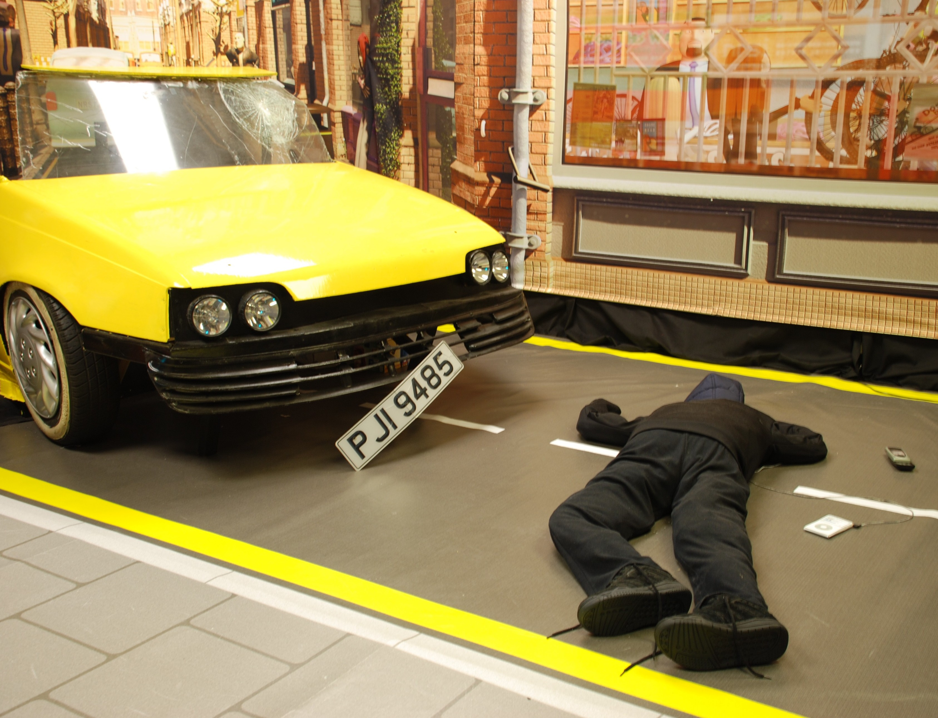

The scenario covers numerous topics and the cause could be one or a mixture of the following:

· Lack of conspicuity
· Inappropriate clothing
· Mobile phone use
· Wearing MP3 Players
· Other distractions
· Not wearing seatbelts
· Inappropriate Speed

Every pupil that attended receives a goodie bag containing safety information. The Road Safety Unit's contribution is a Highway Code for young Road Users called "Tales of the Road" a Road Safety Activity Book and fluorescent/ reflective stickers.

Salford Road Safety Partnership

The Salford Road Safety Partnership was initially established to steer the delivery of the ‘Neighbourhood Road Safety Initiative’ (NRSI) projects. The partnership currently monitors the delivery of the Road Safety Partnership Strategy and develops new partnership procedures and projects. This partnership currently includes representation from a wide range of public and voluntary sector agencies.

The Road Safety Partnership Strategy, which evolved as a result of input from the partners, is intended to steer the direction of future road safety work.

This year the Road Safety Partnership has adopted an alternative format in order to start to plan beyond the existing 2006-2010-road safety strategy action plan. Subgroups have been established to tackle six key road safety themes. These themes have been identified using recent casualty data. The themes are:

- 0-11 year olds
- 11-16 year olds
- 17-25 year olds
- Motorcyclists
- Driving for Work
- Growing Older

The main purposes of the subgroups are:

- To identify the key road safety issues for the relevant road user group and carry out an ‘audit’ of existing measures
- To identify, deliver and monitor key actions to reduce casualties in the relevant road user group These actions will contribute to the development of a new action plan for the road safety strategy
- To report progress to the full Salford Road Safety partnership meetings (twice yearly)

The subgroups have met a number of times since their inception in March 2009 and have begun work on road safety projects to tackle the relevant key issues identified. It is recognised that continued partnership working is required as it is fundamental in the RCRG's ongoing efforts to reduce casualties.

Partnership Projects
Project | Partners | Description
0-11 year olds
Seat Safe | Road Safety, Greater Manchester Fire and rescue Service, Salford PCT | A pilot child seat fitting advisory service is currently under development. Fire officers will be trained and offer advice to families concerning child seats. Road safety staff, Health visitors and other PCT staff will advertise the scheme.

11-16 year olds
PSHE ‘Road Safety’ Pack for High Schools | Road Safety, Children’s Services, Schools, Healthy Schools, Greater Manchester Fire and Rescue Service, GEARS+ | A programme and pack of resources for High Schools is currently being developed to assist schools in delivering the road safety element of PSHE and citizenship curriculum
Road safety young driver training | Y.O.S, GEARS+, Road Safety, ‘Brake’ | Training has been given to staff at the youth offending service and GEARS+ to assist them in the future delivery of young driver education programmes with their service users.
17 –25 year olds
‘Think for Yourself’  Media campaign | Salford City College, Road Safety | Students from the media department at the Pendleton Campus of Salford City College were invited to develop a road safety campaign to deliver road safety messages to their peers. The resulting ‘Think for Yourself’ campaign tackling peer pressure issues is being used in the college and across the city including radio and TV adverts, leaflets and web pages are being used.
University road safety awareness campaign | University of Salford, Road Safety, GMFRS | A flyer has also been produced by the RCRG to be distributed to students when they collect their university parking permits during Freshers week.  The subgroup is also working on a joint road safety campaign at the university later in the term.
Motorcyclists
Salford Motorcycle Event | Road Safety, Blue Knights (Police officers motorcycle club), | The subgroup has aspirations to hold a motorcycle event in Salford. Plans include handling skills sessions and safe gear and clothing stands. A funding application will be submitted to DriveSafe.
In 2 Bikes Motorcycle Project | GEARS+, Road Safety | DriveSafe funding has been allocated to GEARS+ to run a motorbike project that includes elements of motorcycle maintenance and road safety.
Driving for Work
Driving for Work Policy audit and Surveys | Road Safety, Salford PCT, GMP, GMFRS, Arriva Buses, Local Businesses | An audit has been carried out to ascertain what support businesses in the city may need from the partnership to assist them with the development or implementation of a Driving for Work policy. Possible future plans include circulation of policy guidance, distribution of road safety information for employees and employers and holding seminars for employers.
Older Road Users
Workshops | Road Safety, Salford PCT, Salford Forum of Older People, Neighbourhood Management Teams | Consultation and advice workshops held at Salford Forum of Older People Events.
Advice Leaflets | Road Safety, Salford PCT, Salford Forum of Older People, Neighbourhood Management Teams | Leaflets with advice for older pedestrians and drivers have been designed and distributed at various events throughout the city.
Mobility Scooter Highway Codes | Road Safety, Retailers, Salford PCT | Distribution of Mobility Highway codes to retailers and health centres, libraries etc across the city
Mature Driver Seminars | Institute of Advanced Motorists, Road Safety, Age Concern | Currently investigating the introduction of seminars and free assessment drives for mature drivers.
Additional activities
Community Road Safety  Training | Community Committees, Local residents, RCRG | Training for volunteers from each of the community committee areas. These volunteers act as a point of contact for local issues to be addressed and for meaningful liaison between local authority and the community.
Seat Belt campaign | Greater Manchester Police, Road Safety, Greater Manchester Fire and Rescue Service | Seat belt education/enforcement campaigns continue to take place at Fire stations in the city. Offending drivers are given the option to attend a presentation or receive a fixed penalty. These are now included within the partners’ regular programme of work.

APPENDICES

APPENDIX 1 Local Safety Scheme Programme of work 2009/2010

Milestones

Scheme Name | Start  Prelim’  Design | Start Consultation | Start Detailed Design | Out to Tender | Start on Site | Finish on Site | Comments
Anti-skid Surfacing Programme | - | - | - | - | Apr-09 | Mar-10 | Treatment of sites identified as having high number of skidding collisions.
Collision Investigation | - | - | - | - | Apr-09 | Mar-10 | Ongoing investigation work
White Lining Programme | - | - | - | - | Apr-09 | Mar-10 | Improvements to road markings at a number of sites identified as being collision ‘hot spots.
A580 East Lancs Road – Speed limit reduction |  | Apr-08 | Jul-08 | - | Aug-09 | Sep-09 | Proposal to reduce speed limit from 60 to 50mph. Consultation completed. Legal advertising of Order in Nov 08. Complete, to be enforced by Drivesafe partnership.
Leigh Road/ Ellenbrook Road junction improvement | Sep-09 | Oct-09 | Nov-09 | Dec-09 | Feb-10 | Mar-10 | Problem with vehicles (predominantly motorcycles) right turning onto Ellenbrook Road colliding with vehicles on Leigh Road.
A575 Walkden Road (Dales Brow rdbt to A580) pedestrian improvements | Jan-09 | Feb-09 | Mch-09 | Apl-09 | Oct-09 | Nov-09 | Concentration of collisions involving pedestrians along this length of Walkden Road. Proposal involves provision of pedestrian refuges.
Liverpool Road adj Moorfield Parade, Irlam – pedestrian improvements | Apl-09 | Jun-09 | Aug-09 | Oct-09 | Jan-10 | Feb-10 | Concentration of pedestrian collisions. Investigating feasibility of pedestrian crossing.
A666 Bolton Road adj Rivington Crescent – pedestrian improvements | Sep-08 | Oct-08 | Nov-08 | Dec-08 | Feb-09 | Mar-09 | Concentration of pedestrian collisions on A666 – extension of scheme to provide pedestrian refuges on Bolton Road. Recently Completed.
School 20mph Zones | Mar-09 | Sep-09 | Oct-09 | Jan-10 | Mar-10 | Apl-10 | Phased introduction of 20mph zones around school premises.

Local Safety Scheme Programme of work 2009/2010
Milestones

Scheme Name | Start  Prelim’  Design | Start Consultation | Start Detailed Design | Out to Tender | Start on Site | Finish on Site | Comments
Safer Routes to School | Mar-09 | Sep-09 | Oct-09 | Jan-10 | Mar-10 | Apl-10 | Upgrade of footpaths adjacent to school premises.
A666 Bolton Road (Agecroft Rd to Irlams O’th Ht) pedestrian facilities | Apl-09 | Aug-09 | Oct-09 | Nov-09 | Apr-10 | May-10 | Concentration of collisions involving pedestrians along this length of A666 Bolton Road. Proposal involves provision of pedestrian refuges.

APPENDIX 2

Road Safety Primary School Activities School Year 2008/09

Community Primary Schools | Parent lefl  YearsR+3 | Traffic Education | Pedestrian Training | Cycle  Training | CTC | Crucial Crew | Other | STP
BartonMoss |  |  | T |  |  |  | WB | 
Beech Street |  |  | T |  |  |  |  | 
Brentnall |  |  |  |  |  |  | WB | 
Bridgewater |  |  |  |  |  |  |  | 
Broadoak |  |  |  | BR |  |  |  | 
Cadishead |  |  |  |  |  |  |  | 
Charlestown |  |  |  |  |  |  | WB | 
Clarendon Road |  |  |  | BR |  |  | WB | 
Clifton |  |  |  | BR |  |  |  | 
Deans (The) |  |  |  |  |  |  |  | 
Dukesgate |  |  | T |  |  |  |  | 
Ellenbrook |  |  |  | BR |  |  |  | 
Fiddlers lane |  |  |  |  |  |  |  | 
Friars (The) |  |  |  |  |  |  |  | 
Grosvenor Road |  |  |  | BR |  | 
Hilton Lane |  |  |  | RSx2 |  |  |  | 
Irlam |  |  |  |  |  |  |  | 
James Brindley |  |  |  | BR |  |  |  | 
Langworthy Road |  |  |  |  |  |  | WB | 
Lark Hill |  |  |  |  |  |  |  | 
Lewis St |  |  |  |  |  |  | WB | 
Light Oaks Infant |  |  |  |  |  |  |  | 
Light Oaks Junior |  |  |  |  |  |  |  | 
Lower Kersal |  |  |  |  |  |  |  | 
Marleborough Road |  |  |  |  |  |  |  | 
Mesne lea |  |  |  | BRx2 |  |  | PS | 
Monton Green |  |  |  |  |  |  |  | 
Moorfield |  |  |  |  |  |  | WB | 
Moorside |  |  |  |  |  |  |  | 
Mossfield |  |  |  |  |  |  |  | 
North Grecian Street |  |  |  |  |  |  |  | 
North Walkden |  |  |  |  |  |  |  | 
Peel Hall |  |  | T | BR |  | 
Primrose Hill |  |  | T |  |  |  |  | 
Seedley |  |  | T | RS |  | 
Summerville |  |  |  |  |  |  |  | 
Tootal Drive |  |  |  |  |  |  | WB | 
Westwood Park |  |  | T | BR |  |  |  | 
Wharton |  |  | T |  |  |  |  | 
Voluntary Primary Schools | Parent lefl  YearsR+3 | Traffic Education | Pedestrian  Training | Cycle Training | CTC | Crucial Crew | Other | STP
All Souls RC |  |  | T |  |  | 
Boothstown Methodist |  |  |  |  |  |  |  | 
Broughton Jewish Cassel-Fox |  |  | T |  |  | 
Christ Church CE |  |  |  |  |  |  |  | 
Christ the King RC |  |  |  |  |  |  |  | 
Godfrey Ermen Memorial CE |  |  |  |  |  |  |  | 
Holy Cross & All saints |  |  |  | BR |  |  |  | 
Irlam Endowed |  |  |  | RS |  |  | WB | 
St Andrews CE |  |  |  |  |  |  |  | 
St Andrews CE (Boothstown) |  |  |  | BR |  |  |  | 
St Andrews Methodist |  |  |  | BR |  |  |  | 
St Augustine's CE |  |  |  |  |  |  |  | 
St Boniface RC |  |  |  |  |  |  |  | 
St Charles' RC |  |  |  |  |  |  |  | 
St Edmunds RC |  |  |  |  |  |  |  | 
St Georges CE |  |  |  |  |  |  |  | 
St Gilberts RC |  |  |  | BR |  |  |  | 
St James' RC |  |  |  |  |  | 
St Johns CE |  |  |  | BR |  | 
St Josephs RC (Orsall) |  |  |  |  |  | 
Voluntary Primary Schools | Parent lefl  YearsR+3 | Traffic Education | Pedestrian  Training | Cycle Training | CTC | Crucial Crew | Other | STP
St Joseph the Worker RC |  |  |  |  |  |  |  | 
St Luke's CE |  |  |  |  |  |  |  | 
St Lukes RC |  |  |  | BR |  |  |  | 
St Mark's CE |  |  |  | BR |  |  |  | 
St Mark's RC |  |  |  | RS |  |  |  | 
St Mary’s CE |  |  |  |  |  |  |  | 
St Mary's RC (Eccles) |  |  |  | RS |  |  |  | 
St Mary's RC (Swinton) |  |  |  | BR |  |  |  | 
St Paul's CE (Cross Lane) |  |  |  |  |  |  |  | 
St Paul's CE (Neville Road) |  |  |  |  |  |  |  | 
St Paul's (Crompton Street) |  |  |  |  |  |  |  | 
St Paul's CE |  |  |  |  |  |  |  | 
St Paul's Peel CE |  |  |  |  |  | 
St Peter's CE |  |  | T | RS |  | 
The Cathedral School of St Peter & St John RC |  |  |  |  |  |  |  | 
St Philip'S CE |  |  |  |  |  |  |  | 
St Philip's RC |  |  |  |  |  |  |  | 
St Sebastians RC |  |  |  |  |  |  |  | 
St Teresa's RC |  |  |  | RS |  |  |  | 
St Thomas of Canterbury |  |  |  |  |  | 
Wardley CE |  |  | T |  |  |  |  | 
Private Primary Schools | Parent lefl  YearsR+3 | Traffic Education | Pedestrian  Training | Cycle Training | CTC | Crucial Crew | Other | STP
Brandwood prep |  |  |  | BR |  | 
Tashbar Jewish |  |  |  | BRx2 |  | 
Clarendon Cottage |  |  |  | RS
Oakwood High Youth Club
High schools with approved School Travel Plans – Wentworth High, Irlam & Cadishead High, Swinton High, St Georges RC High, Walkden High

All Hallows RC High, St Ambrose Barlow RC High, St Patrick’s RC High The Albion, Buile Hill, Harrop Fold, Oasis Academy

(Hope High), Moorside

WB - Walking Bus PS- Park and Stride CTC – Children’s Traffic Club Packs. Scheme on hold awaiting funding
STP – Adopted an approved School Travel Plan BR – Cycle Training by Bikeright RS – Cycle training by Road Safety Unit

APPENDIX 3
Annual Programme of Road Safety Education, Training and Publicity (ETP) Work
ETP Event | Jan |  |  |  | Feb |  |  |  |  | March |  |  |  |  |  |  | April |  |  |  |  |  |  |  | May |  |  |  |  |  |  | June |  |  |  |  |  |  |  | July |  |  |  |  |  |  | Aug |  |  |  |  |  |  |  | Sept |  |  |  |  |  |  | Oct |  |  |  |  |  |  |  | Nov |  |  |  |  |  |  | Dec
Distribution of Parent Guides
Distribution of 'Making Choices'
Crucial Crew
Nursery Visits
Primary School Lessons
Kerbcraft
Cycle Training by RS Staff
17-25 Project (as and when)
Adult Publicity | Jan |  |  |  | Feb |  |  |  |  | March |  |  |  |  |  |  | April |  |  |  |  |  |  |  | May |  |  |  |  |  |  | June |  |  |  |  |  |  |  | July |  |  |  |  |  |  | Aug |  |  |  |  |  |  |  | Sept |  |  |  |  |  |  | Oct |  |  |  |  |  |  |  | Nov |  |  |  |  |  |  | Dec
Speed
Drink Drug Driving
SeatBelts (Joint Enforcement event every 3 months)
Motorbikes
Mobiles
Fatigue
Child Publicity | Jan |  |  |  | Feb |  |  |  |  | March |  |  |  |  |  |  | April |  |  |  |  |  |  |  | May |  |  |  |  |  |  | June |  |  |  |  |  |  |  | July |  |  |  |  |  |  | Aug |  |  |  |  |  |  |  | Sept |  |  |  |  |  |  | Oct |  |  |  |  |  |  |  | Nov |  |  |  |  |  |  | Dec
Parents
Teens
6-8s
9-11s Timings TBC
KEY
Education |  |  |  |  |  |  |  |  |  |  |  |  |  | Training |  |  |  |  |  |  |  |  |  |  |  |  |  |  |  |  |  |  |  |  |  |  |  |  |  |  |  |  |  | Publicity

Child Road Safety Learning Curve
All road safety education interventions should be matched to the age of the pupils and behavioural objectives.

Age (yrs) | Year | Stage | Learning curve | Behaviour Objectives for Road Safety
3 - 4 | Nursery | Foundation stage | Learning by example | Pedestrians  - Below age 5 hold hands  - Always find a safe place to cross and follow the Green Cross Code  - Always ensure drivers can see you in poor light by wearing something bright  Child Car Occupants  - Parental control  Child Cycle safety  - Cycle away from roads and with an adult.  - Always wear a cycle helmet  - Get into the habit of wearing something bright in poor light, so you can be seen
4 - 5 | Reception class |  | Learning by example
5 - 6 | 1 - Primary school | Key stage 1 | Basics of green cross code
6 - 7 | 2 |  | Basics of green cross code
7 - 8 | 3 | Key stage 2 | Full Green cross code
8 - 9 | 4 |  | Full Green cross code
9 -10 | 5 |  | Start cycle training | Pedestrians  - Always find a safe place to cross the road and give the road your full attention  - Always ensure drivers can see you in poor light by wearing something bright  Child Car Occupants  - Use a type of restraint on every trip – booster seat or seatbelt  Child Cycle safety  - Enrol in cycle training and give the road your full attention.  - Always wear a cycle helmet and ensure that drivers can see you in poor light by using lights and wearing something bright.
10 -11 | 6 |  | Transition between schools
11 - 12 | 7 – Secondary school | Key stage 3 | Transition between schools
12 - 13 | 8 |  | More independent | Pedestrians  - Always stay aware, avoid distractions and look out for your friends  Child Car Occupants  - Belt up front and back and ensure others do the same on every trip  Child Cycle safety  - Always stay alert and follow the Highway Code  - Always wear a cycle helmet and ensure that drivers can see you in poor light by using lights and wearing something bright.  - When cycling at night you must have a white front light, a red back light and a red reflector at the back, so make sure that your bike is fitted with these and that they are all clean and working.

