PART 1  (OPEN TO THE PUBLIC) | ITEM NO.  4

REPORT OF THE CITY TREASURER AND LEAD MEMBER FOR
CUSTOMER AND SUPPORT SERVICES

TO THE CITY COUNCIL ON WEDNESDAY, 20TH FEBRUARY, 2008

Subject : 2008/09 REVENUE BUDGET AND CAPITAL PROGRAMME

RECOMMENDATIONS : Members are requested to:

- Approve a revenue budget of £213.152m for 2008/09 ;

- Approve the Council Tax levy in accordance with the formal resolutions contained in Appendix 8 ;

- Approve the HRA budget for 2008/09 as set out in Part 2 ;

- Request each Lead Member and Strategic Director to monitor rigorously the implementation of the accepted savings and expenditure against budget on a regular basis, to identify and report to Budget Scrutiny Committee any alternative savings which may be necessary to compensate for any savings not achievable in full and to ensure that overall net expenditure is contained within budget, and for the Lead Member and City Treasurer to report monthly to Budget Scrutiny Committee on progress with the budget on a corporate basis ;

- Approve a capital programme of £115.242m as set out in Part 3 and detailed in Appendix 15.

- Agree to the list of assets for disposal in 2008/09 as set out in Appendix 14 to allow the Strategic Director of Housing and Planning, in conjunction with Urban Vision Partnership Ltd, to proceed to market those sites where a commitment to dispose has not already been made.

- Approve the prudential indicators for 2008/09 to 2010/11 as set out in Part 4.

EXECUTIVE SUMMARY :

Context

This report sets out the specific proposals for the 2008/09 Revenue Budget and Council Tax, HRA Revenue Budget, Capital Programme and Prudential Limits.

The proposals match the available resources from Government and local tax and rent payers with spending needs through inflationary and other pressures and Council priorities, taking into account matters raised in consultation with the public and tenants.

The budget process is driven by the Council’s strategic planning framework and aims to provide the means by which the Council’s priorities as reflected in its vision for the City, its 7 pledges and sub-pledges and the Cabinet’s cross-cutting priorities, and its contribution towards achieving the aims of the Community Plan and the Local Strategic Partnership, are delivered.

Through Budget and Efficiency Group, a sub-group of Cabinet, the budget strategy has been developed and aligned with the strategic priorities. The budget strategy has aimed to avoid cuts in service so that priority services can be maintained, whilst also maintaining the financial health of the Council and improving value for money from its services.

This report is produced in 6 parts :-

- 2008/09 Revenue Budget and Council Tax

- Identifies that the approximate outturn expenditure for 2007/08 is expected to underspend budget plans by £1.242m, and consequently the balances held in reserves at 31st March, 2008 are taken into account would be £9.672m.

- Sets out the key factors taken into consideration in determining the budget and Council Tax, the prime financial driver being the delivery of a low Council Tax increase of no more than 3% for Salford’s services.

- Sets out the details of the RSG settlement for 2008/09 to 2010/11 for Salford, which allows for increases in Formula Grant over the three years of 3.4%, 2.3% and 1.8%, which has been disappointing when compared with other similar and neighbouring districts .

- Identifies that, taking into account a 3% Council Tax increase and Government resources from Formula Grant, total resources of £213.152m are available to deliver the desired outcomes for 2008/09.

  - Continues to improve value for money through the identification of new efficiencies in services amounting to £7.149m and improvements in productivity and performance.

  - Proposes to use £4.396m of reserves to support revenue expenditure, of which £1.060m relates to underspending identified in 2007/08 since imposing a freeze on discretionary expenditure.

  - Continues to maintain the financial health of the Council by retaining a sufficient level of reserves that is supported by a risk assessment.

- Identifies that the Greater Manchester Police Authority and the Fire and Civil Defence Authority precepts will increase by 7.5% and 3.5% respectively.

- The overall Council Tax will be £974.84 at Band A and £1,462.26 at Band D, an overall increase of 3.39%. Single person households will pay 25% less.

  - 2008/09 HRA Revenue Budget

- Identifies that the approximate outturn expenditure for 2007/08 is expected to require a contribution from reserves of £1.7m towards funding gross expenditure of £88.2m, and consequently the balances held in reserve at 31st March, 2008 are estimated to be £1.6m or 1.8% of the gross budget.

- Identifies that a balanced HRA revenue budget can be achieved for 2008/09 that will maintain the Council’s investment in the management and maintenance of Council dwellings.

- Identifies that the Lead Members for Housing and Customer and Support Services have approved under delegated authority a rent increase of £3.15 per week on a 48-week basis, equivalent to a 5.37% increase.

- Identifies that the HRA will utilise all available reserves to fund stock options appraisal costs and subsidy implications arising from transfer leaving nil reserves at 31st March 2009.

- Identifies the strategy that the HRA will follow to re-instate a prudent level of reserves for future years as part of the 30-year HRA Business Planning process.

- 2008/09 Capital Programme

  - Identifies that funding is available for a capital programme of £115.242m in 2008/09.

  - Identifies the contractual commitments and the priority new starts to be met from that available funding.

    - Prudential Indicators for 2008/09 to 2010/11

      - Identifies the prudential limits for the next three years required to be set in accordance with the Local Government Act 2003 and the Prudential Code for Capital Finance produced by CIPFA to indicate the affordability of the Council’s capital expenditure and borrowing plans from the revenue budget and housing rents, together with the limits that will be adopted in the management of the Council’s borrowing and investments.

- Future Prospects 2009/10 – 2010/11

              - Identifies the key issues for future consideration in rolling forward the medium-term financial strategy.

BACKGROUND DOCUMENTS :

Letters from the ODPM dated 6th December, 2007 and 24th January, 2008 entitled "Local Authority Finance (England) : Revenue Support Grant for 2008/09, 2009/10 and 2010/11 and Related Matters”
Report to Budget Scrutiny Committee dated 30th January, 2008 re 2008/09 Revenue Budget.
Reports to joint meeting of Housing and Customer and Support Services Lead Members, 28th January 2008 on housing rents and service charges.

ASSESSMENT OF RISK :

Paragraph 10 in Part 1 of this report contains an assessment by the City Treasurer of the risks associated with the 2008/09 revenue budget and Appendix 5 contains a risk assessment of the adequacy of reserves held at 31st March 2008. Similarly, Part 2 and Appendix 10 set out similar details for the HRA.

SOURCE OF FUNDING : Revenue Budget, HRA Revenue Budget and Capital Programme.

COMMENTS OF THE STRATEGIC DIRECTOR OF CUSTOMER AND SUPPORT SERVICES (or his representative):

1. LEGAL IMPLICATIONS The City Solicitor, as Monitoring Officer, has been consulted in the preparation of this report and is satisfied that the proposals set out in this report satisfy all legal requirements.

2. FINANCIAL IMPLICATIONS This report has been prepared by the City Treasurer and Principal Group Accountant (Housing, Planning and Chief Executive) in consultation with the Strategic Director of Customer and Support Services and other Strategic Directors and Heads of Function, and contains full financial implications around the budget, council tax and housing rent setting.

3. PROPERTY The proposals for generating capital receipts from the disposal of assets have originated from Urban Vision Ltd in consultation with the Acting Strategic Director of Housing and Planning.

4. HUMAN RESOURCES The efficiency savings proposals involve the loss of a modest number of posts, mostly through the non-filling of vacant posts, but also through some voluntary early retirements. There are no compulsory redundancies planned.

CONTACT OFFICER : John Spink Tel No : 793 3230
E-mail : john.spink@salford.gov.uk
Nigel Dickens Tel No : 793 2585 E-mail :nigel.dickens@salford.gov.uk

WARD(S) TO WHICH REPORT RELATES : All wards

KEY COUNCIL POLICIES : Budget Strategy, Pledges, Sub-Pledges, Cabinet Priorities, Service and Performance Plans
INTRODUCTION

This report is presented in 6 main parts and is designed to pull together the key components of the Council’s budget into a single document.

It is also presented in this format in order to ensure that inter-related decisions between the revenue budget and the capital programme, and between the General Fund and HRA revenue budgets, are taken at the same time and can be seen to be consistent between the different funding sources.

Finally, it also allows the requirement for the Council to set 3-year forward prudential indicators under the Local Government Act 2003 and CIPFA’s Prudential Code for Capital Finance to be integrated with the budget setting process, as required by the Code.

Parts 1 to 4 seek the approval of members of the Council to the following :-

Page
Part 1 - The proposed revenue budget and Council Tax levy 2008/09 (Pink) 7

Part 2 - The proposed HRA revenue budget 2008/09 (Green) 35

Part 3 - The proposed capital programme 2008/09 (Yellow) 45

Part 4 - The proposed prudential limits 2008/09 to 2010/11. (White) 56

Part 5 informs the Council of the future prospects for 2009/10 and 2010/11 (White) 61

A summary of the recommendations is contained in Part 6. 65

Appendices to each of the parts follow Part 6 and have the same colour coding 67

PART 1

THE REVENUE BUDGET AND COUNCIL TAX LEVY FOR 2008/09

- THE STRATEGIC PLANNING AND BUDGET FRAMEWORK AND PROCESS

- The revenue budget forms part of the Council’s overall strategic planning framework. It provides the means whereby the Council’s overarching vision and priorities, as reflected in its 7 pledges, its sub-pledges and the Cabinet’s priorities, and its contribution towards achieving the aims of the Community Plan and the Local Strategic Partnership, are delivered and which, in turn, are supported by each directorate’s service and performance plans.

- This strategic planning framework informs proposals for the realignment of the Council’s resources in order to put additional resource into its key priority services and draw them from areas of lesser priority or where efficiencies can be delivered.

- The Budget and Efficiency Group, a sub-group of Cabinet, and comprising the Leader, Deputy Leader, Lead and Executive Support Members for Customer and Support Services, Chief Executive, Strategic Director of Customer and Support Services, Assistant Chief Executive, Director of Change and City Treasurer, lead on the budget process to ensure the alignment of the strategic and budget planning processes.

- REVIEW OF 2007/08 PERFORMANCE

- On 21st February, 2007, the Council set a budget for 2007/08 of £198.229m in the expectation that unearmarked reserves at 31st March 2007 would be £7.212m and by 31st March 2008 would be £6.652m, consistent with the minimum risk assessment, after taking account of a planned contribution of £0.560m to be made from reserves to support the 2007/08 revenue budget.

- The final outturn for 2006/07, which was determined after the 2007/08 revenue budget was set, resulted in unearmarked reserves at 31st March 2007 being £8.4m, ie. better than the budget expectation by £1.2m.

- The forecast outturn for 2007/08 is for an underspend against the budget of £1.2m, giving a revised expected level of unearmarked reserves at 31st March 2008 of £9.6m, almost £3m better than the original budget plans for 2007/08.

- The main variations have been :- £000s
Overspendings on :

- Children’s Services –foster care payments and special needs transport, offset by underspend on outside care placements 200

- Housing and Planning – shortfall in income from building control, accommodation charges, markets, Salford Business Park and increased expenditure on homelessness 670
--------
870
--------
Offset by :-

Underspendings on :

- Waste Disposal Levy – refund of levy following delayed start to GMWDA’s PFI scheme 486

- Capital Financing – accounting change to minimum revenue provision, increased investment income and reductions in borrowing costs 521

- Chief Executive – staffing vacancies 250

- Community Health and Social Care – staffing vacancies 300

- Customer and Support Services – staffing vacancies 100

- Environment – delay in introducing co-mingled recycling, reduced refuse disposal, supplies and property maintenance costs, staffing vacancies 455
--------
2,112
--------
Net Underspending 1,242
=====

- These matters have been reported to Budget Scrutiny Committee during the year.

- Other significant spending pressures, notably in Adult Social Care, have also been considered by the Budget Scrutiny Committee but here the directorate has been able to meet them from within their existing resources.

- All other directorates are indicating that they will contain expenditure within their budget, or will make good any overspending that cannot be avoided from future years’ budgets via the carry forward scheme.

- The main achievements that services have made during the year are detailed in Appendix 1.

- Of particular highlight in terms of financial achievement has been the strengthening of the 3 star rating obtained for the use of resources under the CPA assessment.

- The financial performance of directorates is shown in Appendix 2.

- DETERMINING THE MEDIUM-TERM FINANCIAL STRATEGY 2008/09 TO 2010/11

  - Through Budget and Efficiency Group the medium-term financial strategy for the next 3 years has been developed to ensure alignment between the strategic and budget planning processes.

  - The key priorities that the Group has identified for the Council for its financial strategy have been to develop a budget which :-

              - maintains a policy of low Council Tax increases ;
              - reflects the strategic priorities of the Council ;
              - continues to seek increased efficiency from existing services ;
              - delivers services which represent value for money ; and
              - maintains the financial health of the Council.

- The financial objectives consistent with the key priorities have been identified as :-

  - Council Tax rises to be no more than 3% per annum for Salford’s services ;
  - resources to be allocated on a policy-led basis ;
  - providing for growth in priority services ;
  - cuts in service to be avoided wherever possible ;
  - improvement in value for money from services through improved outcomes and outputs, continuous performance improvement and cost and performance efficiencies ;
  - integrated revenue budgets and capital programmes ;
  - reserves to be supported by a detailed risk assessment ;
  - making appropriate allowance for expected pay and price inflation and other expected commitments over the next three years ;
  - generally maintaining the long-term financial health and viability ; and
  - taking into account the results of public consultation.

- The continued tightness of the RSG settlement for next year and the following two years has meant that financial provision for service growth has been possible, but limited, and service priorities have at least been maintained whilst continuing to maintain the financial health of the Council and a positive CPA “direction of travel” in improving services well.

- The Group has also sought and considered efficiency savings from services in order to maintain low Council Tax increases.

- The Group has purposefully sought to avoid cuts in any area of service.

- The feedback from the public consultation has also been taken into account in determining the revenue budget and Council Tax.

- Details of the priorities for each directorate for 2008/09 analysed against the Council’s pledges and the Cabinet’s priorities are shown in Appendix 1.

- A detailed analysis of the responses to the public consultation is contained in Appendix 4.

- LEVEL OF GENERAL RESERVES

- The level of unearmarked general reserves as at 31st March, 2008 is estimated to be as follows :-
£m
Actual Balance of Unearmarked Reserves at 1st April, 2007 8.990
Less : Budgeted contribution from reserves 2007/08 - 0.560
--------
8.430

Add : Net underspending 2007/08 (per paragraph 2.4) 1.242
--------
Forecast Unearmarked Reserves at 31st March 2008 9.672
=====

- This level of reserves is equivalent to 4.25% of the 2007/08 net revenue budget.

- Section 25(1)(b) of the Local Government Act 2003, which came into effect for the 2004/05 revenue budget, requires the chief financial officer to report to the authority on the adequacy of the proposed financial reserves and guidance from CIPFA is that local authorities, on the advice of their chief finance officers, should make their own judgement on a minimum level of reserves. CIPFA states that a well-managed authority with a prudent approach to budgeting should be able to operate with a relatively low level of general reserves and that chief financial officers should take account of the strategic, operational and financial risks facing the authority.

- A risk assessment has therefore been undertaken to establish what should be a minimum level of general reserves for Salford. The details are provided at Appendix 5. Whilst the assessment is not an exact science, and views may differ on what constitute key financial risks and their evaluation, it indicates that the level of general reserves during 2008/09 should range between an absolute minimum of £5.3m and a desirable target of £9.7m.

- A strategy for the use of reserves in support of the 2008/09 revenue budget is considered further later in this report at section 8.

- THE REVENUE SUPPORT GRANT (RSG) SETTLEMENT 2008/09 to 2010/11

3-Year Revenue and Capital Settlements

- In 2006/07, the Government introduced a 2-year settlement covering 2006/07 and 2007/08 as preparation for moving to rolling 3-year settlements from 2008/09 which would dovetail with future Comprehensive Spending Review (CSR) announcements, starting with CSR 2007, which would apply from 2008/09.

- Under this arrangement, the first year grant is fixed with the 2nd and 3rd years being provisional, although only changing with the annual updating of certain key data, eg taxbase, borrowing approvals. This therefore offers the opportunity for greater certainty and predictability in future budget setting.

- The Government has kept to its intentions and announced the first 3-year grant settlement to cover the period 2008/09 to 2010/11.

Formula Grant

- Formula grant is now determined by 4 blocks of funding :-
- Relative needs – the “Relative Needs Amount”
- Relative ability to raise Council Tax – the “Relative Resources Amount”
- Grant per head of population – the “Central Allocation”
- Grant floor to give a minimum grant increase – “Floor Damping”

  - Grant floor increases that will apply are as follows :-

 | 2008/09 | 2009/10 | 2010/11
For education and personal social services authorities (ie like Salford) | 2% | 1.75% | 1.5%
London boroughs | 2.4% | 2.1% | 2.0%
Unitary authorities | 6.3% | 4.2% | 3.8%
Shire counties | 5.7% | 4.1% | 3.8%
Shire districts | 1.7% | 1.4% | 1.3%

- Those authorities whose grant increase is above the floor have their grant increase scaled back to pay for those protected by the floor. Education and social services authorities whose grant increase is above the floor only get to keep 35.8% of any cash increase above the floor in 2008/09, 27.5% in 2009/10 and 28.7% in 2010/11 (compared with 30.6% in 2007/08).

- The headline national impact of the grant distribution is as follows :-

 | 2008/09 |  | 2009/10 |  | 2010/11
 | £bn | % | £bn | % | £bn | %
Business Rates (NNDR) | 20.500 | + 10.8 | ) 24.001 | + 2.8 | ) 24.622 | + 2.6
Revenue Support Grant (RSG) | 2.909 | - 28.4 | ) |  | )
Formula Grant | 23.409 | + 3.6 | 24.001 | + 2.8 | 24.622 | + 2.6
RSG for specified bodies | 0.056 |  | 0.050 |  | 0.050
PFI | 0.677 |  | 0.853 |  | 1.069
Net Aggregate External Finance | 24.086 | + 4.2 | 24.905 | + 3.5 | 25.742 | + 3.4
Specific Grants | 46.330 | + 3.9 | 48.585 | + 4.9 | 50.928 | + 4.8
Total Aggregate External Finance | 70.416 | + 4.0 | 73.490 | + 4.4 | 76.671 | + 4.3

- The major features of the provisional RSG settlement have been :-

- Formula Grant for local authorities (Revenue Support Grant plus NNDR plus Police Grant) will increase by 3.6% in 2008/09, 2.8% in 2009/10 and 2.6% in 2010/11.

- On average, Formula Grant increases over the three years for the different types of authority are :-

 | 2008/09 | 2009/10 | 2010/11
Metropolitan districts (ie like Salford) | 3.9% | 2.9% | 2.5%
London boroughs | 2.4% | 2.1% | 2.0%
Unitary authorities | 5.9% | 4.3% | 3.9%
Shire counties | 5.4% | 4.1% | 3.8%
Shire districts | 1.7% | 1.4% | 1.3%

- Regionally, Formula Grant for the NW increases by 3.8%, 3% and 2.7%.

- Overall, the Government’s grant settlement has fallen far short of what local government was seeking. The Government has basically ignored the lobbying by the LGA for additional funding to meet spending pressures on waste disposal, children’s services and adult social care.

- The business rate multiplier will be 46.2p (45.8p for small businesses), an increase of 3.8% in line with the increase in RPI.

Impact of the National Grant Settlement on Salford

- The amount of Formula Grant available from the Government to Salford over the next 3 years will be as follows :-
2008/09 2009/10 2010/11
£m £m £m
Formula Grant 125.092 127.964 130.231

% increase 3.4% 2.3% 1.8%
Grant floor % increases 2% 1.75% 1.5%

- Because Salford is one of the authorities with a grant increase above the floor it has had its grant scaled down to pay for those authorities supported by the floor, to the tune of £3.5m in 2008/09, £2m in 2009/10 and £0.9m in 2010/11 (following on from losses of £5m in 2006/07 and £4m in 2007/08).

- The Formula Grant settlement for Salford in comparison to other authorities has been disappointing. Formula methodology changes implemented for this grant settlement by DCLG in adult social care, highway maintenance, the area cost adjustment and data updates all resulted in grant reductions, totalling £0.8m in 2008/09. Nevertheless, Salford’s increase in grant has been at the national level, although below other metropolitan districts and only 7th best in Greater Manchester.

- For 2009/10 and 2010/11, Salford’s settlement fairs worse, being only better than Trafford in Greater Manchester. This has been due to the manner in which ONS population projections for 2009 and 2010 have been determined, rolling forward the 3-year historic average as at 2004. Salford’s population has only started to show an increase since that time and so it follows that the Formula Grant calculation has not taken account of the emerging trend of a population increase.

- Comparative Formula Grant increases for Greater Manchester authorities are shown below :-

 | 2008/09 | 2009/10 | 2010/11
 | % | % | %
Bolton | 5.0 | 3.6 | 3.1
Bury | 3.2 | 2.6 | 2.3
Manchester | 3.6 | 2.5 | 1.9
Oldham | 6.0 | 4.1 | 3.5
Rochdale | 5.4 | 3.9 | 3.4
Salford | 3.4 | 2.3 | 1.8
Stockport | 3.1 | 2.6 | 2.3
Tameside | 5.2 | 3.6 | 3.0
Trafford | 2.0 | 1.8 | 1.5
Wigan | 5.3 | 3.7 | 3.2

- A response to the consultation on the Formula Grant settlement approved by the Leader of the Council and Lead Member for Customer and Support Services and submitted to DCLG on 7th January made representation concerning the population methodology used in the Formula Grant calculation, but the DCLG have not made any significant changes between provisional and final settlement.

Specific Grants

- Specific grants make up two-thirds of total Government grant funding and are a significant contribution towards local authority expenditure, feeding directly into budget income streams. The most significant developments are :-

Area Based Grant

- This grant is a non-ring-fenced grant and is an amalgamation of various former ring-fenced grants, which local authorities will have flexibility to use as they see fit provided they meet the targets that will be agreed with Local Strategic Partnerships and negotiated with regional Government Offices as part of Local Area Agreements.

- Salford will receive a total of £23m of Area Based Grant in 2008/09, rising to £38.6m for each of 2009/10 and 2010/11, when £13m of Supporting People grant is merged in.

- A full schedule of the components of the Area Based Grant is shown at Appendix 3.

Working Neighbourhoods Fund

- This is the largest component of the Area Based Grant. Salford’s entitlement is :-

2008/09 2009/10 2010/11
£m £m £m
8.693 10.144 10.493

- The Working Neighbourhood Fund (WNF) replaces the Neighbourhood Renewal Fund (NRF), and is expected to focus more on combating worklessness and deprivation. Grant in 2008/09 represents a £615k or 7% reduction on 2007/08.

- The increase in 2009/10 appears quite substantial at £1.451m, or 16.7%, and appears to be due to the unwinding of a one-year transitional protection the Government has allowed to losing authorities in 2008/09.

Social Care Reform Grant

- Salford’s entitlement is :-
2008/09 2009/10 2010/11
£m £m £m
0.464 1.077 1.317

- This is a new ring-fenced grant towards demographic pressures in adult social care.

Local Authority Business Growth Incentive Scheme (LAGBI)

- The provisional settlement announced LABGI funding of nil in 2008/09, £50m in 2009/10 and £100m in 2010/11 to support a reformed scheme. This compares with the current LABGI arrangements, whereby local authorities can expect LABGI funding of over £400m in 2007/08.

- The cessation of LABGI funding after 2007/08 has been a matter for grave concern amongst authorities generally, and has been of particular concern to Salford as early budget plans had been predicated on LABGI continuing to grow from current levels.

- The response to the Formula Grant consultation included comment with regard to the withdrawal of LABGI grant.

Schools Funding

- In 2006/07 the Government changed the way in which schools are funded by introducing a new specific grant, the Dedicated Schools Grant (DSG), so that schools will be wholly funded from this source in future, and separate from Formula Grant. The grant is distributed according to the number of pupils in schools, with minimum grant increases as a safeguard against falling pupil numbers.

- In keeping with 3-year grant settlements, the Government has announced total DSG funding nationally for 2008/09 to 2010/11 will be £29.138bn, £30.110bn and £31.356bn, cash increases of 3.9%, 3.3% and 4.1%.

- The headline increases in the DSG per pupil are 4.6%, 3.7% and 4.3% for each of the next 3 years.

- Salford’s indicative DSG for 2008/09 to 2009/10 is £130.085m, £132.915m and £137.277m respectively, cash increases of 2.5%, 2.2% and 3.3%. Salford’s increases per pupil will be 4.2%, 3.5% and 4.0% respectively.

- The main reasons for Salford receiving a below average increase are that it has traditionally spent above FSS on education and the national average includes additional funding to bring those authorities that spent less than FSS up to their FSS figure.

- The Government has announced that for authorities which are losing pupil numbers a cash floor of 2% will apply to their annual DSG increase. The provisional October pupil census for Salford indicates that pupil numbers in mainstream schools are 629 (2.1%) lower than the January 2007 count. The overall cash increase in the DSG is therefore likely to be close to or at the cash floor of 2%, which will mean an increase of £2.5 million to £129.4 million, rather than the announced grant of £130.085m. Further increases at the floor of £2.6 million in 2009/10 and £2.7 million in 2010/11 are also anticipated.

- Within the headline announcements the minimum funding guarantee (MFG) per pupil for schools is set at 2.1% for each of the next three years. This is significantly below the level over the last 3 years. The Government have stated that this level is 1% lower than their estimate of cost pressures to take account of efficiencies that schools are achieving.

- In comparison, the teachers’ pay offer has been announced at 2.45% for 2008/09 with 2.3% for each of the following two years. The level of the minimum funding guarantee is therefore likely to put more financial pressure on a number of schools to fund non-pay expenditure.

- All schools will receive a below inflation increase per pupil, those schools with static numbers will receive a real terms decrease in budget. Schools with reducing numbers will receive an even lower budget and the potential for deficit budgets is increased.

- The difference between the headline DSG and the MFG is accounted for by two factors : “headroom“ and ministerial priorities. Due to schools receiving the higher of the MFG or the formula allocation there is a need for “headroom” to meet this need for extra resources above the MFG to make the funding mechanism work.

- Within the national DSG increase 1.5% of the 2008/09 allocation is for ministerial priorities. This money is being distributed to local authorities on pupil numbers aged 5-15 for personalisation. The mechanism for distributing this allocation will be discussed by Schools Forum on January 31st .

- In addition to the ISB the DSG also funds some central activities e.g. pupil referral units, early years provision, high cost SEN pupils. These areas have historically had high demand pressures but the reduction in total pupil numbers will restrict the amount of resources available for these areas.

- The announcement also makes some changes to the School Development Grant (Standards Fund). Overall, the SDG will increase by 2.1% per pupil but individual schools are guaranteed a nil increase per pupil. The difference is approx £280,000 and a distribution method will be discussed by Schools Forum on January 31st. The Government have stated that the differential in funding between the most deprived and the least deprived schools should not be narrowed. This mechanism will also be applied in 2009/10 and 2010/11.

- 2008/09 AVAILABLE RESOURCES

Estimate of Available Resources

- The RSG settlement and the resource assumptions in the financial strategy, particularly over the level of Council Tax increase, can now be brought together to determine the available resources for revenue expenditure in 2008/09 and provisional amounts for 2009/10 and 2010/11.

Formula Grant

- As mentioned at paragraph 5.12 above, the Formula Grant available to Salford for 2008/09 is £125.092m. Indicative amounts for 2009/10 and 2010/11 are £127.964m and £130.231m respectively.

Council Tax

- The Council Tax revenue for Salford’s services in 2007/08 was budgeted at £81.693m. This included an assumption that an additional £1m revenue would be obtained by an increase in the taxbase of 1,623 from 63,722 to 65,345 band D chargeable dwellings to reflect the numbers of new dwellings under construction and expected to be built and ready for occupation during 2007/08.

- That assumption has continued to prove buoyant during the year. When Police and Fire precept income is added, and the assumed collection rate factored in, the total Council Tax required to be billed to achieve a balanced budget was £95.280m. The current amount of Council Tax revenue billed is approximately £96m, ie some £0.7m higher than budgeted.

- This position has been used as the basis for forecasting the likely revenue in 2008/09 bearing in mind the continued buoyancy of the taxbase and what a 3% increase would produce.

- In the anticipation of further occupied new dwellings coming into Council Tax, and consolidating the current excess revenue into the calculation, a further increase of 2,355 in the taxbase to 67,700 band D dwellings has been recommended to the Lead Member for Customer and Support Services on 21st January, 2008.

- This would require total Council Tax to be billed of £101.692m, which is approximately £1m in excess of grossing up the current year’s taxbase for a 3% increase.

- The share of the expected revenue from Council Tax in 2008/09 for Salford’s services from the increase in taxbase and a 3% increase in the tax is as follows :-

Band D Council Tax for Salford’s services 2007/08 £1,250.17
Add : 3% increase £ 37.51
--------------
Band D Council Tax for Salford’s services 2008/09 £1,287.68
--------------

Taxbase (no of band D equivalent dwellings) 67,700

Estimated Council Tax revenue 2008/09 (£1,287.68 x 67,700) £87.176m
========

- This represents an increase in total Council Tax revenue of 6.7%.

Collection Fund

- The Collection Fund is the account in which the Council Tax and Business Rates raised must be balanced with that collected. Each year the Council is required by legislation to determine whether it has a surplus or deficit in collection on the account, taking into account its overall expected collection (not just the collection within the year). Any surplus or deficit declared must be shared with the precepting authorities in proportion to each authorities share of the Council Tax.

- As at 31st March 2008, it is expected that the Collection Fund will be in surplus by £1m and that Salford’s share will be £0.884m.

Total Available Resources

- The total available resources arising from the above are therefore as follows :-

£m
Formula Grant 125.092
Council Tax 87.176
Collection Fund surplus 0.884
------------
Total Available Resources 2008/09 213.152
=======

- 2008/09 REVENUE BUDGET

Development of the Forecast of Medium-Term Spending Requirements

- Forecasts of 3-year spending requirements began in March last year as a rolling review of medium-term spending requirements and have been refined as developments have unfolded during the year, particularly as the financial strategy was developed during the autumn, as details of the RSG settlement were announced in December, as submissions were received from directorates and implications for services and outcomes considered during December and January.

- The medium-term financial strategy has addressed the major challenges facing the City in order to fulfil the Council’s vision for the City, its 7 pledges and sub-pledges and the Cabinet’s cross-cutting priorities, and its contribution towards achieving the aims of the Community Plan and the Local Strategic Partnership, as referred to in paragraph 1 above. Accordingly, clear links have been developed between the key outcomes expected and the resources made available.

During 2007/08, the Budget and Efficiency Group reviewed the medium-term financial strategy and established the following framework for determining its expenditure requirements :-

- Council Tax increases for Salford’s services to be no more than 3%
- Cuts in service to be avoided wherever possible
- Resources to be allocated on a policy-led basis
- Improvement in value for money from services through improved outcomes and outputs, continuous performance improvement and cost and performance efficiencies
- Integrated revenue budgets and capital programmes
- Ensuring the long-term financial health and viability.

Development of Expenditure Requirements

- The expenditure requirements have been built up from the 2007/08 base budget to initially develop a continuation of service budget and take account of :-

- expected pay and price inflation
- capital financing costs arising from new borrowing
- emerging and expected new spending pressures
- adjustment for assumptions around the use of reserves

- The continuation of service produced an initial spending requirement of £221.623m, as follows :-
£m
2007/08 Base Budget 198.229

Add : Use of reserves included in 2007/08 base budget 0.560
Government grant changes – transfer of specific grants into Formula Grant 5.094
------------
Adjusted 2007/08 Base Budget 203.883

Add : Pay inflation 3.125
Pensions – increased employer’s contribution rate 0.900
Price inflation 4.320
Capital financing costs - 0.421
Government funding withdrawal 4.136
Pay and grading review 4.196
Other adjustments 1.484
------------
Continuation of Service Budget 221.623
=======

Budget Assumptions

- The key assumptions made in constructing the continuation of service budget shown above are as follows :-

- Pay inflation at 2.5%.

    - Pensions – an increase of 0.8% (to 13.6%) in the employer’s contribution rate as required under the 3-year actuarial review by the GM Pension Fund, as part of a phased increase in contribution rates to 15.9% over the 4-year period to 2011/12.

- Price inflation of :
  - 12.5% for water charges
  - 11% for waste disposal
  - 5% for gas/electricity costs
  - 5% for insurance
  - 4% for passenger transport
  - 2.5% for premises costs and externally determined charges
  - 2.5% for DSO costs
  - 0% for general supplies and services.

    - Capital financing costs
  - additional borrowing requirement of £20m, including an allowance for the use of £10m of unsupported borrowing to fund capital spending requirements in excess of available capital receipts
  - 5% for interest payable on new borrowing and for interest earned on investments
  - Taking into account the impact of the transfer of housing stock from 28th July 2008.

Efficiencies

- New efficiencies to be made in service budgets are summarised in the following table and itemised in Appendix 6.

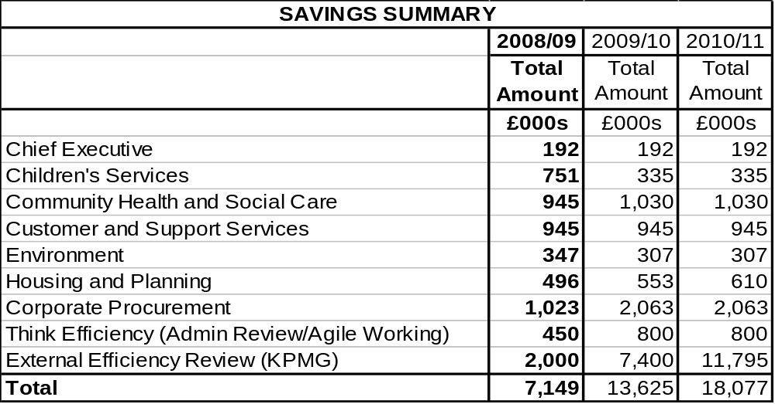

- The approach to seeking efficiencies was two-pronged in that :-

- Directorates were requested to identify proposals that would seek to achieve the Government’s 3% Gershon cashable efficiency target for 2008/09 ;

- An external efficiency review was commissioned, engaging KPMG to undertake it, to identify efficiencies of a cross-cutting nature that could be delivered over the medium-term, ie over the 3-year grant settlement period.

Growth

- Areas for the reinvestment of efficiencies in the growth in services to be funded by the revenue budget are :-
£m
LIFT 1.076
Recycling 0.494
Planning capacity (2007/08 budget decision – full year cost) 0.250
Worklessness (2007/08 budget decision – full year cost) 0.250
Other minor growth adjustments relating to 2007/08 budget 0.025
--------
Total 2.095
=====

Final Budget Spending Plans

- Bringing the continuation of service budget, growth in priority services and service efficiencies together produces a final budget for 2008/09 as follows :-

£m
Continuation of Service budget 221.623
Less : Service efficiencies
- new efficiencies 2008/09 - 7.149 - full year effect of 2006/07 efficiencies - 0.055
- full year effect of 2007/08 efficiencies + 1.034 ----------- - 6.170
Add : Growth in priority services 2.095
------------
217.548
Less : Use of reserves (see section 8 below)
- from 2007/08 underspends - 1.060 - from accumulated unearmarked reserves - 3.336 ------------ 4.396
-----------
Revenue Budget 2008/09 213.152
=======

- It should be noted that savings continuing into 2008/09 are £1.034m less than proposed for 2007/08 due to a number of one-off proposals made for 2007/08, principally in Community Health and Social Care, where there will be a need to make up a net £927k in savings for 2008/09 to replace their one-off proposals for 2007/08.

- The following chart shows the increase in budget for each directorate in 2008/09 by comparison with 2007/08. It particularly emphasises that whilst large cash increases have gone into Community Health and Social Care, and to a lesser degree Housing and Planning, no directorate has received a significantly higher proportionate increase than others, whilst Customer and Support Services show a significant reduction due to the allocation of Procurement savings against their budget.

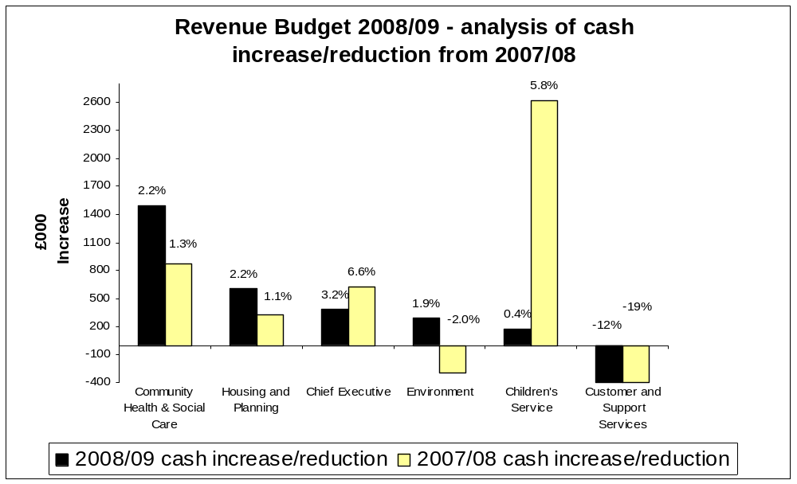

whilst the following chart illustrates efficiency savings by service in comparison with 2007/08 :-

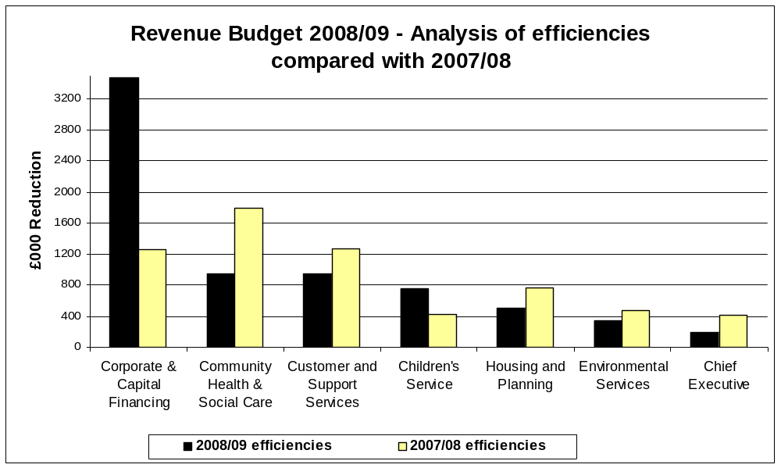

RESERVES

As part of the budget development, the position with reserves has needed careful consideration bearing in mind the exceptional circumstances which required a call upon reserves to fund equal pay claims.

2007/08 position

- The assumptions made in the 2007/08 revenue budget with regard to the level of general reserves over the next three years were as follows :-

Planned Level of Reserves at 31st March 2007 through to 31st March 2010
2007/08 Revenue Budget

 | 2006/07 | 2007/08 | 2008/09 | 2009/10
 | £m | £m | £m | £m
Balance at 1st April | 9.631 | 7.212 | 6.652 | 7.000
Less :
Contribution from Reserves – general budget support | - 2.000 | - 0.560
Planned Reserves – 2006/07 Budget | 7.631
Less :
Equal Pay claims | - 1.919
Add :
Review of provisions – Insurance Fund | 0.800
Review of provisions – Grant Loss | 0.700
Budgeted contribution to Reserves |  |  | 0.348 | 0.700
Balance at 31st March | 7.212 | 6.652 | 7.000 | 7.700

- The risk assessment undertaken for the 2007/08 revenue budget identified minimum and desirable levels of reserves as follows :-

- Minimum level of reserves £3.6m
- Desirable level of reserves £7.7m

Outturn Position 2006/07

- The planned position for reserves at 31st March 2007 in drawing up the 2007/08 revenue budget was £7.212m, as per the table above.

- The outturn position for 31st March 2007 following completion of the final accounts and after allowing for earmarked commitments such as settling the balance of equal pay claims was £8.430m, ie £1.218m favourable to budget plans.

Approximate Outturn 2007/08

- An assessment of the outturn expenditure for 2007/08 has indicated an underspend of £1.242m (as detailed in section 4 above), which would give reserves in hand at 31st March 2008 of £9.672m.

Reserves Strategy for 2008/09 To 2010/11

The way in which the revenue budget for 2008/09 has taken shape means that, without the use of reserves, there would be a significant funding gap that cannot be met by means other than cuts in service and/or raising Council Tax beyond the planned increase of 3%.

- The use of reserves to reduce net expenditure should be done in a planned manner that adopts the following principles :-

- Does not support recurring expenditure ;
- Is only therefore used in a one-off manner ; and
- Identifies the strategy for replenishing them to the desired level.

- A risk assessment of reserves is attached at Appendix 5, which identifies the minimum and desirable levels of reserves that should be held for the key financial risks facing the Council.

- Based on this assessment :-

- A desirable level of reserves would be £9.7m, whilst
- The minimum level of reserves would be £5.3m.

- It should be noted that this assessment requires a higher level of reserves to be held than for 2007/08, but this is due to the tightness of the Government’s grant settlement and hence the fact that there are greater risks inherent with the 2008/09 budget process than in 2007/08.

- However, the current assessment includes for the risk of a delayed stock transfer by 3 months at a cost of £1.2m, which would not recur after 2008/09 assuming transfer is completed satisfactorily within the year. It would therefore be appropriate to plan for around £8.5m in the longer-term.

- Adopting the principles set out above, a strategy for the use of reserves in 2008/09 to support the revenue budget could be adopted whereby they are replenished over the subsequent two financial years so that by 31st March 2011 the level of balances were broadly back to the position expected at 31st March 2008 and the assessed longer-term desirable level, ie a balance of £8.5m.

- The table overleaf therefore sets out how the level of reserves would appear over the next three years should this strategy be adopted.

Proposed Reserves Strategy 2008/09 to 2010/11

 | 2007/08 | 2008/09 | 2009/10 | 2010/11
 | £m | £m | £m | £m
Balance at 1st April | 8.4 | 9.6 | 5.3 | 6.9
Add : Contribution to Reserves  – approximate outturn 2007/08 underspend | 1.2
Less : Budgeted contribution from Reserves  - use of 2007/08 underspend  - general use of reserves |  | - 1.0  - 3.3
Add : Budgeted contribution to Reserves |  |  | 1.6 | 1.6
Balance at 31st March | 9.6 | 5.3 | 6.9 | 8.5

- For 2008/09, this position would leave the Council with a number of challenges that will need to be managed at a time when reserves are at their lowest, with the most significant risks being around :-

- Pay and grading review – the cost of any potential service disruption and equal value claims ;

- Spending pressures – especially from those services with continuing demographic pressures, ie adult and children’s social care ;

- Housing stock transfer – the capital financing costs which any delay could cause, the implications for support services to City West if they choose alternative providers and the ability of Housing Connections Partnership to reduce their subsidy ;

- Delivery of efficiencies.

- However, this would be a high risk exposure for 12 months only, assuming all risks and other pressures can be contained, as reserves would start to be built back up during 2009/10, at the end of which, all things being equal, reserves would only be slightly less than they were when the 2007/08 budget plans were put together, ie £6.9m by 31st March 2010 compared with £7.2m at 31st March 2007, and rise to a higher level of £8.5m by 31st March 2011.

- The table above and the detail in Appendix 5 illustrate how this strategy can be managed without over-burdening any one year’s budget with an excessive contribution to reserves, and which can satisfy the District Auditor that the current CPA use of resources 3 star assessment on financial standing can be maintained.

- THE 2008/09 COUNCIL TAX LEVY

  - If a revenue budget is set at £213.152m then this would lead to a Council Tax requirement calculated as follows :-
£m
Total Net Budget 213.152

Less : Formula Grant - 125.092
Collection Fund surplus - 0.884 -----------
Total Amount required from Council Tax for Salford 87.176
======

Divided by : Taxbase (number of band D equivalent dwellings) 67,700

Band D Council Tax for Salford's services £1,287.68
Band A £ 858.45

Increase 3%

- However, the final Council Tax increase is also dependant upon the increases from the 2 precepting authorities :
Greater Manchester Police Authority
Greater Manchester Fire and Civil Defence Authority

- The precepts were due to be set by both authorities on 15th February, which is after the deadline by which this report has had to be prepared for the Council agenda. However, subject to confirmation, it is understood that the following precepts are to be recommended to the respective authorities :-

 | Precept at Band D | Increase
 | £ | %
Police | 124.90 | 7.5
Fire & Civil Defence | 49.68 | 3.5

- Local authorities need to be mindful that the Secretary of State can impose capping restrictions on authorities, including precepting authorities, to limit Council Tax increases and the Local Government Minister has announced that he will continue to cap what he considers to be excessive increases. The capping criterion he has indicated for 2008/09 is that average Council Tax increases should be “significantly less” than 5% and that this limit would apply equally to precepting as to billing authorities.

- It will be noted from the table at paragraph 9.3 above that the Greater Manchester Police Authority (GMPA) will have set their precept above the capping limit and therefore run the risk of being capped. AGMA district leaders have unanimously supported the increase, including at a similar level for 2009/10 and 2010/11, in the belief that this increase can be met from within district headline Council Tax increases whilst still keeping within the capping limits.

- An assurance has been given by the Treasurer to GMPA that they will indemnify districts against the costs of reproducing Council Tax bills should the Secretary of State choose to cap GMPA and therefore require districts to re-run their bills.

- Taking these elements together, Salford’s overall Council Tax for 2008/09 would be significantly within the Secretary of State’s indicative limit, as follows :-

 | Council Tax at Band D | Increase
 | £ | %
Salford | 1,287.68 | 3
Police | 124.90 | 7.5
Fire & Civil Defence | 49.68 | 3.5
Total Council Tax at Band D | 1,462.26 | 3.39

- For most taxpayers in Salford, who live in Band A properties, the bill will be £974.84.

- Single persons will pay 25% less. For the majority of households this will mean an increase of 61p per week.

- The average bill, which allows for discounts, will be around £978.

- The full range of Council Tax amounts at each tax band are as shown in the following table, by comparison with this year :-

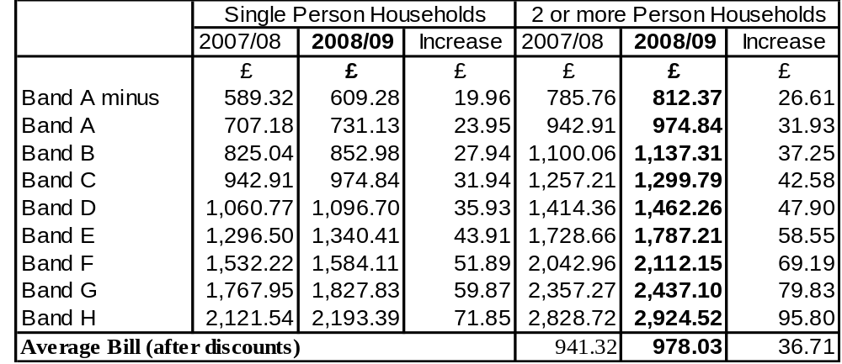

- BUDGET ASSUMPTIONS AND RISKS

Requirement of the Chief Financial Officer

- It is a requirement under Section 25 of the Local Government Act 2003 for the chief financial officer to report to the Council on the robustness of the estimates and the assumptions made in compiling it, and the adequacy of reserves.

- This section of the report seeks to fulfil that requirement.

Financial Health

- The financial health of the Council has contributed towards maintaining a 3 star CPA rating for the use of resources in 2007, with 9 of the 11 sub-categories achieving 3 star and 2 achieving 4 star, including an improvement from 3 to 4 star in one of the sub-categories, external accountability, the other 4 star being probity.

- Despite the need to partly fund the extraordinary cost of equal pay claims from general reserves, the financial health of the Council still remains relatively strong by maintaining a satisfactory level of general reserves which has been strengthened during 2007/08, reducing outstanding debt further, declaring a surplus on the Collection Fund for the second year running, and reducing provisions no longer required at their current levels.

- Reserves are expected to increase to £9.672m by 31st March 2008 as a result of underspending in 2007/08. A risk assessment has been undertaken which identifies this level of reserves to be significantly above the minimum required to meet key risks and at the upper end of requirements.

- The budgetary plans for 2008/09 would reduce the level of reserves to the minimum recommended level of £5.3m but the plans for 2009/10 and 2010/11 would restore them to an assessed desirable level of £8.5m by making budget provision for contributions back to reserves .

- In addition, the provision for irrecoverable bad debts on sundry debtor accounts and Council Tax continues to improve.

- The level of outstanding sundry debtors is the lowest it has been for several years, which has enabled the provision to be reduced from £200k to £100k this year and further to £50k for 2008/09 without increasing the risk of an under-provision.

- Previous deficits on the Collection Fund have been eliminated through improvements in the collection rate of Council Tax in recent years and a surplus of £1m has been declared for 31st March 2008, the second year running.

- The medium-term financial strategy will continue to address these and other issues in a structured and considered manner to ensure that the financial health of the Council is maintained.

Inflation

- Adequate allowance has been made for the impact of inflation.

- A provision of 2.5% has been made for the pay increase in 2008/09 for administrative staff, slightly above the expectations of the Chancellor of the Exchequer for public sector pay settlements this year. The teachers pay increase will fall to be met from schools budgets, which are now wholly funded by the Dedicated Schools Grant.

- Increases for price inflation have been made in accordance with the expectations of the level of increases for different types of expenditure. Where exceptional increases are expected, higher provision has been made, eg 12.5% for water costs, 11% for waste disposal, 5% for gas/electricity. Otherwise, inflation increases are limited generally to 2.5% where it is known an inflationary uplift is a recurring trend, eg care charges by outside agencies, whilst no inflationary increase has been allowed for general supplies.

- Inflationary increases during 2008/09 will require close monitoring and scrutiny, and where they exceed the assumptions made will need to be contained within the budget allocations to directorates. The risk assessment of reserves makes allowance for the possibility of excessive inflationary costs being unable to be met by directorates.

Potential Spending Pressures

- The areas of greatest risk from spending pressures have been adequately addressed in the risk assessment of reserves.

- Key areas of spending pressure which are likely to be high risk have been identified in social care for adults and the elderly, children in care, housing and planning. In each case, directorates have identified mitigating steps to contain expenditure within existing allocations, but where this is judged not to be possible, additional provision has been made.

- The risk assessment of reserves makes allowance for any potential breach of the assumptions built into these areas of the budget.

Savings

- It is assumed that directorates will achieve their savings targets and have appropriately robust action plans in place to deliver them or can take alternative steps to achieve them. This will require rigorous monitoring during the year by Lead Members, Strategic Directors and Budget Scrutiny Committee.

- Total efficiency savings of £7.149m have been identified for 2008/09 in consultation with Lead Members and Strategic Directors. This is a significant increase on recent years and will require rigour in their delivery.

- Budget Scrutiny Committee has examined the proposals and considers them to be achievable in principle, although wishes to examine the progress with their implementation during 2008/09 as part of the monitoring process.

- It is assumed that all directorates will meet their required savings targets by the means proposed in this report, but should it not prove possible by those means then alternative means will be identified to ensure that net expenditure is contained within directorate budget allocations.

Partnerships

- Partnerships that the Council has with other external public, voluntary and private sector organisations play an increasing role in the Council’s budget plans.

- Key formal partnerships exist with the following organisations :-

- Primary Care Trust under section 31 of the Health Act 1999 for support services to learning difficulty clients, adaptations and equipment services for adult and elderly clients, and to clients who require support to combat drug and alcohol problems, whereby in each instance budgets of the two organisations are pooled together and jointly managed. Combined pooled budgets exceeding £26m will be managed in this manner in 2008/09.

- Salford Community Leisure, a not-for-profit trust, provide leisure services and manage leisure centres owned by the Council, for which a management fee of £3.8m is included in Council budget plans.

- Urban Vision Ltd, a partnership with Capita plc and Morrisons Construction, provide architectural, engineering, property and highway services, for which a management fee of £9.9m and highway works of £5m are provided for in Council budget plans. Urban Vision also derive a further £10m from capital works and further income from sources external to the Council.

- LAPP, a purchasing consortium with other Greater Manchester authorities, from whom goods and services are procured to the value of £4.5m for the Council, which are included in Council budget plans.

  - The budget plans assume the appropriate provision based upon the most up-to-date information regarding the likely level of commitment to these partnerships. Any variation to the budget provision will need to be managed by the relevant directorates within the allocation provided to them.

Area-Based Grant

- The non-ring-fenced nature of the new Area Based Grant is sufficient as to provide the desired flexibility to allow funded projects to be aligned with the new national targets under the Local Area Agreement in agreement with the Local Strategic Partnership and Government Office whilst also being able to afford continuation of funding for existing time-expired grant funded projects for up to six months pending the outcome of a review of existing projects to assess alignment with the new national targets.

Capital Programme

- The revenue budget incorporates the provision for capital financing costs on the use of £10m of new unsupported borrowing in funding the 2008/09 capital programme, in addition to the use of £4.8m of borrowing supported by Formula Grant, previous commitments to £4.1m of unsupported borrowing and future annual maintenance costs from completed schemes, but otherwise assumes that there will be no significant revenue implications arising.

Control of Risk

- Risk will be controlled through a combination of :-

- Monthly directorate level budget monitoring reports to directorate senior management and Lead Members ;
- Meetings between the Lead Member for Customer and Support Services and other Lead Members as appropriate to agree action plans from issues arising from monthly budget monitoring and other developments not budgeted for ;
- Monthly corporate budget monitoring reports to Budget Scrutiny Committee to identify issues, agree appropriate action and call for special reports on issues of concern ;
- A quarterly update of risks which shall be incorporated into the monitoring reports to Budget Scrutiny Committee : and
- Reports from Budget Scrutiny Committee to Cabinet after each meeting on recommendations to be considered by Cabinet.

Budget Assumption Details

- The key assumptions made in drawing up the 2008/09 revenue budget are contained at paragraph 7.6.

PART 2

THE HOUSING REVENUE ACCOUNT (HRA)

REVENUE BUDGET 2008/09

1. INTRODUCTION

1.1 This report is intended to inform members of the Housing Revenue Account (HRA) 2007/08 Approximate (the “expected” outturn) and the 2008/09 Budget

-incorporating

  - effects of the Government’s proposals on rent restructuring from April 2003, approved on the 28th January 2008
  - the actual HRA subsidy determinations for 2008/09
  - the actual Item 8 credit and Item 8 debit (general) determinations 2008/09
  - previously approved service developments
  - the effects of the 2007/08 outturn
  - the relationship with New Prospect Housing Limited
  - the relationship with Salix Homes
  - future planned changes to the management of the housing stock.

1.2 This report reviews the current year's plans and achievements in financial terms and also reflects aspirations for the coming year taking into account the wishes and needs of its tenants and available resources.

2. PUBLIC SECTOR HOUSING PRIORITIES

Housing Priorities

2.1 Although there were many notable achievements in 2007/08, and these are shown at Appendix 9, the significant items were the launch of Salix Homes within Central Salford, securing an overwhelming mandate from the tenants of West Salford to transfer their homes to a new social landlord and the launch in shadow mode of Housing Connections Partnerships (HCP).

2.2 Consequently for ease of reference the priorities for 2008/09 and achievements for 2007/08 are not split between General Fund and HRA activities but shown for the Housing Service in its entirety.

2.3 All priorities for 2008/09 can be directly linked to the action plan arising from the Housing Strategy which is subject to regular monitoring and review. It should be noted that the over-riding priorities are

- the transfer of stock to City West
- supporting Salix in its inspection to obtain a minimum of a two star assessment
- submission of the Outline Business Case for PFI
- ensuring that there is no detrimental affect on service delivery in the transitional period.

Public Consultation

2.4 In previous years there has been consultation with tenants through making a presentation to each of the five Local Boards and the NPHL Parent Board. However for 2008/09 for the reasons outlined below there has only been a report to the NPHL Parent Board for information, with Salix adopting a similar approach on the rent increases and not the HRA itself. Details of the rent increases are covered later in this report.

2.5 Through work on stock options there has been considerable consultation and information passed to tenants within the offer documents for City West as to how the future organisations will follow rent convergence, the effects upon tenants and their needs.

  - Therefore had there been consultation for 2008/09 confusion could have arisen by tenants requesting services that will not occur until after the new organisations are established. Any consultation could have also detracted from the further work being undertaken on stock options linked to the PFI proposals.

  - Additionally, as considered later, there is pressure on the HRA through the funding of the implementation costs of stock options, implications arising from a part year transfer and changes occurring on almost a monthly basis as the new organisations become established which makes it almost impossible for meaningful consultation to be undertaken as to how resources are going to be utilised.

3. REVIEW OF 2007/08

The 2007/08 Base Budget

3.1 The original approved budget for 2007/08 provided for gross expenditure of £89.303m, funded by matching income from rents, charges and subsidy.

3.2 At the time the budget was approved it was assumed there would be a contribution from reserves during 2007/08 of £1.462m and at 31st March 2008 reserves would be £1.379m or 1.55% of the budget which is lower than the 3% Audit Commission guidelines.

The 2007/08 Approximate

- Following determination of the 2006/07 outturn, which was finalised after the 2007/08 base budget was set, the actual reserves at 31st March 2007 were £3.270m (£0.429m higher than budgeted) due mainly to higher rental income arising from fewer right to buys, timing of stock option implementation costs and adjustments for housing subsidy. The reasons for the increased surplus and the implications for 2007/08 were reported to the Housing Lead Member as part of the monthly monitoring reports in July 2007.

- During 2007/08 the HRA budget has been continually monitored and in order to balance the budget it is forecast that a contribution from balances of £1.665m will be required, to give outturn expenditure of £88.158m.

- The base data used and assumptions made in the calculations are highlighted in Appendix 11(b).

3.6 Brief details are also given at Appendix 11(c) of the variance between the original budget and the expected outturn for 2007/08.

4. HRA RESERVES 31st MARCH 2008

4.1 Members will note that as a consequence of the approved variations to the budget during 2007/08, the expected level of reserves at the 31st March 2008 is now forecast to be £1.605m or 1.8% of the budget, as follows :-
£m %
Opening Balance 1st April 2007 3.270 3.7

Less : Stock options appraisal costs 1.665
--------
Estimated Reserves 31st March 2008 1.605 1.8
=====

5. THE 2008/09 ESTIMATE

Summary

5.1 The HRA gross revenue budget for 2008/09 is proposed at £54.721m. Although this is £34m less than 2007/08 it must be remembered that only for the first four months of 2008/09 will the Council still be responsible for a comparable level of stock to the previous year. Following the transfer of almost 60% of the stock to City West at the end of July 2008, subject to the relevant approvals, the HRA will only own the stock in Central Salford and as such will be significantly smaller. This actually makes any direct comparisons between figures for the two years almost meaningless due to the significant changes.

5.2 The base data used and assumptions made in the calculations are highlighted in Appendix 11, which also compares the budget for the HRA for the 2008/09 Estimate with the 2007/08 Approximate.

5.3 The following paragraphs consider the major issues which have arisen in consideration of the HRA revenue budget for 2008/09, although most are directly linked to the changes in the stock numbers.

5.4 It should be noted that it is planned to use £1.605m from reserves, leaving a forecast zero balance in reserves compared to the minimum 3% level recommended by the Audit Commission. The plans to restore the reserves to a prudent level following the major implications of stock options will be addressed in the later section. As reserves are at such a low level a risk assessment has been undertaken to determine what factors could affect the position during 2008/09. This is shown at Appendix 10.

Resources

Housing Rent Restructuring And Service Charges

5.5 Members will recall that Cabinet on the 16th July 2002 approved a revision to HRA rent review policy to align it with the HRA budget process with effect from 1st April 2003, and in order to align with Government proposals on rent restructuring.

5.6 The Government’s aim is that rents should reflect more closely the qualities which tenants value in properties, and that there should be no unwarranted differences between the rents set on similar properties by different local authorities or registered social landlords (RSLs). The key to achieving this is a common formula for both local authority and RSL rents to be based on.

  - The size, condition and location of the property
  - Local earnings

5.7 30% of the property’s rent will be based on relative property values, whilst 70% of the property’s rent will be based on relative county level earnings. A bedroom factor will be applied to reflect the size of the property.

5.8 The Government previously wanted the transition from old rent to new rent to be completed within 10 years from 2002 to 2012. However during 2007/08 the Government consulted on possible changes to the period in order to try and mitigate the impact upon tenants. Salford along with many authorities responded welcoming this approach and as such the period for convergence has now been extended to 2016/17, although this could be subject to change in future years.

5.9 All property rents have been recalculated and modelled over the remaining transition period in line with Government recommendations and included in the ‘Rent Restructuring Plan’.

5.10 At the Council meeting of the 18th February 2004 approval was given to the rent restructuring plan to ensure convergence and that any annual refinements during the period would be approved by the Lead Members for Housing and Customer and Support Services. A copy of the rent restructuring plan is shown at Appendix 12 for information.

5.11 Accordingly, at the Joint Lead Member meeting of the 28th January 2008 approval was given for an average rent increase of £2.91 per week for 2008/09 and an increase to service charges of inflation plus half a percent as permitted by Government. The average increase of £2.91 per week is based on 52 weeks. The £2.91 increase equates to an average increase of £3.15 per week on a 48 week basis due to the rent free weeks.

5.12 This increase has been incorporated into the recommended budget for 2008/09 for the HRA. Any deviation from these figures will result in the HRA being out of balance for 2008/09 and could affect the ability to achieve convergence in accordance with the prescribed timetable.

Housing Subsidy

5.13 There were 2 important changes to housing subsidy in 2004/05, as follows :-

- removal of rent rebate subsidy (see paragraphs 5.31 to 5.33 below) ; and
- no longer subsidising the minimum revenue provision (MRP) required to be set aside for the repayment of HRA debt.

5.14 Local authorities have the discretion from 2004/05 to use part of their Major Repairs Allowance (MRA) to repay debt if they wish, but there is no compulsion so to do.

5.15 On the basis that using part of the MRA for MRP purposes would provide less resource to maintain the current repair condition of the housing stock, the HRA revenue budget for 2007/08 makes no provision for the repayment of debt.

5.16 The major change for 2008/09 is that authorities will no longer receive the Rental Constraint Allowance that was previously given to reduce the impact of rent increases upon tenants. This removal is the major factor why the Government consulted on the rent convergence period and extended it to 2016/17 as covered in the section above on rent restructuring.

5.17 Details of the housing subsidy calculation are shown in Appendix 13.

  - Again it must be remembered that when looking at the appendix comparisons can not be made between years due to 2007/08 being based on full stock and 2008/09 showing a part year transfer.

  - The date of transfer does have a major implication in relation to subsidy received compared to loan interest charged. Loans are charged to the HRA based on the average stock at the mid-year point, whereas subsidy is paid based on when stock actually changes.

  - This means the HRA based on a transfer at the end of July is charged for two months to the mid year point for stock on which it will not receive subsidy. For Salford this equates to approximately a £1m shortfall on the HRA.

Expenditure

New Prospect Housing Limited (NPHL) – Management Fee and Repairs

5.21 On 16th September 2002, the Council established an arms length management company, New Prospect Housing Limited (NPHL), to manage and maintain its council housing stock.

5.22 The HRA pays to NPHL a monthly management fee based on a jointly agreed annual budget between the Council and the Company.

5.23 A fee for 2008/09 of £3.655m is proposed and will be considered by the Lead Members for Housing and Customer and Support Services in February 2008. This fee has been incorporated into the HRA budget for 2008/09.

5.24 The 2008/09 management fee has been developed on the basis that New Prospect will continue with its present structures up to the proposed date of transfer to City West of 28th July 2008. This will ensure that the monthly management fee is at an appropriate level for the first few months of the financial year to allow operations and service to be maintained.

5.25 As NPHL will be responsible for repairs in the West of Salford up to transfer they have been working with Salix Homes to establish a split of the budget between the two areas. This proposed split has been discussed with the Council who have ensured that the split has been done in such a way that there is not a detrimental impact upon service delivery or tenants between the two areas. As such NPHL are being requested to manage a net repairs budget of £4.330m up to transfer.

Salix Homes – Management Fee and Repairs

5.26 On 4th July 2007, the Council established an arms length management company, Salix Homes, to manage and maintain its council housing stock in Central Salford.

5.27 The HRA pays to Salix Homes a monthly management fee based on a jointly agreed annual budget between the Council and the Company, which currently only covers housing management functions.

5.28 A net fee for 2008/09 of £10.173m for the housing management activities is proposed and will be considered by the Lead Members for Housing and Customer and Support Services in February 2008. This fee has been incorporated into the HRA budget for 2008/09.

5.29 The Council’s then Housing Committee on 18th December 1998, approved the creation of a separate Housing Repairs Account within the ring-fenced HRA under Section 77 of the 1989 Local Government and Housing Act to facilitate future budget management.

5.30 A Housing Repairs Account is used to keep a separate record of income and expenditure relating to the repair and maintenance of an authority’s HRA houses or other property. The main item of income within the Housing Repairs Account will be the contribution from the HRA.

5.31 Salix Homes have requested through their monthly monitoring meetings with the Council that their management fee for 2008/09 also includes repairs to give them the true ownership and accountability for this expenditure. The benefits of this approach are that it will aid their Audit Inspection scheduled for November 2008 which when successful will allow ALMO funding to be accessed and will also remove the risk from the HRA as Salix will have to manage within the allocations.

5.32 As such a net management fee for repairs of £8.950m is proposed and will be considered by the Lead Members for Housing and Customer and Support Services in February 2008. This fee has been incorporated into the HRA budget for 2008/09.

Major Repairs Reserve

5.33 The Major Repairs Allowance (MRA) was introduced for the first time in 2001/2002 as part of the switch to Resource Accounting. It represents the estimated long term average amount of capital spending required to maintain the stock in its current condition.

5.34 The Local Authorities (Capital Finance and Accounts) (England) Regulations 2000 require authorities to set up a Major Repairs Reserve to facilitate the utilisation of the MRA.

5.35 The funds are an HRA capital resource and are paid to local authorities by Government via HRA subsidy.

5.36 The Item 8 Determination provides for the HRA to benefit from the potential for short-term investment of any unspent sums in the reserve each year.

5.37 The amount available for capital expenditure in 2007/08 is £16.208m and for 2008/09 is £9.693m. Further details of this and the overall Housing capital programme for 2008/09 are covered in Part 3 of this report. The formation of the capital programme for 2008/09 and the utilisation of resources in relation to the HRA have been formulated based on work programmes submitted by Salix to achieve decent homes standards.

Implementation Costs of Stock Options

5.38 An initial report was presented to the Joint Lead Member meeting for Customer and Support Services and Housing on the 28th November 2005 detailing the initial forecasted costs arising from the preparation for stock options, with update reports being submitted on a regular basis.

5.39 These costs cover staff seconded to work on the project from Housing, NPHL, Finance, Legal and Personnel, plus specialist consultants for Finance, Legal, Tenant Consultation, Stock Condition Surveys and Marketing. Whilst some of these costs particularly those associated with transfer will be recovered as shown within Appendix 11(a), the remainder have to be funded through the HRA.

5.40 Consequently within the report there was a funding proposal that would allow the costs to be met, through a contribution from balances. The effect upon balances at the end of 2008/09 is covered in the section below.

5.41 A separate monitoring report is prepared on a monthly basis to Housing Lead Member on the budget for the implementation costs and this practice will continue for 2008/09.

HRA Reserves

5.42 Members are reminded of the volatile nature of the HRA and the need, particularly under ringfencing, to maintain reserves to meet unforeseen circumstances which might arise and to minimise the effects of:-

- Right to buy applications
- Any possible adverse performance issues
- Budget variations identified during the year
- Decent homes investment requirements
- ODPM continually reviewing HRA subsidy
- Trends in void properties
- Rent restructuring and convergence
- Service charges
- New legislative requirements
- Homelessness and Supporting People changes
- Environmental and Estate investment

5.43 In an ideal situation reserves associated with an account of this size taking particular account of the comments in the previous paragraph would amount to approximately 3% of the gross budget as recommended by the Audit Commission. A formal risk assessment exercise has been undertaken similar to that for the General Fund to review risks in relation to reserves and this is shown at Appendix 10.

5.44 The HRA revenue budget for 2008/09 would normally aim to achieve a minimum level of reserves of 3%, or £1.640m on the gross budget of £54.721m.

5.45 Actual reserves at 31st March 2009 are expected to be nil, as follows:

£m %
Opening Balance 1st April 2008 1.605 1.8

Less : Difference in Loan Charges to Subsidy loss 1.000
Stock Option appraisal costs 0.605

Estimated Reserves 31st March 2009 Nil

5.46 Although this would normally be an unacceptable level of reserves it has always been accepted that 2008/09 was going to be a difficult year financially due to the transition to City West and the need to draw down a substantial amount of external investment to make homes decent. Consequently the important point is the future strategy to restore balances to a more prudent level as covered in the next section.

Future HRA Financial Strategy

5.47 When the ALMO bid was submitted to CLG in July 2006 a 30 year HRA Business Plan was produced which demonstrated its’ financial viability over this period.

5.48 The Plan at this time assumed an earlier start for both City West and financial close for the PFI than is currently envisaged. Also the Plan had to use financial figures for 2006/07 and then uplift them for assumed changes and inflation.

5.49 As part of the current work being undertaken for submission of the Outline Business Case for PFI it has to be demonstrated that this is affordable and because the costs associated with PFI will flow through the HRA then in effect the HRA Business Plan has to be viable.

5.50 Consequently there is a major piece of work ongoing to review and update the full Business Plan for all elements including PFI data as whilst individual parts may be affordable it is the overall position of the HRA that matters.

5.51 In order to submit the PFI in accordance with the required deadlines it is timetabled that the affordability of the full HRA Business Plan will be updated by late February / early March 2008.

5.52 Through this work the PFI scheme will need to demonstrate that it is affordable in order to draw down Government funding and it will be implicit that adequate provision will need to be made for an appropriate level of HRA reserves. Therefore, although detailed figures cannot be given at this stage, members should be re-assured that through this work the future shape and level of balances will become clearer for future years.

- CONCLUSION

- Members are reminded of:-

- The volatility of the HRA and changes arising through the establishment of new organisations making 2008/09 a transitional year of change.

- The need to:-

- maintain reserves to provide adequate cover against anticipated risks
- sustain improvements to the housing stock and in housing management performance
- continually review service delivery
- review the void property situation and the resultant impact on HRA income
- meet any further subsidy changes and inflationary factors that could affect the account during 2008/09 and beyond.

- RECOMMENDATION

Being mindful that, under Section 76(3) of the Local Government and Housing Act 1989, on the basis of the best available information, the Housing Revenue Account will not be in deficit, members are requested to approve the proposed HRA budget and contribution from reserves for 2008/09.

PART 3

CAPITAL INVESTMENT STRATEGY
2008/09 TO 2011/12

and

CAPITAL PROGRAMME 2008/09

THE PRUDENTIAL CODE FOR CAPITAL FINANCE

- In considering the capital programme, due regard needs to be given to the implications of the new prudential capital finance system, which became operative on 1st April 2004 under the Local Government Act 2003, and is guided by CIPFA’s Prudential Code for Capital Finance.

- The key principle behind the new system is that any capital expenditure plans must be affordable. In particular, local authorities will have the freedom to determine the amount of new borrowing it will undertake, subject to the capital financing costs being affordable in the revenue budget.

- To reflect this freedom, the Government has abolished the system of credit approvals and replaced it with amounts of borrowing that it will support through RSG.

- Whilst this still imposes a form of constraint on borrowing, there is now more freedom for local authorities to determine their own borrowing, providing they can afford to meet the capital financing costs from their revenue budget.

- Also, capital planning over longer timescales is better facilitated as the timing of capital receipts is less critical and borrowing can be used to regulate any delays in completion of disposals at year-end, provided any resulting temporary extra debt is repaid from the capital receipt.

- Borrowing to fund invest to save proposals now also becomes a realistic proposition.

- As far as funding capital expenditure from borrowing is concerned, Council in February 2004 agreed the following principles :-

- Borrowing will only exceed the amount supported by Government in prescribed circumstances.

- The prescribed circumstances will be :

- invest to save proposals where a business case has been approved by the Lead Member for Corporate Services (now Customer and Support Services) which provides for revenue savings at least equivalent to the capital financing costs of the borrowing ;

- where a capital receipt expected and built into financing plans in a financial year is delayed until the following financial year, provided the borrowing is repaid by the capital receipt in the following year ;

- where Government grant is certain or expected with a high degree of confidence and it is essential that expenditure is committed ahead of the grant being approved or paid, in order to maximise the amount available.

- These principles continue to remain valid and form part of the medium-term financial strategy. However, to sustain the capital investment demands which the Council currently has, it will be necessary to use unsupported borrowing to provide the necessary resource in 2008/09 to deliver a fully funded capital programme.

- Furthermore, because the new prudential system requires a chief financial officer to recommend prudential borrowing indicators to the Council, the determination of the capital programme needs to be aligned with the revenue budget by considering and approving them at the same Council meeting.

- REVIEW OF 2007/08

- Based on the latest capital monitoring report to Budget Scrutiny Committee (January 2008) outturn capital expenditure is expected to be £121.352m.

- Available resources are expected to be £114.022m, giving a shortfall in resource of £7.330m.

- This shortfall will need to be made good by the short-term use of unsupported borrowing and will be a first call upon usable capital receipts available in 2008/09. This matter is addressed more fully later in this section.

- The capital financing costs of the unsupported borrowing have been factored into the revenue budget.

- CAPITAL INVESTMENT STRATEGY 2008/09 TO 2011/12

Regeneration

- Regeneration is at the heart of the City’s priorities for capital investment. It aims to:

- Develop an integrated strategy to regenerate Central Salford including the areas of major change in Ordsall, Lower and Higher Broughton, Seedley and Langworthy and Charlestown/Kersal

- Target action to stabilise communities in Salford West and maximise opportunities

- Work with communities to achieve change.

- Increasingly, the Council relies on funding from the Government via grants from NWDA and English Partnerships, from special funding such as the Housing Market Renewal Pathfinder and from PFI, but seeks to add value by the use of its own resources.

- Several major developers, house builders and financial institutions are investing within the City and working in partnership with the Council and the Pathfinder. This creates a new and key challenge for the Council to integrate resources and programmes effectively and to gear the use of the Council’s own resources clearly to meet the objectives of stimulating other investment to promote the regeneration of the City and better services.

- Approval was given in February 2005 to set up an Urban Regeneration Company (URC) within Central Salford with founding partners the Council, the NWDA and EP. The URC co-ordinates and adds value to strategic interventions and promotes Central Salford to the private sector.

Housing

- In addition to supporting the HMRF Pathfinder for investment in private sector housing, as referred to above, the Council has embarked on a mixed procurement strategy for its social rented housing to ensure that it acquires sufficient capital funding to deliver decent homes standards. Following an appraisal of its options, a new ALMO, Salix Homes was established in July 2007 to manage 10,000 homes in Central Salford and a new registered social landlord, City West Housing Trust, will commence business in July 2008 to manage 16,000 homes in Salford West to be transferred by the Council following a successful tenants’ ballot. It is expected that total capital resources of £400m will be invested in achieving decent homes standards as a result of this strategy.

Schools

- The Education Asset Management Plan (AMP) sets out the need to provide high quality education in accommodation that stimulates a learning environment for school pupils and members of the community.

- The Council was successful with its Building Schools for the Future (BSF) outline business case submission to the Government and is now progressing towards selection of a preferred bidder to form a local educational partnership to deliver the replacement and refurbishment of all secondary schools not previously replaced or renewed with PFI and other Government funding.

- The current strategy for primary schools is to remove surplus places and reduce the backlog of poor condition. The Government has announced major new funding that from 2008 will provide for the upgrading of over half of all primary schools.

Transport

- The Unitary Development Plan and Greater Manchester Local Transport Plan set out the transport priorities for the City and wider conurbation. The policies contained in these documents focus on safety, sustainability and regeneration whilst conforming to planning policy and regional planning guidance.

Community, Health and Social Care

- The capital strategy aims to Improve the life chances and promote the independence of people in Salford, through a whole system approach towards health and social care in partnership with users and carers, Salford Primary Care Trust, NHS Trusts, the voluntary sector, independent providers and others to shape services across all areas.

- In particular, Salford‘s Local Investment Finance Trust (LIFT) programme will provide new service outlets in primary health, social care and community services opening in Eccles, Walkden and Pendleton during 2008/09, with future plans for Swinton.

Culture and Leisure

- The capital strategy aims to ensure that, through wide and inclusive access to learning and creativity, the City meets its targets on health, crime, learning, young people, community cohesion and inclusion. It aims to upgrade, extend and replace facilities in support of regeneration in Central Salford, notably in Ordsall, Lower Broughton, Kersal/Charlestown and the Central area, and also in parts of Salford West, eg Irlam.

Environment

- The capital strategy is targeted at supporting the regeneration of the City, promoting health and well being through the Parks for People strategy, addressing national targets with regards to waste management and recycling, and providing investment in the sustainability of key heritage, community assets and services.

Crime and Disorder

- in conjunction with the Crime and Disorder Reduction Partnership, the capital strategy aims to develop the corporate security strategy through the replacement of the CCTV control centre and integration of security services.

Property

- The capital strategy aims to provide office accommodation and other facilities that are fit for purpose in supporting services to meet their plans and priorities, focussing on four core operating sites supported by other satellite offices.

- Where assets are no longer fit for purpose they are disposed of for the most economically advantageous terms.

Underlying Financial Strategy

- The underlying financial strategy is to :-

- Meet contractual commitments ;

- Maximise available Government grants, borrowing approvals and other external contributions, where these are confirmed or expected, by providing appropriate Council match funding ;

- Meet national and regional priorities, eg HMRF ;

- Meet key local spending priorities, eg regeneration ;

- Protect the revenue budget ;

- Earmark capital receipts for reinvestment only where required to do so, eg school playing fields and buildings, or where tied into a development agreement with private sector developers ;

- Affordable within the scope of available funding, particularly the amount of capital receipts that can be generated.

AVAILABLE CAPITAL RESOURCES 2008/09

- The amount of resource expected to be available in 2008/09 is as follows :-

£m
External Resource
Borrowing supported by Government via Formula Grant 4.826
Government Grants 68.118
Other External Contributions 1.732
---------- 74.676
Internal Resource
Unsupported Borrowing funded from the revenue budget
- commitments from previous year’s programmes 4.100 - new commitment 10.000
Unsupported Borrowing funded from the HRA 1.000
DSO Appropriation Account 0.239
Usable Capital Receipts 23.290
---------- 38.629
-----------
Total Resources Available 113.305
=======

- It should be noted that, whilst there are some Government grants still to be confirmed, there is a high expectation that they will be confirmed in due course, where necessary following confirmation of proposed programmes, business plans or grant applications.
- The critical figures within this table are :-

  - the £23.290m of usable capital receipts, and
  - the £11m of new unsupported borrowing.

    - The extent to which this total of £34.290m of new internal resource can support grant-funded proposals and its sufficiency to fund other non-grant-funded priorities, both national and local, is the key to determining a fully funded programme.

    - Gross usable capital receipts expected to be generated in 2008/09 are expected to be £30.620m, but the first call upon them is to repay the £7.330m of unsupported borrowing used to finance the 2007/08 programme. This therefore reduces the amount available to support the capital programme to £23.290m.

    - The £11m of unsupported borrowing is to be funded £10m from the General Fund revenue budget and £1m from the Housing Revenue Account. Appropriate revenue provision has been made in each of these budgets for the capital financing costs.

    - A detailed breakdown of the list of assets for disposal which forms the estimate of usable capital receipts to be generated in 2008/09 is attached at Appendix 14.
    - Members are requested to agree to the list of assets for disposal to allow the Director of Housing and Planning, through Urban Vision Partnership Ltd, to proceed to market those sites where a commitment to dispose has not already been made.

    - Agreement to the list of assets for disposal will also allow a greater degree of predictability and certainty to be built into the forecast of available resources and hence better determine those proposals that are able to be funded.

    - It should be noted that, where certain Government grants remain to be confirmed, estimates have been included on the basis of informal indications of grant amounts. It will be necessary in such instances to only commit related expenditure when the grant award is confirmed formally or there is a high degree of certainty that formal confirmation of grant will be made.

- CAPITAL EXPENDITURE PROPOSALS 2008/09

- On the basis of the Council’s priorities for capital investment, and having regard to the estimate of available resources, then a possible capital programme amounting to £115.242m could be determined as set out in the table below :-

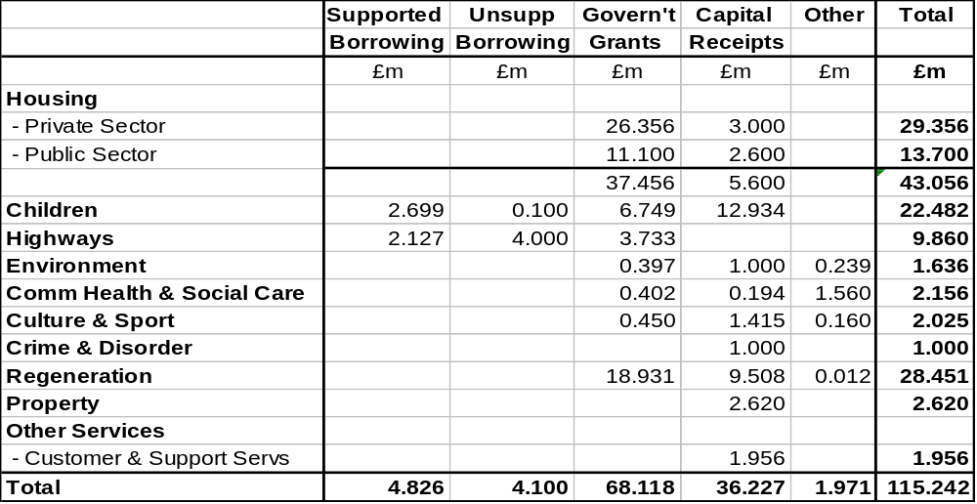

- It can be seen from the table above that the total proposed programme exceeds the estimated available resource by £1.937m. This is an acceptable over-programming tolerance that would be reviewed following the 2007/08 outturn and continually through monthly monitoring of capital receipts and expenditure during 2008/09 to ensure that expenditure is managed within the available resources.

- A capital programme of £115.242m would enable the following capital priorities to be delivered in 2008/09 :-

Housing

- To meet the requirements of the HMRF pathfinder

- To stimulate the regeneration of areas in Central Salford

- To support improvements to property occupied by disabled residents

- To maintain the condition of Council housing stock.

Education

- To remove surplus places in both secondary and primary schools, with support to the BSF and PFI 2 programmes, and replacement primary schools in Weaste/Seedley/Langworthy and Charlestown/North Grecian St

- To invest in improving the condition of primary schools

- To provide new playing fields at Dukesgate and for a new RC primary school in Little Hulton

- To provide suitable nursery provision

- To Improve children’s homes and foster carers’ properties

Highways

- To maintain the fabric of the City’s highways

- To improve road safety

- To improve the condition of footpaths and thus reduce tripping claims

Health and Social Care

- To modernise residential care facilities for older people and day care facilities for adults and older people, eg White Meadows supported by Booths Charities

- To invest in ICT

Culture and Sport

- To improve leisure facilities by undertaking the necessary design, feasibility and preparatory work for a replacement facility in Broughton, enhancement at Irlam, improvements at Ordsall and a phase 2 for Littleton Rd Sports Village

- To improve cultural facilities with preparatory work for the remodelling and refurbishment of Salford Museum and Art Gallery and Ordsall Hall

Crime and Disorder

- To replace the CCTV control centre

Regeneration

- To support the URC to secure investment in the regeneration of key areas of Central Salford

- Design work for the Higher Broughton Community Hub

- Acquisitions and relocations to facilitate development at Salford Shopping City

- To invest in certain outer areas of the City through the completion of LIFT facilities in Eccles and Walkden and the Salford West action plan

Environment

- To improve parks, allotments, cemeteries and linear walkways

- To improve waste recycling

Property

- To Improve the fabric of the Council’s offices, providing for office improvements, refurbishments and relocations and better disabled access.

Other

- Funding software development.

- A schedule of the schemes contained in the proposed capital programme is included at Appendix 15.

- It should be noted that, in addition to the above-mentioned programme, which focuses on expenditure on assets in the ownership of the Council, major investment is planned for the future through other proposed public private partnership arrangements which will benefit the residents of Salford, as follows :-

- The replacement of 2 high schools – Buile Hill and Harrop Fold – via a PFI
- The replacement and refurbishment of secondary schools via Building Schools for the Future wave 3 funding
- A new waste disposal PFI contract for Greater Manchester Waste Disposal Authority
- A new magistrates courts for Salford based in Eccles via a PFI contract to be let by the Courts Agency, which includes a similar facility in Bolton
- Meeting decent homes standards through new management arrangements for Council housing
- Development agreements with private sector developers in Ordsall, Lower Broughton, Higher Broughton and Kersal/Charlestown..

- It should be noted at this stage that the capital programme can be subject to change as the year unfolds, with new schemes being introduced as funding sources are confirmed, schemes being removed if the expected funding proves not to be available, expenditure forecasts changing and the amount of usable capital receipts varying as marketing and disposal proceeds.

- Approval to the proposed capital programme at this stage should be seen as giving consent to an initial programme of those schemes that are at present contractually uncommitted proceeding to design and tender stage. Approval to commit capital expenditure on individual projects will continue to be referred to the Lead Member for Customer and Support Services, as at present, to ensure that projects will only be committed if funding is available or certain to become available.

- The capital programme will therefore need to be continuously reviewed during 2008/09 to reflect any significant variations that may arise, any new priorities that may emerge and certainly following the 2007/08 capital outturn.

- UNDERLYING ASSUMPTIONS

- Use of Borrowing

  - The use of supported borrowing will be maximised at £4.826m and a further £15.1m will be borrowed using unsupported borrowing powers.

  - The capital financing charges on unsupported borrowing can be met from the revenue budget. Appropriate provision has been made in the revenue budgets for both the General Fund and the Housing Revenue Account to fund the unsupported borrowing to be used in funding of the capital programme.

    - Use of Capital Receipts

      - Usable capital receipts amounting to £30.620m are expected to be available from asset disposals.

        - The first call on these receipts will be to repay the use of £7.330m of unsupported borrowing required to fund the shortfall in the capital programme in 2007/08, leaving a net £23.290m to be available for use in 2008/09.

- RISKS

- The key risks are that :-

- Any over-commitment of resources is not managed within the resources available. The management of individual service allocations allows for the natural tendency of capital programmes to underspend. Services are permitted to set over-programming levels to reflect this in the expectation that the outturn expenditure will be managed within the resource made available. This approach runs the risk of expenditure over-shooting the resources available, but limits are applied to the over-programming that reflects the level of contractually committed expenditure and provision for new starts.

- Expected capital receipts will not be realised. Delayed receipts will be managed through unsupported borrowing or through the temporary use of earmarked receipts. Any substantial receipts from asset disposals which are critical to funding the capital programme and which cannot be realised, or realise less than expected, will be managed by adjusting the capital programme.

- Government grants not being realised. Capital projects which are dependant upon grant support will not be commissioned unless a grant approval has been received or is confidently expected. All proposed capital expenditure will be subject to the approval of the Lead Member for Customer and Support Services, who must be satisfied with the certainty of grant support.

- Cost overruns. Expenditure on capital schemes is monitored regularly and project managers are required to report any significant cost increase to their director and lead member. Where possible, cost overruns will be managed within resource allocations to services. Where an increase in resource is required this will be considered by the Lead Member for Customer and Support Services and, if necessary, Cabinet.

PART 4

PRUDENTIAL INDICATORS
2008/09 TO 2010/11
- BACKGROUND

- The Local Government Act 2003 changed the system of capital finance with effect from 1st April, 2004 and one of the requirements of the Act (Section 3) is for each local authority to determine its own affordable borrowing limits and to have regard to specified codes of practice when determining these limits.

- Regulations issued pursuant to the Act endorsed a code of practice produced by CIPFA (the Prudential Code for Capital Finance) which local authorities should follow in determining its borrowing limits. The code advises local authorities to determine its limits for 3 years ahead.

- This report therefore sets out the limits for 2008/09 to comply with the requirements of the Code and to establish the affordability of the Council’s capital investment and treasury management plans.

- PRUDENTIAL LIMITS 2008/09 TO 2010/11

Prudential Limits for Capital Expenditure and Borrowing

Capital Expenditure

- The actual capital expenditure that was incurred in 2006/07 and the estimates of capital expenditure to be incurred for the current and next three years that are recommended for approval are :-

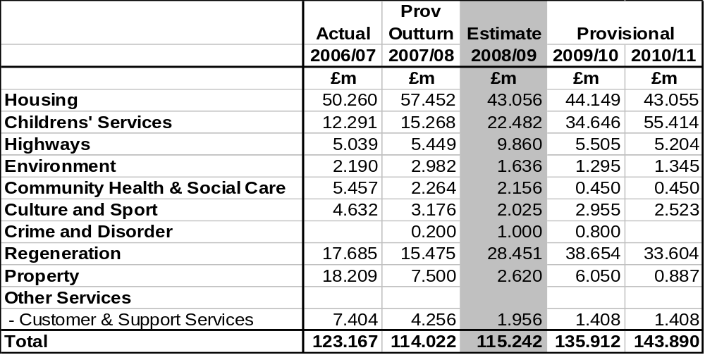

- The estimates of capital expenditure in 2008/09 and 2009/10 are provisional and are taken from the capital investment proposals contained in Part 3 of this report. They should only be considered as indicative at this stage as assumptions made may change in the light of future developments.

Ratio of Capital Financing Costs to Net Revenue Stream

- Ratios are required to be reported which identify the capital financing costs on the proposed capital expenditure shown in the previous table as a proportion of the net revenue stream for the same periods.

- The net revenue stream is defined as :-

- For General Fund - the total of income from NNDR, RSG and Council Tax
- For the HRA - total rent income (exclusive of service charges) and income from Government grants.

Ratio of Capital Financing Costs to Net Revenue Stream
 | Actual | Prov Outturn | Estimate | Provisional
 | 2006/07 | 2007/08 | 2008/09 | 2009/10 | 2010/11
 | % | % | % | % | %
General Fund | 10.14 | 10.50 | 9.74 | 10.24 | 9.91
HRA | 21.86 | 22.03 | 23.48 | 20.15 | 19.39

- It should be noted that the estimates of capital financing costs in 2009/10 and 2010/11 are provisional and are based on the cost of borrowing £20m each year to fund the capital investment strategy. They should only be considered as indicative at this stage.

Incremental Impact of Capital Investment Decisions

- An estimate of the incremental impact is required to be made in Band D Council Tax and average weekly housing rent terms of the capital financing and other revenue costs of the proposed capital programme.

- As approval is being sought from the Council to the 2008/09 capital programme only, and the future contractual commitments that flow from that programme, the incremental impact does not include any future new capital proposals and therefore does not reflect the full cost of the potential capital investment in 2009/10 and 2010/11.

Incremental Impact of Capital Investment Decisions
 | 2008/09 | 2009/10 | 2010/11
 | £ | £ | £
Band D Council Tax | 12.85 | 27.13 | 39.47
Average weekly housing rent (48 week equiv) | 0.11 | 0.16 | 0.15

Capital Financing Requirement

- The capital financing requirement measures the Council's underlying need to borrow for a capital purpose and is measured net on investments held.

- Advice from CIPFA in their prudential code is that net external borrowing should not, except in the short term, exceed the total of the capital financing requirement in the preceding year plus the estimates of any additional capital financing requirement for the current and next two financial years. The figures in the following table make no allowance for new borrowing beyond that required in each year.

Capital Financing Requirement
2007/08 |  | 2008/09 | 2009/10 | 2010/11
£m |  | £m | £m | £m
270.019 | General Fund | 275.580 | 277.821 | 278.951
241.748 | HRA | 102.897 | 102.897 | 102.897
511.767 | Total | 378.477 | 380.718 | 381.848

- The anticipated reduction in the capital financing requirement in 2008/09 reflects the debt to be redeemed by DCLG when housing stock is transferred to City West.

- The capital financing requirement represents a key benchmark and an early warning system of any potential breach of formal borrowing limits. As such, it is subject to continual detailed monitoring by the City Treasurer and his treasury management staff.

- The maximum net debt (borrowing less investments) held during 2007/08 has been £459.879m against a capital financing requirement of £511.767m.

Authorised Limit for External Debt

- This limit represents the total level of external debt the Council is likely to need in each year to meet all possible eventualities that may arise in its treasury management activities.

- These limits are required to show separately the Council's borrowing from its other long term liabilities, such as finance leases.

Authorised Limit for External Debt
 | 2008/09 | 2009/10 | 2010/11
 | £m | £m | £m
Borrowing | 647 | 518 | 549
Other Long Term Liabilities | 15 | 20 | 25
Total | 662 | 538 | 574

Operational Boundary for External Debt

- The operational boundary limits for external debt reflect the estimate of the most likely, prudent, but not worst case, scenario without the additional headroom included within the authorised limit.

Operational Boundary for External Debt
 | 2008/09 | 2009/10 | 2010/11
 | £m | £m | £m
Borrowing | 547 | 417 | 451
Other Long Term Liabilities | 15 | 20 | 25
Total | 562 | 437 | 476

- It should be noted that the maximum actual level of debt held during the current financial year has been £537.315m and it currently stands at £530.715m.

- Members should note that the Council at its meeting in February 2004 delegated authority to the (now) Strategic Director of Customer and Support Services to effect movement between the separately agreed limits for borrowing and other long term liabilities, in urgent circumstances to exceed these limits without Council approval, and to report any such changes to the Council at its next meeting following the change. (NB. Such a course of action, if deemed necessary, is permitted within CIPFA's code). In the light of the change of roles of the Strategic Director of Customer and Support Services and the creation of the City Treasurer as section 151 officer, this responsibility should now pass to the City Treasurer.

- It has not been necessary to invoke this delegation since the inception of prudential borrowing on 1st April 2004. Accordingly, there have been no breaches of these limits in 2007/08.

Prudential Indicators for Treasury Management

- The following limits (which remain unchanged from 2007/08 apart from amending the upper limit for investments beyond 364 days from £30m to £40m) will be included in the annual Treasury Management Strategy for 2008/09 to be reported to the scheduled Council meeting in March.

Prudential Indicators for Treasury Management
 | 2008/09 | 2009/10 | 2010/11

Limits on Interest Rate Exposure
Upper Limit on Fixed Interest Rate Exposure | 100% | 100% | 100%
Upper Limit on Variable Interest Rate Exposure | 50% | 50% | 50%
 |  | All Years
 |  | Upper Limit | Lower Limit
Maturity structure for fixed rate borrowing
Under 12 months |  | 50% | 0%
12 and within 24 months |  | 50% | 0%
24 months and within 5 years |  | 50% | 0%
5 years and within 10 years |  | 50% | 0%
10 years and above |  | 100% | 40%
Variable rate debt maturing in any one year |  | 30% | 0%
 | 2008/09 | 2009/10 | 2010/11

Limits on Interest Rate Exposure
Upper Limit on Fixed Interest Rate Exposure | 100% | 100% | 100%
Upper Limit on Variable Interest Rate Exposure | 50% | 50% | 50%
Upper Limit for Investments beyond 364 days | £40m | £40m | £40m

PART 5

FUTURE PROSPECTS
- REVENUE BUDGET PROSPECTS

3-Year Formula Grant Settlement

- The first 3-year RSG settlement was made in 2008/09 to cover the period to 2010/11. This has brought more stability and predictability into local government funding and facilitates better longer-term planning. and is therefore welcome in principle. However, the tightness of the 3-year grant settlement will mean that the next 3 years will provide some difficult challenges.

- The details of the 3-year grant settlement are set out in part 1 of this report at paragraph 5. Of particular relevance is the amount of grant for the years 2009/10 and 2010/11 as these are key influences upon the budget strategy, and are as follows :-
2009/10 2010/11
£m £m
127.964 130.231

Council Tax Revenue

- Locally, Salford will continue to benefit from the redevelopment work taking place in terms of providing additional Council Tax revenue from new dweliings and this buoyancy should, to some extent, help to alleviate the full impact of the tight grant settlement.

- Future revenue planning assumes that the Council Taxbase will grow by 1,500 dwellings (or just over 2%) per annum, and accordingly that Council Tax revenue with an annual 3% increase in the tax rate would produce total revenue in 2009/10 and 2010/11 as follows :-

2009/10 2010/11
£m £m
  - 96.578

Total Resources Available

- Bringing together the forecasts for future Formula Grant and Council Tax will give estimated total resources as follows :-

2009/10 2010/11
£m £m

Formula Grant 127.964 130.231
Council Tax 91.789 96.578
------------ ------------
Total Resources Available 219.753 226.809
======= =======

- These amounts are therefore the indicative budgets around which future spending plans need to be developed.

Future Spending Plans

- On the basis of a continuation of service budget, applying similar inflation factors as 2008/09, and rolling forward the full year effect of efficiency savings planned for 2008/09 gives the following base position for current spending plans :-

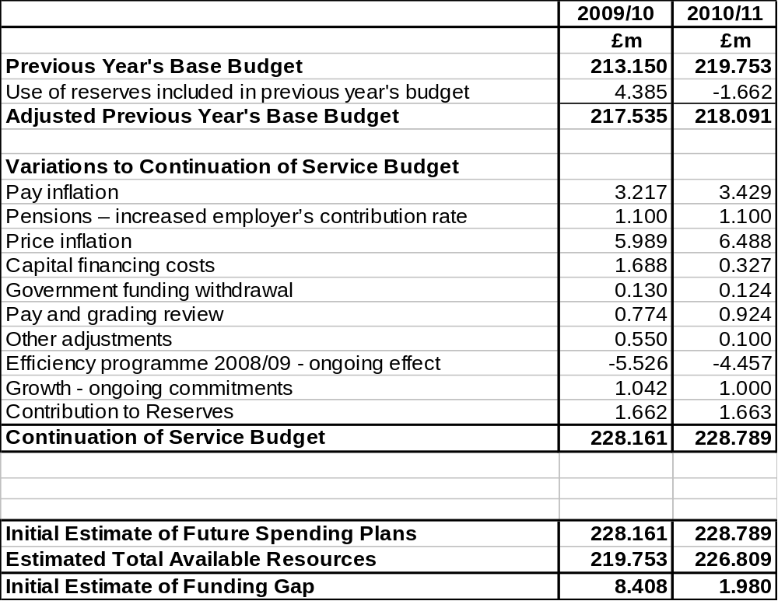

- It can be seen from the above that the initial estimate of the funding gaps for 2009/10 and 2010/11 based on a continuation of service budget is around £8.4m and £2m respectively.

- It should be emphasised that this is before any new efficiencies have been identified for those years and this will form part of the planned review work during 2008 and 2009.

- The medium-term financial forecast will need to be updated to take account of changes in circumstances as the year unfolds and strategy is developed. In particular, regard will need to be given to :-

- Inflation and other economic factors – changes to pay and price inflation forecasts and other external factors, eg interest rates

- Growth – the desire to invest in the improvement of priority services

- New efficiencies.

- Through the work of the Budget and Efficiency Cabinet Working Group, these matters will be addressed in rolling forward the medium-term financial strategy.

- CAPITAL INVESTMENT STRATEGY 2009/10 TO 2011/12

- The proposals in Part 3 would determine a capital programme for 2008/09 in keeping with rolling forward directorate capital strategies of recent years.

- However, it does not facilitate adopting a longer-term nor strategic perspective to capital investment requirements.

- It is proposed that through Budget and Efficiency Group a review of the capital investment strategy for future years is undertaken during 2008 that :-

  - Reviews and updates directorate and portfolio capital investment strategies in line with strategic priorities to develop a corporate capital investment strategy to 2011/12 ;

  - Identifies a basis for determining corporate priorities that can be funded, and the means of funding them ;

  - Identifies a basis for determining a prioritisation process for bringing into funding any proposals that cannot be immediately funded within the approach identified above ;

  - Reviews the assets owned by the Council to determine those assets that can be released for disposal in order to maximise the availability of usable capital receipts.

PART 6

SUMMARY OF RECOMMENDATIONS

RECOMMENDATIONS

Members are requested to :-

- Approve a revenue budget of £213.152m for 2008/09 ;

- Approve the Council Tax levy in accordance with the formal resolutions contained in Appendix 8 ;

  - Approve the HRA budget for 2008/09 as set out in Part 2 ;

  - Request each Lead Member and Strategic Director to monitor rigorously the implementation of the accepted savings and expenditure against budget on a regular basis, to identify and report to Budget Scrutiny Committee any alternative savings which may be necessary to compensate for any savings not achievable in full and to ensure that overall net expenditure is contained within budget, and for the Lead Member and Strategic Director of Customer and Support Services to report monthly to Budget Scrutiny Committee on progress with the budget on a corporate basis ;

  - Approve a capital programme of £115.242m as set out in Part 3 and detailed in Appendix 15.

  - Agree to the list of assets for disposal in 2008/09 as set out in Appendix 14 to allow the Strategic Director of Housing and Planning, in conjunction with Urban Vision Partnership Ltd, to proceed to market those sites where a commitment to dispose has not already been made.

  - Approve the prudential indicators for 2008/09 to 2010/11 as set out in Part 4.

JOHN SPINK COUNCILLOR BILL HINDS
City Treasurer Lead Member for
Customer and Support Services

APPENDICES
Appendix Details

Part 1 -REVENUE BUDGET 2008/09 (Pink)

  - Directorate Profiles – 2007/08 Achievements ; 2008/09 Plans

- 2007/08 Financial Performance

- Area-Based Grants 2008/09 – 2010/11

- Public Consultation Responses

- Risk Assessment to Establish Level of General Reserves for 2008/09

- Efficiency Savings 2008/09

- Summary of Directorate Outturn Revenue Budgets 2008/09

- Formal Resolutions - 2008/09 Council Tax

Part 2 - THE HRA REVENUE BUDGET 2008/09 (Green)
- HRA Profile – 2007/08 Achievements ; 2008/09 Plans

- Risk Assessment of HRA Reserves for 2008/09

- Details of Major Variances between 2007/08 Budget and Expected
Outturn and 2008/09 Proposed Budget

- Rent Restructuring Plan

- General background to the HRA and HRA subsidy 2008/09

Part 3 - CAPITAL PROGRAMME 2008/09 (Yellow)

- Schedule of Assets for Disposal 2008/09

- Capital Programme 2008/09 - Proposed Programme

