 | PART 1 (OPEN TO THE PUBLIC) | ITEM NO.

Report of the

Leader of the Council

To
COUNCIL
20th May 2009

Title: Salford’s Sustainable Community Strategy: Connecting People to Opportunities 2009 – 2024

Recommendations:

1. Council is invited to approve the Sustainable Community Strategy.

Executive summary:

The local strategic partnership and the council as the accountable body have a statutory duty to prepare a Sustainable Community Strategy, replacing the current Community Plan. The Strategy needs to articulate how the partnership will deliver sustainable development for communities in Salford and it is this distinct focus on sustainability that makes it different from the current Community Plan. The Strategy will need to reflect global and national challenges and set out how they will be tackled locally.

Work began to review the objectives within the current community plan in October 2007 and has continued during the preparation of Salford’s second Local Area Agreement, the Salford Agreement 2008-11.

A draft version of the Sustainable Community Strategy was published on the Partners in Salford website in January 2009, which included a description of our partnership vision, aims and objectives. All partnership board members, all councillors and a large number of other stakeholders received notification of the consultation on the draft, which closed on 20th February 2009.

Officers also attended all strategic partnership meetings in the period of the consultation (eg. Strategic Partnership Board, Strategic Housing Partnership, Health and Wellbeing Board) in order to highlight the opportunity to comment on the draft and to encourage debate on its content.

Since the end of the consultation period, the Strategy document has been updated and reviewed by the Leader of the Council, Cabinet and the Partnership Executive. Key changes to the document include the addition of case studies, a review of language used throughout the document and reference to key delivery programmes under each theme.

As a statutory document, the Sustainable Community Strategy must be signed off by Council and it is therefore recommended for Council’s approval, following which it will be printed and distributed across the partnership.

Background documents: None

Contact officer:
Kevin Brady Tel No: 0161 793 3406

Assessment of risk: The Sustainable Community Strategy is a statutory document which the local authority must approve. More importantly, it is an opportunity to set out our strategic framework for the city and to highlight the importance of narrowing the gap as part of that vision. It will provide an important context for the Comprehensive Area Assessment. Not completing the Strategy will potentially have a detrimental impact on outcomes for our most vulnerable residents.

Source of funding: Not applicable

Legal advice obtained: Not applicable

Financial advice obtained: Not applicable

Ward(s) to which report relates: The Sustainable Community Strategy applies to all wards

Key Council policies:
Current Community Plan: Making the Vision Real 2006-2016
Salford Agreement 2008-2011

Report detail:

- Sustainable Community Strategy
  - The local strategic partnership and the council as the accountable body have a statutory duty to prepare a Sustainable Community Strategy.

  - A draft of Salford’s Sustainable Community Strategy: Connecting People to Opportunities was published on the Partners in Salford website at the start of January 2009 and key stakeholders were notified of the consultation including all councillors and all members of the partnership board.

  - The draft set out the structure of the Strategy, the partnership’s vision, and provided detail of the partnership’s objectives, ordered under the existing seven themes.

  - The objectives within the Strategy are based on the Community Plan 2006-2016, the outcome of the Future Search event in summer 2008 and the broad negotiations which took place within the partnership whilst working towards the Salford Agreement 2008-2011.

2. CONSULTATION RESPONSES
  - The draft contained a number of gaps which stakeholders were asked to comment on. Valuable feedback was received from a number of sources.

  - In addition to receiving written feedback from key stakeholders, the draft of the Sustainable Community Strategy was reviewed at the following key partnership meetings:

    - Neighbourhood Management Implementation Group (19 January 2009)
    - Community Cohesion Strategic Leads (22 January 2009)
    - New Deal for Communities Board (26 January 2009)
    - Health and Wellbeing Board (26 January 2009)
    - Community Committee Chairs and Deputies and Communities of Identity Representatives (28 January 2009)
    - Salford Strategic Partnership Management Group (28 January 2009)
    - Crime and Disorder Reduction Partnership (By email following cancellation of 5 February 2009 meeting)
    - Salford Strategic Partnership Board (11 February 2009)
    - Strategic Housing Partnership (12 February 2009)
    - Older People’s Partnership (16 February 2009)
    - Children and Young People’s Partnership (17 February 2009)

3. FINAL Document
  - Following consultation and detailed conversations with key stakeholders, a final version of the strategy has been prepared.

  - Key changes since the consultation period include case studies highlighting progress already made, a greater emphasis sustainability and on the mechanisms for delivery against our objectives and references throughout to the Local Development Framework and how the Sustainable Community Strategy and the Core Strategy are aligned.

  - The final version of the Strategy is attached at appendix A. Although the Strategy is a partnership document, the local authority as the accountable body has the duty to approve the final version.

  - Following approval, the Strategy will be printed and distributed across the partnership and launched at the July meeting of the Salford Strategic Partnership Board meeting.

- CONCLUSIONS
  - The final version of the Sustainable Community Strategy is referred to full Council for approval.

Cllr John Merry
Leader of the Council
20 May 2009

Salford’s Sustainable Community Strategy 2009-2024:
Connecting People to Opportunities

Contents

Foreword 2

PART 1: Story of Salford 3
Looking to the future: our vision 4
Sustainable Salford 5
Story of place: the history of our partnership and plans 7
Case study: Salford Fire Service 8
Story of place: Salford the city 9
Case study: MediaCityUK 10
Opportunities and challenges in Salford 13
Salford and everywhere else 15

PART 2: Delivering our objectives 18
Delivery, accountability and performance management 19
Strategic alignment 19
How we will deliver 19
Accountability and performance management 21
Cross-cutting principles for delivery 22
Narrowing the gap 22
Community engagement and empowerment 23
Equality and diversity 24
Community cohesion 25
Our objectives 27
Our vision of a healthy city 28
Case study: Gateway centres 32
Our vision of a safe city 33
Case study: SNAP 36
Our vision of a learning and creative city 37
Case study: Building Schools for the Future 40
Our vision of a city where children and young people are valued 41
Case study: 21CC 44
Our vision of an inclusive city 45
Case study: Spotlight on Salford 49
Our vision of an economically prosperous city 50
Case study: Horticultural Academy 53
Our vision of a city that’s good to live in 54

Appendix A: Linked strategies and plans 57
Appendix B: Glossary 59

Foreword
On behalf of Partners IN Salford we are proud to present the city’s third Community Plan, our Sustainable Community Strategy: Connecting People to Opportunities.

Connecting people to opportunities is what we as a partnership believe we need to do in order to make a real difference to people’s lives in our city. Our vision and objectives as set out in this strategy are all about seizing Salford’s moment and working across the whole partnership system to make a difference to the city and the people who live here by connecting them to the wealth of opportunities that exist in Salford.

The Sustainable Community Strategy sets out our vision for Salford in 2024: a city which offers prosperity, good health, equality, accessible and affordable housing and a clean, green, safe environment; a city in which all residents are active and engaged. We want to ensure that people who live, work and invest in Salford feel that they belong to Salford, are proud of their city and of their local neighbourhoods.

This strategy sets out the objectives which we believe will help us achieve this vision. and establishes a framework within which all agencies and individuals in Salford will work. Our vision will be delivered through the Salford Agreement and through our organisational plans. All partners have signed up to delivering our aims through collective and individual action and are committed to partnership working to improve quality of life in Salford.

John Merry
Chair of Partners IN Salford and Leader of Salford City Council

Professor Eileen Fairhurst
Vice-Chair of Partners IN Salford and Chair of Salford Primary Care Trust

Logos from all partner agencies to be included here

Part one: Story of Salford

Looking to the future: our vision

Our vision for the future of the city:

In 2024, Salford will be a beautiful and welcoming city, driven by energetic and engaged communities of highly skilled, healthy and motivated citizens, who have built a diverse and prosperous culture and economy which encourages and recognises the contribution of everyone, for everyone.

The Sustainable Community Strategy sets out what we, as a partnership, believe we need to achieve in order to make Salford the city described in our vision.

Our seven partnership themes, listed below, describe the different elements within which we need to work as a partnership in order to achieve our 2024 vision:

To show the themes in diagrammatic form:
Healthy city
Safe city
Learning and creative city
City where children and young people are valued
Inclusive city
Economically prosperous city
City that’s good to live in

Under the banner of each of our themes, we will set out a vision for that area of work. We will explain where we are now, our current challenges and then more detailed objectives for each theme which we believe will contribute to creating a city in which we are all proud to live, proud to work and proud to welcome visitors.

Throughout this strategy, we will also make the connections between our objectives across the seven themes. In practice, this means that our service delivery must consider the needs of individuals and particular localities in order to improve their quality of life. We will make the connections between services and neighbourhoods for the most vulnerable people who may need a tailored or personalised approach.

At the start of part two of the strategy, we will describe how we will ensure that the partnership delivers against its vision and how we will performance manage and measure our success. However, we will know that we are succeeding when the lives of individuals and communities in Salford improve and when their needs are met in personalised and creative ways.

In part two we will describe more fully some cross-cutting principles for delivery which will impact on how we do things, across all areas of our work. These are:
- narrowing the gap
- equality and diversity
- community engagement and empowerment
- community cohesion.

Sustainable Salford
According to the Academy for Sustainable Communities (a government agency which encourages all local strategic partnerships to work towards sustainability) a sustainable community is one that is made up of the following eight elements:
- active, inclusive and safe
- well run
- well connected
- well served
- environmentally sensitive
- fair for everyone
- thriving
- well designed and built.

This section of the strategy explains what we as a partnership think a sustainable Salford will look and feel like in 2024 and how we will ensure that we get there.

What does this mean in Salford?
In order to ensure that our work to improve quality of life in Salford is sustainable for the long-term, we will consider the environmental, social and economic impacts of all of our decisions.

For example, when we plan new developments to improve opportunities for work and economic prosperity, we will ensure that their delivery is sensitive to the environment. When we develop new programmes of work to improve the health of individuals and communities, we will look for ‘added value’ and opportunities to complement existing programmes or to create new pathways which enable people to access employment.

We will consider the environmental, social and economic consequences of all of our services and decisions and through this Sustainable Community Strategy we recognise that all of our objectives are interlinked and can impact on one another.

A sustainable approach for Salford is one which makes the connections between our work to improve environmental, social and economic wellbeing. The delivery section of this strategy and the pages that detail our objectives show the links between our objectives, demonstrating our commitment to sustainability in all we do.

Salford’s Local Development Framework and Core Strategy
The Local Development Framework is the key set of planning documents for the city and is central to our aim to deliver sustainable communities.

The Core Strategy (the central document within the Local Development Framework) will set out the spatial plan for use of land across the city, how the city should develop, and how the city’s environment can be protected and enhanced. Its policies will assist us in delivering our vision by guiding the location and nature of development in the city over the next 20 years. The Core Strategy provides the spatial planning framework within which we will work as a partnership. We must ensure that the Core Strategy and other documents produced as part of the Local Development Framework can support and deliver our partnership vision.

There are references to how the Local Development Framework, the Core Strategy and our planning policies can support and deliver key elements of our partnership vision throughout this document.

Through the Local Development Framework and the Core Strategy, we will ensure that Salford is a sustainable city in 2024: that it is a place where people want to live, work and enjoy their leisure time and that it remains an attractive city for future generations. We will ensure that neighbourhoods within the city reflect mixed, balanced communities and that our development policies and regeneration programmes contribute to their sustainable development.

We will ensure that our services meet the diverse needs of a changing population, now and in the future, and that communities and individuals are safe, well-connected, well-served and active.

We will consider the environmental impact of our services and decisions to promote economic and social wellbeing, and vice versa.

Story of place: the history of our partnership and plans
Salford has a long history of partnership working. The Local Strategic Partnership was accredited by Government in 2003, building on a strong multi-agency partnership focussed on regeneration set up in 1994.

The partnership provides both a vision within which all stakeholders work and a strong framework for delivery of major improvements in the city.

The partnership has regularly reviewed its structures and processes on its journey to a more unified public service approach. We work to continuously improve both our performance and processes as well as the ‘softer’ aspects of partnership working: the strong relationships and trust necessary to move forward together.

Neighbourhoods
The partnership has consistently encouraged a neighbourhood approach to its work, recognising the differing levels of need and opportunities across the city as well as the distinct and rich histories and perspectives of the different neighbourhoods. We have established arrangements for neighbourhood level working that is well supported by communities and partner organisations; the Community Committees have been contributing to local improvements for over 10 years.

The partnership seeks continuous improvement to governance, engagement and delivery at this neighbourhood level. We recognise that delivering on many of our critical shared priorities requires more flexible and joined up services from the public sector and other organisations at this local level to reflect a better understanding of people’s needs and expectations.

Partnership working
A diverse range of partners are involved in the different parts of the partnership structure - at board, executive and operational levels - and partnership processes consistently seek to engage new and seldom heard perspectives. The partnership uses innovative processes to achieve good collective understanding of the challenges that need to be overcome.

The partnership has demonstrated a commitment to whole systems working and transformation. It sees both of these as critical to making the step change in outcomes needed to realise the partnership’s vision. (For a full definition of whole systems working, see the glossary on page 56).

The partnership undertook ‘Future Search’, an innovative whole systems planning event, in July 2008, focussed on Connecting People to Opportunities. The agreed objectives have been incorporated into this strategy. The partnership hopes to invite the Future Search participants, particularly the young people, to get back together in July 2024 to celebrate the achievement of these objectives and the partnership’s vision.

Case Study: Greater Manchester Fire and Rescue Service

When we, Partners in Salford, are operating at our best, we are collaborative, engaging, inclusive and challenging; we seek new ways of doing things and new ways of working together to achieve our collective aims.

Greater Manchester Fire and Rescue Service is one of our partners which embodies these behaviours. The fire service in Salford is empowered by the partnership to work outside of its own services. For example, working with young people and vulnerable adults, to not only meet their own objectives around fire safety but to contribute to a whole range of other outcomes such as raising attainment, raising aspirations and improving the appearance of public spaces.
One such example, FIRETEAM6 is a six week programme aimed at groups of young people aged between 14 and 16. Each FIRETEAM6 course is run in term time and young people attend for two days per week for six weeks. It is targeted at those young people who might need support at school, who are not attending school or who are at risk of involvement in crime or anti-social behaviour.
A code of conduct is agreed by the group at the start of every course. The young people involved will learn about the work of the Greater Manchester Fire and Rescue Service, health and safety, fire risk and car crime. However the course also aims to promote educational achievement and to spread the values of citizenship and social inclusion. The course helps to meet fire service targets to improve the environment (by reducing anti-social fires and promoting community safety) but also improves social wellbeing (by engaging with young people in a way that helps raise aspirations and enables them to become active members of their communities) and improves economic prosperity (by ensuring that Salford is an attractive city where people want to live, work and invest).
We aim to be inclusive… and we are!

Story of place: Salford the city
TO INCLUDE: PHOTOS (how we’ve changed, challenges)

Salford as it exists today was formed in 1974 when the former county borough of Salford was combined with Eccles, Swinton, Pendlebury, Worsley and Irlam. The area’s earlier history was as one of the country’s first major industrial towns and as a maritime centre following the opening of the Manchester Ship Canal in 1894.

Population
Today around 219,200 people live in Salford and our population is growing. By 2024 our population is likely to have increased by nearly 10% to 240,700 and our population make-up is also projected to change significantly.

For a city that had previously seen population decline, current and future projected population increases are a significant indication of the growth and opportunity within Salford.

In 2024, more than 38,000 people in the city will be aged 65 and over, an increase of more than 4,000 on today’s figure and a significant new pressure for public services.

Our population is also likely to be more diverse. In 2001, the census results showed that 3.87% of the population of Salford was non-white; by 2006 the Office of National Statistics estimated that the proportion of the population who are non-white had risen to 7.29%. The data from our school census suggests a continuing trend towards diversity: 86.8% of Salford pupils were white British in 2008 compared to 96.8% in 2001.

Place
Salford sits at the heart of the Greater Manchester city region, which in economic terms is the largest city region outside London and accounts for half of the North West’s total economic output.

Salford makes a significant contribution to the city region’s overall economic success. Its location at the hub of motorway and rail networks provides links to the other strong city regions in the north, particularly Leeds and Liverpool, and to Europe and beyond as part of the North West European Trade Axis and as a result of its position approximately ten miles from Manchester airport. Salford’s position as a hub for economic connections is also strengthened by our commercial assets such as the Manchester Ship Canal and City Airport Manchester, the airfield at Barton in the south of the city.

Whilst this strategic location puts Salford in an economically strong position, it also impacts on congestion, air quality, environmental sustainability and quality of life for residents of the city: a challenge which public services in the city must tackle.

Salford’s economic contribution is in part driven by its proximity to Manchester and the fact that it effectively shares part of Manchester city centre. Whilst the primary shopping area is in Manchester, the part of the city centre which stretches into Salford offers other employment and residential opportunities. In addition, the Salford/Manchester city centre forms part of a much larger regional centre which includes Salford Quays, Chapel Street, The Crescent and the internationally significant University of Salford. It is this regional centre which is identified as the priority for growth within the North West regional strategies and which will become an increasingly important source of employment opportunities.

Other areas of Salford have very different characteristics from those within the regional centre. The area immediately adjacent to the centre known as ‘Central Salford’ is characterised by high levels of deprivation. Whereas ‘Salford West’ is much more suburban and includes some of the most affluent parts of Greater Manchester, key tourism and heritage sites as well as designated green belt sites and large areas of open land such as Chat Moss, a key landscape and biodiversity resource.

Case study: MediaCityUK

Connecting people to opportunities
The former dockland on the edge of the Manchester Ship Canal, next door to the Lowry and opposite the Imperial War Museum, was once part of Salford’s industrial landscape; today it is the development site for MediaCityUK, the revolutionary new home for media and creative industries. From 2011, MediaCityUK will house five key BBC departments and will include space to host creative, digital and media enterprises, which will be built up around the broadcaster’s new home.

Such a development offers new and exciting opportunities for employment, entrepreneurship, community engagement and recreation. MediaCityUK will provide employment and enterprise opportunities for over 15,000 people and more than 1,000 businesses. MediaCityUK will bring £1.5bn to the regional economy and will create 700,000m² of new and refurbished floor space for business, retail and residential purposes.

Our partnership, led by Salford City Council and Central Salford Urban Regeneration Company, has a role in ensuring that those opportunities are open and accessible to all individuals and communities across Salford. As part of the development of a local supply chain for the development, local construction companies have been invited to register with an accredited scheme and so far, £80million of construction work has been awarded to Salford companies and 10% of the workforce on site is from Salford: both figures are expected to rise significantly as a result of the promotional activity undertaken by the partnership to attract local companies to the development.

We will also ensure that young people can engage with the developments at MediaCityUK, encouraging them to develop skills and experiences which are relevant and appropriate for future careers based around MediaCityUK; so far, 671 students have been involved in the project.

Regardless of which arena our work is in, ensuring that local people benefit from such exceptional investment in the city is our key driver.
We aim to be aspiring and forward looking… and we are!
Neighbourhoods
According to the national Index of Multiple Deprivation, Salford is the fifteenth most deprived local authority area in the country. This means that when all 354 local authorities are given an average ‘score’ which shows the level of deprivation in that area, Salford is in the worst 5%.

This reflects some of the significant challenges that public services face in order to improve quality of life for all Salford residents. Yet Salford is also a city of contrasts and whilst the effects of deprivation permeate some areas of the city and affect the lives of residents, the city also has areas of significant affluence and therefore different service needs across the city which we must meet as a partnership. In some areas, this has involved key regeneration programmes such as the New Deal for Communities programme in Charlestown and Lower Kersal; in others neighbourhood management takes a lead role in communicating with the wider partnership about community priorities.

A number of communities in the city are concentrated in particular localities, such as the 10,000 Orthodox Jewish community in East Salford, the Yemeni community in Eccles and long-established Irish Traveller community in Little Hulton.

Other Black and Minority Ethnic communities are spread across the city and can suffer the effects of isolation, such as the Kurdish community in Salford which is spread across Eccles, Broughton, Pendleton and Little Hulton.

Similarly other communities of identity (people with disabilities, people who are lesbian, gay, bisexual or transgender) may come together in order to engage with public services but are dispersed across the city as individuals. Public services need to be able to respond to these individual needs.

Salford’s student population is concentrated in East Salford, particularly Irwell Riverside and Kersal, wards which are characterised by a higher proportion of young people than other areas of the city. Given that students tend to live in the area for relatively short periods, the partnership faces specific challenges in these areas of the city to tackle the impact that a transient population can have on the environment, community cohesion and access to services.
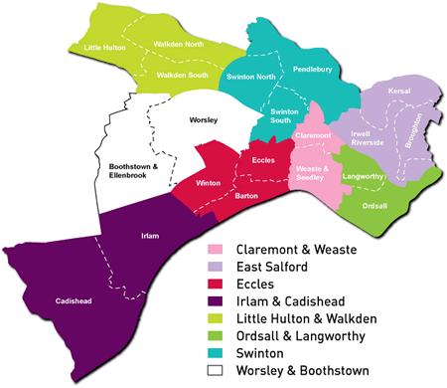
Eccles Gateway Centre
Pendleton Gateway Centre
Walkden Gateway Centre
To be added to map:
Co-located team (O&L) - Diamond House
Leisure Centres / Libraries

Each of the eight neighbourhoods in Salford are covered by a dedicated neighbourhood policing team: Salford Central neighbourhood policing team covers Ordsall and Langworthy and Claremont and Weaste; Salford East neighbourhood policing team covers the same area as East Salford; Salford North covers the Swinton area; Salford South covers Irlam and Cadishead and Eccles neighbourhoods; and Salford West covers Worsley and Boothstown and Little Hulton and Walkden neighbourhoods.
In those areas of the city where there is most need, we are developing Working Neighbourhoods Teams which will support local people through a variety of services in order to help them overcome barriers and gain access to skills and work opportunities.

The statistics over the page set out some of the service challenges and opportunities that we as a partnership face in the city. In order to meet the needs of the city’s population, the partnership is committed to making the most effective use possible of our local knowledge and evidence about the make-up and needs of our communities.

Opportunities and challenges in Salford

 |  | Opportunities | Challenges
Birth | ④ | Take-up of immunisations is generally higher than the national average. | The proportion of mothers who initiate breast-feeding is lower than the national average.  27.8% of children in Salford live in out-of-work poverty, higher than the North West and regional averages.
Child | ③ | The proportion of children achieving Level 4 at Key Stage 2 in English and Maths in Salford is the same as the national average.  14.3% of pupils in Year 8 are identified as gifted and talented – higher than the national average. | On average, each child in Salford aged five has 2.4 decayed, filled or extracted teeth, worse than the regional and national averages.  21.22% of primary school age children in Year 6 are obese, higher than the national average.
Young Person | ② | 66.9% of pupils achieved five GCSEs graded C or above in 2008, above the national average.  There are emerging graduate and entrepreneurial opportunities in the city, eg. MediaCityUK.  Children and young people are empowered to influence decisions in Salford, through the youth council and neighbourhood youth forums.  Approximately 70% of school leavers in Salford go on to further education. | The proportion of pupils who achieve five GCSEs graded C or above including English and Maths is lower than the national average.  8.1% of young people are not in education, employment or training.  Salford has a higher rate of teenage conceptions than the regional and national averages.  Only a quarter of Salford’s working age population are qualified to degree level or above.
Adult | ① | The number of criminal offences in Salford has reduced in recent years, for example, the number of burglaries has reduced from 7,748 in 2002/03 to 3,504 in 2007/08.  Salford’s employment rate has improved significantly to close the gap on the national rate over recent years and Salford now has the fourth highest employment rate in Greater Manchester at 73.6%.  £900million will be pulled into the city over the next thirty years to ensure that all social housing can under-go improvements to meet the decent homes standard.  Our enhanced housing advice service is currently expanding its work to focus on preventing homelessness. | Crime rates remain higher than the regional and national averages.  The rate of people admitted to hospital because of an alcohol-related condition is more than double the national average.  Smoking is the biggest reason for ill health in the city and costs the local economy £53,685,000.  Over 16% of Salford residents do not have any qualifications, higher than the national average.  Salford has the highest proportion of Incapacity Benefit claimants in Greater Manchester.
Older Person | ⓪ | A higher proportion of adults, older people and carers receive social care through a direct payment (and/or an individual budget) in Salford than elsewhere in Greater Manchester. | Life expectancy is currently lower than the regional and national averages.  More people aged 60 or over are admitted to hospital in Salford than elsewhere in Greater Manchester.
All age groups |  |  | Salford has a challenge across all age groups and communities to reduce inequalities, particularly around health, education, access to services and access to employment.

Salford and everywhere else

The partnership’s vision concerns itself with improving the lives of people in Salford. However we cannot always operate at a city level. Just as sometimes we need to ensure that our services meet very local and individual needs, in other cases we need to work with our neighbouring authorities, other cities and with national partners to ensure that we get the best results for Salford residents.

Salford operates as part of the city region of Greater Manchester, within the North West region and within a context and policy framework influenced by national government across England and the United Kingdom.

Greater Manchester
Within Greater Manchester, the Multi Area Agreement sets out how partners will meet ambitious targets across eight building blocks, which are focused on improving economic performance across the city region. The building blocks, listed below, deal with those issues which can be more effectively tackled at that broader spatial level and where added value can be gained from local authorities working together:
- Developing the Greater Manchester Strategy, combining spatial, economic and housing priorities for the city region.
- Reducing worklessness.
- Strengthening our skills offer.
- Achieving more for 14-19 year olds.
- Accelerating business expansion to generate growth.
- Enhancing investment, knowledge and innovation.
- Ensuring the city region’s critical infrastructure will sustain our economic growth.
- Meeting the housing needs of a competitive Manchester city region.

Salford’s vision and aims within the Sustainable Community Strategy relate to all eight of the city-regional building blocks.

North West
The North West Regional Strategy from 2010 will set out a long-term vision of sustainable economic growth and development. It will integrate our spatial and economic ambitions into one coherent vision which provides a framework to ensure that all decisions and investment, locally, regionally and by central government support our vision as a region.

The regional strategy will build on the well-established principles within existing regional strategies, for example aims to improve productivity, improve the strength and capabilities of the region’s workforce, creating the right conditions for investment and sustainable growth, improving accessibility and managing travel demand, adapting to climate change and making the best use of existing resources and infrastructure.

Salford’s role as part of the regional centre is as an economic driver for the region, providing a focus for investment and enterprise opportunities. However, the region’s framework also aligns with other local priorities in Salford in terms of transforming local economies and ensuring a good mix of high quality, affordable housing which can help attract newcomers and families to the city.

The Northern Way
The Northern Way is a collection of stakeholders and partners committed to tackling the traditional ‘north – south divide’ and opening up opportunity and enterprise in the North of England. The Northern Way Growth Strategy sets out ambitions for the north, as follows, which are closely aligned to Salford’s ambition to connect local people to greater opportunities:
- bringing more people into work
- driving up innovation
- building entrepreneurship
- capturing more global trade
- meeting employers' skills needs
- improving connectivity
- building quality homes and places
- marketing the north to the world.

The national picture
As well as aligning our Salford aims and objectives to our regional and sub-regional frameworks, we must also contribute to the delivery of nationally set performance and outcome frameworks.

For example, we have a statutory duty to ensure that every child matters in Salford, delivering the five outcomes below:
- be healthy
- stay safe
- enjoy and achieve
- make a positive contribution
- achieve economic well-being.

We must also deliver against the seven national outcomes for adult social care, as set out by the Department of Health:
- improved health and emotional wellbeing
- improved quality of life
- making a positive contribution
- exercise of choice and control
- freedom from discrimination or harassment
- economic wellbeing
- personal dignity and respect.

We will deliver our statutory responsibilities in Salford by ensuring that quality of life improves for all: every individual matters.

Part two: Delivering our objectives

Delivery, accountability and performance management

Strategic alignment
Salford’s Sustainable Community Strategy: Connecting People to Opportunities, is the overarching vision for every organisation, providing a strategic framework within which the partnership will work to achieve better outcomes for everyone.

As described earlier, the Core Strategy is the key planning document within our Local Development Framework. The Core Strategy and the Sustainable Community Strategy must be aligned and the partnership’s vision and objectives will be supported by a number of policy areas within the Core Strategy. The Core Strategy must be accompanied by an Infrastructure Plan, which will provide more detail about the infrastructure needed to support new development and how, when and by whom this will be delivered.

Throughout the Sustainable Community Strategy under every theme heading, the links to opportunities where the Local Development Framework (including the Core Strategy) could help to contribute to our aims are detailed, making clear how the environmental, social, economic and spatial elements of our vision are connected and interlinked.

All of the other strategies that we produce as a partnership will contribute to delivery of our vision and our objectives, which are set out under the heading of each theme on the following pages. Some of the headline strategies and programmes which will support delivery of our objectives are also referenced within these pages.

Our mainstream organisational and departmental business planning, as well as community action plans, must all contribute to achievement of the Sustainable Community Strategy’s vision and objectives. The diagram below sets out how those connections will be made.

How we will deliver
Salford’s Sustainable Community Strategy sets out the vision for our city in 2024. Our vision will be translated into action through the three-year improvement priorities we address in the Salford Agreement and through our organisational plans. The Sustainable Community Strategy gives us direction, but our annual cycle of planning, delivery and performance management will ensure that our objectives are achieved and that improvements are made to people’s quality of life.

Delivery tools
Delivery tools

Sustainable Community Strategy:
Connecting People to Opportunities
Local Development Framework:
Core Strategy

Salford Agreement 2008-2011

Multi Area Agreement / Greater Manchester Strategy

Organisational and partnership strategies
Organisational and departmental business plans
Neighbourhood and community action plans
Over recent years the Salford Strategic Partnership has made excellent progress in adopting a whole systems approach to planning and delivery. For example, Salford’s Spotlight tool has enabled us to gather a detailed understanding of issues such as worklessness and alcohol misuse at a small area level, identifying the specific problems which must be overcome in particular neighbourhoods and then shaping the delivery of public services to achieve this.

The partnership is committed to jointly commissioning services which are directed at those areas and individuals in greatest need, ensuring value for money in all public expenditure. We have developed a joint commissioning model which will be used throughout the city to ensure services on the ground are efficient, effective and targeted at need. This intention to be an intelligence-led delivery partnership is reflected in the way we organise ourselves and carry out our business.

It is vital that we continue to develop our knowledge base about the city - its people, its economy and its environment. In particular we will, through our research and intelligence capacity, improve our understanding of the issues within particular neighbourhoods and for particular people groups. This enhanced understanding will enable targeted services which meet actual and not perceived needs, especially for the most vulnerable individuals within the city.

Accountability and performance management
The Salford Agreement identifies our priorities for improvement, supported by performance indicators with three-year targets. These targets are formally agreed with central government and are the focus of partnership performance management. The duty to co-operate, introduced through the Local Government and Public Involvement in Health Act, puts a requirement on the council and other local service providers within the city to work together to ensure that our challenging improvement targets are achieved.

Different partners have committed to delivering improvements set out in the Salford Agreement. We will continue to hold one another to account through our partnership performance management framework, working together to overcome barriers to improvement.

Salford’s Sustainable Community Strategy sets out a 15-year vision. In order to check our progress towards realising this vision we will review the strategy, its themes and objectives, every three years. This will be complemented by six-monthly reviews of the Salford Agreement to ensure we are addressing our immediate priorities.

Cross-cutting principles for delivery

We will only achieve our vision for Salford in 2024 if we connect people to opportunities in the city.

Connecting people to opportunities is about ensuring that local people and places benefit from investment, innovation and enterprise in the city. Whilst that will require different solutions and approaches depending on the issue or service, there are some common requirements which are about empowering all people, understanding needs and ensuring equality of opportunity.

The following cross-cutting principles represent those areas which must run right through everything we do as a partnership in order for us to achieve our objectives. They are included in our Sustainable Community Strategy to reflect all partners’ commitment to applying the principles across the delivery of all services:
- narrowing the gap
- equality and diversity
- community cohesion
- engagement and empowerment.

As our descriptions of the four principles below illustrate, there are clear but complex connections between equality, cohesion, community engagement and empowerment and narrowing the gap. They all reflect the value that we as a partnership place on the right of every individual to a good quality of life and the right to improve and demand services for themselves, engaging with public services to ensure that their needs are met.

The four cross-cutting principles are reflected in our Inclusive City theme but given their importance across all areas of our work, our approach to each one is also described here. The section below explains what each of the principles means in Salford, why they are strategically important, and how they will be applied to our Sustainable Community Strategy objectives.

Narrowing the gap
By narrowing the gap, our ambition is to make outcomes (such as health, wellbeing, quality of life, access to services, housing and employment) less dependent on wealth.

We are not only committed to narrowing the gap between levels of deprivation in Salford and the rest of the country, but also to narrowing the deprivation gap within Salford.

Our commitment as a partnership is to always ensure that:
- People can access services when and where they need them.
- The services we provide in the city meet the needs of individuals and communities. This means that we will know and understand our communities.
- Services tackle exclusion and support vulnerable people.
- Resources are targeted to the areas of most need.
- All services understand the ‘gap’ in their area.

Whilst Salford is identified by central government (through the Index of Multiple Deprivation) as one of the most deprived areas in the country, we also see a real diversity of outcomes across different localities in the city. There are areas of real affluence in Salford in comparison to areas where life chances are severely affected by poverty and low aspirations.
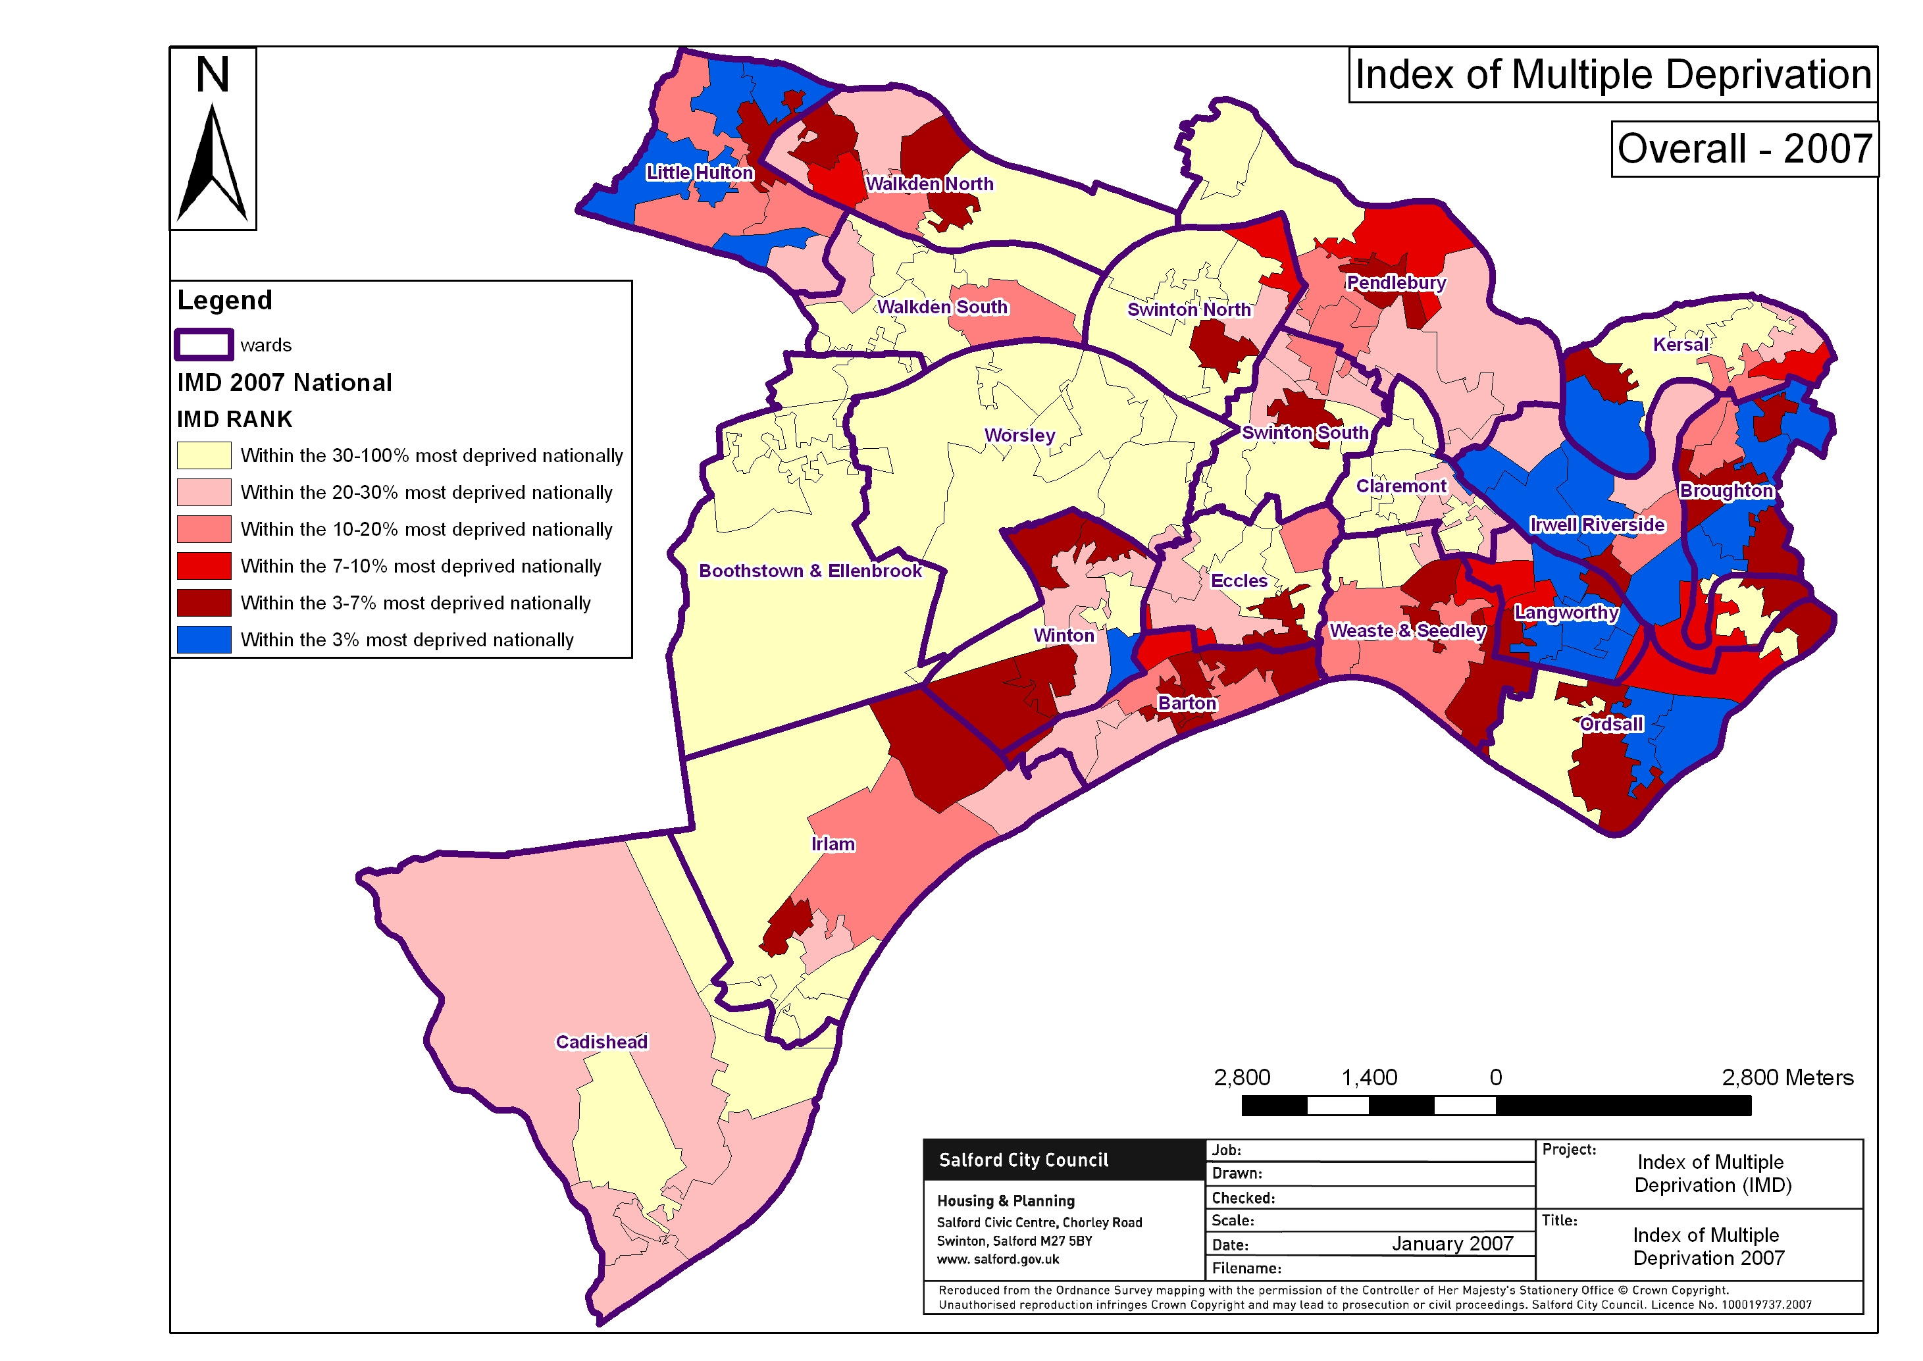

For example, in 2008, serious acquisitive crime (a term which describes crimes involving theft, including burglary, robbery and theft of vehicles) in the ward with the highest rate was seven times higher than the ward with the lowest rate. And in the highest achieving ward the proportion of young people gaining five or more GCSEs graded C and above was more than double the proportion in the lowest ward.

Our approach to narrowing the gap will apply across all services and all outcomes, from health issues to improving the local environment and access to parks.

Tthe partnership will focus on prevention, with integrated services with a ‘no wrong door’ for all residents at its heart. This means that when an individual (or indeed a community) makes contact with services in the city, we will make the links between different areas of work to provide a seamless and efficient response.

We will work to ensure that we build bridges between individuals and between groups and communities, for example promoting intergenerational work which can connect people to opportunities and raise aspirations.

Partners IN Salford want to narrow the gap between those who are affected by deprivation and those who are not. This means that we will improve outcomes for people in deprived areas of the city at a faster rate than for those in more affluent places and we will reduce the rate at which the deprivation gap widens.

We will understand the causes of deprivation and work to prevent them, raising the aspirations of individuals and communities.

We will make services more efficient and effective, ensuring that they meet the needs of the most vulnerable amongst our communities.

Community engagement and empowerment
Community engagement and empowerment are included within our partnership framework as key principles for the whole system because of their potential to improve quality of life, reduce inequalities and improve services for all individuals and communities.

Community engagement is both the process and the result of working together to ensure the whole population influences the decision-making processes that affect their lives.

Community empowerment is the result of activity that enables communities, people and citizens to have the power to influence, access and choose the changes that affect their lives. The process requires the provision of resources, support and leadership.

Community engagement is essential for all partner organisations and the community in order to contribute to:
- Empowering local citizens to have control over their lives.
- Reducing inequalities and closing the gap between the most and least deprived areas of the city.
- Ensuring that services genuinely meet the needs of service users and that resources are used efficiently and directed towards our partnership objectives.
- Fulfilling our commitment to local democracy.
- Meeting our statutory duties, for example around community cohesion.

Our approach to engagement and empowerment in Salford will be to ensure that it is reflected and resourced in every area of our work. We will ensure that our structures for engagement are clear and accessible and remove barriers to engagement for the most vulnerable. We will also ensure that our structures provide appropriate vehicles for children and young people, building on our work on the youth council and neighbourhood youth forums.

We will devolve service and resource decisions to effective and representative neighbourhood groups where it is appropriate to do so and in the best interests of service users and council tax payers. We will use participatory budgeting to ensure that those resource decisions are in the best interests of our local communities.

Equality and diversity
The partnership is working towards a cohesive approach to equality and diversity.

We value equality and diversity in Salford and more importantly we are committed to ensuring that we continue in our work to create a fair Salford, a place where we tackle inequalities and celebrate our diversity.

We aim to achieve a Salford where all our citizens feel they are receiving an appropriate service and are actively encouraged and feel able to participate at all levels of our organisations and our partnership.

We will continue to develop relationships with our established communities and develop responsive services to welcome our new and emerging communities. We want to create a Salford free of fear and hate crime, where the contributions of all members of our communities are welcomed, recognised and celebrated.

We will continue to challenge ourselves to raise ambitions, to increase opportunities and involvement of those from our most deprived areas and communities.

The partnership is working towards a shared definition of what equality is in Salford, based on the Equalities Review and the Equality Framework for Local Government. According to the framework:

“An equal society protects and promotes equal, real freedom and opportunity to live in the way people value and would choose, so that everyone can flourish. An equal society recognises people’s different needs, situations and goals and removes the barriers that limit what people can do and be.”

Our approach to equality and diversity across the city will be to:
- Develop proactive, creative and innovative services and ways of working that reach out to all our diverse communities.
- Develop processes that allow us to share data, intelligence, knowledge and research.
- Continue to develop our hate crime awareness and reduction work.
- Celebrate differences and commonalities.
- Pool resources to work with our communities of identity.
- Develop cross-partnership consultation events.
- Use information, knowledge and intelligence to develop localised priorities.
- Conduct cross-partnership service needs and equality impact assessments, ensuring the removal or reduction of any identified barriers.
- Develop joint partnership projects.
- Develop outcome focussed methods of working.
- Develop an equality and diversity strategy which goes beyond simply meeting our statutory duties.
- Continue to work with partners regionally and nationally to develop further good practice.

Community cohesion
Community cohesion is what must happen in all communities to enable different groups of people to get on well together. A key contributor to community cohesion is integration which is what must happen to enable new and existing residents to adjust to one another.

An integrated and cohesive community is based on three foundations:
- people from different backgrounds having similar life opportunities
- people knowing their rights and responsibilities
- people trusting one another and trusting local institutions to act fairly.

As well as three ways of living together:
- a shared future vision and sense of belonging
- a focus on what new and existing communities have in common, alongside a recognition of the value of diversity
- strong and positive relationships between people from different backgrounds.

In simple terms when we talk about community cohesion in Salford, we mean feeling comfortable and positive about living and working alongside your neighbours.

Promoting community cohesion is a central part of fulfilling our vision and making Salford a welcoming city that celebrates and values diversity. However, changes in communities create new challenges for the partnership which must now (as part of our commitment to all four cross-cutting principles) find new and flexible ways to ensure that we understand our communities, can meet their diverse needs and promote tolerance and trust amongst individuals and groups.

Our approach to promoting community cohesion has strong links to our work to narrow the inequalities gap, promote engagement and empowerment and to value equality and diversity.

Our Community Cohesion Strategy sets out how we are going to achieve cohesive communities in Salford around nine headlines:

- establishing leadership and engagement
- developing shared values and a shared sense of place
- improving information and communication
- community safety and tension monitoring
- involving and supporting young people
- intergenerational work
- interfaith work
- valuing and developing the role of local third sector organisations
- tackling inequalities and deprivation.

The Community Cohesion Strategy has been developed by the partnership based on a ‘whole community approach’ which supports the existing cohesion work in neighbourhoods.

Our objectives

Our vision of Salford in 2024 is based on achievement of objectives under seven themes:

- A healthy city
- A safe city
- A learning and creative city
- A city where children and young people are valued
- An inclusive city
- An economically prosperous city
- A city that’s good to live in

The following section is split into those seven themes and our key objectives are shown underneath.

Where objectives can be linked across themes, demonstrating our sustainable approach, the symbols above show those connections.

Our vision of a healthy city
We aim to improve health across the city and remove health inequalities. We will create a joined-up system that responds to local needs and gains public confidence. We believe that prevention is better than cure and that by empowering people we can improve quality of life, improve the long-term health of communities in the city and promote individual responsibility and behavioural change. We will take a broad view of health which considers the impact of the environment, physical activity and how to connect people to other health opportunities.

Why it’s important
Health has a significant impact on quality of life, including our ability to take up employment and education opportunities and as such has an impact on the capacity of the city to regenerate. Our vision for Salford is of a city with good health, the right support and treatment for those who need it, and a city in which our economic and social conditions no longer impact on our life expectancy and our long-term health. A broad view of the city’s health is vital to ensure that we tackle the social determinants of poor health, whether that’s housing, attainment, aspirations or access to opportunities to improve health.

Where we are now
Salford currently suffers from severe health inequalities; the Index of Multiple Deprivation 2007 states that overall 46% of Salford’s population live in areas which are classed amongst the fifth most deprived in the country. However, when deprivation is considered just in terms of health outcomes, 65% of Salford’s population live in areas classed as the fifth most deprived, demonstrating the broad range of health issues and challenges that the city must respond to and particularly the concentration of those challenges in small areas and particular wards.
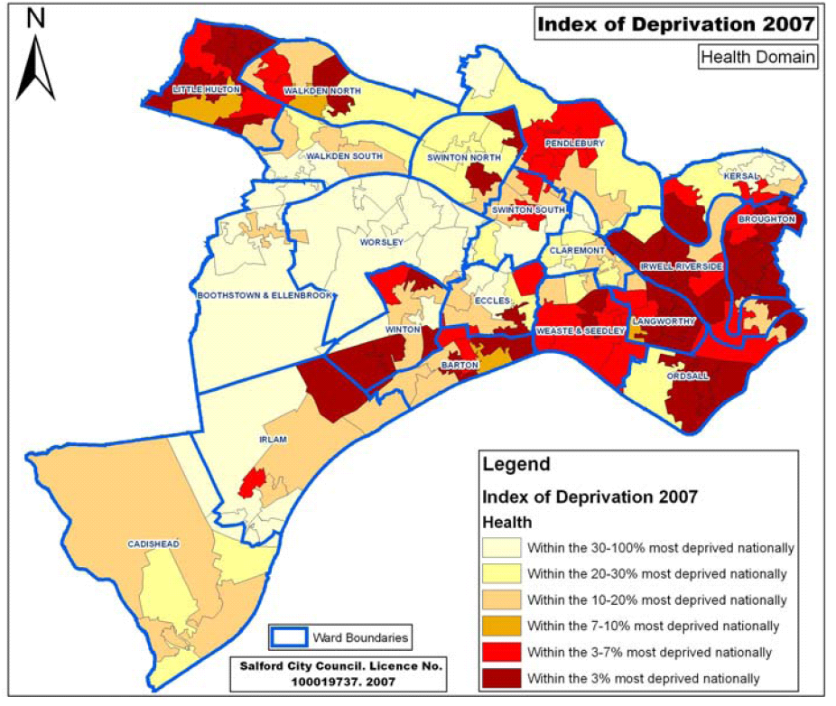

Statistics showing city-wide averages illustrate that Salford has a number of health challenges. The Joint Strategic Needs Assessment 2008-2013 and the Health Profile for Salford 2008 show that key indicators such as those listed below are demonstrating health outcomes that are significantly worse than the national and regional averages:

- The rate of under-18 conceptions at 60.8 per 1,000 is worse than the national average of 41.2.
- 26.4% of adults binge drink (compared to the national average of 18.0%); whilst only 29.17% of women and 34.67% of men keep within
the recommended weekly limits for alcohol consumption.
- 55.8 per 1,000 adults are in receipt of incapacity benefit for mental illness, compared to the national average of 27.5 per 1,000.
- Life expectancy at birth for both men and women is worse than the national average by roughly three years.
- 332.5 per 100,000 deaths (amongst the population aged 35 and over) are caused by smoking, which is higher than the national rate of 225.4 per 100,000.
- 22.45% of adults and 14.50% of children in Salford are obese, compared to 23.70% of adults and 10% of children nationally.

Our challenge as a partnership is to tackle these big issues whilst also recognising that demand and need are changing: an ageing population, new patterns of migration and a growing population all demand a fresh look at how we prioritise, plan and deliver services that meet local needs. We have already begun to work in new ways and our joined-up approach to service delivery, as demonstrated in the case studies throughout this document, must continue.

Our approach to creating a healthy city will be centred on prevention rather than cure. We will promote behavioural change and empower individuals, families and communities to take responsibility for their health and wellbeing and to access information and support when they need it. We will work with the support frameworks that are already there for individuals and families to improve quality of life.

The partnership will work to deliver against national frameworks for improving health outcomes where they exist, for example the seven adult social care outcomes and the National Health Service Quality Outcomes Framework. However, we will also ensure that the priorities for the city and for communities are reflected in the delivery of health and social care services across the city.

As part of our commitment to removing health inequalities from our city, we will take a neighbourhood approach and ensure that health and social care organisations can reach out to people in the community, promoting skills and employment opportunities as well as tackling health issues. This will mean working in partnership with all agencies in the city who have contact with communities and individuals to make sure that we are able to reach the most vulnerable within the city, enabling access to our services in the most appropriate way for each person.

We will work to understand the scale of health issues and inequalities across the city and we will effectively communicate our priorities and our progress to residents.

Local Development Framework
Our spatial planning policies will contribute to improving mental health and emotional wellbeing by ensuring access for all to green spaces and play facilities – both large-scale attractions within the city and local recreation facilities. We will improve health outcomes by striving to ensure that appropriate housing is available across the city to respond to different needs (for example, wheelchair housing, adaptable homes and lifetime homes). We will also encourage all individuals to commit to healthy lifestyles through planning policies which promote walking and cycling as a way of managing travel demand in the city.
Our objectives to deliver a healthy city
Promote positive attitudes to sexual health and wellbeing

Increase life expectancy
Improve quality of life, mental health and wellbeing

We will promoting positive attitudes to sexual health and wellbeing. We will:
reduce teenage pregnancy
support those young people who do become pregnant
reduce the prevalence of sexually transmitted diseases in the community
raise the aspirations of young people, particularly through engagement with further and higher education  LEARNING
expand access to sexual health services, especially for young people
ensure young people have access to information about sexual health and sex and relationship education.

We will improve quality of life, mental health and wellbeing by:
tackling dementia
providing good quality open and green spaces which promote healthy lifestyles  LIVE
improving access to services and housing for older people and people with disabilities  LIVE
promoting independence and self-care
supporting people with dementia and their families
improving quality of life for older people
safeguarding vulnerable adults
reducing deaths from suicide
promoting emotional and mental health and reducing levels of mild and moderate depression, stress and anxiety.

We will increase life expectancy by:
reducing risk factors for heart disease, stroke, cancer and diabetes
reducing obesity
reducing smoking
increasing levels of physical activity
increasing healthy eating
promoting safer alcohol use and reducing alcohol misuse  SAFE
reducing drug abuse, and creating a rehabilitation focus for drug use treatment  SAFE
improving children’s health and giving all children a good start in life through engagement with families and schools.  CYP

Our mechanisms and plans that will help to deliver these objectives:
Salford Agreement - Salford PCT Strategic Plan - Teenage Pregnancy Strategy and reviews - Local Development Framework - Supporting People Programme - business plans - Healthy Weight Strategy – Alcohol Strategy – Older People’s Strategy – Carers’ Strategy – Tobacco Control Strategy – Health Inequalities Strategy – Oral Health Strategy – Sexual Health Strategy – Heart Strategy – COPD Strategy

Case Study: Gateway centres

Evolving services in neighbourhoods
New state-of-the-art buildings known as Gateway centres are now open in three locations: Eccles, Pendleton and Walkden. They bring together a broad range of services right in the heart of their communities, improving the local environment as well as social and economic outcomes for local people.

Services available at the Gateway centres include GP surgeries, dental surgeries, pharmacies, libraries, housing and council tax benefit drop-in services, free PC and internet access, registrar services, teaching and learning facilities, community paediatricians and midwives, as well as information about a wide range of other council and health and social care services. The centres are a hub for advice from Work Solutions, Skills and Work, Age Concern and New Deal for Disabled teams and also host advice surgeries for neighbourhood policing teams and anti-social behaviour teams.

All of the centres are designed to be welcoming, accessible facilities for everyone, from longer opening hours and rooms for community groups to use free of charge, to the atrium artwork designed in partnership with the local community.

The centres demonstrate our commitment to working in new and innovative ways as a partnership, putting residents at the heart of service design and delivery. Since opening, high numbers of residents have been making use of the centres and in March 2009, 11,442 people visited Eccles Gateway, 14,210 visited Pendleton and 14,978 used the services at Walkden. Even usage of the library service has increased since the Gateway centres opened – 737 people joined the new libraries in February 2009 and another 931 joined in March, meaning that even more people are benefitting from accessible services.

We aim to be innovative… and we are!

Our vision of a safe city
We aim to create safe neighbourhoods across the city. We will reduce crime, fear of crime and anti-social behaviour. We will work across the partnership to ensure that our most vulnerable groups and individuals feel safe in their neighbourhoods. We will create a neighbourhood approach to intervention, prevention and detection which ensures that we respond to local need. We will engage with and empower communities to tackle difficult issues around behavioural change and individual and community responsibility for issues of safety and anti-social behaviour.

Why it’s important
Reducing crime, anti-social behaviour and fear of crime has the potential to significantly improve quality of life for individuals and communities. Feeling safe enables us to take advantage of other social and economic opportunities and to play a role in our communities, empowered and engaged to take control of our own environment and neighbourhoods. Our feelings of safety also significantly impact on our physical and mental health, linked to our ability to walk and cycle around the city and our feelings of isolation.

Where we are now
Since our first Community Plan in 2001 we have made real progress in Salford to reduce crime. However, it continues to affect the quality of life of people who live in Salford, more than other places in the region and nationally. For example, the total number of recorded offences reduced from 165.2 in 2002/03 to 132.2 in 2007/08 in Salford, but that’s still in the worst 20% in the country and higher than the Greater Manchester average.
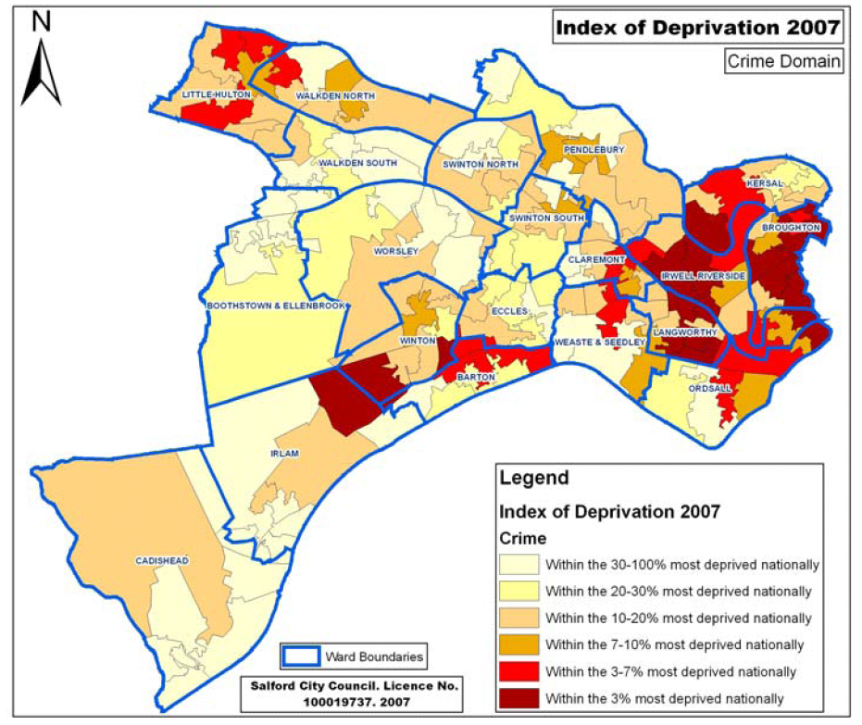

The difference between areas of the city in terms of crime rates is also stark. For example between April and September 2008, the rate of serious acquisitive crime (a term which describes crimes involving theft, including burglary, robbery and theft of vehicles) in Boothstown and Ellenbrook was 61 per 1,000 population; in the same period in Irwell Riverside, the rate was 431 per 1,000 population, demonstrating a significant and very real difference in outcomes for communities in the city.

Our approach to creating a safe city will be centred on partnership activity which addresses the causes of crime. We will focus on prevention, promoting behavioural change and responsibility both for individuals and communities, with neighbourhood policing focused on what the individual and the community can do to improve quality of life and tackle crime. We will encourage reporting of crime and anti-social behaviour and work with communities to understand the key community safety issues in each area. We will operate as an intelligence-led partnership, tailoring our approach to meet the variety and breadth of needs across the city.

Empowering people will be central to our work, enabling communities to feel they have a voice and ownership of their neighbourhood.

Our approach will ensure that our work to reduce crime and increase feelings of safety reaches the most vulnerable in our communities and our partnership working will enable new ways of working, for example tackling a mistrust of some agencies by gaining contact with hard to reach groups through less traditional routes. We will take a culturally sensitive approach to community safety and policing.

Local Development Framework
We will support the vision of a safe city by influencing the approach to design in the city through planning policies which ensure that new design reduces fear of crime. We will contribute to the improvement and regeneration of town centres in a way that makes people feel safer in the evenings.

We will also mitigate against flood risk in the city, ensuring that planning policies do not put homes at risk and that communities are able to adapt to climate change.

Our objectives to deliver a safe city

Reduce crime and disorder
Help all communities to feel safer and reduce fear of crime
Reduce anti-social behaviour

We will reduce crime and disorder by:
targeting high crime areas and vulnerable groups
reducing re-offending
reducing arson
reducing domestic violence
creating safe transport networks  LIVE
tackling hate crime.  INCLUSIVE

We will reduce anti-social behaviour by:
reducing alcohol misuse and drug abuse  HEALTHY
supporting parenting  CYP
involving children and young people in developing solutions and tackling the causes of anti-social behaviour  CYP
providing diversionary activities and educational programmes which promote individual responsibility.  CYP
We will help communities to feel safer by:
supporting victims and witnesses
helping people to get on better  INCLUSIVE
increasing domestic fire safety
improving perceptions of Salford
monitoring tensions and promoting cohesive communities.  INCLUSIVE

Our mechanisms and plans that will help to deliver these objectives:
Salford Agreement - business plans - Community Safety Strategy – Road Safety Strategy – Greater Manchester Police Authority Policing Plan – Sustainable Neighbourhood Action Projects – intelligence-led policing and strategic assessments

Case Study: SNAP

Neighbourhood action weeks
SNAP stands for Sustainable Neighbourhood Action Projects. They are intensive weeks of action in small areas or neighbourhoods across the city, run in partnership by Salford City Council, Greater Manchester Police, Greater Manchester Fire and Rescue Service, local housing providers and the Probation Service’s community payback team. They involve all of these agencies working closely together in an intensive way to improve the environmental, social and economic conditions in an area.

SNAPs involve a variety of activities depending on the specific needs of the neighbourhood but they might include activities like removing graffiti, collecting large items of rubbish, education programmes in schools about drugs, alcohol or crime, initiatives to improve fire safety and programmes to reduce anti-social behaviour and levels of crime.

As well as involving all of the key service providers in a neighbourhood, SNAPs also encourage residents to get involved, to take pride in their local community, to report crime and anti-social behaviour and tell us when we need to make environmental improvements to the area. SNAPs are a real opportunity to make a visible difference to neighbourhoods in Salford and working together means that we get maximum impact.
We aim to be engaging… and we are!

Our vision of a learning and creative city
We aim to provide cultural, creative, sporting and academic opportunities which enable everyone to maximise and fulfil their potential. We aim to enrich lives, creating fully rounded individuals through cultural engagement and top quality personalised education and training for all. All people in Salford, particularly children and young people, will be empowered to pursue personal development and to fulfil their ambitions.

Why it’s important
Our ability to access employment opportunities and to increase our earning potential is dependent on our education and skills. The cycle of deprivation, now recognised as significantly reliant on weak economies within which residents do not work, cannot be broken without education and learning opportunities for all, which in turn empower and give all individuals accurate self-esteem and positive aspirations.

As an area which suffers from pockets of severe multiple deprivation, improving education and learning in Salford is critical if we are to achieve our other ambitions to create a prosperous city in which people want to live, work and study.

As individual organisations across the partnership we have a duty to continually work towards achieving the five Every Child Matters outcomes (as set out by central government) and these are embodied in our Children and Young People’s Plan, aiming to ensure that every child is healthy, stays safe, enjoys and achieves, makes a positive contribution and achieves economic wellbeing.

However, our vision of a learning and creative Salford is not just about children and young people; it is about ensuring that every person is equipped with the right skills, the right opportunities and the means through which to access high quality creative, cultural, sporting and leisure opportunities which enrich their lives, improving quality of life and physical and mental health for both individuals and whole communities.

Where we are now
Salford has made great strides in recent years to improve the attainment rates of our young people: 66.9% of 16-year-olds in Salford achieved five or more GCSEs graded A* to C in summer 2008, which is higher than the national average; a remarkable achievement given the levels of deprivation in the city. However, as the map overleaf shows there is still a lot of work to do to ensure that every person in Salford is able to break the cycle of deprivation. Significant inequality exists within the city: even at GCSE level whilst nearly 90% of young people achieve five GCSEs graded A*-C in Cadishead, less than 40% do the same in Little Hulton, and key groups of young people across the city, such as Looked After Children, face real challenges and barriers to learning. As a partnership we must be acutely aware that averages can mask the significant challenges that smaller groups and individuals still face.

However, Salford has real assets and a good base from which to improve. The city offers a wealth of further and higher education opportunities. Salford University is one of the leading universities in the country, highly rated across the board for its teaching quality and research. Salford City College is one of the largest and most successful colleges in Greater Manchester, with beacon status for its delivery of teaching and learning. Its campus stretches across the city and offers learning opportunities for young people, adults and businesses.
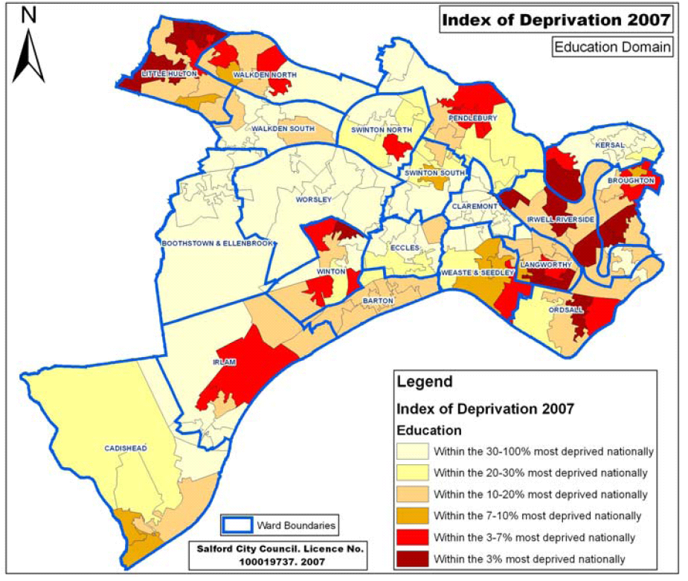

We also have great cultural and sporting assets in the city. For example, the Lowry, the arrival of MediaCityUK, heritage sites around Worsley and big sporting events such as the triathlon. Given our proximity to Manchester city centre and the wealth of community sport and leisure opportunities within Salford, fulfilment and engagement within sport and the arts should be part of life for lots of our residents. However, there is more work to do to ensure that the people of Salford think of those assets as belonging to the city of Salford and therefore the people that live here. We must also work to enable everyone in Salford to get involved in sport and leisure at the grassroots community level. It is vital that we empower local people and connect them to the cultural and leisure opportunities that already exist.

Our approach to creating a learning and creative city will be to ensure personalised education and training which is inclusive of all children, young people and adults. We will engage with people in Salford in new ways, for example through mentoring, so that pathways into jobs and opportunities are visible to all individuals. We will respond to local and individual need and work across the partnership to create pathways from all of our communities to our rich cultural assets as well as our grassroots provision. We will nurture our cultural, sporting and heritage assets.

Local Development Framework
Our Local Development Framework can help to deliver our vision of a learning and creative city through planning policies which support the expansion of the university, improvement of colleges and schools, and the provision of recreation facilities at both city-wide and local levels. The Local Development Framework will seek to ensure that our allocation of employment land is diverse and supports local job opportunities and skills development. Our approach to regeneration will support learning and creativity through supporting the development of key sites such as MediaCityUK, Salford Quays and Greengate and by maximising the potential of our existing heritage assets.
Our objectives to deliver a learning and creative city

Make Salford a creative, cultural, active and sporting city  HEALTHY

Improve educational attainment for all children, including the most vulnerable
Improve skill levels
➲ PROSPEROUS

We will improve educational attainment by:
helping young people to get better grades, especially in English and Maths
ensuring that the most vulnerable young people are supported to fulfil their potential, including Looked After Children  CYP
improving attendance and inclusion in education
getting more people into higher education.
We will improve skill levels by:
improving basic literacy, numeracy and IT skills for all
encouraging life long learning and personal development
maximising the benefits of new technology
ensuring that residents have appropriate skills for jobs.  PROSPEROUS
We will make Salford a creative, cultural and sporting city by:
providing cultural, arts and leisure opportunities to meet the diverse needs of all communities and as a means of engagement and bringing people together  INCLUSIVE
promoting the city for major sporting, cultural and leisure events
providing local facilities for recreational, sporting and cultural experiences, including safe environments for children to play and develop.  CYP

Our mechanisms and plans that will help to deliver these objectives:
Salford Agreement - business plans - Children and Young People’s Plan – Building Schools for the Future – Primary Capital Programme – Greater Manchester Challenge – Multi Area Agreement - School Improvement Programme – 13-19 Strategy – Cultural Strategy – Salford Economic Development Plan – Salford Culture and Leisure Alliance

Case Study: Building Schools for the Future

Aspiring to learning environments of the future
Building Schools for the Future is a national programme to rebuild or remodel every secondary school in the country. Alongside our Primary Capital Programme, this means that we are ensuring that every school in Salford will be renewed to provide state of the art facilities. Our vision in Salford is that our rebuilt and remodelled schools drive community regeneration, placing learning at the heart of our neighbourhoods for generations to come.

As well as new buildings, Building Schools for the Future enables unprecedented investment in Information Communication Technology (ICT) to provide new digital student-centred learning environments. Having the latest technology in our schools will not only improve teaching and learning but ensure that children leave school with the ICT skills that employers want.

The Building Schools for the Future programme will also consider the types of environments that students want to see in their schools. Salford students have already been involved in the design and specification for our new buildings, making sure that the things they feel are important are included. These include good social spaces, comfortable and flexible furniture which means classrooms can easily be rearranged to suit different learning styles, and informal learning areas where students can access the internet or do some research.

We are working with children and young people to ensure that our schools and facilities in Salford match our ambition for every child and young person to fulfil their potential. By creating schools for the twenty-first century, we are building a sustainable future with improved buildings to create attractive local environments, improved social wellbeing for our children and young people and the prospect of improved economic prosperity through a future workforce with the right skills and qualifications.

We aim to deliver… and we do!

Our vision of a city where children and young people are valued
We aim to improve the quality of life in Salford for all children and young people. We will narrow the inequalities gap and reduce child poverty to ensure that all children are given the best start in life. We will promote the health and wellbeing of children throughout their young lives and we will empower all children and young people to seek their own solutions. We aim to create opportunities and chances for all children, young people and families to live their dreams.

Why it’s important
Achieving our long-term vision for the city depends on our children and young people having high aspirations and being equipped to achieve them. In order to create vibrant neighbourhoods children and young people must be active and empowered to improve their environment. We cannot break the cycle of deprivation in our most vulnerable communities unless children and young people are valued and have accurate self-esteem which enables them to develop positive aspirations and make use of their individual talents.

We must have high expectations for families in Salford and provide the right support and interventions to enable good parenting and to safeguard all children and young people. Families must be supported to provide secure, happy environments. Where that family support does not exist, particularly for children who are Looked After by the local authority, the partnership must provide other structures to support the dreams and ambitions of children and young people.

Where we are now
There are more than 52,000 children and young people living in Salford (aged under 19). When developing the Children and Young People’s Plan, the partnership looked at the needs of those children and young people in each area of the city and highlighted key challenges which impact on the wellbeing of children and young people and their ability to progress; such as obesity, teenage pregnancy, child protection issues, school attendance, engagement and involvement and homelessness. The Children and Young People’s Plan and the Sustainable Community Strategy will take a holistic view of the wellbeing of children, young people and families in order to address these challenges. Some of the statistics below highlight the specific challenges that face children, young people and families in Salford, and which the partnership must therefore tackle:

- The overall level of deprivation affecting children and young people is highlighted by the fact that in 2007 there were 12,005 children in Salford living within families in receipt of Department for Work and Pensions workless benefits. This equates to 27.8% of the child population, significantly higher than the North West rate of 22.2% and national rate of 19.7%.
- In particular, Salford must address the key challenges surrounding the safeguarding of children. In February 2009, 482 children in the city were Looked After by the local authority, either with foster parents, in residential homes or with parents or other relatives. At the same time, 206 children had a Child Protection Plan.
- In Salford between 2005 and 2007, 769 teenagers aged between 15 and 17 became pregnant, equalling a rate of 60.8 per 1,000 of the female population aged between 15 and 17. That was the second highest rate in Greater Manchester.
- In 2007, 11.7% of reception-aged children in the city were classed as obese.
- In 2009, 67.3% of young people surveyed said that they had good friends and could talk to their parents, a friend or another adult if they were worried about something.

Our approach to creating a city where children and young people are valued will be to empower and engage with children and young people, and as service deliverers to view young people as part of the solution, not part of the problem. We will remove barriers to accessing services and to engaging with services and communities and we will support those structures which are valued by young people, such as neighbourhood youth forums, the youth council and shadowing and mentoring opportunities. We will make use of Information Communication Technology wherever it is helpful to create a culture of open and transparent communication with and between young people.

In order to improve quality of life for the most vulnerable children and young people, including those who are Looked After by the local authority, we will develop an approach which supports the whole family throughout the life of the child and seeks to sustain and maintain children within the family environment.

We will structure our partnership support for children and young people around children’s centres, extended schools and facilities within neighbourhoods, working with the whole community to raise aspirations for all individuals and families.

Local Development Framework
Through the Local Development Framework we will support the development of planning policies which deliver recreation facilities for children and young people; promote school and college improvements and university expansion; support the improvement of health facilities both within neighbourhoods and at a city-wide level; and which create family housing to meet the needs of children and young people across the city.

Our objectives to deliver a city where children and young people are valued
Give children the best start in life
Make young people part of the solution
Reduce child poverty

We will give children the best start in life by:
supporting and improving parenting and family life
promoting intergenerational support and recognising the importance of grandparents
improving the prospects of Looked After Children and reducing the numbers of Looked After Children
improving the oral, physical, emotional and sexual health of young people  HEALTHY
increasing breastfeeding rates  HEALTHY
providing structured support to vulnerable young people when that support is not provided by families
helping young people feel safe and secure  SAFE
providing safe environments where children can play, interact and learn social skills. CYP

We will make young people part of the solution by:
ensuring the engagement of children and young people
involving children and young people in decision-making  INCLUSIVE
putting young people in more influential positions, allowing them to experience leadership  INCLUSIVE
having high expectations for young people and families
changing perceptions and creating a positive image of children and young people in the city.
We will reduce child poverty by:
improving educational attainment and attendance  LEARNING
engaging with families to tackle worklessness  PROSPEROUS
ensuring that families take maximum advantage of the support on offer (eg. free school meals)  PROSPEROUS
providing targeted support for the most vulnerable and disadvantaged children, young people and families
reducing the impact of poverty and disadvantage.

Our mechanisms and plans that will help to deliver:
Salford Agreement - business plans- Children and Young People’s Plan – Safeguarding Improvement Plan – Parenting and Family Support Strategy – 13-19 Strategy - Child Poverty Strategy – Parent and Carer Participation Strategy – Early Intervention Strategy – Extended Schools Programme

Case Study: 21CC

The BBC’s 21st century classroom in Salford
21CC is the BBC’s digital learning centre dedicated to exploring creative ways of using multimedia and new technology in teaching and learning. Until 2009, there was only one 21st century classroom in the UK which was in London but ahead of the BBC’s move to MediaCityUK the second classroom opened at the end of March in Salford.

Based at Moorside High School’s city learning centre in Swinton, the new classroom will enable groups from across the North West and further afield to benefit from contact with professionals in all aspects of multimedia from filmmaking and podcasting to graphic design, music making and animation.

21CC is a resource for children and young people across the North of England and beyond but it is another example of how the BBC’s presence in Salford is benefitting children and young people and opening up new opportunities in exciting and innovative fields.

Salford has a strong tradition of investing in creativity as part of our curriculum and the wider development of all our young people; in order to ensure that the potential benefits from MediaCityUK are sustainable for the future, we are investing in high quality facilities to improve children and young people’s skills and creativity now.

We aim to be creative… and we are!

Our vision of an inclusive city
We aim to create balanced, strong, vibrant and active communities which have services that are locally managed, integrated, accessible, safe and appropriately resourced. We aim to create cohesive communities and we will celebrate and support equality and diversity across the city. We will enable our diverse communities to feel safe and protect them from hate crime and harassment. We will empower everyone, including the most vulnerable and isolated individuals, ensuring that all public services are accountable to local communities.

Why it’s important
The importance of an inclusive city is reflected in our cross-cutting principles for delivery which should be considered across all of the work that the partnership does. However, it is also vital that as a partnership we can articulate our objectives for inclusion and cohesion in their own right. We will promote visible social justice and equality to ensure that everyone has the ability to engage with community life and to influence decisions about their neighbourhoods and about service delivery across the city. This level of empowerment has many benefits, including community ownership of local environments, leading to cleaner, greener and safer neighbourhoods. It will help us to become more representative of our local communities in our governance arrangements at all levels of our organisations and partnership settings. It will also help individuals to gain a sense of purpose, belonging and value, derived from being proactive in their own lives and their communities and making a real difference.

Where we are now
Our story of place at the start of the strategy paints a picture of Salford and its different communities. We are an increasingly diverse city, in terms of our age profile and our ethnicity. Our communities of identity and other partnership bodies represent key groups across the city, these include:
- Salford Disability Forum
- Salford Lesbian, Gay, Bisexual and Transgender Network
- Salford Black and Minority Ethnic Forum
- Salford Faith Network
- Salford Youth Council
- Older People’s Forum.

The changes to Salford’s population represent challenges for services in the city to work in new ways which ensure that all people, regardless of their age, gender, race, faith, sexual orientation or disability, see improved outcomes, improved quality of life and can engage with services in order to shape their delivery.

Our current approach to neighbourhood working has created a sound basis from which to develop our work to engage and empower communities. Our community committees are well developed and for some people in Salford there are already lots of opportunities to engage and influence: in 2008, we found that 24% of people in Salford were happy with the opportunities for participation. We need to work to ensure that all residents’ voices are valued, including those individuals and communities who are the most vulnerable and isolated.

The pace of change in communities is unprecedented. The increasing diversity of Salford’s population and the emergence of new communities will mean that it is increasingly important to support work that brings different communities together, to facilitate dialogue and build tolerance and trust. This could be work at a city-wide level, to support dialogue across communities with the support of communities of identity. However, there also needs to be work at a local level to support more activities that bring people together in ways that benefit the whole community.

Our approach to creating an inclusive city will require intensive partnership working, developing innovative and creative ways of working which look at service delivery and design in new ways, making use of all routes to engagement with residents. We will encourage individual and collective responsibility and behavioural change. We will develop an approach that is intelligence-led and based on good knowledge and understanding of our communities; we will respond as a partnership to demographic changes and ensure that our services meet very local needs.

We will value diversity in the city and seek to attract newcomers and families. We will seek to increase the capacity of the community and voluntary sectors, whose links to individuals and communities are so valuable. We will recognise the need for all of our services to be proactive, accessible, flexible, responsive and appropriate to the needs of all members of our communities, including the most vulnerable. We will ensure that all residents can access the right information about services and opportunities for engagement.

Local Development Framework
Our planning policies within the Local Development Framework can our vision of an inclusive city by:
- Ensuring that housing renewal and improvement schemes provide an appropriate mix of housing across the city and ensuring that regeneration schemes take account of communities’ needs and preferences.
- Ensuring that our design policies enable us to create safe, accessible and attractive open spaces and recreation facilities where individuals and communities can come together.
- Ensuring that our policies around housing provision are capable of meeting the needs of minority groups or individuals with specific needs, for example around student housing, provision for traveller communities, affordable housing and adaptable dwellings.
Our objectives to deliver an inclusive city
Engage, empower and encourage all residents to be active in their community
Create a welcoming and cohesive city
Improve our neighbourhood working to respond to local need

We will engage and empower all residents by:
improving community engagement and involvement in decision making
supporting volunteering
enabling family and community networks to provide support to one another
putting more young people in influential positions CYP
ensuring that individuals and communities have the capacity to be involved, can access information and know their rights
engaging residents in service design and delivery
encouraging individual responsibility, raising aspirations and increasing expectations
improving participation rates of under-represented groups in civic and public life.
We will encourage community cohesion by:
bringing people together from different groups and promoting good relations across diverse communities
supporting the integration of new and emerging communities
valuing individuals in communities
promoting good relationships between younger people and older people and fostering intergenerational work
ensuring that hate crimes are dealt with effectively  SAFE
tackling violent extremism in all its forms.  SAFE
We will improve neighbourhood working by:
supporting neighbourhood level engagement and management structures
ensuring that residents have access to local facilities
ensuring that residents play a role in the governance of local facilities
ensuring that neighbourhood services respond to diverse needs, particularly of vulnerable people and minority communities
improving accountability at neighbourhood level
working to increase the sense of belonging and pride in local neighbourhoods.

Our mechanisms and plans that will help to deliver:
Salford Agreement - business plans – Community Cohesion Strategy – Community Engagement Strategy – Volunteering Strategy

Case Study: Spotlight on Salford

Whole system working to challenge and improve
Spotlight is an approach designed in Salford to enable service providers to get a comprehensive understanding of an issue in a particular area of the city, develop clear plans for improvement and release energy and ideas from communities and front line workers to develop new ways of doing things, all within a relatively short space of time. Spotlights involve all partners working together intensively on key issues that affect quality of life for individuals and communities.

Our Spotlight in Charlestown and Lower Kersal explored issues for young people not in education, employment or training. We explored the causes and effects relating to worklessness for young people as well as some of the issues which arise from how public services operate and interact with young people who are not in education, employment or training.

The programme resulted in a greater understanding amongst service providers about the issues, how to engage with young people and how to break the cycle of deprivation. The new principles and models which were developed as a result of Spotlight have informed our move in the city towards Working Neighbourhoods teams, which will provide a one stop shop for advice and support within communities to help people move towards work and training.

By helping people in Salford to access work and training, we are creating a stronger, sustainable economy for the future and enabling people to take pride in their achievements and their communities.

We aim to be challenging… and we are!

Our vision of an economically prosperous city
We aim to ensure that Salford is a world class city which offers a rich mix of employment, business and investment opportunities and which plays its part in less traditional economies which create and trade in knowledge. Salford will be a city where all residents have the chance to participate in and benefit from the sustainable development of the city, all residents have the right skills to access good jobs and all residents have the desire to work.

Why it’s important
It has long been recognised that work (and opportunities to work) have a significant impact on the ability of families and individuals to break the cycle of deprivation. Salford is a city with massive opportunity and we need to ensure that every person and every neighbourhood can benefit, both in times of economic hardship and prosperity. We must ensure that as a partnership we can face the challenges that come with recession whilst also striving for increasing prosperity, employment and opportunity.

Where we are now
According to the Index of Multiple Deprivation 2007, Salford is the fourth most deprived local authority area in Greater Manchester in terms of both income and employment. The concentration of people who do not work is particularly high in 11 wards of the city, which have been designated priority wards under the Greater Manchester City Strategy Pathfinder. Within these wards there are small areas which demonstrate significant concentrations (more than 25%) of people who are dependent on out-of-work benefits. The figures below demonstrate the scale of the challenge across Salford:

- In 2008, 17.9% of the working age population in Salford were claiming out of work benefits, the second highest rate in Greater Manchester.
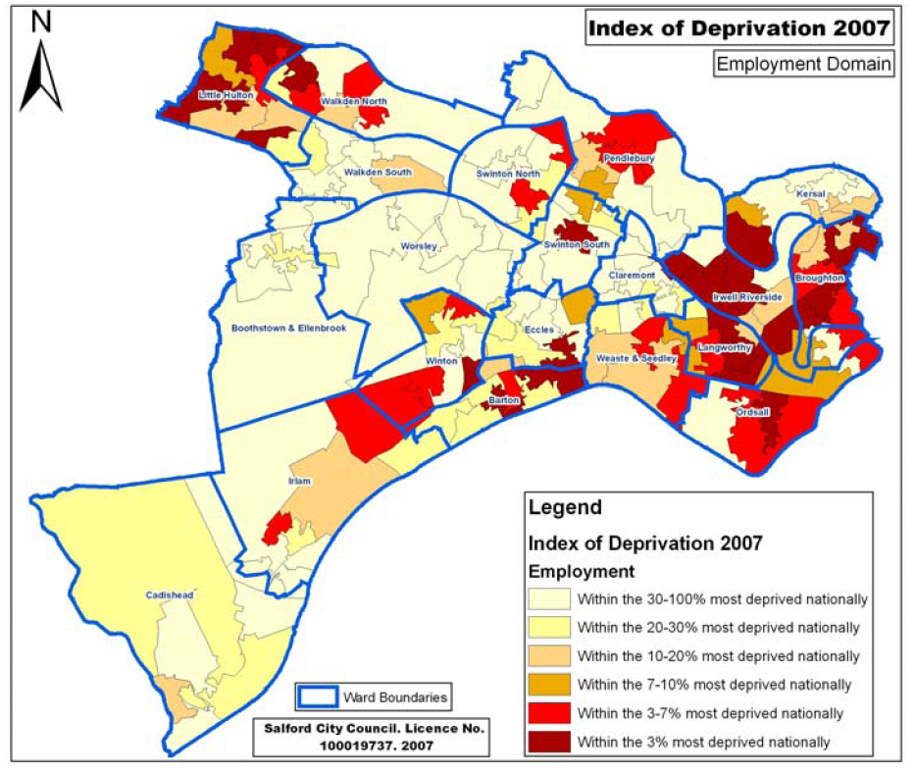
- In August 2008, approximately 11% of the working age population in Salford were in receipt of incapacity benefits, the highest rate in Greater Manchester.

However, Salford is also an expanding economy with huge opportunities such as MediaCityUK, from which local people must benefit:

  - Between 1998 and 2006, the employment growth rate in Salford was 12.7%, a growth of 12,845 jobs and the second highest rate in Greater Manchester.
  - Between 1992 and 2006, the rate of growth in Gross Value Added per head in Salford exceeded both the North West and the United Kingdom rates; in fact by 2006, the gap between Salford’s growth rate and that of the North West was 35%.

Our approach to creating an economically prosperous city will be about ensuring equality of opportunity for Salford residents, creating pathways into work and training for the most vulnerable and isolated residents. We will work with our partners across Salford and Greater Manchester to ensure that Salford residents benefit from investment in our city and our city region, the growth of our economy and that all residents can share in the city’s rising aspirations.

We will connect people to opportunities by ensuring that they have the right skills to access good jobs, and by taking new and innovative approaches to engagement which change individuals’ and families’ attitudes to work as well as employers’ perceptions of Salford residents. We will take seriously the role of the public sector to mentor and create pathways to work for those individuals who are most at risk of worklessness or poverty (for example those people who are managing long-term health conditions). Simultaneously we will strive to ensure an environment that is attractive to both new and existing employees and employers.

Our approach will take both a short and long term view of economic prosperity, which can cope with changing economic climates and new challenges.

Local Development Framework
Our Local Development Framework can support the delivery of our vision of an economically prosperous city through planning policies which:
- promote a diverse range of employment opportunities
- put the right transport infrastructure and connections in place, both within and outside of the city
- support the development of MediaCityUK
- promote regeneration schemes and maximise the city’s potential
- encourage developers to work with training providers, schools and the college to make the links between development and education
- realise the potential of our heritage and tourism assets.

Our objectives to deliver an economically prosperous city

Encourage business and enterprise development

Encourage investment to create job opportunities
We will encourage investment by:
ensuring that we have enough land for business growth
improving infrastructure including transport
promoting regeneration which achieves local benefits
making MediaCityUK a famous success
ensuring there is an adequate pool of suitably skilled labour within the city.

We will encourage business and enterprise development by:
building a more enterprising culture
developing key employment sectors
creating an environment that will improve the performance of existing business
maintaining optimum relationships with business community leaders
creating quality environments which will attract investors and businesses to the city.  LIVE

Reduce poverty, increase income levels and tackle worklessness
We will enable local people to fulfil their potential by:
improving residents’ skills LEARNING
tackling worklessness
raising individuals’ aspirations
getting more local people into work
generating positive relationships between employers and local people
working with families to overcome barriers to work
reducing levels of benefit dependency
encouraging progression from engagement to training and work.

Our mechanisms and plans that will help to deliver:
Salford Agreement - business plans – Multi Area Agreement – Greater Manchester Strategy – 13-19 Strategy – recession planning groups – Salford Economic Development Plan – Financial Inclusion Strategy – Central Salford Vision and Regeneration Framework – Greater Manchester City Strategy

Case Study: Horticultural Academy

Connecting local people to training opportunities
Salford’s Horticultural Academy was launched in 2007 as a partnership between the city council’s Grounds Maintenance Service, the Economic Development unit, Job Centre Plus and Myerscough College near Preston, a specialist horticultural learning centre.

The Horticultural Academy has two aims: to improve and develop the green corridors in the city and to help Salford people back into work.

Local people who are out of work, in receipt of benefits and from some of the most deprived areas of the city are referred to the programme. They undergo an initial advisory interview with Job Centre Plus to identify both their eligibility for the scheme and any basic skills needs.

We are taking a holistic, sustainable approach to improving lives in Salford by considering the environmental, social and economic benefits that can be achieved through a programme like the academy. All participants on the academy’s training programme get the chance to develop interpersonal and horticultural skills whilst also contributing to the development and regeneration of their neighbourhoods. It’s a real opportunity for local people to gain skills which are valuable in the workplace and which empower them to make a difference to where they live.

We aim to be empowering… and we are!

Our vision of a city that’s good to live in
We aim to create sustainable environments and neighbourhoods across the city. We aim to ensure that everyone who lives or aspires to live in Salford can access a home they can afford, which meets their needs in the neighbourhood of their choice. We aim to create desirable neighbourhoods across the city which are accessible, well-connected, safe, well maintained and with high quality recreational and community facilities, joined-up by high quality public transport.

Why it’s important
Our vision of Salford in 2024 as a beautiful, safe and welcoming city depends in part on our ability to deliver attractive public spaces, decent and affordable homes that people want to live in, accessible services and a clean environment. Whilst viewing deprivation as a cycle means that every element is key, a lack of appropriate housing potentially compounds health inequalities and worklessness; equally, safe and clean environments contribute to wellbeing and quality of life and have the potential to impact on other outcomes across our services as a partnership. For example, by creating a city that promotes walking and cycling, we can increase daily activity and therefore improve health; and by providing public spaces in which neighbours and communities can come together, we can contribute to community cohesion.

It is vital that a healthy, well-connected, clean, green and safe city with appropriate housing is available to all people, including the most vulnerable and the least mobile, who can so easily be isolated from support networks, friends and families by poor environment and transport.

Where we are now
Salford’s diversity means that large areas of the city are close to green space and heritage sites. Approximately 35% of the city is designated as green belt and as our story of place sets out at the beginning of this document, we benefit from the diversity of being part of a regional centre, having suburban spaces and more rural areas. We need to connect people in the city to the diversity of opportunities that such a landscape offers. Challenges also remain; as the statistics below indicate, there are proportions of the city’s population who still do not have adequate access to green space, to recreational facilities, to appropriate affordable housing and who do not feel empowered to improve their environment:

- In April 2008, 63% of residents were satisfied with their local area as a place to live.
- In April 2008, 68% of residents were personally concerned about climate change. Whilst 30% felt that they individually can play a role in limiting the effects of climate change, 84% felt that the local authority has a role.
- In 2006 on average each person in Salford was responsible for the emission of 6.4 tonnes of CO₂.
- In 2007, 53% of local-authority owned homes were classed as ‘non-decent’.
- In 2007, 94.2% of people in Salford lived within 20 minutes travelling time of their employment, either by public transport, walking or cycling. 99.1% lived within fifteen minutes of a primary school.

Our approach to creating a city that’s good to live in will be to ensure that we make the relevant connections between services and delivery organisations. We will work as a whole system, identifying how we can work together and deliver in a more joined-up way which is focused on outcomes, providing a cleaner, greener, connected city for all of our neighbourhoods. We will work across geographical and administrative boundaries, recognising the shape of communities and neighbourhoods with which local people associate themselves; and we will work across the city region and beyond on those strategic issues which require a broader view such as climate change and transport.

We will ensure that we understand the housing and transport needs of our communities and empower all people to access the housing, services and information that they need.

We will work with local people to promote lifestyles which are sustainable and encourage communities to take pride in their neighbourhoods and to contribute to their development.

Local Development Framework
We will ensure that our Local Development Framework supports our vision of a city that’s good to live in. The Core Strategy has a significant role to play in achieving this by identifying the most appropriate locations for new development in the city and the type of development that is needed. It will be essential to ensure that development is supported by adequate infrastructure including education, healthcare, transport and recreation facilities. Planning policies will seek to deliver a range of housing and employment opportunities and support the creation of unique and diverse neighbourhoods joined up by a network of green spaces. Policies will help to minimise the impacts of climate change by encouraging sustainable design and construction techniques, and minimising the need to travel through the location of development.

Our objectives to deliver a city that’s good to live in
Provide popular homes in desirable neighbourhoods
Provide an attractive and well-maintained city

Improve access to facilities, services, employment and opportunities

Create an environmentally sustainable city

We will provide popular homes by:
increasing the number of decent homes
providing a good choice of new market housing including family and affordable homes
providing housing for older people  HEALTHY
ensuring that homes are adapted or built to reduce and adapt to climate change
ensuring neighbourhoods of mixed, balanced communities  INCLUSIVE
tackling homelessness.

We will create an environmentally sustainable city by:
addressing climate change
minimising the environmental impact of development
reducing carbon emissions, developing a low carbon economy and improving air quality
mitigating against flood risk
developing green spaces across the city
reducing waste and pollution
ending fuel poverty.

We will provide an attractive and well-maintained city by:
maintaining clean and safe public spaces  SAFE
promoting excellence in design  SAFE
improving green spaces for people and wildlife
providing public spaces where people can come together  INCLUSIVE
providing green spaces which promote active, healthy lifestyles.  HEALTHY

We will improve access to services by:
ensuring that services and transport developments are co-ordinated
ensuring a clean, green, sustainable transport network
promoting walking and cycling
reducing road deaths and casualties
developing a better range of shopping facilities
ensuring the ability of everyone (including the least mobile) to move around the city safely
providing excellent and affordable public transport
creating national and global connections.

Our mechanisms and plans that will help to deliver:
Salford Agreement - business plans – Greater Manchester Strategy – Greater Manchester Local Transport Plan – Housing Strategy – Local Development Framework – Waste Development Plan – Greater Manchester Waste Strategy - Supporting People Strategy – Climate Change Strategy – Affordable Warmth Strategy

Appendix A: Linked strategies and plans

A healthy city
Healthy Weight Strategy 2009 (in development)
Alcohol Strategy 2008-2011
Teenage Pregnancy Strategy 2009 (in development)
Older People's Strategy 2005
Carers’ Strategy 2008-2011
Tobacco Control Strategy 2006-2010
Health Inequalities in Salford – a local strategy for action 2004-2020
Oral Health Strategy 2005
Sexual Health Strategy 2006-2010
Heart Strategy 2005
Chronic Obstructive Pulmonary Disease Strategy 2009
Salford PCT Strategic Plan 2009

A safe city
Community Safety Strategy 2008-2011
Road Safety Strategy 2006-2010
Greater Manchester Police Authority Policing Plan 2009-2011

A learning and creative city
Salford Economic Development Plan 2009
Learning and Skills Council Regional Statement of Skills Priorities 2007-2010*
Children and Young People’s Plan 2006
Salford Education Vision 2006
Greater Manchester Skills Priority Statement 2007

* The Learning and Skills Council will cease to exist on 31 March 2010.

A city where children and young people are valued
Family Support Strategy 2009 (in development)
Early Intervention Strategy 2007
Parent and Carer Participation Strategy 2009 (in development)
13-19 Strategy 2008-2011
Children and Young People’s Plan 2006

An inclusive city
Community Cohesion Strategy 2008-2011
Community Engagement Strategy 2007
Volunteering Strategy 2009 (in development)
Salford Compact 2007

An economically prosperous city
Salix Homes Financial Inclusion Strategy 2008
Salford Economic Development Plan 2009
Central Salford Vision and Regeneration Framework 2006
Greater Manchester Economic Development Plan
Greater Manchester City Strategy 2007
Manchester City Region Development Programme 2006

A city that’s good to live in
Greenspace Strategy 2006
Parks for People Strategy/ Master Plans 2006
Affordable Housing Strategy 2006 (updated 2007/08)
Asset Management Plans 2008/09
Play in Salford 2007-2012
Supporting People Strategy 2005-2010
Sustainable Transport in Salford 2007
Greater Manchester Local Transport Plan 2006-2011
Core Strategy and Local Development Framework 2007-2027
Greater Manchester Joint Waste Development Plan (in development)
Salford Housing Strategy 2008-2011
Central Salford Integrated Transport Strategy (in development)
Greater Manchester Municipal Waste Strategy 2007
Homelessness Strategy 2008-2013
Affordable Warmth Strategy 2005
North West Regional Economic Strategy 2006*
North West Regional Spatial Strategy 2008*
Salix Homes Better Neighbourhoods Strategy 2008/09

* to be replaced by the North West Regional Strategy 2010

Appendix B: Glossary

Anti-social behaviour (ASB) | Behaviour such as vandalism, being rude and abusive or making too much noise, usually in a public place.
Basic skills/ skills for life | The ability to read, write and speak English and understand numerical information.
BME | Black and Minority Ethnic
Communities of Identity | Forums which represent and provide a voice for particular minority groups across the city (older people, faith groups, BME groups, disabled people and Lesbian, Gay, Bisexual and Transgender people).
Community Action Plan | Plans developed by the eight community committees in Salford. The plans identify local people's priorities for service improvement and actions in their area.
Community Committee | A group of local people and councillors who meet to discuss issues that affect their area. The committee is responsible for putting together a Community Action Plan. Each of Salford's eight neighbourhoods has a community committee.
Core Strategy | The Core Strategy will set out the spatial vision for the city and provide a framework for development in the city until 2027. It will reflect the vision and objectives of the Sustainable Community Strategy.
Decent Homes Standard | The Government's definition of the minimum standard that houses owned by social landlords' (housing associations and councils) should meet. A decent home is wind and weather tight, warm and has modern facilities. Non-decent homes do not meet this standard.
Environmental crime | Crime against public spaces, for example, littering, fly tipping, graffiti and vandalism.
Future Search | A ‘whole-systems’ event held in Salford in 2008 to explore our vision for 2024 and how the whole partnership can contribute.
GCSE | General Certificate of Secondary Education. This assesses a pupil at the end of their compulsory education (aged 16).
Incapacity Benefit | State benefit intended for those below the State Pension age who cannot work because of illness or disability.
Index of Multiple Deprivation | A ranking of districts in England which details those areas affected by poverty and outcomes associated with poverty.
Joint Strategic Needs Assessment | This is an analysis of the health and care needs of Salford’s population, which looks forward five years. It is a requirement that every Primary Care Trust and Local Authority jointly undertake regular assessments.
Key Stage | The National Curriculum is a blueprint used by schools to ensure that teaching standards are consistent. The National Curriculum defines a child's progress in four key stages:  Primary School  Key Stage 1 is years 1 and 2 (ages 5-7)  Key Stage 2 is years 3, 4, 5 and 6 (ages 7-11)  Secondary School  Key Stage 3 is years 7, 8 and 9 (ages 11-14)  Key Stage 4 is years 10 and 11 (ages 14-16)
Life expectancy | Life expectancy at birth is a summary measure of the mortality rates in an area in a given period. It is the average number of years a new-born baby would survive, were he or she to experience the particular area's age-specific mortality rates for that time period throughout his or her life.
Local Development Framework | The Local Development Framework is a portfolio of planning policy documents which direct development in the city. The Core Strategy is the central document within the framework.
Local Strategic Partnership (LSP) | A partnership that involves the public, private, voluntary and community sectors working together to improve the way local services are planned. Salford's LSP is called Partners IN Salford.
Looked After Children | Children who are in need of safeguarding, are subject to care orders and are cared for by the local authority in foster homes, residential homes or with a relative.
MAA or Multi Area Agreement | A Multi Area Agreement is an agreement between local authorities in a sub-region (for example, Greater Manchester) and central government. It focuses on those issues which are best tackled at a wider spatial level such as economic development, transport and climate change.
MIER or Manchester Independent Economic Review | The Manchester Independent Economic Review (MIER) is a programme which will provide evidence and research on Greater Manchester’s economic position to inform decision-making.
NEET | A young person who is not in education, employment or training.
NIS or National Indicator Set | The National Indicator Set is a new suite of 198 performance indicators which are collected by partners in every local authority area and reported to central government.
PCT or Primary Care Trust | The Primary Care Trust manages the delivery of local health care.
Salford Agreement (or Local Area Agreement/ LAA) | Every local authority is required by government to develop a Local Area Agreement which sets out the shared priorities for improvement in that area. In Salford it is called the Salford Agreement.  A Local Area Agreement can contain a maximum of '35' 'designated' targets - these are 35 National Indicators against which targets are agreed between central and local government. Salford's Agreement also contains additional supporting measures (some of which are national indicators, others are local indicators) and mandatory measures which relate to educational attainment.
Strategy | A strategy sets out a broad overview and high level objectives for an area of work over several years. It sets out a vision and high level targets, which an action plan will then fill out in more detail.
Sustainability/ sustainable | A sustainable community is one which considers how different areas of work impact on one another. Taking a sustainable approach to our work means considering the long-term impacts and how we can improve quality of life overall. For example, considering the environmental impacts of new buildings or the impact of health programmes on jobs and work.
Sustainable Community Strategy | Connecting People to Opportunities is Salford’s third community plan and it is a requirement that all local partnerships have one. It describes the vision and objectives of Partners IN Salford.
Third Sector / Community and Voluntary Sector | These are non-governmental, not-for-profit organisations which generally have social, environmental or cultural objectives. The term includes charities, community groups, social enterprises, co-operatives and mutuals.
Urban Regeneration Company (URC) | A not for profit partnership set up to develop deprived areas of English cities. Salford's URC is working to develop the east of the city, known as Central Salford.
Whole System Working | Whole systems working is an approach that can give new insights and offer different solutions to complex social problems. Rather than breaking down the problem into small pieces, complex problems are considered as a set of inter-connected elements.

