Part 1 Open To the Public)
Item No11.

REPORT OF THE LEAD MEMBER FOR PLANNING

TO COUNCIL ON 21st NOVEMBER 2007

TITLE: THE ROAD SAFETY PLAN 2007-2008

RECOMMENDATIONS:

That Council approves the content of the current road safety plan, summarising road safety activity in Salford.

EXECUTIVE SUMMARY:

The road safety plan is a document produced annually, outlining progress towards achieving the 2010 national casualty reduction targets. It also provides a summary of current road safety activity in the Engineering and Education, Training and Publicity fields, with the appendices giving detail of the current local safety scheme programme and road safety coverage.

BACKGROUND DOCUMENTS:

- Road Casualty Statistics Greater Manchester 2006 – GMTU report 1288
- 2007/2008 Block 3 Transport Capital Programme

ASSESSMENT OF RISK: LOW

SOURCE OF FUNDING: The schemes identified in the local safety scheme programme are funded via the Block 3 Transport Capital Programme

LEGAL IMPLICATIONS: there are no legal implications to report

FINANCIAL IMPLICATIONS: there are no additional financial implications to report

COMMUNICATION IMPLICATIONS: N/A

VALUE FOR MONEY IMPLICATIONS: N/A

CLIENT IMPLICATIONS: N/A

PROPERTY: N/A

HUMAN RESOURCES: N/A

CONTACT OFFICER: Andy Devine on 779 4859

WARD(S) TO WHICH REPORT RELATE(S): All Wards

KEY COUNCIL POLICIES: ENHANCING LIFE IN SALFORD
Reducing the number of people killed or seriously injured on Salford’s roads

Introduction

The Road Casualty Reduction Group (RCRG) consist of the Collision Investigation Unit and Road Safety Unit, more information about the work that each undertake is included later in the plan, however their sole aim is to reduce the number of casualties involved in road traffic collisions in line with casualty reduction targets set by the government.

National targets require that road casualties are reduced by the following levels by 2010 (compared with the 1994 - 98 average):

Child Killed or seriously injured (KSI) - 50% (Locally agreed targets stretch this to 55% by 2010)

Other KSI - 40% (Locally agreed targets stretch this to 50% by 2010)

10% reduction in slights (Locally agreed targets stretch this to 30% by 2010)

The casualty record over the previous three years is outlined below:

 | 2004 | 2005 | %age reduction on previous year | 2006 | %age  reduction on previous  year
City of Salford | 1180 | 1094 | 7.3% | 991 | 9.4%
Greater Manchester | 13543 | 12805 | 5.4% | 11795 | 7.9%

Our strategy to maintain this downward trend is as follows:

- To continue monitoring the collision statistics and react to any unexpected occurrences.

- To continue using the collision statistics as the basis for designing our highways capital programme. (This includes highway maintenance monies, which are used to ensure that the road surface is inherently safe).

- To increase resources in the traditional areas of education, training and publicity, as well as introducing new training programmes which will specifically target child pedestrian casualties.

- Continue to encourage partnership working as part of the RCRG's ongoing efforts to reduce casualties and also to support the delivery of the road safety partnership strategy.

Measuring Performance

As in the previous Road Safety Plan, the first two charts have been included to provide an overview of how Salford is performing alongside the other 9 Greater Manchester authorities.

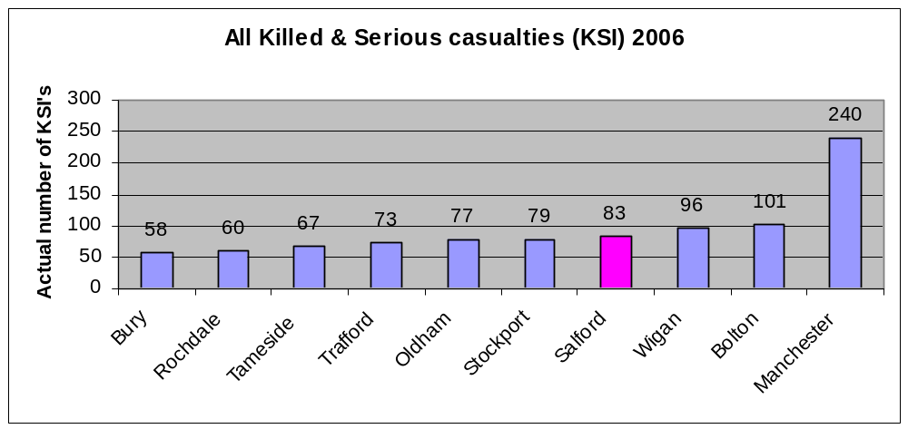
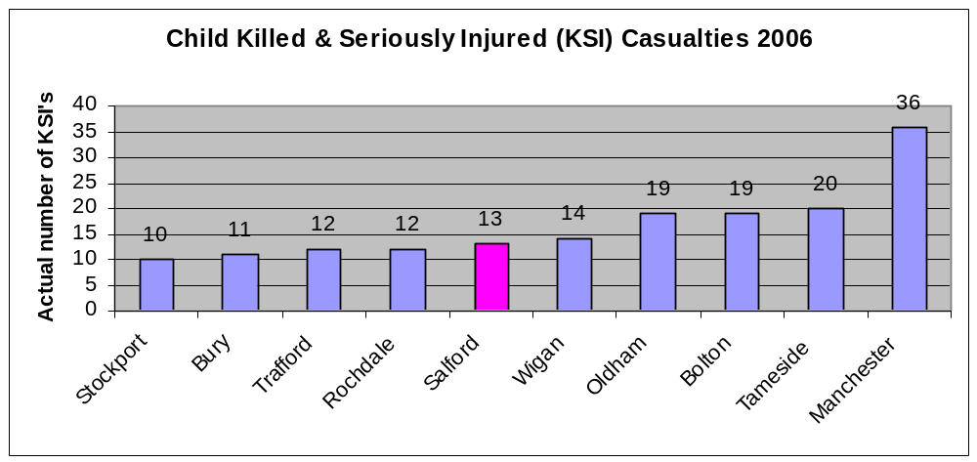

They show that in terms of All KSI’s we are performing on a par with the other authorities, but in terms of Child KSI’s Salford are performing well alongside the other Greater Manchester authorities.

In order to measure successful performance of safety schemes on a more local scale the authority has certain targets within the Best Value basket of indicators and their performance is shown on the graphs overleaf.

BVPI 99a – Reduce the number of people killed/ seriously injured in road traffic collisions

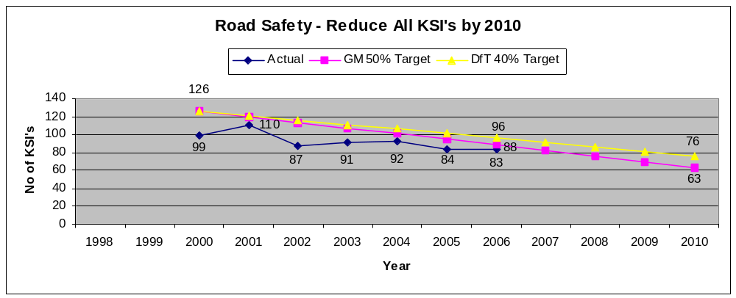
BVPI 99b - Reduce the number children killed/ seriously injured in road traffic collisions

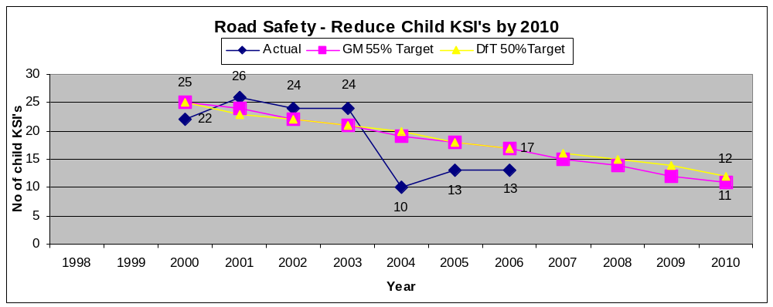

BVPI 99c – Reduce the number of people slightly injured in road traffic collisions

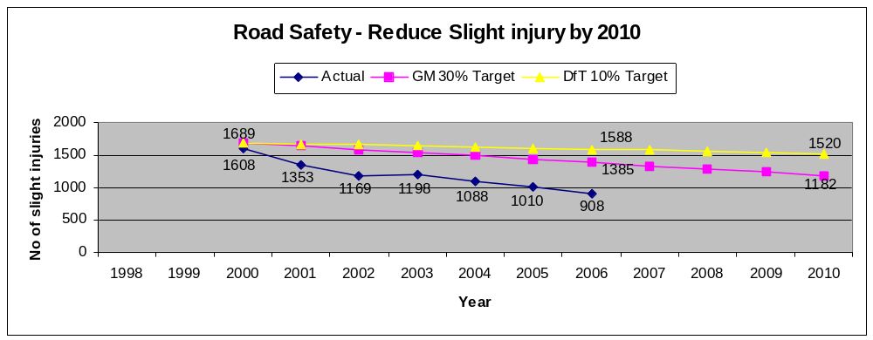
The figures show that across all the indicators results have been very close to or better than the national targets and for the last 3 years all targets have been successfully bettered, with the trend being downward from 2000, the start of the 10 year casualty reduction programme.

The role of the Collision Investigation Unit

The process of identifying locations for inclusion into the Local Safety Scheme programme begins by interrogating the GMAXI system which is a database that holds records relating to all injury collisions that have been recorded by the police via their STATS 19 form. The form has a number of check boxes relating to the date and time of the collision, weather conditions, description of the casualties and their details and a commentary on what actually took place along with any prevailing factors that either definitely or might possibly have contributed to the collision.

It is possible to perform a variety of searches on this system relating to different criteria ie. Identifying those collisions purely involving child pedestrians, or those involving motorcyclists occurring between the hours of 10pm to 12pm on wet road conditions. The output of these searches can be shown in a number of different formats but the most useful is via the GMAPS system that actually places the location of the collision on an ordnance survey background, allowing identification of collision clusters to be highlighted.

‘Hard’ copies of the actual collision reports can also be printed off the system and a further analysis of the information contained in them allows any trends to be highlighted ie. Vehicles failing to conform to red traffic signals might be addressed by the introduction of a red light camera to reduce the likelihood that this type of collision will happen in the future.

Programmes of work are often divided into 4 distinct categories:-

Area wide – a scattering of pedestrian collisions in a residential area might best be tackled by the introduction of area-wide traffic calming measures in order to reduce the level of ‘short cutting’ traffic and to slow down the speed of vehicles that continue to use the residential area.

Mass action – concentrations of collisions involving vehicles skidding in wet road conditions, especially on the approach to junctions across the city may lead to consideration of treatment by implementing lengths of anti-skid surfacing on the relevant approaches.

Single site – collisions identified as being exclusive to one particular location are treated independently ie. collisions involving pedestrians at a signalised junction without protected pedestrian crossing facilities may require the upgrading of the signals to incorporate a red/green man crossing facility.

Route action – a scattering of collisions along a particular length of road involving concentrations at junctions often results in the treatment of the route as a whole, involving the use of refuges to encourage pedestrians to cross in safer conditions and centrally hatched areas of carriageway that not only narrow the road space available to motorists but also allow for the introduction of safe areas in which vehicles can wait before turning at junctions.

Additionally, a process to prioritise areas requiring traffic calming schemes has been undertaken that employed a number of relevant criteria ie. collisions, speeds, volumes, housing density etc. The result has provided us with a plan of the city that identifies locations requiring calming on an area wide basis and this will inform the programme of future work.

Approaches from the community also have a major part to play in the implementation of a scheme, especially if an area is perceived as unacceptably dangerous or traffic has reached levels that effectively divides a community. In these circumstances, improvements may be appropriate and so the approach is more pro-active rather than always being statistically led. Community involvement is always incorporated into the consultation element of scheme development, especially as local knowledge is invaluable in determining locations that are perceived as dangerous.

This has evolved even further with Community Committees being given a devolved budget to spend on highway matters that they have prioritised through their Community Action Plans (CAP). Following a campaign to increase awareness of road safety across the Community Committee membership, a significant number of road safety concerns are being included in the CAP’s.

The Collision Investigation Unit is constantly identifying new sites to be developed into schemes for future programmes of work and a table showing those schemes in the current (07/08) Local Safety Schemes programme is attached as Appendix 1.

An example of identifying and treating a problem area
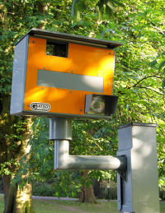
Speeding and red light running continues to be an issue on some of the key routes and locations within the city. Regular monitoring of these routes reveals average speeds, the percentage of vehicles exceeding the speed limit or red light running and also identifies the number of personal injury collisions occurring.

This data is collected and analysed and, if the location reaches the criteria set out by the Greater Manchester Casualty Reduction Partnership, it can be put forward for consideration for a Safety Camera.

Safety camera sites fall into four categories; -

- Fixed Speed Camera Site
- Mobile Speed Camera Site
- Red Light or Combined Red Light and speed camera site
- Route Enforcement (where mobile speed cameras can enforce at any point along the route)

Recently two new sites were identified for a fixed speed camera. Both Lancaster Road and Eccles Old Road reached the criteria and were successfully included into the camera programme and installed earlier this year. At both of these locations, there had been at least 3 collisions resulting in killed or seriously injured casualties (KSI’s) in the three year analysis period as well as a number of slight injury collisions, in addition the 85th%ile speeds (the speed at which 85 % of the vehicles are travelling and the measure used to determine the speed of a road) were at least 37 mph.

The following table summarises the 85th %ile speeds and shows the percentage of vehicles exceeding the 30mph speed limit both before and after the installation of the camera.

 | Speeds Before  Camera | Speeds After  Camera | % vehicles exceeding  speed limit “Before” | % vehicles exceeding  speed limit “After”
Lancaster Road | 37 mph | 29.7 mph | 59.3 % | 8.4%
Eccles Old Road | 37.2 mph | 29.9 mph | 59.4 % | 11.4 %

At present it is too early to assess the success of these cameras in terms of injury collisions as this data needs to be gathered for at least 12 months however, there is research that indicates that for every 1mph reduction in average speed there is a 5% reduction in KSI’s.

The role of the Highways Maintenance Department

In terms of casualty reduction the highways maintenance department plays a dual role. Firstly, Salford City Council is committed to carrying out regular skid resistance surveys on the Principal Road Network and high risk sites on the non-Principal Road network to identify locations where improvement of the skid resistance may be necessary following further detailed site investigations. In order to assist this a Skid Resistance Policy document has been drawn up that details the process that is involved in undertaking the skid-resistance testing, the investigatory levels required to ‘trigger’ the surveys and a range of recommended measures based on the recorded intervention level that is observed at the site.

Secondly, highways maintenance is responsible for the upkeep of all road markings on Salford’s highways. The obvious benefit of properly maintained road markings is to define carriageway lanes and edges and to give instructions to road users in a manner clearly visible in all conditions.

Salford provides road markings in appropriate locations using the layouts described in the ‘Traffic signs regulation and general directions’. Materials and application of road markings are provided in accordance with the "Specification For Highway Works".

Carriageway markings are currently replaced on a 5-year cycle, or on an ‘as-needs’ basis where a potential hazard is identified during the safety inspection process or as the result of third party complaints.

The role of the Road Safety Unit

The provision of a road safety service is a statutory duty of local authorities in Great Britain (Section 39, Road Traffic Act 1988) and includes education training and publicity. (ETP)

In Salford road safety education starts with the very young and their parents, the following are projects undertaken by the unit and a table identifying a detailed break down of what each school received in academic year 2007/2008 is attached as Appendix 2.

Project | Description
“Step Outside-a lesson for life” | A booklet designed to help parents to instruct their children road safety issues as they develop. It is currently issued to parents by their Health Visitors at their child’s 3-year check.
“Prepare them for the roads” and “Out and About” | Parents are given advice on the basic principles of safe behaviour on the roads, these parent guides are used to support this work
Infant and Junior schools | Are visited annually and the children are instructed in the principles of “ Stop, Look, Listen and Think” the “Green Cross Code” and “in-car safety” at levels suitable to their age group. This work is reinforced by the provision of road safety resources, which are left with class teachers to be integrated into appropriate topics.
" Get Across Road Safety (0-6 years)" " Get Across Road Safety (7-10year) | The first is a parental guide to road safety given each year to all new intake pupils.  All year three pupils receive the second booklet which is a parental guide aimed at 7-10 year olds.
Year One Classes | 2 visits of around 45mins to an hour each: Lesson one covers Holding Hands, Stopping, Looking and listening. Lesson 2 covers safer places to cross and In-car Safety.
Year Four Classes | 2 visits of around 45mins to an hour each: Lesson one, The Green Cross Code, safer places to cross and risk. Lesson two covers cycling theory and In-car safety.
Crucial Crew | Attended by all year Six Pupils(approx 2700). The current road safety scenario covers pedestrian safety, conspicuity and seat belts.
Cycle training | Salford City Council Road Safety Unit offers cycle training to every maintained primary school. For independent schools it is necessary to request a training course from the road safety unit. The course is available for pupils who are in year five and six who are aged ten years or over. In 2006/7 the Road Safety Unit undertook 38 courses with a total of 515 pupils receiving training. These numbers are down on previous years because of a reduction of available staff time due to demands of other duties.  Unless more investment is put into training, further reductions are expected next year. This is due to the introduction of the new national standards. These standards introduces reduced instructor /pupil ratios and only allows nationally accredited instructors to carry out the training. Staff members that have previously assisted are no longer eligible to carry out instruction.  The new accredited training courses are practical courses that help children to develop their cycle control skills, road safety knowledge and traffic awareness. Pupils have to complete a Cycling Workbook as homework before commencement of the course. Courses include riding exercises in an off-road area, such as a school playground, leading to riding practice on quiet public roads.
Secondary schools | Are visited on request. Lessons are tailored to suit the requirements of the school or individual teachers.
Pedestrian Training | Currently operates in around 20 schools in the City. It was originally funded by the DfT and is designed to teach pedestrian skills to 5 to 7 year olds by means of practical roadside training rather than in the classroom.  It is built around teaching three skills: - choosing safe places and routes; crossing safely at parked cars and crossing safely near junctions. Children are taught by the roadside on routes around school that they are likely to use frequently. They learn to identify the safest places to cross the roads, to identify potential hazards and to identify where not to cross the roads. The importance of holding hands with a grown up is emphasised in every session. Volunteers, usually parents, train the children in small groups once a week for approximately 10 weeks.  A new Pedestrian training project “Streets Ahead” has been developed, by Salford, to train childcare professionals and carers the skills to carry out pedestrian training.
Children’s Traffic Club | Following the introduction of the Children’s Traffic Club, under the Neighbourhood Road Safety Initiative (NRSI), the club is now available across the city. Parents of all 3 year olds in the city are invited to enrol by post. Members receive 6 storybooks one every month from their third birthday. There are also ‘Hints and Tips’ and a CD with stories and songs to help teach children important road safety messages. The CTC is promoted by the use of an educational Toolkit that has been issued to venues throughout the city. Take up of membership is currently running at around 40%.
School Crossing Patrol Service | The Road Safety Unit is also responsible for the management, recruiting, training and supervision of School Crossing Patrols (SCP's) throughout the City.  We currently have 90 crossing points and have 6 mobile patrols to cover for emergencies.  The School Crossing Patrol is a permissive, not a statutory, function. Even where a SCP is provided, parents/carers remain solely responsible for ensuring their children's safety on their journey to and from school.
Publicity | A number of publicity campaigns are run annually these are usually to support regional or national campaigns the main subjects are;  Green Cross Code  Speed  Seat Belts  Conspicuity  Drink and Drugs  Motorcycle safety  “Drivesafe” The Greater Manchester Safety Camera partnership carries out a number of publicity campaigns per year. These campaigns are funded from monies obtained from the Safety Cameras. Salford is represented on the “Drivesafe” resources group and plays a major part in the development of these campaigns.
Road Safety Partnership Grant | Greater Manchester Authorities were successful in receiving a grant of £1.3Million to tackle the high incidence of road casualties in the 17-25 age group. Statistical research is currently underway to establish where the majority of casualties live and if there are any common factors involved. Once this research has finished we will be looking into what intervention can be used and where to target them to try and reduce the casualties. This will be in conjunction with a number of partners. Greater Manchester Police have been allocated a proportion of this grant to research the effect of Automatic Number Plate Recognition Campaigns on Road Casualties and other related criminal activities.

Salford Road Safety Partnership

The Salford Road Safety Partnership was initially established to steer the delivery of the ‘Neighbourhood Road Safety Initiative’ (NRSI) projects. The partnership currently monitors the delivery of the Road Safety Partnership Strategy and develops new partnership procedures and projects. This partnership currently includes representation from a wide range of public and voluntary sector agencies.

The Road Safety Partnership Strategy, which evolved as a result of input from the partners, is intended to steer the direction of future road safety work. It is recognised that continued partnership working is required as it is fundamental in the RCRG's ongoing efforts to reduce casualties.

Partnership Projects
Project | Partners | Description
Road Safety Partnership Group | Various | Group meets bi-monthly to discuss partnership projects and to monitor the delivery of the road safety partnership strategy
Play Areas | Environmental Services, Road Safety, New Lane Residents co-operative, Urban Vision | A ‘Children’s Traffic Club’ themed play area has been opened at Langholme Place, Winton to provide a safe accessible play area for local children.
Roadwise | Youth Service, Road Safety, CVS Youth Nexus | An annual road safety challenge for young people has been launched. The challenge is to produce a road safety resource that can be used to get a road safety message across to young people in the city. The theme for 2007/2008 is young drivers/passengers.
Road safety young driver training | Y.O.S, GEARS+, Road Safety, ‘Brake’ | Training has been given to staff at the youth offending service and GEARS+ to assist them in the future delivery of young driver education programmes with their service users.
Seat Belt campaign | Greater Manchester Police, Road Safety, Greater Manchester Fire and Rescue Service | Three seat belt education/enforcement campaigns have taken place at Fire stations in the city and it is planned to repeat them every 3 months. Offending drivers are given the option to attend a presentation or receive a fixed penalty.  These are to be included within the partners’ regular programme of work.
‘Streets Ahead’ Pedestrian Training | Road Safety, Out of School providers | Training and resources have been developed for staff involved in out of school provision such as holiday clubs, after school clubs, breakfast clubs etc
Fire Engine advertising | Greater Manchester Fire and Rescue Fire Service, Road safety | Road safety advertising is to be placed on the back of fire engines.
Alcohol Referral Scheme | DAAT, Road Safety | The scheme has been extended to include those arrested for alcohol related driving offences
Community Road Safety  Co-ordinators | Community Committees, Local residents, various professionals, RCRG | Volunteers from Community Committee areas to attend a training course in road safety issues/consultation/engineering/ publicity etc. These coordinators to act as a point of contact for local issues to be addressed and for meaningful liaison between local authority and the community

APPENDICES

APPENDIX 1 Local Safety Scheme Programme of work 2007/2008

Milestones

Cost Code | Scheme Name | Start  Prelim’  Design | Start Consultation | Start Detailed Design | Out to Tender | Start on Site | Finish on Site | Comments
D00101 | Anti-skid Surfacing Programme | - | - | - | - | Apr-07 | Mar-08 | Treatment of sites identified as having high number of skidding collisions.
D00103 | Collision Investigation | - | - | - | - | Apr-07 | Mar-08 | Ongoing investigation work
D00104 | White Lining Programme | - | - | - | - | Apr-07 | Mar-08 | Improvements to road markings at a number of sites identified as being ‘hot spots’ for slight fail to give way collisions.
D00142 | B5229 Monton Centre Scheme | Jul-04 | Aug-05 | Feb-06 | May-06 | Aug-07 | Nov-07 | Speed management measures along route due to high number of collisions to vulnerable users. Construction underway.
D00148 | A6 Chorley Road Route Scheme | May-06 | Jun-06 | Jun-07 | Oct-07 | Nov-07 | Feb-08 | Problem with high number of collisions to pedestrians crossing along the A6. Construction to start in Nov 2007
D00150 | Silver Street Area, Irlam, Consultation | Apr-06 | Jun-06 | Nov-06 | Jan-08 | Mar-08 | May-08 | Problem with high number of injuries to children in this area – poss 20mph zone. Consultation only in 2006/07 with construction anticipated Mar 08
D00181 | Light Oaks Primary Safer Routes | Apr-05 | Oct-05 | Nov-05 | Apr-06 | Aug-07 | Dec-07 | Problem with high number of injuries to children on route to school, measures proposed to improve safety. Almost complete
D00182 | St Georges High School Safer Routes | Apr-05 | Oct-05 | Nov-05 | Apr-06 | Jan-08 | Mar-08 | Problem with high number of injuries to children on route to school, measures proposed to improve safety.
D00183 | Station Rd/Bolton Rd Ped'n Facilities | May-06 | Aug-06 | Jan-07 | Jul-07 | Oct-07 | Mar-08 | Problems with collisions to pedestrians crossing at this junction. Junction re-design to include pedestrian facilities. Utilities diversion work ongoing. Civils work to start in Jan 08
D00186 | A666 / M60 J'n Cyclist Awareness | May-06 | Aug-06 | Jan-07 | Mar-07 | Mar-08 | Apl-08 | High number of collisions involving cyclists therefore improvements for cyclists along this stretch of A666, especially at M60 slip. Scheme deferred whilst in discussion with GMPTE

Local Safety Scheme Programme of work 2007/2008
Milestones

Cost Code | Scheme Name | Start  Prelim’  Design | Start Consultation | Start Detailed Design | Out to Tender | Start on Site | Finish on Site | Comments
D00187 | Parrin Lane/Monton Fields | Jun-06 | Jul-06 | Dec-06 | Feb-07 | Aug-07 | Sep-07 | Improvements to highlight presence of junction due to number of collisions. Complete
D00189 | Motorcycle Casualty Reduction Initiative | - | - | - | - | Nov-07 | Dec-07 | Warning signs erected on ‘hot spot’ routes for motorcycle collisions. Phase 2 soon to be implemented
D00202 | Trafford Rd/Quays Junction Signals | Apr-07 | - | - | Feb-07 | Jan-08 | Mar-08 | Problem identified with right turning vehicles from Trafford Road to Quays. Amendment to signals required, anticipated start Jan 08
D00935 | A6 Chorley Rd / Moorside Rd Ped' Facilities | May-06 | Jul-06 | Oct-06 | Nov-06 | May-07 | Oct-07 | Addition of pedestrian stage at signals
D00203 | Langley Road Traffic Calming Phase 2 |  |  |  |  | Jul-07 | Sep-07 | Additional traffic calming measures adjacent to residential properties
D00204 | Liverpool Road, Cadishead – Anti-skid surfacing |  |  |  |  | Apr-08 | May-08 | Anti-skid surface renewal – programmed to start Apr-08 to tie in with structural maintenance work on adjacent section of Liverpool Road
D00205 | A580 East Lancs Road – Speed limit reduction |  | Apr-07 | Sep-07 | Nov-07 | Feb-08 | Mar-08 | Proposal to reduce speed limit from 60 to 50mph. Consultation currently underway
D00206 | Centenary Circle – Anti-skid surfacing |  |  |  |  | Nov-07 | Dec-07 | Anti-skid surface renewal. Anticipated start in Nov-07
D00207 | Cavendish Road/ Bradford Road – Traffic Calming |  |  |  |  | Oct-07 | Dec-07 | Traffic calming proposal for Cavendish Road/ Bradford Road, Ellesmere park. Anticipated start Oct 07

APPENDIX 2

Road Safety Primary School Activities School Year 2006/07

Community Primary Schools | Parent lefl  YearsR+3 | Traffic Education | Pedestrian Training | Cycle  Training | CTC | Crucial Crew | Other | STP
BartonMoss |  |  |  |  |  |  | WB | 
Beech Street |  |  | (SA) |  |  |  |  | 
Brentnall |  |  |  |  |  |  | WB | 
Bridgewater |  |  |  |  |  |  |  | 
Broadoak |  |  |  |  x 4 |  |  |  | 
Cadishead |  |  |  |  |  |  |  | 
Charlestown |  |  |  |  |  |  |  | 
Clarendon Road |  |  |  |  |  |  |  | 
Clifton |  |  |  |  |  |  |  | 
Deans (The) |  |  |  |  |  | 
Dukesgate |  |  |  |  |  |  |  | 
Ellenbrook |  |  |  |  |  |  |  | 
Fiddlers lane |  |  |  |  |  |  |  | 
Friars (The) |  |  |  |  |  |  |  | 
Grosvenor Road |  |  |  |  |  | 
Hilton Lane |  |  |  |  |  |  |  | 
Irlam |  |  |  |  |  |  |  | 
James Brindley |  |  |  |  |  | 
Langworthy Road |  |  |  |  |  |  | WB | 
Lark Hill |  |  |  |  |  |  | Helmet | 
Lewis St |  |  |  |  |  |  |  | 
Light Oaks Infant |  |  |  |  |  | 
Light Oaks Junior |  |  |  |  |  | 
Lower Kersal |  |  |  |  |  |  |  | 
Marleborough Road |  |  |  |  |  |  |  | 
Mesne lea |  |  |  |  x 2 |  |  |  | 
Monton Green |  |  |  |  |  |  |  | 
Moorfield |  |  |  |  |  |  | WB
Moorside |  |  |  |  |  |  |  | 
Mossfield |  |  |  |  |  |  |  | 
North Grecian Street |  |  |  |  |  | 
North Walkden |  |  |  |  |  | 
Peel Hall |  |  |  |  |  | 
Radclyffe |  |  |  |  |  | 
Seedley |  |  |  |  |  | 
Summerville |  |  |  |  |  | 
Tootal Drive |  |  |  |  |  |  | WB | 
Westwood Park |  |  | (SA) |  |  | 
Wharton |  |  |  |  |  |  |  | 
Voluntary Primary Schools | Parent lefl  YearsR+3 | Traffic Education | Pedestrian  Training | Cycle Training | CTC | Crucial Crew | Other | STP
All Souls RC |  |  |  |  |  | 
Boothstown Methodist |  |  |  |  |  |  |  | 
Broughton Jewish Cassel-Fox |  |  |  |  x 2 |  |  | WB
Christ Church CE |  |  |  |  |  |  |  | 
Christ the King RC |  |  |  |  |  |  |  | 
Godfrey Ermen Memorial CE |  |  |  |  |  |  |  | 
Holy Cross & All saints |  |  |  |  |  |  |  | 
Irlam Endowed |  |  |  |  |  |  |  | 
Our lady and the Lancashire  Martyrs RC |  |  |  |  |  | 
St Andrews CE |  |  |  |  |  |  |  | 
St Andrews CE (Boothstown) |  |  |  |  |  | 
St Andrews Methodist |  |  |  |  x 2 |  |  |  | 
St Augustine's CE |  |  |  |  |  |  |  | 
St Boniface RC |  |  |  |  |  |  |  | 
St Charles' RC |  |  |  |  |  |  |  | 
St Clements (Egerton) CE |  |  |  |  |  | 
St Edmunds RC |  |  |  |  |  |  |  | 
St Georges CE |  |  |  |  |  |  |  | 
St Gilberts RC |  |  |  |  |  |  |  | 
St James' RC |  |  |  |  |  | 
St Johns CE |  |  |  |  |  | 
St Joseph's RC (Little Hulton) |  |  |  |  |  | 
St Josephs RC (Orsall) |  |  |  |  |  | 
St Joseph the Worker RC |  |  |  |  |  |  |  | 
St Luke's CE |  |  |  |  |  | 
St Lukes RC |  |  |  |  |  | 
St Mark's CE |  |  |  |  |  |  |  | 
St Mark's RC |  |  |  |  |  |  |  | 
St Mary’s CE |  |  |  | cancelled |  |  |  | 
St Mary's RC (Eccles) |  |  |  |  |  |  |  | 
St Mary's RC (Swinton) |  |  |  |  |  |  |  | 
St Paul's CE (Cross Lane) |  |  |  |  |  | 
St Paul's CE (Neville Road) |  |  |  |  |  |  |  | 
St Paul's (Crompton Street) |  |  |  |  |  |  |  | 
St Paul's CE |  |  |  |  |  |  |  | 
St Paul's Peel CE |  |  |  |  |  | 
St Peter's CE |  |  |  |  |  | 
The Cathedral School of St Peter & St John RC |  |  |  |  |  |  |  | 
St Philip'S CE |  |  | 
St Philip's RC |  |  |  |  |  |  |  | 
St Sebastians RC |  |  |  |  |  | 
St Teresa's RC |  |  |  |  |  |  |  | 
St Thomas of Canterbury |  |  |  |  |  | 
Wardley CE |  |  |  |  |  | 
Private Primary Schools | Parent lefl  YearsR+3 | Traffic Education | Pedestrian  Training | Cycle Training |  | Crucial Crew | Other | STP
Brandwood prep |  |  |  |  |  | 
Tashbar Jewish |  |  |  |  x 3 |  | 
Clarendon Cottage |  |  |  | 
Oakwood High Youth Club |  |  |  | 
High schools with approved School Travel Plans – Wentworth High, Irlam & Cadishead High, Swinton High, St Georges RC High, Walkden High
All Hallows RC High, St Ambrose Barlow RC High, St Patrick’s RC High

WB - Walking Bus CTC – Children’s Traffic Club Promotion

Helmet – Free Helmet Fitting ‘Sure Start’ STP – Adopted an approved School Travel Plan

