


Your guide to completing Equality Impact Assessments

Contents

What are Equality Impact Assessments (EqIAs)? 4

When to Impact Assess 6

What’s involved in an EqIA? 8

Screening 8

Data collection and analysis 9

Consultation 11

Further details 13

Appendices

Equality Impact Assessment Flowchart 15

Screening form 16

What are Equality Impact Assessments?

Equality Impact Assessment is a process whereby all policies, procedures, strategies and services are assessed to see if they have any negative effect on any individual or group using our services. For example, one or more groups may be accessing services more or achieving better outcomes than other groups. This process will ensure that the council’s services are accessible to everyone.

Equality Impact Assessments (EqIAs) have to be undertaken to check that the policy, procedures, strategies and services of the council do not discriminate on the basis of any of the following:

- Age
- Disability
- Gender
- Race
- Religion and/ or Belief
- Sexual orientation

Community Cohesion should also be considered in the EqIA process to make sure that all communities have the same rights, responsibilities and opportunities. Community Cohesion is what must happen in all communities to enable different groups of people to get on well together. A key contributor to community cohesion is integration which is what must happen to enable new residents and existing residents to adjust to one another.

An integrated and cohesive community is based on three foundations

- People from different backgrounds having similar life opportunities
- People knowing their rights and responsibilities
- People trusting one another and trusting local institutions to act fairly

And three ways of living together

- A shared future vision and sense of belonging
- A focus on what new and existing communities have in common, alongside a recognition of the value of diversity
- Strong and positive relationships between people from different backgrounds

In addition, directorates should also consider if there are any human rights implications arising from their policies, procedures, strategies or services. The Human Rights Act, 1998 lists the following rights and freedoms; the right to; life, not to be tortured or treated in an inhuman or degrading way, be free from slavery or forced labour, liberty, a fair trial, no punishment without law, respect for private and family life, home and correspondence, freedom of thought, conscience and religion, freedom of expression, freedom of assembly and association, marry and found a family, not to be discriminated against in relation to any of the rights contained in the European Convention, peaceful enjoyment of possessions, education and free elections.

EqIAs are not optional and all services must undertake them and publish the results. The council has a statutory responsibility to undertake EqIAs under the Race Relations (Amendment) Act, 2000, the Disability Discrimination Act, 2005 and the Equality Act, 2006 (which will covers gender). The council goes beyond the legal requirements and includes all of the equality strands in the EqIA process.

Service managers are responsible for completing EqIAs. The EqIA process consists of a structured form within which there are a series of questions. Responses must be based on data analysis and consultation (not opinion).

Directorate Quality Assurance Panels will monitor and check EqIAs on a regular basis to ensure that they are being undertaken effectively and consistently.

When to impact assess?

You should undertake an EqIA when:-

- You propose to change a service or offer a new service

- You propose to discontinue a service

- You change your policies

- You adopt new priorities or action plans

All existing policies, procedures, strategies and services must also be impact assessed if this has not already been done.

How do you know if a policy, procedure, strategy or service discriminates?

By collecting and analysing data on the following you can identify potential areas of discrimination:-

- how frequently different groups access a service and
- on the different outcomes achieved by
different groups when accessing services,

Specifically, EqIAs are used to identify where one or more groups are accessing a service more or achieving better outcomes than other groups and to identify potential methods of removing any barriers.


A word of caution!
Discrimination is not only limited to intentional acts on the part of council employees. Discrimination may also come about because of the council’s failure to manage and structure services in a way that makes them accessible to all. EqIAs are a method of ensuring that services are accessible to everyone.
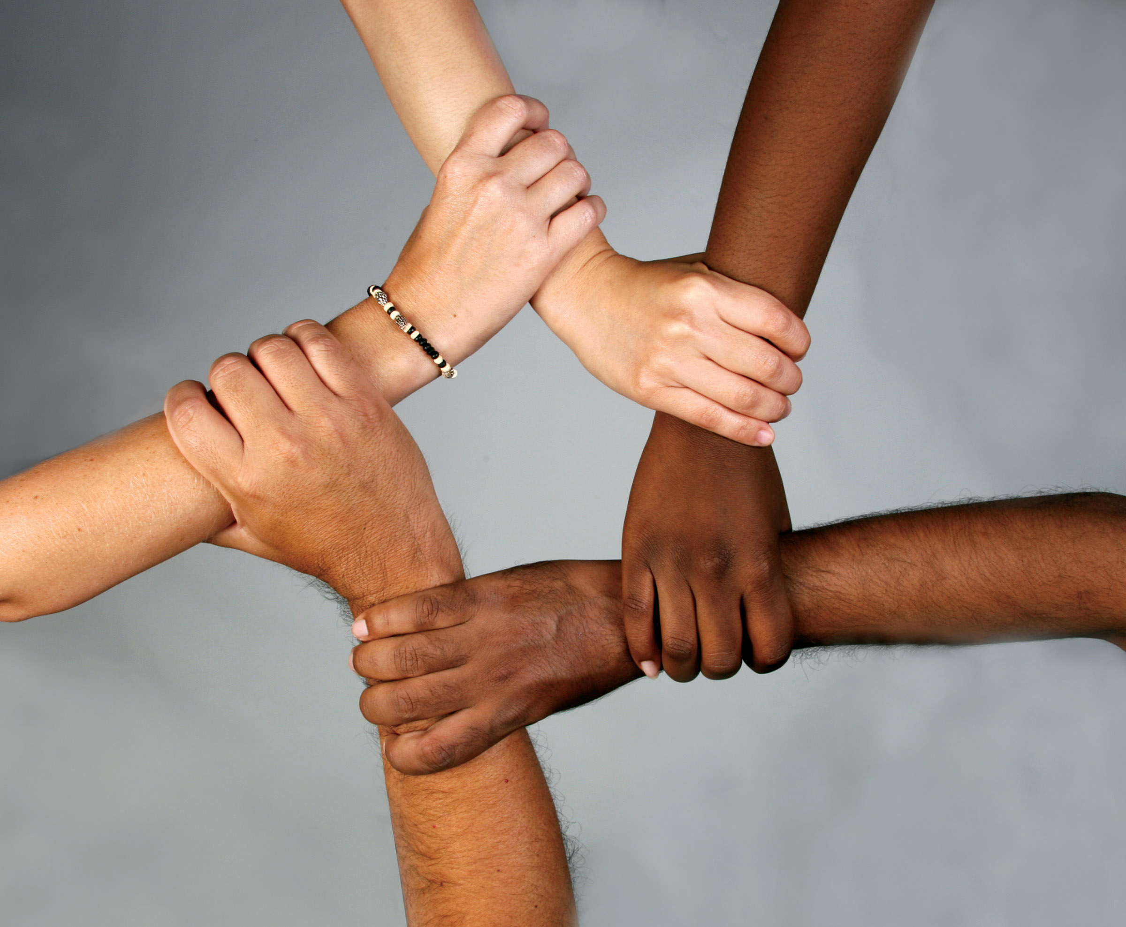

What’s involved?

Potentially there are three stages to the process.

- Screening
- Data gathering and analysis
- Consultation

Screening

The council provides a form for use by officers completing equality impact assessments. This document is used to capture all the relevant information. A copy of the form is attached.

It is suggested that you undertake your EqIA with other officers with whom you can discuss ideas of possible barriers to service for all equality groups and not undertake your EqIA on your own.

At the screening stage, the policies, procedures, strategies and services that have clear equality and diversity implications will need to be identified.

You will need to think about the policy, procedure, strategy or service being screened and ask the following questions:-
- Does the policy, procedure strategy or service affect; people, service users, council staff, residents or the public?
- Does the policy, procedure, strategy or service involve the allocation of council resources or benefits to residents or communities? Is it possible that this will benefit some sections of the community more than others?
- Who are the end users of the policy, procedure, strategy or service?
- Do you have to attract users to your service or facility?
If the answer is “yes” to any of these questions, then you should complete the screening form and progress to the data gathering stage.
If the answer to all questions is “no” then there is no reason to go beyond the screening stage. It is unlikely that every policy, procedure, strategy or service you have will need to be subject to all three stages of the process – only those with clear equality and diversity implications will need to be carried through to the data gathering and consultation stages. Some policies, procedures, strategies or services will not have equality and diversity implications or existing data may show that there are no groups accessing the service more or achieving better outcomes than other groups. These EqIAs should be submitted to the directorate Quality Assurance Panel to be signed off.
Data gathering & analysis
The use of data in the EqIA process is extremely important. If you do not have the data necessary to allow you to make an informed decision about whether your policy, procedure, strategy or service impacts on any group within the community, you must make every effort to collect it.
Gathering and analysing equality data will identify any groups who are accessing a service more or achieving better outcomes than other groups.
The IDeA suggests that potential sources of information for EqIAs include:-
- any previous equality impact assessment
- service monitoring reports
- previous research and customer satisfaction surveys
- user feedback and satisfaction reports
- workforce monitoring
- staff surveys, opinions and information from trade unions
- contract monitoring reports
- complaints and comments
- press coverage
- outcome of consultation exercises
- feedback from focus groups
- feedback from individuals or organisations representing the interests of key target groups or similar
- the knowledge, technical advice, expertise and experience of the people assisting in the completion of the EqIA
- national, regional and local statistics
- information from formal audits
- census data
- academic, qualitative and quantitative research
- demographics.
If no data is available, you should try and collect data from other sources, for example, other providers of the service, focus groups. In the meantime, however, you should make provision to collect the data.
There are a variety of ways to collect the relevant data:
- Include equality monitoring forms in customer communications.
- Use equality monitoring to compare the equalities make-up of your service users with the broader make-up of Salford as a whole;
- Analyse and monitor incoming complaints.
- Seek feedback from front-line staff who deal with members of the public
- Compare your service against other councils;
- Monitor national campaigns by groups representing the six equality and diversity strands.
When you obtain this data you should be able to determine whether some people are accessing services less than others.
For example, suppose that only 2% of users of a library service provided by a council have Black, Minority, Ethnic (BME) heritage, but 10% of the area’s population have BME heritage. This means that a disproportionate percentage of people with a BME heritage are using the library service. You need to find out why and whether there are any barriers which can be removed.
You will also be able to identify whether some people are experiencing less favourable outcomes than others.
For example, if a disproportionate number of a particular group are successful or unsuccessful job applicants.
Consultation
Where the data shows one or more groups accessing a service more or achieving better outcomes than other groups the next step is to consider how the barriers can be removed.
The consultation steps are as follows:
Consult
Plan
Implement
Track changes

Consultation
You should consult with those groups who are accessing a service less or achieving worse outcomes than other groups.
This can be done via surveys, focus groups or consultation events. There are a number of other methods of engaging relevant groups:
- council staff groups such as the Black, Minority Ethnic (BME) staff group, the Lesbian, Gay, Bi-sexual and Transgender (LGB&T) staff group and Equal in Salford (the Disability staff group) can be consulted;
- Relevant community and voluntary organisations can be consulted;
- Direct consultation with residents;
- Relevant charities and social enterprises can provide advice.
The next step involves preparing action plans, with realistic timescales to ensure that barriers are removed where some groups are accessing services more or achieving better outcomes than others.
Barriers that people face include:-
- Physical and geographic barriers
- Information and communication barriers
- Customer care and cultural barriers
- Stereotypes and assumptions
If a solution is not possible or practicable, or if a valid reason one or more groups accessing a service more or achieving better outcomes than other groups, these conclusions should be outlined and evidenced. Feedback must always be given to groups who have been involved in the consultation process, even if no action can be taken.
Where possible, changes must be implemented and, details recorded.

Further details

For audit purposes you need to keep an evidence file of your work on Equality Impact Assessments.

Completed screening forms should be stored in an equality and diversity evidence file.

For more information, please contact your directorate’s equality and diversity lead officer. Please see back of document for details.

Appendices
1.0 Equality Impact Assessment Flowchart
SCREENING

Does the policy, procedure or service have equality and diversity relevance?
Complete screening document
Does the data show that one or more groups are accessing a service more or achieving better outcomes than other groups
Yes
You need to gather data and then complete the screening document
No
Consultation
Yes
Is there any data available on which equality groups access services (age, race, religion or belief, disability, sexual orientation and gender?
Yes
No
Submit to Quality Assurance panel
Consult with all the relevant equality groups to identify methods of removing barriers. Prepare action plan.
Submit to Quality Assurance Panel.
Publish results on the internet and schedule a three yearly review
Implement solutions identified at consultation and feedback to consultees

2.0 Screening Form

Person or person’s responsible for the assessment
(Please note that it is advisable that you undertake your EqIA in a group)
Directorate
Name of policy, procedure, strategy or procedure to be assessed
Date of assessment
Please provide a brief description of the policy, procedure, strategy or service or the proposed change
If you are considering a strategy or service, please list any related policies
What factors could affect the outcome e.g. change in legislation, resources
What are the aims of the service, strategy, policy or procedure
It is important to get this right as they will be the focus of the EqIA
Please list any group who has an interest in or who will benefit from the policy, strategy, service or procedure.
How does the policy, strategy, service or procedure promote community cohesion?
If community cohesion is relevant to your policy, strategy, service or procedure what steps will you take to promote it?
If you do not consider that community cohesion is relevant to your policy, strategy, service or procedure, please explain why.
Please list any aspects of your service or policy which are delivered externally or with external partners.
Has the procurement equality procedure been followed in each case?
Data analysis
Age
Please list any relevant, monitoring data you have e.g. census data, local ward data, tenant profiles
Do you have equality monitoring data on access to services? If no, please go to Consultation stage
Please list any relevant access to services data you have
When comparing the relevant data with your access to services data are there any groups that are over or under represented? Please list.

Do you have equality monitoring data on outcomes for different groups – if no go to consultation
Please list any relevant outcomes data you have
When comparing the relevant data with your outcomes data are there any groups that are over or under represented? Please list.

Have you identified any unfavourable impact from the data analysis for any group(s)
Can this unfavourable impact be justified? For example, having a women’s refuge for victims of domestic abuse may be justified.

Disability
Please list any relevant, monitoring data you have e.g. census data, local ward data, tenant profiles
Do you have equality monitoring data on access to services? If no, please go to Consultation stage
Please list any relevant access to services data you have
When comparing the relevant data with your access to services data are there any groups that are over or under represented? Please list.

Do you have equality monitoring data on outcomes for different groups – if no go to consultation
Please list any relevant outcomes data you have
When comparing the relevant data with your outcomes data are there any groups that are over or under represented? Please list.

Have you identified any unfavourable impact from the data analysis for any group(s)
Can this unfavourable impact be justified

Gender
Please list any relevant, monitoring data you have e.g. census data, local ward data, tenant profiles
Do you have equality monitoring data on access to services? If no, please go to Consultation stage
Please list any relevant access to services data you have
When comparing the relevant data with your access to services data are there any groups that are over or under represented? Please list.

Do you have equality monitoring data on outcomes for different groups – if no go to consultation
Please list any relevant outcomes data you have
When comparing the relevant data with your outcomes data are there any groups that are over or under represented? Please list.

Have you identified any unfavourable impact from the data analysis for any group(s)
Can this unfavourable impact be justified?

Race
Please list any relevant, monitoring data you have e.g. census data, local ward data, tenant profiles
Do you have equality monitoring data on access to services? If no, please go to Consultation stage
Please list any relevant access to services data you have
When comparing the relevant data with your access to services data are there any groups that are over or under represented? Please list.

Do you have equality monitoring data on outcomes for different groups – if no go to consultation
Please list any relevant outcomes data you have
When comparing the relevant data with your outcomes data are there any groups that are over or under represented? Please list.

Have you identified any unfavourable impact from the data analysis for any group(s)
Can this unfavourable impact be justified?

Religion and/ or Belief
Please list any relevant, monitoring data you have e.g. census data, local ward data, tenant profiles
Do you have equality monitoring data on access to services? If no, please go to Consultation stage
Please list any relevant access to services data you have
When comparing the relevant data with your access to services data are there any groups that are over or under represented? Please list.

Do you have equality monitoring data on outcomes for different groups – if no go to consultation
Please list any relevant outcomes data you have
When comparing the relevant data with your outcomes data are there any groups that are over or under represented? Please list.

Have you identified any unfavourable impact from the data analysis for any group(s)
Can this unfavourable impact be justified?

Sexual Orientation
Please list any relevant, monitoring data you have e.g. census data, local ward data, tenant profiles
Do you have equality monitoring data on access to services? If no, please go to Consultation stage
Please list any relevant access to services data you have
When comparing the relevant data with your access to services data are there any groups that are over or under represented? Please list.

Do you have equality monitoring data on outcomes for different groups – if no go to consultation
Please list any relevant outcomes data you have
When comparing the relevant data with your outcomes data are there any groups that are over or under represented? Please list.

Have you identified any unfavourable impact from the data analysis for any group(s)
Can this unfavourable impact be justified?

Are there any human rights implications arising from your policy, procedure, strategy or service? Please detail (Please see guidance notes above)

Action plan following screening
Please list
1) Areas where one or more groups are accessing or achieving better outcomes than other groups
2) Actions required to remove barriers
Issue identified | Action required | Person Responsible |  | Date required by |  | Outcome
Issue identified | Action required | Person Responsible |  | Date required by |  | Outcome

Consultation
With whom have you consulted?
What consultation methods have you used?
When and where did you undertake consultation? (Date(s) and location(s))
What issues has your consultation identified:
- under representation when accessing services
- different outcomes for particular groups
For example, lack of information in community languages.
Have any groups not been included in the consultation?
How have you addressed this?
Is there a possibility that the strategy, policy or procedure may be damaging relations between different groups?
Action Plan following consultation
Please list issues identified from targeted consultation and actions required
Issue identified | Action required | Person Responsible | Date required by | Outcome
Issue identified | Action required | Person Responsible | Date required by | Outcome
Please ensure you have provided as much evidence as possible to support the responses you have given
Additional comments

Additional comments (continued)

Monitoring
How and when will the action plan be monitored?

How and when will outcomes be recorded?

With whom will the results of the EqIA be shared?

Have the actions been mainstreamed into the service plan?

Quality Assurance
When you have completed your EqIA, it must be submitted to your directorate EqIA Quality Assurance Panel for approval.
Signed:…………………………….. Dated ………… (Completing Officers)

Signed: ……………………………. Dated …………. (Lead Officer)

Signed ……………………………… Dated ………….. (Quality Assurance Panel)

…………………………… Dated …………..

…………………………… Dated ……………

……………………………… Dated ……………

Please note when completed this document must be published on the council’s internet pages.
www.salford.gov.uk

This EqIA must be reviewed every three years.

Next EqIA date……………………

Please send your approved EqIA to the Equality and Diversity Team
(e-mail: elaine.barber@salford.gov.uk), for publishing on the council’s web- site.

Contact Details

If you have any queries about the Equality Impact Assessment process please contact your
Directorate Lead Officer

Directorate Name Tel Number Email

Customer and Support Services Allison Lobley 0161 793 3003 allison.lobley@
salford.gov.uk

Environment Directorate Peter Chew 0161 920 8405 peter.chew@
salford.gov.uk

Chief Executive’s Lisa Slingsby 0161 793 3445 lisa.slingsby@
salford.gov.uk

Sustainable Regeneration Rob Pickering 0161 793 2818 rob.pickering@
salford.gov.uk

Children’s Services Paul Greenway 0161 778 0436 paul.greenway@
salford.gov.uk

Community Health & Social Care Keith Darragh 0161 793 3225 keith.darragh@
salford.gov.uk

Equality and Diversity Team
Salford Civic Centre
Chorley Road
Swinton
M27 5BN

Tel: 0161 793 3511
E-mail: elaine.barber@salford.gov.uk

Website address: www.salford.gov.uk

