PART 1  (OPEN TO THE PUBLIC) | ITEM NO. 7a

REPORT OF THE HEAD OF E-GOVERNMENT

TO CUSTOMER AND SUPPORT SERVICES SCRUTINY COMMITTEE
On 21ST March 2005

TITLE: e-Government Update

RECOMMENDATIONS: That this report is noted and supported by the C&SS scrutiny committee to enable implementation and drive improvements and efficiencies in delivering quality services to the citizens of Salford in line with government targets.

EXECUTIVE SUMMARY:

Over the last few years Salford City Council have been steadily working towards implementing the e-Government agenda in line with central government’s directive to modernise service delivery within local government.

ODPM target for E-government enablement (bvpi157) is to 100% by 31st December 2005.

Salford has made good progress, with the mapping, collating and e-enablement of services in ways that the citizen will use in order to meet the target of100% capability of electronic service delivery of government services, and has therefore set a local by March 2005 (as measured by BVPI 157 for local government services). Currently the e-enablement figure for the whole City Council stands at 96.98%.

e-Government progress to date – BVPI 157

- As at the 18th March 2005, The City Council have currently achieved 96.98% e-enablement towards the BVPI 157 target of 100% which needs to be achieved by March 2005. This level of performance is in the top quartile in comparison to other metropolitan councils and we are still very hopeful that we can meet our ambitious target, by completing the remaining 25 transactions in the next 2 weeks.
- Achieving the target ahead of schedule will allow the e-gov team and directorate co-ordinators to concentrate their efforts in implementing the ODPM priority outcomes and transformation areas, which are due for completion by the end of March 2006.

The following tables show the current status for all transactions and Directorates

 |  | %
Interactions Enabled | 728
Interaction Planned | 25
Barriers | 9
Total Interactions | 762
% Enablement | 96.68
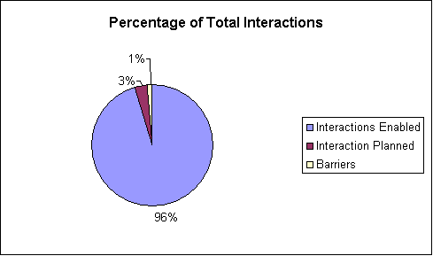
 | % Enabled
CHIEF EXECUTIVES | 98
Chief Executives - Per/Peform | 94
Chief Executives - Strat/Regen | 100
Chief Executives - Housing | 100
SOCIAL SERVICES | 97
CORPORATE SERVICES | 96
ENVIRONMENTAL SERVICES | 100
DEVELOPMENT SERVICES | 96
EDUCATION AND LEISURE | 95
HOUSING | 92

