3b

CLAREMONT / WEASTE COMMUNITY COMMITTEE
OCTOBER 2007

URBAN REGENERATION COMPANY (URC) SCHEMES

Committee will recall that the Central Salford URC has made £50,000 available to the Community Committee area for Neighbourhood Environmental Improvements. Committee undertook a brief prioritisation exercise and improvements to Hope Village shops was the top priority.

Groundwork on behalf of the URC have produced the attached schedule for work to achieve some very short-term environmental improvements. They are also working on a brief for a master planning exercise for the shops. At the time of writing this paper, I do not have the costs for the master planning work but I hope to have this by the time of the Committee meeting.

Depending on the final cost of the Hope Village shops work, there will probably be money left for further works. The other schemes which were prioritised at the earlier meeting were too expensive for this budget. Other possible schemes are:

- Completion of one or two alleygating schemes at the Height (referred to by Cllr Ferrer at the last meeting).
- Environmental improvements on Chandos Grove (Cllr Ainsworth can provide more detail)

Committee are invited to comment on / prioritise these options

Project / site name: |  | Community Committee Area
Eccles Road Shop fronts |  | Weaste and Seedley
Site information
Site address:  Eccles Old Road, Pendleton/Eccles |  | 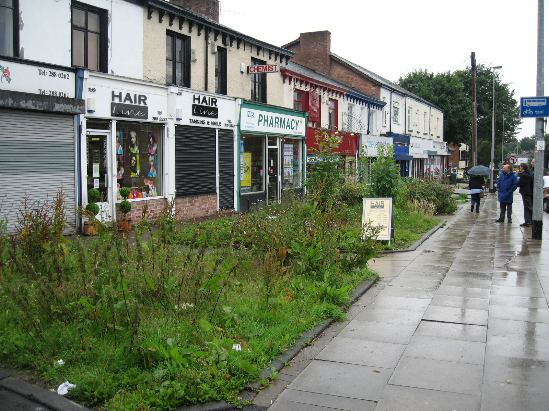
Size of site:
170m2
Site Ownership:
Shop owners and SCC
Land owner permission gained:
TBC
Current maintenance status:
Not visibly maintained.

Future maintenance status:
Currently getting in principle maintenance agreements from the shop owners.
Existing site conditions/ social problems around site:
Derelict planting beds with some planting that does not appear well maintained, the surfacing between the planter is in a fairly poor condition in parts and acceptable in others
Project priorities: Physical |  |  |  | Project priorities: Community involvement
- If sufficient funding available repair footpaths  - Replant planting beds with low maintenance trees and groundcover |  |  |  | - Would mainly be liaison with shop owners and informing users of shops.
Options / proposal (with approximate cost estimates)
Option 1  170m2 covers only the area of beds that we earmarked—not the entire line of shops.  Costs below are for dealing with softworks/beds only (not any of the hardscape surrounding the beds.)  Remove existing vegetation – 120m2 £300.00  Top up with topsoil £650.00  Plant up with low, spreading groundcover £2,000.00  Plant one small tree centre of each bed £750.00  Plant bulbs to come through groundcover £300.00  Total £4,000.00 |  |  |  | Eccles shop front improvements will be the first phase of a wider master plan for improvements in the Hope Village area.
Agreed Action
Option agreed | Consultation includes: Meeting, Consultation questionnaire, Door knock, Design consultation survey, Design an implementation notification, general resident liaison.
Budget allocated and delivery responsibility | Element |  | Amount |  | Delivered by
Budget allocated and delivery responsibility | Capital works |  | £4,000 |  | Groundwork
Budget allocated and delivery responsibility | Landscape fees |  | £600 |  | Groundwork
Budget allocated and delivery responsibility | Clerk of works
Budget allocated and delivery responsibility | Consultation |  | £1931 |  | Groundwork
Budget allocated and delivery responsibility | Total |  | Final budget yet to be confirmed

