

BUDGET CONSULTATION

2008/09

HAVE YOUR SAY


What is this paper about?
This paper is about giving you the opportunity to let us have your views on the priorities that you believe the council should be considering as part of its budget planning process for 2008/09.

It is designed to provide a brief summary of the City Council’s budget for 2007/08, giving details of how much is spent, where it is spent, where it comes from and the services we deliver.

A questionnaire designed to give us a greater understanding of the things that matter most to you is enclosed. These views along with those gathered at consultation meetings will be considered by councillors as part of the budget process and help us make informed decisions.

What is Budget Consultation?
The Council has to set a budget every year based on the cost of providing a wide range of services to residents and businesses in the City. In setting its budget, which in turn sets the level of Council Tax for the year, the Council is keen to hear the views of residents about spending priorities.

The Council has carried out budget consultation exercises in each of the last ten years. Councillors have considered the views and issues raised prior to taking final decisions about the amounts allocated to the various council services and also the level of the Council Tax increase.

The Council is currently developing its spending plans for the financial year April 2008 to March 2009. The Council expects to approve the proposed budget and Council Tax level at its meeting in February 2008.

In advance of this date consultation with the public about its financial plans will take place with Big Listening panel members, community committees, young and older people and at a public meeting in January 2008 at the Civic Centre. Your contribution to the debate on the Council’s spending priorities is welcomed.

What is the size of the City Councils budget?
The City Council’s budget in 2007/08 is £198.229m, this is net of service income generated from fees and charges, grants and other service related income. The grants include the government’s dedicated schools grant which was introduced in 2006/07 and provides the funding for schools. The services the budget is to be spent on are as follows:

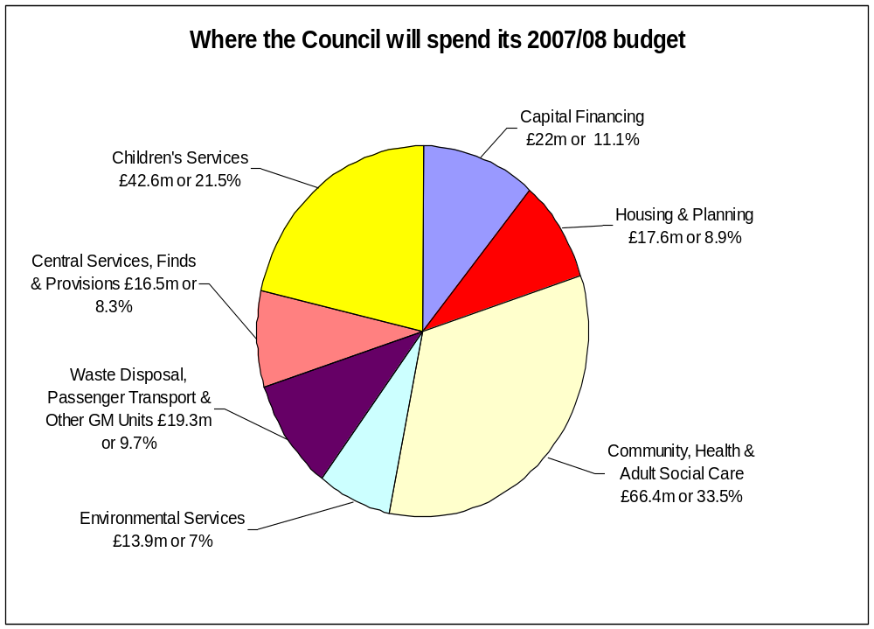

Whilst the council is responsible for a budget of £198.229m the way in which this can be spent on services is directed to a significant degree by the government. Children’s and Community Health and Social Care Services for example account for around 55% of council expenditure but there is limited discretion on how this money can be spent Similarly there are legal requirements to provide and contribute to the cost of other services, including passenger transport and waste disposal, which means that in any one year there is limited scope to reallocate spending from one service to another. It is however possible to increase spending on higher priority services by adopting a longer-term strategy.

Where does the money come from?
The city council’s budget requirement of £198.2m is funded from two main sources, the Government via its revenue support grant and the redistribution of income collected from business rates and council taxpayers via the council tax charge levied by the council. The position is summarised below:

ANALYSIS OF INCOME | Amounts in 2007/08 |  | Proportion of the Budget
 | £m |  | %
Central Government
Government revenue support grant | 16.6 |  | 8.4
Redistributed non domestic rates (business rates) | 99.0 |  | 49.9
 | 115.6 |  | 58.3
Council taxpayers | 82.6 |  | 41.7
 | 198.2 |  | 100.0

What other services does my Council Tax pay for?
In addition to the costs of the City Councils services your council tax also covers the precepts issued by the Greater Manchester Police and the Fire and Civil Defence Authorities. In summary the Council Tax for a Band D property is as follows:

SERVICES | Band D Council Tax 2007/08 | Proportion of the Council Tax Bill
 | £ | %
Salford City Council | 1,250.17 | 88.4
Greater Manchester Police Authority | 116.19 | 8.2
Greater Manchester Fire & Civil Defence Authority | 48.00 | 3.4
 | 1,414.36 | 100.0

Please note that over 54% of taxpayers in Salford live in Band A properties for which the Council Tax payable is £942.91.

Do we pay for Council Housing?
From 1st April 1990 it became a statutory requirement for local authorities to maintain a separate ‘ring-fenced’ account, known as the housing revenue account (HRA) which sets out the expenditure and income relating to the provision, supervision and management of council housing, flats and accommodation.

Under the ‘ring-fencing’ arrangements the costs of council housing are met from rents, government grants and other related income. Therefore, the costs of this service do not have any impact on the council tax you pay.

How do we decide what to spend the money on?
The City Council’s Best Value Performance Plan sets out our aspirations for the City and immediate targets for the Council. A summary of the plan was circulated in April to all households in Salford and was also made widely available in libraries and council offices.

The plan is structured to show how all of the services and activities are focused to build a culture of ‘One Council’ working to one set of priorities designed to deliver the Council’s seven pledges:

- Improving health
- Reducing crime
- Encouraging learning, leisure and creativity
- Investing in young people
- Promoting inclusion – tackling poverty and social inequalities
- Creating prosperity
- Enhancing life

The pledges have been aligned to establish a clear link between national government priorities, the priorities for the city as agreed with our local partners and the work of the council.

The financial resources required to deliver these pledges are controlled within a medium-term financial strategy. This strategy covers a three year period and is designed to ensure that there is a close relationship between the achievement of specific service results linked to the pledges and the allocation of resources to services.

The key priorities identified in the financial strategy have been to develop a budget which :

- Maintains priority services
- Delivers services which represent value for money
- Continues to seek increased efficiency from services
- Avoids cuts in any area of service
- Maintains the financial health of the Council
- Maintains a policy of low Council Tax increases, with Council Tax rises to be no more than 3% per annum for Salford’s services
- Reduces the capitalisation of revenue expenditure
- Makes appropriate allowance for expected pay and price inflation and other expected commitments over the next three years
- Ensures that reserves are supported by a detailed risk assessment
- Takes into account the results of public consultation.

Each year the Council reviews its services and overall performance and realigns its resources to deliver the Councils priorities for the year and its longer term aspirations as set out in its pledges.

What is the current position on the 2008/09 budget?
We are currently firming up our spending plans for next year which are initially based on providing the same level of service as last year. The plans will take into account the conclusions drawn from our review of services and include budget aspirations linked to the investment in services designed to deliver our pledges.

Later this year the government is scheduled to announce the outcome of its comprehensive spending review and in November/December it will provide provisional grant figures for the three years ending 2010/11. Indications are that they will need to tighten public expenditure and local government expenditure. As over 58% of the council’s spending needs is funded from this grant source this has a major impact on the council’s budget and the council tax level.

Initial forecasts of our spending requirements in 2008/09 compared to our estimate of the likely level of the governments financial settlement suggest that there will be a considerable shortfall of resources. Once again it is inevitable that difficult choices will have to be made as we strive to strike the right balance between providing the resources required to achieve of our plans whilst keeping to the priorities identified in the financial strategy. The Council is currently carrying out its annual service reviews which will include the identification of 3% efficiency savings from each of our services.

Are your views listened to?
The budget consultation process for the 2007/08 budget comprised a number of elements. A number of budget consultation questions were included on a questionnaire issued to the “Big Listening” forum. This consultation process was managed by MORI on behalf of the council and its partners.

In addition questionnaires were issued to people included on the council’s budget consultation database, which includes all members of community committees and tenant associations.

In liaison with the Youth Service questionnaires were issued to young people in Salford.

A public meeting was held on 16th January 2007. Some of the issues raised at this meeting were as follows:

- Crime and safety
- Youth centres
- Services for Old people
- Increase in council tax
- Recycling
- Policing
- Outsourcing of council services
- Council tax collection

There are a wide range of issues raised in these sessions covering a vast number of service areas. It is fair to say that the majority of concerns expressed via our consultation processes are shared by the Council and they are reflected in our pledges. The consultation process forms a significant role in the shaping of our budget strategy which in turn forms an important part in the delivery of our pledges and the development of our plans for improvement to our city.

Why should you take the time to contribute to the Budget Debate?
The City Council is again reviewing its services and challenging every area of its spending to ensure that it is used to provide effective services that meet the needs of its residents. It is essential to the success of that process that we continue to hear your views about the services that you value the most.

If you wish to have a greater say in the budget debate please may we encourage you to
attend the public budget consultation meeting to be held at the Civic Centre, Chorley Road, Swinton at 6 p.m. on Tuesday 15th January 2008.

Each community committee is also requested to consider their views on council spending priorities and to present them for consideration. You may wish to make your views known at your local community committee.

The short questionnaire enclosed with this booklet is designed to give us an indication of your priorities. Please can we ask you to spend a few minutes to complete it and return it by sending it to the freepost address:

Budget Consultation
Freepost RLUE-CELG-RHST,
Swinton.
M27 5FJ

The questionnaire is also available on the council website and can be completed and submitted electronically at www.salford.gov.uk/questionnaire-2008-09

You can also let us have your comments or request further information by:

- email: budgetconsultation@salford.gov.uk
- writing to: Budget Consultation, Freepost-RLUE-CELG-RHST, Swinton M27 5FJ
- telephoning: 0161 793 3057

If you have any special requirements such as access or languages please contact Carolyn Haslam on 0161 793 3057

More details of the budget proposals for next year can be found at www.salford.gov.uk/budget-consultation

