PUBLIC TOILET PROVISION IN SALFORD
FINAL REPORT OF THE SALFORD FORUM OF OLDER PEOPLE



“Good quality facilities make a practical difference to the quality of life of many in our communities.” Beverley Hughes (Department for Children Schools and Families)

CONTENTS
Scrutiny Chair’s Foreword | 3
Executive Summary | 4
- Introduction | 10
- Reason for choosing this area of provision | 11
2.1 Importance of Public Toilets | 11
- Approach to the Scrutiny | 12
- Legislation and Further Background Information | 14
4.1 Legislation | 14
4.2 Improving Public Access to Better Quality Toilets | 15
4.3 Community Toilet Scheme | 16
4.4 Changing Places Toilets | 17
4.5 National Key Scheme | 18
- Current Situation in Salford | 18
- Information | 18
5.2 National Key Scheme | 19
5.3 Provision – Area Visits | 19
5.4 Changing Places Toilets | 23
5.5 Accessible Toilets | 24
5.6 Salford City Council Position | 24
- Recommendations | 25
- Conclusions | 31
Appendices | 32

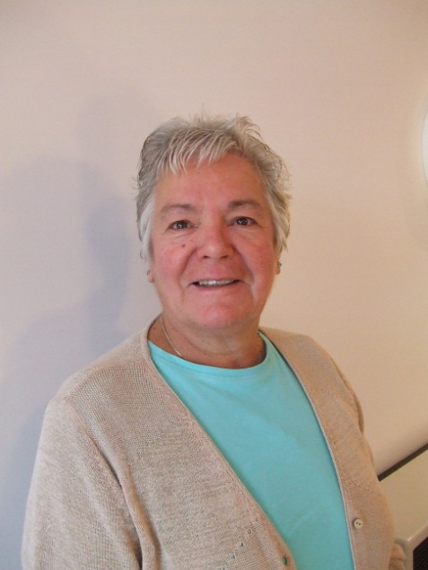
Scrutiny Chair’s Foreword

“At present provision of public toilets in Salford is not sufficient for everyone. The number of public toilets has been allowed to decline and this issue has not recently been considered by the relevant authorities.
The Salford Forum of Older People therefore came together to work on a piece of scrutiny work examining the current provision of toilets and how these facilities can be improved with the needs and wishes of older people and their carers in mind.
The list of recommendations in this report provides a basis for how members of the public feel that this can realistically be achieved. Whilst it is appreciated that the cost of these actions may be of a concern, it is suggested that much time and consideration is given in to addressing how this obstacle can be overcome in providing facilities of value and importance for the local community.
Finally, I would like to thank the members of the scrutiny team, staff and all members of the public who answered our questions.”
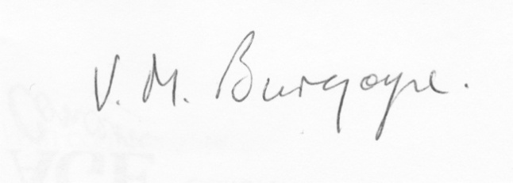
Valerie Burgoyne
If you would like to see any of the responses to questionnaires, correspondence or resources used for this scrutiny report please contact Kathleen Sheridan at Age Concern Salford, 0161 788 7300.
EXECUTIVE SUMMARY
Public Toilet provision was chosen as a scrutiny topic area by the Salford Forum of Older People to assess the effects that public toilet provision has on the health and wellbeing of older people, to examine what provision is already in place and whether it meets the needs of older people, and if appropriate to form recommendations to improve the facilities available.
The Scrutiny Team was formed of volunteers from the Salford Forum of Older People. They met monthly to plan work and exchange information, and worked hard in between to research the topic of public toilet provision.
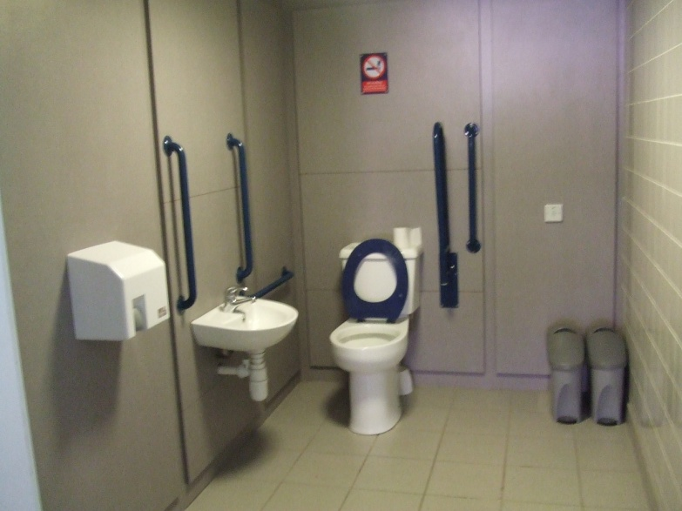
Much discussion was entered in to on the topic of the importance of public toilets. There are fears that the decline of public facilities will, as well as contributing to a general cycle of decline in local environments, cause anxiety and problems for older people who may rely on such facilities to lead full, active and sociable lives in the community.
The work was completed in three parts. The first part was undertaken by a subgroup of the scrutiny team who researched the legislation and background information to public toilets and took responsibility for establishing links with the city council and other relevant bodies. This
Toilet at Salford Central Railway Station

research then enabled the scrutiny team to again form smaller groups and make informed area visits to three localities in Salford. One of these was a tourist area, one was a shopping area and one was public transport related in order to give an overview of current provision. Facilities in these areas were assessed, photographs taken, and businesses approach to establish their stance on allowing the public access to their facilities. The third stage involved more research in to possible strategies to improve toilet provision in Salford in light of the challenges faced such as funding and anti-social behaviour. A number of solutions were investigated such as a Community Toilet Scheme, expansion of the National Key scheme, and the provision of more facilities on the back of national campaigns.
From this work the scrutiny team met and formed a list of recommendations which are detailed below:
- Information
- An up-to-date guide of accessible public toilets and opening times should be available in a format in addition to being online. This information should be produced in a leaflet or in local publications and available from a wide range of sources such as libraries, Gateways, doctors’ surgeries, community meetings and buildings etc.
- Information could be included in publications such as Life in Salford.
- This information should be available in alternative formats such as large print or in audio format.
- This information could be targeted by organisations to those with a health problem requiring increased use of toilet facilities or to isolated older people.
- Local businesses should be encouraged to provide information regarding toilet facilities available on their premises to be included in the council’s accessible toilet information.
- Information should include the location of the public toilets, the precise facilities available, a quality mark for each facility, whether there is a charge, and opening times.
- Local businesses should be encouraged to put a set policy in place regarding use of their toilet facilities by customers and non-customers

- Signage
- Local businesses should be encouraged to provide comprehensive signage outside/in windows regarding toilet facilities available, such as that used in the Community Toilet Scheme (see fig 1 page 16).
- Adequate clear signage should be in place in shopping precincts, centres, parks and near public buildings and other places with high human traffic.
- Summary maps of public toilet facilities in the areas should be provided at central points, such as the information board in Eccles precinct.
- This signage should include distances to the toilet facilities and what toilet facilities are available.

- Provision
- Priority should be given to toilets in parks and shopping areas to promote exercise and independence.
- All parks should have manned toilet facilities.
- Accessible public toilets should be provided in all public buildings such as libraries.
- Toilets in bowlers’ buildings which are maintained by the council should be made available, even if only for a few hours a day with supervision and a charge.
- Other toilet facilities should be manned wherever possible. This will help the user to feel secure when using the facility and deter anti-social behaviour.
- Charging for some or all facilities should be considered to cover costs as it is in the power of the local authority to do so and will help to maintain standards.
- The number of toilets with adequate access for those with disabilities should be increased.
- A campaign should be taken to relevant transport bodies to improve provision of toilets at stations and transport hubs. They should be encouraged to investigate the Department for Transports Access for All Small Scheme funding to make improvements.

- Quality of Toilets
- Guidelines for the quality expectations of accessible public toilets should be produced in regards to both those in council owned sites and private businesses.
- All public toilets should meet quality expectations.
- Salford should aim to develop a quality mark for toilets and therefore be a leader in public toilet provision.

- Community Toilet Scheme
- The Community Toilet Scheme should be implemented in Salford, as piloted in Richmond upon Thames. This would involve the local authority or Government making a financial contribution to local businesses towards the upkeep of their toilet facilities and signage.
- Local businesses should be provided with support and resources to open their toilet facilities to the public.
- This scheme should be well publicised in the media and in line with the information and signage recommendations above.
- The scheme should adopt standardised signage across local businesses as in Richmond upon Thames.

- Local Authority Consideration

- The Government guidance Improving Access to Better Quality Public Toilets (2008)should be considered by Salford City Council
- An individual in the council should be appointed to take responsibility for the issue of public toilet provision outside of parks and cemeteries.
- Relevant local authorities should view and consider the EnCams toolkit on public toilets and implement it in to a public toilet strategy.
- A public toilet strategy should be developed.

- National Key Scheme
- It should be considered that the RADAR key scheme is made available to more groups of people to whom public toilet provision is important, for example those with incontinence problems who may not be categorised as disabled.
- More information should be available in each locality regarding the location of RADAR toilets.
- RADAR toilets should always be well signed.
- There should be more publicity detailing where RADAR keys are available from.
- The system / application process for obtaining a key should also be clarified and well publicised so that it is clear.

- Changing Places Toilets and other Accessible Toilets
- An accessible toilet should be available in all areas of the city.
- The planning of accessible toilets should be thorough, to support all needs.
- The Changing Places campaign should be supported in Salford and Changing Places facilities sought for Salford’s public buildings.
- Relevant bodies: Ian Stewart, Salford City Council, the Forum scrutiny team, MENCAP, should liaise to promote this campaign in Salford.

- Scrutiny Process
- Following presentation to the scrutiny committee, the Salford Forum of Older People scrutiny team should revisit the scrutiny committee after six months to find out how the recommendations have been taken forward.
- Regular feedback and meetings should be set up between the Salford Forum of Older People scrutiny team and a relevant council official to assess how this report has been taken forward.
At present provision of public toilets in Salford is not sufficient for everyone. The number of public toilets has been allowed to decline and this issue has not recently been considered by the relevant authorities.
It is important that the issue of public toilet provision is recognised and that it is appreciated that the need for public toilets is imperative to everyone, but that older people and their carers and relatives especially are currently not considered far enough in this provision.
Establishing public toilets as a priority and acting on the recommendations laid out in this scrutiny can have a positive and significant impact on the quality of the lives of older people in Salford and also it is believed on the local environment, which will be beneficial to everyone.

PUBLIC TOILET PROVISION IN SALFORD
REPORT OF THE SALFORD FORUM OF OLDER PEOPLE
- Introduction
“A lack of accessible and good public toilets affects not only the quality of our town centres, parks or bus stations, it also reduces the dignity and quality of people’s lives.” Baroness Andrews OBE, Communities and Local Government.
The numbers of public toilets have declined rapidly in the past few years, despite them being a necessary facility for all and a way of maintaining a clean and pleasant local environment. The Salford Forum of Older People have chosen to scrutinize this area of service provision due to the concerns that this perceived lack of provision is affecting the lives of older people, their carers and relatives in a negative way through contributing to anxiety, social isolation and lack of confidence and feelings of security, as well as fears of a decline in the local environment.
This scrutiny was carried out over a period of six months by a designated scrutiny team from the Forum and consisted of making area visits to toilet facilities, corresponding with local and transport authorities, private businesses, campaigning bodies, charities and MPs and bringing all this information together at team meetings to form a set of clear and powerful recommendations.
This report aims to highlight the overlooked importance of public toilet facilities, with particular regards to the needs of older people, to provide background information to the provision of them, and to make recommendations to overcome obstacles and improve access to better quality public toilets for all.

- Reason for Choosing this Area of Service Provision
At the initial meeting of the Salford Forum of Older People Scrutiny Team in March 2009, public toilet provision was decided as a key issue to be scrutinised in tackling issues faced by older people, in ensuring services are planned with their needs in mind, and in the promotion of wellbeing in all areas of their lives.
It was discussed by the scrutiny team that the quality and quantity of public toilets has declined significantly over the past few years, which is a country wide trend. The British Toilet Association state that 20% of public toilet facilities have closed over the past three years despite them serving what is a basic unavoidable human need.
The provision of public toilets is particularly important in what are considered to be priorities by the Salford Forum of Older People of combating social isolation and in promoting health and wellbeing.
Adequate provision of public toilets is also in line with a number of key priorities in Salford’s Wellbeing strategy for growing older in Salford:
- Feeling safe and secure
- Involve older people
- Be healthy and active
- Get around in Salford
- Services sensitive to need
- Access good information
2.1 Importance of Public Toilets
The scrutiny team place a great deal on emphasis on the importance of public toilets due to expressed fears that a review of these services would not be taken seriously, and that the debilitating effect a lack of provision can have on the lives of some older people and those with disabilities is not widely seen.
The importance of adequate public toilet provision and the difference it can make can be seen in quotations gathered from older people in Salford:
“I feel like I can’t take my grandchildren to the park because
there are no public toilets and I might need them....it stops me,
not knowing what is there.”

“I plan my route and time carefully so I can get out to the
shops and back again before I need the toilet! If there were
some on the way I might stay out longer.”

“I would be quite apprehensive about locking myself in it...it’s
very dirty and doesn’t feel safe at all.”

And from carers and relatives:
“I worry about taking my dad out as I don’t know if there’ll
be toilet facilities as he needs them and I like to know, before
we go that it’ll be ok.”

The expressed concerns that lack of public toilets can make older people feel unable or reluctant to leave their homes for fear they won’t be able to find a public toilet highlight a possible contributory factor to social isolation, and one which can realistically be tackled. It is important that people have the confidence that facilities will be available when they are out and about. This was a point which the scrutiny team feel very strongly about and was a major contributor to the choice of public toilets as a scrutiny topic.
In addition to this the fact that lack of toilet facilities causes older people not to leave their homes may also have some effect on health. There is an importance in encouraging people to stay physically active, and if they are unable to venture in to the community confident that there will be adequate facilities available this is not successfully promoting a healthy lifestyle amongst older people.
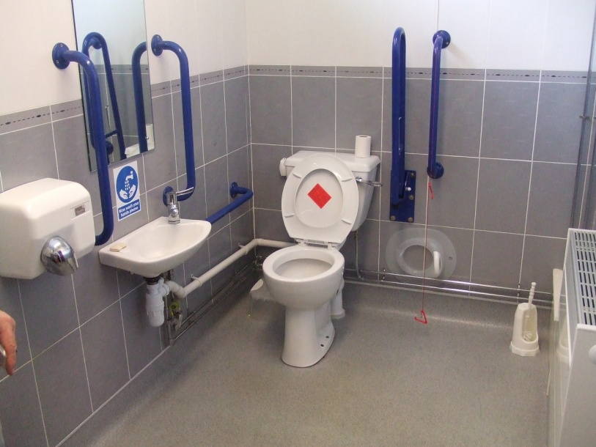
It was widely felt that there was not sufficient provision for everybody in Salford, but that older people are particularly let down as they are one of the groups who may rely on such provision the most. In addition it was noted that allowances made for this kind of reliance on public toilets such as the RADAR keys, which allow access to a number of toilet facilities for those on the disability register, are inadequate as the urgent use of such facilities may not necessarily be due to a physical disability but for other health reasons such as incontinence or the use of water tablets. Therefore, whilst being positive steps, these schemes overlook and neglect the needs of older people.
Princes Park Garden Centre Facilities

Public toilets also make a valuable contribution to maintaining the cleanliness of the environment and preventing the need for cleaning services of human fluids. Lack of facilities can contribute to dirty streets and feelings of insecurity, as detailed by EnCams. This reduction in the quality of the local environment also shows the importance of public toilet facilities.
For the above reasons it is clear that public toilets should be an issue of priority and taken seriously. In summary it was felt that public toilets are an important facility in the lives of many, especially older people and those with disabilities, and that currently this area of service provision was not meeting the needs of these groups. Consequently, it was felt that scrutinizing the service area would be beneficial and may lead to positive outcomes for these groups and wider benefits for communities in Salford.
- Approach to the scrutiny
The Scrutiny Team was formed of volunteers from the Salford Forum of Older People. The Public Toilet Scrutiny Team was supported by workers from Age Concern Salford and met once monthly to plan work and share information. A subgroup was also formed from this team to investigate background information and legislation and to also plan full team meetings. They also met monthly. A list of team members can be seen in appendix 2.
The public toilet scrutiny team researched and collaborated background information regarding public toilets and used this to approach contacts in Salford City Council in order to find out the position in Salford. Concurrently the team chose as a group three areas of Salford to visit and record the current provision of public toilets, and to compare the quantity and quality of provision to relevant guidance. This was done in smaller groups made from the scrutiny team. The information gathered was summarised and formed the recommendations laid out in this report.
- Legislation and Further Background Information
4.1 Legislation
Legislation concerning public conveniences is not comprehensive. Under section 87 of the Public Health Act 1936 the provision and maintenance of public toilets is a power rather that a duty of local authorities. Under section 87 (3) (c) of this act, local authorities have the power to charge for the use of these conveniences with the exception of urinals. The decision therefore whether and how far to provide these facilities is at the local authority’s discretion based on the resources available to them. There is no legislation regarding the quality of public toilets provided.
Public Toilets have been closing at an increased rate over the past few years. The cause of this has been determined to increasing costs in running these facilities and public toilets being less of a priority than they once were. Closures are also largely sourced to the Disability Discrimination Act (1995) which requires toilets to be up to a set of standards that would involve a large cost to achieve and maintain. Local authorities do not have to provide toilets but if they do they should comply with the DDA (1995) standards. It is believed that many local authorities have used this Act as an excuse to close public toilet facilities. Public toilet information and campaigning bodies therefore attribute the closure of public toilets to DDA (1995) cost and the nuisance of anti-social behaviour.
There are six National Indicators (which manage local government performance and set their priorities) that can link to the provision of public toilets: NI4 (percentage of people who feel they can influence decisions in their locality); NI5 (overall/general satisfaction with local area); NI138 (satisfaction of people over 65 with both home and neighbourhood); NI140 (fair treatment by local services); and NI195 (improved street and environmental cleanliness). If public toilet provision is made a priority it should be considered that it is places within one or more of these national indicators.
4.2 Improving Public Access to Better Quality Toilets (2008)
In 2008 Communities and Local Government produced a piece of strategic guidance on public toilets. This is the first time that central government have produced a guide to enable better access to better quality public toilets. This outlined the reasons for the decline in public facilities, the reasons why public facilities are of high importance and suggestions and strategies to promote better access to better quality toilets.
Improving Public Access to Better Quality Toilets (2008) stipulates that public toilet facilities should be clean, regularly inspected and generally fit for purpose. It stresses the requirement for these facilities in regards to the “importance of decent and dignified provision when away from home”. The major initiative of this guidance is the recommendation that local authorities should adopt a Community Toilet Scheme.
4.3 Community Toilet Scheme
In this scheme local shops, cafes, public houses and public buildings are encouraged to invite the public to use their toilet facilities without expecting them to be a customer, and to display clear signage to facilitate this. In return the local authority would make a payment towards the upkeep of the facilities (£600 per annum, plus VAT, plus public indemnity insurance), and would make regular inspections to ensure standards are maintained.
This scheme has been successfully piloted in the London Borough of Richmond upon Thames. The Local Development Framework was used to engage 85 business members and a further 24 council owned sites in the community toilet scheme, making public toilets available to the public in their opening hours without the prerequisite of the person being a customer. All these toilets are free and cleaned daily. The businesses have the right to refuse usage in exceptional circumstances.
The scheme and the location of the toilets are advertised in a widely available leaflet and are updated on the internet. The leaflet can be picked up at council offices, libraries, tourist information centres, hospitals and doctors surgeries. In addition to this there is clear signage in the street and in windows detailing exactly what facilities are available by way of an identity sticker. These can be seen below. The Richmond upon Thames Community Toilet Scheme website also has interactive maps of facilities.
Figure 1

Approximately one third of the participants in the scheme provide wheelchair accessible facilities and one quarter provide baby changing facilities. The scheme has been welcomed enthusiastically by the public and has been successful from the point of view of business owners.
The Select Committee on Communities and Local Government Committee’s Twelfth Report welcomes this strategic guidance and encourages local authorities to adopt it. They too stipulate that clear signage is important and that there should be standard toilet signage across the country. In addition they recommend that local authorities ensure that they take public toilets in to account in needs assessments of older people and in supporting the independence of older people. The report goes further in proposing that this scheme could not meet the needs of everybody and that Local Authorities should supplement this provision with other toilet facilities. It suggests that Government should impose a duty on local authorities to develop a public toilet strategy.

Example of a Changing Places Toilet
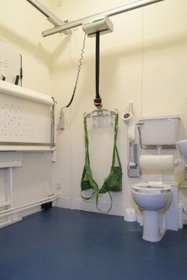
4.4 Changing Places Toilets
The Changing Places campaign is aiming
to increase provision of toilets for people
with profound and multiple disabilities who need special equipment and support from carers and is supported by charities such as MENCAP. They aim to have Changing Places toilets (toilets with the right space and equipment) installed in all large public buildings, and the 100th such toilet in the UK has recently been installed.

4.5 National Key Scheme

The National Key Scheme offers access for disabled people to approximately 7000 toilet facilities countrywide using a RADAR key and is operational in Salford. The purchaser of the key must be “chronically sick or has a disabling condition and is eligible to claim VAT relief for disabled people”. These toilets when locked can only be accessed by someone holding a RADAR key, but the National Key Scheme suggests that they should be left open and only locked under severe threat of vandalism.
RADAR makes no profit in providing the keys but makes a small charge to cover costs. This charge varies across areas and is therefore not consistent.
RADAR Key
.
- Current Situation in Salford
5.1 Information
When enquiring for information regarding the location of public toilets, members of the public are currently directed to the internet, the council WebPages and Disabled GO, a website engaged with Community Health and Social Care to provide this information. The list of accessible toilets from the Salford City Council website can be seen in appendix 3. This information is not as accurate and up to date as it could be and this method poses a problem for those without access to the internet.
Signage around Salford has also been reported as out of date. There is no current standardised signage for toilets.

5.2 National Key Scheme
There have been ad hoc reports that when purchasing a RADAR key in Salford the disabled register is not always checked. The keys allow access to numerous toilets in Salford, which can be seen in the list in appendix 3. The majority of these toilets in Salford remain locked. These toilets therefore can only be accessed by someone with a RADAR key. The scheme therefore does overlook the fact that people who require access to a toilet are not necessarily disabled.
The keys cost £3.45 from Crompton or Burrows house, but there is a lack of publicity and confusion over where they can definitely be obtained from.

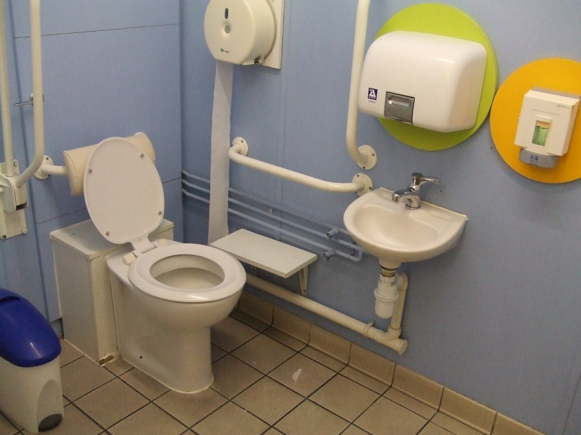
  - Provision - Area Visits
Scrutiny team members formed smaller groups and made visits to three areas of Salford as well as looking at an overview of facilities in parks. It was felt that three areas would provide a useful overview of provision whilst being a manageable undertaking by the scrutiny team.
Tesco Toilet

The three areas were intentionally chosen by the scrutiny team to provide a variety of types of area; two neighbourhood areas (a tourist area and a shopping area) and public transport hubs. The three areas visited were Irlam and Cadishead, Worsley and all railway stations.
It was decided that parks were important areas to consider in toilet provision as they were frequently mentioned in the process of deciding the scrutiny topic and gathering views of older people on public toilet provision. This was due to parks’ usefulness in combating social isolation and improving health and wellbeing.
In each area the team looked for and assessed public toilets. In addition to this the team felt it would be beneficial to visit businesses such as shops cafes and pubs who were likely to have toilet facilities to ascertain whether these facilities were accessible and available to the general public, and whether there was any consistency in opinion or issues with this within the private sector. All approached were found to be very helpful and interested in the issue of public toilet provision, particularly in regards to the Community Toilet Scheme, and many of those spoken to requested to be included for circulation of this report.
These private businesses were approached with a set questionnaire (Appendix 4). Questions included who maintains a list of accessible toilets, whether the council financially aid toilet providers and if there were any relevant appropriate reports.
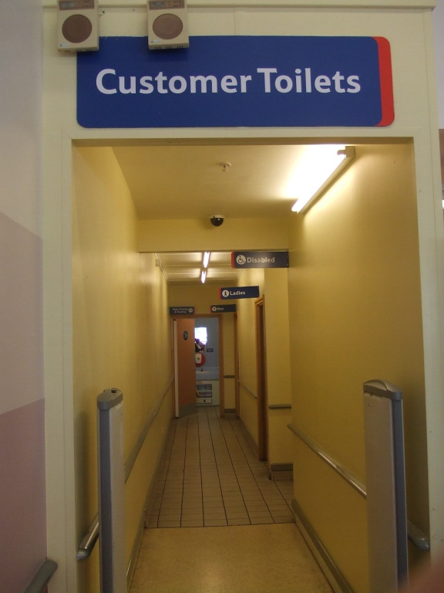
Irlam and Cadishead
Irlam and Cadishead hold numerous shops, a park and a leisure centre so sees a lot of human traffic. The shops are not held within a precinct and there is generally considered to be a lack of provision.
Toilets accessible to the public were found in Irlam library, and Princess Park Garden Centre. These toilets were cleaned, signposted and there is no charge.
Accessible toilets are also available in the catholic club and Irlam leisure centre but these were not signed from outside.
Tesco Toilet Signage
Tesco has accessible toilets which are cleaned and signposted but these are specified to be for customers only.
A number of pubs on the High Street in Cadishead were approached. None of these establishments had signage for toilet facilities, and would be reluctant to install it but would allow public to access to their toilets.
Worsley
Worsley has a long history of being a popular tourist area due to its attractive canal, industrial heritage and pleasant parks. Despite this, and the evidence that adequate toilet provision is an important factor in attracting tourism provision of public toilets was found to be very poor.
The toilet facilities were removed from Worsley Green due to misuse and lack of funds to man them.
Worsley Library has an accessible toilet but not for those with disabilities. There is no signage for the toilet and it is only accessible when the library is open.
Worsley Methodist Church has a toilet but it is only open to those using the church.
The Barton Arms were approached and stated that they would be willing to allow access to their toilet facilities to the public but not to under 14s unless supervised. These toilets have access for disabilities and are cleaned with signage inside the pub. The Milan Italian Restaurant was also approached and stated that access to toilet facilities would be at the owner’s discretion.
Railway Stations
Eight railway stations in Salford were visited: Salford Crescent, Salford Central, Clifton, Swinton, Moorside, Eccles, Patricroft, Walkden, Irlam. Of these eight stations only Salford Central and Salford Crescent had accessible toilet facilities and these were only available to those with radar key and were not signed (see picture below).
The responsibility for the railway stations and any facilities provided are with Northern Rail. Staff approached stated that the main reason for a lack of toilet provision was the likelihood of vandalism and the consequent need for the toilets to be manned, and that toilet facilities were available on the train.
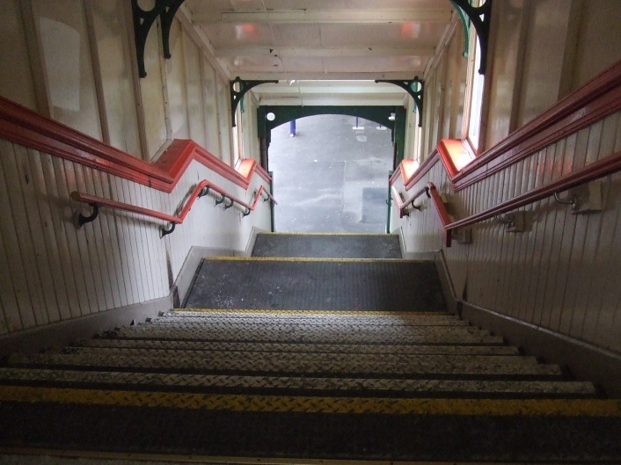
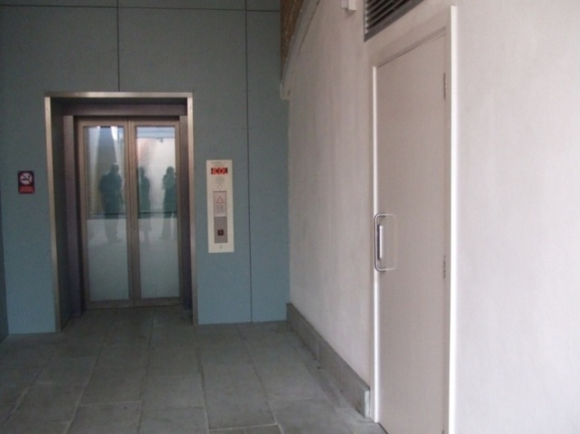
It was also noted that access to most stations is only by a steep flight of steps.
Patricroft Station
Salford Central RADAR Toilet
Parks
Toilets in parks are the responsibility of the Environment Directorate at Salford City Council and information detailing these was kindly provided by Annie Surtees and can be seen in Appendix 5.
There were two parks identified in each of the two neighbour areas visited and assessed by the scrutiny team.
In Worsley in Worsley Woods, a nature reserve there are no toilets, and in Boothsbank Park there are toilets in the bowling pavilion but these are accessible to bowlers only.
In Princes Park in Irlam there are toilets in the garden centre available to the public but only in garden centre opening hours. In Cadishead Park there are toilets in the community buildings but these are not accessible to the public.
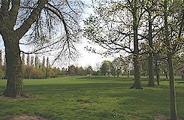
Of the twenty four parks listed in Salford, sixteen have toilet facilities within their boundaries, but only six of these are regularly open to the public with a further four dependent on staff presence or the existence of activities/events. It was
noted that there seems to be a fair number of toilet facilities accessible to bowlers only.
Princes Park

Summary of Area Visits
The areas visited did not have adequate provision of accessible public toilets for the wellbeing of visitors and the maintenance and cleanliness of the area. It was found that in each area with the exception of railway stations, that there was not a lack of facilities as such but that there was a lack of access to them for the public. This was particularly true in parks, and when including private businesses as all visited had toilet facilities. It was considered surprising especially that adequate toilet facilities were not available in the tourist area.
It was noted that quality of public toilets in manned places, especially in the private businesses was high. There is a preference for toilets housed within public buildings which feel secure, and some in local parks do not meet these needs.
Overall, private businesses were inconsistent and did not seem to have a set policy on whether they would be comfortable with non customers using their facilities. It was noted that breweries for example leave this decision to the discretion of individual landlords and therefore there is little consistency across establishments.
  - Changing Places Toilets
Salford currently does not have a Changing Places facility. Contact regarding this campaign was made by a scrutiny team member with Ian Stewart, Labour MP for Eccles. Mr Stewart fully supports the campaign and has taken it further with the Secretary of State for Communities and Local Government and Salford City Council.

It is noted that on the Salford City Council website, Pendleton Gateway and Walkden Gateway are listed as having a Changing Places toilet, but this is inaccurate as they do not have a changing bed.

  - Accessible Toilets
It was noted that some toilets in Salford which are advertised as accessible do not cater for all needs. For example, it is important that a handrail is provided on both sides of the toilet, that there is adequate space and that items such as soap dispensers are accessible for those in a wheelchair. This could be achieved by providing good quality versions of the above changing places toilets.

  - Salford City Council Position
All public toilet conveniences in Salford were decommissioned by the council several years ago with the exception of the precinct toilet in Eccles which is the responsibility of Urban Vision, although this is intended to be transferred to the precinct manager. Other precinct toilets are the responsibility for precinct managers. Any toilets at railway stations are the responsibility of northern rail and the MBC are responsible for the single toilet in the bus station in Eccles.
Salford City Council were approached with a set of questions from the scrutiny team regarding the council’s stance on toilets and whether the guidance Improving Public Access to Better Quality Public Toilets (2008) had been considered. The response to these questions suggested that it has not been and that there was not at present an official responsible or able to answer questions on this topic.
Currently the Environment Directorate of the council are only responsible for public toilets in parks and cemeteries and have a contact for these toilets. There is a problem with a lack of funding and it is foreseen that this problem will continue. It was difficult to ascertain a relevant contact for public toilets in general and whether the relevant guidance has been considered. It seems that the above guidance has not been considered in Salford and that there is no set strategy or policy regarding the provision of public toilets and how they are signed.
- Recommendations
1.Information
- An up-to-date guide of accessible public toilets and opening times should be available in a format in addition to being online. This information should be produced in a leaflet or in local publications and available from a wide range of sources such as libraries, Gateways, doctors surgeries, community meetings and buildings etc.
- This information should be available in alternative formats such as large print or in audio format.
- Information could be included in publications such as Life in Salford.
- This information could be targeted to those with a health problem requiring increased use of toilet facilities.
- Local businesses should be encouraged to provide information regarding toilet facilities available on their premises to be included in the council’s accessible toilet information.
- Information should include the location of the public toilets, the precise facilities available, a quality mark for each facility, whether there is a charge, and opening times.
This scrutiny identified the most important aspect of toilet provision to be clear information about where and what facilities are available.
Knowledge of this will give older people and those with disabilities the confidence to go out in to the community and to visit public areas as they can be sure that there needs will be catered for. How this information is presented is also of high importance, for example, whether most older people have access to the internet and whether those with visual impairments have been taken in to account and where are the most likely places for older people to retrieve information. Again, good provision of this information can instil confidence as well as clarifying any confusion in regards to provision for all involved.
- Signage
Related to good information on available toilets is the need for adequate signage. This ensures that visitors or those who have not received the information are well aware that there is access to facilities if they need them.
- Local businesses should be encouraged to put a set policy in place regarding use of their toilet facilities by customers and non-customers.
- Local businesses should be encouraged to provide comprehensive signage outside/in windows regarding toilet facilities available, such as that used in the Community Toilet Scheme (see fig 1 page 16).
- Adequate clear signage should be in place in shopping precincts, centres, parks and near public buildings and other places with high human traffic.
- Summary maps of public toilet facilities in the areas should be provided at central points, such as the information board in Eccles precinct.
- This signage should include distances to the toilet facilities and what toilet facilities are available.
Comprehensive signage in shopping areas, parks or tourist areas could be important for older people or those with disabilities who cannot walk far to find a toilet facility and/or need to plan their visit to the area carefully. Consistent signage in local businesses could also contribute to combating the social taboo and uncomfortable feelings of using facilities in a business without being a customer, as the person would then be clearly aware whether they are invited to use the facilities and what facilities are available.
- Provision
- Priority should be given to toilets in parks and shopping areas to promote exercise and independence.
- All parks should have manned toilet facilities.
- Accessible public toilets should be provided in all public buildings such as libraries.
- Toilets in bowlers’ buildings which are maintained by the council should be made available, even if only for a few hours a day with supervision and a charge.
- Other toilet facilities should be manned wherever possible. This will help the user to feel secure when using the facility and deter anti-social behaviour.
- Charging for some or all facilities should be considered to cover costs as it is in the power of the local authority to do so and will help to maintain standards.
- The number of toilets with adequate access for those with disabilities should be increased.
- A campaign should be taken to relevant transport bodies to improve provision of toilets at stations and transport hubs. They should be encouraged to investigate the Department for Transports Access for All Small Scheme funding to make improvements.

- Quality of Toilets
- Guidelines for the quality expectations of accessible public toilets should be produced in regards to both those in council owned sites and private businesses.
- All public toilets should meet quality expectations.
- Salford should aim to develop a quality mark for toilets and therefore be a leader in public toilet provision.

- Community Toilet Scheme
- The Community Toilet Scheme should be implemented in Salford, as piloted in Richmond upon Thames. This would involve the local authority or Government making a financial contribution to local businesses towards the upkeep of their toilet facilities and signage.
- Local businesses should be provided with support and resources to open their toilet facilities to the public.
- This scheme should be well publicised in the media and in line with the information and signage recommendations above.
- Local businesses should be encouraged to adopt the scheme on the basis that it will involve free advertising through scheme publications.
- The scheme should adopt standardised signage across local businesses as in Richmond upon Thames.
The implementation of a Community Toilet Scheme would be beneficial to all parties. More accessible toilets and better, clearer knowledge of where they are available would provide the public with key information when planning visits and dispel uncomfortable feelings of asking to use facilities. Business owners would also benefit from the support of this scheme and the positive feelings caused by it. In addition this is a more cost effective way of providing more toilet facilities without having the outlay of building new facilities. It has been successful in its pilot area and could therefore implementing it in Salford also could bring Salford to the forefront on this area of service provision.

- Local Authority Consideration

- The Government guidance Improving Access to Better Quality Public Toilets (2008)should be considered by Salford City Council
- An individual in the council should be appointed to take responsibility for the issue of public toilet provision outside of parks and cemeteries.
- Relevant local authorities should view and consider the EnCams toolkit on public toilets and implement it in to a public toilet strategy.
- It should be investigated whether there is a national body that could be contracted to maintain public toilets.
- A public toilet strategy should be developed.

- National Key Scheme
The National Key Scheme is currently working well in Salford, and is widely known about. The keys ensure that anti-social behaviour is limited and that toilets maintain an acceptable level of quality and security. There is however room for expansion in the scheme.
- It should be considered that the RADAR key scheme is made available to more groups of people to whom public toilet provision is important, for example those with incontinence problems who may not be categorised as disabled.
- More information should be available in each locality regarding the location of RADAR toilets.
- RADAR toilets should always be well signed.
- There should be more publicity detailing where RADAR keys are available from.
- The system / application process for obtaining a key should also be clarified and well publicised so that it is clear.

- Changing Places Toilets and other Accessible Toilets
It is important that as well as increased provision of public toilets is sought, increased provision of toilets which cater for those with complex needs is also sought to ensure fair, all-inclusive toilet provision is achieved.
- An accessible toilet should be available in all areas of the city.
- The planning of accessible toilets should be thorough, to support all needs.
- The Changing Places campaign should be supported in Salford and Changing Places facilities sought for Salford’s public buildings.
- Relevant bodies: Ian Stewart, Salford City Council, the Forum scrutiny team, MENCAP, should liaise to promote this campaign in Salford.

- Scrutiny Process
The Salford Forum of Older People have in the past undertaken three other pieces of scrutiny work and have been pleased with what these have achieved. They would like to ensure that this piece of work also contributes to the planning and review of services in Salford, and that it is taken forward effectively.
- Following presentation to the scrutiny committee, the Salford Forum of Older People scrutiny team should revisit the scrutiny committee after six months to find out how the recommendations have been taken forward.
- Regular feedback and meetings should be set up between the Salford Forum of Older People scrutiny team and a relevant council official to assess how this report has been taken forward.
- Conclusions
It is important that the issue of public toilet provision is recognised and that it is appreciated that the need for public toilets is imperative to everyone, but that older people and their carers and relatives especially are currently not considered far enough in this provision.
By considering the needs of older people in regards to toilet provision and the consequences of a lack of such provision agreed aims and objectives of key priorities such as those in the Wellbeing Strategy can be fulfilled as well as improving the quality of life for many older people.
Establishing public toilets as a priority and acting on the recommendations laid out in this scrutiny can have a positive and significant impact on the quality of the lives of older people in Salford and also it is believed on the local environment, which will be beneficial to everyone.

Appendix 1
SOURCES
EnCams Knowledge Bank: http://kb.keepbritaintidy.org/toilets/
British Toilet Association: http://www.britloos.co.uk/
Improving Public Access to Better Quality Toilets: A Strategic Guide (2008) Communities and Local Government www.communities.co.uk
Public Conveniences: Policy, Planning & Provision (2001) Steve Robinson, Institute of Waste Management.
National Key Scheme: http://www.radar.org.uk/radarwebsite/tabid/0/default.aspx
Community Toilet Scheme in Richmond upon Thames http://www.richmond.gov.uk/community_toilet_scheme

Appendix 2
Contributors to the Public Toilet Scrutiny
Scrutiny Team
Josie Browne Scrutiny Team Scrutiny Subgroup
Valerie Burgoyne Scrutiny Team Chair Scrutiny Subgroup
Chair
Jessie Davin Scrutiny Team
Gilbert Hearn Scrutiny Team
Keith Ivison Scrutiny Team
Wai Kwok Scrutiny Team Scrutiny Subgroup
Terry Mumford Scrutiny Team Scrutiny Subgroup
Beryl Murray Scrutiny Team
Bill Parkinson Scrutiny Team Scrutiny Subgroup
Daisy Shortman Scrutiny Team
June Smith Scrutiny Team Scrutiny Subgroup
Agnes Thorpe Scrutiny Team Scrutiny Subgroup
Derek Thorpe Scrutiny Team Scrutiny Subgroup

Other Contributors
Harry Worgan GMPTE
Annie Surtees Environment Directorate
Lisa Sharp Business Partnership Manager, Richmond
Upon Thames
Linda Sharples Scrutiny Support
Kathleen Sheridan Age Concern Salford
Mary Murphy Age Concern Salford
Paulette Holness Salford Community Health & Social Care
Directorate
Steve Durbar Sustainable Regeneration Directorate
Peter Chew Environment Directorate
Mary Ann Byrne Age Concern Salford
Mike Thwaites Age Concern Salford

Appendix 3.


Home » Living » Life events » Becoming disabled » Accessible toilets

Accessible toilets
If you are out spending your pounds, you need to know where is accessible and where you can spend a penny.

Eccles
- Albert Edward, Church Street - Radar Key
- Eccles Cross, Regent Street - Radar Key
- Eccles Gateway - Changing Places toilet
- Eccles metrolink/bus interchange (GMPTE) - Radar Key
- Eccles shopping precinct - Radar Key
- McDonalds restaurant, West One Retail Park
- Waterside restaurant, Monton

Irlam
- Railway Inn, Liverpool Road - Radar Key
Peel Green
- Eccles Rugby Club - Radar Key

Salford
- Mothercare, West One Retail Park - Radar Key
- Pendleton Gateway - Changing Places toilet
- Quay House Beefeater, The Quays - Radar Key
- Salford Shopping City - Radar Key
- Sainsbury, Regent Road - Radar Key
- Salford Central Station - Radar Key
- Salford City Reds Stadium - Radar Key
- Salford Crescent train station - Radar Key
- Salford Museum and Art Gallery - Radar Key
- Salford Shopping Centre - Radar Key
- Charlestown Library
- Ordsall Community Cafe
- Red Cinema at The Lowry Shopping Mall
- Salford Wheelchair Centre
- The Angel Healthy Living Centre, St Philips Square, Off Chapel Street
- The Lowry Shopping Mall

Swinton
- New Ellesmere, East Lancs Road - Radar Key
- Swinton shopping precinct - Radar Key
- Swinton Free House, Chorley Road - Radar Key
- Victoria Park - Radar Key
- ISIS Restaurant, Bolton Road
- Morrisons

Walkden
- Ellesmere Shopping Centre - Radar Key
- Tesco
- Walkden Gateway - Changing Places toilet

Worsley
- Barton Arms, Worsley - Radar Key
- Millers, Quayside Close, Boothstown - Radar Key
- Worsley Old Hall
- Boothstown Library

Appendix 4.
Scrutiny of toilets
Name:______________________________________________
Place being scrutinised:________________________________
Date:_______________________________________________
Do you have toilets? | Yes  No
Are they accessible to the public? | Yes  No
Is there access for all disabilities? | Yes  No
Is a radar key necessary? | Yes  No
Are they cleaned or manned? | Yes  No
Are they served i.e. opening and closing times? | Yes  No
What signage is there? | Yes  No
Is there a charge? | Yes  No
Any other information:
________________________________________________________________________________________________________________________________________________________________________________________________________________________________________________________________________________________________________________________________________________________________________________________________________

Toilet provision in Salford Parks Appendix 5

Community Committee Area | Site | Park Status | Current Provision | Opening Hours | Comments
Walkden & Little Hulton | Blackleach Country Park | Country Park | Toilets in Visitor Centre include disabled toilet and baby change | When visitor centre open:  Opening times vary depending on staffing | Improved signage planned
 | Peel Park | District | Toilets in Pavilion include disabled toilet and baby change | Open for park events and activities. Open at other times depending on staff presence
 | St Mary’s Park | Neighbourhood | Toilets in bowling pavilion | Accessible to bowlers only
 | Parr Fold Park | District | Toilets in Pavilion include disabled toilet | Open when sports attendants on site, afternoons and early evening April - September
 | Oakwood Park |  | None
Worsley & Boothstown | Worsley Woods | Local Nature Reserve | None
 | Boothsbank Park | Neighbourhood | Toilets in bowling pavilion | Accessible to bowlers only
Irlam & Cadishead | Prince’s Park | District Park | Toilets in garden centre | Open during garden centre opening hours
 | Cadishead Park |  |  |  | Toilets in community buildings – not accessible to public
Eccles | Winton Park | District Park | Toilets on site and within bowling pavilion | On site toilets open during events and activities
 | Eccles Rec | Neighbourhood Park | Toilets within bowling pavilion | Accessible to bowlers only
 | Patricroft Rec | Neighbourhood Park | Toilets within bowling pavilion also public toilets available
Claremont & Weaste | Buile Hill Park | District Park | Public toilets | Open when staff on site | Improved provision included in future parks improvement proposals. Currently no funding available
 | Lightoaks Park | Neighbourhood Park | None
 | Oakwood Park | Neighbourhood Park | None
Ordsall & Langworthy | Chimney Pot Park |  | Toilets within bowling pavilion | Accessible to bowlers only
 | Ordsall Park | Neighbourhood Park | Toilets on site and in separate building | Accessible to bowlers only | Toilet provision included as part of recommendation for master plan. Currently no funding available
Swinton | Clifton Country Park | Country Park | Toilets in Visitor Centre include disabled toilet and baby change | When visitor centre open  Summer opening hours: Daily except Wed: 9.30 am – 4.30pm  Winter: Daily except Wed 12.00 – 4.30
 | Victoria Park | District Park | Public toilets  Disabled toilets with radar lock | Open when gardener on site  8.00am to 3.00pm Monday to Friday
Central Salford | Albert Park | District Park | Toilets on site and within bowling pavilion | Open Mon – Fri 10am – 4.30pm  At weekends to support events and activities only | Signage needs improvement
 | Mandley Park |  | None |  | Toilet provision Included as part of recommendation for master plan. Currently no funding available
 | Clowes Park |  | Public Toilets
 | Kersal Dale | Local Nature Reserve | None
 | Kersal Moor | Local Nature Reserve | None

EnCams knowledge bank
British Toilet Association
EnCams Knowledge Bank
Improving Public Access to better Quality Public Toilets (2008)
Public Conveniences: Policy, Planning & Provision (2001)
EnCams Knowledge Bank
Public Conveniences : Policy, Planning and Provision (2001)
EnCams Knowledge Bank; British Toilet Association
http://www.radar.org.uk/radarwebsite/tabid/0/default.aspx
EnCams Knowledge Bank; British Toilet Association

