Artworks to LIFT Us Exhibition
Salford Museum and Art Gallery
9th February - 8th May 2008

Public Art for Salford's New Social Care and Health Centres
in Eccles, Pendleton and Walkden

The exhibition showcases drawings, models and prototypes of the designs, as well as highlighting the creative community engagement activities in which local people have participated.

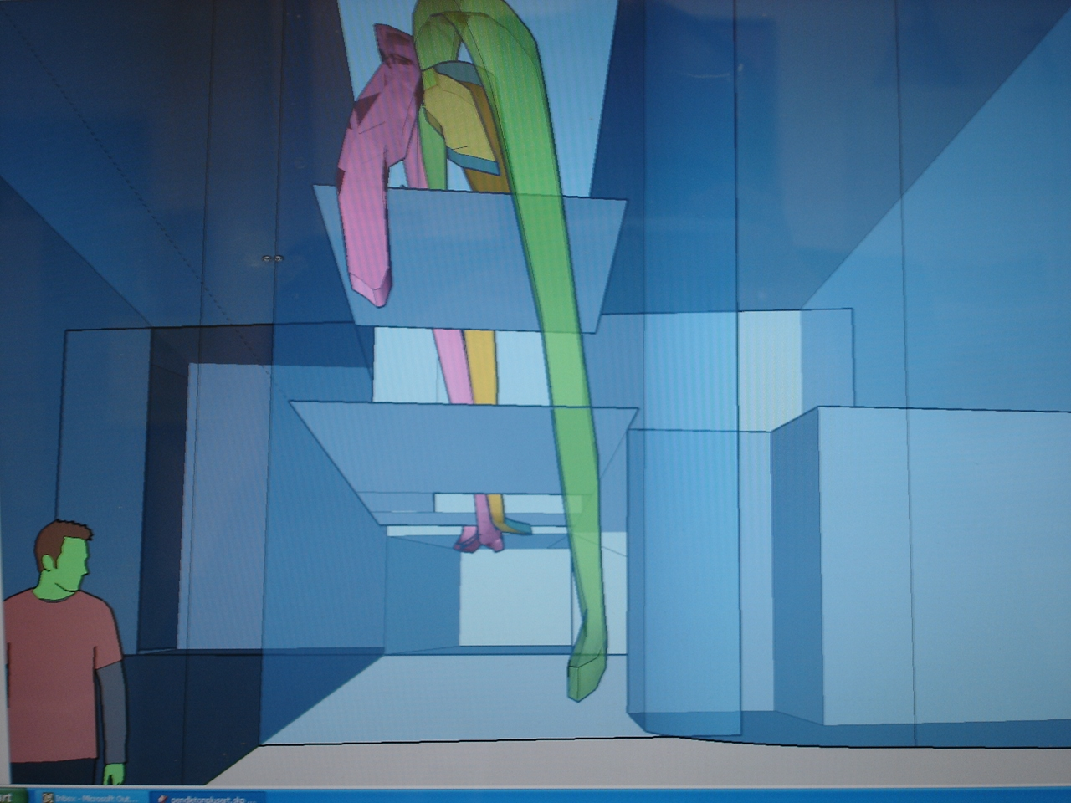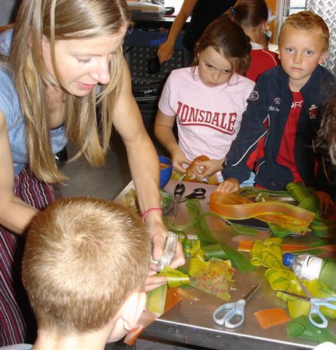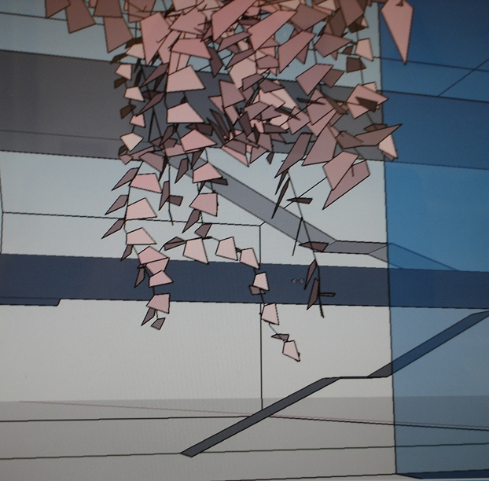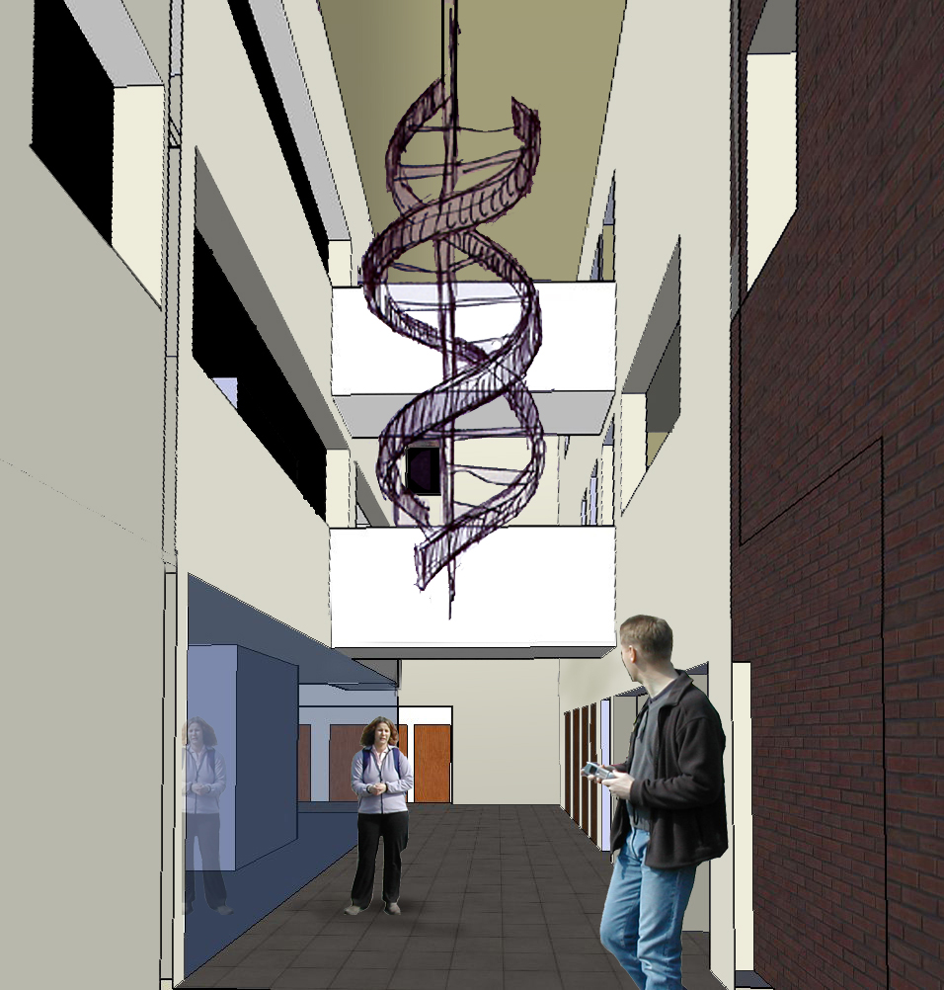
In Salford three new social care and health centres are being built in Eccles, Pendleton and Walkden. They are part of a national pilot to develop Local Improvement Finance Trust's (LIFT Centres) to house Primary Care community services, as well as the local public library and Salford Direct services.

Artists Stella Corrall, Rob Vale and Stephen Charnock have been commissioned to make a piece of artwork for each building and to include ideas from the local community. The Artists engaged local people in creative activities using film, animation, sculpture and creative writing to explore people’s ideas for the designs.

This exhibition is your opportunity to come and see what the artwork will look like and see how local people have been involved along the way.

For more information, please contact Andrea Bushell on 0161 778 0835 or email: andrea.bushell@salford.gov.uk

Salford Museum & Art Gallery, Peel Park, The Crescent, SALFORD, M5 4WU
Tel: 0161 778 0800
Opening hours: Mon-Fri 10am – 4.45pm; Sat & Sun 1pm - 5pm
Entry is free of charge!

