Report of the Strategic Director of Environment

to the

Lead Member for Environment
A Green Paper Discussion Document

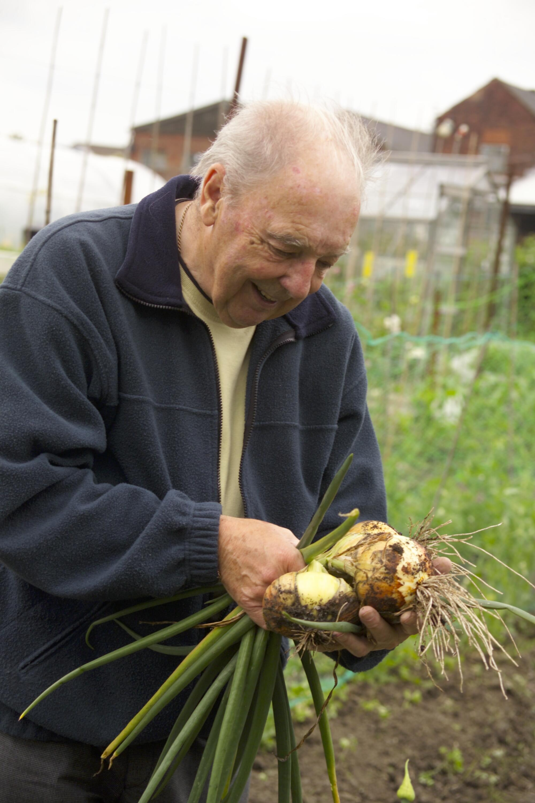
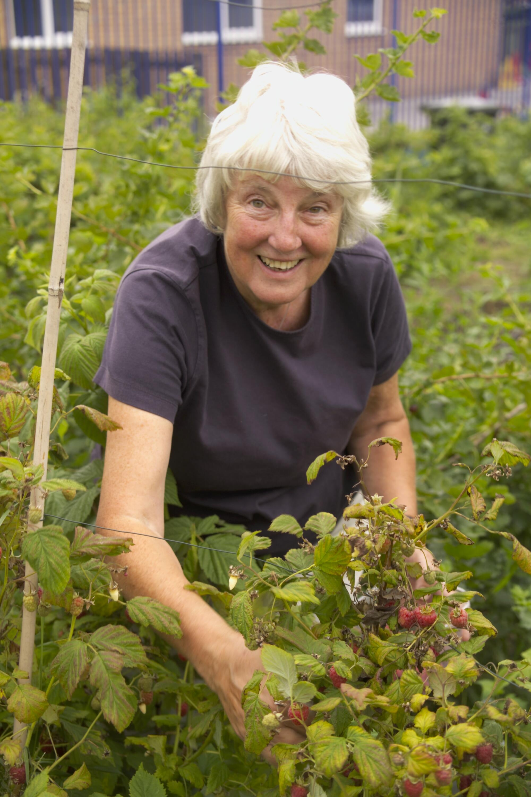

Developing the Future Direction of Salford’s Allotment Service

Prepared by: Alan Rowley - January 2008

Contents
 | Page
Introduction | 3
History of the Service | 4
Why provide allotments? – | 4
The Statutory Implements | 4
Smallholdings and Allotments Act, 1908
The Land Settlement (Facilities) Act, 1919
Allotments Act, 1922
Allotments Act, 1950
Local Government Act,, 1972
Local Government Planning and Land Act, 1980
National, Regional and Local Policies | 5
PPG17
Planning and Compulsory Purchase Act, 2004
Strong and Prosperous Communities (DCLG 1006)
Nature Conservation and Biodiversity SPD (2006)
Obesity
LAA (Partners in Salford 2007)
Planning Obligation Policy (SCC2006)
Financial Policies
The Community Plan
The Seven Themes of the Community Plan
How can allotments support the themes of the community plan? | 8
Cohesion, Improvements to Health, Learning and Creativity | 8
Improving the Environment | 8
Economic Value | 8
Community Engagement | 9
Environmental Sustainability | 9
Best Practice | 10
South Essex Partnership NHS Gold Award | 10
The ‘Cultivo’ Initiative, Nottingham | 10
Cawdor Street Allotment Association | 10
the current service in Salford | 11
SCC Rules and Regulations | 11
Resources | 11
Human
Financial
Land distribution
Land Quality
the service’s stated objectives | 14
The Allotment Charter | 14
What do stakeholders think of the service? | 15
Tenant Feedback | 15
Salford Allotment Association | 17
Cawdor Street Allotment Association and Swinton and District Allotment Association | 17
Primary Care Trust | 17
Missing Data | 17
How does the service measure against national standards? | 17
Availability | 17
National Society of Allotment and Leisure Gardens
Allotments Act 1908
A Chartermark assessment of the service | 19
Investors in People | 20

How does the service measure against the Salford City Council (SCC) Allotment Charter? | 20
How does the service compare with other local authorities on price? | 21
How does the service compare with other local authorities on self management? | 22
Key Issues for the service | 23
Proposed actions to move the City Council and its partners towards a strategy for allotments | 24
Recommendations | 25
Conclusions | 25
Bibliography and References | 26

Appendices
- Salford City Council Allotment Rules and Regulations 2001
- Salford City Council Capital investment programme for allotments
- Allotment Location Map
- Facilities available at allotment sites
- Tenant Feedback Survey Results received January 2007
- Monthly allotment status report August 2007
- Chartermark Assessment of the allotment service
- Allotment Service Development – Proposed Action Plan 2008

INTRODUCTION

The primary function of any allotment garden is the production of fresh, good quality food for the family and with more modern issues such as the use of pesticides and the arrival of GM crops, allotments are as relevant today as they were over 400 years ago, when the allotment movement first started to provide fresh fruit and vegetables for the ’landless poor’.
However, studies have shown that the benefits of allotments reach far beyond simple food production, allotments are now seen as having important social, health, environmental, financial and community benefits.

- Social benefits – in areas of large and dense populations such as the City of Salford, people can feel a sense of isolation due to the inability to develop social networks. Many see allotments as providing an antidote to the alienation of urban living as they become places where people can meet and discuss everyday life with new friends.
- Health benefits - research has shown a ‘synergistic benefit’ in adopting physical exercise while being directly exposed to nature. There are important public and environmental health implications to green exercise, as a fitter and more emotionally content population costs the economy less. There are also long-term health benefits resulting from a diet containing fresh fruit and vegetables. Therefore allotments have a great potential to stimulate interest in healthy eating and the environment, both key elements within the City’s Local Area Agreement.
- Environmental benefits – People are more concerned about the environmental impact of what they eat – and justifiably so. Of growing concern is the issue of the distance food travels before it reaches the plate. Reports show that in 2005, the environmental, social and economic costs of food transport amounted to over £9 bn annually. Ten million tonnes of carbon dioxide were emitted in the UK in 2002 as a result of food transportation which accounted for over a quarter of all HGV miles. As well as transportation issues allotments also have benefits regarding increasing biodiversity as the range of species which thrive on allotment sites is increasing whilst elsewhere in urban areas species diversity is reducing. Many allotment sites are now setting aside wildlife areas, as allotment holders say that watching wildlife on their sites contributes as much as the enjoyment of growing their own food.
- Financial - although some would argue that the cost of hiring an allotment and the fertilisers and seeds required can cost the same as buying the produce from a shop, the quality and freshness of the food is far superior, and once the initial work of the setting up of the allotment is completed costs for food production do reduce.
- Community - allotments do have strong ties with local communities, particularly local schools, disabled groups and often with the local PCT who use them in patient treatments. They provide hands on experience and are important elements in developing social cohesion and in relation to the issue of self management they meet a lot of the Government’s agenda in allowing local communities more self governance.

Despite this resurgence, like most Councils, Salford City Council (SCC) is legally responsible for a service that very much peaked during the second world war, with the “Dig for Victory” campaign”, and when the need for local food production abated due to cheap imports, then the service nationally fell into a slow but relentless decline. In more recent times and as a result of our changing life styles and a growing interest in organic foods, allotment gardens are beginning to undergo a renaissance particularly in young families. As such, allotments now have additional roles to play, as highlighted previously.

This report should be seen as a “Green Paper”, in that it acts as a strategic audit identifying the current situation regarding allotments and following further consultations will be developed and will put forward a series of actions which will lead to an improved allotments service within the City of Salford. Therefore the report should be seen as the first step towards developing a strategy to set out a sustainable future for the City of Salford’s allotments and help maximise their use in supporting the community’s agenda.

The main areas this first report will address are as follows :-

- Identifying the potential value of allotments
- Acknowledging the legislative and regulatory protection framework for allotments
- Identifying the current service provision and benchmarking this against other local authorities.
- Examining the benefits and opportunities for partnership working
- Identifying possible funding sources to improve the City’s allotments
- Determining customer satisfaction with the present service
- Identifying stakeholder needs for the future
- Identifying the key issues for the service
- Proposing an action plan for the next steps

History of the Service

In its origin the word “allotment” means a share of land “allocated or allotted to an individual as the result of an enclosure award”. The enclosure of land began in Tudor times but the first real legislation was the Enclosures Act of 1845. Since the beginning of the 20th Century there has been a succession of law, collectively known as the 'Allotments Acts'.

Many of the substantive provisions of the Acts refer to an “allotment garden” and this is defined by the Act of 1922 as meaning “an allotment not exceeding 40 poles (1011m2) in extent which is wholly or mainly cultivated by the occupier for the production of vegetables or fruit crops for consumption by himself or his family”. The majority of S.C.C allotment plots fall within this definition. The City also has a number of pigeon and stock plots and although used in the plots per household calculations within this report, they are not considered to be allotment gardens insofar as this report is concerned.

Like in many towns and cities, the main drivers in modern times behind allotment provision in Salford were the Wars of 1914-1918 and 1939-1945. As a result, allotment provision nationally, peaked at 1.1 million plots in 1950 and sank to 297,000 in 1996. This decline was partly due to the provision of Council housing accommodation with gardens and partly due to increased financial wealth in the population coupled with cheaper food. Salford’s allotments followed a very similar downward trend until quite recently when the community and our partners began pressing for an improvement to the service and to make it more widely available to our communities.

Why Provide Allotments?

THE STATUTORY IMPLEMENTS

Smallholdings and Allotments Act 1908
By section 3 of this Act, it was made the express duty of every allotments authority, where they are of the opinion that there is a demand for allotments in their area, to provide a sufficient number of them and then let them to persons resident in the area. If the duty is not carried out, an interested person would be able to apply for a judicial review and seek a mandatory order(1), in accordance with Part 55 of the Civil procedure rule.

Section 25 empowers allotment authorities to compulsorily purchase land to provide allotments.

(1)A "mandatory order" (until 1999 called an order of mandamus) is an order made by a court directing a public authority (technically, any person) to perform some duty which it ought to perform. New Civil Procedure Rules came into force on 26th April 1999 and renamed the old order of mandamus as a "mandatory order" (see CPR rule 54.1).

The Land Settlement (Facilities) Act 1919
Made a number of minor but important amendments in the 1908 Act, including making Metropolitan Borough Council's allotment authorities for the first time.

Allotments Act 1922
Gave some measure of security of tenure to the tenants of allotment gardens and improved the rights of tenants to compensation on termination; the Act has since been amended by the Local Government Act 1972 and the establishment of allotments committees is no longer compulsory for local authorities.

Section 22 defined an allotment garden as meaning “an allotment not exceeding forty poles in extent which is wholly or mainly cultivated by the occupier for the production of vegetable or fruit crops for consumption by himself or his family”

Allotments Act 1950
This Act improved security of tenure and also the compensation rights of tenants. It also restricts the obligations of local authorities in the matter of allotment provision (reduces the maximum size of an allotment garden from 40 poles to 20 poles) and increases the amount they may expend out of the rates on allotments (to what? - Nicki Smith checking)

Allotment-holders who have allowed their allotment plot to deteriorate through neglect should be made liable to pay compensation for dilapidation on quitting.

Section 10 states an Allotment Authority may charge such rent “as a tenant may reasonably be expected to pay for the land if let for such use on the terms (other than terms as to rent) on which it is in fact let”. The sub section goes on to provide that land may be let by an allotments authority “to a person at a less rent if the Council are satisfied that there exist special circumstances affecting that person, which render it proper for them to let the land to him at a less rent”.

Note : The present market value of 250m² (e.g. garden extensions) is £120 per annum.

Local Government Act, 1972
Made a number of amendments to the 1908 Act in matters of detail. One important change was to repeal Section 27(3) of the 1908 Act. This resulted in the removal of the restriction on the size of an allotment that may be let by a local authority to a single person.

Local Government Planning and Land Act, 1980 and Amendment Act, 1981
Consolidated planning legislation which has further influenced the forward planning of allotments
(The Law of Allotments 2002)

National, Regional and Local Policies

“Allotments, community gardens and city farms are valuable green spaces that can help improve people’s quality of life by promoting healthy food, exercise and community interaction. The Department for Communities and Local Government (DCLG) aims to ensure that these spaces are properly preserved, promoted and cared for”.
Urban Research Summary (DCLG 2006)

PPG17

“contains a range of policies designed to protect and enhance open space, sports and recreational facilities. It recognises allotments in its typology of open spaces. Local authorities should assess the existing and future needs of their communities for all open spaces of public value, including allotments. Local authorities should then plan to meet those needs”
Urban Research Summary (DCLG, 2006)

The companion guide to PPG17 anticipates increased demand from the growth of organic farming, increasing housing densities and a reduction in garden sizes, recommending local demand based standards (DCLG, 2002).

Planning and Compulsory Purchase Act (2004) - The Core Strategy
In compliance with the Act, the City Council is preparing a Core Strategy that will, amongst other things, set out the long-term spatial vision for the city until 2026 and the overall strategy for delivering that vision; It will identify the overall level of different types of development (including housing, employment, retail, and leisure) that is envisaged in the city during that period. Officers within the Environment Directorate are working closely with colleagues in Housing and Planning to ensure that the future demand for allotments is known and catered for.

Strong and Prosperous Communities (DCLG 2006)
Identifies a need to involve and consult service users more fully and to provide better information about standards in their local area. The Government is proposing to put measures in place to promote increased community ownership and management of local facilities and assets. Allotments provide a relatively inexpensive opportunity to bring like minded folk together, who can be supported and encouraged to form allotment associations and/or self management trusts. This would help the City Council to deliver on this agenda and provide improved services without incurring commensurate increases in costs.

City of Salford Unitary Development Plan 2004-2016 (UDP) (SCC 2006)
Salford UDP contains local policies for the protection and provision of recreation land and facilities:

Policy R1 – ‘Protection of Recreation Land and Facilities’ makes specific reference to ‘allotments’ as one of the existing types of recreation provision that are protected from inappropriate development.

Policy R2 – ‘Provision of Recreation Land and Facilities’ supports new and improved recreation provision provided that specific criteria are satisfied particularly to ensure that development does not cause unacceptable impacts.

Salford Greenspace Strategy Supplementary Planning Document (SCC 2006)
This document supplements the recreation policies in the UDP. The audit for this supplementary guidance identified 20.64ha of allotments in the city. A specific local standard was not identified however the principal of appropriate new and improved allotments will be supported.

Nature Conservation and Biodiversity Supplementary Planning Document (SCC 2006)
Implementing the Biodiversity Duty (DEFRA 2007)
Allotments sites provide one of the richest urban resources for wildlife. Both cultivated and empty plots, nectar producing plants, compost heaps, grass areas, sheds and stores, and the boundary hedges and banks all provide a variety of habitats, attracting birds, insects and small mammals.
Public authorities now have a duty to have regard to the conservation of biodiversity in exercising their functions.

Obesity
A recent report by Ken Fox, professor of exercise and health science at the University of Bristol. states that “nearly a quarter of adults are now judged to be obese and if current trends continue, 60% of men, 50% of women, and 26% of children and young people will be obese by 2050”. Regular physical effort, daily for many tenants, is required to manage an allotment. This burns calories and reduces the likelihood of obesity. There is also an added bonus in that once converted to the wonders of allotment gardening, a family will be more inclined to satisfy appetites with home grown vegetables, rather than resorting to other less healthy options.

LAA (Partners in Salford 2007)
An increasing focus on improving services in the wards of Ordsall, Irwell Riverside, Barton Winton, Langworthy, Little Hulton and Broughton. Environmental sustainability is a key objective, with good quality, well managed greenspaces being identified as a key mechanism for delivering a cleaner, greener more sustainable City.

Central Salford’s seven wards rank in the top 7% most deprived in the country. In Salford West, 25 of its super output areas fall within the 5% most deprived. (HMG National Statistics 2006). Many of the households in the more deprived areas do not have access to good quality allotments nor do they have gardens of a sufficient size to provide home produce. The many benefits of an allotment garden just cannot be realised by these communities unless they are prepared to travel considerable distances.

Planning Obligation Policy (SCC 2006)
The Planning Obligations Supplementary Planning Document (SPD) sets out the city council’s approach to planning obligations when considering planning applications for residential and commercial development in Salford. It provides clarity to developers, development control officers, stakeholders and local residents regarding the basis on which planning obligations will be sought and will assist in securing both local and national objectives in respect of the provision of sustainable development across the city.

The emphasis of the document is on securing the highest quality open spaces and recreation spaces within the city, coupled with a first class public realm. Financial contributions that are secured in accordance with the policies of the SPD will be invested in accordance with corporate strategies (e.g. an Allotment strategy) and local priorities identified in Community Action Plans.

Financial Policies
The Government has placed a duty on Councils to deliver services to clear standards of cost and quality by the most economic, efficient and effective means available. The City Council is presently under pressure to make considerable revenue savings over the next 3 years. The way allotments are administered, managed and maintained needs close scrutiny to ensure compliance with this requirement but when compared with some other methods of supporting the community themes, this service can be very cost effective, if managed correctly.

The Community Plan
The community plan was launched in December 2005 by the City of Salford’s Local Strategic Partnership. It sets out a clear vision and a number of challenging ambitions. The vision statement reads;

“In 2016, Salford will be a beautiful and welcoming city, driven by energetic and engaged communities of highly-skilled, healthy and motivated citizens, who have built a diverse and prosperous culture and economy which encourages and recognizes the contribution of everyone, for everyone”.

Seven inter-related themes have been agreed, underpinned by specific actions and targets to promote the economic, social and environmental well-being of the city. The themes also reflect the priorities expressed by local people in community action plans:-

The Seven Themes of the Community Plan:

1. A healthy City
2. A learning and creative City
3. A safe City
4. A City where children and young people are valued
5. An inclusive City with stronger communities
6. An economically prosperous City
7. A City that’s good to live in

How can allotments support the themes of the community plan?

Cohesion, improvements to health, learning and creativity

“….there are particular qualities of the plant-person relationship that promote people’s interaction with their environment and hence their health, functional level and subjective wellbeing. The embeddedness of allotments within communities means that they have great potential as media for occupational therapy and as mechanisms for social inclusion”
(COT 2003)

“The value of allotments is considerable - they provide the opportunity for eating healthy, locally-produced food, for healthy exercise and for youngsters to learn that food actually comes from the soil, not a supermarket shelf”
(Friends of the Earth 2007)

Improving the Environment

“Allotment gardens have, on average, up to 30% higher species diversity than urban parks, and hence are ecologically more valuable”
(National Society of Allotment and Leisure Gardeners)

“Food produced on an allotment is food you can trust. You know what, if anything, it has been sprayed with. You know if it is genetically modified (GM). Most certainly you know that it has been produced locally, so it has not been driven, or worse, flown for hundreds or thousands of miles, producing air pollution and greenhouse gases. What better reasons for growing food on an allotment!”
(Friends of the Earth 2007)

Composting on allotment plots lessens waste and can be used to enrich the soil for the next food crop. 9% of household waste could be composted in this way. Home grown fruit and vegetables also contributes significantly to reducing packaging.

Allotment holders often grow a surplus of produce which could be sold locally, contributing to a reduction in ‘food miles’.

(Note : SCC Rules and Regulations Paragraph 6.1 presently prevents the sale of surplus produce.)

Economic Value

Food prices rose by 2.7% in September 2007 (BRC Oct 2007) and some forecast that food prices will continue to rise at above inflation as a result of the additional purchasing power of China and India; more unpredictable weather conditions affecting crops; and increased transportation costs.

Allotment food production is of course affected by weather but the cost of food produced on an allotment is not influenced by world food markets and retail prices. This offers some financial stability for financially challenged groups in a vitally important budget area.

The cohesive value of allotments also encourages alternative economic systems such as food swap and trading food for favours.

The Bolton Gathering of Organic Growers (GOG) has established a food Co-op to provide cheaper healthier food to local families. Over the last two years, GOG has created 5 new ‘community food gardens’ involving over 300 volunteers.

The income that could be generated from the sale of surpluses on allotment sites, could be used to support legitimate Allotment Association activities such as the improvement of sites, if it is possible to alter the regulations to permit such activities.

Allotments also provide great opportunities for preventative or alternative physical and mental health treatments, which can reduce health care costs considerably.

Community ENGAGEMENT

The community plan also contains seven strategic imperatives that must be addressed in order for the city to improve. Allotments can and do support at least two of these as identified below.

Imperative 5: Increasing community engagement
The City Council and its partners are committed to achieving the Gold standard for community engagement. These standards are as follows:

Value the skills, knowledge and commitment of local people.
Develop working relationships with communities and community organisations.
Support staff to work with and learn from each other (as a whole community).
Plan for change with and take collective action with the community.
Work with people in the community to develop and use frameworks for evaluation.

Seven allotment sites representing approximately 300 tenants, already have active Associations and a recent survey indicated that 43 tenants would be keen to participate in new Friend’s Groups or Associations. With support from the City Council and its partners, existing Associations could improve and new ones develop and prosper, some perhaps developing sufficiently enough to take complete responsibility for their own affairs.

Environmental Sustainability

Imperative 7 Improving Environmental Sustainability

Allotments are proving to be text-book examples of how communities can become more sustainable in that they offer social economic and environmental benefits through their use. They allow food to be produced locally, thereby reducing food miles with the resultant reduction in fuel used in transportation and lower levels of carbon dioxide emissions, avoid the production of packaging to store food in, protect natural greenspace resources, improve the health of local communities by increasing exercise and promoting healthier diets, promote personal well being through the rewards of growing your own food and inspire families and younger people to become more environmentally aware.There is therefore a real need to protect and promote the allotments within the City of Salford through community involvement/management and by ensuring allotments are recognised in key priorities through documents such as the Local Area Agreement.

Best Practice

There are many examples within Salford and around the country of allotments being used to support key areas such as cohesion, health, learning and creativity. Below are three examples; One from Salford itself and two from other public sector partnerships.

1) South Essex Partnership NHS Gold Award September 2007
Road to Recovery, Castle Point Community Mental Health Team
This ground-breaking project set up by a Castle Point team is having extraordinary benefits for clients. Staff and service users have set up an allotment club where clients with mental health problems are encouraged to try their hand at growing flowers and vegetables.

The allotment, provided free of charge by Castle Point Council, was initially run by the staff but is now entirely in the hands of service users. The allotment is just one of several projects run by the team aimed at improving the physical health of clients which in turn has a positive influence on their mental health…….staff have seen not only an improvement in their clients’ physical health but also in their confidence and self-esteem.

Andrea Arnold, community psychiatric nurse and cluster leader of the Castle Point Mental Health Team, states “We have had some wonderful results. The changes we have seen in some clients have been amazing, with the result that several no longer need so much support, or even any and have been able to be discharged.”
(southessex-trust.nhs.uk)

2) The ‘Cultivo’ Initiative, Nottingham

“One of Nottingham’s best kept secrets is the ‘Cultivo’ initiative at Bulwell Hall Community Garden. It’s a project with two aims. On the one hand it gives young people the chance to study for formal horticultural qualifications and gain practical experience of gardening in the fresh air and it also allows local people to buy healthy locally grown produce direct from Cultivo”. It was awarded the Civic Trust’s coveted Green Pennant award in 2006.

(Reducing the Gap – Addressing Health Inequalities, Nottingham City Council 2006)

3) Cawdor Street Allotment Association - Salford

The Association, made up of tenants from the site, has managed to attract over £50, 000 of external funding over the last 4 years to improve the site. This has funded:

- Improved paths for better access
- Fencing
- Purpose built compost facilities on each plot
- Community orchard
- Fruit bushes and trees on plots
- Poly-tunnels
- Educational trips
- Site flushing toilet
- Site container –
- Electrical supply - solar panels and wind turbine ( subject to planning permission)
- Reclaiming derelict plots

As well as the funding, there have been considerable benefits on site in terms of education, i.e.

- On-site policy on composting and removal of site tip means all material is now composted on site and very little rubbish generated.

- Education of plot holders with raised awareness of biodiversity issues.

- Education activities with adjacent school – children come on site for planting days, allotment holders have helped out at school, e.g. building pond in nature area.

- Considerable community cohesion with self help attitude, work days, outings to horticultural shows, regular BBQ’s ( even in winter) etc.

- Setting up of apiary with active members.

- The Probation Service has provided over thirty hours of community service this year earlier to help the Association in clearing land on the site.

the current service in Salford?

SCC Rules and Regulations

The Council’s rules and regulations (attached as Appendix 1) were adopted by the City Council in December 2001. They were made under Section 28 of the Small Holdings and Allotments Act 1908 (as amended) and apply to all allotments let by SCC. They set out Council and Tenant responsibilities on such matters as assignment, rent, cultivation and use of allotments, site maintenance, disputes management and termination.

Resources

This section identifies the Council resource available for the allotment service.

Human
At present, seven members of staff, as identified in Table 1, are engaged in the delivery of the service. The percentage of time and overall hours spent by each group on the service, is also provided.

Table 1
Human resource allocation to allotment service in Salford
Staffing | No. of posts | Time allocated  % | Total hours per week
Managerial | 1 | 10 | 3
Technical | 1 | 70 | 25
Operational | 4 | 33 | 39
Administrative | 1 | 20 | 7

CURRENT ALLOTMENT MANAGEMENT ARRANGEMENT
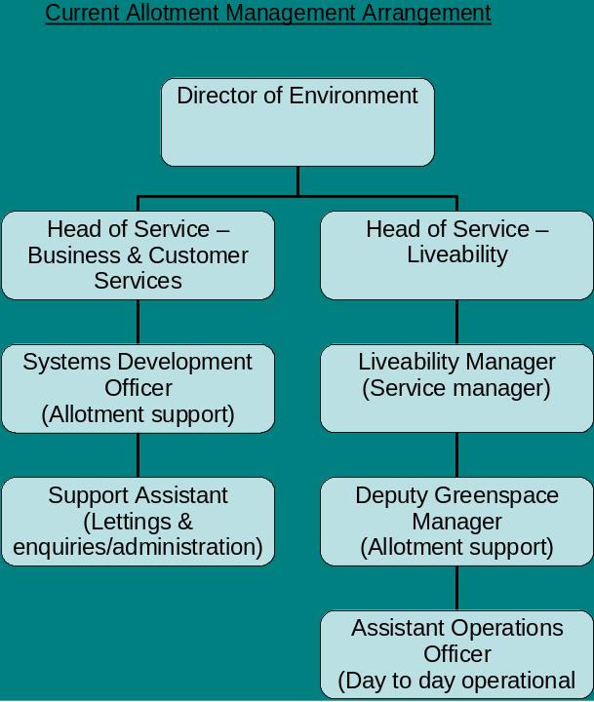

Strategic Director

Financial
The revenue budget available for the service is detailed in Table 1 below :-

Table 2
Allotment Services EXPENDITURE
Heading | £
Staffing costs | 45,452.00
Premises | 7,870.00
Transport | 0.00
Services | 0.00
Income | (13,370.00)
Net budget | 39,952.00
DC to provide update budget to cater for SD 70%
The service has a net cost to the Council tax payer of £39,952, which equates to a subsidy of £91.84 per tenant (based on August 2007 occupation levels).

The service has a capital budget of £25,000, available for the period April 2007 to March 2008, and a bid has been submitted for a further £75,000, over three years, but will be considered in line with other spending requirements / pressures. The 2007 / 08 programme is detailed in Appendix 2.

Land Distribution
Information regarding the land holding is detailed in Table 3. A map showing the distribution of allotments in the city is attached as Appendix 3. There are no allotment sites within the Ordsall and Langworthy area.

Table 3
Distribution of allotment sites within Neighbourhood management areas.
Location | No. of sites | No. of plots
Little Hulton / Walkden | 5 | 86
Worsley / Boothstown | 1 | 10
Irlam | 4 | 74
Eccles | 4 | 126
Swinton | 8 | 106
Claremont / Weaste | 1 | 86
Salford East | 1 | 76
TOTAL | 24 | 564

Notes: i) One statutory allotment near Blackleach leased by Urban Vision on our behalf.
ii) Clovelley Allotments, although geographically located in Worsley, are included in Swinton for this report.

Land Quality
The condition of most allotment sites is generally considered to be poor. 11 sites presently do not have access to fresh water. Only 7 sites have access to toilet facilities and 7 have access to an acceptable community building. Most sites would not be regarded as secure and poor drainage is also an issue at some. Beechfield allotments are known to have a contamination problem and corrective treatment may not be economically sustainable. See Appendix 4 for details of the available facilities at each site.

A report produced in October 2006 by the Directorate, entitled “Position Statement Allotment Service” indicated that c£708,000 capital would be required to improve the quality of sites. The report did not however indicate what standard is aimed for and didn’t take into account the requirements of the Disability Discrimination Acts.

the service’s stated objectives?

The Allotment Charter

The City Council’s Environment Directorate introduced an allotment charter in 2002 which made the following pledges: :

The City Council is committed to its legal duty to provide sufficient land to meet local demand within the city for allotment gardens.

The City Council recognises the benefits to health, anti-poverty, education and community togetherness that arise from the provision of well run public allotments and will: -

- ensure that there are a sufficient number of allotment/gardens in the City to meet demand

- safeguard wherever possible, existing allotment gardens in public and private ownership from redevelopment

- ensure, when necessary that alternative allotment gardens are provided in areas where facilities have been lost

- consult with allotment holders before any proposal to develop allotments for other purposes are considered

- aim to improve the standard of public allotment gardens by providing new and maintaining existing facilities

- guarantee that investment in allotment gardens will be at least equal to the income obtained from rents

- assist disabled people to take up allotments by improving access and plot facilities

- encourage the use of allotment gardens by demonstrating the benefits to be gained through publicity and marketing

- encourage allotment holders to form site associations and self management schemes

- encourage good relations by regular consultation between tenants, Councillors and officers of the City Council

- review this charter annually

The charter has been reviewed annually and no changes have been proposed.

The City Council’s allotment service presently has just two objectives within its 2007 / 08 business plan. These are as follows:-

- Ensure 80% of allotments occupied
- Ensure 100% of allotment sites and plots inspected yearly.

Although there is a statement within the Charter that indicates the City Council recognises the benefits the allotment service can bring to themes such as health, learning and community cohesion, there are no specific objectives or targets set to ensure those benefits are realized or monitored by those providing the service or partners such as the Primary Care Trust (PCT) which may share the same objectives.

There are however a number of partnerships and projects presently delivering on these agendas in Salford. As an example of best practice, the success at Cawdor Street has been detailed earlier in this report.

At Tindall Street Allotments, Eccles, the Probation Service has been working since April of this year and has committed 3,600 hours to date. They have completed several projects including a community orchard. Several derelict plots have also been brought up to standard and have been rented out.

The Salford PCT has also been involved with the Association on Tindall Street. A raised bed has been created with funding provided by the PCT, and special implements have been provided to allow people with special needs to enjoy working on the allotments.
Future partnerships proposed for this site include:-

- The creation of a sensory garden for the blind, in conjunction with Henshaw’s Institute for the Blind.

- A second raised bed for the disabled, again funded by the PCT.

- The creation of a war-time allotment including an Anderson Shelter as part of the ‘Dig For Victory Campaign’, in conjunction with the Imperial War Museum (North).

The Langworthy Men’s Action Group has been on Weaste Allotments for a number of months. This group consists of unemployed men from the area working together to get used to a working environment. They have been given two plots and pledge to bring a further five back into use.

‘Help The Aged’ has worked a plot on Victoria Park for over two years. Twice every week, the volunteers supervise a group of elderly people working on the allotment.

The Swinton and District Allotment and Leisure Gardens Association has secured £7,500 in grants. It has purchase three community sheds for the Destructor Site Allotments and a container for Victoria Park. The group is in the process of obtaining individual sheds for their members.

What do the stakeholders think of the service?

Key stakeholders were identified and consulted by a variety of methods including postal surveys of tenants, attendance at Association meetings, one to one interviews etc. The results of those consultations are as follows.

Tenant Feedback

In January 2007, four hundred and forty questionnaires were sent out to existing tenants, of which 119 (27%) were returned.

37% of those returning questionnaires visited their allotment garden at least once per day and 49% visited at least once per week. The car was the most significant mode of transport (48%) even though 94% of tenants live a mile or less from their allotment site (See Appendix 5). Walking (37%) and bicycle (18%) were also popular. Over 90% considered their allotment sites were easy to get to.

Although cultivating the plot was the prime reason for visiting the allotment (92%), other activities such as meeting friends (56%) to exercise (73%) and to relax/contemplate (69%) were also significant.

As for tenant perception of the quality of their allotments, Chart 1 details the scores for each service area during 2006. A more detailed analysis is attached as Appendix 5. (Questionnaires returned January 2007).

Chart 1
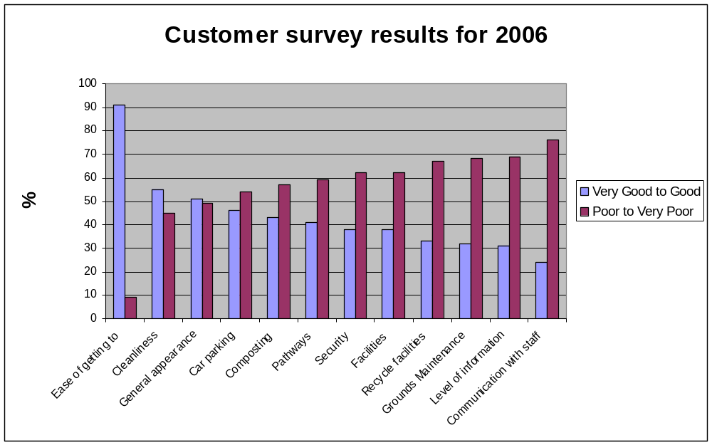

Chart 2 identifies the trend in tenant feedback over the 4 year period during which surveys were undertaken. This identifies that services have been averaging c.40% satisfaction rate over the period, with a marginal improvements during the last two surveys.

Chart 2
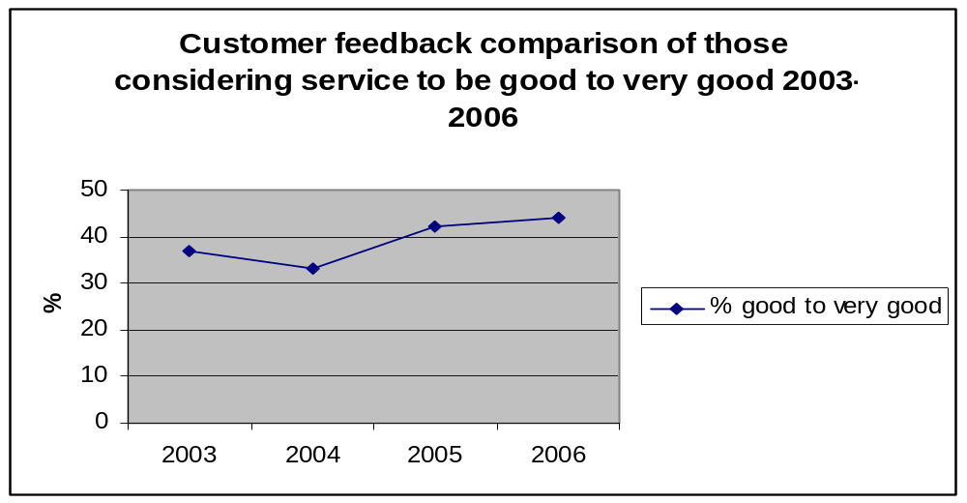

Most areas of the service scored poorly in 2006 and are of some concern but there are particular concerns about communications with the council and the levels of information customers perceive to be available. Of interest is the fact that 43 tenants expressed an interest in being a member of a Friend’s Group. There were 7 sites where at least 3 tenants expressed this interest.

Salford Allotment Association

At its meeting on 7th August 2007, the Committee voted 11 in favour, none against and seven abstentions that; “City of Salford be requested to offer concessions, in line with Manchester, Wigan and Preston Councils, for pensioners, the disabled, the unwaged, the unemployed people on benefit etc”.

It was “agreed by all” at its meeting on the 5th June 2007 “that the allocation of plots and general record keeping is out of control and needs to be addressed. At the same meeting it was also recorded that members of the committee recognise “what a lot of hard work” (named officers) do on our (Committee’s) behalf”

Cawdor Street Allotment Association and Swinton and District Allotment Association (Destructor Site, Townsend Road and Little Moss Lane).

The above two Associations have expressed a desire to manage three sites on the City Council’s behalf. Discussions are taking place with the groups to determine how this might work.

Primary Care Trust

“Older people told us (Salford PCT) that there was often a real sense of community in the areas that they lived, “being with like minded people”. They particularly valued local groups and organisations which offer opportunities to pursue particular hobbies” e.g. “allotments”.
(Growing Older in Salford 2005)

Officers from the PCT do recognise the potential allotments have for improving health in a number of ways and are actively working with the City Council on the development of new projects that make contributions to health improvement, particularly in areas of the city where health is of most concern (i.e. Langworthy, Irwell Riverside, Broughton, Ordsall, Little Hulton, Winton, Barton and Kersal (LAA 2007))

Missing Data

There is no data on the perceptions or needs of the vast majority of people who presently don’t tenant an allotment plot.

How does the service measure against national standards?

Availability

Attached as Appendix 6, is a copy of the SCC monthly allotment status report for August 2007. This provides details of plot availability, occupation levels etc at individual sites within the city.

National Society of Allotment and Leisure Gardens
A survey undertaken in 1997 showed that the provision of allotments in England averaged out at 15 plots per 1,000 households (National Society of Allotment and Leisure Gardeners 2006). Table 5 identifies how each Neighbourhood management area performs against this national benchmark. Living Places: Cleaner; Safer; Greener (ODPM 2002) gave a commitment to improve information on allotments by updating the 1996 survey but this has yet to be undertaken.

Table 6
Benchmarking allotment plot provision against the national average of 1997
Location  (population) | No. of Sites | Potentially available plots | Potentially available plots per 1,000 households | Usable plots | Useable plots per 1,000 households
Claremont / Weaste  (9513 households) | 1 | 86 | 9 | 59 | 6.2
East Salford  (16732 households) | 1 | 76 | 4.5 | 72 | 4.3
Eccles  (16326 households) | 4 | 126 | 7.7 | 108 | 6.6
Irlam/Cadishead  (8109 households) | 4 | 74 | 9.1 | 44 | 5.4
Ordsall and Langworthy  (12610 households) | 0 | 0 | 0 | 0 | 0
Swinton  (15172 households) | 8 | 106 | 7 | 76 | 5
Walkden/Little Hulton  (15512 households) | 5 | 99 | 6.4 | 96 | 6.2
Worsley / Boothstown  (8264 households) | 1 | 10 | 1.2 | 10 | 1.2
TOTAL | 24 | 577 |  | 465

OK  Achieving over 75% of the national average | POOR  Achieving over 50% of the national average | VERY POOR  Achieving over 25% of national average | EXTREMELY POOR  Falling below 25% of national average

- Population data based on salford.gov.uk ward profiles extracted from 2001 census.

- Plot information based on SCC Monthly allotment report, 2007.

- Salford’s actual number of plots at the time of the survey in 1997 was approximately 550, thereby falling somewhere in-between the potential and usable positions indicated in the Table 5.

From the above table it is clear that in 1997, allotment provision in the city was not achieving 50% of the national average in any neighbourhood management area and that position has deteriorated since. Bringing all those plots that are presently unusable into use, would only bring 3 areas above 50% of the 1997 national average but all would still fall well below 75% of national average. Furthermore, the national average in 1997 itself (15 plots per 1,000) falls well short of the 20 plots per 1,000 households recommended by the NSALG (2007)

Table 7
Benchmarking allotment plot provision against A.G.M.A Authorities
Council | No. Households  (Census 2001) | No. Available Plots | Plots per 1,000 Households
Bolton | 108,085 | est 1000 | 9.3
Bury | 74,335
Manchester | 167,451
Oldham | 87,824
Rochdale | 83,452 | 682 | 8.2
Salford | 94,238 | 465 | 4.9
Tameside | 89,981
Trafford | 89,313 | 1340 | 15
Wigan | 125,096 | 541 | 4.3

(2007 figure for Salford = 102,238

Allotments Act 1908
As stated earlier, there is an express duty placed on the City Council (as an allotment authority) to provide a sufficient number of allotments to meet demand from its residents. Table 6 sets out how the City Council is presently performing against this statutory requirement.

Table 8
Prospective tenants – Length of time on waiting list
Location  (population) | Total No. of people on waiting lists October 2007 | Waiting less than 4 months | Waiting over 4 but less than 7 months | Waiting 8 months or longer
Claremont / Weaste  (pop; 21,397) | 17 | 7 | 4 | 6
East Salford  (pop; 34,737) | 13 | 3 | 2 | 8
Eccles  (pop;35,194) | 30 | 10 | 11 | 9
Irlam / Cadishead  (pop;19,157) | 21 | 5 | 5 | 11
Ordsall and Langworthy  (pop;18,927) | 9 | 3 | 1 | 5
Swinton  (pop;33,492) | 19 | 7 | 4 | 8
Walkden / Little Hulton  (pop;34,124) | 25 | 12 | 4 | 9
Worsley / Boothstown  (pop;19,763) | 35 | 6 | 3 | 26
TOTAL | 169 | 53 | 34 | 82

Table 8 identifies that SCC is not presently meeting demand. See also Appendix 5 which identifies that most applicants would prefer not to travel further than two miles to an allotment site and this should be taken into consideration when allocating plots.

There are numerous ways in which the City Council can manage its obligations. The first and perhaps most obvious is to simply remove people from the measured waiting list once offered what the City Council considers to be a ‘reasonable plot’. Multiple occupations could be reduced over time; plots could be reduced in size, thereby permitting an increased number of plots without increasing the number of, or size of existing sites; Allotment fees which are very low in Salford, could be increased (perhaps with concessions for the most needy) to reduce demand from sectors of the population that have a lesser need. This could in turn release funds for re-investment into the service

A Chartermark Assessment of the Service

Chartermark is the UK Government’s national standard for excellence in customer service. The scheme is a tool designed to help organisations focus on and improve their customer service and delivery to users. There are six criteria against which organisations are measured. (www.cabinet office.gov.uk/chartermark2007).

Interviews were carried out with key personnel within the team and a report is attached as Appendix 7 detailing how well the allotment service presently measures against the standard, both in terms of its understanding and implementation of corporate policy such as Customer Care as well as the development and use of its own internal procedures. The report identifies that ”the service has about 50% of the attributes required to meet the criterion involved. However, the evidence will have to be gathered to support the 50%. The service will have to undergo a rethink in its approach to the customer before a Chartermark application can be made. It should start with a complete review of the service policy and procedures” (A Chartermark assessment of the Allotment Service, SCC May 2007).

Investors In People

The Investors in People Standard is a business improvement tool designed to advance an organisation’s performance through its people. (http://investorsinpeople.co.uk). The SCC Environment Directorate in which the Allotment Service sits is an IIP accredited organisation and procedures are in place and monitored to ensure that the allotment service does comply fully with the Standard.

However, other research does suggest that appraisals cannot fully relate individual objectives to the support of the City Council’s strategic objectives through the Directorate’s business planning and performance management framework, until the allotment service itself relates to those same objectives.

How does the Service Measure Against the SCC Allotment Charter?

SCC adopted a Charter for its allotment Service in 2002. The objectives and commentary on the performance against those objectives between its introduction in January 2002 and July 2007 is provided in Table 9.

Table 9

1 Ensure that there are a sufficient number of allotment/gardens in the City to meet demand.
The supply of allotment plots fell by 10% (53nr) during the period, whilst demand rose by 450%. There are presently 170 people waiting for an allotment to become vacant in their area, 83 of these have been waiting over six months for a plot to become free.

2 Safeguard wherever possible, existing allotment gardens in public and private ownership from redevelopment.
No City Council allotments sites have been lost to development in the period?

3 Ensure, when necessary that alternative allotment gardens are provided in areas where facilities have been lost.
44 allotment plots have been taken out of use but not replaced.

4 Consult with allotment holders before any proposal to develop allotments for other purposes are considered.
None required.

5 Aim to improve the standard of public allotment gardens by providing new and maintaining existing facilities.
There has been no new provision during the period and although some improvements have been made at a few sites, the overall quality has reduced.

6 Guarantee that investment in allotment gardens will be at least equal to the income obtained from rents.
Expenditure on the allotment service continues to exceed income by a margin of at least £39,000

7 Assist disabled people to take up allotments by improving access and plot facilities.
A few improvements have been made through partnership arrangements. As no formal DDA audit has been undertaken, the situation regarding access is largely unknown.

8 Encourage the use of allotment gardens by demonstrating the benefits to be gained through publicity and marketing.
There is very little promotional activity at present and with demand outstripping capacity by a considerable margin, any promotion at present would simply exacerbate the problem.

9 Encourage allotment holders to form site associations and self management schemes.
In 2002 there were two associations, there are now seven. There are no self managed sites.

10 Encourage good relations by regular consultation between tenants, Councillors and officers of the City Council.
Tenant feedback suggests this pledge has not been achieved.

11 Review this charter annually
There is no formal record that the Charter has been reviewed annually.

How does the service compare with other local authorities on price?

Chart 4 shows a comparison of 12 local authorities’ average allotment charges. SCC charges £10 per annum less than the average of all authorities. (Source: SCC Environment Directorate Lead Member report July 2007). This survey does not take into account comparability of products on offer.

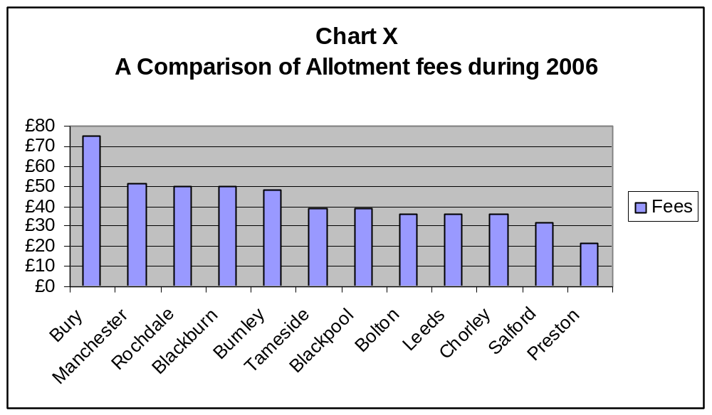

SCC does not presently give concessions, although some could argue that all tenants receive a concession. Table 10 details the policy of seven local authorities in the North West on this issue.

Table 10
Concessions provided by a selection of other Local Authorities
BOLTON | - 25% for over 60s
PRESTON | - half price for unemployed, retired, disabled
WARRINGTON | - for leisure card holders and senior citizens
TRAFFORD | - 50% reduction on the first 250 sq metres for over 60’s.  - 50% reduction for registered disabled.
PENDLE | - retired, student, disabled, unemployed
BLACKPOOL | - community/school groups have free plots
MANCHESTER | - community/school groups have free plots

How does the service compare with other local authorities on self management?

There is no doubt that tenants working together on sites, forming allotment associations to support bids for external funding and generally taking more responsibility for their own affairs is providing a valuable contribution to the overall service. The example of best practice at Cawdor Street in Walkden provides good evidence to support this. The city now has seven allotment associations representing approximately 68% of allotment tenants. There has been a recent expression of interest from some allotment associations to become self managed. Negotiations are presently ongoing but careful thought needs to be given to the impact of going down this route on the city’s overall service. The question that needs to be considered carefully by the Council is - Would a well run LSP/Council service supported by active allotment associations provide a better overall service than a fragmented one?

Seven local authorities in the North West were consulted on levels of self management. Of these, Bolton and Pendle do not presently have any form of self management arrangements. In Warrington, all sites are managed in a partnership arrangement between the Council and the Allotments Committee. In Manchester, 30 (78%) of sites are controlled by Allotment Societies. Blackpool has 3 self maintained sites which are allocated a budget and tenants work to a Service Level Agreement. Preston Council has one self managed site. Trafford MBC has thirteen and they pay subsidised rents which are dealt with through their Estates Departments. They manage their own plot lettings, including the issuing of ‘Notices to quit’ and are responsible for routine maintenance and burst repairs. Major infra structure repairs are undertaken by the Council.

Key issues for the service

- Between 2002 and 2007 the supply of allotments has fallen at the same time demand has risen, resulting in significant waiting lists in all areas. 49% of applicants have been waiting 8 months or more.

- There is no access to allotments in Ordsall and Langworthy, even though there is demand, without any kind of promotional activities and in an area of high deprivation.

- When compared with national average, there is serious under provision in Worsley and Boothstown and very poor provision in all other areas. Compared with AGMA??

- Quality of existing provision is poor at many sites

- Significant capital investment required to improve current stock and address current demands

- Customer service poor when measured against Chartermark criteria.

- No DDA audit or action plan in place, contravening DDA Act (1995)

- No strategy or policies in place to guide the development of the service

- No means of measuring performance against community themes or the allotment charter

- No marketing or promotional activities. Customer services and supply of information regarded by a significant majority of tenants as poor.

- No understanding of non user needs or perceptions of service

- Fees relatively low when compared with other local authorities and market values. There are no concessions available for targeted groups but the service is heavily subsidised.

- The SCC Allotment Regulations are now six years old and in need of updating, to take into account such issues as sale of produce / waste management.

- There are presently insufficient resources for important service areas such as a) supporting the development of allotment associations, whether self managed or not. b) forging closer links with health, educational and community organisations in a bid to develop the service c) working with allotment groups and partners on the preparation and submission of bids for external funding and implementing projects if successful.

Proposed actions to move the City Council and its partners towards a strategy for allotments

Action | Time frame
1) Work with groups interested in self management and establishment of associations. | Ongoing
2) Liaise with the Primary Care Trust and other key organisations to agree a joint strategy and identify projects and funding to deliver joint objectives. | Jan 08 – May 08
3) Include allotment performance information for key areas such as waiting lists, site quality and customer feedback, into 2008/9 performance management framework. | Jan 08 – Mar 08
4) Establish Chartermark working group to bring allotment customer services up to required standard. | Jan 07 – Sep 08
5) Produce detailed report identifying what needs to be done at what cost to bring the 112 sub-standard plots back into use and to maintain them. (Estimated cost of producing report = £5,000). | Feb 07 – June 08
6) Liaise with colleagues within Housing and Planning and local prospective tenants to identify areas for new allotment garden sites. On the assumption that sub standard plots will be brought back into use, the key areas for new sites would be as follows. (Highest priority first and those areas which include LAA target wards are highlighted in bold)  - Worsley and Boothstown  - Walkden and Little Hulton  - Eccles  - East Salford  - Ordsall and Langworthy | Feb 08 – Aug 08
7) Identify possible resources to support the creation of a community allotment development post and produce a report on way forward. | Feb- 08 – Jul - 08
8) Identify and pursue external funding opportunities to improve the standards of allotments within the City of Salford. | Ongoing
9) Secure policy decision on way forward with self management of sites. | Feb 08
10) Identify ways of engaging with the wider community on the value of allotments. | Feb 07 – Jul 08
11) Update SCC Allotment Regulations. | Apr 08 – Dec 08
12) Secure policy decision on way forward with plot restoration. | Jun 08
13) Provide funding for and produce report on sites identified in 1.3 above, providing details, capital and revenue estimates for establishment and maintenance (£2,000). | Aug 08
14) Secure policy decision on way forward with creation of new sites. | Sep 08
14) Produce detailed Lead member report to determine policy on charges5and concessions for the period Apr 2010 – Mar 2015. | Oct 08
16) Secure policy decision on charges and concessions for the period Apr 2010 – Mar 2015. | Oct 08
17) Produce ‘partnership’ strategy for the future direction of the service, with vision; clear plans and funding for achieving the vision. | Sep 08-Dec 08
This action plan is attached as Appendix 8 in Gant form.

Recommendations

- That this action plan be approved and that approximately £12,000 be made available to produce the additional reports required.

- That a further report be submitted in June 2008, providing details and seeking a policy decision on the way forward with respect to plot restoration;

- That a further report be submitted in September 2008, providing detailed proposals and seeking a policy decision on the creation of new sites

- That a further report be submitted in October 2008 providing details of a proposed charging policy and concessions for implementation during the period January 2010 – December 2014.

Conclusions

There is ample evidence from around the country and within Salford itself to suggest that allotments do provide a wonderful opportunity to support most, if not all the community themes and key service priorities. They can have a particularly important part to play in maintaining or achieving good physical and mental well being; They do help communities come together and are a valuable resource for learning, creativity, bio-diversity and reducing the negative impact of human activity on the planet.

Unfortunately and due primarily to a lack of investment over many years, the service is failing to deliver anything more than a mere fraction of its potential. The prolonged neglect will now require substantial investment just to satisfy current demands. To lift the service to the average of AGMA authorities or the national average will take a significant but presently unknown amount of finance.

It is vitally important that any strategy that is agreed for the future of the service, proves to be sustainable. To achieve that, its development needs to be a staged approach. Some of the actions included above will require internal human or financial resources and time to complete but until they are completed and their implications understood, it is not possible to propose a sustainable way forward beyond their preparation.

Bibliography and references

Abbreviations  BRC – British Retail Consortium  COT – College of Occupational Therapy  GM genetically modified crops  DCLG - Department for Communities and Local Government  DEFRA - Department for the Environment, food and regional affairs  HMG – Her Majesty’s Government  IIP – Investors in people  LAA – Local Area Agreement  MBC – Metropolitan Borough Council  NHS – National Health Service  NSALG – National Society of Allotment and Leisure Gardens  ODPM – Office of the Deputy Prime Minister  PCT – Primary Care Trust  SCC - Salford City Council  SMT – Senior management Team  SPD – Supplementary planning Document  Bibliography and References  C.O.T, 2003 – The British Journal of Occupational Therapy, Volume 66, Number 7, 1 July 2003, pp 286-296. Published by the College of Occupational Therapy.  The Law of Allotments, Paul Clayden. Published by Shaw and Sons  DCLG, - Survey of Allotments, Community Gardens and City Farms: Urban Research Summary No.23. Published September 2006  DCLG, 2002 – Assessing Needs and Opportunities: A Companion Guide to PPG17. Department of Communities and Local Government.  DEFRA – Implementing the Biodiversity Duty 2007  LAA (Partners in Salford 2007) | NSALG - National Survey of Allotment Gardens 1997  Nottingham City Council – Reducing the Gap – Addressing health inequalities, 2006  Salford PCT Growing Older in Salford 2005  SCC Planning and Obligations Supplementary Planning Document 2007  SCC Community Plan 2005  BBC  http://news.bbc.co.uk  Friends of the Earth -  http://www.foe.co.uk  SCC  http://www.salford.gov.uk-  South Essex Primary Care Trust http://www.southessex-trust.nhs.uk/  Chartermark  http://www.cabinetoffice.gov.uk/chartermark  IIP  http://investorsinpeople.co.uk

APPENDICES

Appendix 1.

SALFORD CITY COUNCIL
THE ALLOTMENTS ACT 1908 TO 1950

RULES AND REGULATIONS RELATING TO
ALLOTMENT GARDENS WITHIN THE CITY (THE ALLOTMENTS)

- Application

1.1 These rules are made under Section 28 of the Small Holdings and Allotments Act 1908 (as amended) and apply to all Allotments including any let before these rules came into force. They come in to force on the date they are sealed.

- Allocation of Vacant Allotments

2.1 Vacant Allotments on a Site must be offered by the Council to applicants in order of application on the waiting list for that Site kept by the Council.

- Assignment

3.1 The Tenancy of an Allotment is personal to the Tenant. Tenants may not assign, underlet or part with possession of all or part of their Allotments (including chalet or tool locker or greenhouse) during the lifetime of the Tenancy.

3.2 The new Tenant shall be responsible for his Allotment and all that is on it (unless it is unsafe or unrequired by the new Tenant which will result in it being taken away). The Tenant shall be responsible for the removal from the Allotment at the termination of the Tenancy, of all goods, chattels and buildings whether or not subject to hire purchase or rental agreements. Any items left on the Allotment after the Tenancy has terminated will be retained for a period of six months but may thereafter be disposed of in any manner, which the Council deem fit and the cost of such disposal may be recovered from the Tenant.

3.3 Any person, who at the time of application to the Council for an allotment garden is resident in the City, shall be eligible to become a tenant of an allotment garden.

- Rent

4.1 The rent of an Allotment shall, unless otherwise agreed in writing, be paid annually in advance on the first day of January.

4.2 Tenants must pay rent when the Council requires. The Council may from time to time offer or require discounts to be made on whatever basis the Council decides.

  - Rent may be increased at any time provided the Council takes reasonable steps to give all Tenants twelve months notice.

  - The Council may increase the rent with not less than three months notice where additional amenities (e.g. water supply) are provided on a Site i.e. to the level appropriate to a plot with those facilities.

- Composting

5.1 Allotment holders must make every effort to compost waste materials.

5.2 Non-compostable waste may be burnt on the designated site.

  - Any other non-compostable material (other than re-cyclable glass, plastic, metal etc) must be bagged and sealed and placed in the designated waste collection bay.

  - All farmyard manure must be covered at all times.

- Cultivation and Use of Allotments

6.1 Tenants must use Allotments for their own personal use and must not carry out any business.

6.2 Allotments must be kept clean and in good condition, free from weeds and must be cultivated to the extent of at least fifty per cent of the total area.

6.3 Tenants must not cause any nuisance or annoyance to the occupier of any other Allotment or obstruct any path set out by the Council for the use of the occupiers of the Allotments.

6.4 Allotments must not be used to grow any crops for which compensation may be payable at the end of the Tenancy.

  - Tenants must keep hedges, fences and gates within the boundary of their Allotment properly cut, trimmed and maintained and ditches within the boundary of the Allotment properly cleaned and maintained.

  - Tenants must not cut or prune any trees adjoining the Allotments.

  - Tenants must also observe any other rules or regulations, which the Council makes at any time in the future.

  - Tenants must comply with all directions given by a duly authorised Officer of the City

Council.

- Hoses, Bonfires and Other Restrictions

7.1 Hoses or sprinklers are not allowed except where required to fill water containers.

7.2 Bonfires are only permitted on site for the burning of diseased plant material, providing that such bonfires do not cause nuisance or annoyance to other Tenants or local residents.Bonfires must under any circumstances be left unattended.

7.3 Tenants must not bring or use corrugated or sheeted iron (or similar metal objects) or barbed wire or razor wire on the Allotment unless authorised in writing by the Allotments Officer

7.4 If carpets or underlay are to be used it must be at the decretion of the Allotments Officer.

7.5 Rubbish refuse or decaying matter (except for a reasonable amount of manure or compost required for cultivation) must not be deposited on the Allotment or any adjoining land by the Tenant or by anyone else with the Tenant’s permission.

7.6 Tenants must not remove any mineral, gravel, sand, earth or clay from the Allotment unless they have written permission to do so by the Council.

7.7 Tenants must not cause or allow any nuisance or annoyance to the Tenant of any other Allotment and must cover any manure on the Site which has not been dug in to the Allotment.

7.8 The Allotment may not be used for any illegal or immoral purpose and the Tenant must observe all 31elevant legislation or Codes of Practice relating to activities he/she carries out on the Allotment.

7.9 Where the Council’s legal title to a Site requires certain covenants and conditions to be observed, all Tenants on that Site must observe those covenants and conditions.

- Dogs, Animals and Bees

8.1 Dogs, with the exception of guide dogs, must not be brought on to the Allotments or any part of the Site unless they are on a lead.

  - Animals or livestock (other than hens or rabbits) must not be kept on Allotments with the exception of designated plots.

  - Beehives are now allowed on the Allotments at the decretion of the Allotments
Officer.

  - The Council reserve the right to permit outside agencies (e.g. R.S.P.C.A) to inspect Allotments with respect to animal health and environmental issues.

- Unauthorised Persons

  - Only the Tenant, or a person authorised and/or accompanied by the Tenant is allowed on a Site.

  - The Council may order any person entering the Site unlawfully or in breach of these

rules to leave immediately.

  - The Council may take action against a Tenant for allowing an unauthorised Person to be on the Site, when it has reasonable grounds for believing that by permitting unlawful access, has seriously inconvenienced other users of the site.

  - The transfer of keys to any unauthorised person(s) is strictly prohibited.

- Paths

  - Paths provided by Tenants must be within the boundaries of their own Allotments and kept reasonably free from weeds.

  - Paths between two Allotments must be kept reasonably free from weeds up to the
nearest half width by each adjoining Tenant.

  - Paths must be kept clear of obstructions at all times except for paths provided by Tenants only for use on their own Allotments.

- Sheds, Building and Structures

11.1 The Tenant must not erect any new fences or gates or any other structures on the allotment garden without the prior written consent of the Council, and the Council may impose such conditions to the consent as they think fit.

11.2 RULES AND REGULATIONS CONCERNING THE ERECTION OF BUILDINGS ON ALLOTMENT SITES CAN BE FOUND IN THE ATTACHED DOCUMENT.

- Council Chalets, Greenhouses and Tool Lockers

12.1 Any chalet, greenhouse or tool locker must not be used except in connection with the proper cultivation of the Allotment and in particular no trade or business may be carried out from the chalet, greenhouse or tool locker.

12.2 Petrol, oil, fuel, lubricants or other flammable liquids must not be stored in the chalet, greenhouse or tool locker.

12.3 The Council is not to be liable for loss of, or damage to, whether by accident, fire, theft or otherwise, any tools or contents in the chalet, greenhouse or tool locker.

12.4 The Council shall not be obliged to replace or repair any chalet, greenhouse or tool locker which is destroyed or damaged.

12.5 The Tenant shall take reasonable care of the contents of the chalet, greenhouse or tool locker and shall be liable for any damage caused by the contents.

13.0 Inspection

13.1 The Allotment (and any shed or greenhouse on it) may be inspected by an Officer or member of the Council at any time and the Tenants must give whatever access is required by them.

- Disputes

14.1 Disputes between Tenants are referred to the Council and the decision of the Council will be binding on all the Tenants involved in the dispute.

15.0 Termination

15.1 Unless otherwise agreed in writing, the Allotment Tenancy is to terminate on the 31st December next after the death of the Tenant, or whenever the Tenancy or right of occupation of the Council terminates.

15.2 The Allotment Tenancy may be terminated by the Council by re-entry after one-months notice if:

  - The rent is in arrear for not less than forty days

    - The Tenant is not duly observing the rules affecting the Allotment, or any other
condition of his/her Tenancy, or

    - If the Tenant becomes bankrupt or compounds with his creditors.

  - The Allotment Tenancy may be terminated by the Council or the Tenant by 12
month’s notice in writing expiring on the 31st March in any year.

  - The Allotment Tenancy may be terminated by the council by re-entry after 3 month’s
notice in writing on account of the Allotment being required:

    - For any purpose, other than use for agriculture, for which it was acquired by the
Council or has been appropriated under any statutory provision: or

15.4.2 For building, mining or any other industrial purpose for roads or sewers, necessary in connection with any of these purposes.

16.0 Change of Address

16.1 Tenants must immediately inform the Council in writing of changes of address.

  - Any notice must be served on a Tenant either personally or by leaving it at his last known address, or by registered letter or by recorded delivery letter addressed to him there, or by fixing a notice in a conspicuous manner on the Allotment.

  - Notices served under paragraph 15.2 will be treated as properly served even if not in
fact received.

  - Notices to be given to the Council should be addressed to the Director of Environmental Services, c/o Crompton House, 100 Chorley Road, Swinton, M27 6ES or such other addresses as the Council notifies in writing to the Tenant.

17.0 Interpretation and Repeal

  - In these rules, the following words are to have the following meanings:

Allotment any allotment or leisure garden let by or on behalf of the Council.
The Council Salford City Council, including an Allotment Manager appointed by the Council under the Allotments Act 1908 to 1950.
Rent the annual rent payable for the Tenancy of an Allotment and all amenities provided with it.
Tenant a person who holds a Tenancy of an Allotment.
Tenancy the letting of an Allotment to a Tenant.

  - The headings of these rules are not to affect their interpretation.

  - The allotment rules made on the 18th November 1976 are hereby repealed.

Given under the Common Seal of the Council this 11th day of December 2001.

Appendix 2.
Allotment Capital programme 2007/8

Ref | Location | Works | Estimated value  £
 | Bingham Street | Secure planning permission for and undertake security fencing works | 6,000
 | Cotton Street | Secure planning permission for and undertake security fencing works | 3,000
 | Lorne Street | Secure planning permission for and undertake security fencing works | 3,000
 | Tynesbank, Walkden | Secure planning permission for and undertake security fencing works | 3,000
 | Weaste | Secure planning permission for and undertake security fencing works | 10,000
 |  | Total | 25,000

Appendix 3

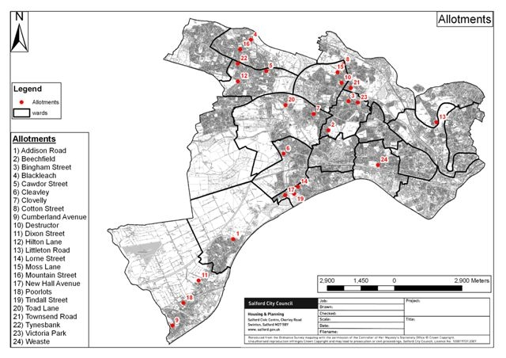
Appendix 4.
ALLOTMENT SITES
Location  Allotment Site | Manure/  Compost Bay | Secure  Perimeter | Communal  Hut | Council  Shed | Re-cycling  Centre | Pigeon | Stock | Toilet | Water | Communal  Container | Constituted  Association
Littleton Road | Yes | Yes | Yes | Yes | Yes | Yes | No | Yes | Yes | Yes | Yes
Weaste | Yes | Yes | Yes | Yes | Yes | No | No | Yes | Yes | Yes | Yes
Beechfied |  |  | UNDER |  | REVIEW
Bingham Street | No | Yes | No | No | No | No | No | No | No | Yes | Yes
Clovelly | No | Yes | No | No | No | No | No | Yes | Yes | No | Yes
Cotton Street | No | Yes | No | No | No | No | No | No | Yes | No | Yes
Destructor | No | Yes | Yes | No | No | No | No | No | Yes | No | Yes
Moss Lane |  |  | UNDER |  | REVIEW
Townsend Road | No | Yes | No | No | No | No | No | No | No | No | Yes
Victoria Park | No | Yes | No | No | No | No | No | Yes | Yes | Yes | Yes
Blackleach | No | No | No | No | No | Yes | Yes | No | Yes | No | No
Cawdor Street | Yes | Yes | No | No | Yes | No | No | Yes | Yes | Yes | Yes
Hilton Lane | No | Yes | No | No | Yes | No | No | No | Yes | No | No
Mountain Street | No | Yes | No | No | No | No | No | No | Yes | Yes | No
Toad Lane | No | No | No | No | No | Yes | No | No | Yes | No | No
Tynesbank | No | Yes | Yes | No | Yes | No | No | Yes | Yes | Yes | Yes
Cleavley | Yes | Yes | Yes | No | No | No | No | Yes | Yes | Yes | Yes
Lorne Street | No | No | No | No | No | No | No | No | Yes | No | No
New Hall Ave | No | Yes | No | No | No | No | No | No | Yes | No | No
Tindall Street | Yes | Yes | Yes | No | Yes | No | No | Yes | Yes | Yes | Yes
Addison Road |  |  | UNDER |  | REVIEW
Cumberland Ave |  |  | UNDER |  | REVIEW
Dixon Street | No | Yes | No | No | No | No | No | No | Yes | No | No
Poorlots | No | Yes | No | No | No | No | No | Yes | Yes | No | Yes

