ITEM NO.

REPORT OF: Strategic Director Environment and Community Safety;

TO: Lead Member for Environment,

and

Lead Member for Customer and Support Services

ON 6th February, 2012

TITLE: GRANT FUNDED PLAY AREA DEVELOPMENT – PEAR TREE CROFT RESIDENTS ASSOCIATION

RECOMMENDATION:
That Lead Member for Environment approves:

1) The proposed improvements to Ivy Street play area as detailed within this report at a total cost of £128,138.75 consisting of:-

Landscape scheme target cost - £109,876.75
Project design/ surveying/ Clerk of Works/ CDM - £18,262.00

2) The appointment of Horticon Ltd. in accordance with Paragraph 2.1(e) of Section 3, Part 4 of Contractual Standing Orders and Rethinking Construction, to undertake the landscape works for the target price of £109,876.75

That the Chief Finance Officer approves:

1) The request to act as the Accountable Body as required by the Big Lottery (Community Spaces) Fund and Community Foundation, Greater Manchester.

2) The acceptance of the grants.

EXECUTIVE SUMMARY:

The Pear Tree Croft Residents Association who are a local community group have been working in conjunction with the Environment and Community Safety Directorate, the Eccles Neighbourhood Management Team and Irwell valley Housing to produce a scheme for the development of the existing play area at Ivy Street, Barton. Successful grants have been made to the Big Lottery Fund in July 2011 for £49,808 and the Community Foundation, Greater Manchester in January 2010 for £25,000.
In addition to the above secured funding, the Environment and Community Safety Directorate has secured a further £75,720 of S106 funding from the following two developments located close to Ivy Street play area:-
ref 79 - application number 45495 - £49,800
ref 148 - application number 53066 - £25,920
There is a financial difference of £22,389.25 between the project cost (£128,138.75) and the secured funding (£150,528.00). The Principal Planner - Planning Obligations has confirmed that if required, only part of the S106 funding can be used for the project with the remainder being used on other projects within the park which will be discussed with the Pear Tree Residents Association.

Confirmation via a Record of Decision signed in April 2010 is displayed on appendix 1.
The scheme is supported by the Eccles Community Committee and local Councillor’s.

BACKGROUND DOCUMENTS:
(Available for public inspection)

KEY DECISION: YES

DETAILS:

1.1 Ivy Street play area is located within the Barton ward and consists of a grass field and a dilapidated play area. The area had a reputation for anti-social behaviour, but the local community were determined to improve recreational facilities in their area via the provision of improved play facilities.

1.2 As a result of this, the local residents formed a group (The Pear Tree Croft Residents Association) who began working with the Environment & Community Safety Directorate and the Eccles Neighbourhood Management Team to seek funding to address the lack of facilities within the play area.
The group initially commissioned Groundwork to undertake a master plan exercise for the refurbishment of the play area. However, after careful consideration of the design produced, it was felt that the design would not vastly improve the site and meet the desired local needs.

1.3 Following on from this, the group then secured funding from Irwell Valley Housing Association to commission Urban Vision to deliver a design for the play area and the design that emerged out of this (Appendix 2) was agreed.
The design of the play area has received input from young people and local residents and successfully combines formal and natural play. A range of equipment has been chosen which includes a basket swing, slide, climbing boulder and a trim trail This equipment provides opportunities for all ages and abilities to use the play area. The majority of the existing hard standing will be removed and be replaced with grass, which will encourage more natural play opportunities.

1.4 The park is the only area of green space immediately available to local residents.
It is anticipated that it will make a significant contribution to making the park a far more attractive place for local people (not just children) to visit. The improvements will effectively bring the park back into use.

1.5 It is anticipated that the Directorate will next engage with the group on the design and development of a nature garden that is to be incorporated into the area.

2.0 Financial

2.1 Further to the recent grant applications an offer from the Big Lottery Fund of £49,808 and the Community Foundation, Greater Manchester to the value of £25,000 has been made to the Pear Tree Croft Residents Association for the purpose of the refurbishment of Ivy Street Play Area.

2.2 In addition to the above awards, the Environment and Community Safety Directorate has secured a further £75,720 of Section 106 funding.

2.3 There is a financial difference of £22,389.25 between the project cost (£128,138.75) and the secured funding (£150,528.00). The Principal Planner - Planning Obligations has confirmed that if required, only part of the S106 funding can be used for the project with the remainder being used on other projects within the park which will be discussed with the Pear Tree Residents Association.

2.3 The receipt of the two grants is conditional upon confirmation that Salford City Council will act as the accountable body. In common with other Big Lottery and Community Foundation funded programmes the delivery grants will be paid post completion upon the receipt of a report confirming the works have been completed in accordance with the profiled expenditure.

2.4 It is estimated that the additional annual cost to maintain the improvements is £6,500. Confirmation has been received from the City Treasurer to support the additional maintenance requirement as shown on appendix 3

2.5 The City Council are required to act as the Accountable Body for the two grants. To accept the offer the “Form of Agreement to Act as Accountable Body” will need to be completed by the City Treasurer and returned to the grant administrators.

KEY COUNCIL POLICIES:
Budget Monitoring – Community Strategy – Cultural Strategy – Environmental strategy – Equalities – Health – Planning Strategy – Procurement Policies – Regeneration

EQUALITY IMPACT ASSESSMENT AND IMPLICATIONS:-
Proposed improvements comply with Disability Discrimination Act and will assist with delivering equality of access.
ASSESSMENT OF RISK:
Low

SOURCE OF FUNDING:

• Big Lottery Fund, Community Spaces Grant award
• Community Foundation, Greater Manchester
• Section 106

LEGAL IMPLICATIONS
Works to be procured through the partnering agreement

FINANCIAL IMPLICATIONS
Advice received from Accountants that the City Treasurer will be required to confirm that Salford City Council agree to act as the Accountable Body for the administration of the grant awards.

OTHER DIRECTORATES CONSULTED:
Neighbourhood Management Team for Eccles
Salford Community Leisure
Greater Manchester Police

No concerns have been raised

CONTACT OFFICER: Steve Jones TEL. NO. 925 1016

WARD(S) TO WHICH REPORT RELATE(S): Barton

Appendix 1

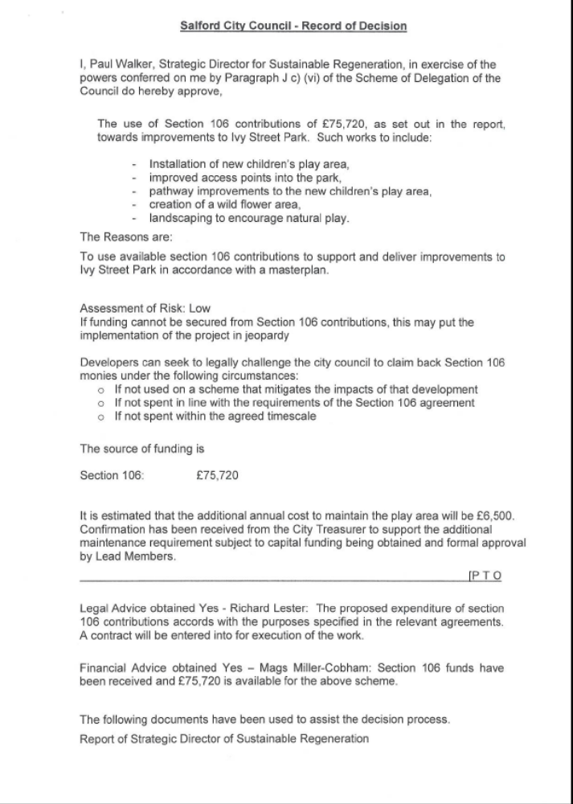

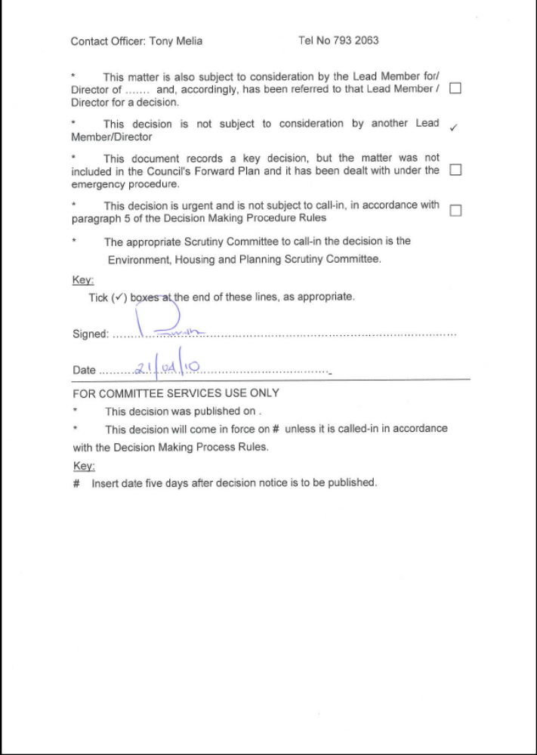

Appendix 2
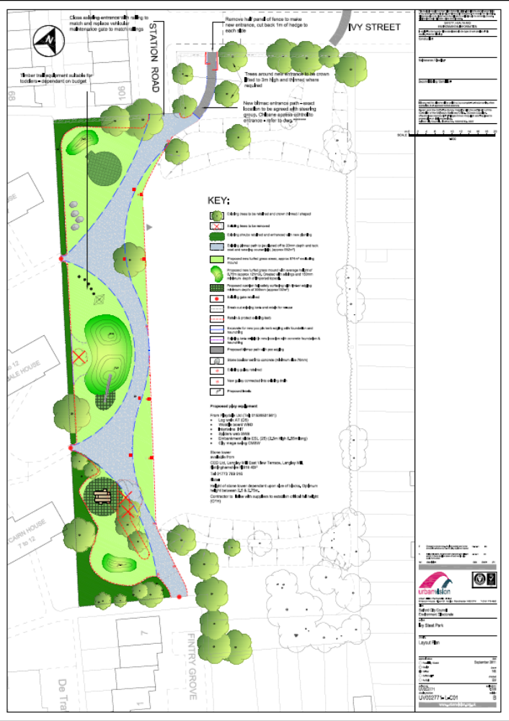

Appendix 3

From: Jones, Steve
Sent: 17 August 2011 15:51
To: Spink, John
Subject: RE: Ivy Street play area
Hello John
The following funding has now been secured
S106 - £75,720
Barton Fair Share - £25,000
Community Spaces - £49,808

It is anticipated that the scheme will be completed by April 2012, therefore can the additional annual revenue requirement (£6,500) be made available from next April onwards.

Regards
Steve

From: Jones, Steve
Sent: 08 February 2010 12:42
To: Spink, John
Subject: RE: Ivy Street play area
Thanks John
I'll keep you updated on progress.
Regards
Steve

From: Spink, John
Sent: 08 February 2010 12:10
To: Jones, Steve
Cc: Prady, Phil
Subject: RE: Ivy Street play area
Steve,
The annual maintenance cost can be covered from the budget allocation from annual maintenance, subject to capital funding being obtained and formal approval by lead members, and we will note this as a potential commitment.
Regards
John

From: Jones, Steve
Sent: 05 February 2010 15:50
To: Spink, John
Subject: Ivy Street play area
John
We are looking at refurbishing Ivy Street play area within the Barton ward.
A local resident group (Pear Tree Croft Residents Association) in conjunction with Groundwork has been involved with a master plan for the play area (attached)
The estimated cost to deliver the master plan is £101k and the residents are at present applying for this funding. To date they have secured £25k via Barton Fair Share, and have been successful with a stage 1 bid to Community Spaces. The stage 2 application is due to be submitted in May and if successful a total of £50k will be awarded to the group. In addition to this they are hoping to secure a further £40k from the Irwell Valley Housing Association thus establishing a potential budget of £115k which will be sufficient to deliver the master plan including professional fees.
It is the intention to increase the size of the play area and amount of play equipment. We have estimated that there will be an additional annual revenue requirement of £6,500.
If the scheme does go ahead, could the budget for the annual maintenance of new capital schemes cover the increase in the annual maintenance?

Kind regards
Steve

Steve Jones

Development Officer| Environmental Strategy & Development
Environment Directorate | Turnpike House | 631 Eccles New Road | Salford | M50 1SW

 0161 925 1016 Fax: 0161 925 1029

 steve.jones@salford.gov.uk

Improving our Environment IN Salford
 please don't print this e-mail unless you really need to.

