East Salford Group Meetings Agenda Item 8

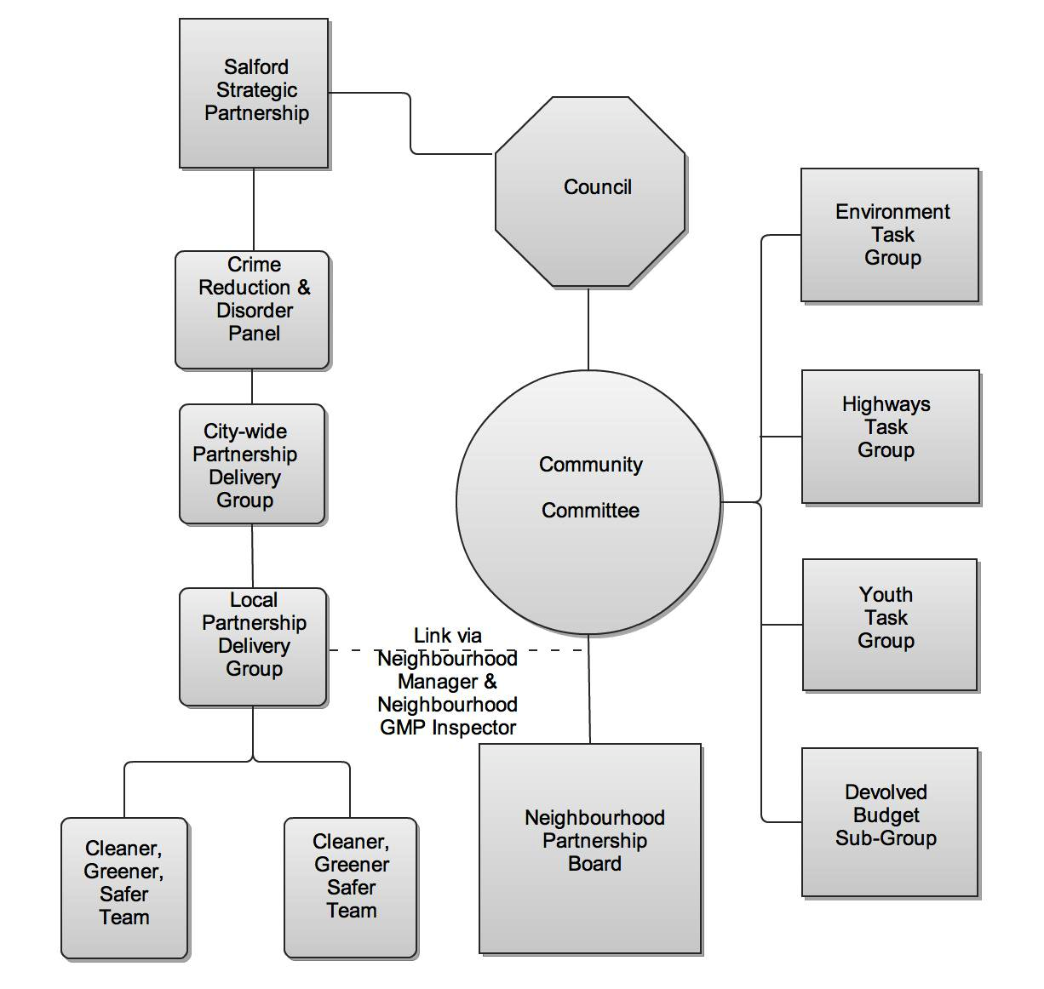

Community Committee – is a sub-committee of Council. Amongst its duties is to act as a focus for the concerns of local people, to review and monitor the delivery of local services and contribute towards the strategic development of the area.

Neighbourhood Partnership Board – it supports and strengthens the work of the Community Committee.

Environment Task Group – brings together the community, statutory and voluntary sectors to support and develop environmental services and projects in the neighbourhood.

Highways Task Group - brings together the community, statutory and voluntary sectors to decide what schemes that the Devolved Highways Budget should be spent on each year.

Youth Task Group - brings together the community, statutory and voluntary sectors to promote and develop services for young people.

Devolved Budget Sub-Group – made up of community representatives who consider and make recommendations to on applications for funding from constituted groups in the neighbourhood.

Salford Strategic Partnership - brings together people form the City’s public, private, community, voluntary and faith sectors. These people work closely together to ensure that Salford’s citizens have an equal chance to thrive.

Crime and Disorder Reduction Partnership – the Partnership is made up of public and private agencies each with a part to play in reducing crime and disorder in Salford.

City-wide Partnership Delivery Group - strategic service managers meet monthly to consider issues around crime and safety and develop services to meet them.

Local Partnership Delivery Group – service managers meet monthly to develop plans and procedures around cleaner, greener, safer issues.

Cleaner, Greener, Safer Teams – East Salford has two. One serving, Kersal and the other Irwell Riverside and Broughton. Local service representatives meet every two weeks to tackle day-to-day issues.

