Local Government Act 2000

FORWARD PLAN OF KEY DECISIONS
The following is a list of key decisions that are proposed to be made during the period of four months commencing on 1st May, 2004.
Particulars of each proposed decision are contained in the attachments to this list.

No | Subject | Date/Period of Decision | Decision  Taker | Scrutiny Committee, if Decision is Called-in
8. | Improvement of Barton Road/Lane Junction   | May, 2004 | Lead Member | Environmental
9. | Improvement of Leicester Road/Great Cheetham Street Junction   | May, 2004 | Lead Member | Environmental
15. | Seedley North West, Phase 3 – External Refurbishment of Dwellings   | July/August, 2004 | Lead Member | Environmental
16. | Light Vehicle Fleet Tender   | 2nd June, 2004 | Cabinet | Environmental
20. | Walkden High School – Temporary Classrooms   | May, 2004 | Lead Member | Environmental
21. | Declaration of Clearance Area – Certain Properties in Salford 7   | May, 2004 | Lead Member | Environmental
25. | Designation of Blackleach Country Park as a Local Nature Reserve   | 5th May, 2004 | Cabinet | Environmental
28. | Modernisation of six “Homeswap” dwellings  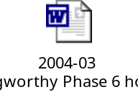 | May/June, 2004 | Lead Member | Environmental
29. | Albert Park Changing Accommodation - Rebuilding Works   | June/July, 2004 | Lead Member | Environmental
30. | Preferred bidder to form a Joint Venture for the provision of development services   | June, 2004 | Cabinet | Environmental
31. | Acquisition of Land  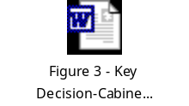   | Throughout the 2004/05 financial year | Lead Member | Environmental
33. | Approval of two “Rethinking Construction” Partners – Major New Building and Refurbishment Work   | July, 2004 | Lead Member | Environmental
 | Items for Future Forward Plans
A. | Approval of two “Rethinking Construction” Partners – Other New Build and Refurbishment Work   | September, 2004 | Lead Member | Environmental
B. | Approval of a “Rethinking Construction” Partner – Highway Structures  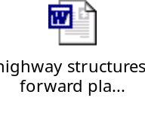 | February, 2005 | Lead Member | Environmental
C. | Approval of two “Rethinking Construction” Partners – Highway and Civil Engineering  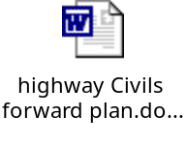 | February, 2005 | Lead Member | Environmental
D. | Approval of a “Rethinking Construction” Partner – Mechanical Services   | February, 2005 | Lead Member | Environmental
E. | Approval of one or two “Rethinking Construction” Partners – Landscape Works   | February, 2005 | Lead Member | Environmental
F. | Approval of a “Rethinking Construction” Partner  – Electrical Services   | February, 2005 | Lead Member | Environmental
G. | Approval of two or three “Rethinking Construction” Partners – Minor Building Works   | March, 2005 | Lead Member | Environmental
H. | Approval of two or three “Rethinking Construction” Partners – Responsive and Routine Maintenance   | March, 2005 | Lead Member | Environmental

The following list gives the names of the members of the Cabinet: Councillors Antrobus, Connor, Hinds, Lancaster, Mrs. Lea, Mann, Merry, Sheehy, Warmisham and Warner.

16th April, 2004
Law and Administration Division
Corporate Services Directorate
Salford City Council
Salford Civic Centre
Chorley Road, Swinton, M27 9TN
Tel No: 0161 793 3018
Fax No: 0161 793 3160
E-mail Address: Paul.Templeton@salford.gov.uk
Internet Site: www.salford.gov.uk

