Local Government Act 2000

SALFORD CITY COUNCIL

FORWARD PLAN OF KEY DECISIONS

The following is a list of key decisions that are proposed to be made during the period of four months commencing on 1st October, 2002.
Particulars of each proposed decision are contained in the appendices to this list

Number | Subject | Date/Period of Decision
1. | Broughton Area Traffic Calming  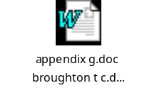 | 1st September to 31st December, 2002
2. | A6 High Street/Manchester Road, Walkden  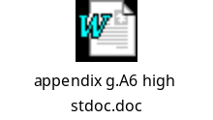 | ditto
3. | Westwood Park Traffic Calming Scheme  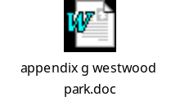 | ditto
4. | Improvement to Little Moss Lane  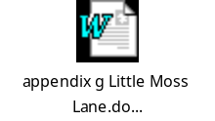 | ditto
5. | Canterbury Gardens Traffic Calming Scheme  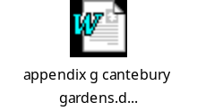 | ditto
6. | A56 Bury New Road Resurfacing Scheme   | ditto
7. | Armitage Avenue Resurfacing Scheme  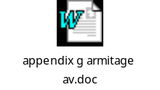 | ditto
8. | Agreement to Sell Land/Property  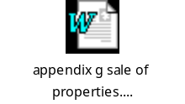 | September, 2002 to March, 2003
9. | Neighbourhood Wardens Street Crime Bid  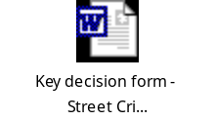 | September/October, 2002
10. | Home to School and Social Care Transport   | 2nd October, 2002
11. | Community and Social Services Budget Strategy  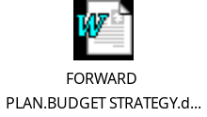 | ditto
12. | Community and Social Services Charging Policy  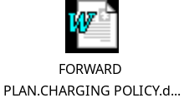 | ditto
13. | The Corporate Housing Strategy for the City  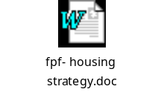 | ditto
14. | Regulatory Reform of Private Sector Renewal (Housing)  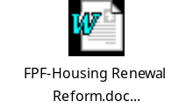 | 17th September, 2002 / January, 2003
15. | Greater Manchester Weaste Disposal Authority  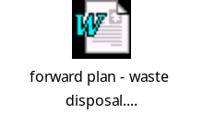 | 2nd October, 2002
16. | Cliveley Estate, Swinton – Internal Refurbishment Works to Properties  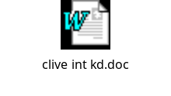 | October, 2002
17. | Beehive Estate, Clifton – Gas Heating Replacement  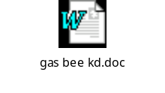 | ditto
18. | Moss Vale Estate, Eccles – Gas Heating  Replacement  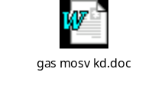 | ditto
19. | Installation of C.C.Tv. Systems at Philip Street, Eccles   | ditto
20. | Installation of C.C.Tv. Systems at various locations in the City   | ditto
21. | Neighbourhood Renewal Strategy  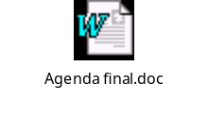 | 2nd October, 2002
22. | New Foodstore, Salford Shopping City  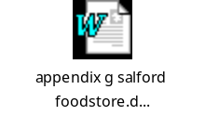 | ditto
23. | Floral Court Car Park  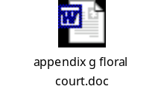 | 1st September – 31st December, 2002
24. | Greenspace Strategy for Salford   | ditto
25. | Establishment of a Schools Forum  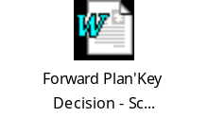 | October, 2002
26. | St. Paul’s C.E. Primary School – Roofing, etc.   | ditto
27. | James Brindley Primary School – Roofing, etc.  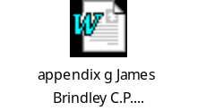 | ditto
28. | Fiddlers Lane Primary School – Roofing  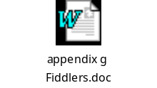 | ditto
29. | Marlborough Road Primary School – Heating  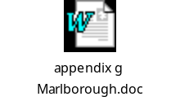 | ditto
30. | Lower Kersal Primary School – Heating   | ditto
31. | Electrical Rewiring at various schools  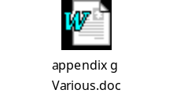 | ditto
32. | St. Peter’s C.E. Primary School – Electrical Rewiring  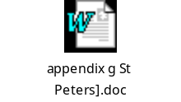 | ditto
33. | St. Paul’s C.E. Primary School – Electrical Rewiring  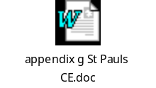 | ditto
34. | St. Luke’s R.C. Primary School – Heating   | ditto
35. | St. Ambrose Barlow R. C. High School – Heating  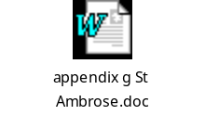 | ditto
36. | Mitchell Shackleton Changing Rooms   | ditto
37. | Winton Library Alterations  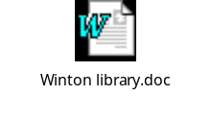 | ditto
38. | Contaminated Land Inspection Strategy  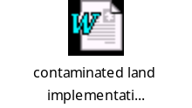 | 30th October, 2002
39. | Special Educational Needs and Inclusion  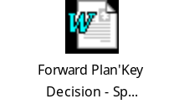 | 16th October, 2002
40. | Pre-painting and Repair Work at Duchy Road – Phase 2  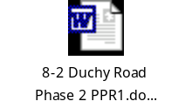 | 2nd October, 2002
41. | Neighbourhood Wardens – Future Areas for Deployment  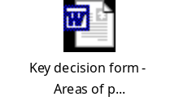 | 16th October,2002
42. | CCTV Strategy  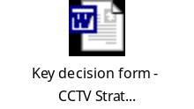 | 30th October, 2002
43. | Corporate Security Strategy   | ditto
44. | Mobile Patrols   | ditto
45. | Trading Standards Service Delivery Plan  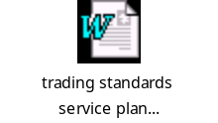 | 16th October, 2002
46. | Community and Social Services Homes to Trust  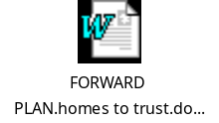 | ditto
47. | E-Government Programme  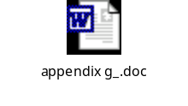 | ditto
48. | Pre-painting and Repair Work at Duchy Road – Phase 1  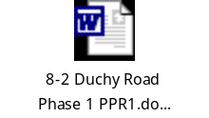 | 18th October, 2002
49. | Contaminated Land Inspection Strategy | 30th October, 2002
50. | Extension to Winton Nursery  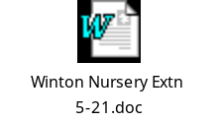 | November, 2002
51. | Barton Strategic Site  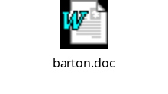 | 13th November, 2002
52. | Admiralty Estate, Eccles – Internal refurbishment of Properties  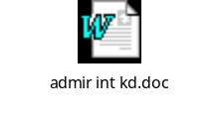 | November, 2002
53. | Lower Broughton Road, Salford – Gas heating Replacement in Properties  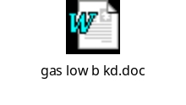 | ditto
54. | Harrop Street, Worsley – Internal Refurbishment Works to Properties  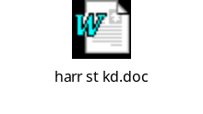 | ditto
55. | Salford’s Tourism Strategy   | 13th November, 2002
56. | S.E.N./Schools Budget  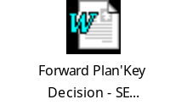 | ditto
57. | New Funding Arrangements for Education  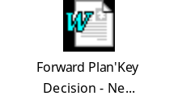 | ditto
58. | Juvenile Nuisance Strategy – Early Intervention Model  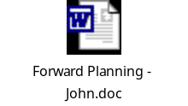 | 27th November, 2002
59. | Pre-painting Repair Work to Properties at Hilltop (Phase 1)   | 29th November, 2002
60. | Unitary Development Plan   | 11th December, 2002
61. | Review of Museum Opening Hours  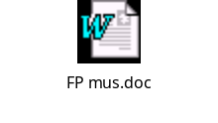 | ditto
62. | Lords Street : Contaminated Land Remediation Scheme  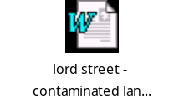 | 22nd January, 2002
13th September, 2002

