SALFORD BEST VALUE
SERVICE IMPROVEMENT PLAN

Housing Services

AUGUST 2002

HOUSING SERVICES

CONTENTS

Introduction

Key Theme One - Improving the Organisational Infrastructure

Key Theme Two - Performance Management, Procedures and Access to Services

Key Theme Three - Improving the IT Infrastructure

Key Theme Four - Improving the Repair Service

Key Theme Five - Introduce Partnering Approach to Repairs Procurement

Key Theme Six - Reducing Voids

Key Theme Seven - Reducing Rent Arrears

Key Theme Eight - Ensuring Quality Support Services

Key Theme Nine - Improving Services to Asylum Seekers

Key Theme Ten - Developing the role of Caretakers

Key Theme Eleven - Improving Estate Management and Tackling Anti-Social Behaviour

Related Performance Indicators

Risk Assessments

INTRODUCTION

PRIORITIES

Improvements arising out of the Best Value Review of Housing Services will be addressed within three priority bands:

- Priority One – improvements which need to be put in place to create a suitable infrastructure for building excellent housing services. Improving repairs is also a Priority One given the importance of the repair services to the housing service as a whole.

Priority One improvements will be given absolute priority in the allocation of resources and in monitoring. A risk assessment has been included for all Priority One improvements.

Key Themes One to Five are in the Priority One banding.

- Priority Two – improvements which are very important to the housing service and its tenants, including bringing in rental income, but are not infrastructure issues.

Key Priorities Six to Eleven are in the Priority Two category.

- Priority Three – these are “quick win” improvements which can be achieved without a significant increase in resources.

Priority Three improvements do not appear within the Service Improvement Plan. They will be monitored via a separate checklist approach.

RESOURCES

This is an ambitious programme with tight timescales determined by the need to improve some aspects of the service quickly and to draw down ALMO resources to improve the housing stock. Bearing this in mind, substantial additional resources have been allocated to delivering the plan. These include:

- An 8 person Best Value Team
- An 8 person IT Projects Team which will be enhanced by 5 further temporary post holders
- A 12 month secondment of the current Surveying Manager Maintenance to work exclusively on procurement with back filling in place.
- A staff member fully dedicated to Business Process Re-Engineering
- A substantially increased Human Resource Team including two training officers
- An additional Principal Officer dealing with Asylum Seekers services and Supported Tenancies
- A six month secondment of the Principal Officer Allocations to be fully dedicated to SIP projects with back filling in place
- An additional half time Principal Officer Rents post to be fully dedicated to SIP projects

The time individual staff will spend on a project identified within the plan is expressed as a percentage of time available to that staff member. Unless stated otherwise, this will be for the life of the project.

All the staffing arrangements identified within the plan have been agreed by the Council’s Cabinet Lead Member for Housing Services who is empowered to agree such matters on the behalf of the Council.

MONITORING

Progress on the Service Improvement Plan will be monitored on a monthly basis by the ALMO’s Parent Board with information also going to Local Boards.

Progress will also be reported each quarter and the Council’s Environmental Scrutiny Committee and Cabinet.

The ALMO’s Senior Management Team, which includes Group Managers, will co-ordinate the change process across all areas.

Monitoring will be against the project charts and outcomes included within the plan. In addition, key performance indicators have also been identified for project where appropriate.

PROJECT MANAGEMENT

The City Council has used the Prince 2 project management approach to monitor Corporate IT developments. This approach is being adopted for the Priority One improvements within this plan.

As part of this approach, we will set up steering groups for key projects which will include tenants, staff and other stakeholders.

MANAGEMENT DEVELOPMENT

Key Theme One includes the provision of management development training for managers and board members. We recognise that this is of primary importance for the successful implementation of the Service Improvement Plan. This training will seek to provide, as a key output, a concensus view for the ALMO organisation on:-

- how managers and staff work as a team
- how decisions are made speedily and effectively
- how change can be managed effectively

The ALMO is already committed to pursuing Investors in People accreditation . As part of the management development process, we will also look at other appropriate frameworks for service improvements.

INVOLVING TENANTS AND STAFF

Tenants will play an important role in pushing forward many of the improvements identified within this plan. They will be involved in a number of ways:-

- As members of steering groups for projects.
- As members of specific focus groups within projects.
- Via satisfaction surveys (there will be an annual tenant survey of key service areas as part of our Performance Management Strategy).
- Via specific surveys at the end of projects or as part of the evaluation process.
- As members of ALMO Parent and Local Boards monitoring progress and agreeing project conclusions.

Similarly, staff representatives will sit on steering groups and focus groups, and staff will be surveyed. Monthly team meetings will also be used to keep staff informed and involved in the improvement process.

TENANT PARTICIPATION
A Best Value Review of Tenant Participation will begin in January 2003 and be completed by April 2004. This will pick up a number of themes which have arisen out of the review of housing services and the subsequent inspection:-
- Formulating a comprehensive Tenant Participation Strategy.
- Encouraging a broader involvement of tenants in housing management.
- Resourcing tenant participation.
- Developing the role of the Peoples Forum.

PROGRAMMED REPAIRS
A review of Programmed Repairs is currently underway and will be completed by January 2003. This will be heavily influenced by the approach to repairs procurement described within this plan, and will also pick up on ensuring quality, determining investment priorities and involving tenants.

KEY THEME ONE – IMPROVING THE ORGANISATIONAL INFRASTRUCTURE
IMPROVEMENT  ISSUE | SOLUTION (TASK) | SERVICE IMPROVEMENT/ OUTCOMES | LEAD OFFICER | TARGET DATE | RESOURCE | COMMENTS/ EVIDENCE
KT1  Successful service provision depends in no small measure on the commitment and skill of the workforce.  At the same time all staff are having to deal with change at a frantic rate.  Managers face significant challenges as well as conflicting demands on their time. | - Create an enhanced Human Resource Team including additional training capacity.  • Implement a management development process for key managers to include:  - team building  - action based management  - management of change  - Implement a management development process tailored to the needs of Parent and Local ALMO boards  - Develop framework for all managers on decision making, joint working and change management | • Better trained workforce leading to improved services  • Lower sickness level  • Lower staff turnover  • Investing in People Accreditation in 2003/2004  - Greater staff participation  - Speedier and more effective decision making  - Better management of change  - More support for staff and managers  - Better manager and employee relationships  - Production of an employees’ handbook | Human Resource Manager | June 2004 | Approximately 25% of the Human Resource Team (8 staff)  Management Development will be supported by Corporate and external resources  Consultant already identified for IIP assessment. | The Human Resource Team has been agreed and recruitment is well advanced.  Draft Management Development Programme produced and out for consultation.  Note links with Performance Management  Staff will be surveyed as part of the review this project and also for IIP accreditation.  Staff have already been consulted on the PDR implementation. Further staff focus groups will consider the other

IMPROVEMENT  ISSUE | SOLUTION (TASK) | SERVICE IMPROVEMENT/ OUTCOMES | LEAD OFFICER | TARGET DATE | RESOURCE | COMMENTS/ EVIDENCE
- Extend staff involvement in service monitoring and planning via monthly team meetings and focus groups
• Create and implement annual training programmes to meet key business related skill requirements
• Extend induction training package to all staff
- Develop a Human Resource Strategy for the ALMO

- Implement Personal Development Records for all staff to include appraisal and a checklist for key work related skills
- Implement Attendance Management Policy including training.
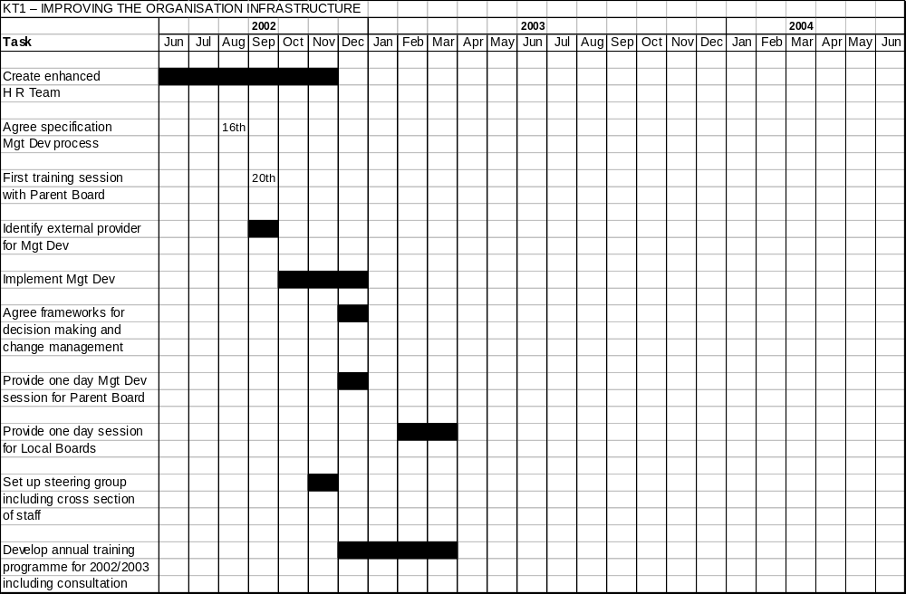

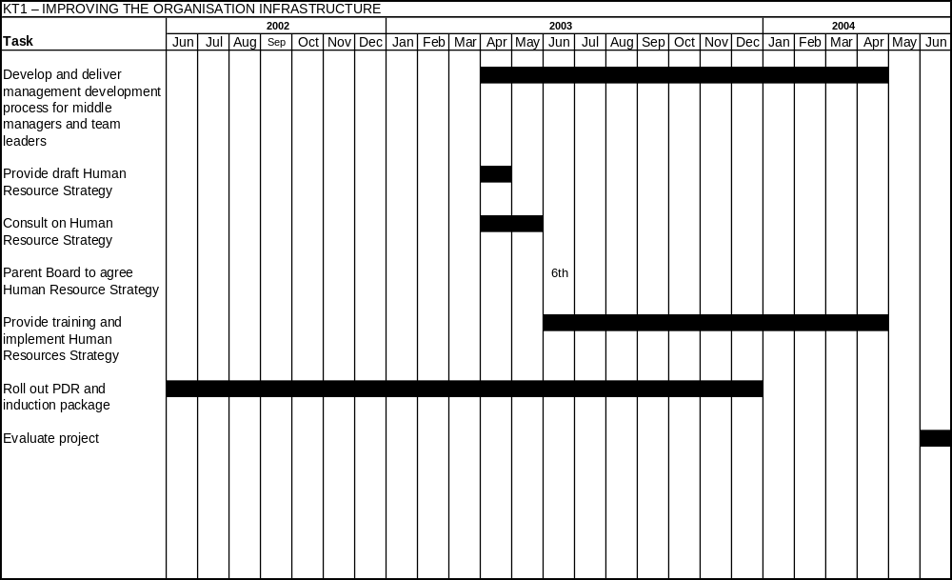
KEY THEME TWO – PERFORMANCE MANAGEMENT, PROCEDURES AND ACCESS TO SERVICES
IMPROVEMENT  ISSUE | SOLUTION (TASK) | SERVICE IMPROVEMENT/ OUTCOMES | LEAD OFFICER | TARGET DATE | RESOURCE | COMMENTS/ EVIDENCE
KT2/1 Revising Procedures  • Existing procedures are in need of clarification and updating  - Recent IT changes need to be reflected in policy and procedures  • Implementation of procedures is inconsistent  • Existing processes require re-engineering to facilitate a call centre approach to service access  - Existing area based “Call Centres” are seen as on interim solution only and do not meet the performance standards of a more professionally managed call centre | - Review and revise existing procedures. Include monitoring arrangements and customer feedback.  - Provide training as part of implementation  - Build in equalities issues  • Consult and involve staff and tenants  • Carry out Business Process Re-engineering process  • Provide costed options to the ALMO Parent Board for service delivery including a Call Centre and One Stop Shop  - Provide implementation plan  - Improving guidance, scripting and training for front line staff  - Review Housing Officers workloads following implementation of new systems. | - Improved access to services  • More consistent implementation of processes and procedures  - Clearer guidance on repair priorities – fewer emergencies.  - More efficient and consistent delivery of services to tenants  - Services more responsive to tenants’ requirements and more customer focused  - Better information to tenants on services including a tenants handbook with service standards. | Principal Officer (Management) | April 2003 | Business Process Re-Engineering Officer (100%).  Principal Officer Best Value (100%).  X 3 Principal Officers (20%)  Training Officer (20%)  Management Services input on workload assessment  x 5 group managers (5%)  Input from Salford Advance  (Corporate IT Team dedicated to service access issues) and Salford Direct (Corporate Call Centre and One Stop Shop) | The Business Process Re-Engineering Project has been in progress since January 2001 with a specialist officer leading it.  Revision of procedures and processes already in progress  Other resources are also in place  Focus groups are being used to involve tenants and staff. A tenant survey will test out tenant responses to current services and aspirations for future services  Note link with Salford’s Corporate Customer Contact Strategy

IMPROVEMENT  ISSUE | SOLUTION (TASK) | SERVICE IMPROVEMENT/ OUTCOMES | LEAD OFFICER | TARGET DATE | RESOURCE | COMMENTS/ EVIDENCE
KT2/2 Improving Performance Management  - Salford Housing Services has recently introduced a Performance Management Strategy which will form the basis of performance management within the ALMO. This is designed to address a key weakness, but will require effective implementation | - Confirm adoption of draft Performance Management Strategy by ALMO Parent Board  • Develop appropriate documentation and provide training  • Role out Personal Development Record (including appraisal).  - Implement framework of monthly and quarterly performance monitoring.  • Identify individual and team targets  - Introduce monthly and quarterly performance monitoring for ALMO Parent and Local boards  - Establish customer feedback and consultation arrangements for each major service area. | - Improved focus on service provision  • Improved customer feedback  • Improved quality monitoring  • Extended role for tenants in performance management via ALMO boards  - Improved service planning  - More accurate and consistent measurement of key performance indicators  - Clear monitoring arrangements between the ALMO and the Council | Principal Officer Management | December 2003 | Principal Officer (Performance) 100%  Senior Officer (Customer Care) 20% | Existing project which began January 2002  The organisation has an officer dedicated to co-ordinating and checking performance indicators.

IMPROVEMENT  ISSUE | SOLUTION (TASK) | SERVICE IMPROVEMENT/ OUTCOMES | LEAD OFFICER | TARGET DATE | RESOURCE | COMMENTS/ EVIDENCE
KT2/3 Ensuring Equality of Access to Services  • Although Salford has produced an action plan for addressing equality and diversity within the Housing Service, there remains a good deal of catch up work required.  • One initial weakness is the current failure to meet the CRE Code of Practice for Rented Housing, completely (currently 70%)  - Backlogs are building up for disabled adaptations | - Establish quality measures for each major service area  - Complete current training initiative for all staff on a broad range of equality issues.  • Complete similar training for all ALMO board members  • Incorporate ethnic monitoring arrangements within Performance Management Strategy  • Analyse 2001 Census information and identify service implications  - Integrate equalities issues within ALMO Delivery Plan  - Set up contract with Salford Link Project | - Ensure the service meets the CRE Code of Practice and the CRE Standard for Local Government Level 1 and 2  • Improved access to service for all minorities  • Greater involvement of BME Communities in service planning and monitoring  - Improved ethnic monitoring arrangements | Deputy Director of Housing | June 2003 | Principal Officer Best Value 20%  Senior Officer Customer Care 10%  Principal Marketing Officer 10%  Training Officer 50% (currently being recruited)  Human Resource Manager 5% (as above)  Senior Officer Tenant Participation (10%) | This project started with the setting up of Equality Group at the end of 2001.  Note links with performance management.  Note link with partnership procurement (KT5) for equalities issues for contractors  Note link with corporate IdeA Peer Group on equality issues

IMPROVEMENT  ISSUE | SOLUTION (TASK) | SERVICE IMPROVEMENT/ OUTCOMES | LEAD OFFICER | TARGET DATE | RESOURCE | COMMENTS/ EVIDENCE
- Consult on and publicise Equality and Diversity Statement
• Review target in 2003/2004 Tenants Compact
• Set up service user focus group for BME communities
• Set up service user focus group for disabled tenants
• Carry out access survey for all area offices
- Establish improvement plan for area offices
- Review Equalities Action Plan
Review budget arrangements for disabled adaptation
- Identify equality issues within revised procedures

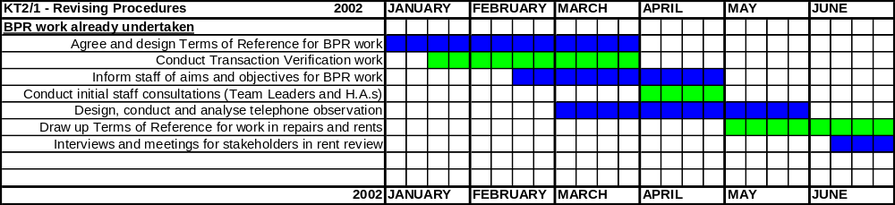

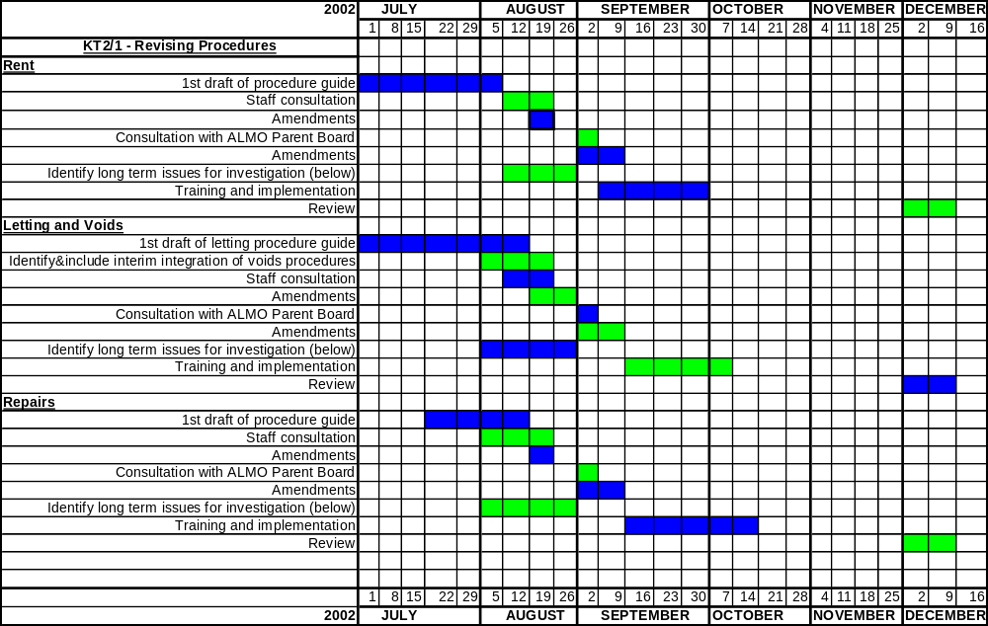

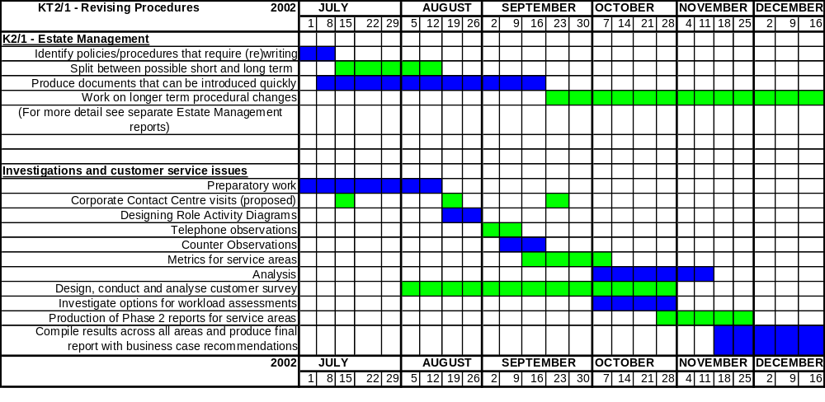

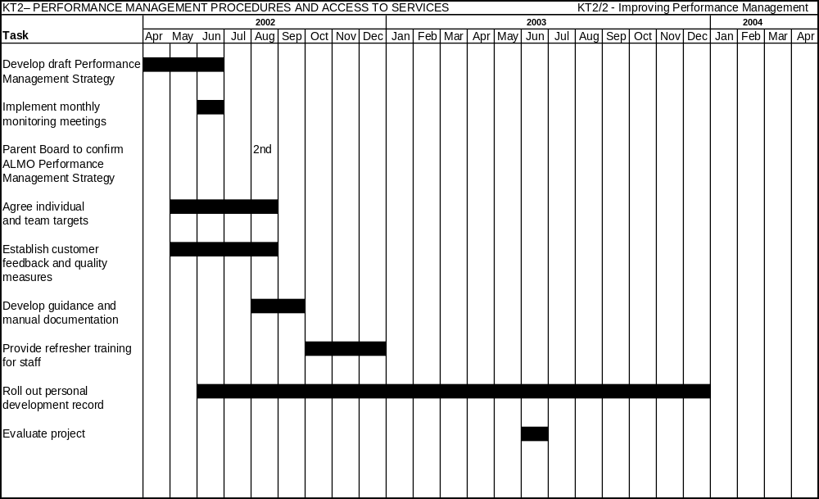
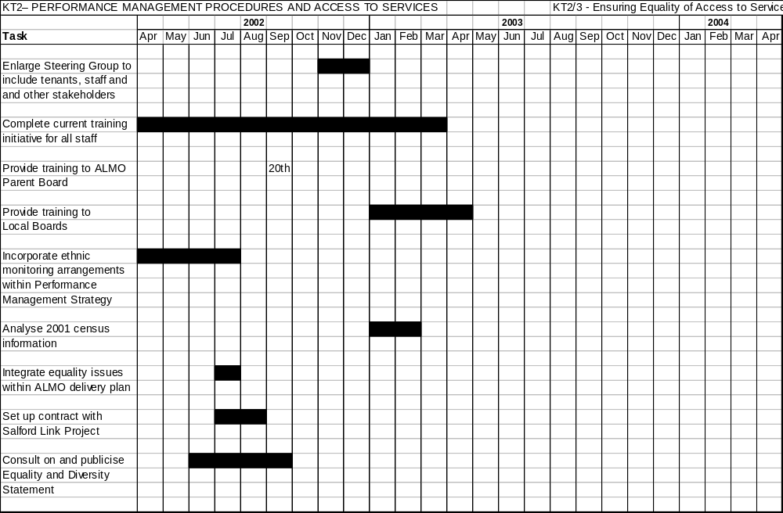

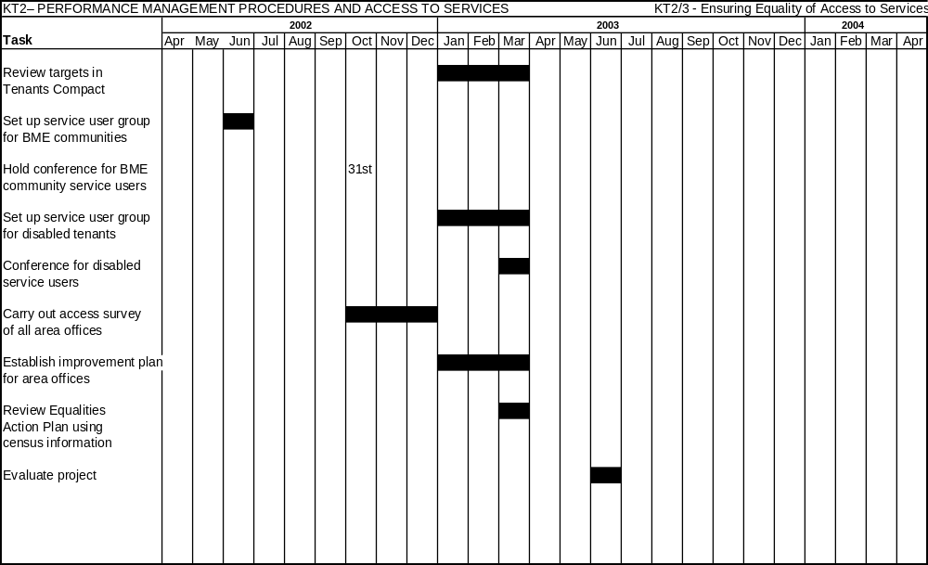
KEY THEME THREE – IMPROVING THE IT INFRASTRUCTURE
IMPROVEMENT  ISSUE | SOLUTION (TASK) | SERVICE IMPROVEMENT/ OUTCOMES | LEAD OFFICER | TARGET DATE | RESOURCE | COMMENTS/ EVIDENCE
KT3  Salford is in the process of introducing a new integrated housing management. computer system. Whilst this will bring considerable long term benefits, initial problem have to be overcome.  • The delayed delivery of system models and the expiry of licenses of old systems adversely affected implementation  • Training was incomplete  • Data input from previous systems was incomplete  - “Teething problems” resulted in elements of the system being non-functional | - Establish a revised implementation plan which:  - Addresses problems with implemented modules and training as a first priority  - Prioritises the implementation of further modules  - Brings additional resources to bear  - Includes realistic timescales  Carry out further development of the system to support longer term service improvements including call centres | - Teething problems and training addressed  - Fully operational gas servicing module as a basis for better procedures  - Fully implemented system to support:-  - service improvement to tenant  - performance management  - efficiency savings  - better service information | Graham Strachan | April 2004 | IT Projects Team (6 members) Additional for 12 months:  1 Principal Officer  2 Trainers  2 Data inputters  Support from corporate IT teams | Additional resource have been agreed for the team on a temporary basis to address the immediate problems. Recruitment well advanced. Future staffing resources will be based on system improvements to be identified.  Link with Corporate Customer Contact Strategy
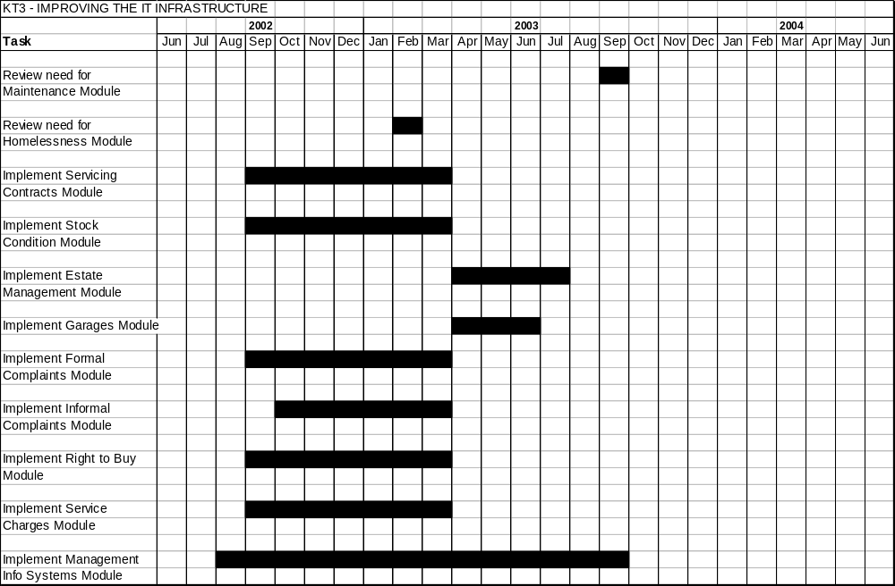
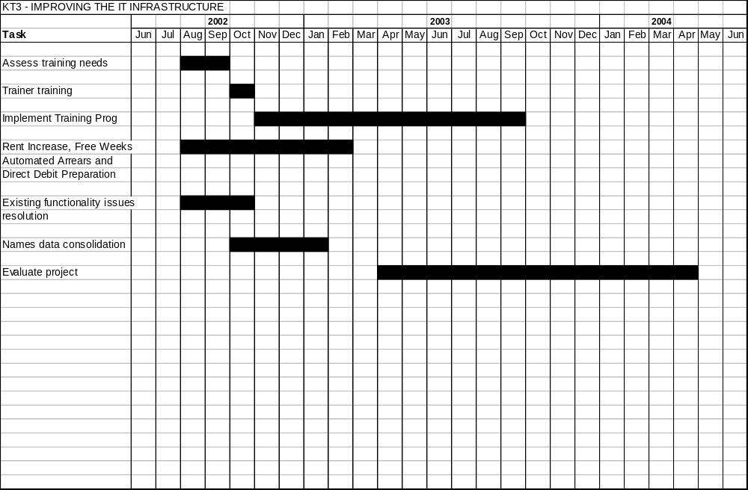
KEY THEME 4 – IMPROVING THE REPAIR SERVICE
IMPROVEMENT  ISSUE | SOLUTION (TASK) | SERVICE IMPROVEMENT/ OUTCOMES | LEAD OFFICER | TARGET DATE | RESOURCE | COMMENTS/ EVIDENCE
KT4/1 Review of Existing Bonus Scheme  Existing bonus arrangements are a barrier to more flexible working and the achievement of high quality repairs with a customer focus.  The replacement of the existing bonus system will make possible a radical re-organisation of the repairs service including the creation of a void repair team, and fewer pre-inspections.  KT4/2 Central Void Working Arrangements  Void repairs are slow and quality is inconsistent. Void repair processes are overly complex . | - Replace current bonus system with more appropriate arrangements.  - Implement a multi-skilling approach to repair work  - Create a single void repair team in partnership with private sector providers which will carry out all security, repair and cleaning processes for all voids.  - Introduce a common banded approach to repair completion | - Improved performance on repair completions  - Greater customer focus  - Improved quality of services for tenants  - Speedier void repairs  - More reliable completion target dates  - More consistent implementation of void repair standards already agreed with tenants.  - More voids repaired | K Pearson  J Caulfield | 1st April 2003  1st April 2003 | Ian Blease (50%)  20% Personnel Officer (currently being recruited)  10% Dave Rowe  10% Mike Watkinson  Ian Blease (50%)  2 Repair Inspectors  (100%)  Senior Housing officer (10%)  Contracts Manager Jackson Lloyd (10%) | Ian Blease is the full time Best Value Implementation Officer for repairs.  An enlarged Human Resource Team for the ALMO has already been agreed and recruitment is well advanced.  This project will run in parallel with replacement of the bonus scheme. It will reflect a partnership with Jackson Lloyd (building contracts) with specialist contractors coming in as sub-contractors.

IMPROVEMENT  ISSUE | SOLUTION (TASK) | SERVICE IMPROVEMENT/ OUTCOMES | LEAD OFFICER | TARGET DATE | RESOURCE | COMMENTS/ EVIDENCE
KT4/3 Salford North Pilot Area  Salford has used its Salford North Pilot Project as a test bed for detailed changes to the repair service. This project included a number of “trials” | timescales depending on the work content.  - Introduce “Just in Time” approach for ordering materials.  - Use new tenant survey to test out service improvements as part of the evaluation of the project.  - Reduce the number of pre-inspections to 10% and increase post inspections to 10% minimum  - Empower operatives to carry out additional repairs and variations within set limits.  - Introduce a scripting approach to repair reporting and ordering to improve accuracy and reduce emergencies  - Provide mobile phones to operatives to improve communications with area office and tenants | - Better product and more reliable estimated lettings dates for prospective tenants  - Reduce void levels and improved voids performance (see BVP1 targets)  - Improved repairs performance  - More flexible response to tenants on minor repairs  - Improve efficiency by more accurate repair reporting  - Fewer abortive “no access” calls  - Better feedback to tenants  - Better customer feedback  - Better joint working between area team and contractor  - Improved communication | J Caulfield | June 2003 | Mark Magahey  John Watson  (in place)  Jeff Boardman) 10%  Group Managers  (5%) | 2 repair inspectors will be released to carry out work on this project by a reduction of pre-inspectors within Salford North  This project commenced in late February 2002. The project has a Steering Group which includes tenant representations, staff and other stakeholders.  Following evaluation the pilot trials will be rolled out to other areas linking in with the replacement of the bonus scheme and the creation of a voids repair team.

IMPROVEMENT  ISSUE | SOLUTION (TASK) | SERVICE IMPROVEMENT/ OUTCOMES | LEAD OFFICER | TARGET DATE | RESOURCE | COMMENTS/ EVIDENCE
- Implement Rapid Response Team as an immediate and flexible approach to minor repairs
- Appoint specialist officer to chase up repairs on behalf of tenants
- Increase the number of appointments offered to tenants on non-emergency work
- Improve customer feedback via better use of customer care cards, tenant focus groups, and satisfaction surveys
- Create arrangements for recording customer feedback and quality information, and feeding into service planning

IMPROVEMENT  ISSUE | SOLUTION (TASK) | SERVICE IMPROVEMENT/ OUTCOMES | LEAD OFFICER | TARGET DATE | RESOURCE | COMMENTS/ EVIDENCE
KT4/4 Revision of the Schedule of Rates  Salford’s current Schedule of Rates was developed within a traditional CCT environment and has been in place for a number of years.It is a barrier to more efficient working. | Review and revise the current schedule of rates and working practices to:  - Reduce the overall number of items  - Increase the proportion of repairs carried out within repair programmes.  - Decrease the proportion of emergency repairs by introducing a 3 day category for “Right to Repair” jobs  - Introduce an upper limit for the value of repairs ordered via the SOR  - Introduce system of notification for tenants for “Held Work” tenant and staff  - Use tenant and staff focus group to test out project proposals | - Greater cost effectiveness using programmed repairs  - Simpler administrative system for ordering repairs  - Reduced held work – increase in work carried out within programmes  - Fewer emergencies  - Overall improved repairs performance | Surveying Manager Maintenance | July 2003 | Graham Bullock  Les Wareham  Module Leader IT Projects Team  (10%)  Jeff Boardman  (15%) | The two officers assigned to this task are currently employed on the Best Value Review of Programmed Repairs, but will be available from December 2002.  Charges to the SOR will be linked with the replacement of the bonus scheme and the creation of a void repair team

IMPROVEMENT  ISSUE | SOLUTION (TASK) | SERVICE IMPROVEMENT/ OUTCOMES | LEAD OFFICER | TARGET DATE | RESOURCE | COMMENTS/ EVIDENCE
KT4/5 Developing New Arrangements for Gas Servicing and Repairs  Gas servicing is currently unsupported by IT systems and processes which offer effective monitoring and client control. | - Introduce module of Saffron computer system to order and record gas servicing and repairs  - Introduce more effective access arrangements for servicing  - Introduce more effective performance management  - Extend appointments system to gas servicing and repairs  - Test out project conclusions via a tenant and staff focus group | - Minimise risks from dangerous and faulty gas equipment  - Minimise non-servicing and repair because of no access  - Ensure better contract performance and value for money from the contractor | Surveying Manager Maintenance | March 2003 | Module Leader IT Projects Team (100%)  Principal Services Surveyor (20%)  Legal Officer  (5%) | Link with IT Implementation Project  Note: interim arrangements for recording service visits and no-access put in place July 2002
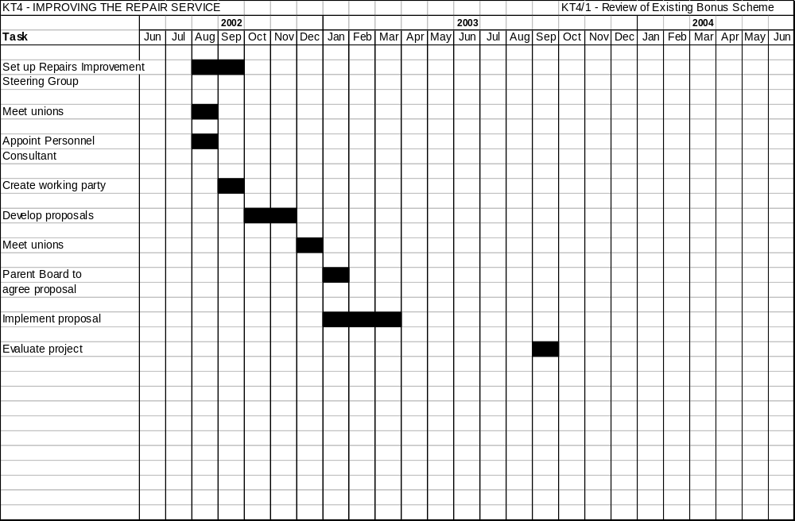
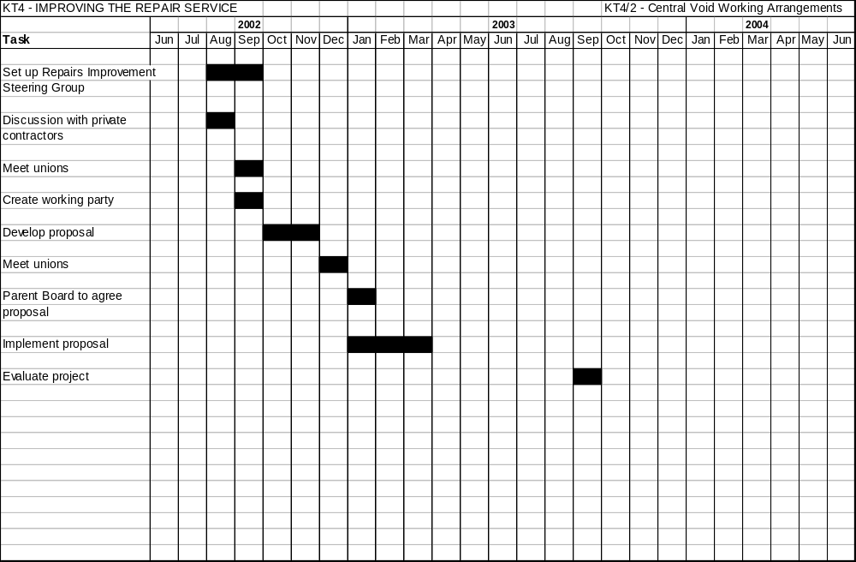
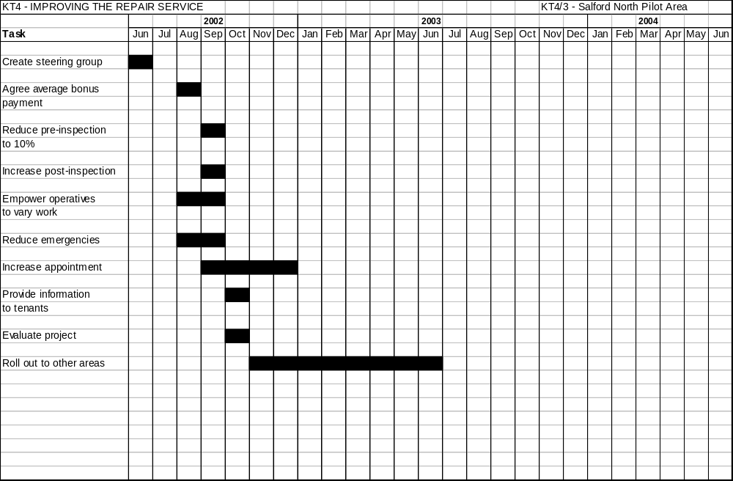
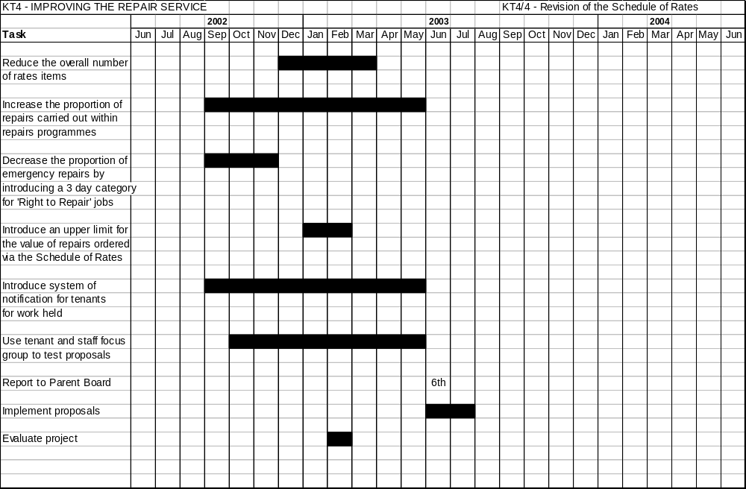
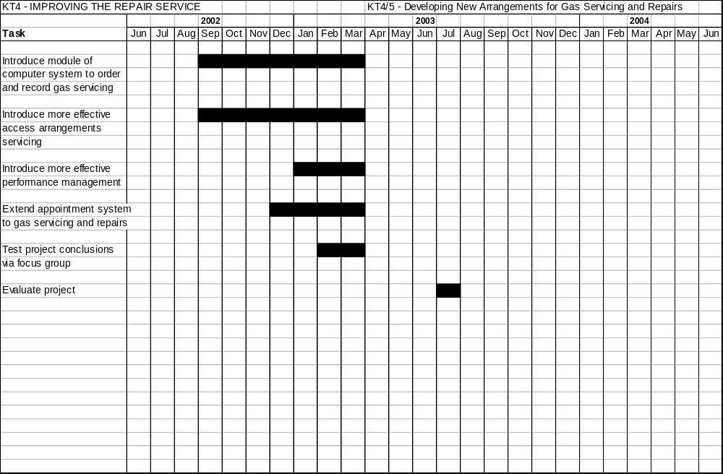
KEY THEME FIVE – INTRODUCE PARTNERING APPROACH TO REPAIRS PROCUREMENT
IMPROVEMENT  ISSUE | SOLUTION (TASK) | SERVICE IMPROVEMENT/ OUTCOMES | LEAD OFFICER | TARGET DATE | RESOURCE | COMMENTS/ EVIDENCE
KT5  Existing arrangements for procuring repairs contracts are based on a traditional CCT approach, although limited Partnering pilots have been established.  Current services cannot demonstrate value for money or high quality. | - Introduce procurement via Partnering principles:  - large scale  contracts  - long term  contracts  - holistic contract  functions cutting  out unnecessary  bureaucracy  - performance  management based  on key  performance and  quality outputs  - evaluation based  on price, quality  and added value  - Pursue a  Partnering procurement exercise:  - formulate procurement strategy in consultation with consultant and key service providers  - advertise for  expressions of  interests | - Better value for money  - Increased capacity to carry out a wide range of repairs  - Increased capacity to spend ALMO resources  - Improved quality for tenants  - Added value e.g. local employment and training opportunities, encouraging a greater ethnic diversity in the workforce.  - Speedier repairs for tenants  - Customer involvement in performance management  - Clarity of roles and less duplication | Nigel Sedman | January 2004 | Nigel Sedman (100%)  Principal Finance Officer (10%)  Principal Legal Officer (10%)  Human Resource Manager (10%) | Nigel Sedman will be seconded to this project with his current post being back filled for the period of the project.  A consultant advisor is being identified to support the project.  The City Council agreed in principle a partnering approach to the procurement of repair services at its July meeting.  Networking with other authorities who have followed the Partnering route currently  in hand

IMPROVEMENT  ISSUE | SOLUTION (TASK) | SERVICE IMPROVEMENT/ OUTCOMES | LEAD OFFICER | TARGET DATE | RESOURCE | COMMENTS/ EVIDENCE
 | - select tender  shortlist  - carryout formal  tendering process  - create an  evaluation model  - identify a  preferred partner  or partners |  |  |  |  | The project steering group will be led by the ALMO but will include a wide range of stakeholders including Parent Board members, and tenants and staff representation

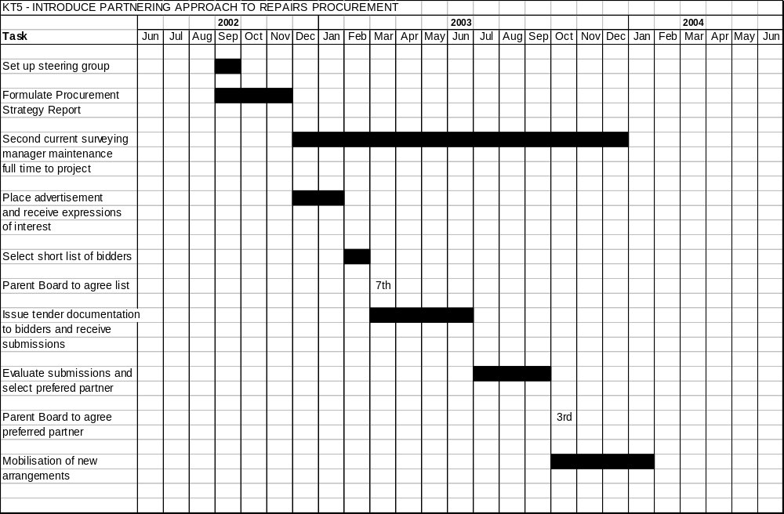
KEY THEME SIX – REDUCING VOIDS

IMPROVEMENT  ISSUE | SOLUTION (TASK) | SERVICE IMPROVEMENT/ OUTCOMES | LEAD OFFICER | TARGET DATE | RESOURCE | COMMENTS/ EVIDENCE
KT6  Procedures need clarification and updating  - Performance Management needs improving to ensure consistency and quality  - Marketing is not focused – training needs topping up  - IT systems are not fully functional  - The property shop is not operating effectively | - Complete review of policies and procedures. Train staff  - Complete implementation of IT system. Train staff  - Review property shop  - Develop targeted marketing policy following the release of census information  - Review allocation policy to include latest government guidelines and evaluate existing policy  - Implement Performance Management Strategy | - Greater consistency in service provision  - Better integration of property shop with area offices  - More effective marketing  - Speedier allocations  - Fewer voids (see BVP1 targets)  - Better quality services for customers  - Better customer feedback | Principal Officer  (Management) | Jan 2004 | Principal Officer  (Allocations)  (100%)  Group Manager  (10%)  Principal Officer IT Projects Team  (20%)  Principal Officer Marketing  (20%) | PO Allocation will be seconded to this project for 6 months, with her existing post being back filled  Note links with Performance Management, IT systems and improving procedures projects

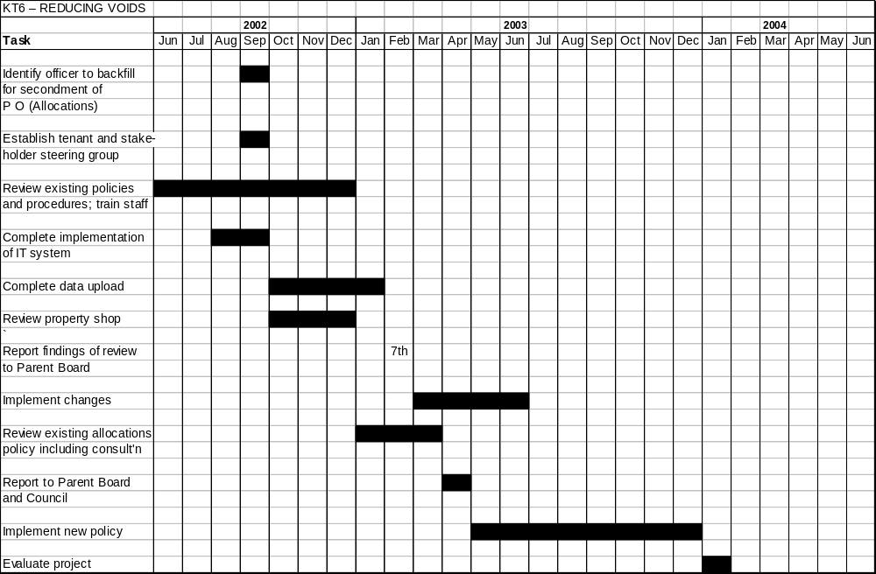
KEY THEME SEVEN – REDUCING RENT ARREARS
IMPROVEMENT  ISSUE | SOLUTION (TASK) | SERVICE IMPROVEMENT/ OUTCOMES | LEAD OFFICER | TARGET DATE | RESOURCE | COMMENTS/ EVIDENCE
KT7  - Rent arrears levels are high in comparison to other providers  - Housing Benefit processing performance has been poor  - There is no corporate debt strategy or targeting of benefit advice  - IT systems are not yet fully functional  - Procedures and Performance Management require clarifying | - Review and revise procedures  - Extend free phone facility to all offices  - Implement Performance Management Strategy for rent arrears  - Finalise service level agreement on housing benefit  - Create corporate debt recovery strategy  - Introduce Direct Debit payment with incentives  - Complete IT implementation and data upgrading  - Provide ongoing arrears profile information to area offices  - Implement "Hit Squad" pilot  - Create service level agreement for providing smart payment cards | - Clear processes and procedures, and more consistent application  - Greater support for staff from IT system  - Better focused support and advice to tenants struggling to pay rent  - Wider payment alternatives for paying rent  - Speedier legal action  - Lower rent arrears levels (see BVP1 targets) | Principal Officer  (Management) | April 2005 | Principal Officer Rents (50%)  1 Module Leader IT Projects Team  (50%)  Group Manager  (10%) | PO rents currently ½ time post. Will increase to full time for the duration of this project  Links with IT , reviewing procedures and performance management project.  Note corporate links for debt strategy and SLA’s on Housing Benefit and currant payment cards.
IMPROVEMENT  ISSUE | SOLUTION (TASK) | SERVICE IMPROVEMENT/ OUTCOMES | LEAD OFFICER | TARGET DATE | RESOURCE | COMMENTS/ EVIDENCE
- Review make up and role of the central rent section following successful implementation of the IT system rent module
- Carry out procurement exercise for managing former tenants arrears
- Extend access to HB IT system within area offices

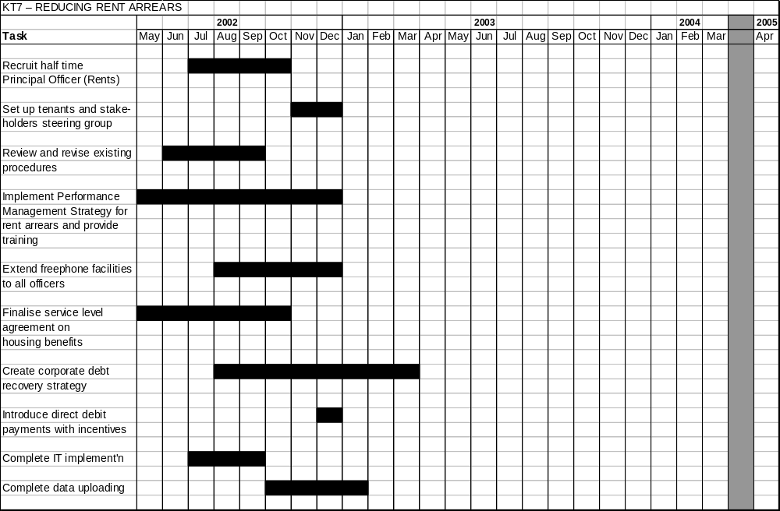

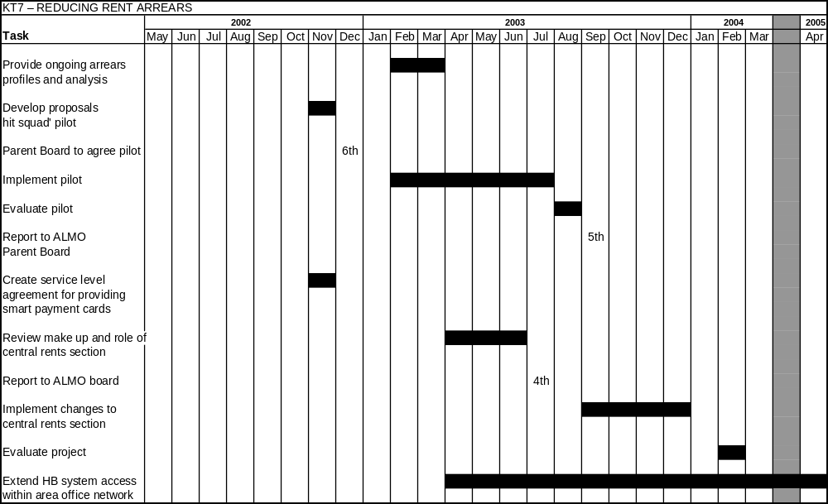

KEY THEME EIGHT – ENSURING QUALITY SUPPORT SERVICES
IMPROVEMENT ISSUE | SOLUTION (TASK) | SERVICE IMPROVEMENT  OUTCOMES | LEAD OFFICER | TARGET DATE | RESOURCE | COMMENTS
KT8  - The Housing Service depends upon support services, many from corporate providers.  • The ALMO will have a duty to ensure good quality, value for money services.  • Historically, the development and monitoring Service Level Agreement has been poor. | • Establish in house ALMO team for Personnel, Legal and Finance.  • Finalise current (2002/2003) SLAs and monitoring arrangements.  • Agree SLA’s for 2003/2004 prior to April 2003.  • Involve ALMO Parent Board in agreeing and monitoring SLAs.  • Review procurement of Support Services including:-  - benchmarking  - corporate best value review  - market testing where appropriate | • Better quality Support Services  • Better value for money | Assistant Director of Housing – Support Services | April 2004 | Principal Accountant (10%)  Principal Officer Best Value (50% for 6 months) | Negotiations on current SLA’s well advanced.  Training provided for ALMO Parent Board.

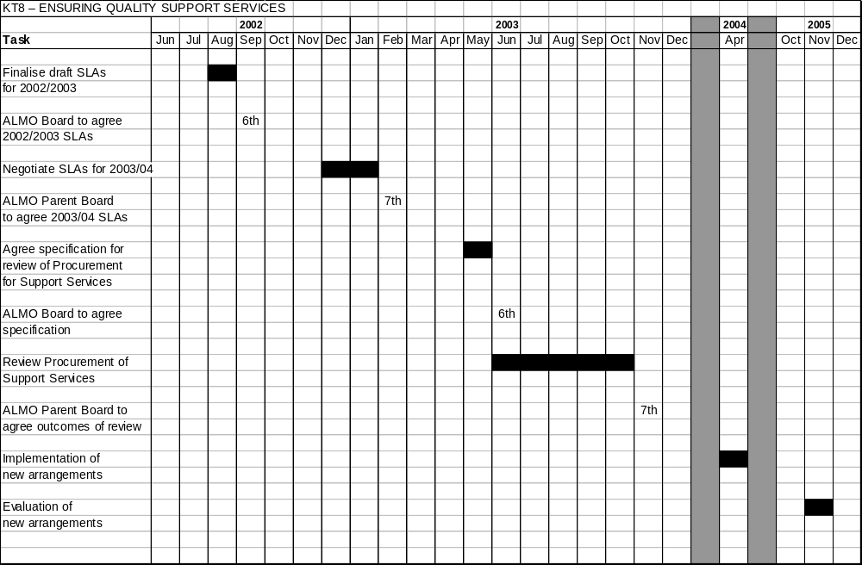
KEY THEME NINE – IMPROVING SERVICES TO ASYLUM SEEKERS
IMPROVEMENT  ISSUE | SOLUTION (TASK) | SERVICE IMPROVEMENT/ OUTCOMES | LEAD OFFICER | TARGET DATE | RESOURCE | COMMENTS/ EVIDENCE
KT9  There has been limited feedback from service users  - There are few formal processes or procedures in place  - Performance needs to be managed more effectively | - Review current service including :-  - Effectiveness  of current service  - Service user response to existing services  - Creating a firmer  framework for services  - Formalising move on arrangements  - Putting in place  Performance Management including customer feedback | - Clearer procedures and processes  - Better Performance Management and customer feedback  - Smoother and faster move on arrangements  - More responsive to varying needs of service users | Principal Officer  - Supported Tenancies | December 2003 | Principal Officer – Supported Tenancies  (50%) | This is a newly established additional post.  Recruitment well advanced.

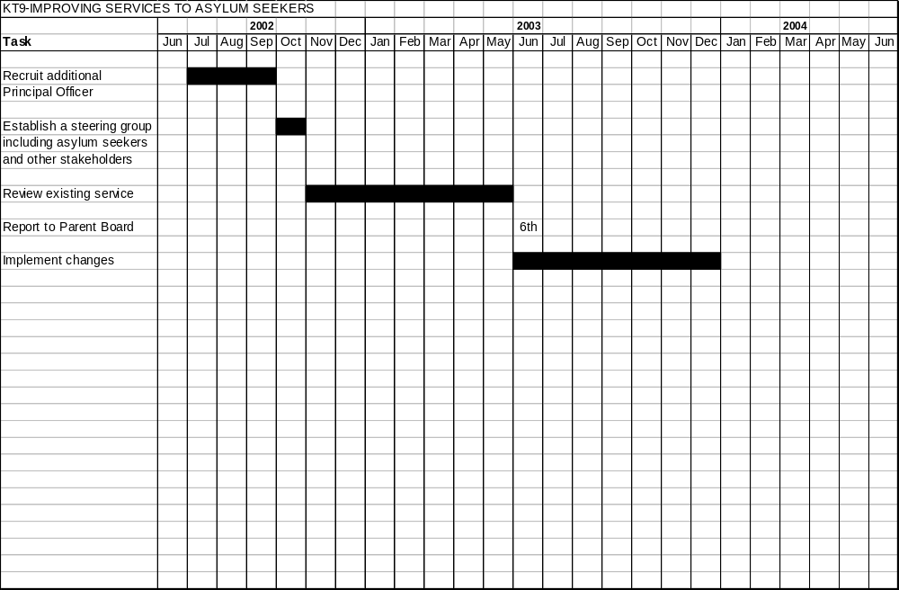
KEY THEME TEN – DEVELOPING THE ROLE OF CARETAKERS
IMPROVEMENT  ISSUE | SOLUTION (TASK) | SERVICE IMPROVEMENT/ OUTCOMES | LEAD OFFICER | TARGET DATE | RESOURCE | COMMENTS/ EVIDENCE
KT10  - There are unexplored opportunities to extend the role of caretakers to the advantage of tenants | - Revise the caretaker handbook to include:-  - carrying out minor repairs  - accompanied viewing for prospective tenants  - visits to new tenants  - Introduce structured training based on BICS  - Implement Performance Management Strategy  - establish performance indicators and benchmarking  - Review Liaison arrangements with Environmental Services and with area staff | - Added value from caretaking service  - Improved Performance Management  - Better information to tenants  - Better services for tenants | Group Manager Salford South | April 2005 | Group manager  (10%)  x 3 District Service Cleaning Managers  (20%)  Training Officer  (20%) | Work on this project has already started  Link with Performance Management Strategy and improved procedures

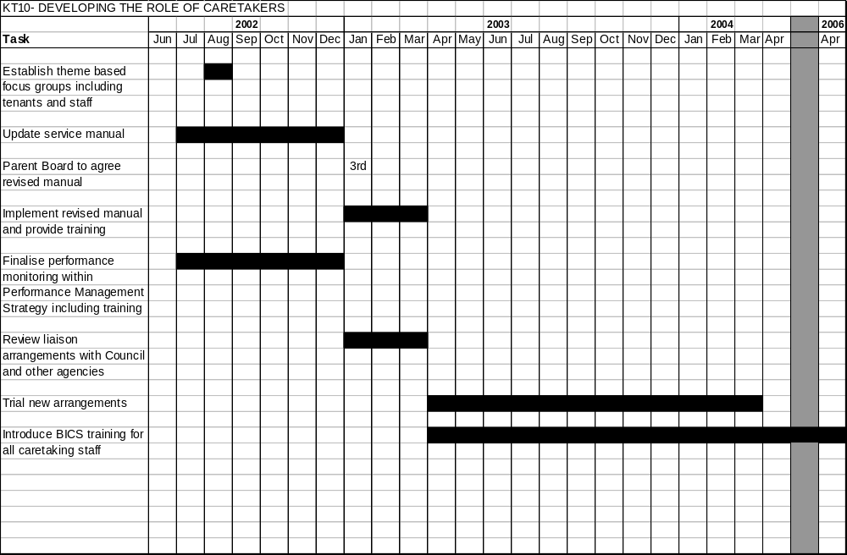
KEY THEME ELEVEN – IMPROVING ESTATE MANAGEMENT AND TACKLING ANTI-SOCIAL BEHAVIOUR
IMPROVEMENT  ISSUE | SOLUTION (TASK) | SERVICE IMPROVEMENT/ OUTCOMES | LEAD OFFICER | TARGET DATE | RESOURCE | COMMENTS/ EVIDENCE
KT11  Good practice in estate walkabouts and Community Liaison Schemes need to be extended across the city  - Performance Management needs improving  - Liaison and joint working needs to be finalised  - Capacity within the Housing Legal Team needs to be improved | - Review processes and procedures  - Implement Performance Management Strategy  - Establish formal liaison arrangements with other council services including Environmental Services and Community Safety  - Improve links with external agencies  - Review staffing arrangements within Housing Legal Team  - Extend Community Liaison Scheme to 2 additional estates where funding has been secured  - Bid for Community Liaison Scheme in 1 further area  - Introduce visits to new tenants following workload assessment for Housing Officers | - Improved joint working  - Better record keeping  - Improved Performance Management and customer feedback  - Speedier legal response | Principal Officer  (Management) | September 2003 | Principal Officer Anti-Social Behaviour  (30%)  Group Manager  (10%)  Housing Legal Team Leader  (20%) | Strong links with other projects on reviewing procedures, Performance Management and IT systems

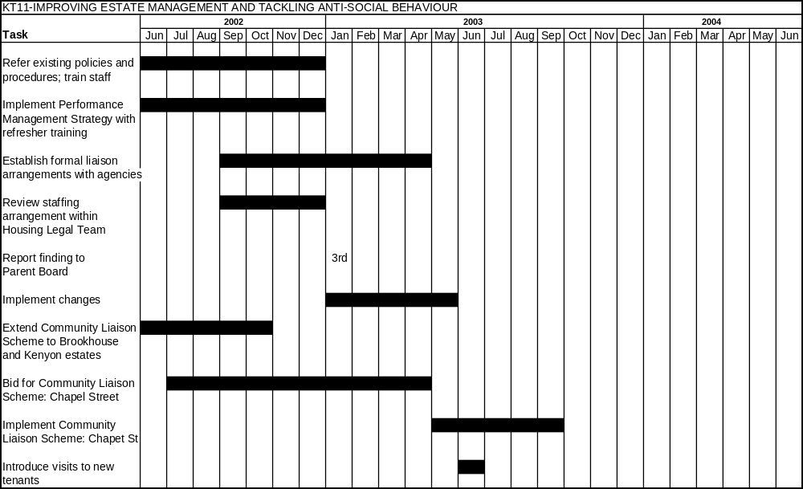
SERVICE IMPROVEMENT PLAN – RELATED PERFORMANCE INDICATORS

KEY THEMES Four and Five – rEPAIRS

 |  | 01/02 | 02/03 | 03/04 | 04/05 | 05/06 | 06/07
BVPI 72 | % urgent repairs completed within government time limits | 74.48% | 85% | 90% | 95% | 95% | 96%
BVPI 73 | Average time taken to complete non-urgent repairs(days) | 17.8 | 25* | 24 | 22 | 20 | 16
BVPI 185 | % responsive but not emergency repairs for which the authority both made and kept an appointment | N/A | 60% | 65% | 70% | 75% | 80%
* A planned reduction in Salford defined emergency repairs will lead to a short term decline in performance for non – urgent repairs

KEY THEME SIX – REDUCING VOIDS

 |  | 01/02 | 02/03 | 03/04 | 04/05 | 05/06 | 06/07
BVPI 68 | Average relet time for local authority dwellings let in the financial year (days) | 108.92 | 90 | 85 | 75 | 65 | 50
BVPI 69 | % rent lost through local authority dwellings becoming vacant | 4.67% | 4.25% | 4.25% | 4.00% | 3.50% | 3.00%
LPI | Average relet time for local authority dwellings let in the financial year excluding long term voids (over 6 months) | Information not yet available

KEY THEME SEVEN – REDUCING VOIDS

 |  | 01/02 | 02/03 | 03/04 | 04/05 | 05/06 | 06/07
BVPI 66a | The proportion of local authority rent collected | 93.36% | 95% | 95.50% | 96.25% | 96.50% | 96.90%
BVPI 66b | Rent arrears of current tenants as a proportion of the authority’s rent roll. | 5.39% | 4.5% | 4.25% | 4.00% | 3.50% | 3.00%
LPI | % current tenants owing over 13 weeks rent at 31st March excluding those owing less than £250 | 9.12% | 7.50% | 7.00 | 6.5% | 5.50% | 4.50%

PRIORITY ONE KEY THEMS – RISK ASSESSMENTS

KEY THEME ONE –IMPROVING THE ORGANISATIONAL INFRASTRUCTURE
Risk Area | High/ Low Impact | Possible Consequences | Reducing Risks
Unable to recruit suitable HR Team | H | Poor HR Strategy and Implementation. Poor training affecting quality of service. | Employ Council or external rsources.
Fail to meet IIP standards | L | De-motivate workforce. | Ensure all elements in place prior to final IIP assessment. Involve staff in preparations. Learn from successful IIP applicants.
Fail to reach concensus on frameworks for change management, decision making, etc. | H | Slow down change processes, etc. | Employ effective trainers for management development. Communicate objectives to all managers.
Failure of Management Development process for board members. Board members have differing background and opinions. | H | Ineffective decision making. Lack of concensus on boards. | Employ effective trainers. Communicate objectives to all board members.
The process of change causes disruption to services. | H | Although change can bring long term benefits, it can also bring short term performance failures. which would prevent the organisation attaining its goals. | Develop management of change framework as part of management development. Ensure that staff are kept informed and involved. Provide training and resource the change process.
Fail to implement attendance management strategy effectively. | L | High sickness levels. Negative effect on productivity and service quality. | Ensure good quality training to all managers. Monitor effectively.

KEY THEME TWO – PERFORMANCE MANAGEMENT, PRCEDURES AND ACCESS TO SERVICES
Performance management is ineffective. | H | Performance may deteriorate or not improve. Staff supervision and motivation will drop. Stress levels will increase. Organisation will not meet its targets and fail to achieve improved Best Value rating and draw down ALMO funding. | Ensure effective strategy in place. Provide clear guidance and training. Involve staff at all levels in performance management. Ensure senior managers and boards adopt an action based response to performance issues. Review strategy on an annual basis.
Procedures are ineffective and unfit for purpose. | H | Performance and service to tenants will suffer. Organisation will not achieve its objectives. | Ensure that staff and customers are consulted in developing and implementing procedures. Review procedures annually. Identify lead officer for updating procedures.
Procedures are not implemented consistently. | H | Procedures will be ineffective, poor quality of service to tenants, unclarity about service standards. Organisation will fail to achieve its objectives. | Provide training to all staff. Integrate monitoring within performance management.
Organisation fails to meet CRE objectives | H | Will not achieve a higher B V rating and draw down ALMO resources. Poor services to ethnic minorities. Fail to exploit new housing markets. | Ensure action plan is fully implemented and monitored. Involve BME community tenants in service improvements.
KEY THEME THREE – IMPROVING THE IT INFRASTRUCTURE
Fail to correct initial flaws in system | H | Full benefit of IT facilities for the service will not be realised. Service quality to tenants will suffer. Barrier to effective performance management. Staff lose confidence in systems. | Bring additional resources to bear on remedial work. Re-prioritise implementation programme. Monitor to ensure implementation targets met.
Staff are not well trained on new systems. | H | As above. | Employ additional trainers and implement new training programme. Monitor effectiveness of training.
New modules are not implemented | L | Added value from the system will not be realised. Service improvements and performance management will suffer. Health and Safety implications for Service Contracts (gas) Module. | Prioritise introduction of modules. Increase resources available. Effective monitoring of project.  Note: gas servicing high impact

KEY THEME FOUR – IMPROVING THE REPAIR SERVICE
Unable to agree acceptable alternative to current bonus scheme. | H | Major barrier to other improvements in the repair service. Adversely effect ability to meet objectives and achieve a higher BV rating and prospects of ALMO funding. | Ensure joint approach with staff from the outset. Use consultant and examples from other providers. Fall back on average bonus.
Failure to create a central void repair team. | H | Void repairs will remain slow and inconsistent. Void levels will remain high. | Use external contractors as a fallback.
Failure to agree revised schedule of rates. | L | Current SOR’s are unhelpful and confusing. Emergency repairs and low levels of programmed repairs will remain. | Introduce revised arrangements within partnership procurement.
Unable to retain and recruit tradesman arising out of uncertainties of procurement. | H | Services would deteriorate and performance targets not met. Negative effect on future BV assessments and ALMO resources. | Provide clear information to all staff on procurement exercise and its implications for staff. Involve staff in procurement process. Use sub-contractors and external contractors to plug gaps.

KEY THEME FIVE – INTRODUCE PARTNERING APPROACH TO REPAIR PROCUREMENT
Failure to attract interest from partners. | L | Need to rethink procurement strategy. Alternative contractors may not have high capacity or give value for money. May adversely affect ability to spend ALMO resources. | Continue procurement but with smaller contracts to attract local providers. Retain as much of the partnering principles as possible.
Potential partners unable or unwilling to carry out full range of repair work | L | Slow down procurement process and achievement of service improvements. | As above
Partner(s) fail to deliver good service quality or value for money. | H | Adverse affect on achievement of performance targets, BV assessments and ALMO resources. | Build into contracts and partnering arrangements clear targets and penalties. Create effective performance monitoring, including tenant feedback.  Bring in other contractors if necessary.

