
Forward plan of key decisions

The forward plan

Forward plans contain the key decisions that the authority proposes to make. A forward plan is published every month and covers the four months commencing on the first day of each month. The forward plan is available for public inspection 14 days before the beginning of each month.

Key decisions

A key decision means a decision that is likely to (i) involve expenditure or the making of savings amounting to £100,000; or (ii) be significant in terms of effects on communities living or working in an area comprising two or more wards in the city.

Contents of the forward plan

The forward plan includes information about –

(a) key decisions that are due to be made in the next four months;
(b) who will make the decisions;
(c) when the decisions are likely to be made;
(d) arrangements for consultation on the proposed decisions;
(e) who may make representations;
(f) what documents will be submitted to the decision maker; and
(g) who may be contacted for further information.

Decision makers

The following list gives the names of the members of the cabinet: the cabinet, or an individual member of the cabinet (also known as a lead member), makes key decisions. The following list gives the names of the members of the cabinet and their portfolio

Portfolio | Lead Member
Leader of the Council with portfolio responsibility for communications and marketing; performance, policy, regeneration, strategic overview and AGMA | Councillor Merry
Deputy Leader of the Council with portfolio responsibility for community safety; asset management; electoral matters; procurement | Councillor Lancaster
Adult Social Care and Health | Councillor Warmisham
Children’s Services | Councillor Morris
Finance & Support Services | Councillor Hinds
Human Resources and Equality | Councillor Murphy
Housing | Councillor Connor
Environment | Councillor Mashiter
Neighbourhoods, Culture and Leisure | Councillor Boshell
Planning | Councillor Antrobus

Contacts

Each item in the forward plan gives the name of the person to be contacted for further information, together with that person’s contact details.

Forward plan of key decisions as from 1 October 2011

The following is a summary of the key decisions that are proposed to be made during the period of four months commencing on 1 October 2011. Each key decision is due be made by a lead member, with the exception of those to be made by the cabinet that are marked “cabinet decision.”

Particulars of each proposed decision are contained in the attachments to this list.

 | Subject | Date / period of decision | Ward(s) | Scrutiny committee, if decision is called-in
1 | Network railway protection works  acceptance of tender   | February, 2010 to December, 2011 | Various | Sustainable Regeneration
2 | Highway investment works funded via unsupported borrowing  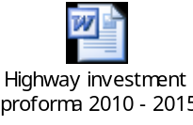 | Various Dates 2006 - 2015 | All wards | Sustainable Regeneration
3 | Council tax - write-off of irrecoverable amounts   | April 2011 to March 2012 | All wards | Budget
4 | Business rates - write-off of irrecoverable amounts | April 2011 to March 2012 | All wards | Budget
5 | Housing benefit overpayments - write-off of irrecoverable amounts | April 2011 to March 2012 | All wards | Budget
6 | Property update  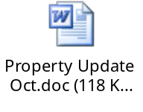 | April 2011 to March 2012 | All wards | Sustainable Regeneration
7 | Sundry debtor write offs 2010/11  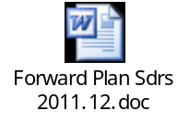 | April, 2011 - March, 2012 | All wards | Budget
8 | Building schools for the future  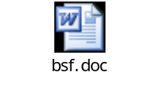 | April 2009 - December 2011 | All wards | Children, Young People and Families
9 | Write off of former tenants arrears for housing rents.  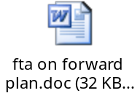 | March, 2011 to April 2012 | All wards | Budget
10 | Rates Relief applications   | April 2011 to March 2012 | All Wards | Corporate Issues
11 | The acceptance of Target Costs and tenders under the Council's Construction Partnering contractual arrangements for enabling works contracts to prepare for the upgrading and modifications to Barton Moss Secure Unit in advance of a capital bid to the DCSF for the main works elements   | March 2012 | All Wards | Children, Young People and Families
12 | TfGM Cross City Works A580 Quality Bus Corridor(Old Clough Lane -Trinity Way) – Acceptance of tender  (in conjunction with TfGM)   | January to April 2012 | Worsley / Swinton North / Swinton South / Claremont / Irwell Riverside / Langworthy | Sustainable Regeneration
13 | MediaCityUK | October  2011 | All Wards | Sustainable Regeneration
14 | The Street Lighting Capital Programme  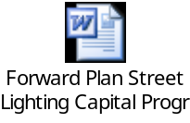 | March 2012 | All Wards | Sustainable Regeneration
15 | Highway Maintenance and Network Recovery   | November 2012 | All Wards | Sustainable Regeneration
16 | Approval to commission an Eccles Town Centre Masterplan  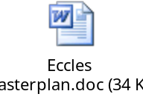 | September 2011 to March 2012 | Eccles, Weaste and Seedley | Sustainable Regeneration
17 | Approval to consult on the Draft Housing Revenue Account Subsidy and determinations. | December 2010 to March 2012 | All Wards | Sustainable Regeneration
18 | Property Renewals  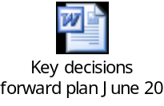 | August 2011 to January 2012 | All Wards | Corporate Issues
19 | Purchase of Software and Hardware to facilitate improvements in service delivery in the Customer Contact Centre | March 2011 to March 2012 | All Wards | Corporate Issues
20 | Charlestown Riverside – Regeneration   | September to December  2011 | Irwell Riverside | Sustainable Regeneration
21 | Salford West Priorities for Action 2011/12 / Salford West Focus for Regeneration 2011/14  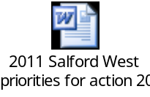 | September to November 2011 | Eccles, Barton, Winton, Irlam, Cadishead, Boothstown & Ellenbrook, Worsley, Little Hulton, Walkden North, Walkden South, Swinton North, Pendlebury, Swinton South. | Sustainable Regeneration
22 | Renewal of framework for the supply of print services.  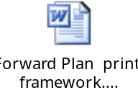 | September/  October 2011 | All Wards | Corporate Issues
23 | Vanguard Site / Remediation Strategy   | April - December 2011 | Ordsall / Irwell Riverside | Sustainable Regeneration
24 | Charlestown Riverside Site - Further Remediation Works   | September to December  2011 | Irwell Riverside | Sustainable Regeneration
25 | Extension to Fit City Irlam to accommodate a proposed new library and information service.   | August to October 2011 | Irlam and Cadishead | Sustainable Regeneration
26 | Office Moves and refurbishment 2011/12 | April 2011 to March 2012 | All Wards | Sustainable Regeneration
27 | Greengate Regeneration. Enabling development  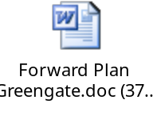 | October  2011 | Ordsall | Sustainable Regeneration
28 | Purchase of software and hardware to enhance the Contact Centres telephony systems  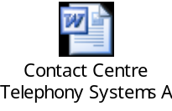 | May 2011 to March 2012 | All Wards | Corporate Issues
29 | Re-procurement of the Re-thinking Construction Partnering Programme  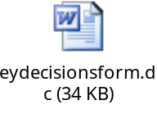 | September/  October  2011 | All Wards | Sustainable Regeneration
30 | Realignment of current MFP leases and proposal to extend contract with Danwood Group Ltd.  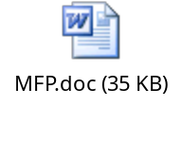 | September/  October 2011 | All Wards | Corporate Issues
31 | Sherbourne Footbridge Refurbishment  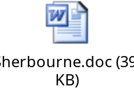 | May to August 2011/2012 | Irwell Riverside, Broughton | Sustainable Regeneration
32 | Intensive Support to Families with Complex Needs  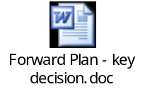 | October  2011 | All Wards | Children, Young People and Families
33 | Surplus homeswap properties in Langworthy – proposal to rent on the open market with Salix Homes providing a management service.   | September/  October 2011 | Langworthy | Sustainable Regeneration
34 | Hancock's Legacy   | July – October 2011 | Boothstown | Sustainable Regeneration
35 | Renewal of Mobile Phone Contract   | October  2011 | All Wards | Corporate Issues
36 | Re procurement of the Council’s insurance services for Combined Liability, Property & Motor &  Re procurement of Council’s legal panel for the handing of complex personal injury & court work.  Starting tender process September 2011–(insurance in place) Feb 2012, (legal panel in place) Feb 2012.   | August, 2011 to February, 2012 | All Wards | Corporate Issues
37 | Approval to carry out tender exercise for the procurement of Fuel Saving Devices.   | August – October 2011 | All Wards | Corporate Issues
38 | Approval to carry out tender exercise for the procurement of a Tyre framework on behalf of AGMA authorities.   | August – October 2011 | All Wards | Corporate Issues
39 | Joint Outcomes Fund   | October  2011 | All Wards | Cabinet Decision
40 | Strategic Decisions relating to the Creating a New Pendleton Housing PFI Project – Final Business Case Approval   | July to December 2011 | Langworthy | Sustainable Regeneration
41 | Improvements to Eccles Recreation Ground   | October  2011 | Eccles | Neighbourhoods
42 | Improvements to Buile Hill Park   | September/  October 2011 | Claremont, Weaste & Seedley | Neighbourhoods
43 | The Revenue Budget 2011/12 – Review and Update  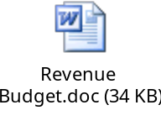 | October/  November  2011 | All Wards | Corporate Issues
44 | Approval to develop a scheme and to go out to tender for works at Salford Museum & Art Gallery to improve the visitor experience, namely the creation of a new café and display gallery  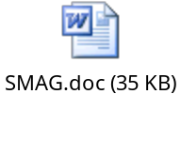 | October  2011 | All Wards | Neighbourhoods
45 | Acceptance of a tender – A666 Agecroft Road Junction  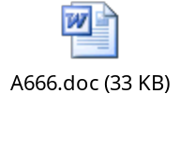 | September/  October 2011 | Pendlebury, Claremont | Sustainable Regeneration
46 | Re procurement of the Council’s insurance services for Combined Liability, Property & Motor & Starting tender process September 2011 – (insurance in place) February 2012   | September 2011 to February 2012 | All Wards | Corporate Issues
47 | Refurbishment of the existing play area at Ivy Street, Barton, Eccles  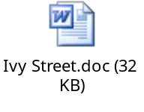 | October 2011 | Barton | Neighbourhoods
48 | Following procurement exercise to award Arboriculture Services contract work to successful tender  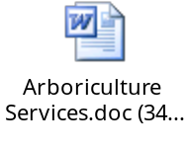 | December 2011 to January 2012 | All Wards | Neighbourhoods
49 | Variation of professional services fees for Liverpool Road Building Front Improvement Scheme.  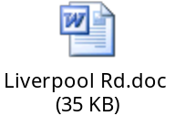 | September/  October 2011 | Eccles, Irlam & Cadishead | Sustainable Regeneration
50 | Highway Drainage – Recovery Programme  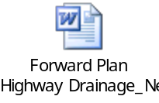 | August 2011 to March 2012 | All Wards | Sustainable Regeneration
51 | Agreement for the procurement process to be undertaken for voluntary sector contracts managed by the CHSC directorate, in partnership with NHS Salford, and for offer of contracts to providers delivering a range of services   | September 2011 to March 2012 | All Wards | Health Wellbeing & Social Care
52 | Extension of contract (by 12 months, until October 2012) with Horizon Care and Railway Cottage to allow the undertaking of a tendering process for the service to continue  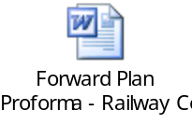 | October 2011 to October 2012 | All Wards | Children, Young People and Families
53 | Liverpool Road Corridor Strategy Action Plan 2011/12  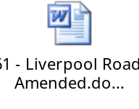 | September/  October 2011 | Cadishead, Irlam, Winton, Barton, Eccles | Sustainable Regeneration
54 | Salford West Town and Neighbourhood Centres Investment Programme 2011/12   | September/  October 2011 | Walkden North, Walkden South, Pendlebury | Sustainable Regeneration
55 | Bridgewater Canal Update and Next Steps  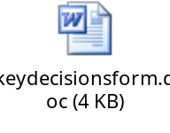 | September/  October 2011 | Barton, Boothstown & Ellenbrook, Eccles, Winton and Worsley | Sustainable Regeneration
56 | Variation of professional fees in relation to Eccles Town Centre building front improvement scheme   | October  2011 | Eccles | Sustainable Regeneration
57 | Manchester Ship Canal Aeration (Salford Quays) Re Procurement  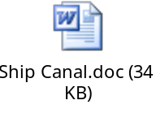 | September/  October  2011 | Ordsall | Corporate Issues
58 | Transition from the Housing Revenue Account subsidy determination system to self financing for council housing  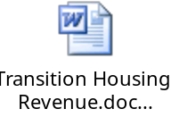 | September 2011 to March 2012 | All Wards | Corporate Issues
59 | Introduction of a charge and a voucher system for transport to Day Services  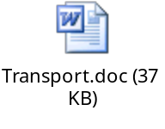 | October 2011 | All Wards | Health, Wellbeing & Social Care
60 | Employment Agency Contract for Operational Services of Grounds Maintenance and Refuse Collection  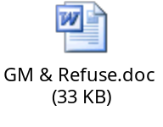 | September/  October 2011 | All Wards | Neighbourhoods
61 | Consultation and adoption of a development framework for the Crescent area of Salford  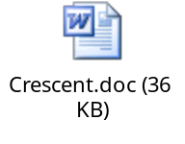 | September 2011 to April 2012 | Irwell Riverside,  Broughton | Sustainable Regeneration
62 | Salford’s High Street Support Fund Proposal  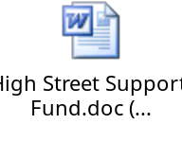 | October  2011 | Irwell Riverside, Ordsall & Langworthy, Broughton | Sustainable Regeneration
63 | Housing related support contracts for a variety of services, commissioned through the Supporting People programme | July to December  2011 | All Wards | Sustainable Regeneration
64 | Greengate Ph1A and Ph1B Public Realm Scheme – underwriting the reduction in funding contributions from the HCA, NWDA and ERDF as a result of failing to meet the private sector milestones set down by the funders  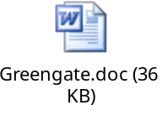 | September/  October 2011 | Ordsall Riverside | Budget
65 | Cargo Cranes, Ontario Basin, Salford Quays   | October/  November 2011 | Ordsall | Sustainable Regeneration
66 | Impact Assessment Report on any potential changes to funding for childcare for 3 and 4 year olds  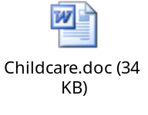 | October 2011 | All Wards | Children, Young People and Families
67 | Winter Weather Emergency Plan 2011/12  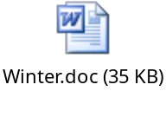 | September 2011 to March 2012 | All Wards | Sustainable Regeneration
68 | Agreement to tender the Drug and Alcohol Treatment and Recovery System   | October 2011 | All Wards | Neighbourhoods
69 | Salford Central Acquisition Fund Update  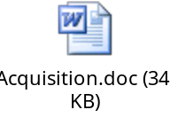 | October/  November  2011 | Ordsall, Irwell Riverside | Sustainable Regeneration
70 | Approval of the consultation draft of the Charlestown and Lower Kersal Development Framework Update and the consultation programme  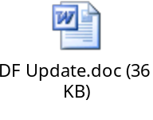 | September to December 2011 | Irwell Riverside and Kersal | Sustainable Regeneration
71 | Award of short-term interim contracts for care and support for people with learning difficulties living at 6 properties within the City   | October 2011 | Swinton North,  Little Hulton,  Swinton South,  Boothstown/  Ellenbrook,  Worsley,  Winton | Health, Wellbeing & Social Care
72 | Red Rose Retail Park, Regent Road – new access facilities   | September  to November 2012 | Ordsall | Sustainable Regeneration
73 | Extension of Parking Enforcement contract with NSL Services Limited and parking notice processing IT system contract with MTS (Mouchel Traffic Support)   | October to December 2011 | All Wards | Sustainable Regeneration
74 | Phase Three Strategic Cross Tenure Review of Sheltered Housing  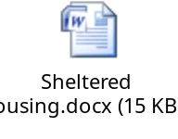 | October  2011 | Barton, Boothstown & Ellenbrook, Cadishead, Eccles, Irlam, Little Hulton, Pendlebury, Swinton North, Swinton South, Walkden North, Walkden South, Winton, Worsley | Sustainable Regeneration

Publication Date: 16 September 2011
Office of the Chief Executive Tel No: 0161 793 2602
Salford City Council E-mail: claire.edwards@salford.gov.uk
Salford Civic Centre Internet: www.salford.gov.uk
Chorley Road, Swinton M27 5DA

