Part 1

REPORT OF THE STRATEGIC DIRECTOR OF SUSTAINABLE REGENERATION

TO THE LEAD MEMBER FOR HOUSING
FOR DECISION ON 3rd February 2008

TITLE: Options appraisal Albert Park Lodge, Grecian Street, Salford, M7 2JW

RECOMMENDATIONS:

That the Lead Member for Housing is recommended to approve:

- The release of Albert Park Lodge, Broughton ward, from the Sustainable Regeneration Directorate, as surplus to requirements. The Strategic Property Management Unit to explore the options available for the future use of the property.

EXECUTIVE SUMMARY: The Housing Asset Management Team has identified three options for the future use of the Albert Park Lodge:

- Re-attribution to the Environment Directorate for use as a community and visitor centre. Broughton ward elected members Councillors Merry, King and McIntyre has shown support for this option The Environment Directorate have requested that refurbishment costs are met through the Housing Revenue Account. There are no funds identified in the capital programme for this work.

- The property to be retained and managed by Salix Homes as per current arrangements. It should be noted that future use as a tenanted property may be in breech of covenants restricting the property to a use associated with the park.

- The release of Albert Park Lodge, Broughton ward, from the Sustainable Regeneration Directorate, as surplus to requirements. The Strategic Property Management Unit to explore the options available for the future use of the property.

BACKGROUND DOCUMENTS: Small scale options appraisal, November 2007 (Margaret Graham - Salix homes).

ASSESSMENT OF RISK: Low

SOURCE OF FUNDING: Options 1 and 2 will require funds from the Housing Revenue Account. There are no funds identified in the capital programme for this work.

LEGAL IMPLICATIONS:

Contact Officer and Extension No: Norman Perry 2325

Date Consulted: 20/10/2008

Comments: There are covenants regarding the use of this property, restricting it to use for the purposes of a public recreation ground and the buildings and offices necessary or appurtenant thereto. It is important, particularly in view of the problems which have arisen before in respect of old covenants, that we take account of these covenants in any plans which we have for the property for the future.

FINANCIAL IMPLICATIONS:

Contact Officer and Extension No: Nigel Dickens – 2585

Date Consulted: 19/09/2008

Comments: The cost of bringing the building back into use is estimated at £10,000. The cost of repairs due to vandalism and maintenance are ongoing. In addition a new roof to the property may be required, at a cost likely to exceed a further £10,000.

COMMUNICATION IMPLICATIONS: N/A.

VALUE FOR MONEY IMPLICATIONS: Albert Park Lodge is currently an unused council asset that is incurring ongoing costs. By identifying a preferred option, the asset will be brought into use and avoid repair costs.

CLIENT IMPLICATIONS: Currently, Albert Park Lodge is an unused asset, providing no benefit or added value to Salford residents.

PROPERTY: The Council currently owns Albert Park Lodge. The property is attributed the Sustainable Regeneration Directorate.

HUMAN RESOURCES: N/A

CONTACT OFFICER: Stephen Simm Extension No: 8708

WARD(S) TO WHICH REPORT RELATE(S): Broughton ward.

KEY COUNCIL POLICIES: Pledge 7 - Enhancing Life In Salford

DETAILS:

1.0 | Background
1.1 | Description - Located within the boundary of the park, Albert Park Lodge, Grecian Street, has been previously used as the park keepers’ house. The property is a three bedroom detached house, constructed in 1910. The lodge was acquired by the Council in 1992 but has been listed as void since July 2007. Access to the property is on Grecian Street, although parking and access to the rear garden is via a road in the park. The Lodge stands alone as a single property; Neighbouring properties directly opposite on Grecian Street include those owned by Contour Housing.
1.2 | A recent site visit has identified that the property is deteriorating with an overgrown garden area, damage to the roof, guttering and the yard wall. It has been identified that because this property stands alone in the park it is vulnerable to vandalism, in particular arson attack due to inadequate security in the rear yard area.
1.3 | The Housing Asset Management Team have identified the following options for the future of the lodge:
2.0 | Details
2.1 | Option 1 - Use as a community and visitor centre. In May 2008 the Environment Directorate expressed an interest taking control of Albert Park Lodge for use as a community and visitor centre. This proposal required transfer of the lodge from Sustainable Regeneration in order to make the project financially feasible. Consultation with Broughton ward elected members Councillors Merry, King and McIntyre has shown support for this option. Furthermore, community group Friends of Albert Park have requested to be more involved if this option were taken forward.
2.2 | Although initially the Environment Directorate were confident of obtaining substantial funding for refurbishment of the Lodge, they have recently requested that Sustainable Regeneration carry out and finance the required works from the Housing Revenue Account.
2.3 | Option 2 - Retention by Salix Homes. The property could be retained and managed by Salix Homes as per current arrangements. However, future use as a tenanted property may be in breech of a legal covenant restricting the property’s use for the purposes of a public recreation ground only. Furthermore, continuing to take no action will result in the further deterioration of the properties condition. The Lodge is currently not being maintained and is vulnerable to vandalism and arson attack.
2.4 | Option 3 - Declare the Lodge as surplus to housing requirement. Instruct the Sustainable Regeneration Strategic Property Management Unit to investigate and identify a future use for the lodge that will represent best value.
3.0 | Conclusion
3.1 | As a matter urgency, instruct Salix Homes to increase security at Albert Park Lodge to protect the building against arson attack and vandalism.
3.2 | Albert Park Lodge should declared surplus to housing requirements.
3.3 | Once declared surplus to requirements a more detailed options appraisal should be undertaken by the Strategic Property Management Unit.
Paul Walker
Strategic Director of Sustainable Regeneration

Annex 1

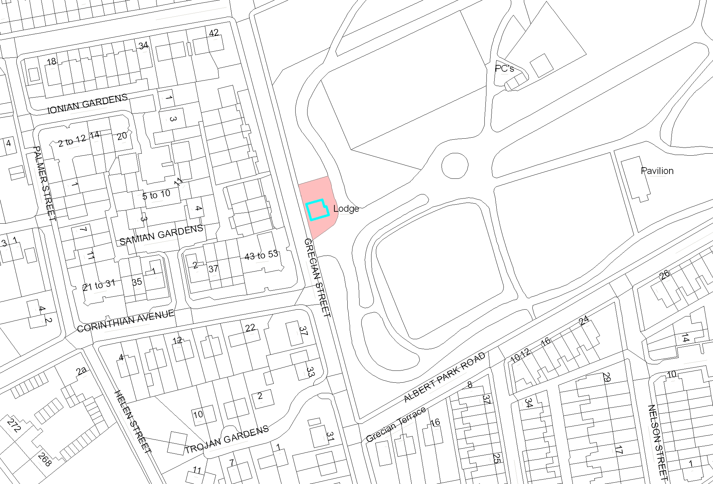

Annex 2



