PART 1  (OPEN TO THE PUBLIC) | ITEM NO.

REPORT OF THE HEAD OF HOUSING SERVICES

TO THE LEAD MEMBER FOR HOUSING SERVICES
ON
15TH SEPTEMBER 2003

TITLE : 25 AND 27 GREEN AVENUE, SWINTON

RECOMMENDATIONS :

That 25 and 27 Green Avenue, Swinton be disposed of to Portico Housing Association, on terms to be negotiated and agreed by the Head of Housing Services and Director of Development Services, and subject to all other necessary approvals and consents being obtained, in order for the properties to be refurbished and relet by the association.

EXECUTIVE SUMMARY :

25 and 27 Green Avenue are Council owned properties in need of major structural and refurbishment works. One is tenanted and one has been vacant and boarded since March 2000. A decision needs to be made on the future of these properties based on the option appraisals that are outlined in this report.

The recommended course of action is to dispose of the properties at nil value to Portico HA in order for them to fully refurbish the properties and then continue to rent them to people at affordable rent levels.

BACKGROUND DOCUMENTS :
(Available for public inspection)

25 – 27 Green Avenue Project File.

ASSESSMENT OF RISK :

‘Do nothing’ would result in increased risks of property deterioration, vandalism and a blight on surrounding properties. With the area now more popular and sustainable for the longer term investment in the properties is more secure.

THE SOURCE OF FUNDING IS :

Any expenditure would fall to the Housing Revenue Account, including any Home Loss, Relocation, or Disturbance costs that are incurred.

LEGAL ADVICE OBTAINED :

The course of action chosen to follow will be subject to all necessary consents and other approvals being obtained.

FINANCIAL ADVICE OBTAINED :

Various financial details are provided in the report itself.

Valuations obtained:

25 Green Avenue - Vacant and boarded property. Value following structural and refurbishment work is estimated to be £40,000 - £45,000

27 Green Avenue - Tenanted and well maintained, but assuming vacant possession obtained the current value is probably around £7,500 - £9,500. Value following works is estimated to be £45,000 - £47,000.

CONTACT OFFICER :

Malcolm Barton – Lead Officer, Investment, Partnerships & Special Projects. (925 1311)

WARD(S) TO WHICH REPORT RELATE(S) :

Swinton South

KEY COUNCIL POLICIES :

Housing Strategy Statement
HRA Business Plan

DETAILS :

An option appraisal has been undertaken in order to assist in deciding the most appropriate course of action to take in respect of 25 and 27 Green Avenue, which are situated in the Swinton Management Area. They are in the Valley Estate, Swinton, which in recent years has undergone a significant amount of environmental investment in terms of physical improvements, community and economic regeneration initiatives.

The approach is in accordance with the principles of Housing Revenue Account (HRA) Business Planning and the Housing Services policy of reviewing the future of accommodation where indications are that medium / long term viability of a property, or value for money investment criteria, needs to be challenged.

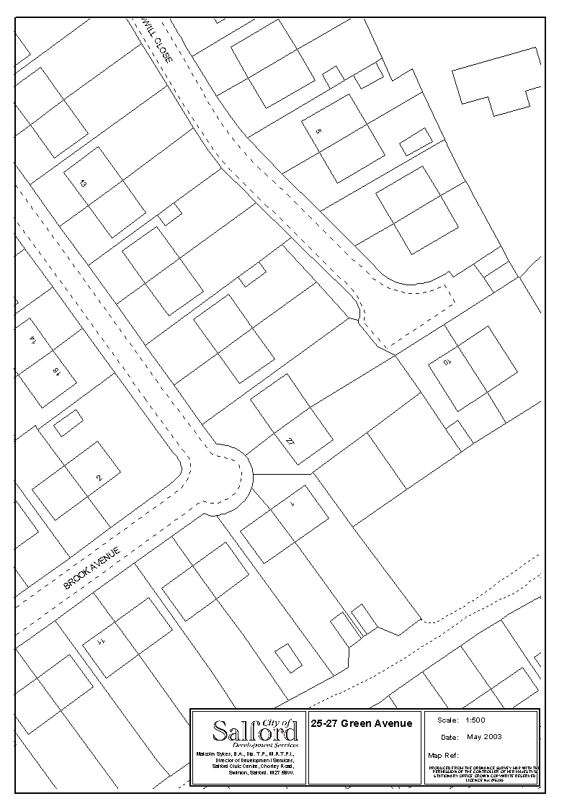

The properties are a pair of semi-detached houses. The roof is pitched with hipped ends and concrete tile covering, and there are gabled dormers above the front bedroom windows. External walls appear to be cavity construction in red brickwork with a textured outer surface. The first floors have suspended timber construction floors and the ground floors have part suspended timber and part solid construction.

The demand for the properties within this area has significantly improved in the last couple of years and there is now a reasonable waiting list for people wishing to move into properties in the area. 25 and 27 Green Avenue are also in a key location to the open fields at the rear and provide a ‘barrier’ which could lead to problems for other local residents if the properties were removed and an access route created.

NPHL has ceased to actively market and let 25 Green Avenue since it became empty in March 2000 due to the costs associated to bringing the property up to the Decent Homes standard. However, there is a long standing tenant resident in No. 27, who has carried out significant personal investment to the interior of her property over the years.

A detailed structural survey has been carried out and has identified the main problems relate to the structural integrity of the properties. The cost of making the two properties structurally sound and to a Decent Homes standard is estimated to be in the region of £75,000, a sum that cannot easily be found in the HRA budget due to other pressing demands on limited resources.

Options Appraisal

Using the standard option appraisal formulae the following information has been obtained:

- Do nothing in terms of substantial investment. The properties are structurally at fault and the continued vacancy at No. 25 will only lead to further deterioration to the properties and become a potential target for vandalism. This option is therefore discounted.

Net benefit assessment over next 10 years from financial modelling = £13,734.

- Retain the properties in Council ownership and refurbish to a structurally sound condition and to a Decent Homes standard. It is estimated that the cost of this work will be in excess of £75,000, which poses serious budget restraint implications.

Net benefit assessment over next 10 years from financial modelling = £101,466.

- Demolition. Relocate the tenant of No. 27 and then clear the houses followed by the treatment of the site to prevent fly tipping and anti-social activities. The cost of this exercise would be in excess of £6,000, although there may be the potential to market the site to a private developer so as to accrue a capital receipt.

Net benefit assessment over next 10 years from financial modelling = £24,766.

The above assessments therefore indicate that when all costs and incomes are assessed over a ten-year period retaining the properties in Council ownership for refurbishment is the most beneficial financially, although funding for the work cannot be identified in the HRA and therefore demolition would have to be the financially practical option if action is to be taken imminently. In order to retain the properties and have them fully refurbished and relet a further option has therefore been considered in terms of transferring the properties to a local Registered Social Landlord.

Portico Housing Association, a leading housing association partner in the Swinton area, has indicated that it would be pleased to acquire the properties in principle on terms to be agreed. They have also indicated that the tenant of No. 27 may be able to remain as tenant of the property should she not accept permanent rehousing, although due to the scale of the works a temporary relocation may still be needed. Unfortunately there are no grants available from the Housing Corporation at the present time for this project, and in order for the project to be economically viable to the association and retain social housing rent levels (albeit with a small increase on current rentals - £53.84 pw) it would be necessary to transfer the properties at nil value. This would be subject to confirmation following survey and valuation, and subsequent terms and conditions to be negotiated and agreed.

However, it may be possible to enter into a license agreement with the Council for the refurbishment works, and this could then provide the equivalent of a capital receipt of up to £10,000 from savings on VAT.

In order to retain the properties in a fully refurbished condition, and at affordable rent levels, then the transfer to Portico HA option provides a more preferable solution to demolition.

HRA Subsidy Information

HRA stock numbers for subsidy purposes are fixed at the 1st April prior to each subsidy year. The effect in loss of subsidy, based on 2003/04 figures, from the disposal would be:

Management 2 x £380.16 = £760.32
Maintenance 2 x £722.13 = £1,444.26
--------------
Total Subsidy loss = £2,204.58

Consultation

The tenant occupying No. 27 has been kept informed of developments. Alternative and acceptable permanent accommodation has been found, and the tenant would be entitled to receive a £3,100 Home Loss payment as well as any relevant costs associated with Relocation/Disturbance. Funding for this is available within the current year’s approved Home Loss and Disturbance budget. Should the option to transfer the properties to Portico HA be followed then further consultation will take place with both the tenant and the association with a view to her possibly being able to remain/return to the property while the project is undertaken.

