PART 1  (OPEN TO THE PUBLIC) | ITEM NO.

REPORT OF THE HEAD OF HOUSING SERVICES

TO THE LEAD MEMBER FOR HOUSING SERVICES
ON

18TH DECEMBER, 2003

TITLE : SHAKESPEARE ROAD / BLANTYRE STREET, SWINTON

RECOMMENDATIONS :

- That the properties at 96-98 Blantyre Street, 93-99 & 105-115 Shakespeare Road be demolished, subject to all other necessary approvals and consents being obtained.
- That in view of the wider subsidence problems evident on the estate and the need for longer term site investigations to be commissioned to guide future action, the four flats at 101-103 Shakespeare Road also be demolished.
- That all remaining tenants be rehoused as quickly as possible and receive the usual statutory compensation Home Loss and Disturbance payments.
- That the action under delegated powers for the Head of Housing Services to negotiate and agree terms with the owner of the sold property for its acquisition be noted.
- That the site be included on the Assets Register for possible future disposal / development purposes, but grassed and maintained by the Council (via NPHL) until its long term future use is determined.
- That an appropriate 2M high green powder coated iron-spiked security fence be erected and maintained along the boundary with the properties at 72-84 Shelley Road.
- That the need to establish a longer term investment strategy for the wider area be noted due to the impact of mining subsidence in the area.

EXECUTIVE SUMMARY :

A total of 12 houses and 4 flats in this locality have become increasingly difficult to let in recent years. They also require significant investment on repairs, improvements and the appearance of the area if they are to be relet and have a sustainable longer term demand. There is also a problem of subsidence in the area, and this is evident in the works that are identified as needed on some of the properties. Vacant properties in this part of Shakespeare Road have not been attempted to be repaired and relet by NPHL for some time due the lack of demand and structural issues, and they are becoming a blight on the area.

A decision has been made, in principle and subject to consultation with remaining residents, to demolish the properties as any other form of action would be both uneconomic and unsustainable. Details are now provided in this report on the results of the consultation and to authorise an appropriate course of action.

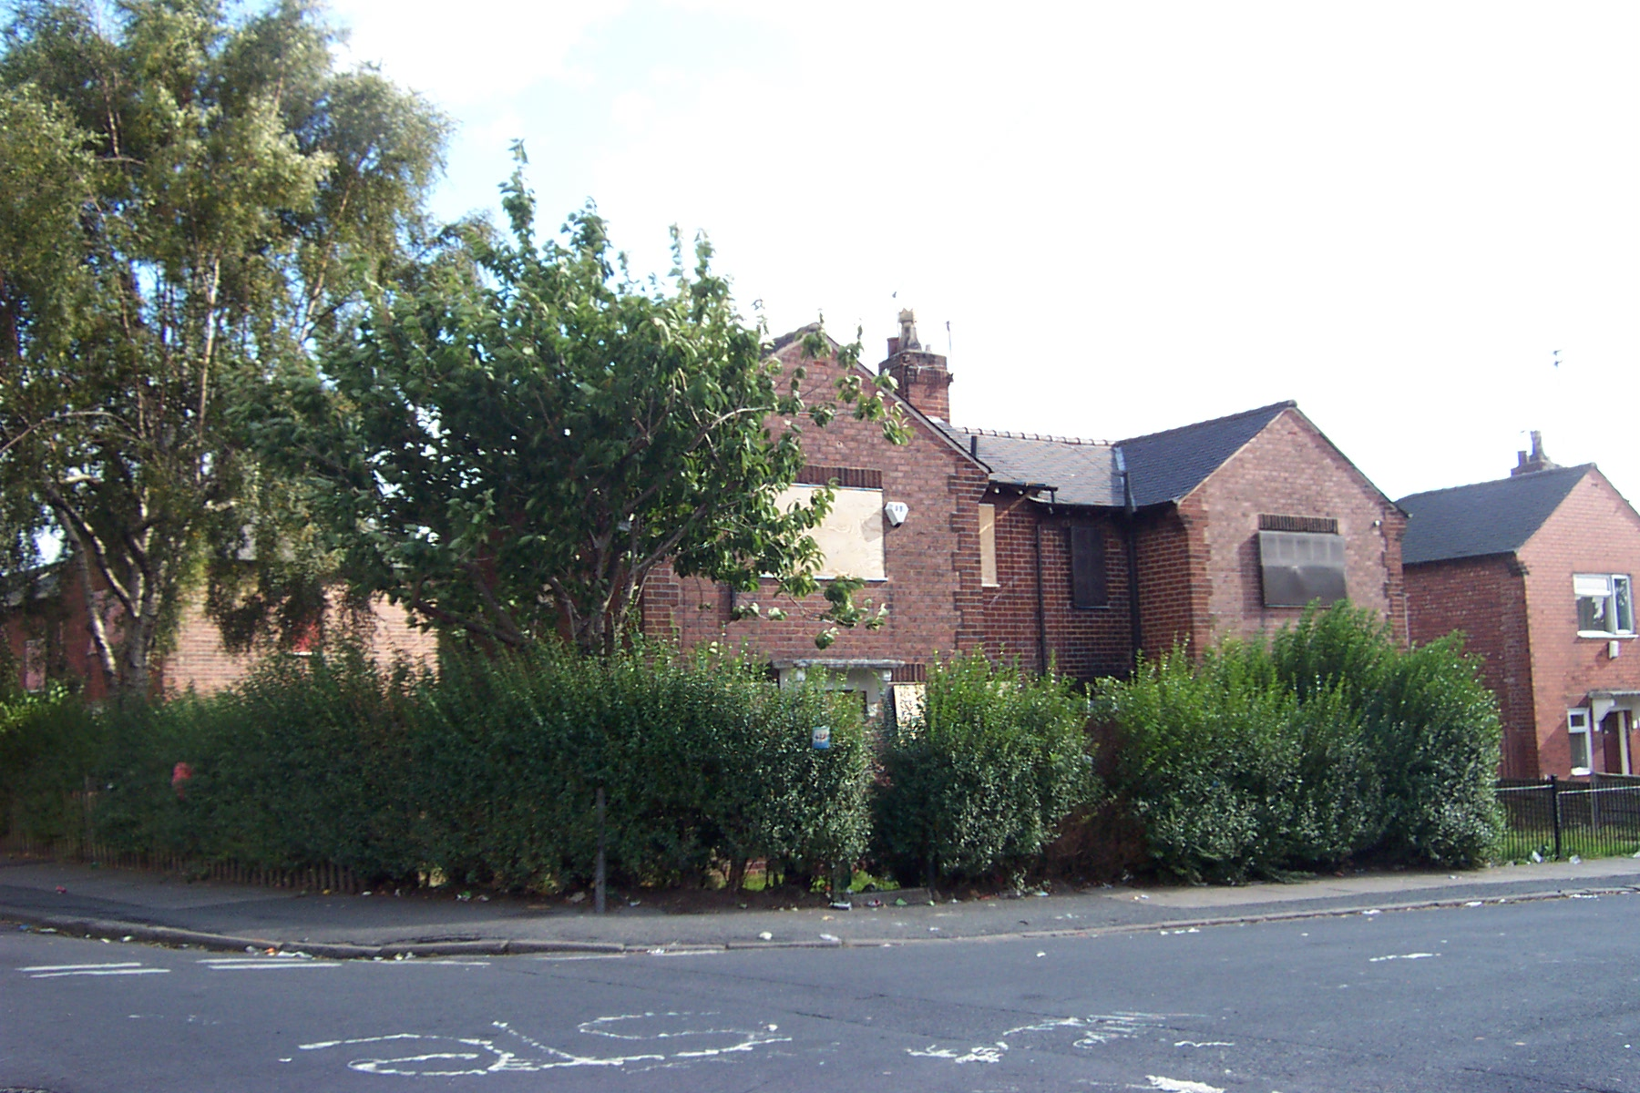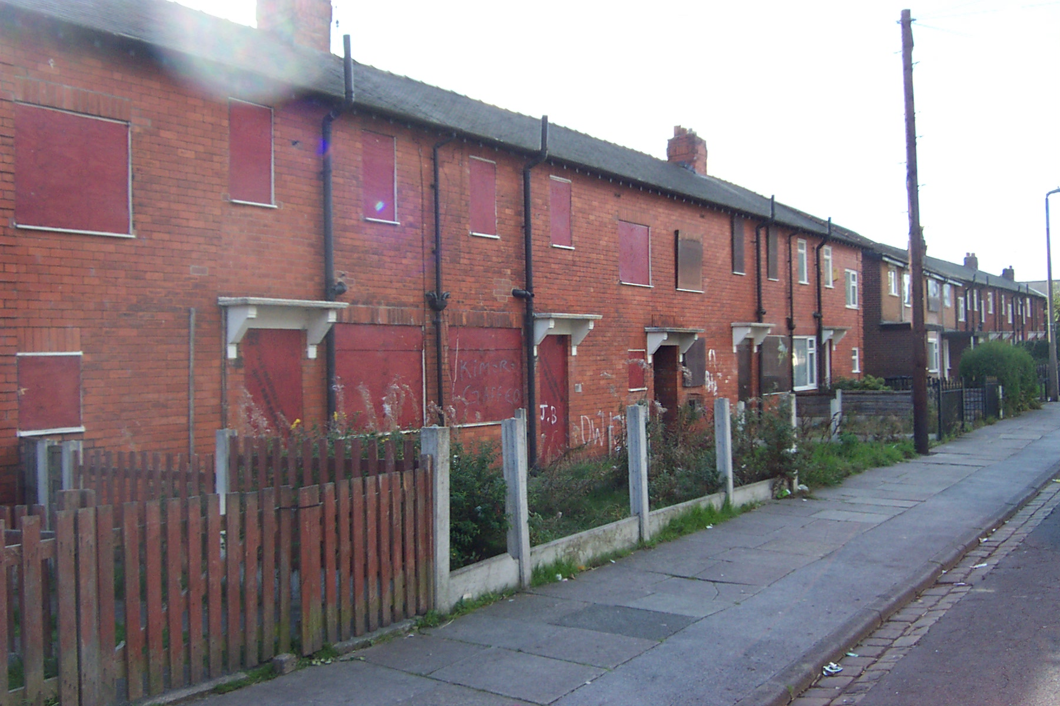

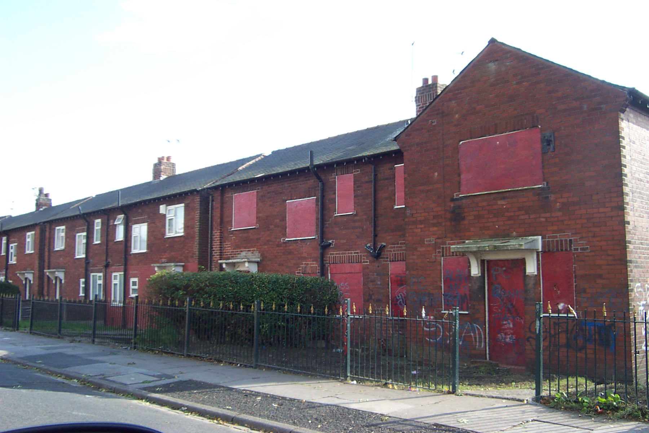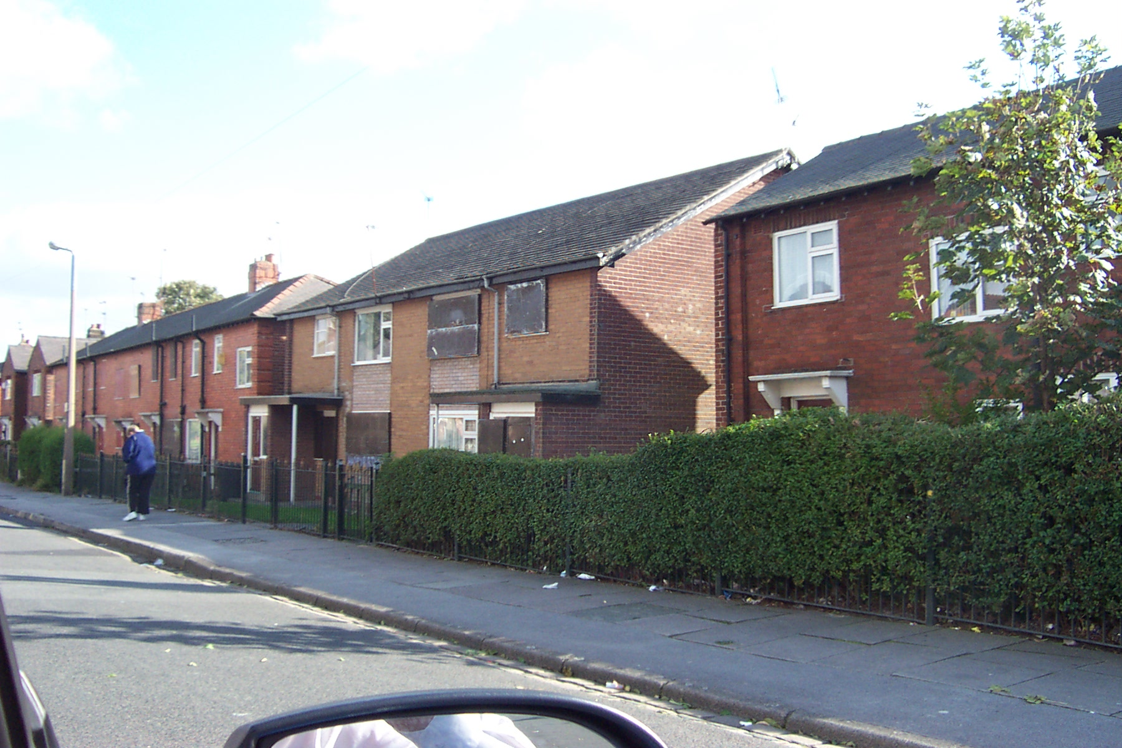

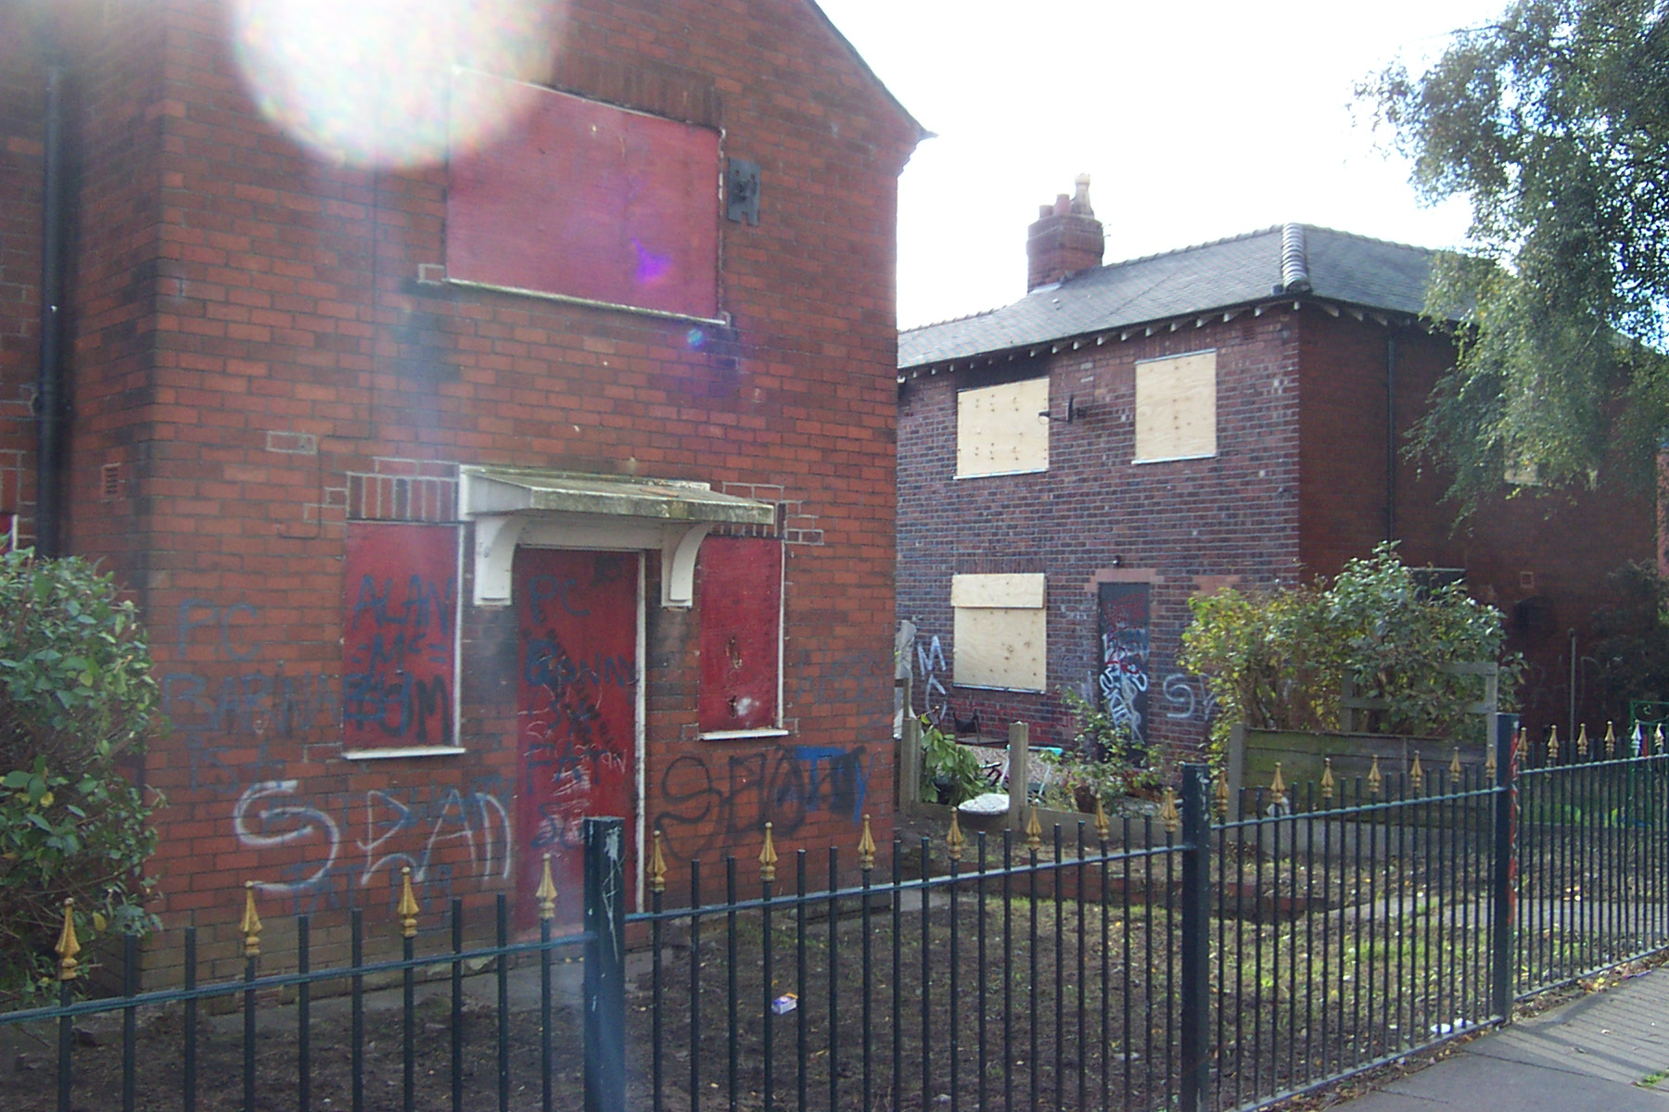

ASSESSMENT OF RISK :

‘Do nothing’ would result in increased risks of property deterioration, vandalism and a continued blight on surrounding properties. There is also the risk of break-ins and the risks of vandalism and injury that this could entail. It is therefore essential that appropriate action taken as quickly as possible.

THE SOURCE OF FUNDING IS :

Expenditure would fall to the Public Sector Housing Capital Programme, including all costs incurred for any acquisition, site clearance, ancillary works such as fencing, and site seeding. Home Loss, Relocation, or Disturbance costs for existing NPHL tenants are funded by the Revenue budget allocation. Ongoing maintenance works for the cleared site will also require future Revenue funding provision having to be made.

LEGAL ADVICE OBTAINED :

The course of action chosen to follow will be subject to all necessary consents and other approvals being obtained.

FINANCIAL ADVICE OBTAINED :

Various financial details are provided in the report itself. The report has been checked and approved by the NPHL Financial Accountancy Division.

HRA Subsidy Information:

HRA stock numbers for subsidy purposes are fixed at the 1st April prior to each subsidy year. The effect in loss of subsidy from a disposal or demolition option for each dwelling, based on 2003/04 figures, would be:

Management = £380.16 per dwelling
Maintenance = £722.13 per dwelling
-------------
Total Subsidy Loss = £1,102.29 per dwelling per annum
------------

Major Repairs Allowance = £543.28 per dwelling per annum

WARD(S) TO WHICH REPORT RELATE(S) :

Swinton North

KEY COUNCIL POLICIES :

Housing Strategy Statement
HRA Business Plan
HMR Prospectus

BACKGROUND DOCUMENTS :
(Available for public inspection)

Blantyre Street / Shakespeare Road Project File.

CONTACT OFFICER :

Malcolm Barton – Lead Officer, Investment, Partnerships & Special Projects.
Tel: 0161 925 1311 E-mail: malcolm.barton@salford.gov.uk

ADDITIONAL DETAILS :

An option appraisal has been undertaken in respect of 96-98 Blantyre Street and 93-115 Shakespeare Road, which are situated in the Swinton Management Area. Subject to resident consultation, demolition has been decided previously as the most appropriate course of action for these properties based on the Housing Services policy of reviewing the future of accommodation where indications are that medium / long term viability of a property, or value for money investment criteria, needs to be challenged.

A location plan of the properties that are being referred to in this report is included for information purposes. It will be seen from this plan that the project involves 12 houses and 4 flats, all but one of the houses being Council owned, and some in need of major refurbishment works. The four flats are of a much newer construction than the houses, although are still over 30 years old, in need of some refurbishment work and have recently evidenced low demand. Due to the emerging difficulties of releting all of these properties, a decision had previously been taken to board and secure any future vacancies that arise until a clearer strategy for their future could be determined. The remainder of this side of Shakespeare Road is currently fully let, and 6 properties have been sold under RTB procedures.

In terms of the occupation position of the 16 properties as at the 26th November 2003:

4 x Tenanted Houses
1 x Tenanted Flat
7 x Vacant Houses
3 x Vacant Flats
1 x Sold House (and currently unoccupied) under RTB procedures

The area has been monitored in recent years for mining subsidence, and there are serious issues identified. Many properties in the area are suffering from ‘tilt’, and some so seriously that it would be uneconomic to invest up to £45K per property in underpinning and refurbishment work – a figure potentially higher than the value of the houses themselves. A wider investment strategy appraisal needs to be planned for the area as a whole.

The estate is definitely in an area influenced by coal mining in the form of subsidence. The foundations to the properties are traditional shallow strip footings in natural drift deposits. These two reasons coupled together explain ‘tilts’ of between 25mm and 200mm on many properties. A common observation is that there is little recent evidence of old or recent cracking to external brickwork on the estate, which suggests that the blocks have tilted en-mass and the conditions now settled. Special Tenancy Agreement terms in respect of repairing obligations should continue to be included by NPHL for any properties relet on this estate in the future. A further concern is the potential for damage to drains caused by subsidence on this estate, and a number of complaints have been received in recent years relating to problems arising from drains damage. This could cost over £1M+ to remedy properly if the situation continues to deteriorate on the estate.

The houses currently under review clearly demonstrate serious ‘tilt’ from subsidence and could not justify substantial underpinning and refurbishment investment when demand for these properties in the longer term cannot be shown to be sustainable. Demolition of these properties is the only sensible option, as the properties cannot be left to remain uninhabitable and boarded.

The four flats, however, were only built in the 1960s and on ‘raft’ foundations, and therefore not demonstrating signs of subsidence. Some refurbishment and improvement works would be needed to be able to relet these properties, at an average cost of around £5-6,000 per flat. Assuming the houses on either side are demolished this would include some garden enclosures and fencing for future ground floor occupants. Due to the surrounding demolition works these flats would need to be kept vacant and boarded until the adjoining sites were cleared. There would, however, be a risk in this course of action in that long term demand is not clear for this type of property, they could be subject to a future Right To Buy (and potential future re-acquisition), and the future of the wider area is seen as in need of review. However, the investment needed on the flats could be recouped in a relatively short term if they are kept fully let as any wider longer term strategy for the area would take time to implement. However, with the subsidence issue and long term future of the estate requiring further investigation, careful consideration is clearly needed before committing to any investment in the flats at this point in time.

CONSULTATION AND COMPENSATION

All remaining tenants have now been consulted on the rehousing options available to them and are willing to be relocated as soon as possible when suitable homes arise. Neighbouring residents have also been advised of the position and provided with an opportunity to comment on the proposals, as have Local Ward Councillors who have confirmed their preference for demolition – although there is an acknowledgement of the issues over the four flats being included.

Feedback from some of the residents whose properties back onto the rear of Shakespeare Road has raised two issues of concern. Firstly, although demolition of the houses is seen as inevitable and supported, the four flats are of a reasonably sound condition and could be economically improved and retained. However, residents do acknowledge the need to consider the longer term issues affecting the wider estate as well. Secondly, that there is concern over what may happen with regard to the security of their own premises once the site is cleared, and that a good security fence should therefore be erected by the Council at the rear of their properties.

In terms of these two issues, the cost of improvement works to the flats is a major consideration, as it will clearly be a risk to demolish the houses and leave the flats with vacant land on either side of them. The evidence of wider subsidence on the estate and the need for longer term decisions to be made on the appropriate action needed also needs to be considered. However, with regard to the fencing issue it is recommended that the Council should abide by the wishes of residents in Shelley Road and erect an 2M green powder coated spiked iron fence adjacent to their rear boundaries, and retain any trees possible, to help maximise security to their homes.

In terms of Home Loss and Disturbance payments to the remaining residents, this will involve their compulsory relocation, and based on an average cost of £4,500 per tenancy will total £22,500 for this tenanted element of the overall project cost. Entitlement to payment will become due to any affected tenant once a formal decision on disposal has been made and they subsequently terminate their tenancy to move home.

The cost of purchasing the former RTB property at 98 Blantyre Street has been discussed with the property owner and under ‘delegated powers’ the Head of Housing Service is negotiating the acquisition for a price in the region of £23,000, although there are no additional Home Loss and Disturbance costs as the property is unoccupied. In view of the fire damage suffered at Council owned 96 Blantyre Street, approximately £10,000 can be claimed from the Insurance Budget towards the overall demolition costs of the project.

RECENT INVESTMENT

Over the last few years NPHL have advised that there have been no significant items of expenditure for house improvements to these properties in the last five years.

OVERALL SCHEME COST

If all the properties are to be demolished and entered on the Asset Register until a decision is made on the future use of the site. Temporary site works and maintenance will need to be undertaken by NPHL until the long term decision on the site is established and agreed.

The overall works costs of the project will be approximately £99,500, and budget provision is currently available to undertake the work in this financial year:

Home Loss and Disturbance for NPHL tenants £22,500 (Revenue)
Acquisition of RTB House £23,000 (Capital)
Demolition, Fencing and other Site Treatment £54,000 (Capital)

In addition there will be an ongoing maintenance cost for the cleared site until its long term future has been resolved.

However, despite these costs there becomes the potential value of the vacant site which, for redevelopment purposes, is expected to be negligible at the present time and likely to only be of interest to other social housing providers.

It should also be noted that a receipt of approximately £10,000 from the Insurance Budget can be expected for the fire damaged property on Blantyre Street.

If the four flats were to be retained then the additional cost to the overall project would be anticipated to be approximately £20,000, but a rental income would then be received on these.

LOCATION MAP

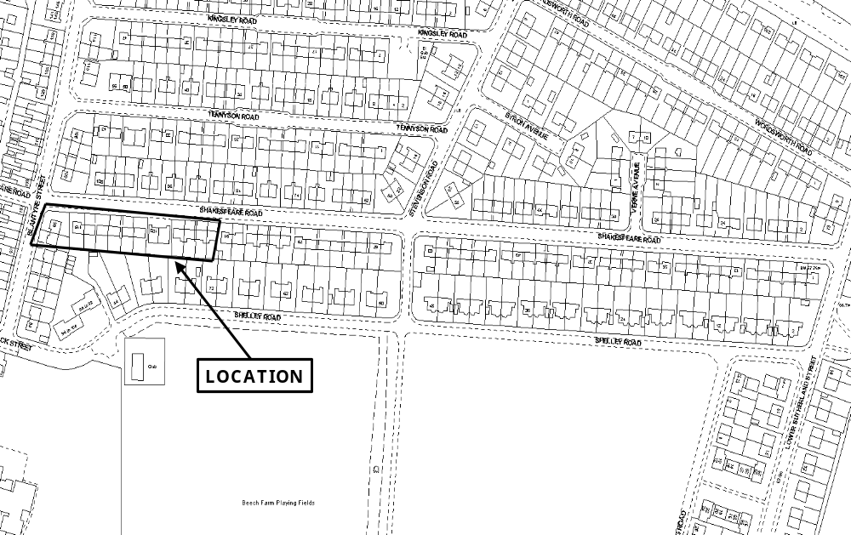
(Plan not to scale and to be used for identification purposes only)

