PART 1  (OPEN TO THE PUBLIC) | ITEM NO.

REPORT OF THE HEAD OF HOUSING SERVICES

TO THE LEAD MEMBER FOR HOUSING SERVICES
ON
18TH DECEMBER, 2003

TITLE : 73 HULTON AVENUE, LITTLE HULTON (FORMER LAUNDERETTE UNIT)

RECOMMENDATIONS :

- That the single-storey commercial property at 73 Hulton Avenue, Little Hulton, be demolished, subject to all other necessary approvals and consents being obtained.
- In consultation with local residents an appropriate resurfacing of the site / environmental works specification be agreed, with budget allocation being subject to the approval of the Lead Member for Housing.
- That the site be included on the Assets Register for possible future disposal / development purposes, and maintained by the Council (via NPHL) until its long term future use is determined.

EXECUTIVE SUMMARY :

The single-storey commercial unit at 73 Hulton Avenue was leased for the purpose of a launderette until May 1999, when it ceased to trade. Since that time the premises have been unoccupied and unable to be relet for any suitable purposes.

It is clear that the condition of the building is no longer satisfactory and the best course of action is for it to be demolished. Local consultation has been undertaken with the community and this course of action is supported, with further consultation being undertaken to determine the surfacing treatment work required for the cleared site.

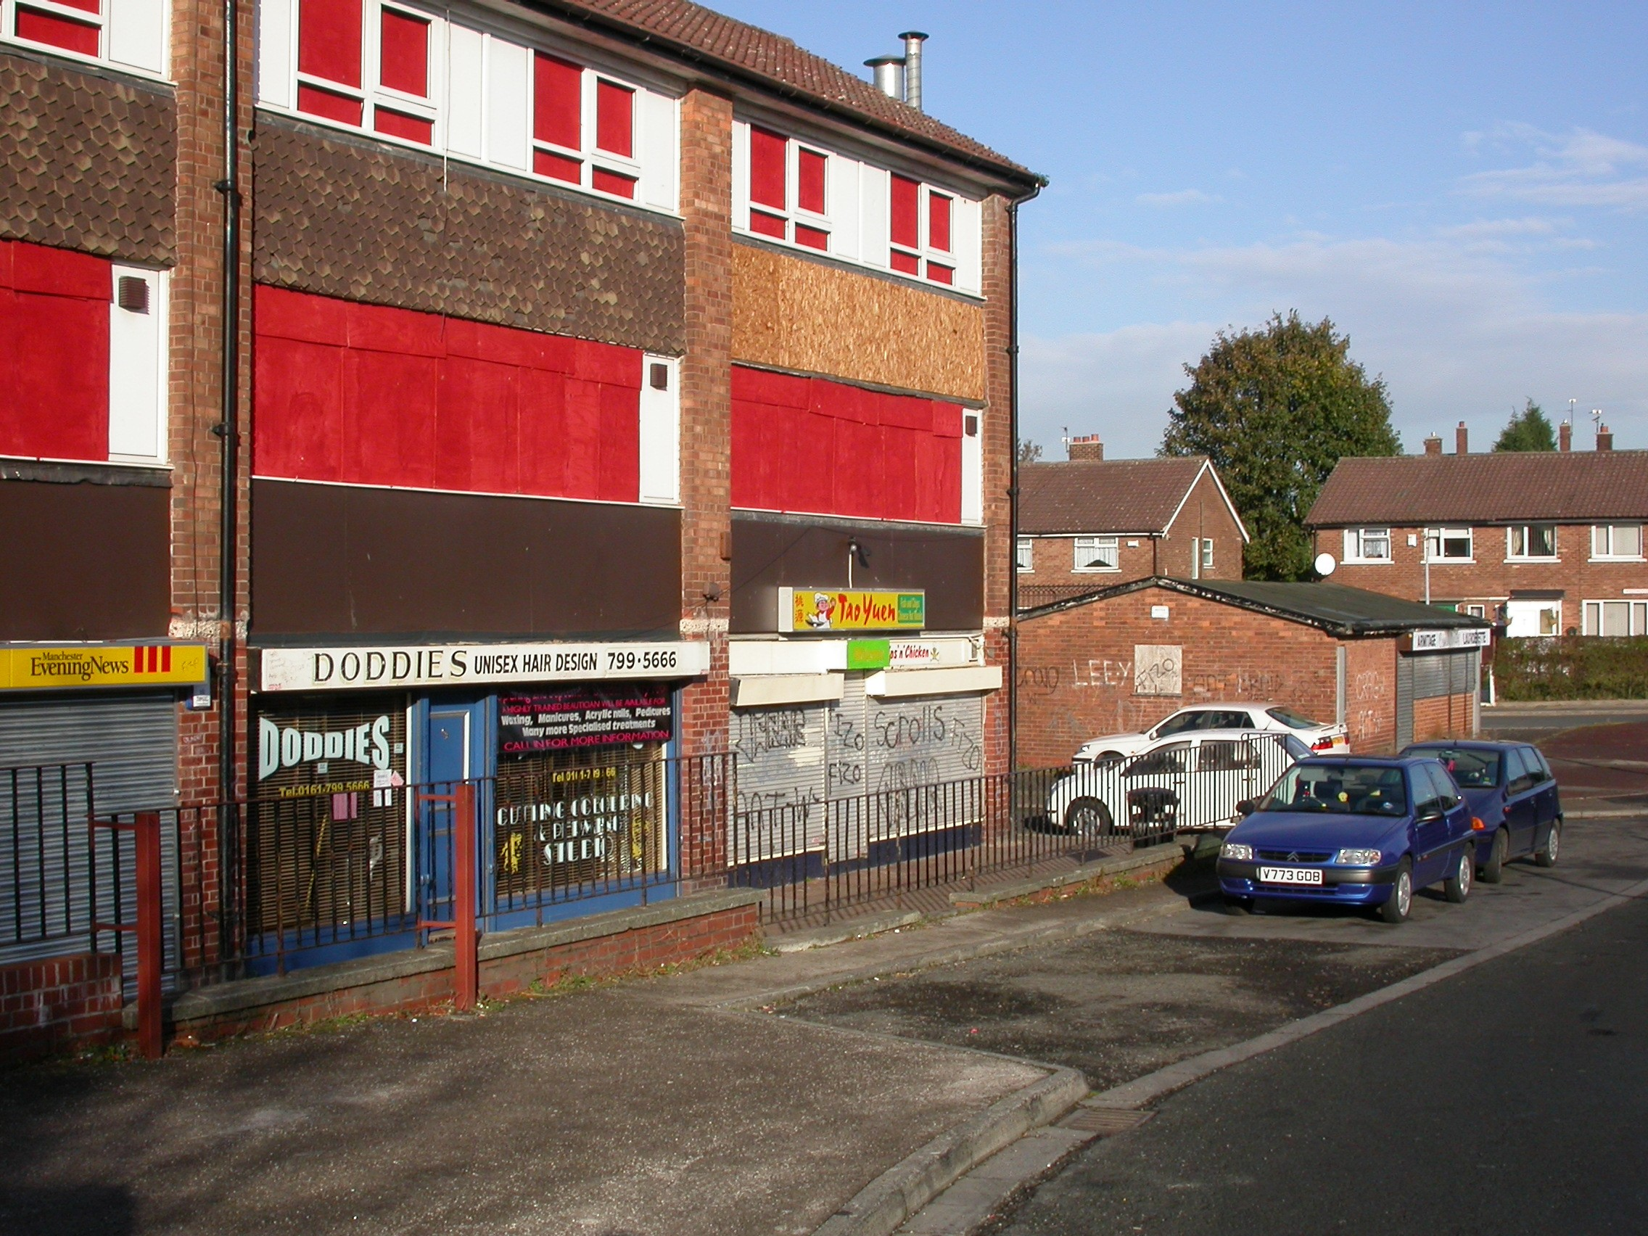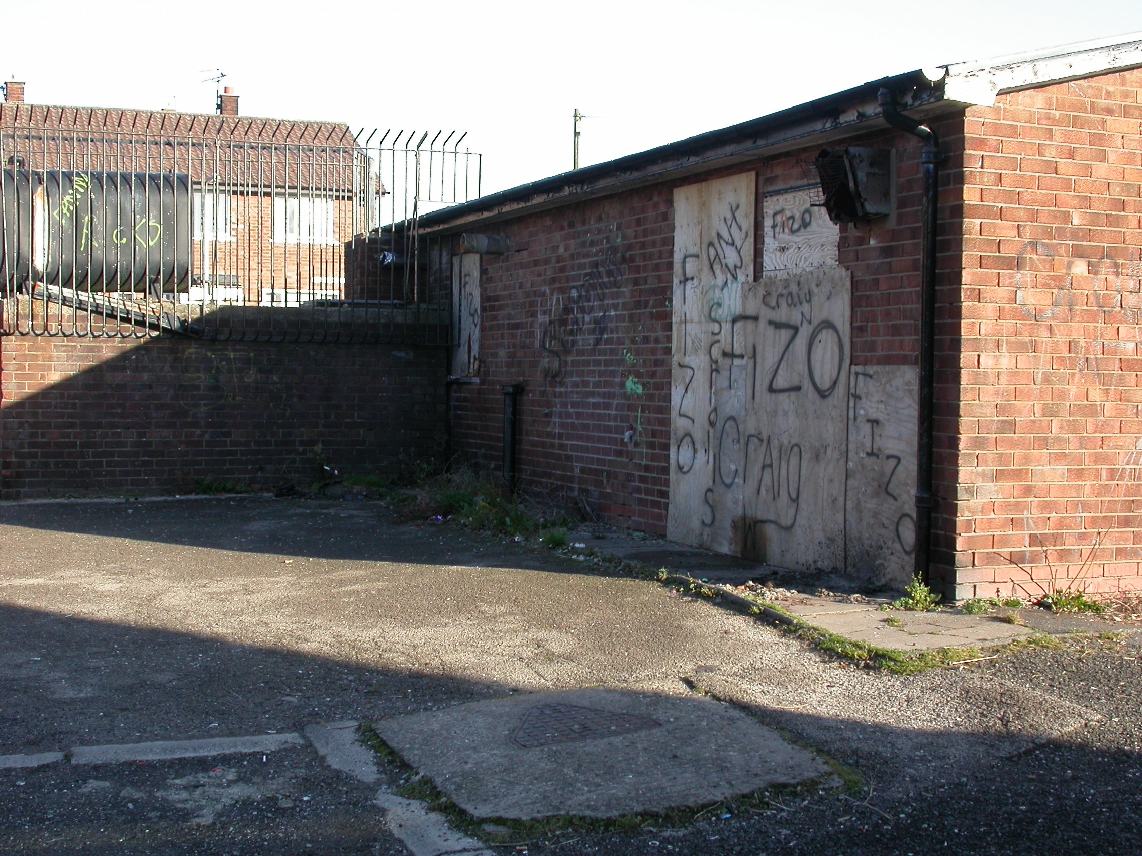
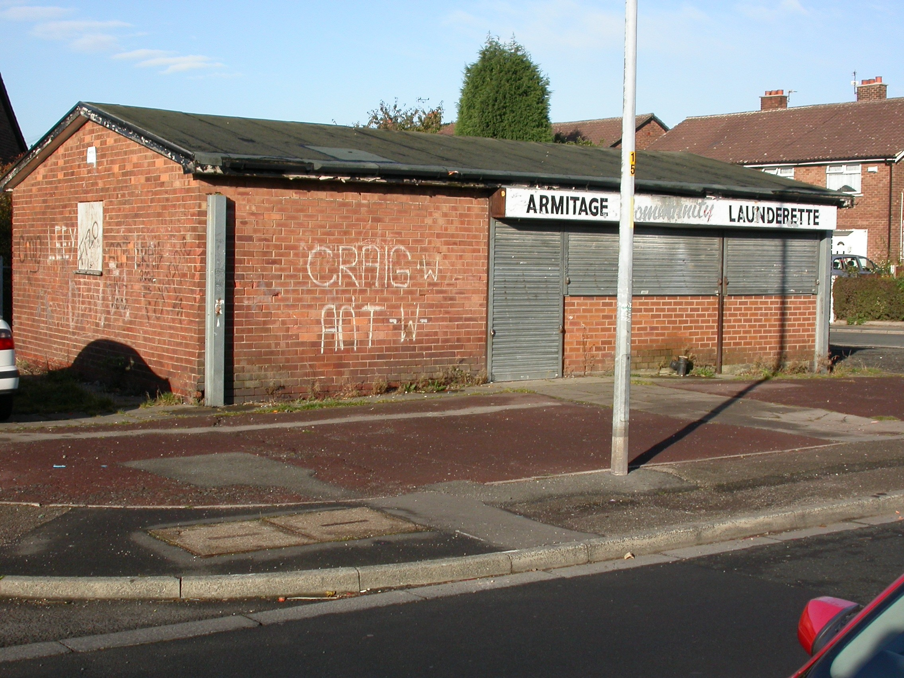

ASSESSMENT OF RISK :

‘Do nothing’ would result in increased risks of property deterioration, vandalism and a continued blight on surrounding properties. There is also the risk of break-ins and the risks of vandalism and injury that this could entail. It is therefore essential that appropriate action taken as quickly as possible.

THE SOURCE OF FUNDING IS :

Expenditure would fall to the Public Sector Housing Capital Programme, including all costs incurred for any acquisition, site clearance, ancillary works such as fencing, and site seeding. Ongoing maintenance works for the cleared site will also require future Revenue funding provision having to be made.

LEGAL ADVICE OBTAINED :

The course of action chosen to follow will be subject to all necessary consents and other approvals being obtained.

FINANCIAL ADVICE OBTAINED :

Various financial details are provided in the report itself. The report has been checked and approved by the NPHL Financial Accountancy Division.

HRA Subsidy does not apply to commercial premises.

WARD(S) TO WHICH REPORT RELATE(S) :

Walkden South and Little Hulton

KEY COUNCIL POLICIES :

Housing Strategy Statement
HRA Business Plan
HMR Prospectus

BACKGROUND DOCUMENTS :
(Available for public inspection)

73 Hulton Avenue (Launderette Site) Project File

CONTACT OFFICER :

Malcolm Barton – Lead Officer, Investment, Partnerships & Special Projects.
Tel: 0161 925 1311 E-mail: malcolm.barton@salford.gov.uk

ADDITIONAL DETAILS :

An option appraisal has been undertaken in respect of the former commercial unit (launderette) at 73 Hulton Avenue, which is situated in the Little Hulton Management Area. The property has been unoccupied and secured since May 1999.

The future of this condition, appearance and potential future commercial viability of this property would clearly suggest demolition as the best course of action.

CONSULTATION AND COMPENSATION

The last lease on the property has been terminated and there are no compensation issues to consider.

Surrounding tenants and the local community association have been consulted on the proposal to demolish the property and no adverse comments received. Local Ward Councillors have been consulted and confirmed their preference for demolition.

It is proposed that the cleared site be included on the Assets Register for possible future disposal / development purposes. In the meantime the cleared site will need to be surfaced, and the community is being consulted on their views for how this should be carried out. The normal Council standard of soiling, seeding, and erection of knee rails just on the cleared area would be unsatisfactory, although cost substantially less than other resurfacing options, but is considered inappropriate for this particular site in view of the locality and likely wishes of local residents. The wishes of the community should be considered on options for the resurfacing of the area, including any environmental works, with budget allocation being subject to the approval of the Lead Member for Housing.

OVERALL SCHEME COST

Budget provision is currently available to undertake the work in this financial year:

Demolition and other Site Treatment £ To be determined (Capital)
Surfacing, fencing, etc. £ 3,500 (Capital)

The above costs assume there no asbestos materials have been used in building construction or any subsequent alterations – if there has then this will need to be removed by a specialist contractor at extra cost.

In addition there will be an ongoing maintenance cost for the cleared site until its long term future has been resolved.

In the longer term there is a potential income from any disposal of the vacant site.

LOCATION MAP

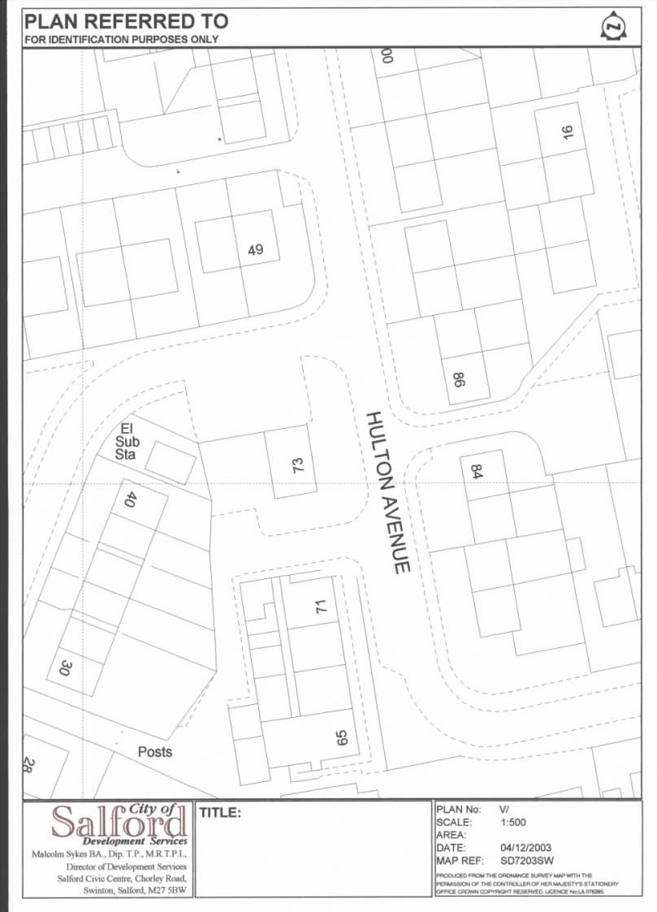
‘Launderette’
73 Hulton Avenue
Little Hulton
Launderette Site
(Plan not to scale and to be used for identification purposes only)

