ITEM NO.
REPORT OF THE LEAD MEMBER FOR COMMUNITY STRATEGY

Cabinet

Date: 6th January 03

TITLE : Ward boundary review and the implications
for Community Committees

RECOMMENDATIONS :
Following the redrawing of the ward boundaries, the following recommendations are made for the formation of Community Committees:
- Community Committees continue to follow ward boundaries.
- The Community Committees should reduce in number from nine to eight.
- Worsley and the new ward of Boothstown & Ellenbrook should form the Community Committee of Worsley & Boothstown.
- The present Community Committees of Eccles, Irlam & Cadishead, Swinton, Walkden & Little Hulton, Ordsall and Langworthy, Claremount and Weaste & Seedley should continue, following the new ward boundaries as proposed by the electoral committee.
- The wards of Broughton, Kersal and Irwell Riverside should form a new Community Committee, the name of which is to be agreed.

EXECUTIVE SUMMARY :

The Electoral Committee has proposed changes to ward boundaries, which will come into effect in June 2004, with elections to all council seats.
Community Committees have followed ward boundaries. This report makes recommendations for the new Community Committee areas, taking into account the new ward boundaries.

BACKGROUND DOCUMENTS :
(Available for public inspection)

Cabinet reports:

CONTACT OFFICER : Tom McDonald, Assistant Director (Community Strategy)

WARD(S) TO WHICH REPORT RELATE(S) : Citywide

Introduction
The Boundary Commission has now agreed the new ward boundaries for the CIty, which will come into effect in June 04 when elections for all seats on the Council will take place. The Community Committee boundaries follow ward boundaries and therefore the ward boundary changes will have implications for Community Committees. This paper outlines proposals for the new Community Committees, based on the new ward boundaries.

Detail

Principles
The proposals for the new Community Committee boundaries are based on the following principles.
- To reinforce the role of ward members within Community Committees
- To promote partnership working in Community Committees

The role of elected members
Community Committee boundaries have followed ward boundaries for some time, which has reinforced the role and responsibilities of locally elected members vis-à-vis their communities. These proposals retain and build on that important principle.

Work with partners
The Community Strategy has increasingly become a vehicle for the development of partnership work in local communities.
Thus, the police have been significant contributors to the development of sector teams, which serve each Community Committee. They are in the process of structural change with the purpose of strengthening their work in communities.
Similarly, the PCT has organised its services so that they have a stronger geographical focus and have followed Community Committee boundaries in defining their four localities in the City.
Thus, there have been discussions with the Police and the PCT to ensure that the proposals for the new Community Committee boundaries allow the partnership to retain its capacity for integrated work at a local level, which recognises Community Committee areas.
The agreement of partners to work to coterminous boundaries of Community Committees is vital for the ongoing development of integrated services and neighbourhood management, which will be the subject of a separate report to Cabinet.

Ward changes
The Boundary Commission’s proposals have resulted in changes to every ward boundary in order to ensure the required number of electors in each ward.
The Central Salford area has lost a ward and a new ward has been created in the West of the City, Boothstown Ellenbrook, which includes the Boothstown part of the former Worsley Bootshtown ward and parts of the former Walkden South ward.
However, there have been significant changes in the ward boundaries in the area now known as Central Salford, particularly through the creation of a new ward, Irwell Riverside, that runs from the border with Manchester City through the A6 corridor, encompassing Duchy estate, up to the Pendlebury border.
A comparison of the maps of the existing wards (appendix 1) with the new wards (appendix 2), shows the significance of the changes in Central Salford and particularly through the creation of the ward of Irwell Riverside.

Implications for the new Community Committees
In order to maintain stability, these proposals seek to retain the existing Community Committees where possible, taking into account the new ward boundaries.
On the west side of the City, the relatively minor changes in ward boundaries would allow the current Community Committee arrangements to continue, with Swinton, Walkden & Litlle Hulton, Eccles and Irlam & Cadishead Community Committees encompassing the same wards as they do under the existing boundaries.
Worsley & Boothstown Community Committee would now include the new ward of Boothstown Ellenbrook and Worsley ward.
The loss of a ward in the Central Salford area raises the possibility of a reduction in the number of Community Committees from four to three. If four Community Committees were to be retained, there would be one Community Committee that would cover a much smaller population than the other three, irrespective of the different combinations of wards.
In addition, the geographical position of Irwell Riverside ward which runs from east to west across the centre of Central Salford and which, to the north, dissects Broughton and Kersal, makes the separation of these three wards from each other very problematic.
It is proposed, therefore, that there is a reduction in Community Committees from four to three within the Central Salford area. This will include a completely new Community Committee area of Irwell Riverside, Broughton and Kersal, which will require a new name. The wards of Claremont and Weaste & Seedley and Ordsall and Langworthy should continue to form the same Community Committee areas, as at present.

Populations in the new Community Committee areas
The populations in the new Community Committee areas vary from 14,600 in Irlam and Cadishead to 25,000+ in Eccles and Worsley/Boothstown Community Committees. However, as can be seen in appendices 4 and 5, there is significantly less variation in the population of the Community Committees proposed compared to the current Community Committees.

Implications for partnership work
Discussions have taken place with the Police and the PCT on the new ward boundaries and the implications of for Community Committee boundaries. Both organisations are committed to working to coterminous boundaries and not to cut across Community Committees.
The PCT has, therefore, four localities and the police will deploy their resources within five geographical units. The names of and the Community Committees covered by the PCT and Police geographical units are listed in Appendix 5.

Conclusion
Members are asked to:
- Agree the composition of the new Community Committees.
- Agree a period of consultation with Community Committees and other relevant groups.
- Agree a name for the new Community Committee, covering Kersal, Broughton and Irwell Riverside wards.
- Agree a date when shadow arrangements, following the new Community Committee boundaries, should come into effect.

Appendix 1
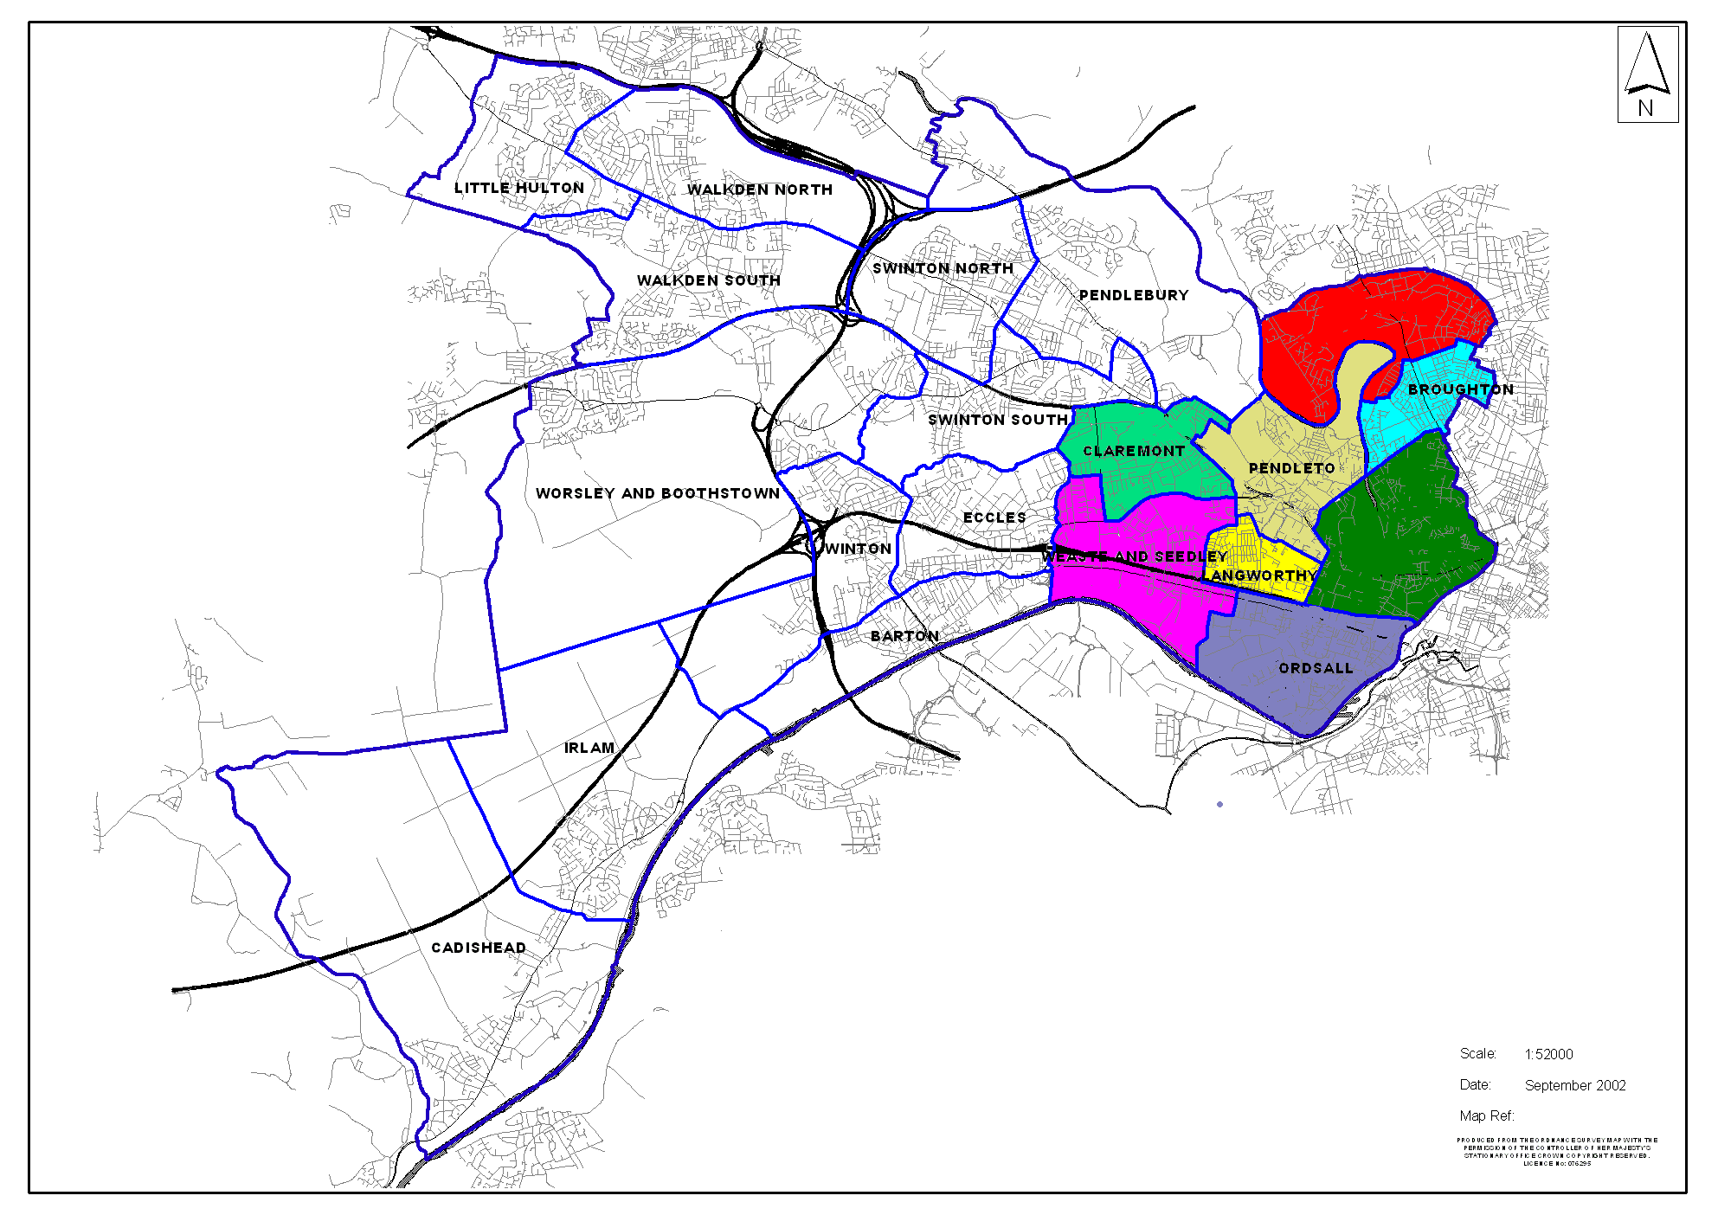
Current Ward Boundaries

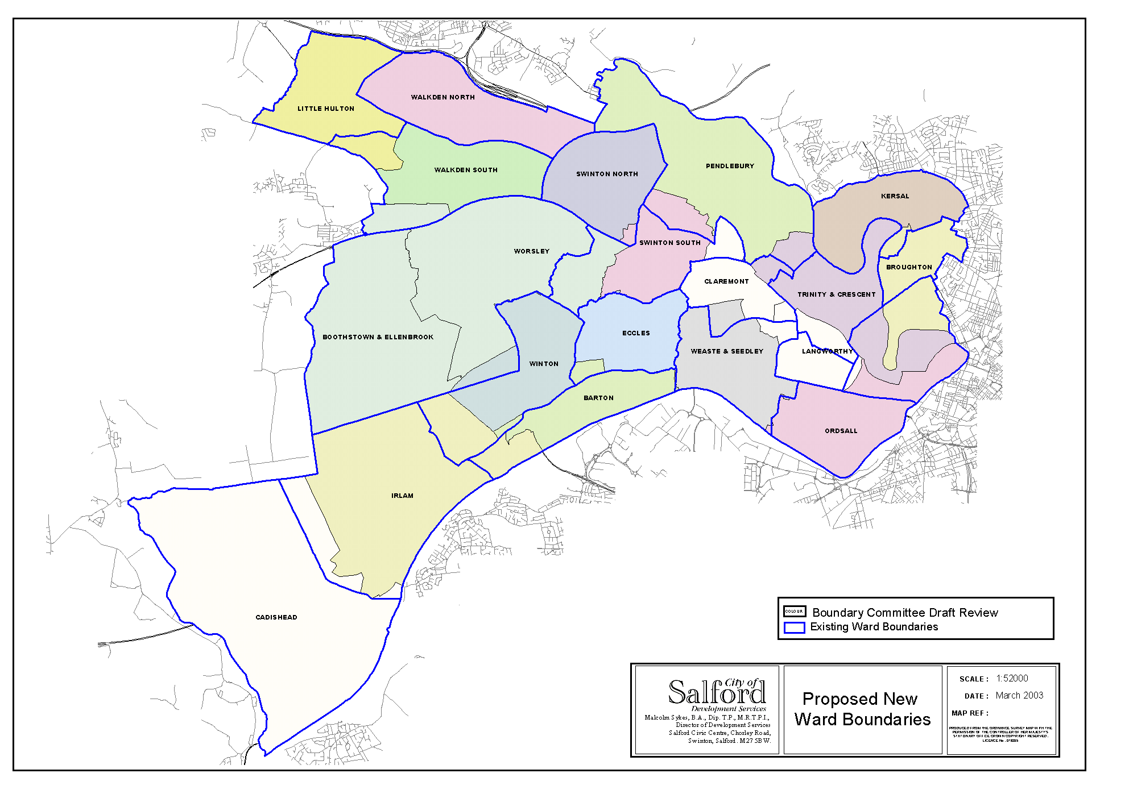
New Ward Boundaries
Appendix 2

Populations of the proposed Community Committees
Appendix 3

Ward Name | Electorate
Irlam | 7468
Cadishead | 7154
Total | 14622
Barton | 8525
Eccles | 8422
Winton | 8325
Total | 25272
Broughton | 8291
Kersal | 8253
Irwell Riverside | 7544
Total | 24088
Langworthy | 8543
Ordsall | 7441
Total | 15984
Walkden North | 7903
Walkden South | 8364
Little Hulton | 8330
Total | 24597
Boothstown and Ellenbrook | 7731
Worsley | 8411
Total | 16142
Claremont | 8225
Weaste and Seedley | 7662
Total | 15887
Swinton North | 8490
Swinton South | 8455
Pendlebury | 8155
Total | 25100

Electors in proposed
Community Committees

Appendix 4
Partnership Work

Police Geographical areas

Name | Community Committee areas
West Salford | - Walkden & Little Hulton  - Worsley & Boothstown
North Salford | - Swinton
South Salford | - Eccles  - Irlam & Cadishead
Central | - Ordsall & Langworthy  - Claremount & Weaste
East Salford | - The new Community Committee of Broughton, Kersal and Irwell Riverside

Appendix 5

PCT Localities

Name | Community Committee areas
West | - Walkden & Little Hulton  - Worsley & Boothstown
North | - Swinton
South | - Eccles  - Irlam & Cadishead
Central | - Ordsall & Langworthy  - Claremount & Weaste  - The new Community Committee of Broughton, Kersal and Irwell Riverside

