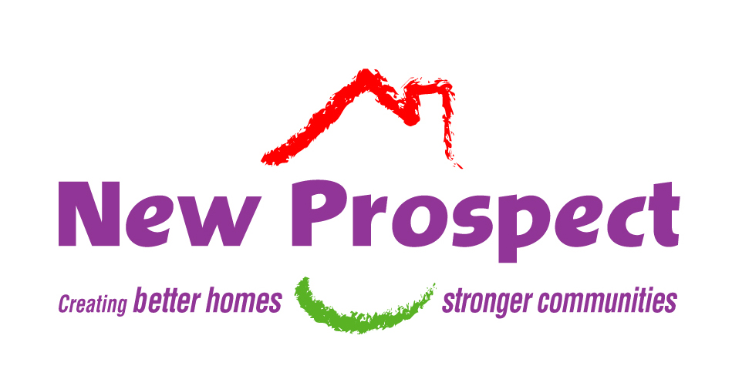
BECOME A BOARD MEMBER

If you want to have more say in how New Prospect is run, then you might want to consider Local Board Membership.


Is it for me?
A good way to find out if Board Membership is for you is to arrange to observe a Board meeting. It will give you a good idea of how your Local Board is run.

For further information contact William McKay
Local Board Administrator on: 0161 925 1103
or Email: william.mckay@new-prospect.org
or visit our website: www.new-prospect.org

Election of Board Members
Board Members are normally elected at the Annual General Meeting (AGM), but we can also fill any vacancies which arise in the course of the year. The successful applicants then stand down at the AGM in October and seek
re-election as a full member of the Board.

But I’ve never done anything like this before!
That’s not a problem. As a new Board Member you will be given full training and induction in order to be able to play a full and active part in New Prospect. There are opportunities to take part in the wider housing movement through conferences and seminars, and you would be encouraged to do so, particularly in areas which match your particular expertise or interest.

Would I get paid?
Board members are volunteers. Although all your expenses are met, unfortunately Board membership doesn’t pay – at least not financially! But you do gain a wealth of experience and the chance to really make a difference in your community and further afield.

Current vacancies
We currently have a number of vacancies in the west of Salford and require tenants from the following areas:

Eccles and Irlam - 2 Little Hulton and Worsley - 3 Swinton – 1

