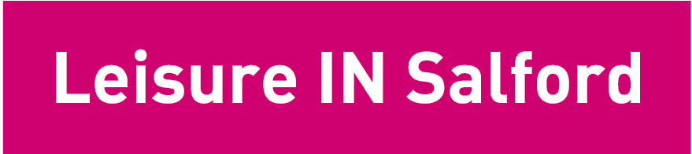

CARING 4 CARERS

A free leisure pass for unpaid Carers to access Salford Councils leisure facilities, from the 1st of November until the 31st of December 2006.

Carers Confirmation

Please enter your name and address below. The rest of this form is to be filled in by a social worker, G.P. or health worker who can confirm you are a carer for a Salford resident. Voluntary Agencies such as Age Concern, Barnardo’s and Making Space, may also confirm you are a carer. Carers in receipt of Carer’s Allowance are also entitled to a pass.

Name and age of carer _________________________________________________

Address of Carer ________________________________________________

_______________________________________________________________

I can confirm that _______________________________________ is a carer

Print Name_______________________________________ Date ______________

Job Title_________________________________________________________

Please supply your contact details in case of queries

Contact Address __________________________________________________

Contact Phone Address: ____________________________________________
FOR STAMP OF AUTHORISATION SEND OR TAKE TO:
SALFORD CARERS CENTRE
1 ST.PHILIPS PLACE
SALFORD
M3 6FA TEL 8330217

