Liverpool Road, Irlam and Cadishead Public Art Project
Interim Report Provided by Liam Curtin & Marcela Livingston - Thursday, 16th November 2006

The aim of this report is to provide members of the Irlam & Cadishead Community Committee with an update on progress for the above project.
Initially the intention had been to consult with the community through a web site. The web site was to be promoted through temporary artworks placed on the roundabout and it was envisaged that this would give us an opportunity to test out scale and also enter into a dialogue with roundabout users.

Various temporary artworks were proposed including a pyramid of traffic cones, however many questions about these temporary artworks were raised on the grounds of safety and traffic management and despite strong political support the idea of using temporary art as a consultation exercise was considered unfeasible. This process took some time and as a result the consultation stage of the project was delayed.
The project management group, myself & Marcela re-visited other consultation suggestions and decided to keep the web site to promote and consult the aim of the project and offer members of the Irlam & Cadishead community the opportunity to express their views and opinions about the project, together with providing additional ideas and suggestions. The website name is extremely appropriate and one which truly reflects what we are seeking to achieve on the ‘island’.

The website has been developed in conjunction with the local high school and their input has been invaluable. This work is ongoing and we are planning that by mid December the web site will be updated again and advertised on the roundabout. Please take a look at www.islandart.org.uk and keep an eye out for the updates before Christmas and contribute your views. This is your chance to have your say!
In August we held a workshop day at the Irlam Festival in which large numbers of local people and businesses participated and in fact this event has led directly to the idea that is currently being developed! There were two workshop sessions, in which people helped to make an artwork resulting in them constructing a traffic cone pyramid and a jewel like shape made with many CD's. Questionnaires were also completed and many discussions with local people took place.
At the festival we showed 4 main ideas including:
Iconic art - represented by a large golden star on a pole
Figurative art such as ‘The Angel of Irlam’
Decorative Art, in the form of geometric patterns
Fantasy Art - as in inventing a new super hero to represent the area.
and examples of public artworks which used these ideas were on display for comment.
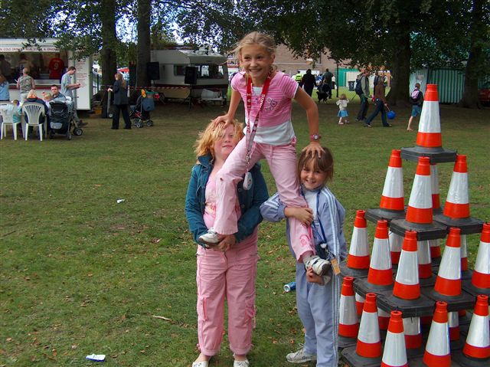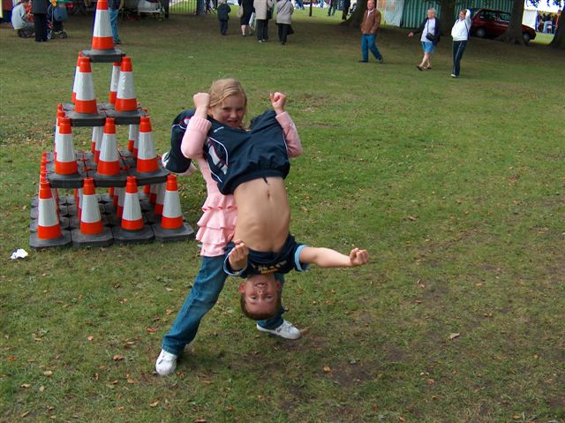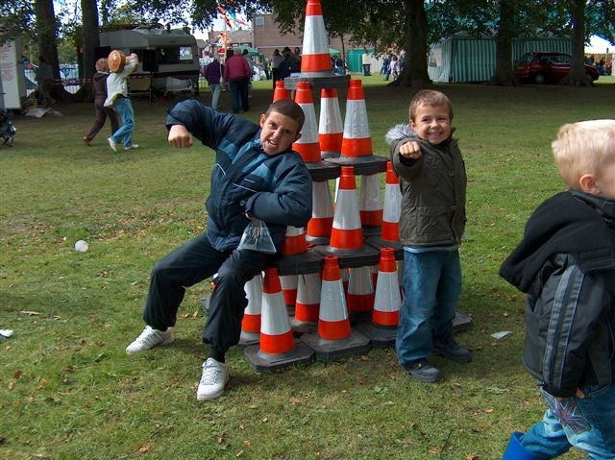
It was much to our surprise that it was this latter idea that seemed most popular. Most people we spoke to mentioned the two former industries of the area, steel and margarine. People felt that these industries should somehow be represented in the artwork as it's an important part of the area's history.
This notion gave us the opportunity to combine two things:
A super hero to represent margarine (one young person suggested "Margerina") and
A super hero to represent Steel (“Steelman" was suggested)

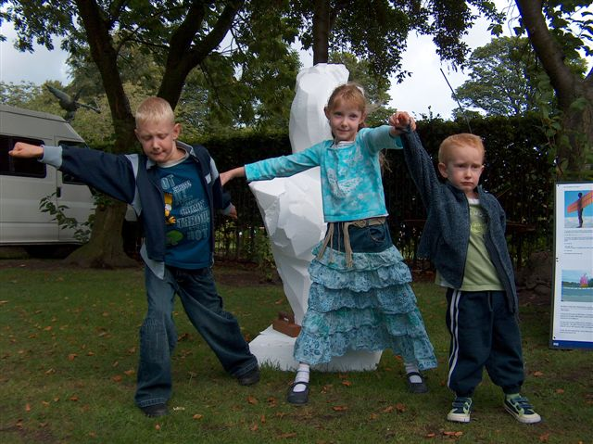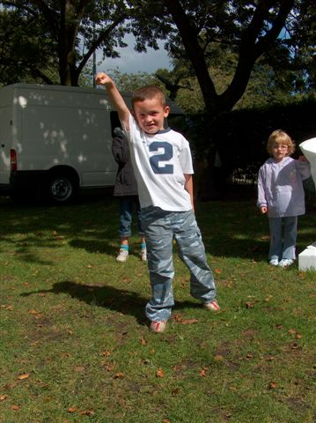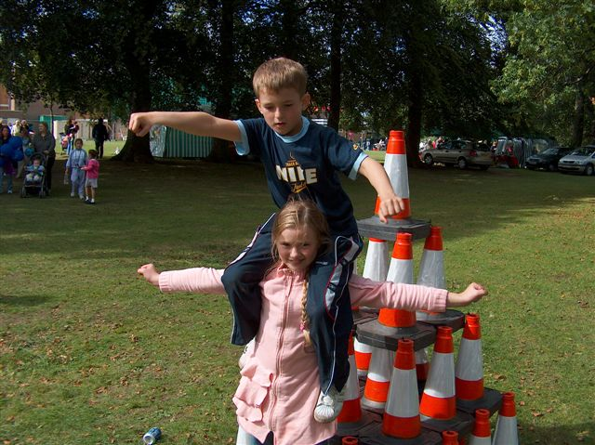
We would like to depict both these characters in an artwork that has them dancing together on the roundabout. It unites the men and women of the area in a romantic way and commemorates the two most important former industries.
We have many ideas about what form these dancers could take and will be working up these ideas for presentation in the very near future.
As for the name it could be Marge and Steel or the Cadishead Dance but we'll leave that decision to the community who can let us have their ideas through the web site.
Finally we would like to take this opportunity to thank all those people in the council and the community who have been supportive and helpful in the development of our proposal. We are delighted that the delays are over and we look forward to installing an artwork that will be popular with local people and visitors alike.
Marcela Livingston and Liam Curtin

Background Information

- In March 2006, Economic Development commissioned the Arts Development Service to deliver a Public Art project at the new roundabout at the A57. A £75,000 commission funded via NRF.

- A multi disciplinary team appointed artists Liam Curtin and Marcela Livingston after a competitive tendering process.

- The artist’s proposal was to produce a website as a consultation tool and install a number of temporary installations at the roundabout to encourage debate and use of the website – www.islandart.org.uk The high school are running and managing the website.

- A steering group including Highways, Neighbourhood Management, Planning and Economic development are supporting the project

- This commission, using high profile Artists, is key to the development of Public Art in Salford and is grounded in the following context:

Three years of work between Arts Development and Irlam and Cadishead Neighbourhood Management and Community Committee

Three years of collaboration between Salford City Council and Arts Council England North West – focusing on participatory work and Public Art. The Arts Council have just given a vote of confidence in our status as leaders in Public Art in the region by awarding us the commission to deliver the £420,000 Irwell Sculpture Trail project

Approval and funding for £68,000 from the Arts Council to develop a new Arts Commissioning model.
For more information please contact:
Shirley Lundstram
Salford Museum and Art Gallery
Peel Park, Salford Crescent
M5 4WU

Tel. 0161 778 0831

