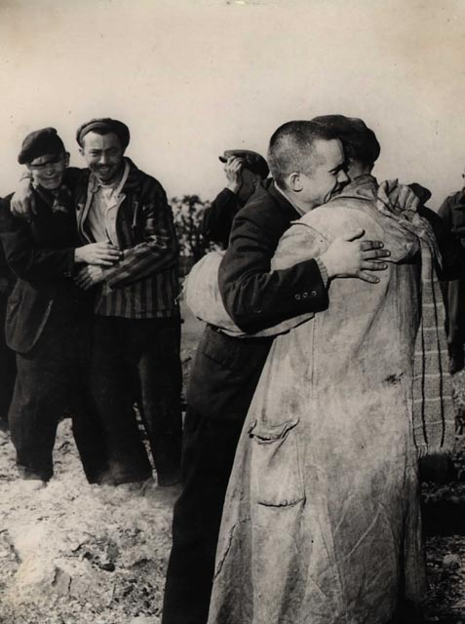
A commemorative event to mark

National Holocaust Memorial Day

The Dignity of Difference

Salford City Council, through the SACRE, is keen to mark this event in a way that reflects its intention to ensure that future generations learn the lessons of the holocaust.

For more information on Holocaust Memorial Day please refer to www.holocaustmemorialday.gov.uk

For more information about local events please contact Bev Walker on 0161 778 0154
Car park security is available at Buile Hill Banqueting Suite



