Item 9


Forward plan of key decisions
Sustainable Regeneration

 | Subject | Date / period of decision | Ward(s) | Scrutiny committee, if decision is called-in
1 | Network railway protection works  acceptance of tender  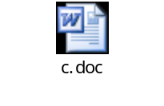 | February, 2010 to March 2012 | Various | Sustainable Regeneration
2 | Highway investment works funded via unsupported borrowing  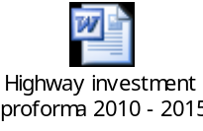 | Various Dates 2006 - 2015 | All wards | Sustainable Regeneration
6 | Property update  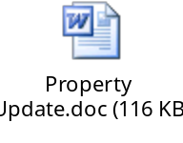 | April 2011 to March 2012 | All wards | Sustainable Regeneration
12 | TfGM Cross City Works A580 Quality Bus Corridor(Old Clough Lane -Trinity Way) – Acceptance of tender  (in conjunction with TfGM)  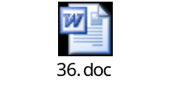 | January to April 2012 | Worsley / Swinton North / Swinton South / Claremont / Irwell Riverside / Langworthy | Sustainable Regeneration
13 | MediaCityUK   | November  2011 to  April 2012 | All Wards | Sustainable Regeneration
14 | The Street Lighting Capital Programme   | March 2012 | All Wards | Sustainable Regeneration
15 | Approval to commission an Eccles Town Centre Masterplan  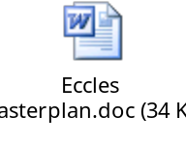 | September 2011 to March 2012 | Eccles, Weaste and Seedley | Sustainable Regeneration
16 | Approval to consult on the Draft Housing Revenue Account Subsidy and determinations.   | December 2010 to March 2012 | All Wards | Sustainable Regeneration
18 | Charlestown Riverside – Regeneration  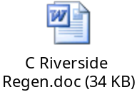 | December  2011 to March 2012 | Irwell Riverside | Sustainable Regeneration
19 | Vanguard Site / Remediation Strategy  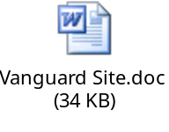 | December  2011 – June 2012 | Ordsall / Irwell Riverside | Sustainable Regeneration
20 | Charlestown Riverside Site - Further Remediation Works  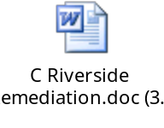 | December  2011 to March 2012 | Irwell Riverside | Sustainable Regeneration
21 | Office Moves and refurbishment 2011/12 | April 2011 to March 2012 | All Wards | Sustainable Regeneration
22 | Greengate Regeneration. Enabling development  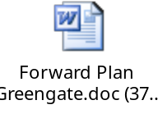 | January/  February  2012 | Ordsall | Sustainable Regeneration
24 | Re-procurement of the Re-thinking Construction Partnering Programme  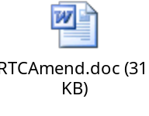 | January/  February  2012 | All Wards | Sustainable Regeneration
25 | Sherbourne Footbridge Refurbishment  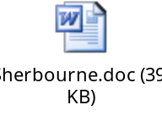 | May to August 2011/2012 | Irwell Riverside, Broughton | Sustainable Regeneration
26 | Surplus homeswap properties in Langworthy – proposal to rent on the open market with Salix Homes providing a management service.   | January/  February  2012 | Langworthy | Sustainable Regeneration
27 | Hancock's Legacy  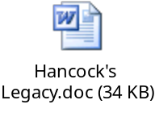 | November 2011 – February 2012 | Boothstown | Sustainable Regeneration
30 | Strategic Decisions relating to the Creating a New Pendleton Housing PFI Project – Final Business Case Approval  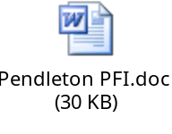 | July 2011 to July 2012 | Langworthy | Sustainable Regeneration
33 | Acceptance of a tender – A666 Agecroft Road Junction  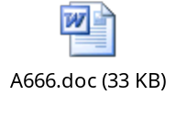 | April 2012 | Pendlebury, Claremont | Sustainable Regeneration
37 | Highway Drainage – Recovery Programme  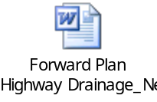 | August 2011 to March 2012 | All Wards | Sustainable Regeneration
40 | Consultation and adoption of a development framework for the Crescent area of Salford  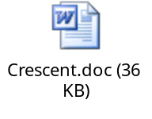 | September 2011 to April 2012 | Irwell Riverside,  Broughton | Sustainable Regeneration
42 | Housing related support contracts for a variety of services, commissioned through the Supporting People programme   | January to March 2012 | All Wards | Sustainable Regeneration
43 | Cargo Cranes, Ontario Basin, Salford Quays   | January/  February 2012 | Ordsall | Sustainable  Regeneration
44 | Impact Assessment Report on any potential changes to funding for childcare for 3 and 4 year olds  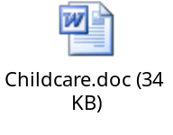 | December 2011/  January  2012 | All Wards | Cabinet Decision
45 | Winter Weather Emergency Plan 2011/12  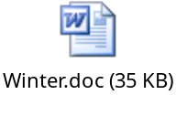 | September 2011 to March 2012 | All Wards | Sustainable Regeneration
46 | Agreement to tender the Drug and Alcohol Treatment and Recovery System   | December  2011/  January 2012 | All Wards | Cabinet Decision
47 | Salford Central Acquisition Fund Update  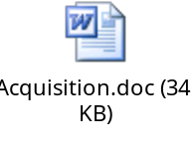 | January/  February  2012 | Ordsall, Irwell Riverside | Sustainable Regeneration
48 | Approval of the consultation draft of the Charlestown and Lower Kersal Development Framework Update and the consultation programme  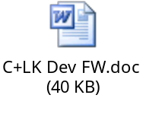 | December 2011 to March 2012 | Irwell Riverside and Kersal | Sustainable Regeneration
49 | Red Rose Retail Park, Regent Road – new access facilities   | September  to November 2012 | Ordsall | Sustainable Regeneration
50 | Operational Policies and Standards for Highway and Street Lighting Maintenance – Proposed Amendments  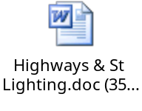 | November 2011 to March 2012 | All Wards | Sustainable Regeneration
51 | The Highway Network Recovery Programme – 2011/12 Review  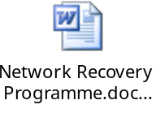 | November 2011 to March 2012 | All Wards | Sustainable Regeneration
52 | Demolition of the Ordsall District Centre building  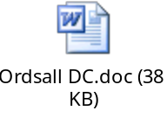 | December  2011 to March 2012 | Ordsall | Sustainable Regeneration
53 | Shared Services Partnership  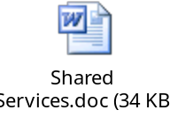 | November 2011 to March 2012 | All Wards | Cabinet
54 | Irwell River Park: Clippers Quay Bridge  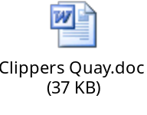 | November 2011 to April 2012 | Ordsall | Sustainable Regeneration
55 | University Road Lay-by  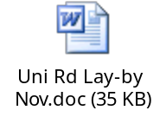 | November – April 2012 | Irwell Riverside | Sustainable Regeneration
56 | Islington Way Realignment  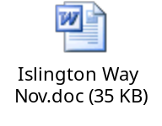 | November 2011 – April 2012 | Ordsall | Sustainable Regeneration
57 | Learning Difficulty Service Invest to Save Application – returning people with Learning Difficulties, who are currently accommodated ‘out of borough’ to supported accommodation sites in Salford  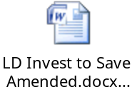 | January to March 2012 | Not yet known | Sustainable Regeneration
58 | A580/A6 Crash Barrier Renewals – Acceptance of a Target Price  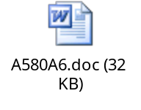 | November 2011 to March 2012 | Claremont | Sustainable Regeneration
59 | Greater Manchester Road Activity Permit Scheme   | December  2011/  January 2012 | All Wards | Cabinet Decision
60 | Licensing Activities on the Highway  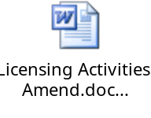 | January/  February  2012 | All Wards | Sustainable Regeneration
61 | Developing Building Control  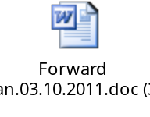 | November 2011 to March 2012 | All Wards | Sustainable Regeneration
62 | Footway Protection Work to Network Rail Bridges  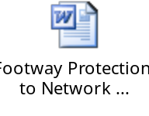 | December 2011 to March 2012 | Irwell Riverside, Pendlebury and Swinton North | Sustainable Regeneration
63 | Centenary Bridge Refurbishment  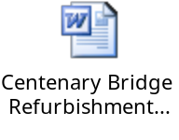 | December 2011 to March 2012 | Weaste and Seedley | Sustainable Regeneration
64 | Introduction of Pay and Display car park on land off Corporation Road, Eccles  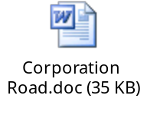 | December 2011 to March 2012 | Barton | Sustainable Regeneration
65 | Permission to spend allocated budget for AGMA’s Low Carbon Economic Area Work Programme 1 for the retrofit basic home insulation scheme  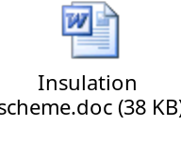 | January/  February 2012 | All Wards | Sustainable Regeneration
67 | Salford QuaysLink  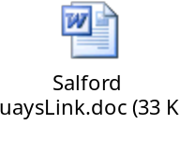 | December 2011 to April 2012 | All Wards | Sustainable Regeneration
68 | Proposal to increase the Controlled Parking Zone operating hours and the Council’s on and off street parking charges   | December 2011 to March 2012 | Barton, Eccles, Langworthy, Ordsall, Swinton North, Swinton South, Worsley | Sustainable Regeneration
69 | Salford Rail Strategy  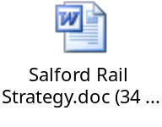 | January to March 2012 | All Wards | Sustainable Regeneration
72 | Review of Current School Crossing Provision   | January/  February  2012 | All | Sustainable Regeneration
73 | Additional Bus Journeys on the 74/75 Service  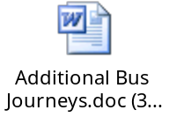 | January/  February  2012 | Claremont, Irwell Riverside, Langworthy, Pendlebury | Sustainable Regeneration
74 | Chapel Street Area Parking Strategy and Delivery Plan  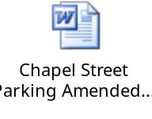 | January to March 2012 | Irwell Riverside and Ordsall | Sustainable Regeneration
75 | Block 3 Transport Capital Programme 2012/13   | February/  March 2012 | All | Sustainable Regeneration
76 | Approval of updated list of Sites of Biological Importance to take account of annual updates provided by the Greater Manchester Ecology Unit. We have not done this since the Unitary Development Plan was adopted in 2006   | January – March 2012 | All | Sustainable Regeneration
80 | Pendleton Way Improvement   | February/  March 2012 | Langworthy | Sustainable Regeneration
81 | A6 Broad Street, Irlams o’th Height  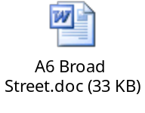 | January – March 2012 | Claremont | Sustainable Regeneration
82 | Water Taxi Infrastructure  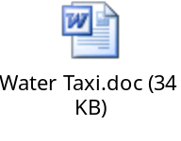 | January – April 2012 | Ordsall, Irwell Riverside | Sustainable Regeneration
83 | Greengate – Acceleration of Works  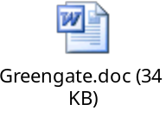 | January – April 2012 | Irwell Riverside | Sustainable Regeneration
84 | School Admission Arrangements 2013/14 – as set out in the School Standards and Framework Act 2008  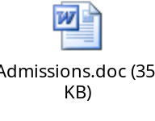 | March/April 2012 | All | Cabinet Decision
85 | Requirement to use £75,000 of Capital Programme funding (2011/2012) identified to contribute to the delivery of the network changes in Salford and Manchester to facilitate the closure of Victoria St, to deliver the new signalised junction to Victoria Bridge St and Chapel St as part of the Greengate public realm contract.  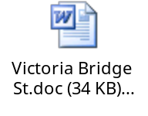 | January to March 2012 | Ordsall and Irwell Riverside | Sustainable Regeneration
88 | Implementation of an internal repairs and maintenance service within Salix Homes current business structure  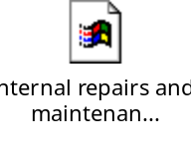 | February 2012 | Broughton, Claremont, Irwell Riverside, Kersal, Langworthy, Ordsall, Weaste & Seedley, Swinton North | Sustainable Regeneration
90 | Irwell River Park – LSTF Active Travel. To update on external funding decisions and seek endorsement to deliver capital schemes along Irwell River Park’s routeway to promote sustainable travel.  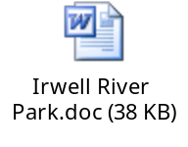 | February to December 2012 | Irwell Riverside | Sustainable Regeneration
93 | Residential Service Charge Policy  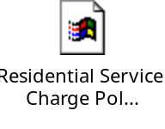 | February/  March 2012 | All Wards | Sustainable Regeneration
94 | A new strategic approach to configure and deliver supported accommodation for people with mental health problems in Salford   | February/  March 2012 | All Wards | Cabinet Decision
96 | Hydro-electricity Proposal  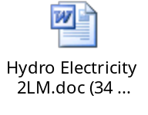 | February to April 2012 | Irwell Riverside, Broughton | Sustainable Regeneration
97 | Salix Homes – Solar PV Scheme  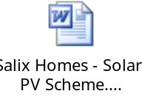 | February 2012 | Ordsall, Broughton, Langworthy, Irwell Riverside, Kersal, Swinton North, Claremont, Weaste & Seedley | Sustainable Regeneration

