CONTENTS | Page No.

STRATEGY: EXECUTIVE SUMMARY

Vision

To improve the health, quality of life and life-chances of people in Salford and support the regeneration of the City by, as relevant, directly providing, promoting, enabling and facilitating access to sport and physical activity across the whole community. This to occur by using sport and physical activity as a vehicle to deliver key social objectives and laying specific emphasis on improving provision for the under-represented.

The primary outcome of Strategy implementation should be more, and a broader range of, people participating in sport and physical activity. It will also contribute to a range of broader social outcomes, including:

Health:

- An increased proportion of residents (in particular those of school age and the over 55s) taking part in physical activity and exercise.
- Improved movement literacy and general physical and mental health among young people.

Educational attainment:

- Raised attainment levels and a reduction in attainment gaps.
- More young people successfully engaged/re-engaged with education/training.
- Reduced levels of truancy/exclusion from schools.

Inclusion:

- Clear identification of areas in which sport and physical activity can contribute in the context of engaging and subsequently attracting young people from under-represented groups.
- An increase in the proportion of young people from specifically identified groups introduced to, and permanently involved in, sport and recreation activity.

Community safety:

- Reduced crime (and fear of crime) across the City and in priority neighbourhoods.
- Reduced youth offending and improved prevention of offending amongst young people at risk of so doing
- A reduction in reported anti-social behaviour.
- A higher proportion of young people resident in the City able to swim.

Young people are a primary focus. This is because:

- They are a priority in Government, City Council and Sport England national sports and community strategies.
- The most effective way to increase involvement in sport is to attract people at an early age and retain them via provision of appropriate, sustainable opportunities.
- Utilising sport and physical activity as a key vehicle to combat crime, enhance health and promote social inclusion is most effective when implemented via intervention at an early age.
- Raising standards in the City’s schools is a high priority.
- Affecting lifestyle change to improve health is acknowledged to be more effective if healthy habits (good diet, regular exercise etc.) are introduced at an early age.

The Strategy has been developed in the context of emerging national policy and the City’s Community Plan and Cultural Strategy. It reflects the findings of the CPA Inspectorate report and the issues that emerged from the Council’s own exhaustive internal Best Value review. It identifies ways in which SCC can, via the operation of a seamlessly managed and delivered Leisure and Quality of Life (LQL) Trust which incorporates the functions of City Leisure, Sports Development, Regeneration, Community Arts and Sports Events:

- Develop a co-ordinated system for promoting lifelong participation in sport and active recreation and utilise sport and physical activity to contribute to health promotion, crime prevention, social exclusion, economic regeneration, lifelong learning and environmental sustainability.
- Work to improve community links with, and contribute to raising the quality of, physical education, sport and physical activity delivered in and via the school environment.
- Co-ordinate delivery of sports specific activity and partnership-based services, including school-club links, club development, coach development and player development.
- Where appropriate and/or relevant support talented performers from the City.

The strategy ties into national strategic frameworks for sport and physical activity by:

- Linking closely to education to ensure that there is a co-ordinated system dovetailing effectively with programmes designed to increase the quantity and quality of PE and school sport.
- Providing a focused, core role for SCC in promoting lifelong participation in sport and utilising sport to contribute to issues such as:

- Health promotion.
- Crime prevention.
- Social inclusion.
- Economic regeneration.
- Lifelong learning.

- Identifying a clear focus for the facilitation, enabling and direct service delivery roles of the City Council

The Strategy and service plans that follow are underpinned by a core approach to the work and service orientation of the ‘Leisure and Quality of Life’ Division. This is illustrated on the diagram shown

Salford: Leisure & Quality of Life Division
LQL

Partnership-based project income
Commercial services income
(Regular) earned core LQL income
City grant to LQL Trust
Finance
& Admin.
SPORTS
SERVICES

Venues:
Pools
Sports Centres
Watersports Centre
Lledr Hall

Activities:
Sports
Coaching & instruction
Clubs & squads
Recreation
Events & holiday programmes
Community functions

Policy/marketing/market research & performance measurement
EVENTS, VENDING & CONFERENCES

Venues:
W-sports Centre
Lledr Hall
Meeting/comm. rooms in centres

‘Subjects’
Sport & crime
Sport & regen.
Quality Protects
Special schemes; SLAM WAP etc.

Other commercial:
Vending/catering

LEARNING & ATTAINMENT

Impact on (say):

Punctuality
Educ attainment
Training retention
LSC-linked targets
‘Non-exclusions’
Rewards schemes
Outdoor education
Special education
Provision for disabled people
Quality Protects
Connexions
Pupil Support unit targets

INCLUSION & HEALTH

Sports/Community & Community Arts Dev.

Provision/impacts:
Health
Crime
Safety
Specific areas
Specific groups
SCC workforce

Valuers!
Police
CSP
Area committees
Pupil Support Units

Business
Devt.
Key LQL drivers & outcomes

To improve health outcomes and reduce health inequalities.
To raise education & skill levels and promote cultural & leisure enhancement.
To tackle social inequities, maximise opportunities for children and young people and increase involvement of local people and communities in sport and physical activity.
To deliver and support programmes designed to reduce crime & disorder.
To co-ordinate, manage & develop sport in, and across, the City.
To deliver value for money – effectively balancing financial efficiency and the delivery of high value social outcomes.

CPD
CO-ORDINATE, DRIVE, SUPPORT, DEVELOP, MEASURE & EVALUATE
Introduction

Salford is situated on the western side of the Greater Manchester conurbation in the north-west of England. It includes towns and villages such as Boothstown, Cadishead, Eccles, Irlam, Swinton and Pendlebury, Walkden and Worsley.

It contains a mix of urban and rural landscapes covering an area of 9,690 hectares. The City is dissected by motorways (M60, M62 and M602) and busy A roads (A6, A580, A57 and A666).

Salford: Location

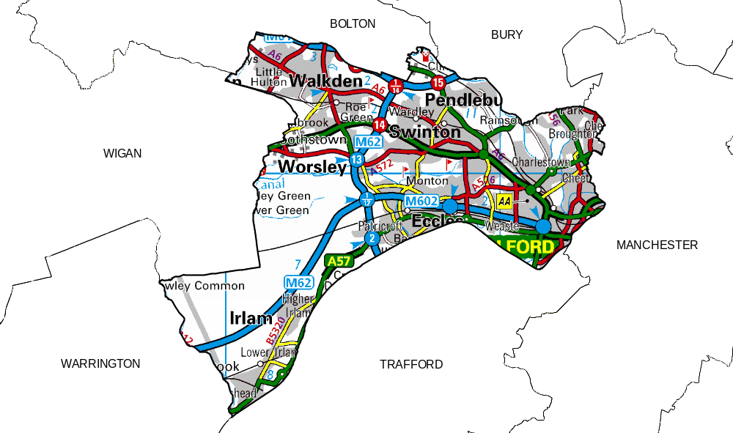

Sport and physical activity – the National rationale

The Government rationale for investing in sport and physical activity is predicated upon the assumption that it has a major part to play in promoting health and, as part of a basket of measures, contribute to improved educational outcomes, reduced crime and greater social inclusion. The, nationally defined, possible beneficial outcomes from sport and physical activity include:

- Personal satisfaction and better social life;
- Improved health;
- Improved educational outcomes;
- Crime reduction;
- Social inclusion; and
- Enhancing the environment.

The existence of benefits does not, however, automatically mean that government should intervene in sport. The Government thus requires a rationale for intervention on efficiency and equity grounds, either to stimulate provision by the private or voluntary sectors in order to reduce the health costs of inactivity; or to address inequality of access or opportunity: For example differences in participation between social groups or absence of facilities in certain areas.

Intervention is considered justified when it corrects “inefficiencies” in provision by the private or voluntary sectors (eg. to reduce the health costs of inactivity); or it addresses inequality of access or opportunity (eg. differences in participation between social groups). The Government’s view is that it should not seek to replicate the activities of the private or voluntary sectors.

The difficulties of measuring benefits and impacts still restrict the quality and quantity of evidence available.

Sport provides opportunities for individuals to express their physicality, and can be a source of personal satisfaction. Pleasure from sport as a leisure activity is derived as a complex mix of physical and psychological benefits. In many cases, sport is the means to providing an individual with a wider social circle. For women, in particular, it can be one of the main reasons why they choose to participate in leisure activities generally.

The Government view is that a 10% increase in adult activity would benefit England by at least £500m a year (saving about 6,000 lives). The burden of physical inactivity is an increasing problem, as the continuing rise in obesity and other inactivity-related health challenges demonstrates. As these escalate, so does the cost of physical inactivity.

It states that the benefits of physical activity on health are clear, well evidenced and widely accepted. 30 minutes of moderate activity five times a week can help to reduce the risk of cardiovascular diseases, some cancers, strokes and obesity. Estimates put the total cost to England of physical inactivity in the order of at least £2bn a year. Conservatively, this represents about 54,000 lives lost prematurely.

A range of international medical research evidence shows that regular physical activity can yield a number of physiological benefits in adults. Research has also found a consistent link between exercise and anxiety reduction; and protection against the development of depression.

Nationally, there is less evidence relating to the benefits of sport in the context of crime reduction and social inclusion. This is not to say that they do not exist, but it is difficult to isolate and assess the impact of sport and physical activity. Experience suggests that where such benefits exist they are best achieved by using sport and physical activity as part of a wider package of measures.

Various studies and the recent Greater Manchester Strata survey would suggest that education plays a key role in affecting levels of participation. There is some also evidence to suggest that sport and physical activity benefits education.

The health benefits from physical activity are, thus, those most strongly supported by the evidence currently available, and the most likely to achieve good outcomes for government. There are indications of links between sport and physical activity provision and wider educational benefits. Some practitioners also report positive results from schemes that use sport to help to reduce crime and social exclusion. However, systematic evidence is lacking.

There is, thus, a widely held (and promoted) belief that sport confers a broad range of economic and social benefits on individuals, communities, and the nation as a whole. As the (then) English Sports Council claimed in its strategy document, England, the Sporting Nation (1997): “the benefits of sport are well rehearsed – national identity and prestige, community development, personal challenge, as well as economic and health benefits. Sport is a central element in the English way of life.”

STRATEGIC CONTEXT

PAT 10

The Social Exclusion Unit Policy Action Team report on Arts and Sports (PAT 10) highlights the central role of sport at the heart of comprehensive neighbourhood renewal. It identifies its potential to contribute to key outcomes including personal development, community capacity building, reducing crime and long term unemployment, better health and attainment.

The report identifies best practice in using sport and the arts to engage people in poor neighbourhoods, particularly those who may feel most excluded such as disaffected young people from ethnic minorities. It highlights areas where sport can play a key role in generating positive outcomes associated with crime, health, education and employment.

Salford’s strategy reflects the ambitions and proposals made in PAT 10 and identifies ways in which sport can contribute to issues such as community capacity building, reducing crime and improving health.

A Sporting Future for All

In April 2000, the Department for Culture, Media and Sport published its strategy for sport in England – ‘A Sporting Future for All’. This identifies the Government’s aims for sport as:

More people of all ages and all social groups taking part in sport.

More success for England’s top competitors and teams in international competition.

A Sporting Future for All identifies four key issues to be tackled to improve performance in sport:

There are not enough opportunities for children and young people to take part.

People lose interest as they get older, reducing participation and diminishing the pool of talent.

There are too many obstacles to the progress of those with the potential to reach the top.

The organisation and management of sport is fragmented and too often unprofessional.

Game Plan

More recently, in 2002, the Department for Culture, Media and Sport (DCMS) and the Government’s Strategy Unit published ‘Game Plan’. This identifies the two overarching objectives for Government as:

- A major increase in participation in sport and physical activity, primarily because of the significant health benefits and to reduce the growing costs of inactivity.
- A sustainable improvement in success in international competition, particularly in the sports which matter most to the public, primarily because of the ‘feelgood factor’ associated with winning.
Three distinct aims arise from these objectives:

- To encourage a mass participation culture, with a target for 70% of the population to be reasonably active (for example 30 minutes of moderate exercise five times a week) by 2020.
- To enhance international success, with a target for British and English teams and individuals to sustain rankings within the top five, particularly in more popular sports.
- To adopt a different approach to hosting mega sporting events. They should be seen as an occasional celebration of success rather than as a means to achieving other government objectives.

The report highlights that participation levels need to be raised for the whole population, but that interventions should focus on the most economically disadvantaged groups and within those, especially on young people, women and older people. For young people, the aim should be to develop ‘sports literacy’ (i.e., an ability across a range of skills).

This Strategy identifies strong links to the health agenda, identifies the required interventions and advocates a structure that enables young people to develop physical literacy.

Sport England

Sport England is the national agency driving sports development. It takes a strategic view on provision for sport. Until very recently, the key themes underpinning its work were:

- More people involved in sport.
- More places to play sport.
- More medals through higher standards of performance in sport.

The primary themes of Sport England’s ‘More People’ policy emphasis were driven via the ‘Active’ programmes:

Active Schools – designed to help schools improve standards of PE/sports provision.
- Active Communities – designed to increase/sustain lifelong participation in sport.
- Active Sports – designed to help young people get more from involvement in sport.

The ‘More Places’ policy leans upon the premise that participation in sport at all levels, requires well planned, designed and managed facilities. Sport England has, thus far, supported this via a planning, design, development and management service intended to maximise the benefit derived from investment in sports facilities and services.

The ‘More Medals’ programme focuses on an excellence programme designed to improve the standard of sporting performance of English competitors. Funding is targeted at those with the potential to win medals in significant international competitions and events.

Notwithstanding the potential reduction in policy emphasis on the ‘Active’ programmes, the broad thrust of Sport England policy, and the emphasis of the main programmes, inasmuch as it affects Salford is reflected in this strategy.

North West Cultural Strategy

The Cultural Strategy for the North West was developed in 2001. It sets out five strategic objectives with key actions for each:

- Advocacy: Make the case for the role of culture and creativity within all aspects of regional policy, their role in the quality of life and their capacity to add value to other commercial and industrial sectors.
- Image: Make culture central to our self-image and the external marketing of the region as a place to live, learn, work, visit and do business with.
- Cultural Economy: Develop a sustainable as well as innovative cultural and creative economy and ensure that talented people are retained and attracted to the region through an integrated and focused approach.
- Social Economy: Develop the role of culture in sustainable, healthy communities that work; in education and in employment.
- Environment: Promote our heritage and landscape as central to the culture of the region - pride in our diversity, history and sense of place, and its role in developing excellent design and planning in the public realm.

North West Development Agency

The Northwest Development Agency (NWDA) is the regional development agency (RDA) for the North West. Its remit is to co-ordinate economic development and regeneration of the region; to promote relocation, inward investment and competitiveness; enhance training and skills; and contribute to sustainable development. It is just starting to consider where and how investment in sport can deliver economic development. It has, in 2002/2003 commissioned a number of studies to assess attitudes to and perceptions of sport and culture in the region and the contribution it does, or could, make to the Agency’s corporate responsibility to support inward investment in the Region.

North West Sports Board

The Sports Board is one of nine regional boards created by the Government to co-ordinate the work of sports providers in the region. It acts as a central consultation outlet for developing the regional sports agenda. Its strategy outlines six key priorities:

- Creating a strategic network.
- Developing sport.
- Young people.
- Community development.
- Research and information.
- Raising the profile.

At the time of preparation of this strategy the exact role, composition and status of the board is, given the present upheaval in Sport England, still unclear. The present position is, however, that the Board will be the entity responsible for the allocation of a significant proportion of the Sport England Lottery funds allocated to capital and revenue projects supported in the Region. It is also likely to be the Agency responsible for the determination of which local authorities are designated with Sports Action Zone status, should the programme be maintained.
Salford

Salford covers an area of 9,719 hectares and has a population of approximately 216.119 (2001 Census).

The changing employment picture of the last 20 years, the loss of traditional industry including the docks, coal mining and manufacturing has had a dramatic impact upon the City (at one point in the mid to late 1980s, unemployment in Salford was over twice the national average. It is still relatively high; 3.8 per cent compared to the national average of 3.2 per cent.

Salford: IMD employment ranking – by ward

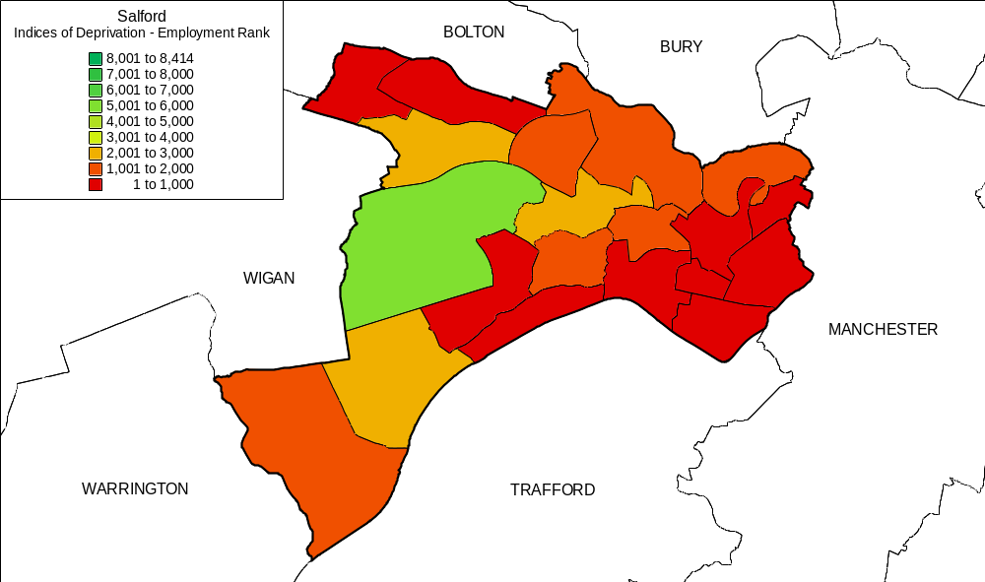

Salford is the 28th most deprived council area in England. The City comprises 20 wards, seven of which are in the top 500 (of 8,414) deprived wards in England. Eight other wards are also in the top 20% and, as such, are designated by Sport England as Priority Award Initiative (PAI) wards. These are listed below:

PAI ward (top 500) | IMD ranking | PAI ward (top 20%) | IMD ranking
Broughton | 126 | Weaste and Seedley | 570
Little Hulton | 138 | Barton | 729
Blackfriars | 156 | Walkden North | 880
Ordsall | 166 | Pendlebury | 1030
Pendleton | 201 | Kersal | 1542
Langworthy | 260 | Eccles | 1551
Winton | 471 | Swinton North | 1608
 |  | Cadishead | 1652

Salford: PAI wards
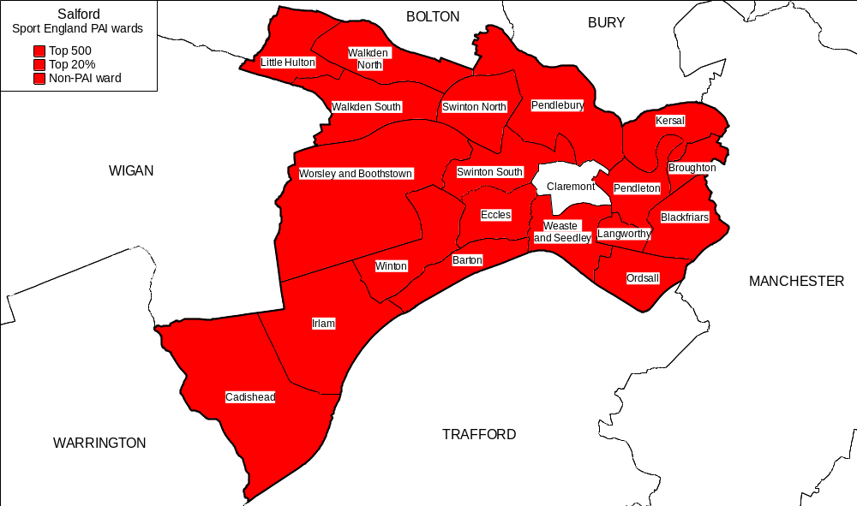
Poor health is commonplace, death rates are 35 per cent higher than the national average and the City has the third highest proportion of children in care in England. Overall crime rates and incidences of street/car crime and anti-social behaviour are high. Crime and poor health has had a detrimental impact upon the City’s communities. The City centre has experienced considerable out-migration while significant dereliction is located alongside the City’s well-known regeneration areas.

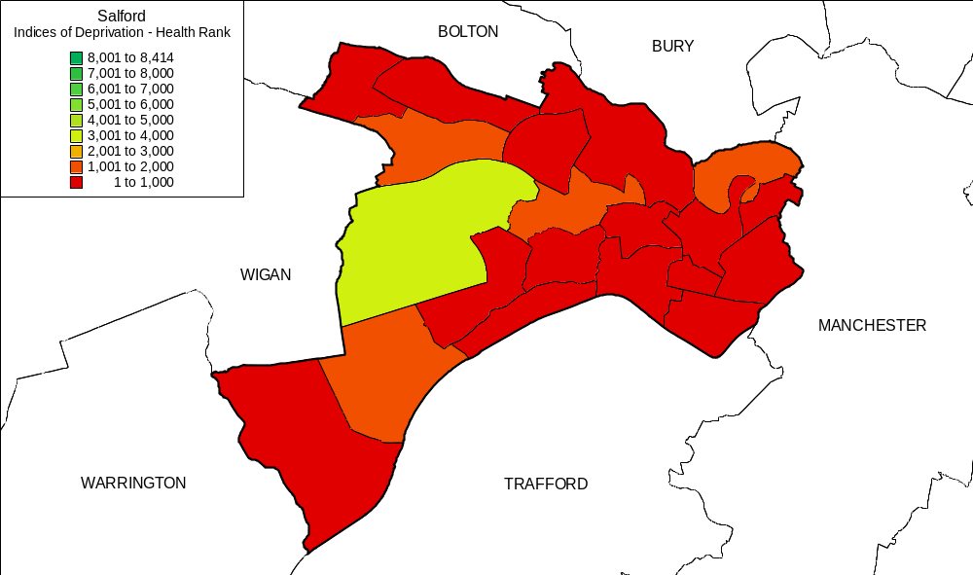
Salford: IMD health rankings – by ward
Salford faces other key problems. Educational attainment is low. In Greater Manchester only Manchester City Council has a lower proportion of pupils gaining 5 A-Cs at GCSE.
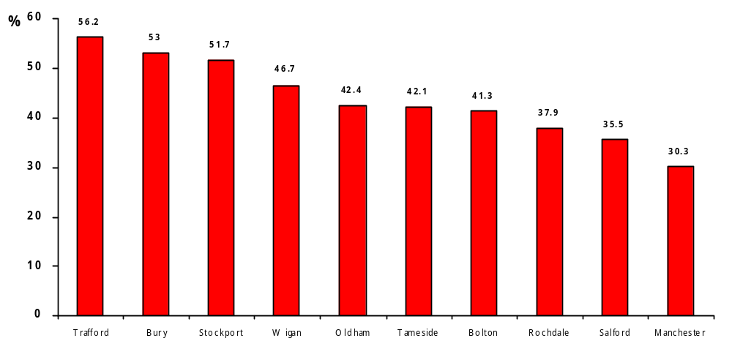
Greater Manchester: Proportion of young people gaining 5 or more A-Cs at GCSE – 2001

There is, of course, significant variation across the City but in 2000-2001, at only two of the City’s secondary schools did more than 50% of pupils gaining 5 or more A-C grades at GCSE. (Research Assessment Exercise 2001).

Salford schools – by GCSE passes at A-C: 2001
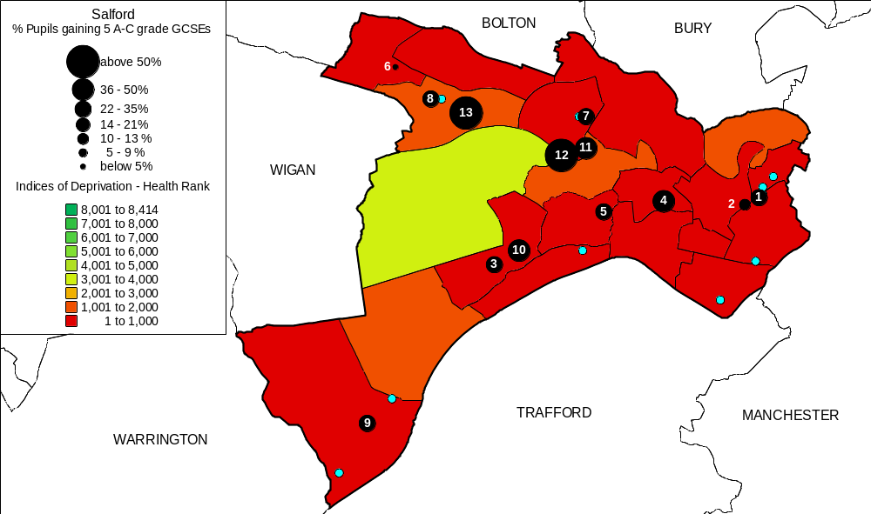
This is, of course, linked to a number of factors. There is, for example, unsurprisingly a fairly strong correlation between school academic performance and the relative deprivation of the catchments areas serviced.

Id | School | % Free School Meals
1 | The Albion High School | 49.4
2 | All Hallows RC High School | 47.7
3 | Canon Williamson CofE High School | 37.8
4 | Buile Hill High School | 35.2
5 | Wentworth High School | 29.1
6 | Harrop Fold School | 28.6
7 | The Swinton High School | 25.0
8 | St George's RC High School | 23.6
9 | Irlam and Cadishead Community High School | 21.6
10 | St Patrick's RC High School | 15.9
11 | St Ambrose Barlow RC High School | 13.6
12 | Moorside High School | 10.3
13 | Walkden High School | 7.7

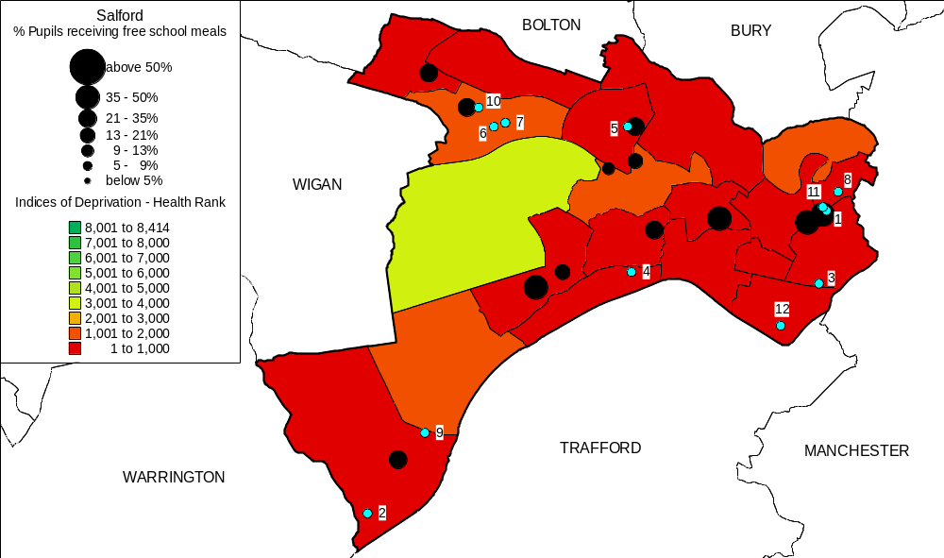
Percentage of pupils on free school meals (97-01 Research Assessment Exercise)

At 34%, levels of car ownership in the inner city are half the national average. Physical isolation, mobility and variable public transport means that travel within and across the City and commuting between one neighbourhood and another can be problematic. These issues, confirmed within the CPA report, are clearly barriers to use of sport and leisure facilities and services that need to be taken into account in the Strategy.
Best Value review

This review considered the services provided by Sports Development & City Leisure; collectively referred to throughout the rest of this document as the Leisure & Quality of Life functions of the Council (LQL). The two sections directly provide services across the City, and also have an enabling role to support a range of partners delivering sporting activities. The full range of services included in the review is itemised in appendices 1 and 2:

Further details on the services are contained in the Best Value Review files and particularly, the service profile documents.

Salford’s six pledges

The City Council has responded to the demographic and social needs of its citizens by defining 6 key pledges that underpin the Community Plan and the City’s overall strategies. LQL (Sports Development and City Leisure) contribute to the achievement of these pledges in a number of ways, the main ones being:

Pledge 1 – Better education for all

- Sport and physical activity opportunities, providing participants of all ages with training, qualifications and valuable experience
- Training opportunities that enable local people to obtain sporting and coaching qualifications, including those required for jobs within the leisure industry
- A large development programme delivered in schools and in recreation centres on behalf of schools. If this service was not available, some schools would not be able to fulfil National Curriculum requirements. Swimming provision made available through City Leisure centres is also of particular importance as, without access to this, schools would be unable to deliver this aspect of the National Curriculum.
- Training for teachers improving their management, organisational and coaching skills. This enables them to more effectively deliver parts of the National Curriculum requirements for PE and sport themselves.
- The ICT suite at Broughton Centre provides family learning opportunities. This resource is used by local people to improve their basic skills, ICT skills, information, CV writing etc, and provides a first step towards college/formal education for adult returners.

Pledge 2 – Quality homes for all

- Sporting Playgrounds Initiative, through which LQL has secured external funding (DfES) to improve playgrounds and playing fields in 15 local primary schools.
- Open spaces strategy (working jointly with Planning), rationalising City open spaces and playing fields in order to ensure that there are suitable resources adjacent to all of the major areas of population.
- Recreation areas – LQL teams advise on the maintenance and improvement needs of recreation areas across the City.
- Local, community based services, e.g. sports centres, making local housing more attractive to residents and encourage people to settle in the area.

Pledge 3 – A clean and healthy City

- LQL provides a wide variety of sports and health and fitness activities, that allow individuals or groups of individuals access to modern, clean sports facilities to exercise at their own leisure and thus improve their health and fitness.
- Joint initiatives with the PCT are a major priority for LQL. Current partnerships include the following:

- ‘Fitbods’ activity sessions in schools; which teach children about the importance of physical fitness and introduces the concept of healthy eating.
- Health Walks for people who currently take little or no exercise – offered in all areas of the City.
- GP Referral Scheme; which allows people who are suffering from certain illnesses to access exercise on prescription, thereby improving both physical and mental health.

- LQL also works on capital initiatives to support schools to improve their sporting provision and has recently been successful in securing funding from:

- NOF PE in schools to improve provision for all secondary schools across the City, as well as improvements to changing rooms in recreation facilities.
- DfES Sporting Playground Initiative, for improvement works to 15 playgrounds in primary schools. This will enable schools to deliver improved sports activities both during curriculum time and out of school hours as well as providing an opportunity to train welfare assistants to work with the children during these times.

Pledge 4 – Safer Salford

- The PAT 10 report identified that arts, sport, cultural and recreational activity can contribute to neighbourhood renewal and make a real difference to health, crime, employment and education in deprived communities.
- LQL provides opportunities for young people’s participation, which engenders feelings of self worth and positive things to do. There are many examples of good practice in this area; these include ‘SPARKY’, the Summer Splash scheme, ‘SLAM’ etc. The effectiveness of such schemes in contributing to crime reduction can be seen in the table in Appendix 4, which shows the reduced incidences of crime during the period of the Summer Splash scheme 2002.

The Summer Splash scheme which ran between July-September 2002 generated significant reductions in juvenile nuisance and criminal damage across certain areas of the Authority. A comparison between the same period in 2001 and the period during which the scheme was operational in 2002 is included in this document as Appendix 4.

Pledge 5 – Stronger communities

- The aforementioned PAT 10 report identified the importance of arts, culture and recreation to neighbourhood renewal. Sport and physical activity helps to build communities providing a local base for people to meet, achieve healthy lifestyle for children within communities and it enhances adult roles within communities both playing, or being involved in sport in a coaching or administrative capacity.
- LQL provides capacity building and general support for Salford’s voluntary sports clubs and local communities helping with funding, grants, coach development and training and the preparation of sports development plans. It also provides local children with activities during the evenings, weekends and holidays. This has, as is shown above, made some areas safer and strengthened community spirit.
- LQL provides many local facilities which accommodate a wide variety of activities. They are a hub for local communities.

Pledge 6 – Supporting young people

- LQL supports young people by providing sport and physical activity opportunities, opportunities for training and employment, capacity building and general support for voluntary sports clubs and local communities.
- LQL provides a wide variety of coaching sessions in recreation centres and schools, as well as providing other activities and support in regeneration areas and areas of deprivation. Funding support has been obtained from SRB, Community Committees, Youth Justice Board, Sport England, Youth Sports Trust, ERDF, Greater Manchester Waste, Barton Moss, M5 4WT, Greater Manchester County Sports Partnership.

Best Value review process

This document is the culmination of an extensive best value review and provides the services with a challenging improvement plan framed within a new sports strategy for the City. It follows the standard format – as shown:

- Compare
- Challenge
- Consult
- Compete

Three active groups worked on the Review:

- Review Team –service managers, corporate and Directorate performance staff, Sport England, an external consultant, the PCT, unions, staff members, service users, the PE advisor, SCC Personnel & Finance.
- Scrutiny Panel – this panel includes service managers, corporate performance staff, elected members and a parent governor.
- Core Team - service managers, corporate and Directorate performance staff.

Review terms of reference were developed by:

- Involving staff from LQL in focus groups to determine the scope and key issues.
- Including the key issues identified by Partners through a questionnaire.
- Involving neighbourhood co-ordinators via a focus group to determine key issues.
- A challenge session chaired by the Director of Personnel & Performance
- Submission to Scrutiny Committee for approval.

(See Appendix 1 for full terms of reference and details with reference to the composition of Review teams).

Compare

The review has incorporated the gathering of extensive information from other authorities. These include:

- Local authorities in Greater Manchester.
- Salford’s ‘CIPFA Family’ authorities.
- Authorities specifically recommended via Sport England and other sources.
- Beacon councils.
- Authorities in Sport England’s ‘Performance Measurement for the Development of Sport Pilot’; London Borough of Newham, Barrow Borough Council and North Norfolk District Council.

Information gathered compares Salford’s progress in a range of operational areas through the limited quantity of broadly and/or directly comparable, performance measures available via mechanisms such as the Greater Manchester Year 9 Census Survey of youth participation in sport and related indicators, and the Sport England Performance Measurement Pilot.

In addition, LQL, through City Leisure undertook a “census week” to assemble a comprehensive snapshot of the user profile at the City’s sports facilities. This information provides a baseline for ongoing comparison of the City’s provision with other authorities that have followed this process, for example, Leeds City Council.

Member and officer visits to authorities that had recently undertaken a Best Value review and received at least a 2 star rating, Beacon councils and authorities utilising different types of service provider (e.g. private sector contractor and trust). Authorities visited include:

- Blackpool  - Stockport  - Trafford  - Tameside  - Gateshead  - Pendle | - St Helens  - Chester  - Tynedale  - Greenwich  - Kirklees

The extensive information gathered demonstrates a mixed picture. Salford compares very favourably, and could legitimately claim to be a leading authority, in certain areas of provision (for example the low proportion of young people in the City that are poor, or non-swimmers). There are, however, clear deficiencies in other areas such as girls extracurricular and out-of-school participation rates. In addition the participation of young people at the City’s leisure facilities compares favourably with the others surveyed by Sport England in its National Performance Measurement Pilot, although adult participation rates are much lower in comparison.

What is clearly highlighted is the difficult nature of collecting worthwhile performance measurement information and the need to develop relationships and comparable processes with a network of partner authorities to enable effective future performance benchmarking.

Challenge

The service has been rigorously challenged both internally and by partner organisations. Review team meetings and sessions set up to provide stimulating and challenging debate, were facilitated and supported via the use of an external consultant and the attendance of a representative of Sport England. The challenge process covers:

- Provision.
- Customers.
- Performance.
- The external & internal environment.

Four further staff and management sessions following the EFQM model were undertaken. This was managed via a process whereby information was circulated to all staff enabling everyone to contribute. By doing this information on the strengths and weaknesses of the services was gathered. The eventual concentration of the process was on Service strengths, weaknesses and improvement potential in 9 areas:

- Leadership.
- Policy & strategy.
- People.
- Partnerships & resources.
- Processes.
- Customer results.
- People results.
- Society results.
- Key performance results.

Supplementing this, LQL (City Leisure) has used the (Sport England provided) QUEST Quality Service Scheme as a framework for service improvement since 1998/9. In addition, community committees, the Bowls Forum, the Football Consultative Group and voluntary sports clubs (both independently and via the District Sports Council) have all provided continuous challenge to services.

There has also been a session with members of the Core Team to draw out political, economic, social and technological (PEST) issues affecting the services.

A number of specific challenge sessions covering topics identified through the review process have been held. These included, for example; sessions on the following:

- The Swimming Programme: This incorporated external involvement from the Amateur Swimming Association and explored the relationships between various service elements (e.g. City Leisure & Sports Development) - highlighted as an area of focus in the terms of reference.
- Service marketing: The marketing session included members of the City’s Marketing & Communications team.

In addition, the CPA ‘Gap Inspection’ in August 2002 also provided information to feed into the Best Value Review process (see Comprehensive Performance Assessment section below).

The service has been subject to considerable external scrutiny through the PPP/NPDO process. This scrutiny has involved external consultants, private sector companies, GMB, APSE and District Audit.

Consult

Prior to the Best Value Review, LQL undertook a number of user and non-user surveys. Its ‘Points of View’ scheme is also a regular source of information on user issues and has informed service improvement work delivered to date. It has evaluated specific service areas and the findings have, again, underpinned service delivery improvements. Liaison with, and through, community committees and the Salford District Sports Council provides an ongoing consultation and resident involvement mechanism of which LQL has taken full advantage.

Residents

- Linked to Salford’s inclusion in Sport England’s pilot for performance measures for the development of sport, MORI has recently undertaken two surveys in the City - one of (adult) residents and one, through schools, for children/young people.
- Information from the “Points of View” scheme, disability user forums, customer satisfaction surveys etc. has been collated. Information from the most recent “Quality of Life” Survey has also been considered.

Service users

- Users of outdoor pitches have been consulted via a postal survey.
- Sports clubs, as users of facilities and services, were consulted via a focus group organised in conjunction with Salford District Sports Council.
- Schools that work with LQL were consulted via a survey.

Partners

- Review meetings involved a range of external and cross-departmental partners.
- A session with neighbourhood co-ordinators was undertaken to confirm/establish local issues for the services.
- A focus group, with members of Salford District Sports Council (umbrella organisation for the voluntary sports clubs in the city), examined service strengths, weaknesses and areas for improvement.

Staff

- Four staff focus groups using the EFQM model were held. Results were collated and circulated to all staff for comment and the presentation of ideas for improvement.

The many key messages from this extensive source of information were fed into the review at all points and are available in the best value review files.

Compete

Information from CIPFA, other local authorities and locally gathered information would suggest that Salford has a very competitive pricing structure. Salford’s key prices are often in the lower quartile, for example the current “all inclusive membership” monthly pass prices for Greater Manchester Authorities are as follows:

Greater Manchester authorities | All-inclusive direct debit membership charges
Rochdale | £17.50
Salford | £23.50
Wigan | £24.50
Oldham | £25.00
Bury | £25.00
Bolton | £26.00
Trafford | £29.00
Stockport | £29.00
Tameside | £31.00
Manchester | £33.50

The Statistical Information Service report on “Charges for Leisure Services Statistics 2001/2” reinforces this.

Neighbourhood leisure facilities are located throughout the City. There is provision in 8 of the 9 community committee areas. Survey results indicates that a significant proportion of residents would cease exercising all together if their local sports facility closed. Other complementary surveys demonstrate the very parochial nature of Salford residents in the context of their awareness and use of facilities.

There is limited competition within the City relative to that faced in many neighbouring and comparable authorities. The small number of private fitness facilities operate, and appear to attract most of their custom from, areas where the City Council has no, or only limited facilities; e.g. Worsley/Boothstown. The opening of the JJB Soccer Dome in Trafford has had an impact on demand for 5 –a-side football.

Future management and delivery

In 2002, the City Council resolved to:

- Approach the private sector to obtain, and discuss, proposals for transfer of the services under an outsourcing contractor.
- To transfer its leisure services to a charitable NPDO in the event that an outsourcing deal of better value appears unlikely following consideration of private sector proposals.

Consultants Deloitte & Touche worked with the City Council to consider the outline proposals received from four private companies and to compare them with the perceived benefits of moving to a locally managed trust. The procurement process followed by the City Council is detailed overleaf:

Overview: PPP/NPDO decision tree

Compatible
feedback
No
Invite Potential PPP partners to discuss opportunities

Set up NPDO
(1st October 2003)

No
Yes
Compatible
Proposals
No

Obtain Outline
Proposals & PQQs

Compatible Affordable Tenders

Yes
Compatible Affordable Tenders

Obtain Detailed

Tenders

Yes

Procure Outsourced PPP Deal
PPP – Public Private Partnership
NPDO – Not for Profit Distributing Organisations
PQQ – Pre Qualification Questionnaire

The evaluation of the outline proposals from the four companies provided the City Council with an opportunity to benchmark the options using an agreed methodology, (Appendix 8) against a new local NPDO. At this point of the process the City Council decided to set up a new locally managed trust. It is intended that this will be operational from October 2003.

The Council, in conjunction with trade unions and staff representatives, has also developed a set of criteria for rationalisation of leisure facilities (Appendix 9) that assesses eighteen different measures to consider when determining any future facility closures.

Comprehensive Performance Assessment

Salford received its final CPA ‘gap’ inspection report in November 2002. This covered the provision and management of:

- Sports development activities
- Indoor sports and leisure centres
- Indoor swimming pools
- Parks and open spaces (including grounds maintenance insofar as it affects the quality of the City’s sports and leisure environment)
- Sports pitches including all weather surfaces
- Events in parks
- Countryside parks
- Grant aid
- External funding
- Partnership working.

Inspectors stated that, in their view, the Council provides a ‘fair-one star’ service that has uncertain prospects for improvement.

Positive features and weaknesses identified included the following:

Identified strengths | Identified weaknesses
The commitment of staff, managers and councillors to providing quality leisure services.  SCC staff are excellent, willing and helpful;  Success attracting funding for local projects from external sources via partnership work with other organisations.  The ‘state of the art’ water sports centre at Salford Quays and the wide range of activities offered.  City involvement in the hosting/management of, successful events such as the Millennium Festival and the Commonwealth Games 2002 Triathlon;  Work in the community to help people develop their potential  Creation of pathways to excellence in gymnastics, trampoline and swimming’;  SCC participation in local, regional and national initiatives;  Work with community committees, local groups and organisations to establish the needs of local people and promote initiatives to meet these needs; | The absence of an overarching (single) set of aims and objectives for sport and leisure services to direct what SCC does. The resulting lack of clarity about priorities and the propensity to chase short-term goals and funds;  Multiple layers of strategic, corporate, service and project plans with uncoordinated aims, objectives and few outcome targets;  No overall explicit pricing policy  Not maximising the availability and use of the Council’s Passport to Leisure;  The poor condition of sports facilities. (Although they are considered to have been clean & tidy)  The overall poor quality of play areas. The poor condition of a significant proportion of grass sports pitches. The poor condition of ‘many’ artificial all weather pitches  Key functions and services not working effectively in tandem with each other  The use of ICT to access information (centres with new fitness suites will have new cash/data systems)  Poor quality of signage  Both indoor and outdoor leisure services are high cost with low participation and satisfaction levels.
The CPA inspectors judgement in relation to Salford’s ‘uncertain prospects for improvement’ is based upon the following positive and negative observations:

Positive observations | Negative observations
The Council sees leisure services as fundamental to achieving its six pledges.  ‘Dismantling’ of divisions between commissioning and service delivery arms of the Council.  The recent radical reorganisation of how sports and leisure services and activities are delivered. Closer working between previously separate teams;  Realisation that balancing Community Committee initiatives, City wide priorities and the needs of communities requires complex solutions  The initiation of closer work with other parts of the Council and external organisations to decide what actions should be taken  Council realisation that it cannot provide the scale of investment required to bring indoor and outdoor facilities up to appropriate standards.  Its investigation of alternative ways of managing indoor sports and leisure centres to attract external investment. | The way resources are used has not been effectively challenged. SCC priorities are, on this basis, difficult to ascertain.  A number of (worthwhile) projects have uncertain futures because ongoing funding has not been secured;  Performance management is not consistently applied throughout leisure services and not used to convert strategies and policies into working practices and measurable targets  There is continued reliance on cumbersome administrative mechanisms  Growth in revenue budgets has been cut year on year.  SCC is not dealing with building maintenance, grounds maintenance and maintenance of play areas and other facilities in parks and open spaces.

Recommendations
The City Council strongly challenged the findings of the Inspectors and therefore there is not a consensus over the review’s recommendations. However, the inspectors suggested that the Council should take action to resolve a number of general, political, managerial and partnership issues and the following actions - to improve ‘customer service’ were recommended:

Immediate

Recommendation
‘Common sense’ steps to improve the quality of the service, including:

- Ensuring that the standard of routine grounds and general buildings maintenance is agreed and monitored;
- Improving the standard of maintenance of play areas;
- Reducing the amount of graffiti, litter, dog fouling and vandalism evident at indoor and outdoor sport and leisure locations; and
- Improving signage in and about leisure centres, parks and open spaces, to attract and inform users and facilitate safety.

By the end of December 2003

Recommendation | Response/action
Develop a single purpose and set of clear and concise aims for the whole of leisure services which link to the corporate aims and issues that local people say matter to them and which are clearly understood by all staff and the public; | A key recommendation. The Strategy seeks to fully addresses this
Improve service planning and performance management systems to identify, measure and monitor short (one year), medium (three year) and long-term (five year) outcomes clearly linked to the Community Plan pledges and the agreed aims for leisure services; | A key recommendation. The Strategy seeks to fully addresses this
Write and widely publicise easily understood customer charters for indoor and outdoor facilities and services clearly describing the standards users can expect; | This should be picked up in the context of a clearer service rationale and be geared to the provision of quality services for the wider range of residents at which services will be targeted
Draw up and implement a planned and costed programme to repair and improve all leisure buildings including buildings within green spaces, such as changing facilities and toilets and agree appropriate standards and monitor against these; | This must be dealt with prior to, or as part of, the completion of any process to externalise elements of the services presently delivered by the City Council.
Improve the marketing and promotion of indoor and outdoor sports and leisure services including effectively promoting the Leisure Card; | This is picked up in the context of the clearer service rationale and is geared to attracting and supporting programmes designed to engage, a substantially wider cross-section of, and specific target groups within, the City’s population.
Involve all staff more effectively in the planning and delivery of better customer outcomes | The internal consultation about the Strategy will, following up on the comprehensive internal reviews that underpin it, will be a stage of this process.
Establish challenging but realistic targets to achieve upper quartile customer satisfaction and cost per visit and monitor against these. | These targets while still relevant in the context of ‘front-of-house’ service operation will be a minor element in a more significant, relevant package of performance measures geared to assessing overall service impact.

STRATEGY

Corporate context

The Strategy has been developed in the context of emerging national policy and the City’s Community Plan and Cultural Strategy. It reflects the findings of the CPA Inspectorate report and the issues that emerged from the Council’s own exhaustive internal Best Value review.

Core strategic aims

The core strategic aims of the City’s sport and health strategy (the Strategy) are as follows:

- To improve health outcomes and reduce health inequalities.
- To raise education & skill levels and promote opportunities for cultural & leisure enhancement.
- To tackle poverty and social inequities, maximise opportunities for children and young people. To increase the involvement of local people and communities and specific targeted groups in the City.
- To use sport, physical and leisure activity to help to reduce crime & disorder and improve the actuality, and local perceptions, of community safety.
- To manage and develop sport and physical activity.
- To improve infrastructure, marketing, performance measurement and deliver value for money.

Key issues, parameters and provisos

As part of the CPA review and the more extensive and detailed internal Best Value review of the service, a number of factors have been taken into account that influence the context and direction of the Strategy.

In the context of Greater Manchester, and the Northwest Region, Salford has a strong overall track record in provision of sports and recreation opportunity. It was among the first local authorities to invest in sports specific development officers and has a legacy of effective intervention work with young people. The extent of the City’s investment in sport and sports development has, however, over a considerable period of time, declined. Much of the work for which the City is nationally known and which makes the most difference in some of Greater Manchester’s most problematic neighbourhoods is funded on a short-term basis, via a range of specific externally funded initiatives.

While the initiative and resourcefulness of staff should be, and has been, applauded, this appears to have led to political and corporate complacency about the capacity of the City to maintain a core service and to continue to resource the presence of specialist staff in key neighbourhoods.

The City has, in recent years acquired national profile and recognition for its work utilising sport and physical activity to tackle crime, disaffection, juvenile nuisance and anti-social behaviour. This has been recognised by, for example, Sport England, which despatched a team of senior staff to Salford to assess the work being done.
Virtually all this work is, however, delivered by staff employed on fixed-term contracts directly funded by external agencies. Much of LQL’s other intervention work is only sustained by income generation. While this is not, in and of itself, an issue, the need to generate income for such programmes has, and does delimit LQL’s ability to directly address some of the key social and regeneration issues in the City. This has not enhanced service cohesiveness nor has it enabled officers to make long-term plans to, for example, run projects such as Sparky, in locally adapted forms, in other localities in the City.

This Strategy, while not, in itself a bid for new City resources, is predicated upon the benefits that accrue from the operation of a unified service and the need to provide LQL managers and staff with a degree of medium-term financial and operational stability. The Trust mechanism should enable LQL to function with this necessary degree of operational independence and stability.

It is also important to note that, while it is recognised that LQL staff do a good job maintaining the appearance and presentation of the Council’s sports facilities, a structured, strategic investment programme is required. Securing external partnership funding to invest in fitness is, properly implemented, a positive step. It must, however, be matched by Council commitment to the provision of proper quality amenities.

The desire to provide services that are more locally responsive is particularly important to LQL. Many of the projects and schemes already being supported at local level by Community Committees (CCs) involve the use of sport and physical activity and facility provision to tackle local issues associated with crime and diversionary activity. LQL’s capacity to offer a menu based selection of proven programmes and mechanisms will enhance the Council’s overall capacity to deliver meaningful local programmes.

All SCC policy is couched in the context of its commitment to ‘Support children and young people and help enable them to achieve their full potential’. This is particularly true of this Strategy. While City commitment to generic provision for sport and physical activity catering for the whole community remains, much of the proactively targeted work to which commitment is made in this document will be aimed at young people.

Partnership with the health sector is vital. Current levels of illness and ill-health and the statistical probability that this will, without positive intervention, be repeated in new generations among substantial sections of the community is a key driver. The positive working relationship between the Directorate of Public Health and LQL will enhance the effectiveness with which core provision and programmes proposed can be implemented.

Key to Strategy implementation and the generation of a proper understanding of the value of the work delivered, supported and enabled by the LQL Service is marketing, market research and performance measurement. Particular emphasis is placed upon utilising some of the baseline measurement that is available within/about the City and to ensuring that the capacity to assess the impact and effectiveness of work undertaken is built into the ‘modus operandi’ of the service in the future.

The capacity to demonstrate service value and impact and to ensure that the value of the work undertaken (whether income generation, crime reduction, community safety or health improvement orientated) is recognised, is fundamental.
There is a need for initial recognition among elected community representatives, officers from other departments of the City Council and partner agencies of the cross-cutting value and relevance of programmes offered. It is important that LQL ensures that this is proved and tracked via the generation and effective use of appropriate performance measurement/evaluation data.

This is particularly important in the context of the present situation whereby what is an, externally, positively viewed service, has, by virtue of the cuts and limitations imposed upon it by the variable, and generally indifferent, corporate environment in which it has to operate, been given little opportunity to maximise local impact. The imposition of income targets and related mechanisms has, for example, delimited the capacity of the service to operate with the flexibility required to deliver corporate and social objectives.

There is need for recognition of the value of ‘net subsidy’ based operational practice. The service is thus, enabled to operate within clearly defined financial parameters while working on, and achieving clearly identified delivery usage, social and health impact based targets. This may be a more appropriate model upon which to base the move to a trust/NPDO based management mechanism.

It is, furthermore, assumed that the Strategy must be delivered within existing resources. Supplementary assumptions are, however, also made about the way in which the Council will manage (or allow LQL resource to be managed) in the future. The assumptions relate to the way in which various service elements will be combined and the capacity of LQL management to work flexibly with and across both ‘trading’ and ‘social capital’ based aspects of provision.

Another key facet of the Strategy – that directly addresses one of the key criticisms levelled at the Council by the CPA inspectorate – is the need to target the subsidy provided for sport, physical activity and recreation provision. Within the positive parameters provided by the Council’s community plan, Strategy aims are clearly geared to directing human and capital resource more specifically at people (and localities) that need it.

Strategy service plan sections

Core theme 1: Improve health outcomes & reduce health inequalities
- Health, well-being & lifechances.
- Exercise & fitness activity
- The right to swim.
Core theme 2: To raise education & skill levels. Promote opportunities for cultural & leisure enhancement.
- Improve the physical literacy of young people in Salford and the quality of delivery of PE and sport in and around schools.
- Use sport and physical activity to reduce exclusion, improve attainment and attendance.
- Community use of schools.
- Work with the University and FE colleges.
Core theme 3. Tackle poverty and social inequities, maximise opportunities for children and young people.
- Girls.
- Targeted young people.
- People with physical and sensory impairment
- Quality Protects – the ‘looked after’ sector
- Black and ethnic minority communities
Core theme 4: Community safety.
- Community safety.
Core theme 5: Managing and developing sport
- Sports-specific work
- Youth Games
- Support for talented individuals
- Grant aid and devolved community committee budgets
- Events and holiday programmes
Core theme 6: Infrastructure, marketing, performance measurement and value for money
- Staffing
- Facility infrastructure
- Leisure facility programming
- Leisure activity pricing and leisure card.
- Market research, marketing and promotion
- Performance measurement and management information
- Quality systems and consultation
Core theme 1: Improve health outcomes and reduce health inequalities

There are clearly identified links between participation in sport/physical activity and health. The City has, over a long period provided a range of fitness training facilities and organised classes. It has also, recently, entered a partnership with Alliance Leisure to improve and upgrade fitness room provision at a number of sports facilities. However, notwithstanding elements of the work undertaken, the City has not, as yet, geared its fitness provision, or the pricing, promotional and membership mechanisms attached to it, to tackling the problems of ill-health.

Health, well-being & lifechances

Thus, at present, the effectiveness of the City’s existing role in, and methods of, contributing to improving the health of the community must be questioned. Salford faces major public health issues. The core area of common interest between public health and the City Council is exercise. LQL must, thus, in this context, focus upon how its resources and services can be used most effectively to make a difference to effective exercise – and related physical activity.

There is a need to build upon the emerging and strong links with the Director of Public Health. Salford has, at present (on an externally funded basis) a GP referral scheme, a health walks scheme and a cardiac rehabilitation programme. There is a keen-ness to see these programmes extended and to enhance the level of concentration on health initiatives for the over 55s. This, balanced with the mutual desire to, on a preventative basis, tackle lifestyle and related issues affecting the health and prospects of young people is considered below.

Develop effective, integrated programmes to improve the health of key groups in Salford and enhance the effectiveness of partnership work with key agencies in this context.
Action: LQL will | Timescale | Reason for improvement/ action | Responsible | Resource
Extend the basis, and targeting of, SCC resource input/subsidy (i.e. discounting/leisure pass) to apply to people linked to their defined health status e.g.:  - Those who are obese or at risk of becoming obese  - Diabetics  - People with CHD or those defined as at risk | April  2005 | Tackle poverty and social inequities.  Improve health outcomes & reduce health inequalities | LQL  SCC
Introduce a proactive contact (not just a referral) system for people defined (by specific partner agencies) as actually/potentially ill, or at risk. Such agencies to include, for example:  - GP practices/practice nurses  - Health visitors  - Early Years co-ordinators  - Surestart  This will be linked directly to this, develop/expand existing health programmes to incorporate all practices in Salford. | Sept  2004 | Improve health outcomes & reduce health inequalities | LQL
Develop a specific young person’s proactive contact/referral scheme, designed to tackle, and targeted at, issues such as youth obesity. | Sept 2004 | Improve health outcomes & reduce health inequalities | LQL

Action: LQL will | Timescale | Reason for improvement/ action | Responsible | Resource
Implement a system to enable staff working within, and on programmes linked to, LQL to carry information about, and be able to deliver, health messages as part of, and alongside their core activity. | Ongoing | Improve health outcomes & reduce health inequalities | LQL
Set and review the targets for such work and put in place systems to track effectiveness of both programmes in the context of:  - Referral numbers  - Initial ‘course completion’ numbers/proportion  - Referred individuals taking exercise on an ongoing basis (e.g. the number of health walks)  - Visible improvements – as observed by health practitioners and referral agencies  - Number/proportion of GP practices involved  - Perceptions of the scheme(s) among key partners in the Health sector. | Sept  2004 | Improve health outcomes & reduce health inequalities | LQL  &  SCC
Wherever feasible:  - Support promotion of the Healthy Schools Initiative across Salford.  - Support the City-wide promotion and organisation of health walks.  - Work with all staff to develop and effectively utilise the leisure pass scheme as a mechanism to support delivery of health-related objectives. | On  going | Improve health outcomes & reduce health inequalities | LQL

Exercise and fitness activity

Basis - Year 9 survey (plus MORI) The promotion of exercise and fitness, particularly within schools is an opportunity to encourage positive sport/activity habits. It should be a key element of the City Council’s contribution to its partnership with the PCT and is particularly relevant for girls, many of whom demonstrate greater interest in lifestyle based activities than in traditional team sports.

The 2001 Year 9 survey (table below) indicates just how significant dance, keep fit and exercise to music is as a source of, or rationale for, regular involvement in sort and active recreation - for girls. The levels of involvement achieved were reached with minimal structured input and support from the City. A positive gearing of facilities and programmes to catering for this group should be adopted.

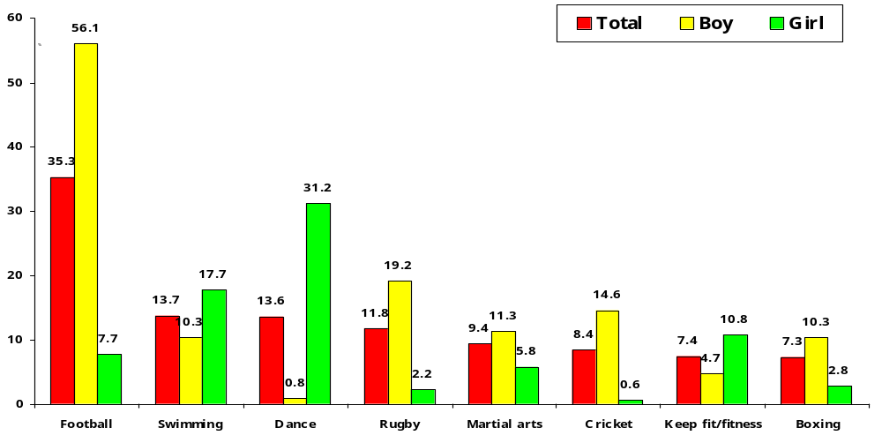
Year 9: Club membership/regular attendance at a session or activity

Exercise/fitness development to become an integrated, whole service programme and process and to be picked up as a ‘priority sport’ activity in the work of LQL.
Action: LQL will | Timescale | Reason for improvement/ action | Responsible | Resource
Manage exercise and fitness provision and programmes as a cross-division ‘sport-specific’ programme, operating within LQL facilities and at a range of other venues designed to extend the reach of the programme. It must balance ‘positive income generation’ elements with ‘high value provision’ in relation to servicing the unfit and the ill as well as proactive and preventative work with specifically identified key targeted groups. | On going | To contribute to corporate policy in relation to improving levels of health in the City | LQL
Ensure that all SCC facilities (plus provision made by other community and commercially based operators) offer a comprehensive range of regularly provided fitness and exercise related options for young people between 16.00 – 19.30, Monday-Friday. All fitness facilities and classes run in facilities to be available to/suitable for including young people i.e. operating a satisfactory programme in the context of:  - Audit the quality and appropriateness of current programmes. Identify gaps in provision.  - Running and promoting specific sessions (including fitness room use) targeted at young people aged 12-16.  - The quality and range of fitness and exercise activities provided.  - The attitude and qualifications of staff involved.  - Local promotion and marketing of programme.  - Placing specific emphasis on promotion of positive lifestyle/appearance/activity for girls  - Training specific instructors to offer specific instruction for girls. | Sept  2003 | To contribute to corporate policy in relation to improving levels of health in the City | LQL  &  SCC
(Because of the high level of drop-out among this age group and the difficulties often experienced in attracting girls into mainstream sporting activity) develop a programme aimed at encouraging girls aged 12-16 to take more exercise. This will include:  - Work with secondary school teachers to encourage positive referral of girls from all schools to all programmes  - Targeting additional information and/or subsidy based support directly at young girls resident, or attending schools in, identified key areas. | Jan.  2004 | To contribute to corporate policy in relation to improving levels of health in the City | LQL
Develop a comprehensive range of school holiday fitness/exercise programmes for girls aged 12-16 and pre-emptive introductory programmes for those aged 11-12. This programme and range to be improved and enhanced from then on and to be used as a ‘shop-window’ for ongoing provision. | March 2004 | To contribute to corporate policy in relation to improving levels of health in the City | LQL

The right to swim!

Positive action is required to build upon the relatively successful impact of swimming delivery within the City. Swimming could and should become a key corporate goal in context of contribution to health, community safety, personal health and well-being

Non-swimmers (at Year 9) by local authority: Greater Manchester

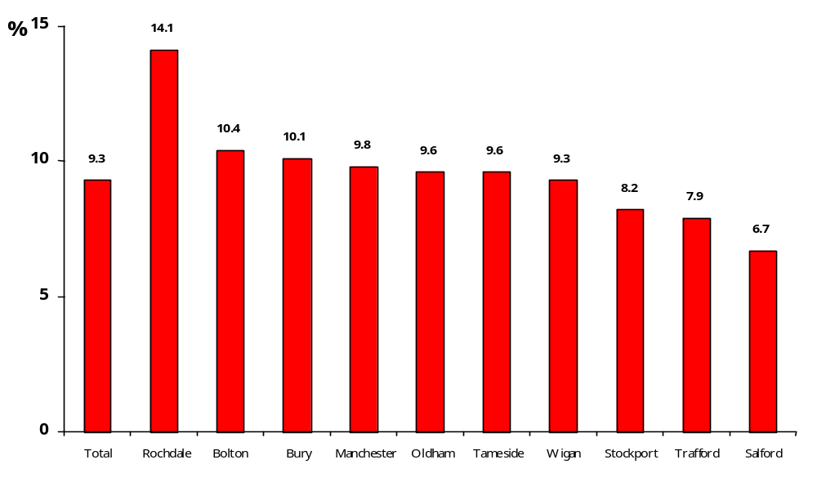
Learning to swim
Action: LQL, working with the PE advisor, will evaluate | Timescale | Reason for improvement/ action | Responsible | Resource
Present schools swimming lesson provision (in the context of the effectiveness with which the system ‘produces’ young people that can swim to an agreed ‘Salford standard’: Level 4).  Pilot new methods of swimming lesson organisation (possibly linked to improved inter-school liaison and assessment of cost-effective methods) | On going | Tackle poverty and social inequities.  Improve health outcomes & reduce health inequalities | LQL
Practice elsewhere (for example; longer lessons over fewer weeks and intensive one-week instruction periods) to ascertain whether comparable/improved outcomes, can be achieved more efficiently. | Dec 2003 | Maximise efficiency and effectiveness with which swimming is managed. | LQL
Assess where and how support can be provided for young people that do not achieve the standard over a recognised time period. | July 2004 | Tackle poverty and social inequities. | LQL
Assess whether, how, and how effectively, the City caters for swimming teaching for children with special needs and disabled children | July 2004 | Tackle poverty and social inequities. | LQL

Action: LQL, working with the PE advisor, will evaluate | Timescale | Reason for improvement/ action | Responsible | Resource
Post-measurement of programme impact, gear additional support for schools swimming teaching (e.g. additional teachers, smaller classes, extended lesson programmes) to ensure that young people from schools/communities where swimming levels are lower are taught to swim to the specified, ‘Salford standard’. | Sept 2004 | Tackle poverty and social inequities. | LQL & SCC
Target the marketing and delivery of non-schools based swimming lessons via:  - Setting up a system to enable referral of (and appropriate provision for) young people that do not achieve the requisite standard to appropriately set-up lesson programmes geared to receipt of children of that age.  - Provision of additionally subsidised swimming lessons to specifically targeted young people.  - Placing children that are directly referred (via, for example; schools, Social Services etc.) at the top of swimming lesson waiting lists.  - Introduce mechanisms to assist young people from families with low incomes to access swimming lesson provision via, for example, allowing weekly payments. | Jan  2004 | To maximise efficiency and effectiveness with which the programme is managed. | LQL

Efficiency and effectiveness of pool use
Action: LQL will: | Timescale | Reason for improvement/ action | Responsible | Resource
Review how SCC owned/managed and other pool provision in the City is managed. Within this, it will assess present community, club, Swim Squad and other use of pool lane hours and existing/latent demand for pool space. | Initial detailed & then annual review | To maximise efficiency and effectiveness with which existing SCC owned/managed and other pool provision in the City is managed. | LQL & SCC
Expand the existing systematic swimming teaching auditing system As part of this it will consider:  - A more ‘shallow’ tiered lesson programme progression structure allowing both for acceleration of stronger swimmers, and appropriate progression for the less strong.  - Giving all swimming teachers a regular opportunity to teach at different levels.  - Maintain and expand the reciprocal external agency (for example with Stockport) audit of programme, teaching and coaching.  - Develop and maintain a regular, consistent, process of refresher courses and updates for teachers and coaches of swimming in the City. | On  going | To ensure that the quality of tuition at all levels, and in schools and LQL programmes, is of a uniformly high standard. | LQL

Supporting progression in swimming
Action: LQL will: | Timescale | Reason for improvement/ action | Responsible | Resource
If maintenance of City support and subsidy is considered to be desirable:  - Assess whether/how early stages of this process could/should be more effectively supported through, the Active Sports process  - Consider whether some form of bursary option to support a process of feeding talented swimmers into appropriate club/squad environments elsewhere would represent:  - A better progression option for the swimmers concerned  - Better value for money in the context of the City’s subsidy for this. | April  2004 | Consideration of the rationale for, and the effectiveness of, City investment in a Swimming Squad programme and process.  (See also page 49) | LQL  &  SCC
Assess the level and efficiency of transfer of young people between the swimming lesson programme and either SCC squad or club provision | Annual review | Inclusion in positive, lifelong, healthy activity | LQL

Recreational swimming and swimming for fitness
Action: LQL will: | Timescale | Reason for improvement/ action | Responsible officer | Resource
Review/consider:  - The effectiveness and value for money offered to SCC, current users/customers and potential swimmers of the present range of discounted swim options.  - Whether lane/fitness swimming could be expanded and or tailored to better meet the needs of people from specific referral groups.  - The skills and capacities of pool staff to develop a system that would enable an individual referred to be appropriately advised/supported at any/all open sessions.  - The extent to which staff are geared to proactive customer care. For example ‘laneing off’ space for people at any/all open swimming times. | April  2004 | Consideration of the effectiveness with which City subsidy for swimming provision is targeted at those that need it most. | LQL

Core theme 2: Raise education & skill levels. Promote opportunities for cultural & leisure enhancement.

As is stated and illustrated earlier, educational attainment across the City is low. It is particularly low in wards and schools located to the east of the City, for example; Ordsall, Weaste and Seedley. The focus of LQL work with education is, thus, threefold:

- To improve standards of physical literacy among young people in the City
- To use sport, recreation and leisure activity to assist in improving educational attainment
- To use specific sports interventions to support the work of PRUs and to help individual schools to tackle issues such as truancy and exclusions.

The development of a strong sporting infrastructure linked to schools is important. Strong curricular and extracurricular programmes, catering for a broad range of pupils, will not only provide young people with access to sporting opportunities, but will also contribute to improved standards, behaviour and attendance. It is anticipated that some of the ‘in-school’ work presently undertaken by LQL will, as SSCPs become embedded, be taken on by them. This will, working within resources available and taking account of the fact that work in schools has generated income to cover the direct costs of delivery, enable more specific attention to be directed at the use of sport to tackle key problems.

In addition, there needs to be a strong link between activities delivered in the school environment and opportunities available outside of it. Many formative opportunities for young people to develop movement literacy and gain initial sporting experiences take place in school and pre-school environments. LQL will be in a position to support and enhance this. The focus of such work will, however, be in areas of recognised low sporting participation and/or high deprivation.

Supporting movement literacy initiatives for very young children
Action: LQL will: | Timescale | Reason for improvement/ action | Responsible officer | Resource
Work to ensure that support for, and delivery of movement literacy and sports skills opportunities through ‘early years’ is achieved. Consideration will be given to seeking to secure additional funding resources to:  - Work with the Early Years and Childcare Partnership and Sure Starts to ensure that movement literacy and sports skills form a major part of early years learning opportunity.  - Work with parents through the delivery of sporting opportunity at a local level. To include the development of programmes – such as ‘skilling’ local volunteers.  - If additional resource can be secured, develop/ introduce a programme of sports/movement skills training for parents and nursery workers  - Support/encourage sports based training, qualification and employment opportunities delivered through the youth service structure. | April  2004 | Tackle poverty and social inequities. Improve young people’s lifechances ensuring that movement literacy & sports skills form a major part of early years learning. | LQL

Improve the physical literacy of young people in Salford and the quality of delivery of PE and sport in/around schools

There is a Government policy imperative to ensure that all pupils receive a minimum of 2 hours of ‘quality PE and sport per week’. A considerable quantity of LQL-led coach supported work is delivered in schools in Salford. While this is widely regarded to be of good quality it is delivered on the basis of which schools are prepared to pay for the service. Given the officers resources applied, there is a need to ensure that the rationale for LQL involvement in this area of work is clear. The focus should be on the specific objective of improving the movement literacy of young people at primary school in the City. This will be most efficiently and effectively measured via a system of Year 7 pupil assessment – for example; evaluating physical literacy, participation, awareness of sporting opportunity etc.

Clarity of core focus will be particularly important in light of the need to maximise the beneficial impact of national investment in Salford on school sports co-ordinator partnerships (SSCPs) and the potential development of the specialist sports college at Harrop Fold School

Work to raise the standards of movement literacy and general fitness among young people attending primary schools in Salford
Action: Currently schools ‘buy-in’ LQL coaching support. LQL will: | Timescale | Reason for improvement/ action | Responsible | Resource
LQL will review its investment in supporting coaching work in schools and assess its purpose, orientation and impact  If human/financial resource subsidy for such intervention activity is to be maintained, SCC should agree a core rationale for LQL work in and with schools; preferably one that emphasizes:  - Movement literacy – for all young people 5-11 years – provision of skills acquisition opportunity across a range of sports  - Swimming competence  LQL should assess the potential to extend existing coaching interventions in primary schools (via the use of appropriately qualified sports coaches to deliver curriculum and associated extra-curricular PE and sporting opportunity) to more/all schools – to develop something that more closely reflects the Tameside provision model.  Alternatively, as the SSCP evolves, consideration should be given to progressively reducing LQL commitment to direct work in schools and the concentration of effort on alternative support services (see below) and dovetailing out-of-school provision with programmes run, and interest generated, by SSCP and other in-, and after-, school activities. | Sept  2004  SSCP  (est.  date) | Review of the basis, rationale for, and value of investment in supporting coaching work in schools. | LQL  &  SCC

Action: LQL will, in this context: | Timescale | Reason for improvement/ action | Responsible | Resource
Support and seek to influence the nature, orientation and implementation of, the SSCP programme in Salford – on the basis of relevance to Strategy objectives. It should (where relevant) working with/through the SSCPs:  - Identify specific City objectives for the work of SSCPs and associated primary school staff, linked to addressing key issues in Salford, e.g., shared transport, peripatetic coaches.  - Ensure that SSCPs and their work are integrated into development plans and programmes  - Encourage and support all schools to provide a minimum of 2 hours of PE/meet the requirements of the PE Entitlement.  - Encourage and support primary schools to apply for Activemark and to deliver upon the commitments made in the Activemark process.  Support schools to deliver PE through, for example, appropriately qualified coaches and adults other than teachers (AOTTs) | Sept  2004 | Tackle poverty and social inequities. Improve young people’s lifechances. Ensure that movement literacy & sports skills are a major part of schools delivery. | LQL  &  SCC
Action: LQL will: | Timescale | Reason for improvement/ action | Responsible | Resource
Implement, with schools, an evaluation process that utilises the point of transition between primary-secondary to develop an evaluation baseline to assess the impact of interventions at primary level. This will be implemented in the context of:  - Generating improvements in the movement literacy of young people across the City.  - Generating specific, targeted improvements in movement literacy among young people from areas/schools where (post-measurement) deficiencies are found to most prevalent.  - Swimming competence (again, seeking to generate specific, targeted improvements among young people from areas/schools where (post-measurement) deficiencies are prevalent.  - Provision of access to information and LQL services (via ongoing contact with young people, promotion of the leisure pass scheme & a young persons website). | Sept  2004 | To develop an evaluation baseline and ongoing deice to assess the impact of LQL and/or SSCP managed/delivered interventions at primary level. | LQL  &  SCC

Develop and implement mechanisms to enable secondary schools to (continue to) improve the delivery of PE and sport for young people aged 11/12-16 years
Action: LQL will: | Timescale | Reason for improvement/ action | Responsible | Resource
Support the development of a submission for Specialist Sports College status for Harrop Fold School – on the basis of its relevance to delivery of Strategy objectives.  Support and seek to influence the nature, orientation and implementation of the SSCP programme in Salford – on the basis of relevance to Strategy objectives:  - Identify specific city objectives for school sport coordinators, linked to addressing key issues for PE and sport in Salford, e.g., shared transport, peripatetic coaches  - Ensure school sport coordinators and their work are integrated into development plans and programmes  Linked to the strata survey – and the renewed data that results from its re-run, audit extracurricular provision at secondary schools for groups and geographic areas where extracurricular participation is lower than average and develop responsive action plans as appropriate:  Work with schools to ensure that activities developed in curricular and after-school provision can be continued and enhanced outside of the school environment.  With the SSCP, identify volunteers through the ‘Step into Sport’ programme and other initiatives and link them to the provision of after-school activity | April  2004 | To improve young people’s lifechances, physical literacy and sports skills by assisting to improve the quantity, quality and variety of delivery of PE and sport for young people aged 11-16 years | LQL  &  SCC

Co-ordinated outdoor activities/watersports activity provision
Action: LQL will: | Timescale | Reason for improvement/ action | Responsible officer | Resource
Give consideration to linking (or, as relevant, replacing) existing generic coaching input to/with the co-ordinated provision of, for example:  - A comprehensive generic outdoor pursuits and watersports option for schools in Salford enhanced by ensuring that LQL manages and controls resources at Lledr Hall and the Salford Watersports Centre.  - A range of (possibly additionally subsidised) outdoor activities/watersports services geared to support for the work undertaken by Pupil Support Units, Social Services, Youth Offending Team etc. | Sept  2004 | If LQL, either in its present form or as a NPDO/trust, is to continue to ‘sell’ services to schools, the range, sophistication and ‘profitability’ of this service should be considered. | LQL  &  SCC

Use sport to reduce exclusion, improve attainment and attendance

PE and sport can be a major contributory factor to improving standards within schools and as a key strand in improving inclusion within the school environment. Provision of PE and sport should be further developed to assist initiatives designed to reduce exclusion and truancy and to improve standards of performance and attendance.

The Sparky project in Langworthy has, via its work in and with local schools, provided informal and anecdotal evidence about what can be achieved via such work

Given the likelihood that SSCPs will, in future, deliver some of the schools-based intervention work managed by LQL, consideration will be given to transferring resource to the management of more specific intervention programmes related directly to tackling objectives related to behaviour and attainment.

Support and develop programmes designed to improve performance, behaviour and attendance
Action: LQL will: | Timescale | Reason for improvement/ action | Responsible | Resource
Work directly with pupil referral units (PRUs) to provide diversionary activity for those identified as at risk of being excluded/excluded pupils.  Maintain and develop links with the Connexions programme and, in tandem with it, provide specific opportunities, in particular for the key cohort of young people at which specific effort is to be directed.  Target, in conjunction with PRUs, excluded pupils/those at risk of being excluded for the Step into Sport volunteering programme.  Develop and expand links with key sporting organisations in the City (e.g., Salford Reds) to develop and support education, training and personal development programmes for persistent truants and excluded pupils. This should include the use of rewards (e.g., tickets, coaching sessions) for those whose behaviour improves.  Balance high value, resource intensive programmes and high value, but low marginal cost based provision. An example of this would be use of/access to swimming facilities to accommodate class reward mechanisms or the SLAM process. Programmes could/should include:  - Sport, Libraries, Arts & Museums (SLAM)  - Healthy Options (HOP)  - Rewards schemes (swimming/watersports/outdoor pursuits etc.) – related to punctuality/ reduced truancy etc.  - Training scheme for mid-day supervisors to increase participation and physical activity  - Specific provision for people from black and ethnic minority groups  - Investigation of the potential to collaborate more closely with the LSC to set up a specific ‘sports support’ programme working to pre-, and re-, engage young people in vocational and/or academic training and education. | On  going  April  2004  On  going | Tackle poverty and social inequities.  Improve young people’s lifechances.  To maximise efficiency and effectiveness with which LQL assist in the delivery of key corporate/social objectives. | LQL

Evaluate the impact and effectiveness of provision made in and with schools and education
Action: LQL will: | Timescale | Reason for improvement/ action | Responsible | Resource
Introduce a system of measurement to enable evaluation of impact and quantify the City’s ‘return on investment’ in this aspect of provision:  - Improved academic results  - Improved punctuality  - Reduced truancy  - Reduced disruptive behaviour and vandalism  - Greater proportion of young people retained on academic/vocational courses.  - Higher proportion progressing to FE  - Teacher perceptions of sporting impact  - School perceptions of beneficial impact on behaviours/attendance/vandalism etc.  - Evidenced improvements in physical literacy; young people entering secondary school | Sept  2004 | To clearly measure, prove and present evidence pertaining to the positive impact of sporting interventions in the context of key educational problems and targets. | LQL  &  SCC

Community use of schools

Some schools already open their sports facilities for community use. Pendlebury Sports Centre (at Swinton High School) operates as a dual-use sports centre and Leisure Services controls and allocates the out-of-hours use of Walkden High School. The potential for such use will be further enhanced by the generation of additional facilities (including the six half-sized, artificial turf pitches) supported through New Opportunities Fund Round 3. Where schools presently open facilities, bookings tend to cater for ‘first come – first served’ user groups and there is no evident link to, and no obvious co-ordination with, other sports provision in Salford. Efforts in this area will concentrate on:

- Provision in those areas of the City where participation is relatively low, thereby providing more local venues for the delivery of sporting opportunities
- Greater co-ordination of the existing allocation of school sports facilities.

Develop community use of schools within Salford, focusing initially on improving co-ordination of community use and the development of new agreements in areas of low sporting participation.
Action: LQL will: | Timescale | Reason for improvement/ action | Responsible | Resource
Where possible, develop close working relationship with schools that offer community use to ensure that provision made is complementary to that offered at/in other sports provision in Salford. It will also, working with SSCPs and CCs, seek to develop community access to/use of, school facilities, particularly in areas where sporting participation is low.  If appropriate/viable, work with schools and the LEA to develop a central facility programming co-ordination role within LQL covering community and dual use provision (including facilities funded post through NOF Round 3) across the City.  Support the development of community use of school sites, particularly those with the potential to support increased provision for girls and young people from targeted communities. | April  2005 | To develop community access to/use of, school facilities, particularly in areas where sporting participation is low. | LQL  &  SCC

Work with the University and FE colleges

Salford is home to Salford University, Salford, Eccles and Pendleton colleges. All have sporting facilities. Some use is made of them to accommodate holiday programmes. LQL will work more closely with them to develop and support specific programmes.

Develop closer working relationship with further and higher education institutions in the City
Action: LQL will: | Timescale | Reason for improvement/ action | Responsible | Resource
Explore with HE/FE institutions in Salford, opportunities to manage community use of their facilities more productively in the context of, for example:  - Access for specific intervention and activity programmes for key groups (e.g. 16-19 year olds being targeted via Connexions.  - ‘Fat’ clubs (GP Referral based provision for obese young people)  - Taking opportunities to identify, train and deploy students (as volunteers) from local educational institutions to deliver sporting activity and events.  - Identify, train and deploy local students (as volunteers as part of their course qualification) to work on all relevant elements of LQL’s health programmes.  - Use of Connexions cards as a promotional mechanism to maximise young peoples’ learning and participation.  Investigate the potential to, linked to the above, and generic facility use, seek to further develop its ‘student market’.  Investigate the potential to work with the University to develop longitudinal tracking studies relating to the impact of specific LQL managed/orchestrated intervention programmes. | April  2005  Sept  2005  Sept  2004 | To develop community access to/use of FE & University facilities, particularly in areas where sporting participation is low. | LQL  &  SCC  LQL

Core theme 3: Tackle poverty and social inequities, maximise opportunities for children and young people.

Involvement in sport, and using sport as a vehicle through which to engage young people, can impact right across communities in terms of wider educational achievement, health, employment and tackling social exclusion.

Operating practice in Salford will need to be more geared to liaison both directly with young people and with the agencies that work with them in a range of community settings. Voluntary sports resources are also vitally important in the context of offering opportunities in selected activities.

A strategic, criteria led approach to prioritising areas where there is significant value in change and improvement should be adopted. Specific service areas should be highlighted where the provision of additional support, advice and facilities is appropriate to ensure that designated residents/groups have:

- Equal choice when considering participation.
- Equal opportunity to maintain and develop involvement in sport.

Delivery of sporting opportunity in the context of social exclusion deserves particular attention. Exclusion from sport and the wider issues leading to (and reinforcing) wider and more fundamental exclusion from community activity are closely linked. Sports participation does not prevent social exclusion but the process of access, contribution and participation in sport can support a process of inclusion.

Participation in sport cross-referenced against car ownership

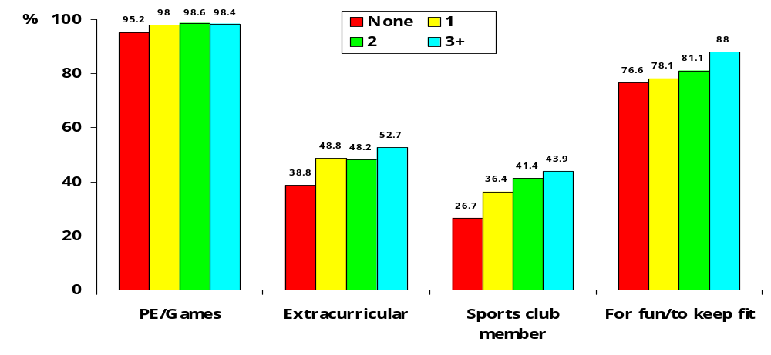
Many of the actions outlined in this Strategy will help to increase access to sporting opportunity in the City. However, additional input may be required to generate increased involvement and higher levels of sporting participation amongst those groups who are currently more likely to be excluded from sporting provision. Specific additional strategies are needed to address particular barriers and to develop sporting participation amongst these groups.
Girls

Girls have lower levels of participation than boys in all forms of sporting participation, including leisure centre usage (despite having better levels of awareness for some key facilities in Salford) than boys. Specific action is required to seek to address this.

Participation in sport; boys v. girls - Salford

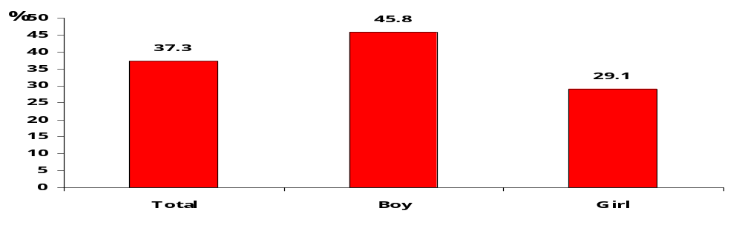
LQL will review and, as achievable, realign existing (human and financial) resource allocation, in particular that applied to existing schools-based programmes, as the role, function and capacity of SSCPs evolve, to enable management and delivery of programmes and services for key groups.

Develop programmes to cater for the sporting needs and aspirations of girls.
Action: LQL will: | Timescale | Reason for improvement/ action | Responsible | Resource
Work with SSCPs to review extracurricular provision to ensure that it reflects activity organised and realistically available to girls outside school. It will liaise with SSCPs to support the development of additional extracurricular opportunity in activities such as dance and aerobics. Such provision should be directly linked to better orientated and more effectively promoted out-of-school provision at leisure centres and may include:  - Centres offering targeted free fitness induction for girls aged 13-16 – linked to promotion direct with schools and via its own staff.  - Developing a system to offer free/low cost ‘class inductions’ led by pre-qualified teachers.  - Implementing programmes of staff training specifically geared to the suitability of fitness supervisors working with girls.  - School holiday programmes offered at centres (and other venues) to incorporate a range of introductory and innovative fitness and exercise opportunities. | Jan  2004 | To increase participation in sport and physical activity among girls and women in the City – positively seeklng to address the present imbalance in levels of participation between boys and girls. | LQL

Action: LQL will also: | Timescale | Reason for improvement/ action | Responsible | Resource
Work with schools and other agencies to specifically promote wider sporting provision for girls at facilities.  Plan, promote and implement specific school holiday programmes targeted at girls. It will apply greater attention to detail in the context of making appropriate and attractive provision for girls of different ages.  Work with secondary school teachers to encourage positive referral of girls to programmes and opportunities provided, targeting those in key areas.  At its facilities introduce a criteria-led allocation process giving priority to clubs/activities providing opportunities for young people and specifically for girls.  Work with sports clubs to set up specific mechanisms/posts with responsibility to broker contact between girls and the club environment.  Ensure that, in both ‘facility-owning’ and ‘facility-dependent’ clubs, an identified key individual is responsible for managing the introduction of girls to the club environment. | Jan  2004 | To increase participation in sport and physical activity among girls and women in the City – positively seeklng to address the present imbalance in levels of participation between boys and girls. | LQL

Targeted young people

The Year 9 survey clearly illustrates that young people from particular wards and communities tend to have lower levels of participation. Specific action is required to address this inequity. There is also a need to take account of the growing number of Asylum seekers and people from black and ethnic minority groups located in the City.

In the context of the City’s move to a more neighbourhood responsive (community committee-based) method of governance and community responsiveness, consideration must also be given to how local groups are supported to deliver sporting programmes and activities in their localities. Those best placed to support delivery in key target geographic areas and with key groups should be targeted.

Work closely with key groups in Salford to develop programmes to cater for the sporting needs and aspirations of young people from targeted communities.
Action: LQL will concentrate its direct intervention and agency support work on: | Timescale | Reason for improvement/ action | Responsible | Resource
Work with the SSCPs to review extracurricular schools programmes serving young people from deprived communities to ensure that they complement activity organised and available outside school by clubs and at leisure centres.  Introducing a criteria-led facility allocation process that gives priority to clubs/activities providing targeted opportunities for young people from key communities.  Systems to broker contact between young people from specific communities and sports clubs.  Ensuring that development and facility based resources combine to ensure that, in key clubs, an identified individual is responsible for introducing young people from targeted communities to the club environment.  Identifying staff with liaison responsibilities for identified schools to be a conduit for the promotion of activities, courses and programmes.  In tandem with key partners evaluating the feasibility of expanding WAP-type activity via, for example, opening LQL sports/leisure facilities on a ‘drop-in’ youth centre type basis on Friday/Saturday/Sunday evenings.  Work with specified CCs to develop opportunities for young people from targeted communities. | Sept  2004  April  2004  On going  On going | To target human and financial resource more specifically at generating interest and participation in identified, deprived communities in the City | LQL

Work closely with and inform other key professionals in youth/ community/social work to ensure that they are in a position to utilise sport as a vehicle in the delivery of their objectives and are in a position to refer young people to appropriately structured sporting options
Action: LQL will: | Timescale | Reason for improvement/ action | Responsible | Resource
Identify groups/agencies with a track record of work with young people from deprived/ targeted communities through which Strategy priorities can be effectively delivered and offer sporting opportunity to these groups as a genuine tool to assist other professionals in the delivery of their work programme objectives.  Broker contact with key clubs to enable interested young people from targeted communities to gain access to the voluntary sports sector.  Work with Connexions advisers/mentors to support young people from targeted areas/groups (i.e., girls and young people from targeted communities) in the context of enabling them to access sport and recreation opportunity.  Identify funding to support the establishment of a community sports development officer post to work in targeted/deprived areas.  Support community groups in applications for external or CC grant funding to support the development of sporting opportunities in Salford. | On going  April 2004  On going  On going  On going | To achieve inclusion and community safety targets via effective partnership work with other departments and agencies. | LQL
People with physical and sensory impairment

Programmes to cater for the sporting needs and aspirations of people with physical and sensory impairment must be fundamentally integrated into programming and delivery policy. Mechanisms that encourage clubs, sporting organisations and managers to plan for and support provision for disabled people should be put into place. To support this, there should, wherever possible, be appropriate disability representation on sports specific development groups and a programme of disability awareness training for all coaches, club administrators, volunteers and facility managers across the City.

Work closely with the disability sport groups (or other disability groups) in Salford to develop key measures and programmes to cater for the sporting needs and aspirations of disabled people.
Action: LQL will: | Timescale | Reason for improvement/ action | Responsible | Resource
Ensure that provision for disability sport is integrated into all key programmes.  Ensure, wherever possible, appropriate disability representation on all sports specific development groups.  Undertake, and develop an action plan response to, a physical and ‘attitudinal’ access audit of all Salford sports facilities.  Develop and deliver a comprehensive programme of initial and ‘refresher’ based disability awareness training for all coaches, club administrators, volunteers and managers/ staff at LQL facilities.  Promote integrated and specific provision for disabled people via LQL website, in generic LQL promotional material and via other mechanisms in schools etc.  Utilise a range of ‘mystery visitors’ to assess centre atmosphere and responsiveness to disabled people.  Develop a specific programme (featuring specific sports) offering quality, sustainability and continuity (e.g. swimming, athletics, watersports.)  Via SSCPs develop/refine systems whereby information about sport and recreational options and opportunities can be transferred directly to disabled young people attending mainstream schools.  Maintain existing programmes of work with disabled young people and ensure consistency of delivery of such programmes throughout the City and at each LQL service contact point. | On  going  Sept 2004  April 2004  Sept  2004  April 2004  Sept 2004  On going | To target human and financial resource more directly at generating interest and participation among people from specifically targeted groups in the City | LQL  LQL & SCC  LQL

Quality Protects – the ‘looked after’ sector

Sport is well placed to help improve the quality of life for children in the Looked After sector. Whilst some good work has been undertaken and the location of an officer operating within the existing SDU set up is clear evidence of appropriate management and good operational practice, there is potential for further development of greater links between the delivery of sports services and this sector. Greater effort should be made to incorporate ‘looked after’ children into work programmes through, for example, targeting leisure card and holiday programmes.
Work closely with Social Services/other agencies to identify and make specific provision available for ‘looked after’ young people and the family and/or workers involved in the foster care settings or residential units in which they live.
Action: LQL will: | Timescale | Reason for improvement/ action | Responsible | Resource
Continue to offer a comprehensive programme of sport and recreational activity for looked after young people and the families/carers that look after them.  Give priority to ‘looked after’ young people in key programmes, including holiday schemes, swimming lessons and fitness inductions.  Financially/socially justify provision made in the context of factors such as improved behaviour, reduced attrition among foster carers etc. | On  Going | To target human and financial resource more directly at generating interest and participation among people from specifically targeted groups in the City | LQL

Black and minority ethnic communities

The proportion of people from BME groups in Salford is relatively low. People from such groups tend, however, to participate less (in sport). Targeting specific communities will help to ensure that access to opportunities to take part is made available. Nonetheless, there is a need to address key service equity issues. The key is to identify mechanisms via which organisational change can effected. The City also has a growing refugee/ asylum seeking population.

Work closely with key groups to develop programmes to cater for the sporting needs and aspirations of young people from targeted BME communities.
Action: LQL will: | Timescale | Reason for improvement/ action | Responsible | Resource
Undertake an ‘attitudinal’ access audit of all Salford sports facilities.  Develop programme of equity training for all coaches, club administrators, volunteers and managers/staff at SCC facilities.  Identify key operational staff to be responsible for liaison with local BME communities. These staff to make contact with the relevant young people and broker access to centre-based/other activity.  Review marketing and promotion. Develop mechanisms appropriate to BME communities (adopting good practice utilised elsewhere).  Utilise ‘mystery visitors’ to assess centre atmosphere and wider LQL approaches to BME communities.  Offer sport and physical activity options to young people from asylum seeking/refugee communities.  Provide all young people in this sector with a leisure card option.  Identify, with the Children’s Fund, mechanisms to provide sporting opportunities for ‘newly arrived’ 5-13 year olds. | Sept 2004  Annual  April 2004  June 2004  Sept 2004  Dec 2003  April 2004  April 2004 | To target human and financial resource more directly at generating interest and participation among people from specifically targeted groups in the City | LQL

Core theme 4: Community safety

Corporately SCC is committed to reducing crime and the development of programmes to reduce crime. Involvement in sport can help to reduce the chances of young people committing crime and levels of reoffending. Whilst the work of this Strategy will contribute to the development of sporting opportunities, more focused and targeted work, including that conducted on a one-to-one basis is required to help reduce levels of crime and offending amongst young people.

LQL work will aim, over the lifetime of the Strategy, to progressively become more geared to providing support and sporting opportunities to both its own projects, and work undertaken by other agencies working locally to reduce crime (e.g., Youth Offending Team). It will also actively encourage youth, community and other outreach workers working in identified areas to use sports facilities and activities as a key facet of programmes geared to the delivery of other social objectives. This will include work with sports clubs to take on potential/actual offenders as members.

The work of the LQL and the Youth Service needs to be more closely integrated to ensure effective service delivery and reducing duplication.

Salford Community Safety Partnership to promote sport as a vehicle to achieve its objectives
Action: LQL will: | Timescale | Reason for improvement/ action | Responsible | Resource
Allocate resource to enable the Police/other agencies to access facilities and coaches for programmes designed to reduce/prevent crime, possibly linked to the work of CCs and the City’s grant aid programme.  Work with Connexions to support young people to access sport and recreation opportunities.  Work with sports clubs to encourage them to provide places for those at risk of offending, linked to referral from YOT, the Police, exclusion officers and schools.  Develop volunteering opportunities (and linked training) for those at risk of offending.  Develop a programme of one-to-one opportunities with offenders/those most at risk of offending.  Provide training to all staff in relation to with disaffected young people.  Evaluate how it uses programmes such as the Duke of Edinburgh Award to frame and support work undertaken with disaffected young people  Evaluate the feasibility of opening key facilities on a ‘drop-in’ basis on Friday/Saturday/ Sunday evenings. | April  2004  Sept  2004  Jan 2004 | Improve actual levels & perceptions of community safety in the City. | LQL

Ensure effective co-ordination between the delivery of sports and sports development work and youth work services. Support and encourage training, qualification and employment opportunities linked to the sport ‘sector’ which are/can be delivered through the youth service structure.
Action: LQL will: | Timescale | Reason for improvement/ action | Responsible | Resource
Improve general relationship with the youth service and work towards a joint strategy in key work areas targeting key groups (e.g. black and minority ethnic communities).  Work with/through Connexions to enable targeted young people to access sport and recreation opportunity.  Coordinate the delivery of CSLA (and comparable) courses, targeting groups currently under represented in sporting participation.  Maintain its commitment to working with partners to tackle issues such as juvenile nuisance and to specific programmes in crime hotspots’ etc. | Sept  2003  Sept 2004  Ongoing | Tackle poverty and social inequities.  Improve young people’s lifechances. | LQL  &  SCC  LQL  LQL

Make effective use of the full range of sports, arts and watersports based activities available in the City, and via LQL resources, to work with disaffected young people.
Action: LQL will: | Timescale | Reason for improvement/ action | Responsible | Resource
Utilise the combined resources of the Watersports Centre and Lledr Hall to, working with key partners, provide a resource to support the delivery of programmes and activities for disaffected young people and young offenders.  Via the resources at its disposal, utilise sports, arts and other cultural activities interchangeably to ensure that the variety and appeal of programmes, services and options offered maximises service appeal in the context of community intervention and targeted work with disaffected young people. | Sept 2005  Sept 2005 | Tackle poverty and social inequities.  Improve young people’s lifechances. | LQL  &  SCC
Core theme 5: Managing & developing sport

Corporate priorities dictate that everyone in Salford should have the opportunity to take part in sport and enjoy full and active recreation. For nearly everybody, first experiences of taking part in organised sport occur at school. Assisting young people to move through involvement in school sport to play for a local club or, via other routes, regular involvement is an important steps in delivering sustainable personal sporting opportunity.

Provision of access routes into sport for those young people statistically and practically less likely to get involved is a key responsibility of LQL. Its use of sport as a vehicle through which to engage young people, will impact right across the community in terms of wider educational achievement, health, employment and tackling social exclusion.

The diagram below illustrates the notional ‘Salford continuum whereby young people enter sport via a range of routes and via the City’s own programmes and its involvement in the Greater (Manchester Sports) Partnership have the opportunity to take their interest in particular sports as far as their interest, talent and ability allow.

‘Salford continuum’
Greater Sport

County
performer

Locally talented performer

Committed participation

Salford LQL

TRANSITION & POTENTIAL PROGRAMME EFFECTIVENESS MEASUREMENT POINT
Coach/volunteer development
Sports specific development
Club development)
INTRODUCTORY PARTICIPATION
Schools-links programmes
COUNTY SQUADS
PARTNERSHIP SQUAD

PARTNERSHIP SQUAD
PARTNERSHIP SQUAD

SPORT C
(Local club setting)
SPORT A
(Local club setting)
SPORT B
(Local club setting)
COMMITTED PARTICIPATION
HEALTH INTERVENTIONS & ‘INFRASTRUCTURAL SUPPORT
Other intervention programmes
CC linked work
Sparky
INCLUSION
Quality Protects
Physical literacy support ‘intervention programmes
Young people - key neighbourhoods
SLAM/ WAP etc. linked work
PRUs
Physically and sensory impaired
Black & ethnic minorities support ‘intervention programmes
Sports-specific work

Effectively targeting support and resources underpins the development of robust, sustainable opportunities to participate in sport. A key part of this is work with individual sports in a co-ordinated way, possibly through a number of clubs in different locations. Giving priority to the development of specific sports is important to ensure that resources are maximised. Identifying key sports for support does not mean that other sports are overlooked but rather that those identified are, based upon specific criteria, proactively rather than reactively supported.

This should be reviewed in the context of the infrastructure in Salford and the potential impact targeted work can have. The value of certain sports in attracting groups traditionally under represented in sporting participation (e.g. judo, martial arts), and the City’s specific capacity to service others (e.g., gymnastics, triathlon disciplines, trampolining, fitness, wrestling and watersports) should not be overlooked.

Review the sports with which LQL will work on a priority basis
Action: LQL will: | Timescale | Reason for improvement/ action | Responsible | Resource
Identify/agree priority sports for the next five years based upon criteria set out overleaf.  Develop a clear, consistent pattern of support ensuring that work to strengthen the infrastructure of designated sports and deliver their ‘sustainable growth’ is cohesively managed | April  2004 | To be more effective via the targeting of human/financial resource more directly at specific targeted sports | LQL

Criteria: Sports that offer: | High | Fairly high | Avg. | Below avg. | Low | Multiple
Established club/progression infrastructure in Salford | □ | □ | □ | □ | □ | X 1
Capacity to cater for men/boys and women/girls equally | □ | □ | □ | □ | □ | X 1.5
Coaching provision providing a local pathway to higher performance levels. | □ | □ | □ | □ | □ | X 1
Suitability to support delivery of Strategy social and community development objectives. | □ | □ | □ | □ | □ | X 2
Facilities presently available in the City. | □ | □ | □ | □ | □ | X 2
Immediate potential to access/develop facilities in the City. | □ | □ | □ | □ | □ | X 1
Strong, sustainable opportunities for young people | □ | □ | □ | □ | □ | X 3
Access for people with physical and sensory impairment. | □ | □ | □ | □ | □ | X 1.5
An infrastructure that caters for people with physical and sensory impairment | □ | □ | □ | □ | □ | X 1.5
Open access (the nature, and costs, of participation, do not restrict access to City residents). | □ | □ | □ | □ | □ | X 1
Potential to significantly improve the range and quality of opportunity for young people. | □ | □ | □ | □ | □ | X 2
‘Greater Sport designation & associated County structures | □ | □ | □ | □ | □ | X 2
NGB commitment to working in Salford | □ | □ | □ | □ | □ | X 2

Action: LQL will develop and enhance its commitment to triathlon and its feeder sport disciplines by: | Timescale | Reason for improvement/ action | Responsible | Resource
Initiating a programme designed to encourage young people to get involved in and take up running.  In the context of its contribution to triathlon, work to develop the capacity of the Athletics Club operating at Cleavley’s Track and its gearing to absorption and training of young road and track runners.  Pending the reviews cited elsewhere in this Strategy, maintaining an agreed form of commitment to swim squads  Facilitating the development of a programme in tandem with partners such as the University, specifically geared to developing triathletes  Developing a system to assist triathlon recruitment from the key discipline of swimming  Maintaining its commitment to support and run triathlon, duathlon and comparable events in the City. | Sept  2004  On going | To ensure that City investment in ‘grass-roots programmes and high profile events is managed effectively and productively | LQL  LQL & SCC

Linked directly to the issue of priority sports, is the City’s participation in the Greater (Manchester) Sport Partnership. The extent of, nature of and key gains emanating from SCC’s involvement with Greater Sport needs to be clarified. A key facet of the City’s contribution to this is its role getting young people to the ‘entry point’ of other structures – as illustrated below.

Clarify rationale for involvement in Greater Sport Partnership (GSP)
Action: LQL will, in the context of the abovementioned review: | Timescale | Reason for improvement/ action | Responsible | Resource
Allocate financial support and programming priority at LQL (and schools) sports facilities to clubs involved in the delivery of ‘Active Sports’ pathways and those that meet key GSP criteria, (e.g. Clubmark, child protection, equity policies).  Promote pathways to higher levels via commitment to the GSP driven programmes (specifically clarifying and setting achievement targets in relation to young people emanating from defined priority areas and groups).  Make more use of GSP programmes (and its measurement capacity) to support (and evaluate) development programmes aimed at increasing participation amongst groups currently under represented in sporting participation. | April  2004 | To ensure that the effectiveness of, and opportunities generated by, development work undertaken in the City is maximised. | LQL

Work to strengthen the voluntary sector is vital. Sport England’s ‘Clubmark accreditation provides a clear framework for this and identifies the basic level of provision that all clubs should aspire to. Intervention or support priorities should be directly linked to assisting LQL to deliver other key programmes, working towards this standard and/or club potential to address key issues, such as capacity to development participation amongst young people from targeted wards.

This is difficult and often time consuming. Immediate impact is hard to generate and assess. However, given the corporate commitments within which LQL is required to operate, it must focus resource on development of a sporting infrastructure in areas/for groups of identified low sporting participation.

Notwithstanding some high quality intervention work undertaken to date, greater support is required to enable voluntary sector sports clubs to provide opportunities for young people, focusing particularly on key priority groups. Work in this area should be based upon the key principles of Clubmark (for example working on the identification of individuals in clubs to manage links with local schools).

Target the skills, facilities and resources available to the voluntary sports sector for the delivery of sport for young people
Action: LQL will, in the context of the abovementioned review: | Timescale | Reason for improvement/ action | Responsible | Resource
Identify and target key clubs to support. Initial priority will be given to those delivering, or with the potential to deliver, recognised development work in agreed priority sports and/or working in areas/with groups of identified low sporting participation.  Identify/target key clubs to progress towards the principles of Clubmark, e.g. identifying person(s) responsible for managing the introduction of young people. Initially, priority should be given to clubs in identified priority sports and working in areas/with groups of identified low sporting participation.  Give booking priority to groups working effectively with young people. | Ongoing  Sept 2004 | To ensure that the effectiveness of, and opportunities generated by, development work undertaken in the City is maximised. | LQL

Key shortfalls in coach/volunteer availability and quality should be addressed. Work should be managed on both a generic basis and clubs/groups serving priority sports/ areas/groups targeted. LQL and schools need to ensure that they are in a position to benefit from the planned support for volunteers through the Step into Sport programme.

Develop a programme for the recruitment, training and deployment of coaches and volunteers
Action: LQL will: | Timescale | Reason for improvement/ action | Responsible | Resource
Identify the number and level of coaches required to effectively deliver key programmes by sport/ club/area/targeted group.  Focus coach recruitment/training on filling gaps in structure required to deliver programmes.  (As per identified Strategy priorities -promote/ financially support coach education courses  (As per identified Strategy priorities - promote/ financially support access to leadership courses.  Identify key community groups to assist in the identification/recruitment of coaches/volunteers, particularly in key target areas and groups.  Identify opportunities in the development of after-school sports activities for volunteers trained through the Step into Sport programme | Sept  2004 | To ensure that the effectiveness of, and opportunities generated by, development work undertaken in the City is maximised. | LQL

Youth Games

Involvement in the Greater Manchester Youth Games is a considerable commitment for the City. Consideration should be given to reviewing the involvement basis, and linked selection criteria for the Games in the context of achieving more equitable representation and using participation in the event as a vehicle to support programmes to engage young people from targeted groups/communities. For example, programmes could be developed around schools and schools based competition.

Review nature of involvement in Youth Games and associated development programmes
Action: LQL will: | Timescale | Reason for improvement/ action | Responsible | Resource
Review the basis upon which it is involved in the Youth Games  In the context of this review, revise selection criteria for Youth Games, focusing on opportunities for groups currently under represented in sporting participation. | Dec  2003 | To ensure that involvement supports LQL’s drive to deliver corporate objectives | LQL

Support for talented individuals

At present, SCC invests in directly managed progression opportunities in several sports, notably swimming, gymnastics and trampolining. The quality of the work undertaken is widely recognised, however, the justification for the sports supported and the level of support offered should be examined. The marginal cost of supporting, for example, swimming squads in the context of, for example, facility use is not excessive. However, 7% of Year 9 pupils in the City are poor or non-swimmers. Should emphasis, and thus primary investment be directed at raising the quality and reach of learn to swim options ahead of support for the talented?

It should also be noted that high level progression opportunities are available in several neighbouring local authorities. Consideration could/should be given to the level to which talented swimmers are taken by the City prior to passing them on to other clubs/squad programmes possibly supported by individual bursaries. The justification for the operation of the Gymnastics Centre is also open to question. If it is to be retained, it may need to be better locally justified via the implementation of a more comprehensive and consistent underpinning cross-City gymnastics programme.

Assess why, to what level and how SCC provides support for talented individuals.
Action: LQL will: | Timescale | Reason for improvement/ action | Responsible | Resource
Evaluate whether and how its support for talented performers can be retained/maintained.  Assess the potential for an individual bursary support system, possibly managed in conjunction with the Salford & District Sports Council.  Evaluate whether and how talented performers could take advantage of elite work supported locally (e.g. athletics at Sale/Stretford, swimming at Wigan/Stockport/ Manchester, gymnastics at Manchester etc.). | Sept  2005 | To ensure that the effectiveness of City support for talented performers is maximised. | LQL  &  SCC

Grant aid & devolved community committee budgets

Strategy development provides an opportunity to work with Salford District Sports Council and community committees to build upon Strategy priorities through the adoption of criteria to ensure that discretionary grant resources are directed to organisations and community-based projects that will help to deliver Strategy objectives. By proactively gearing support for clubs and agencies, SCC and CCs will be able, through LQL, to positively endorse and encourage good practice.

Similar issues apply in the context of discretionary rate relief (DRR). The level of relief available should be geared to the contribution made by the relevant club to the development of sport and the achievement of wider corporate objectives. Such criteria should be closely aligned to those that determine priorities in relation to access to SCC owned and managed facilities. Responsibility for the allocation of DRR should rest with LQL.

Support should, as applicable, also be provided to clubs to progress towards community amateur sports club status.

Review grant aid (and DRR) criteria.
Action: LQL will: | Timescale | Reason for improvement/ action | Responsible | Resource
Introduce developmental criteria to ensure that grant support and DRR is targeted at organisations on the basis of the extent to which they fulfil/ support the delivery of Strategy aims.  Support clubs to progress to CASC status.  Work closely with Salford District Sports Council and community committees to maximise the level of funding being channelled into sport, leisure and recreational activity.  Develop systems to ensure that grant and resource support processes are, and are seen to be, equitable and endorsed by the sports voluntary sector and local community representatives. | April 2005  On  going  Sept 2004 | To ensure that the mechanisms available to influence/support the work of the voluntary sports sector in the City are used effectively. | SCC  LQL  &  SCC

Events and holiday programmes

Information from partners and the community (such as neighbourhood co-ordinators) highlight that LQL has a strong and positive reputation for the delivery of holiday programmes. There is considerable evidence to suggest that recent targeting of such provision has had an impact upon crime and juvenile nuisance in the City. There is a need to ensure that LQL has management access to appropriate resources (e.g. built facilities, watersports, outdoor activities facilities and staff), if it is, operating under trust management, to maintain and improve its delivery in this area.

Events and holiday programmes.
Action: LQL will review and prioritise its current and future commitment to events and holiday programmes provision in the context of: | Timescale | Reason for improvement/ action | Responsible | Resource
Their contribution to the abovementioned, stated strategic aims of LQL and the City  The efficiency with which they are utilised as a ‘shop window’ for ongoing provision/programmes  How subsidy, in the context of delivering Council corporate objectives, can be judiciously targeted to ensure equitable provision and programmes that achieve genuine social impact  How such events and programmes can be most efficiently and effectively promoted in, with and by schools and SSCPs  Measurement of their impact upon quality of life and their concomitant value. | June  2004 | To ensure that events are effectively linked into, and used to positively promote other aspects of LQL/ Council services. | LQL  &  SCC

Core theme 6: Infrastructure, marketing, performance measurement and value for money

Strategy implementation necessitates an operational ethos where all service elements clearly understand and are working to deliver core targets in the context of a clear understanding of the overall social value as well as the trading elements of LQL

Quality delivery of effective development work must be underpinned by improved service orientation, revised systems and in some instances, infrastructural change. The externalisation to Trust operation, given that the right service elements are combined, may optimise the capacity of LQL to effectively combine and maximise the cross-benefits of the resources the City has at its disposal.

Existing corporate management has, thus far served largely to weaken and delimit the capacity and proactivity of the service. Much of the positive work undertaken occurs despite rather than as a result of the corporate environment in which staff must operate.

It is essential that LQL provides a quality service to resident and that this service practically, and in the context of key outcomes, targets subsidy effectively. To do this it must measure and assess the relevance and impact of what it does and, on this basis, continually review the extent to which it delivers value for money. The City Council must assess the potential benefits of the following options:

- The opportunity to function as ‘freestanding ‘business unit – operating within its own ‘net subsidy threshold.
- Linked to this setting an output/outcome driven performance-based specification.
- Allowing LQL the operating flexibility to vire between budgets – according to performance requirements
- Enabling it to substantially improve its own ‘case-making’ capacity.

Staffing

It is vital that LQL staff whether directly linked to facility management and operation, designated as development officers, full,or part time, temporary or permanent fully understand core service goals and their actual/potential contribution to service delivery and improvement. Service segregation and delineation will be progressively de-emphasized. There will be a concomitant emphasis upon enabling staff to operate across the service, enhancement of understanding and skills and improved ‘vertical’ and ‘horizontal’ communication.

There is a key need to maximise the use of LQL resources whether financial, human or facilities-based, and its networks of partners and contacts. Working effectively with, utilising, and responding to the interests, needs and requirements of CCs will also be key to maximising the opportunities available to the various communities of the City.

Notwithstanding the relatively positive relationships between officers in different sections of LQL, there is a need for greater mutual understanding and appreciation of the issues that identifiable disciplines within the service face.

To further develop the relationship between different service disciplines and staff in the context of improving generic mutual understanding of core service objectives and the contribution made in, with and by the various staff operating within LQL.
Action: LQL will move to a position where staff roles - in facilities, ‘field’ environments, marketing, inter-agency work and with clients and customers of all ages and types are interchangeable. This will be supported by: | Timescale | Reason for improvement/ action | Responsible | Resource
Appropriately specified/managed staff training and interaction opportunity. This to include a review of training provided in the context of staff ‘comfort’ dealing with, for example; young people, people with physical and sensory impairment, BEMs, older people etc.  Linked to Quest accreditation; LQL will utilise ‘mystery visitors’ to assess centre and programme atmosphere and responsiveness to, for example; young people, people with physical and sensory impairment, BEMs, older people etc.  Exposure of staff to different work areas  Staff involvement in a variety of cross-service reviews  Improved communication frequency and devices – ensuring that performance is measured and information presented in a cross-departmental context.  Progressive move towards full ‘interchangeability’ of staff | Dec 2003  April  2004 | To ensure quality front-of-house service delivery and underpin ongoing staff development and training processes | LQL

Facility infrastructure

Physical provision for sport and physical activity within Salford includes facilities provided by/at agencies including SCC, schools, Salford University, FE colleges, sports clubs, community groups (and the private sector – Total Fitness, Marriott & Sportslife). The City operates and supports a range of sports facilities.

There is, particularly in the context of the decision to take LQL out to NPDO/trust, a need for considered review of the City’s facilities stock. An integrated approach to facility development is required. All provision, regardless of the nature of the manager or provider, should be considered in the context of the role it can play in supporting Strategy and service plan aims.

The review should take account of facility provision made by all providers. Closer integration and better co-ordination is required. All facilities should operate to the same broad parameters. The roll-out of NOF Round 3 and PFI-supported school facilities and future planning permissions for school based and private sector investment in sports facilities should also be contingent on their capacity to deliver community use and their willingness to be linked to a central programming co-ordination system.

Central co-ordination of policy development, facility improvement (or rationalisation) and development is essential in the context of ensuring a coherent, cohesive approach to facilities within the City. All submissions for external funding should be co-ordinated centrally and prioritised with a degree of detachment ensuring strategic fairness.

A set of rationalisation criteria for the leisure facilities is available, having been developed by the Trust Steering Group as part of the externalisation process (Appendix 8 – not yet attached!)

Plan strategically for facility provision among all sectors in the City. As appropriate, seek and allocate (SCC, partner and external) resources to improve the quality, and accessibility, of sports and recreational facilities.
Action: LQL will working either within the Council, or with it as a strategic partner: | Timescale | Reason for improvement/ action | Responsible | Resource
Develop a facilities strategy for Salford, encompassing all provision. Rationalisation of existing/development of new facilities will, in this context, be clearly linked to Strategy objectives.  Linked directly to this, develop closer operating and programming links to other providers, particularly schools and community groups, to ensure a coherent pattern of complementary provision, cutting down on unnecessary duplication.  Identify community groups that can be supported in facility development/management.  Consider an indoor sports facility master-planning exercise. This will ascertain how best use can be made of existing provision and to assess where and how specific amenity provision catering for key localities can be provided.  Work with planning officers to identify ways in which potential provision of sporting facilities, including open space, can be linked to the planning process.  Explore opportunities to further develop water based activity in the City.  Exploit opportunities through the planning process (planning gain, use of Section 106 agreements) and working with providers of community housing to identify potential opportunities to develop a broader range of provision. | April  2005  Ongoing | To ensure quality front-of-house provision for residents of the City.  To inform, and ensure that, future investment and rationalisation decisions are underpinned by proper planning and consideration of all key factors. | LQL  &  SCC  SCC  LQL  &  SCC

Leisure facility programming

There is a need to maximise the developmental content and impact of programmes, development-led projects, work undertaken in partnership with CCs and ‘free-standing’ activity. LQL should at SCC venues, and, where possible (preferably via central facility programming co-ordination), at schools-based facilities, introduce a criteria-led facility/resource allocation process so that priority is given to groups providing junior opportunities and those demonstrating genuine sports development practice.

Facilities operation:
Action: LQL will: | Timescale | Reason for improvement/ action | Responsible | Resource
Revise the present system of booking allocation within SCC sports facilities and develop a central co-ordination function for facility programming and programming policy development.  Introduce a criteria-led facility allocation process, whereby priority for bookings at all times is given to groups/clubs/agencies.  Conduct an annual ‘improvement review’ of facility programming to identify levels (and the effectiveness) of provision for under represented groups  Establish minimum targets for programmes. | April  2006  April  2003 | To ensure that the effectiveness of development work undertaken in the City is maximised. | LQL  &  SCC

Facility access priority proposed ‘social criteria’

Indicative approved user group/club/agency/activity priority criteria
Criteria | Very good | Good | Avg. | Below avg. | Poor | Multiplier
Club/group conformity to LQL aims |  |  |  |  |  | x2
Demonstrable provision orientation/planned response to local need/demand. |  |  |  |  |  | x2
Extent and breadth of coaching provision planned:  - Non-participants (introductory)  - Juniors  - Women & girls  - People with physical and sensory impairment |  |  |  |  |  | x1.5
Potential overall sports development impact. |  |  |  |  |  | x1.5
Potential impact on health. |  |  |  |  |  | x1.5
Significance; specific target groups (girls, young people from targeted communities) |  |  |  |  |  | X2
Significance; people from defined disadvantaged areas. |  |  |  |  |  | X2
Significance; referred disaffected young people (excluded, those with ASBOs etc.) |  |  |  |  |  | X3
Significance; (priority sports). |  |  |  |  |  | X1
Significance: Performance |  |  |  |  |  | X1.5
Demonstration of effective partnership to deliver GCC priorities. |  |  |  |  |  | x1

Leisure activity pricing and leisure card

Current pricing policy and mechanisms are not set up to enable SCC to ensure that subsidy (or flexible elements within it) is targeted at those most in need or those with low levels of sporting participation. Use of mechanisms such as hypothecated cross-subsidisation of service, and price elasticity testing has, to date, been limited. This is, in part, due to the inflexibility with which LQL is allowed to operate by the Council.

The present pricing structure means that subsidy is not, in an equity and ‘Best Value’ context, directed at who most need it. Subsidy application is not clearly geared to corporate policy delivery. A review of pricing policy, geared to directing greater levels of subsidy at key, strategically targeted, groups or activities. Irrespective of the delivery mechanism selected for service management, this review is required. In tandem with review of marketing and ‘presentation’ mechanisms, pricing flexibility in the context of both ‘headline’ costs of certain activities and the extent to which this can be reduced, is required. Learning from work being undertaken in other urban boroughs and cities, SCC needs to work with LQL to develop a more sophisticated pricing, performance measurement and front-of-house ICT systems.

Leisure card systems must be considered in the context of both overall pricing structures and their value in performance measurement. A leisure card system is in operation in Salford. Recent consideration has been given to its effectiveness.

Further careful refinement and revision to develop a mechanism that provides greater flexibility to innovate in the context of both of day-to-day operational practice and when promoting courses, programmes, use of facilities and holiday provision to identified targeted groups. Linked to an appropriately specified, operated and used, computerised, front-of-house pricing, entry and swipecard system, it will provide SCC with substantially improved management information about users (and hence non-users) of its services. Any such development needs to be linked to Connexions.

Review of pricing policy
Action: LQL will review its pricing policy structure and mechanisms by, for example: | Timescale | Reason for improvement/ action | Responsible | Resource
Moving to a system of individual charging. This should lead to the evolution of a simpler overall pricing system.  Reducing the number of defined ‘headline’ activities (see matrix in Appendix 7).  Linked to this, adopting a single headline price for each defined activity – linked to a card system that enables scale based price reductions as relevant.  Allowing card-holders relevant discount at all times for all facilities/activities/classes.  Removing the concept of peak and off-peak pricing in the context of all activities.  Establishing systems of advance payments for classes/courses to be set alongside a system whereby cardholder advance commitment to a course but payment on a weekly basis will even out the accessibility of such provision. | April  2005 | To be more effective via the targeting of human/financial resource more directly at individuals/groups that need it most. | LQL

Action: LQL will, linked to the above: | Timescale | Reason for improvement/ action | Responsible | Resource
Develop and agree mechanisms to accurately target subsidy at those in low-participant groups or resident in particular parts of the City (where sporting participation is low).  Utilise flexible pricing policy as a support mechanism for processes designed to proactively encourage young people (particularly girls), people from BEMs and people from deprived communities to take up, and maintain their involvement in, sport and physical activity.  Test ‘price elasticity’ for current facility user base and assess the capacity of the service to increase the cost of facility use for non-priority groups (e.g., adult, working men) to counteract any impact that pricing realignment may have on overall income levels. | April  2005 | To be more effective via the targeting of human/financial resource more directly at specific targeted sports | LQL

Develop an effective, universal Salford leisure card
Action: LQL will: | Timescale | Reason for improvement/ action | Responsible | Resource
Within the context of a clearly understood rational for the targeting of subsidy and a clarity about LQL management and performance measurement information requirements, explore the feasibility of developing a comprehensive leisure card system with a view to:  - Enhancing the quality and utilisation of management information provided.  - Extending the groups to whom the card is available.  - Introducing mechanisms (e.g., through central marketing staff) to contact those who have stopped using facilities.  - Broadening the range of referral points for the card/groups that can support distribution of the card.  Introducing mechanisms to facilitate access to facilities/activities for those who have been referred/recently obtained a card. | April  2005 | To be more effective via the targeting of human/financial resource more directly at specific targeted sports | LQL

Market research, marketing and promotion

Work is needed to focus the marketing and branding of LQL. This work needs to be carefully managed to ensure that the new approach to marketing does not conflict with the more targeted approach advocated within the Strategy.

The manner in which the service has been handled corporately over recent years would appear to indicate that key decision makers have limited understanding of either the operational dynamics of the service and the ‘cost’ of the social value it delivers. The prevailing view of LQL being primarily a ‘trading’ function of the Council appears to have undermined political appreciation of the wider benefits of the service.

It is, therefore, crucial that LQL markets itself, its contribution, its performance and its value effectively within the Council.

Marketing & promotion
Action: LQL will: | Timescale | Reason for improvement/ action | Responsible | Resource
Link marketing initiatives to usage/market research data, i.e., marketing investment will be informed by data about who is/is not using the service, under-represented groups etc.  Present marketing and promotion work via more appropriate language and fora, i.e., using language appropriate to target groups, advertising where target groups congregate and utilising alternative communication methods; text messages, email, interpersonal referral.  Develop an intranet website listing local sporting options.  Reinforce existing, and further develop formal and informal communication links to local schools, clubs and community groups.  Use appropriate role models to market and promote sport and physical activity in the City.  Use specific techniques to track and measure the value of key service intervention work.  Use a variety of marketing methods to ensure that information about the performance and positive impact of the service is presented in easily digestible formats to key decision-makers at SCC and to partner agencies with which LQL deals.  Commission specific market research (either in tandem with partners (for example the Year 9 Strata survey) or as part of its commitment to the delivery of key outputs and outcomes.  Work with key stakeholders to develop/measure the impact of key social objectives and programmes and the effective presentation of the overall community case for sport and recreation.  Initiate/use a transfer point assessment system to evaluate the baseline position in relation to physical literacy, swimming, fitness and health – via partnership with SSCPs, schools and PE advisor | Sept  2004  Ongoing  Sept  2004  April  2004 | To ensure that operational resource, investment, staff allocation and subsidy are effectively and appropriately targeted.  To test the effectiveness of methods use to attract and work with specific groups. | LQL  LQL  &  SCC

Develop, maintain and update an intranet website with a local sporting options bulletin board for use by young people and partner agencies and professional staff.
Action: LQL will: | Timescale | Reason for improvement/ action | Responsible | Resource
Offer up-to date-information presented in a form suitable for use by stakeholders, key workers and young people. To cover, for example:  - Leisure card information  - Promotions/holiday activities run by LQL/ voluntary sector/other agencies  - Qualification courses  - Club contacts, activities, sessions, coaching etc.  - Facility drop-in sessions, key community/facility contacts, themes etc.  Offer a graffiti wall for young people to input views/responses/comments about its services | April  2004 | To ensure that all possible avenues of communication with key targeted groups are explored and utilised. | LQL

Performance measurement and management information

Any assessment of value for money requires the application of clear performance indicators and the collation of underpinning information. Performance measures should clearly demonstrate the impact made by the service. They must also take account of the difficulties associated with working with particular groups and generating participation.

Management information collected must be integrated and be such that it is possible to identify those who are/not engaged by, and benefiting from, the service provided. Development of improved management information systems is not just an issue for sports facilities. LQL must generate more detailed information in the context of CPA/Best Value and developing a clear justification for ongoing investment in leisure/sport.

Salford has, in collaboration with Sport England and others, been piloting a range of potential performance measures and indicators. Dependent upon their relevance and ‘replicability’, some of these should, where it is possible to build upon them inform the baseline position for the Strategy.

Develop clear performance indicators and associated management information systems
Action: LQL will: | Timescale | Reason for improvement/ action | Responsible | Resource
Agree outcomes to be achieved by the service (and local delivery agencies). (See sample PIs in Appendix 3).  In the light of these outcomes, as described earlier in this document, adopt a series of performance indicators that reflect the impact made by the service.  Adopt weighting mechanisms that enable the City to take account of the difficulty of developing, and ascribe an appropriate value to, participation among key target groups.  Implement the computerised ‘front-of-house’ IT systems linked to the implementation of revised pricing frameworks, programming policies and new leisure card mechanisms. This will have the capacity to provide detailed (useful) information on usage/participation and enable the impact of programmes on priority groups/areas to be assessed.  Implement tracking in all sports development programmes.  Utilise performance measurement data to gear marketing and service delivery.  Review marketing and adopt more relevant mechanisms of communicating with key groups. | Oct  2003  Jan  2004 | To ensure that operational resource, investment, staff allocation and subsidy are effectively and appropriately targeted.  To test the effectiveness of methods use to attract and work with specific groups. | LQL  &  SCC  LQL  &  SCC

Quality systems and consultation

There is a clear need, reflecting the City’s wider corporate approach, and given the ambition and corporate validity of the elements in this Strategy, to ensure that that they are backed up by appropriate quality systems and mechanisms for community consultation.

Quality systems, partner and community consultation
Action: LQL will: | Timescale | Reason for improvement/ action | Responsible | Resource
Utilise Sport England’s Quest (or its newly developed alternative) the basis for evaluation of the quality of its operation.  Plan and implement consultation mechanisms to ensure that its approach, services and practices are understood by and appropriate to the communities with which it works. This may include:  - Regularly scheduled consultation with CCs  - Piggybacking upon resident surveys conducted by SCC  - Commissioning specific ‘service user’ surveys ensuring that the views of all types of user are represented.  - Commissioning mystery visits to assess front-of-house quality by users of all types including men, women, women with children, young people, people with physical or sensory impairment etc.  - Making use of leisure card based communication processes to regularly test and canvas the views of users and customers about the existing, and proposed changes to the service offered.  - Regularly surveying the views of key delivery partners; schools, Youth Service, Police, YOT etc. to gauge their views about LQL effectiveness. | Oct 2004  April  2004 | To ensure quality front-of-house provision for residents of the City.  To satisfy external audit and scrutiny processes. | LQL

APPENDIX 1: TERMS OF REFERENCE FOR THE BEST VALUE REVIEW

The provision of opportunities for sporting activities falls within the remit of the Education and Leisure Directorate. The best value review involves two major service areas, these being City Leisure and the Sports Development Team.

Aims

The aims of the review contained in the terms of reference are:-

- To determine the efficiency, economy and effectiveness of the service and compare its performance with other providers.
- To develop an understanding of users and non-users expectations for the service and to test the service from the user’s perspective.
- To determine the extent to which the service contributes to the City Council’s strategic objectives and social inclusion agenda.
- To develop a service improvement plan which will identify the actions which need to be taken, to deliver a quality service that meets or and exceeds the needs of the population of Salford and achieves continuous improvement. The plan should include service standards and targets, which can inform future service provision regardless of future management arrangements (for example, it could contribute to any specification under an outsourcing arrangement).

Areas of focus

- Assessment of current management and performance information and identify improvements. This will include the examination and implementation of new performance indicators suggested by Sport England.
- Evaluation of the Sports Development Strategy 1997 – 2001 and the Leisure Centre Service Plan 1997 – 2000 to assess achievement and develop insight into our track record.
- The extent to which the service is suitably structured to meet social inclusion policies and other strategic objectives such as health improvement and tackling crime and disorder. This will cover issues such as pricing policy, programme of activities, use of facilities by Sports Development and capacity building within the voluntary sector.
- An examination of how the service fits with the various Government initiatives aimed at social inclusion and increased participation in sport by all sections of the community.
- The relationship between City Leisure and the Sports Development Team including an examination of the increased potential for joint working. Wider relationships such as the interaction with the Youth Service, supporting Directorates, Community Committees and the Health Authority will also be considered.
- To draw upon the consultancy work being undertaken and assess each centre using the rationalisation criteria previously developed and agreed by the City Leisure Trust Steering Group.
- To consider structures and alternatives for future management and delivery.

Review team membership

- Stephen Hassall – Education & Leisure
- Joanne Hardman – Best Value Team
- Mark Chew – Sports Development
- Anne Oakes – Sports Development
- Garry Bateman – City Leisure
- John Eady – Knight, Kavanagh & Page (consultants)
- Philip Shirfield – Sport England
- Richard Dodd – PE Advisor
- Jane Jefferson – Health Promotion
- Anita Cooper – Personnel
- Ray Higson - Finance
- Mike Appleyard – Oakwood High Youth Club for disabled young people
- Elaine Gilmour – Sports Development staff
- Paul Bland – City Leisure - staff
- Ken Cook – City Leisure user
- Matt Varley – Education & Leisure Performance Team
- Ray Walker – Unison
- John Torpey / Bill Pope - GMB
- Wendy Walker – Education & Leisure

Scrutiny Panel membership

- Stephen Hassall – Education & Leisure
- Joanne Hardman – Best Value Team
- Mark Chew – Sports Development
- Anne Oakes – Sports Development
- Garry Bateman – City Leisure
- Cllr Judge - Councillor
- Cllr Carter (retired) - Councillor
- Cllr Upton – Councillor
- Cllr Pennington - Councillor
- Mr Wilson – Parent Governor
- Wendy Walker – Education & Leisure

Core team membership

- Stephen Hassall – Education & Leisure
- Joanne Hardman – Best Value Team
- Wendy Walker – Education & Leisure
- Mark Chew – Sports Development
- Anne Oakes – Sports Development
- Garry Bateman – City Leisure
- John Charlson – City Leisure
- Heather Grove – Education & Leisure Best Value

APPENDIX 2: FACILITIES & SERVICES COVERED BY THE BEST VALUE REVIEW

City Leisure facilities

- Fit City Worsley: 25m pool, 2 x teaching pools, sauna, sunbeds, fitness suite, activity room.
- Fit City Irlam: 33m pool, teaching pool, sauna, sunbeds, fitness suite.
- Fit City Cadishead: Sports hall, squash court, fitness suite, out of school club.
- Fit City Pendlebury (Dual Use site): 25m pool, sports hall, fitness suite.
- Fit City Eccles: 25m pool, sports hall, sauna, sunbeds, fitness suite.
- Fit City Broughton Pool: 25m pool, Teaching pool, Fitness suite, Sauna, Sunbeds.
- Fit City Broughton Centre: Sports hall, climbing wall, squash courts, gym, ICT suite in partnership with Community Consortium, off site full size astroturf pitch.
- Fit City Ordsall: Sports hall, squash courts, fitness suite (in need of modernisation), long mat bowling area, full size astroturf pitch.
- Fit City Clarendon: 25m pool, Teaching pool, squash courts, sports hall, fitness suite, full size astroturf pitch, 2 multi sport pitches.
- Cleavley Athletics Track: Polymeric surfaced 8-lane track, weights room (needs modernisation), changing accommodation (serves neighbouring playing fields) football/rugby pitch/field events grassed area.

Outdoor facilities

- 75 football pitches + 12 mini soccer pitches
- 6 rugby pitches
- 3 cricket squares
- 22 bowling greens
- 26 tennis courts
- 1 putting green

Sports development services and facilities

- Salford Watersports Centre: Climbing wall, multi activity centre @ Salford Quays, Office accommodation, training room.
- North Salford Gymnastics & Trampolining Centre: Specialist gymnastics and trampolining hall.

In addition the review covers all the services provided by the Sports Development Team such as community sports development officers, healthy lifestyles team, support for Salford District Sports Council and club development, and work with Salford schools.

2002/03 City Leisure budget: Expenditure/Income/Net cost

2002/03 Sports Development staffing: 26 full time and 19 part time

2002/03 City Leisure staffing: 64 full time and 79 part time
APPENDIX 3: SAMPLE PERFORMANCE INDICATORS

The key aim is to measure performance effectively and utilise performance measurement to guide revisions and improvements to SDU work programmes and practices. Based upon this LQL should focus on what are entitled ‘headline’ performance indicators which relate directly to the impact of services provided.

Outcome based performance measure | Measurement method
% increase in the number (& proportion) of young people (U16) in Salford regularly participating in sport and physical activity | Strata survey  SDU focus groups
% increase in the number (& proportion) of young people in Salford aware of locally provided sports facilities/ opportunities | Strata survey  SDU focus groups
Physical literacy – assessed at transition point between primary and secondary | Year 7 assessments
% increase in personally perceived (‘self-reported) levels of health (fitness) among young people (U16) in Salford | Strata survey  Specific health survey  SDU focus groups
Using surveys of specific groups/questions about sport and recreation in wider surveys allied to national and local statistics and GIS/mapping, all suggested SCC PIs should, to enable effective adjustment and equitable targeting of work, be further evaluated and analysed by:

- Age
- Gender
- Ethnic origin
- Disability
- Residential neighbourhood – by ward/postcode
- Other factors such as car ownership, employment status, social group etc.

Annual independent facility programme quality review

Annual independent review/scrutiny of grants programme developmental effectiveness

APPENDIX 4: COMPARISON: JUVENILE NUISANCE AND CRIMINAL DAMAGE FIGURES (23-7-01 COMPARED TO 22-7-02)

Area | Crime type | % Change
Citywide | Criminal Damage | -13%
 | Juvenile Nuisance | -6%
Little Hulton | Criminal Damage | -52%
 | Juvenile Nuisance | -19%
Walkden North | Criminal Damage | -16%
 | Juvenile Nuisance | 26%
Walkden South | Criminal Damage | 4%
 | Juvenile Nuisance | 33%
Irlam | Criminal Damage | 8%
 | Juvenile Nuisance | 28%
Cadishead | Criminal Damage | -24%
 | Juvenile Nuisance | -7%
Barton | Criminal Damage | 16%
 | Juvenile Nuisance | 8%
Winton | Criminal Damage | -38%
 | Juvenile Nuisance | -47%
Eccles | Criminal Damage | -27%
 | Juvenile Nuisance | 32%
Swinton North | Criminal Damage | -8%
 | Juvenile Nuisance | 31%
Swinton South | Criminal Damage | -14%
 | Juvenile Nuisance | 95%
Pendlebury | Criminal Damage | -5%
 | Juvenile Nuisance | -26%
Claremont | Criminal Damage | -50%
 | Juvenile Nuisance | -11%
Weaste & Seedley | Criminal Damage | -15%
 | Juvenile Nuisance | -2%
Langworthy | Criminal Damage | 12%
 | Juvenile Nuisance | 17%
Ordsall | Criminal Damage | -20%
 | Juvenile Nuisance | -38%
Pendleton | Criminal Damage | 8%
 | Juvenile Nuisance | -4%
Blackfriars | Criminal Damage | -7%
 | Juvenile Nuisance | -31%
Broughton | Criminal Damage | 0%
 | Juvenile Nuisance | 8%
Kersal | Criminal Damage | 42%
 | Juvenile Nuisance | -43%
Worsley & Boothstown | Criminal Damage | 5%

APPENDIX 5:LONG-TERM ATHLETE DEVELOPMENT MODEL

The Strategy links directly to the principles of the long-term athlete development (LTAD) model. The LTAD aims to provide a framework for the development of individuals through sport. Its key principles have been adopted by all key agencies working in sport in England. The overall philosophy is to provide a more child-centred approach to the development of sport and sporting skills. The key contention is that the present sports development system in England is structure and team, rather than child-development focused. This leads to, for example:

- Too much early sports specialisation among young people – delimiting their all-round athletic development and their ultimate performance level.
- Use of chronological age, rather than individual maturation, as the basis for training and competition structures.
- An inappropriate emphasis on (and too high a proportion of time allocated to) structured competition at too early an age.

The key tenets of the LTAD model are:

- FUNdamentals – emphasis on fun, developing core movement skills and introducing young people to as many sports as possible; approximate age band 6-10 year olds.
- Training to train – a concentration on developing the skills of a sport rather than competing; approximate age band, males 10-14, females 10-13. (Desirable training: competition ratio 75:25).
- Training to compete – a concentration on learning to perform skills and apply tactics in a range of competitive conditions; approximate age band, males 14-18, females 13-17. (Training: competition ratio 50:50).
- Training to win – training to peak for major competitions; approximate age band, males 18 plus, females 17 plus. (Training: competition ratio 25:75).

The LTAD clearly advocates the adoption of appropriate junior competitive structures, which suit the needs of young people and do not replicate adult structures, e.g., the use of shorter seasons and greater use of festivals to follow a period of training. This, potentially, has major implications for the way that much club and school sport is presently organised and managed.

There is plenty of room for, and it is desirable to incorporate, competition and competitive activity within training schedules. The proposition is, simply, that the emphasis throughout a young person’s sporting career should, reflecting biological and maturation differences, be upon training and developing the individual rather than on his/her involvement in straight, structured competition.

The LTAD model is applicable to both the development of talented individuals, capable of winning medals at major championships and to the generic development of sport; equipping young people with the key and core skills for lifelong sporting participation. This Strategy adopts the principles of the LTAD and identifies a framework for local delivery of the model.

APPENDIX 6: PROPOSED STRUCTURE FOR DEVELOPMENT OF SPORT IN ENGLAND
COMMUNITY PLATFORM
REGIONAL DIMENSION
Co-ordination of a system for promoting healthier more successful communities through increased investment in sport and active recreation.
Regional development agencies
Regional Government offices
Regional health authorities
Local authorities

LOCAL DIMENSION
Co-ordination of plans for sport to contribute to health promotion, crime prevention, social exclusion, economic regeneration, lifelong learning, environmental sustainability
Local authorities & LSPs
Primary Care Trusts
Community Safety Partnerships
Neighbourhood/comm. planning
Connexions Service

SPORT DIMENSION
Co-ordination at a local level of sport specific delivery and partnership services including school and club links, coach development, club development, talent (player) development and volunteer support
County sports partnerships
NGBs
Local authorities

SPORT ENGLAND

REGIONAL SPORTS BOARDS
GOVERNMENT DEPARTMENT
FUNDING
(Health, Local Government, Home Office, Transport)

DCMS
FUNDING

NATIONAL GOVERNING
BODY PLATFORM
Co-ordination of plans for international, national and regional-level sports specific delivery

NGB Performance plans
UK SPORT

N
G
B

F
R
A
M
E
W
O
R
K
S

F
O
R

L
O
N
G

T
E
R
M

A
T
H
L
E
T
E

D
E
V
E
L
O
P
M
E
N
T

THE EDUCATION PLATFORM
Co-ordination of system for quality
Physical Education and school sport
Schools, Further and Higher Education
PE and School Sport Entitlement & club links
School Sport Partnerships

L
O
C
A
L

A
U
T
H
O
R
I
T
Y

&

L
S
P

P
L
A
N
S

DfES FUNDING
NOF EDUCATION FUNDING

YOUTH
SPORT
TRUST

S
P
O
R
T
S

C
O
A
C
H

U
K

E
N
G
L
I
S
H

I
N
S
T
I
T
U
T
E

LOTTERY
SPORTS FUND

APPENDIX 7: PRICING/LEISURE CARD MATRIX CONSIDERATIONS
Trampolining
‘Activity/Unit’
individually priced
Badminton (1/4 hall!)
Class *
Fitness
Approved club block space booking’ *

Gymnastics
Whole hall activity:
5-a-side/Basketball Netball etc

Squash
Payment options
No card - cash
door
LQL card
Cash
Door
LQL card
D-debit advance
Swim/swim lesson
Tennis
Whole ATP activity:
Football, Hockey …other!

Grass pitch activity:
Football, Rugby League

LQL card
LQL credit/tab
LQL card
Credit card
Advance
(All users swipe)
Other??
Data/info. about individual users
Nature of activity
Time of day
Venue
Day of week
Travel mode
Type of card..
‘Grouping’ *
Ind. postcode
Amount paid
Payment method
Booking options
Web: From:
Home
Work
Library
Sports centre
School/college
Other LQL venue
Any dial-up location

Telephone – central booking system

door
In centre – on system terminal
At busier centres; over a separate (time-limited) ‘bookings’ counter

In quieter centres; at centre reception

Other??
Student union
Hospitals
GP surgeries (direct referral bookings!)

User profile
Age
Gender
Disability
Ethnicity
Employment status
School
Free school meals?
Car owner
Stated interests
Family situation
Nature of travel
First language
Carer status
Looked after!

Athletics
Holiday activities
APPENDIX 8: ISOP EVALUATION

Scoring Methodology

The evaluation methodology adopted assesses the degree to which the respondent has addressed the issues under consideration. Each issue requested statements, intentions or proposals to inform the level of interest and commitment to the procurement process. Each response was scored using the measures set out in Table 1, and a multiplication factor applied according to the importance given to each response (Table 2).

In setting out the weightings attention was given to the Council’s core service, the Market Brief and the early draft Output Specification.

Table 1. Scoring

Rating | Score
Not addressed | 0
Inadequate | 1
Adequate | 2
Strong | 3
Very strong | 4

Where a bidder scores 0 or 1 (on any point) this flags a warning requiring discussion by the panel to determine the affect of such a low score.

Issues to be addressed

The Council has identified four Core Objectives that it would wish to address through entering into a partnership to manage and develop its sports and leisure facilities. These are to:

- Reduce the subsidy required to support leisure services whilst maintaining or even enhancing the sport and leisure services provided;
- Develop and enhance the services and the facilities that support the delivery of sport and leisure through appropriate investment;
- Meet on-going Best Value & Inspection responsibilities;
- Build upon and continue to develop the skills and potential of the current management and staff employed at its sports and leisure facilities to achieve a high performance culture.

Weightings

Each of the four core objectives was considered to have the same importance. Weighting reflects this; each of the sections 1, 2, 3 and 4 carries an equal number of total points. The maximum score that can be achieved is 448 points.

Sections 5 and 7 are not seen as key points for the evaluation and subsequently have no weighting attached. Section 6 is seen as a key point for the evaluation with the importance the City Council places on Sports Development, particularly for young people and in achieving the City’s Social Inclusion Objectives.
Section 8 contains general contract issues, particularly relating to staff. This section was viewed to have the same importance as one of the Core Objectives.

Evaluation criteria and weighting

Evaluation criteria | Weighting
Issue 1. In respect of the Council’s objective to reduce the leisure service subsidy whilst maintaining services, please:
1.1 Confirm that you could provide the Services in accordance with other aspects of your Outline Proposal within an annual Contract Fee no greater than £1,666,550 i.e. the estimated equivalent annual cost of the alternative Trust option. | 3.33
1.2 Please provide indication of how you consider that your approach to managing the facilities will provide “substantially greater benefits” than the new local NPDO option. | 3.33
1.3 Outline how you would go about enhancing and encouraging greater social inclusion in the use of the services provided. This should include the approaches that you would take to facility programming, outreach activity, pricing strategy (not a detailed list of prices), but excluding investment proposals. | 3.33
1.4 Outline strategies/tactics (not covered elsewhere) that you would adopt to optimise income and expenditure related to the provision of the services. | 3.33
1.5 Outline the maintenance and other procedures/plans that you would put in place to assure that the programmed services are fully available at all programmed times without restriction. | 3.33
1.6 Outline what you consider to be the benefits of a Public/Private Partnership over a NPDO. | 3.33
 | 20.00
Issue 2. In respect of developing and enhancing the services through investment, please:
2.1 Outline the range of investment based developments that you would include in your bid including estimated of the level of financial investment that you would make, the timescales over which you would be prepared to guarantee such investment being completed and any conditions to which such investment would be subject, e.g. minimum contract periods.  Please set out this answer on a site by site basis, highlighting specific improvements and enhancements that you would make to each site. | 6.66
2.2 Indicate whether you would be prepared to enter into a contract with the Council based on the Contractor taking full repairing risks for the facilities (including without limitation all structural and plant replacement risks) and the conditions that you would place on such agreement, e.g. minimum contract length, and the basis on which you would calculate an adjustment to the contract fee figure given in 1.1 above. | 6.66
2.3 Please indicate whether or not, in your view, it is possible for the Council to achieve reduced running costs and increased capital investment with the current facilities. | 6.66
 | 20.00
Issue 3. In respect of enhancing the skills of management and staff, please outline your proposals including:
3.1 The actions that you would take to effect immediate improvements in locally available management skills. | 6.66
3.2 How training would be used to develop existing and future staff. | 6.66
3.3 The type of support that would be provided from central resources and how these will be allocated to meet local needs. | 6.66
 | 20.00

Evaluation criteria | Weighting
Issue 4. In respect of Best Value and Inspections, please outline:
Your understanding of what arrangements would need to be put in place to ensure that the outsourced management of the leisure facilities and services is, and remains, compatible with the government’s expectations over the Contract Period.
4.1 Your understanding of what arrangements would need to be put in place to ensure that the outsourced management of the leisure facilities and services is, and remains, compatible with Government expectations over the Contract Period. | 6.66
4.2 Your proposals, including any particular structures that you would put in place, for engaging and consulting with the community to ensure services continue over time to meet local needs and expectations. | 6.66
4.3 The processes you would put in place to effect “continuous improvements” in service value. | 6.66
 | 20.00
Issue 5. Please indicate your initial proposals as to how you would approach managing the City Council’s playing fields, if these were to be included within the contract. | 1.00
Issue 6. Please provide proposals on your approach to Sports Development. | 10.00
Issue 7. Please confirm that your ultimate holding company (if relevant) would be prepared to provide a Parent Company Guarantee to cover the full liabilities of the Contract or if not any alternative arrangement that would be offered to fulfil the same function. | 1.00

Issue 8. General Contract Issues
3.4 The proposals for maintaining the terms and conditions of staff who transfer for the life of the contract and what proposals you have for new employee terms and conditions bearing in mind the Council’s desire to see a single tier workforce maintained. | 4.00
3.5 Please indicate if there are any terms and conditions of employment you feel you would not be able to maintain. | 4.00
3.6 Please indicate if you would seek approval to allow staff to remain in the Local Government Pension Scheme, and if not what arrangements you have for providing broadly comparable pensions and details of such a scheme you would offer. | 4.00
3.7 Please outline how you would ensure equalities issues are addressed both in employment terms and in service delivery to the customer. | 4.00
3.8 How would you manage the health, safety and welfare issues both in relation to staff and customers. | 4.00
 | 20.00

APPENDIX 9

Rationalisation Criteria and Weightings
Criterion | Rank | Weighting
Passports sold | 1= | 5
"All inclusive" members | 1= | 5
"TD" & "Young Star" members | 3 | 4
Number of "over 60's" passes sold | 4 | 4
Social Inclusion Pass usage | 5 | 4
Schools use (number of wet & dry bookings) | 6 | 4
Distance to nearest alternative | 7 | 3
Ward deprivation index | 8 | 3
Net present cost (maintenance) | 9 | 3
Subsidy | 10= | 2
Ward health deprivation index | 10= | 2
Catchment population | 12 | 2
Cost per head of population | 13= | 2
Disposal value potential | 13= | 2
Development potential | 15 | 2
Travel time to nearest alternative | 16 | 2
Cost per user | 17 | 2
Catchment population overlap | 18 | 1

Year 9 Survey
Sport England
Manchester Aquatics Centre

