Salford Crime and Disorder
Reduction Partnership

Strategy Monitoring Report

3rd Quarter
October – December 2009

COMMUNITY SAFETY STRATEGY
2008–2011
PERFORMANCE INDICATORS

Contents

Page
Introduction | 3
Objective 1 - Helping all our communities feel safer | 4
Objective 2 - Reducing crime | 5 - 15
Objective 3 - Effectively tackling anti-social behaviour together with the community | 16 - 21
Objective 4 - Reducing the harm caused by drug and alcohol abuse | 22 - 29
Youth Offending Service (YOS) Indicators | 28 - 30
Introduction

The performance framework 2008-11, introduced in April 2008, uses the National Indicators (NI) which includes the assessments of police and community safety (APACS) indicators. 2009-10 is the second full year report using these new or adapted indicators for the strategy monitoring report to the CDRP Executive Group.

The Community Safety Strategy is at the heart of the strategy monitoring report. The structure of this report follows the four key objective headings which are:

- Helping all our communities feel safer
- Reducing crime
- Effectively tackling anti-social behaviour together with the community
- Reducing the harm caused by drug and alcohol abuse
The content of this report was agreed by the CDRP Joint Chairs prior to initial publication. The structure follows the four key strategy headings together with Local Area Agreement (LAA) and supporting indicators, which are clearly identified within the report.

The report represents key performance changes using the following colour codes:

- red - the most significant negative performance with over 10% change;
- amber - performance which has changed by less than plus or minus 10%;
- Green - the most significant positive performance with over 10% change.

Indicators are reported in the most user-friendly format, allowing for the clearest understanding of performance with commentary from data contributors, where available.

Performance data is reported using the most appropriate level, agreed by the CDRP Joint Chairs. Four levels of reporting are used:

- Ward;
- Priority Ward;
- Community Committee Area (CCA); and
- Citywide.

Objective 1: Making Communities Feel safer

Residents Perception of Safety [Local Indicator]

This indicator is measured through the annual Big Listening survey. The next survey is due out in April 2010.

Improved street and environmental cleanliness [NI195]
Lead: Damian Thornton

Commentary

Measured by levels of litter, detritus, graffiti and fly posting this indicator is collected every four months and reported in four parts, one for each element of environmental and street cleanliness, on a citywide basis.
Performance in Salford is above the national average and annual targets are achieved in this period for all measurements.
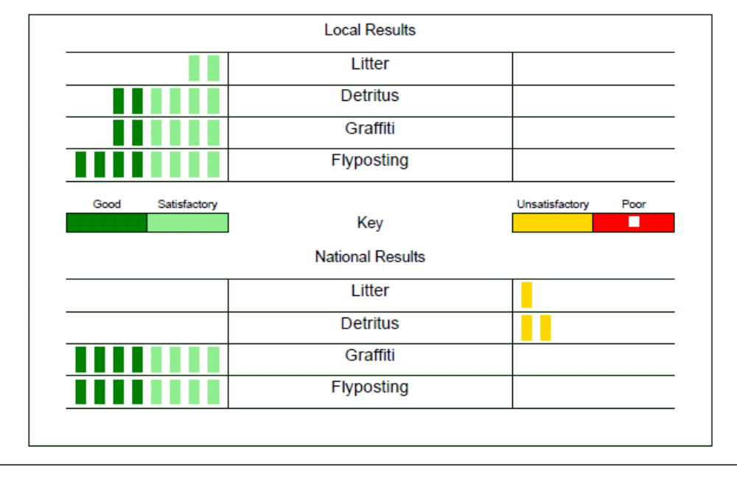
Source: Environment January 2010

Objective 2: Reducing Crime

Serious Violent Crime [NI15]
Lead: Susan Puffett

Commentary

The Tackling Violent Crime Group’s action plan is in place which includes high profiling policing initiatives to combat violent crime. The knife arch has been used by officers across the division to deter people from carrying weapons. In hotspot areas the police run the Domestic Violence Enforcement Campaign (DVEC) car which attends domestic abuse incidents/crimes only.

£30,000 has successfully been obtained from the Home Office to continue work with partners to reduce alcohol related crime.

Serious Violent Crime
(data source: GMP iBase)  Ward | October – December 2008 | October – December 2009 | Difference | % Change
Swinton North | 3 | 1 | -2 | -67
Swinton South | 0 | 1 | 1 | 100
Pendlebury | 2 | 3 | 1 | 50
Kersal | 0 | 1 | 1 | 100
Broughton | 7 | 2 | -5 | -71
Irwell Riverside | 3 | 5 | 2 | 67
Ordsall | 6 | 4 | -2 | -33
Langworthy | 6 | 3 | -3 | -50
Claremont | 1 | 0 | -1 | -100
Weaste & Seedley | 1 | 4 | 3 | 300
Eccles | 1 | 2 | 1 | 100
Barton | 8 | 7 | -1 | -13
Winton | 1 | 0 | -1 | -100
Irlam | 1 | 1 | 0 | 0
Cadishead | 2 | 2 | 0 | 0
Little Hulton | 4 | 11 | 7 | 175
Walkden North | 0 | 1 | 1 | 100
Walkden South | 0 | 5 | 5 | 100
Worsley | 0 | 0 | 0 | 0
Boothstown & Ellenbrook | 0 | 0 | 0 | 0
City total | 46 | 53 | 7 | 15
This indicator measures all serious violence from woundings through to murder and attempts. The cut-off point is S. 47 assault, actual bodily harm, which is measured separately under NI 20 and included later in this report.

NI 15 Performance Against Target – Citywide
LAA 2008/2009  Baseline | LAA Target  2009-10 | YTD Target | YTD Actual  Offences  Qu1 + 2+3 | Difference  Actual v Target | % Difference
266 | 250 or 254 | 188 or 191 | 173 | -15 or -18 | -8 or -9
Source data: NW Regional Tracker 14/01/2009, NB: The final 2009-10 target is to be confirmed by GONW.
Serious Acquisitive Crime [NI16]
Lead: Stephen Kearney

Commentary

On the 21.12.09 Salford City Council opened its new CCTV control room. The control room provides 24 hour monitoring to over 150 public space CCTV cameras and incorporates direct lines of communication to Greater Manchester Police via the police airwaves radio system. This close partnership working together with the ability (March 2010 onwards) for GMP operational control rooms to access live camera images, will significantly contribute to reductions in serious acquisitive crime.

Table 5 shows the period October – December 2009 compared with the same period in 2008. There has been an overall decrease of 27% Citywide in SAC recorded crimes. Priority Wards for this crime type are highlighted in red.

Serious Acquisitive Crime (SAC)*
(data source: GMP iBase)  Ward | October- December 2008 | October- December 2009 | Difference | % Change
Swinton North | 65 | 35 | -30 | -46
Swinton South | 66 | 53 | -13 | -20
Pendlebury | 71 | 51 | -20 | -28
Kersal | 85 | 77 | -8 | -9
Broughton | 235 | 145 | -90 | -38
Irwell Riverside | 441 | 232 | -209 | -47
Ordsall | 309 | 306 | -3 | -1
Langworthy | 140 | 86 | -54 | -39
Claremont | 47 | 50 | 3 | 6
Weaste & Seedley | 62 | 43 | -19 | -31
Eccles | 76 | 64 | -12 | -16
Barton | 73 | 87 | 14 | 19
Winton | 72 | 66 | -6 | -8
Irlam | 28 | 24 | -4 | -14
Cadishead | 50 | 29 | -21 | -42
Little Hulton | 72 | 51 | -21 | -29
Walkden North | 76 | 58 | -18 | -24
Walkden South | 61 | 30 | -31 | -51
Worsley | 66 | 44 | -22 | -33
Boothstown & Ellenbrook | 20 | 22 | 2 | 10
City total | 2,115 | 1,553 | -562 | -27
* This indicator measures burglary dwelling, personal and business robbery; and vehicle crime

NI 16 Performance Against Target – Citywide
LAA 2007/2008  Baseline | LAA Target  2009-10 | YTD Target  Qtrs 1 + 2+3 | YTD Actual  Offences  Qtrs 1 + 2+3 | Difference  Actual v Target | % Difference
7,633 | 6,717 | 5,038 | 4,805 | -233 | -5
Source: NW Regional Tracker

Burglary Dwelling [Local Indicator]
Lead: Stephen Kearney

Commentary

We are continuing to deliver our vigilance programme (funded by the Home Office) with the newly appointed outreach workers actively engaging with up to twenty high risk offenders. We have also arranged for the Metropolitan Police Force to deliver training to CDRP partners on the benefits and use of the National Mobile Phone Register, with the date of 7th March 2010 arranged.

Domestic burglary resulting from insecurities continues to be an issue both in Salford and nationally, for which in December 2009 we launched a public awareness campaign, which used direct mail and Life in Salford media channels to educate citizens.

Table 7 compares October – December 2009 with the same period in 2008, and shows that there has been an overall decrease citywide of 24% in offences.

Burglary Dwelling
(data source: GMP iBase)  Wards | October- December 2008 | October- December 2009 | Difference | % Change
Swinton North | 30 | 10 | -20 | -67
Swinton South | 32 | 24 | -8 | -25
Pendlebury | 17 | 14 | -3 | -18
Kersal | 35 | 35 | 0 | 0
Broughton | 71 | 44 | -27 | -38
Irwell Riverside | 69 | 50 | -19 | -28
Ordsall | 14 | 32 | 18 | 129
Langworthy | 35 | 31 | -4 | -11
Claremont | 11 | 8 | -3 | -27
Weaste & Seedley | 23 | 14 | -9 | -39
Eccles | 23 | 28 | 5 | 22
Barton | 30 | 28 | -2 | -7
Winton | 37 | 29 | -8 | -22
Irlam | 11 | 11 | 0 | 0
Cadishead | 19 | 11 | -8 | -42
Little Hulton | 47 | 26 | -21 | -45
Walkden North | 30 | 20 | -10 | -33
Walkden South | 23 | 13 | -10 | -43
Worsley | 19 | 10 | -9 | -47
Boothstown & Ellenbrook | 9 | 5 | -4 | -44
Total | 585 | 443 | -142 | -24
Vehicle Crime [Local Indicator]
Lead: Stephen Kearney

Commentary

Theft from Motor Vehicle (TfMV) remains a priority as does our crime hotspot in the area of Irwell Riverside. In December 2009 a number of commissioning bids were approved, including a project that will see street lighting on a prolific Irwell Riverside hotspot (48 recorded TfMV offences in the last 12 months) redesigned to meet the lighting standards for high crime areas (estimated completion date March 2010). In addition and working in partnership with Salford Probation we have undertaken a number of other environmental improvement works, including Middlewood Street where recorded offences of vehicle related crime have reached their lowest recorded levels.

Unfortunately and due to a delay in the collation of offender interviews, receipt of our offender based academic research study, commissioned form the University of Salford has been deferred until end of January. We are however confident that at this time the findings will be used to inform and drive tailor made responses.

Table 8, compares October – December 2009 with the same period in 2008, and shows that there has been an overall decrease citywide of 28% in offences.

Vehicle Crime
(data source: GMP iBase)  Wards | October- December 2008 | October- December 2009 | Difference | % Change
Swinton North | 34 | 22 | -12 | -35
Swinton South | 31 | 26 | -5 | -16
Pendlebury | 51 | 34 | -17 | -33
Kersal | 44 | 39 | -5 | -11
Broughton | 151 | 89 | -62 | -41
Irwell Riverside | 354 | 165 | -189 | -53
Ordsall | 266 | 257 | -9 | -3
Langworthy | 81 | 44 | -37 | -46
Claremont | 30 | 38 | 8 | 27
Weaste & Seedley | 31 | 26 | -5 | -16
Eccles | 43 | 34 | -9 | -21
Barton | 39 | 47 | 8 | 21
Winton | 27 | 26 | -1 | -4
Irlam | 17 | 10 | -7 | -41
Cadishead | 25 | 13 | -12 | -48
Little Hulton | 21 | 22 | 1 | 5
Walkden North | 35 | 34 | -1 | -3
Walkden South | 37 | 16 | -21 | -57
Worsley | 41 | 33 | -8 | -20
Boothstown & Ellenbrook | 10 | 16 | 6 | 60
Total | 1,368 | 991 | -377 | -28

Assault with injury crime [NI 20] Local Indicator
Lead: Susan Puffett

Summary
Although there are increases in seven wards there is an overall decrease of 18 offences. The tactical resources for this indicator are shared with those aimed at reducing Serious Violent Crime (NI15).

Assault with Injury crime
(source: iBase GMP data)  Wards | October- December 2008 | October- December 2009 | Actual Difference | % Change
Swinton North | 24 | 18 | -6 | -25
Swinton South | 19 | 15 | -4 | -21
Pendlebury | 10 | 18 | 8 | 80
Kersal | 13 | 9 | -4 | -31
Broughton | 20 | 33 | 13 | 65
Irwell Riverside | 35 | 33 | -2 | -6
Ordsall | 23 | 22 | -1 | -4
Langworthy | 42 | 26 | -16 | -38
Claremont | 8 | 10 | 2 | 25
Weaste & Seedley | 19 | 23 | 4 | 21
Eccles | 17 | 19 | 2 | 12
Barton | 39 | 32 | -7 | -18
Winton | 21 | 24 | 3 | 14
Irlam | 22 | 12 | -10 | -45
Cadishead | 15 | 11 | -4 | -27
Little Hulton | 28 | 30 | 2 | 7
Walkden North | 22 | 22 | 0 | 0
Walkden South | 11 | 11 | 0 | 0
Worsley | 4 | 8 | 4 | 100
Boothstown & Ellenbrook | 5 | 3 | -2 | -40
TOTAL | 397 | 379 | -18 | -5

Adult reoffending rates for those under Probation supervision [NI18]
Lead: Paul Keech

Commentary
In Salford, with a caseload of 4892 offenders, there was an actual re-offending rate of 9.75%. This means that 477 offenders were convicted / cautioned for a further offence in the measurement period. This is 9 less offences than had been predicted (9.94%). These results reflect that in Salford there has been an decrease in re-offending of 1.9% compared to the baseline. Salford are now one of 6 Districts were the actual rate is below the predicted rate of reoffending.

Nationally there has been an decrease in re-offending of 0.52% compared to the baseline. In the North West there has been an increase in re-offending of 1.01% compared to the baseline.

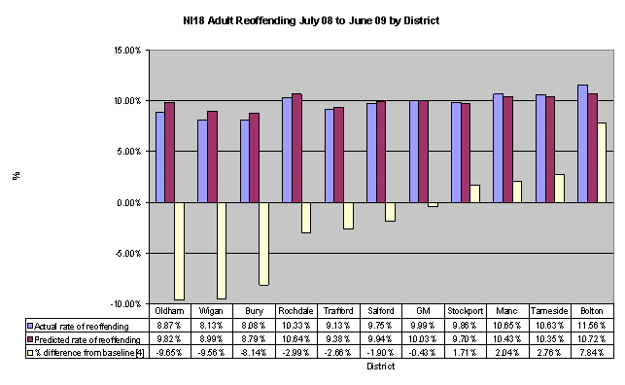
Source: Greater Manchester Probation Trust performance report November 2009

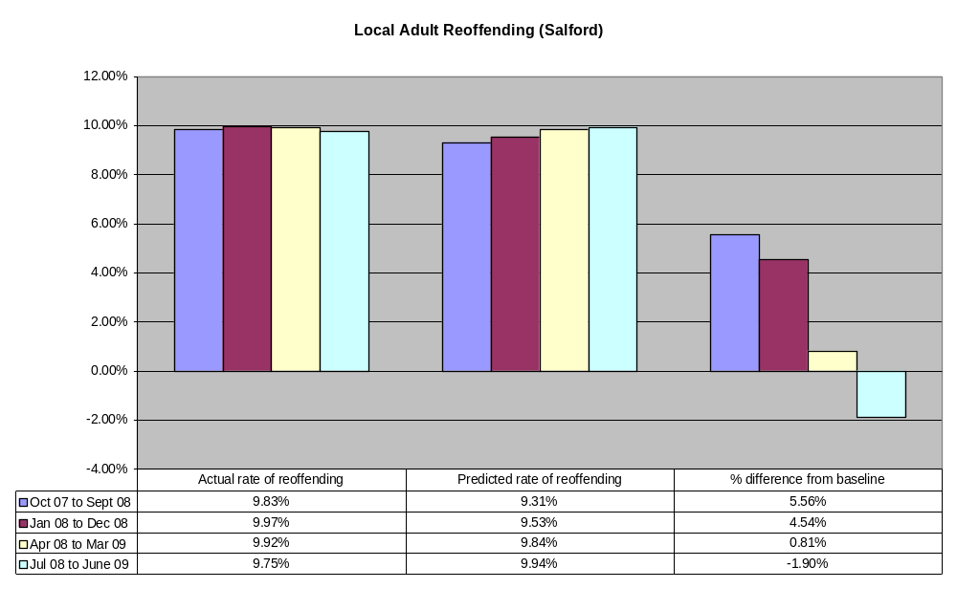

After 3 quarters where the actual rate has been above the predicted rate there has finally been a positive shift the other way. It has been coming though as this is the 4th continuous quarter of improvement.

Working with offenders
Lead: Susan Puffett

Commentary

The Back to Work in Salford (BWIS) team supports people who want to change their lives through action planning for change and finding them employment on release. The BWIS had 44 people sign on to the project this quarter (113 YTD), 11 found employment this quarter (22 YTD), and 6 entered training this quarter (29 YTD).

The Changing Direction mentoring project currently has 44 trained mentors, with 34 being recruited this quarter. An additional 16 were waiting for CRB checks. 8 mentors and mentees were matched this quarter.

Re-offending rate of prolific and priority offenders (PPO’s) [NI 30]
Lead: Supt Anderson Data Supplied by: Adele Piddington

Target Overview

As per the Salford LAA, the reduction target for National Indicator 30 has been agreed as 22%

CDRP/CSP | Number of PPOs | Average number of months on scheme | Performance ceiling | Suggested stretch for Local Area Agreements | Actual Local Area Agreement Target
Salford | 53 | 16.5 | 18% | 22% | 22%

The baseline data for offences by the APACS cohort from 1st October 07 – 30th September 08 is a combined 224 convictions.

The numerical target for offences by the APACS cohort from 1st April 09 to 31st March 2010 is a combined 176 convictions.

Performance and Commentary

Quarter | LAA Target Number of Crimes (accumulative to achieve 22% reduction) | Actual Result (accumulative) | Percentage difference; actual against target  ((y2 - y1) / y1) x100 | Good/Bad?
1 (1st April – 30th June) | 44 | 32 | -27% | GOOD  ☺
2 (1st July – 30th September) | 88 | 63 | -28% | GOOD  ☺
3 (1st October – 31st December) | 132 | 100 | -24% | GOOD  ☺
4 (1st January – 31st March) | 176

The Salford Priority Prolific Offender (PPO) scheme targets the top 53 most prolific offenders in Salford. A PPO team lead by police and probation, utilising other partnership resources, actively target these offender with enforcement action. They also seek to engage with them encouraging them to take up education, training and employment as well as assisting with housing and priority drug and alcohol treatment.

‘Actual Result’ data derives from a manual count of convictions of the PPO cohort on the Police National Computer (PNC). Only finalised convictions have been counted from 1st April to the date of collection (14th January 2010). Therefore, this result is provided as an indication of performance only. The Home Office take a snapshot of data from PNC 3 months after the end of each quarter being analysed. Therefore there will be a difference in the number of convictions detailed in this report against those obtained by the Home Office.

Of the 100 recorded convictions, 5 PPOs (from 53) account for 42% of these convictions (n=42). 30 PPOs out of the cohort of 53 have no recorded convictions over the two quarters.

Performance data, to date, is positive towards the achievement of NI30. A review of the Salford PPO cohort for the purposes of NI30 2010/2011 will be conducted towards the end of quarter 4. This review is planned in synchronisation with the ongoing work towards implementing integrated offender management ‘Spotlight’ in Salford.

Repeat Incidents of Domestic Violence [NI 32]
Lead: Susan Puffett

Commentary

The lead for domestic abuse has been integrated into the Community Safety Unit and the following actions are planned:

- A Draft ‘Violence Against Women’ strategy is out to consultation
- A training programme is being developed

The Association of Chief Police Officers (ACPO) defines domestic abuse as ‘any incident of threatening behaviour, violence, or abuse (psychological, physical, sexual, financial or emotional) between adults, aged 18 or over, who have been intimate partners or family members regardless of gender and sexuality).’ Family members are defined as mother, father, son, daughter, brother, sister, and grandparents, whether directly related, in-laws or stepfamily.

Domestic Violence (DV) is measured in the National Indicators (NI) by DV repeat incidents which are referred to a Multi-Agency Risk Assessment Conference (MARAC) through NI 32 and by the number of DV homicide offences which is NI 34.

Figures from 2008-9 have been used to set the baseline for this year and next. The Salford target for 2009-10 is to reduce repeat MARAC referrals by 28%.

More work is required to ensure that the data processes are correct and robust enough to measure performance for this indicator.

Additional local measures for DV include the number of DV crimes (see Table below). The table counts all crimes with a Domestic Violence Marker. However, there are issues around the utilisation of this marker.

Number of Domestic Violence Crimes
 | Qu 1 | Qu 2 | Qu 3 | Qu 4 | Total
Domestic Violence Crimes of 2008/2009 | 303 | 308 | 263 | 314 | 1,188
Domestic Violence Crimes of 2009/2010 | 366 | 302 | 309
% Change | +21 | -12 | +17
Data source: Crime data from Ibase January 2009.

Criminal Damage [Local Indicator]
Lead: Damian Dallimore

Summary

The table below displays the number of offences of criminal damage reported to police for the period of October - December 2009 compared to the equivalent period in 2008.

There has been a 32% decrease (493 offences) citywide for the current quarter compared to the equivalent period in 2008.

This decrease has been achieved by positive enforcement of liquor licensing regulations and the active targeting of anti social behaviour via the joint agency operation – Operation Brocade.

The priority Wards for this crime type are Broughton, Ordsall, Eccles and Boothstown/Ellenbrook.

The largest single reduction in recorded offences was in Irwell Riverside with 88 fewer offences.

Criminal Damage (not including arson)
(source: iBase GMP data)  Wards | October - December 2008 | October - December 2009 | Difference | % Change
Swinton North | 68 | 48 | -20 | -29
Swinton South | 64 | 37 | -27 | -42
Pendlebury | 70 | 32 | -38 | -54
Kersal | 73 | 46 | -27 | -37
Broughton | 133 | 119 | -14 | -11
Irwell Riverside | 158 | 70 | -88 | -56
Ordsall | 141 | 119 | -22 | -16
Langworthy | 102 | 90 | -12 | -12
Claremont | 39 | 22 | -17 | -44
Weaste & Seedley | 68 | 42 | -26 | -38
Eccles | 51 | 35 | -16 | -31
Barton | 68 | 69 | 1 | 1
Winton | 105 | 64 | -41 | -39
Irlam | 34 | 33 | -1 | -3
Cadishead | 58 | 47 | -11 | -19
Little Hulton | 128 | 68 | -60 | -47
Walkden North | 114 | 64 | -50 | -44
Walkden South | 60 | 27 | -33 | -55
Worsley | 20 | 10 | -10 | -50
Boothstown &Ellenbrook | 7 | 26 | 19 | 271
TOTAL | 1561 | 1068 | -493 | -32

Objective 3 - Effectively tackling ASB together with the community

Perceptions of ASB as a problem [NI 17]
Lead: Damian Dallimore

The current position from the Autumn 2009 Big Listening survey of 23.6%, is better than the 31.5% achieved in the 2008 Place Survey, i.e. fewer see ASB as a problem. See below responses to the question: Thinking about this local area, how much of a problem do you think each of the following are?

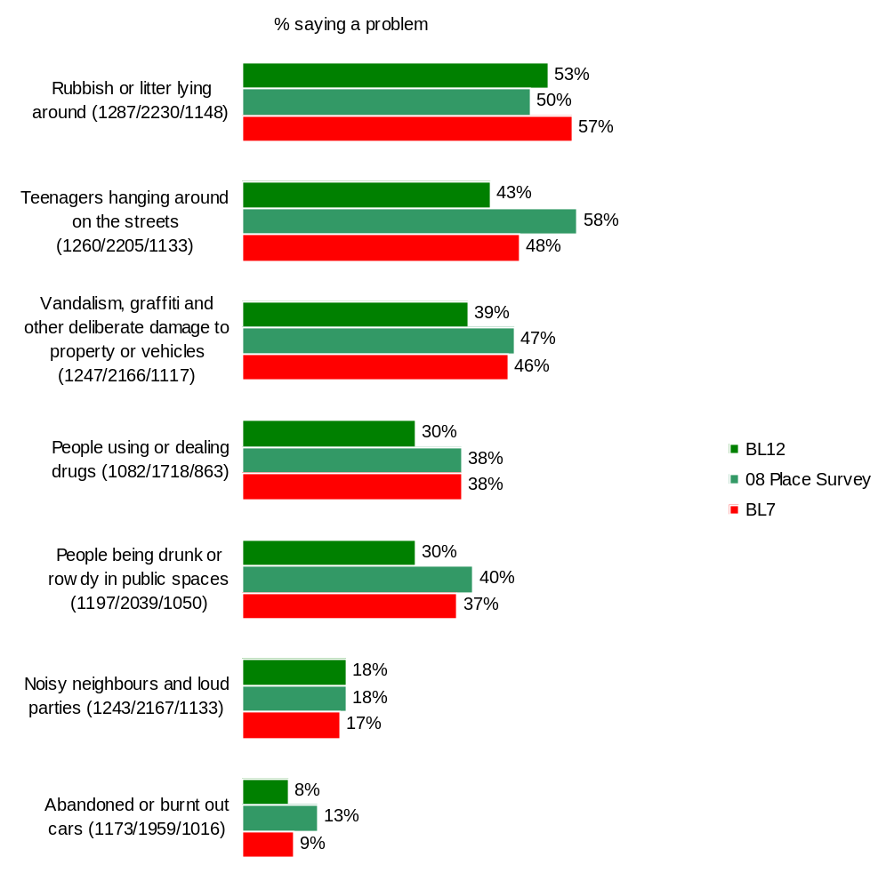
Base: All respondents excluding don’t know and not stated
Source: Ipsos MORI

Worsley & Boothstown and Claremont & Weaste have the lowest number of residents who perceive anti-social behaviour to be a problem in the area across all of the different measures.

Ordsall & Langworthy, East Salford and Irlam & Cadishead have the highest number of residents who perceive anti-social behaviour to be a problem.

Rubbish and litter lying around in the street is the top concern, cited by over half of the respondents (53%), followed by teenagers hanging around.

Rubbish and litter lying around is the only issue showing an increase from the 2008 Place Survey results. Perceptions of ASB are generally improving over time.

NI 17 Percentage of respondents who perceive anti-social behaviour as a problem in their local area
LAA Baseline  (08/09) | Current position  (BL 12 Autumn 2009) | 2010/11 target
31.5% | 23.6% | 28.7%

Note: NI 17 is calculated by combining the seven strands of the question together using a weighting system to produce an overall ASB issue score. The score is the sum of each respondent’s scores for each attribute where 0=not a problem at all and 3=a very big problem. That is, the larger the score, the most likely it is that respondents perceive ASB to be a problem, 21 would be the highest possible score.

Commentary

- Operation Staysafe ran on 12 consecutive Friday evenings between 2nd October to 18th December. During that time the team engaged with 799 young people, of whom 12 were taken home as they were deemed vulnerable and 3 were referred to other services.

- The Ordsall SNAP ran between 14th and 20th December.

- Operation Treacle helped to reduce ant-social behaviour, firework misuse and arson around the period of Halloween and Bonfire night.

- Officers from the police, community safety, neighbourhood management and DAAT visited every neighbourhood across the city during Not In My Neighbourhood Week (2nd - 6th November), engaging with residents, promoting the positive work of the CDRP (including showing the CDRP film) and responding to questions and problems that residents raised.

- GMP arranged a Force Action Day for 30th October, which involved Councillors, council officers and Fire Service staff working alongside police officers, responding to minor incidents and ASB, in particular focusing on reports of dangerous bonfires and firework nuisance.

- The police introduced a dispersal order in New Broughton in response to problems of ASB and criminal damage.

- The official opening of Clifton Youth Centre by the Deputy Mayor and Anne Weinstock (Director of the Youth Taskforce) took place in November.

- The police issued 25 Youth Restorative Disposals for young people with no previous convictions who admitted to committing a minor criminal offence.

ASB interventions and referrals [Local Indicator]
Lead: David Walsh

ASB interventions and referrals: 3rd quarter 2009/10

(source: David Walsh)  Community Committee Area | ASB per 1000 population | Injunction | ASBO/CRASBO | Evictions | Warning Letters | Warning Interviews | ABA’s | Parenting Contracts | YISP referrals | ASSFAM referral | LPDG referrals
Claremont & Weaste | 14 | 0 | 0 | 0 | 14 | 10 | 1 | 0 | 1 | 0 | 2
Eccles | 19 | 2 | 0 | 0 | 71 | 63 | 1 | 1 | 2 | 0 | 2
Irlam & Cadishead | 16 | 1 | 0 | 0 | 62 | 8 | 5 | 4 | 3 | 2 | 1
Ordsall & Langworthy | 35 | 7 | 0 | 0 | 63 | 77 | 5 | 1 | 2 | 0 | 5
Salford East | 26 | 4 | 1 | 0 | 43 | 65 | 12 | 4 | 3 | 2 | 3
Swinton | 18 | 2 | 0 | 0 | 98 | 52 | 6 | 0 | 0 | 2 | 0
Walkden & Little Hulton | 20 | 4 | 1 | 0 | 56 | 32 | 4 | 1 | 1 | 0 | 1
Worsley & Boothstown | 8 | 0 | 0 | 0 | 9 | 1 | 0 | 2 | 1 | 3 | 0
Total | - | 20 | 2 | 0 | 416 | 308 | 34 | 13 | 13 | 9 | 14
City average | 20 | 2.5 | 0.2 | 0 | 52 | 38 | 4.2 | 1.6 | 1.6 | 1.1 | 1.7

ASB interventions and referrals: 3rd Quarter 2008/9

(source: David Walsh)  Community Committee Area | ASB per 1000 population | Injunction | ASBO/CRASBO | Evictions | Warning Letters | Warning Interviews | ABA’s | Parenting Contracts | YISP referrals | ASSFAM referral | LPDG referrals
Claremont & Weaste | 17 | 1 | 0 | 0 | 24 | 7 | 0 | 0 | 1 | 2 | 5
Eccles | 24 | 10 | 0 | 0 | 64 | 46 | 3 | 2 | 3 | 1 | 6
Irlam & Cadishead | 15 | 5 | 0 | 1 | 43 | 15 | 2 | 1 | 2 | 2 | 0
Ordsall & Langworthy | 35 | 1 | 0 | 1 | 58 | 32 | 0 | 2 | 2 | 2 | 5
Salford East | 26 | 8 | 1 | 1 | 29 | 43 | 0 | 3 | 6 | 6 | 1
Swinton | 20 | 3 | 0 | 1 | 94 | 54 | 17 | 5 | 6 | 1 | 1
Walkden & Little Hulton | 22 | 2 | 0 | 1 | 101 | 68 | 2 | 0 | 1 | 3 | 4
Worsley & Boothstown | 9 | 0 | 0 | 0 | 7 | 2 | 0 | 1 | 0 | 1 | 0
Total | - | 30 | 1 | 5 | 420 | 267 | 24 | 14 | 21 | 18 | 22
City average | 21 | 3.7 | 0.1 | 0.6 | 52 | 33 | 3 | 1.7 | 2.6 | 2.2 | 2.7

Commentary

The citywide rate of anti social behaviour (ASB) incidents in quarter 3 (October to December 2009) was 20 incidents per 1,000 population, reduced by 1 from quarter 2 2008/9. This is the lowest recorded quarterly rate in the last 3 years. Local rates range from 8 incidents per 1,000 in Worsley & Boothstown to 35 in Ordsall & Langworthy. Only Irlam & Cadishead showed an increase in reported incidents (by 1 per 1,000 to 16), with all others reducing or staying the same.

Enforcement activity overall has reduced from the same period last year. This is largely due to a targeted operation in 2008 in Eccles which resulted in a high number of injunctions at once last year. ASBO & CRASBO use is still relatively low and remains a challenge.

Early intervention through warnings and agreements is as usual by far the most popular form of action. Use of acceptable behaviour agreements is increased from last year, as are warning interviews with warning letters remaining static.

Options such as referrals to YISP, ASSFAM and LPDG have fallen this quarter compared to last year. Further research will be need as to the reasons why if this trend continues.

Dealing with concerns about ASB by the police and other local agencies [NI 21]
Lead: David Walsh

The following questions were asked in the Autumn 2009 Big Listening survey (BL 12):

How much would you agree or disagree that the police and other local public services seek people’s views about these issues in your local area?

And how much would you agree or disagree that the police and other local public services are successfully dealing with these issues in your local area?

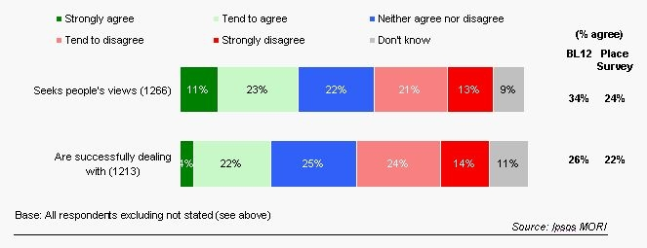

How well informed or not do you feel about what is being done to tackle anti-social behaviour in your local area?
Lead: David Walsh

The above question was also asked in the Autumn 2009 Big Listening survey (BL 12) and the results are shown below.

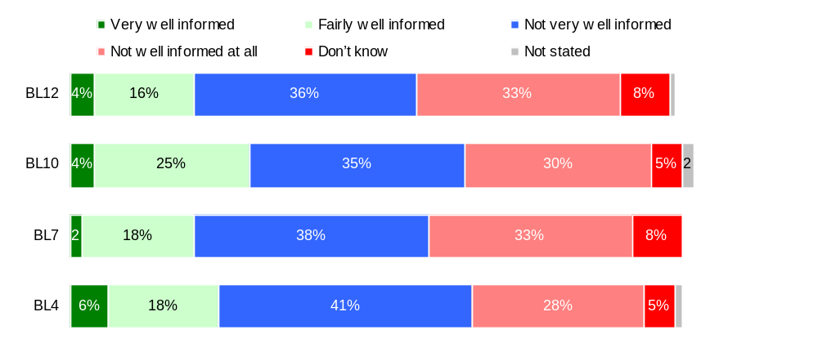Base: All respondents – BL12 (1331) BL10 (2439) BL7 (1183) BL4 (1097)
Source: Ipsos MORI

Commentary

There is a strong relationship between people who feel informed about what is being done to tackle anti-social behaviour and perceptions that anti-social behaviour is being successfully dealt with.

There has been a drop in the number of respondents who feel informed – from 29% in the 2008 Place Survey to 20% in 2009. This is of concern as it is bucking the trend of other results from the BL 12 survey.

Parents take enough responsibility for the behaviour of their children [NI 22]
Lead: David Walsh

Commentary

Perceptions that parents take responsibility for the behaviour of their children is a key driver to overall satisfaction with the local area and a big issue in general. The result in the Autumn 2009 Big Listening survey (BL 12) is significantly more positive that that achieved in the 2008 Place Survey (32% agree in BL12 versus 21% in the Place Survey).

Residents who are dissatisfied with the council (69%), do not agree that the council offers value for money (62%) and do not feel informed about anti-social behaviour measures (60%) are all more likely to disagree that parents take responsibility for their children in the local area.

There is a lot of activity to provide support for parents through the locality teams. Stay safe also identifies young people who may be vulnerable where the follow up will be to offer parenting support. The courts will also impose statutory parenting orders when appropriate for the parents of young people involved in the youth justice system.

Arson [NI 33]
Lead: Paul Starling

Summary

The arson measure (NI 33) is split into two parts, deliberate primary fires and deliberate secondary fires, sometimes referred to as ASB fires. Both are reported on a Citywide basis.

Commentary

Overall, we are seeing a sustained improvement in the reduction of deliberate primary fires especially in domestic dwellings. Vehicle fires have seen slight increase in our priority wards which have been subject to partnership intelligence gathering to reduce these levels of incidence.

Deliberate secondary fires have been reduced by a significant level due to the passing of information gained on fly tipping and general levels of flammable materials to partners to be removed prior to them being targeted by fire setters.

The data is analysed to see if any particular trend pattern emerges which will be targeted by all partners to reduce these levels of Arson incidents.

Arson [NI 33]
NI 33 | Q3  2008/9 Actual | Q3  2009-10 Actual | Difference
(a) Deliberate Primary  Fires | 119 | 92 | -27  (-22.7%)
(b) Deliberate Secondary  Fires | 413 | 279 | -134  (- 32.5%)
Data source: GMF&RS

All Arson Performance Against Target - Citywide
LAA Baseline* | Pro Rata Target Actual  2009-10 | Year to Date Actual  Total Arsons | Actual Difference | % YTD Difference
2169 | 1521 | 1132 | - 389 | -25.6%
* calculated using a three-year rolling average 2004-7

Objective 4 - Reducing the harm caused by drug and alcohol abuse

Drug-related (class A) offending rate [NI 38]
Lead: Jane Birch

Background

This indicator was introduced in 2009-10. It aims to achieve a reduction in drug related offending by: reducing the volume of proven offending in a follow-up 12 month period by (Class A) drug misusers identified in the course of their contact with the criminal justice system.

The cohort consists of adults identified at two key points: Those who test positive in police detention following arrest/charge (DIP) and those recorded on OASys (Offender Assessment System) as having criminogenic (Class A) drug use whilst on licence or on a community sentence.

Performance

For the cohort identified Jan – Mar 2008 offending levels after 12 months were:
Number in cohort | 174
Actual volume of proven offences | 373
Predicted volume of proven offences | 433
NI 38 (Actual / Predicted) | 0.86

For the cohort identified Jan – Mar 2009 offending levels after 3 months were:
Number in cohort | 113
Actual volume of proven offences | 66
Predicted volume of proven offences | 94
NI 38 (Actual / Predicted) | 0.70

Commentary
Salford DAAT is responsible for the delivery of The Drugs Interventions Programme. The programme, often known as DIP, involves identifying Class A drug misusing offenders as they go through the criminal justice system and putting into action a range of interventions to deal with their behaviour, getting them out of crime and into treatment and other support. This begins at an offenders first point of contact with the criminal justice system and continues through the journey that can include custody, court, sentence, treatment and beyond into resettlement.
Rates of reoffending are on target i.e. below expect levels for the first quarter of 2009-10 and performance is better than in 2008-09. However performance levels can be affected by relatively few individuals. Reoffending rates are double the expected level for the 10% of the cohort identified by both OASys and Mandatory Drug Testing. Salford DAAT continues to monitor mandatory drug tests and provides analysis for the Partnership Delivery Group. Data on repeat positive testers was provided for the Strategic Threat Assessment and the profiling of these offenders is being conducted by the DAAT and treatment providers. A lead indicator around repeat positive testing also features in the DAAT Performance Management Framework.

As shown overleaf, favourable commentary has been received by email from the National Treatment Agency for Substance Misuse (NTA).

I thought I’d write you a quick note to pass on my thanks to you and your respective teams for their efforts with respect to NI38 performance. The reductions in the re-offending rates against the predicted rates in Salford are significant (0.7). I believe the fact that this sizable reduction, which is largely due to the performance against the DIP cohort where the equivalent drop is down to 0.52, is as a direct result of the formulation and inclusion of the “Reduce the average frequency of MDT+ repeat tests (rolling 3 month cohort) [PDU only]” into the drug PMF. I appreciate that this is a difficult indicator to monitor and an even difficult indicator to perform against (Steve!) but nonetheless the results are clear to see.

Hopefully the reductions seen to date will be sustained.

Regards

Phil Conley
Deputy Regional Manager
National Treatment Agency for Substance Misuse

Number of drug users recorded as being in effective treatment [NI 40]
Lead: Colin Wisely

Background
This indicator measures the number of Problematic Drug Users (PDUs) in effective treatment. By this we mean those that are either successfully discharged and/or are retained in treatment for at least 12 weeks. There is a time lag in reporting from the National Drug Treatment Monitoring System (NDTMS) of at least 12 weeks to allow for retention rates to be calculated.
The baseline is equal to the number of PDUs effectively treated in 2007/08 as verified by the National Treatment Agency (NTA). The baseline for 2007/08 was 844.

The Partnership signed up to a 4% increase for 2008/09. For both 2009/10 and 2010/11 we have agreed further 1% annual increases. These targets were agreed with the NTA regional office in May 2008.

Target for 2008/09: 878
Target for 2009/10: 886
Target for 2010/11: 886

Performance
In 2008/09 the target of was exceeded. We are currently above target for 2009/10 as can be seen from the rolling annual data shown below.
Oct2007 Sep2008 | Nov2007 Oct2008 | Dec2007 Nov2008 | Jan2008 Dec2008 | Feb2008 Jan2009 | Mar2008 Feb2009
874 | 876 | 873 | 877 | 877 | 879

Apr2008 Mar2009 | May2008 Apr2009 | Jun2008 May2009 | Jul2008 Jun2009 | Aug2008 Jul2009 | Sep2008 Aug2009
896 | 885 | 885 | 895 | 900 | 901

Commentary
It is likely that we will achieve this target once again this year. Salford DAAT commissions a range of drug treatment services which contribute to this target. The target is focused particularly on problematic drug users (PDUs). PDUs are people who use heroin and/or crack. The main group of individuals who contribute to this target are those who have been in treatment for some time, who annually are counted as ‘effectively’ treated. During the year a further cohort of new individuals contribute to this target once they have been retained in treatment for more than twelve weeks. Most of the individuals that we retain in this manner are receiving a methadone or ‘subutex’ prescription for heroin dependency with the Greater Manchester West prescribing service that we commission. A small number of these individuals are in a similar form of treatment with our specialist service for under 21 year olds. Another small cohort are accessing detoxification and/or structured day-care.

Perceptions of drunk or rowdy behaviour as a problem [NI 41]
Lead: David Walsh

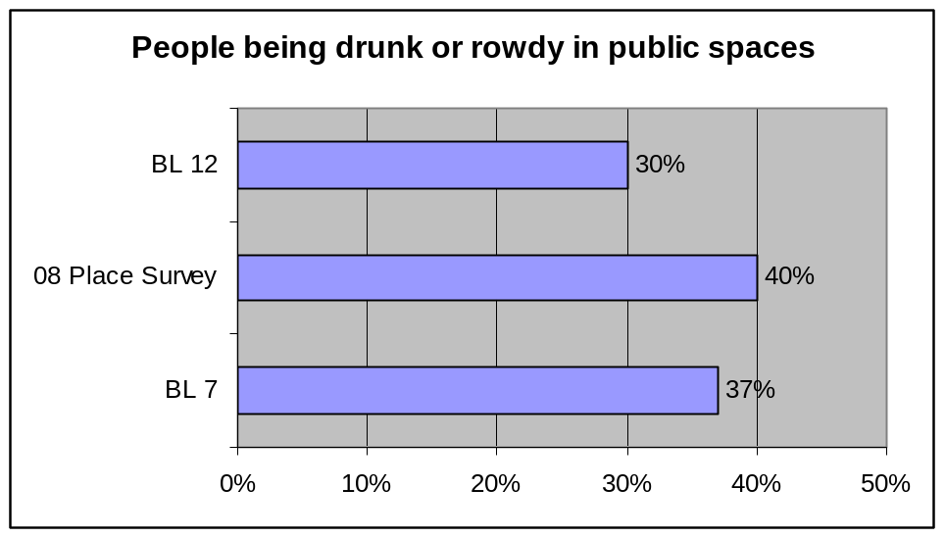

Commentary

There has been a significant improvement in perceptions for this indicator, dropping ten percentage points from the 2008 Place Survey.

The improvement will at least in part relate to work Salford does as to the management of alcohol sales, reducing sales to those already drunk, and test purchasing on sales to those who are underage, licensing and enforcement, and policing responses, as represented in other indicators in the LAA.

Failure rate for sales of alcohol, cigarettes and knives to young people during test purchases. [Local Indicator]
Lead: Caroline Clarke

Commentary

The Bottle to say no campaign

Currently 85 members (42.5% of off licensed premises) in Salford have signed up to voluntary best practice conditions to prevent sales of age restricted products to underage.

Test purchasing operations (October to December 2009)

Alcohol – There were 18 attempted test purchases with 3 sale of alcohol to 15 year old volunteers. Two formal cautions issued and investigations are ongoing for one premises.

Fireworks – There were 6 attempted test purchases with 2 sales of fireworks to 15 year old volunteers. Investigations are ongoing
One sale was made by the owner of the firework business who had been issued with an £80 Fixed Penalty Notice by the Police for setting off fireworks and disorderly behaviour causing distress to local residents. This will be used as evidence of bad character should criminal proceedings be instigated for the sale of fireworks to a person under the age of 18.

Perceptions of drug use or drug dealing as a problem [NI 42]
Lead: David Walsh

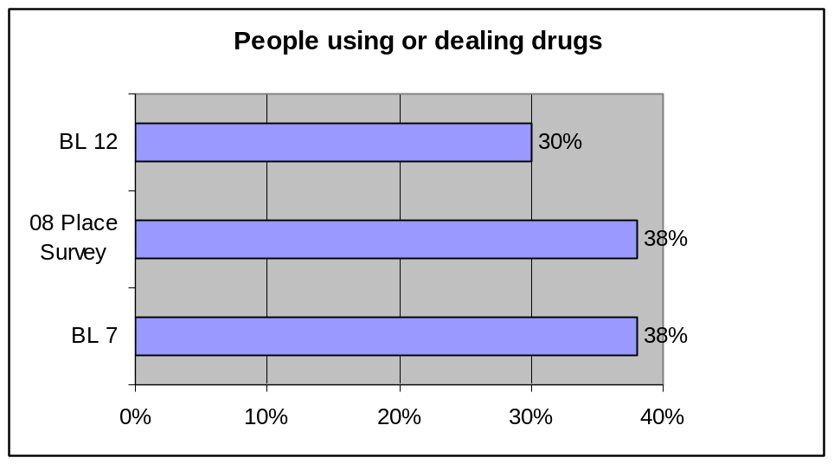

Commentary

There has been a significant improvement in perceptions for this indicator, dropping eight percentage points from the 2008 Place Survey.

Salford DAAT has coordinated a range of communications campaigns across the last three years concerning ‘Tackling Drugs’ in the city of Salford. This is an annual event. The DAAT has continued throughout the year with a range of campaigns aimed at the general public, reassuring local residents and informing them. Local treatment facilities across the city have been established which may have had an impact in Little Hulton and the Cathedral areas of the city. Police activity around drug dealing has been assertive and high profile and publicity associated with this activity will also have reassured the public. The prevalence of heroin and crack cocaine use amongst younger people is also declining. This will also be making an important contribution to perceptions of drug problems in the city.

Substance misuse by young people [NI 115]
Lead: Maggi Heavey

Commentary

The ‘TellUs’ school based survey is voluntary and the data are weighted to match local area profiles based on school census data. The indicator measures progress in reducing the proportion of young people frequently misusing substances – including illegal drugs, alcohol and volatile substances such as glue, gas or solvents. Tellus4 (2009) data is not expected until January / February 2010, surveying is expected to be completed by the end of November 2009.

Comprehensive analysis and commentary in relation to Tellus3 findings has been provided in previous reports.

Salford DAAT invest in the Healthy Schools programme developing and delivering education and interventions to inform children and young people in education settings about the risks associated with substance misuse and to build resilience. A Drugs Education Consultant sited in Children’s Services School Improvement Services develops polices with schools and trains staff, parents and governors. Both services target excluded young people and those with poor attendance in Pupil Referral Units. The DAAT supports specialist workers in the YOS and Next Step, the leaving care service, to engage other vulnerable young people in order to reduce the substance misuse and the harm it causes to them, their families and communities.

Rate of hospital admissions for alcohol related harm [NI 39]
Lead: Andrew Macdonald

Background

The methodology for this indicator was developed by the North West Public Health Observatory (NWPHO). It takes account of a wide range of diseases and injuries in which alcohol plays a part and estimates the proportion of admissions that are attributable to the consumption of alcohol. The Department of Health produced estimates of the rate at which alcohol-related hospital admissions were expected to rise through to 2010/11. Salford is committed to curbing this rise by one percentage point year-on-year. In other words, admissions will continue to rise but the actions undertaken will mean this rise will be less than was otherwise predicted. Data on the rate of hospital admissions for alcohol-related harm for every 100,000 members of the population are derived from Hospital Episode Statistics (HES). The DAAT monthly data reporting system went live for the first time in December 2009. Salford partners are now able to make use of the local (Secondary Use Services) data on a monthly basis to predict what the cleansed regional (Hospital Episodes Statistics - HES) data will show at year end. This deals with the major impact the time lag on the North West Public Health Observatory cleansing of local data.

Commentary and Performance
The trend is that Salford will meet the NI39 target for this year. Salford it is predicted will meet the target for NI39 until 2012-2013. The future prediction of underperformance in 2012 to 2013 relates to strategic underinvestment in alcohol nationally over many years so that by that stage with nil investment and nil strategic support treatment services will be unable to cope with demands, hence the Department of Health High Impact Changes Guidance and new Alcohol Treatment Pathways, informed by Social Marketing and Alcohol Harm Reduction approaches outside of treatment.
The latest SUS and HES data combined as shown in the chart show Salford on target for NI39 this year but going off target in 2012 – 2013 – this relates to the Alcohol Business Case for investment and national High Impact Changes Guidance commissioning therein, and which forms a major strand of the Alcohol Harm Reduction Strategy now drafted. The strategy once agreed would commence in 2010 and last until 2020 well beyond the scope of the existing Alcohol Strategy 2008-2011 which will clearly become overwhelmed by events.

While Salford NI39 performance now means 9th as opposed to 6th place in the national table - the current NI39 trajectory still reflects the national, regional and local picture of the need for major investment in Alcohol Harm Prevention – industrial scale investment is required to turn the trend around over coming years. The clear message however from the work on NI39 is that Alcohol Related Harm is not just about hospital admissions it is about how a whole system contributes to harm and mortality and how only a strategic partnership, which is better informed, more commercially aware, more community focussed, can deliver a long term approach to address the primary and secondary drivers of alcohol related harm and head off 2012.

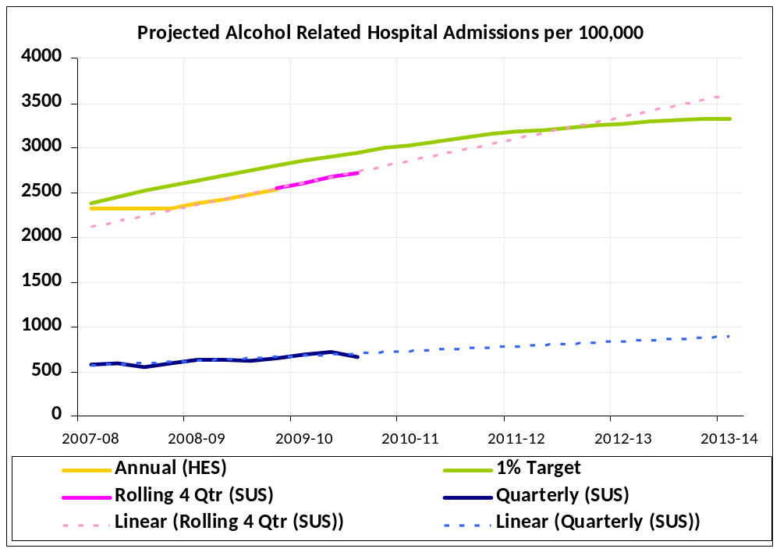

(HES=Hospital Episodes Statistics SUS=Secondary Use Services)

Youth Offending Service (YOS) Indicators
Lead: Lee Harding

Reoffending by Young Offenders [NI19]

The baseline data for re-0ffending rates is the 2005 cohort which had a re-offending rate of 1.55 after 12 months. The target set within the LAA is to reduce this by 6% to 1.46 by 2011.

The 2008 cohort had a reoffending rate of 1.25 after 12 months which was a reduction of 19% and exceeded the target.

The data for the 2009 cohort is being tracked at quarterly intervals. The reoffending rate after 3 months was 0.20 compared to 0.48 for the 2008 cohort so the data is indicating continued improvement in performance. The 6 month data (which has still to be validated) shows a re-offending rate of 0.52 compared to the baseline data of 0.95 (after 6 months) and 0.82 for the 2008 cohort (after 6 months).

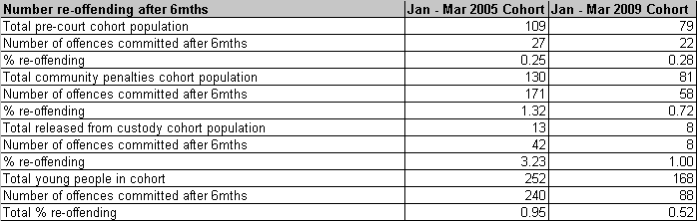

Sentenced To Custody [NI43]

There are no LAA or national targets set for this indicator but comparisons are made with statistical neighbours as well as regional and national data. The performance data is calculated by dividing the number of court disposals by the number of custodial sentences. There has been a significant reduction in the use of custody in Salford down from 87 five years ago to 55 last year and a projected figure of 40 for the current year. However there has also been a corresponding reduction in the number of disposals so that performance has not greatly improved and Salford is slightly above statistical neighbour, regional and national averages.

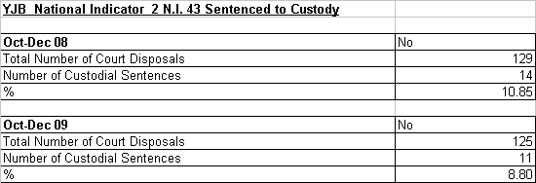

ETE [NI 45]

Again there are no LAA or national targets set for this indicator and comparisons are made with national regional and statistical neighbours. However not being in ETE is a key risk factor in terms of offending or re-offending. Salford compares favourably with national regional and statistical neighbour data.

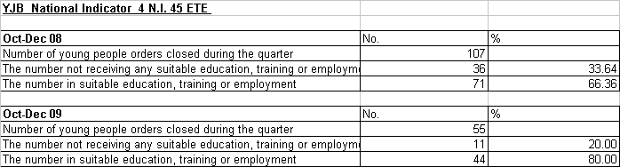

Accommodation [NI46]

There are no targets for this indicator which measures the suitability of accommodation for young people. All YOS score very highly on this measure and there is some concern as to its effectiveness.

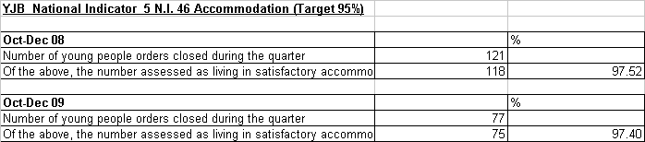

FTE [NI111]

The baseline data for this measure is taken from the PNC for 07/08 and is 2160 FTE’s per 100,000 of the juvenile population. FTE is a priority target within the LAA for a reduction of 6% (2032) by 2011.

The data for 08/09 recently released indicates that in Salford there were 1,700 FTE’s a reduction of almost 22% which if maintained would mean that the target was achieved comfortably.

YOS data indicates that there were 233 FTE’s for April to December 09 compared to 270 for the corresponding period in 08/09 which is indicative of a continued reduction.

All information in this section taken from Home Office data provided by e-mail from GONW dated 13/2/09
Those named Salford PPOs as of 1st April 09 became a collective group known as the APACS cohort. This cohort remains static for the 12-month financial year regardless of offenders being deselected over the same period.
The actual results may be adjusted for up to three months following the end of the quarter to allow for offences to be processed through the CJS and for convictions to be recorded on PNC.

