
Would you like to make a difference and help people in your community?

Do you want to volunteer in Salford?

Would you like to meet new friends and get out and about and have some fun?

- We are looking for local people to help out in your neighbourhood, sharing their knowledge to help raise awareness about heart health issues and cancer.

- You would be given any help required and access to other support, including expenses paid so you would never be out of pocket. You would also be doing work that can be put on your CV.

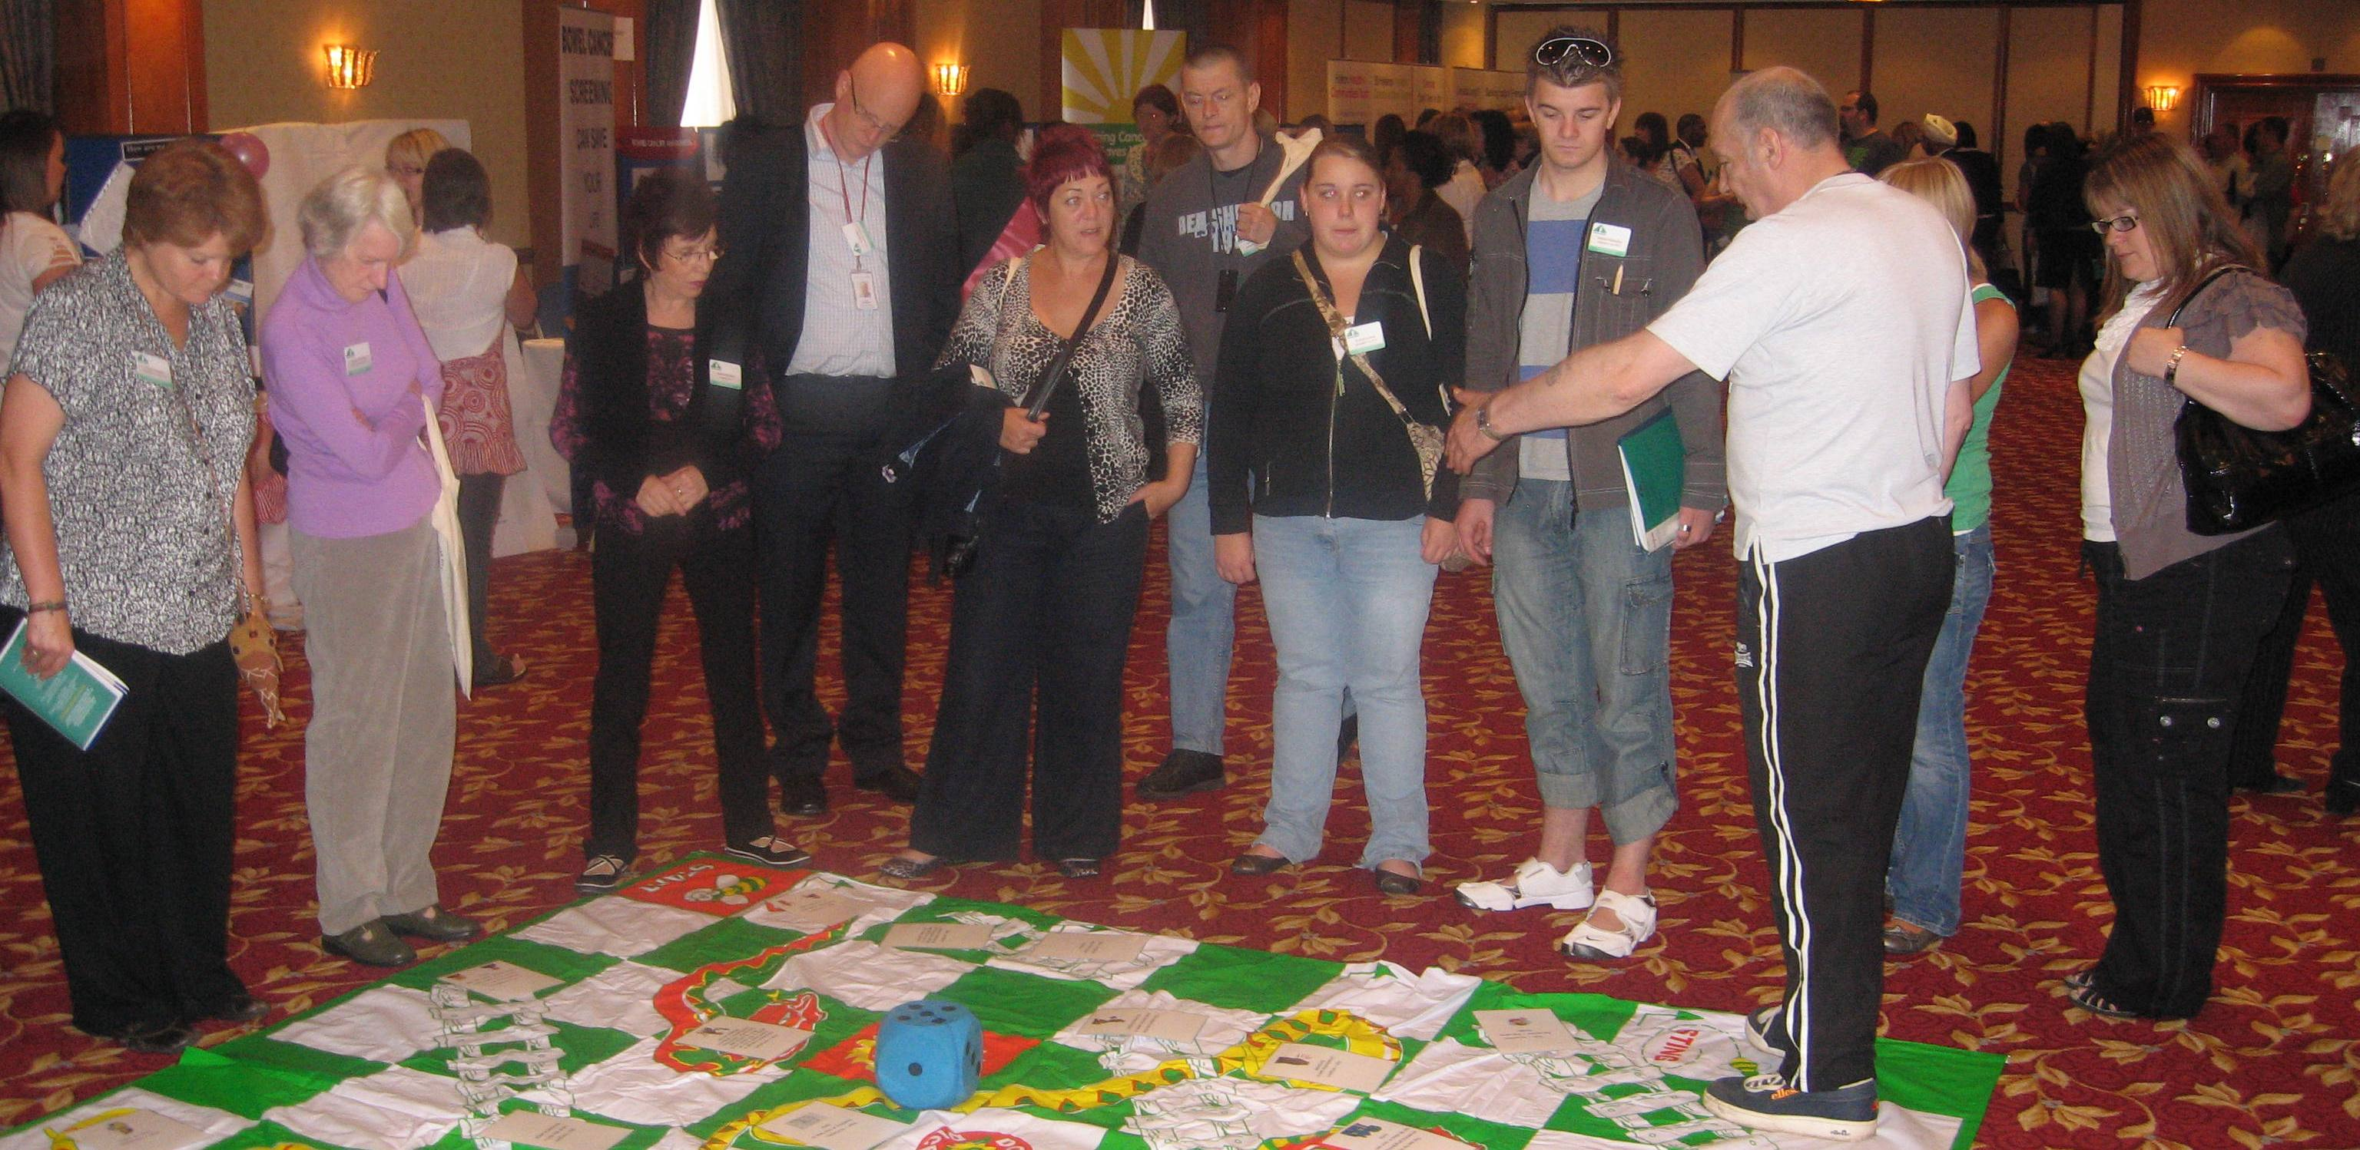



- You would be part of an action team in your community, doing as much or as little as you wanted, doing things in a way that suits you and is as much fun as possible.

Your community, your family and friends, your choice!
So who do you contact to find out more?
Kieron McGlasson, Engagement Coordinator.
Phone; 0161 743 0088

Email; kieron.mcglasson@unlimitedpotential.org.uk

