Part 1

REPORT OF THE STRATEGIC DIRECTOR OF SUSTAINABLE REGENERATION

TO THE LEAD MEMBER FOR PLANNING
FOR BRIEFING ON 7th July 2009
FOR DECISION ON 21st July 2009

TITLE: Chapel Street Green Streets Programme Phase 1

RECOMMENDATIONS:

That the Lead Member is recommended to:

- Approve the sketch proposals for the Chapel Street Green Streets Programme Phase 1.
- Approve expenditure of £400,000 from the Central Salford Business and Investment Plan 2009/2010 in connection with Chapel Street Green Streets Programme Phase 1.
- In principle, support the expenditure of £70,160 from the Central Salford Business and Investment Plan 2010/2011 to support the management and maintenance of the projects within the Chapel Street Green Streets Programme Phase 1 for a ten year period.
- Approve that Urban Vision enter into negotiations with Salford City Council’s appropriate partner contractors to obtain a target cost for constructing the works on site.

EXECUTIVE SUMMARY:

The Chapel Street Green Streets Programme is a key project in Central Salford URC’s Business and Investment Plan 2009/2010. The Phase 1 works will be focused on Bexley Square, St John’s Square and walkways and the gardens to the west of the Cathedral and will involve creating a series of safer and improved public spaces connected with better quality streets through:

- Improvements to paving and lighting;
- New street furniture and public art;
- Repairs to walls, railings and gates; and
- Tree and shrub management.

The works will be designed and implemented within a budget of £400,000. Funding from Salford City Council is identified in the URC’s approved Business and Investment Plan in 2009/2010.

BACKGROUND DOCUMENTS: None

KEY DECISION:

DETAILS:

1.0 | Background
1.1 | Lead Member will recall that a report summarising the background to this project was brought to Lead Member briefing on the 5th May 2009 for information.
1.2 | The report on the 5th May recommended that Central Salford Urban Regeneration Company’s sketch proposals for a Green Streets project in Chapel Street would be brought forward to Lead Member Briefing in June.
1.3 | The proposals stem in part from the requirements of the Adelphi Bexley Square Conservation Area Appraisal (adopted July 2007) to improve the quality of the public realm. As such, it helps meet the city council’s duty to formulate and publish proposals for the preservation and enhancement of conservation areas.
1.4 | The project details are the subject of this report.
2.0 | Details
2.1 | The URC’s approved Business and Investment Plan 2009/2010 incIudes investment in the Green Streets Programme over the next five financial years and beyond. £590,000 is identified to be spent in 2009/2010, the funding to be provided by Salford City Council.
2.2 | The URC is proposing to spend £400,000 of this financial year’s Green Streets funding in Chapel Street. A Chapel Street Green Streets Phasing Plan (Annex 1) has been developed for the area bounded by Chapel Street, Trinity Way, Cleminson Street and Adelphi Street. From initial cost estimates indications are that four projects can be selected from the Phasing Plan to form a Phase 1 programme of works.
2.3 | The four projects selected were prioritised for the following reasons:  - Proximity to the Chapel Street corridor, which has a large number of users and will therefore have greater impact;  - Availability of sites on which projects could be delivered this current financial year; and  - Ability to open up underused existing pedestrianised streets.
2.4 | It is recommended that the Chapel Street Green Streets Programme Phase 1 therefore consists of the following projects:  - Improvements to Bexley Square;  - Improvements to Cathedral Walk, part of the key pedestrian route from Adelphi Street to Trinity Way;  - Enhancements and repairs to St John’s Square and walkways; and  - Reopening and improvements to the gardens to the west of the Cathedral.
2.5 | Discussions are currently taking place with the Diocese about the reopening of the Gardens for public use.
2.6 | The improvements and enhancements will reflect the principles set out in the recently approved Central Salford Public Realm Handbook.
2.7 | The Chapel Street Green Streets Programme Phase 1 consists of the following projects:  a) Bexley Square (Annex 2)  An important public space to the front of the former Town Hall. This area was pedestrianised in the mid 1980’s and refurbished in the late 1990’s in a style that respected the heritage qualities of the surrounding buildings. Although the space is maintained to a reasonable condition it is beginning to look tired with architectural lighting that has not worked for some time and street furniture in need of replacement/repair. The space is also poorly lit. The front of the space consists of a large raised area that forms a trip hazard and does not connect well with Chapel Street.  The key proposals therefore involve:  - Improving lighting to make the space feel safer and to encourage appropriate use of the space at night. This will be achieved through removing the sodium street lighting with the ‘orange glow’ and replacing with modern ‘white’ lighting. Modern architectural lighting will also be introduced to replace the up-lighters that no longer work;  - Integrating Bexley Square with the proposed improvements on Chapel Street. This will be achieved in advance of works being carried out on Chapel Street and will entail removing York stone paving within the raised area and replacing this with granite paving to the same specification as that proposed for use on Chapel Street. By doing this a level direct route will ultimately be created between the proposed new wide and straight pedestrian crossing on Chapel Street and Bexley Square;  - Replacing existing dilapidated items of street furniture (seats, bollards and bins) with new to the same specification as those proposed for use on Chapel Street;  - Introducing public art to create the feeling of Bexley Square being part of an arts and cultural quarter; and  - Upgrading works that will include power wash cleaning the existing footways and pruning untidy growth from the base of the trees.

b) Cathedral Walk (Annex 3)

This forms part of a key pedestrian route between Adelphi Street and Trinity Way, linking the key historic buildings within the Adelphi Bexley Square conservation area. The route is currently surfaced in bitmac and is poorly lit and in future will potentially be enclosed by the Cathedral’s proposed multi storey car park.

The key proposals therefore involve:

- Improving lighting to make the street feel safer to use at night. This will be achieved through removing the outdated sodium street lighting with the ‘orange glow’ and replacing with modern ‘white’ lighting. Some modern architectural lighting will also be introduced; and
- Creating a pedestrian walkway that has a similar appearance to Ford Street and the existing walkway to the rear of the Cathedral. To achieve this, the existing bitmac will be removed and replaced with York stone paving.
c) Cathedral Square and flanking walkways (Annex 4)

This pedestrian space with connecting walkways was implemented towards the end of the 1980’s and although of reasonable quality it has a neglected appearance, is poorly lit and consequently is not very well used by pedestrians.

The key proposals therefore involve:

- Improving lighting to make the street feel safer to use at night. This will be achieved through removing the outdated sodium street lighting with the ‘orange glow’ and replacing with modern ‘white’ lighting. Some modern architectural lighting will also be introduced;
- Replacing existing dilapidated items of street furniture (seats, bollards and bins) with new to the same specification as those proposed for use on Chapel Street;
- Repairing, cleaning and repainting existing walls, railings and gates;
- Pruning overgrown trees and shrubs; and
- Repairing and painting the existing sculpture and illuminating at night through the use of light projection.

And if funding allows:

- Replacing the existing concrete replica stone paving with York stone.

Or alternatively if funding does not allow:

- Power-wash cleaning the existing footways.

d) Cathedral gardens (Annex 5)

The existing gardens form a quiet green haven adjacent to Chapel Street. They were constructed at the same time as the Cathedral Square and walkways in the late 1980’s. The land is in the ownership of the City Council. However an agreement is in place with the Cathedral, whereby the Cathedral is responsible for locking/unlocking the access gates each day. Unfortunately due to issues of security the Cathedral do not permit daily access to the gardens.

Also, although the gardens are reasonably well maintained, the shrubs have become tall and restrict visibility into the gardens, thereby creating issues of personal safety.

Discussions are taking place with the Diocese to seek agreement to open up the gardens to the public during the day.

The key proposals therefore involve:

- Improving natural surveillance into the gardens through crown lifting tree canopies and the removal of tall shrubs and replacing with lower growing varieties;
- Repairing, cleaning and repainting existing walls, railings and gates;
- Power wash cleaning the existing footways; and
- Graffiti and litter removal.

3.0 | Future Management and Maintenance
3.1 | The future management and maintenance of these projects within the Green Streets Programme will be critical to the long term quality, appearance and attractiveness of these streets and spaces.
3.2 | Existing and estimated future maintenance costs are set out below:

Project | Annual Existing Maintenance Cost | Annual Estimated Future Maintenance Cost
a) Bexley Square | )  )  ) £741  ) | )  )  ) £2610  )
b) Cathedral Walk | )  )  ) £741  ) | )  )  ) £2610  )
c) Cathedral Square and flanking walkways | )  )  ) £741  ) | )  )  ) £2610  )
d) Cathedral Gardens | £2025 | £4406
Total | £2766 | £7016

3.3 | It is proposed that the URC includes a sum for maintenance of these projects for a ten year period following completion of the capital works – this will be a combination of contractor maintenance for two/three years and agreement of a commuted sum to cover the remaining period up to ten years. This will be funded from the Green Streets Programme in the URC’s Business and Investment Plan 2010/2011
3.4 | After ten years, new development in the Chapel Street area will generate increased income for the City Council from business rates and Council Tax. This will contribute towards ongoing maintenance into the future. In the interim, the Urban Regeneration Company and the City Council are working on proposals to address issues of long term management and maintenance of unadopted high quality public realm (eg Greengate/Irwell City Park) which will also address areas like the Cathedral walkway.
3.5 | The funding required to maintain these four Phase 1 projects for ten years will be £70,160 (£7016x10). It is proposed that an allocation to cover this sum is included in the URC’s Green Streets Programme for 2010/2011.
4.0 | Conclusion
4.1 | The Green Streets Programme is a key element within the URC’s Community Regeneration Programme and will ensure that high quality public realm is delivered in local areas supporting the sustainable regeneration of those areas and linking major boulevarding and public realm projects into adjacent neighbourhoods.
4.2 | This report sets down details of the Chapel Street Green Streets Programme Phase 1.
4.3 | Lead Member approval is therefore sought :  - for sketch proposals for the Chapel Street Green Streets Programme Phase 1;  - to expend £400,000 in connection with Chapel Street Green Streets Programme Phase 1;  - to request the expenditure of £70,160 for the management and maintenance of the Chapel Street Green Streets Programme Phase 1; and  - to allow Urban Vision to enter into negotiations with Salford City Council’s appropriate partner contractor to obtain a target cost for constructing the works on site.

KEY COUNCIL POLICIES: None

EQUALITY IMPACT ASSESSMENT AND IMPLICATIONS: An Equality Impact Assessment will be carried out as part of the detailed design of the individual projects.

ASSESSMENT OF RISK: Low

SOURCE OF FUNDING: Central Salford URC’s approved Business and Investment Plan 2009/2010 identifies the Green Streets Project within its Community Regeneration Programme. In 2009/2010, there is £520,000 to support the whole Green Streets Programme and it is intended that £400,000 of this will be spent on the Chapel Street Green Streets Programme Phase 1. The source of the funding is Salford City Council.

LEGAL IMPLICATIONS:

Contact Officer and Extension No: Richard Lester - 793 2129
Date Consulted: 15th May 2009
Comments: There are no legal implications in approving the recommendations in this report. In the longer term, there will be implications in carrying out the proposed work:

- The contractor will have various statutory responsibilities to the workforce and to the general public in the performance of the work. Work sites will need to be suitably fenced. If works are being carried out in the highway, the city council will be strictly liable for any interference with public rights of safe passage. Suitable risk management strategies will need to be in place to eliminate as far as possible the risk of claims.
- Where work is proposed on property that is not owned by the city council, this will need the prior written consent of the interested parties, who will need to be fully identified. They may require the city council to enter into a licence, the terms of which would have to be approved by the City Solicitor. It would be prudent to make a photographic ‘before and after’ record of the internal (where appropriate), as well as the external condition of such property, in order that any claims that might arise may be handled appropriately.

FINANCIAL IMPLICATIONS:

Contact Officer and Extension No: Alison Swinnerton (on behalf of Nigel Dickens) - 601 4887
Date Consulted: 15th May 2009
Comments: The Chapel Street Green Streets Programme Phase 1 will be met within Central Salford URC’s Business and Investment Plan Capital Programme 2009/10. Future maintenance will be provided by way of a commuted sum funded from Central Salford URC’s Business and Investment Plan 2010/11. There will be no additional resources needed from the city council to fund this project as it forms part of the Salford City Council Capital funds allocation to the URC.

OTHER DIRECTORATES CONSULTED: Environmental Services, Urban Vision (Highways)

CONTACT OFFICERS: Peter Baker Central Salford URC (0161 601 7728)
Perry Twigg Urban Vision (0161 779 6053)

WARD TO WHICH REPORT RELATES: Irwell Riverside

Paul Walker
Strategic Director for Sustainable Regeneration

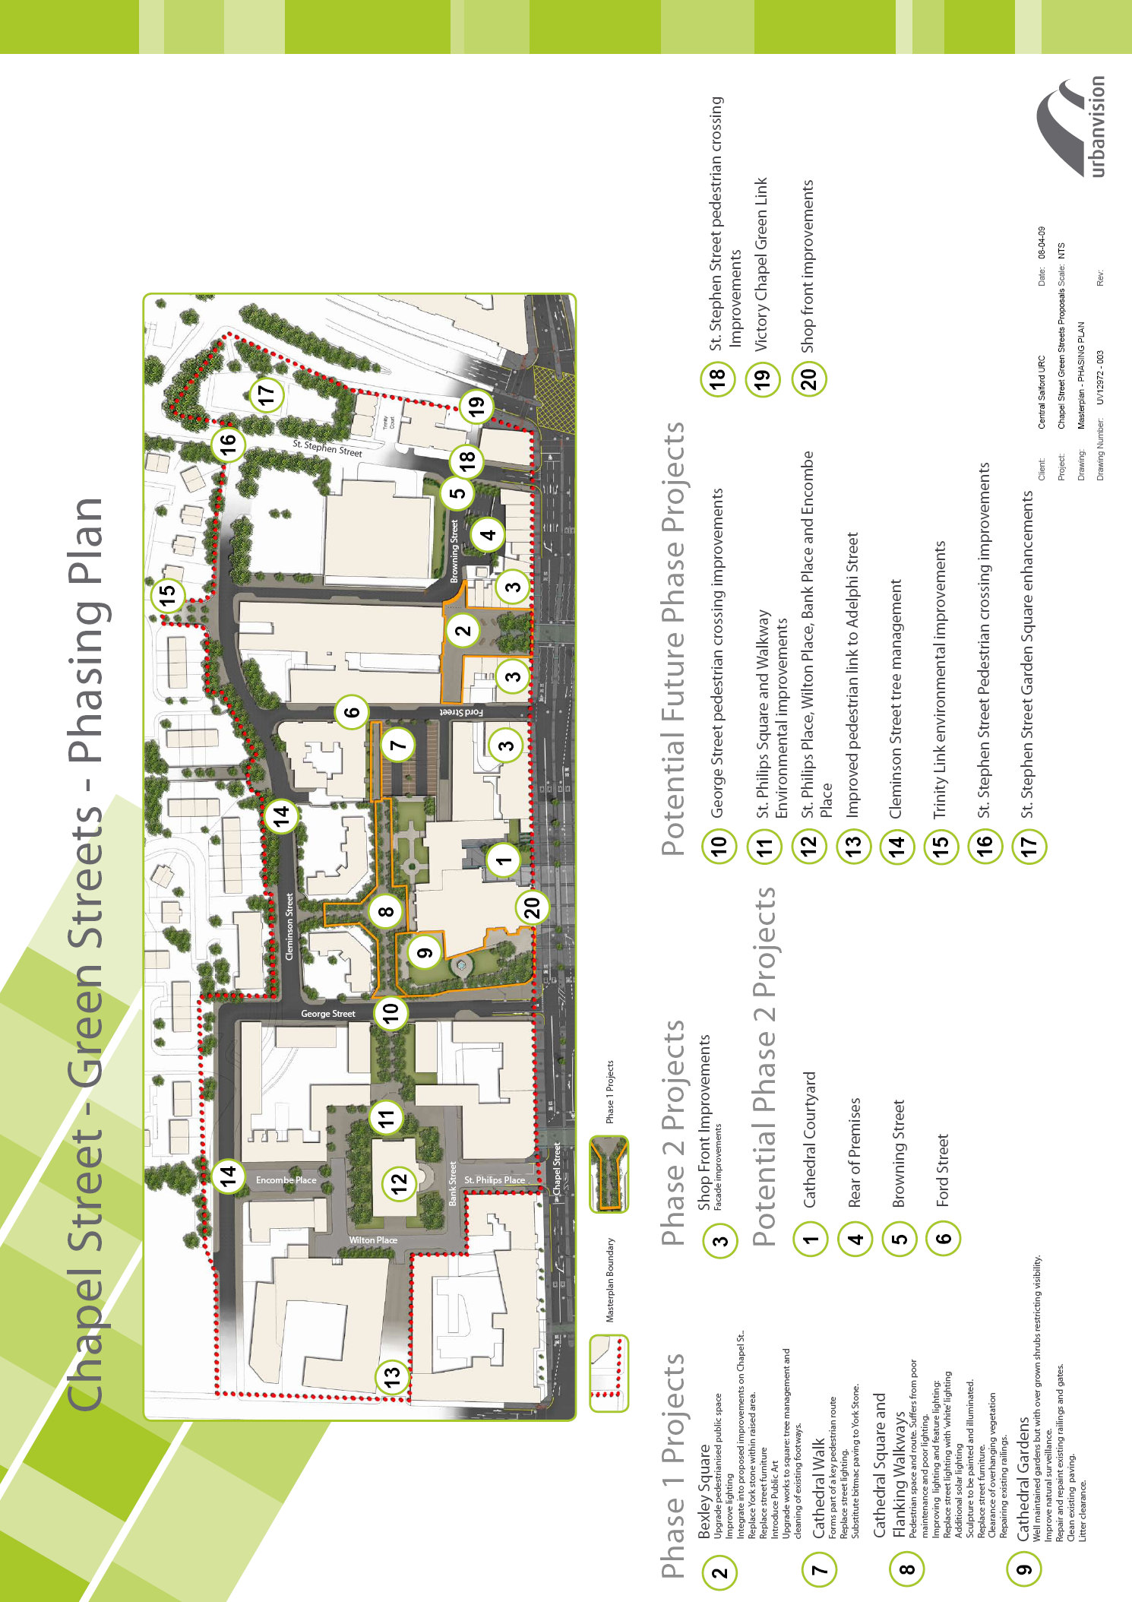
Annex 1
Annex 2

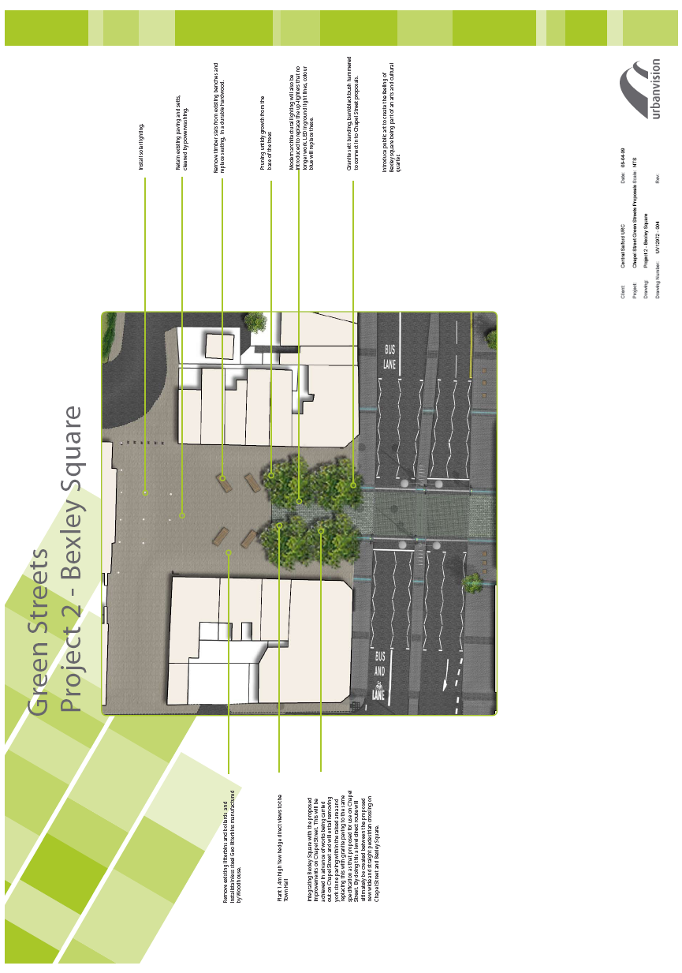
Annex 3

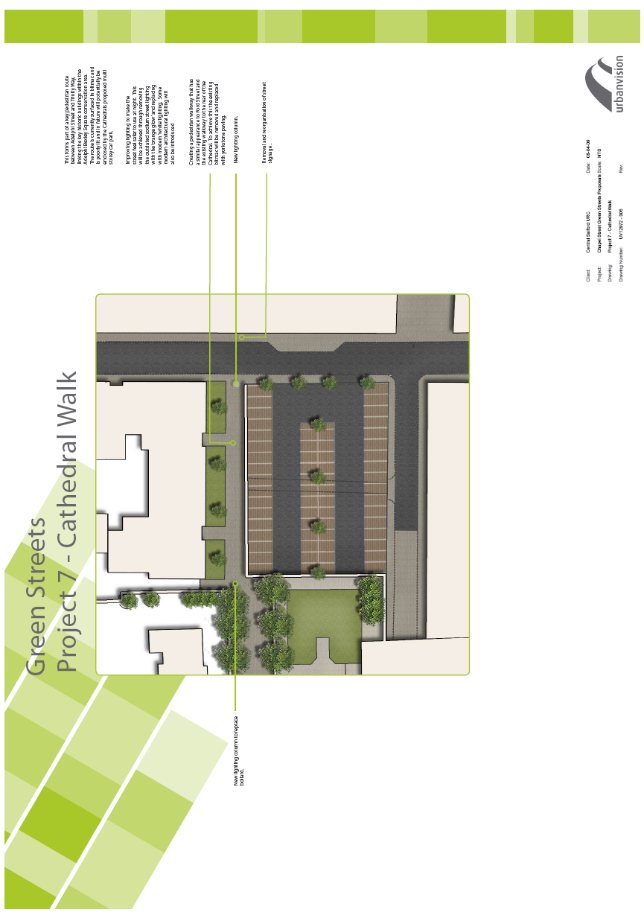
Annex 4

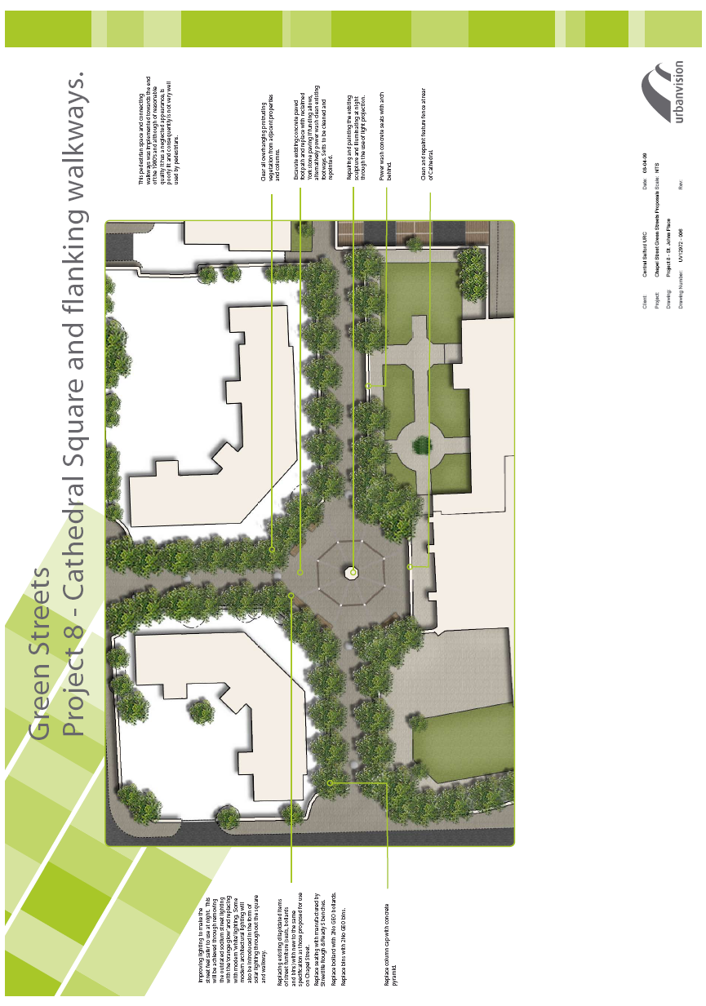
Annex 5



